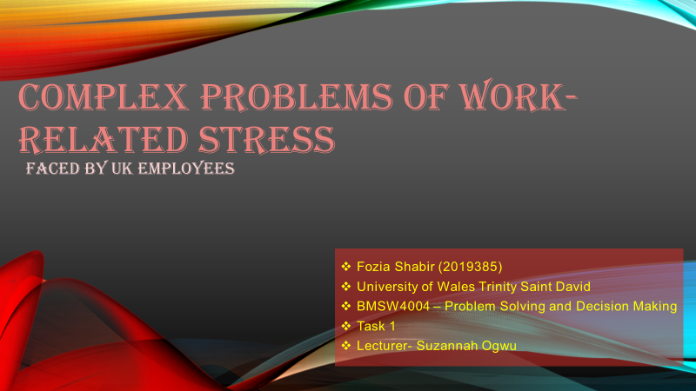
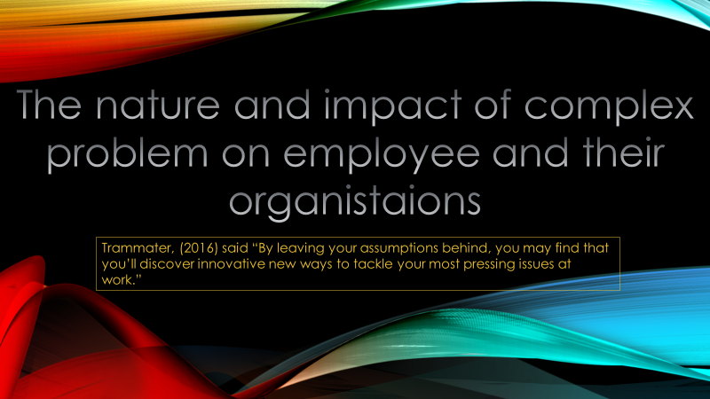

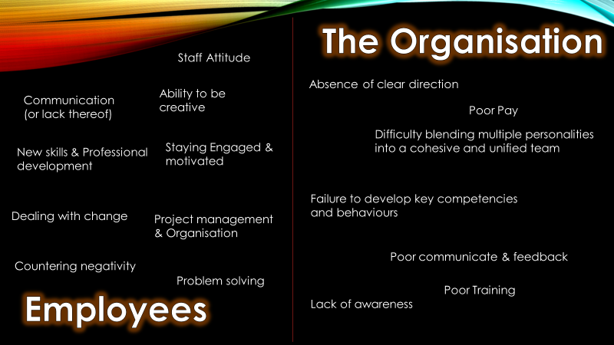
The nature and impact of complex problems on employees and their organisations are very common for people to face while working in a busy work environment, many people face this problem as most of these are very common in the work placement, I believe the most common complex problem an employee could face is dealing with change as this is not very easy to deal with when you have been working for a long period of time with no change and this can cause them in having problems in being flexible that can result in having conflicts or missed deadlines.
The complex problem that the organistaions could face within the company are facing bad communicate and feedback, this could prevent the company in fixing their errors and maintaining a good connection with the clients and customers and this will gain them in losing customers and having a bad repression Infront of new clients or customers.
Stuart (2014), said that “Complex problems are difficult to define because different people will have differing opinions about the cause, nature and extent of the problem. It is often their social complexity, rather than their technical complexity that makes complex problems so hard to address.”

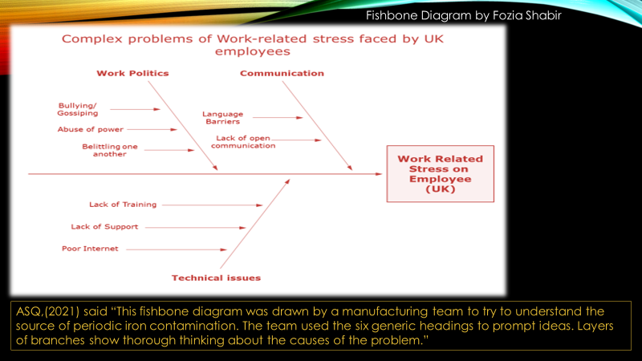
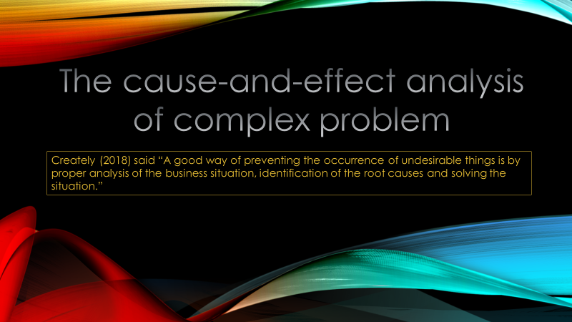
The cause-and-effect analysis of complex problem also known as the fishbone diagram, as you can see, I have used this method to show most common causes and effect of the work-related stress, the three main causes I believe are work polities, Communication and technical issue. There are several more, but I believe these are the main problems because is very related to have problems with commutation between co-workers or bosses as these problem are could put a stop to having a team success as well as reason lots of employee stress as people could miss deadlines in bad communicate or cause conflicts between each other within a team or the company.
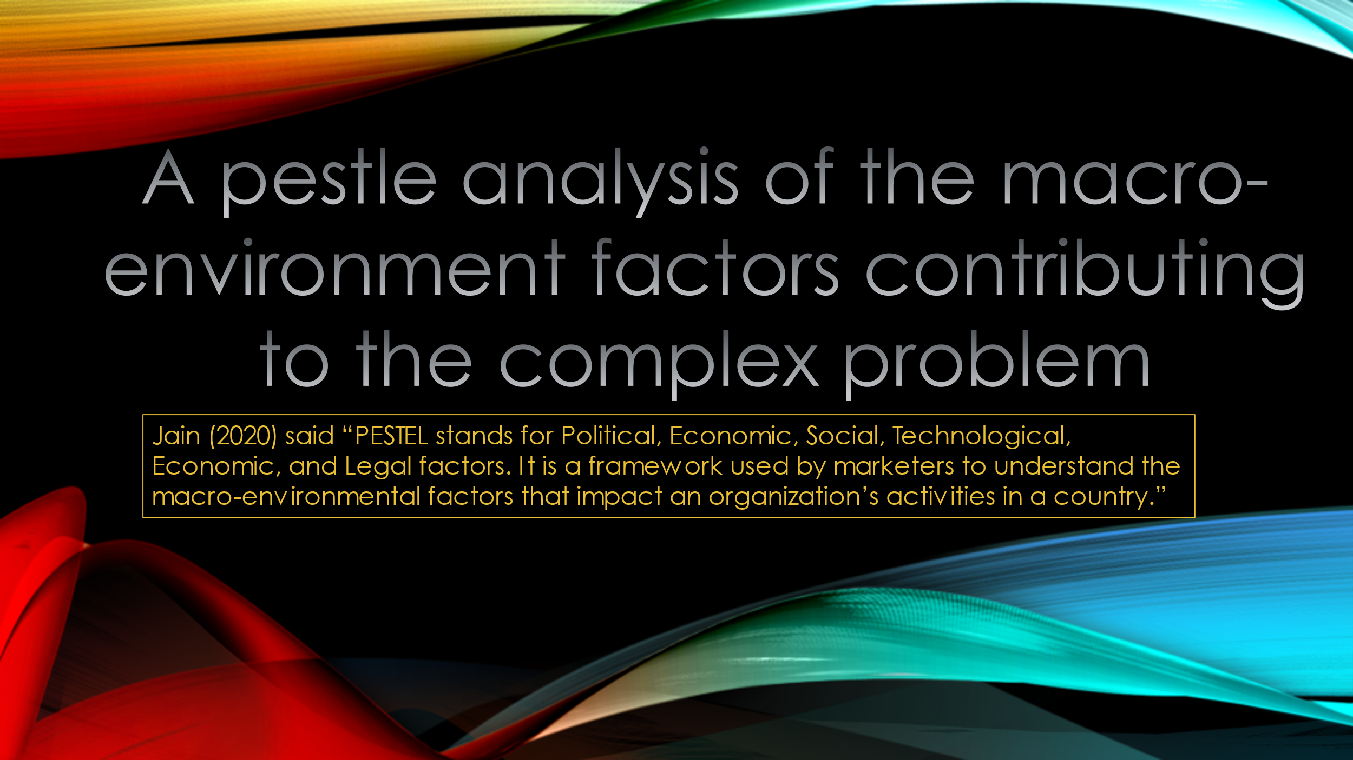
ASQ,(2021) said “This fishbone diagram was drawn by a manufacturing team to try to understand the source of periodic iron contamination. The team used the six generic headings to prompt ideas. Layers of branches show thorough thinking about the causes of the problem.”
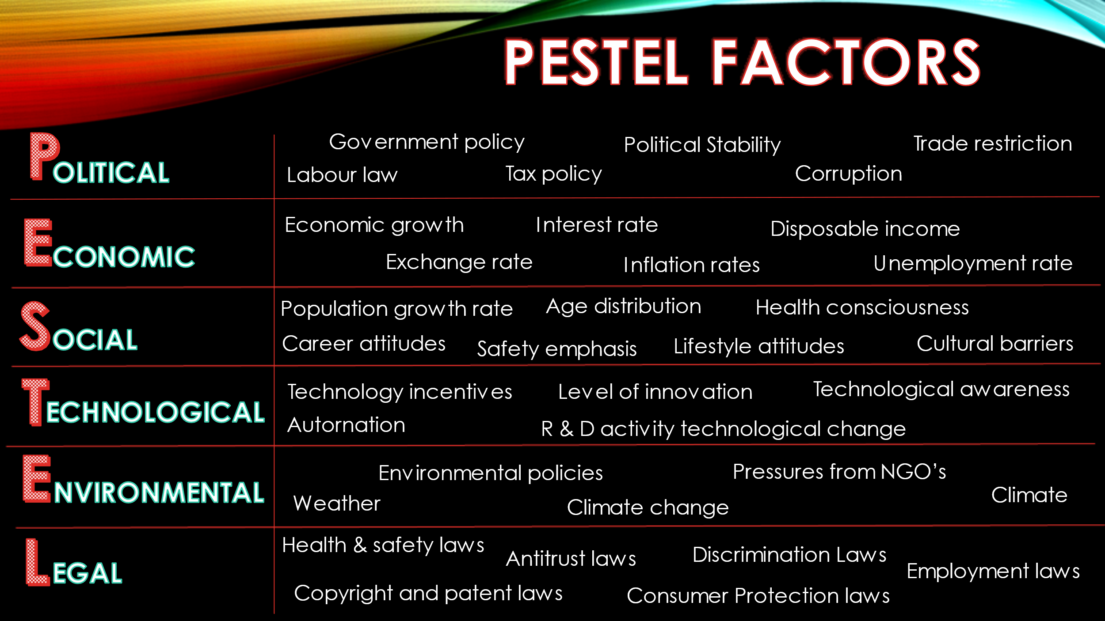
A pestle analysis is a useful tool for business to understand market growth or declines this could help them in choosing which positions, potential and directions are in best for the business. Pestle stands for P- Political E- economic S- social T- technological E- environmental L-legal, all of these are used to assess the market and to gain information which could be used for the good reasons of the business. Organisational use these factors so the business could make better and good decisions for the company.
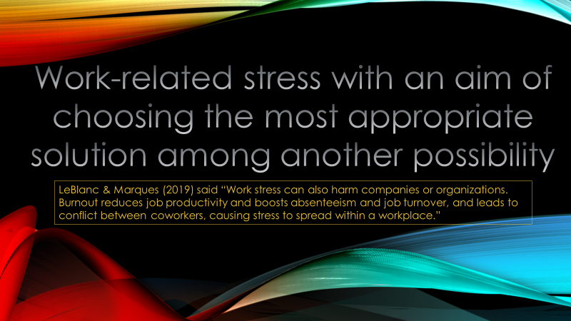
Parhak (2021) said “PESTLE analysis sometimes referred to as PEST analysis, is a concept in marketing principles. This concept is used as a tool by organizations to keep a track of the external factors impacting the organization.”
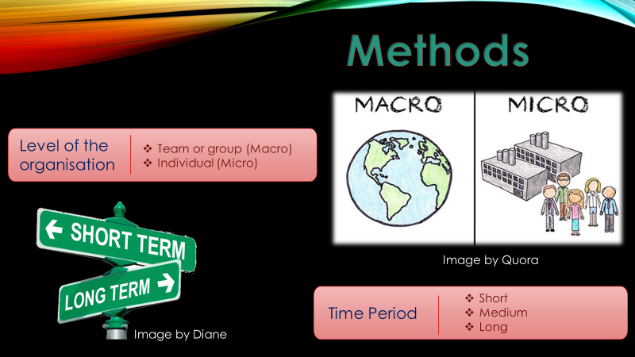
Level of organisation

Macro means the big picture and micro gives a deep dive
Macro
Macro is a way of seeing the bigger picture how do we reason of the problem. The companies and businesses are more concerned about the future of the company rather than the information all the details they are being done currently at the business using the macro the company are searching for success and the reason of failure within the work environment.
Micro
A micro is based on small and details is provided by the employees for the company’s future and the reason for the company to see the bigger picture. This system measures the amount of problems and solutions they would need for the further success
Time period
SMART- Specific, Measurable, Achievable, Relevant, Timely
There are three stages of time period short-term, medium-term and long-term.
Short-Term
By using a short term solution businesses and companies are able to see an progress further on for the employees such as having training courses available for employees and having equipment checked and quality fix such as machine while using at the workplace this should be set in a carefully for the long term.
Medium-Term
Medium term planning is put in place for a permanent solution for short term problems, this is place to be seen if the short term solution is working for example, To see if the training courses that have been set for employees are working and the problems are being solved an if these problems are not being solved setting a definite goal that could help progress and strengthen their companies, This could also help the companies by setting more schedules on training session and course for employees.
Long-Term
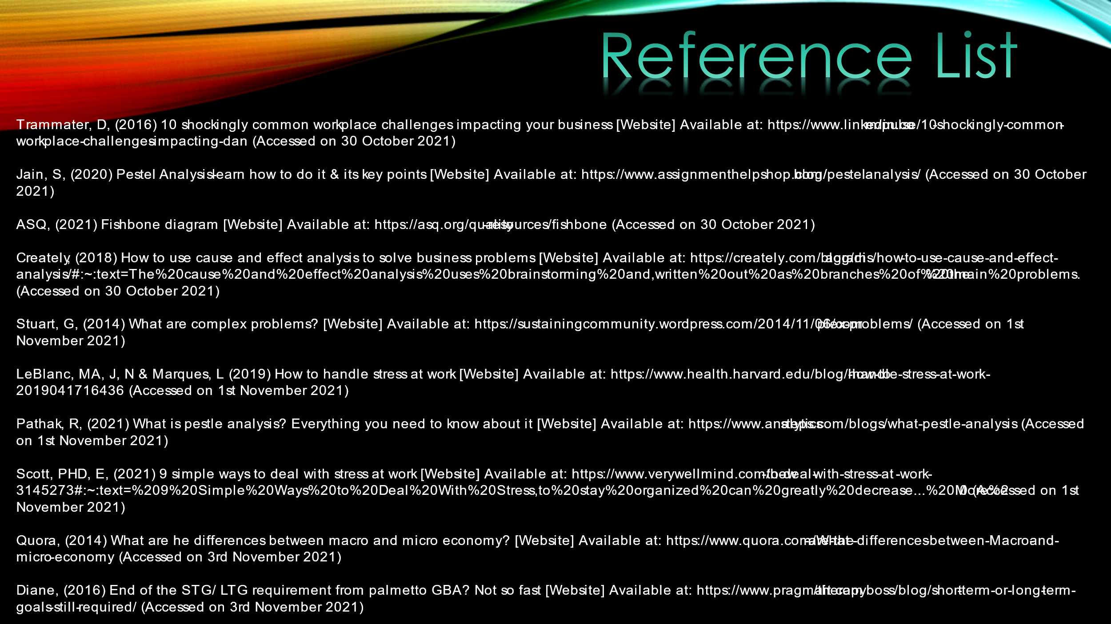
The long term goals for companies and businesses are mainly based on their permanent and future success this is seeing all the short term and medium term planning is successful and working in the rightful manner by setting a long term plan would help the company in progressing in further and achieving the goals that are required by them.

Trammater, D, (2016) 10 shockingly common workplace challenges impacting your business [Website] Available at: https://www.linkedin.com/pulse/10-shockingly-common-workplace-challenges-impacting-dan (Accessed on 30 October 2021)
Jain, S, (2020) Pestel Analysis- learn how to do it & its key points [Website] Available at: https://www.assignmenthelpshop.com/blog/pestel-analysis/ (Accessed on 30 October 2021)
ASQ, (2021) Fishbone diagram [Website] Available at: https://asq.org/quality-resources/fishbone (Accessed on 30 October 2021)
Creately, (2018) How to use cause and effect analysis to solve business problems [Website] Available at: https://creately.com/blog/diagrams/how-to-use-cause-and-effect-analysis/#:~:text=The%20cause%20and%20effect%20analysis%20uses%20brainstorming%20and,written%20out%20as%20branches%20of%20the%20main%20problems. (Accessed on 30 October 2021)
Stuart, G, (2014) What are complex problems? [Website] Available at: https://sustainingcommunity.wordpress.com/2014/11/06/complex-problems/ (Accessed on 1st November 2021)
LeBlanc, MA, J, N & Marques, L (2019) How to handle stress at work [Website] Available at: https://www.health.harvard.edu/blog/how-to-handle-stress-at-work-2019041716436 (Accessed on 1st November 2021)
Pathak, R, (2021) What is pestle analysis? Everything you need to know about it [Website] Available at: https://www.analyticssteps.com/blogs/what-pestle-analysis (Accessed on 1st November 2021)
Scott, PHD, E, (2021) 9 simple ways to deal with stress at work [Website] Available at: https://www.verywellmind.com/how-to-deal-with-stress-at-work-3145273#:~:text=%209%20Simple%20Ways%20to%20Deal%20With%20Stress,to%20stay%20organized%20can%20greatly%20decrease...%20More%20 (Accessed on 1st November 2021)
Quora, (2014) What are he differences between macro and micro economy? [Website] Available at: https://www.quora.com/What-are-the-differences-between-Macro-and-micro-economy (Accessed on 3rd November 2021)
Diane, (2016) End of the STG/ LTG requirement from palmetto GBA? Not so fast [Website] Available at: https://www.pragmait.com/therapyboss/blog/short-term-or-long-term-goals-still-required/ (Accessed on 3rd November 2021)

