Task One: Professional, ethical, and inclusive behaviours
Define the term professional and explain what it means to be a ‘people professional’. (AC 1.1)
The Cambridge Dictionary (2023) defines the term professional as “relating to work that needs special training or education”. The CIPD (2022a) believes that people professionals must have expert knowledge of people, work, and change. An integral component of this involves possessing a fundamental understanding of various people practices and comprehending how they interconnect. People practices refer to the methods and strategies utilised throughout the employee lifecycle. This includes analysing learning requirements, forming talent pools, developing people policies, analysing data, handling complaints, and hiring employees, all of which are illustrations of people practices.
The CIPD (2021) clearly sets out what excellent professional standards look like in its Profession Map. The Profession Map sets the gold standard for people professionals, whether they are members of the CIPD or not. With a particular focus on the knowledge and behaviours required to produce value and generate impact, there is a shift from a blanket best practice approach to decision-making that is values-based. The Profession Map flows from its core purpose and values of being, principles-led, evidence-based, and outcomes-driven. This is then built upon with the elements of core knowledge, core behaviours, and specialist knowledge. It has been purposefully designed to adapt to the ever-changing landscape of the people profession. Although the core values behind the professional standards will remain constant, the map will adapt to incorporate any new roles, specialisms, priorities, and opportunities as they arise.
SHRM (2016) have also developed a model to benchmark people professional success, as well as providing a framework to communicate what the profession is comprised of. It consists of nine competencies:
- Human Resource Expertise
- Ethical Practice
- Leadership and Navigation
- Business Acumen
- Consultation
- Critical Evaluation
- Communication
- Global Cultural Effectiveness
- Relationship Management
This model can also effectively be used to enhance the professional development of people teams by identifying any competency gaps.

Explore how the role of a people professional (either a generalist or a particular specialist) is evolving and the priorities this raises for continuing professional development (CPD) (AC 3.1)
Harbert (2021) highlights how the role of the people professional has evolved in recent years. The Covid-19 pandemic has not only increased the corporate influence of HR but also resulted in a renewed focus on employees and their wellbeing. The ‘human’ has been put back into HR, and whilst still having influence on workforce productivity, performance, and efficiency, understanding the challenges faced by employees both inside and outside of the workplace is paramount. Emotional intelligence needs to be applied with a proactive approach taken to employees physical and mental health.
According to Price (2020) the role of HR is rapidly evolving with innovative technologies emerging and changes in how we operate. Organisations and their employees have new expectations of people professionals which will require new skills along with an agile approach. MacArthur (2021) states that organisations of the future will understand the positive correlation between increased employee wellbeing and revenue. People practitioners should move away from prioritising themselves as a compliance and administrative resource, transitioning from being task to service oriented. Critical skills for people professionals of the future will be those that are human-centred, enabling policies and structures that support employees.
The CIPD (2020) raise that these soft skills will become even more critical for people professionals in the future. A digital word will allow increased opportunities for the focus to be on individuals, making interpersonal skills extremely desirable. Automation, AI, and digital systems will leave these critical soft skills as a key differentiator.
When reviewing Continuous Professional Deveopment (CPD) the CIPD (2020) stresses the importance for the modern organisation to embrace technology, which will influence how learning is delivered in the future. Mobile bite-sized learning is one example of this, with continuous learning now becoming more important than ever with learned skills typically lasting only two to three years before further upskilling is then required. This continuous learning approach is one that should be role-modelled by those within the people profession.

Discuss the concept of ‘ethical values’, and how at least three ethical values that you hold personally, impact (or could impact) on your work as a people professional. (AC 1.2)
The CIPD (2022b) defines ethical values as providing the moral compass for decision making, which is essential for organisations to make the right decisions that positively impact individuals and the organisation’s reputation. Good ethical decisions can improve people’s experiences at work, while poor ones can have significant negative consequences.
The CIPD (2015) sets out how eight ethical lenses can assist individuals in marking ethical decisions by providing various perspectives. These lenses are fairness, merit, markets, democracy, well-being, rights and duties, character, and handing down. A publication by Changeboard (2019) posits that utilitarianism can be employed in ethical decision making to achieve an outcome that minimises harm and maximises benefits for the greatest number of people.
Three personally held ethical values that impact the work of people professionals are those of honesty, integrity, and respect. According to Vitasek (2022), honesty plays a critical role in defining a company’s culture, including how employees are treated and interacted with. When employees receive honest and transparent communication, they are more likely to reciprocate the same courtesy to the organisation, leading to a collaborative and innovative work environment.
Indeed (2022) outlines the crucial role integrity plays establishing a prosperous and harmonious relationship between employees and their employers. People professionals assume vital part in ensuring that the organisation cultivates a culture of integrity, where employees trust one another. An example of this would be sensitively handling any confidential information that may be shared by employees. People professionals are instrumental in setting the benchmark for integrity for both management and employees.
Mind Tools (2022a) defines respect as being the foundation of ethical and humane behaviour. People professionals play a vital role in promoting mutual respect throughout the workplace, from designing policies and processes to fostering positive individual interactions. A Lack of mutual respect, on the other hand, can negatively affect workplace relationships and lead to illegal or unethical behaviours such as bullying and harassment.
In summary, people professionals who embody ethical values such as honesty, integrity, and respect can establish robust relationships, cultivate a positive workplace culture, and significantly contribute to the organisation's success.

Changeboard (2019) Ethics in decision making – what leaders need to know. Available at: https://www.changeboard.com/article-details/16962/ethics-in-decision-making-what-leaders-need-to-know (Accessed: 1 March 2023).
Mind Tools (2022a) Mutual Respect. Available at: https://www.mindtools.com/adilccw/mutual-respect (Accessed: 1 March 2023).

Explain why it is essential for people professionals to contribute confidently to discussions, and ways of doing this that are (AC 1.3):
- informed
- clear
- Engaging.

One of the fundamental core behaviours in the Profession Map by the CIPD (2022c) is professional courage and influence. To effect change, generate ideas, gain stakeholder support, or assist line managers in personnel matters, the ability to influence others is an essential skill for people practitioners. This often entails courage: the capacity to confront resistance or opposition, speak up when we sense something is amiss, and take a stance when necessary.
According to Ulrich (2020), the inclusion and contribution of people professionals in organisational discussions bring added value, with practitioners offering unique insights in the areas of talent, organisation, and leadership. This will support in promoting employee wellbeing, enabling organisations to implement strategic initiatives, ensuring continued provision of products and services to customers, and maintaining investor confidence. If people professionals are unable to make meaningful contributions to business discussions, there may be adverse consequences for the organisation. According to Lennon (2017) there include inefficient decision-making and processes, as well as an increased risk of non-compliance with employment law.
Mind Tools (2022b) notes that staying informed on industry news and trends is crucial to earning the trust and respect of stakeholders. This objective can be achieved by employing various strategies, such as accessing reputable online sources, networking with industry leaders on social media platforms, and attending relevant training sessions and conferences.
Mills (2017) outlines the most effective methods of ensuring that communication is clear, as clarity is crucial for comprehension. Unclear messages will lead to confusion and will not produce the intended outcome. Therefore, when delivering a message, it is necessary to consider the audience’s needs and desires by providing a distinct advantage or by establishing a specific course of action.
Indeed (2023) explains several strategies to facilitate engaging workplace discussions, such as asking well-crafted questions, discussing pertinent topics, utilising engaging body language, and considering different perspectives. Active engagement in discussions enables individuals to express their ideas more easily, providing a pivotal advantage.

Discuss when and how to raise concerns when issues such as organisational policies or leadership approaches conflict with ethical values or legislation. (AC 1.4)
A notable challenge within the workplace is the occurrence of issues that conflict legislation and ethical principles. Gallo (2015) states that there can sometimes be instances where it is perceived that something is amiss within the workplace. It is crucial that any such concerns are raised through the appropriate channels, as even seemingly minor issues can have severe negative consequences. Clear guidelines reinforced by policy should be established for identifying ethical issues, and the procedures for reporting them should be equally transparent.
Ladlika (2021) highlights a four-step approach that can be used by people practitioners to determine how and when to proceed when a situation may be unethical, or even illegal. These four steps are:
- Observe: Take notice and recognise any potential misconduct.
- Orient: Assume responsibility by acknowledging a duty to act.
- Decide: Deliberate on the appropriate course of action, explore all available alternatives, and consult with individuals whose guidance you trust.
- Act: Implement your decision by enlisting a reliable ally to accompany you, dramatically increasing your power.
Gentile (2010) suggests approaching ethical dilemmas similarly to other business issues. The appropriate stakeholders to engage with should be determined and a convincing business case, reinforced by evidence, that supports doing the right thing should be communicated. As individual stakeholders may encounter difficulty in prioritising long-term outcomes, it is advisable to recognise the immediate benefits that may arise from exhibiting ethical conduct. How a problem is framed can significantly impact in its resolution.
Webley (2016) provides an example of the Sports Direct scandal in their article. Following the publication of a report exposing the poor working conditions in its warehouses, the company’s share price plummeted. Smith (2016) addresses one of the ethical issues raised in the report regarding employees being paid less than the minimum wage. This was due to the time taken to carry out mandatory searches at the end of each shift not being considered. By adhering to proper procedures, communicating effectively with employees, and implementing robust policies, Sports Direct could have operated within the law in this instance.

Provide a robust argument for ethical people practice that is supported by academic theory and details both the business and human benefits of people at work feeling included, valued and fairly treated. (AC 2.1)
Indeed (2021) states that by maintaining ethical people practice, organisations can experience significant benefits that improve the lives of employees, customers, leaders, and the public. Establishing high workplace ethics is crucial for creating a successful organisation with satisfied and loyal team members. Ethical standards can reassure stakeholders that the organisation is prioritising their interests. By intentionally integrating ethical guidelines into their structure, organisations can prioritise employee wellbeing while positively impacting those affected by their processes.
Byrne (2017) asserts that organisations with robust ethical cultures typically have more engaged and committed employees with lower turnover rates and higher productivity generally observed. Employees experience less pressure to compromise company standards to achieve organisational goals. Furthermore, if they do witness misconduct, they are more likely to feel at ease reporting it. Further to this Byberg (2019) emphasises the critical link between an ethical culture and employee wellbeing, with ethical management fostering a psychologically safe work environment.
Peek (2023) cites that ethical people practices are critical to achieving business success with research into the relationship between ethics and business performance revealing a significant correlation between the two. Ethisphere, which monitors ethical behaviour among the world’s largest companies, discovered that the companies listed on its 2022 most ethical list outperformed a comparable index of companies by 24.6 percent. Maintaining a high ethical standard extends to customers by creating a reputation for positive ethical behaviour that attracts potential clients, customers, and partners while building customer loyalty. In contrast, engaging in unethical behaviour can have a detrimental impact on business prospects.
A MasterClass (2021) article evaluates Stakeholder Theory in business ethics which requires companies to consider all stakeholders to achieve success. While prioritising profits may yield short-term gains, this ethical theory dictates that companies must acknowledge the interests and concerns of all parties involved in the business, to succeed long-term.

Drawing on your own or a hypothetical example of providing a people practice solution to meet a particular need or introducing a new policy or initiative, describe:
- strategies for designing the solution/initiative so that it will be inclusive
- strategies for checking that, when in practice, the solution/initiative engages and meets the needs of all those it is aimed at. (AC 2.2)
In my capacity as a people practitioner, I have recently implemented a comprehensive Maternity & Family Friendly policy for my organisation. In doing so I incorporated a range of strategies to ensure its inclusivity, successful adoption, and execution.
The initial step involved conducting an initial Needs Assessment, as defined by SHRM (2021) to ascertain the optimal benefits selection and design in response to employees’ needs and preferences. This was accomplished through surveying all employees.
Bedwell (2018) suggests that by shifting employees to stakeholders, organisations can benefit significantly. Specifically, this approach can offer employees a sense of purpose and meaning, providing them with an authentic experience of doing work that matters. During the policy design stage, I placed emphasis on stakeholder engagement, gathering insights and perspectives from a diverse range of individuals who would be affected by the policy. I accomplished this through consultation and discussion, which allowed me to actively seek input and feedback throughout the design process. Acas (2021) asserts that involving employees in consultations regarding changes to policies or procedures can result in improved decision-making and increase the likelihood of employees understanding and agreeing with any proposed changes.
Finally, I implemented a robust annual policy review process for this policy and other policies, guaranteeing that all policies undergo a review within a 12-month period, which includes obtaining employee feedback. Bradley (2018) emphasises the importance of policy review, noting that most businesses possess obsolete policies, creating an environment conducive to the non-compliance of employment law. It is recommended that each policy revision should be documented and any policies that are no longer relevant should be removed to ensure the relevance of the policies that are in use. Leonard (2018) stresses the importance of ongoing policy evaluation to assess efficacy. In cases where a policy fails to meet its intended objectives, the underlying causes must be identified, and any necessary improvements implemented.

Task Two: Professional Development
Using a range of information, including feedback from others assess your practice against the five CIPD profession map core behaviours listed below: (AC 2.3, AC 3.2)
- Ethical practice
- Professional courage and influence
- Valuing people
- Working inclusively
- Passion for learning
Barnett (2020) emphasises the critical significance of developmental feedback in shaping and refining individuals' professional development and growth. To transform ourselves, it is imperative we seek the assistance from those around us to identify potential areas of strength that we can capitalise on, as well as growth opportunities that require our attention. To assess my practice against the CIPD Profession Map's five core behaviours at the associate level, I gathered verbal feedback from both senior leadership and my peers, reviewed performance appraisals, and reflected on my own experiences. This then allowed me to gain a clearer understanding of my strengths and areas for development by using the CIPD self-assessment tool (see Appendix 1). By seeking feedback from multiple sources and reflecting on my own experiences, I was able to gain valuable insights into how I was demonstrating the five core behaviours and how I could incorporate them more fully into my practice in the future.

Having identified your main development needs in relation to these 5 areas, formulate appropriate development activities to meet these needs and add there to your professional development learning plan. (AC 3.3)
After thoughtful consideration, I have carefully chosen the following developmental activities to be included in my learning plan (see Appendix 2), aimed at enhancing my skills, knowledge, and behavioural competencies:
- I will complete the CIPD's online course on professional courage and influence to enhance my ability to positively influence others and achieve favourable outcomes in my role.
- I will explore the CIPD's course on Data Protection and GDPR to understand the regulations and standards related to data protection within the UK.
- I will prepare and present a case or recommendation with the support of a colleague, improving my communication and presentation skills and my ability to handle different perspectives.
- I will ask for feedback from those involved in a project after completion. By soliciting input from team members, stakeholders, and other relevant parties, I can gain valuable insights into the strengths and weaknesses of the project, identify areas for improvement, and enhance future development plans.
- I will research the 70:20:10 model and identify further opportunities to learn and develop with the support of my manager and colleagues.
- I will actively listen to colleagues who express the need for help or share concerns or ideas. Encouraging colleagues to speak up and supporting them to do so will promote a culture of openness and collaboration in the workplace.
I feel that these development activities will positively impact my personal and professional growth and I am committed to taking ownership of my development, becoming more effective as a people practitioner.

Select 3 formal or informal development activities you have undertaken over the last 12 months and reflect on how each of these has impacted your behaviour and performance. (AC 3.4)
According to Business Balls (no date), reflective practice is a method of evaluating our own thoughts and actions, with the aim of enhancing personal learning and development. This approach holds significant relevance and value in the context of Continuous Personal Development (CPD), as it enables individuals to critically reflect on their experiences and identify areas for improvement. Keeping this in mind, I have actively engaged in several development activities over the past 12 months.
I volunteered to participate in a Lean Six Sigma training programme, which was primarily for the senior leadership team, because I recognised the potential for significant benefits to my profession development. According to Huering (2004), one of the crucial elements of Six Sigma is the ability to deconstruct processes into management parts and optimise each element to enhance overall performance. Using this approach, I analysed several HR processes, such as onboarding and performance management, to identify and eliminate inefficiencies. An obstacle initially faced was the challenge of comprehending existing processes, being new to the company and with the absence of any historical process maps. By engaging with the relevant individuals on current practices, I was able to create streamlined process maps that not only improved efficiency but also ensured consistency where appropriate.
I firmly believe that the training enhanced my performance as a people practitioner, enabling me to more directly contribute to the organisation. Specifically, I was able to identify and eliminate further process inefficiencies, while also creating clear process maps for the benefit of relevant stakeholders. This training also provided me with more confidence in effectively communicating these processes to key stakeholders, in the knowledge that they had been rigorously reviewed and optimised.
Another development activity I pursued for my CPD was writing a suite of HR policies, which entailed both designing new policies as well as updating existing ones. This task had a far-reaching impact on my overall performance in several ways. It has enhanced my research skills as I was required to ensure that our policies were in line with best practices, legal requirements, and the specific needs of our organisation. These research skills have also proven useful in other areas of my professional development, such as developing strategic plans.
In addition, this task has positively impacted my written communication skills. Upon receiving initial feedback, it became evident that although my policy writing was clear, there was an opportunity to adopt a warmer tone. Dale (2014) emphasises the importance of tone when writing engaging policies. Tone is critical as it should read like one human conversing with another. The experience of adjusting the tone within my writing has helped me develop the ability to convey information in a relatable and engaging manner.
Lastly, this also allowed for the advancement of my critical thinking skills through the process of evaluating existing policies and practices, enabling me to make informed decisions backed by evidence. I consider this to be a key skill, as noted by Grensing-Pophal (2020), who highlights that it assists in making sound decisions by avoiding assumptions, untrustworthy sources, and biases.
I have also sought out various resources to expand my knowledge and skills. One such resource has been podcasts, which have provided me with valuable insights on a range of HR-related topics. This gave me the opportunity to listen to Adam Grant’s thought-provoking ideas through a podcast guest appearance he made. Although I had previous been exposed to his work through social media, it was hearing him speak that prompted me to delve deeper into his work.
In his appearance on The High Performance Podcast, Grant (2022) highlights the significance of prioritising learning and growth over seeking validation and approval from others. He argues that individuals often focus on proving themselves rather than improving themselves, thereby feeding their egos instead of fuelling their personal and professional development. I incorporated Grant’s Ideas into my CPD by implementing various strategies aimed at promoting learning and growth.
Focusing on my learning and growth, led to an increased drive to improve my skills and knowledge, resulting in improved performance. Actively seeking constructive feedback and maintaining an open-minded attitude has assisted me in identifying areas where I can improve, enabling me to take prompt action to address them. Additionally, I have learned to view any setbacks or failures as chances for growth and learning, rather than personal failures. Regular reflection on my progress has allowed me to celebrate successes and identify areas for further development, enabling me to set new learning objectives.

Appendix 1
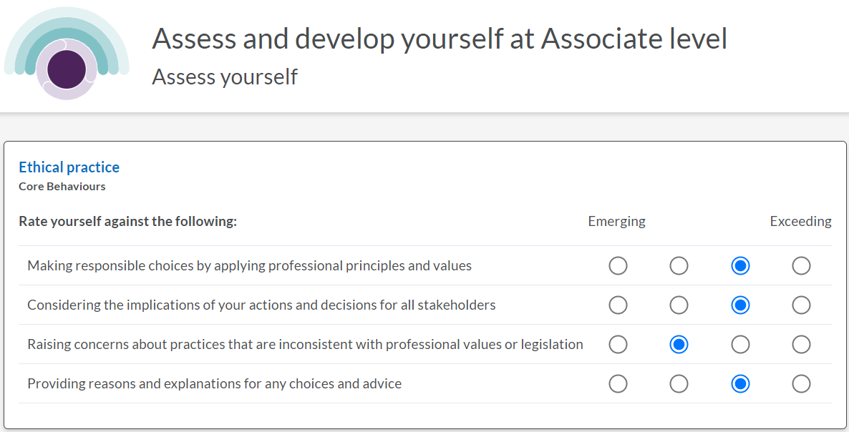
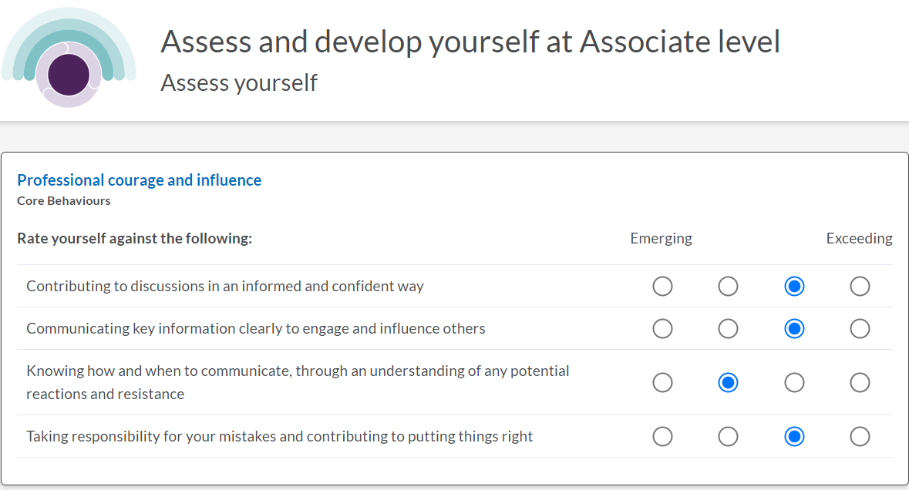
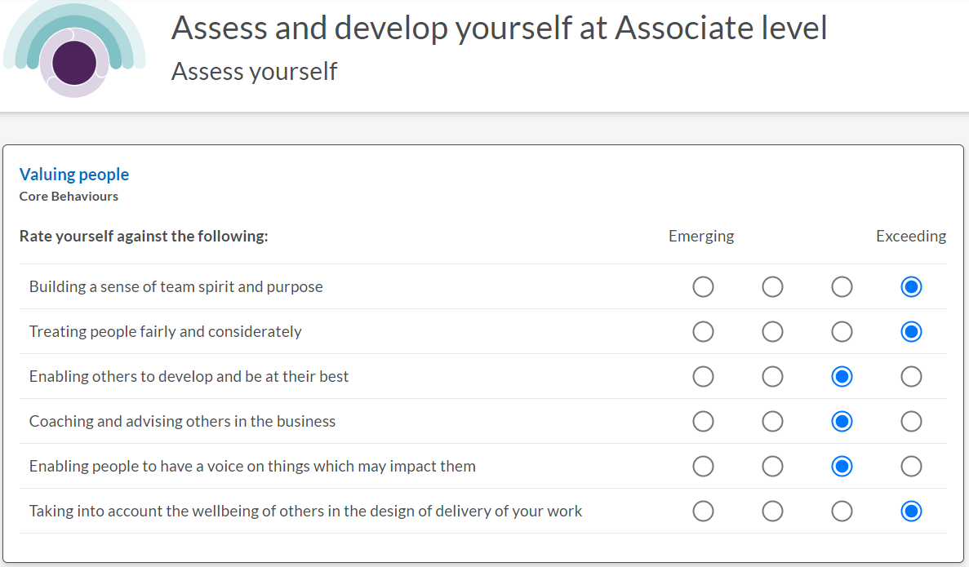
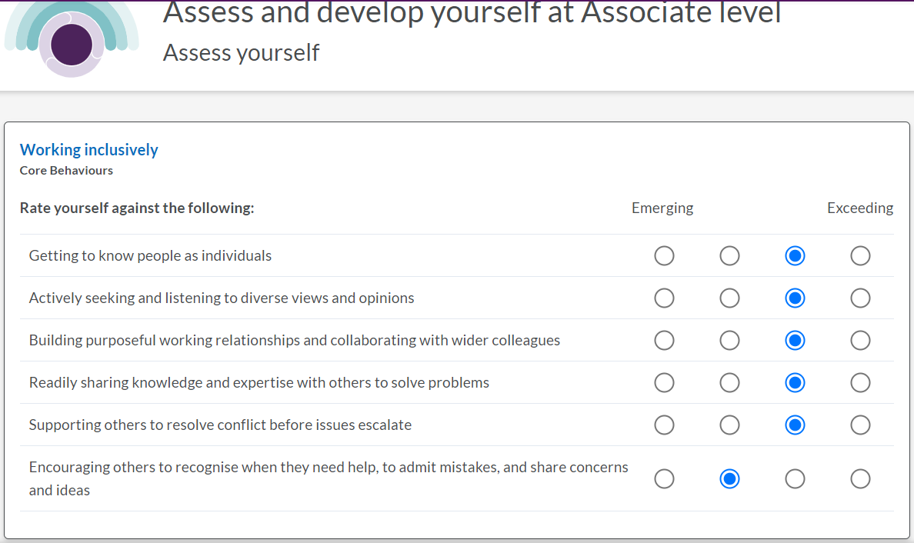
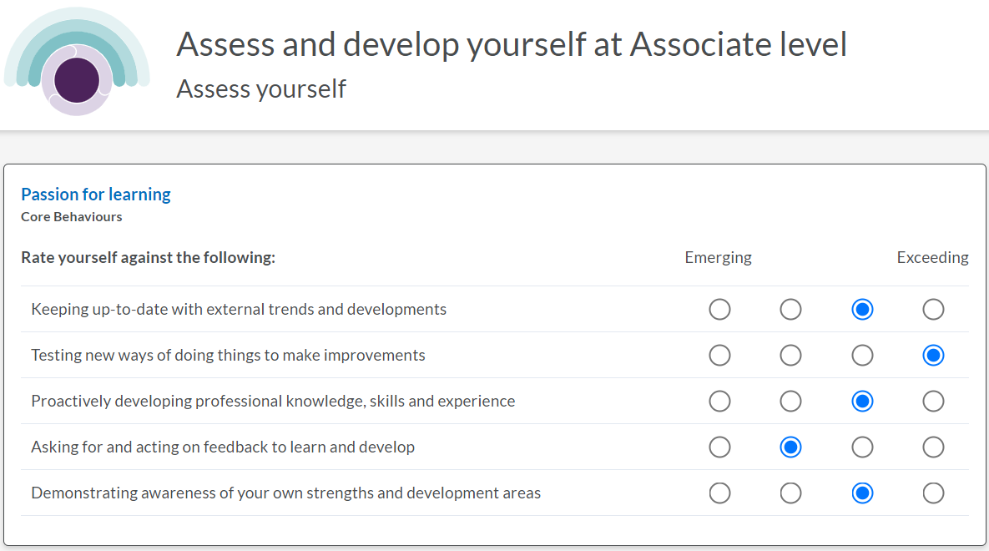

Appendix 2


