
ACADEMIC SKILLS

Module Name: Academic Skills
Module code: LCLM 4001
Student Name: Maribel Soares
Student ID: 2326528
Lecturer´s Name:- Tim Hopkins

contents

Contents
contents 2
Introduction 3
Academic writing skills 5
Paraphrasing skills 5
Summarising Skils 6
Conclusion 7
Reference 8

Introduction

I was given this assignment in the academic skills discipline to demonstrate how much I have learned from this discipline so far.
In this work, I would talk about the importance of some qualities such as academic skills, paraphrasing skills, and summarising skills. I chose these 3 because they are what I understood the most and can explain better.

Academic writing skills

During this first semester, we learned in the academic skills class that Academic writing skills are characteristics taught when writing college or university essays that can be useful in the workplace. Academic writing involves communicating ideas clearly and concisely and conveying arguments logically and convincingly. The skills used in this type of writing are transferable to a range of workplace tasks and are the traits and academic strategies that help students become better students. They prepare you for your career, help you stay focused and motivated, get you exposed to new ways of thinking, and so much more.
I believe that this quality is very important not only for future work but also for our lives, I hope to be able to develop all these qualities by the end of the course.

Paraphrasing skills

Paraphrasing is when you use your own words to express something that was written or said by another person.
Putting it into your own words can clarify the message, make it more relevant to your audience, or give it a greater impact. 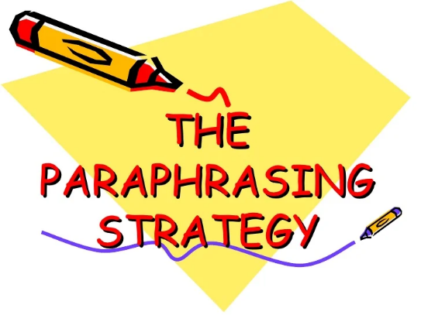
You might use paraphrased material to support your own argument or viewpoint. Or, if you're putting together a report, presentation, or speech, you can use paraphrasing to maintain a consistent style and to avoid lengthy quotations from the original text or conversation.

Summarising Skills

A summary is a brief overview of an entire discussion or argument. You might summarize a whole research paper or conversation in a single paragraph, for example, or with a series of bullet points, using your own words and style.
People often summarize when the original material is long, or to emphasize key facts or points. Summaries leave out details or examples that may distract the reader from the most important information, and they simplify complex arguments, grammar, and vocabulary.

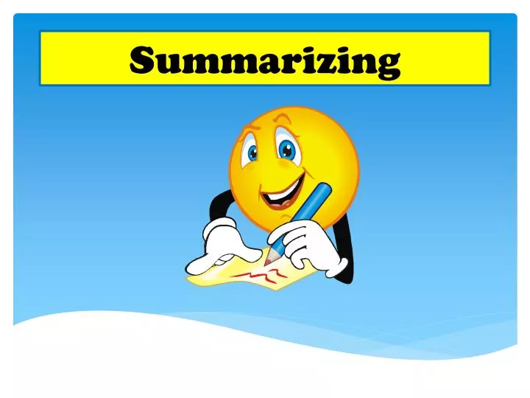

Conclusion

With these 3 themes, I concluded that we need all types of qualities to be successful in our careers in the future, when we develop these qualities, such as knowing how to summarize information and being able to have a positive impact with just a few words, it is something of value for life. In my opinion, I don't find much or almost no difficulty in understanding these topics as it was very well explained in the academic skills subject.
with this subject I'm learning things that I didn't know could make a big difference in my professional life, I hope I was able to convey the idea of what I understood about these topics, thank you.

Reference

https://www.mindtools.com/axggxkv/paraphrasing-and-summarizing
file:///C:/Users/taigo/Downloads/ctrstreadtechrepv01983i00270_opt.pdf
https://www.jstor.org/stable/747913

https://www.brookes.ac.uk/students/academic-development/online-resources/paraphrasing/

