Finca de Cuelgauros (Valley of the Fallen)

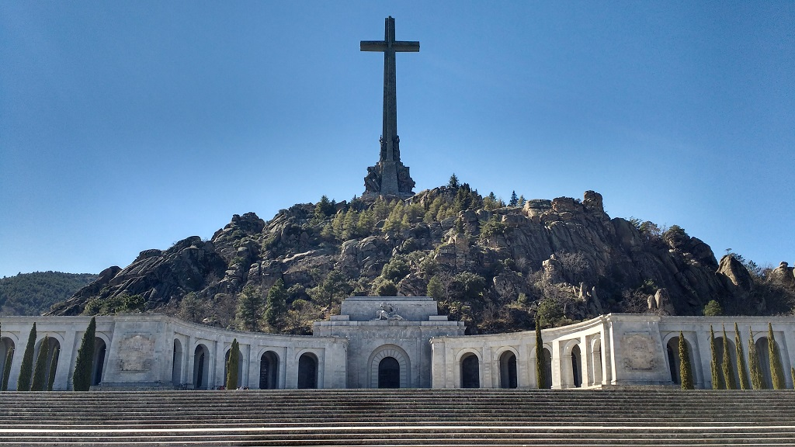
Monuments and memorials play an important role in creating public memory, frequently reflecting the narratives of those in power at the time they were built. This dynamic is best illustrated by Spain's Valley of the Fallen (Valle de los Caídos), a controversial representation of the country's complicated past. General Francisco Franco commissioned the monument, which was built between 1940 and 1959 and was said to be dedicated to all those who lost their lives during the 1936–1939 Spanish Civil War. But because of its ties to Franco's government, many people see it more as a monument honouring his triumph than as a tool for promoting national harmony. ​With a basilica set into the Sierra de Guadarrama mountains and a 150-meter-tall cross, the tallest memorial cross in the world, the site's architectural magnificence is evident. This enormous scale, which conveys permanence and strength, is consistent with authoritarian aesthetics. It is noteworthy that political prisoners, many of whom were Republicans, worked on the building, adding layers of agony and duress to its legacy. Its role as a location of ideological conflict was further solidified by Franco's burial there until his exhumation in 2019.
A powerful illustration of problematic heritage that represents traumatic or contentious histories is the Valley of the Fallen. Its existence raises important issues regarding how societies perceive and remember traumatic pasts. The monument's story is complicated by the fact that it serves as both a place of worship and a cemetery for thousands of people, including victims from both sides of the war. Ongoing attempts to reframe the location within Spain's democratic framework are shown in the recent exhumation of Franco's remains. ​It is necessary to investigate the historical context, material importance, and sociopolitical dynamics underlying the creation and continuous reinterpretation of the Valley of the Fallen in order to comprehend it. We can better understand the difficulties of resolving disputed narratives and prevailing power structures at heritage places by looking at these aspects, taking into account both present values and potential future ramifications. ​

The Valley of the Fallen (Spanish: Valle de los Caídos) was conceived in the aftermath of the Spanish Civil War (1936–1939) and during the early years of Francisco Franco’s dictatorship (1939–1975). In 1940, one year after the war ended, Franco ordered the construction of an immense memorial complex to commemorate his Nationalist victory. The site was explicitly intended to celebrate Franco’s “Glorious Crusade” against the Spanish Republic​.
Initially, its purpose was to entomb and honour the war dead from the Francoist (Nationalist) side, symbolizing a monument “only for the victors”​. Later, the regime claimed the mausoleum would hold “all the fallen” of the Civil War from both sides, adopting a rhetoric of national reconciliation​. In practice, however, this reconciliation narrative was largely symbolic and driven by Francoist aims. By the late 1950s, Franco’s government orchestrated the transfer of remains of tens of thousands of Civil War victims (including Republican casualties) into the Valley’s crypts, often without informing or obtaining consent from their families​. In total, the underground crypts hold the remains of 33,833 people from the Civil War, making the site the largest mass grave in Spain​. Franco inaugurated the Valley of the Fallen-on April 1, 1959 (the 20th anniversary of his victory), firmly entrenching its status as a monumental testament to his regime.
The Valley of the Fallen is renowned (and notorious) for its grand scale and symbolism in 20th-century Spanish architecture. The complex occupies a secluded valley in the Sierra de Guadarrama (northwest of Madrid) covering over 13.6 km². Its centrepiece is a vast underground basilica and crypt carved directly into the granite hillside. Towering above is a 150-meter-high stone cross, the tallest such cross in the world. This giant cross, visible for miles, crowns the mountaintop, dominating the landscape and serving as a potent symbol of National-Catholic ideology (the fusion of Spanish nationalism with Catholicism) championed by Franco. The basilica itself stretches 262 meters in length (only slightly shorter than St. Peter’s Basilica in Rome) beneath the mountain, reflecting Franco’s desire for a monument with the “grandeur of the monuments of old” that would “defy time and memory.”​
Architects Pedro Muguruza (later succeeded by Diego Méndez) designed the site to embody Franco’s vision of a “Catholic, nationalist and powerful” Spain for the ages​. Every element of the design, from its basilica, abbey, and towering cross to its imposing neoclassical sculptures, was meant to project Franco’s triumph and link his regime to traditionalist imperial glory. Construction of the Valley of the Fallen, which spanned nineteen years (1940–1959), came at great human and material cost. A significant portion of the workforce were Republican prisoners compelled to work as forced labour – an estimated 20,000 political prisoners in total, according to historians. These prisoners, many of them war captives or convicted “enemies” of Franco’s new regime, toiled under harsh conditions to excavate the basilica cavern and erect the monumental cross​.
The use of penal labour served a dual purpose for Franco: punishing and “rehabilitating” defeated Republicans, while achieving an extravagant monument at minimal cost. Even so, the project’s expense was enormous, roughly seven million 1950s euros in cost (in modern terms) funded by the regime through mandatory “national subscriptions” and donations extracted from Spanish citizens​. This huge expenditure and long build time were controversial, as the construction took place during the autarkic post-war decade when Spain was impoverished and on ration cards​. Franco originally demanded the monument be finished in a year, but the ambitious engineering (boring a massive cavern tomb into rock) and Spain’s post-war economic crises delayed completion to nearly two decades​. The site finally opened in 1959, featuring not just the basilica and crypt but also a Benedictine abbey and a host of sculptures laden with religious and patriotic symbolism. In sum, the Valley’s architecture and building process, colossal in scale, spiritually grandiose, and built on the backs of prisoners, physically enshrine Franco’s authoritarian and ideological imprint on the Spanish landscape.

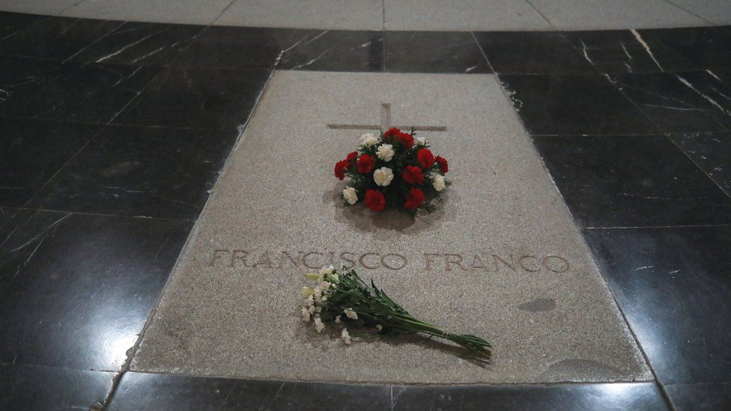
From its inception, the Valley of the Fallen has been steeped in controversy and “dissonant heritage”. Many in Spain regard it not as a neutral war memorial but as a Francoist shrine that for decades glorified the dictatorship​. During Franco’s rule and even long after, the site functioned as a pilgrimage destination for Franco’s supporters. It housed the tombs of Franco himself and José Antonio Primo de Rivera (founder of the fascist Falange party) in the basilica’s central nave, marked with honour while thousands of other victims lay anonymously in the crypts​. This created a literal “funerary hierarchy” with the dictator and his chief ideologue elevated above all other dead​. State ceremonies and masses were held to honour Franco, and each year on November 20 (the anniversary of the deaths of Jose Antonio in 1936 and Franco in 1975) crowds of regime nostalgists would gather at the Valley to pay tribute​.
The absence of any frank interpretation or contextualization at the site meant that for decades it remained an unchanged fascist monument in a democratic Spain​. As Alfredo González-Ruibal discusses the Valley of the Fallen as a monument that "remains fully operative" and "provides a material narrative that exalts the dictatorship." standing as Europe’s last fully operative fascist monumental complex well into the 21st century​. This uncritical preservation of Franco’s mausoleum was an anomaly in post-WWII Europe and a source of domestic and international criticism​.
Debates over the Valley’s meaning intensified with Spain’s democratic transition and especially from the 2000s onward, as a new generation began to openly confront the dictatorship’s legacy. Spanish memory activists and human rights advocates pointed out the troubling paradox that a monument built by Franco still ostensibly honoured only the victors while the trauma of the vanquished went unacknowledged​. Research in the early 2000s brought to light the stories of Republican civilians and soldiers whose remains had been secretly reinterred at the Valley in the late 1950s, often taken from mass graves across Spain without their families’ knowledge​. Far from symbolizing true reconciliation, the site was seen as enshrining what one official report called a “deceptive narrative of reconciliation” crafted by the Franco regime​. The continued prominence of Franco’s tomb until recently, and the public veneration it attracted from far-right groups, made the Valley arguably the most polarizing historical site in Spain​.
Heritage scholars classify it as “difficult” or contested heritage, imbued with the unacknowledged violence of the Franco era and conflicting interpretations of history​. In short, the Valley of the Fallen stands as a contentious site of memory where Spain’s divisions over the Civil War and dictatorship are set in stone. Democratic Spain’s government has grappled with how to address the Valley of the Fallen’s legacy. The 2007 Historical Memory Law (Law 52/2007) formally prohibited any public exaltation of the Civil War or Francoism at the site and called for it to be a place of remembrance for all victims of the conflict​. This law reflected a consensus that the State should not allow the monument to serve as a Francoist propaganda site. In 2018, the Spanish government went further by amending the law to facilitate the exhumation of Franco’s remains from the basilica​. A government decree established that only those who died in the 1936–39 Civil War may be interred at the Valley, explicitly to end the anomaly of a dictator buried in a place of honour there​.
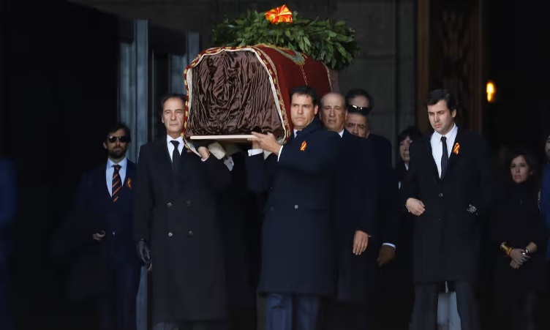
After protracted legal battles, on 24 October 2019 Francisco Franco’s body was exhumed from the Valley of the Fallen and reburied in a municipal cemetery near Madrid​. This historic act – carried out 44 years after Franco’s death was hailed by many as Spain “fulfilling its duty to itself” by removing a glorification of dictatorship from a national monument​. (Franco’s prominent tomb had required visitors to literally kneel on it when approaching the high altar, a potent metaphor for enforced memory of the region.) The exhumation was backed by a broad parliamentary mandate and marked a turning point in the state’s approach to the site​.
In 2022, Spain’s new Democratic Memory Law (Law 20/2022) further cemented the Valley’s transformation. The law officially renamed the site “Valle de Cuelgamuros”, removing the Franco-era term “Valley of the Fallen,” and it reiterated that the complex is to serve as a civil cemetery and memorial to those who died in the Civil War​. It also required the “relocation of any remains occupying a preeminent place in the sanctuary”, a clause aimed squarely at addressing the remaining symbolic imbalance​. In April 2023, following this mandate, the remains of José Antonio Primo de Rivera were exhumed from their exalted tomb at the basilica’s altar and transferred to a family cemetery​. With this, the Francoist funerary hierarchy has been dismantled, no figure of the dictatorship now holds a place of honour above others at Cuelgamuros​.
Looking ahead, the Valley of the Fallen/Cuelgamuros poses ongoing heritage challenges. Spanish authorities and historians continue to debate how to reframe the site’s meaning in a democratic context. Some advocate converting it into a neutral memorial or museum of memory that educates visitors about the Civil War and the Francoist repression, rather than celebrating nationalist “martyrdom”​. The official plan under the Democratic Memory Law is to signify the monument through historical and educational interpretation: for example, establishing an on-site interpretation centre, comprehensive signage, and digital resources that explain the true history of its construction and symbolism​. The Spanish government’s newly launched website on Cuelgamuros (hosted by the Ministry of Democratic Memory) is one step in this direction, providing context on the monument’s architectural, religious, and political history and drawing comparisons to other cases of contested heritage worldwide​.
There is also discussion of how to handle the giant cross and other overt symbols: whether they should remain as historical artifacts or be toned down or removed. Meanwhile, opposition from right-wing sectors (including Franco’s descendants and the populist Vox party) has been vocal, they argue that altering the site or removing symbols like the cross is an affront to Spanish heritage or an attempt to erase history​. For instance, a Spanish Catholic group petitioned church authorities to prevent the removal of the giant cross and the Benedictine monastery, emphasizing the site's religious and cultural significance. International heritage bodies and scholars are closely watching Cuelgamuros as a test case for dealing with “difficult heritage,” the UNESCO concept of handling sites associated with trauma or authoritarian pasts in a way that promotes reflection rather than veneration. While the Valley of the Fallen is not a UNESCO World Heritage Site, its future treatment may set an example for how nations confront monuments of dictatorship. As of now, with Franco and Primo de Rivera removed, Spain has begun transforming the Valley from a polarizing mausoleum into a site of critical remembrance. The ongoing efforts – balancing preservation with re-interpretation – underscore the broader struggle in Spain to reconcile with the memories of civil war and tyranny while respecting the need for historical truth and the victims’ dignity.

The Valley of the Fallen's contentious position calls for careful analysis grounded on international models of handling challenging legacy. Nations facing difficult histories have taken many approaches worldwide, from creative intervention and symbolic change to reinterpretation and recontextualization. These encounters provide Spain with possible routes to approach the Valley in lines fit for modern democratic norms.
One such paradigm is Germany's handling of sites from the Nazi era. German officials have turned places like former concentration camps into memorial museums instead of dismantling them, therefore ensuring that they remain potent teaching tools fostering historical understanding and reconciliation. Likewise, the Documentation Centre, which offers critical historical narratives preventing the elevation of the government, currently resides at the former Nazi Party gathering grounds in Nuremberg. Germany has specifically avoided honouring offenders, though; for instance, Hitler's bunker site is still unmarked except for little plaque discouraging neo-Nazi pilgrimage. In order to turn the Valley into a site of critical thought rather than adulation, Spain might similarly maintain its buildings and apply significant interpretative measures including memorial sites and educational exhibits.
Post-Soviet republics handling communist monuments reflect still another strategy. Countries like Hungary and Lithuania have moved Soviet-era sculptures to specialised museum parks, notably Memento Park in Budapest, therefore eliminating ideological symbolism from public areas and conserving historical objects for educational uses. Contextual remedies can be successful where removal is neither desirable nor practical. Adding an illuminated quotation from philosopher Hannah Arendt, "No one has the right to obey," reinterpreted a site of oppression into a critique of authoritarianism in Bolzano, Italy, a Fascist-era bas-relieve. Similarly, the Valley of the Fallen might incorporate creative interventions or counter-monuments within the current design, so clearly opposing Francoist doctrine and encouraging democratic thought.
Ethical models from legacy sites such as UNESCO and ICOMOS stress cautious, inclusive interpretation of challenging legacy, therefore guiding countries to tell controversial history authentically and respectfully. Using heritage places connected to trauma or conflict as venues for conversation and reconciliation instead of glorification or erasure, UNESCO especially promotes preservation mixed with education. These rules provide insightful ideas for Spain, implying that integrating critical, multi-layered narratives that interact freely with the site's sad past could be more successful than just destroying Francoist emblems at the Valley. But the idea to reinterpret or change symbolic components like the 150-meter cross has proven politically divisive. Viewing any change as an attempt to erase or distort Spanish legacy, conservative groups, including the Vox party and Franco's descendants, argue fiercely against changing the monument. International precedents, however, show that changing contentious heritage sites can highlight previously marginalised narratives, advance historical openness, and help society heal rather than erase past.
In conclusion, based on foreign experience, Spain's Valley of the Fallen should give openness, inclusiveness, and education first priority. Spain might properly address contested narratives, honour victims' suffering, and firmly align the Valley's future with democratic values by using these techniques, such as contextual reinterpretation, careful preservation combined with critical education, and the deliberate addition of counter-monuments. Such actions would guarantee that the monument transforms from a continual emblem of separation into a real centre of memory and education.

Bibliography

- Agencia EFE. 2018. “El Valle de los Caídos: los números de un monumento de futuro incierto.” El Mundo, July 16, 2018.
- Boletín Oficial del Estado. 1940. “No. 93,” April 2, 1940, p. 2240. Disponiendo se alcen Basílica, Monasterio y Cuartel de Juventudes, en la finca situada en las vertientes de la Sierra del Guadarrama (El Escorial), conocida por Cuelgamuros, para perpetuar la memoria de los caídos en nuestra Gloriosa Cruzada.
- CG. 2019. “Diez curiosidades del Valle de los Caídos.” Levante, September 24, 2019.
https://www.levante-emv.com/espana/2019/09/24/diez-curiosidades-valle-caidos-11753435.html.
- Cué, Carlos E. 2007. "La ley de memoria se aprueba entre aplausos de invitados antifranquistas." El País.
https://elpais.com.
- Efe. 2018. “El Valle De Los Caídos En Cifras Y Fechas.” El Mundo, August 24, 2018.
https://www.elmundo.es/espana/2018/08/24/5b801f0ce2704ef2a08b45ae.html.
- Forest, B., and Johnson, J. 2011. “Monumental politics: regime type and public memory in post-communist states.” Post-Soviet Affairs 27(3), 269–288.
- González-Ruibal, Alfredo. 2021. “Excavating Europe’s Last Fascist Monument: The Valley of the Fallen (Spain).” Journal of Social Archaeology 21(4): 1–22.
- González-Ruibal, Alfredo. 2022. “Excavating Europe’s last fascist monument: the Valley of the Fallen (Spain).” Journal of Social Archaeology, 2022, p.1.
- Hepworth, Andrea. 2023. “Memory Activism as Advocacy for Transitional Justice: Memory Laws, Mass Graves and Impunity in Spain.” International Journal of Transitional Justice 17 (2): 268–85.
https://doi.org/10.1093/ijtj/ijad017.
- “Inicio | Gobierno de España - Valle de Cuelgamuros.” n.d.
https://elvalledecuelgamuros.gob.es.
- Jones, Sam. 2019. “‘Spain Is Fulfilling Its Duty to Itself’: Franco’s Remains Exhumed.” The Guardian, October 24, 2019.
https://www.theguardian.com/world/2019/oct/24/franco-exhumation-spain-dictator-madrid.
- Jones, Sam. 2025. “‘Closing the Circles of Pain’: Franco Victims Finally Come Home as 50th Anniversary of Dictator’s Death Looms.” The Guardian, March 16, 2025.
https://www.theguardian.com/law/2025/mar/16/franco-victims-50th-anniversary-dictator-spain-civil-war.
- Jordan, Jennifer A. 2006. Structures of Memory: Understanding Urban Change in Berlin and Beyond. Stanford: Stanford University Press.
- Macdonald, Sharon. 2010. Difficult Heritage. Routledge eBooks.
https://doi.org/10.4324/9780203888667.
- “A New Democratic Memory Law | Gobierno De España - Valle De Cuelgamuros.” n.d.
https://elvalledecuelgamuros.gob.es/en/chronology/new-democratic-memory-law.
- Reyes Rincón. 2019. “Supreme Court authorizes immediate exhumation of Francisco Franco.” El País, September 30, 2019.
- “Spanish Catholic Group Seeks Help to Prevent Removal of Cross, Monastery.” n.d. Detroit Catholic.
https://www.detroitcatholic.com/news/spanish-catholic-group-seeks-help-to-prevent-removal-of-cross-monastery.
- “El Valle, Historia Y Contexto | Gobierno De España - Valle De Cuelgamuros.” n.d.
https://elvalledecuelgamuros.gob.es/es/el-valle-historia-y-contexto#:~:text=El%20Valle%20de%20Cuelgamuros%2C%20antes,monumento%20solo%20para%20los%20vencedores.
- Wikipedia contributors. 2025. “Valley of the Fallen.” Wikipedia, February 24, 2025.
https://en.wikipedia.org/wiki/Valley_of_the_Fallen.

Efe. 2018. “El Valle De Los Ca Dos En Cifras Y Fechas.”
Reyes Rincón, 2019 “Supreme Court authorizes immediate exhumation of Francisco Franco”
Jones, Sam. 2019. “‘Spain Is Fulfilling Its Duty to Itself’: Franco’s Remains Exhumed.”
Boletín Oficial del Estado, no. 93, April 2, 1940, p. 2240.
“El Valle, Historia Y Contexto | Gobierno De España - Valle De Cuelgamuros.” n.d.
Wikipedia contributors. 2025. “Valley of the Fallen.”
A. González-Ruibal. 2021 “Excavating Europe’s Last Fascist Monument: The Valley of the Fallen (Spain)”
Agencia EFE. 2018. “El Valle de los Caídos: los números de un monumento de futuro incierto.”
CG. 2019. “Diez curiosidades del Valle de los Caídos”
González-ruibal, alfredo. 2022. “excavating Europe’s last fascist monument: the valley of the fallen (spain).” P1
Hepworth, Andrea. 2023. “Memory Activism as Advocacy for Transitional Justice: Memory Laws, Mass Graves and Impunity in Spain.” International Journal of Transitional Justice 17 (2): 268–85.
Jones, Sam. 2025. “‘Closing the Circles of Pain’: Franco Victims Finally Come Home as 50th Anniversary of Dictator’s Death Looms.”
Cué, Carlos E. 2007. "La ley de memoria se aprueba entre aplausos de invitados antifranquistas".
Jones, Sam. 2019. “‘Spain Is Fulfilling Its Duty to Itself’: Franco’s Remains Exhumed.”
“A New Democratic Memory Law | Gobierno De España - Valle De Cuelgamuros.” n.d
Inicio | Gobierno de España - Valle de Cuelgamuros
“Spanish Catholic Group Seeks Help to Prevent Removal of Cross, Monastery - Detroit Catholic.” n.d.
Macdonald, Sharon. 2010. Difficult Heritage
Jordan, Jennifer A. 2006. ‘Structures of memory: understanding urban change in Berlin and beyond.’
Forest, B. & Johnson, J. (2011). "Monumental politics: regime type and public memory in post-communist states," Post-Soviet Affairs, 27(3), 269-288.
Silberman, Neil. 2008. ICOMOS Charter for the Interpretation and Presentation of Cultural Heritage Sites. University of Massachusetts.

