

Programme: Master of Business Administration
Module: Marketing Management
Module code: LCMB7024
Assignment Title: Assessment component 2: Marketing Portfolio

Student Name: Sri Ram Vijayaragunathan

Student ID: 2432875

Table of Contents
1. Introduction 3
2. Element 1: STDP Analysis 4
2.1 New Brand Concept Overview 4
2.2 Market Segmentation 6
2.3 Targeting Strategy 8
2.4 Differentiation 9
2.5 Positioning 10
3. Element 2: Marketing Mix 11
3.1 Product 12
3.2 Price 13
3.3 Place 14
3.4 Promotion 15
4: Element 4: Reflection 15
References 18
Appendices 21
Appendix 1: Element 3: Marketing Strategy Pitch 21

1. Introduction
Red Bull is a universally known drink and sports marketing giant that has implemented its activities in over 175 countries and has a brand image that closely relates to energy, adrenaline and high-performance action culture (Redbull, 2023). Its impact goes way beyond energy drinks into extreme sports systems like Formula one, BMX, cliff diving and parkour events that assist in establishing Red Bull into the youth performance ecosystem of the world. Popular energy drink Red Bull sold 12.7 billion cans of the drink in 2024 across the globe compared to over four billion cans in 2011 (Statista, 2024). It sponsored over 1,500 professional athletes in the high intensity sports, further strengthening its image of pushing the boundaries of physical and mental capabilities.
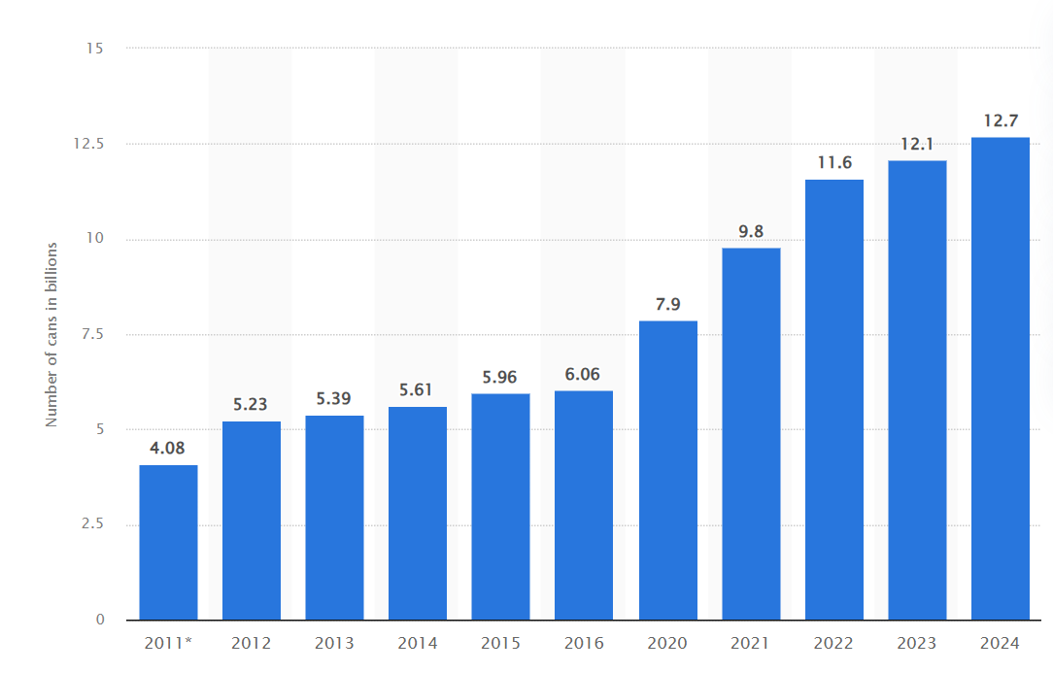
Figure 1: “Number of Red Bull cans sold worldwide from 2011 to 2024”
(Source: Statista, 2023)
APEX will be presented as the Red Bull extension of performance-gear to support athletes who are involved in the freerunning, parkour, calisthenics and urban movement sports. APEX has been created in an appearance of high-grip, durable, and flexible materials which align with the identity of Red Bull, which is challenging boundaries. It is projected that the global sports apparel market will experience an annual growth of 4.45% due to increased sales to USD 199.58 Billion in 2022 and further to USD 308.47 Billion in 2032 (Finance, 2023). The identity-based functional street wear is also increasingly popular among Gen Z consumer research, which suggests that the market is highly ready. This portfolio is aimed at using STDP analysis to create a strategic market background of APEX, create a marketing mix to fit its brand position, a poster is created to visualise the recommendations, and finally a reflective analysis of the brand-building process is discussed.

2. Element 1: STDP Analysis

2.1 New Brand Concept Overview
APEX is also designed as an extremely sophisticated performance-gear that is focused on athletes in high-impact urban settings. It combines high-quality materials like shock-absorbing impact-foam soles, wall traction rubber with multi directional grip, reinforced stitching, landing, abrasion, and the use of elastic compression fabrics maximising flexibility and stabilising the joints during high and rapid movement. These characteristics indicate the increasing overlap of sportswear and urban lifestyle apparel, in which the functionality and aesthetical identity meet. The size of the global market in sports apparel was USD 211.57 billion in 2024. The forecast period has a CAGR of 4.41, so the market will increase to USD 298.06 billion in 2032, starting with USD 220.35 billion in 2025 (Fortunebusinessinsights, 2023).
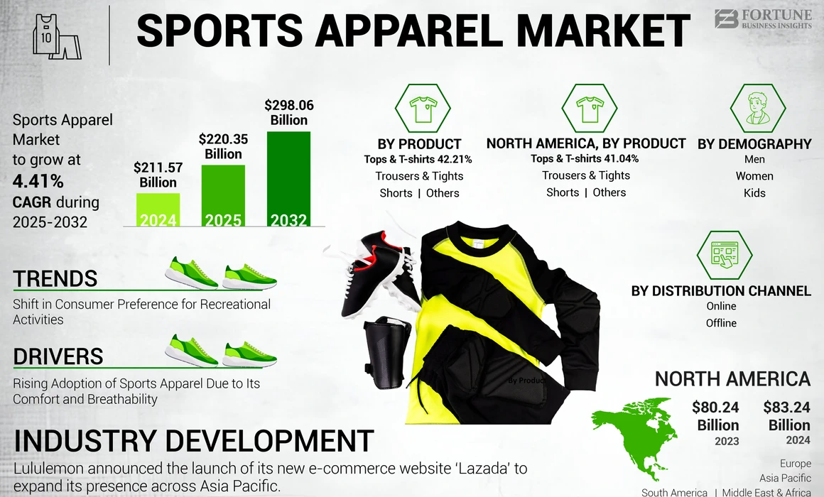
Figure 2: “Sports Apparel Market”
(Source: Fortunebusinessinsights, 2023)
The choice of APEX by Red Bull represents the brand extension logic to a field where the company enjoys cultural power. The company has built a source of extreme sports athletes, events and media platforms, which offers a legitimate platform to venture into performance apparel. The categorization theory is more effective at explaining brand extension success than signaling theory, owing to the fact that Peng et al. (2023) propose that extension fit is relatively more valuable in brand extension success than parent brand equity. A majority of consumers (63%) have made purchases on a website of a brand (Pwc, 2023). The young people of the city who are already turning into Red Bull athletes via freerunning, BMX, and parkour show a behavioural inclination that is natural towards dressing as reflected by the culture projected by the brand.
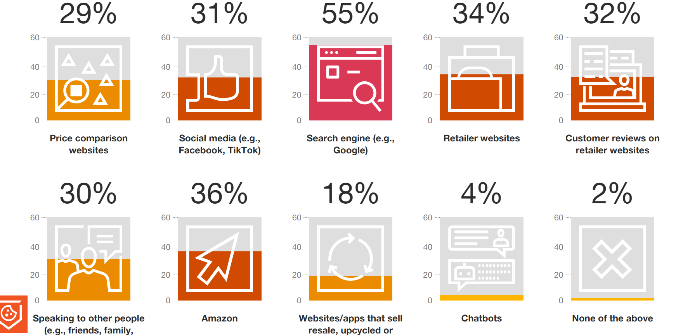
Figure 3: “Social media is also important for gen Z”
(Source: Pwc, 2023)

2.2 Market Segmentation
The demographic segmentation targets the customers aged between 16 and 35 in all genders who are majorly in the aspirational middle-income brackets like students, young professionals and urban employees who make fitness a part of their daily life. Gen Z and millennials are shifting the importance they put on fitness and well-being, which has caused the increase in gym attendance and outdoor sports (Gminsights, 2023). Wardana et al. (2023) state that one of the simplest and most used types of segmentation in the lifestyle and performance markets is demographic segmentation, which provides an excellent understanding of the reasons behind the purchase and the purchasing power.
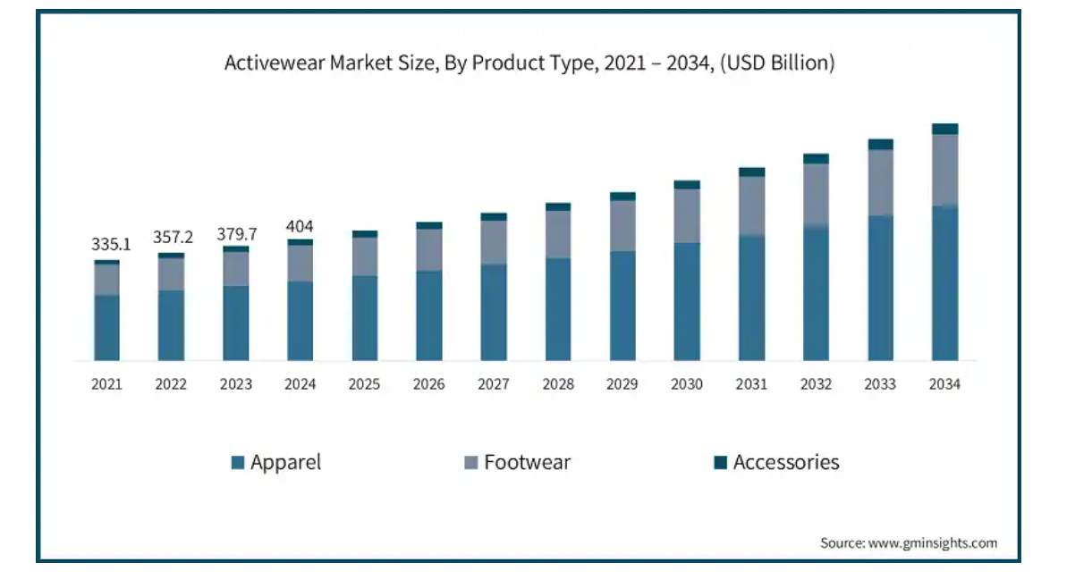
Figure 4: “Activewear market size”
(Source: Gminsights, 2023)
Psychographic segmentation is one that recognizes consumers that appreciate performance, self-expression and physical mastery. These people tend to be risk-takers, thrill-seekers and have a physical movement as a part of their personality. Most of them engage in outdoor training sessions, capture their moves on social networks, and are attracted to brands that lead to self-identification. Gen zers are brand conscious, with 82 per cent admitting that the more an image of a real customer in an advertisement and 72 per cent admitting that they are more likely to purchase a product when the company donates to a social cause (Marketingdive, 2023). The fact that it demonstrates the compatibility between the high-adrenaline positioning of APEX and the psychographic expectations.
Durability, grip, flexibility and movement freedom are the main benefits that these consumers are trying to pursue. In 2023, Walmart ad business had a revenue of $3.4 billion worldwide (Capgemini, 2023). Therefore, social influence is also highly dependent on behaviour patterns, and parkour and urban movement athletes are often influenced by professional freerunners and content creators on Tik Tok and YouTube who influence the equipment choice and brand loyalty.
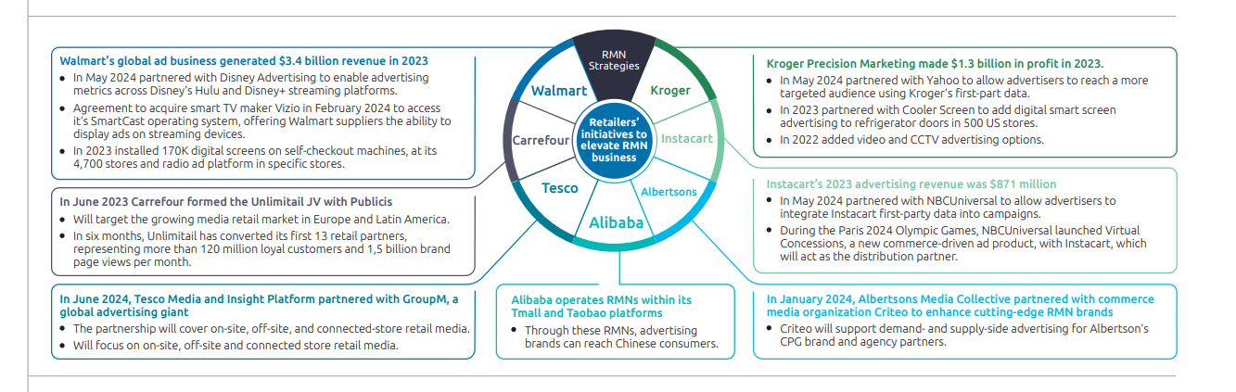
Figure 5: “Retailers are focusing on RMNs”
(Source: Capgemini, 2023)
Geographic segmentation targets the people of major urban centres where people can easily practice freerunning and parkour culture due to the nature of urban architecture. The Urban centers like London, Berlin, Paris, New York and Tokyo are settled centers whereby the sport enjoys popularity in the open fields, rooftops and special training parks.

2.3 Targeting Strategy
The APEX target market is primarily dedicated freerunners, traceurs, parkour performers and urban fitness users aged 16-30 years old that actively consume the extreme sports content on social media. These buyers are keen on high technical functionality, athlete tested equipment and show interest in products that improve grip, fluidity of movement and shock absorption when performing complicated moves.
The secondary target market consists of calisthenics athletes, functional fitness communities, micro-influencers and content creators that combine both athletic and lifestyle expression. The Gen Z consumer trends indicate that nearly 60 percent of adults in the US Gen Z generation would like to be identified with a brand whose values resonate with their personal ones (Mintel, 2023). Gen Z purchases clothing and footwear more than others. They buy due to the trend adoption, beauty and identification to the athlete culture.
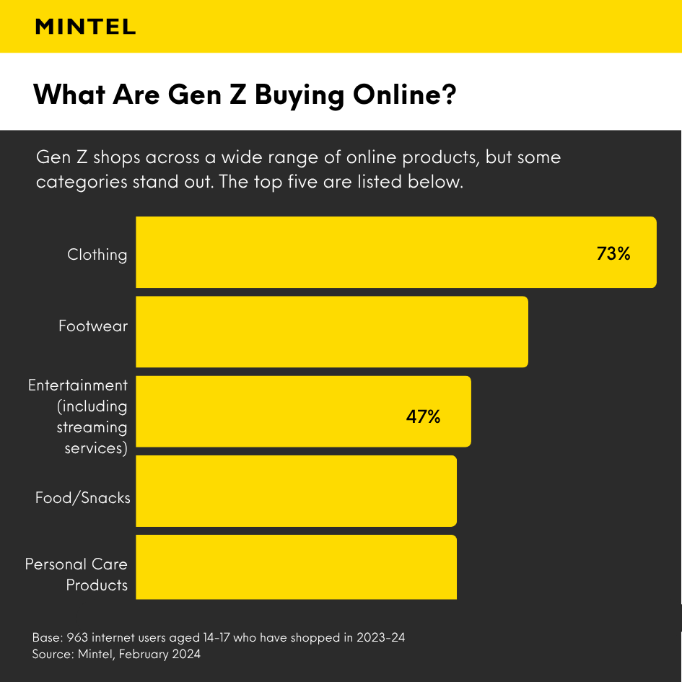
Figure 6: “What Gen Z buying online”
(Source: Mintel, 2023)

2.4 Differentiation
APEX has the foundation of product differentiation on its technical engineering. The shoes incorporate multi-layer grip rubber on its footwear to provide vertical traction, the midsoles of its shoes are made of impact-foam, which absorbs high drops, and tough toe guards to help in landing on walls. Clothing combines tear-resistant compression garments and sweat-wicking materials, which are made to be used in dynamic movement on the street. Nike Free technology gives that barefoot feel compared to other competitors and offers some lightweight support to support each step or stride, (Nike, 2023). Adidas Terrex is geared towards exterior trail running as opposed to city building, and On Running is focused on cushioning to road running as opposed to body-contacts.

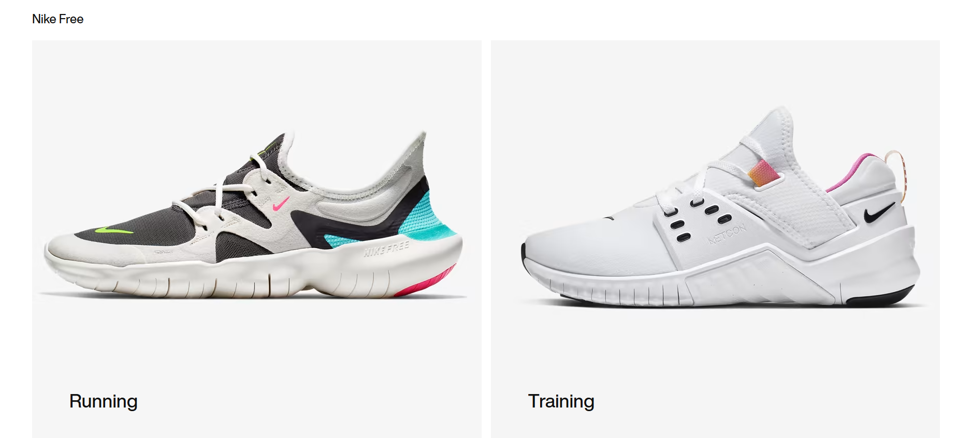
Figure 7: “Nike Free Run”
(Source: Nike, 2023)
APEX is distinguished by being designed especially to suit urban action athletes. Image differentiation relies heavily on the image of extreme sports that is known worldly by Red Bull. Its participation in cliff diving, freerunning, BMX, F1 and breakdancing events over the years provides an inherent credibility that most apparel companies cannot achieve. This is why APEX inherits a symbolic image of speed, power and performance innovation.

2.5 Positioning
In the case of urban movement athletes, APEX is the sole performance gear brand designed in parkour and freerunning that has excellent grip, durability and movement since it is designed using the technology and expertise of Red Bull athletes and extreme sports. APEX is at the crossroads of high performance specialisation and high lifestyle identity. Comparatively, Nike and Adidas have quality athletic products that serve a greater number of multi-sport audiences, whereas Under Armour targets strength training and tactical performance, and On Running is focused on cushioning innovation. APEX also stands out as the highest rungs of specialisation and high technical performance which are directly aimed at athletes whose demands are not adequately met by mainstream brands. Brand development involves establishing a distinct brand identity, which reflects the organization’s mission and resonates with its target audience (Schofield et al. 2025).
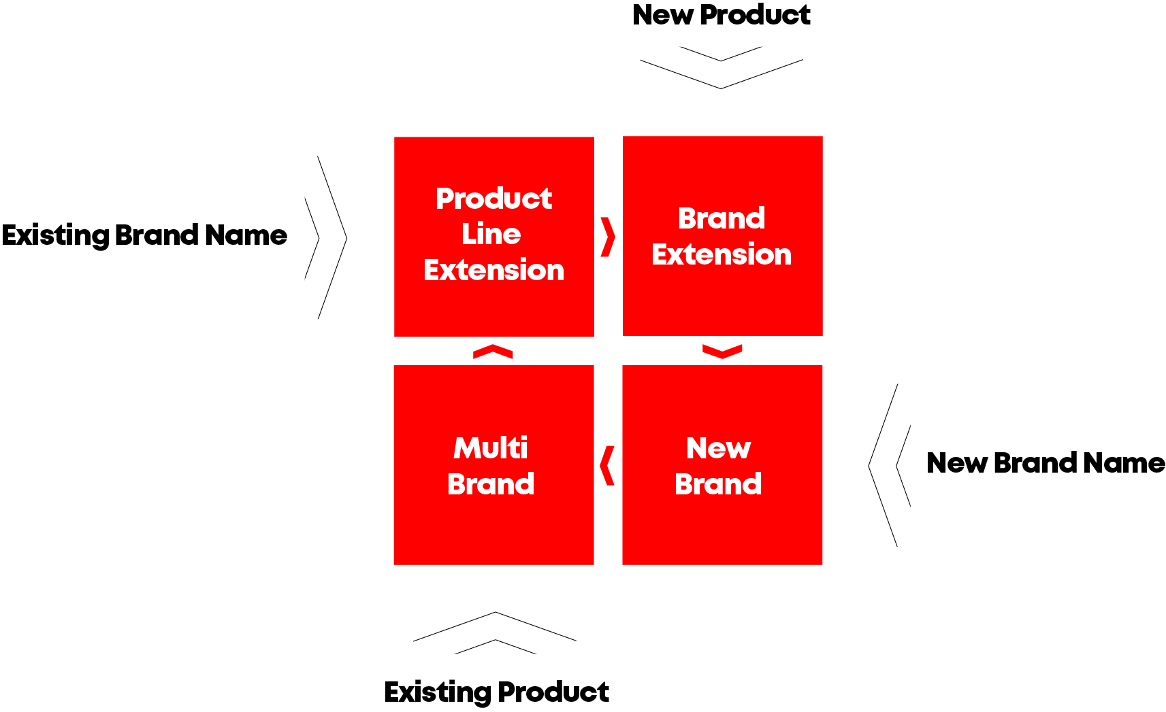
Figure 8: “Captivating brand development”
(Source: Adapted by Schofield et al. 2025)

3. Element 2: Marketing Mix
The Marketing Mix offers a feasible approach to realisation of the APEX brand strategy by converting the STDP knowledge into action marketing choices. Since APEX is a performance based product line. The 4Ps framework Product, Price, Place and Promotion has been introduced and extensively used in modern marketing (Audly et al., 2023).
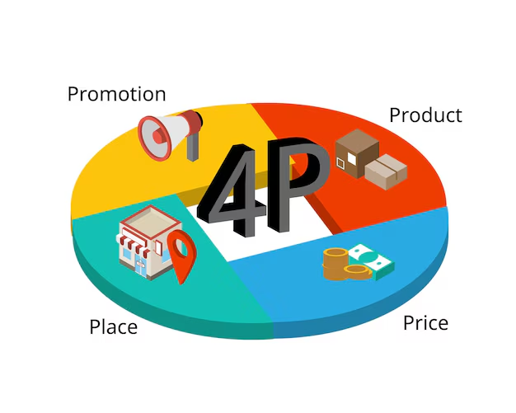
Figure 9: “4Ps Marketing Mix”
(Source: Audly et al., 2023)

3.1 Product
APEX is a quality, athlete designed performance apparel line that is developed to be used in the urban movement sports including parkour, freerunning and calisthenics. It has a fundamental advantage of providing maximum movement efficiency, support and durability when subjected to high-intensity movement. The main advantage of APEX is improving the performance of athletes, whereas the enriched components are the use of advanced materials, brand and technology identity test by athletes and value indices.
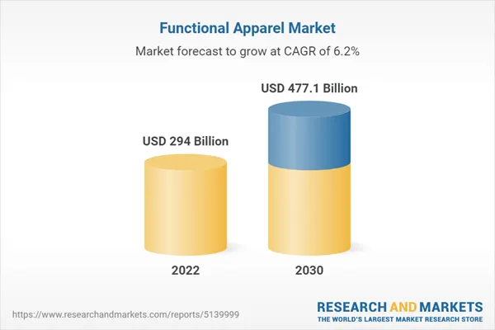
Figure 10: “Functional Apparel Market”
(Source: Finance, 2023)
The US 294 Billion of global market in Functional Apparel as of the year 2022, is estimated to grow to a revised amount of US 477.1 Billion at the analysis period of 2022-2030 with a CAGR of 6.2% to 2030. One of the market segments, which the report evaluated, is sportswear that is expected to achieve 6.1% CAGR and US dollar 155.5 Billion by the expiry of the analysis period (Finance, 2023). The Athletes Lab of Red Bull is also an added benefit as the prototypes are tested on professional freerunners and hence accuracy in design and performance checks. APEX product line consists of footwear like APEX Blitz, APEX Stealth Run and APEX Urban Grip; apparel like compression tops, flex-fit joggers and urban stealth hoodies and accessories like grip gloves, performance backpacks and protective support gear.

3.2 Price
APEX follows a high-end value pricing strategy, meaning it follows a high-performance engineering and niche athletic orientation of the brand. With specialised products, value-based pricing is the most effective due to the fact that consumers purchase based on perceived value and not the cost of production, and can enable brands to directly gain maximum value exchanged (De Toni, et al. 2022). This is the same strategy that APEX follows with the target market of parkour and urban athletes who are more interested in durability and technical innovation and performance tested by athletes.
The shoes are priced at £120-180 based on the complexity of the model, with the clothing costing between 60-120 which is based on quality of materials, durability and functionality. Benchmarking helps maintain such prices: Nike Metcon models are generally sold at the range of between £130, Adidas Terrex products are sold at the range of between 150 and On Running performance shoes; they are sold at the range of between 140 (Nike, 2023). These brands are good competitors, and none of them sell footwear that has been specifically designed with vertical traction, wall impact resistance or freerunners dynamics.
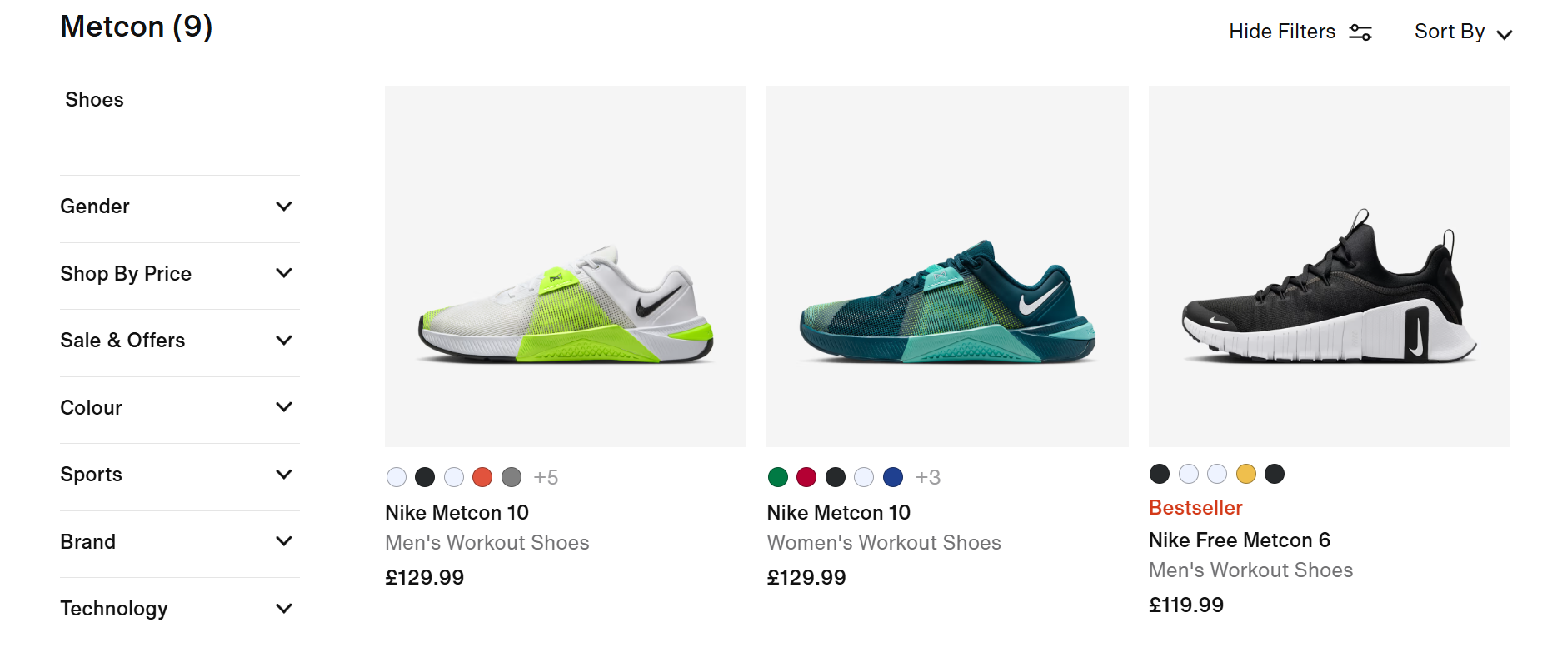
Figure 11: “Nike Metcon”
(Source: Nike, 2023)

3.3 Place
The target market would be calisthenics athletes, communities of functional fitness, micro-influencers and content creators that integrate both sport expression and lifestyle. This subsequently transfers to Gen Z consumers that may not be interested in the sport of parkour but enjoy wearing performance streetwear as a form of identity and cultural association. The consumer trends of the Gen Z generation show that almost 60 percent of adult members of the US Gen Z generation would prefer to associate themselves with a brand the values of which are compatible with their own values (Mintel, 2023). Gen Z spends in clothing and footwear than the rest. They purchase because of the fashion following, attractiveness and identification to the sports culture.

3.4 Promotion
On its technical engineering, APEX bases its product differentiation. The shoes have many layers of grip rubber on its footwear to give it vertical traction, impact-foam which absorbs high drops as its midsoles, and hardened toe guards to aid in landing on walls. The Nike Free technology makes them feel like they are walking on barefoot, like the other competitors and provides some kind of light weight support to ensure one step or stride, (Nike, 2023). On Running is oriented on cushioning to road running and Adidas Terrex is oriented on exterior trail running as compared to city building.

4: Element 4: Reflection
Reflection on Developing the Brand
Gibbs Reflective cycles consist of six steps namely, description, feelings, evaluations, analysis, conclusion, and action plan (Praveena et al. 2025). This is what I have done to give my reflection.

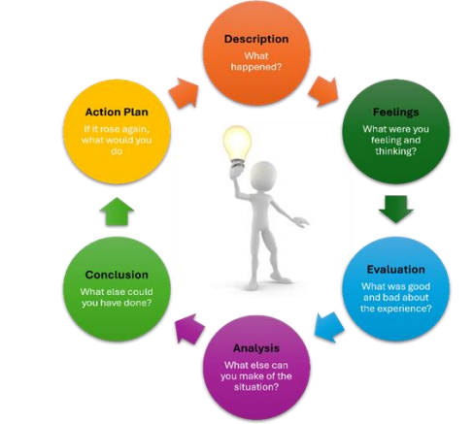
Figure 12: “Gibbs Reflective Cycle”
(Source: Praveena et al. 2025)
Description:
I launched the project by conducting an analysis of the brand identity, symbolism, and consumer culture of Red Bull in order to make sense of the way the parent brand is created. This made me realise that any brand extension should not be inconsistent with the original equity to ensure the presence of strong associations. I have also studied segmentation, targeting and positioning theories and this helped me realize that the combination of STDP insight and product development was critical towards developing APEX as a strategic extension.
Feelings:
I was confident regarding the creative point at first but doubted the possibility of converting academic model into a realistic brand strategy. Later on in my development I got more at ease with the application of theory and began to value the depth that is needed to support every decision.
Evaluation:
One of the biggest positives was acquiring a better understanding of segmentation theory, in particular psychographic and behavioural levels that affect sports lifestyle consumers. I also got to know about the specialised equipment required in niche markets such as parkour athletes. My analytical skills were strengthened by working with industry information in the form of CAGR trends and youth behaviour reports. Nevertheless, I was not able to convert general information into concrete information easily and did not see powerful distinction in the overcrowded sportswear market.
Analysis:
This problem taught me the need to have competitive positioning and innovativeness. Studies indicate that the innovation of products plays a crucial role in high-performance markets in which the value is based on functional superiority (Leppaa et al. 2023). The application of academic literature, such as Kotler and experiential knowledge provided by McKinsey and Deloitte contributed to making me critically incorporate theory and real-life data.
Conclusion:
I understood that a successful strategy is a result of organised thinking. The 4Ps combined with the use of the STDP model and Brand Identity Prism developed by Kapferer made me narrow down on the path of the brand. The differentiation opportunities were also explained through competitor benchmarking (Nike, Adidas, ON Running).
Action Plan:
In subsequent project development, I will enhance the early insight development, apply structured frameworks earlier and increase competitor studies to have a more precise strategic focus.

References
Audly, T.B., Susanti, R.D. and Hermayanti, Y., (2023). 4P Relationship (Product, Price, Place, Promotion) in Purchasing Decisions for Virtual Reality (VR) as a Learning Medium for Nursing Students. Journal of Nursing Care, 6(3).
Capgemini (2023) Consumer Trend Available at: https://www.capgemini.com/wp-content/uploads/2025/01/Consumer-trends14012025.pdf (Accessed on: 13/12/2025)
De Toni, D., Reche, R.A. and Milan, G.S., (2022). Effects of market orientation, innovation strategies and value-based pricing on market performance. International Journal of Productivity and Performance Management, 71(8), pp.3556-3580.
Finance (2023) Functional Apparel Available at: https://uk.finance.yahoo.com/news/global-functional-apparel-strategic-market-081300544.html (Accessed on: 13/12/2025)
Finance (2023) Sports Market Apparel Available at: https://finance.yahoo.com/news/global-sports-apparel-market-expected-120000207.html (Accessed on: 13/12/2025)
Fortunebusinessinsights (2023) Sports Market Apparel Available at: https://www.fortunebusinessinsights.com/sports-apparel-market-107401 (Accessed on: 13/12/2025)
Gminsights (2023) Activewear Market Available at: https://www.gminsights.com/industry-analysis/activewear-market (Accessed on: 13/12/2025)
Leppänen, P., George, G. and Alexy, O., (2023). When do novel business models lead to high performance? A configurational approach to value drivers, competitive strategy, and firm environment. Academy of management journal, 66(1), pp.164-194.
Marketingdive (2023) Gen Z wants brands to be authentic Available at: https://www.marketingdive.com/news/gen-z-wants-brands-to-be-fun-authentic-and-good-study-says/581191/ (Accessed on: 13/12/2025)
Mintel (2023) Online Shopping Available at: https://www.mintel.com/insights/retail/gen-z-online-shopping-behaviour-and-trends-what-brands-need-to-know/ (Accessed on: 13/12/2025)
Nike (2023) Metcon Price Available at: https://www.nike.com/gb/w/metcon-3yxqs (Accessed on: 13/12/2025)
Nike (2023) Nike Free Run Available at: https://www.nike.com/in/free (Accessed on: 13/12/2025)
Peng, C., Bijmolt, T.H., Völckner, F. and Zhao, H., (2023). A meta-analysis of brand extension success: The effects of parent brand equity and extension fit. Journal of Marketing, 87(6), pp.906-927.
Praveena, K.S., Juslin, F., Patil, C.M. and Bhargavi, K., (2025). Using Gibb's Reflective Model Approach for Enhancing Project-Based Learning Among Students Through Reflective Assessment. Journal of Engineering Education Transformations, pp.148-155.
Pwc (2023) Consumer Insights Available at: https://www.pwc.com/gx/en/industries/consumer-markets/consumer-insights-survey.html (Accessed on: 13/12/2025)
Redbull (2023) About Redbull Available at: https://www.redbull.com/in-en/energydrink/company-profile (Accessed on: 13/12/2025)
Schofield, A., Duber-Smith, D. and Baker, B., (2025). The Three B’s of Branding: Navigating Multicultural Markets. Journal of Marketing Development and Competitiveness, 19(1), pp.1-20.
Statista (2023) Brands on Social Media Available at: https://www.statista.com/topics/2057/brands-on-social-media/?srsltid=AfmBOooBX8shsui6iHoTVAkeVWSsi-60txWvtjzx2OoIXcTEIBf0DSvY#editorsPicks (Accessed on: 13/12/2025)
Statista (2023) Ecommerce in UK Available at: https://www.statista.com/topics/2333/e-commerce-in-the-united-kingdom/?srsltid=AfmBOoq27kp3_0ztiLKUD8YzaPpcW_KY3QdV0FFQjvWQrMWFKVqbXzz0#statisticChapter (Accessed on: 13/12/2025)
Statista (2023) Red Bulls Available at: https://www.statista.com/statistics/275163/red-bulls-number-of-cans-sold-worldwide/?srsltid=AfmBOorG_FAD5omFEpKrA0ZEIkS84vSS2Hduo7ipfbepSPwnDTcJJ4mG (Accessed on: 13/12/2025)
Wardana, M.A., Masliardi, A., Afifah, N., Sajili, M. and Kusnara, H.P., (2023). Unlocking purchase preferences: Harnessing psychographic segmentation, promotion and location strategies. Jurnal Informatika Ekonomi Bisnis, pp.713-719.

Appendices

Appendix 1: Element 3: Marketing Strategy Pitch


