

A Study of how machine learning models, supported by XAI, can effectively predict the impact of learning and development on employee attrition and promotion

by
Nicholas Gelstharp

Supervisor: Mark Huntly

Project submitted as part of the requirements for the award of
BSc (Hons) Computing (stream)
BEng (Hons) Data and Information Systems

July 2026

Contents
Introduction 2
Research Gap 2
Aims and Objectives: 3
Literature Review 4
Employee attrition and Promotion in HR Analytics 4
HR analytics and Early Predictive approach 4
Machine Learning in HR Analytics 5
Evaluating the performance of machine learning 5
Explainable AI in HR Analytics 6
Literature review summary: 7
Methodology 8
Design 10
Workflow 12
Implementation 13
Data Cleansing (Excel) 13
Python Data Cleanse and Transformation 16
Python Machine Learning 20
Implementing Evaluation Metrics 22
Implementing SHAP 25
Algorithm Performance 29
SHAP – Explainable AI 38
Conclusion, Recommendations and Reflections 42
References 44

Introduction
Central government delivers millions of pounds of services to the UK public annually with the increasing expectation that these services are available digitally. However, employee attrition within IT departments across all organisations that deliver digital services has a high impact [1]. Organisations invest millions of pounds into training its staff as well as trying to retain them through increased salaries to match the market rate. The problem facing these organisations is that highly technically capable and experienced staff are needed in order to be able to deliver the services needed, but there is a skills shortage [2] and a lack of personnel that are able to replace the people that are leaving. It is also unclear what impact training is having on retaining and developing staff within these organisations and what impact the investments that are being made are having if any.
Having a good understanding of the underlying reasons behind why people may leave could provide vital information that will allow the organisation to be able to pro-actively mitigate them which will ultimately lead the timely delivery of business objectives which is important across all organisations public or otherwise. Similarly understanding the impact of training and development on both attrition and promotion within these technical departments, and which features are most important could help the organisation to ensure that it is able to maintain and build on its digital service offering and should help inform where investments could be made going into the future offering the greatest value for money.
The proliferation in availability of both hardware and algorithms means that utilising machine learning with a HR context is now both feasible, practical and a proven approach with many researchers using the IBM HR analytics dataset to try and focus on the features that are most likely to impact attrition [3] . Research is also abundant for which algorithms work best be it Decision Tree, Random Forest, CNN’n, XGBoost to name but a few [4], however there is not a consensus as to which features analysed are the most effective in this context, and also which algorithm will also work best. These machine learning algorithms have been refined over recent years [5], and with the developments in hardware they are now able to process millions of records very efficiently meaning that the timeliness of any data analysis is improved and very useful in a business context.

Research Gap
However, the current gap exists in that there is very little research on actually datasets available other than the fictitious IBM data, and there is hardly any research which combines the attrition research into XAI and promotion and the links that training and development has as features that machine learning could use to make these predictions. The availability and use of XAI in this context is very important and the outcomes relate to real people and the transparency of decision making [6] in this process will be vital to any organisation that would be looking to adapt policies or decision making based on the machine learning algorithms used. XAI is a relatively new concept and its impact on HR attrition data and promotion data in the context of looking at learning and development data is very limited. The most efficient workflow in order to achieve the results using machine learning as a solution to this HR problem, is also something for which there is no singular consensus available from the research that has been completed. To address this the following research question is proposed:
“Can machine learning models, supported by explainable AI, effectively predict the impact of learning and development on employee attrition and promotion outcomes?”

Aims and Objectives:
The aim of the project is to investigate how machine learning can assist with predicting the influence that employee learning and development has on attrition and promotion outcomes through the deployment and evaluation of machine learning models and explainable ai (Xai)
The objectives are:

- To critically review existing research on employee attrition, promotion prediction and machine learning /XAI application in HR analytics to identify research gaps and methodology trends
- To design and implement a machine learning pipeline that preprocesses employee data and applies an optimised classification algorithm and Xai for predicting attrition and promotion outcomes using learning and development data
- To evaluate model performance and analyse feature importance to quantity and the impact of learning and development variables on employee outcomes
- To generate data-driven recommendation and critically assess model limitation, ethical considerations and future research opportunities.

Literature Review
There is a significant amount of research available that established that both attrition and internal development of staff to meet attrition needs is an area of significant importance in modern organisations [7] [8] [9]. These challenges are ever present in a competitive environment however, what is new is the modern availability of data in relation to staff as almost all organisations in the modern day will hold their HR records digitally. Organisations will not only hold basic information such as tenure, job role etc, but will also hold information on what learning and development an individual has undertaken and also how they may have progressed during their tenure. This information is available however this has not always been the case, and how this data has been utalised in organisations still varies. Though there is a lot of research in this developing area.

Employee attrition and Promotion in HR Analytics
The analysis of HR information in the field of attrition and promotion are very valuable to digital organisations in both ensuring that investment in learning and development opportunities represent value for money and that they are having the desired business impact which includes retaining and developing key staff [10] [11]. Even though learning and development is widely believed to have a significant impact on these metrics, the outcomes are rarely studied together and this means that currently the correlation between learning and development initiatives, employee attrition and promotion is sparse. Attrition and promotion are traditionally researched independently however there is some research that suggests that the two are linked. The human capital theory suggests that the investment that an organisation makes in training its staff will improve their productivity which in turn increases the likelihood that the employee is able to achieve promotion [12] [13]. The social exchange theory also suggests that staff will perceive support when they are allowed to participate within development opportunities, which in turn can become loyalty to the organisation and have a positive impact on attrition [14] [15]. These literature sources suggest that there is a link between learning and development, despite the lack of this being applied within a machine learning context.
Despite research into employee attrition and promotion being performed, not much of it looks to examine these as connected process. Existing research suggests that employees leave organisations due to a lack of career progression, which show that there is a link between promotion and retention strategies [16] with further research showing that organisation that invest in learning and development opportunities will enhance promotion prospectives and improve capability [17]. However, there is no research on linking the two and capturing whether one is impacted by the other and this is representative of a big research gap highlighting the need for these features to be captured at the same time as they are linked.

HR analytics and Early Predictive approach
Analysis of data and approaches to predicting staff movements has changed in a significant way over the last 5 to 10 years. Organisations will now routinely gather, collect, process and seek to utilise this information to help with decision making processes. Developments and the cost effectiveness of machine learning algorithms have empowered organisations to be able to make this move in an effective way to anticipate attrition and promotion [18] [19]. Pipelines have been developed that will process the information gathered to ensure that this can be done accurately and also to assist with ensuring that the information is in a format that can be consumed effectively by the models, for example ensuring incomplete records are removed or adjusted [19].
One of the challenges in making predictions using HR data is that HR data is often not balances and contains a significant amount of features not all of which are useful, but could interfere with any classification. Data collection practices are also inconsistent, and promotion events could make up a very small part of overall datasets which could lead to bias, and there is research available to show that removing features and applying techniques to resample information could be key to producing reliable models [20] and ensemble models may be particularly useful such as Random Forest of gradient boosting in generating predictions in employee behaviour [21]. As well as suggesting these models there is further evidence from research available to suggest that the key features within HR data in predicting promotion or attrition would likely be employee engagement, performance metrics, length of service and access to training opportunities, which gives further weight to the fact that skills development and training could be a key indicator of loyalty to an organisation and of career progression [22].

Machine Learning in HR Analytics
Machine learning is seen today as a key tool in enabling data driven decisions and predictions as it enables organisations to be able to leverage their existing data assets to be able to see patterns which otherwise would have been unlikely to be discovered. At a basic level machine learning is a set of algorithms that have been developed over the last 50 years. These algorithms have been developed to glean information from large, complex datasets, allowing the user to identify relationships using complex mathematics and without the user having to create new code or in some cases even understand programming languages at all [23]. Machine learning models are split into supervised and unsupervised approaches. Supervised machine learning algorithms have often been employed with the HR context as algorithms such as decision trees, SVMs or gradient boosting can map the relationship between a target feature, and an input column i.e. have you received training and have been promoted are two examples here [24] [25].
Unstructured algorithms have also been applied within this context in order to group (cluster) segments of staff based on features within the data that they have in common, without the organisation having to provide these labels, this is useful in uncovering patterns or similarities that the business may not have otherwise been aware of [24] and this can potentially be useful in finding segments of the business with similar training and career trajectories, which can then also help influence business policy and action as a result. By utilising the available data including learning and development variables, machine leaning models will be able to discover complex relationships between the features of the data they hold and the links to both attrition and promotion.
A wide range of machine learning algorithms have been developed and applied within the HR context and their performance against each other within this context from research seems to suggest that ensemble methods such as Random Forest and gradient boosting are more likely to be able to outperform the simpler models, which research is suggesting is because these ensemble methods have the ability to capture non-linear relationships [26]. However, there is also contradiction in other research where simpler methods such as linear regression has been used and provided similar performance but with much easier to interpret and explain results, especially where the data provided is limited [27]. This lack of agreement as to which model to select shows that the true answer to this question could be the specific context to which the model is being applied, and therefore multiple test of different models should to ascertain the most appropriate for that situation, and essentially there is never going to be a one size fits all situation.

Evaluating the performance of machine learning
As shown in the previous research machine learning is commonly used and often seen as a fundamental aspect of data exploration within modern day organisations with large and complex data sets. The evaluation of how these machine learning models works is vitally important in ensuring that predictions made are reliable and repeatable if organisations are going to use them within the decision making process. In most studies that have been performed the performance of the models has been assessed using metrics such as accuracy, precision, recall and F1-score, which will all measure to what extent the predictions made by the algorithms match the actual real world outcomes [28]. These are common and to some degree a fairly simplistic way of evaluating performance, however there is research that increasingly shows that as attrition and promotion are influenced by multiple factors the practical value of making decisions based on just these outcomes may be problematic [29].
The limitations being identified in research indicate that HR datasets will often have imbalances, where things like attrition and promotion will not occur frequently in comparison to the entirety of the datasets being processed and as such models may not always be tuned into finding minority outcomes which could be significant to the organisation, especially in a technical work context where you would want to put efforts into keeping those hard to recruit individuals but there may only be a few of them in your data, whereas you may have a lot of service desk staff who are relatively easy to recruit and so the models may not have the desired impact of saving those hard to recruit, train and keep staff [30]. Recent research has suggested that as a result of this metrics such as recall and precision are recommended to be taken into greater consideration as they may provide a more balanced assessment of the performance of the models that have been employed, minimising the impacts described above [31]. Though the true difficulty is that there simply may not be enough information on these smaller communities of employees to effectively run a machine learning model due to the limited data causing overfitting and potentially producing unreliable results.
These statistical metrics in whatever combination employed will certainly be useful, but there is a concern that the application of machine learning with a HR context can have significant ethical implications if they are used to assist decision making processes. An example of this may be that a model could achieve a good predictive score, but may inadvertently attribute this to gender, age or ethnicity for example where a staff body is not particularly diverse [32]. Further studies also show the importance of choosing the features that will not have legal and ethical implications where the outcomes will be used in the decision making process, and that statistical metrics should be accompanied by thorough evaluation to ensure that no one is unfairly disadvantaged which could have significant legal consequences for any organisation and would likely also have an adverse impact on attrition in itself [33]
Overall, research has demonstrated that machine learning can and has been successfully employed within the HR context but this research has shown that the evaluation needs to go beyond simply statistical analysis. This provides a clear justification for the application of explainable AI with the aim of becoming more transparent to support a more informed decision making process that could have significant ethical and legal implications.

Explainable AI in HR Analytics
The opportunities that have been presented by machine learning to decipher significant amounts of data quickly and efficiently for use in a business context and specifically within the decision making process has huge ethical and potentially legal implications. As these decisions directly impact employees careers, job prospects and sometimes opportunities within organisations the use of a black box style AI is open to these challenges. This has resulted in Explainable Artificial Intelligence (XAI) emerging as an important area of research, with the ultimate goal of being able to make the decisions made by the machine learning models understandable to those that have employed them [34]. XAI should enable organisations to more safely use Machine learning as it will enable them to justify the decisions that have been made and in gaining this understanding they will also be able to evaluate them against any organisational and legal frameworks to make sure that they are compliant.
Research has shown that the employment of XAI is should be considered a fundamental technical requirements for the responsible use of AI in an organisational context. This research highlights that this will likely lead to more trust in the adoption of the systems and also it will allow organisations to feel empowered to make decisions based on machine learning models [35]. There are also some regulatory frameworks that call for any automated decision making to be reinforced with XAI, with suggestion that this a key aspect of an organisation maintaining legitimacy [36].
Despite this research and what seems to be widespread acknowledgement that XAI should be a fundamental component of the application of machine learning with a HR context, there are limited tools and research where this has been applied. Many algorithms or deep learning models are very difficult to interpret. SHAP and LIME have been developed as two examples of tools that could be used to introduce XAI, but their applicability within an HR context is still not well researched [37] which some other sources suggest is because the interpretation of the outputs of XAI tools is difficult and therefore not being applied or researched consistently across the industry [38]. Also, there is additional research that suggests that XAI will not on its own overcome the issues identified previously where biases and discrimination based on gender etc would still be performed and XAI really wouldn’t have any impact in addressing those issues on its own and so it would still need to be used as part of a holistic approach to interpreting the output of any models [39].

Literature review summary:
Overall, the literature shows that machine learning is a powerful tool for analysing HR data and is able to predict outcomes such as attrition and promotion. There are limitation identified in that existing research largely focusses on the IBM dataset which is not representative of available of real world data. Accuracy and success of models is also mostly evaluated using statistical analysis of the results, without really looking at interpretability or explainability. There is also very limited research on the specific factors of how learning and development within this context can be used and if it has statistical significance. This project will aim to better understand the feature importance of Learning and development on attrition and promotion outcomes whilst also aiming to better understand the reason for the predictions using XAI so that the impacts can be measured holistically instead of statistically.

Methodology

This project will use a combination of quantitative, experimental and development approaches. For the research methodology a quantitative experimental and developmental approach will be used as this will run on an experiment using a predictive model to process the data and check the outcomes, then the relationships between the features will be explored and then iterated on to build a machine learning solution.
The research philosophy will be a positivist philosophy, this is because the focus is on objective statistical data. The advantage to this is that it should make the experiments easily replicable and the results will be very objective. XAI will be used to try and improve the interpretation of the end results.
The search approach will be deductive and based on the Human Capital Theory and the Social Exchange Theory that was uncovered in the literature review. The advantage of this is that it will be simple to test against these established and structured hypothesis, but there may be some lost insights from doing this too rigidly.
The research strategy will be experimental, and using a case study from the civil service. A comparison of the ML models will be done using real world data, which has the advantage of being applicable with a real scenario but then also has the real world scenario limitation of data being not captured to this specific purpose and potentially being overfitted if there is not enough information available. A significant amount of pre-processing the information is going to likely be needed.

The pipeline for the machine learning algorithms is displayed in the diagram below

The experimental hypotheses are that a Machine Learning algorithm can be successfully used to predict both attrition and promotion. That learning and development engagement has a significantly impact on these outcomes, and that XAI will improve the interpretability of the results that are generated using machine learning. The data that will used to achieve this will include job role information such as title, department, length of tenure, length of time in role, have they had access to training, what value was this training (financial), duration of training (days), have they left the department, left the agency, have they been promoted, performance information. There will also need to be a likely significant amount of preprocessing of this information to ensure standardisation of roles, departments and descriptors and making sure that any missing values are handled in a way that can be interpreted by the models that are being used, also an assessment of the available information will need to be performed to ensure that only relevant information is included so as not to skew the results.
The models that will be used in the experiments will be
- Logistical Regression – This has been chosen as it will provide a benchmark. It was used frequently in research and is commonly used in HR analytics, it is easy to interpret, fast to train and will output a probability which is needed for decision making in relation to attrition.
- Random Forest - This should be less prone to overfitting, and as it is able to more reliably handle complex relationships it would likely be able to produce a better end result. However, it is slower and the results may be difficult to visualise and interpret.
- Gradient Boosting – This has been chosen as research indicated that ensemble methods provided the best results for this context. This model will have a higher predictive performance that the others, but its results will be less interpretable
The hardware that will be used for the will include a fairly standard laptop that has 32gb of ram, and a core i9 ultra processor which should be more than capable of running the machine learning algorithms. The tools that will be used will include Python, Pandas, NumPy, Scikit-learn and SHAP as these are industry standard toolsets that will be able to perform and evaluate all of the experiments required.
The evaluation of the models will be completed using Accuracy, Precision, Recall and F1-Score metrics, as well as using a confusion matrix to ensure that each of the models is thoroughly evaluated and considered. The ethical considerations for the experiments is considerable as real world information is being used and in doing this all personally identifiable information will be obscured to make sure that no one can be identified as part of the research. Also, XAI is a key focus of the experimentation which will be used to try and provide transparency to the machine learning models results.

Design

This section will show the design and implementation of the machine learning pipeline that has been developed with the explicit aim of investigating whether or not learning and development variables can support the prediction of employee attrition and promotion outcomes. An experimental approach will be used within a Jupyter workbook using python where data sources will be combined and the machine learning models applied, followed by outputting metrics and graphics that will allow the performance of each of them to be evaluated.
The machine learning pipeline that needs to be designed must take data from multiple sources and combine them using a primary key, it must also then clean and standardise all of the staffID’s which is a primary key that exists within all of the datasets and this will then align and allow for combining the information so that it can be processed by the machine learning algorithms. This is a numeric column and so it will need to be cleaned to ensure that the type is the same, for example a number may be saved as text, and also to remove any spaces that may be hidden or formatting that could affect the ability to combine the datasets.
The target columns that will indicate on a row level will need to be created (where 1 row represents one member of staff), whether they have been promoted or left in order that these target features can be used by the machine learning models and their ability to predict the outcomes of these based on the other features within the dataset.
The pipeline is also going to have to encode each of the features that is currently in use so that where currently there is a column for grade and within that column there are 7 different categories, it will need to instead have 7 columns with a binary value. This will have to be repeated for all of the available columns as the machine learning models will not be able to read the information as it is and instead will need to have binary values to allow the analysis and prediction to take place.
The pipeline must import all of the tools needed, and this will include the models themselves, and any other python tool that will be needed to achieve the goals and continually experiment, including SHAP and the ability to evaluate the models using accuracy, precision, recall, F1-Score, ROC AUC and confusion matrices. Accuracy gives an indication of how may correct predictions were made, but on its own may give misleading results especially where outcomes are weighted which in this instance is likely as most people will stay and not be promoted, and so it won’t necessarily be difficult to work that out. Precision will be used so that the results show how reliable the predictions were and how often it was right. Recall will look for true positives and false negatives for the models which again will all feed into how successful the models have been. F1 score is a combination of recall and precision taking the mean values of each and providing a score (value) that will help evaluate performance. ROC AUC will provide a score with a maximum of 1, where 0.5 demonstrates that the predictions made by the models are no better than guessing and 1 would demonstrate that the model is perfect (which would probably indicate that there is an error. The confusion matrix will be used to show true positives, false positives, true negatives and false negatives that have been identified and provides great context for reliability.
The models that will be used within the pipeline are Random Forest, Logistic Regression and Gradient Boosting. The reason for this is that as the literature review demonstrates, there is no consensus currently available as to which machine learning algorithm that would be “best” for this experimentation and as such choosing a range would ensure that a comparative evaluation can be performed to identify which of these 3 may be the most reliable and best performing in this specific situation. Logistic Regression is widely used within a HR context as shown in the literature review and as it is a relatively simple model, it is easier to justify its resolutions as they may have ethical considerations, which is why it is often employed in similar contexts. Random Forest was also used frequently for similar reasons and research showed that it may be better at identifying complex patterns than linear models like logistic regression. Both of these also work well with SHAP and can provide good explanations of how decisions were made. Gradient Boosting was selected as the lit review again showed that this model would often come out top where comparisons were being made in similar environments and it could help identify even more complex relationships if they exist.

Workflow

The whole process will follow the following workflow

The results of the above will then be analysed. This workflow has been designed in this was so that the data is in a consumable state for machine learning with 1 row per staff member and all the information will be binary. This will be repeated for both attrition and promotion and SHAP will provide the explainability element as per the aims and objectives,

Implementation

Data Cleansing (Excel)

The first action was to gather all of the data, this came from four sources. The first two is a resource called the SML, this file contains all of the staff information showing who has left the agency or been promoted. The file was provided as two excel files, one for each of the last two financial years. The next two files needed were the training datasets, this information included all of the training details for all staff from 2022 to present day. This was also provided in two different files, one that contained all of the information from 2022 to March 2025, and then another file which contained the information from March 2025 to present day. These four files would allow it to be seen who has left the agency of got promoted as well as who has done training, and contain everything needed in order to run my experiments. The intention would be to make two files one that contains staff information, promotion and leaver status as well, and then one with just the training records needed. One-hot encoding was then used as there are over 800 different courses, to make a single dataset in python that can be used for the analysis. The final source of information would be the overall staff list.
Now that all of the source information was provided the next action was to combine all of the training data into one file to allow for ease of use. This was achieved by going through both of the files and ensured that the columns of information were identical, and then adding the current data to the historic data so that everything was in one file for ease of processing. The process began by checking that the column names and contents are the same so that they could be copied and pasted easily from one to another. Although all of the column names and data types were the same in both the current and historical datasets, they were in different orders so the columns were moved around to make this fit. Once this was completed the next stage was to copy and paste the information from the current into the historic data to make one file that is labelled projectData. Now that this training information was in once place, each column was iterated through to see which were needed to be kept and then removeing the following information as they weren’t relevant to this experiment
Delegate First Name, Delegate Surname, Email, Booking Reference Number, Person Responsible, PO Number, Exam Platform, Notes, Equipment Reminder Sent, Calendar Invite Sent, Joining Instruction Reminder Sent, Start Date, End Date, Date Paid (GRN), Goods Receipted, Budget, Catalogue Reference, Delivery Method, Survey Sent, Send 2 Month Survey, Created, Survey 1 Send Date, Modified, Modified By, Exam Expiry, Delegate Full Name, Month Extracted, Extracted Financial Year, Contract Number, Cert Length, Month of Training, Financial Year, Ongoing, Course End Date, Average Days, Today, ITSTrainingIndex, Date of Next Action, Status Code, Requirement Title Text, Item Type, Path.
This significantly reduced the scope of the training data to only include what may be relevant to the actual experiment.
The next task was to process the remaining data and look at what needed to be removed or changed in order to work, first training was analysed and that had a status of cancelled, as this shouldn’t be in the data for this experiment and I removed all of these rows. Then it needed each of the remaining columns to be analysed and made sure that there were no blanks or information that was incorrect and could have an adverse impact on the experimentation. Below show the remaining data, with all personal information removed that could identify anyone that has completed the training.



The next dataset to be cleansed is the overall staff list, this information contains a lot of personally identifiable information and so again it was processed by going through the columns of information and removed any information that would allow someone to be personally identifiable and removing any columns that would not be needed for this experiment. This included
Description, CoDE Scheme, CoDE Student, Role number, Name, Email, Line Manager, Line Manager Email, Heads, Role type
The next action was to go through each of the columns and ensured that there were no blanks or anomalies that would cause any issues with the dataset then being able to work with the dataset.
The next task was to mark those staff within the current dataset that had received promotions. To do this, staffID’s for everyone were gathered that has been promoted since April 1st 2025 and put them into a new sheet in Excel. Then another column next to it with the number was created. In the dataset itself a new column called promotions was created to run the following Xlookup (=XLOOKUP(E2:E789,Sheet1!A2:A76,Sheet1!B2:B76,0,0) to put either a 0 for those not promoted or a 1 for those that had. This allowed identification of anyone that has been promoted in this period. For those that have left the agency it changed the contents of the Status column so that anyone with Active in there, which meant they were still active within the agency, it was changed to a 1, then the imported staff details for those that have left and put the status to a 0 to signify that they had left the agency. Once these staff had been added, the Xlookup was also used on them to see if any of them had been promoted within the 2 year period. Once this was all done, it replaced the Xlookups with the raw data of 0s and 1s to prevent any issues with the data being used in python.
Finally one more pass of the data was completed and there weresome inconsistencies with job roles that were the same, but spelt slightly differently and so all of these were resolved again to make sure that the most accurate results could be achieved.

Python Data Cleanse and Transformation

The data is now ready for transformation in Python and for the coding element to begin. Within a Jyputer notebook the first thing done was to load in the data and transform it as shown in the code below. There is a section in the code that is commented out that show the print, this was needed as when originally this code was developed the section where the staff number is cleaned within the two datasets was not present, as was assumed that this was ok from the csv files. However, the machine learning models were failing. And so the printed section was added put in this printed section that allowed it to see what data was being used to feed into the models, this showed that the combination of the data was not working and everything was 0. As the primary key that was being used for the join is staff number this was most likely the issue, and so code was added as shown below which shows additional cleaning of that information, which then when printed showed the table as was expected to work, and this also showed that the one-hot encoding had also worked and that the information was now ready to be used. This print is commented out as after the issue had been diagnosed there was no longer any requirement for this to be kept.

# This is where I have loaded the data, the sheet name here is showing that I used that data that was correct
#up to the 30th April. The filenames shown are not relevant to whether I processed the data or not and really
#they shouldn't be taken into consideration into anything.
capability = pd.read_excel(
r"C:\Users\GelsthN\OneDrive - DVLA\Desktop\Level 6 Project\unprocessedData\capabilityPlan.xlsx",
sheet_name="30.04.26"
)

training = pd.read_excel(
r"C:\Users\GelsthN\OneDrive - DVLA\Desktop\Level 6 Project\unprocessedData\projectData.xlsx"
)

# Here I am having to convert the Staff number in the data sources into string, this is because originally
# when the first iteration of the code was run the results didn't work, it was because the staff numbers
#across both of the data sources were not the same, and so this cleaning needed to happen in order to get
#the machine learning models to work.
capability["Staff Number"] = capability["Staff Number"].astype(str)
training["Staff Number"] = training["Staff Number"].astype(str)
capability["Staff Number"] = (
capability["Staff Number"]
.astype(str)
.str.strip()
.str.replace(".0", "", regex=False)
)

training["Staff Number"] = (
training["Staff Number"]
.astype(str)
.str.strip()
.str.replace(".0", "", regex=False)
)

# Again here I am making sure that the Cost and duration are numeric values so taht the sum that is needed
#to later on be calculated can be done. Again this was to remedy errors in the output where the sums for
#these features were not working at all in the first couple of iterations. This is specifically forcing
#everything to be a number, and if it is not able to it will make into NAN, or putting 0 in the blanks,
#This is all to ensure that the sums can be calculated.
training["Cost"] = pd.to_numeric(training["Cost"], errors="coerce").fillna(0)
training["Duration (days) this FY"] = pd.to_numeric(
training["Duration (days) this FY"], errors="coerce"
).fillna(0)

# In this section I am taking the training information which is stored as multiple lines per person, and
#each course is a row by itself, and grouping them all together by staff number. This will allow the machine
#learning algorithms to work as I intend. I am creating four features here 2 are sums, one counts how many
# unique courses there are and the other is a count. The reset_index at the end is what put this information
#back into the data frame
training_features = (
training
.groupby("Staff Number")
.agg(
courses_completed=("Requirement Title", "count"),
unique_courses=("Requirement Title", "nunique"),
training_cost=("Cost", "sum"),
training_days=("Duration (days) this FY", "sum")
)
.reset_index()
)

# This is where I am jooining the features I created into the capability report using the staff number. The
#how=left makes sure that even if someone is not in my training data, they they will still be included which
#is important because all people need to be represented, not just those that have had training.
df = capability.merge(
training_features,
on="Staff Number",
how="left"
)

# This is where I am printing out the dataframe, which is important to check a sample of the data to make
#sure that the transformation and cleaning process has been performed as needed. This was used to diagnose
#the issues with the staff number as when it was originally run, it showed all of the new features I
#created were blank. This I have kept in even after the diagnoses to ensure that I could pick up any
#errors that could have been caused as the python code was developed. I have commented this all out
#as after I used it to diagnose the issues I was having I no longer needed the outputs, but left this in
#just in case I was going to use it again in future, or wanted a quick reminder on the table and contents.
#print(df[
# [
# "Staff Number",
# "courses_completed",
# "unique_courses",
# "training_cost",
# "training_days",
# "ROLE"
#]
#].head(20))

# Here I am filling in any missing values with a 0, this is precaution to make sure that blanks in the
#dataset do not caause any issues.
for col in [
"courses_completed",
"unique_courses",
"training_cost",
"training_days"
]:
df[col] = df[col].fillna(0)

df["ROLE"] = df["ROLE"].fillna("Unknown")

#Here I am defining the target variable. This looks in the status column for the number 0 which
#will indicate someone still in the agency, or if not if will be a one which shows that they left

df["left_company"] = (
df["Status"] == 0
).astype(int)

#Here I am creating a list of the columns within the dataset that are not numerical. Machine learning models
#must have only numeric values, and so I need to identify which are not and mark them as columns I want to
#change in the one-hot encoding
categorical_cols = [
"Capability",
"Grade",
"Sub Capability/Team",
"ROLE"
]

#Here I am using one hot encoding on the columns above, changing each of the categories into columns, which is
#what get_dummies does. For example it will take each of the grades and make them a column of 0 or 1, if that
#was originally what they had in them. df_encoded is the new dataframe that this information will be stored in
df_encoded = pd.get_dummies(
df,
columns=categorical_cols,
drop_first=True
)

#These are the fields that I am ommiting from the raw data, staff number isn't relevant to the output, Status and left_company would
#give the algoithms the answer as it says if they are here or not. FTE End Date isn't needed as I don't currently have the start
#date and so it currently isn't usable to work out tenure. I had planned to try and get this information added but
#unfortunatley wasn't able to and so this remained in the code to exclude the information that I wasn't able to use, this
#was simpler than removing it from the cleaned data as it was already created to not use this information anyway.
X = df_encoded.drop(columns=[
"Staff Number",
"Status",
"left_company",
"FTE End Date" # Excluded
])

y = df_encoded["left_company"]
Fig 1

Python Machine Learning

Now that the data is being loaded as needed, it is time to implement the machine learning algorithm. In the code segments below you can see each of the models loaded in as well as the train, test split and explanations for each of them. In implementing these models a lot of work was done tuning the hyperparameters as originally the metrics that came out for evaluation showed that the data was being overfitted, especially for attrition and this is largely because there is significantly more people staying than leaving within the data. Each model was configured to ensure appropriate scaling was applied which would stop things like cost of training from dominating numerically as those numbers are very large. Set states were also chosen to ensure repeatability.

#Within this code section I am using repeatedStratifiedKFold for splitting the data into train and test data through cross-validation,
#What it means is that I am splitting the data into 5 parts each with the same amount of leavers and non leavers
#this is to ensure each one is balanced. A random state of 42 is there so that this is repeatable. The repeats
#is the amount of times the model is testes, so here I am doing it 25 times (5 times per split) which should
#in theory mean that the end results are repeatable and also reliable.
cv = RepeatedStratifiedKFold(
n_splits=5,
n_repeats=5,
random_state=42
)

#I have used Pipeline to scale the datea before passing into the the LR machine learing model. The pipeline
#is just the order that things get done here. The sclare is used so that single numerical values that are high
#like if I have training courses that cost 40k would not dominate the results and they provide a more balanced
#data set for the model. The Model part here is againt used to balance the leavers feature because the amount
#of people that stayed is way more than those that left. The iterations are used to basically say to the model
#that it can try up to 5000 times to improve the model, but it will stop at that point. The default value is
#100 so this is giving my LR model more time to try and get it right. This made the outputs more reliable
#in testing as more doesn't always mean better, but it did here.
lr_pipeline = Pipeline([
("scaler", StandardScaler()),
("model", LogisticRegression(max_iter=5000, class_weight="balanced"))
])

#Here I am creating the Random Forest Model which is the second algorithm that I wanted to use. The Estimators,
#500 branches will be used, a fixed random state is chosen so that my experimentation is repeatable and the class
#weighting is the same as the LR model I have spoken about above, due to the natural imbalance in the amount
#of peole that left compared to those that stayed.
rf_cv_model = RandomForestClassifier(
n_estimators=500,
random_state=42,
class_weight="balanced"
)

#Here I am doing the Gradient Boosting Model, the only hyper perameter I have changed here is the random state
#which I have done just to ensure this experiment is repeatable. I am not able to use class_weight as it
#does not exist within this model as something that can be changed.
gb_cv_model = GradientBoostingClassifier(
random_state=42
)
Fig 2

Implementing Evaluation Metrics

Within this section of the python code the results were analysed from the machine learning models and either printing them out on screen so that it can use the metrics for the evaluation of each of the models. The results shown within the evaluation section of this report are the results after the tuning mentioned above.

#Here I am priting a classification report that will show precision, recall, F1 score and support to help
#me to evaluate the models performance. This will give a clearer insight into how each of them is performing
#and is a cornerstone of my analysis of their performance and whether or not the outputs can be considered
#reliable.
from sklearn.metrics import classification_report

print("Logistic Regression")
print(classification_report(y_test, lr_pred))

print("Random Forest")
print(classification_report(y_test, rf_pred))

print("Gradient Boosting")
print(classification_report(y_test, gb_pred))

#Here I am producting a confusion matrix, for each of the machine learnin gmodels to see how again how
#accuratley true positives are being as a further indication of how each of the models are performing.

lr_cm = confusion_matrix(y_test, lr_pred)
rf_cm = confusion_matrix(y_test, rf_pred)
gb_cm = confusion_matrix(y_test, gb_pred)

print("Logistic Regression Confusion Matrix:")
print(lr_cm)

print("\nRandom Forest Confusion Matrix:")
print(rf_cm)

print("\nGradient Boosting Confusion Matrix:")
print(gb_cm)

#Table showing training cost, training days, courses completed and unique courses for staff. This is a handy
#Table that I am using to see if these have any material difference from the data, which could help to
#Indicate whether training has a positive or negative indluence.
print(
df.groupby("left_company")[
["training_cost", "training_days", "courses_completed", "unique_courses"]
].mean()
)

#This is where I am processing the results for the ROC_AUC
results = pd.DataFrame({
"Model": [
"Logistic Regression",
"Random Forest",
"Gradient Boosting"
],
"Accuracy": [
accuracy_score(y_test, lr_pred),
accuracy_score(y_test, rf_pred),
accuracy_score(y_test, gb_pred)
],
"ROC_AUC": [
roc_auc_score(y_test, lr_prob),
roc_auc_score(y_test, rf_prob),
roc_auc_score(y_test, gb_prob)
]
})

print(results)

#Within this section I am wanting to see what the most positive and the most negative features are that have
#an impact on the prediction of attrition. I have chosen to only show 10 as that is more than enough for the
#requirements of the report I do this for each of the models

print(lr_coefficients.head(10)) # Most positive
print(lr_coefficients.tail(10)) # Most negative

# Gradient Boosting
gb_importance = pd.DataFrame({
"Feature": X.columns,
"Importance": gb.feature_importances_
})

gb_importance = gb_importance.sort_values(
by="Importance",
ascending=False
)

print(gb_importance.head(20))

#Random Forest
importance = pd.DataFrame({
"Feature": X.columns,
"Importance": rf.feature_importances_
})

importance = importance.sort_values(
by="Importance",
ascending=False
)

print(importance.head(20))
Fig 3

Implementing SHAP

Within this section of code is the implementation of SHAP so that it can be explained, originally it was going to be that the implementation of both SHAP and LIME but after having the outputs from SHAP it was satisfactory that the explainability element was provided. It was decided that these outputs should be saved as .png files instead of printing on the screen as the window was very small and difficult to see and saving them as files was much easier for the analysis to take place than it was when it was originally printed on the screen.

#This section is all about SHAP and LIME and trying to get a better understanding of how the machine
#learning algorithms have come to the conclusions that they have which is a key considerations when using
#machine learning in a HR context.

#shap.TreeExplainer is a part of SHAP that is used to help explain machine learning algorithms that have
#a decision tree based model and as I have used Random Forest and Gradient Boosting it should work well for
#helping explain how 2 out of my 3 models came to their conslusions. The "explainers" in the last 2 lines
#of code
rf_explainer = shap.TreeExplainer(rf)
rf_explanation = rf_explainer(X_test)
rf_shap_class1 = rf_explanation.values[:, :, 1]
rf_base_value = rf_explanation.base_values[:, 1]

# This is where I am using the data gathered from the above code block and making some visual charts that will
#help explain. This one will show which features are overall the most important. I have also had to include
#a section here that creates an image file as within my jupyter notebook the results were compressed, this also
#is done to help assist with using these artefacts within the project documentation as well. the bbox_inches
#element is there to trim whitespace that was around the charts to make them easier to use.
shap.summary_plot(
rf_shap_class1,
X_test,
plot_type="bar",
max_display=20,
show=False
)

plt.savefig(
"SHAP Random Forest Bar Chart.png",
bbox_inches="tight",
dpi=300
)

plt.close()

# This is almost identifical to the above, but it produces a beeswarm chart instead of a barchart. This chart
#gives a lot more detail as I can see everyone that went into the model, and the influence on staying or leaving
#on a per attribute level. The further to the left the more that attribute influenced them staying and the
#further to the right the more it influenced them leaving. Blue means the value was low, red means high.
shap.summary_plot(
rf_shap_class1,
X_test,
max_display=20,
show=False
)

plt.savefig(
"SHAP Random Forest Beeswarm.png",
bbox_inches="tight",
dpi=300
)

plt.close()

#This is SHAP for Gradient boosting, all the same code as before but specifically now
#for the gradient boosting algorithm

gb_explainer = shap.TreeExplainer(gb)
gb_explanation = gb_explainer(X_test)
gb_shap_class1 = gb_explanation.values
gb_base_value = gb_explanation.base_values

shap.summary_plot(
gb_shap_class1,
X_test,
plot_type="bar",
max_display=20,
show=False
)

plt.savefig(
"SHAP Gradient Boosting Bar Chart.png",
bbox_inches="tight",
dpi=300
)

plt.close()

shap.summary_plot(
gb_shap_class1,
X_test,
max_display=20,
show=False
)

plt.savefig(
"SHAP Gradient Boosting Beeswarm.png",
bbox_inches="tight",
dpi=300
)

plt.close()

#Here I want to use SHAP to analyse my Logisital Regression algorithm, this needs a different
#element from SHAP so I used lr_explanation insteaf of tree explainer to allow it to work with the differnet
#way that Logitical regression works.
shap.summary_plot(
lr_explanation,
X_test_scaled_df,
plot_type="bar",
max_display=20,
show=False
)

plt.savefig(
"SHAP Logistic Regression Bar Chart.png",
bbox_inches="tight",
dpi=300
)

plt.close()

shap.summary_plot(
lr_explanation,
X_test_scaled_df,
max_display=20,
show=False
)

plt.savefig(
"SHAP Logistic Regression Beeswarm.png",
bbox_inches="tight",
dpi=300
)

plt.close()
Fig 4
Evaluation

Algorithm Performance
The code shown was essentially used twice, but with the target feature being attrition in one example and promotion in the other. The table below shows the Mean ROC_AUC score which shows average model performance for identifying attrition or promotion, and the std (standard deviation) shows the consistency of performance. Overall, the tables show the models were more reliably able to predict promotion as the Mean values show. For attrition, Random forest has the highest mean score and the lowest standard deviation which means it is the most accurate at making predictions and also the most consistent of the 3 models tested. Logistic Regression has the lowest mean value for attrition and at 0.59 it shows it is a very poor result and the standard deviation score also shows it was the most inconsistent across the folds. With Random Forest being the strongest this result suggests that there may be a non-linear pattern which the tree based models will likely be better at picking them up. For promotion the results are stronger across the board and all three models performed similarly, but interestingly Logistic Regression is the best performing here. Overall, this could suggest that the promotion outcomes are more consistently related to the data provided.

 |  | Attrition |  | Promotion
 | Model | Mean ROC_AUC | Std ROC-AUC | Mean ROC_AUC | Std ROC-AUC
0 | Logistic Regression | 0.593591 | 0.086954 | 0.738923 | 0.068858
1 | Random Forest | 0.694553 | 0.065515 | 0.734689 | 0.072974
2 | Gradient Boosting | 0.670900 | 0.076829 | 0.704086 | 0.084067

The next set of tables show for each algorithm the precision, recall, F1-score and support. In rows 0 show information related to members of staff that either stayed or were not promoted and 1 represents a member of staff that left the organisation or was promoted. Precision shows how often the algorithms was able to predict the outcome, Recall shows out of how many predictions it should have made, were actually made accurately, the F1-scroe is a balance between the two and the support column shows how many examples there were which is included for context and not performance.

Logistic Regression

 | Attrition |  |  |  | Promotion
 | Precision | Recall | F1-score | support | Precision | Recall | F1-score | support
0 | 0.94 | 0.89 | 0.92 | 237 | 0.94 | 0.84 | 0.89 | 232
1 | 0.14 | 0.24 | 0.17 | 17 | 0.20 | 0.41 | 0.26 | 22

Here it can be seen that the model is able to predict people that stayed or were not promoted well, this is the case for all three of these algorithms and the simple explanation for this is that most of the examples in the data did not leave or get promoted and so it is easier to achieve. What is more important to analyse is how many people that left or were promoted were actually identified and it can be seen that the recall value for attrition is 0.24 which means that the model correctly predicted only 24% of those that left, promotion is better as 41% of people that were promoted were found.

Random Forest

 | Attrition |  |  |  | Promotion
 | Precision | Recall | F1-score | support | Precision | Recall | F1-score | support
0 | 0.94 | 0.99 | 0.96 | 237 | 0.92 | 0.99 | 0.95 | 232
1 | 0.25 | 0.06 | 0.10 | 17 | 0.40 | 0.09 | 0.15 | 22

For Random Forst it can be seen that the Recall is much lower for both attrition and promotion with just 6% and 9% of leavers and people that were promoted were found. This is significantly weaker that Logistic Regression.

Gradient Boosting

 | Attrition |  |  |  | Promotion
 | Precision | Recall | F1-score | support | Precision | Recall | F1-score | support
0 | 0.94 | 0.99 | 0.96 | 237 | 0.92 | 0.98 | 0.95 | 232
1 | 0.33 | 0.06 | 0.10 | 17 | 0.29 | 0.09 | 0.14 | 22

Gradient Boosting performed just as badly in correctly identifying those that left and were promoted compare to Logistic Regression. Even though the precision was a little big higher. It is therefore clear that the data which has significant amount of training information within it has a clearer link to promotion that attrition, and that overall accuracy of the models needs to be balanced in any analysis as this is heavily weighted towards predicting the majority of people as staying or not being promoted which represents the vast majority of the data that the models were provided.

The following confusion matrices can be used to further analyse the output of these machine learning algorithms and see how they categories predictions.

Confusion Matrices – Logistic Regression

(Green Left hand side value is Attrition/ Blue right hand side value is Promotion)

True Negative  212/195 | False Positive  25/37
False Negative  13/13 | True Positive  4/9

Confusion Matrices – Random Forest

(Green Left hand side value is Attrition/ Blue right hand side value is Promotion)

True Negative  234/229 | False Positive  3/3
False Negative  16/20 | True Positive  1/2

Confusion Matrices – Gradient Boosting

(Green Left hand side value is Attrition/ Blue right hand side value is Promotion)

True Negative  235/227 | False Positive  2/5
False Negative  16/20 | True Positive  1/2

As the previous evaluation metrics showed each of the algorithms were able to make the majority of True Negative predictions accurately, however even though Logistic Regression was able to predict the most True Positives of all three of the algorithms and has by far the best predictive performance, it also produced substantially more False Positives that the other algorithms which shows that the model is more inclined to make guesses compared to the other two where their performance is almost identical. This could be an enhancement to consider to force the model to make more predictions by changing the confidence threshold at which is operates by default.
It was now important to look at what these models considered to be the most important or relevant features in relation to prediction of both attrition and promotion as shown below. The information within the tables has been redacted where it didn’t specifically relate to this project. Blank rows remain to show where the other features were originally.
Attrition Feature Importance
Logistic Regression Attrition Feature Importance
The table below has been shows that training days is amongst the features that are most likely to be related to leaving. This is interesting as the table directly below this shows the features least likely to be associated with someone leaving and training cost, promotion and unique number of courses all feature as things that look statistically to lead to people staying.
Feature Coefficient
276 0.766455
144 0.742767
50 0.728559
200 0.684869
16 0.683456
143 0.625818
4 training_days 0.618913
167 0.607633
270 0.593310
97 0.535285

Feature Coefficient
87 -0.405895
157 -0.434282
2 unique_courses -0.437546
46 -0.451560
337 -0.502914
241 -0.629181
330 -0.665820
269 -0.692737
0 Promoted -1.414045
3 training_cost -1.423517

Gradient Boosting Attrition Feature Importance
The table below shows the importance and influence of a feature in making a prediction for attrition and for this model training days is high, with courses completed and training cost also present amounts this top 20 for most important features that have been used by the model to make the predictions. This shows that training is an important contributing factor.

Feature Importance
144 0.078564
143 0.078172
338 0.074384
343 0.072237
169 0.072131
4 training_days 0.062137
50 0.058869
142 0.038758
264 0.038747
67 0.038674
200 0.037654
66 0.037644
167 0.033654
285 0.033491
292 0.033483
1 courses_completed 0.030664
74 0.023932
3 training_cost 0.020335
13 0.019895
76 0.019077

Random Forest Attrition Feature Importance
This table shows that training made up the top 4 features by importance and it shows that the Random Forest Model was relying on training data to be able to make its predictions.

Feature Importance
3 training_cost 0.108971
4 training_days 0.108283
1 courses_completed 0.078597
2 unique_courses 0.071695
12 0.023283
15 0.021731
8 0.020561
7 0.019145
270 0.018690
13 0.018620
50 0.017835
11 0.017067
10 0.013708
9 0.013446
143 0.011495
338 0.011475
144 0.011112
308 0.010803
6 0.010177
70 0.010087

Logistic Regression Promotion Feature Importance
This table shows the direction of the relationships for promotion and clearly shows that amongst the negative indicators there are no attributes associated with training, but the most positive coefficient is with unique course, which means that the employees that complete the broadest training are more likely to be promoted.

Feature Coefficient
1 unique_courses 1.358272
314 1.131121
329 0.828497
88 0.807726
311 0.652467
268 0.647979
285 0.626006
325 0.587868
324 0.558399
250 0.514938

Feature Coefficient

235 -0.353930
59 -0.366061
89 -0.384324
232 -0.388737
269 -0.400300
161 -0.403577
76 -0.408982
328 -0.435431
75 -0.577898
20 -0.738441

Gradient Boosting Promotion Feature Importance
The table below shows the importance and influence of a feature in making a prediction for promotion and for this model you can see that 3 of the top 4 features were training related and courses completed wasn’t far behind in the rankings. This means that Gradient boosting is relying heavily on features related to training to make its predictions

Feature Importance
1 unique_courses 0.132136
2 training_cost 0.129353
3 training_days 0.113510
325 0.060946
311 0.052345
0 courses_completed 0.036914
324 0.033109
329 0.030652
288 0.028897
214 0.028841
244 0.028835
166 0.028707
211 0.026023
240 0.025369
213 0.023535
274 0.023121
314 0.018354
11 0.018231
313 0.014481
268 0.014091

Random Forest Promotion Feature Importance
This table shows the same as the Attrition importance feature set where the top four attributes that the Random Forest model was using were all training and development related, which again indicates that these features are likely related to being promoted. Overall, training related features have consistently appeared across both the promotion and attrition tables. The values have always been different but it is clear that in order to predict

Feature Importance
2 training_cost 0.123021
3 training_days 0.108460
1 unique_courses 0.092040
0 courses_completed 0.086905
110 0.019946
314 0.018814
311 0.018670
325 0.018506
11 0.018253
329 0.018179
6 0.015647
12 0.015193
14 0.014908
8 0.014346
7 0.013768
9 0.013762
324 0.012560
40 0.011454
23 0.011396
88 0.011383

Overall, training related features have consistently appeared across both the promotion and attrition tables. The values have always been different but it is clear that in order to predict both attrition and promotion. The models were able to more accurately and consistently predict promotion and training features were most prevalent within this section, where attrition data was still strongly in favour of the training features it was less reliable. Overall though the data provides meaningful insight into the strong correlation between training and development features and the likelihood of retaining staff or for staff becoming promoted which does link back to the Human Capital Theory and the Social Exchange theory within the literature review.

SHAP – Explainable AI

In order to get better insight into how the machine learning models have been able to generate their predictions and improve transparency it was decided that SHAP analysis be applied to them all for both their attrition and promotion predictions. The bar charts show the mean value for each of the features, and this is showing on average how valuable those features have been to each of the models. These charts corroborate the information that has already been described in the previous evaluation metrics. The beeswarm charts have given better insight into individual staff members as each dot represents a row or staff member from the data, with each dots position on the chart showing the feature that influenced it most strongly and the colour also giving insight into the value for that feature and whether it was high or low. This has allowed insight into the distribution and value of the features and this was not available through the previous evaluation metrics. So from this SHAP has been used to not only confirm which variables were important, but also how they influenced the predictions at an individual levels which has improved the interpretability of the machine learning algorithms.

Logistic Regression
Logisitc Regression Bar Chart Attrition | Logisitc Regression Bar Chart Promotion
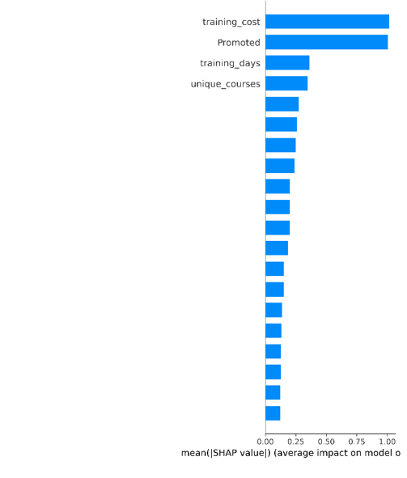 | 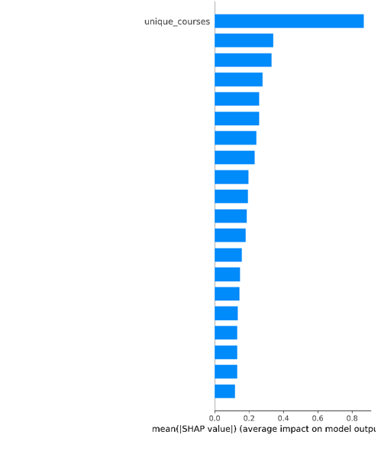
Logisitc Regression Bee swarm Attrition | Logisitc Regression Bee swarm Promotion
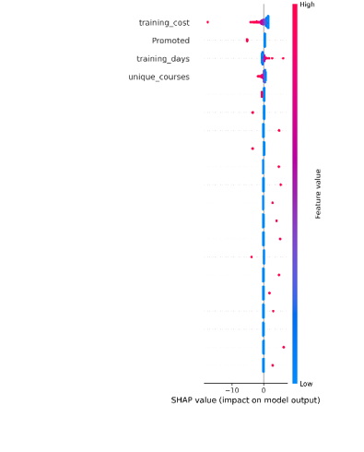 | 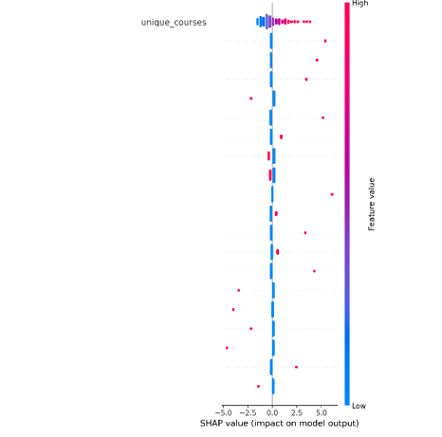
Random Forest
Bar Chart Attrition | Bar Chart Promotion
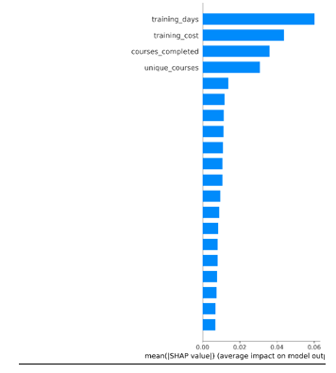 | 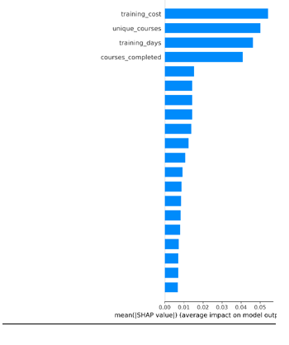
Bee Swarm Attrition | Bee Swarm Promotion
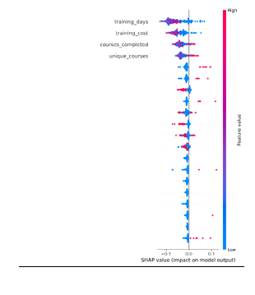 | 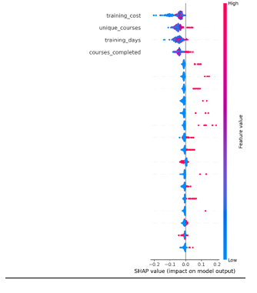

Gradient Boosting
Bar Chart Attrition | Bar Chart Promotion
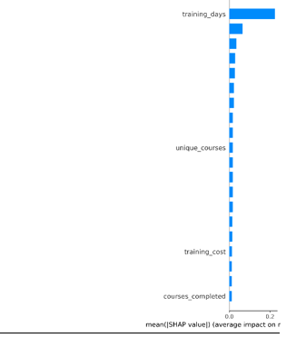 | 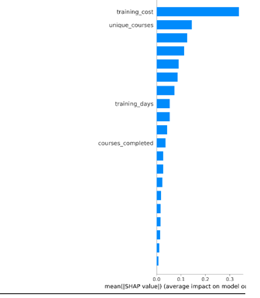
Bar Swarm Attrition | Bar Swarm Promotion
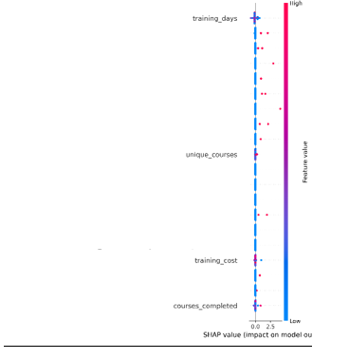 | 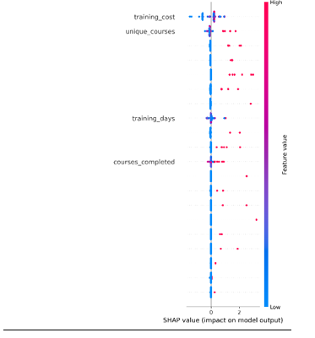

Conclusion, Recommendations and Reflections

The original aims and objectives of this project have all been met. The literature review showed the current research gaps and opportunities as well as supporting machine learning with theoretical models. A machine learning pipeline was created in Python that used real world data to evaluate attrition and promotion. It used 3 algorithms and compared them and also applied explainable AI in the form of SHAP which was also successfully applied to all 3 algorithms and recommendations from all of these results can now be generated. This study has shown that machine learning models can effectively predict the impact of learning and development activities on both attrition and promotion. The evaluation of the results have shown that there is a consistently clear relationship between staff being retained within the organisation or securing promotion regardless of the machine learning algorithm applied. Promotion was consistently easier for the models to be able to make more and accurate predictions which does suggest that training has a stronger and perhaps more linear relationship with promotion outcomes. Attrition is still predictable though the scores across the accuracy, precision, recall, F1 and ROC-AUC are all lower, which suggests that the relationship between training features and attrition may be more complex, and are in the least more difficult for the models to be able to make predictions.
SHAP was used to improve the interpretation of outputs from the machine learning algorithms and whilst the bar charts produced largely confirmed what the other evaluation metrics had output, the beeswarm charts allows much more insight on an individual staff member and has provided advancements in explaining how the models came to the conclusions that they did. Overall, the models did support both the Human Capital Theory and Social Exchange Theory that were identified within the literature review in that staff that have received more investment are less likely to leave the organisation.
Overall I have learned a lot from this study and it has confirmed statistically the link between learning and development and attrition and promotion. I learned about SHAP and explainable AI and even though this did shed a light on what was going on in within the machine learning models it wasn’t as illuminating as I had hoped in the beginning and so one area that could be expanded in future is looking more into the capabilities of SHAP and LIME which wasn’t explored as part of this study. If this study was to be performed again there are some key considerations that could further this study. The first is the scope of the features that were included, I would recommend including time served in the organisation, time served in role, home post code at the very least as in the IBM studies in the literature review these features dominated for attrition and although these wouldn’t diminish the link between training and both attrition and promotion it would enable a more holistic view of why and how people leave and get promoted. A further recommendation would be to develop a tool that would risk each of the individual employees based on their risk of attrition, this would turn the algorithmic outputs into a tool that could help mitigate or at least prepare for people that may leave. Another recommendation would be that the duration of the data was 3 years, expanding this to a greater amount of time would also help give a better understanding of the features and their importance and perhaps trying out some more models beyond the three used and changing the threshold for making predictions would also perhaps be something that could be done to further enhance the study through further experimentation.
I have learned a lot throughout the duration of this study about Python and certainly it has increased my skills in this regard, especially around one hot-encoding and merging data sources something that I have previously used within power query but now I think this skill I can utilise to do some more of my data analysis in python as the techniques I learned would be a lot more efficient than what I was doing previously. I also have a better understanding of the impact of what learning and development means to the outlook for people and although initially I was very sceptical of the Human Capital Theory the data is clear and consistent and this is a positive reflection on hard work of many individuals. I think now that I have learned some lessons, doing more of the cleaning within Python would have been a more positive as then I could have taken the code and used it with the data as it exists, but by doing so much of the pre-processing in Excel first this means that this element is still re-usable but more time consuming that it should have been. I would also not have done the bar charts as for SHAP as they added little and I think exploring other opportunities within XAI would perhaps have been something that I could look into a learn from in the future. Overall though this was a study I enjoyed immensely and hope to continue.

References

[1] | A. Cavescu, “A general investifation of attrition and retention factors in organisations:,” Springer Nature, vol. 5, no. 3, p. 99, 2025.
[2] | P. Rikela, “Broad context of skill gaps in modern digital workforce,” Elsevier, vol. 197, 2024.
[3] | I. H. Kose and A. E. Sahin, “Integrating machine learning and explainable AI for employee attrition prediction in HR analytics,” Scientific Reports, vol. 16, no. 1, 2026.
[4] | M. T. Abelwahed and S. A. Hussein, “Predicting Employee Attrition: A Comparative analysis of Machine Learning Models using the IBM human resource analytics datasets,” Procedia Computer Science, vol. 258, pp. 4048-4093, 2025.
[5] | S. Tufail, H. Riggs, M. Tariq and A. I. Sarwat, “Advancements and Challanges in Machine Learning: A Comprehensive Review of Models, Libraries, Applications and Algorithms,” Electronics, vol. 12, no. 8, p. 1789, 2023.
[6] | J. Miller, “Explanation in Artificial Intelligence: Insights from the Social Sciences,” Journal of artificial intelligence research, vol. 78, pp. 217-265, 2023.
[7] | M. Aldossari and M. F. Almutairi, “Ethical AI in the workplace: ensuring fairness and transparancy,” AI and Ethics, vol. 5, no. 3, pp. 619-635, 2025.
[8] | I. T. Basar and B. T. Tilmaz, “Predicting Employee Attrition: XAI‐Powered Models for Managerial Decision-Making,” Systems, vol. 13, no. 7, p. 583, 2025.
[9] | A. Johannsen and N. Chukhrova, “The crucial role of explainable artificial intelligence (XAI) in improving health care management,” Health Care Management Science, vol. 28, pp. 565-570, 2025.
[10] | Z. Ahmad and F. Lim, “Human resource analytics adoption and its impact on talent management outcomes,” Journal of Management & Organization, vol. 32, pp. 78-94, 2026.
[11] | S. W. Woon, “People Analytics and Human Resource Development,” Human Resources Development Quarterley, vol. 35, no. 2, pp. 120-142, 2024.
[12] | G. S. Becker, Human Capital, Chicago: University of Chicago, 1993.
[13] | Y. Qamar and T. A. Samad, “Human resource analytics: A review and bibliometric analysis,” Personnel Review, vol. 50, no. 1, pp. 251-283, 2021.
[14] | P. M. Blau, Exchange and Power in Social Life, New York: Wiley, 1964.
[15] | B. Keary and K. A. Perry, “Possibility theory quantification in human capital management: A Scientific machien learning perspective,” 2023.
[16] | M. De Vos and B. M. Van, “Contemporary CAreers: Boundyless and protean perspectives,” Journal of Vocational Behaviour, vol. 126, 2022.
[17] | J. W. Smither, M. London and R. R. Reilly, “Does Performance improve following multisource feedback?,” Personnel Psychology, 2023.
[18] | M. Al-Ali and e. al, “Integrating machine learning and explainable AI for employee attrition prediction in HR analytics,” Scientific Reports, 2026.
[19] | S. B. Kotsiantis, D. Kanellopoulos and P. E. Pintelas, “Handling imbalanced datasets: A Review,” Applied Sciences, vol. 5, no. 13, pp. 1-22, 2023.
[20] | M. Madanchian, “Artificial intelligence and human resource management: Applications and future trends,” Applied Sciences, vol. 24, no. 14, 2024.
[21] | A. Margherita, “Human resource analytics: A systematization of research topics and directions for future research,” Human Resource Management Review, vol. 32, no. 2, 2022.
[22] | M. Edwards, K. Edwards and D. Jang, Predictive HR Analytics: Mastering the HR Metric, London: Kogan Page, 2024.
[23] | A. Geron, Hands on machine learning with sciklit-learn and tensorflow, California: O'Reilly, 2022.
[24] | F. J. Han and H. Liu, “Challanges of big data analysis,” National Science Review, vol. 11, no. 1, 2024.
[25] | N. Berente and K. Lyytinen, “Managing AI,” MIS Quartetly, vol. 45, no. 3, pp. 1433-1440, 2023.
[26] | J. H. Freidman, “Greedy function approximation: A gradient boosting machine,” Annals of Statistics, 2022.
[27] | S. K. Dhaliwal and A. Benyoucef, “Data Analytics in HR: A review of predictive modelling approaches,” Expert Systems with Applications, 2023.
[28] | T. Fawcett and F. Provost, Data Science for business: What you need to know about data mining and data-analytic thinking, O'Reilly Media, 2023.
[29] | E. Brynjolfsson and A. McAfee, “The business of artifical intelligence: Practical implications for HR and management,” Harvard Business Review, 2022.
[30] | G. Haixiang, L. Yijing, G. Mingyun and H. Yuanyue, “Learning from class-imbalance data: Review of methods and applications,” Expert Systems and Applications, vol. 73, pp. 220-240, 2022.
[31] | S. Barocas and M. Hardt, Fairness and Machine learing: Limitations and Opportunities, USA: MIT Press, 2023.
[32] | M. e. al, “A survey on bias and fairness in machine learning,” ACM Computing Surveys, vol. 54, no. 6, 2022.
[33] | A. Caton and C. Haas, “Fairness in Machine Learning: A survey of definitions and evaluation Metrics,” IEEE Access, vol. 10, p. 102456, 2022.
[34] | F. Doshi-Velez and B. Kim, “Towards a rigorous science of interpretable machine learning,” Communications of the ACM, vol. 66, no. 1, pp. 54-64, 2023.
[35] | D. M, “Accountability in algorithmic decision making,” Communications of the ACM, vol. 8, no. 65, pp. 56-62, 2022.
[36] | European Commision, “Ethics guidelines for trustworthy AI: 2022 update,” Brussels, 2022.
[37] | S. M. Lundberg and e. al, “From local explanations to global understanding with explainable AI for trees,” Nature Machine Intelligence, vol. 5, pp. 479-500, 2023.
[38] | M. T. Ribierio, S. Singh and C. Guestrin, “Anchors: High Precision model agnostic explanations,” in Conference on Artificial Intelligence, 2022.
[39] | I. Pessach and E. Shmueli, “Algorithmic fairness in hiring: Evaluating fairness in machine learning models for HR,” Informaiton systems frontiers, vol. 25, pp. 123-150, 2023.

