Students Name: Nwakaego peace Elumese
Students number:2114106
Module BMSW4003
Lecturer Name: MR Amitave

Table of contents

Introduction………………………,,.,……………………………………………………………….1
Study objective…………………………………………,..,. ………………………………. 2
Aims of the study…………………………………………………………………………. ……….2
Review of the literature…………………………………………………………………………..2
Students effective VLE………………..,,,………………………………………………………..3
Data gathering Techniques ………………………………………………………..4
Qualitative ……………………………………………………………………………………….4
Examining and talking………………………………………………………………………..5
PLEASE RESPOND TO THE FOLLOWING INQUIRIES:………………………………………………………….5
data analysis of secondary sources…………………………………………………………..8
Conclusions……………………………………………………………………,…,,,. ………………..9
Reference………………………………………………………………………………………………10

Introduction

The learning environment, or VLE was developed so that students might l earn activity rather than passively.
It is becoming more and more important for students' personal growth and the development of their critical thinking skills (Aleven, v., E.stahl, S (el) al.2003
Such interactive teaching methods encourage students to think critically and ask questions, which are crucial for applying what they learn in class.
Critical thinking is a skill that students will learn in the classroom and acquire throughout their life (Abd Ghani, 2018).
The impact of the virtual learning environment (VLE) on students is the main topic of this study.

Study objective
The goal of this study is to investigate the effects of the virtual learning environment (VLE) on all students in the United Kingdom.

aims of the study

• To enhance students' digital literacy abilities in relation to the workplace, which is based on a virtual learning environment.

• To raise awareness of the significance of this examination of the virtual learning environment.

• To enhance the learning environment for all students at the University of Wales Trinity Saint David London Campus.

The primary problem facing students nowadays is the shift in learning culture
The installation of new and advanced technologies within institutions and the use of well-trained teachers are to blame for this transformation.
All of the students now have access to a wealth of online resources as a result of this.
That is why they don't conduct such study in their area of expertise (Ward, and Abubacker, 2018).

Review of the literature

the elements of a virtual learning environment that are relevant to students' course syllabi.
On the information about the course pertaining to the credits, requirements, registration, and payment of the physical session and not information pertaining to the contact for the teacher (Pirnau, et al, 2020).
A complete course of distant learning apps makes up the essential content of the virtual learning environment.
This typically comprises all the materials, such as copies of the lectures in systems of text, video, or audio presentations, and visual presentations for the assistance (Al-Azawei, and Al-Masoudy, 2020).

Students Effects of VLE

Self-assessment and quizzes are likewise regarded as analogue devices that are typically graded automatically (Do Carmo, et all, 2020).

One of the most important issues in the education sector right now is the virtual learning environment (Al-Azawei, and Al-Masoudy, 2020).
When it comes to lecturers, a student's experience with all the different learning styles in the classroom depends entirely on how effectively they are able to learn from them.
The type of instruction in a virtual learning environment suited each student's learning preferences.
Institutions of very high learning are becoming more and more disjointed and lacking in cohesiveness (Majid, and Hasim, 2019).
The student's interest in the subject matter and their contentment with their learning progress appeared to have increased dramatically in a virtual learning environment (Jones, et al, 2018).
The favourable effects of the learning environment have been minimised.
The introduction of the VLE also aimed to encourage students accommodation and reflection on their learning capacities.
But the virtual learning environment also helps all students gain confidence when using their knowledge and technological skills (Singh, et al, 2019).
Additionally, it improves the ability for pupils to research deeper on the pertinent subject to deepen their grasp.
(Ward, Abubacker, and Ward, 2018).

Students' pleasure, engagement, and memory appeared to improve dramatically with virtual learning.
The classes attracted a total of 40 students.
Although the VLE-taught student group outperformed the didactic group in terms of mean retention scores, this difference was not statistically significant.
Ryan Eimear and others
J. Medical Imagining

Data gathering Techniques

To find solutions to the research problem, test the hypothesis (if you're using a deductive approach), and assess the results, data collection is the act of gathering information from all relevant sources.
Secondary and main methods of data collecting can be used to categorise various data collection techniques.

When the researcher wants to quantify the data in order to respond to "what," "how many," and "how often" questions, quantitative data is frequently used.
This kind of information is usually used for final statistical analysis, math computations, and scientific findings comparison.

Qualitative

Qualitative data is information that cannot be quantified, counted, or simply stated in terms of numbers.
Tools for data visualisation can be used to gather it from text, audio, and visual sources and disseminate it.
It contrasts the "whole picture" of the data gathered, giving researchers a more detailed perspective into the data they have investigated or acquired, while also informing us of the causes and explanations of the relationships between variables—something that quantitative data is unable to provide.

The data collection technique involved a large number of respondents, which helped to determine the sample size.
According to fifteen students at the University of Wales Trinity Saint David London Campus.
Any bias in perceptions and statements is thought to be eliminated by the sample non-probability procedures.
This. The execution and examination of research connected to VLE is made possible is they people engagement in voluntary and virtual environments.
The findings of the educational research related VLE show that students' participation in research
This study discusses traditional as well as ethical issues related to virtual world educational research.
It also explores how technology developments have brought forth new ethical conundrums with the preservation of privacy, informed consent, and determining the most recent efficacy of a certain topic.

Examining and talking

Survey created for the primary analysis

Moodle's resources, in your opinion, are valuable.

he impact of virtual Learning Environment {VLE} Moodle on students learning experience at the University of Wales Trinity Saint David London Campus.

This poll is being done as part of a Digital skills and study Methods research project {BMSW 4003}

Group: BMSW 4003 Digital skills and research methods [SFTW} Module Name: Digital skills and Research methods {SFTW}

PLEASE RESPOND TO THE FOLLOWING INQUIRIES:

Question 1: Do you get any advice about how to make use of Moodle?
1 YES
2 NO
Question 2 on a scale of 1 to 10 how effective is the Moodle App 1 2 3 4 5 6 7 8 9 10
Question 3: has Moodle helped you learn more effectively?
Yes
No
Question 4: do you have a good understanding of Moodle?
On a scale of 1 to 4, how would you rate yourself?
1, 2, 3, and 4
Question 5: can you tell how much time are you spending on Moodle in a day?
30 minutes
45 minutes
1 hour
2 hours
0 minutes
Question 6: Can you mark what age groups are you?
18 to 25?
25 to 35?
35 to 50?
50 to 65?
Question 7: Can you mark a tick on your gender?
Female
Male
Others
Question 8: can you tick on your educational level?
Level 4
Level 5
Level 6
Level 7
Tabulation of Data in Likert Scale
1.Do you get Advice about how to use the moodle?
Yes score are 5
No score are 0
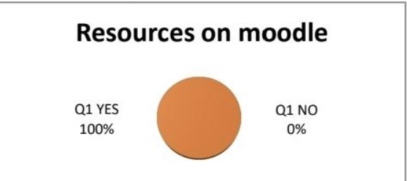
How effective is the moodle?

Yes 10 score are 100%
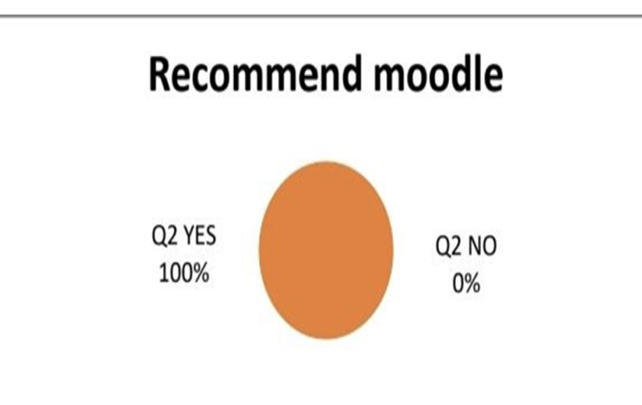
No score are 0%
has Moodle helped you learn more effectively?
Yes score 100%
No 0%
Q3 yes 100%

No 0%

do you have a good understanding of Moodle? Scale 1-4
Yes 75%
No 25%

can you tell how much time are you spending on Moodle in a day?
45 Minutes to 1 hours 60%
30 minutes 20%
2 hours 20%

Can you mark what age groups are you?
28-35 80%
18-25 10%
35-50 10%

In order to make primary data available to other researchers and secondary data ports sources from other sources that have already been prepared.

data analysis of secondary sources.

When conducting research, secondary data is neither accurate nor available.
Secondary data also provide a variety of alternatives (which save you money and time as then primary data).
It is accompanied by some issues.
however it is still extremely helpfully assessed.
Secondary data Discussion.

These findings, which have been discussed from the analysis, have also been supported by Maiti and Kayal (2017), who state that students today are well aware of the digitalization helping the employee to reach their personal best while also climbing the ladder of success due to the increase in the use of mobile devices.
The purpose of the study was to understand the final-year students' worries about balancing their employability with retaining professional work ethics.

Limitation.

Some of the students who were asked questions during the main data collection process might have given responses based on their current module rather than their overall experience.

Conclusions
The majority of students in their final year believe they don't have the necessary digital abilities, which may limit their options for employment while also lowering their level of productivity and efficiency at work.
When one or both of these work together as a team, productivity will rise and the employability factor as a whole will benefit.
Understanding of digital marketing is one of the many reasons why this has happened.

Reference
Aleven, V. E. Stahl, S. (el) al 2003 Learning environments review of educational research available online at https://www.tandfonline.com
Access 18/09/2022

Impact of implementing a( VLE) in the classroom .Mosquera,,L. H. 2017. Available online at https://www.Tandfonline.com
Access 10/09/2022

Virtual learning environment By A Melissa Ng less yen 2020
Available online at https://www.scholar.Google.com
Access 12/09/2022

C. Pirnau, et , al (05/07/2022 Development of a virtual learning environment available online https://www.researchgate.net

