

THE IMPACT AND VIGILANCE

HTTPS AND TRANSPORT LAYER SECURITY HAS ON

MAN-IN-THE-MIDDLE ATTACKS:

CAN WE BE COMPLACENT?

By
Betty Julie Millard
Supervisor: Associate Professor Carlene Campbell
Second Marker: Nitheesh Kaliyamurthy

Project submitted as part of the requirements for the award of
MSc Computer Networks and Cyber Security

November 2021
Declaration of Originality
I, Betty Julie Millard declare that I am the sole author of this Project; that all references cited have been consulted; that I have conducted all work of which this is a record, and that the finished work lies within the prescribed word limits.
This work has not previously been accepted as part of any other degree submission.

Signed : ....... .........
Date: ...November 11th 2021............
FORM OF CONSENT

I, Betty Julie Millard hereby consent that my Project, submitted in candidature for the M.Sc. Computer Networks and Cyber Security, if successful, may be made available for inter-library loan or photocopying (subject to the law of copyright), and that the title and abstract may be made available to outside organisations.
Signed : ....... ..........

Date: ...November 11th 2021.............
Copyright Acknowledgement

I acknowledge that the copyright of this project report, and any product developed as part of the project, belong to University of Wales Trinity Saint David, Swansea.

Abstract
Keeping personal and private information confidential when using the internet has become and increasing problem for everyday users and cyber security experts alike. There has been an increase in people that use the internet for everyday things like banking, shopping, and more recently, working from home, and with that increase, the threat to security has also intensified.
HTTPS and TLS use encryption, authentication, and integrity along with public and private keys to protect private and confidential information from being harvested by nefarious people.
This project, the impact and vigilance HTTPS and transport Layer security has on Man-in-the-Middle attacks: Can we be complacent? Concentrated on performing Man-in-the-Middle attacks to gain private and confidential information that was protected by the HTTPS and transport layer security Uniform Resource Locater lock, with the use of virtual machines, Kali-Linux, and readily available open-sourced tools.
Using a virtual network to execute attacks that would allow the author access to the private and confidential information from a victim’s Windows based laptop.
An attack against the Wi-fi was executed. Using Wifite and Hashcat resulted in the default numerical password of a WPA2 access point being revealed.
An Address Resolution Protocol poisoning attack was accomplished, with the use of a sniffing and spoofing program called Ettercap. This resulted in the Media Access Control addressing table being compromised, altering the address which in turn allowed the Kali-Linux machine access to all information flowing to and from the victim’s machine.
A Man-in-the Middle attack in conjunction with a phishing attack, led the victim to a cloned website where private and confidential information was input. This resulted in the information being harvested.
There was enough evidence to conclude we cannot become complacent regardless of the security of HTTPS and transport layer security.

Contents
List of Figures 9
List of Tables 11
Chapter 1 Introduction 12
1.1 Introduction 12
1.2 Aim 14
1.3 Objectives 14
1.4 Project Structure 15
1.4.1 Chapter One 15
1.4.2 Chapter Two 15
1.4.3 Chapter Three 15
1.4.4 Chapter Four 16
1.4.5 Chapter Five 16
1.4.6 Chapter Six 16
1.4.7 Chapter Seven 16
1.5 Summary 16
Chapter 2 Research and Literature Review 17
2.1 Introduction 17
2.2 Wi-Fi Eavesdropping 17
2.3 Address Resolution Protocol Spoofing 17
2.4 Secure Socket Layer Stripping 18
2.5 Email Hijacking 18
2.6 Website Cloning 19
2.7 Proxy 19
2.8 MitM Proxy 19
2.9 Email Conversation Thread Hijacking 20
2.10 ICMP Redirect 20
2.11 Domain Name System Poisoning 21
2.12 Cookie Hijacking 21
2.13 IP Spoofing 22
2.14 Ettercap 22
2.15 Bettercap 23
2.16 Netsniff-ng Toolkit 24
2.17 Wireshark 24
2.18 Hashcat 24
2.19 Macchanger 25
2.20 Aircrack-ng 25
2.21 Wifite 25
2.22 Social Engineering Toolkit 25
2.23 Spear-Phishing 25
2.24 Related Work 26
2.25 Summary 28
Chapter 3 Research Methodology 29
3.1 Introduction 29
3.2 Research Overview 29
3.3 Research Philosophy 30
3.4 Research Approach 31
3.5 Methodological Choice 31
3.6 Strategies 31
3.7 Time Horizon 31
3.8 Data Collection and Analysis Methods 32
3.9 Risk Assessment 32
3.10 Resources and Planning 33
3.11 Design 33
3.12 Contingency Plan 33
3.13 Ethics Form 33
3.14 Summary 33
Chapter 4 Design & Implementation 35
4.1 Introduction 35
4.2 Problem Formation 35
4.3 Design 35
4.4 Implementation 36
4.5 Virtual Network 1 36
4.6 Virtual Network 2 37
4.7 Kali-Linux Virtual Machine 37
4.8 Wi-Fi Attack Set-Up 38
4.9 Summary 38
Chapter 5 Experiment and Results Discussions 39
5.1 Introduction 39
5.2 Attacking the Wi-Fi 39
5.3 ARP Poisoning 48
5.3.1 Kali-Linux – Attackers Machine 49
5.3.2 Windows 10 Machine 58
5.3.3 Kali-Linux Machine Output 64
5.4 Social Engineering Toolkit (SET) 65
5.4.1 Kali-Linux Machine 66
5.4.2 Windows Machine 69
5.4.3 Kali-Linux 77
5.4.4 Results Discussions 78
5.4.5 Summary 79
Chapter 6 Conclusion & Recommendations 80
6.1 Conclusion 80
6.2 Recommendations for Further Research 82
Chapter 7 Reflections 82
7.1 Reflections Overview 82
7.2 Positives 82
7.3 Negatives 82
7.4 Summary 82
References 83
Appendix 1 89

List of Figures
Figure 1: HTTP versus HTTPS [8] 13
Figure 2: Typical Network Configuration [53] 26
Figure 3: The Research Onion [58] 29
Figure 4: Network Layout 36
Figure 5: WPA Network Types [63] 38
Figure 6: Wi-Fi and Wifite Commands [64] 40
Figure 7: Wifite Scanning Networks [64] 40
Figure 8: TP-Link Found and Attack Started [64] 41
Figure 9: Attacks Interrupted [64] 42
Figure 10: WPA Handshake Attack Using a Wordlist [64] 42
Figure 11: Wireless Password Numerical [64] 43
Figure 12: Password Not Found [64] 43
Figure 13: Dot Cap File Created [64] 44
Figure 14: Utilities Used and File Conversion [64] 44
Figure 15: File Being Copied [64] 45
Figure 16: Command Window Initiating Hashcat [64] 46
Figure 17: Name of Attack, Target, and Estimated Time [64] 46
Figure 18: Attack Completed and Time Taken [64] 47
Figure 19: Password Displayed [64] 47
Figure 20: Password Revealed in Windows Machine [64] 48
Figure 21: Oracle VirtualBox 6.1 49
Figure 22: IP and MAC Address for Kali-Linux 50
Figure 23: Options for Attack Types 51
Figure 24: Options for MitM Attacks 52
Figure 25: Authentication Required for Ettercap 53
Figure 26:Ettercap Home Page with Settings 54
Figure 27: Ettercap Running 54
Figure 28: Dropdown Menu for Host 55
Figure 29: Network Scanned for Hosts 56
Figure 30:MitM Attack Options 57
Figure 31: Further Options for Attack 57
Figure 32: Targets Attacked 58
Figure 33: IP Address and ARP Table 59
Figure 34: Windows 10 Running Wireshark in the Background 60
Figure 35: Ping Request 60
Figure 36: Wireshark Traffic 61
Figure 37: ARP Table After Attack 62
Figure 38: HTTP Test Site 63
Figure 39:Ettercap Capturing HTTP Information 64
Figure 40: PayPal E-mail [66] 65
Figure 41: SET Initial Menu 66
Figure 42:SET Website Attack Vectors 67
Figure 43: Credential Harvester Attack Method 67
Figure 44: Site Cloner 68
Figure 45: Coning PayPal Website 68
Figure 46: Information Collected 69
Figure 47: Cloned PayPal Site 70
Figure 48: PayPal Login Page 71
Figure 49: Bogus Facebook Security Alert [56] 72
Figure 50: Cloned Facebook Login Page 73
Figure 51: Genuine Facebook Account 74
Figure 52: Pin Security Page 75
Figure 53: Change Shipping Address 76
Figure 54: Payment Information Page 77
Figure 55: Facebook.com Site Cloned 77
Figure 56: Username and Password Captured 78

List of Tables
Table 1: ARP Table 59

Chapter 1 Introduction

1.1 Introduction
The internet has been around for many years, and each year the amount of people and businesses that access it are growing exponentially. In 1995 the International Data Corporation (IDC) reported the number of internet users was 16 million people, 0.4 per cent of the world population. [1]
Ten years later, the number was reported by Internet World Statistics to be at 1,018 million, 15.7 per cent of the population and in March of 2021, they reported the users to be 5,168 million, which relates to 65.6 per cent of the world population. [1]
With this acceleration in growth, the internet has evolved. New advancements in technological communication have culminated in data being more vulnerable to cyber-attacks and with more devices being used daily for both business and personal applications it is no revelation that cyber-attacks and security threats have increased.
Bring your own technology (BYOT), which is a concept where businesses allow employees to use their own devices to connect to the company network, has enabled more individuals to work from home enriching life quality for many people worldwide.
Many businesses now employ electronic mail (e-mail) for communication both internally and externally. The internet of things (IOT) connects devices to the internet, and with each connection there is an opportunity for a security breach. So, it is no surprise that with over 4 billion connections daily, cyber-attacks are on the increase.
There are many types of attacks, ransomware, trojans, worms even APTs (advanced persistent threats). These are often reported in the news, and yet Man-in-the-Middle (MitM, MITM, MiM, MIM, MITMA) attacks, which according to the UK editor of CSO, Dan Swinhoe, are often overlooked and are
one of the oldest forms of cyber-attack. [2]
These MitM attacks are performed by unauthorised individuals who intercept the flow of data between two parties. Once this has been attained the individual or individuals, referred to as an attacker or attackers, are then able to capture, alter, and even redirect the information without the victims knowledge. [3]
With cyber threats being so prevalent, [4] the use of Hyper Text Transfer Protocol Secure (HTTPS), and Transport Layer Security (TLS) has been adopted as the
de facto standard for secure Web browsing. [5]
HTTPS is a secure version of HTTP and uses TLS protocols to ensure encryption, authentication, and integrity to protect users from cyber-attacks when traversing the internet, using both public and private keys. [6]
Fig 1 shows how the same data looks after being sent over HTTP and HTTPS. [7]
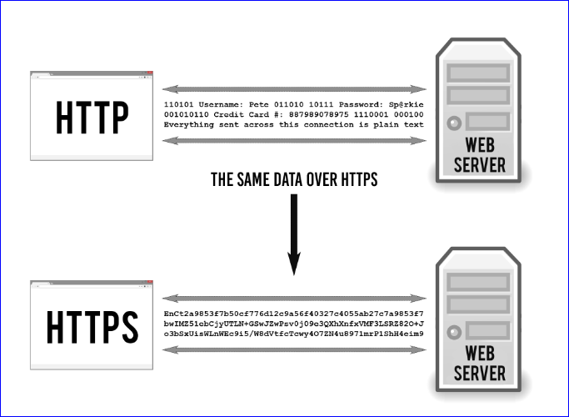the
Figure 1: HTTP versus HTTPS [8]

1.2 Aim
The project aim is to utilise virtual machines to identify whether networks are still susceptible to Man-in-the-Middle attacks and, despite the HTTPS and Transport Layer Security, can private and confidential information be harvested. This will aid organisations, cyber security analysts and the public to understand the necessity for additional security measures against MitM attacks and will be achieved by simulating MitM attacks using readily available penetration testing equipment, practices, and procedures.

1.3 Objectives
The following objectives have been identified as being crucial to achieving the project aim:
- MitM attacks: Research in this area is fundamental to comprehending how the various attacks are executed. By scrutinising and evaluating the research data, the project’s success will be augmented.
- MitM techniques and tools: There are numerous approaches to MitM attacks and various devices available to conduct them. Therefore, to discover the most efficient approach for penetration testing MitM attacks researching the necessary penetration testing techniques and tools used is essential.
- Bring Your Own Technology (BYOT) [9]: This objective is explored owing to more employees working from home due to the Covid pandemic, and as no matter how strong security is, human beings make mistakes. This human aspect has been described by Kevin Mitnick, to be the weakest link. [10] Mitnick is said to be the world's number one hacker by Kaspersky. [11]
- Construct MitM attack experiments in conjunction with other social engineering attacks, to explore vulnerabilities on existing technology: Utilize various penetration testing equipment to realise the project’s aim.
- Execute experiments and evaluate the results: The aim of the project will be determined by analysing the attacks.

1.4 Project Structure
The structure of this report consists of a literature review which includes related works and encompasses various MitM attacks, how they are executed, and how they manipulate the security afforded by HTTPS and TLS to harvest personal and sensitive information. It also covers various readily available tools that can be and were used to carry out these attacks.
The design and implementation section showcases the layout of the network and encompasses how the MitM experiments were conducted. The results of these experiments will then be analysed, which will provide the necessary information for the author to conclude the outcome of the project.

1.4.1 Chapter One
Chapter one consists of an introduction to Man-in-the-Middle attacks, what they are, how they are executed and why they are so dangerous. It also contains the aim of the project and the objectives carried out by the author to successfully meet the project’s aim.

1.4.2 Chapter Two
Chapter two contains various perspectives of Man-in-the Middle attacks, to ascertain diverse viewpoints on how Man-in-the-Middle attacks occur and portray various techniques recommended to minimise such attacks.

1.4.3 Chapter Three
Chapter three allows the author to outline the research methodology that was used for this project. It consists of an overview of the research, the philosophy used, the research approach and methodological choice that was determined. It covers the strategies that were utilised, the time horizon, data collection and analysis method. It covers the risk assessment that was considered, the resources and planning, and the experiment design. This chapter also includes the contingency plan that was considered for this project.

1.4.4 Chapter Four
Chapter four provides the documentation and implementation of the design process that was employed to ensure the completion of the project. It contains the network design, the devices utilised and the execution of the experiment.

1.4.5 Chapter Five
Chapter five allows the author to document the experiments conducted and discuss the results.

1.4.6 Chapter Six
Chapter six contains the conclusion of the project and recommendations for future work.

1.4.7 Chapter Seven
Chapter seven allows the author to reflect on the project’s success or failure, and what the author has learned.

1.5 Summary
In conclusion of chapter one, the project’s aim, and objectives, along with who could benefit from the project were introduced. This was divided into individual segments to elucidate the distinct structure of the project.

Chapter 2 Research and Literature Review

2.1 Introduction
Chapter two documents research into MitM attacks, how they are performed and what they can achieve. It also touches upon HTTPS and TLS, and how these protocols protect data with the use of encryption. SSL stripping was also researched along with numerous open-source attacks that are readily available to use. Attacks against Access Points (AP) was also investigated.
This chapter also details related works that the author found paramount and both aided and guided the author in the completion of the project aim.

2.2 Wi-Fi Eavesdropping
Wi-Fi eavesdropping, otherwise known as the ‘evil twin’ attack, is attained by an attacker imitating a legitimate AP. By using the same Service Set Identifier (SSID), the name of the wireless network, and the MAC address (Basic service set identifiers (BSSID)) of the legitimate AP, an attacker allows, or forces a user to join the unsecured network. This can be performed in an attack against a private network, or in public places such as airports, or anywhere free Wi-Fi is advertised. Once the user has joined the network, the attacker is able to perform MitM attacks. [12], [13]

2.3 Address Resolution Protocol Spoofing
Address Resolution Protocol (ARP) was created to work on an internetwork. It is outlined in Request for Comments (RFC) 826 of the Internet Engineering Task Force (IETF), which delineates research, behaviours, methods and the applicable advances to the internet and systems that are interconnected. [14]
Internet Protocol (IP) network addresses are given a Media Access Control (MAC) address, which is stored in an ARP table. When datagrams are sent from one device to another, the ARP cache is first inspected for a MAC address. This address has an equivalent IP address which is used for the destination address. If there is no MAC address in the table, then a broadcast message is sent from the source device to all devices on the network. These devices then check their IP address to see if there is a match. The device with the matching IP address sends a response containing their MAC address (excluding “proxy ARP”) back to the source device which then adds this MAC address to the ARP table. [15]
ARP Spoofing, also known as ARP Poisoning, is a MitM attack that works by firstly scanning a network for devices with known IP addresses then with the use of a spoofing tool, bogus ARP responses are sent to the devices informing them of a new MAC address. As ARP does not confirm where the replies come from, this address is then updated in the ARP cache as being legitimate. However, the address belongs to the attacker. Subsequently any communications made between the devices is now being intercepted by the attacker, the man-in-the-middle. At this point, the attacker can choose to observe the information being sent and forward it to the destination, or alter the information and send the altered information to the destination. [16]

2.4 Secure Socket Layer Stripping
SSL (Secure Socket Layer) provides encryption, authentication and data integrity for financial undertakings, communications, and transactions with the use of a certificate. The certificate is issued by a Certificate Authority (CA). [17]
SSL stripping, or SSL Downgrade Attack is a technique that allows a secure HTTPS connection to be downgraded to an HTTP non-secure connection. It uses a tool that masks the connection to an entity that has a bogus certificate, or a certificate that has expired. Users do not see any alerts or observe the absence of the lock icon from the Uniform Resource Locator (URL) bar. The SSL strip tool then redirects the secured information to the attacker’s machine and removes the SSL enabled features. This allows the attacker to view the data being transmitted in plain text, revealing personal or sensitive information. [16], [18]

2.5 Email Hijacking
Email hijacking is another form of man-in-the-middle attack, in which the hacker compromises and gains access to a target's email account. This is achieved by tricking the victim into opening mail that contain malicious malware or getting the victim to click on a link provided in the email. The link would look legitimate, such as an invoice, or even mimic an address of a well-known associate of the victim. Once the email has been opened, or the link clicked, the attacker, depending on what attack was being used, will have achieved the desired goal. Any information retrieved can then be used for malicious purposes. [19], [20]
The experiment set out in (4.7.1) illustrates how this attack can be performed and some of the information that can be obtained from it.

2.6 Website Cloning
Website cloning is the unlawful duplication of a website created for the intention of deceiving users into revealing private and secret information. Many websites can be copied, with the cloned site looking identical to the original site except for the information in the URL or the web address. Website cloning was successful on a government website and was only noticeable in the URL which read mygovau.net. instead of my.gov.au. [21]–[23]

2.7 Proxy
A Proxy is a way of hiding your IP address when traversing the internet, making web browsing anonymous while giving an elevated degree of privacy. It is useful when encountering web pages with content restrictions. Proxies act as gateways and utilise IP masking to enable them to locate and access content that would otherwise be prohibited. Proxies also allows users access to websites that have been restricted by monitoring rules of a company, allowing them access to otherwise banned content.

2.8 MitM Proxy
A software system that runs on computers and hardware acting as the go-between connecting the server and end-user is known as a proxy server. It operates on items such as base servers, mobiles and computers and connects to the internet for resources such as videos, web pages and files. To achieve this, a client/user requests data, or a web page. This page is stored on the internet/base server. Once the internet server receives the requests, a response is provided to the client/user, that includes the server’s destination address.
To perform a MitM Proxy Attack, a proxy server is inserted between the base server and the client/user. Once this has been achieved, the information sent from the client/user is intercepted and decoded in one SSL session. The information is then sent to the base server in a separate SSL session. The reply to the client/user is then received via the proxy server and includes a reply advising the client/user that the digital certificate being used is invalid. This information is modified before being forwarded to the client. The use of two individual SSL sessions is required for this attack.

2.9 Email Conversation Thread Hijacking
As more people are becoming aware of email hijacking, a different technique called email conversation thread hijacking has come into play. Also known as email thread hijacking or email reply chain attack, this technique, which was first detected in May of 2017, [24] exploits email conversations by replying to conversations in the victim’s mailbox and the attacker spreads to new victims. Old as well as current conversations are used, and as they are deemed trustworthy to the victim(s) the emails are therefore opened, or links clicked. Further to this attack becoming known, a threat actor called Emotet, adopted the attack and adapted it to include a module that steals the victim’s e-mails and login information and forwards them to Emotet’s Command-and-Control-Server (C2). This server then circulates the information to other victims that have previously been infected with a spam module, to be used in attacks against more victims. Furthermore, Emotet has added a module that also steals victim’s attachments. These are used to further legitimise the emails used by the attacker and to obscure any malicious attachments. [25]

2.10 ICMP Redirect
Internet Control Message Protocol (ICMP) RFC 792 is used to report errors back to the source. One of the errors is redirect. This is sent when a datagram is transmitted over a network but does not use the most efficient route. The message is used to update the routing table. [26]–[28]
ICMP redirect is used by attackers in MitM attacks by sending false ICMP redirect information to be added to the routing table. Once the information has been updated, the attacker has access to data being sent as it is being forwarded to them. [18], [29]

2.11 Domain Name System Poisoning
Domain Name System (DNS) was founded by Paul Mockapetris in the ‘80s, [30] and is used to translate human-readable names such as www.amazon.com or www.google.com into IP addresses such as 172.168.200.1 or 8.8.8.8.
DNS Poisoning is a method of falsifying information in a DNS server, for example instead of Google being translated as 8.8.8.8. the new information says it is to be translated to 172.168.22.2. Anyone who tries to get to Google through this DNS server will now be directed to somewhere of the attackers choosing. [20], [31], [32]

2.12 Cookie Hijacking
Cookie Hijacking, also known as Session Hijacking, Cookie Scraping, or Cookie Steal, is a MitM attack that occurs after a victim has logged into a particular service, such as online banking. It uses information called cookies, which is a small packet of data, temporarily stored on the user’s computer by the website the user is visiting. Some websites set-up temporary session cookies which indicate the user is logged in to a specific session. For Cookie Hijacking to be effective, the attacker must obtain either the session ID or key. If successful, the attacker can then take over the session as if he were the victim. [33] There are numerous ways to steal cookies to hijack a session. Among the most popular methods are Session Sniffing, which includes the use of a packet sniffer. A packet sniffer is software used to monitor traffic on a network. The sniffer is activated and looks for the information being sent over the network. This is most successful when only the login pages of a site use the SSL/TLS encryption. When used on open Wi-Fi networks where the user does not require authentication to connect to it, the packet sniffer monitors the traffic and is able to steal the cookies. [34]
Session Fixation is a malicious link sent via email to the victim. The link could advertise something new for the victim to use for example a new feature from his bank. Once the link is activated the attacker has access to the session ID and can take over the victim’s session.
Malware Attacks use programs to perform packet sniffing. The malware is introduced to the user’s computer by clicking on malicious links or by accessing unsecure websites. Once introduced, the malware searches for the session cookies and forwards them to the hacker.
Cross-site Scripting (XSS) is used to mislead the victim’s computer into handling the malicious code sent from the attacker, as if it came from a trusted source. Once the code is run, the attacker is able to access the Cookie information. [33], [35]

2.13 IP Spoofing
When data is transmitted over the internet, it is separated into packets. These packets are sent individually and are eventually reconstructed. Each packet must have an IP header which includes the source and destination of the packet.
IP Spoofing occurs when an attacker alters the IP address of their packet to mimic a legitimate network IP address and therefore appearing to be from a trusted source. Spoofing tools such as Aranea or Netcommander are just two tools that can be used to achieve this. [36]–[38]

2.14 Ettercap
Ettercap is a free to use open-source tool that was developed by Alberto Ornaghi and Marco Valleri (a.k.a ALoR and NaGa) to be used on a Local Area Network (LAN). [39] It is a pre-loaded program of Kali-Linux, and can also be used by Microsoft Windows, Solaris, Mac OS X, and other UNIX-like systems. It has a user-friendly graphical user interface (GUI) and contains many features.
Ettercap disables the kernel IP forwarding and initiates the forwarding process itself.
The ARP spoofing element is a Sniffing and Spoofing application that can be used either over ethernet or Wi-Fi. Ettercap monitors traffic on a network and has different modes of operation. The Unoffensive, Promiscuous and Set Netmask.
The Unoffensive mode is usually used on gateways as it only listens on a single network interface, this mode will allow the rerouted packets back through the gateway to be routed correctly.
Promiscuous mode is used to capture live traffic on the network, and the Set Netmask uses a specified netmask in place of the one connected to the current interface.
Ettercap allows interception of transmitted data over HTTP and gives clear text information.
Hyper Text Transfer Protocol Secure (HTTPS) support is used by being injected into an HTTP SSL session and will only work if the fictitious certificate is accepted by the victim. Character Injection allows insertion of haphazard characters into a live connection bi-directionally, mimicking commands from the client and responses from the server.
Point-to-Point Tunneling Protocol (PPTP) suite is initiated when MitM attacks are required for PPTP tunnels, and the Kill Connection tool allows the user to view and kill individual live connections on the victims computer. [40]
Packet filtering automatically filters all TCP and UDP packets during a live connection. It searches for random hexadecimal or ASCII strings, once found there is a choice of either substituting this string or allowing the filtered packet to be dropped. [28] Secure Shell 1 (SSH1) support allows the username and password, along with any data of the SSH1 connection to be captured in plain text.
The Active Dissector element is an automatic password collector (for the majority of the general network protocols) which identifies and withdraws applicable data from numerous protocols automatically. The protocols include SSH1, HTTP, Network News Transfer Protocol (NNTP), Telnet (TN), File Transfer Protocol (FTP), POP3 (Post Office Protocol 3), Simple Network Management Protocol (SNMP), Socket Secure 5 (SOCKS5), Network File System (NFS), Virtual Network Computing (VNC), Remote Login (Rlogin), I Seek You (ICQ), My Structured Query Language (MySQL), Server Message Block (SMB) , Lightweight Directory Access Protocol (LDAP), Border Gateway Protocol (BGP), Routing Information Protocol (RIP), X Window System (X11), Internet Relay Chat (IRC), Internet Mail Access Protocol version 4 (IMAP 4), and NAPSTER.

2.15 Bettercap
Bettercap is an updated version of Ettercap. It can be used on most operating systems and architectures including Docker containers. It has all the features of Ettercap plus the ability to perform SSL stripping.
There are three approaches to using Bettercap. The Web UI is the simplest approach and is useful for first time users. The interactive Mode allows the user to access the advanced features and uses the terminal interface for commands.

2.16 Netsniff-ng Toolkit
Netsniff-ng toolkit is a program specific to Linux. It is used to capture and replay netsniff.pcap files, has the ability to redirect traffic amongst interfaces. The toolkit can be utilised in network reconnaissance, debugging, auditing and as a network packet analyser. The .pcap files can be viewed for analysis using Wireshark. [41]

2.17 Wireshark
Wireshark is a free software program that is used to analyse networks. Created by Gerald Combs in 1998 it holds the GNU version 2 General Public License. [42] It can be used on many different platforms such as Linux, Windows, and OS X for example. The program captures live data and can be used to inspect the data while live or it can export the data to be analysed at a later time. Vivens Ndatinya et al described Wireshark as:
One of the best software tools to analyse network traffic. [43]
Wireshark uses network sniffing to capture usernames and passwords and can be used by network administrators to troubleshoot problems on a network along with the ability to analyse the security of the network. [44]

2.18 Hashcat
Hashcat is a password hacking tool that is open-source and can be used on multiple platforms. It is a tool that is used by penetration testers and works by running through a pre-defined list and checking the hash value of everything on the list against the hash value it is trying to crack. There are many lists available online and can be composed of dictionary attacks such as the rockyou.txt wordlist which house more than fourteen million passwords including alphanumeric and combination passwords that use special keys. [45] Hashcat, can be downloaded from https://hashcat.net/hashcat/ [46] or https://github.com/hashcat. [47]

2.19 Macchanger
Macchanger is a penetration testing tool available to use with Kali-Linux and is used to change a Media Access Control (MAC) address. MAC addresses are assigned by the manufacturer of a device and are, therefore, unique. If someone wants to gain access to a network and knows the MAC address of a device that is already allowed on the network, then an attacker can gain access with the use of this tool. [48]

2.20 Aircrack-ng
Aircrack-ng is a suite of tools that can be used with either Windows or Linux-based machines. It allows penetration testers to assess Wi-Fi security on networks [49] and captures data packets to enable the cracking program to recover the WAP2-PSK key.

2.21 Wifite
Wifite is a Linux based free auditing tool designed to use numerous techniques to attack multiple WPS, WEP and WPA networks simultaneously. It requires root privilege to run and is designed to use all known methods for retrieving passwords of a wireless AP. [50] Wifite can be downloaded from https://github.com/derv82/wifite.

2.22 Social Engineering Toolkit
Social Engineering Toolkit (SET) is an open-source penetration testing tool which was written by David Kennedy and is readily available pre-loaded on Kali-Linux. It can be used to attack websites, conduct spear-phishing attacks (2.23) and carry out spoofing attacks (2.13) among other uses. [51]
SET has been downloaded over two million times, and is used by penetration testers when testing against advanced technological social engineering attacks. [52]

2.23 Spear-Phishing
Spear-phishing uses electronic communication such as emails, and targets individuals, companies and/or employees of a company. The emails look genuine, follow the company layout, and have the company logo attached looking completely genuine, to entice the recipient or target, to open and reply or act upon the information contained in the email. The email could look like they were sent from companies such as PayPal and Facebook, or, in the case of an employee of a company, could look like the genuine company email.

2.24 Related Work
Reviewing numerous papers, journals, books, and countless online sources has provided a vast amount of insight and knowledge pertaining to how MitM attacks are executed. By focussing on how Wi-Fi attacks are performed, along with ARP poisoning, social engineering and web cloning, the information gathered allowed the author to expand upon their knowledge and execute the necessary MitM experiments.
“Man in the Middle Attack on HTTPS Protocol” by Dragoș GLĂVAN, Ciprian RĂCUCIU, Radu MOINESCU, and Sergiu EFTIMIE, [53] explores the concept of a MitM attack using ARP poisoning and Domain Name System (DNS) spoofing to obtain information that could be used for nefarious reasons.
The paper stated that HTTPs and TLS was widely believed to be secure due to the “lock” symbol that appears in the URL, and also stated how intercepting the data could be accomplished.
This was achieved by redirecting all traffic between the victim and an HTTPS server to the attacker. A DNS spoof was used to redirect all DNS requests sent from the victim and the HTTPS server to the attacker’s machine. The interception of the traffic was made between the end user (victim), and the victim’s home router. Outlined in Fig 2.
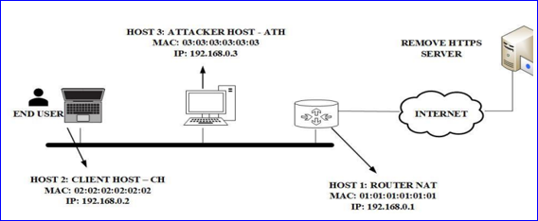
Figure 2: Typical Network Configuration [53]
The conclusion of the paper was to emphasise the ability to attack HTTPS connections which are thought of as being secure, by using LAN properties and exploiting them. This in conjunction with attacking users with little experience, was proved to be effective. The authors also stated that although attacking inexperienced users was possible, executing a MitM attack against an experienced user was achievable, but would not be as easy. Furthermore, that personal devices are used more and more for professional and personal life alike, therefore emphasising although there is protection provided by HTTPS and the strong encryption it uses, the security any protection provides is only as strong as the ‘weakest link’.
In the paper “Fragment and Forge: Breaking Wi-Fi Through Frame Aggregation and Fragmentation” by Mathy Vanhoef [54] the IEEE 802.11 standard was examined and found that all the protected Wi-Fi networks he tested were affected, and stated that:
In our experiments, all devices were vulnerable to one or more of our attacks, confirming that all Wi-Fi devices are likely affected. [54]
This consisted of dated networks still using Wired Equivalent Privacy (WEP) up to and including Wi-Fi Protected Access 3 (WPA3). The design flaws allow attackers to make counterfeit encrypted frames resulting in data being obtained and exfiltrated.
[54] also used an attack called the “BEAST” which attacks TLS and uses social engineering to deceive the victim into visiting the attacker’s website.
In “Advanced Wi-Fi Attacks Using Commodity Hardware “Mathy Vanhoef and Frank Piessens [55] used a multi-channel MitM technique to clone an existing AP which then forced the victim into connecting with it. This allowed the attacker to have complete control over whether information was altered or forwarded to the original AP.
[56] examined the security relating to operating systems (OSs) and MitM attacks, in particular ARP poisoning or spoofing attacks.
The paper examined ARP poisoning of different OSs and laid out the results. The results showed modern operating systems such as Ubuntu 16.04 and Windows 10 had no protection against ARP request-based poisoning attacks.

The Man-In-The-Middle by [57] states that Transport Layer Security protocols are insufficient in protecting web sites against man-in-the -middle attacks.
The paper referred to a MitM attack which outsmarted a two-factor user authentication by harvesting a one-time password (OTP) and using it immediately with username and password combination. This attack was carried out against Citibusiness, a Citibank web site.
Also referenced was a phishing attack against AT&T and DSL which included an email with an attached link, leading the victim to a cloned web site. The web site information required the victims to enter personal information including their Social Security Number and date of birth.
The conclusion of the paper suggests using session-aware user authentication (TLS-SA) as a countermeasure to MitM attacks.

2.25 Summary
Chapter two, which covered the literature review and related works, was imperative in providing the author insight through research into how the project could be completed. The investigation into MitM attacks that exploit the LAN providing information to be harvested prior to the HTTPS connection being made was insightful.
The way Wi-Fi could be attacked using the flaws in the IEEE 802.11 standard, [13] proved to be valuable as a starting point for Wi-Fi hijacking, along with the information garnered from the multi-channel MitM technique used to clone an AP. This, along with recreating the ARP experiment [56] and MitM attacks [57] was paramount to the success of the project.
This chapter also researched open-source tools that could be utilised to perform the experiments and investigated how HTTPS and TLS protocols worked.

Chapter 3 Research Methodology

3.1 Introduction
Chapter three encompasses the research process utilised, the methodology selected, what philosophies were employed, the strategies and approach that was implemented, and how the time horizon was organised for the project. This chapter also contains procedures and techniques used along with an evaluation of risks associated with the project.

3.2 Research Overview
Saunders et al (2007), [58] outlines that developing a methodology to be effective, a researcher must navigate numerous stages. The research onion framework is utilised in exploring the research methodology. Outlined in Fig 3
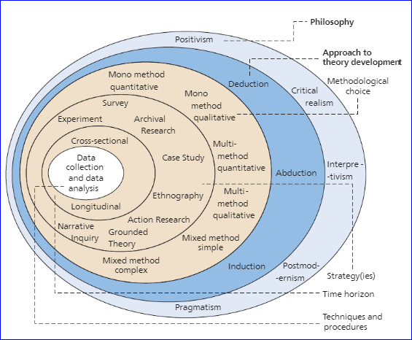
Figure 3: The Research Onion [58]

Firstly, the outer layer is examined. This identifies the initial path the research will take. Subsequent layers are assessed, each layer refining the process to be employed. Eventually all the layers are completed, and the methodology is obtained.
For the project’s aim and objectives to be successful, the author utilised the research onion to discover which methods would best serve the project’s needs.
Pragmatism, Postmodernism, Positivism, Critical Realism, and Interpretivism, all related to Philosophy, was explored. To make an appropriate choice of which philosophy to use, the research question was examined, and Positivism was concluded to be the appropriate choice.
The next layer contains Deduction, Induction and Abduction. Working on the refining choices of the onion framework, only allowed for Abduction or Deduction as a choice. On closer examination of the options, Deduction was considered to be the suitable approach. The subsequent layer contained Mono Method Qualitative, Quantitative Mono Method or Multi-method Quantitative. Of these methods, Mono Method Quantitative was deemed the appropriate option.
Further analysis of the framework allowed for a survey or an experiment to be the next choice available. Experiment was chosen as the best fit for the aim and objectives of the project. This choice meant that the time horizon for the project would be Cross-sectional, which corresponded well with the objectives set out for this project. The final layer contains the collection and analysis of the data.

3.3 Research Philosophy
As mentioned above, the research onion framework was utilised to provide guidance for the research methodology overall and was fundamental in choosing Positivism as the philosophy to use for a successful outcome of the project. Positivism is based on factual scientific knowledge. [59] The hypothesis of this project will be evaluated and analysed using experiments that can be scientifically replicated to produce similar or quantifiably comparable results and thus conform to criteria that uses positivism as the research philosophy.

3.4 Research Approach
For the research approach, the author explored abduction, deduction, and induction. Deduction was found to be most relevant when existing theory is being tested. [60] This project will allow experimentation to be conducted to permit the collection of data. The author will then analyse this data and apply the findings to the project theory in either support of or rejection of the theory.

3.5 Methodological Choice
To identify the methodical choice to be utilised in this project, research was performed to detect if qualitative or quantitative exploration would be the best choice, or if a combination of the two methods would be more fitting. [60] As statistical analysis of experimentation that has been obtained empirically is being utilised, allowing for a replicable process to be developed, the use of the quantitative method, or mono method quantitative (as there is only one method being used), will be employed.

3.6 Strategies
The author referred to the research onion for strategies to use and experimental research was identified as being beneficial for the project’s success as this strategy permits manipulating an independent variable to assess a theory. As MitM attacks take on many forms using a variety of tools/techniques, this will be the independent variable used to measure the attacks’ outcome. The collated data will be used for critical analysis.

3.7 Time Horizon
The research onion uses cross-sectional and longitudinal as the two choices available for the time horizon. Collecting data repeatedly over a protracted time period using only one variable is known as longitudinal and does not meet the project’s needs. Therefore, the use of cross-sectional time horizon will be used. This fits with the project’s prerequisites of collecting and collating observations of the numerous MitM scenarios which are required for this experiment and analysing them at the conclusion of the experimentation.

3.8 Data Collection and Analysis Methods
The outcome of the project aim, whether it would be a failure or success, will be determined by the examination of the accumulated information.
Data from the numerous attacks will be used as the primary data, whereas the use of peer-reviewed journals from sites such as Elsevier Ltd, Science Direct, IEEE Xplore, which are available online, along with material from the University Library will be the secondary data. Using both primary and secondary data allows for a comprehensive observation of differences and/or similarities between the collected information from the primary source, the experimentation, and the secondary material provided by the findings observed in the literature review.

3.9 Risk Assessment
To ensure a successful project outcome, risk assessment was taken into consideration. As there are numerous factors of the aim and objectives that could present a risk, the following factors have been outlined and investigated with solutions being suggested.
Highlighted Risk Factors:
- Time constraints for experiments.
- Unobtainable software.
- Data corruption or loss.
Suggested Solutions:
- Outlining goals that are realistic and attainable will ensure the necessary time constraints are met.
- For a successful outcome, ensuring the availability of crucial software is paramount.
- As data loss and corruption can sometimes be unavoidable, ensuring there are copies of all data which has been clearly identified should be stored in separate locations. The 3-2-1 rule, which states that keeping three independent copies of the relevant data on two distinct mediums, and a separate copy stored in a remote location, [61] or even utilising readily available cloud storage would keep the risk to a minimum.
There is also a contingency plan being implemented to further mitigate risks.

3.10 Resources and Planning
The project will use virtual machines to execute the experiments. A Windows-based machine with Virtual Box installed to accommodate the necessary virtual networks will be used, and the MitM attacks will be executed on a Linux based machine.
A Gantt Chart has been utilised to outline the time constraints of the project and the final version is found in Appendix 1.

3.11 Design
There will be two virtual networks set-up for the experiment. One network will consist of a connection between a Company network and the internet. To simulate a public website there will also be two other connected devices. The second network will be a simulation of a home office. This will consist of a BYOT laptop connected via Wi-Fi and a home computer that is hard-wired to the router. Fig 4 outlines the design.

3.12 Contingency Plan
In the case that a contingency plan is required to be implemented, for example if a secure virtual network cannot be executed, the author has access to existing hardware which will be utilised to perform the experiments.

3.13 Ethics Form
The requisite ethics form was completed and accepted for this project.

3.14 Summary
In conclusion, chapter three highlights how this chapter will aid the author in obtaining a successful outcome for the project. It has presented a structured plan on how to implement the required sections of the research process as described by the research onion, and it emphasises the importance of conducting each step of the procedure in a timely manner.
This chapter also outlines what direction the author should undertake to obtain the desired outcome for the project, covers a risk assessment, and a contingency plan should one be needed. The use of this chapter will be paramount for the successful outcome of the project.

Chapter 4 Design & Implementation

4.1 Introduction
Chapter four is set up in three distinct sections. The first section outlines why the author believes the experiment should be conducted.
The second section, the design, describes the hardware used, and displays the topology created to fulfil the experiment.
The third section, the implementation, details the steps taken in the execution of the experiments.

4.2 Problem Formation
HTTPS and TLS are the protection people have become used to seeing when traversing the internet and have made users comfortable knowing these protocols use encryption to transmit and receive data. [53] With that in mind, assessing whether HTTPS and TLS are sufficient against MitM attacks is a question the author believes should be considered.
With the use of virtual machines set up to imitate a private network that connects to the internet, the author intends to see if attacking the victim’s machine before it connects to the home router will allow information such as usernames and passwords to be harvested. The author will be using readily available MitM tool to carry out the attacks, along with a social engineering attack.
Using Kali-Linux to carry out the MitM assaults, and a Windows 10 laptop as the victim’s machine, several attacks will be executed and documented.

4.3 Design
To make this experiment as authentic as possible, a network was designed to mimic a home office. A laptop which is used for work purposes along with personal usage, that connects wirelessly to the home router was implemented on a virtual network. This laptop uses Windows 10 as its operating system. There is also a wired computer in the network which will not be targeted.
Virtual Network two, the home office, connects to the internet through the home router, as shown in Fig 4.
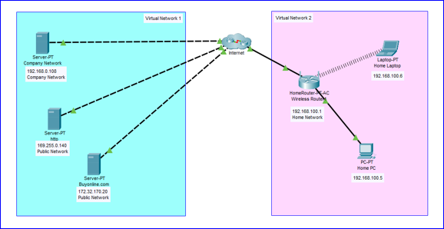
Figure 4: Network Layout
Virtual network one comprises of a company server, and two other public facing servers to mimic connection via the internet to places such as Facebook, Twitter, YouTube, and shops or banks that can be accessed online from the home office.

4.4 Implementation
The base computer used for the experiments was a HP ELITEBOOK which had an Intel ® Core ™ i5-8250U CPU @ 1.60GHz 1.80 GHz. The RAM capacity was 16.0GB and operated on a 64-bit system. The laptop had Windows 10 Pro version 20H2 installed. The base machine was DHCP enabled.
The next step was to instal VirtualBox 6.1.22. This was used as it has the capacity to create multiple virtual machines and allowed for the testbed to be created as per the layout in Fig 4.

4.5 Virtual Network 1
For Virtual Network 1, the servers were created using Windows Server 2016 Datacenter with a 20GB capacity. They had a base memory capacity of 3729 MB, and acceleration was set to VT-x/AMD-V, nested paging, PAE/NX. The servers were set to bidirectional under the Advanced Tab of the general settings. The network was set-up with the bridged adapter and an ethernet connection. Under the advanced tab of the network settings, the Promiscuous Mode was set to Allow All.

4.6 Virtual Network 2
Virtual Network 2 consisted of a Home Laptop with Windows 10 (64) bit Operating System with a base memory capacity of 5974 MB and acceleration set to VT-x/AMD-V, nested paging, Hyper-V Paravirtualization. The storage capacity was Windows.vdi (Normal, 20.00 GB), and the network was set-up with the bridged adapter and an ethernet connection, the Promiscuous Mode was set to Allow All. The Virtual Machine was also set to bidirectional.
The Home PC in Virtual Network 2 was set up to be identical to the Home Laptop, as set out above.

4.7 Kali-Linux Virtual Machine
For the attacks a Kali-Linux based machine was created in the VirtualBox. This tool, which is based on a Debian version of the Linux operating system, is open-source, funded and maintained by Offensive Security, and is designed for penetration testing and digital forensics. [62]
The version used consisted of a Debian 64-bit Operating System with a base memory of 3066 MB. There were two processors set up, and the acceleration was set to VT-x/AMD-V, nested paging, PAE/NX, KVM Paravirtualization. The machine was set to bidirectional, as above, and the network was set to bridged adapter with an ethernet connection. The Promiscuous Mode was set to Allow All.
The Debian based Kali-Linux version was Kali GNU/Linux Rolling and the release was 2021.2 with the codename kali-rolling. This version of Kali had many programs pre-installed, including sniffing and spoofing tools such as Ettercap-graphical, version 0.8.3.1 and Wireshark version 3.4.4-1. One of the exploitation tools that was pre-loaded was the Social Engineering Toolkit (SET), the version was 8.0.3 with a codename of Maverick.
All virtual machines were DHCP enabled.

4.8 Wi-Fi Attack Set-Up
To perform the attack against the Wi-Fi, a GEFORCE GTX 1650 GPU was installed in the base laptop. An Alfa AWUS036NHA wireless adapter was connected to the laptop via the USB port. Kali-Linux version 2020.4 was installed as a virtual machine using VMWare workstation 16 on a Windows based laptop. A TP-Link router model: TL WR841N was used for the attack, which still had the default password.
Wifite, is a Wi-Fi hacking tool and the tool of choice for the experiment and it looks for all WPA networks outlined in Fig 5.
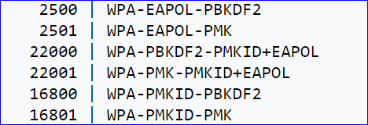
Figure 5: WPA Network Types [63]

4.9 Summary
Chapter four was used to outline the three distinct stages of the project. Firstly, the problem formulation was delineated, followed by the design layout, finishing with the implementation.
The problem formulation outlined the reasoning for this project, inasmuch as how HTTPS and TLS encrypt the data being transmitted and therefore in itself is secure but does not protect against MitM or social engineering attacks capturing data en-route.
Secondly, the design was laid-out and examined the prerequisites required to implement the project aim.
Part three summarised the hardware and software utilised in the experimentation and analysis of the project.

Chapter 5 Experiment and Results Discussions

5.1 Introduction
Chapter five consists of three distinct experiments, documents how they were executed, and what information, if any was garnered. The first attack was against the Wi-Fi, the second was aimed at the LAN while the third attack combined social engineering with the MitM attack.

5.2 Attacking the Wi-Fi
The first objective was to gain access to the network via the Wi-Fi. This was accomplished by using Kali-Linux, the Wifite hacking tool, Aircrack-ng (2.20) and the password cracking tool Hashcat (2.18).
Using the set-up outlined in (4.8) and Wifite (2.21), the Wi-Fi network was attacked at the AP. Due to time constraints, the author was unable to carry out this attack, so the following attack information was used to demonstrate what the author would have executed, and the result the author would have expected. [63], [64]
To ensure the Wi-Fi was detected, the command ip addr was input into the Kali-Linux machine. The following outcome, showing the wlan0 being detected, was achieved, and is depicted in Fig 6. The next step was to execute the sudo wifite –wpa –kill. This command started the wifite program, ensuring the attack was on all WPA network types found as outlined in Fig 5, and stopped any conflicting processes from interrupting the procedure. Fig 6 demonstrates this process.
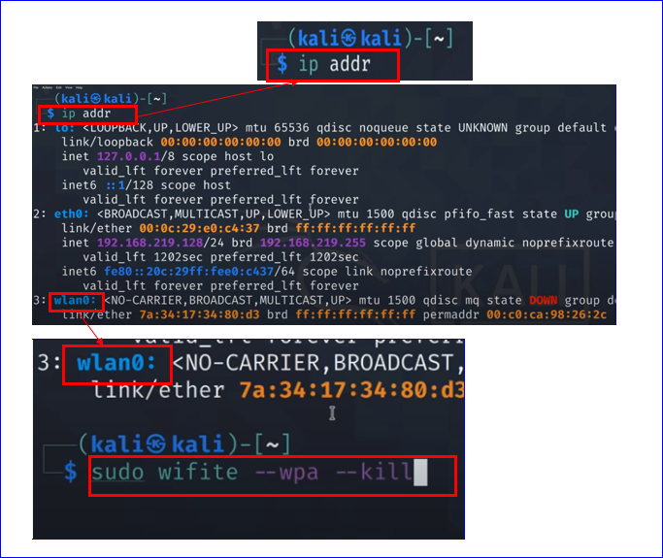
Figure 6: Wi-Fi and Wifite Commands [64]
Once Wifite was running, it scanned for available networks as outlined in Fig 7.
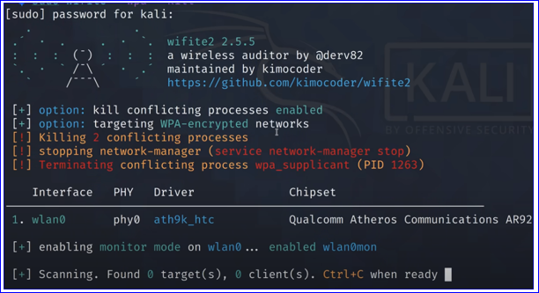
Figure 7: Wifite Scanning Networks [64]
Once the scan had found the network to be attacked, Ctrl + C was depressed, and this stopped the scan.
As shown below in Fig 8, the TP-Link was found. The number on the left-hand side of the figure, shows the target number was 1.
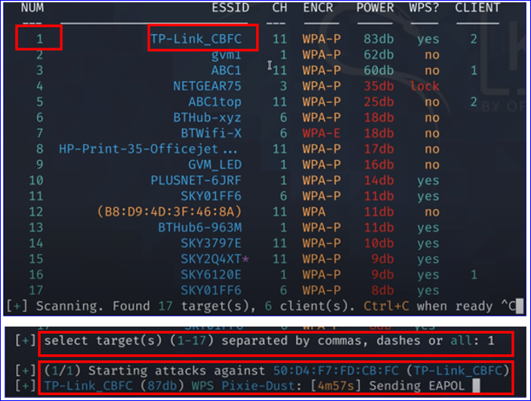
Figure 8: TP-Link Found and Attack Started [64]
To execute the attack, the target number was input and the enter key depressed.
The Wifite program contained many attacks which were sequential. The first attack to run was WPS Pixie-Dust, then WPS NULL PIN, WPS PIN Attack, and PMKID CAPTURE. All depicted in Fig 9. As these were not required, Ctrl + C was the command used to move the attacks along.
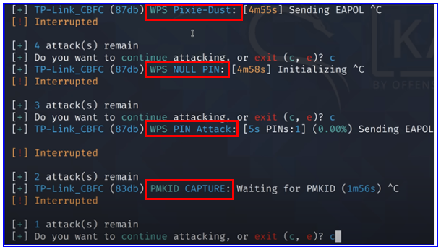
Figure 9: Attacks Interrupted [64]
Once the desired attack was reached, in this case the capture of the WPA2 Handshake of the TP Link router with the WPA2-PSK AES encryption, the attack was allowed to run its course. Fig 10 depicts the attack running and outlines that a wordlist was used to attempt to crack the password.
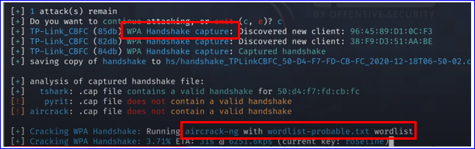
Figure 10: WPA Handshake Attack Using a Wordlist [64]
If the password had been based on the alphabet, and was included in the wordlist used, the password would have been found at this point. in this case, the password was numerical, and therefore was not found. The password is outlined in Fig 11.
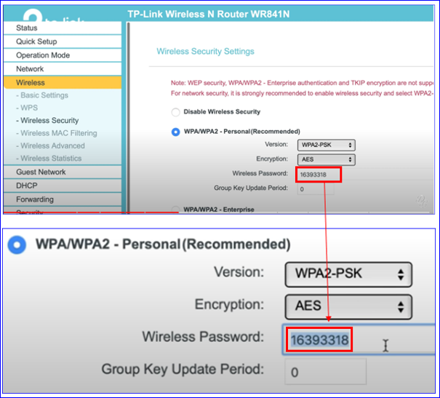
Figure 11: Wireless Password Numerical [64]
Fig 12 clearly shows the attack did not find the password as it was not in the wordlist used.
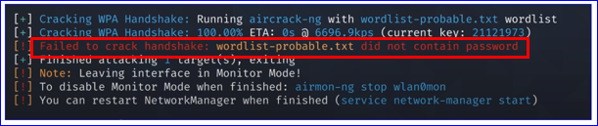
Figure 12: Password Not Found [64]

Although the password was not found, a .cap file was created, as outlined in Fig 13.
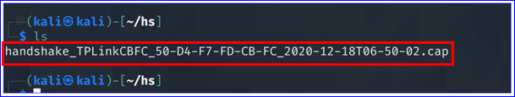
Figure 13: Dot Cap File Created [64]
The .cap file needed to be converted into a wpa2.hccapx file and this was achieved with the use of the Hashcat utilities (2.18). Fig 14 depicts the utilities file and the cap2hccapx.bin being used. This Handshake file was then written, and with the list (ls) command, the file could be seen as a new file in Kali-Linux, Fig 14 also displays the file.
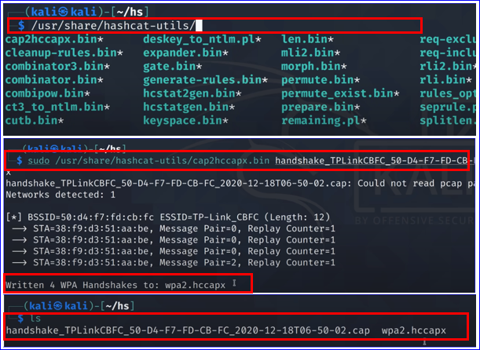
Figure 14: Utilities Used and File Conversion [64]
As the password was not found, the next step required traversing to the /hs directory, opening the folder and accessing the newly created file inside. Fig 15 depicts the open folder, and the file, which was then copied into the Window’s hashcat directory.
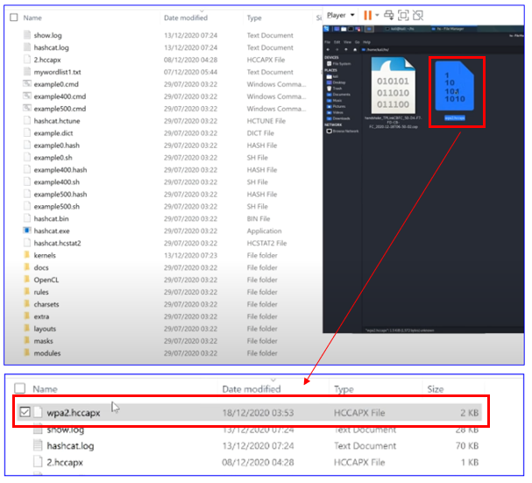
Figure 15: File Being Copied [64]
Initiating the cmd prompt on the Windows-based computer opened a command window and hashcat was initiated. Exe was the executable file that was run. The type of attack was WPA version 2, which used the -m 2500 command. The -a command outlined the attack was a brute force, and the attack was being launched against the WPA2 file previously created. The final command was the? d, which let the program know it was to attack and look for digits, and the length of the digits was, in this case, eight. Therefore, the command input included ?d repeated for the length of the eight digits. Fig 16 outlines the commands used.
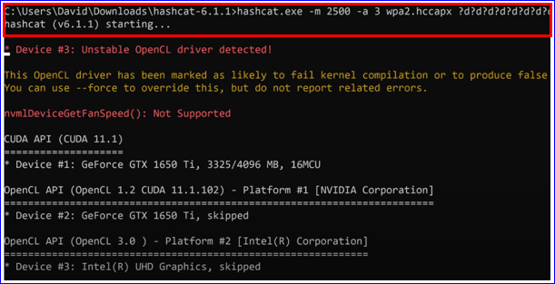
Figure 16: Command Window Initiating Hashcat [64]
The status of the attack was checked by entering the letter s and pressing enter in the command line which displayed the following output displayed in Fig 17. The name of the attack being used, the name of the target file, an estimation of how long it would take to run the attack and the number of digits it was looking for as a password.
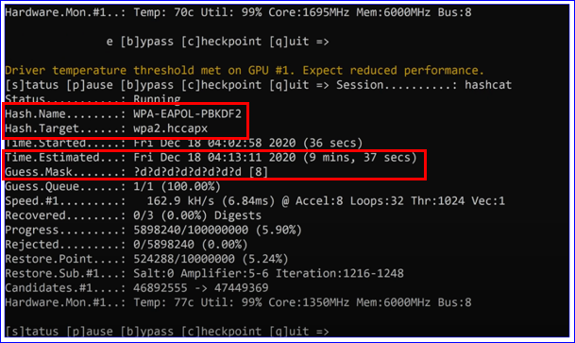
Figure 17: Name of Attack, Target, and Estimated Time [64]
As the attack progressed, further updates were required and to obtain this, the letter s and enter was again depressed. After six minutes and fifty-five seconds, the password was cracked. The program had gone through sixty-nine per cent of one hundred million combinations to find the password. Outlined in Fig 18.
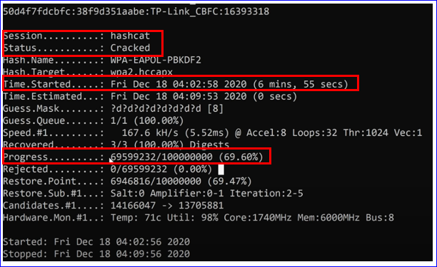
Figure 18: Attack Completed and Time Taken [64]
To display the password, re-entering the command hashcat.exe -m 2500 -a 3 wpa2.hccapx? d?d?d?d?d?d?d?d, was performed. This resulted in the program displaying that the next step was to use the –show command to retrieve the password and is depicted in Fig 19.
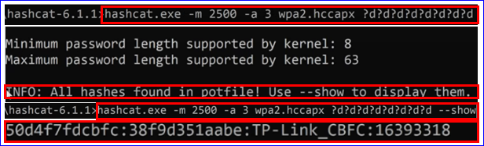
Figure 19: Password Displayed [64]
In the Windows machine the hashcat.potfile, was opened using notepad and revealed the password that was used on the TP Link router. The password is displayed in Fig 20.
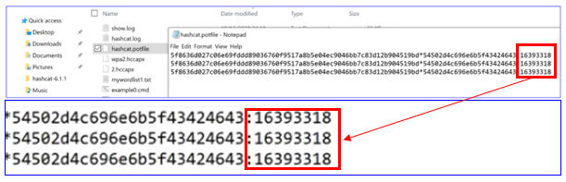
Figure 20: Password Revealed in Windows Machine [64]
Once this was achieved, the next objective was to perform an ARP Poisoning attack. This attack outlined the network and allowed for any unsecured HTTP traffic on the network to be collected.

5.3 ARP Poisoning
An ARP Poisoning attack was carried out on the Windows 10 machine which is depicted in Fig 4 as the Home Laptop.
As stated in 2.1, the intention of ARP poisoning is to alter MAC addressing tables. With the use of an ARP poisoning tool, in this case Ettercap (2.14) was used, the IP and corresponding MAC address were altered so that when a specific IP address was contacted, the Windows server for example, the information was sent to an alternate MAC address without the sender’s knowledge.
To accomplish this, the Kali Linux system as outlined in 4.7 was used in the VirtualBox setting as the attacking machine. Fig 21 depicts the VB Manager with the Kali-Linux (Clone), Windows Server 2016 Datacenter and Windows 10, powered on and running.

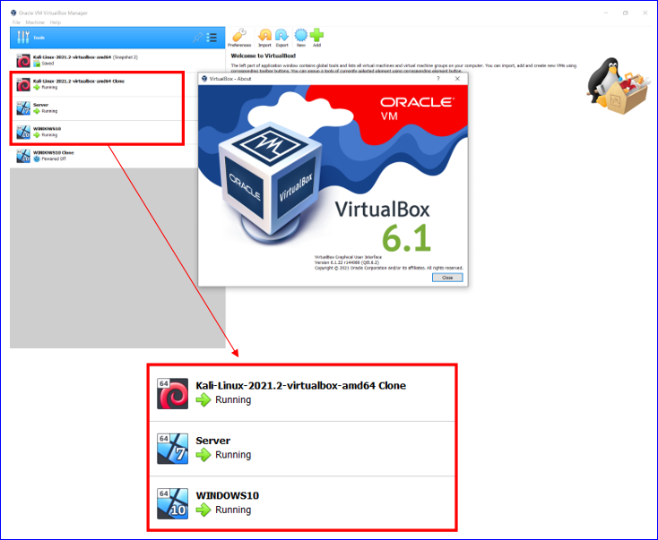
Figure 21: Oracle VirtualBox 6.1

5.3.1 Kali-Linux – Attackers Machine
The ifconfig command was used to find the IP and MAC address of the Kali-Linux machine. As illustrated in Fig 22, the IP address shown was 192.168.0.106 with a MAC address of 08:00:27:0e:34:8d. This MAC will be used later to show the MitM attack outcome.

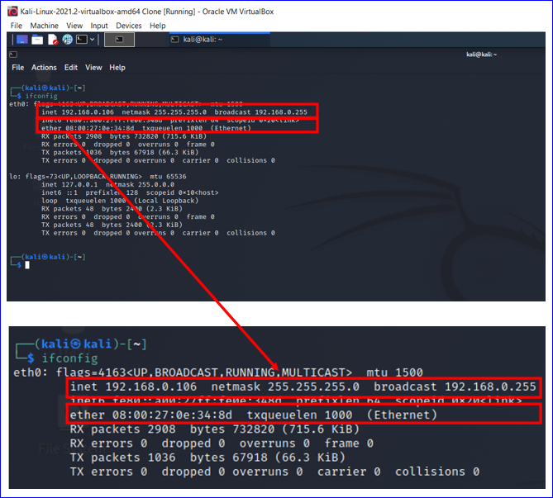
Figure 22: IP and MAC Address for Kali-Linux
The Kali-Linux machine included many options for penetration testing, or ethical hacking a system. Fig 23 outlines the menu of attacks that could have been utilised. The Sniffing and Spoofing category was chosen.

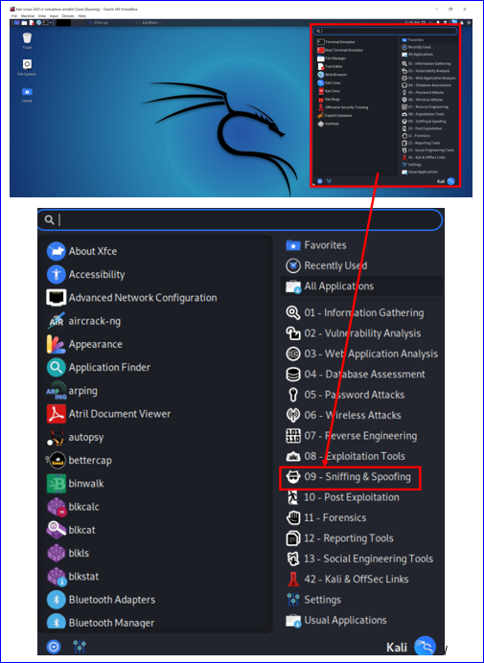
Figure 23: Options for Attack Types
Under that category there was a further list of the tools that could have been used to carry out the attack. Fig 24 illustrates some of the tools that could have been used. As previously stated, this experiment used Ettercap (2.14) as it had a GUI (Graphic User Interface) and was simple to operate.
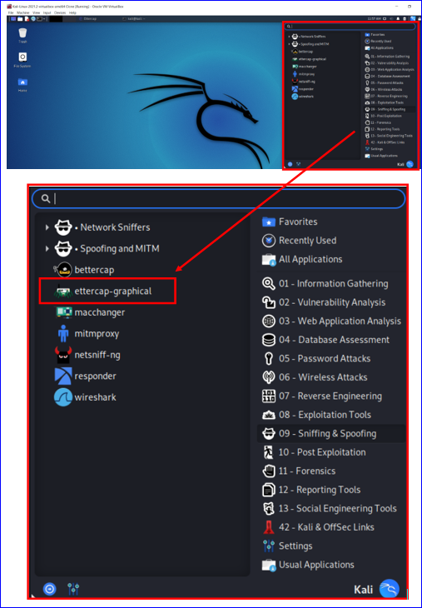
Figure 24: Options for MitM Attacks

To run the experiment Ettercap needed to be initiated with root, or administrative rights and therefore there was a prompt asking for the password before proceeding, illustrated in Fig 25.
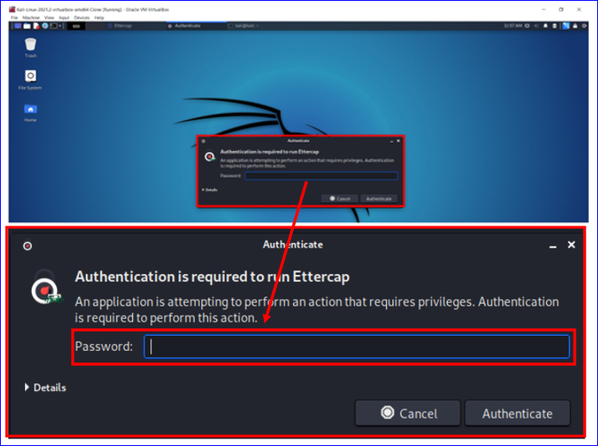
Figure 25: Authentication Required for Ettercap
Once the password had been entered, Ettercap opened to the home page and the settings were checked for accuracy, in this instance the settings were correctly set and ready for use. For the attack to commence, the tick in the top right-hand corner was depressed by right clicking the mouse, as shown in Fig 26.
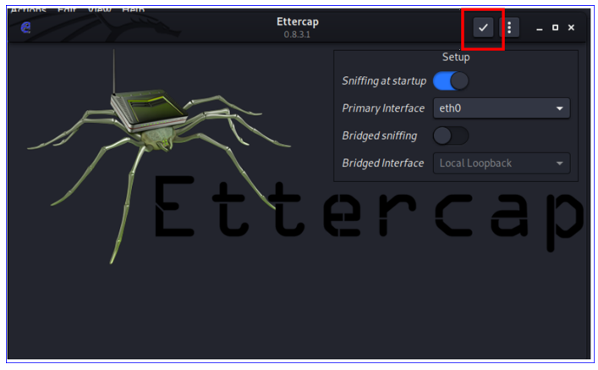
Figure 26:Ettercap Home Page with Settings
Once the tick has been depressed, the program started to run, as show in Fig 27.
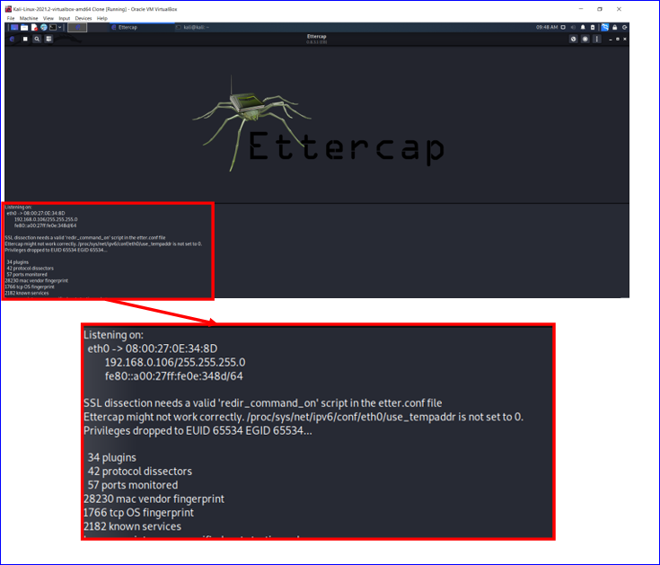
Figure 27: Ettercap Running
Once the program had started and was scanning for networks, the next step was to scan for hosts. This was achieved by clicking on the globe button to display the menu. There were several options available at that time, Fig 28 depicts the globe button and the menu available. For this experiment Host was chosen, and under that heading the Scan for Hosts. The program then scanned the network and identified the IP and MAC addresses.
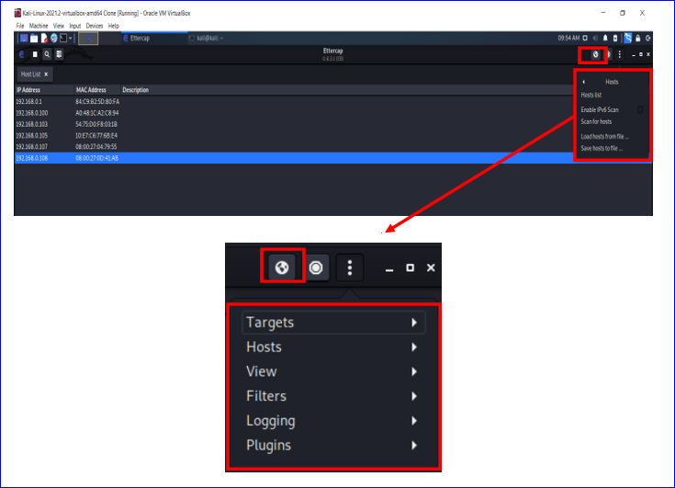
Figure 28: Dropdown Menu for Host
Fig 29 outlines the resulting IP and MAC addresses that were identified as being present on the network.
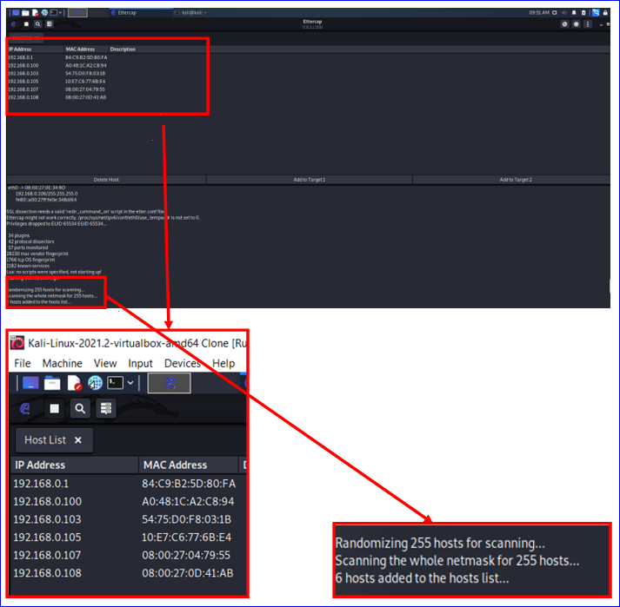
Figure 29: Network Scanned for Hosts
With the network identified, it was time to choose the IP addresses that were going to be attacked. The Windows 10 IP address of 192.168.0.107 and the Windows Server, 192.168.0.8 were the targets. The Windows 10 address was chosen for target 1 while the server was added to target 2. The MitM dropdown menu was opened by clicking on the globe button on the top right-hand corner of the screen. The menu showed the different options available to use. As this experiment was to change the ARP table, the ARP poisoning attack was chosen and is shown in Fig 30.
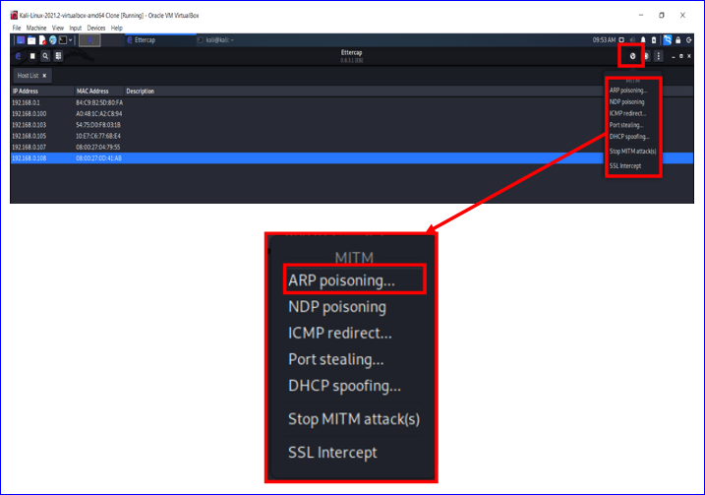
Figure 30:MitM Attack Options
Once chosen, a pop-up box appeared with further options. The option to sniff a remote connection was selected as shown in Fig 31.
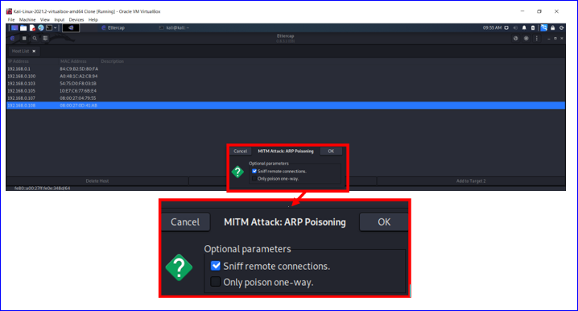
Figure 31: Further Options for Attack
Once the targets were selected and added to Target 1 and Target 2, as depicted in Fig 32, the attack began. This was carried out in conjunction with Wireshark being started on the victim’s laptop (5.3).
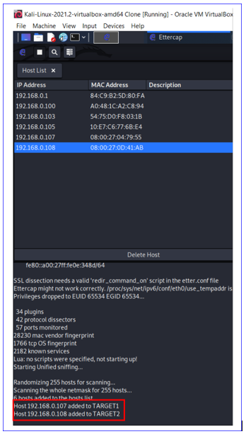
Figure 32: Targets Attacked

5.3.2 Windows 10 Machine
To identify the IP address of the Windows 10 machine, the ipconfig command was entered in the command prompt page. This returned the IP address of 192.168.0.107. So that the ARP table could be identified the arp -a command was issued. Fig 33 displays the results. This was carried out before the ARP poisoning occurred and was used to show the original contents of the ARP table. Wireshark (2.16) was initiated on the machine to document the process of the attack. Once Wireshark was initiated, so was the ARP attack.
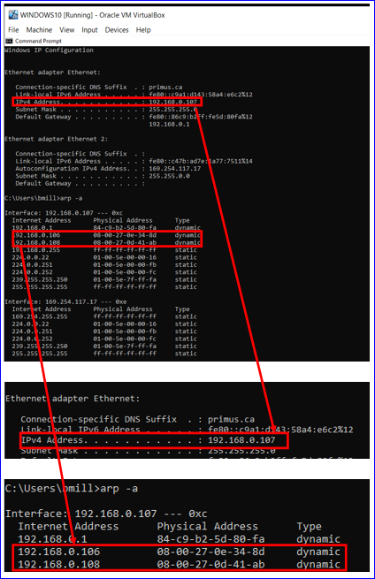
Figure 33: IP Address and ARP Table
Machine | IP Address
Windows 10 | 192.168.0.107
Kali-Linux | 192.168.0.106
Windows Server | 192.168.0.108
Table 1: ARP Table
Fig 34 displays the Windows 10 machine with Wireshark running in the background.
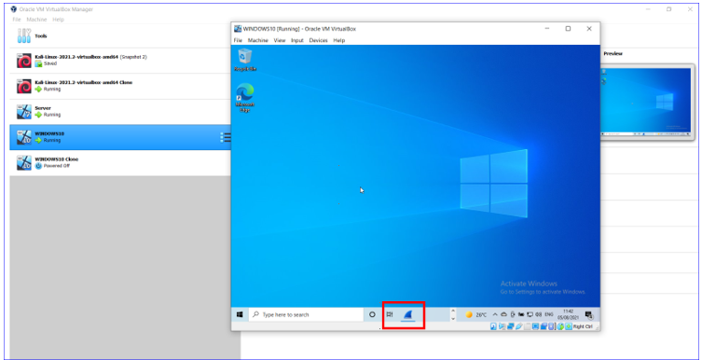
Figure 34: Windows 10 Running Wireshark in the Background
With Wireshark running to capture all the traffic on the Windows (victim) machine, a ping request was sent from the victim’s machine to the server on 192.168.0.8 using the command prompt page as shown in Fig 35.
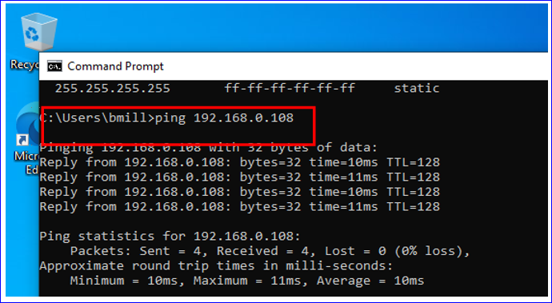
Figure 35: Ping Request
Once the ping was sent, Wireshark started to record the data flow. The first entry of the traffic capture outlined the ping request being sent as seen in Fig 36. Entry number twelve outlined the ARP reply from the Windows server. On further inspection the MAC address associated with the IP 192.168.0.108 had changed to the MAC address of the Kali-Linux machine (192.168.0.106, Fig 33). Further when the Address Resolution Protocol (reply) was expanded, the sender MAC address and sender IP address clearly outlined the changed MAC address of sender IP 192.168.0.108 as it was communicating with the Windows’ computer.
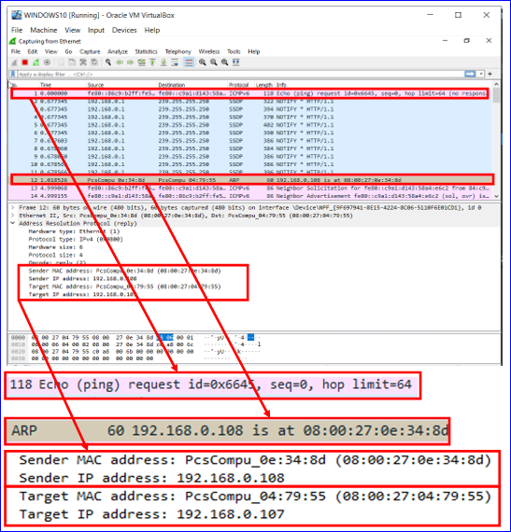
Figure 36: Wireshark Traffic
With the ARP poisoning being successfully executed, the final test was to verify the ARP table on the Windows 10 machine and do a before and after comparison. Fig 37 clearly outlines the MAC address for the Windows server and the Kali-Linux machine being identical.
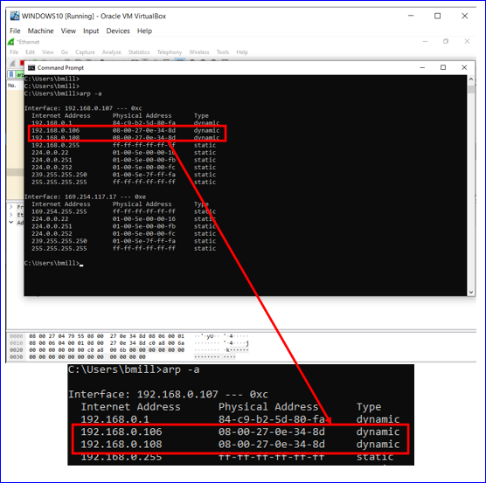
Figure 37: ARP Table After Attack
Once the ARP poisoning had occurred, the next test was to see if when connecting to an HTTP website with the Windows machine, the username and password was captured. Fig 38 outlines the connection made to an insecure test site with username and password entered.
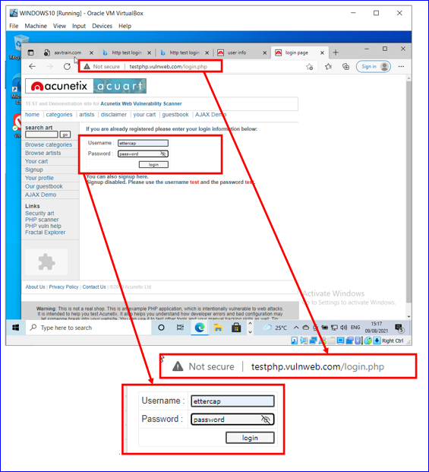
Figure 38: HTTP Test Site
Once this was entered, the Kali-Linux machine, which still had Ettercap running, was accessed to see if the username and password had been captured. Fig 39 outlines the result, which clearly showed the username, password and website accessed were captured.

5.3.3 Kali-Linux Machine Output
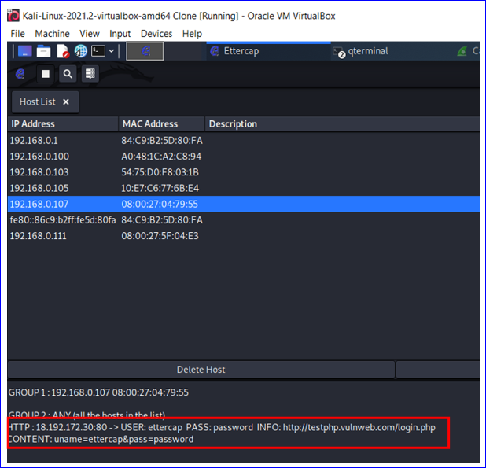
Figure 39:Ettercap Capturing HTTP Information

5.4 Social Engineering Toolkit (SET)
The Third stage of the experiment was to see if, with the use of social engineering, a MitM attack could harvest login information from a website protected by the HTTPS and TLS lock symbol in the URL.
The author used SET tool (2.22) to perform the social engineered MitM attack. The attack was two-fold and required the victim to open an e-mail and click on the link provided. [65]
An email used for this attack would look similar to Fig 40, which was originally sent to the author in a spear-phishing (2.23) attempt. The e-mail appeared in the inbox as service@paypal.com and when opened looked very much like PayPal with the PayPal logo on the top left-hand side, and the copyright at the bottom of the e-mail.
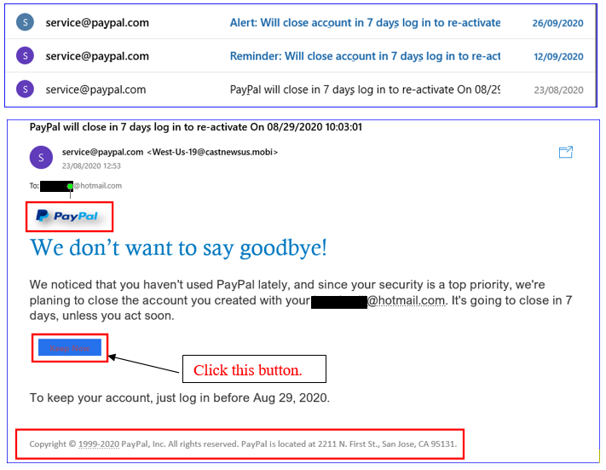
Figure 40: PayPal E-mail [66]
The victim would have received an email stating a problem with one of their accounts which could be rectified by clicking on, in this instance, the ‘Keep Now’ button. This in turn directed the victim to the attacker’s cloned website.

5.4.1 Kali-Linux Machine
On the Kali-Linux machine, which had been set up as outlined in (4.7), the attack was set-up and executed as follows:
The first step was to open the SET, and select the desired number from the menu displayed, as in Fig 41. As this experiment was a social engineering attack number one was chosen.
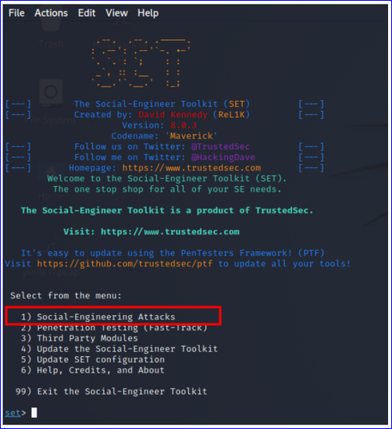
Figure 41: SET Initial Menu
Once the selection was entered, the following menu was displayed and number two, the Website Attack Vectors was chosen and is depicted in Fig 42.
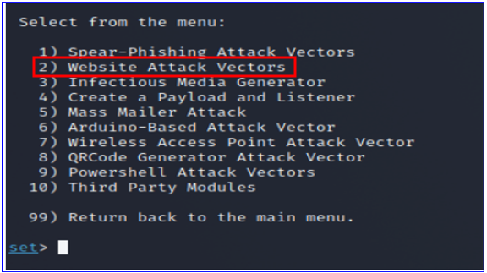
Figure 42:SET Website Attack Vectors
As the attack was aimed at collecting personal login information, the next option chosen was the Credential Harvester Attack Method. It was numbered 3, and was chosen, as per Fig 43.
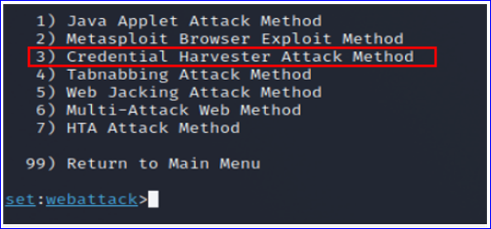
Figure 43: Credential Harvester Attack Method
The attack included cloning a website, therefore, number two was selected, the Site Cloner depicted in Fig 44.
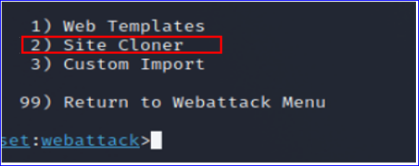
Figure 44: Site Cloner
When all the specifications for the attack had been input, the web page to be cloned, www.paypal.com, was used and is depicted in Fig 45.
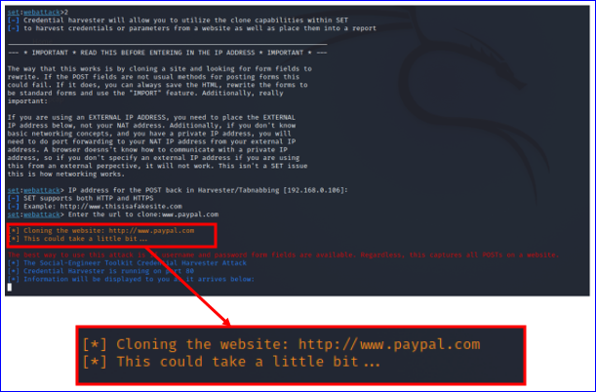
Figure 45: Coning PayPal Website
Fig 46 displays the information collected up to the PayPal login website.
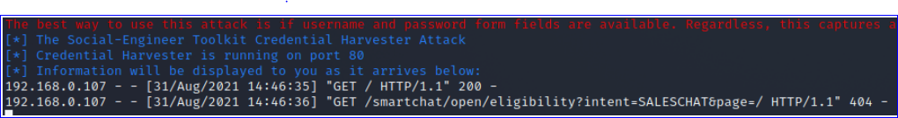
Figure 46: Information Collected
As this was a genuine site, for ethical reasons the experiment for this site stopped here.

5.4.2 Windows Machine
On the Windows Machine, the email link was depressed which took the victim to the login page of PayPal depicted in Fig 47. This was on a virtual network, therefore the ip address was placed in the URL, the rest of the website looked identical. If this had not been a simulation, the URL would have had a name such as www.PayPal.con instead of an ip address.
For ethical reasons, as stated earlier, the author could not complete the attack on an existing account, so the attack was followed and documented to the point where username and password were required
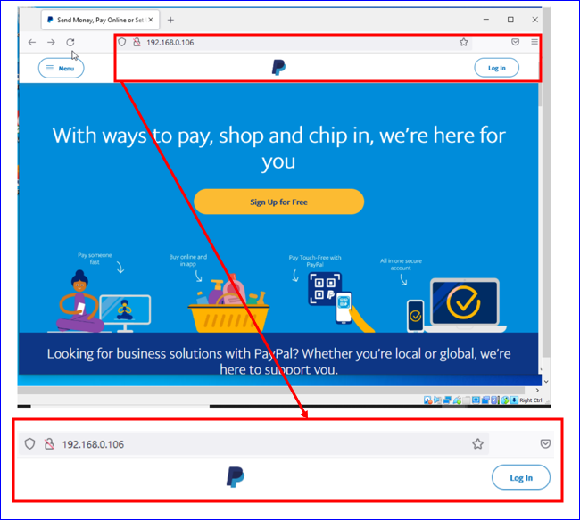
Figure 47: Cloned PayPal Site
Once the login button was depressed, the next page displayed was the official PayPal login page. This page was an HTTPS web page with the security lock, which required username and password. Outlined in Fig 48.
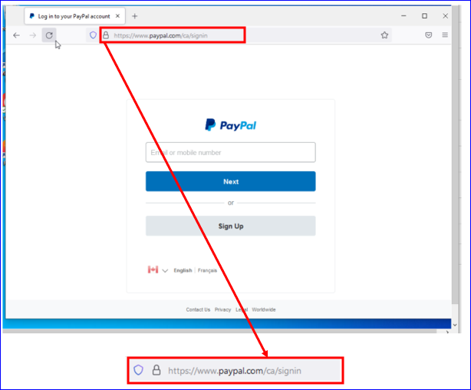
Figure 48: PayPal Login Page
As this seemed to be successful, the next step was to complete an attack to see if the username and password could be retrieved from a Facebook account which was opened specifically for the purpose of this experiment and therefore had no ethical issues. The author assumed there was a similar e-mail to the one depicted in Fig 49 sent to the victim address and that it was acted upon by following the link that would have been provided.
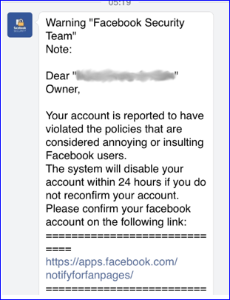
Figure 49: Bogus Facebook Security Alert [56]
Once the link was clicked, the victim was directed to a cloned Facebook login page. In this instance, as previously mentioned, the page was on the virtual network so showed the ip address in the URL. With more time, the URL would have looked like wwww.Facebook.com for example.
Fig 50 depicts the cloned Facebook login page. This Facebook and email account was opened specifically for the purpose of this experiment, so no personal information was disclosed. The login information was input, and the Create New Account button was depressed.
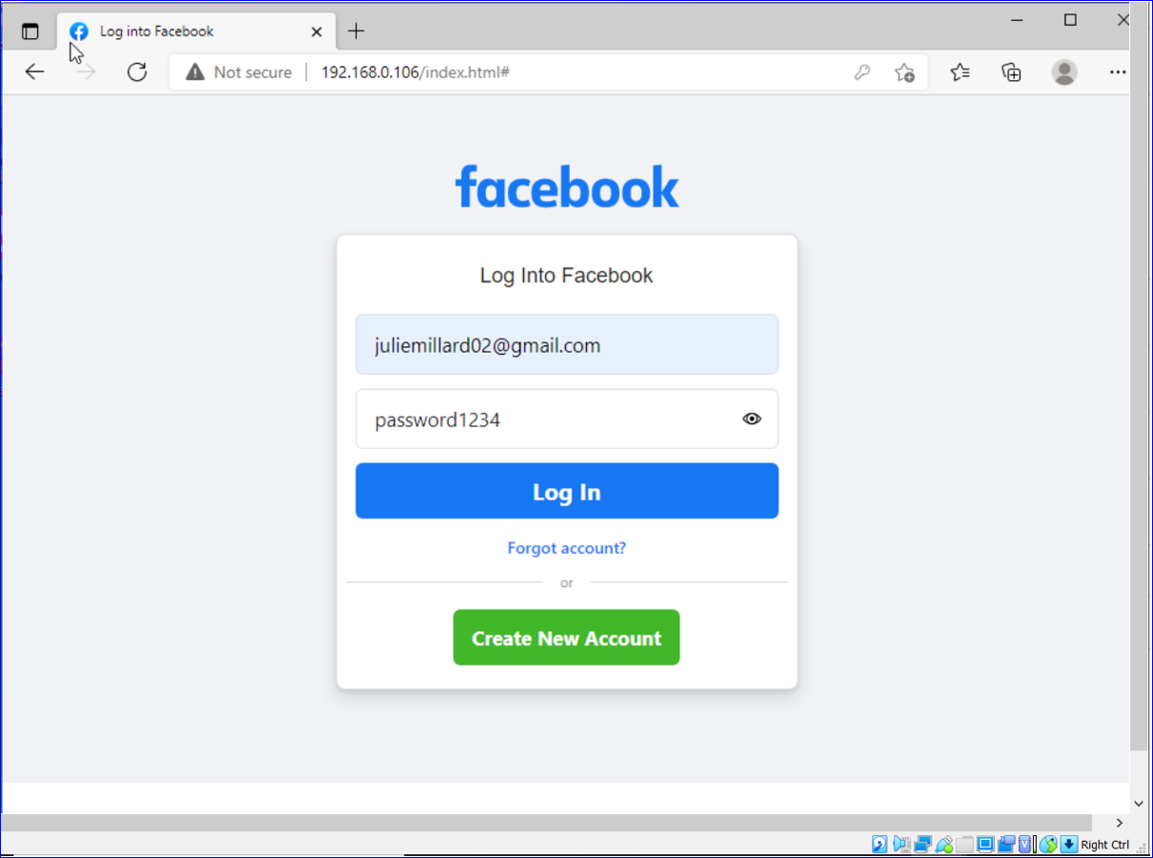
Figure 50: Cloned Facebook Login Page
Once the username and password were input, the next page was the genuine Facebook page This page included the HTTPS secure lock in the URL. Fig 51 displays the page.
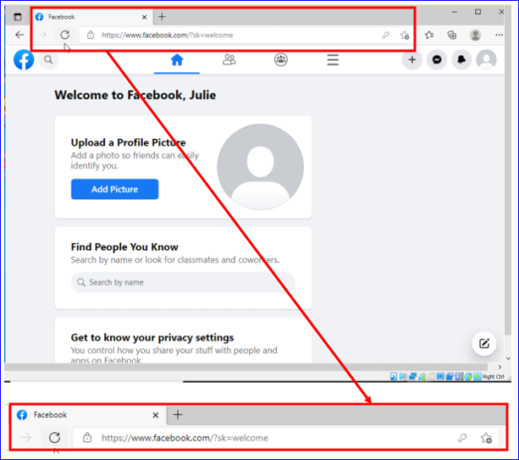
Figure 51: Genuine Facebook Account
As the victim accessed the account successfully, they would have no reason to think they had been compromised.
Using the information harvested by the SET tool, accessing this account was achievable. Once inside the account, information such as security settings were accessed. On the Facebook Pay page, the ability to remove the security PIN for payment confirmation was obtained, as per Fig 52.
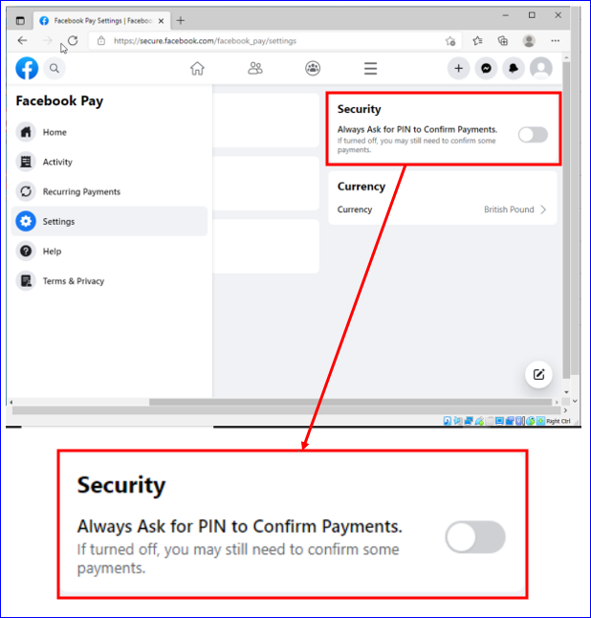
Figure 52: Pin Security Page
The ability to change the shipping address was also accessed, shown in Fig 53.
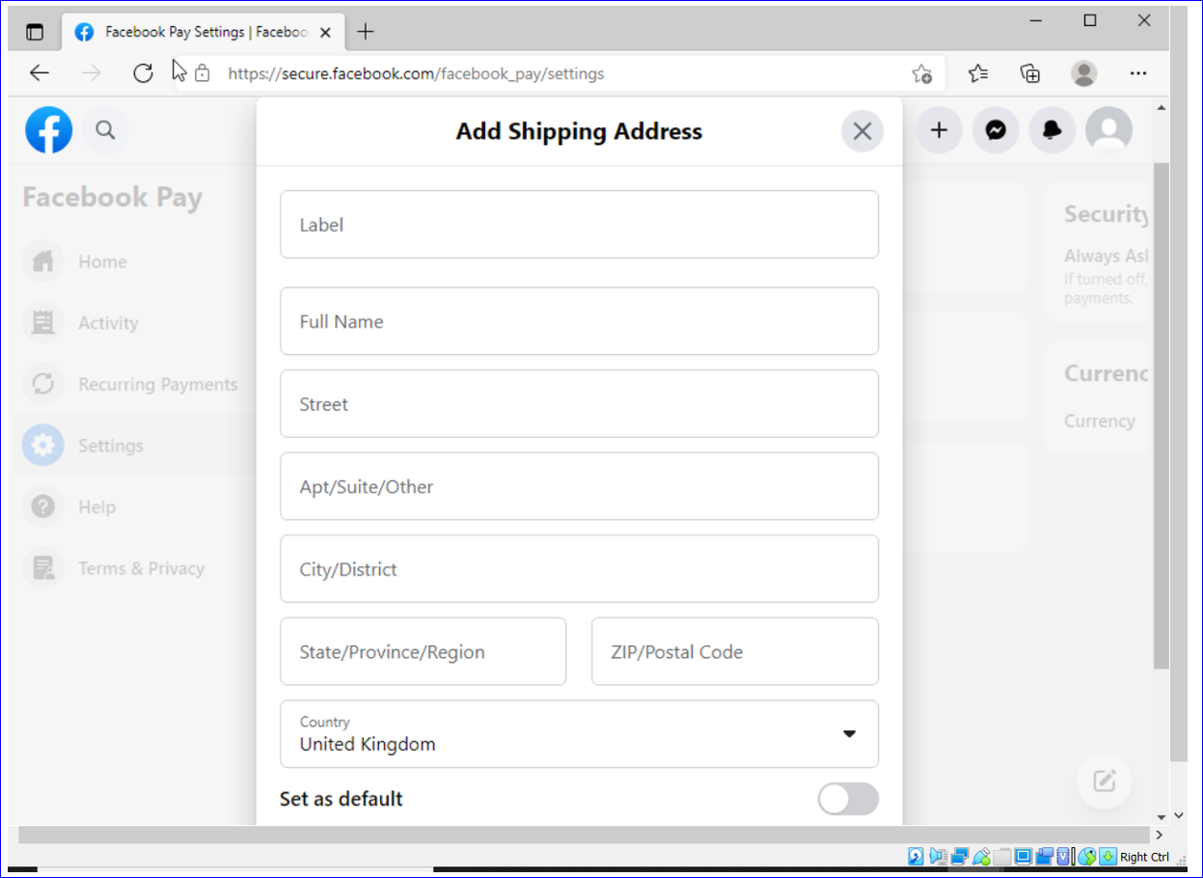
Figure 53: Change Shipping Address
Access to payment methods for Facebook Pay was achieved and is shown in Fig 54. Any Credit, Debit and PayPal information would have been harvested.
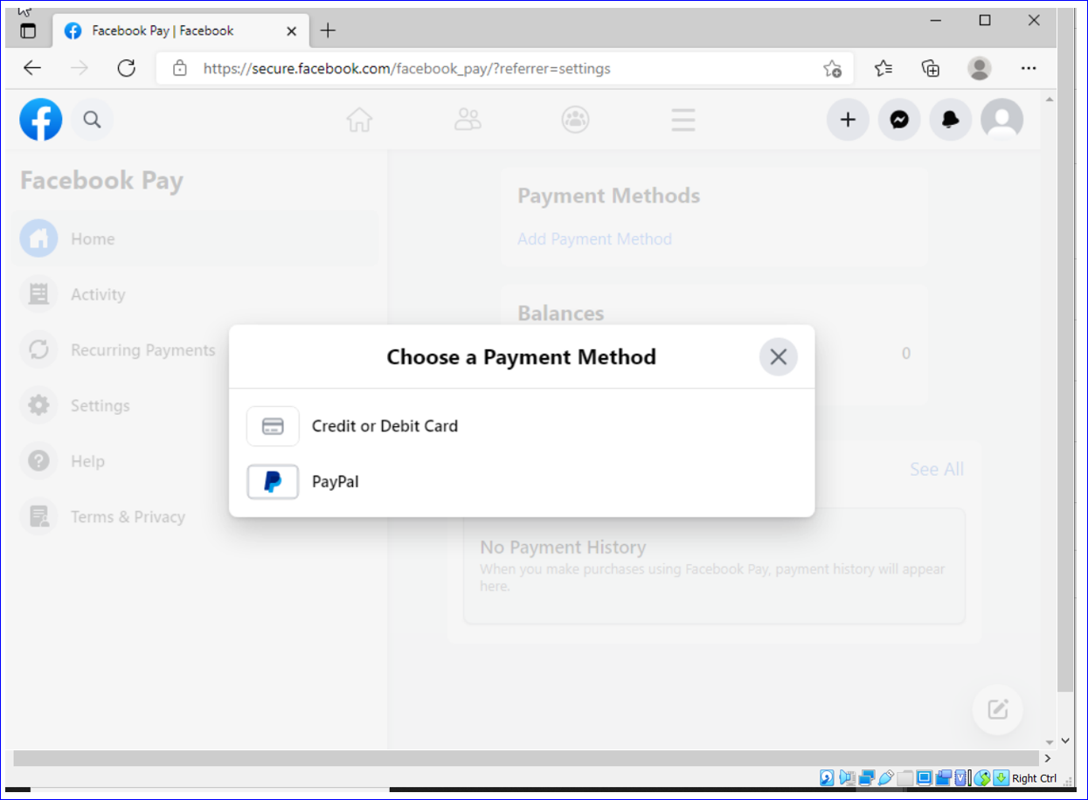
Figure 54: Payment Information Page

5.4.3 Kali-Linux
On the Kali-Linux machine, the SET information was followed as per (5.4.1) up to inputting the website to be cloned, and www.facebook.com was entered at that point.
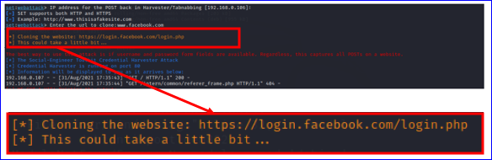
Figure 55: Facebook.com Site Cloned
Once the victim entered the username and password into the Facebook login page, the information was sent to the attacker’s computer. The output is clearly depicted in Fig 56.
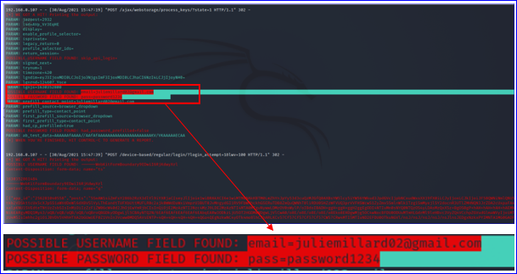
Figure 56: Username and Password Captured

5.4.4 Results Discussions
The aim of this project was to identify if MitM attacks on networks could harvest confidential information notwithstanding HTTPS and TLS.
This was to benefit organisations, cyber security analysts and the public understand that despite what is inferred by a security lock in the URL on HTTPS and TLS sites, the information being transmitted is not safe from MitM attacks. Therefore, they cannot be complacent.
With the use of virtual machines, a network was simulated as set out in chapter four. MitM attacks combined with social engineering exploits were executed using penetration testing equipment that was readily available.
The network was initially compromised by using Wifite (22.1), and Hashcat (2.18), which used a brute-force attack and a password hacking tool to find the network password.
Once this was accomplished, the next step was to explore the network and spoof the target IP address. Using similar techniques to [56] an attempt to alter the MAC addressing table was executed. As [56] stated Windows 10 was vulnerable to ARP attacks, the experiment was replicated using Ettercap (2.14) to Spoof the IP address. The resulting effect allowed the author to have access to any incoming and outgoing information. While this permitted HTTPS traffic to be captured, it did not allow the traffic to be decrypted.
A further attack was conducted, based on the work of [57], which stated SSL and TLS protocols were not safe against MitM attacks. This was to ascertain if in the many years since this paper was written, an experiment replicating the MitM attack would produce a different outcome.
This attack used a program called SET, outlined in (5.4), and was dependant on the victim following the attached link. Once the link was accessed, the victim was lured to a cloned website where they input personal information, which was intercepted by the attacker. Once the information was input, the victim continued seamlessly to the genuine site with the secure lock and would therefore be oblivious to the theft of information.
With the advances in technology and the advent of HTTPS and TLS, the author expected a changed outcome. The author was surprised that the information could still be harvested successfully in the same manor.
As the information recovered was confidential, the author believes the aim and objectives of the project were successful, and that although HTTPS and TLS are secure in as much as the data sent and received is encrypted, MitM and social engineering attacks which are readily available pose a real threat to security and we should not therefore become complacent.
The information collected was achieved using readily available penetration testing tools. Should an attacker with experience, and a more sophisticated range of tools target an individual, the outcome could be considerably dire.

5.4.5 Summary
Chapter five comprised all aspects of the project as described in chapter one. The chapter was broken into sections, and each section examined the different facets of the experiments. The results were then gathered and analysed.
The aim of the project as outlined in (1.2), was to identify whether despite HTTPS and TLS, are networks susceptible to MitM attacks, and whether private and confidential information could still be harvested. This was to be determined with the use of readily available penetration testing equipment, practices, and procedures.
Careful analysis of the results determined the outcome of the experiments were successful. Confidential and personal information can be obtained, and we should not become complacent.

Chapter 6 Conclusion & Recommendations

6.1 Conclusion
Concluding the project of the impact and vigilance HTTPS and TLS has on Man-in-the-middle attacks: Can we be complacent? The success or failures encountered will be outlined by an overview of the chapters.
Chapter one outlined the project’s aim, the objectives were clearly defined, and the structure of the project was introduced.
Chapter two comprised of the literature review, related works, research into MitM attacks, and how HTTPS and TLS protocols work. This chapter provided an abundance of information, in particular, the information regarding the flaws in the IEEE 802.11 standard, and the research into open-source MitM attack tools, proved to be extremely useful.
The methodology and how to conduct the project was examined in chapter three. This was reliant upon Saunders et al’s research onion and included a structured plan of how to conduct the project. Risk assessment was also investigated along with a contingency plan, should one be needed.
Chapter four comprised of the project’s problem formulation, the design layout, and the implementation.
Chapter five covered all the aspects of the project as outlined in chapter one. It contained several sections which allowed inspection of all phases of the experiments. This allowed all results to be collected, collated, and analysed. A brief synopsis is outlined below.
A Wi-Fi attack (5.2) using Wifite (2.21) and Hashcat (2.18) was conducted. Wifite originally failed to crack the default password of the Wi-Fi network, but after converting the .cap file that was captured, into a wpa2.hccapx file and running Hashcat, the password was finally exposed.
An ARP Poisoning attack was executed (5.3) which altered the MAC addressing table. This was achieved with the use of a sniffing and spoofing tool called Ettercap (2.14). This led to all further information being routed via the attacker’s computer.
Finally, a MitM attack in conjunction with a social engineering attack was performed to ascertain if private and confidential information could be harvested from a website that had an HTTPS and TLS protected lock symbol. This was achieved with the use of a spear-phishing e-mail (2.23), and SET (5.4). A website was cloned, in this instance Facebook, and the victim was lured to the website where login information was input and captured. This allowed access to the original Facebook page seamlessly. The login information was then used to access the account which led to all private and confidential information stored on the account.
The information was collected from an account that had a lock symbol in the URL, therefore the aim and objectives of the project were successful and prove that HTTPS and TLS, even with encrypted data, does not protect against MitM attacks. As this was achieved with readily available open-source penetration testing tools, the author believes there is a threat to security, and we should not become complacent.
From the research performed in the execution of the project, it is plain to see that HTTPS and TLS encrypt messages that cannot easily be decrypted without the private and public keys associated with the encryption.
What is also evident is that MitM attacks, even simplistic ones that use readily available open-source tools, can harvest personal and confidential information.

6.2 Recommendations for Further Research
The author needs to become more proficient with Kali-Linux and other penetration testing tools and gain a better understanding on how MitM attack scripts are written. With greater knowledge of both Kali and MitM attacks, it is felt that the outcome could have been a lot worse.

Chapter 7 Reflections

7.1 Reflections Overview
Chapter 7 allows the author to discuss the positives and negative encountered in the execution of this project.

7.2 Positives
One of the major positives of the project was the related works as these covered flaws in the IEEE 802.11 standard, researched HTTPS and TLS protocols, and researched numerous penetration testing tools. This background information proved to be vital in the execution of the project.
Along with related works, time management and the Gantt chart also had a positive impact on the completion of the project. Outlining the steps required and time limit for each step allowed the author to always have a clear objective.

7.3 Negatives
Using Kali-Linux as a penetration testing tool was necessary for this project. The author had some prior experience with this tool and believes with an even better understanding of the many programs that are used by this tool the outcome of the project could have been even more compelling.

7.4 Summary
During the completion of this project, and to accomplish the aim and objectives successfully, new skills were acquired, and old skills were honed. These skills will be very useful in obtaining gainful employment in my future profession.

References
[1] M. M. Group, “INTERNET GROWTH STATISTICS,” Miniwatts Marketing Group, 2021. [Online]. Available: https://www.internetworldstats.com/emarketing.htm.
[2] D. Swinhoe, “What is a man-in-the-middle attack? How MitM attacks work and how to prevent them,” CSO Online, Feb-2019.
[3] S. R. Radhika.P1 , Ramya.G2 , Sadhana.K3, “Defending Man In The Middle Attacks,” Int. Res. J. Eng. Technol., vol. 04, no. 3, pp. 579–585, 2017.
[4] Harjinder SinghLallieaLynsay A.ShepherdbJason R.C.NursecArnauEroladGregoryEpiphaniouaCarstenMapleaXavierBellekense, “Cyber security in the age of COVID-19: A timeline and analysis of cyber-crime and cyber-attacks during the pandemic,” Comput. Secur., vol. 105, 2021, 2021.
[5] N. ARNBAK, AXEL and ASGHARI, HADI and VAN EETEN, MICHEL and VAN EIJK, “Security Collapse in the HTTPS Market,” Commun. ACM, vol. 57, no. 10, pp. 47–55, 2014.
[6] C. Administrator, “What is HTTPS?,” SSL.com. [Online]. Available: https://www.ssl.com/faqs/what-is-https/.
[7] E. Cloudflare, “What is HTTPS?” [Online]. Available: https://www.cloudflare.com/en-ca/learning/ssl/what-is-https/.
[8] “How Does HTTPS Work? RSA Encryption Explained « TipTopSecurity.” [Online]. Available: https://tiptopsecurity.com/how-does-https-work-rsa-encryption-explained/. [Accessed: 23-Sep-2021].
[9] A. Simpson, “THE FACTORS THAT IMPACT GENERATION X TO ADOPT BRING-YOUR-OWN-DEVICE WITHIN THE WORKPLACE: A CORRELATIONAL STUDY,” Capella University, 2020.
[10] K. Mitnick, “Cyber Security Articles & News,” Mitnick Secur., 2017.
[11] Kaspersky, “Top 10 Most Notorious Hackers of All Time,” Kaspersky Lab, 2021. [Online]. Available: https://www.kaspersky.com/resource-center/threats/top-ten-greatest-hackers.
[12] D. M´onica and C. Ribeiro, “WiFiHop - Mitigating the Evil Twin Attack through Multi-hop Detection,” ESORICS 2011, LNCS 6879, pp. 21–39, 2011.
[13] K. Bauer, H. Gonzales, and D. Mccoy, “Mitigating Evil Twin Attacks in 802.11.”
[14] “Request for Comments (RFC) – Network Encyclopedia.” [Online]. Available: https://networkencyclopedia.com/request-for-comments-rfc/. [Accessed: 27-Jul-2021].
[15] “Address Resolution Protocol.”
[16] A. R. Chordiya, S. Majumder, and A. Y. Javaid, “Man-in-the-Middle (MITM) Attack Based Hijacking of HTTP Traffic Using Open Source Tools,” 2018 IEEE International Conference on Electro/Information Technology (EIT), 2018, doi: 10.1109/EIT.2018.8500144., 2018. [Online]. Available: https://ieeexplore.ieee.org/document/8500144. [Accessed: 26-Jul-2021].
[17] “What is certificate authority (CA)? - Definition from WhatIs.com.” [Online]. Available: https://searchsecurity.techtarget.com/definition/certificate-authority. [Accessed: 28-Jul-2021].
[18] “IEEE Xplore Full-Text PDF:” [Online]. Available: https://ieeexplore.ieee.org/stamp/stamp.jsp?arnumber=8500082&casa_token=IweLBNjYTkcAAAAA:HdWDr12GEgpKmz7Vyu81COsbhyKICEKhHdxgvM28aDjR83Hjbw_ht__oIxAKN9UUw_uKO8CTLkYUXg&tag=1. [Accessed: 26-Jul-2021].
[19] E. Chow, Ethical Hacking & Penetration Testing. 2011.
[20] B. Nenovski and P. Mitrevski, “Real-World ARP Attacks and Packet Sniffing, Detection and Prevention on Windows and Android Devices.”
[21] K. Okereafor and O. Adelaiye, “Deploying Effective Cybersecurity Education View project COVID-19 and Cybersecurity View project,” 2020.
[22] “Attack of the Clones: How to Avoid the Website Cloning Trap - Infinity.” [Online]. Available: https://www.infinityinc.us/attack-of-the-clones-how-to-avoid-the-website-cloning-trap/. [Accessed: 23-Sep-2021].
[23] “Clone myGov site captures Australians’ credit card info - ARN.” [Online]. Available: https://www.arnnet.com.au/article/617638/clone-mygov-site-captures-australians-credit-card-info/. [Accessed: 23-Sep-2021].
[24] “Email Conversation Thread Hijacking - Hornetsecurity.” [Online]. Available: https://www.hornetsecurity.com/en/security-information/email-conversation-thread-hijacking/. [Accessed: 14-Aug-2021].
[25] S. Mansfield-Devine, “Who’s that knocking at the door? The problem of credential abuse,” Netw. Secur., vol. 2021, no. 2, pp. 6–15, Feb. 2021.
[26] “ICMP (Internet Control Message Protocol) - Cisco Community.” [Online]. Available: https://community.cisco.com/t5/networking-documents/icmp-internet-control-message-protocol/ta-p/3116636. [Accessed: 27-Jul-2021].
[27] “What is the role of ICMP protocol? Explain the error messages of ICMP.” [Online]. Available: https://www.ques10.com/p/10591/what-is-the-role-of-icmp-protocol-explain-the-er-1/. [Accessed: 27-Jul-2021].
[28] D. Norton, “An Ettercap Primer,” 2004.
[29] “IEEE Xplore Full-Text PDF:” [Online]. Available: https://ieeexplore.ieee.org/stamp/stamp.jsp?arnumber=5459486&casa_token=Wo1EiB8G2gYAAAAA:Ge19FgqjCkt1lFWLOCp2u-wcrd9KPxOlzhE_gnq-Z1uU5-JqQ54wfXbA5G6-hIO0I2-EvW2AUG34JA. [Accessed: 27-Jul-2021].
[30] “What is DNS (Domain Name System)? | DNS Made Easy.” [Online]. Available: https://dnsmadeeasy.com/support/what-is-dns/. [Accessed: 27-Jul-2021].
[31] “RFC 3833 - Threat Analysis of the Domain Name System (DNS).” [Online]. Available: https://datatracker.ietf.org/doc/rfc3833/. [Accessed: 28-Jul-2021].
[32] D. Glavan, C. Racuciu, R. Moinescu, and Se. Eftimie, “Man in the middle attack on HTTPS protocol,” Sci. Bull. Nav. Acad., vol. 23, no. 1, pp. 199–201, 2020.
[33] “Cookie Stealing or Scraping: Why do Hackers want your Cookies?” [Online]. Available: https://www.thewindowsclub.com/cookie-stealing-or-scraping. [Accessed: 14-Aug-2021].
[34] B. Pingle, A. Mairaj, and A. Javiaid, Y, “Real-world Man-in-the-middle (MITM) Attack Implementation Using Open Source Tools for Instructional Use,” 2018 IEEE Int. Conf. Electro/Information Technol. (EIT), Rochester, MI, USA, pp. 0192–0197, 2018.
[35] K. S, “Cross Site Scripting (XSS),” OWASP, 2020. [Online]. Available: https://owasp.org/www-community/attacks/xss/.
[36] “IP spoofing: What is it and how does it work? | NortonLifeLock.” [Online]. Available: https://us.norton.com/internetsecurity-malware-ip-spoofing-what-is-it-and-how-does-it-work.html. [Accessed: 16-Aug-2021].
[37] “What is IP spoofing❓ Definition, Types and Protection.” [Online]. Available: https://www.wallarm.com/what/ip-spoofing-definition-types-and-protection. [Accessed: 16-Aug-2021].
[38] “IP Spoofing - A Comprehensive Guide For 2021.” [Online]. Available: https://www.jigsawacademy.com/blogs/cyber-security/what-is-ip-spoofing/. [Accessed: 16-Aug-2021].
[39] “IEEE Xplore Full-Text PDF:” [Online]. Available: https://ieeexplore-ieee-org.ezproxy.uwtsd.ac.uk/stamp/stamp.jsp?tp=&arnumber=8500082. [Accessed: 09-Aug-2021].
[40] M. Betts, J. Stirland, F. Olajide, K. Jones, and H. Janicke, “Developing a State of the Art Methodology & Toolkit for ICS SCADA Forensics,” 2016.
[41] “Sniffing network traffic with Netsniff-ng | by David Artykov | Purple TEAM | Medium.” [Online]. Available: https://medium.com/purple-team/sniffing-network-traffic-with-netsniff-ng-55b8f5d436c2. [Accessed: 01-Sep-2021].
[42] “Wireshark · About.” [Online]. Available: https://www.wireshark.org/about.html#authors. [Accessed: 01-Sep-2021].
[43] Z. Xiao, V. R. Manepalli, K. Meng, and Y. Xiao, “Network forensics analysis using Wireshark,” Int. J. Sens. Networks, vol. 10, no. 2, pp. 91–106, 2015.
[44] I. Journal, “Analysis of Network Traffic by using Packet Sniffing Tool: Wireshark Related papers,” 2017.
[45] “Hashcat explained: How this password cracker works | CSO Online.” [Online]. Available: https://www.csoonline.com/article/3542630/hashcat-explained-why-you-might-need-this-password-cracker.html. [Accessed: 22-Sep-2021].
[46] “hashcat - advanced password recovery.” [Online]. Available: https://hashcat.net/hashcat/. [Accessed: 20-Oct-2021].
[47] “hashcat · GitHub.” [Online]. Available: https://github.com/hashcat. [Accessed: 20-Oct-2021].
[48] “MAC Address 101 and Easy Spoofing Methods | Dong Knows Tech.” [Online]. Available: https://dongknows.com/mac-address-explained/. [Accessed: 23-Sep-2021].
[49] “GitHub - aircrack-ng/aircrack-ng: WiFi security auditing tools suite.” [Online]. Available: https://github.com/aircrack-ng/aircrack-ng. [Accessed: 20-Oct-2021].
[50] “GitHub - derv82/wifite.” [Online]. Available: https://github.com/derv82/wifite. [Accessed: 20-Oct-2021].
[51] “GitHub - trustedsec/social-engineer-toolkit: The Social-Engineer Toolkit (SET) repository from TrustedSec - All new versions of SET will be deployed here.” [Online]. Available: https://github.com/trustedsec/social-engineer-toolkit. [Accessed: 31-Aug-2021].
[52] “The Social-Engineer Toolkit (SET) - TrustedSec.” [Online]. Available: https://www.trustedsec.com/tools/the-social-engineer-toolkit-set/. [Accessed: 22-Oct-2021].
[53] D. GlĂVan, C. RĂCuciu, R. Moinescu, and S. Eftimie, “Man in the Middle attack on HTTPS protocol,” Sci. Bull. Nav. Acad., vol. 23, no. 1, pp. 199–201, 2020.
[54] M. Vanhoef, “Fragment and Forge: Breaking Wi-Fi Through Frame Aggregation and Fragmentation.”
[55] M. Vanhoef and F. Piessens, “Advanced Wi-Fi Attacks Using Commodity Hardware.”
[56] I. Jana, “Effect of ARP poisoning attacks on modern operating systems,” Inf. Secur. J., vol. 26, no. 1, pp. 1–6, Jan. 2017.
[57] D. Oppliger, Rolf; Hauser, Ralf; Basin, “Protecting Ecommerce Against The Man-In-The-Middle - ProQuest.”
[58] M. Saunders, P. Lewis, and A. Thornhill, M04 Research Methods for Business. Pearson, 2018.
[59] J. Seymour and P. Tully, “Weaponizing data science for social engineering: Automated E2E spear phishing on Twitter.”
[60] A. Melnikovas, “Towards an Explicit Research Methodology: Adapting Research Onion Model for Futures Studies,” J. Futur. Stud., vol. 23, no. 2, pp. 29–44, 2018.
[61] M. Lobur, S. Shcherbovskykh, and T. Stefanovych, “Availability Audit of IoT System Data Reserved by 3-2-1 Backup Strategy based on Fault Tree and State Transition Diagram Analysis,” International Conference on Computer Sciences and Information Technologies (CSIT), Zbarazh, Ukraine, 2020. .
[62] “Some ethical hacking possibilities in Kali Linux environment - ProQuest.” [Online]. Available: https://www-proquest-com.ezproxy.uwtsd.ac.uk/docview/2394928471?pq-origsite=primo&accountid=130472. [Accessed: 07-Sep-2021].
[63] G. Sharma, “Cracking WiFi(WPA2) Password using Hashcat and Wifite,” Website, 2019. [Online]. Available: https://medium.com/@govindsharma606040/cracking-wifi-wpa2-password-using-hashcat-and-wifite-85cd024d9c83.
[64] “(1660) Brute force WiFi WPA2 - YouTube.” [Online]. Available: https://www.youtube.com/watch?v=J8A8rKFZW-M. [Accessed: 20-Sep-2021].
[65] C. Sarfraz, How to Using the Social Engineering Toolkit SET. 2018.
[66] J. Millard, “Paypal email.” 2020.

Appendix 1
Final Gannt Chart



