
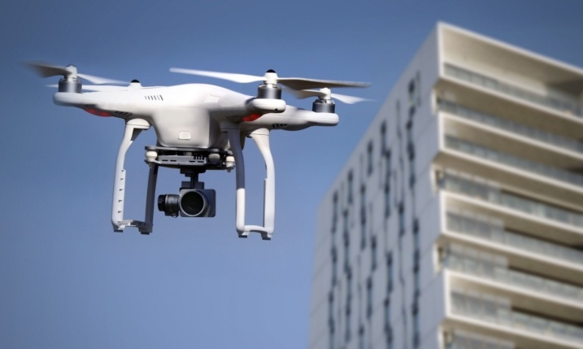
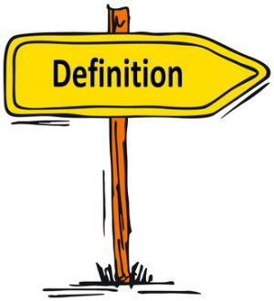

Construction is a type of engineering that uses art and science to form systems, structures or organisations. any data that is generated for a project would be done by a surveyor as they are qualified to collect data efficiently.
digital tools and resources used in
construction

Drones are used mainly in construction for data collection. The data accumulated from the drone is primarily used for surveying and inspection purposes.
Rotary laser levers are used in many construction projects . indoors it is capable of shooting a 360-degrees horizontal and vertical beam around the room whereas outside it will be used as a laser detecter and a grade rod.
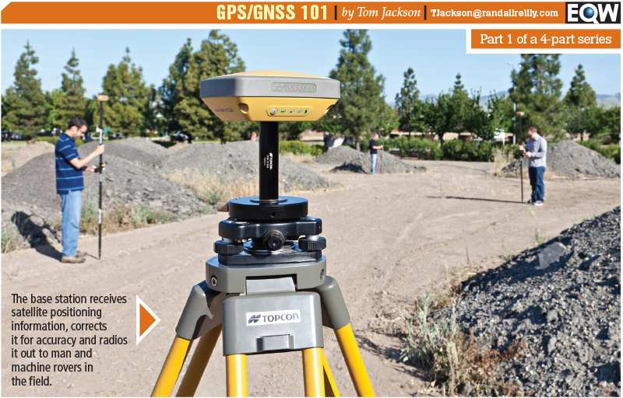
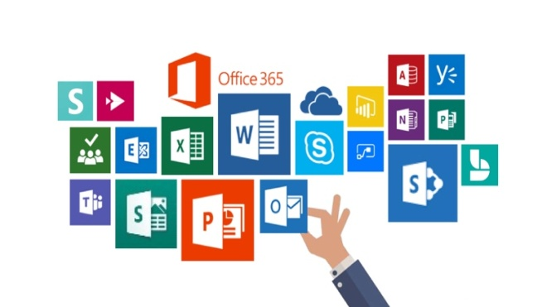

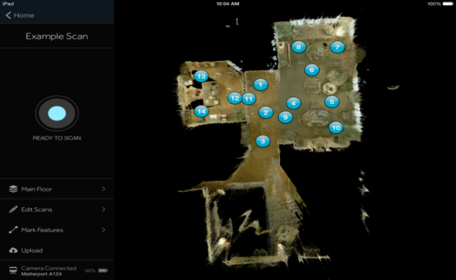

GNSS receiver is used to show velocity,time, and position of locations in construction. It uses signals fm a navigation saelite constellation.

Matter port software is used in construction as an ideal solution for documentation.it offers an 3d expireence of immersive interation rather than having 2d photos.
PROPERTIES | VR  (virtual reality) | AR  (augmented reality) | MR  (mix reality)
USER PER DEVICE | 1 USER | MULTIPLE USERS | MULTIPLE USER
INDOOR/OUTDOOR USESAGE | INDOOR ONLY | INDOOR/OUTDOOR  (Outdoor recommended) | INDOOR/OUTDOOR  (Indoor recommended)
INTERACTIONS | FULLY IMMERSIVE | - INTERACTIVE IN REAL TIME  - FIELD TO OFFICE SHARING | - INTERACTIVE IN REAL TIME  - FIELD TO OFFICE SHARING
USE OF HAND CONTROLLERS | HAND CONTROLLED | HANDHELD OR MOUNTED | HANDSFREE

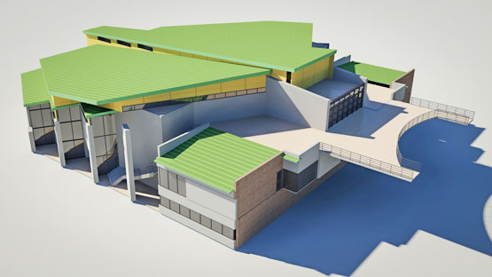

Sketchup is a computer programme for 3D modelling and has wide range of drawing applications. These include interior design, landscape, mechanical enginerring and many more
REFERENCE

- https://cdn-images-1.medium.com/max/2000/1*ONzgfs-vATrLX0jSMNelow.jpeg(drone picture)

https://wingtra.com/drone-mapping-applicatins/drones-in-constraction-and-infrastructure/ (definition drones)

- https://www.equipmentworld.com/wp-content/uploads/sites/2/2016/06/GPSGNSS101Lead.jpg (gnss picture)
https://www.gsa.europa.eu/european-gnss/what-gnss (definition of gnss receiever)

- https://static.matterport.com/mp_cms/media/filer_public/41/a5/41a5a4ef-175a-4373-bed1-cb30c3f649e3/5f8272080793382e05e07cfaeda93f49750cf135.png(matter port pic)

https://go.matterport.com/virtual-tours-general.html?utm_source=bing&utm_medium=ppc&utm_campaign=EN_EMEA_UK_Brand_GEN_matterport_EXT&utm_content=81226485159016&utm_term=matterport&matchtype=e&device=c&msclkid=156574d408351be3a7ad2b3890d2f6cd (Matterport definition)

- https://www.google.com/url?sa=i&url=https%3A%2F%2Fdepositphotos.com%2Fvector-images%2Fconstruction-worker.html&psig=AOvVaw2-o9pFTYSWuy-n8MNS_VEP&ust=1607876355095000&source=images&cd=vfe&ved=0CAIQjRxqFwoTCID0-rLsyO0CFQAAAAAdAAAAABAK (rotary laser pic)

https://www.johnsonlevel.com/news/rotarylaserlevels (definition rotary laser)

- https://mhcdce.com/wp-content/uploads/2019/07/office365.jpg ( Microsoft pic)

- https://www.google.com/url?sa=i&url=http%3A%2F%2Fwww.cadresolution.com%2Fsketchup-3d-modeling.php&psig=AOvVaw2tCkywShp7CzB38Ka38eE2&ust=1609253980056000&source=images&cd=vfe&ved=0CAIQjRxqFwoTCPDWhLH48O0CFQAAAAAdAAAAABAa ( skechup pic)

https://www.howtogeek.com/364232/what-is-sketchup/ ( skechup definition)

- https://buildingpointohiovalley.com/wp-content/uploads/2020/05/Virtual-Augmented-or-Mixed-Reality.png ( picture in teams vr/ar/mr)

https://buildingpointohiovalley.com/archives/tag/sitevision ( information in table)

