

Module Code: ECAD5015

Assignment Title: Deepening Practice
ALN – Part 1 Journal / Part 2 Video Reference list and link (delete as appropriate)
Student Name: Jessica Strong
Student Number: 2304319
BA Primary Education (QTS)

AI Acknowledgement

OR:

I acknowledge the use of mybib https://www.mybib.com/#/projects/5axZZR/citations on 18/05/25 to reference my work . I used the prompt(s):
1. how do I reference …
I confirm that I have not presented any AI generated text as my own work.
I confirm that I have copies of my drafts, notes, and other resources I used before and after the use of AI tools which I may be asked to provide in evidence.

Targets from previous module | How I have worked on these? | An example can be seen on…
Continue to develop a supported critical approach throughout, offering the opposing view whenever possible. | Barriers and limitiatons slides clear and with clear knowledge | Barriers and limitiations slide
Make slides clear and presentable to aid your overall presentation skills. | Slides were clear and had specific information on each | Examples on all slides

Title- My inclusive classroom
Introduction
Children and young people with Additional Learning Needs (ALN) may need more support to learn than the majority of children and young people of the same age. Some pupils may have a disability which prevents or hinders them from making use of the educational facilities provided for learners. “All children and young people work at different rates and will have different events going on in their lives that can also affect their rate of learning” all schools, colleges and local authorities must support all children and young people, including those who have ALN or may have ALN. One of the principles of the ALN Code is inclusive education where children and young people are supported to participate fully in mainstream education, wherever feasible, and a whole setting approach is taken to meet the needs of the pupils with ALN. Pembrokeshire County Council (2021). UNICEF (2025) states that “Inclusive education is the most effective way to give all children a fair chance to go to school, learn and develop the skills they need to thrive. Inclusive systems value the unique contributions students of all backgrounds bring to the classroom and allow diverse groups to grow side by side, to the benefit of all”. The additional learning needs code for Wales states that the duty of the practitioner is to seek the child and parents views on decisions that need to be made to benefit the child, provide clear and relevant information to the child and parent, encourage the child to participate fully in the process, use the child's and parents views to inform decisions and ensure the child and parent has access to information and advice about ALN and the ALN system. Welsh Government (2021). The new Curriculum for Wales offers teachers more flexibility to teach in a way that best meets the individual needs of each child, breaking down barriers to provide excellent education opportunities and outcomes for all learners”. The changes to the curriculum have come from a result of the Additional Learning Needs and Education Tribunal (Wales) Act, giving pupils the opportunity to reach their full potential. The Act aims to identify those needs as early as possible so the school setting can put the right support in place to help the pupil. Pupils with ALN will be supported by an Individual Development Plan (IDP) which sets out in detail the support the pupils need and sets them targets. Welsh Government (2022). The barriers to inclusive education are well- understood now, and include inadequacies in policy and legal support, resources and facilities, specialised staff, teacher training, pedagogical techniques, flexible curricula, supportive leadership and cultural attitudes. To support this, school reviews and plans in training and supporting all teachers in inclusive practices, not just specialised ones, and supporting school leadership to enact an inclusive vision for the school. Enabling policy to clearly articulate and support inclusive education, having strong systems to data collection and management, providing flexibility in curriculum and coordinating with other aspects of the curriculum. Schuelka, M. (2018).

Inclusive practice inside the classroom

Strategy 1-
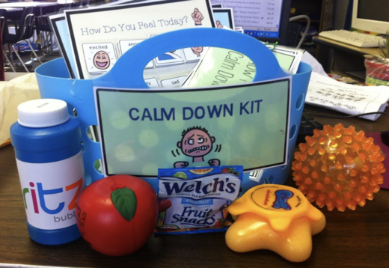 Fidget toys in the classroom are becoming more and more common for learners with Autism, ADHD, Anxiety and other complex additional needs. Fidget toys are small, handheld objects that can be moved around in various ways. Studies have shown that using fidgets and stress balls can increase focus and attention and also work as a stress management tool. Fidget toys are most effective to many students by improving focus, reduce anxiety and managing sensory needs. However other pupils may be distracted or find them disruptive to their learning environment. National Autism Resources (2013). I have seen this first hand in practice during PTE1 and PTE2, it was extremely effective and showed many benefits, such as, increased attention in lessons, less outbursts and more focus. In my future practice this is definitely something I would like to incorporate into my classroom for my ALN students.

Strategy 2-
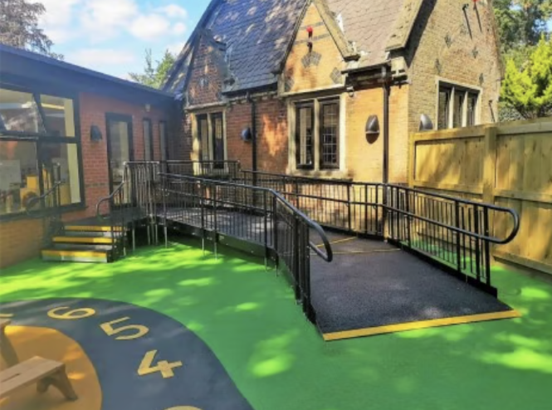The UN Convention on the Rights of the child states that on Article 23” a child with a disability has the right to live a full and decent life with dignity and, as far as possible, independence and to play an active part in the community” UNICEF (2022). The Gov. UK (2012) Education law for school's state that the schools should make reasonable adjustments for inclusion of disabled pupils, physical features such as ramps, lifts and reasonable access with wider doorways etc. The use of ramps in school enables students, staff, visitors, wheelchair users and people with walking aids, to gain access to parts of the school building which would otherwise be inaccessible. Ramps make access much easier without the stress of using stairs and steps when necessary. Ramps have proved to be most effective in schools, access has been much easier and in turn had led to increased pupil attendance due to all schools in Wales having published an accessibility plan and a disability equality scheme that included and updated action plan. Estyn (2011). From my PTE experiences I have seen some of the limitations effecting the use of ramps. The limitations to the use of ramps are usually because of wear and tear, awaiting maintenance, sometimes vandalism especially on outside areas.

Strategy 3-
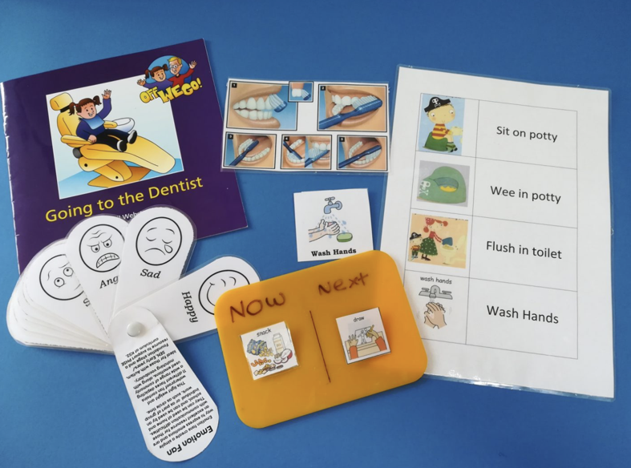Visual aids are used across all schools in Wales. Visual supports refer to objects, photographs, symbols and pictures to communicate. It supports, aids and enhances communication. Visual support helps to provide structure and routine, improving understanding, avoid frustration and offer opportunities to interact with others. Some pupils need support to make choices, and visual supports help them to form opinions, express emotions and support transitions and changes within school. National Council for Special Education (2021). Visual aids are one of the most effective learning tools. It is most effective in its ability to enhance comprehension and information retention. Visual aids simplify complex information and make it more accessible to learners. By presenting information in a visual format learner are able to more effectively process and internalise content. Alabi, M. (2024). In my PTE experience I have seen visual aids in practice across the entire school. It is extremely effective and a learning tool I would like to incorporate into my future teaching. However, when not used correctly it can have a negative impact. Poorly designed visual aids can lead to confusion, misunderstanding or frustration. Poor quality visuals can make it harder for learners to understand the lessons content or can lead to information overload. All visual aids should be used alongside the teacher verbally expressing the key points to be observed.

Strategy 4-
 A pencil grip is a writing aid that fits onto a pencil to help improve finger positioning and fine motor skills. It helps the pupil hold the pencil more securely and may improve pencil control. McGivney (n.d.). This makes writing more comfortable and reduces fatigue or arthritic conditions. A young pupil whilst on my PTE practice often used these grips to help her with her juvenile arthritis. However, some younger pupils can find them awkward or uncomfortable to use when writing, making it harder to control the pen/ pencil precisely.

Conclusion
In conclusion, inclusive learning should be available for all pupils, many different strategies and staff training are important to help any student reach their full potential. I found that all learning strategies worked effectively and had many benefits as long as they were implemented correctly and explained clearly at the child's level and pace. Overall, I feel that the fidget toys were a positive learning aid with some benefits. However, I feel that the negatives outweigh the positives as they are proving to be more of a distraction to the learners and the learners around them. These could be kept in a small box with me so the learners can have them on a need-to-know basis. To ensure that pupils have them for support and not to play with. Accessibility through the use of ramps proves to be highly effective and supports not only the child but also the staff and visitors as well. To remain effective the ramps must be maintained and looked after. To me, visual aids are the most effective for all learners and will be a learning aid that I will use consistently, constantly updating myself with new ideas. Every child has the right to access all educational strategies and use them to their full potential.

References
Image 3- admin (2018). Using visual aids to support understanding. [online] The Autism Page. Available at: https://www.theautismpage.com/using-visual-aids-to-support-an-individuals-understanding/.
Alabi, M. (2024). Visual Learning: The Power of Visual Aids and Multimedia. [online] research gate. Available at: https://www.researchgate.net/publication/385662029_Visual_Learning_The_Power_of_Visual_Aids_and_Multimedia.
Image 1- Autism Adventures. (2013). Calm Down Kit» Autism Adventures. [online] Available at: https://www.autismadventures.com/calm-down-kit/ [Accessed 16 May 2025].
Estyn (2011). Review of Disability Equality Schemes and Practice in schools and pupil referral units. Available at: https://www.estyn.llyw.cymru/system/files/2020-07/Review%2520of%2520Disability%2520Equality%2520Schemes%2520and%2520practice%2520in%2520schools%2520and%2520pupil%2520referral%2520units%2520-%2520June%25202011.pdf
GOV UK (2012). Disability rights. [online] GOV.UK. Available at: https://www.gov.uk/rights-disabled-person/education-rights.
McGivney, J. (n.d.). Occupational Therapy Tip Sheet PENCIL GRIPS. [online] Available at: https://jmccentre.ca/ckuploads/files/10_Pencil_Grips.pdf.
National Council for Special Education (2021). Using Visuals to Support Communication. [online] Government of Ireland. Available at: https://ncse.ie/wp-content/uploads/2021/06/Using-Visuals-to-Support-Communication.pdf.
Nationalautismresources.com. (2025). Fidgets in the Classroom - A Guide for Educators. [online] Available at: https://nationalautismresources.com/fidgets-in-the-classroom/?srsltid=AfmBOoqS4V_-kVKrsJUTZDM6x4FRQfSNqLejpsYgmm4paw-ypQJlSDvy [Accessed 16 May 2025].
Pembrokeshire County Council (2021). Additional Learning Needs (ALN). [online] www.pembrokeshire.gov.uk. Available at: https://www.pembrokeshire.gov.uk/parent-partnership-service/additional-learning-needs-aln.
Image 2- Rapid Ramp Systems. (2025). wheelchair ramps and steps for schools | Rapid Ramp. [online] Available at: https://www.rapidramp.co.uk/education.
Schuelka, M. (2018). Implementing Inclusive Education. [online] Gov.uk. Available at: https://assets.publishing.service.gov.uk/media/5c6eb77340f0b647b214c599/374_Implementing_Inclusive_Education.pdf.
UNICEF (2025). Inclusive Education. [online] UNICEF. Available at: https://www.unicef.org/education/inclusive-education.
Welsh Government (2021). The Additional Learning Needs Code for Wales 2021 WG21-23. [online] Available at: https://www.gov.wales/sites/default/files/publications/2025-01/250124-the-additional-learning-needs-code-for-wales-2021.pdf.
Welsh Government (2022). Education Is changing: Additional Learning Needs | GOV.WALES. [online] www.gov.wales. Available at: https://www.gov.wales/education-changing-additional-learning-needs.

