Task 1: Locating Sources
Identify and locate three different sources (a report, a journal article, and a website) related to the question
“What employability skills do university graduates need to succeed in the workplace?”
Show how you used keywords, search terms, and Boolean operators to find them, and explain how you know which type of source each one is and why it is appropriate for the research question.

Source Type & Why It Is Appropriate | URL/DOI | What search engine did you use? Google/Online Library/Library AI Assistant | Keywords/Boolean Operators Used
journal | https://doi.org/10.1177/23294906251358387 | Uwtsd library online | Employability, skills , succeed and workplace

Task 2: Evaluating Information (CRAAP Test)
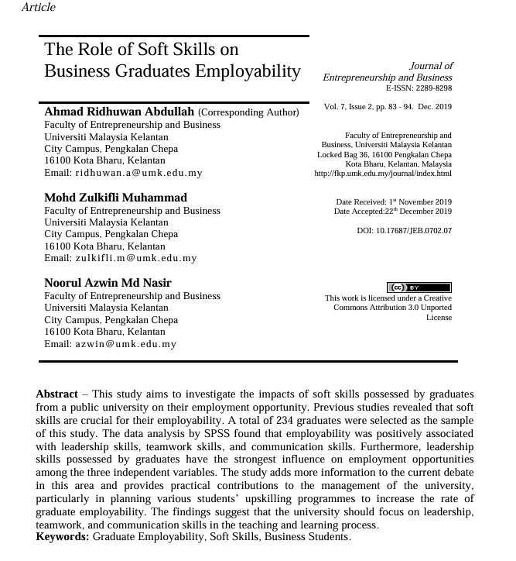
Your colleague has forwarded you a source from a peer reviewed journal, and they are not sure whether it is appropriate to use and has asked for your help. Your task is to evaluate the source by using the CRAAP Test to assess its appropriateness for the following question “What employability skills do business university graduates need to succeed in the workplace?”

CRAAP Test
Currency | The article was written in Decembre 2019
Relevance | The article is relevant because discuss about soft skills and employability
Authority | The author is credible because him is working at university
Accuracy | The study use data from 234 graduates
Purpose | The article aim to inform readers about soft skills
Task 3: Source Analysis
Your manager has provided you with a short extract from a source and has asked you to analyse the source by Identifying one strength, one weakness, and providing a brief explanation of the strength and weakness identified.
If you want to read the article online, please click the following link: https://www.universitiesuk.ac.uk/latest/news/strong-demand-graduates-employers

.
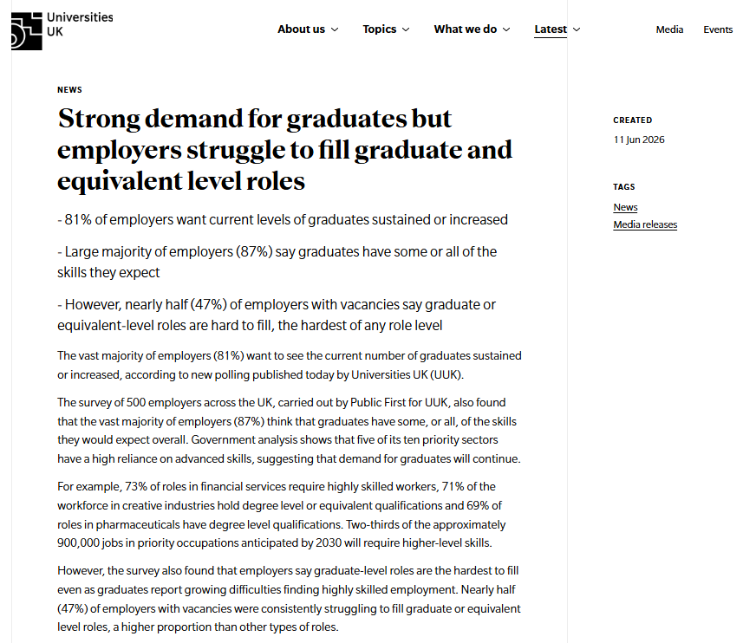

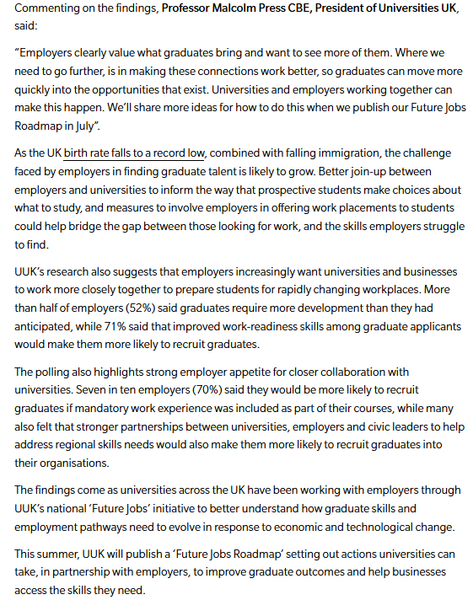

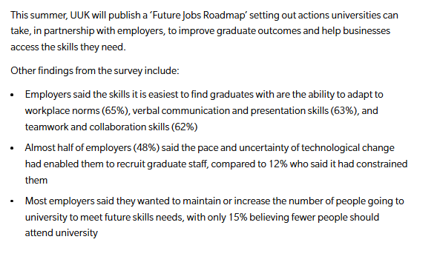

Strength of the Source:

One strength of the article is it’s the currency. It was published in 11 june 2035 that make it recent and relevant.

Weakness of the Source:

one weakness of this source is that only include 500 employers. this may not represent all the employers in UK.

