ASSIGNMENT DETAILS AND FEEDBACK
SOUTH WEST WALES CENTRE FOR TEACHER EDUCATION
Sections marked with * should be completed by module lead
Student number: | 1700654
Programme: * | PGCE Primary
Module: * | School Development and Pupil Progress | Module Level (6 or 7):* | 7
Module code: * | M7X02153 | Contribution to Overall  Module Assessment (%): * | 70%
Module Lead:* | Helen Lewis | Word count: | 4750
Assignment Details:* | Written assessment 4,500 words | Assignment No (x of x):* | 1/2
Start date:* | 5/3/17 | Submission deadline:* | 30th May 2018
Return date of provisional marks & written feedback:* | 27th June 2018

Referencing: | In the main body of your submission you must give credit to authors on whose research your work is based. Append to your submission a reference list that indicates the books, articles, etc. that you have read or quoted in order to complete this assignment (e.g. for books: surname of author and initials, year of publication, title of book, edition, publisher: place of publication).
Submission: | All assignments must be submitted to Turnitin unless otherwise instructed by the Lecturer.  Note: the Turnitin version is the primary submission and acts as a receipt for the student. Late submission of the electronic version of the assignment will result in a late penalty. Penalties for late submission: Up to one week late, maximum grade D. Over one week late, Refer. Only the Extenuating Circumstances Panel may grant an extension. | Date: | 30th May 2018

Module lead to tick to indicate if a hard copy version of the assignment must be submitted.* | YES
 | NO

Student Self Evaluation Form

This section repeats in brief the common assessment criteria detailed on previous pages. The extent to which these are demonstrated by you determines your mark. Using these criteria, tick the box that best indicates the level of achievement you feel you have achieved with regard to each of them.

Common Assessment Criteria Applied
Common Assessment Criteria Applied | REFER |  | D |  | C |  | B | A
 | OUTRIGHT FAIL | UNSATISFACTORY | SATISFACTORY | GOOD |  | VERY GOOD |  | EXCELLENT
1. Subject Knowledge and Understanding (which includes using research-informed literature and knowledge and understanding of the subject)
 |  |  |  |  |  | ☒
2. Intellectual Skills (Analysis)
2. Intellectual Skills (Analysis) |  |  |  |  |  | ☒
3. Pedagogic and Professional Applications (Practical Application and Deployment)
 |  |  |  |  |  | ☒
4. Key Transferable Skills
4. Key Transferable Skills |  |  |  |  |  | ☒

PLEASE COMMENT ON AREAS IN WHICH YOU FEEL THAT YOU HAVE PERFORMED WELL | PLEASE COMMENT ON AREAS you feel that you need TO DEVELOP
I was able to analyse the data well and research strategies to address next steps. | I found it difficult to write in an academic style given the nature of the assignment.

Supporting pupil progress: a detailed analysis of one child’s holistic development, with justification for the next steps in learning.
The research was conducted in a small Church in Wales school situated in a village in the South-West of Wales. 162 pupils attend the school and a low amount of pupils receive free school meals (My Local School, 2017). All pupils reach the expected level in the core subject indicator in Key Stage 2 (My Local School, 2017). The school and its staff will not be named in this assignment in order to ensure confidentiality and anonymity (United Kingdom Government, 2018).
This study will focus on the learning of one focus child. After a conversation with the class teacher, a learner was selected based on their attendance and current attainment. The study focuses on one female year 6 pupil from a classroom which consisted of 26 year 6 pupils and 4 year 5 pupils. The learner is 11 years and 2 months old and has a reading age of 11 years. She has a high attendance rating of 97%. The learner has currently been working at a level 4 standard but the teacher has targeted the pupil to reach a level 5 by the end of the academic year. Child A is a popular member of the class and is well liked by her peers. She enjoys participating in the school’s Can Actol for the Urdd Eisteddfod and is a keen member of the school choir. Recently, Child A demonstrated grit and determination when she challenged herself to complete every activity at the residential visit to Glan Llyn.
In order to ensure the learner’s anonymity and confidentiality, they will be referred to as Child A. This study will explore Child A’s learning through several different areas of evidence in order to assess their holistic development, which is important given the current emphasis placed on the development of the child as a whole in order to meet the four purposes of the new curriculum (Donaldson, 2015). From this analysis, logical next steps will be identified for the learner and suggestions will be made on how these next steps can be facilitated by the teacher.

Methodology
Design
The Mosaic Approach (Clark & Moss, 2011) was the main methodology applied in this study. This is a multi-method approach which focuses on the experience of the child. It encompasses several approaches which Clark and Moss (2011) claim are child friendly and allows for their learning and learning preferences to be explored. It also allows for logical next steps in learning to be identified and addressed. This is in line with the research guidelines published by the British Educational Research Association (BERA) (2011) as they specify that the researcher must comply with Articles 3 and 12 from the Rights of the Child (United Nations, 1990). Article 3 involves the best interests of the child being at the centre of all actions which affect children. Therefore, research undertaken must be done for the greater good of the child. This study is being conducted with the best interests of the child at the forefront of its aims as it aims to explore how the child learns and identify next steps to develop her as a learner and move her learning forwards.

Participants
Child A is female and is 11 years and 2 months old. She has a reading age of 11 years. The child was selected for the study after consulting the class teacher using the purposeful sampling method which Koerber & McMichael (2008) explain involves the researcher selecting participants based on the qualities they possess. The child was selected because she is currently targeted for a higher level than the level she is working at and therefore, this study would be of benefit to the learner. The criteria also included the necessity of obtaining informed consent to conduct the study in the school from the class teacher (See appendix A). Another key element of the criteria was the child providing informed assent because children are not able to legally consent (Dockett, Perry & Kearney, 2012). The child provided verbal assent (See Appendix B). Moreover, BERA (2011) state in their research guidelines that the informed consent and assent must be provided voluntarily and without duress. This is part of the Nuremberg Code (United States Government, 1947). It was ensured that the child knew that they did not have to participate and could withdraw at any time, in line with BERA (2011; United States Government, 1949).

Materials
Qualitative data was collected because it has been argued that this form of data is most appropriate to educational research as it allows for insight into the classroom, coherence and for idiosyncratic ideals to be explored (Eisner, 2017). Opposing this argument, Cohen, Manion and Morrison (2017) suggest that as there is no defined criteria for data analysis the true findings may be overlooked. However, the Mosaic Approach allows for an individual’s idiosyncratic learning preferences to be explored and therefore findings should not be overlooked as the learner’s views and preferences have been explored with the learner and therefore have been taken into account. Moreover, the researcher was aware of the subjective quality of the quantitative data and tried to ensure that they were objective and refrained from letting personal views interfere with the study. Under the data protection act (2018), all data collected on Child A will need to be kept secure and it must be ensured that the child and school must not be identified in order to ensure confidentiality and anonymity.
A semi structured interview was conducted with Child A after the learning walk in order to gain further insight into their views on learning. Given article 12 of the Rights of the Child (United Nations, 1990) and Estyn’s current recommendations of good practice (Estyn, 2016), this was an important part of the process as it allowed for the child to voice their views and to have them considered. This is also an important aspect of BERA (2011). The questions asked had been pre written (See Appendix C), in order to minimise the risk of asking leading questions which would not have been ethical and could have resulted in false findings (Bell, 2010). However, they were asked in any order as was relevant and natural on the learning walk. A potential issue with the semi structured interview was that social desirability bias hay have occurred and resulted in the child providing answers they thought they should rather than being honest about their own views. To minimise this risk it was ensured that the child knew to answer honestly. BERA (2011) states that the researcher has the responsibility to ensure that participants are treated fairly, sensitively and are not exposed to prejudice. Moreover, they must feel at ease and not be put in a situation which risks emotional or physical harm (BERA, 2011; United States, 1949). In line with this, questions were asked naturally on the learning walk which occurred in an environment which they felt comfortable in.
Similarly, the observation notes (See appendix D) collected could have been affected by social desirability bias and the Hawthorne effect (Gillespie, 1991) as the child may behave differently or in a way they think they are supposed to if they realise they are being observed. In order to minimise this risk the researcher observed the child in an unobtrusive way.
Child A’s work (See Appendices E, F, G, H, and I) was levelled using the National Curriculum level descriptors for mathematics and numeracy (Welsh Assembly Government (WAG), 2016b) and English and literacy (WAG, 2016a) and wellbeing was explored using the Personal and Social Education (PSE) framework (WAG, 2008). Consent to take and use photographs was obtained from the head teacher (See Appendix J) and it was ensured that the child’s parents had provided consent for photographs to be taken. Child A was listened to reading by the researcher and this was recorded on a reading record (See Appendix K). A possible limitation to this is that the reading record is subjective and based on the opinion of the researcher. In order to minimise this risk, the researcher tried to ensure that comments made were solely about the reading they had listened to.

Procedure
Once informed assent had been obtained from the child and informed consent had been obtained from the teacher, data was collected following the three stages of the Mosaic Approach which are gathering documentation, piecing together information and deciding on continuity or change (Clark & Moss, 2011).
Information was gathered from a range of different sources as the Mosaic Approach suggests with its many tiles of information (Clark & Moss, 2011). The researcher observed the child in a number of different setting including in the classroom, on a residential visit and on an educational visit to the national park. A learning walk was conducted in order to explore the learning spaces in the school and which ones were most important to her. An informal interview was also conducted with the child to find out more about them and their preferences. Child A’s work was also collected in order to see what level they are working at.
Once data had been collected, it was analysed using the attitudes, skills and knowledge (ASK) model (Nottingham, 2013) in order to piece information together in a meaningful way which would provide an insight into the child and the learning taking place. This is of importance as Watkins, Carnell and Lodge (2007) note that too much focus has been placed on superficial terms rather than the key elements of learning. Moreover, the four purposes of the new curriculum (Donaldson, 2015) highlight the importance of the child being active in their learning and clearly state that they need to develop a range of qualities in order to be successful individuals. Therefore, the child’s attitudes, skills and knowledge need to be developed in order for them to fulfil each of the four purposes. By organising the data collected into the areas of the ASK model (Nottingham, 2013), the child’s areas for development will be clearly identifiable.
Finally, once the data had been analysed, the third part of the Mosaic Approach (Clark & Moss, 2011) was completed. This involved identifying logical next steps for Child A and the tools which would be used to support the learner.

Analysis of Child A as a learner
The data collected will be analysed in this section using the Attitudes, Skills and Knowledge (ASK) model (Nottingham, 2013). In order to analyse Child A’s attitudes the data must be explored to find information about her open-mindedness, curiosity, desire to succeed, resilience and self-regulation (Nottingham, 2013). Exploring what the data illustrates about Child A’s attitudes it is apparent that she demonstrates some curiosity about learning. Looking at her “know, want to know and learnt” (KWL) grid (See Appendix E) from the beginning of the class topic “Heroes and Villains” it is clear that she is able to assess her own knowledge and come up with her own questions about the topic. On the learning walk Child A showed the researcher the school council displays and said that she is part of the eco-council. She was enthusiastic about having a responsibility and this showed her desire to succeed both in her learning and in her role. Moreover, whilst on the learning walk, when asked to show the researcher her favourite display she took the researcher to the corridor display that her class had done and said she liked it because “my work is on this display and I think I did really well this lesson.” This shows that the learner takes pride in her achievements and enjoys celebrating her work. She is able to be open minded and can approach situations both in the classroom and outside of school with an open mind that is ready to learn about what ever opportunity may arise. This has been demonstrated in topic lessons where she has participated in activities to familiarise with the topic and explored the new topic from several perspectives. On the recent residential visit to Glan Llyn Child A demonstrated her ability to be open minded as she did not react to any of the activities negatively and gave them all a try. Her resilience and self-regulation were also demonstrated at Glan Llyn when she completed the high ropes despite being fearful of them (See Appendix D).
However, in the semi-structured interview (See Appendix C) which took place during the learning walk, she said that “my spelling is bad.” This suggests that she has a fixed mindset (Dweck, 2007) with regards to her spelling and it could be argued that her resilience and open-mindedness are lacking with regard to her ability to spell words. Moreover, relating back to PSE framework (WAG, 2008), this suggests that in order to prepare Child A for lifelong learning she needs to be encouraged to take responsibility for her learning and to work on areas of development rather than see them as permanent flaws. Despite this weakness in her current attitude, she regulated her emotions well whilst on the high-ropes in order to complete the course. She demonstrated self-regulation on the bus on the way home as well as she was feeling unwell but did not let her emotions rule her behaviour (See Appendix D). On the learning walk, it was interesting to note that Child A pointed out a map of the school (See Figure 1 below) and said her favourite areas of the school were the classroom “because I feel safe there” and the outdoor area “because there are pretty gardens and I can play with my friends.”
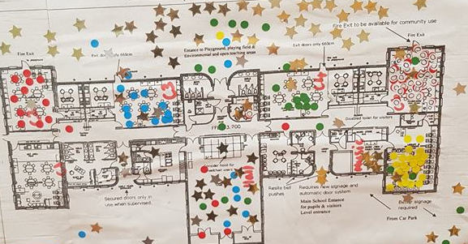

Figure 1: Map of school with Child A's favourite areas circled.
In order to analyse Child A’s skills, her intellectual, social, communicative and physical skills must be explored from the data collected (Nottingham, 2013). Analysing her social and communication skills, Child A has demonstrated an ability to talk and listen to others with confidence in a range of contexts such as in classroom discussion, in group work tasks and outside of school such as our class residential visit to Glan Llyn. She adapts her speaking to the purpose of the situation such as when she conveyed her opinions about the school on the learning walk and when she discussed the history of the last invasion of Britain with her group in a thematic topic lesson in order to re-enact parts of the history (See Figure 2 below). Overall, her oracy best fits a judgment of level four (WAG, 2016a). A possible area for improvement is that she uses some appropriate standard English but her vocabulary could be improved. Moreover, her confidence with her spelling is a target which she identified herself on the learning walk.
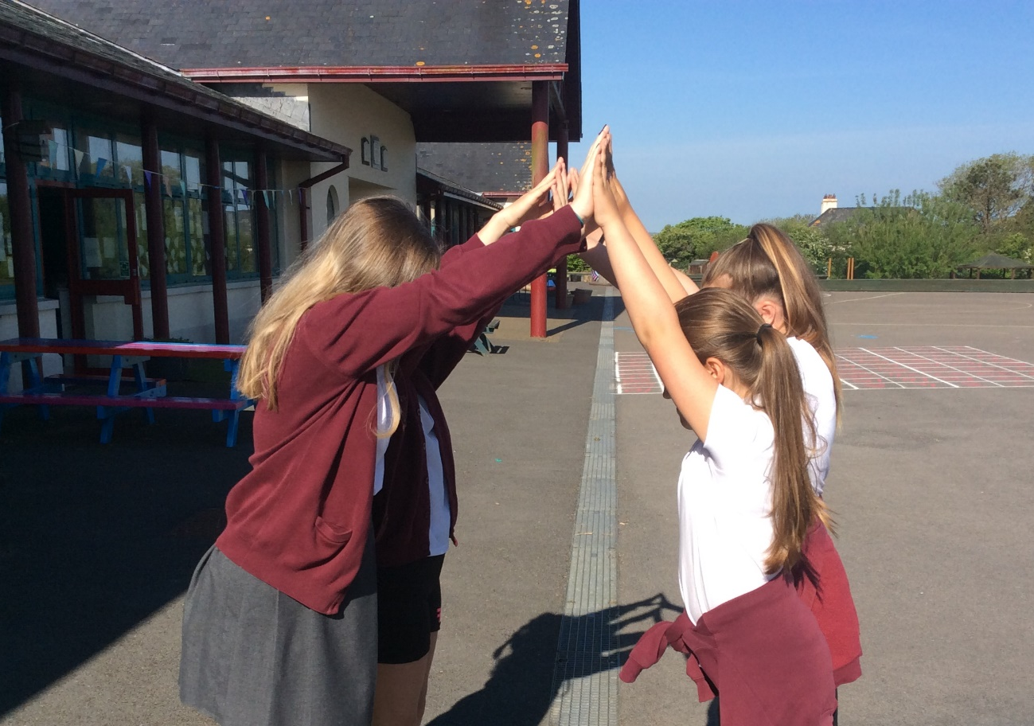

Figure 2: Child A and her friends re-enacting scenes from the history of the last invasion of Britain.

Exploring her intellectual level of literacy, Child A’s reading age is 11 years which is on par with her actual age. Moreover, she researched the author Roald Dahl as homework and effectively located information about him from a range of websites and used them effectively to inform her own writing of a non-fiction information portrait about the author (See Appendix F). When reading her book she is able to read fluently and can make inferences about what may happen next in the book (See Appendix K). However, she has not demonstrated her ability to make inferences. Overall, as a best fit judgment her reading is currently of level four standard.
Exploring her writing as seen in her extended writing on Roald Dahl (See Appendix F) Her writing is imaginative and clear but is not very lively. She is able to organise her writing appropriately for the purpose and can express her opinion in the text and support it with some reasons. She uses a variety of sentence structures and her spelling is usually accurate. She organises her work clearly into paragraphs and uses a range of punctuation accurately. However, she does not use very interesting vocabulary. Interestingly, when exploring texts (See Appendix G) Child A struggled to think from an alternative point of view.
Similarly, her mathematical intellectual skills are currently a best fit judgment level four. When set a rich thematic task to find the grid references of key areas of the last invasion of Britain and work out the distances between them (See Appendix H) she was able to provide a four figure grid reference, read the scale on the map and convert from centimetres to Kilometres correctly, using the scale. In other work (See Appendix I) she has demonstrated her ability to identify appropriate approaches and tried different strategies for different questions such as knowledge of place value, times tables, chunking and other strategies. She is also able to check her work. She demonstrated an understanding of place value and could apply this knowledge when finding 10% of a quantity. She was also able to apply this to find 15% of a quantity through the chunking strategy. It is interesting to note that at the end of this lesson, when the child wrote about the way she worked she stated that she worked in a pair. She has also been observed working in pairs on several occasions (See appendix D).
Her physical intellectual skills have been demonstrated both in the classroom and on our residential visit to Glan Llyn. Child A was able to participate in the range of physical activities at Glan Llyn both on and off the water (See Appendix D). She also applied her physical intellectual skills in a topic lesson in which pupils worked in groups to re-enact images associated with the history of the last invasion of Britain (See Figure 2). As is evident in the image Child A was able to arrange herself into several different poses in order to recreate scenes. However, on a walk through part of the national park, she misplaced her footing and fell in some mud during the walk (See Appendix D).
Finally, exploring Child A’s knowledge it is apparent that she is able to identify the key facts learnt in the lesson as she consistently places them onto her information grid after the lesson in topic (See Appendix L). In maths lessons (See Appendix I) she has demonstrated her knowledge of concepts and was able to select appropriate strategies in order to answer different questions. She was also able to think about these strategies and identify their use in real world situations. This demonstrates her knowledge and level of understanding of the strategies. Child A has demonstrated her knowledge of ideas and was able to be creative and think of poses in order to re-enact scenes from the last invasion of Britain (See Figure 2). Unfortunately, Child A has not had the opportunity to demonstrate her knowledge of figures recently.
Although next steps have been identified, it is important to note that the study has some limitations. In particular, the attainment levels provided for the child in this analysis may not be accurate as there was not much evidence to consider to base those levels upon. Ideally there would have been more work to level in order for a more accurate best fit judgement to be made but due to the time constraints of the study and the class commitments to extra-curricular activities there has not been much teaching time recently. Moreover, due to the time constraints of the study, Child A was only worked with for a few weeks and the researcher may have learnt more about Child A if there had been more time to spend with her to explore her learning. Using the mosaic approach was interesting as it is aimed at the early years (Clark & Moss, 2011). However, it worked well as a data collection method as the child was seen from different perspectives rather than only in terms of her academic attainment.

Next Steps
Throughout the process of analysing the data, areas for improvement were identified from different sections of the ASK Model (Nottingham, 2013) and will be addressed below. To summarise, Child A has developed some positive attitudes towards her learning but needs to develop her open-mindedness and resilience particularly when working on skills which she perceives she is weak at, such as spelling. In terms of her skills, Child A has demonstrated both creative and practical physical skills. Her communication and social skills are flourishing but she currently has a limited vocabulary and would benefit from expanding it in order to be able to use it orally and when writing. She has also identified spelling as an area of her literacy which could be improved. Her intellectual skills are developing well and she is able to write at a best fit judgement level four standard. In numeracy tasks she has demonstrated several skills and now needs to work on applying her knowledge of place value to decimal numbers as well as whole numbers and thus reach part of the level five descriptor. Summarising her knowledge, Child A needs to be provided with opportunities to work with figures.
Beginning with Child A’s attitude for learning, it is suggested that she needs to improve her open-mindedness and resilience in order to improve her capability to take responsibility for her own learning as part of the PSE framework (WAG, 2008). A possible strategy to facilitate this would be to use growth mindset (Dweck, 2007). Growth mindset (Dweck, 2007) is the theory that people can have a fixed mindset which involves them believing that they are unable to improve or they can have a growth mindset which allows people to believe that skills can be developed overtime (Dweck, 2007). Arguably, Child A has a fixed mindset in relation to her ability to spell and may benefit from changing her attitude to that of a growth mindset. Supporting Dweck (2007), studies have found that children that have a growth mindset are able to work harder and achieve more (Good, Aronson & Inzlicht, 2003; Blackwell, Trzesniewski & Dweck, 2007). This would enable Child A to overcome her previous failures and rather than see them as negatives she would instead see them as first steps in her learning (Maxwell, 2012). The benefits have also been recognised by Estyn (2017), they reported that implementing a growth mindset has enabled schools to successfully change pupil’s attitudes towards their learning. By teaching children to apply positive vocabulary from the growth mindset approach to all learning activities and building up the ethos across the school, pupils achieve better outcomes. The Education Endowment Foundation (EEF) (2018a) have shown that pupils that received growth mindset intervention made an additional two months progress in literacy and numeracy. However, it must be acknowledge that these findings did not have a high level of statistical significance. Therefore, it can be argued that enrolling this ethos out across the school would not only help Child A and other pupils to develop their attitude towards learning and improve their resilience and open mindedness, but it may also improve their academic achievements generally.
Analysing Child A’s skills it is apparent that she needs to address some intellectual targets in literacy and numeracy. Although the aim of this study is to enhance the holistic development of the child, it is also important to set high expectations of the child academically and Griffiths and Burns (2014) note that children that are set high expectations excel in their learning. Therefore, it is important to set next steps in learning for Child A which relate to the curriculum levels and aim to move her attainment up to the next level. A target of importance related to Child A’s numeracy skills is to apply her knowledge of place value to decimals - which is a level five skill, as she has already proven that she can apply it to whole numbers - which is a level four skill. In order to facilitate this target the child needs to understand place value and be aware of how to apply it to different situations, including when working with decimals (EEF, 2017). In order to develop this understanding the child would benefit from the teacher modelling applying the knowledge of place value to decimals. Modelling is an instructional strategy which allows for the approach to be demonstrated by the teacher whilst children observe. However, it can be argued that this approach leaves children passive rather than active in their learning. This would not be ideal given that children need to be actively engaged in their learning (Donaldson, 2015). However, modelling the behaviour would allow the teacher to scaffold the learning (Bruner, 1978). Moreover, this is a key element of direct teaching (Hattie, 2009), which involves a clear success criteria, the teacher modelling how to carry out steps and assessing understanding through the lesson. Donaldson (2015) acknowledges and supports this pedagogical approach.
Analysing her literacy skills a target of importance to move her forwards is to improve her spelling and vocabulary. Being able to spell an increasing number of words would improve her confidence in her literacy skills and having a richer vocabulary would enable her to reach some of the aspects of the level 5 literacy descriptor. In order to facilitate this, Child A needs to be provided with opportunities to collaborate with others in speaking and listening tasks which have been found to extend pupil’s vocabulary (EEF, 2018b). Collaborating with others would allow her to work with someone else which has been identified as a way that she prefers to work (See Appendices D and I). Moreover, Vygotsky (1962) argued that children learn through social interaction. In order for Child A to be exposed to new vocabulary the teacher needs to teach new vocabulary and expose the child to a language rich environment (EEF, 2018b). It is vital that the child is active in learning new vocabulary (EEF, 2018b). Moreover, it has been found that educating pupils about morphemes develops their vocabulary and also improves their spelling (EEF, 2018b). Using helpful displays to support Child A with this is supported by theories such as Vygotsky (1978) and the Zone of Proximal Development (ZPD) as the display would help scaffold the learner to reach her next step. Therefore, approaching these targets together through the use of a language rich environment and supportive displays (Vygotsky, 1978), collaborative work (Vygotsky, 1962) and modelling (Bruner, 1978) aspects of vocabulary and spelling such as morphemes, as suggested by the EEF (2018b), would enable the child to actively work on both of her next steps in literacy.
Finally, in order to develop her knowledge Child A now needs to be provided with opportunities in order to demonstrate her knowledge of figures. This can be implemented by the teacher ensuring figures are planned into topic lessons in order for Child A to experience working with figures and demonstrate a knowledge of key figures related to topic such as the date of the last invasion of Britain. Moreover, given that Child A expressed positive feedback about her work being on displays it will be important to celebrate her work and achievements in future lessons in this way. This is supported by visible learning (Hattie, 2009) as the theory argues that by displaying pupils progress in a visual way learners are motivated by their achievement and the positivity of their success.

Conclusions
To conclude, the study has enabled me to explore the holistic development of the child, which is of crucial importance given the emphasis the new curriculum in Wales places on the development of the child as a whole (Donaldson, 2015). Upon reflection, it has enabled the me to explore assessment for learning and develop next steps which set high expectations of the learner which has been argued to be of key importance in moving the learning forwards (Griffiths & Burns, 2014). I have also been able to identify strategies to implement to facilitate the child to fulfil their next steps. Whilst exploring possible strategies, the strengths and limitations were examined and this allowed me to strengthen my knowledge about different strategies and why they may be effective. Looking forward, I will now be able to support Child A to strive towards her next steps and be able to research and implement strategies to support future children in their learning and development. Moreover, when supporting future learners I will be familiar with the research process and will be able to research new innovative strategies which is part of the new professional standards of teachers in Wales (WAG, 2018).

References
Bell, J. (2010). Doing Your Research Project: A guide for first time researchers in Education and Social Science (2nd ed.). Buckingham: OUP.
BERA (2011). Revised Ethical Guidelines for Educational Research. British Educational Research Association. UK. Retrieved from: https://moodle.uwtsd.ac.uk/pluginfile.php/133352/mod_resource/content/1/20 18%20BERA %20ethical%20guidelines.pdf [Accessed: 14th April 2018].
Blackwell, L., Trzesniewski, K., & Dweck, C.S. (2007). Implicit theories of intelligence predict achievement across an adolescent transition: A longitudinal study and an intervention. Child Development, 78. 246-263.
Bruner, J. S. (1978). The Role of Dialogue in Language Acquisition. In A. Sinclair, R., J. Jarvelle, and W. J.M. Levelt (eds.) The Child's Concept of Language. New York: Springer-Verlag.
Clark, A., and Moss, P. (2011). Listening to young children the Mosaic approach. 2nd ed., London: National Children's Bureau.
Cohen, L., Manion, L., and Morrison, K. (2017). Research methods in education. Routledge.
Dockett, S., Perry, B., & Kearney, E. (2012). Promoting children’s informed assent in research participation. International Journal of Qualitative Studies in Education. Vol 26, Issue 7.
Donaldson, G. (2015) Successful Futures: Independent Review of Curriculum and Assessment Arrangements in Wales. Cardiff: Welsh Government.
Dweck, C. (2007) Mindset – the new psychology of success. New York: Ballantine Books.
Education Endowment Foundation (2017). Improving Mathematics in Key Stages 2 and 3. Available at: https://educationendowmentfoundation.org.uk/tools/guidance-reports/maths- ks-two-three/#closeSignup [Accessed: 28th May, 2018].
Education Endowment Foundation (2018a). Changing Mindsets. Sutton Trust-Education Endowment Foundation Teaching and Learning Toolkit (London: Education Endowment Foundation). Available at: https://educationendowmentfoundation.org.uk/projects-and- evaluation/projects/changing-mindsets#project-results [Accessed: 28th May, 2018].
Education Endowment Foundation (2018b). Guidance Reports, Literacy KS2. Available at: https://educationendowmentfoundation.org.uk/tools/guidance-reports/literacy-ks-two/ [Accessed:28th May, 2018].
Eisner, E. (2017). The Enlightened Eye: Qualitative Inquiry and the Enhancement of Educational Practice. Teachers College press. Columbia University: New York and London.
Estyn (2016). Pupil Participation: a Best Practice Guide. Available at: https://www.estyn.gov.wales/sites/default/files/documents/Pupil%20participation.pdf [Accessed: 26th May, 2018].
Estyn (2017). Encouraging learners to achieve more than they expect of themselves. Available at: https://www.estyn.gov.wales/effective-practice/encouraging- learners-achieve-more-they- expect-themselves [Accessed: 27th May, 2018].
Gillespie R. (1991). Manufacturing knowledge: a history of the Hawthorne experiments. Cambridge University Press; Cambridge, MA.
Good, C., Aronson, J., & Inzlicht, M. (2003). Improving adolescents’ standardized test performance: An intervention to reduce the effects of stereotype threat. Applied Developmental Psychology, 24, 645- 662.
Griffiths, A., and Burns, M. (2014). Teaching Backwards. Crown House Publishing Company.
Hattie, J. (2009). Visible Learning: A Synthesis of Over 800 Meta-analyses Relating to Achievement. Routledge.
Maxwell, J. (2012). Failing Forward: Turning mistakes into stepping stones for success. Thomas Nelson Publishing.
Nottingham, J. (2013). Encouraging Learning: how you can help children learn. London: Routledge.
United Kingdom Government (2018). Data Protection Act 2018.
United Nations (1990). Convention of the Rights of the Child. Available at: https://downloads.unicef.org.uk/wp- content/uploads/2010/05/UNCRC_united_nations_convention_on_the_rights_ of_the_child.pdf?_ga=2.148856759.145814980.1519727583- 1802678951.1507379063 [Accessed: 226th May, 2018].
Vygotsky, L. S. (1962). Thought and language. Cambridge MA: MIT Press.
Vygotsky, L. S. (1978). Mind in society: The development of higher psychological processes. Cambridge, MA: Harvard University Press.

Watkins, C., Carnell, E., and Lodge, C. (2007). Effective Learning in Classrooms. Paul Chapman Publishings: London.
Welsh Assembly Government (2008). Personal and social education framework for 7 to 19 year olds. Department for children, education, lifelong learning and skills.
Welsh Assembly Government (2016a). Curriculum for Wales: Programme of Study for English Key Stages 2-4.
Welsh Assembly Government (2016b). Curriculum for Wales: Programme of Study for Mathematics Key Stages 2-4.
Welsh Assembly Government (2018). Professional standards for teaching and leadership. Available at: http://learning.gov.wales/docs/learningwales/publications/170901-professional- standards-for-teaching-and-leadership-en.pdf [Accessed: 28th May, 2018].

Appendices
Appendix A
Letter to obtain informed consent from the class teacher. Names and signatures have been covered to ensure anonymity and confidentiality.
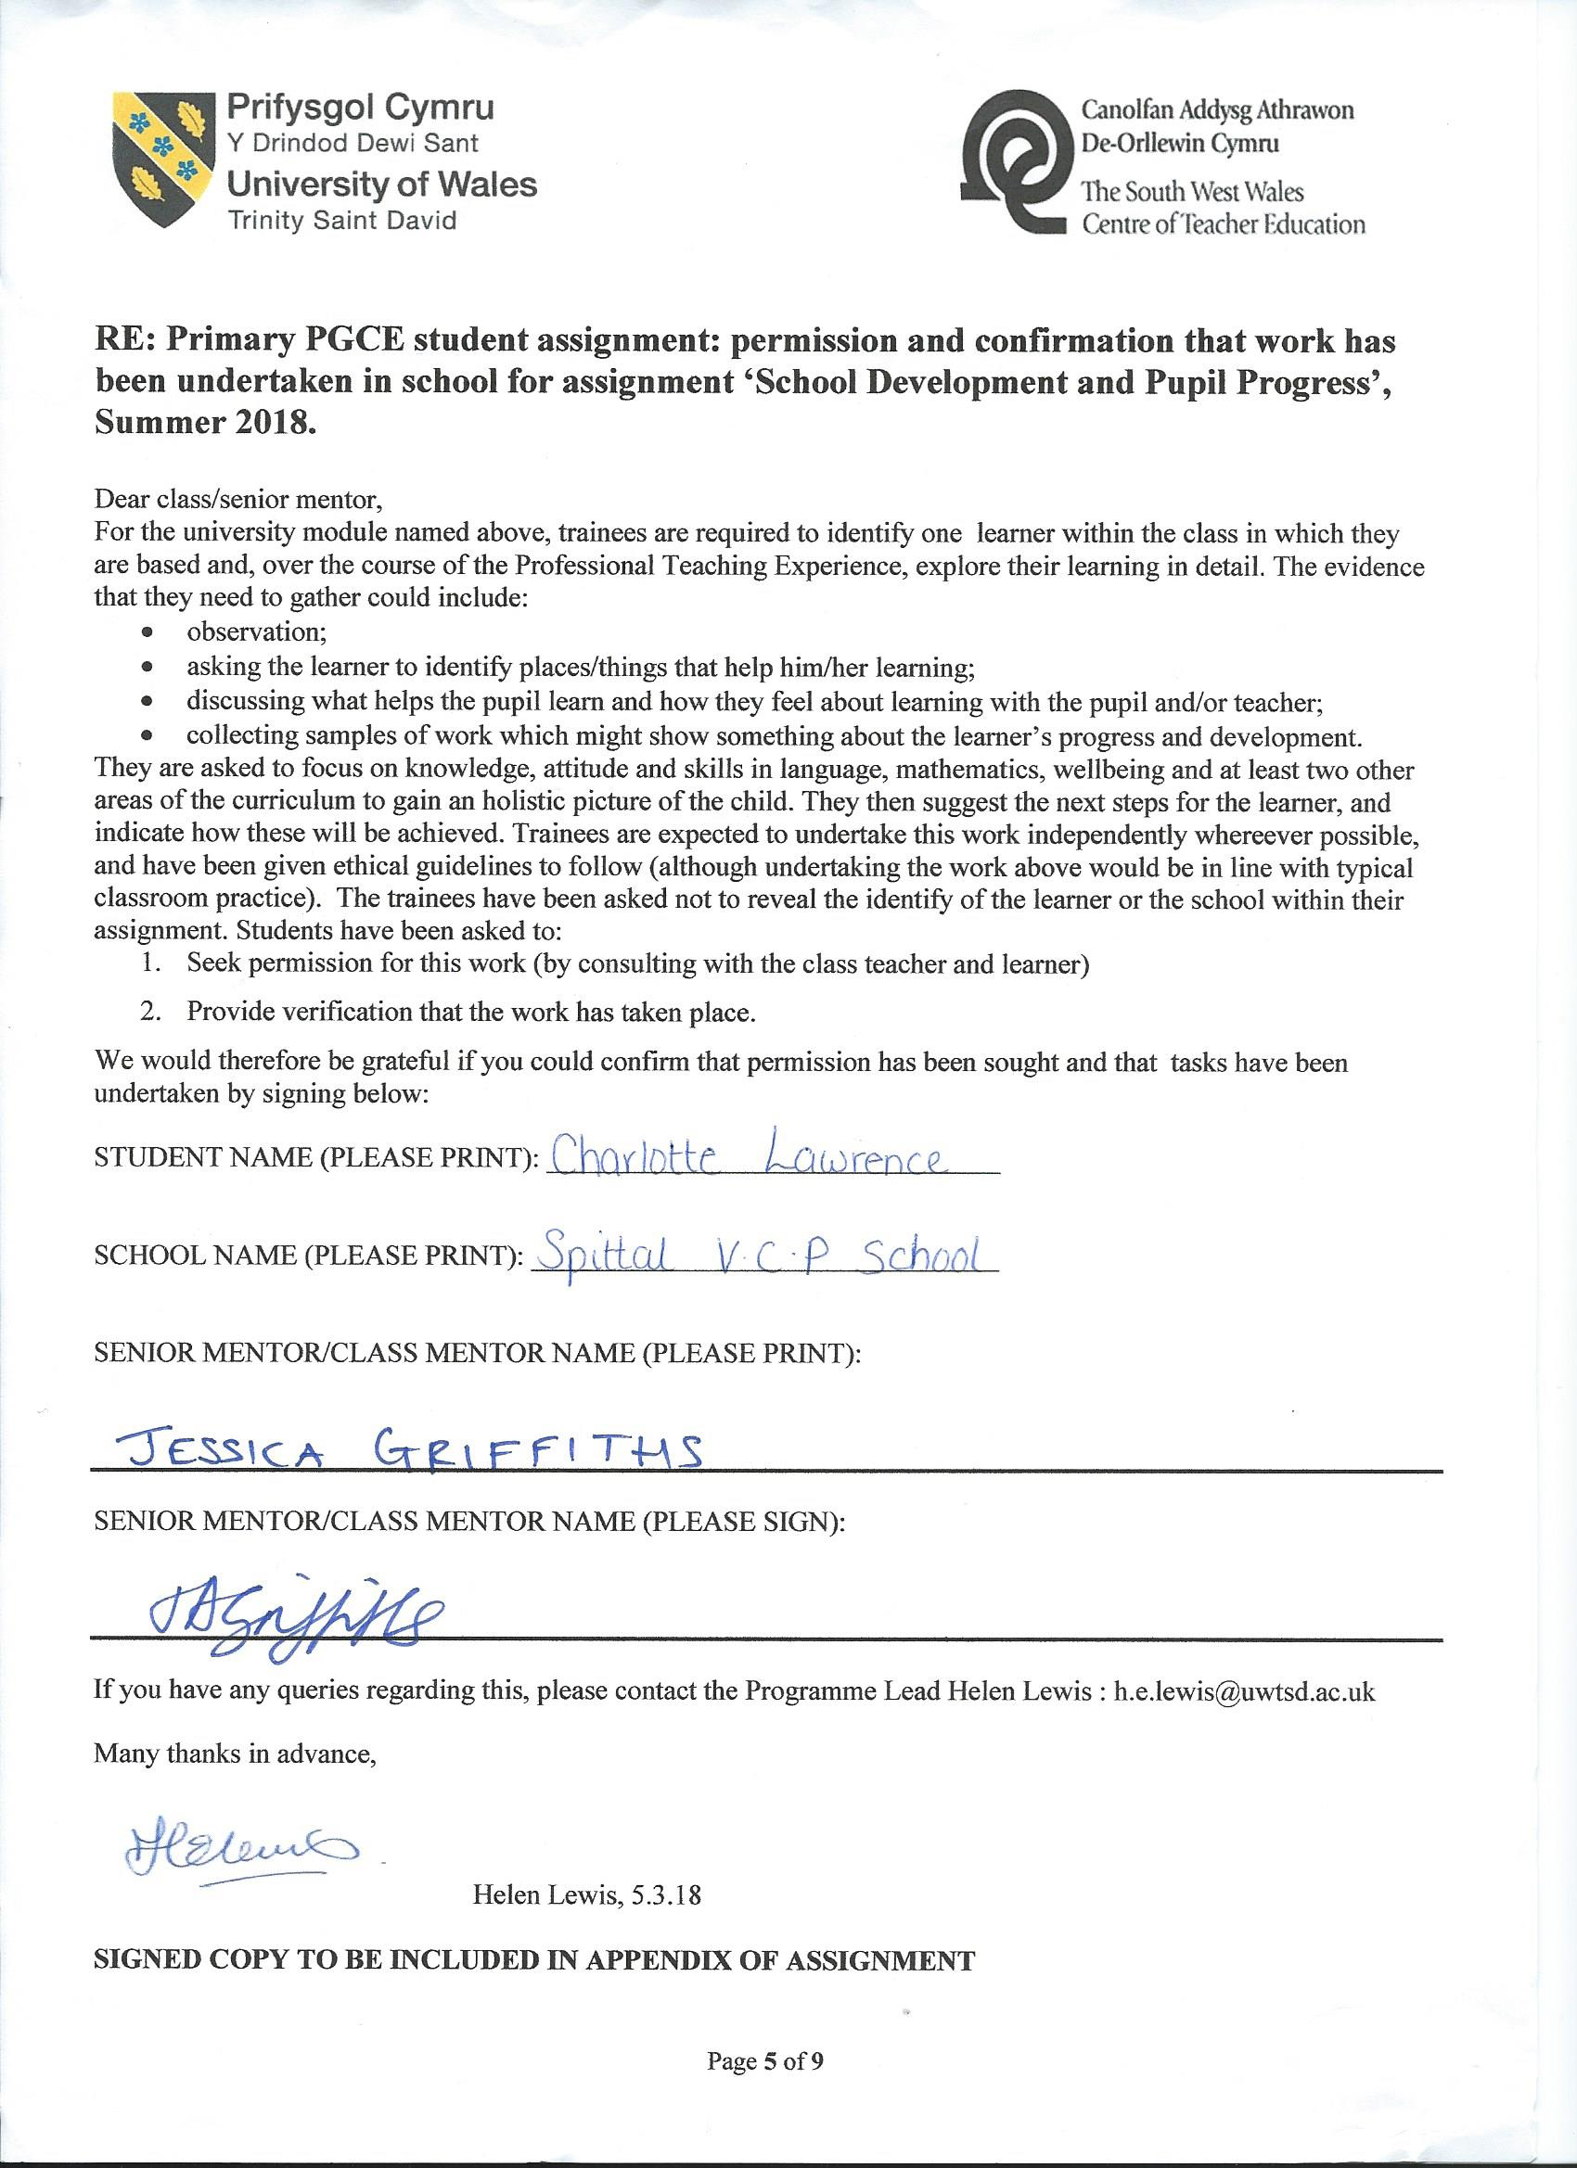

Appendix B
Preamble read to the focus child in order to obtain verbal informed assent.
I am learning how to help children develop as learners. If you want to, you can help me to find out about your school and learning by showing me around the school, answering some questions and letting me see how you work best. You do not have to do this and can say no if you want to. If you do decide to take part you have the right to decide that you do not wish to take part anymore and can tell me and I won’t ask you anymore questions to do with this research and you will not receive any consequences as it is your right to decide if you take part or not. If you are willing to take part let me know.

Appendix C
Semi structured interview questions.
Interview Questions
- What do you remember doing when you were this age?
- Do you have any responsibilities within the school?
- What do your responsibilities involve?
- What would you have put on this display if you were in that class?
- Which is your favourite display?
- Where is your work?

Appendix D
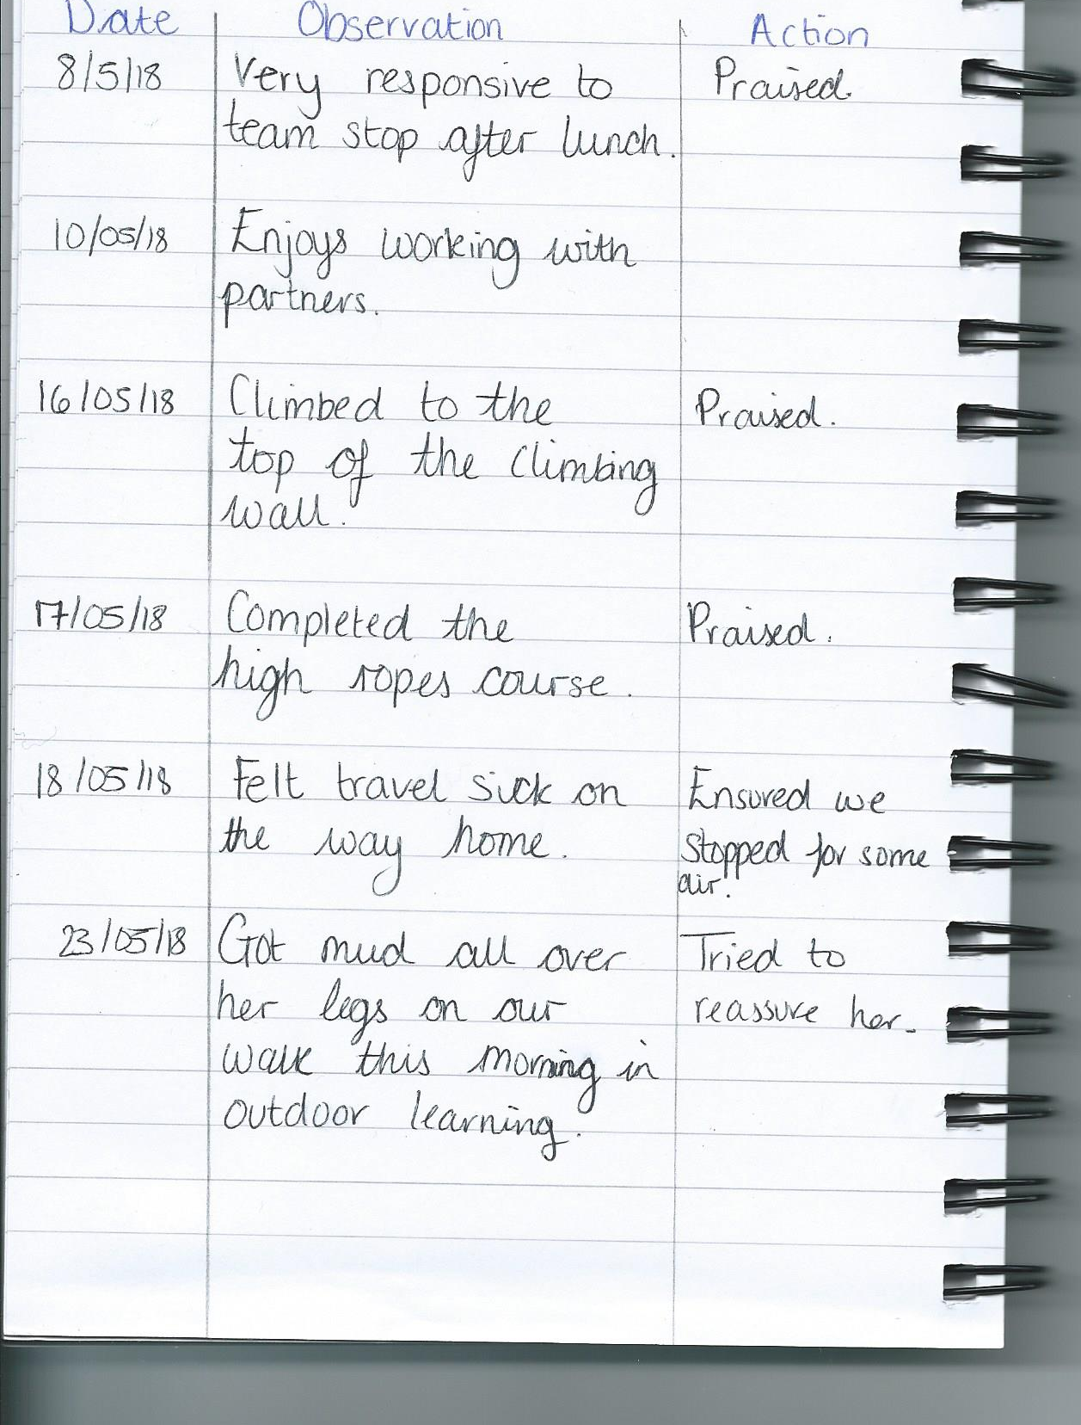
Observation notes.

Appendix E
Introduction to topic – KWL grid.
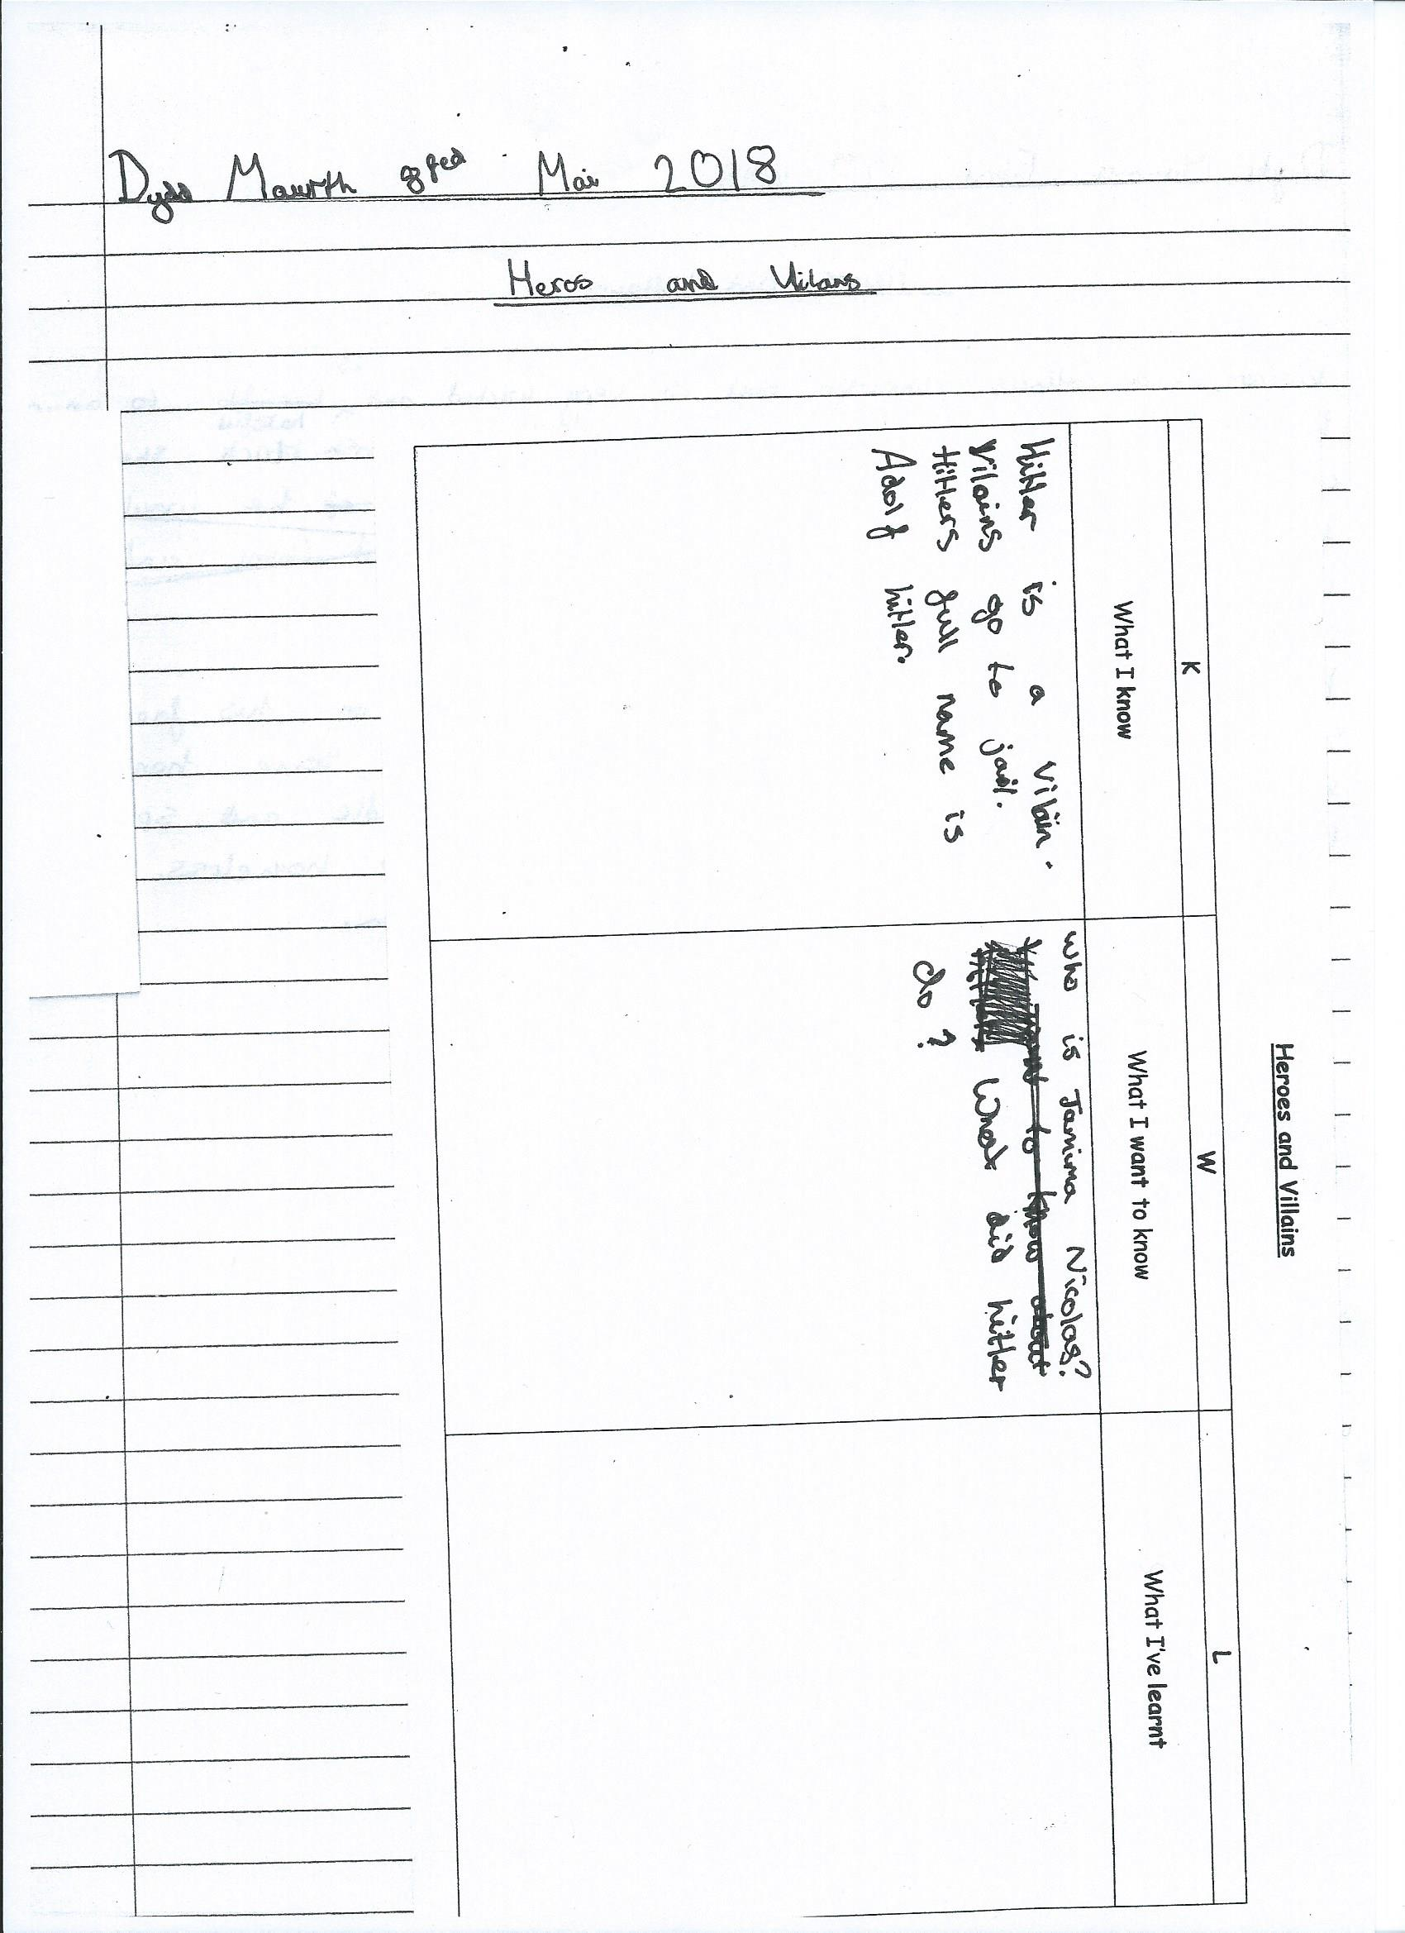

Appendix F
English – writing a non-fiction information text on researched person of choice from Wales.
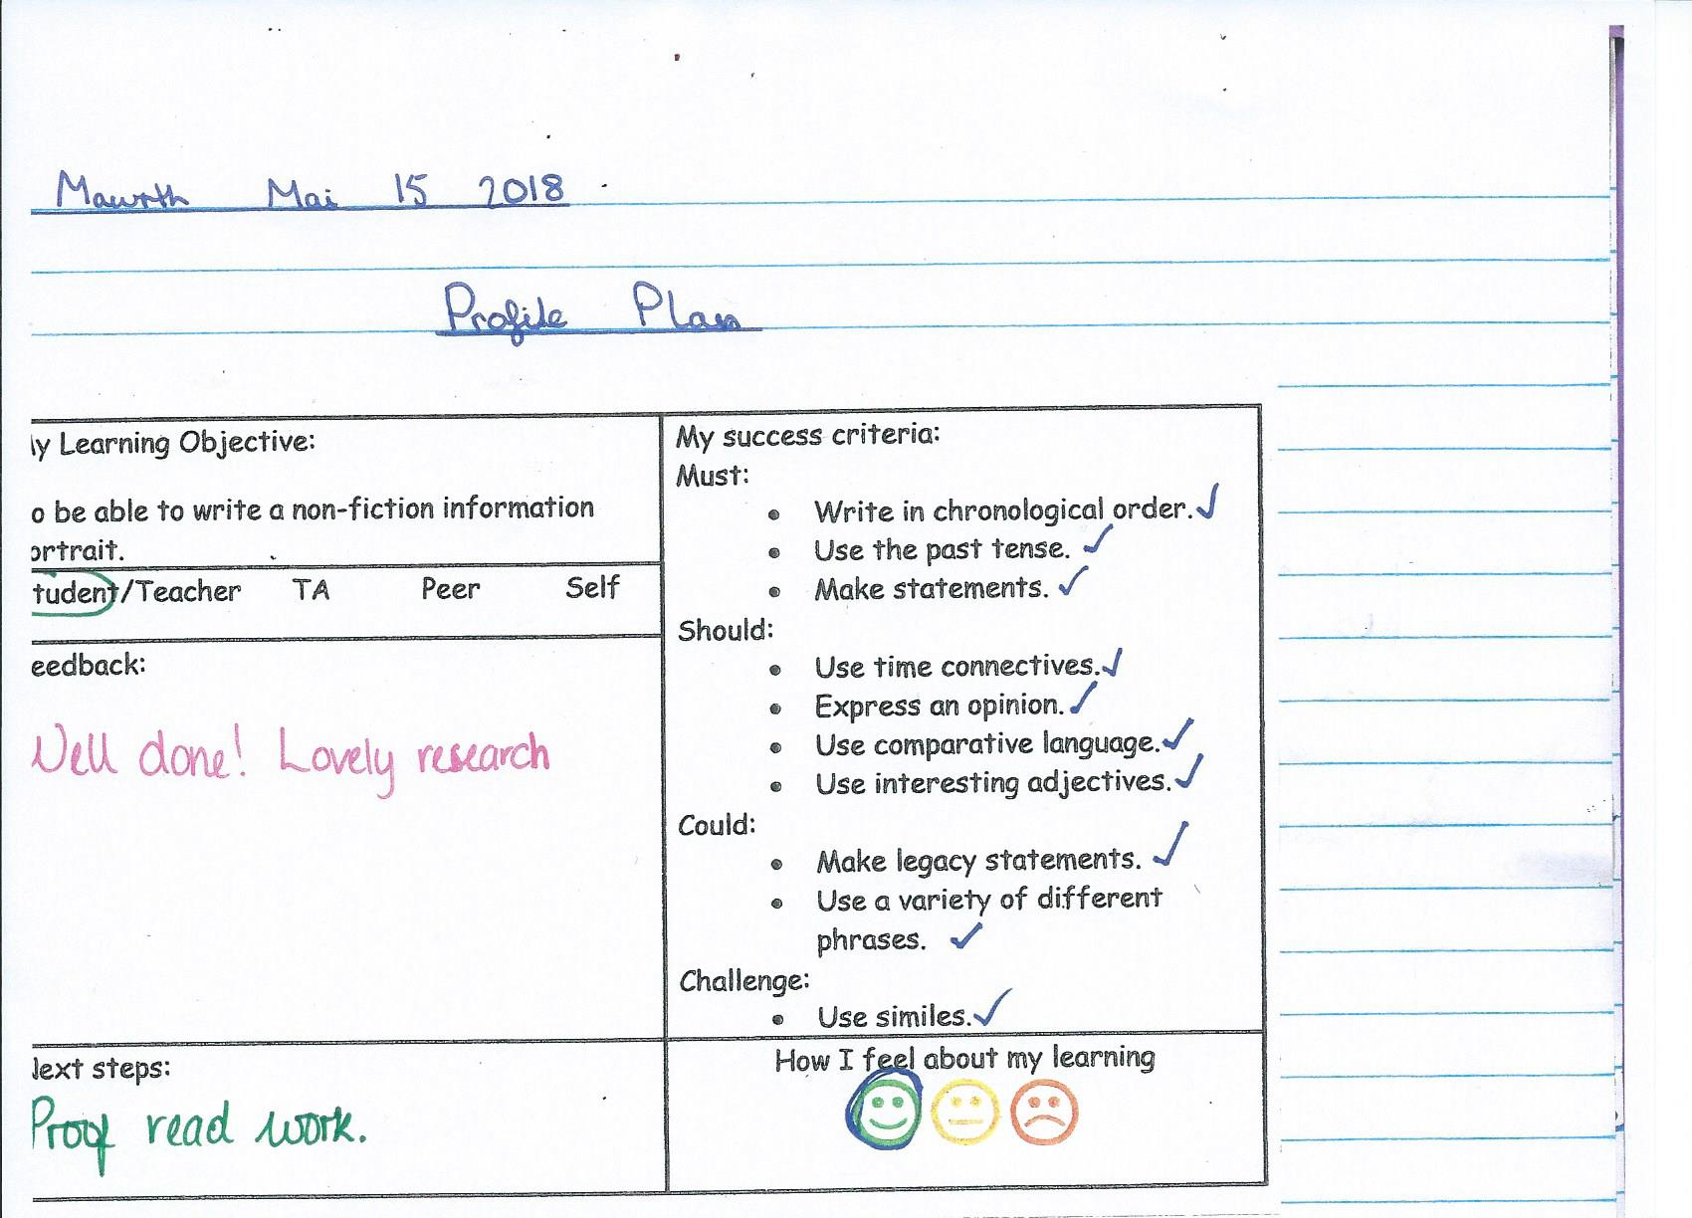
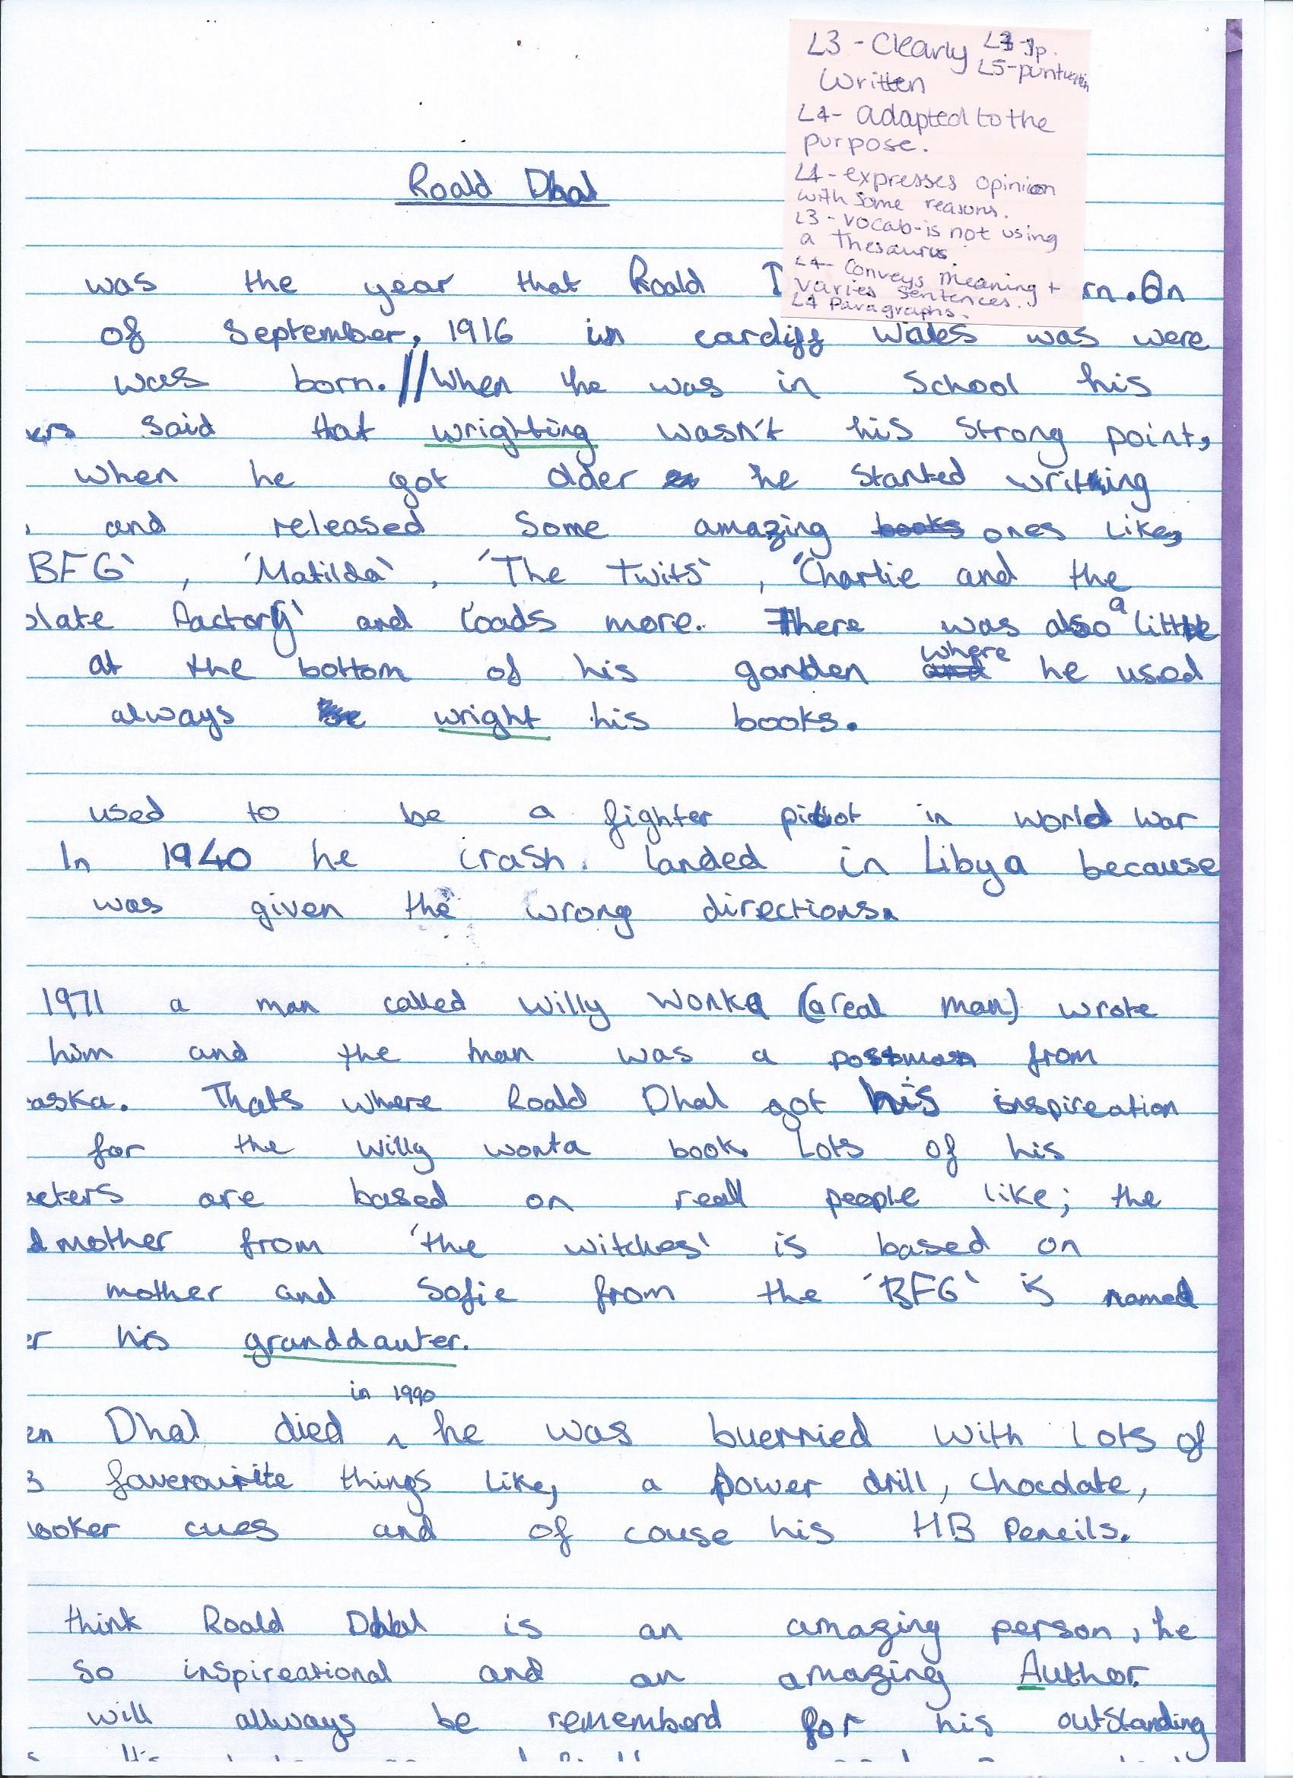

Appendix G
English – evaluation of non-fiction information texts.
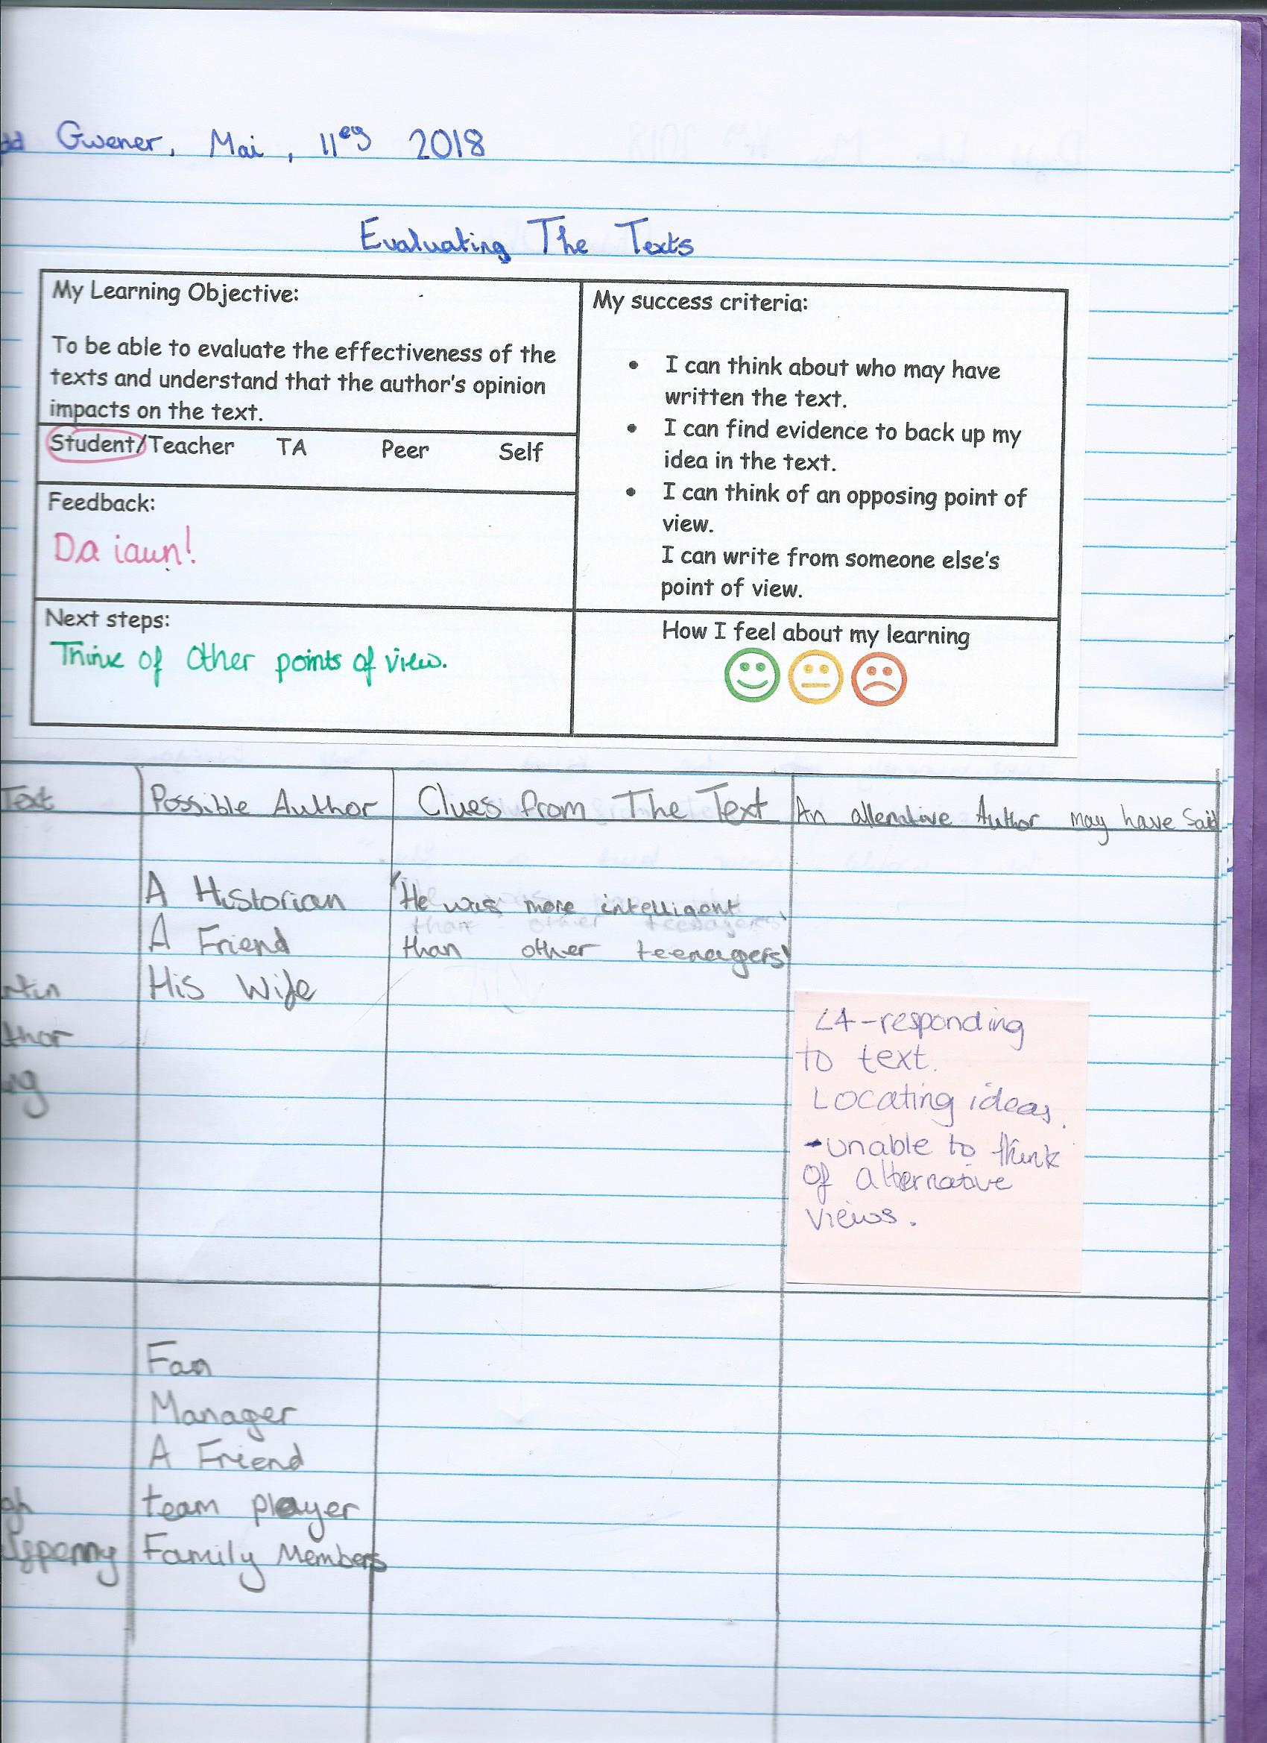

Appendix H
Topic – finding grid references for key areas related to the last invasion of Britain on an OS map and working out the distance between them.
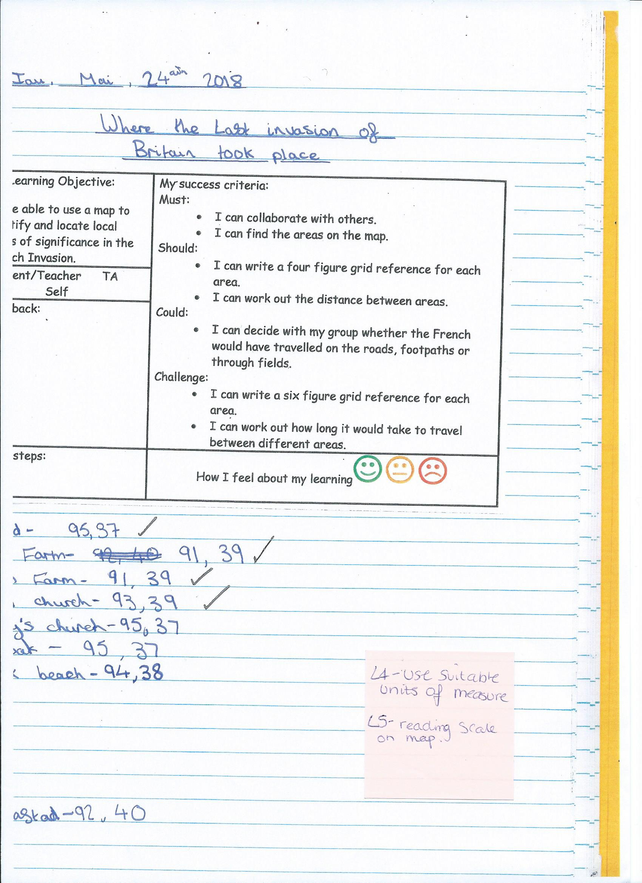

Appendix I
Maths – percentages of quantities.
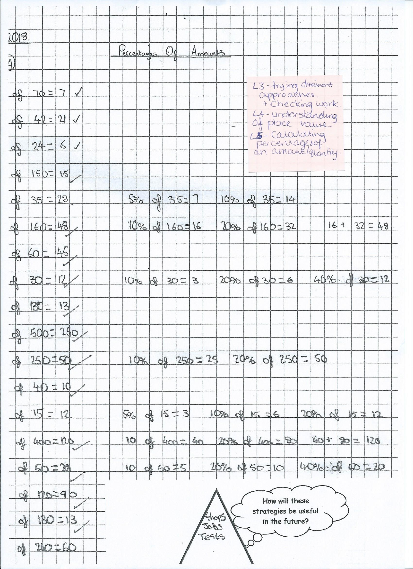
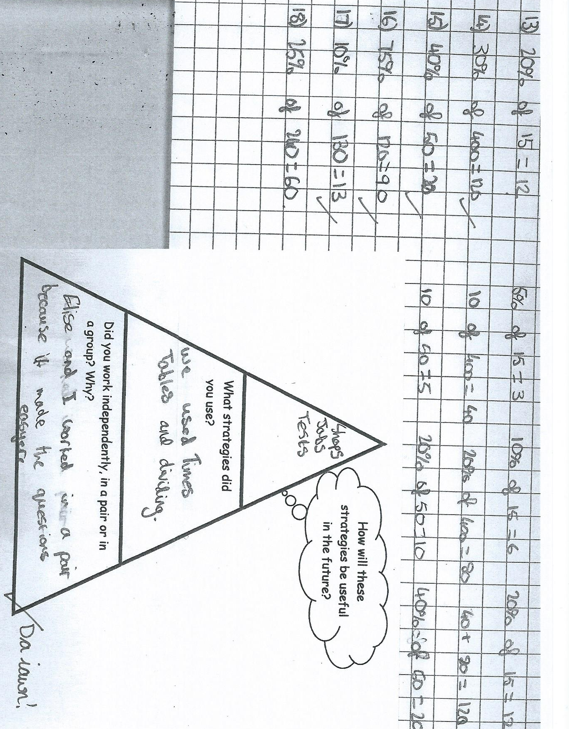

Appendix J
Consent to take photographs from the head teacher.
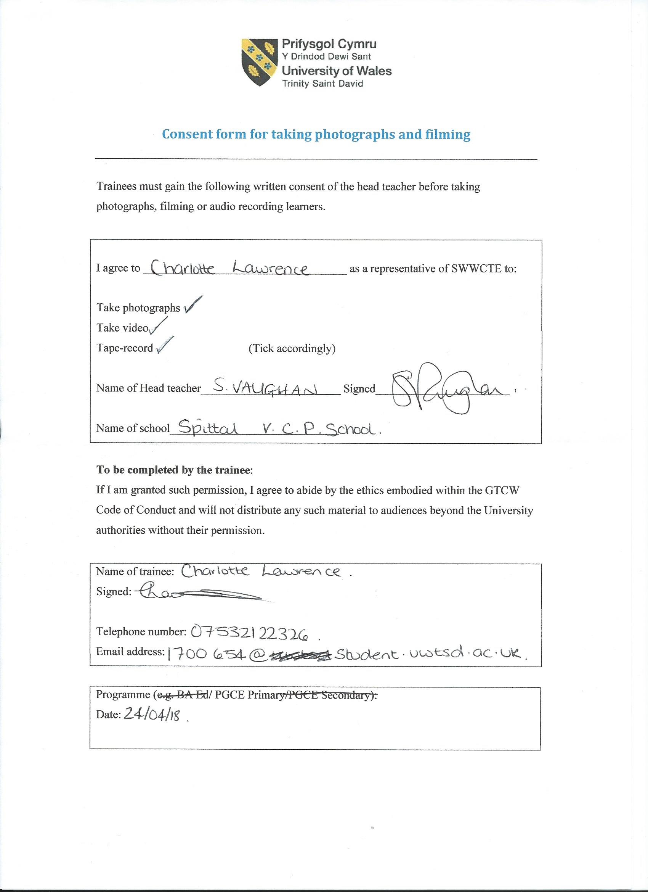

Appendix K
Reading record.
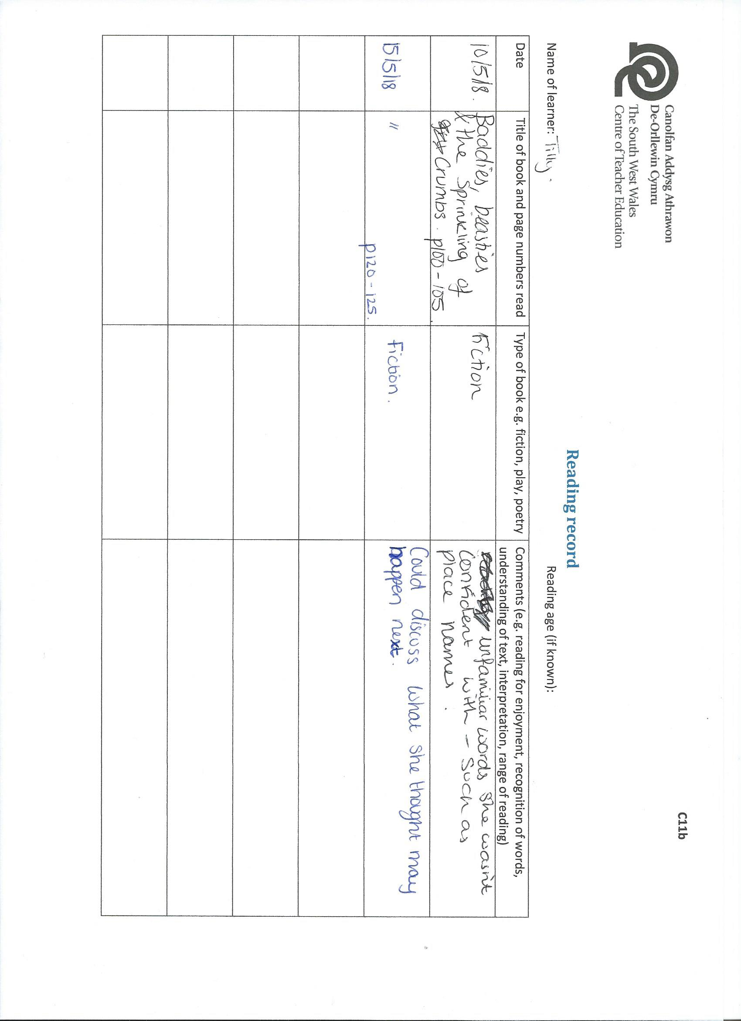

Appendix L
Topic – learning grid. 

