

MARKETING ESSENTIAL
RESIT/REWORK ASSESMENT 2 – MARKETING PLAN AND PRESENTATION

Student name: Elena Stenic
Student ID: 2246472
Module: Marketing Essentials BHIM4005
Lecturer Name: Scott James
Word Count: 1774

Component A

Introduction
The following report is to be about the marketing essentials and will cover different area related to the report topic. The purpose of this report is to identify the internal problems, find marketing opportunities for Hilton and create a communications strategy for the efficient operation of the company in the market. The following market plan is being prepared for the company Hilton which is currently one of the biggest players in the hospitality industry in the UK. The following report will try to analyse the current situation of the company through models like SWOT, STP and PESTLE. The report will also suggest some strategies the company can use for their future growth.

Situation Analysis

5’Cs

Company: SWOT Analysis
Strengths  - Hilton Hotel has a huge brand reputation and currently the third largest hotel chain by market cap.  - A company with a huge customer base. In 2022, the company welcomed a whooping number of 200 million guests (Hilton, 2023). | Weaknesses  - Hilton Hotel had a security problem in 2018 when it had to compromise the credit card details of customers. The company’s brand image was damaged.
Opportunities  - Hilton Hotel can heavily in marketing to increase the customer base.  - Hilton can expand and develop its business in mid-scale and budget segments. | Threats  - Economic problems have caused trouble for the hospitality industry including Hilton.  - Geopolitical tensions and act of terrorism is always a risk for big hotel chains like Hilton.
Table 1: SWOT Analysis
(Source: created by the learner)

Customers: Segmentation and Targeting
Hilton's segmentation strategy focused on building hotels on bustling areas. Hilton customers are basically young to middle-aged professionals with high incomes between the ages of 25 to 40. Hilton mainly focuses on customers like business professionals who travel a lot or people who like to travel in general.
 | Name: Peter Harrison  Profession: Travel Vlogger/YouTuber
Demographic features:  - Age - 25  - Location - London, UK  - Educational Background - Graduated | Interest:  - Making travel videos for social media.  Goals:  - Exploring new places.  - Travelling to every single country in the world.  Communication Channels:  - Instagram  - Twitter  - Facebook  - YouTube
Bio: Peter Harrison, a resident of London is a YouTuber with more than 100k subscribers who make travel videos for people. Harrison explores new places and shares his experiences on social media.
Table 2: Customer Personal
(Source: created by learner)

Competitors: Perceptual Positioning Map
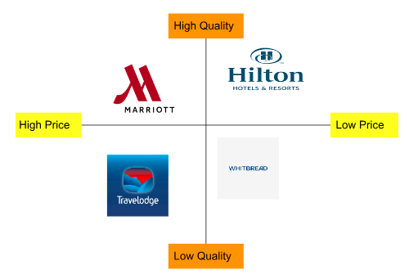
Figure 1: Perceptual Map
(Source: created by learner)
From the above perceptual map, it can be seen that Hilton offers better services as compared to other competitors in the hospitality sector of the UK as it offers better quality service at a low price.

Collaborators: Demonstration of the organisation's B2B Relationships, Partnerships and Franchises.
One of the biggest advantages of B2B business is that hotels can directly access to travel agents. With B2B distribution, Hilton no longer has to connect with customers directly. Hilton is partnered with a B2B business powered by purchasepro.com (Economictimes, 2023). Hilton also offers franchises; a total investment of 38 to 162 million dollars is required to begin operation of a typical 300-room Hilton hotel. Franchising will help to leverage the brand recognition and attract guests who are loyal to a specific brand (Hilton, 2023).

Climate: PESTLE (Macro Analysis)
- Political: Brexit has led to a labour shortage in the hospitality industry as more than 330000 workers left UK country because of changes in policies of migrant workers. As a result, the company also faced huge problems because of labour shortage which impacted the overall performance of the company. The Russia-Ukraine war also led to a hike in fuel prices and other raw materials which increased the cost of operation of the hospitality industry of the UK (O’Carroll, 2023). This also impacted Hilton Hotel as it increased the cost of operation of the company and reduced the overall profitability as well.
- Economic: The inflation rate in the country was 6.1% in 2023 as compared to 11.1% in 2022, which is really high compared to the average rising inflation rates influenced the spending behaviour of customers which reduced the cost of operation of the retail industry (Statista, 2023). As a result, it also impacted Hilton Hotel as it reduced the revenue of the company because of high inflation rate.
- Social: The increasing ageing population has caused a problem for the company as its target audience is young and middle-aged customers who travel a lot which help the hospitality industry to earn profit. Though 50% of the UK population is in the age group of 25-45 which is beneficial for the company as the company can gain huge income because of the increasing population of the targeted age group.
- Technological: Technological adaptation in the hospitality industry of the UK has enhanced customer experience. Smart voice assistants, automation technology and installed AI chatbots by Hilton Hotel have improved customer experience which helps the company to attract and retain more customers.
- Legal: Legal factors like the UK Company Law and Employment Act 2002 can directly affect the hospitality industry. Thus, the Hilton Hotel needs to strictly follow this regulation as the company can face huge consequences if they fail to follow these laws.
- Environmental: People these days are well aware of the impact of hospitality industry on the environment. Hilton has also promised to reduce its carbon footprint and pledged to reduce waste by 50% by 2030 (hilton, 2023). The company also needs to focus on reducing the pollution generated through the business operation and develop strong CSR activities to protect the environment.

Marketing Mix
- Product: Hilton provides a variety of hospitality services and Hilton Hotels is one of them. It is one of the most popular hotel chains with a huge reputation in the market. The brand provides one of the best quality hotels and best guest services in the market.
- Price: The pricing of Hilton is quite high, still lower than the other luxury competitors. The average hotel price of Hilton is 151 dollars which is higher than average.
- Place: Hilton’s main focus is to build hotels in bustling areas in developed countries. It currently operates in 122 countries around the world with over 7000 properties. Most of Hilton's properties are located in the United States (hilton, 2023).
- Promotion: Hilton does its marketing by collaborating with many business firms, multinational companies and various groups. The Hilton Hotels also uses Magazines, Billboard and social media advertising to promote the brand and attract more customers.

Objectives
The main objective of this marketing plan is to:
- Increase the market share by 5% in 6 months.
- Increase the website traffic by 20% in 6 months.

Strategy
Hilton can introduce private villas as a value proposition strategy which can benefit the company in its long term growth.
Market penetration: The company can build the private villas adjoining to its existing properties to penetrate a highly competitive hospitality market of the UK. This will help in attracting customers from the existing properties.
Market development: Hilton can build new properties in the same cities where they have hotels for market development. This will be useful as it can help the company to attract more guest who wish to upgrade their stays.
Product development: Hilton can modify the rooms which see less traffic and convert them into luxury villas for product development. This will be helpful in utilising existing properties and have less risk as the company already has its name in the existing market.
Diversify: Hilton can also explore completely new markets where it can launch private villas where guests are looking for luxury experiences. However, it can be risky for the company as it may not attract customers which can result in reducing the revenue and cash flow of the company.
After studying the above examination, product development can be suggested as the best strategy for increasing the market share in the UK hospitality industry as converting the loss making rooms into a completely new product will not only boost sales, also cut down losses. The company initiating the market development strategy can also save the cost of the company as the company already knows the market where they operate. Furthermore, it can also help the company to retain existing customer by developing the service while also attracting more customers.

Tactics
- Advertising: Hilton can run advertisement campaigns to create awareness of the new luxury villas. Hilton will put advertisements on newspapers and business news channels that most of its clients follow regularly. Hilton should also target major sports events such as The Open, Wimbledon and motorsport events such as F1 and MotoGP to advertise the new offering. The company will also use its presence online to push the new idea into guest’s minds.
- Personal selling: Personal selling refers to one-to-one selling where the seller and the end customer are involved. The hotel receptionists will be the main marketing agents of the luxury villas. The front desk will ask the guests if they wish to switch to the luxury villas and assist them in understanding the benefits and pricing.
- Sales promotion: The hotel will reward its early guests with double Hilton Honors points as a sales promotion strategy. Earning double Hilton Honors reward points will encourage guests to experience the luxury villas.
- Public relations: Hilton can use its good reputation and online presence to create excitement about the new service in the minds of its existing and potential guests. Hilton can further increase its online presence by launching a new social media account and a website mainly focusing on luxury villas. This will allow guests to interact better with the hotel.
- Direct marketing: The company can identify its frequent visitors by studying previous data and identifying who is spending more and who is visiting with families. The company can target those customers by sending them promotional e-mails. This will help in creating awareness and give the new project a head start.
- Packaging: In the service industry, the packaging refers to how the service is presented towards the guests. The interior and layout of the rooms, the envelope which carries the final bill, the complimentary food and the guest services, can all be considered as packaging.

Action
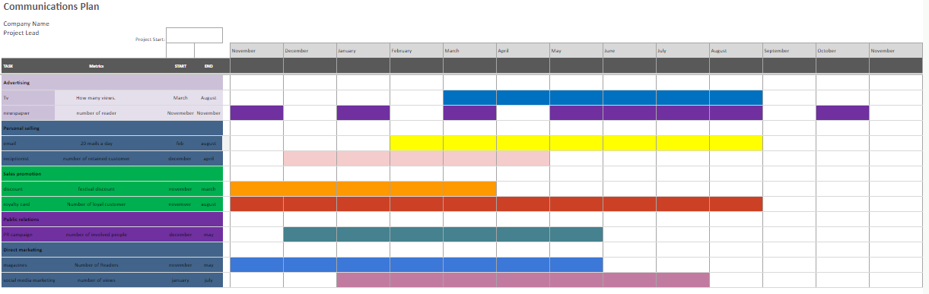
Figure 2: Gantt chart
(Source: created by learner)
TV and Newspaper advertising will be used for this communication plan as these two are the most used media tools in recent times which will help to gain audience reach and engagement. Personal selling can be done through email and receptionist as email makes the customer feel engaged and the receptionist is the one the customer will engage with when they visit the hotel, these two will help in audience retention. Discounts and loyalty cards would be idle for this communication tool as the discount will help to gain more customers and royalty cards will help to retain the loyal customers of the brand. PR campaigns can be used for Public relations and for direct marketing magazines and social media would be best as these will help in increasing market presence.

Control
To attain the marketing objective it is essential for the organisation to focus on controlling the different activities and tasks of the marketing plan. Hilton Hotels can utilise different KPIs to understand the positive outcomes of the implemented marketing plans. KPIs such as Web traffic, conversion rate, retention rate and many more can be utilised to measure the success of marketing. Conversion rate assists the business in understanding the number of customers converted towards the brands outlining the success of the marketing. It can be calculated through the number of customers converted divided by the number of customers visited.

Conclusion
The above report shows that the Hilton hotels are already in a very good position in the market but they need improvements in many sectors. The report has discussed the key problems the company is facing right now and gave solutions to overcome each situation. Currently, it is the third largest hotel chain in the world, so the report has discussed the strategies Hilton can follow to get to the top outlasting the current leading player, Marriot Hotels (Statista, 2023).

Component B

Situational Analysis
Strengths  - Huge brand reputation.  - Huge customer base. | Weaknesses  - Low focus on clients' data protection.
Opportunities  - Investing heavily in marketing.  - Expansion into mid-range and budget hotels. | Threats  - Economic problems.  - Geopolitical tensions.
Table 3: Situational Analysis
(Source: created by learner)

Customer: Segmentation and Targeting
The main customers are mostly high income individuals who fall in the middle age group like business professionals, celebrities, travel vloggers or politicians.
Name: Peter Harrison
Profession: Travel Vlogger/YouTuber
Demographic features:  - Age - 25  - Location - London, UK  - Educational Background - Graduated | Interest:  - Making travel videos for social media.  Goals:  - Exploring new places.  - Travelling to every single country in the world.  Communication Channels:  - Instagram  - Twitter  - Facebook  - YouTube
Bio: Peter Harrison, a resident of London is a YouTuber with more than 100k subscribers who make travel videos for people. Harrison explores new places and shares his experiences on social media.
Table 4: Customer Persona
(Source: created by learner)
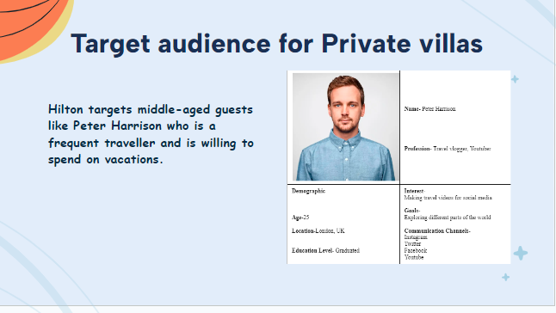
Figure 3: PPT Slide

Figure 4: Competition Analysis
(Source: created by the learner)
From the above map it can be found that Hilton offers premium services to its guests at a very reasonable price compared to Marriott which charges premium to its guests. Hilton also charges equal to Whitbread but delivers better quality services. All of these factors provide the guests with great value and Hilton is preferably the better choice for customers.
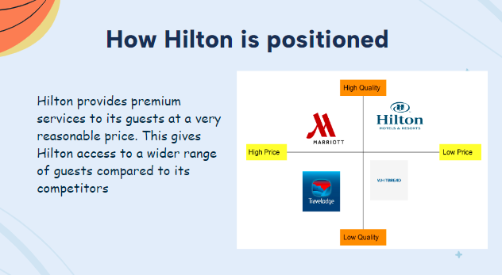
Figure 5: PPT Slide

Collaborators
B2B has helped the company expand its operations to a wider reach. The company partnered with purchasepro.com to offer clients the ease of travel bookings. Hilton’s franchise model which only requires a minimum investment of 30 million pounds is enough to start a 300-room Hilton hotel.

PESTLE (Macro Analysis)
The Brexit, Ukraine-Russia conflict and current inflation are all affecting the sales of the industry negatively. However, a decline is expected in the next few quarters which can increase the sales of the hotel chains in the UK. Almost 50% of the population falls in the age group of 25-60 which is also a boost and technological advancements will help the sector see bookings increase (UK, 2023). Hotels are also expected to follow the Employment Act 2002 and several environmental laws, failing to comply can cause restrictions by the government which can result in the sector negatively.
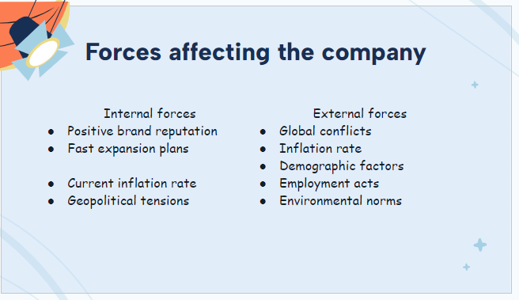
Figure 6: PPT Slide

Marketing Mix
Product: Hilton operates in the guest services industry. The hotel chain provides one of the best guest services which is standard according to the industry. The guests are welcomed with complimentary services and are offered regular offers.
Price: Hilton charges higher than the budget hotels, but, delivers premium services to its guests. Compared to other luxury hotel chains, the price Hilton charges is quite reasonable.
Place: Hilton has 584 hotels on six continents and 7000 properties around the world. The majority of the hotels are located in the United States (Hilton, 2023).
Promotion: Hilton promotes its hotels on billboards, business magazines, newspapers and social media. The company adopted a unique promotional strategy to create a positive brand image.

Action
TV and Newspaper advertisements will be used effectively to aware the potential guests about the new service. Other than that, front office executives will be communicate with guests to offer them upgrades to private villas. Front desk will be the most effective way of converting the guests into premium guests. Emails will also help to let the guests know about the service and pricing. Frequent visitors will be rewarded with loyalty points which will also help retain the guests.

Control
To achieve the marketing goals, Hilton will implement several KPI techniques such as web traffic, conversion rate, retention rate and many more understand how successfully the plans are working.

References
Hilton.com., (2023). Hilton Brands | Global Hospitality Company. [online] Available at: https://www.hilton.com/en/corporate/#:~:text=It%20believes%20in%20honoring%20members,for%20every%20budget%20and%20occasion. [Accessed 5 Oct. 2023].\
Stories From Hilton. (2022). Hilton 2022 Year in Review. [online] Available at: https://stories.hilton.com/2022-annual-report [Accessed 5 Oct. 2023].
Economictimes., (2023) Hilton Hotels unveils B2B Marketplace, E. Available at: https://www.ecommercetimes.com/story/hilton-hotels-unveils-b2b-marketplace-3467.html (Accessed: 05 October 2023).
Hilton., (2023) Franchise disclosure document - hilton. Available at: https://www.hilton.com/en/corporate/wp-content/uploads/2022/03/Franchise-Disclosure-Document-2022-US-Hilton.pdf (Accessed: 05 October 2023).
O’Carroll, L., (2023). Shortfall of 330,000 workers in UK due to Brexit, say thinktanks. [online] the Guardian. Available at: https://www.theguardian.com/politics/2023/jan/17/shortfall-of-330000-workers-in-uk-due-to-brexit-say-thinktanks [Accessed 5 Oct. 2023].
Statista., (2023). UK inflation rate 2023 | Statista. [online] Available at: https://www.statista.com/statistics/306648/inflation-rate-consumer-price-index-cpi-united-kingdom-uk/#:~:text=The%20UK%20inflation%20rate%20was,11.1%20percent%20in%20October%202022. [Accessed 5 Oct. 2023].
Hilton., (2023) Environmental impact: Travel with purpose: Hilton ESG, Travel With Purpose | Hilton ESG. Available at:
https://esg.hilton.com/environment/#:~:text=Energy%20Efficiency&amp;text=We%20have%20pledged%20to%20reduce,intensity%20by%2061%25%20by%202030.&amp;text=Opened%20in%202022%2C%20the%20Hotel,emissions%20hotel%20in%20the%20U.S. (Accessed: 05 October 2023).
Statista., (2023). Largest hotel and resort companies worldwide by market value 2023 | Statista. [online] Available at: https://www.statista.com/statistics/1314352/largest-hotel-companies-market-value-worldwide/ [Accessed 5 Oct. 2023].
UK, G. (2023) Age groups, GOV.UK Ethnicity facts and figures. Available at: https://www.ethnicity-facts-figures.service.gov.uk/uk-population-by-ethnicity/demographics/age-groups/latest (Accessed: 05 October 2023).

‌

‌

‌
‌

‌

‌

