
economics of sustainability bmsp 6007
Tutor: Anthony Burns

Katarzyna White
1905801

Contents
1. Executive Summary 2
2. Introduction 2
2.1 The World Economic Forum 2
2.2 United Nations Sustainable Development Goals 2
3. Sustainable Economic Development 3
3.1 Circular Flow Model 3
3.2 Materials Balance Model 4
3.3 The Environmental Kuznets Curve 5
4. The World Economic Forum Long Term Risks and Consequences 7
5. Assessment of the Risks 9
6. Recommendations 10
7. Conclusion 10
8. References 12

Executive Summary
This report aims to establish the long-term risks and their consequences on the sustainable development proposed by the World Economic Forum. Ten long-term risks were determined that can affect sustainable development. The most spoken risk was climate change failure, and due to its severity and seriousness, this risk was discussed in detail and assessed against several global goals. Moreover, a recommendation was made to help alleviate the climate change failure and aid the achievement of sustainable development goals.

Introduction

2.1 The World Economic Forum
The World Economic Forum (WEF) is the International Organization for Public-Private Cooperation founded in January 1971 in Geneva, Switzerland, by business professor Klaus Schwab. The mission of the WEF is to improve the state of the world through collaboration between a diverse range of stakeholders. The WEF communities include businesses, government and international organisations, civil society, young leaders, scholars and media. The forum's values are based on independence, impartiality and integrity. The WEF strives to make the world a better place for everyone, where collaboration efforts can solve global challenges (The World Economic Forum, 2022).
One of the initiatives undertaken by the WEF is the creation of annual reports highlighting different aspects of global development, e.g. the Global Competitiveness Report, the Global Information Technology Report, the Global Gender Gap Report, the Global Travel and Tourism Report or the Global Risks Report.
The Global Risks Report is of the most interest concerning this paper. According to the WEF, the Global Risk Report is prepared ahead of the forum's annual meeting in Davos and focuses on the threats that can affect global development.

United Nations Sustainable Development Goals
Hunger, corruption, climate change, lack of quality education, and unemployment are everyday challenges for many. The United Nations has called for leaders of the world to come together and commit to stopping the most critical issues.
In 2015, the Sustainable Development Goals were created, presenting 17 pledges made by 193 nations to "end extreme poverty, inequality and climate change by 2030" (UN, 2022).
Although the UN Global Goals are a fantastic initiative to address the global challenges and bring attention to the most pressing issues, it must be noted that the deadlines set by the United Nations seem ambitious and, unfortunately, might not be achievable.
According to the United Nations Global Compact CEO Accenture Strategy Study on Sustainability (2019), it has been reported that progress in achieving the goals has been slow and, in some cases, even reversed (UN, 2019).

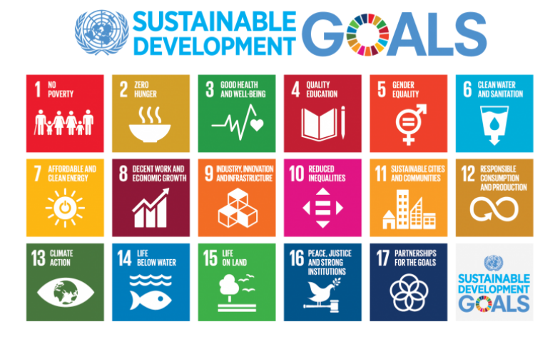

Source: www.globalgoals.org 2022.

Sustainable Economic Development
According to Hammer & Pivo (2016), sustainable economic development can be defined as "programs, policies, or activities designed to create or retain jobs and wealth in ways that contribute to environmental, social, and economic well-being over time".

Circular Flow Model
The circular flow model is the most straightforward representation of an economy. The circular flow model represents how money moves between the firms to households and then back to the firms in an endless cycle. A more practical explanation is when businesses pay wages to their workers, who then spend their money purchasing products and services, which goes back to the companies (Investopedia, 2021). This is also called a two-sector model. The circular flow model can be made more complex by adding more sectors; for example, an addition of a government creates a three-sector model. Within this model, money moves from households to businesses to the government through taxes.
The standard circular flow model does not address the environment and natural resources, as well as the waste and pollution generated during the production process, as can be seen in the image below.

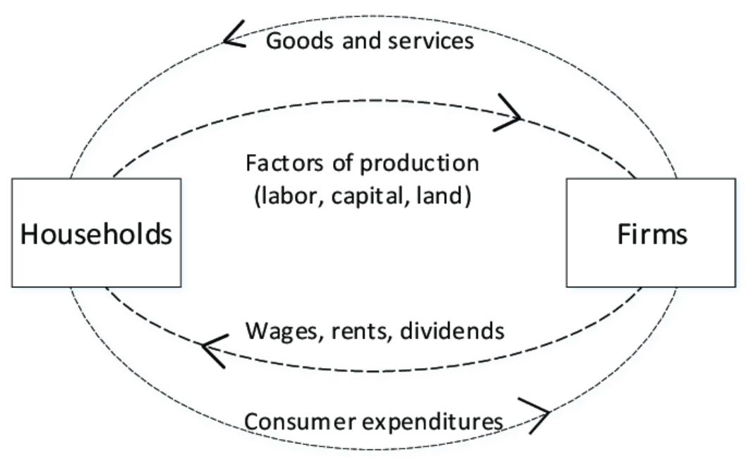

Source: La Notte & Rhodes, (2020).

3.2 Materials Balance Model
The materials balance model is seen as a better representation of an economy, where missing aspects from the circular flow model are addressed. The materials balance model shows the connection between economic activities and the environment. The materials balance model implies that the mass input must equal mass output, meaning that all resources extracted from nature will return to nature in the form of waste. The materials balance model draws attention to the negative impact of business operations on the environment and emphasises that nature has a limited capacity to absorb waste; therefore, economic activities should be reduced (Ayres & Kneese, 1969).

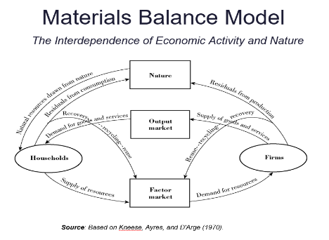

3.3 The Environmental Kuznets Curve
Stern (2004) states that "the environmental Kuznets curve (EKC) is a hypothesised relationship between various indicators of environmental degradation and income per capita". He further contends that in the early stages of the economic development of countries, pollution levels will increase. As the country reaches the developed status and a particular income level per capita, the environmental degradation decreases. Many scholars have highly criticised the EKC; Copeland and Taylor (2004) argue that their study on the EKC led them to believe that there is a minimal relationship between pollution and per capita income.
Dasgupta et al. (2002) state that there is no evidence to confirm the economic advantage of EKC. Moreover, they state that studies have shown more benefits to tightening the environmental regulations even in the poorer countries, as the financial returns compared to pollution abatement costs would justify such actions. A flatter and low environmental Kuznets curve can be observed in this scenario.

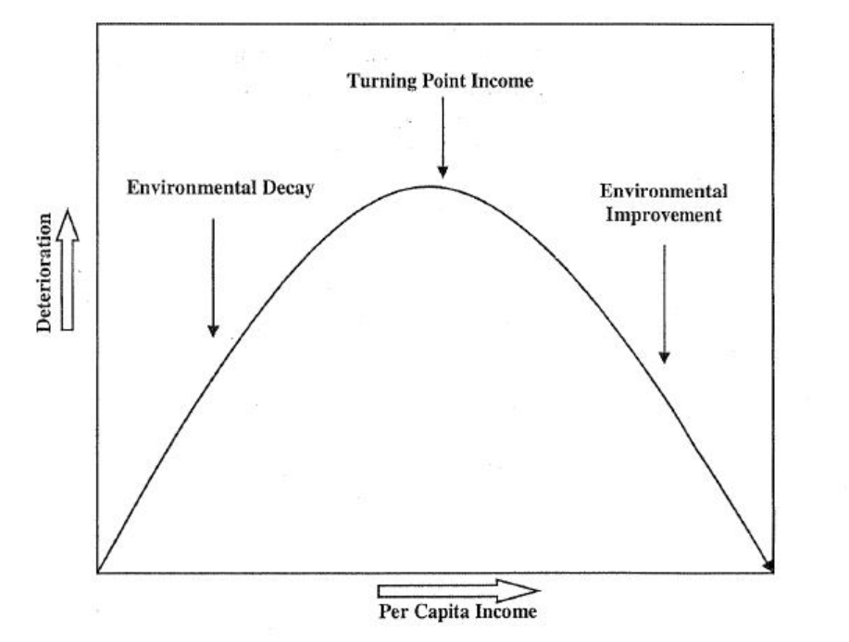

Source: www.perc.org, 2011

The World Economic Forum Long Term Risks and Consequences
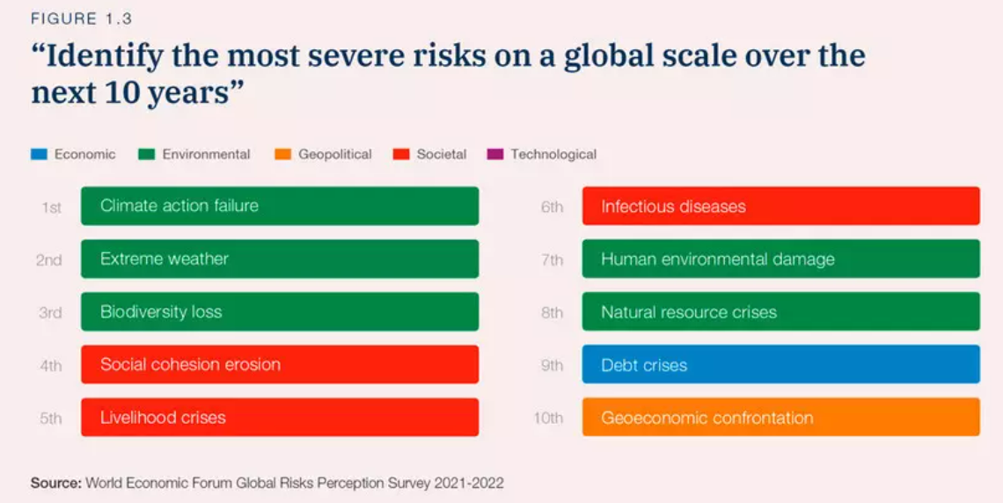

According to the findings from the World Economic Forum Global Risks Perception Survey 2021-2022, ten global long-term risks were identified, and they are as follows:
- Climate action failure
- Extreme weather
- Biodiversity loss
- Social cohesion erosion
- Livelihood crisis
- Infectious diseases
- Human environmental damage
- Natural resources crisis
- Debt crisis
- Geoeconomic confrontation

Risks number one, two, three, seven and eight were classified as environmental risks. The report states that climate change is widespread and moving faster than hoped. It is feared that the set target of 1.5°C will not be reached. Moreover, it is predicted that the current global trajectory will see a warming of 2.4°C, and at the best scenario, 1.8°C. In order to slow down global warming, all long-term pledges and 2030 targets need to be fully implemented. However, in the aftermath of the Covid-19 pandemic, environmental actions have been put on the back burner and countries focused on short term economic recoveries.
If faster/rapid change is implemented to achieve net-zero carbon emissions, the long-term consequences will be eliminated; however, short-term challenges will appear, such as a rise in fuel costs and sustainability of vehicle fuel and gas supplies. Moreover, due to the intense carbon industries, it is predicted that jobs will be lost, but around 40 million new jobs can be created in the renewable energy sector. Additionally, middle-class households could suffer most, as a lack of income would put them at a more significant disadvantage when accessing new technologies and create even greater economic inequalities than already existing ones.
However, if the transition is slow dire environmental consequences will affect many, creating migration and climate refugees due to their land being lost. It is feared that a slower rate of change is not an option, and only rapid changes and regulation implementation will create a positive outcome and save the planet. Years of slow and hesitant implementation of climate change solutions are to be blamed for immediate and drastic actions that must take place now to secure a sustainable future for generations to come.
The risks four, five and six were described as societal and referred to as challenges imposed on societies. The risks discussed in the report originated from the Covid-19 pandemic and posed a threat to public health. Due to the inconsistent progress with vaccinations, only half of the world's population received vaccines, meaning there is still a high risk of the new coronavirus variant emerging. Moreover, during the Covid-19 pandemic, other health issues were deprioritised. There has been reported that mental health issues increased drastically, with reports of 53 million globally; also, due to treatments delayed caused by Covid-19, 41 million people died in low and middle-income countries.
In terms of the social cohesion erosion, it has been reported that this risk has become more significant after the pandemic due to social, political, economic, technological and intergenerational inequalities. The report highlighted that the richest would recover quickly, and the poorest will lose 5% more of their income.
Moreover, poorer developing countries will be disadvantaged due to the lack of internet connectivity. It has been reported that 40% of the population is offline. The technology allowed many countries to seek new opportunities and bounce back; however, many were left behind in the pre-pandemic reality.

Debt crises were another risk within the top ten, and it was classified as an economic risk. The volatile economic situation caused by tensions between Europe and Russia, increased inflation, and energy shortages contribute to disruptions in global chain supplies and intensify debt crisis. Similarly to previously mentioned risks, low and middle-income households are believed to suffer the most.

Lastly, the risks of geoeconomic confrontations were also placed in the top ten risks. The geoeconomics confrontations refer to the rivalry between countries, such as the US and China, and Europe and Russia. The consequences of this risk include increased competitiveness in militarisation, weaponisation in space, and developments in cyberspace.

All information presented within this report section has been collected from the Global Risk Report 2022 (World Economic Forum, 2022).

Assessment of the Risks
This chapter aims to assess the climate action failure risk against sustainable development goals. It is assumed that climate action failure can affect the development of sustainable global goals. The risk assessed within this section was the most spoken of and placed at the top by the survey respondents. Other environmental risks mentioned in the previous chapter will also be discussed as they are all correlated; however, the main focus of this chapter will be the climate action failure risk and its consequences.
According to Brainard (2009), climate change has a detrimental impact on agriculture, fisheries and forestry. Floods and droughts are especially damaging to crops, which could cause a reduction in yields—resulting in a loss in gross domestic product. Lower-income and poor harvests contribute to poverty, especially in developing countries where agriculture is the primary source of employment (Kwa, 2001). Moreover, poorer individuals are more prone to harsher effects of climate change. Natural disasters caused by climate change can interrupt their work, and they are less likely to have insurance to protect themselves from those disastrous events (Leichenko & Silva, 2014).
Climate change also affects food security; as mentioned earlier, crops can be destroyed therefore causing a direct effect on global goal number two, which is zero hunger (Gupta, 2014). In addition, when there is a decrease in the food supply, higher prices will follow, meaning that not everyone will be able to afford food; therefore, climate change can contribute to hunger (Wiggins & Slater, 2011).
According to the World Health Organisation (WHO, 2009), climate change will have adverse effects on "clean air and water, sufficient food, adequate shelter and freedom from disease", which are essential for good health. It has been reported that extreme heat and air pollutions are the leading cause of heart attacks and cardiovascular and respiratory diseases.
Unicef (2022) warns that extreme weather due to climate change makes it hard for people to access clean drinking water. Contaminated water is the primary reason for water-borne diseases such as cholera and typhoid. Unicef states that "by 2040, almost 1 in 4 children will live in areas of extremely high water stress". This directly affects sustainable goals number three and six; good health and well-being and clean water and sanitation.
Climate change can negatively impact the development of other goals; however, the most affected were chosen to be assessed for this report. It is challenging to discuss every aspect of climate change and sustainable development goals due to the complexity of the subjects.

Recommendations
Based on the risks presented by the World Economic Forum and the assessment of climate action failure, it is recommended that the only way forward is through international collaboration. Moreover, developing countries should not be allowed to continue to pollute as their economy grows. It is believed that the Kuznets curve model is not the best solution, as there is no time scale placed on the country of when they will make the adequate income per capita, so it could take decades before starting to implement environmental improvements. The planet cannot wait; there is no time to waste; therefore, it is suggested that collaboration between developed and developing countries to reduce the adverse effects of production activities is the feasible solution.

Conclusion
The Covid-19 pandemic created global chaos. Initially, the lockdowns imposed across the world benefitted climate change; however, very quickly and intensely, the economic recovery began. Many environmental policies were put on hold to deal with the aftermath of Covid-19. The World Economic Forum published a report with the top ten long-term risks. The number one concern was climate action failure. It can be agreed that climate change should be the number one priority for all. The planet is warming, and the current trajectory does not offer positive outcomes. As in many cases, the most disadvantaged and at-risk are developing countries. Countries need to intensify their implementation of sustainable global goals to reduce or, even better, reverse global warming. Millions of people suffer daily due to extreme weather conditions caused by climate change. Climate action failure risk affects many sustainable global goals such as poverty, no hunger, good health and well-being or water and sanitation. They are the basic requirements for a healthy and happy life. The are other goals that are also affected by climate change, such as industry, innovation and infrastructure or sustainable cities and communities; however, the focus in this report was put on the essential needs of every human. It is believed that once those are met, other aspects of sustainable living can be discussed.

References
The World Economic Forum, (2022). A Platform for Impact. Available at: https://www3.weforum.org/docs/WEF_Institutional_Brochure_2019.pdf
Hammer, J., & Pivo, G. (2017). The triple bottom line and sustainable economic development theory and practice. Economic Development Quarterly, 31(1), 25-36.
United Nations Global Compact, UNGC CEO (2019). Accenture Strategy Study on Sustainability 2019 Report. https://www.accenture.com/_acnmedia/pdf-109/accenture-ungc-ceo-study.pdf
La Notte, A., & Rhodes, C. (2020). The theoretical frameworks behind integrated environmental, ecosystem, and economic accounting systems and their classifications. Environmental Impact Assessment Review, 80, 106317.
United Nations (2022). The Sustainable Development Goals Image. Available at: https://www.un.org/development/desa/disabilities/about-us/sustainable-development-goals-sdgs-and-disability.html
Ayres, R. U., & Kneese, A. V. (1969). Production, consumption, and externalities. The American economic review, 59(3), 282-297.
Kneese, A.V. ; Ayres, R. U., & D’Arge, R. C. (1970). Economics and the environment : a materials balance approach. Resources for the Future
Copeland, B. R., & Taylor, M. S. (2004). Trade, growth, and the environment. Journal of Economic literature, 42(1), 7-71.
Perc, (2011). Mexico and the Environmental Kuznets Curves. Available at: https://www.perc.org/2011/02/10/mexico-and-the-environmental-kuznets-curve/
Kwa, A. (2001). Agriculture in Developing Countries: Which Way Forward?. Available at: https://www.iatp.org/sites/default/files/Agriculture_in_Developing_Countries_Which_Way_.htm#:~:text=In%20developing%20countries%2C%20agriculture%20continues,95%25%20of%20the%20farming%20population.
Brainard, L., Jones, A., & Purvis, N. (Eds.). (2009). Climate change and global poverty: A billion lives in the balance?. Brookings Institution Press.
Das Gupta, M. (2014). Population, poverty, and climate change. The World Bank Research Observer, 29(1), 83-108.
Wiggins, S., & Slater, R. (2011). Food security and nutrition: current and likely future issues. Foresight Project on Global Food and Farming Futures, UK Government Office for Science.
Leichenko, R., & Silva, J. A. (2014). Climate change and poverty: vulnerability, impacts, and alleviation strategies. Wiley Interdisciplinary Reviews: Climate Change, 5(4), 539-556.
UNICEF (2022). Water and the global climate crisis: 10 things you should know. Available at: https://www.unicef.org/stories/water-and-climate-change-10-things-you-should-know
World Health Organisation, (2022). Protecting health from climate change. Available at: https://apps.who.int/iris/bitstream/handle/10665/44246/9789241598880_eng.pdf
Investopedia, (2021). Circular Flow Model. Available at: https://www.investopedia.com/terms/circular-flow-of-income.asp
Stern, D. I. (2004). The rise and fall of the environmental Kuznets curve. World development, 32(8), 1419-1439.
World Economic Forum, (2022). Global Risk Report 2022. Available at: https://www.weforum.org/reports/global-risks-report-2022/in-full/appendix-a-descriptions-of-global-risks-2022#appendix-a-descriptions-of-global-risks-2022

