8/9/2026
LDE ASSIGNMENT 1
E-PORTFOLIO
University of Wales Trinity Saint David – London Campus
Module: Learning in the Digital Era
Module Code: ACCA4025
Student: Peter Miles Maswere
Student ID: 2352060
Lecturer: Koushik Modak
Contents
Introduction 2
Task 1: Essential Academic and Employment Skills for the Future Career Path 2
Task 1(a): Written Summary 2
Task 1(b): Similarity and Self-Assessment Reflection 3
Task 1 References 4
Task 2: Collaborative Teamwork and Professional Academic Poster 5
Task 2(a): Collaborative Mind Map 5
Task 2(b): Individual Professional Academic Poster 5
Task 3: Automatic Referencing Tool – Virtual Collaboration and RefWorks 7
Task 3(a): Virtual Collaboration – Forming a Team 7
Task 3(b): RefWorks Evidence and Reflection 7
Task 3 References 9
Task 4: E-Portfolio Creation and Review 10
Task 4(a): E-Portfolio Creation 10
Task 4(b): Illustrative Review of E-Portfolio Tool Selection 12
Conclusion 14
References 14

Introduction
This e-portfolio examines academic and employment skills relevant to future career development, collaborative learning, virtual teamwork and the use of digital tools. The portfolio combines written reflection with visual learning activities, including a collaborative mind map and an individual poster.

Task 1: Essential Academic and Employment Skills for the Future Career Path

Task 1(a): Written Summary
Academic and employment skills are important for successful study and for entering a competitive labour market. For a future career in data analysis, communication, analytical thinking, problem-solving, digital literacy and teamwork are particularly relevant. Recent research into data-analytics job advertisements found that employers seek both technical capabilities and interpersonal, analytical and communication skills [1].
Communication is important because data analysts must explain findings clearly in reports, presentations and discussions with technical and non-technical stakeholders. Analytical thinking supports the interpretation of evidence, identification of patterns and development of reasoned conclusions. Problem-solving complements analytical thinking because analysts often need to define a business problem, select appropriate evidence and recommend a practical response [1], [2].
Digital literacy is also essential. Employers increasingly expect graduates to work confidently with digital systems, data and analytical software. Research on higher-education students identifies digital literacy as an important graduate capability, while the World Economic Forum highlights technological literacy and AI and big-data skills among rapidly growing areas of demand [3], [4]. Teamwork is equally important because data projects commonly involve collaboration across different professional roles. Effective teamwork requires communication, adaptability, mutual support and shared responsibility [5], [10].
Developing these capabilities through university projects, group activities and extracurricular experience can help me demonstrate employability after graduation. I therefore need to strengthen both my technical skills and transferable skills, while continuing to learn as technologies and workplace requirements change. AI-assisted research was used during preparation and was checked against the quality sources cited above [6].
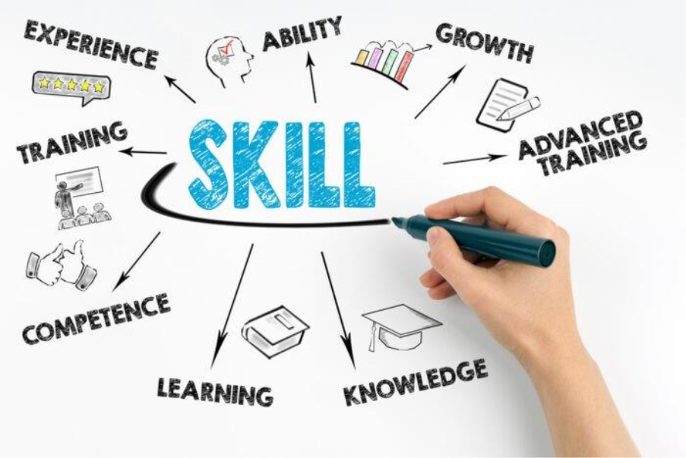

Task 1(b): Similarity and Self-Assessment Reflection
My Turnitin practice submission produced a similarity score of 34%, with the supplied report showing 31% internet-source matching and 34% student-paper matching. This indicates that I need to improve independent paraphrasing, reduce repeated assignment wording and check that borrowed ideas are correctly cited. Using the Generic Assessment Criteria, I would award myself 75%. I have engaged with research, participated in class discussions and developed my academic and digital skills. However, I need to improve critical analysis, synthesis, academic expression and referencing consistency. These will be priorities in future assignments.
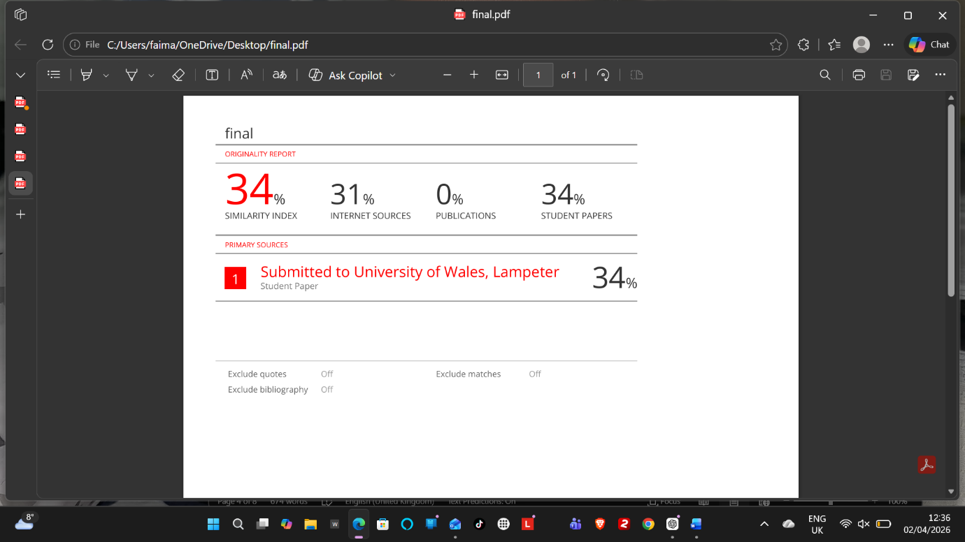

Task 1 References
[1] W. Coetzee and R. Goede, “Employability competencies needed by data analytics graduates: An analysis of online job listings,” South African Journal of Higher Education, vol. 38, no. 6, 2024, doi: 10.20853/38-6-5915.
[2] L. D. A. McGowan, R. D. Peng, and S. C. Hicks, “Design principles for data analysis,” arXiv, 2021. [Online]. Available: https://arxiv.org/abs/2103.05689
[3] A. Morgan, R. Sibson, and D. Jackson, “Digital demand and digital deficit: conceptualising digital literacy and gauging proficiency among higher education students,” Journal of Higher Education Policy and Management, vol. 44, no. 3, pp. 258–275, 2022, doi: 10.1080/1360080X.2022.2030275.
[4] World Economic Forum, The Future of Jobs Report 2025. Geneva, Switzerland: World Economic Forum, 2025. [Online]. Available: https://www.weforum.org/publications/the-future-of-jobs-report-2025/
[5] E. Salas, D. E. Sims, and C. S. Burke, “Is there a ‘Big Five’ in teamwork?” Small Group Research, vol. 36, no. 5, pp. 555–599, 2005, doi: 10.1177/1046496405277134.
[6] OpenAI, ChatGPT, private communication, Aug. 8, 2026. (Use only if the student actually relies on this AI interaction; retain the relevant AI output as a separately titled appendix item.)

Task 2: Collaborative Teamwork and Professional Academic Poster

Task 2(a): Collaborative Mind Map
My collaborative mind map is included as evidence of my group activity. I need to identify my actual team members and the collaboration tools I used because these details were not recorded in the original document.
Mind map link: https://mm.tt/map/3952545938?t=fzeTCzFAHg
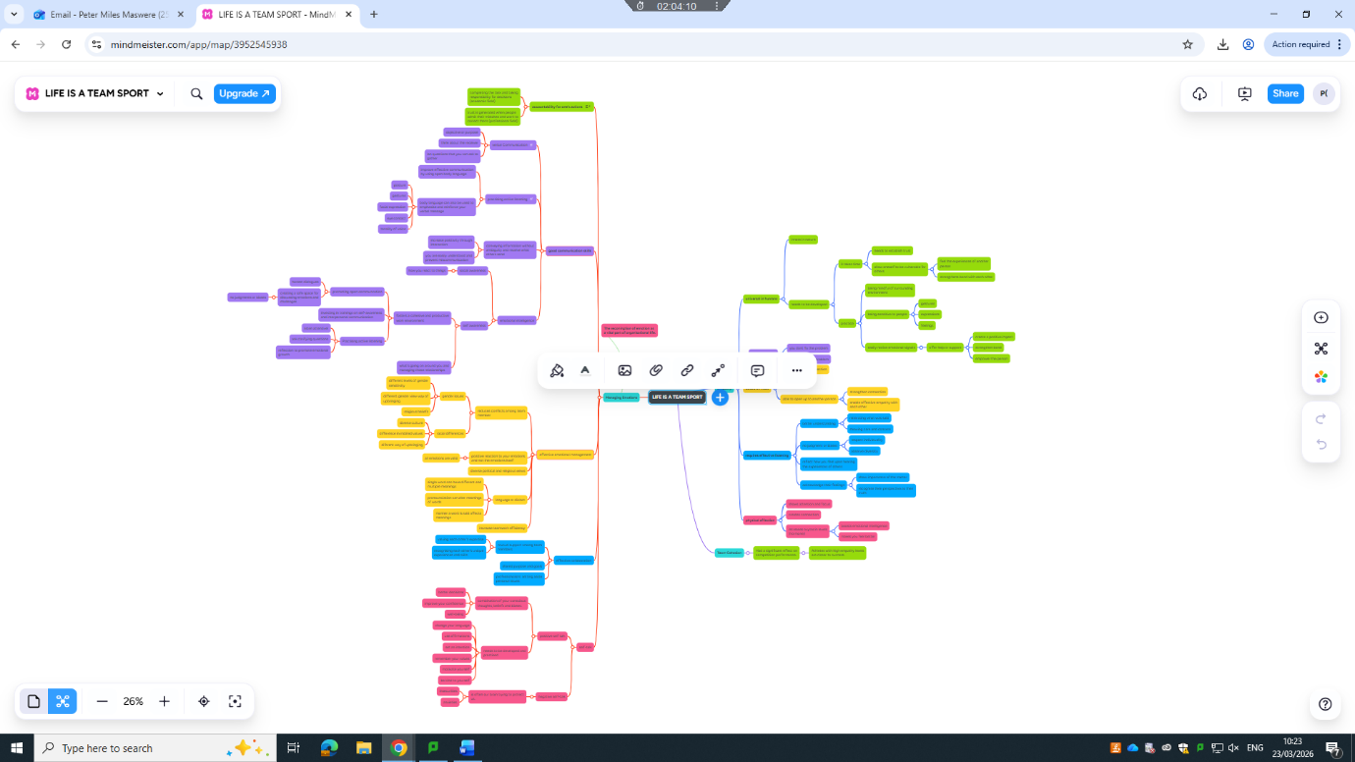

My team members were Hannah and Cynthia
The collaboration tool I used was Mind Minster

Task 2(b): Individual Professional Academic Poster
My individual Canva poster addresses empathy, emotional intelligence, managing emotions, collaboration, career growth, resilience, teamwork, communication and problem-solving.
Poster link: https://canva.link/aoqece0tl5edq8o
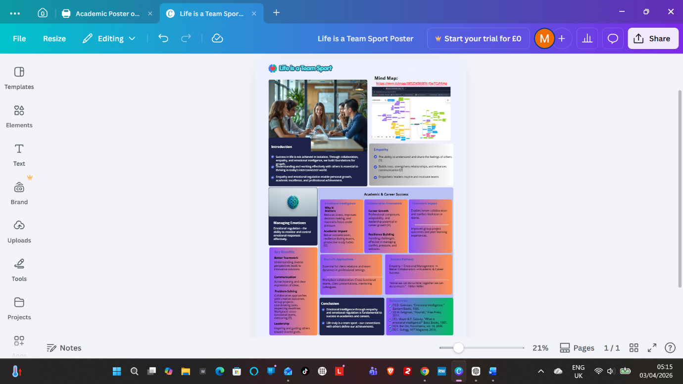

Task 3: Automatic Referencing Tool – Virtual Collaboration and RefWorks

Task 3(a): Virtual Collaboration – Forming a Team
The forming stage is the first stage in Tuckman's model of group development. At this point, team members are becoming familiar with one another and may be uncertain about roles, objectives and expected behaviours [7]. Trust is important because members need confidence that colleagues will communicate reliably and contribute to shared objectives. In virtual teams, the challenge can be greater because communication is mediated by digital technologies and members may have fewer opportunities for informal interaction [8], [9].
Trust can support openness and cooperation during the early stage of team development. Lencioni presents trust as the foundation of effective teamwork and links it to vulnerability, openness and willingness to acknowledge weaknesses [10]. This is relevant to virtual teams because members may need to ask questions, share incomplete ideas and request assistance without the benefit of frequent face-to-face interaction. Trust therefore does not simply create a positive atmosphere; it can make it easier for members to exchange information and participate in the work of the team.
The forming stage also provides a foundation for managing later disagreement. Tuckman's model identifies storming as a stage in which conflict and differences can emerge before teams develop stronger cohesion and functional roles [7]. Trust does not remove disagreement, but it can help members challenge ideas more constructively. Research on virtual teams identifies trust, communication, leadership, technology and team processes as important themes in virtual-team effectiveness [9]. In practice, regular communication and clear responsibilities can reduce ambiguity and help members understand how their individual work contributes to the shared objective.
Leadership and clear goals can reinforce this foundation. Sull and Sull's FAST approach recommends goals that are frequently discussed, ambitious, specific and transparent [11]. In a virtual team, clear goals and agreed communication expectations can reduce uncertainty and make individual responsibilities easier to understand. Overall, trust is important during forming, but it should operate alongside communication, leadership, clear objectives and accountability rather than being treated as the only condition for successful team performance. This combination provides a more realistic explanation of how virtual teams can move towards effective collaboration.

Task 3(b): RefWorks Evidence and Reflection
RefWorks Citation Manager can insert in-text citations and automatically add or update a bibliography, which makes it suitable for demonstrating my use of an automatic referencing tool [12].
A screenshot showing the organisation of folders.
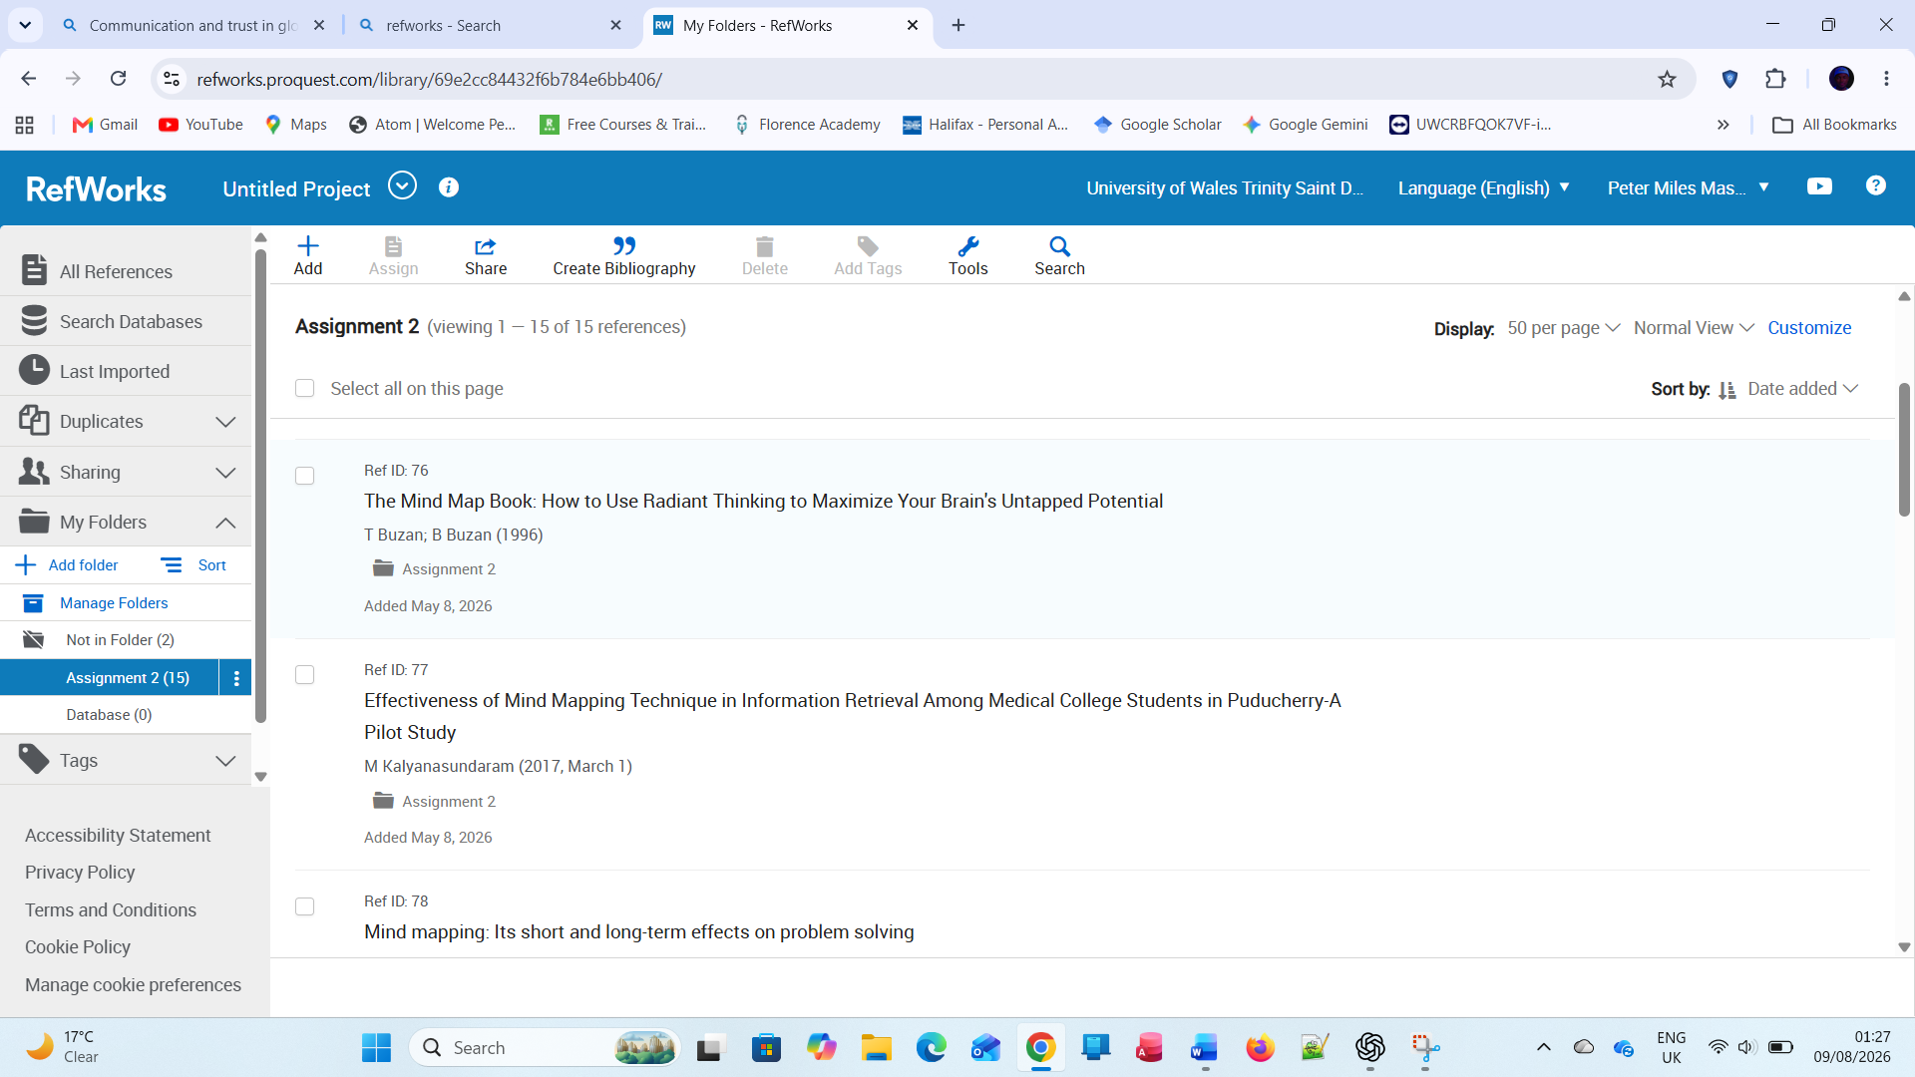
A screenshot showing citation insertion.
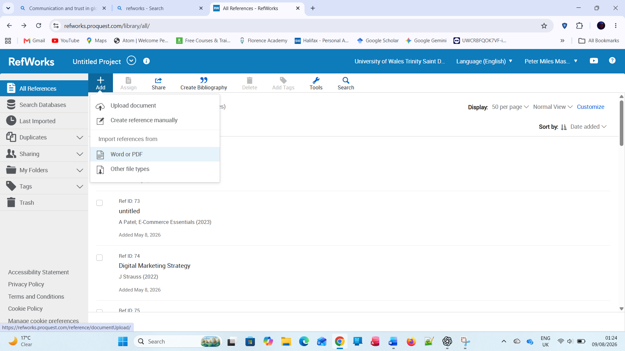
A screenshot showing the reference list in the required style.
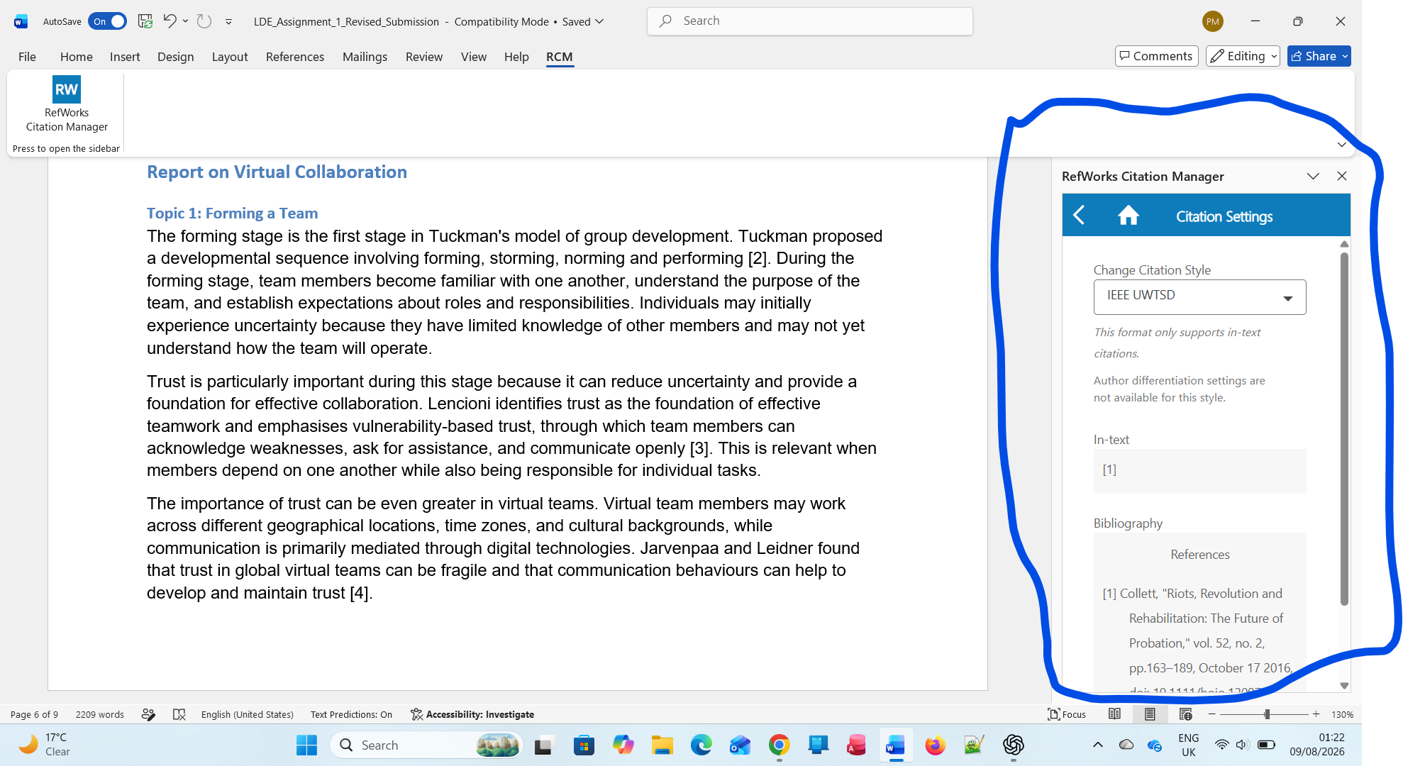

Task 3 References
[7] B. W. Tuckman, “Developmental sequence in small groups,” Psychological Bulletin, vol. 63, no. 6, pp. 384–399, 1965, doi: 10.1037/h0022100.
[8] S. L. Jarvenpaa and D. E. Leidner, “Communication and trust in global virtual teams,” Organization Science, vol. 10, no. 6, pp. 791–815, 1999, doi: 10.1287/orsc.10.6.791.
[9] L. L. Gilson, M. T. Maynard, N. C. Jones Young, M. Vartiainen, and M. Hakonen, “Virtual teams research: 10 years, 10 themes, and 10 opportunities,” Journal of Management, vol. 41, no. 5, 2015, doi: 10.1177/0149206314559946.
[10] P. Lencioni, The Five Dysfunctions of a Team: A Leadership Fable. San Francisco, CA, USA: Jossey-Bass, 2002.
[11] D. Sull and C. Sull, “With goals, FAST beats SMART,” MIT Sloan Management Review, May 22, 2018. [Online]. Available: https://shop.sloanreview.mit.edu/store/with-goals-fast-beats-smart
[12] RefWorks, “Citing and Bibliography in Microsoft Word and Word Online,” updated Jun. 4, 2026. [Online]. Available: https://refworks.zendesk.com/hc/en-us/articles/45387273760017-Citing-and-Bibliography-in-Microsoft-Word-and-Word-Online

Task 4: E-Portfolio Creation and Review

Task 4(a): E-Portfolio Creation
My online e-portfolio homepage: https://sites.google.com/view/masweres/task-4
E-portfolio welcome/home page
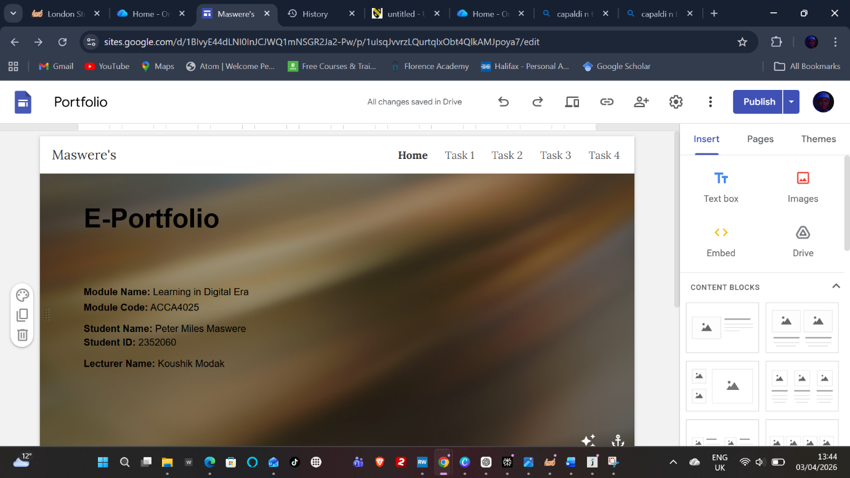
Task 1 page
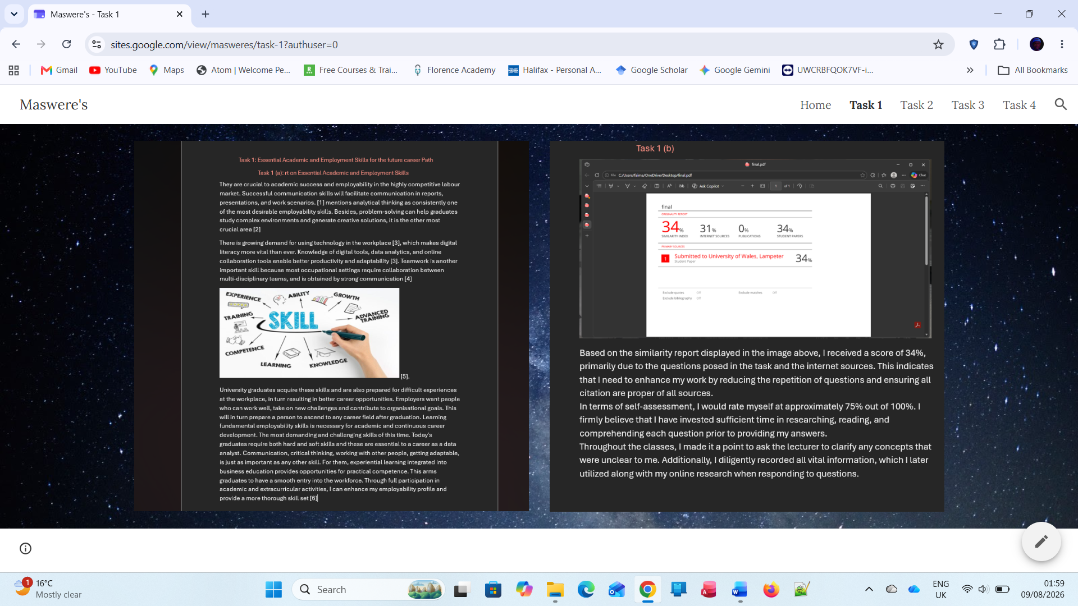
Task 2 page.
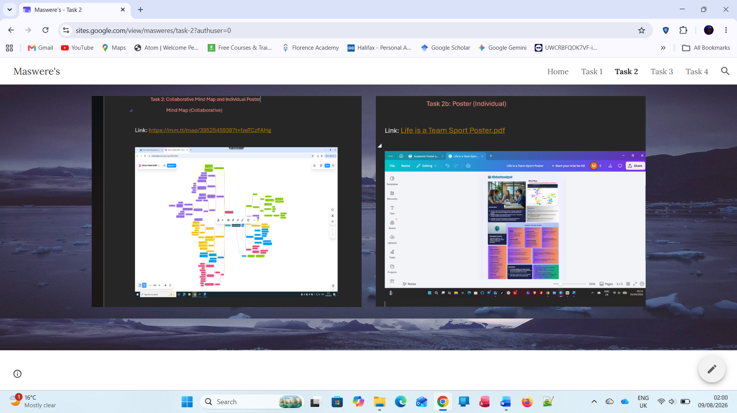
Task 3 page.
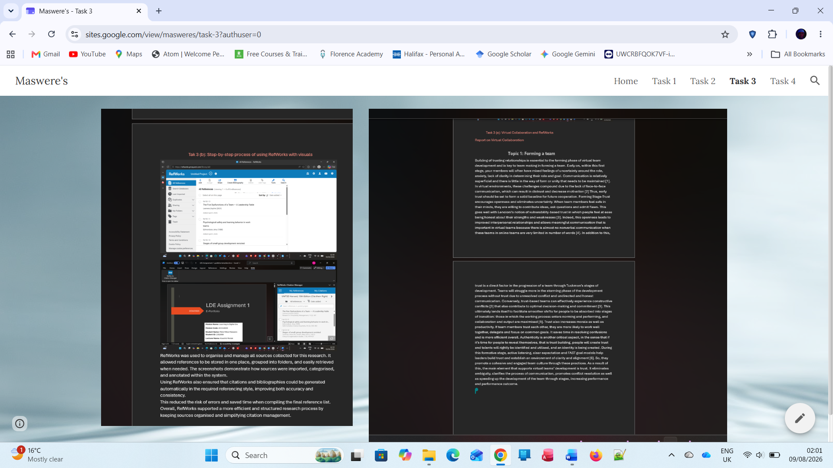
Task 4 page.
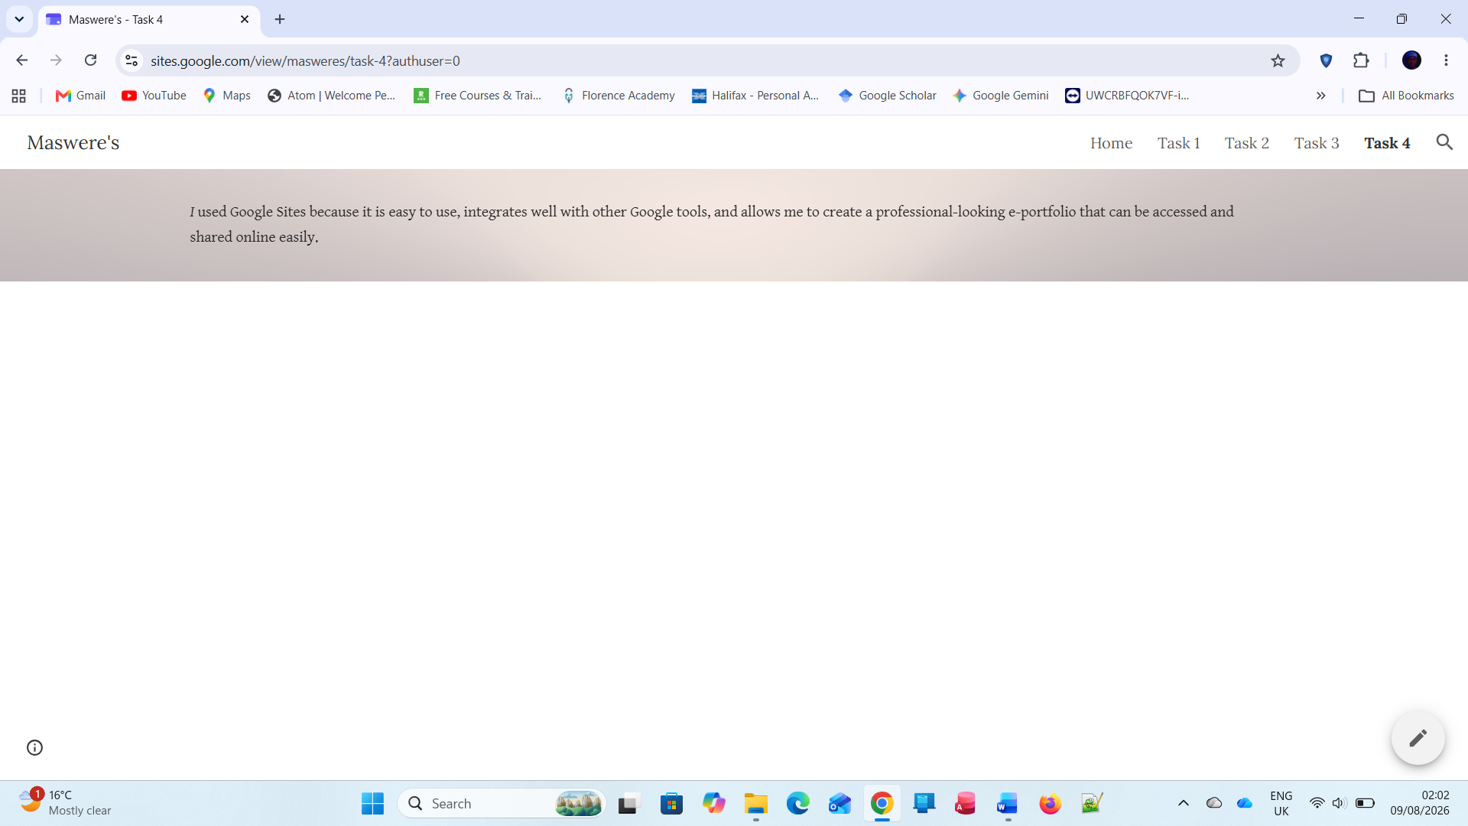

Task 4(b): Illustrative Review of E-Portfolio Tool Selection
I used Google Sites to create my e-portfolio because it allowed me to organise my assignment into separate pages and present my written work, images and links in one place. Google Sites allows users to create and organise pages, add text and images, embed Google files and publish the finished site [17]. This made it suitable for my e-portfolio because I could organise my work by task and present my learning and evidence in a clear structure [13].
One advantage of Google Sites is that I can publish my portfolio and control who can view it. Google Sites provides options for making a published site public or restricting access to selected people [17]. This is useful for my assessment because I need my tutor to be able to access the portfolio. However, I also need to check the sharing permissions carefully because embedded Google files can have their own access restrictions [18]. I will therefore test my published site while signed out to make sure that the tutor can open all required pages and evidence. Overall, Google Sites has helped me present my learning, evidence and achievements in a structured e-portfolio [13], [14].
I have identified Google Sites as the platform I used for my e-portfolio. Before submission, I will make sure my screenshots and final portfolio link accurately represent the published site I created.
Task 4 References
[13] Jisc, “Getting started with e-portfolios,” Aug. 16, 2021. [Online]. Available: https://www.jisc.ac.uk/guides/getting-started-with-e-portfolios
[14] L. Mitchell, C. Campbell, M. Somerville, E. Cardell, and L. T. Williams, “Enhancing graduate employability through targeting ePortfolios to employer expectations: A systematic scoping review,” Journal of Teaching and Learning for Graduate Employability, vol. 12, no. 2, pp. 82–98, 2021, doi: 10.21153/jtlge2021vol12no2art1003.
[15] S. Rodríguez Donaire, B. Amante García, and S. Oliver del Olmo, “e-Portfolio: A tool to assess university students' skills,” in Proc. 9th Int. Conf. Information Technology Based Higher Education and Training (ITHET), 2010, doi: 10.1109/ITHET.2010.5480050.

Conclusion
My portfolio presents a clearer connection between my academic skills, employability and my future career in data analysis.

References
[1] W. Coetzee and R. Goede, “Employability competencies needed by data analytics graduates: An analysis of online job listings,” South African Journal of Higher Education, vol. 38, no. 6, 2024, doi: 10.20853/38-6-5915.
[2] L. D. A. McGowan, R. D. Peng, and S. C. Hicks, “Design principles for data analysis,” arXiv, 2021. [Online]. Available: https://arxiv.org/abs/2103.05689
[3] A. Morgan, R. Sibson, and D. Jackson, “Digital demand and digital deficit: conceptualising digital literacy and gauging proficiency among higher education students,” Journal of Higher Education Policy and Management, vol. 44, no. 3, pp. 258–275, 2022, doi: 10.1080/1360080X.2022.2030275.
[4] World Economic Forum, The Future of Jobs Report 2025. Geneva, Switzerland: World Economic Forum, 2025. [Online]. Available: https://www.weforum.org/publications/the-future-of-jobs-report-2025/
[5] E. Salas, D. E. Sims, and C. S. Burke, “Is there a ‘Big Five’ in teamwork?” Small Group Research, vol. 36, no. 5, pp. 555–599, 2005, doi: 10.1177/1046496405277134.
[6] OpenAI, ChatGPT, private communication, Aug. 8, 2026. (Include the actual AI output used as a separately titled appendix item if this source is used.)
[7] B. W. Tuckman, “Developmental sequence in small groups,” Psychological Bulletin, vol. 63, no. 6, pp. 384–399, 1965, doi: 10.1037/h0022100.
[8] S. L. Jarvenpaa and D. E. Leidner, “Communication and trust in global virtual teams,” Organization Science, vol. 10, no. 6, pp. 791–815, 1999, doi: 10.1287/orsc.10.6.791.
[9] L. L. Gilson, M. T. Maynard, N. C. Jones Young, M. Vartiainen, and M. Hakonen, “Virtual teams research: 10 years, 10 themes, and 10 opportunities,” Journal of Management, vol. 41, no. 5, 2015, doi: 10.1177/0149206314559946.
[10] P. Lencioni, The Five Dysfunctions of a Team: A Leadership Fable. San Francisco, CA, USA: Jossey-Bass, 2002.
[11] D. Sull and C. Sull, “With goals, FAST beats SMART,” MIT Sloan Management Review, May 22, 2018. [Online]. Available: https://shop.sloanreview.mit.edu/store/with-goals-fast-beats-smart
[12] RefWorks, “Citing and Bibliography in Microsoft Word and Word Online,” updated Jun. 4, 2026. [Online]. Available: https://refworks.zendesk.com/hc/en-us/articles/45387273760017-Citing-and-Bibliography-in-Microsoft-Word-and-Word-Online
[13] Jisc, “Getting started with e-portfolios,” Aug. 16, 2021. [Online]. Available: https://www.jisc.ac.uk/guides/getting-started-with-e-portfolios
[14] L. Mitchell, C. Campbell, M. Somerville, E. Cardell, and L. T. Williams, “Enhancing graduate employability through targeting ePortfolios to employer expectations: A systematic scoping review,” Journal of Teaching and Learning for Graduate Employability, vol. 12, no. 2, pp. 82–98, 2021, doi: 10.21153/jtlge2021vol12no2art1003.
[15] S. Rodríguez Donaire, B. Amante García, and S. Oliver del Olmo, “e-Portfolio: A tool to assess university students' skills,” in Proc. 9th Int. Conf. Information Technology Based Higher Education and Training (ITHET), 2010, doi: 10.1109/ITHET.2010.5480050.
[16] University of Wales Trinity Saint David, “ACCA4025 Learning in the Digital Era: Assignment 1 – E-Portfolio, Level 4 Assessment Specification,” 2026.

