Assessment 1 Managing People

Module Code:LCBB5004 Lecturer: Olusoyi Ashaye

(Individual Report)

Case Report

For or Against Flexible Working Hours

Stefan Vasilev Zamfirov
University of Wales Trinity Saint David, London Campus,
BA Business and Management, London, United Kingdom
2024063@student.uwtsd.ac.uk
Contents
Introduction 3
Discussion on flexible working in relation to diversity and inclusion in the workplace 3
Analysis of the role of Human Resources 4
Human Resources in promoting diversity and inclusion through flexible working 6
Issues of flexible working in relation to inequality in the workplace 8
Addressal of the concerns of inequality that may arise from flexible working 9
Analysis of the role of Human Resources in addressing the concerns of inequality that may arise from flexible working 10
Conclusion 11
References 13

Introduction
The commercial sector located in the UK can be observed to have made significant contributions to the development of the national economy. The versatility of the goods that are commercialised daily can be held responsible for the influx of employment opportunities as well. The induction of employees at a significant scale entails a flexible working approach. However, the aforementioned approach has been replete with merits and demerits based upon the practicability of application. Additionally, market conditions brought forth by sociological and environmental adversities such as the Covid 19 pandemic and their effect on the Marks and Spencer enterprise have been further assessed in the study. The induction of employees at a commensurate pace includes due acknowledgement of the ethnocultural identities of the employee demographic. Maintaining equal norms for the workplace such as equal wages for all employees devoid of any discriminatory bias also becomes a primary responsibility of the Human Resources department.

Discussion on flexible working in relation to diversity and inclusion in the workplace
The facets of flexible working have become an integral part of the livelihood patterns that are followed by the common demographic. Conglomerates in countries with a significant Gross Domestic Product (GDP) such as the UK, USA, Japan and others had introduced flexible norms for the execution of corporate responsibilities (Costa-Font et al., 2021). The components of flexible working include job sharing, work from home, part-time work, flexible time shifts, annualised work hours, phased retirement policies, and several others. The adoption of the aforementioned approaches in varying magnitudes can be denoted to have resulted in variations in organisational performance. The job-sharing pattern involves the dilution of the corporate responsibility between corporate professionals to further simplify its execution. The work from home approach has been of major significance owing to its wide adoption rate by commercial enterprises after the Covid 19 pandemic. Employees that have the option to present their tasks via collaboration tools such as Skype, Asana, and others have been able to survive amidst the unemployment hike.
Flexible working norms have been significant in managing employees and encouraging them to render a greater proportion of focus to their duties. The Marks and Spencer enterprise and its plethora of products such as clothing apparel and accessories can be denoted to have amassed an immense clientele. Concurrently, the enterprise has been observed to implement several flexible norms for their employees. Moreover, the introduction of racial and gender sensitivity web seminars has aided in the induction process (Cairney et al., 2021). The multitude of ethnoculturally diverse employees can be denoted significantly to the revenue generations of the enterprise on an annual basis.
The flexible working environment can be assessed to contribute to the management of executive responsibilities in the retail sector. The commercial enterprises in the UK and their variety of goods such as consumable items of the FMCG (Fast Moving Consumer Goods) along with others had evolved the facets of corporate performance. The induction of employees after their due verification by the Human Resources department can be observed to positively contribute to the rate of annual productivity exhibited by the enterprise (Asche et al., 2021). The inclusivity of the variety of cultures can be denoted to provide more practical insights to remedy corporate impediments. The restriction on discriminatory biases can be denoted to render greater accuracy in terms of employee skill development and communication. The induction of ethnoculturally diverse communities can also inform the market of the various products and their demand ranges among the targeted consumer communities.

Analysis of the role of Human Resources
The Human Resources department of an organisation can be described as the primary source of employee induction for an organisation. The assortment of commercial enterprises that are located in the economic paradigm of the UK such as Marks and Spencer’s, Tesco, Sainsbury and others have appointed Human Resources and its management policies. The Human Resources Management (HRM) practices such as employee identification, skill analysis, salary structure establishment and others have been assessed to render further seamless integration to organisational duties (Parsons, 2021). However, the retail sector and its variety of corporations had been relatively affected by the emergence of the Covid 19 pandemic that had resulted in the unprepared halt in services. Enterprises had to adopt remedial measures such as work from home for a category of employees that can execute responsibilities within their domiciles. Employees as observed in the case of Marks and Spencer have been provided with flexible norms for shift timings to maintain the commercial services.
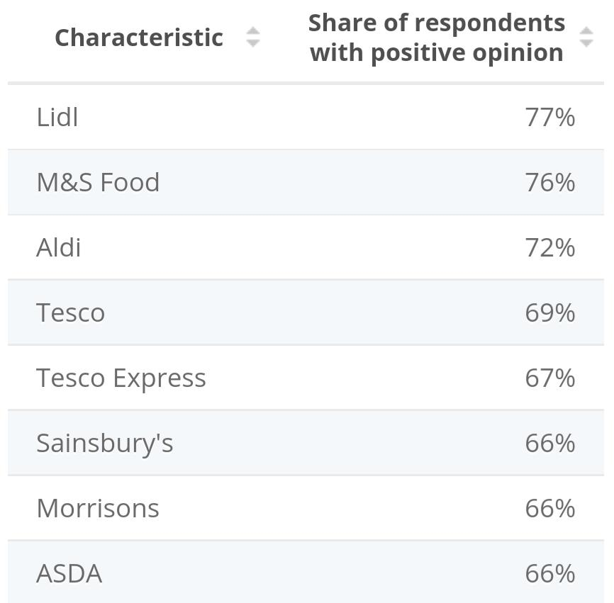
Figure 1: Food revenues of different companies in the UK
(Source: Upadhyay et al., 2021)
The statistical expression provided above informs the various enterprises and the ratio of profit it generates by strategizing their services and management policies. The Marks and Spencer enterprise and its generation of 76% positive feedback from the consumer demographic inform the optimisation of its products and services. The incline in employee induction that is adept at their professional responsibilities can also be denoted to play an instrumental role in corporate performance (Upadhyay et al., 2021). In comparison, the Lidl stores can be evaluated to render immense contention based on its substituted product ranges.
The Human Resources department of an enterprise can be observed to be studded with various managerial responsibilities. One of the primary objectives of Human Resources is to foster amicable work environments by promoting coherent communications between employee ranges. Workplaces that are composed of various ethnocultural communities in their employee demographic have also been assessed to undergo complexities in their management of employee communication. In concurrence, the instances of interpersonal and intrapersonal conflicts and disputes at the workplace further hamper its projected annual rate of productivity (Asche et al., 2021). The management of the employee by the Human Resources department of an enterprise to achieve the organisation's goals as ascertained in the case of Marks and Spencer has been further scrutinised in the study.

Human Resources in promoting diversity and inclusion through flexible working
Human Resources and their management frameworks can be denoted to promote a variety of positive features such as inclusivity and diversity in the workplace. The maintenance of inclusivity in terms of employee induction enables individuals to possess a broad mind in terms of their surrounding work environment and its employee range (Wong et al., 2021). Amicable relations between employees can also contribute to coherent communications in terms of management responsibilities resulting in greater integration. It can be assessed that the emergence of socioeconomic impediments such as the Covid 19 pandemic had resulted in a temporary pause on retail services. Enterprises had adopted technological forums such as website applications, social media identities and others to retain their client populace.
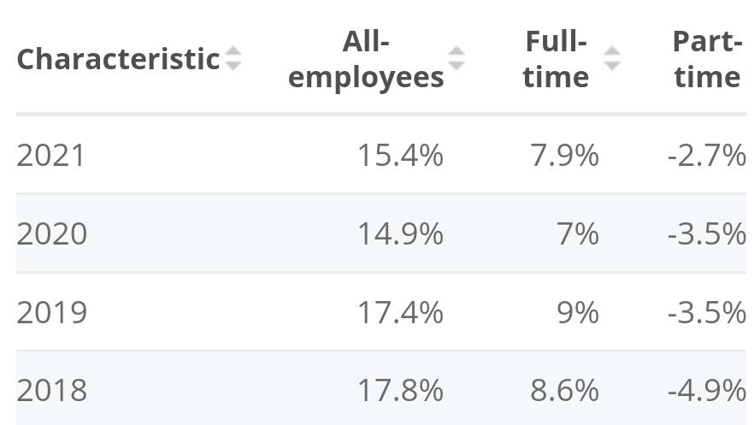
Figure 2: Wage gap in the UK
(Source: Beirne et al., 2022)
The numerical expression provided above informs one of the most blatant instances of workplace inequality that is in deft need of addressed by the authorities. The comparative analysis of the discriminating salary structures between the different genders provides insight into the remedial measures essential to management (Beirne et al., 2022). The approximate 15.4% of disparity in wage structures can yield negative outcomes in terms of employee induction. The promotion of inclusivity at the workplace entails major reconstructions as exhibited in the study.
The imposition of governmental guidelines can be elaborated to have significantly influenced the innovation of inclusivity norms in the workplace. One of the most significant examples includes the Equality Act of 2010 that had been passed in the UK to promote equal treatment of employees. The presence of different perspectives, ideas and abilities at the workplace instilled by ethnoculturally diverse communities has been subjected to analytical treatment. The Marks and Spencer enterprise can be denoted as one of the notable corporations to maintain a grasp on the market trends by expanding their business structure across ethnic boundaries (Sipilä et al., 2022). The enterprise has established its branches on a global basis by aligning its managerial policies to the legal guidelines of the countries of its operations. Maintaining a cultural diversity of the employees at the workplace can also contribute to the international reputation of the enterprise in terms of its services. The socially positive feedback provided by the consumer demographic can be denoted to form the framework of inclusivity norms that can benefit an enterprise.

Issues of flexible working in relation to inequality in the workplace
The paradigm of flexible working can be observed to be replete with the potential to yield positive and negative outcomes based on the practicability of its application. The impediments associated with flexible working are observed to deteriorate the services of the enterprises. The various involuntary factors such as age, physical disabilities, gender identities, marriage and civil partnerships, race, religious beliefs, and sexual orientation are required to be refrained from discriminatory treatment to promote equality in the workplace (Jones and Comfort, 2021). The debilitating effects of inequality have been addressed by the Marks and Spencer corporation as denoted in the study. The aforementioned corporation had aimed at reducing its deplorable effects by approximately 10% in 2020 and 25% by 2025.
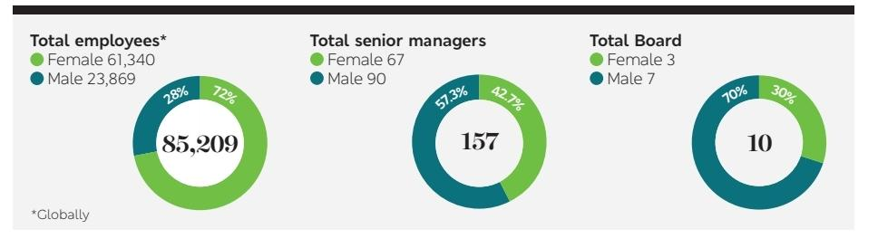
Figure 3: Wage gap in Marks and Spencer, UK
(Source: Stewart et al., 2022)
The diagrammatic expression provided above informs the proportion of the employee demographic that belongs to male and female categories and their corporate positions. In comparison to the 90 senior manager posts acquired by men, 67 positions have also been rendered to the women demographic to maintain inclusivity (Stewart et al., 2022). The eradication of the Wage gap between employees can be assessed to upgrade the quality of services rendered by an enterprise. However, the Marks and Spencer organisation can be observed to have maintained diversity in terms of employee induction to promote equality in the workplace.
The emergence of the Covid 19 has necessitated changes to the management policies that are prevalent in the commercial sector and its retail industries. The enterprises that had stopped their services temporarily had been rendered the option to monopolise their commodities using technological forums. The innovation of website applications has also informed the enterprise regarding the varying nature of the demand of the common populace. Marks and Spencer can be assessed to undergo significant contention from rival enterprises such as Amazon that have attempted to maintain equal salary structures for employees (Lucas, 2021). Maintaining equal norms also involves a focus on employees that are of elder age demographics. Providing opportunities for phased retirement policies also enable individuals to acclimatise themselves to the new norms at the workplace in commercial institutions located in the UK. Job roles pertaining to finance, information technology, logistics, and others have also been observed to amass employees devoid of any discriminatory attitudes.

Addressal of the concerns of inequality that may arise from flexible working
An assortment of hardships associated with an enterprise can be ascertained to debilitate its services and consequent repute among the consumer demographic. The unequal norms at the workplace can be assessed to be instrumental in triggering employee dissatisfaction regarding unfair workplace conditions. Some of the major areas of inequality at the workplace as ascertained from the case of Marks and Spencer can be observed to be based on racial, gender and similar identities. The concept of inequality has also been observed to permeate across various workplace forums such as work from home employees and others. One of the debilitating effects of inequality in treatment during the Covid period is the dismissal of any personal space that is devoid of workplace responsibilities for the employee (Jones and Comfort, 2021). The lack of work-life balance further contributes to the deteriorating condition of the mental health of the employee community. Another major adversity undergone in the case of flexible working patterns includes gaps in communication processes that can hamper the understanding of managerial responsibilities integral to the workplace.
The flexible working norms have been observed to play an instrumental role in the proportion of productivity that is achieved by the corporation on an annual basis. One of the most menacing aspects of the Coronavirus pandemic is the restriction of household structures for prolonged periods that affects the mental health of the common demographic. Additionally, the psychologically deplorable aspects such as employee isolation can also be assessed to be one of the negative aspects of flexible working (Barratt et al., 2022). The unequal treatment of the employees and their contributions to the workplace is also evident from the reduction in the percentage of benefits and other rewards that are rendered by the enterprises. One of the far-reaching negative aspects of flexible working modules is observed in employee communities that apply for flexible working facilities. Employees of the aforementioned category can be assessed to be excused from critical decision-making processes and career progression frameworks. Flexible working can also be observed to enforce segregation mentalities between employees as evident from the ONS Labour Force Survey conducted by governmental hierarchies. Geographical locales such as South-east England, east England, Yorkshire and Humber among others maintain significant malleability in terms of their employee management.

Analysis of the role of Human Resources in addressing the concerns of inequality that may arise from flexible working
Human Resources can be denoted to play an intrinsic role in maintaining equal working conditions in the professional work environment. The aforementioned aspect can be assessed to foster a positive outlook on employee induction as well as management in the socio-economic paradigm of the UK. Human Resources can be assessed to induct employees into the workplace after due scrutinization of the skills and academic potential of the employees and their applicability to the workplace. Human Resources can also be evaluated to be responsible for remedying the grievances undergone by the employed demographic in regard to the workplace. The Marks and Spencers organisation that had entered the market for a significant period has prevailed by maintaining an immense grasp on market trends and demand for commodities.
The aforementioned enterprise that has been selected in the study had been observed to promote several positive features as part of their management training. The positive features of the enterprise such as sensitivity training and others innovated by the governmental departments such as the Equal Employment Opportunity Commission (EEOC). The aforementioned authorities have identified various forms of inequality in employee treatment such as harassment, retaliation, and improper or unfair workplace conditions that require strict modifications (Huoy, 2022). It has also been estimated that the mitigation of workplace inequalities can result in an incline of the UK economy by approximately 55 billion pounds by 2030. A greater proportion of focus on the feedback provided by the BAME community (Black, Asian and minority ethnic) can result in the betterment of working conditions as well as performance. The various managerial frameworks and equality norms that are aligned to the services prevalent in retail establishments such as Marks and Spencers have been subjected to greater analysis in the study.

Conclusion
The various commercial enterprises that are located in the spectrum of the UK and other developed nations can be observed to contribute to the national growth of commerce. Retail enterprises such as Marks and Spencer, Tesco, Amazon and others had been observed to operate their services by subjecting them through evaluation by the Human Resources departments. Governmental frameworks such as the Equality Act of 2010 and others have also aided in the employee induction procedures. The imposition of the global pandemic known as Covid 19 had further regressed several commercial institutions. Consequently, several institutions have implemented flexible working norms to promote equal opportunities in the workplace bereft of any discriminatory biases.

References
Asche, F., Sogn-Grundvåg, G., Zhang, D., Cojocaru, A.L. and Young, J.A., (2021). Brands, Labels, and Product Longevity: The Case of Salmon in UK Grocery Retailing. Journal of International Food & Agribusiness Marketing, 33(1), pp.53-68.
Cairney, P., St Denny, E. and Kippin, S., (2021). Policy learning to reduce inequalities: the search for a coherent Scottish gender mainstreaming policy in a multilevel UK. Territory, Politics, Governance, 9(3), pp.412-433.
Costa-Font, M., Dogbe, W. and Revoredo-Giha, C., (2021). Ready Meals in the UK: An Analysis Based on Their Nutritional and Sustainable Claims.
Huoy, R., (2022). Group Behavior in Social Environment Interaction includes Classification and Factors. Journal of Asian Multicultural Research for Social Sciences Study, 3(2), pp.1-7.
Jones, P. and Comfort, D., (2021). Animal Welfare and UK Food Retailers. International Journal of Sales, Retailing and Marketing, 10(1), pp.14-22.
Jones, P. and Comfort, D., (2021). Leading Retailers in the UK and Modern Slavery Statements. International Journal of Sales, Retailing and Marketing, 10(2), pp.18-26.
Lucas, S., (2021). From Sleaze to Brexit: The UK Government’s Pose of Impunity.
Parsons, R., (2021). The role of plastic packaging in transforming food retailing. British Food Journal.
Sipilä, J., Alavi, S., Edinger‐Schons, L.M., Müller, U. and Habel, J., (2022). Corporate social responsibility and perceived fairness of price increases. Psychology & Marketing.
Stewart, I., Jacob, J., Gerorge, P.M., Molyneax, P.L., Porter, J.C., Allen, R.J., Baillie, J.K., Barratt, S.L., Beirne, P., Bianchi, S.M. and Blaikley, J.F., (2022). Interstitial lung damage following COVID-19 hospitalisation: an interim analysis of the UKILD Post-COVID study. medRxiv.
Upadhyay, A., Kumar, A. and Akter, S., (2021). An analysis of UK retailers’ initiatives towards circular economy transition and policy-driven directions. Clean Technologies and Environmental Policy, pp.1-9.
Wong, B., Elmorally, R., Copsey-Blake, M., Highwood, E. and Singarayer, J., (2021). Is race still relevant? Student perceptions and experiences of racism in higher education. Cambridge Journal of Education, 51(3), pp.359-375.

