An investigation into how the oversaturation of images in the media has affected society’s response to conflict photography.
After having been studying Photojournalism and Documentary Photography for 3 years I have learnt a lot about the history and culture of Art and the society in which these subcultures dwell. I have recently addressed the camera’s place in society and since its birth in the mid-late 1800s although it has seen almost incomprehensible growth for a majority of its time, in many ways its own efficiency and continued expansion is beginning to degrade all it has created.
According to; (https://www.forbes.com) one of the current largest camera companies is “Canon” which is estimated to be worth 41.6 billion as of May 2017, a sum which has seen the camera rise from a single shot box camera to something that can shoot five frames per second, can record in high definition and has a wireless link. This has appeared to make photography more appealing, easier and profitable but it has also contributed to the billions of images we are bombarded with on a daily basis and although this could be argued only evidences the camera’s firm place in visual culture. It could also be argued that when paired with other rapidly evolving technologies such as the internet, which provide a mass platform for the viewing of imagery also contributes to the pressures artists are dealing with to create new and meaningful work.
These pressures have contributed to what has been called “Vemödalen” by The Dictonary of Obscure Sorrows and is seen to be the frustration of taking a photograph which the photographer believes to be visually pleasing and unique, only to find out that the same photograph has been taken and shared thousands of times before. This becomes increasingly significant when reflecting on conflict photography, a heavily criticised section of the art form begins to lose its effectiveness of communicating its messages. With amount of conflict photographs being taken currently, it is becoming increasingly difficult to stand out. Although it is created word its meaning is echoed by a vast majority of artists and inventors that seek to make a mark on society but are finding it increasingly difficult to do so.
Dutch Artist, Photographer and curator, Erik Kessels’ is one of those artists that believes that nothing new can be created and is in search of other ways to make work matter.
“We have reached a place where photographs are not so special anymore because we can all make fantastic photographs every day on our phones. In the past, photographers learned a craft, but now you don’t have to. It feels like all the great and perfect photographs have been taken – but not all the stories have been told.”- Kessels, E. (2016) ‘All the Great Photographs Have Already Been Taken.’ Interview by Sean O’Hagan for The Guardian, 15th April 2016.
Kessels’ view is shared by a number of artists and although this essay does not seek to blame camera companies for the problems that have developed with the camera’s growth, they have created the tools for mass documentation of events within society. These events have often involved a conflict of some kind, an occurrence that cannot seemingly be avoided and has created criticisms for the profession since its invention and contributed to the pressures artists still face.
As a quote from Tobias Jochum in his investigation: “The Weight of Words, the Shock of Photos”: Poetic Testimony and Elliptical Photography in Sergio González Rodriguez’ The Femicide Machine (2012). Suggests conflict photography had often been criticised but it may now be contributing to the overall loss of value from all forms of visual art.

“Photography as such brings with it a long history of documenting injustice and human suffering, accompanied since its invention by critical reflections over inherent ethical risks, rewards, and responsibilities.”
- Jochum, T. (2015) “The Weight of Words, The Shock of Photos.”: Poetic Testimony and Elliptical Photography in Sergio Gonzalez Rodriquez’ The Femicide Machine 2012.” “New Interdisciplinary Perspectives on Feminicide at the US-Mexico Border.” 8(2) :92-119, FIAR, [Online] Available at: http://interamericaonline.org
As Tobias suggests photography or more specifically conflict photography has often been marred by critical reflections and hindsight over the decision made between the suffering of a person and the responsibilities of a photographer which are created during these horrific events. More so, this long history alongside a continued growth in technology has led to these photographs of brutality flooding our screens and numbing our senses. Our senses have been damaged and dulled by this constant flood of imagery to the point in which we barely react to what we are seeing, every photo becomes the same and thus we begin to lose the real reason for photography.
In order to answer the question, I plan to begin by deconstructing the question, firstly by addressing the phrase oversaturation- what it means, what its effects are and how does it relate to society. I will also be looking into a number of major wars that the visual representation has affected in photography over the last century, how they have changed due to imposed censorships or lack of censorship and the effects these images have had on society. I will also be looking into more modern events such as September 11th Bombings which would not have been documented in such mass had it not been for one of the most technically advanced cameras at the time.
I will be looking to read the works of Julian Stallabrass and Fred Ritchen, some of the greatest writers, photographers and curators in the art world in order to inspire and contextualise my work as they bring together the opinions and responses from society and the major events that have affected it as well as scholarly knowledge and opinion. Their books provide the environment for critical reflection to be addressed and analysed whilst providing the historical knowledge that a photograph alone cannot communicate.
I will be using a variety of books, journals and websites by a number of different artists, philosophers and other professionals in order to provide me with a strong foundation of secondary data. I will be able to use this to deconstruct the question and provide a backbone for my essay that I will be able to base a large amount of my opinions on as well as a number of stepping-stones from each of my areas of focus.
Finally, I also plan to visit exhibitions as I look to research the popularity of viewing physical artwork instead of scrolling past on social media sites. I would also like to discuss whether art and artist’s work have had to change in order to adapt and draw in audiences and if being part of an organisation really affects how well your work is accepted. In order to do this, I will be once again looking to visit both the large exhibition spaces as well as the smaller scale spaces and how they cope during a lower demand for this form of art.
As I introduced, the first challenge of this essay would be defining the term specifically for the use of the essay. “Oversaturation,” a verb when directed at a subject for the relevance of this essay. When directed towards the subject of imagery it can be reasonably defined by the dictionary as something that soaks, impregnates or imbues thoroughly or completely. It can also be seen to fill the market with goods to its complete capacity. It therefore can be stated that there has been a rapid growth of the internet and social media that has fed off the demand for a constant supply of imagery and has created an oversaturated market with no filter. It has caused the subject, being society to be completely soaked in the bombardment of images we now view on a daily basis and imbues an idea that the images being viewed no longer matter as not enough time can be devoted to an individual image.
In Fred RItchen’s book “Bending the Frame- Photojournalism, Documentary and the Citizen,” he almost perfectly sums up the oversaturation of media as he attempts to describe the use of the photographer and making pictures matter in a society in which it is becoming continuously difficult to do.
“A cascade of screens submerges viewers with enormous numbers of images, including billions of their own photographs and videos.”- Ritchen, F. (2013) ‘The Useful Photographer.’ ‘In’ Ritchen, F. “Bending the Frame: Photojournalism, Documentary, and the Citizen.” (Page 9)
Although this may appear to set a scene similar to a George Orwell novel, the dangers that are conveyed in RItchen’s work outline the dangers this oversaturation is causing. A mesh of imagery which forms a tailored social hub in which only a users’ interests are met and a constant cycle of the same recreated images and videos in which the true meaning and authorship are lost, created and maintained.
Through reading Ritchen’s work we are able to visualise how difficult It has become to motivate any response in an audience which does not feel any emotion towards an image, trapped within an emotional comfort zone of animal photos and sports videos as an escape from what is seen as the rest of society and the constant creation or continuation of conflict. Overall this can be seen to have caused the power of the image to fall greatly but the demand still remains, relying on “Citizen Journalists” to flood the market with images and the media that is desired.
In order to understand why this is happening, the benefit of hindsight must be used, and it has been constantly in regard to the events of the Vietnam war. The American invasion of Vietnam which was seen as one of the first truly documented wars as well as one of the biggest failures in terms of how little was achieved at such a great cost, caused one of most significant shifts in society as censorship was abandoned and a war taking place thousands of miles away was brought directly to the television screens and newspapers worldwide.
“The picture went around the world. It was held up at demonstrations by members of the intensifying anti-war movement and became one of the two or three iconic photos that symbolized the war for many people. Ironically, there are films of that same execution. But Buell and Arnett both argue that the still photo had more of an impact.”-Addler, M (2009) “The Vietnam War, Through Eddie Adams’ Lens.” [Online] Available at; https://www.npr.org (Accessed date;12/11/17)
The works of photographers such as Eddie Adams and Don McCullin were revolutionary and captured incredible detail but what they were capturing was heavily criticised by both the government and general society as evidenced in the article above. They gave the complete documentation of war and the new weapons that were being created and the thought that they were being used on relatively poor farming people disgusted a majority of society. It was the first time that photographs of conflict were published almost uncensored which was disastrous for the American government that had started an unwanted war but also meant that society would no longer be so completely protected from viewing the brutality of war no matter how hard the government would try and stop it.
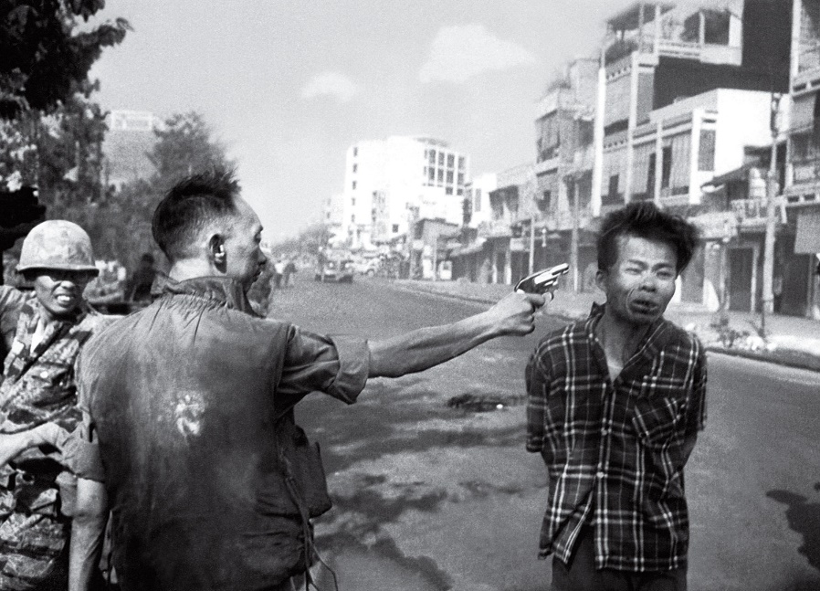
Adams, E. (1968) “Saigon Execution.” [Photograph] Associated Press, New York Times

Eddie Adam’s photograph titled the “Saigon Execution” was a prime example not only of the chaos of the Vietnam war but the effect it had on the individuals involved. The Photograph documents the final seconds of Nguyen Van Lem’s life before he was shot in the head by General Hguyen Ngoc Loan for what was perceived as war crimes. Adams won a Pulitzer Prize for the photograph, but it had much darker consequences on him as it affected him mentally. He felt the guilt of the way in which the General had been treated after the work had been published. The work mentally scared a number of photographers therefore the effects their work would have on society would create similar repercussions.
During an interview with The Guardian, Don McCullin reflects on his experiences of war and the effects it still has on him now. Although he has most recently created work on landscapes, he was still riddled with flashbacks to a more dangerous time. It evidences some of the long term affects the scenes the photographers were capturing had on them and the possibility it could affect others.
"Until I hear the local hunters shooting. Gunfire is a prelude to war for me. I feel I'm back there on some godforsaken road passing dying soldiers lying in culverts."-McCullin, D. (2010) Interviewed by Sean O’Hagan for The Guardian, 7th February [Online] Available at; https://www.theguardian.com (Accessed date;11/11/17)
Magnum photographer, Philip Jones Griffiths’ work was just as horrifying and showed the intense level of work being produced by a large number of artists at the time. He was working in Vietnam during the period and documented the work of the Saigon Fire Department that had to deal with collecting the dead from the street during offences. The young girl in the image below had just been placed in the truck when her brother had found her. The New York Times later published the work although they implied there was no proof she was killed by American firepower.

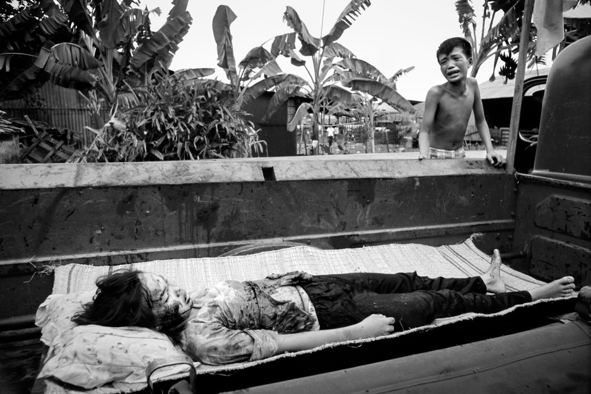
Griffiths, PJ. (1968) “Vietnam” [Photograph] The New York Times.

Images like this one were understandably shocking to society and a number of photographers were heavily criticised for creating these types of pieces. The morals of a photographer are often brought into question during these events and the decision between documenting one and getting involved in one are difficult. Magnum photographer Henri Cartier-Bresson coined the phrase “The Decisive Moment” and he and many others such as Don McCullin have made their decisions based on these events for better or for worse. The fact that a few were “brave” enough to work in such conditions often suffered long term effects creating works that once seen could not be unseen by them nor us.
For a large amount of the period after the Vietnam war it was made very difficult for photographers to continue to take photographs to the same degree as they had been. Stricter censorship laws were enforced, and it wasn’t until the events of the September 11th attacks that the “veil” of censorship was once again removed as described below.
David Levi Strauss in his book “Words Not Spent Today, Buy Smaller Images Tomorrow describes the shift between what he deems an “aestheticization of suffering” i.e., the creation of a “beautiful” image out of suffering and an open media platform.
“… Then came 9/11. I have argued elsewhere that the attack on the twin towers, the most photographed event in history, effectively reset the clock on documenting images, clearing away years of accumulated censure.”- David Levi Strauss, (2006) “Words Not Spent Today, Buy Smaller Images Tomorrow.” Aperture.
This is further backed up by the fact that after the attacks, the fourteen photographs, photographer James Nachtwey had published on Time.com had two million views on the page within its first day. A symbol of the growth of the internet and the capabilities it had as a platform for sharing work and informing people and is therefore a key milestone in terms of the beginnings of the route towards an oversaturation of imagery.
The imagery created at the time of the event by professional photographers such as James Nachtwey were completely different to many forms of conflict photography seen previously and tended to show more of a “metaphorical” damage rather than “Physical” damage this is not to say these images did not resemble the chaos but as you can see in the photograph by Nachtwey below, he has captured the scene of a crucifix still standing whilst one of the tower falls, a thought provoking image which conveys the chaos and suffering being endured during the time but also seems to convey the strength in belief and standing strong. This photograph and the collection of eleven images it was included with portray a calm amidst a chaos and the strength of others to continue to support each other during such a difficult time.
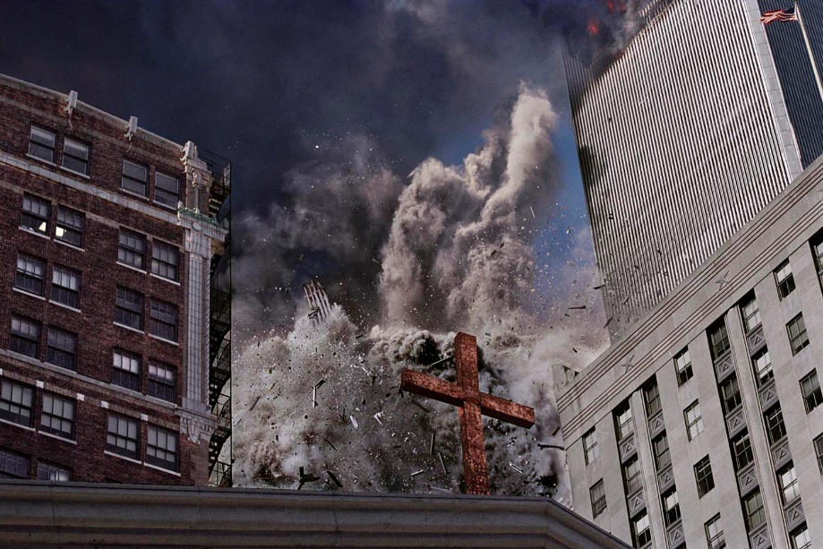
-Nachtwey,J. (2007) September 11th [Photograph]- Time.com.

Nachtwey created important work during a period of chaos which cemented and promoted a positive message amongst a scene where there only appeared to be pain and suffering which is a complete contrast to the Vietnam war photographs which conveyed brutality within a brutal environment. Images of innocent people such as Phan Thi kim Phuc, often crudely referenced as the “Napalm Girl” were completed in such a real way that it portrayed the event without a filter or the tact that was more appropriate for the society at the time and completely changed public opinion on war. Though it also meant the door was permanently held open for the creation of work on a similar level for time to come.
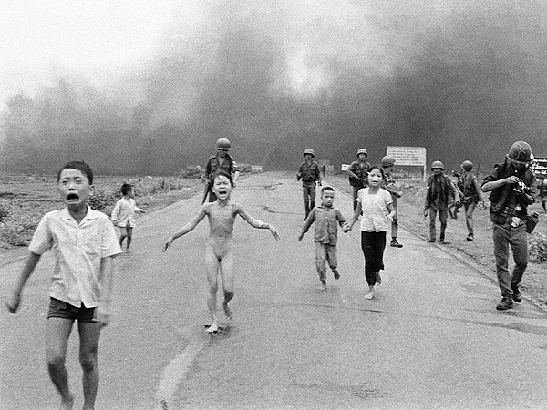
Ut, Nick (1972) “Napalm Girl.” [Photograph] Associated Press.

Nick Ut’s photograph and the many that were created during the Vietnam were produced years before their time. War was shown so graphically that there would be no way of forgetting the events that took place. It has become increasing difficult since photographs began surfacing to ever really impact people in such away due to the visual content therefore the message that the artist’s want to convey often get lost. Photographers such as Nachtwey have had to redevelop their techniques to suit these demands and thus conflict photography would once again change.
The events of September 11th were the first scene of major conflict in which every individual in the near vicinity had their own decisive moment, choosing between safety, helping or filming the scenes that were unfolding. The growth of technology provided the opportunity to document the chaos that was unfolding around whilst the growth of the social media website Facebook and other mass media websites provided a platform to publish their experience.
Over the next weeks, millions of images and videos flooded the internet from both professional and amateur photographers of the events that took place on September 11th, it created what is seen as “Citizen Journalism” as now nearly everyone in society had access to a phone or some form of equipment for documenting scenes and publishing for an audience to view. It would become practically impossible to view images of any other events happening around that point as a constant flow of new and reproduced images covered screens and newspaper pages. It was the largest scale terrorist attack at the time and captured global attention and was an early warning sign that the oversaturation of image could happen. It was now clearer that conflict photography would be part of society, but the demand was for more visually acceptable images, a self-censorship within a less censored society.
Furthermore, it was now becoming increasingly difficult to patrol and censor the work of hundreds of thousands of people and this would only continue to develop as time went on meaning that there was an opportunity for unrestricted work to finally be created and promoted but also meant it could be used for darker schemes and a new form of digital terrorism. Terror tactics now used within film by groups such as Islamic State that attempt to radicalise, indoctrinate and scare on a global platform. The camera and the internet could be a positive or negative partnership depending on the user but was a necessity to maintain a creative freedom.
The Cameras’ place in society may have been changing but the impact a photograph could have was still powerful though and visual images have long had a large amount of influence on public perception and can be a huge driver for public opinion which can be mostly evidenced in the mass outburst of Islamophobic events that took place after the September 11th bombings as a direct response to the images and stories that people had seen and heard on the news and on the internet.
The power of imagery was going to be used if it was not possible to censor it. The mass media would use the images of brutality to control public opinion rather than be controlled by it and this could now start to be done on such a scale, that the whole world could be affected but only if the power of the image remained.
In order to maintain the power of image the areas which could be controlled were and therefore journalist and photographers would find it very difficult to work with anywhere near the amount of freedoms they were once used to in regard to working in conflicts. Militaries now began to take control of everything coming in and out of the media with regards to them but allowing enough of a level so that at least a sense of the events taking place could be conveyed back to an awaiting audience.
A majority of journalist now have to become embedded with militaries now in order to be given access to war zones. They are often spoon-fed information and taken on direct routes with the group they are assigned to but there is no chance of diverting routes therefore a very linear documentation of war is often provided in order to maintain a level of public opinion. It is becoming more the case of the visual documentation of the innocents drawn into the conflict being increasing brutal. The photographs which seem to be used for propaganda attempt to convince us the conflicts are necessary to defeat the evil groups causing the damages being seen.

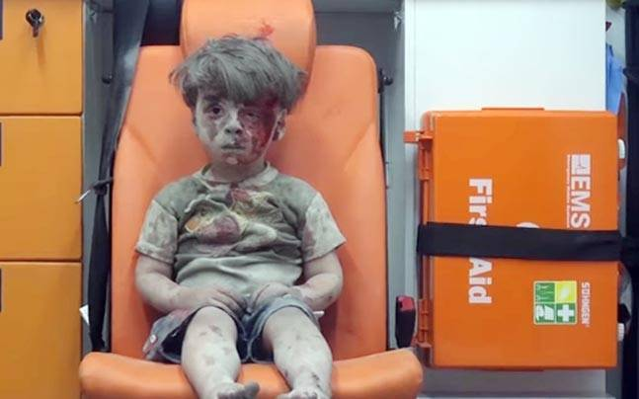
Rslan, M. (2016) “Omran Dagneesh.” [Photograph] Getty Images. Time.com

The Photograph of Omran Dagneesh by Mahmoud Rslan has arguably been one of the most physically moving pieces created in recent years depicting the true brutality of war and the innocents that are enveloped within. Omran was hit by an airstrike from either the Syrian or Russian militarily whilst in Aleppo. The airstrike and the images of those effected sparked outrage, with the initial tweet by Telegraph reporter, Raf Sanchez was retweeted over twelve thousand times. The positives of social media sites allowed for the image to be shared globally within hours of its publication and caused a similar social response to the image of Alan Kurdi. (See discussion on page 9)
Although it could be argued how much of a real physical effect these images have had on society, it is clear the power of an image still remains to provoke public opinion. Therefore, it would seem as though we are likely to continue experiencing images like these as the mass media will be looking to capitalise on the impact these images can have.
When reflecting on the evolution of conflict photography of the Vietnam war, September 11th attacks, Syrian Conflict and the amount of criticism faced by the artists and the worked they created, it is important to understand that the art scene had been portraying brutal scenes without the use of a camera for hundreds of years. This was analysed by Julian Stallabrass in his essay “Troublesomely Bound Up with Reality,” in which he states;
“This censure of beauty in the depiction of suffering is never applied to music, and a seldom to literature or painting but often to photography.”- David Levi Strauss, (2006)” Troublesomely Bound Up with Reality.” “Words Not Spent Today, Buy Smaller Images Tomorrow.” Aperture.
The power of the image is most conveyed within this quote as the only reason for the increased censure for this reason can only be because of the effects that an image can have upon a person, which is seen to be more of a heightened danger than any other form of documentation. However, I believe it is more so the society that decides on the censure, it is a depiction on what they feel to be acceptable and can completely change depending on mass opinion and culture at the time, finding what is and isn’t acceptable. This difficulty is being able to devote the time to making those decisions during such an evolution in technology.
The major problem with conflict photography in the modern generation is the fact that it has evolved so quickly in such a relatively short space of time that there is very little room for “creativity” in terms of creating work that draws people in for more than five seconds, out of a topic that has only so much possible darkness. Photographers are being forced to create photographs that are so intense to the point in which the washed-up body of a child who died trying to escape conflict is made the frontpage image on for nearly every newspaper organisation the day after.
Although this event is not necessarily categorised as conflict photography, it can be seen as the result of conflict and the death of Alan Kurdi and the photographs that were produced sparked global outrage with many questioning whether photography had finally gone too far and if they even should have been allowed to be published. Although the images were incredibly powerful and captured worldwide attention to the story that followed. They brought attention to the horrors that millions of refugees were putting themselves through in an attempt to reach a better place and their total need for support. They inspired international action to begin dealing with the refugee crisis and inspired millions of others to provide aid. The death of Alan Kurdi was truly a horrific one and was an event that should never have taken place, but he was also only one in the hundreds of other refugees that have died in attempt to cross the ocean in the last year. As sad as his death was, it was not in vain and although the photographer was no doubt questioned on her morals after sharing the image, it could be argued she at least tried to ensure this event would not happen again and was a necessary evil that comes with being a photographer.
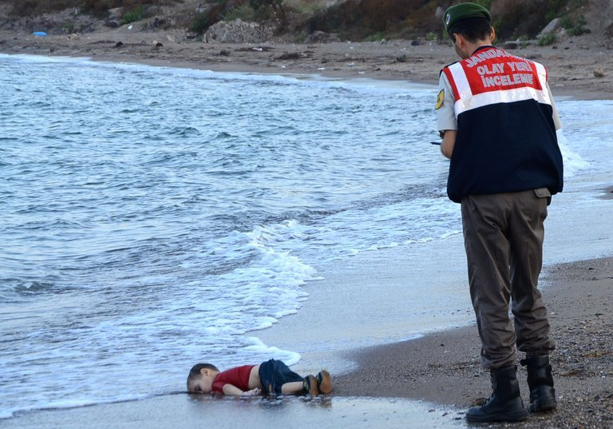
-Nilufer Demir, (2015) “Alan Kurdi” [Online]. Available at: https://www.nytimes.com, Accessed at 15/10/2017

The Death of Alan Kurdi is seen to be a symbol of the horrors of war and escape and the need for change. However, I do believe from all the evidence I have collaborated from the past and the present, that more worryingly, this could resemble conflict photography’s “final destination.” When looking at the Vietnam war photographs, September 11th and all the many other conflicts, I strongly feel very little can actually now be created that impacts as much as the photographs of those events. They were all brutally shocking, gruesome and horrifying at the time, but have sadly become part and parcel of our reality and it is becoming harder and harder to affect us which is why photographers have to be so graphic with their imagery to draw attention. The oversaturation of imagery views on a daily basis has nulled our senses quicker and forced photography into this rapid increase in intensity to the point in which it is almost impossible to cope.
According to http://www.bbc.co.uk the image of Alan Kurdi was viewed over twenty million times by people on social media networks and generated trending topics such as “Refugees Welcome.” Although the image clearly garnered a large amount of social attention, very little has truly been done and over a year after the photograph was taken, hundreds of families still pack into inadequate floats and attempt to make the journey across the ocean. Therefore, the true effect of the image is much less than what was hoped for when it was first published.
Writer Fred Ritchen seems to back up this point in his book: Bending the Frame- Photojournalism, Documentary and The Citizen. In the section of the book entitled “The Useful Photographer,” Ritchen discusses the use of the photographer in a changing society and how many have had to adapt and refine new techniques to compete in a competitive market.
“It was once thought, at least in democracies, that a photographer of the documentary or journalistic persuasion who witnessed a horrific event or situation, or a painful one, would record what it looked like in order to alert society, so that society might respond. The photographer’s sanctioned role as a societal scribe meant that the imagery was received as more than voyeurism, or what is sometimes now crudely labelled as “Violence Tourism.” -Ritchen, F. (2013) “Bending the Frame- Photojournalism, Documentary and The Citizen.” Aperture.
The photographer is seen to take on a sanctioned role which means they open themselves up to the criticisms when photographs such as the ones referenced in this essay are published on a platform which can reach nearly every corner of the globe, but it is the risk that is taken for the rewards that can be gained. The promotion of a message, the growing of an audience or career. It has become significantly harder to make to make an impact on society in which is consumed by a flood of images and causes individual images to be lost completely. The internet has provided a perfect platform for reaching out to an audience, but it can only ever be for a few seconds as the open market allows for a constant flow drawing you to the next image. The idea of contemplating an image is becoming less and less relevant therefore the shock factor is often the only option for getting people to listen.
Overall, I believe that it will be very difficult for society to change from its current ways. We continue to raise generations on the idea that technology can bring us closer together, but it only isolates us. We have our own worlds and often refuse to deal with anything that doesn’t come into that world. We need to find new ways as artists to get people contemplating the work and the messages we are either creating or have been created in and I do not believe we can do that with a continued rise in brutal images flooding our screens. What we need are the photography organisations that have lived through this evolution to begin guiding new paths and inspiring experimentation.
In order to find out whether it is possible to begin contemplating again I have been analysing exhibition work by artists such as Alfredo Jaar who is currently experimenting with new ways of creating work and to expand the reach of the effect their work has on society. Exhibitions have always been the best way of viewing art as they provide the most physical representation of the message an artist wants to portray or created, within an environment completely apart from the original place the work was formed in. The physicality of works within exhibitions often create environments for longer contemplation than their digital counterparts as there is very little room for distraction. There is often a limit to the number of visual images displayed during exhibitions which means time can be devoted to every single one whereas when viewing work digitally, we are often distracted by the spread of advertisements and the hundreds of other visual stimulants available at the touch of a button, less time is devoted to each individual image and therefore it becomes very difficult to convey a message if your work is only ever seen for a few seconds at a time.
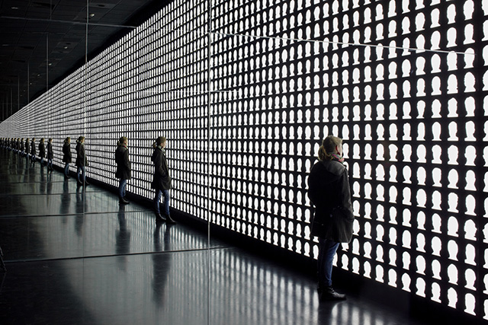
-Jaar, A. (2015) “The Geometry of Conscience.” [Online] Available at; http://forecastpublicart.org
(Accessed; 6/11/2017)

The work above is taken from Alfredo Jaar’s memorial exhibition for the victims of the seventeen-year long Pinochet dictatorship in which over three thousand Chileans where killed or missing, thousands more imprisoned or tortured and over twenty thousand driven into exile due to the extent of the of the violence. The work titled “The Geometry of Conscience,” plunges viewers into complete darkness before hundreds of black and white silhouettes representing the victims of the regime past and the present-day victims still readjusting to life after the regime are flashed onto the screen whilst being reflected by the mirror walls, creating an infinite repetition of the images. After roughly three minutes the viewer is plunged back into darkness and left with an intense afterimage engrained on the retinas.
The work by Alfredo Jaar impacts a viewer both physically and mentally, leaving the viewer with an intense memory without the need for the levels of brutality that have been represented in a number of other images within this essay. The intensity of created by the mix of darkness and bright light creates enough of a contrast that the viewer can contemplate the work but are never removed from what can be seen as a linear journey to the message Jaar is attempting to create. He has not employed the use of shock in the way many artists have done in the past because it is not necessary. The images of the Vietnam war, Syria etc that have been analysed during the course of this essay have often been criticised for the graphic detail they have captured the events with and this has caused a lot of the real messages to be lost and instead becomes another image of an innocent. Jaar has removed the need for the graphic detail whilst maintaining the works’ message as a memorial for those who lost their lives but also are now attempting to rebuild.
The Geometry of Conscience is not a piece which could ever be fully understood when viewing it digitally, it can only have its full impact within its space which although does not cater for the “modern” society’s general demand for art, maintains a level of authenticity which I believe is beginning to once again become the popular form of viewing art with more and more artists creating instalments which demand to be physically seen without the need of graphic imagery.
Overall the goal of this essay was to asses whether the oversaturation of imagery by social media platforms had caused photography to reach an intense level of brutality in the works being created and what could be done about the issue. Although I do feel that the sustained growth that both the Camera and the Internet have benefitted from since their invention has definitely forced both of them to grow much more rapidly. They both work perfectly together as the camera provides the tool for capturing and image whilst the internet provides the perfect platform for sharing the image. There are definitely benefits to this partnership but its now become almost too big for its own good.
The internet has definitely been a catalyst for competition within photography as although it provides the link between the photographer and an audience, it does not guarantee the whole audience. It is now a real competition to have your work viewed by people even for a matter of seconds as there are many other artists creating similar work who are also competing and therefore it is often the most brutal images that capture our attention. Photos of Alan Kurdi and Omran Dagneesh were viewed and shared online thousands of times in the days they surfaced, capturing global attention.
However, I do not believe that the internet can be totally to blame for this evolution as events such as the Vietnam War took place many years before the internet and social media played a major role in the sharing of image. Many of these photos were just as graphic if not more so than many we see today. The Photographs shocked the world who had not seen war portrayed in such detail, they were revolutionary at the time and showed the effects of reduced censorship on media, which was a real turning point in photography. War would never be seen in the same way again as photographers would now be embedded into the military and a censorship would be maintained.
Since Vietnam it could be said that we have never truly viewed war. We are now only shown a director’s cut of the footage. The images that do surface of brutality are often of victims and the results of conflict, they shock us and draw our attention to the horrors being faced by many throughout the world. They are the true photos of today’s society which I believe has not derived from the competition to have work viewed but the need for real work to be created. That’s not to say real work had not been created before hand but work that really reflects the darkness of our society and the need for change.
I believe that images of brutality often shock people into action whether it be the reaction to the Vietnam war or aid relief to refugees after the Alan Kurdi images, but I feel that there needs to be a more effective way of communicating this. If we are able to create work like Alfredo Jaar’s, which not only communicates a brutal time in history but leaves a lasting memory on the viewer without being so graphic. By creating work that appeals and educates a larger audience, we are creating potentially a future environment which relies less on conflict.

Reading List
Books/Journals
David Levi Strauss, (2006) “Words Not Spent Today, Buy Smaller Images Tomorrow.” Aperture.
Ritchen, F. (2013) “Bending the Frame: Photojournalism, Documentary, and the Citizen.”
“The Weight of Words, The Shock of Photos.”: Poetic Testimony and Elliptical Photography in Sergio Gonzalez Rodriquez’ The Femicide Machine 2012.”http://interamericaonline.org
On Photography- Susan Sontag (1977)
Memory of Fire; Images of War and the War of Images- edited by Julian Stallabrass (2013)
Newspaper Articles
Addler, M (2009) “The Vietnam War, Through Eddie Adams’ Lens.” [Online] Available at; https://www.npr.org (Accessed date;12/11/17)
McCullin, D. (2010) Interviewed by Sean O’Hagan for The Guardian, 7th February [Online] Available at; https://www.theguardian.com (Accessed date;11/11/17)
Images
Adams, E. (1968) “Saigon Execution.” [Photograph] Associated Press, New York Times
Griffiths, PJ. (1968) “Vietnam” [Photograph] The New York Times
Ut, Nick (1972) “Napalm Girl.” [Photograph] Associated Press.
Nachtwey,J. (2007) September 11th [Photograph]- Time.com.
Nilufer Demir, (2015) “Alan Kurdi” [Online]. Available at: https://www.nytimes.com, Accessed at 15/10/2017
Jaar, A. (2015) “The Geometry of Conscience.” [Online] Available at; http://forecastpublicart.org
(Accessed; 6/11/2017)
Rslan, M. (2016) “Omran Dagneesh.” [Photograph] Getty Images. Time.com
Websites
https://www.forbes.com
https://www.theguardian.com/artanddesign/2016/apr/15/erik-kessels-unfinished-father-deutsche-borse-photography-prize
https://petapixel.com/2014/11/10/fear-everythings-done-video-identical-photos-taken-different-photographers/
http://www.dictionaryofobscuresorrows.com/post/59306080288/vem%C3%B6dalen
http://www.cah.utexas.edu/db/dmr/gallery_lg.php?gallery=eddie_adams&s=3
https://www.rorybanwell.com/single-post/2014/05/09/Saigon-Execution-The-consequences-of-Eddie-Adams-Pulitzer-Prize-winning-photography
http://www.apimages.com/Collection/Landing/Photographer-Nick-Ut-The-Napalm-Girl-/ebfc0a860aa946ba9e77eb786d46207e
http://time.com/4465904/omran-daqneesh-aleppo-survivor/
https://www.theguardian.com/world/2016/aug/18/boy-in-the-ambulance-image-emerges-syrian-child-aleppo-rubble
http://www.bbc.co.uk/news/blogs-trending-37257869
http://forecastpublicart.org/public-art-review/current-projects/2015/07/the-geometry-of-conscience/
https://www.designboom.com/architecture/the-geometry-of-conscience-memorial-by-alfredo-jaar/
https://www.amnesty.org/en/latest/news/2013/09/chile-years-pinochet-s-coup-impunity-must-end/
http://www.artesmundi.org/artists/nastio-mosquito
http://www.contemporaryartsociety.org/news/friday-dispatch-news/artes-mundi-7-cardiff/
https://www.forbes.com
https://www.npr.org/2009/03/24/102112403/the-vietnam-war-through-eddie-adams-lens
https://www.theguardian.com/artanddesign/2010/feb/07/don-mccullin-shaped-war-review

