

UNIVERSITY OF WALES
TRINITY SAINT DAVID

CRITICAL THINKING
NAME: Patrick Mokwe
NUMBER: 1604804
Word count:
May, 2018
Table of Contents
1.0 Introduction 3
2.0 Impact Of Beliefs, Attitudes And Values On Management Theory 4
2.1 Difference Bewteen Belief, Attitude And Value 4
2.2 Management Theories Relevant To The Author’s Role In The Workplace 6
2.3 The Impact Of My Belief, Attitude And Values On Particular Management Theory 11
3.0 The Impact Of Beliefs, Attitudes And Values On Own Workplace Behaviour. 12
3.1 Beliefs, Attitudes And Value’s Impact In Workplace 13
3.2 Range Of Managerial Theories Relevant To My Role In The Workplace. 16
4.0 Conclusion 19
Bibliography 20

1.0 INTRODUCTION
Critical thinking is the aptitude to evidently and objectively reflect about actions and ideologies. This encompasses the capacity to undertake in reflective and independent thought (Lai, 2011). Critical thinking skills help in understanding the logical relationships between concepts and as such it is useful in the workplace to establish why phenomenon exists and the steps needed to address them. This report will provide an identification of a specific organizational context in which the construct of beliefs, attitude and value system can be expressed through critical thinking and evaluation. Hence, the impact of beliefs, attitude and value on a couple of management theories including my workplace behavior will be investigated.
To achieve this, this report will be divided into two sections. The first section will identify the differences between beliefs, attitude and value and a theoretical model will be deployed to aid the discussion. Moreover, managerial theories relevant to my role as a manager in my company Den Security Group Ltd will be analyzed and justification will be made to the reason why a given theory was selected. Also, using scenarios from my workplace as an example, the impact of belief, value and attitude on a given management theory will be investigated.
Moreover, the third chapter will examine with the aid of a theoretical framework, the impact of beliefs, attitude and value on my workplace behavior. Additionally, the impact of workplace attitude will be investigated. Moreover, management theories related to my role in the workplace will be highlighted and justification will be made to why the theories were selected. Furthermore, the conclusion will be made to give inference to the influential role of beliefs, values and attitude in the interpretation of managerial theories and organizational behavior.

2.0 IMPACT OF BELIEFS, ATTITUDES AND VALUES ON MANAGEMENT THEORY
This section will give an account of the impact my of beliefs, attitude and values on a management theory relevant to my role with examples from my workplace.

2.1 DIFFERENCE BETWEEN BELIEF, ATTITUDE AND VALUE
Humans and their relationship with its environment are a complex one, and its environment intertwined with beliefs and values is a major determinant of their attitude which predicts behavior. Scholars such as (Bergman, 1998) and (Schwartz, 1997) have contributed to the distinction between the three variables. Belief is an acceptance that an idea or phenomenon exists even without proof (Zajonic, 2008). Belief could be, religious or political considered being a state of mind generally held by a group (Van Deth & Scarbrough, 2005). Values however, are originally core characteristics of an individual which in turn forms conventions about reality (Bergman, 1998). (Schwartz, 1997) argues values and attitude are closely related, but while values are intangible ideas and notions, attitudes are rather perceived by other individuals in a group. Attitudes on the other hand are psychological depositions (for instance feeling of favor or disfavor, approach or avoidance) expressed after the evaluation of an entity or event (Zajonic, 2008). Three components of attitude include cognitive, affective and behavioral.
Scholars have conducted numerous researches that suggest belief, values and attitude be determinants of individual behavior. The value-belief-norm theory of pro-environmental behavior postulated by (Stern, 1999) states that values such as environmental, egotistic and altruistic as a determinant of pro-environmental behavior. Similarly, values have been shown to influence environmental consequences in the work of (Abramson, 1997) and (Brechin & Kempton, 2004). As a result, the perception level of environmental issues is dependent on the core value of the individual. The diagram below illustrates the important variable of the model.
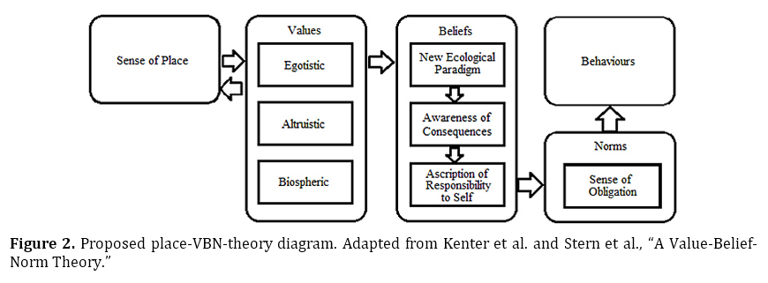Moreover, the theory of planned behavior in psychology helps in understanding the influencing role of belief and attitudes in the behavior of an individual. Adopted from the theory of reasoned action as an upgrade, the theory makes consideration for an individual’s non-volitional behavior which the former did not address. (Ajzen, 1985) postulated human behavior is predicted through a belief context namely behavioral, normative and control. Consequentially, their collective aggregates result in favorable or unfavorable attitude, subjective norm and perceived behavioral control. Moreover, all these lead to a behavioral intention (Ajzen, 1985). However, perceived behavioral control affects the actual behavior indirectly via the behavioral intention. Subsequently, if the attitude exhibited by an individual is favorable including the subjective norm with a great perceived behavioral control (Ajzen, 1985), it will increase the chances of performing the intended behavior. The diagram below points out the variables.
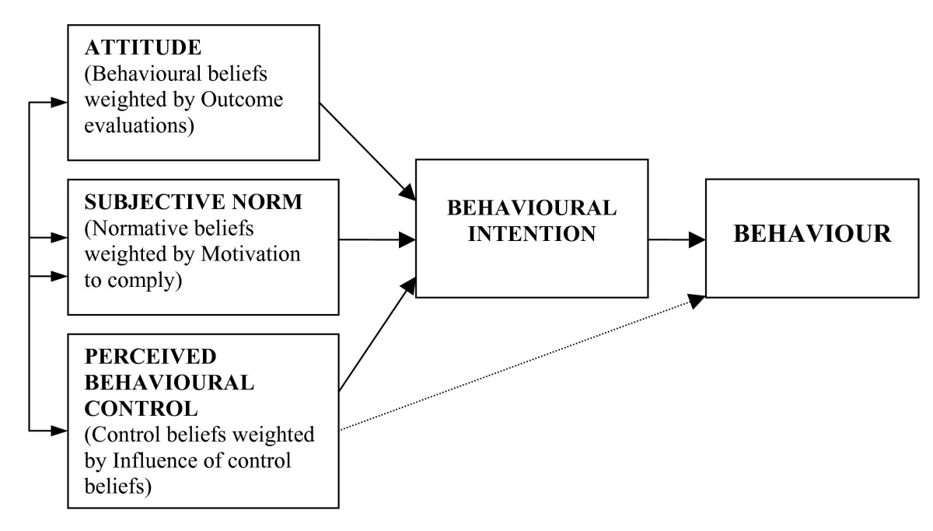
Theory of planned behavior. Source: (Ajzen, 1985)
Normative belief as argued by (Ajzen, 1985) is derived from social pressure which indicates that an individual will gauge the beliefs of other members of the group before behaving in a certain way. Also, subjective norms branches from normative belief as the view of an individual about a type of behavior heavily influenced by the social setting such as family members and friends. On the other hand, control beliefs are dependent on an individual’s locus of control (Ajzen, 1985), the degree to which an individual believes they have control over the outcome of events in their lives (Brechin & Kempton, 2004) which in turn positively or negatively influence performance. This influences perceived behavior control which is a determinant of an individual’s sense of ease or difficulty of discharging a performance. This will influence the intention to carry out the performance (Ajzen, 1985). Lastly, behavioral intention shows the keenness to perform a behavior. This is the sole determinant of the final behavior, a personal response in a given scenario.

2.2 MANAGEMENT THEORIES RELEVANT TO THE AUTHOR’S ROLE IN THE WORKPLACE
The author is a security manager at The Den Security Group Ltd. As a manager my job includes the enforcement of the company’s policy through organizing, planning, controlling and directing of the human resources to achieve shared goals and objectives. To give substance to the roles performed daily in my organization, management theories will be employed. These theories will include Hersey-Blanchard’s situational leadership and Edwin Locke’s Goal-path theory. These theories have been selected owing to their interrelatedness. Also, my job activities primarily revolve around the theories. For instance, the goal-path theory model depicts that clear and specific conditions with timed leadership style removes obstacles and motivate employees for enhanced job performance (Locke & Latham, 1990), a security manager needs to keep these factors in mind for increased performance from the security operatives, also the situational leadership model gives insights into the adoptable leadership style according to the performance readiness level of the employees (Hersey & Blanchard, 1993). Security operatives often exhibit different performance level therefore a flexible leadership style rather than rigid is expected from me. Consequently, these reasons informed the chosen theories.
HERSEY-BLANCHARD’S SITUATIONAL LEADERSHIP AND GOAL-PATH THEORY
The models advocate for changeable levels of leadership and management for different scenarios in the workplace instead of adopting a “one size fits all” mentality. However, (Hersey & Blanchard, 1993) suggest an identification of important tasks in the work activities and the employee’s ability and willingness for the effectiveness of the model. Consequently, in a given scenario these variables will be put together and measured to match the suitable leadership style. The diagram below depicts the situational leadership model.
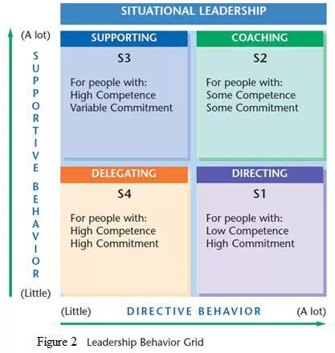
Situational leadership. Source: (Hersey & Blanchard, 1993)
Similarly, the goal-path theory aids the identification of the different roles of leaders and explores the situational eventualities that influence these roles (Locke & Latham, 1990). The figures below depict goal-path theory.
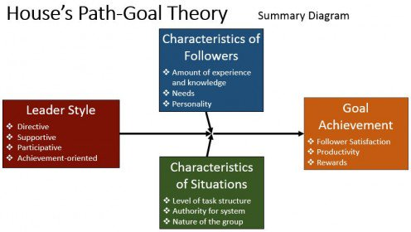
Goal-path theory. Source: (Locke & Latham, 1990)

Both models have an agreement about the flexibility of leadership styles according to the work situation however, goal-path theory rather highlights the variables that could influence the flexibility unlike the situational leadership model. From the employee’s characteristics of the Goal-path model, Security operatives have different characteristics which is noticeable from the years of experience in the job, self-confidence, communication skills, intelligence and technical skills required for the job which are often put into consideration Moreover, environmental and task characteristics are obstacles (Locke & Latham, 1990) which include the job requirements, scope, location and duration of a security contract that needs execution and the required chain of command needed for the job. The number of security operatives required for a given contract and the type of individuals that make up the team is also essential for team chemistry and motivation as argued by (Locke & Latham, 1990). It is my duty to make sure that to ensure performance and motivation of the team by understanding these variables by removing possible obstacles aided by adopting a directive, supportive, participative, coaching, supportive or performance-oriented leadership styles in situations to ensure that the security objectives set by our clients and my organisation’s standards are met. For instance, when selected security operatives for a given job have many inexperienced operatives often characterized with low ability and low willingness, I adopt the directing and participative leadership style since operatives are not yet familiar the mode of operation and cannot perform optimally as suggested by (Hersey & Blanchard, 1993). Moreover, such operatives often possess low locus of control and low sense of autonomy as argues by (Locke & Latham, 1990) therefore, possible obstacles such as authority system (bureaucracy) and workgroup might inhibit their motivation and performance. To remove them, I adopt a one-level chain of command by dividing them into groups while adding experienced co-workers in the mix and appointing experienced supervisors among them. Also, part of my duties in that scenario is to supervise closely, seek suggestions, provide a succinct definition of the tasks and their role (Hersey & Blanchard, 1993) and to enforce a one-way decision-making process. This usually makes inexperienced operatives know what is expected of them.
Moreover, certain situations arise when security operatives are internally motivated with a high locus of control but lack the required ability and experience to performance optimally. (Locke & Latham, 1990) argues the characteristics of the job (simple, repetitive or ambiguous) might be an obstacle for such operatives. My response to this scenario is to adopt a coaching leadership style. Since they don’t have the ability to perform exceptionally, I make sure their roles are still clearly defined but their suggestions are highly sought after since they are enthusiastic (Hersey & Blanchard, 1993). Moreover, the decision-making process comes from me since the operatives lack the technical acumen. Communication in this scenario is two-way as operatives need feedback and praise for their self-esteem needs. Furthermore, certain situations arise in my organization when experienced security operatives (high locus of control and ability) under my line of command are demotivated. Demotivation might arise owing to the job requirement and authority system (Locke & Latham, 1990). My reaction to such situation is to remove such demotivators by providing them with ambiguous jobs opportunities which allow a degree of autonomy. Moreover, I often adopt the supporting leadership style since these operatives are already experts and require little or no clarification. This style enables me to be empathetic to understand how operatives might be demotivated.
Lastly, certain situations arise when I work with sounds security operative under my command who are characterized by their high willingness and ability to discharge their duties. These operatives according to (Locke & Latham, 1990) possess high locus of control and experience and often love to have a degree of control over their work activities. Moreover, since they are self-motivated, they love challenging and complicated tasks. I often adopt a delegating leadership style when working with them since they can be trusted (Hersey & Blanchard, 1993). Although, decisions are taken by me, I often leave the execution of the task to them hence, little or no supervision is noticeable. While I give these operatives occasional recognition as argued by (Hersey & Blanchard, 1993), they often communicate back to me.

2.3 THE IMPACT OF MY BELIEF, ATTITUDE AND VALUES ON PARTICULAR MANAGEMENT THEORY
The belief, attitude and norm theory of (Stern, 1999) and the theory of planned behavior postulated by (Ajzen, 1985) support claim that certain factors influence the behavioral intention of individuals and they determine their final behavior towards an event or as a response to an initial behavior. It is therefore necessary to ascertain the influence of my beliefs, attitudes and values on a management theory that suits my work activities. My role as a security manager requires the facilitation of human resources through controlling, planning, directing and organizing of work activities. The management of security operatives has functions embedded in the (Hersey & Blanchard, 1993) situational leadership model. The model was adopted since I mostly deal with security operatives with the varying ability (a function of their experience) and willingness level.
The theory suggests a flexible leadership style for different situations (Hersey & Blanchard, 1993). For instance, when operatives show low willingness and the low ability for tasks, for example when they need to contribute to team’s effort by performing related results, the theory expects a directive approach which requires a close supervision and less relationship to get the required level of performance. However, the author is a people’s person and values relationships and personal connections in the workplace. Consequently, even while adopting a directive style, as opposed to the theory, I seek to connect with such operative on a personal level as I believe such connection will increase confidence and a sense of belonging. Moreover, when dealing with security operatives who exhibit high willingness and enthusiasm but lack the ability to perform optimally in work activities, the situational theory suggests a coaching leadership style which requires a clear definition of roles as well as a two-way communication for feedback and confidence building (Hersey & Blanchard, 1993). This suits my planned behavior as I consider myself to be empathetic therefore, I naturally listen, advice and help such operatives develop the needed confidence for work.
Moreover, when the workplace scenario requires me to deal which experienced security operatives who exhibit high ability but lack the right motivator to carry out tasks, the theory suggests a supporting role to find out the obstacles draining their motivation and help eliminate them. This persuasive gesture will in turn re-ignite their motivation (Hersey & Blanchard, 1993). Security jobs unlike professional jobs do not guarantee frequent promotion and pay increase hence, many experienced operatives often lack the motivation to perform optimally. When dealing with these demotivated operatives, I naturally possess a supportive vibe around people as I have a strong family culture and therefore want people to feel happy. I naturally provide the needed support for employees in this bracket by giving them autonomy over job activities. Coupled with this, I often arrange social gatherings outside of work to create strong bonds amongst operatives. Lastly, among employees under my chain of command are employees characterized by their high willingness and ability to perform work activities. (Hersey & Blanchard, 1993) beliefs they are self-motivated and should be trusted to perform job function without supervision although. They also argue a delegating leadership style is appropriate in such situation. Personally, this theory also suits my ideology as I prefer a laissez-faire approach to dealing with people. I have shown a degree of dislike for authority in the past and I try not to impose it on others. As a result, when I am dealing with trusted and tested operatives, I just show them the client’s expectation for a contract and leave the decision-making process to the those I trust among my team.

3.0 THE IMPACT OF BELIEFS, ATTITUDES AND VALUES ON OWN WORKPLACE BEHAVIOUR.
This section will examine the role played by belief, attitude and values on workplace behavior with the aid of a theoretical model. Also, my roles will be clearly defined through the integration of management theories.

3.1 BELIEFS, ATTITUDES AND VALUE’S IMPACT IN WORKPLACE
Beliefs, attitude and values of an individual are a determinant of their behavior and this behavior might be parallel to the expectations of the organization. It is then expected of organizations to build a workforce that buys into their culture and value. However, studies have been carried out to understand those variable responsible for the behavior of individuals. The most popular amongst these studies is Hofstede. He believes work behavior is a measure of cultural and sociological factors and this will influence an individual’s behavior such as motivation, communication and disposition to change (Hofstede, 2011). From the survey of approximately 116,000 IBM workers in 40 countries about their work-related values, the inference showed employees have diverse value dimension of national culture. The table below depicts the inferential variables from selected countries.
 | Power distance | Individualism | Masculinity | Uncertainty avoidance | Long-time orientation
USA | 40 Low | 91 High | 62 High | 46 Low | 29 Low
Germany | 35 Low | 67 High | 66 High | 65 Medium | 31 Medium
Japan | 54 Medium | 46 Medium | 95 High | 92 High | 80 High
France | 68 High | 71 High | 43 Medium | 86 High | 30 Low
Netherlands | 38 Low | 80 High | 14 Low | 53 Medium | 44 Medium
Hong Kong | 68 High | 25 Low | 57 High | 29 Low | 96 High
Indonesia | 78 High | 14 Low | 46 Medium | 48 Low | 25 Low
West Africa | 77 High | 20 Low | 46 Medium | 54 Medium | 16 Low
Russia | 95 High | 50 Medium | 40 Low | 90 High | 10 Low
China | 80 High | 20 Low | 50 Medium | 60 Medium | 118 High

Hofstede cultural dimension. Source: (Hofstede, 2011)
The table above highlights the cultural dimension of individuals from the selected countries. Firstly, (Hofstede, 2011) claims power distance, a degree to which people in a country have a sense of normalcy about the unequally distributed power in groups and establishments. He argues a country with high power distance possess an enormous wealth and power inequalities while countries that score low on the scale generally have a sense of social equality and opportunity. Moreover, these feelings are acceptable and considered normal in these societies (Hofstede, 2011). High power distance is evident in my country Nigeria, a West African country with extremely rich and powerful political and royal class with high inequality. Consequently, I naturally appreciate a hierarchical organization rather than a flat one. It is however, understandable that an American might love a flat organizational structure. Second, individualism vs collectivism is other variables used in measuring cultural dimension. Individualism is a tendency for people to cherish individual privileges above that of the group and makes one acts independently while collectivism is a direct opposite as it favors a close social framework which breeds interdependency amongst members of a group (Hofstede, 2011). The ideology difference plays a huge role in team works in organizations. Again, since Nigeria has a low individualistic ideology, I cherish work activities that involve working in teams and appreciate shared goals and rewards. However, an average American will love to work alone and take all the glory. Third, Masculinity vs femininity according to (Hofstede, 2011) shows a country’s perceptions towards gender roles in the society. Masculinity is an affinity to favor the conventional masculine roles for instance, control and supremacy over the notion that advocates gender equality. Individuals from a country with high masculinity ratings share an ideology that put men before women and this will influence their workplace behavior while femininity is a view that advocates for gender equality including their roles in the society (Hofstede, 2011). Individuals from countries with high femininity rating will treat women as equals in the workplace. However, Nigeria scores medium on the scale as we are in fact mostly indifferent to the ideology.
Fourth, uncertainty avoidance indicates a national culture that influences the tendency for individuals in a society to withdraw from unpredictable and untested situations (Hofstede, 2011). He argues country ranking high on uncertainty avoidance will impose legislation to dissuade uncertainty. An individual from these countries might be unwilling to take risks or try new methods in his work activities. However, countries with low avoidance are more eager to venture into untested grounds in their workplace and are generally eager to accept change (Hofstede, 2011). Nigeria scores medium in the typology as we are mostly indifferent to the yardstick. Fifth, long-term vs short-time orientation measures a country’s long-term commitment to conventional values. (Hofstede, 2011) argues individuals from countries with long-time orientation are future-oriented, love savings, tenacity and conventions while the country with short-time orientation has a “here and now” mentality including a tendency and flexibility to accept change moreover, they do not see commitments as impediments to change. Consequently, workplace attitude of individuals from these countries is bound by these cultural dimensions. Nigeria has a short-time orientation, and Personally, I believe change is constant, and commitments are not self-imposed barriers. During change process in organizations, individuals with long-term orientation might be reluctant to change while those with short-time orientation might exhibit flexibility during the change process. Lastly, Indulgence and restraint “a new addition to the yardstick” shows a measure of a society’s affinity or the absence of it to indulgence (Hofstede, 2011). Countries scoring high on indulgence will exhibit a natural tendency to appreciate life noticeable through their fun-seeking adventures while countries scoring high on restraint will emphasize a more reversed approach to the gratification of needs.
Scholars have drawn a distinction between organizational culture and individual culture. Organisational cultures are embedded norms usually influenced by leaders and managers to guide the workplace activities (Rokeach, 1973) while individuals organizational attitude is influenced by individual beliefs system and culture (Smith, et al., 2002). However, job satisfaction and performance can only be achieved when individual underlining workplace attitudes suit or are channeled to aid workplace job performance. (Trompenaars, 1993) argues that the performance of organizational members whose attitude does not suit the organizational pronounced culture might decrease. Consequently, they might leave the organization in the long-run (Peters & Waterman, 1982). Organisations therefore, must take this into consideration in their recruitment policy to have the right workforce needed to achieve organizational goals and objectives.

3.2 RANGE OF MANAGERIAL THEORIES RELEVANT TO MY ROLE IN THE WORKPLACE.
As a security manager, my role involves the coordination of security operatives under my line of command to simultaneously satisfy the expectations of clients and maintain the standards set by the security firm. This is achieved by directing security operatives, controlling the scope of their operations, dissemination of information from senior management, and helping them remove anticipated and unanticipated barriers in their work activities. However, since security jobs are physically and mentally demanding, it is also my duty to motivate the operatives should they display signs of unwillingness to discharge their duties. Also, I often train new operatives and I deploy suitable leadership style when I need to get the best from the operatives. Consequently, the Alderfer ERG motivation model will be used in describing my role in the organization owing to its suitability and applicability in motivating my subordinates. Furthermore, the transactional and transformational leadership styles will be employed since certain situations arise in my firm that demands a leadership style-switch to get the job done.
For instance, when dealing with new operatives, it is understandable that the company’s culture must be communicated to the operatives hence, I tend to be transactional when them. This involves setting goals and standards and communicating the consequences of their failure (such as dismissal) should they fail to adhere to the standards (Kuhnert & Lewis, 1987). As a result, their compliance helps maintains the culture of the bureaucratic firm. This approach is useful in helping the employee achieve set goals through reward and punishment (Dvir, et al., 2017) and this is evident in my work as I appeal to their self-interest by communicating the benefits of achieving targets through gradual wage increase to my subordinates. Moreover, operatives have levels of human needs, these needs are often used as motivation tools to get the best from them. The ERG model below, an advancement to Maslow motivation theory depicts the needs.
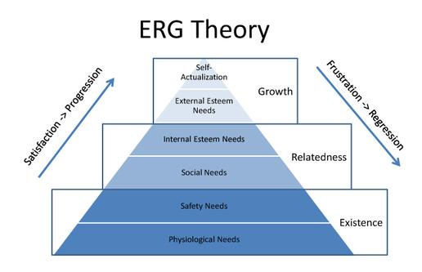
ERG theory. Source: (Alderfer, 1969)
From the model, I understand that the reward of labor is wage hence, to motivate security operatives to achieve their existential needs according to the ERG model, I use a transactional leadership approach as rewards such as promotion to supervisory roles, job security and gradual wage increase is given as a reward for exceptional work. However, when security operatives have satisfied their existence needs, relatedness needs arise (Alderfer, 1969). These needs range from interpersonal relationships with superiors and other security operatives to connecting with loved ones and family. I understand this need must be met to have a motivated workforce. (Dvir, et al., 2017) argues transformational leadership style must be adopted to satisfy the higher needs of the model (relatedness and growth). Consequentially, I proactively change my leadership style to help in the identification and satisfaction of the needs. Additionally, transformational leadership style also involves motivating and building morale to enhance job performance as well as the creation of alignment between the sense of identity of employees to the collective identity of the organization (Kuhnert & Lewis, 1987). To motivate security operatives through the provision of platforms to satisfy the relatedness needs, I organize social events last Saturday of every month for operatives regardless of the rank to socialize and connect on a social level. This creates a sense of inclusion and acceptance among the employees in the organization. This in turn satisfies their relatedness needs and gives them the motivation needed for job performance.
Furthermore, using the ERG model, when relatedness needs are met, individuals seek to satisfy growth needs (Alderfer, 1969). These needs include self-fulfillment at work and professional growth needed intrinsically for personal development. However, when growth needs are not met, (Alderfer, 1969) postulates a frustration-regression theory that such employee will redouble their effort invested in a lower need. The security industry does not create much room for career growth and as such, it creates a motivational problem when dealing with security operatives who have satisfied their relatedness needs. (Alderfer, 1969) further argues that dissatisfaction of growth needs breeds the increase of the importance of relatedness or existence needs among employees. Using a transformational leadership style, I have no choice than to redouble my effort to create social platforms needed to increase the satisfaction of relatedness needs. This will in turn motivate employees for increased performance. The table below illustrates the differences between transformational and transactional leadership style that I adopt when managing security operatives.
Transactional | Transformational
Leadership is reactive | Leadership is proactive
Organisational culture is taken into consideration | New ideas are encouraged to change the existing organizational culture
Carrot and stick approach is employed by the leader to achieve organizational goals | Values and innovative ideas are fostered to achieve objectives
Employees are motivated by appealing to their self-interest | Motivation comes from shared goals
Status-quoism and improved performance is stressed | Intellectual stimulation is enforced to create innovative ideas
Difference between transformational and transactional leadership. Source: (Kuhnert & Lewis, 1987)

4.0 CONCLUSION
Beliefs, attitude and values are major determinants of the behavior of an individual. This behavior in turn determines the workplace behavior of individuals. Beliefs could be religious or political regarded as a state of mind generally held by a group. However, values are characteristics of an individual which in turn form conventions about reality. The attitude on the other hand is psychological depositions expressed after the evaluation of an entity or event. Scholars have postulated theories on the variables. The value-belief-norm theory postulated by (Stern, 1999) indicates that value such as environmental, egotistic and altruistic are a determinant of pro-environmental behavior. Moreover, the theory of planned behavior put designed by (Ajzen, 1985) explains the variables such as behavioral, normative and control are the determinants of the behavioral intention of individuals which in turn determines their final behavior. These behavioral differences amongst individuals play an important role in the workplace as a result, the cultural difference will influence the interpretation of the managerial theories and, also workplace behavior. This however, creates the need for organizations to understand the extent to which cultural diversity plays an important role in determining the organizational behavior of the workforce.

Bibliography
Abramson, P., 1997. Postmeterialism and environmentalism: A comment on an analysis and a reappraisal. Social Science Quarterly, 78(1), pp. 21-23.
Ajzen, I., 1985. From intention to action: A theory of planned behaviour. 1st ed. New York: Springer-Verlag.
Alderfer, C., 1969. An empirical test of a new theory of human needs. Organisational Behaviour and Human Performance, 4(2), pp. 142-175.
Bergman, M., 1998. A theoretical mote on the difference between attitude, opinions, and value. Swiss Political Science Review, 4(2), pp. 81-93.
Brechin, S. & Kempton, W., 2004. Global environmentalism: A challenge to the postmaterialism thesis?. Social Science Quarterly, 75(4), pp. 245-269.
Dvir, T., Eden, D., Avolio, B. & Shamir, B., 2017. Impact of Transformational leadership on follower development and performance: A field experiment. Academy of Management Journal, 45(4).
Hersey, P. & Blanchard, K., 1993. Management of organisational behaviour: Utilizing Human Resources. 6th ed. New Jersey: Prentice-Hall.
Hofstede, G., 2011. Dimensionalizing culture: The Hofstede modeling context. Online Readings in Psychology and Culture, 2(1).
Kuhnert, K. & Lewis, P., 1987. Transactional and Transformational leadership: A constructive/ Developmental analysis. Academy of Management Review, 12(4).
Lai, E., 2011. Pearson Assessment. [Online]
Available at: http://images.pearsonassessments.com
[Accessed 20 April 2018].
Locke, E. & Latham, G., 1990. A theory of goal setting and task performance. 1st ed. Psychological Science: Prentice-Hall.
Peters, T. & Waterman, R., 1982. In Search of excellence: Lessons from America'sbest-run companies. 1st ed. New York: Harper & Row.
Rokeach, M., 1973. Beliefs, attitude and Values: A theory of organisation and change. 1st ed. California: Jossey-Bass.
Schwartz, s., 1997. Values and Culture. 1st ed. New York: Routledge.
Smith, P., Peterson, M. & Schwartz, S., 2002. Cultural values, sources of guidance, and their relevance to managerial behaviour: A 47-nation study. Journal of Cross-Cultural Psychology, 33(3), pp. 188-208.
Stern, C. P., 1999. A value-Belief-Norm theory of support for social movements: The case of environmentalism. Human Ecology Review, 6(2), p. 1.
Trompenaars, F., 1993. Riding the waves of culture: understanding cultural diversity in business. 1st ed. London: Economist Books.
Van Deth, J. & Scarbrough, E., 2005. The impact of values. 1st ed. Oxford: University Press.
Zajonic, R., 2008. Feeling and Thinking: Preferences need no inferences. American Psychologist, 39(3), pp. 151-175.

