Name: Porsha Schofield
Student number: 2501762
Course title: BA surface pattern and textiles
Module: Ways of thinking ADDA4022
Tutor: Menna buss

Task1- manifesto- 511 words
Task2- observational writing- 499 words
Task3- practice based writing- 495 words

Task 1: Manifesto writing

1. Art can be comforting to the uncomfortable.
2. Art tells a story that can’t be seen in people.
3. Art doesn’t have to be a profession, it can be a hobby.
4. Just because a individual studies art does not equal them less in a society driven with success or money.
5. being creative is a escape.
6. Art has no limit.
7. Art is more of a passion then job.
8. In a world of bright colours paint the dull ones.

- ‘Art can be comforting to the uncomfortable.’
As artists we can with this statement relating to more of a mental health factor for the artist/ practitioner, they often use art to express a mind state, feelings, and situation they are experiencing. Furthermore Picasso’s blue period 1901-1904 this was a period of time in which he created a series of blue monochromatic works relating this his friend’s suicide, his personal struggle with poverty and grief too. His work show cases the poor, unfortunate and vulnerable. Blue is often recognised for calmness, peaceful and stability however these can be juxtaposed with sadness, depression, melancholy, grief and loss or very commonly ‘feeling blue’ is a statement often used to describe how someone can feel. Additionally ‘Being creative is a escape.’ Can also be linked to this as using art within a way to cope with mental health or an upsetting situation giving the person an escape/ release of these emotions enabling them to move on, cope and spread awareness which also benefits them and others who may struggle and feel the same way.
Robert J. Boardingham wrote of Picassos work in 1938: “needing to completely empty himself of everything he had, he emptied himself into the blue period”

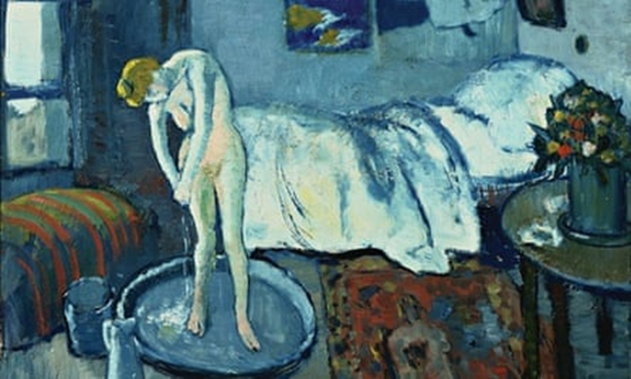
Fig 1, (The Blue Room,1901, oil painting)

4. ‘Just because a individual studies art does not equal them less in a society driven with success or money.’
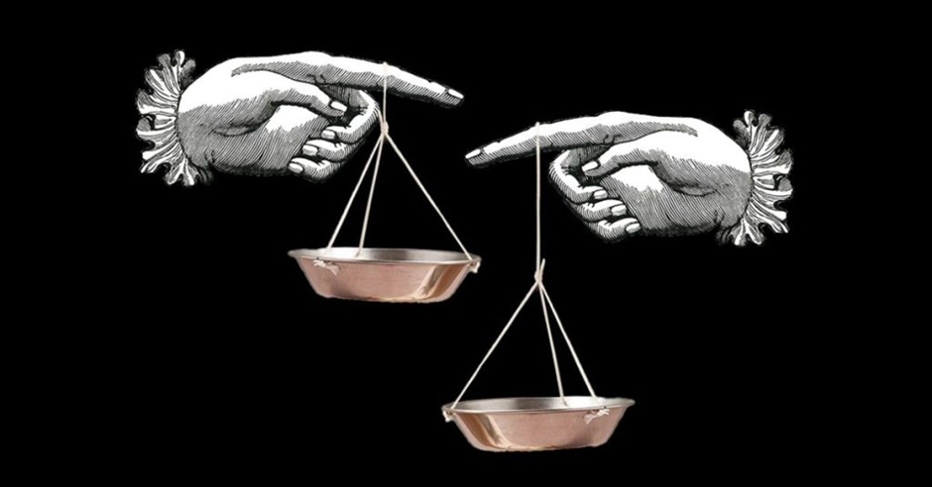
Fig 2. Google image, stock image

As a society people often see art as a career choice as not successful, not beneficial and more collectively a pathway that does not earn enough money ‘to make a living out of’, while art its self is a multi-million industry there is more non-profited artists then profited that result to non-profit exhibitions as a way to include and hopefully spread their art in the industry. While researching artist’s success rates I found “the number of unregistered and unexhibited artists worldwide is most likely a multiple sitting between approximately 15 and 30 million artists worldwide.” Further more to support this there has been study’s taken place that showed that artist from a smaller country or region also have lower popularity/ recognition “Although talent is difficult to measure, we expect an artist’s talent to be uncorrelated with their country of origin, implying that the distribution of initial reputation should not vary across artists of different origin. However, initial reputation was not equally distributed across artists of different country of origin” This emphasises a society’s point of not being successful and a art career as a ‘dead end’ also linking to the fact most small artists art careers are not enough to support them. Artists don’t have to be driven by money to determine if they are successful creating art is a success with in its self.

6. Art has no limit.
Art culture is the values, collective practices and expressions that correlate art and aesthetics within a society. Examples of art cultures are visual arts, sculptor and performing arts. In theory art and society is forever evolving and embracing new and also unusual art practices, however older art styles or artists work can regain/ maintain popularity such as Pop Art (mid- to late 1950s) this is described as the most loved and known inspired in mass culture, American consumerists culture, comics, advertisements and objects.

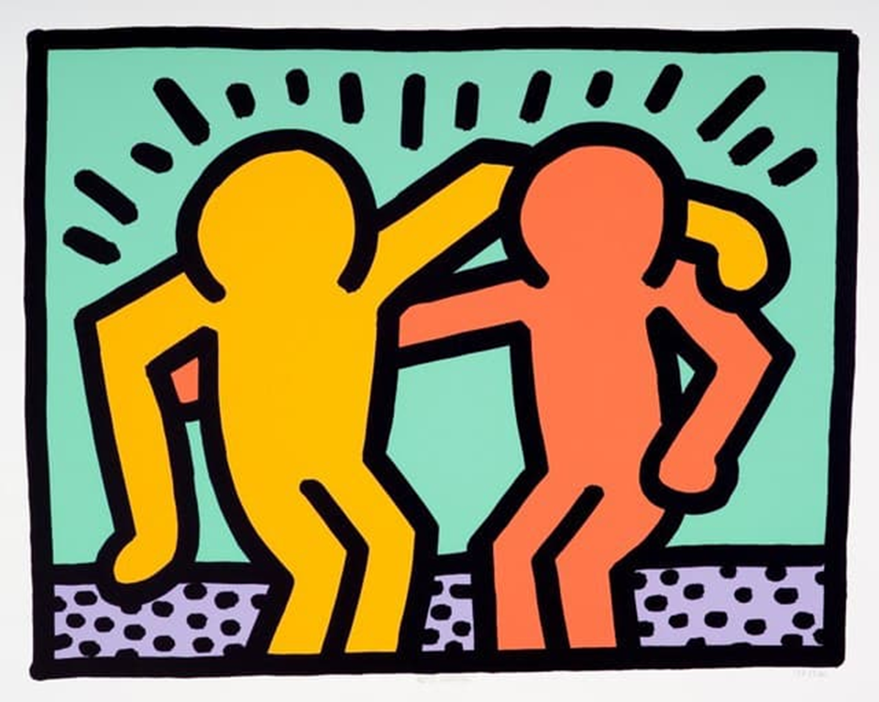
Fig3, (Keith Haring, best buddies, 1990)

Task 2: observational writing

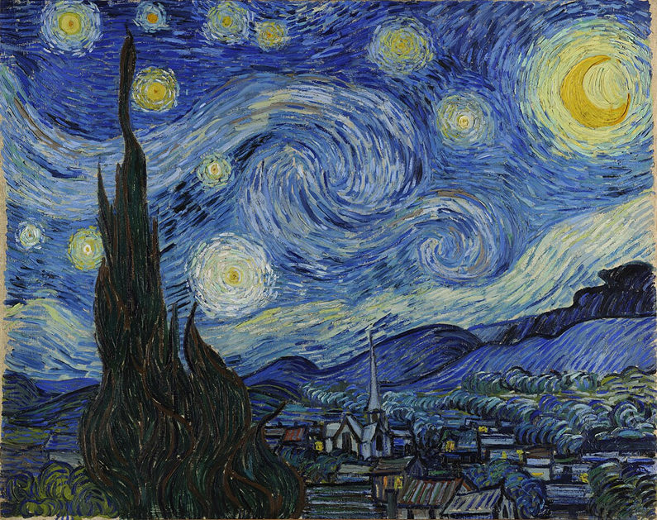
Fig1. Vincent van Gogh, The Starry Night, 1889

Semiotics is the interpretation and meaning of signs, semiotics is useful with reading images and looking at art as it enables people/ society to be able to gather information and connotations from just looking/ seeing. Roland Barthes was a 19th century thinker, he wrote about myths and published his book ‘mythologies, 1957’
“He believed the media and other forms of mass culture were manufacturing versions of reality which the audience were being taught to accept as natural. They were publishing myths – widely held but false beliefs and ideas.”
Van Gogh’s The Starry Night was produced in June 1889 while he was admitted to Saint-remy in south of France for his mental health. He was inspired by his view from the window creating from observation and imagination, even while being visualised at night he also worked on this painting at day times. “ “This morning I saw the countryside from my window a long time before sunrise, with nothing but the morning star, which looked very big,” wrote van Gogh to his brother Theo, describing his inspiration for one of his best-known paintings, The Starry Night.” Throughout his painting he used a technique called the impasto technique this enforces the stars to appear brighter within the night sky.
The village was not based on the view directly from his window and the cypress being more up-front and close within the painting, this work displays lots of gestural organic shapes and marks from the cypress and the sky that generates a unique glow round and with the moon and stars also creating stronger/ different layers/ eye catchers. This work is a clear view into what Vincent was feeling with the blue tones engaging emotions and thoughts to how he might of saw the world during his depression that tragically ended his life, blue symbolises sadness, grief and feeling lost. Furthermore Kudrya-Marais, Elena and Olalere, Folasayo Enoch wrote focusing on semiotics in colour “Semiotics of Color in Hinduism: A Visual Guide to Its Application in Design Practices (2022)” this entails how colours are thought of and how they can not only effect people mentally but physically also describing colour as its own language enhancing it speaks or it self more often than not.
This art work is exhibited in the Museum of Modern Art and is a permeant work there since 1941, this is also a huge attraction for visitors.
Looking closer Into art works and semiotics helps people and artists understand the precipitations also meaning of art helping us understand not just value but situations, social difficulties and problems. With the Starry Night being blue this gives the feeling of a more sombre painting which is reinforced by further research stating his poor mental health condition and his struggles that during the time were more of taboo subject also not widely spoke about or accepted by the public, thankfully mental health is more spoke about and understood in present day this also enables us to understand Van Gogh and his work.

Task 3: reflective writing
Four f’s my quarter turn. Fact: what I did?, Feeling www? Ebi? , finidngs: what did I learn, further research learning from others??? Include refrance o quote. Future how will I do it different nexr time, has it inspired me/ impromnets made.
For my final project this semester I have been assigned to create 3 scarves that feature 3 different presentations one that features a quarter turn, boarders and one with multiple designs/ sporadically layout. I have chosen to reflect on my quarter turn design development. The task requires to me look at incorporate various layouts and different ways to repeat designs, for my quarter turn I used a square of paper and collaged and once my composition was ready I added drawn on elements to complete my design.
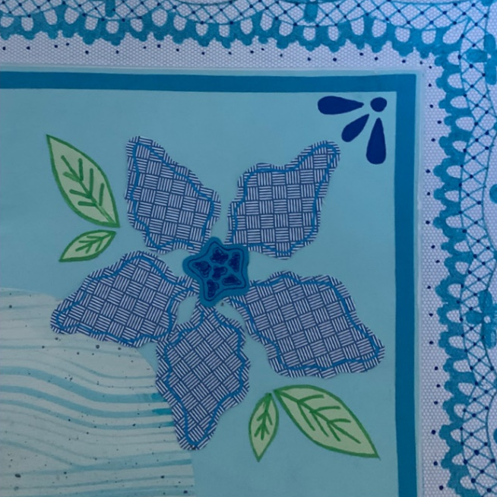

Fig 1. Porsha Schofield, quarter turn original (design one)

At first I really liked my design, it was neat around the boarder and visually worked together. However the lace I drew around the boarder didn’t line up which was unexpected, also the circle in the middle was slightly of centre that was frustrating. During the making of my turn I should have considered more proportions and symmetry, for my next design I will make sure to incorporate these factors so my final product will line up smoothly and as a full design this could be done by taking measurements or making measurements onto my work to able me to work in the guides drawn and have the proportions equal or create my quarter turn but instead of it being one design that is copied work on 4 separate pieces of paper with the same design throughout and while working on these place them together to make sure they line up correctly and equally.
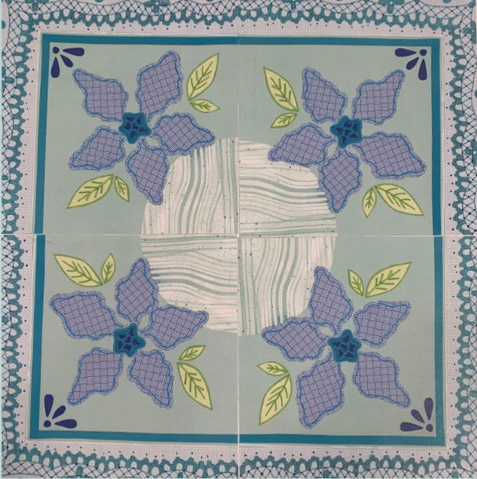
Fig2. Porsha Schofield, full quarter turn original (design one)
Additionally I could use Photoshop to correct/ redesign my piece using the guides, rulers and measurement axis’s I can do this by using a Wacom drawing tablet and pen.
“”how do we tell if something is good? And who tells us that it’s good? That’s perhaps even more important.” Grayson Perry said this during his speech at “Playing to the Gallery” for the 2013 BBC Reith lecture series.” Greyson Perry (born1960) is an artist commonly known for his scarf and pottery designs that feature a range of things from cultural views, maps and contemporary art work with his fashion garments. His work also features a lot of bright colours.

During the process of my improvements I used the methods I stared above within Photoshop outside of my timetable and the Wacom tablet to recreate my quarter turn to be more fluent and line up during this process I did have to leave out some details such as smaller more detailed elements but this was equalised by the design now being functional to piece together or make repeat design out of. I used a similar colour pallet (cold colour tones of blues, greens) with the improvement it was difficult using the Wacom table to draw with as I’m not very coordinated with them as of yet but it was good practice and I enjoyed the learning curve of using them with Photoshop to get me result that will help to develop deigns featuring my 3 final designs due at the end of the semester.
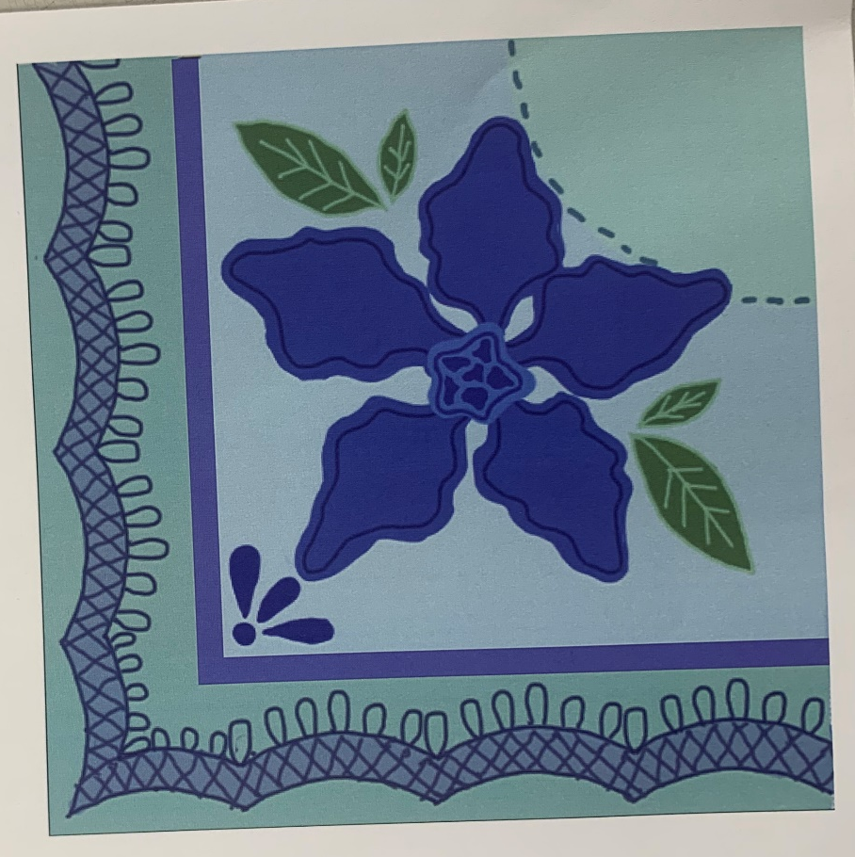
Fig3. Porsha Schofield developed improved digital quarter turn (design 2)

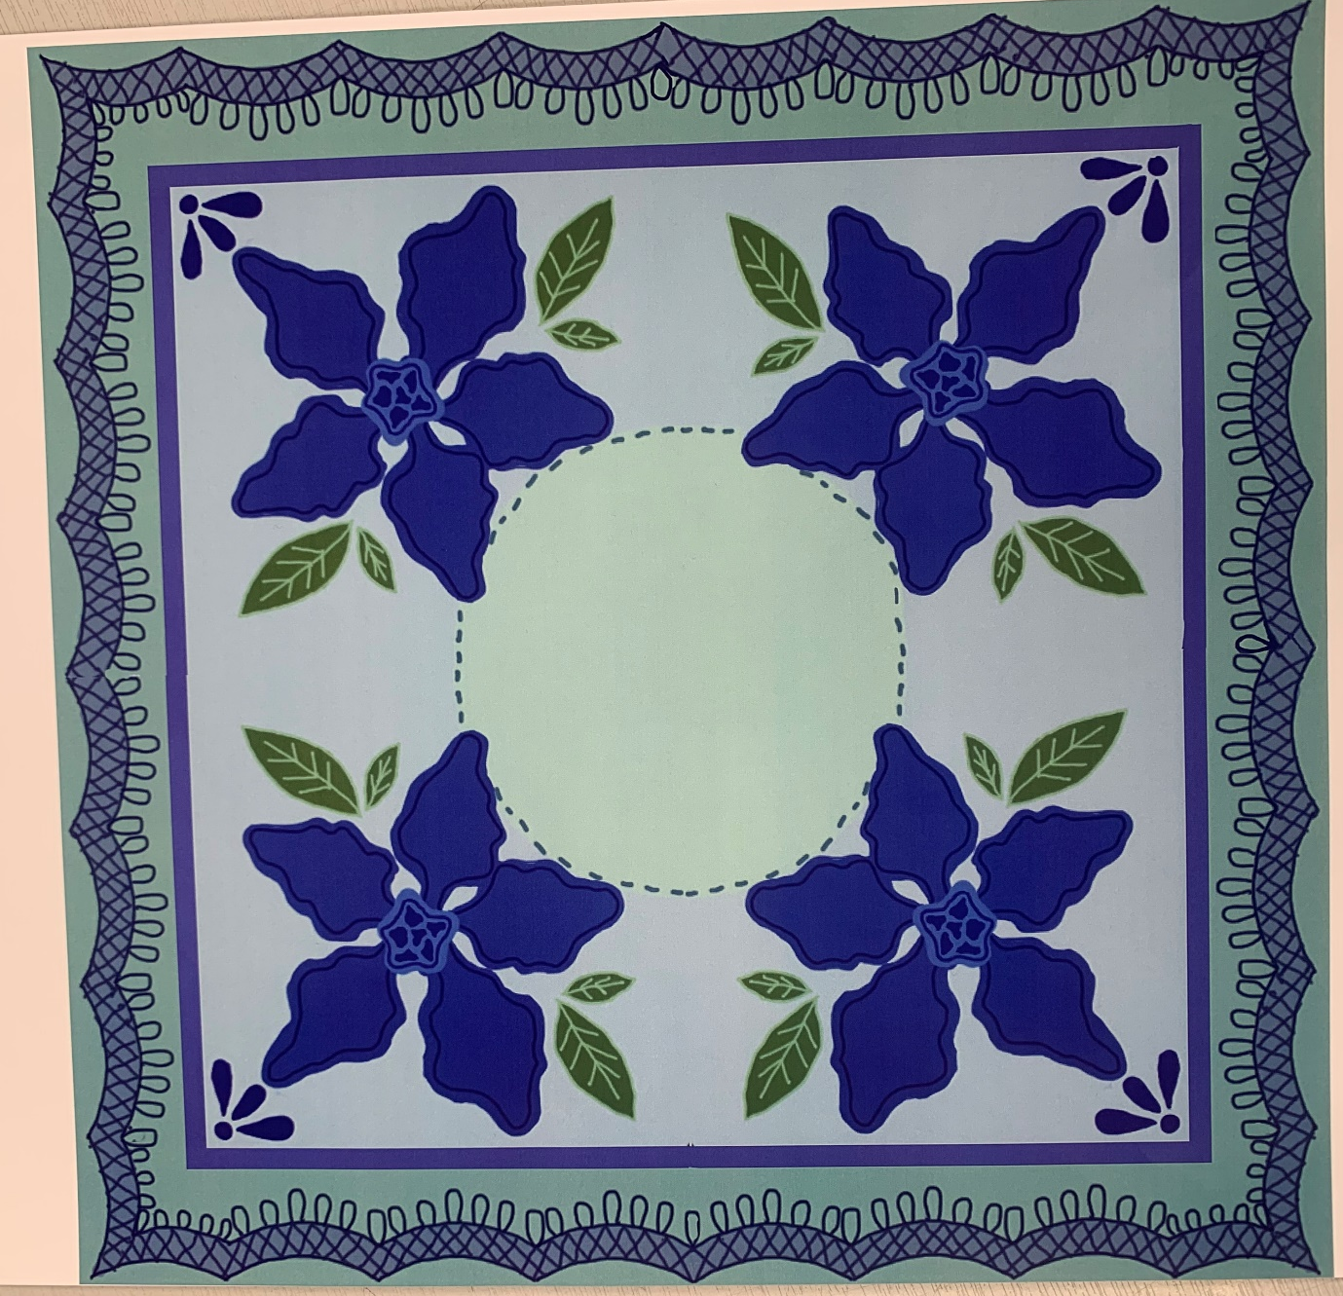
Fig4. Porsha Schofield full quarter turn, developed improved digital quarter turn (design 2)

References:

Manifesto-
Book: Picasso the early years 1892-1906
https://www.pablopicasso.org/blue-period.jsp

https://www.contemporaryartissue.com/how-much-money-do-visual-or-contemporary-artists-make/
Fraiberger, S. P., Sinatra, R., Resch, M., Riedl, C., & Barabási, A.-L. (2018). Quantifying reputation and success in art. Science (American Association for the Advancement of Science), 362(6416), 825–829.
https://doi.org/10.1126/science.aau7224
https://www.tate.org.uk/art/art-terms/p/pop-art

Observational writing-
https://www.moma.org/collection/works/79802
https://www.timeout.com/newyork/art/top-famous-paintings-in-art-history-ranked
https://media-studies.com/barthes/
https://doaj.org/article/76936a7d3bf9438890fbba9b2a29805e

reflective-
https://cfileonline.org/commentary-grayson-perry-makes-art-good/
https://www.brainyquote.com/quotes/grayson_perry_1205708
https://www.tate.org.uk/art/artists/sir-grayson-perry-cbe-ra-4657

