

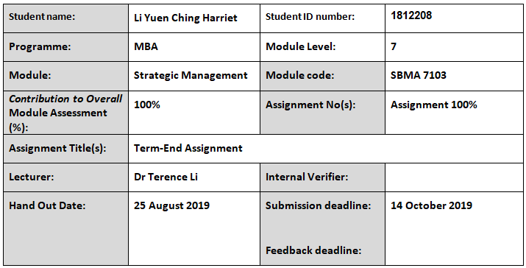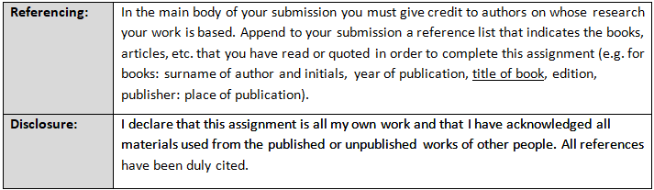
Executive Summary
Esprit International S.A is a manufacturer and retailer of skincare, body and home products. Its products are natural and organic ingredient-based. With analysis the skincare and cosmetics industry by using PEST and investigate Esprit’s present marketing strategies, Esprit is suggested to shift its target group to millennial and leverage the advanced technology and social media platforms to launch its marketing plan so that to sustain its competitive advantage to the future.
Key Words:

Analysis of Causal Wear Industry and the Strategic Plan of Esprit Holdings Limited in Hong Kong
Contents
Executive Summary
1. Introduction 1
2. Situation Analysis 2
2.1. Macro Environment 2
2.1.1. Political Factors 2
2.1.2. Economic Factors 3
2.1.3. Socio-cultural Factors 5
2.1.4. Technological Factors 7
2.2. Micro Environment 8
2.3. What is the industrial trend in the coming three years in Hong Kong? 11
3. Market Strategy 13
3.1. 4P 13
3.1.1. Product 13
3.1.2. Price 13
3.1.3. Place 14
3.1.4. Promotion 15
3.2. Esprit’s STP 15
3.2.1. Segmentation 15
3.2.2. Positioning 16
3.2.3. Targeting 16
3.3. Critical Success Factors for Esprit 16
4. Recommendation and Conclusion 17
4.1. Recommendations 17
4.1.1. AR helps luxury brands compete with large groups 17
4.1.2. Instagram to boost the brand awareness among young customers 17
4.2. Conclusion 19
Bibliography i

List of Figure

Figure 1: Hong Kong GDP Trend 3
Figure 2: The Revenue Growth in the Skincare and Cosmetic Industry in Hong Kong 4
Figure 3: Top 5 Countries of the Most Revenue Generated in Skincare & Cosmetics Industry 5
Figure 4: Hong Kong Female Spend More on Skincare 6
Figure 5: Age 35-44 Have the Highest Spending 6
Figure 6: Total Spending - Skincare VS Cosmetics 7
Figure 7: Instagram KOL 18
Figure 8: Online retail penetrating rate in Hong Kong is far lagged behind i

List of Table
Table 1: The Top Beauty Companies And Their Skincare Brands In Hong Kong 9
Table 2: Current Esprit STP In Hong Kong Market 15

- Introduction
Esprit Holdings Limited (Esprit) is a Hong Kong listed company (SEHK: 330). The group is a manufacturer, retailer and wholesale distributor of fashion and non-apparel products, such as skincare, body and home products, under two brands, namely Esprit and edc by Esprit. (The Wall Street Journal., 2019)
The Esprit’s founder, Susie Tompkins and Douglas Tompkins, created its first line of products in 1968 and its headquarter is locating in Hong Kong. As at 30 June 2019, Esprit products are in presence over 40 countries through more 580 store locations and more 5,400 wholesale of points of sales (Zhai, 2019). The Company recorded revenue reached HK$12,932 million in FY18/19, which a decline of -12.9% year-on-year. Geographically, Germany is the key market to contribute the group’s overall financial growth. It accounted for 51.7% of total Group’s revenue that around HK$6,687 million in FY18/19 while Hong Kong is a tiny piece of business for Esprit. Hong Kong’s net sales in FY18/19 plunged to HK$104 million that was a decrease of 41% as compared the year before. It was only contributing 0.8% to overall growth. (Esprit Holdings Limited, 2019)
Another distribution channel for Esprit is e-shop platform that generated HK$3,728 million in FY18/19, which mainly contributed from Germany and rest of Europe. There was no sales is generated from Hong Kong market via e-shop channel. (Esprit Holdings Limited, 2019)
In June 2018, the Company appointed Mr. Kristiansen as the Group CEO. Mr. Kristiansen led the management team conducting the Company strategic plan regarding the Company ability to adopt the rapidly market change. (Esprit Holdings Limited, 2019) In this paper, we would evaluate the current Esprit’s strategy plan. With nowadays adverse financial performance and ambiguous market positioning, and under the technology is keeping evolving, how does Esprit regain its competitive advantage in such fierce competition industry in the future.
- Hong Kong Clothing Industry Analysis
  - Macro Environment
To formulate the strategic plan for Esprit’s Holdings Limited, this first priority is to understand the industrial environmental trends and the changes are expected to happen in Hong Kong. Keller & Kotler (2009) depiected that the marketing environment affects Company’s management’s capabilities to establish and maintain long-term relationships between the company and targeted customers. Macro and micro environment have very important roles to sustain the Company’s growth. Thus, Esprit needs to analyze the global and Hong Kong environments that surrounding them.
The clothing industry here is a major part of the Hong Kong manufacturing sector, with 603 manufacturing employers hiring 4,027 workers as of March 2018. Most of them have set up offshore production lines and factories in order to reduce the expense expenses, so the number of clothing manufactures here is minimal. (Chan, 2018). More and more Hong Kong’s manufacturers relocate their factories to the country other than China, such as Vietnam, Cambodia, due to recent tense US trading war, uprising labor costs, strict environmental rules and regulations in the Mainland China. (HK Knitwear Exporters and Manufacturers Ass Ltd, 2018) Hong Kong is changing its role as a clothing sourcing hub globally. They are experienced in high value-added tasks, like supply chain, marketing and retailing, product design and development, and also the quality. Their professionalism that they command is experienced and is hardly matched elsewhere.
    - Political Factors
Some political factors may impinge the business operations unconsciously, for example international campaigns, local trading practices, legislations on merging and acquisitions, controls and guidelines on advertising.
Closer Economic Partnership Arrangement (CEPA)
Clothing products produced in Hong Kong can enter China market tariff free because of the implementation of Chinese mainland and Hong Kong Closer Economic Partnership Arrangement (CEPA) in January 2006. Taxation cost incurred here is much lower than the company operates the business in other countries. For those clothing products will still subject to tariff rate of 7 to 25% if entering the mainland. (Trade and Industry Department, 2018)
Hong Kong Protest in 2019
The civil protest in Hong Kong starts in June 2019, which is having a direct impact to Hong Kong’s retail stores. Retailer revenues were sharp dropped immediately that result of the operation hours are disturbed especially on Saturdays, Sundays and public holidays. The latest figures released from The Hong Kong Tourism Board, the number of visitor arrived declined 8.4% year-on-year in the July 2019. The United States, Australia, Japan and the UK had issued a heightened travel advisory onto Hong Kong because of the protest. (Fitch Solutions Group Limited, 2019) The protest also impacts Esprit’s business because of traffic is down everywhere that result in its sale dropped 40%.
Swire Properties and Hysan Development imitated the rent cuts offers to the retailers that is suffering from the protest while Link Reit has other measurement to help retailers. (Leung, 2019) Esprit management reverted that the Company would find the opportunity to find the development room if a rental here is cheaper and it is quiet down in the society (Fair Disclosure Wire, 2019)
    - Economic Factors
Esprit has to keep track on economic factors at both domestic and international levels so that the company could be aware of the coming threats and take corresponding remedial measurements to keep itself at a better position in the market.
In 2019, Hong Kong’s Gross Domestic Product (GDP) was worth US$362.99 billion. (Trade Economics, 2019) From figure 1, the Hong Kong GDP curve is going up steady, it depicts the economic is growth. Aged between 25-34 Hong Kong consumers is the largest age group (35.5%) is also the larger group of buyer of fashion products. (Statista Global Consumer Survey, 2019) Compared to 3.1% of unemployment rate between 2014 and 2018, in 2019, the rate is reaching 2.9% which is a very low figure regarding a city. This would expect the household and per capita income is growing up. (Fitch Solutions Group Limited, 2019) However, the protest breakout from June 2019, this is expected the unemployment rate might rise in next year and might impact the Hong Kong consumers’ spending power.
Figure 1: GDP Growth in Hong Kong
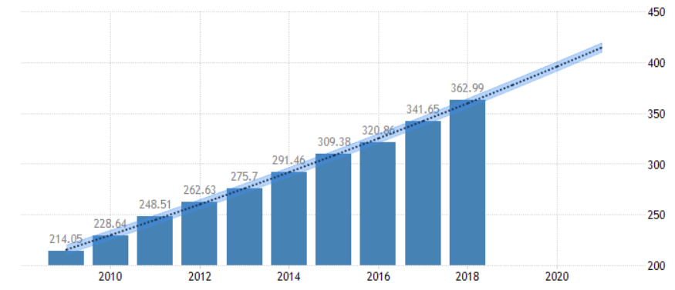
(Source: Trade Economics, 2019)

Figure 2: The Revenue Growth in the Fashion Industry in Hong Kong 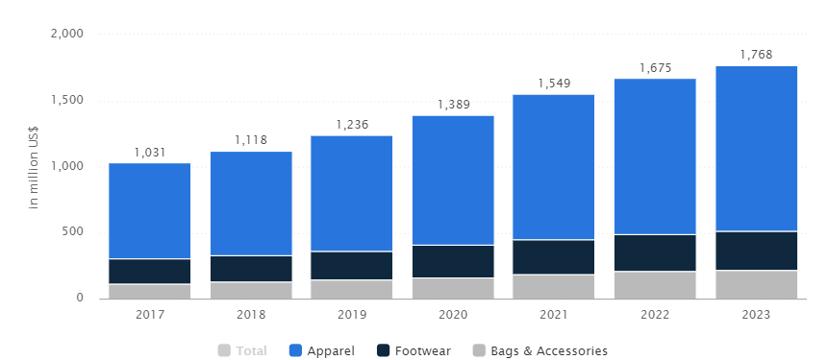
(Source: Statista Global Consumer Survey, 2019)
According to Statista Global Consumer Survey (2019) revenue in the fashion market in Hong Kong amounts to US$1,236 million in 2019 (figure 3). It is expected that the market is gradually grow by 9.4% annually (CAGR 2019-2023). From figure 4, it shows the industry volume of US$281,979 million in the year of 2019 in which the most revenue is generated from China (US$281,979 million in 2019) and followed by the US, Japan, the UK and Germany. Meanwhile, Hong Kong is ranked at 15 around the Globe. And the largest segment is “Apparel” with the market volume of US$875 million this year.
Compared with the top 5 countries, Hong Kong’s revenue in the market is only US$1,236 million that shows fashion market in the region is very small. Nonetheless, huge number of international brands in presence Hong Kong, proves that they treat Hong Kong is a step stone to China’s giant skincare and cosmetics market.
Figure 3: Top 5 Countries of the Most Revenue Generated in Fashion Industry 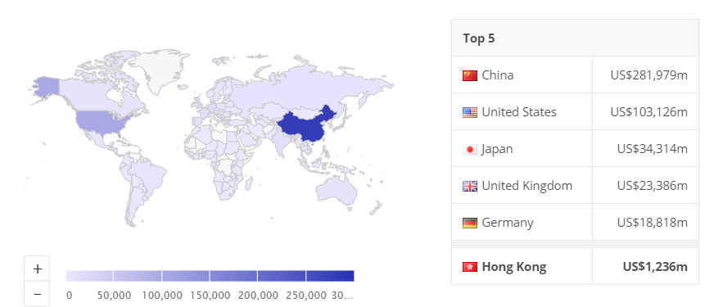
(Source: Statista Global Consumer Survey, 2019)
Industrial financial support from the HK government
From the FY2016-17 budget announced by Hong Kong Government that there is HK$500 million has been earmarked to Hong Kong fashion market for the industrial development enhancement through below purposes: (Chan, 2018)
(a) Promoting Hong Kong fashion designers and emerging fashion brands
(b) Set up an incubation fashion programme for young designers, drawing on the fashion experience from other industry capitals like New York, Japan, London and Seoul; and
(c) Providing technical support and training to the young fashion designers via establishing the resources centre.
    - Socio-cultural Factors
Numbers of studies proved that the demographic factor is one of the most influencing elements in predicting consumer behavior towards apparel products.
Figure 4: Clothing Spenders Distribution
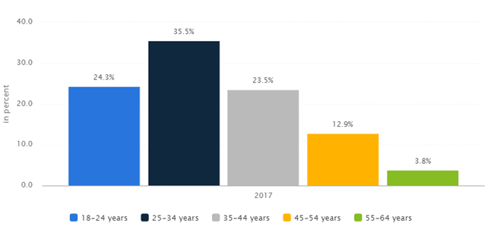
(Source: Statista Global Consumer Survey, 2019)
The above figures showed that consumers aged 35 to 34 are generally the biggest clothing spenders who keep regular pattern to do purchasing clothing. (Statista Global Consumer Survey, 2019) Meanwhile, the different age groups vary in their preferences of purchase channel. So, it is essentially for Esprit to formulate the strategies to gain the bigger market share with using appropriate sales channels to get connected with its relevant age groups customers.
The Consumer Council (2016) stated that 35% of consumer aged 35-44 would shop online, but with elderly, like aged 55 or above, least of them would like to do online shopping. 51% of post-secondary educated people are online consumers. In general, Hong Kong people who do online shopping mainly are highly educated and they aged young and middle.
    - Technological Factors
In the past, the goods consumer bought was decided by the collection of people ranged from designer, wholesaler, souring parties to retailer through many months ago. Nowadays is the digital era. The information technology provided has completely changed the fashion business model. Social media and E-commerce allows consumers easily access the most popular product information and follow the clothing trend closely from around the globe. So, this turns the new generation customers become much more sophisticated and increasingly interested in personalized products that can differentiate themselves. (HK Knitwear Exporters and Manufacturers Ass Ltd, 2018) Such valuable product information also is a chief resource that contributes to inter-enterprise competition, trading relationships on their negotiations for their business. (Yu, et al., 2012)
Under such circumstance, a new “norm” is formed – the fashion business should by run in a more agile supply chain, ability to predict personalization product and good consumer interaction model in a very near future. (HK Knitwear Exporters and Manufacturers Ass Ltd, 2018)
    - Environmental Factor
The fashion industry has been criticized as the second most polluting industry that is impacting on planet. Thus, many leading brands have joined the sustainable fashion campaigns. They include H&M, Patagonia, ASOS, etc. They have launched initiatives on the entire production lifecycle from recycling to regeneration. There were a total of 142 brands from 64 companies signed the Circular Fashion System Commitment 2020 at Copenhagen Fashion Summit in 2017. The motivation behind the industry is induced be the raising awareness of consumers’ minds and behaviors, especially the Generatoin Z and the Millennials. It is reported that much of millennials are not hesitate to pay more for the brands that with high sustainable credibility. This also assists the brands to build esteemed reputation and loyal customer base. (HK Knitwear Exporters and Manufacturers Ass Ltd, 2018)
  - Micro Environment
    - The Five Forces Framework
Rivalry Among Competing Firms
The sustainability of industry force depends on the intensity and nature of the rivalry among competing firms in the fashion industry. Here in Hong Kong, you can find a large number of retailers, no matter luxury brands, chain stores or small boutiques, they are selling very similar products. Nonetheless, there is the very strong concept of brands, hence part of the companies able to sell apparel for extremely high rates. And nowadays, it is only limited room for innovation and the market seems becoming saturated about such similar apparel. In such circumstances, the competition among the brands is strongly intense. (Bush, 2016)
Esprit operates in Hong Kong, definitely, in which it has to face a fierce business competition among wide variety of international or domestic’s competitors. To prevent losing market share to the competitors, Esprit have to retain its competitive advantage by formulate its strategies plan. Otherwise, it may suffer from adversely financial loss.
A number of competitors in Hong Kong market (Table 1), including Fast Retailing (the parent company of Uniqlo), H&M, Inditex (the parent company of Zara) have been dominating the fashion industry. Other popular brands like Calvin Klein, Giordano, Guess? can also be easily found in big shopping malls and the major department stores, e.g. Sogo. Recent years, some global brands launches their store in Hong Kong, J.Crew (May 2014) and Top Shop (June 2013) from UK, Hobbs from US (December 2018@IFC mall), Canada Goose (October 2018@IFC mall) from Canada. (Fitch Solutions Group Limited, 2019) This phenomenon indicated that many international brands anticipant Hong Kong is potential location to expand their fashion business and also because of the high spending market here.
Table 1: The Competitors List of Esprit
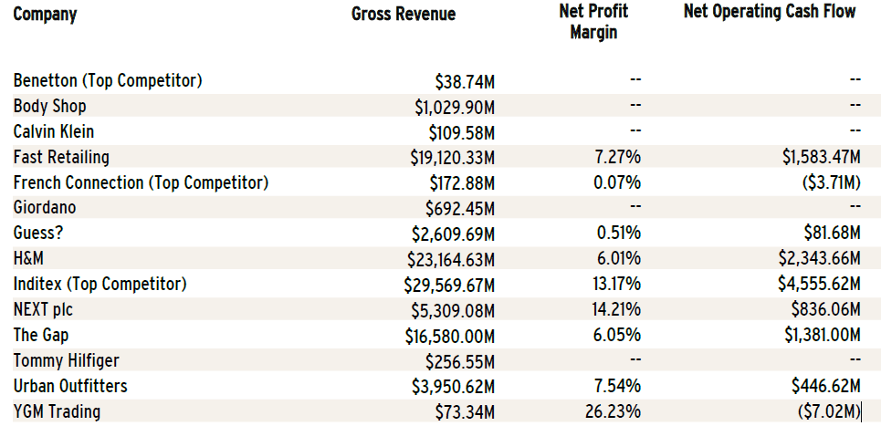
(Source: Hoovers, 2019)
Bargaining Power of Consumers
Customer power/force tends to be lower if the cost for the customers to switch to other brands is high. (Baye, 2010) The bargaining ability of customers is first important force, which customers can choose not to buy products or switch retailers. In fashion industry, the consumer force is relatively high as there are many alternative brands for customers to consider for and the switching cost is low if the brand has not provide any incentive to stay. Esprit has not provided any incentive plan or customer loyal scheme, thus its consumers switching cost to other is low, hence the bargaining power of consumers is high. Customers switch to other brands directly affect Esprit’s revenue amount.
Bargaining Power of Suppliers
The force of the suppliers tends to be lower if they have the bargaining power to negotiate the favorable terms. However, this bargaining power tends to be decrease if the input is relatively standardized and no room to be negotiated. (Baye, 2010)
In the past few years, Esprit has drastically reduced the number of their supply chain partners that they’ve worked for long time and regular reviews on their performance are conducted every six months. (Esprit Holdings Limited, 2018) This helps Esprit easily to manage their partners and their production orders and operations are more focus on certain suppliers so that to increase Esprit’s bargaining power over them. And this may help Esprit to decrease the production cost and finally increase the Company revenue.
Potential Entry of New Competitors
In case new entries formulate its own business strategies to promote its products, the barrier to the fashion industry is not high in Hong Kong; they will be able to set up the novel brands here. However, the industry now is as the state of ‘high risk, high reward’ (Bush, 2016), if the strategies is not unique enough, or it just copied from its rivalry, the chance can be sustain is not high. Thus, this entry force is not high.
Potential Development of Substitute Products
In the fashion industry, there is little or none of products to substitute clothes with. Such force is negligible.
To sum up as below figure, it is difficult dive into the emerging fashion industry, even if there is few threats and low bargaining power from the suppliers, customers force is so high and the force of rivalry among completive firms is extremely high – i.e. splendid of choice of brands, make it difficult to sustain.
Figure 5: The five force model of Esprit Holdings Ltd.
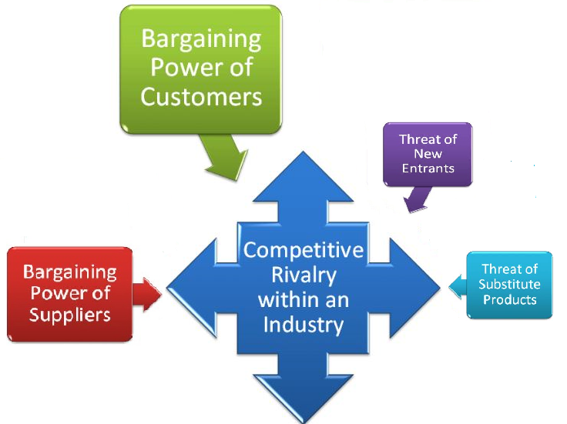
(Source: Created by the Author)

- Corporate Strategy and Business Strategy
To against the backdrop of the challenging business operating environment in globe, Esprit has formulated a clear Strategy Plan in 2018 in order to restore the Company to sustainable growth and increase the profitability.
This Strategy Plan involves 2 directions (Fair Disclosure Wire, 2019),:
- Business Strategy: establishing a new model for our business in all the channels, that is the brand, the product, the digital experience;
- Corporate Strategy: restructure the cost base to construct a powerful organization
  - Business Strategy
    - Sharpen Esprit’s Brand Identity
Esprit has redefined both its brand’s positioning and it target customer. “ESPRIT is not fast fashion. ESPRIT is not a discounter”. (Esprit Holdings Limited, 2019)
Esprit wants its brand which is a brand with a purpose – To delivery Joy. The brand stands for - radical positivity, with the vision is – Offer products that make people feel good every day. (Esprit Holdings Limited, 2019)
With this new brand spirit, the mission is expected to deliver a consistent customer shopping experience with a clear handwriting.
edc is another brand of Esprit. Many of its wholesaler complained that nobody can see a difference between Esprit and edc. Two brands become the same over time. edc’s design will be much younger, more urban, more street-wear, so that to target a brand-new audience.
Evaluation:
It is a top urge that Esprit re-builds it brands. Its brands identity is inconsistent what their strategy doing – they are not selling clothing at the way of value-for-money, however, Esprit always provided high discount for their customers. Esprit devalued its own label. The sale turnover is 5 times higher compared with the same month in last year, while they are doing the discount. (Fair Disclosure Wire, 2019) Due to lack of the customer focus, its product was not able to attract it target audience.
Under such circumstances, Esprit resulted in failing to achieve the expected profit and what we descript is “the organization being stuck in the middle-of-the road”. A bold change is needed. Brand Health Tracker survey (Stockdill, 2018b) revealed that 87 percent people in Germany gave position comments on Esprit’s brands awareness change.
    - Improving the Product Offering
Esprit is revamping its products offering which is more commercial and that is what customers actually want now. The product’s style, quality and price are all customer focused. (Fair Disclosure Wire, 2019) Esprit will cut the number of stock options by 20-30 percent. It leads to lower the development cost and simply the stock management. And allow customers to easily make a decision. (Fair Disclosure Wire, 2019)
Esprit’s competitors are offering 30-40 per cent black, while they have 15 per cent. In order to be more customer focus and follow the fashion trend, Esprit will strengthen its lines offering of neutrals, such as black, white, beige or grey. (Stockdill, 2018b)
To improve the production efficiency, Esprit would get a core fabric in place for T-shirt production (Stockdill, 2018b). They would not follow what they did before changing the fabric every time. They also invest in forecasting tools (Stockdill, 2018b) that will plan far batter by market demand rather than using the past sale forecasting (Yu, et al., 2012) in order to minimize the excess stocks which are finally be marked down and pushed to customers and avoiding to dilutes the brand image.
To cope with the change of products offering plan, Esprit employed new Chief Product and Brand Officer, they will refined the brand direction base on the Company’s mission, vision and purpose to improve the Esprit products’ quality. (Esprit Holdings Limited, 2019)
Market Practice:
Sustainable fashion is a hot topic in the industry. Brands are widely applied the concept of a circular economy by enable the reuse of textile fabric while the product is at end-of-life stage. Against this backdrop, more brands in the market is certificated. The Global Organic Textile Standard (GOTS) which is one of the traceability standard. 5,024 facilities across 62 countries are certified in 2017, and the number increased 8% compared with 2016. Reputable brands includes Nike, Adidas, H&M, Wal-Mart have already certified its product of sustainable products.
    - Enhance Customer Experience
Esprit will be a brand that is customer focused by utilizing it customers and competitors’ data to improve its consumers’ shopping experience via both online platform and the brick-and-mortar stores. Meanwhile, Esprit also launches product collaboration with Craig & Karl on limited-edition collection. (Chan, 2018)
To strengthen the customers’ engagement, Esprit will increase the intensity of online presence, via the online platform - Instagram to direct communicate with its target audience to understand their thoughts and needs. Instagram also allow company feature real-time content. Esprit will also re-launch a CRM loyalty program. All above initiatives clearly depicts what Esprit doing putting the customer’s needs at the focus. (Esprit Holdings Limited, 2019)
To align with the brand name is mentioned Esprit opened the first pilot concept store in Beijin in August 2019. The concept store’s image and renovation is storytelling will let its customer feel what Esprit’s brand name is. It is simple, fresh, clean and minimalistic. It looks amazing with not much options there with the music that lift your spirit. (Stockdill, 2018b)
  - Corporate Strategy
    - Restructure the Cost Base and Build a Powerful Organization
The Company had made the plan to eliminate the under-performance stores and reduce the number of staff in the globe so that to rationalize operations and turn the organization will be leaner and more efficient to sustain profitable growth. It targets eliminate the occupancy cost and personnel cost 37 percent and 20 percent respectively. Esprit thus has closed 169 unprofitable stores, made 14 rental reductions with the landlord. And the remaining 20 stores are planned to be closed (or with rent reduction instead) in FY19/20.
For the senior management as example, the team only consists of CEO, chairman, head of marketing, CEO for Asia, Chief Brand Offer and Chief Product Officer, in which culled from thirteen to six. This is to reduce hierarchy and allow faster decision making. It will merge five offices at headquarters into one and reduce the size of the office in Hong Kong. (Stockdill, 2018b) The simplified organization got 31% less staff in Hong Kong headquarters. Meanwhile, the space of head office is also reduced and 75%cost on the rental is saved. And, in Germany, the five offices is combined into one. (Fair Disclosure Wire, 2019)
Evaluation:
Esprit is building up a healthier cost base now by using the retrenchment strategy which aims to reverse the declining sales or turnover by regrouping through the assets / stores / cost, etc. In the case of Esprit, it cut down part of its human resource, locations and product options. It is estimated the annualized savings for the Company of $2 billion in FY19/20, such is critical to provide operation leverage in nearly future. It is expect in the coming 3 years, the gross profit rate will increase 3 to 5 points. (Fair Disclosure Wire, 2019)

- Recommendation
  - SWOT
Table 2: SWOT analysis for Esprit Holdings Limited
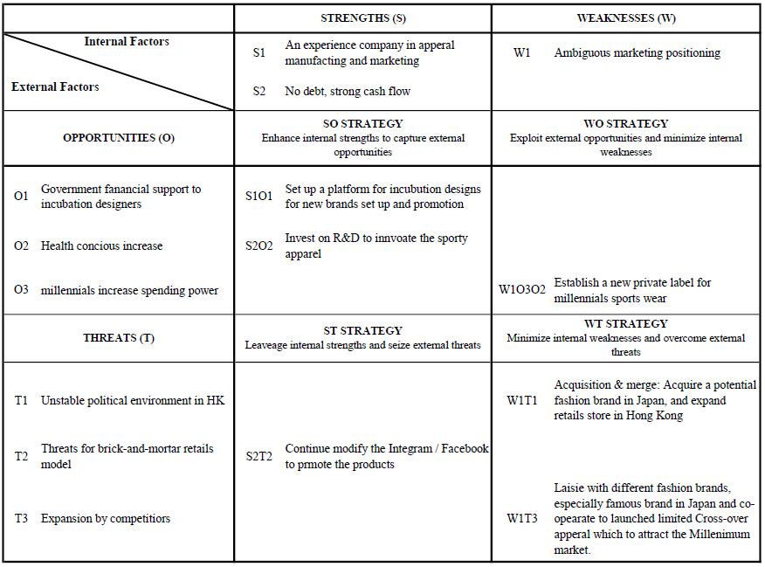(Source: Created by the Author)
    - S1O1: Fashion Guru

    - W1T1: Acquire a Potential Brand Labels
Horizontal Intgration

    - W1O3O2
    - S2T2: Develop Omni-channels Digital Platforms
Shopping via the mobile Apps or online is increasingly popular in fashion industry market. For those online shoppers, they think purchasing via Apps is their lifestyle rather than a tool. (Chan, 2018) However, GO-Globe (2018) revealed that Hong Kong e-Commerce is in its infancy phase, there are 88% of consumers purchased online at least one in the last three months and four out of ten of them place the order via their mobile phone in the last three months. But, everyone will agree that the e-Commerce market in Hong Kong is growing unconscious steadily.
Using the discount sale to push the revenue is recommended for Esprit. However, to promote Esprit Omni-channels (both online and offline) digital platforms, Esprit can accept a certain discount for its product if they are order online and pick up at the brick-and-mortar stores so that to boost the footprints for Esprit store and minimize the product delivery cost.
Esprit should start using new technology such as Augmented Reality (AR) and Artificial Intelligence (AI) may fulfill their customers’ expectation. AR can be combined with its brick-and-mortar stores to uplift the customers’ shopping experience. AR technologies helps consumers visualize new products and let them “feel” or “try” the products at home before making purchases. (Arienti, et al., 2018) Esprit should closely follow the trend that development of some online shopping technologies such as virtual fitting by AR, video shopping by AR and mobile snapshot for clothing. (Chan, 2018)
      - BCG Model
From the BCG matrix in figure 7 (Boston Consulting Group, quoted in Value base management.net), Esprit’s E-shop in Hong Kong falls in the question marks quadrant – with high-market-share, low-competitive-index. Refer to Wickham (2012), the phase also called ‘problem children’, the Company does invest in improving the competitive advantage – investing on the tools for develop the AR, AI and big data analysis program. Once the market share is increasing, Esprit would moves to star quadrant then – that is high-growth, high-competitive index.
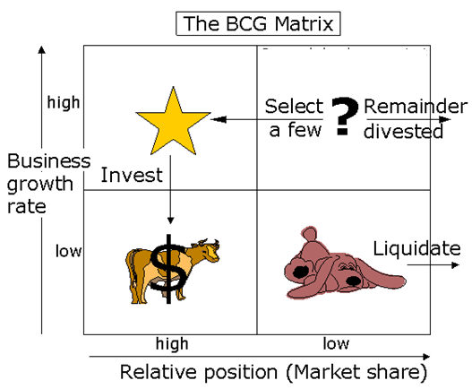
Figure 7: BCG Matrix (Source: Boston Consulting Group, quoted in Value base management.net, 2016)
    - Best Utilize the Big Data Capability
One of the most valuable intangible assets of the Company is its customer database and the information about their buying behaviors. Galloway (2016, quoted in KPMG, 2016b, p.14), Finance Director with Dairy Farm, mentioned that technology nowadays allows online retailers to build one-to-one relationship with their customers, the promotion information for customers are more personalize, precise and informed, which greatly help to raise the bar of customer’s expectation. To extend the business scope, Esprit should strengthen its digital marketing team and utilize its Big Data capabilities, and provide commercial advertising solution and production services to its suppliers and merchant partners.
      - Personalized Fashion
Personalization is no longer a VIP only service in luxury fashion, nowadays, the advance development of digital and technological advances, consumers can be simply created his/her personalize labels, customized style products online or in brick-and-mortar location. (Stockdill, 2018b) Esprit should recived its consumers designs that can be used for big data analysis and predict the coming trend or estimate its customers’’ favors / style, so that to enhance the customer’s engagement and loyalty.
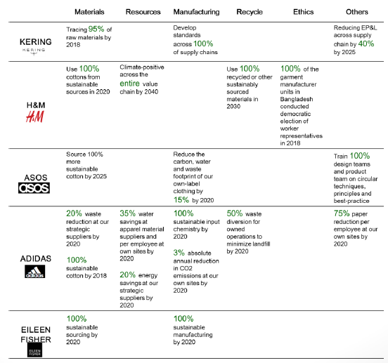

- Conclusion
Hong Kong is hosting numerous of international fashion brands across the spectrum, from mass market fast-fashion to high-end designer labels. Hong Kong Business (2017) concluded that different sectors of the retail industry, even come from the same backdrop, different customer loyalty approaches is required. Brands should start by listen / know individual consumer’s buying behaviors and purchasing decisions by the aid of customers data analytics so that to engage customer and strengthen the customer relationship by formulating an integrated strategy. Ultimately, the group can optimize the Company’s profit and maintain the competitive advantage.
To sustain our competitive advantages, the company needs to throw out old playbook. The industry is more transparency about the product information as the advance technology development. The fashion market – actually is real to apply on all industries - that will be successful, will be true and customer-focused, and equipped with the digital platforms or tools to achieve their Company objectives.

Bibliography

Appendix 1:
Environmental Impacts
As a second large consumer industry, the fashion industry has a €1.5 trillion market with more 300 million people in 2016. But it is estimated 85% of the discarded clothes were sent to the landfill. Although there are different on-going programs in circular fashion, around 15% of these wastes was reused or recycled. (HK Knitwear Exporters and Manufacturers Ass Ltd, 2018)
Figure 9: Impacts on Environment from Fashion Industry
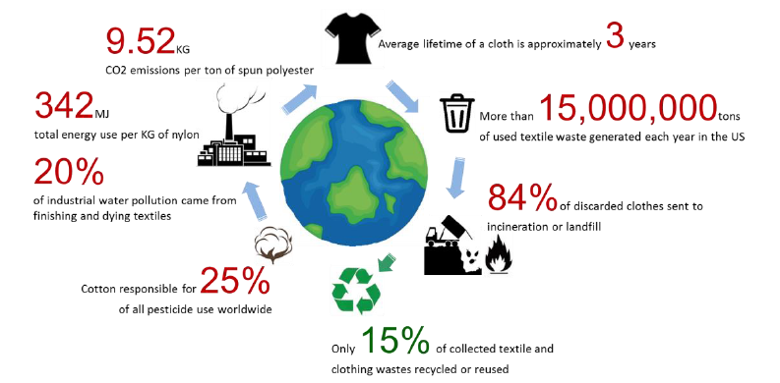
(Source: HK Knitwear Exporters and Manufacturers Ass Ltd, 2018)
Appendix 2:
Table 3: Esprit changes its color proportion of assortment
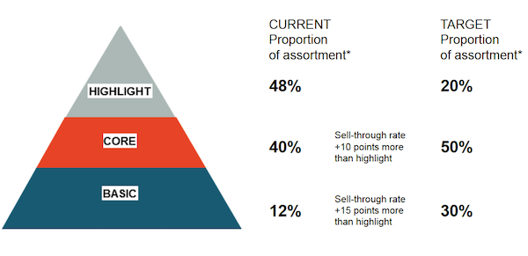
(Source: Stockdill, 2018b)



