Title: A Personal Learning Environment
Assignment Name: The Relevance of Digital Technology and How It Aids Personal Learning Environments in Undergraduate Studies
Student Name: Daniel Ramsey
Course Name and Number: Learning and Collaboration for Global Citizenship BMSP4003
Lecturer: Dr Alex Bell
Date: 28th March 2018

Introduction
The way in which undergraduate students undertake learning has evolved, and with the use of digital technology, personal learning environment (PLE) limits have been greatly exceeded, as illustrated by Beyrouti (2017), who states, “Universities have discovered that learning need not dwell inside the confines of the four traditional classroom walls” (p.391-400). This paper will analyse the different forms of digital technology available, and how it has transformed the learning environment as we see it today. Furthermore, an exploration of my own PLE will be evaluated and critiqued, underpinning the most effective and relevant digital technology study tools I have used to further enhance my undergtraduate learning experience.

The Changing Nature of Higher Education
With the threat of deinstitutionalisation and the feeling that higher education is one of anarchism, changes in the industry must be made or face the risk of being marginalized (Odin & Manicas, 2004).
Before the introduction of digital technology, learning environments consisted of a formal, chronologically graded education system whereby its main structure was one of hierarchy (Leone, 2013). For the most part, the way in which lessons are delivered have changed. The days of information givers standing at the front of a class bestowing their knowledge to passive receivers is becoming a thing of the past. Information taught is now stored on various platforms such as moodle or a student intranet, whereas, before the introduction of digital technology in learning, a student’s information was limited to what was taught on that day. Advances have now enabled universities to embrace the use of digital technology, making it a fundamental tool in undergraduate learning (Lai, 2011).
Higher education associates itself with digital technology on increasing levels. Whether it be accessing various databases, administrators, other students, faculty, social media or word processing, digital technology associated with the internet and its related computing devices lends itself, be it part or whole, to higher education in practically every aspect (Smale & Regalado, 2016). The move from Web 1.0 to Web 2.0 was the initiator of this change.
The Web 2.0 conference birthed the concept in 2004. From then it has grown from strength to strength, and through extensive trial and error, Web 2.0s characteristics are easily definable from the previous version, as outlined in figure 1 (Lee & Lan, 2007).

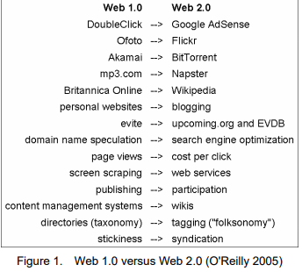
Web 2.0, in its purest form, has the ability to not only consume and remix data from several or individual sources, but also the users of its software or programmes can at any time, create a network or community (Lee & Lan, 2007), described by O’Reilly (2005) as an “architecture of participation”. One that was never present with the use of Web 1.0. Lee & Lan (2007) also describes Web 2.0 as having defining features. Every user of the internet can provide or upload information or knowledge content. Whereas Web 1.0 was restricted in its use, platforms such as Facebook and Youtube give the web voice, made possible with Web 2.0. Parties that once had to meet in person to collaborate, can now do so while being at opposite ends of the earth. The idea of open source learning is integrated into Web 2.0, with its dynamic features, it allows users to participate in lessons or online forums as a form of social interaction, creating specific communities where knowledge and content can be shared freely (Lee & Lan, 2007).
Web 2.0 and its properties are being likened to a form of informal learning and questions are being posed as to the educational potential of Web 2.0. Although the primary function of Web 2.0 was not that of an educational purpose, e-learning applications are now prominent, and form an important element in higher education learning and undergraduate studies. However, with its content unregulated and knowledge sharing open and free, control of the learning environment is seen to be slipping away from institutions, with outside influences contributing to unsanctioned information and material that could influence or hinder the education institution’s core teachings (Selwyn, n.d)
The role between the instructor and learner is being transformed, and at the forefront of this transformation is social media. It provides learning in a way that is evolving over time. Whereas previously, the instructor was the primary source of information to learners, social media has allowed the learner to now not only be a consumer of information, but to be an active prosumer, co-producing and shaping the content they learn and, in some respects, how it is delivered (Wankel, 2010).
The connectivity afforded to both students and educators by Web 2.0 lends itself in part to the framework of Pedagogy 2.0. Pedagogy 2.0 outlines a specific set of principles designed with the learner in mind and capitalizing on the core strengths of Web 2.0. It recognises that in order to maximise learning potential, the learning environment must fulfil content, curriculum, communication, resources and have a strong scaffold network for both educators and learners alike. To achieve this, these key elements to success were categorised
into three Ps ( McLoughlin & Lee, 2008) (outlined in the diagram below)
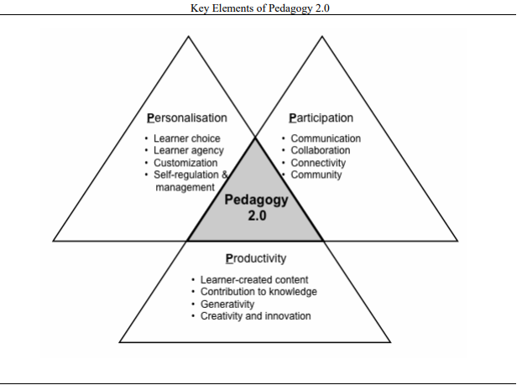

My Personal Digital Learning Environments Experience
After extensive research, it has been concluded that no single application or environment can be classed as a representative to an individuals personal learning environment (Martindale & Dowdy, n.d). Although no clear concept has been realised, research has established four main functions that PLEs need to thrive. Mirroring the conventional learning environment”, “An environment for reflection”, “An environment to showcase skills”, and, “and an environment for collaboration and networking” (Rahimi, Berg, & Veen, 2015). In my opinion, Carmarthen campus university and its faculty has provided in part a positive personal learning environment experience. My use of digital technology as a learning tool is minimal in comparison to most. Pre-university, the digital applications used were purely for social purposes, and having now undertaken an undergraduate degree, the tools and online resources I have discovered have greatly aided my development and broadened my learning horizons. Moodle, pioneered in Carmarthen campus university by Dr Alex Bell (Bell, 2018), is at the forefront of my undergraduate learning experience. Within this application, not only can the lectures delivered be accessed at any point, but also a variety of university resources.
Google and its array of functions has also facilitated my progression. To aid assignment writing, search engines such as Google books and Google scholar are of great use when sourcing relevant and academic information relating to the subject being studied. I find the wealth of books and peer reviewed journals at the click of a button, and the ease of access makes the process of information gathering seem effortless. Google and its learning tools are recognised by academics as having as much as, if not more power than library’s, with the once renowned information system being urged to embrace and integrate the Google search engine to further benefit their patrons (Caldeira, 2008). However, as with any technology, there are disadvantages. Whilst accessing some journal articles, it is with great disappointment that several articles do no not display full text. Re-direction to a foreign page is given, prompting you to enter information to become a member of a newsletter before the article can be accessed. I find this misdirection very frustrating.
One drive is also an integral part of my personal learning environment. Work that is created on one computer can be stored on a cloud system to be accessed at a later date on any device of your choosing. Documents can also be shared with a third party, who, alongside yourself, can edit or make any relevant adjustments whilst being typed. This function is highly valuable while assignment writing. The use of two computers, one for research and one for typing, is utilised by myself, adding references to one document while still typing in the other.
In regard to the social media aspect of my personal learning environment, Facebook and Snapchat are at the forefront of my social media technological usage. Widely used as a social tool, questions have been posed as to whether educational value exists. Having been described as similar in all their functionalities, the consensus is one of loose behaviour. One in which content uploaded can be manipulated, therefore, giving false information to the reader of said social media content (A.Tess, 2013). However, despite the loose content upload, qualitative research has found social media to be an effective teaching and learning environment. Collaboration, the promotion and ability for student engagement, online idea sharing, and the ability to communicate outside class without being face to face make social media a valuable platform for education, if utilised in the right manner (Ruhi & Umar, 2018).
My personal digital learning environment is represented and outlined in my PLE diagram below. Outlined are the online technological applications that are in use in my day to day life. In comparison to the google generation, my use of the digital technology is limited to mainstream online technology.
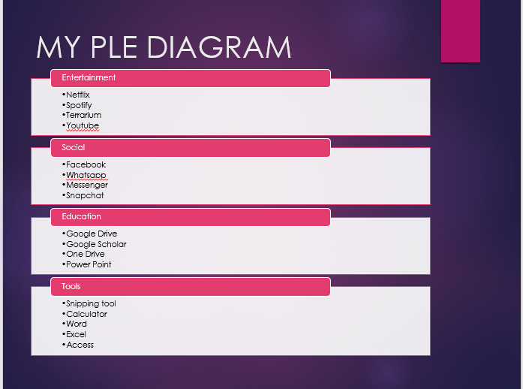

My Digital Literacy
My digital literacy competency can be summed up in one word, average. As previously stated, use of digital technology was purely limited to that of a social use. Discovery of online tools for educational purposes has broadened my horizons in terms of how it can be used to further aid my undergraduate studies.
Walsh’s (2015) notion that the majority of young people are competent in their use of technology, but not digitally literate, rings true in my case. As my degree progresses, I am gaining the relevant skills required to form above average status on the digital literacy spectrum, moving beyond the primitive realms of basic computer knowledge, to high level navigational and information finding skills whilst completing assignments set.
The rapid progression in digital technology learning is owed in part to the fantastic lecturers I have had the great fortune of having. The complexity of the assignments we have been given have enabled me to enhance, explore and practice digital technologies that would have otherwise felt out of reach. Although my digital literacy competency, as describe by Walsh (2015), is in its formative years, many skills have been gained that I now consider strengths. Strengths such as academic writing, referencing skills, creating Power Point presentations, the use of google books and google scholar as information sources, and work-related collaboration are now part of every day practice. A sense of digital curation has now been achieved. A feeling of being able to learn in a formal or informal environment, as the way our course has been delivered has allowed just that.
As with technology, by no means am I perfect. Weaknesses are rife in my personal learning environment. Although the use of digital technology has been embraced in the classroom environment, participation in online tasks set could be improved.
As my undergraduate studies progress, my use of technology grows. The ever-changing world we live in aids technological use as fundamental, and sooner or later, in my opinion, the need for classroom-based learning will be no more. As technology advances, the need for human input reduces, losing that personal touch we once held with the primary education giver. Same could be said in life. The art of conversation has died out. Whilst we stay connected through our use of digital technology, the personal connection has been lost.

