Marketing Fundamentals
Table of Contents
INTRODUCTION 1
MAIN BODY 1
Understanding the Process of STP (Segmenting, Targeting and Positioning) 1
Marketing Mix 6
CONCLUSION 10
REFERENCES 11

INTRODUCTION
Marketing refers to the activities that a company undertakes in order to promote sales and distribution of its products or services. For this report, TESCO is chosen which is a retail supergiant headquartered at Welwyn Garden City, UK, founded in the year 1919. The report will include the communication strategy with the use of blogs by company to communicate its specific buyers. Moreover the report will cover analysis of the process related to segmenting, targeting and positioning. At the end of report, it involves the marketing mix strategies of the company to communicate with its customers.

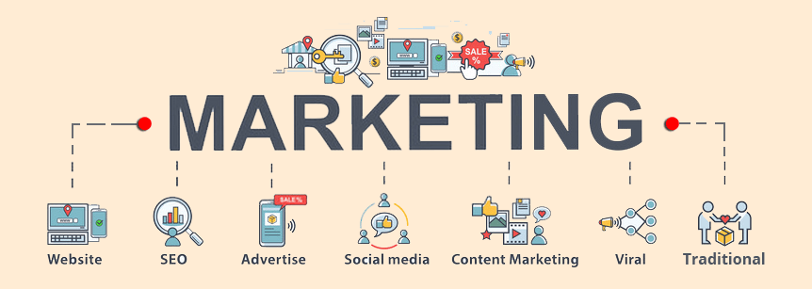
MAIN BODY
Understanding the Process of STP (Segmenting, Targeting and Positioning)
STP Framework
STP framework of marketing is an acronym for S-Segmentation, T-Targeting and P-positioning (Laspia and et. al., 2021). It is a three step framework that investigates services or products of a company and how the benefits of these services or products could be communicated to specific customer groups. The STP framework is an outstanding embodiment of significant changes that occurred in the market in the way from product-centric approach to prioritising customers. This enables the companies to better understand the customers and prospects to whom the company should target and and reach them and position their products accordingly.
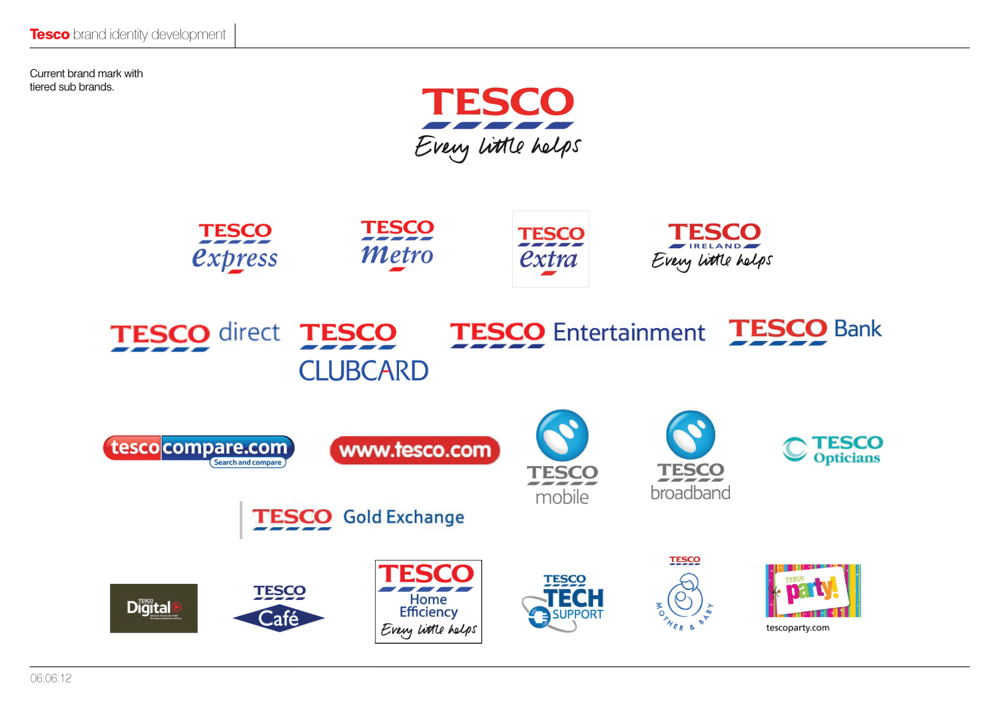

In relation to TESCO, there are a various types of macro and micro environmental factors which affects the marketing decisions of the company by direct or indirect means. There are many extrinsic factors which impacts the marketing decisions of the organisation and these can be identified through environmental scanning. The extrinsic environment aspects includes factors such as technology changes, socio-cultural impacts, political factors, legal aspects etc. In context to TESCO, its all the products and services may not be chosen by all the people therefore, it needs to initiate better segmenting, targeting and positioning for its products. To identify and attract the most suitable buyers with different tastes and preferences the company use STP approach to market its products in optimistic ways. With the purpose for evaluating the market and the potential customers whom company needs to target for promoting their products or services it uses analytical tool of segmenting, targeting and positioning. It consists of analysis through three plans that helps to examine the offers of a company and explain its positive aspects to specific group of customers to attract their attention (Ye and et. al., 2021).
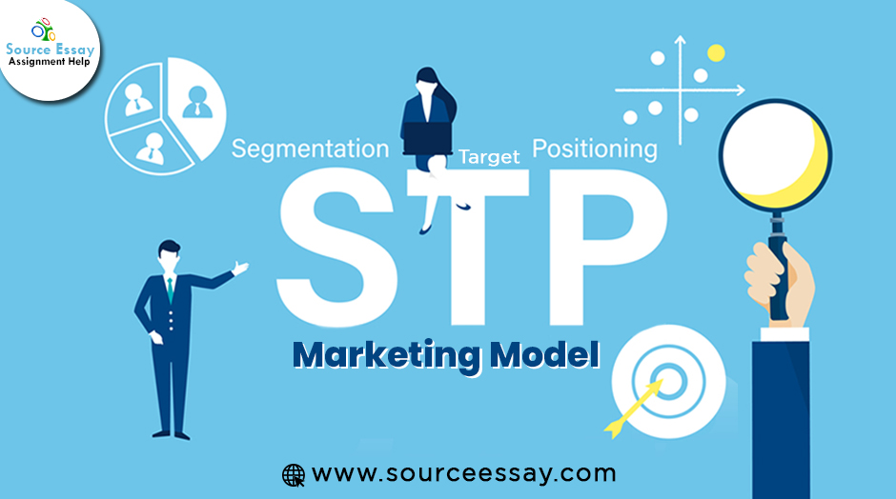

STP of TESCO is provided below:
• Segmentation of the Market: A segment is a set of marketable attribute that involves factors such as demography, geographical location, psychology and behaviour of people towards a product to reach and cover a huge market. In UK, the market is segmented according to the demands and requirements for the products and services that are required by the customers. It is a good way to to conquer market and divide it into smaller segments according to the behaviour, needs and characteristics according to market strategies in accurate manner. TESCO does market segmentation to identify the customers according to their needs and requirements. It involves four aspects of segmenting that consists of geographic, demography, behaviour and psycho-graphic evaluation of the customers and market (Direction, 2020). With the help of market segmentation the company can better sell its products in unique and more innovative ways in the marketplace of the UK.

Basis for Segmentation, Targeting and Positioning |  | Target Customer Segment for TESCO
Geographic | Region | UK, and 13 other countries
 | Density | Rural and Urban
Demographic | Age | All age categories
 | Gender | Males and females
 | Income | Low to Middle and Higher Income Groups
 | Occupation | Students, employees and professionals
 | Education | High school, technical, bachelors
 | Social Status | Working class, skilled class,lower income, middle income
 | Family Size | Single individuals, nuclear and extended families
Psycho-graphic | Lifestyle | Traditional, contended conformers
 | Personality | Easy-going, determined
Behavioural | Occasions | regular
 | Benefits sought | Cost advantage, variety
 | User Status | Active user
 | Attitude | Sceptical, Positive

• Targeting Potential Buyers: It is a way to specifically choose the customers who could be most profitable to the business, through analysing several factors (Sharma, Kaur and Syan, 2021). It is the process of identifying potential customers to whom firm wants to sell products or services involving segmentation of market , choosing appropriate market and determining products to be offered. The decision of targeting the customers was done on the basis of demographic factors which includes targeting the all income group of customers.


In context to TESCO , its necessary to serve good quality products and services to targeted customers in order to maintain company's reputation. In order to maintain continuity in growth and incur huge profits it also targets those people who loves standard and quality in relevant-appropriate prices (Seifert, Clement and Otten, 2020). In order to identify the target customer it is important to decide which customer need to be served with the new product. The target customer for TESCO involves women as well as men including sportsperson, common people, students employees, professionals, celebrities, specific personas etc. All these customers are targeted due to their continuous interest on variety of products that the company offers.

• Positioning of Product: In the last step of STP, the aim is to identify how the organisation would want to position its produce to impact the most relevant group of customers. The company may use unique selling proposition, positioning map, marketing mix or a value position (Iwu-James, Haliso and Ifijeh, 2020). It involves the final stage in the 'STP' process and involves focusing on the customers view points regarding the service or product as compare to its competitors and it plays an important role in gaining a competitive advantage for the organisation. Positioning involves perceptions of customers as they play an important impact on the brands performance in the market. In context to TESCO, the product needs to be arranged in such a way that services or products can occupy a desirable and clear image in the minds of target customers. In order to grab customer attention, the product need to be placed in the market in a way that it can be differentiated from competitors in the marketplace.
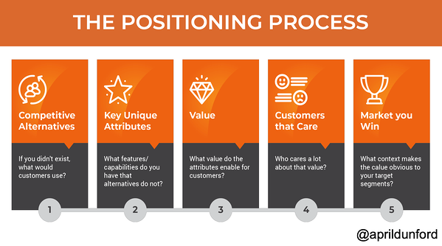

Marketing Mix
It is a multidimensional tool comprising product, price, place, promotion, people, physical evidence and process. The marketing mix involves the set of tactics or actions that a organisation uses in order to promote its product or brand in the market. The 4Ps involved in marketing mix are Price, place, product or promotion. The company uses marketing-mix in order to create awareness and promote their products (Caliskan, Özen and Ozturkoglu, 2020). Marketing can be considered to be an important aspect in order to enhance and differentiate the image of the product or services in the marketplace. In relation to TESCO, the company's marketing strategy helps to analyse the market with the use of marketing mix framework which involves 4Ps and uses these strategies which involves promotion planning, product innovation and pricing approach which helps the brand to succeed. The company's marketing strategy helps to position itself in order to achieve objectives or goals, it involves many aspects that are given below:
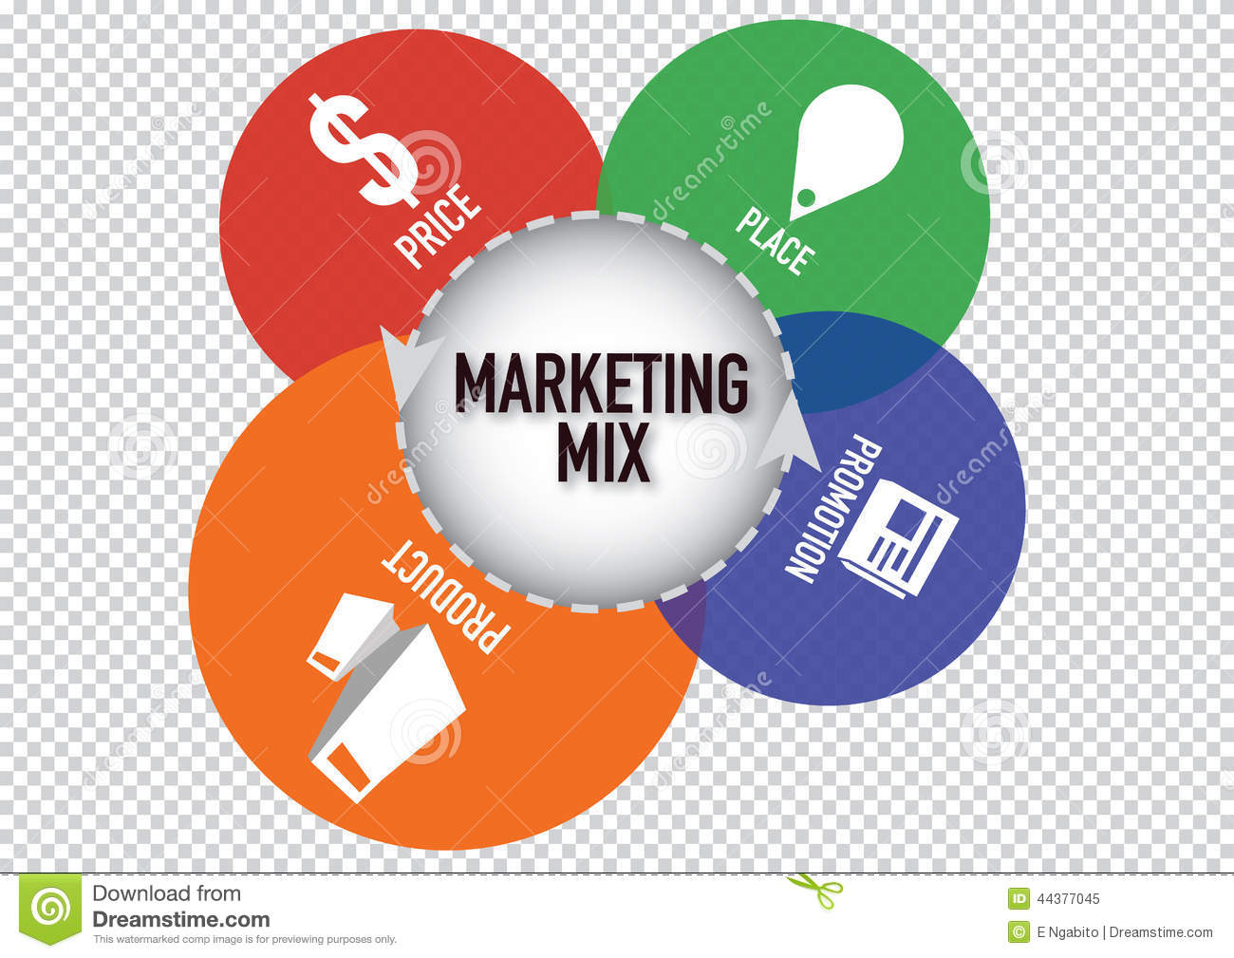

• Product: A product is an item or service offered and sold by the producer for the purpose of consumption by the consumers. It can be elaborated as, how the product is unique in its branding, packaging, offers, quality, etc. to attract its customers (Iacobucci, 2021). In relation to TESCO, which is among the largest retailers across UK. It offers a variety of products in various stores in order to satisfy preference or need of the customers from different segments in the market. The main products of TESCO involves technological equipments, petrochemicals, gaming, pet-care, frozen-food, fast-food, home and garden, sports , baby, health, clothing etc. In terms of services the company provides various financial services such as insurance, credit cards, savings accounts, loans and mortgages. All these products and services are widely availed by the company to many of its customers across many nations.

• Price: IT can be explained as, defining the worth of a produce in terms of money or it can be termed as the amount of money to be paid to acquire a given product. The price of products by the company are based on the overall quality, defining the standard of its brand (Lee and Kim, 2021). In context to TESCO, the products provided are of relevant price and maintain its quality standards at the same time. It uses best channels and economies of scale in order to maintain low prices and quality defined products. The company constantly works with its suppliers to make the supply chain efficient so the costs could be reduces significantly.. The company has also restructured its product team in order to get best offers for customers. It's superstores offers huge range of items and groceries that can be availed by every customer who is willing to pay a significant price. TESCO Express are small stores which involves high margin products and essentials that can be availed by its customers. TESCO Extra are large hyper stores which carries a variety of products under one roof where everything is available and these shops comes under one-stop-shops. The company's website also allows customers to make easy purchases online while not going to the stores, and the shops carried their operations in the same manners during the COVID-19 pandemic.


• Place: Its a location or area normally that is occupied or unoccupied for the various purposes. It defines the distribution strategy by organisation for a location where the product can be sold effectively to its targeted customers (Wang, 2021). The company ensures the availability of its products across each and every store at sigma level by using place mix, so the customers could find its products and services with ease. TESCO involves a chain of intermediaries consisting of distributors, retailers, wholesalers etc. through which its product passes until it reaches to the end consumer. In context to TESCO, the company has approximately 7000 stores across many countries and are basically classified as TESCO Express, TESCO superstores, TESCO Extra etc.
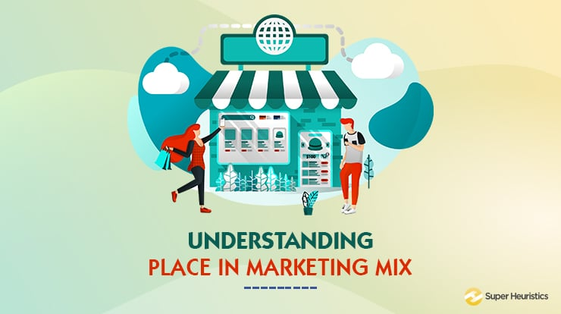

• Promotion: It is a terminology used to attract customers through direct or media communication for promoting the commodities produced by a company. It means spreading info about a product or service by using variety of means across many places to diversity of customers. The business uses extensive marketing and costly advertising to promote its individual brands and products. It involves developing a brand image among its audience and in the marketplace. In context to TESCO, which has a strong brand image that relies upon its reasonable prices and high quality products. The company's promotional activities involves use of television, charitable events, hoardings. The company also uses promotional discounts and offers such as buy one get one free. The company provides its customers a loyalty card called 'TESCO Club-card' that helps the company to attract the loyalty of customers. The company also promotes and sells its product online that helps in diversifying its activities. The company also enjoys a strong digital marketing strategy and engage with customers through promotional campaigns, online-advertisements and social media promotions. The company in order to carry out its communication activities involves theses segments to reach maximum customers.
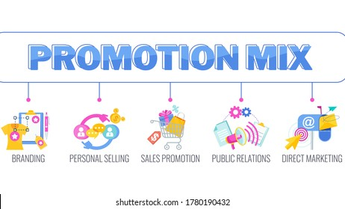

CONCLUSION
In the above report it had been identified that marketing is a essential activity that is done by almost all the businesses in order to cover a larger market area. It had been identified from the report that marketing fundamentals plays a important role in the business organisation, in order to effectively understand the customer's need and demands. In context to the above report customer's demand is understood through STP analysis is done. In order to develop products and services according to the needs and demands of customers, marketing mix had been elaborated in the report.
REFERENCES
Books and Journals

Caliskan, A., Özen, Y. D. Ö. and Ozturkoglu, Y., 2020. Digital transformation of traditional marketing business model in new industry era. Journal of Enterprise Information Management.
Direction, S., 2020. A blueprint for international marketing: Reaching audiences in the digital era.
Iacobucci, D., 2021. Marketing management. Cengage Learning.
Iwu-James, J., Haliso, Y. and Ifijeh, G., 2020. Leveraging competitive intelligence for successful marketing of academic library services. New Review of Academic Librarianship, 26(1). pp.151-164.
Laspia, A. and et. al., 2021. The organization of innovation services in science and technology parks: Evidence from a multi-case study analysis in Europe. Technological Forecasting and Social Change, 173. p.121095.
Lee, W. Y. and Kim, K. R., 2021. Target market. In Encyclopedia of Sport Management (pp. 485-486). Edward Elgar Publishing.
Seifert, R., Clement, M. and Otten, C., 2020. 15 Designing marketing models for media products. In Management and Economics of Communication (pp. 281-310). De Gruyter Mouton.
Sharma, R. R., Kaur, T. and Syan, A.S., 2021. The Basic Concept of Sustainability Marketing. In Sustainability Marketing. Emerald Publishing Limited.
Wang, K., 2021. Characteristics of urban groundwater pollution based on abnormal data processing and optimization of sports health market. Arabian Journal of Geosciences, 14(17). pp.1-15.
Ye, G. and et. al., 2021. The value of influencer marketing for business: A bibliometric analysis and managerial implications. Journal of Advertising, 50(2). pp.160-178.

