Student ID: 2226176

Lecturer: Kadi Berry

Course: HNC Process Operations Engineering

Module: Environmental Protection And Sustainable Manufacturing Systems

Assignment Title: Research Report


Abstract

This assignment will firstly contain information regarding fired heaters in an oil refinery. It will also contain how they work with added information of how energy can be saved with them. The basic breakdown of how they work is that they have inner tubes with product running through them which is heated by burners inside the heater. The burners themselves are powered by fuel gas and an air intake, which are optimised so that the burner is running at the best possible temperature. There are multiple burners in some heaters which will a have to be running in unison so they can heat the product correctly. There will be an introduction into ways in which these fired heaters could be improved to not only save money for the refinery but to also improve environmental factors. There will be references to back up the fact that the information is valid in the first task.

On the second task in the assignment this will cover the waste management systems incorporated in Valero Pembroke. There will be photographic evidence to show how the systems are in place in Valero. They will show how the company and the outside contract company handle everything, so it is done safely and to all the correct standards. Included in the assignment will be an introduction into the assignment, also a contents page to show where everything can be located. There will also be a conclusion to sum up all the work that has been discussed. Then the reference table will be included with all websites used and a bibliography for all the books that were used for references.

Contents
Figure Table 3
Introduction 4
Task 1 5
Fired Heaters 5
Conclusion Of Heater Upgrades. 10
Case Study 10
Task 2 10
Waste And Recycling In Valero Energy 10
Conclusion 14
References 15

Figure Table

Figure 1 – Fired Heaters 6
Figure 2 - General waste bin on unit. 12
Figure 3 – Clean lagging skip on unit. 12
Figure 4 – Oily waste barrel outside of unit. 12
Figure 5 – Recycling and waste bins next to blue cabins. 12
Figure 6 – Wood skips on units. 13
Figure 7– General waste skip on unit. 13
Figure 8 – Full oily waste barrel with identification sticker. 13
Figure 9 – Scrap metal skip on unit. 13

Introduction

This assignment will contain details regarding a fired heater and waste management systems that are used in Valero Pembroke oil refinery. It will contain detailed information regarding fired heaters and how they can be improved to meet government guidelines and to possibly save the company money and resources. It will also contain another task which will go into the details of the waste management systems that are set up in Valero Pembroke and how they meet guidelines/work.

Task 1

Fired Heaters

Fired heaters in an oil refinery use the process of heating liquids with burners to a certain temperature for the next process in which they are required. They heaters vaporise hydrocarbons in the fluids which will then be sent out as flue gas at around 400 degrees Celsius. The flue gas is then sent to the stack where it is cooled and let off into atmosphere once filtered. The burners use fuel gas which is sent into the heater with oxygen and once ignited become a large flame inside of the heater. Heaters can have multiple burners or they can have singular burners depending on the need for heat (XRG, 2022).
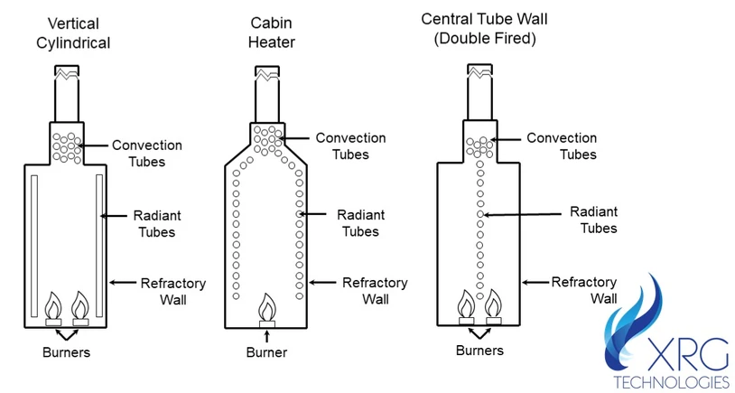
Figure 1 – Fired Heaters
(XRG, 2022).

Single burners are not common in oil refineries and may only be introduced if really needed after the construction of the original heaters. In that case the refinery would bring in a single burner heater to take on the amount of product needed to keep the plant running efficiently. This is the case in HTU1 in Valero Pembroke as they brought in a single heater to help with the process. When it was originally built there was a smaller demand, so output and input was lower than now. With the increased demand of product there became an increased need for heat so that’s why the extra single burner heater was introduced (Platvoet, 2022).

The burners are fired on the inside of the heater and there are pipes going around the inside which are being heated from them. This is because a fluid which needs to be heated is using this process to meet the optimal temperature for the next process in the refinery, where be it raw crude oil, heavy distillates of crude oil or heavy naphtha. The different configuration on the heaters are cylindrical heaters, box heaters, cabin heaters and multi cell box heaters which can all be vertical or horizontal. They can also have down fired burners, up fired burners or wall fired burners, these are all different depending on what the heaters needs are to heat the product (Dey, 2017).

There are also different draft systems for the air intake such as natural draft which is an induced negative pressure which needs no fans. A forced draft intake which requires air to be supplied for higher heat of the product. Induced draft which is used to remove any flue gasses produced while keeping the negative pressure. Then there is a balanced draft system which will expel all flue gasses necessary while keeping the systems heat high with forced air flow (Axtman, 2018).

There are three main types of fired heaters, there are radiant heaters, convection heaters and radiant convection heaters. A radiant heater is one that is made up of tubes that are bare and are in a spiral pattern to allow for a radiant heat to transfer around it. There are downsides to this type of heater as if you want to alter the heat very specifically then you may struggle and also the heat change may be uneven around the coils surface. A convection heater makes up for the faults in the radiant heater as it is able to have even spread of heat change due to having a combination of tubes which are bare and added with fins arranged in a bundle. The most common type of heater and the ones used in Valero Pembroke are radiant convection heaters. These are a mix up of both radiant and convection as they combine the ability to transfer heat evenly around the heater and also, they are able to get to intense heats within them (Anon., 2017).

A way in which a fired heater can lose energy is a bad mix or overuse of fuel gas which is used as the fuel for the flames in the burner. This can be solved by having constant monitoring of the flue gas going into the burners. It is also a problem that there are no perfect ways to monitor the thermal efficiency of the fired heaters within oil refineries and other sectors. The models that are present on the fired heaters now have found to be ineffective at any disturbances to the flow pressure in the fuel gas coming in. This is a major problem as if there is a low or high pressure change in the fuel gas instead of working out a way to fix the problem the burner it will go out which may cause the heater to trip. This will effectively lose energy as the burners with still be expelling flue gas with out burning. In this process the heaters use a lot of air so there needs to be pre heats of the air to make it efficient. This is why the flue gas can be used to heat up air before going into the heater as this will save money and time (Matrix, 2022).

Problems affecting heaters efficiencies also include such things like failing brick walls on the side of the heater. If the bricks start to crumble and fall into the heater then then can cause loss of heat as the heater will need to be burning at a higher rate to add to loss from a hole in the outer wall. This could affect the UKs Environmental Act of 1995, as there may be an increase in the flue gasses released as the burning may be too much for the stack to handle. This may also include other cracking on the heater such as in the floors as this may cause loss of heat also. This problem will causer a loss of energy so ways around it would be to have more scheduled inspections of older heaters to make sure the structural integrity is up to standards (Guliyev, 2017).

The bigger problem would be a loss of product into the heater. For example, if one of the tubes containing the heating product melted or corroded away which lead to loss of product then there could be a serious issue. This may include burning of product directly onto the burners which will lead to harmful gasses not being filtered and releasing into the environment. The worse possible outcome would for there to be an out-of-control fire or an explosion which could cause other units to go up with it with a huge loss of energy and effect the Explosives regulations act of 2014 (Martin, 2022).

The upgrade that would be the best for all heaters on Valero would be an air pre-heater which will allow the air coming into the system to be hot before going in. This is done by the air being taken in being warmed up by the flue gasses which are at 400 degrees Celsius. The flue gasses which are the output of the burning process will run down glass tubes inside the heaters air system and warm any air coming into the system. This way the company will not have to spend resources on heating the air manually. They have systems in place on the heaters to warm the air through large pumps each side of the heater. This costs a lot of money and adds to emissions being produced into the atmosphere (IGS, 2022).

Another change that can be made to the existing heaters could be a change in tube bundles within them. The tubes could be moved into a bundle of corrosion resistant housing of pipes to allow more product to enter the system to be heated. This would allow for less power to be used by the heater and more product would be moving through it at one time and to the same temperature. These polymer heat exchanging pipes will be able to withstand high thermal shocks, resist high gas velocities, require less maintenance, and have corrosion resistance due to a polymer coating
(Matrix, 2022).

Conclusion Of Heater Upgrades.

The air preheating system would only be worth upgrading on the heaters when a heater has been taken out of service due to it falling. As there would have to be major modifications to change the ones at Valero at the current time. It would cost more than its worth plus the environmental damage would be worse after having to scrap a working heater. The heaters now are worth maintaining until fail and then when that happens a new plan can be made to swap the cost efficient and environmentally safer new heaters with the air pre heat system.

The pipes could be changed out as soon as major maintenance is required on a unit as the cost savings on having these will make it worth swapping. The energy savings and the environmental impact will be better as less power would be required and the same amount of product will be going through it. Less maintenance will be required on the heater due to the corrosion resistance upgrade as well.

Case Study
“A flue gas flow from a large steam boiler of 100000 kg/hr at a temperature of 170°C enters the polymer air pre-heater and is cooled to 85°C by 95000 kg/hr combustion air at 15°C. The recovered energy is 2.6 MW, which is approximately 5% of the steam boiler duty” (BERG, 2018).
As shown by this case study the author Bart Van Den Berg agrees with the findings that the upgrade of the air preheater would be important to improve in fired heaters.

Task 2

Waste And Recycling In Valero Energy

In Valero Pembroke the segregation and recycling of waste products is split up into a variety of different disposal ways. There is a work area which is run by the company Veolia which consist of the average waste such as carboard, glass, plastics, cans, general rubbish and other goods. This is gathered up from all over Valero then picked up and dropped off by Veolia staff daily. If they do not pick it up or you have excess waste, then it can be dropped off at the Veolia area and put into the separate bins for what it is by yourself.

They are all stored in large skips which are labelled with exactly what needs to be in each one. Once they have been filled they can be sent to an outside company to be disposed of correctly. There are multiple forms that need to be filled in to say what is in these bins exactly. Such things that will be included on this will be the disposal of waste request to outside companies and the initial request to the waste originator who will forward it to the HES environmental department. They will then sign off on the request to dispose of the waste as long as all contaminants are correctly labelled and all waste is segregated correctly by the workers at the waste site in Valero (GOV.UK, 2023).

On the sheet you will have to report the source and nature of the waste with a description of it, it may be contaminated so may require special disposal. The physical state must be reported, so if it is a solid or not for example, and what it is stored in. There must be risk assessments done for the picking up of waste and how heavy it will be. If any of the waste is classed as contaminants then a special request form must be raised to make sure that the hazardous waste can be disposed of correctly by the outside company. Special companies may have to come in to get the waste arranged for disposal due to substances in an oil refinery. There are a variety of chemicals some of what may be too dangerous to have around other waste products and can only be disposed of by specialists.

The HES may ask to audit Valero’s recycling program and they may check that all the items that should be in a certain place are correct for that bin. If this is not done correctly then Valero may become open to unlimited fines for not following the HES rules and guidelines.
Valero has its own environmental team that will be in charge of in-house audits of the recycling and waste centre. They will have surprise visits weekly to make sure the contracted company is following all the local and British laws and standards. They will pick certain places in the tip to check such as the carboard skips to make sure nothing is getting into there that shouldn’t be there. If the team do find anything wrong with the way that the contracted company are running, they will report it to their supervisors who will then be in contact with the company and disciplinary actions could happen (GOV.UK, 2023).
That is why the company Veolia will make sure to the best of their abilities that the correct procedures are followed at all times. This all shows that Valero’s waste and recycling program is one of the best in the UK at making sure that the guidelines are followed and all waste is disposed of in the correct ways to meet all standards.

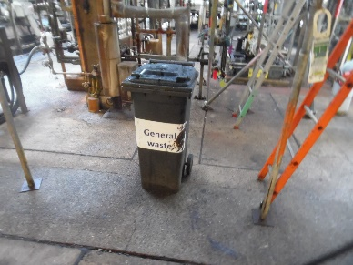

Figure 2 - General waste bin on unit.
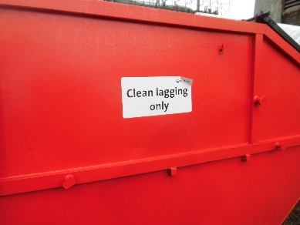

Figure 3 – Clean lagging skip on unit.
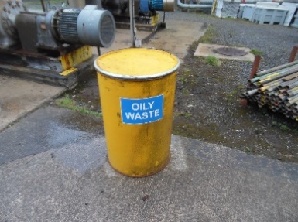

Figure 4 – Oily waste barrel outside of unit.
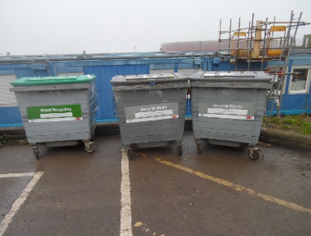

Figure 5 – Recycling and waste bins next to blue cabins.
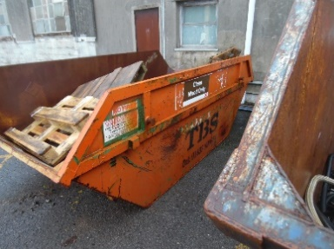

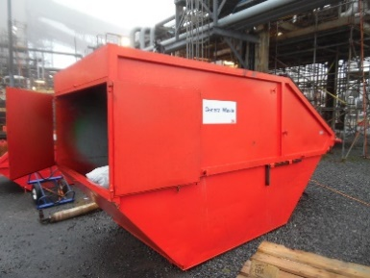
Figure 6 – Wood skips on units.

Figure 7– General waste skip on unit.
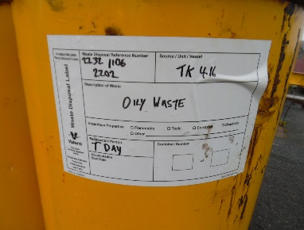

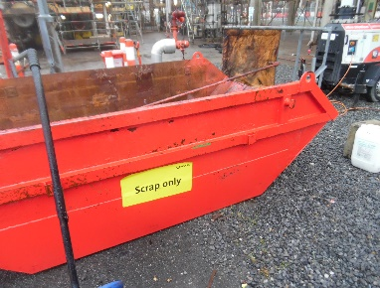
Figure 8 – Full oily waste barrel with identification sticker.

Figure 9 – Scrap metal skip on unit.

(Figure 2-9 are own images.)

Conclusion

In conclusion fired heaters are vastly important in oil refineries and other sectors due to what they do. They have small flaws, but the research shows that they could be fixed with modifications made. It shows that it may be too costly to replace or carry out modifications while the heaters still have life span in them and to do all of this when the heaters are past repair. Then to conclude the second task it shows that Valero’s waste and recycling disposal system, is up there with the best they can have. Mainly due to the fact that Valero has a trustworthy company with high standards to make sure the process is done correctly. Then to also make it better Valero has its own team to make sure that all the processes that should be done are carried out to the highest standards.

References
Anon., 2017. Convection or Radiant Heating. [Online]
Available at: https://www.thegreenage.co.uk/convection-vs-radiant-heating/
[Accessed 15 02 2023].
Anon., 2022. What is a Fired Heater in a Refinery? For Dummies. [Online]
Available at: https://xrgtechnologies.com/what-is-a-fired-heater-for-dummies
[Accessed 14 02 2023].
Axtman, W. H., 2018. Air Requirements. s.l.:Industrial press.
BERG, B. V. D., 2018. Air pre-heater improves energy efficiency. s.l.:Digital Refining.
Davies, C., 2017. Calculations In Furnace Technology. Swansea college of technology: A.R.I.C.
Dey, A. K., 2017. Fired Heaters. [Online]
Available at: https://whatispiping.com/tag/fired-heater-2/
[Accessed 17 02 2023].
GOV.UK, 2023. Government regulations. [Online]
Available at: https://www.gov.uk/government/publications/legal-definition-of-waste-guidance/definition-of-waste-2018-waste-framework-directive-amendments
[Accessed 19 04 2023].
GOV.UK, 2023. Waste. [Online]
Available at: https://www.gov.uk/guidance/waste
[Accessed 19 04 2023].
Guliyev, A., 2017. Increasing Energy Efficiency of Fired Heaters. [Online]
Available at: https://www.linkedin.com/pulse/increasing-energy-efficiency-fired-heaters-other-how-anar
[Accessed 11 02 2023].
IGS, 2022. Crude, Coker and Vacuum heaters, Ethylene furnaces, and Steam Methane Reformers. [Online]
Available at: https://integratedglobal.com/services/fired-heaters-with-process-pre-heat/
[Accessed 16 02 2023].
Jr, C. E., 2018. Hamworthy Combustion. s.l.:Taylor and Francis.
Martin, M., 2022. Use of tube inserts in fired heaters. [Online]
Available at: https://www.digitalrefining.com/article/1002790/use-of-tube-inserts-in-fired-heaters
[Accessed 14 02 2023].
Matrix, H., 2022. Polymer Air PreHeater - APH. [Online]
Available at: https://heatmatrixgroup.com/products/air-preheater/
[Accessed 16 02 2023].
Matrix, H., 2022. Waste heat recovery from Fired heaters. [Online]
Available at: https://heatmatrixgroup.com/thermal-processes/fired-heater/
[Accessed 14 02 2023].
Newnham, R., 2018. Direct-Fired Heaters. s.l.:s.n.
Platvoet, E., 2022. Digital Refining. [Online]
Available at: https://www.digitalrefining.com/
[Accessed 13 02 2023].
Towler, G., 2020. Principles, practice and economics of plant and process. BH: ELSEVIER.
XRG, 2022. Fired Heaters. [Online]
Available at: https://www.sciencedirect.com/topics/engineering/fired-heaters

