Ellie Bowen (2200584)
11/11/2004
BMPL4007/C
E-portfolio report
Learning in the Digital Era

Table of Contents
Summary 2
Mind Map 4
Video 5
Reflection 6
Reference 7

Summary



Image: Bright World Guardianships

In order to prepare for higher education, you must plan accordingly to ensure that you are successful. A crucial element of this is time management, you must be able to assess situations in order to prioritise and achieve the best outcome of your study. The National Extension College (2016) recognises that this is an essential yet demanding skill that an individual needs develop throughout their studies and have created a guideline to support students. Another factor that contributes to the preparation for higher education is creating an appropriate environment for your study. In order to achieve a suitable environment, you must ensure that it is both comfortable and an area where you can be productive. Once you have selected your designated study area, it is important that you create an inviting space where you would be motivated to complete tasks. A report produced by the University of Salford (2015), introduced a series of recommendations that is essential to achieve a functioning study space based on their research. This can be done by considering the layout of your room, temperature, and lighting. In addition, you can aid your concentration by turning your mobile phone off. The research of Felisoni and Godoi (2018), demonstrates that the use of mobile phones during study can have a negative impact on academic performance. Therefore, a student will benefit from minimising distractions and capitalise on their study. To conclude, students must find a suitable time for them to study. In doing this, they can focus on tasks at their convenience which will reduce stress. According to a scientific suggestion provided by the PSB Academy (2020) the best hours of study are between 10am-2pm or 4pm-10pm.

Mind Map
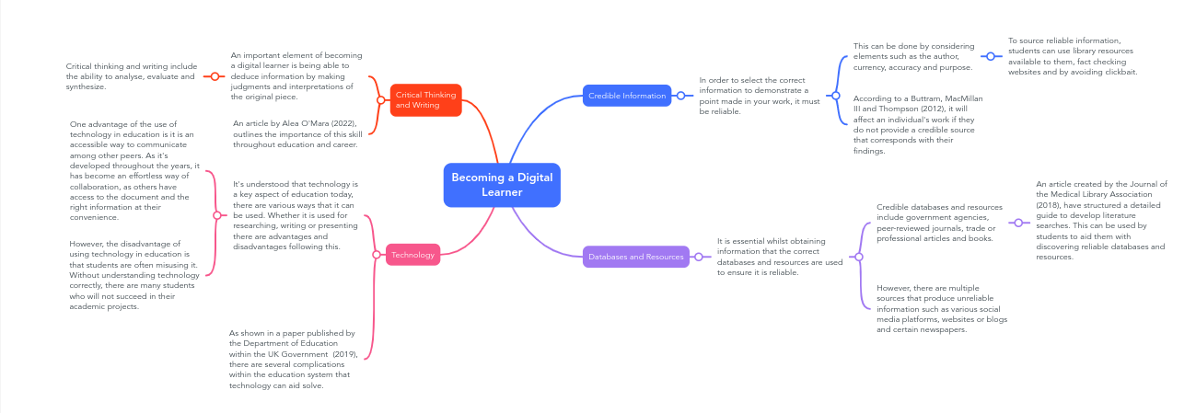

Mind Map created on Mind Meister

Video

Please follow the link attached to access my video: https://www.youtube.com/watch?v=aPd8bG8ODG4

Reflection

To reflect on my progress of starting university, adapting to online recourses and the process of writing my first my first assignment I will be using Borton’s reflective tool. Firstly, I shall be outlining the process of starting university which consisted of several weeks of preparation. It all started around December 2021, when I submitted my personal statement for University of Wales Trinity Saint David with the aspiration of graduating and joining the police. During the period of applying for university and receiving my final grades, I was in the vetting process to become a Special Constable for South Wales Police. This was a challenging, extensive procedure that required a lot of resilience and patience. As soon as my place at UWTSD was confirmed, there was a mixture of excitement and fear of what was about to lay ahead. I arrived at Swansea at the beginning of September, completely oblivious to the process of starting university. My first week of lectures contained an extensive amount of information which was quite overwhelming. However, I would say that I am rather confident with using online resources now in comparison to when I first started back in September. Reflecting on adapting to online learning and resources at this current time, there are different approaches I would have undertaken to ensure I adapted quickly and efficiently. If I had taken a different approach to adapting to online resources, it would have been beneficial to me as I proceeded to draft my essay. At the beginning of planning my essay, I found it difficult to discover appropriate references. Although it was challenging at first, researching reliable sources and adhering to the assessment criteria assisted me correctly. In addition to adapting the way I would use online resources; I am determined to plan out my essay accordingly so that I would have plenty of time to make amendments and complete it to an exceptional standard before the deadline.

Reference

Aley O’Mara (2022) Why Critical Thinking and Writing Skills are More Important Than Ever. Tutor Corps. Available at: https://www.tutorcorps.com/about/blog/why-critical-thinking-and-writing-skills-are-more-important-than-ever#:~:text=Critical%20thinking%20and%20writing%20are,unfair%20treatment%2C%20and%20identify%20solutions. (Accessed:19 October 2022)

Barrett, PS, Zhang, Y, Davies, F and Barrett, LC (2015) Clever Classrooms: Summary report of the HEAD project. University of Salford, Manchester. Available at: https://core.ac.uk/download/pdf/42587797.pdf (Accessed: 18 October 2022).

Bramer, M. W, de Jonge, B. G, Rethlefsen, L. M, Mast, F and Kleijnen, J (2018) ‘A systematic approach to searching: an efficient and complete method to develop literature searches.’ Journal of the Medical Library Association, 106(4), pp 531-541. Available at: https://www.ncbi.nlm.nih.gov/pmc/articles/PMC6148622/ (Accessed: 19 October 2022)

Cayla Buttram, David MacMillan III, and Leigh Thompson (2012) Source Credibility: How to Select the Best Sources. UNA Centre for Writing Excellence. Available at: https://www.una.edu/writingcenter/docs/Writing-Resources/Source%20Credibility.pdf (Assessed: 19 October 2022)

Department of Education (2019) Realising the potential of technology in education. Gov.UK. Available at: https://www.gov.uk/government/publications/realising-the-potential-of-technology-in-education (Accessed: 19 October 2022)

Felisoni, D and Godoi, A. (2018) 'Cell phone usage and academic performance: An experiment.’ Computers & Education, Volume 117, pp 175-187. Available at: https://www.sciencedirect.com/science/article/abs/pii/S0360131517302324?via%3Dihub (Accessed: 18 October 2022).

Irina Berdzenishvili (2021) Personal Identity 101: The Body Theory. Available at: https://www.byarcadia.org/post/personalidentity101-thebodytheory (Accessed: 7 November 2021)

National Extension College (2016) Study Skills Guide Series. Available at: https://www.ucas.com/file/62646/download?token=6B3kQ_5Q (Accessed: 17 October 2022).
Organizational Communication Channel (2020) How to become an effective team member. Available at: How to Become an Effective Team Member (Accessed: 9 November 2022)

Physiopedia (2022) Personal Values and Beliefs. Available at: https://www.physio-pedia.com/Personal_Values_and_Beliefs#:~:text=Personal%20Values%20are%20%E2%80%9Cbroad%20desirable,or%20spending%20time%20with%20family. (Accessed: 9 November 2022)

PSB Academy (2020) When is the best time to study: Morning, Noon or Night? Available at: https://www.psb-a cademy.edu.sg/blog/best-time-to-study (Accessed: 19 October 2022).

Suzanne Degges-White PH. D (2021) Personal and Social Identity: Who Are You Through Other’s Eyes. Available at: https://www.psychologytoday.com/intl/blog/lifetime-connections/202110/personal-and-social-identity-who-are-you-through-others-eyes (Accessed: 8 November 2022)

