Francois Riches (2318399)
2318399@student.uwtsd.ac.uk
Module: Software Engineering Principles and Testing
Module Code: ACCB5030
Bachelor of Science: Computing (Software Engineering)
Software engineering design & testing
Contents
1. Introduction 2
1.1. Task: Battleships Game 2
1.2. Teamworking 2
2. User Stories 2
2.1. The Purpose of User Stories 2
2.2. User Story Mapping 3
2.3. Evaluation of User Stories and Story Mapping 4
2.3.1. User Stories 4
2.3.2. Story Mapping 6
2.3.3. Teamwork 8
3. Class Responsibility Collaboration Cards (CRC) 9
3.1. Evaluation of CRC Cards 9
4. Testing 11
4.1. Black Box Testing 11
4.2. White Box Testing 11
4.3. Testing the Project 12
5.4. Unit Testing and White Box Application 15
5. Conclusion 16

Introduction

Task: Battleships Game
Each team was tasked with producing a development plan for a Battleships application using Agile Methodology, user stories, and user mapping. The result would be a development map of user stories complete with Minimum Viable Product (MVP), some wireframe designs of the application, and a set of Class-Responsibility Collaboration (CRC) cards. The design was to include all the functionality of the typical Battleships game, including tracking ships, hits, misses, and successful sinkings. Keeping a turn order and determining a winner by the end. In addition, two extra gameplay features were required for use once per game. The first allowed a player to deploy a bomb capable of destroying an entire ship in a single successful hit. The second introduced a counter-manoeuvre mechanic, enabling a player to reposition a ship into available free spaces to avoid an incoming attack. These additional features would increase the complexity of both the design and testing requirements.

Teamworking
To achieve this task, teams worked collaboratively within the class environment, with communication encouraged between members. A shared online workspace was established for each team using Miro [1] . Each team initially consisted of four to five members.
However, the author’s team (hereafter referred to as team ‘Merge’) experienced a reduction in active participation and was subsequently combined with another group. This restructuring had a significant impact on team dynamics and communication, introducing challenges in coordination, consistency, and shared understanding.

User Stories

The Purpose of User Stories
At first glance, user stories can appear to be a method of collecting individual requirements and combining them into a cohesive product. When organised effectively, they provide a structured way to approach development incrementally, supporting planning, task prioritisation, delegation, and progress tracking.
However, this initial interpretation overlooks a critical aspect of user stories: their role in facilitating communication and developing shared understanding. The term “user story” is not merely a naming convention but reflects the intention to create the story of the user’s experience as they interact with the product. This process is inherently collaborative, requiring team members to both articulate and discuss how a user progresses through the application [2].
“Stories in Agile development get their name from how they should be used, not what you write down. If you’re using stories in development and you’re not talking together using words and pictures, you’re doing it wrong.” Jeff Patton [2, p. 26].
This highlights that the effectiveness of user stories is not determined solely by their structure, but by the quality of interaction and discussion they generate within the team. It is through this discussion, user stories become more than static requirements, they act as a tool for aligning the team’s understanding of functionality and user experience. This shared understanding is essential to ensuring that the product is developed consistently and in a way that reflects user needs [2].

User Story Mapping
The user story mapping process continues the telling of the user’s journey through the product. User stories are organised along a backbone of activities and steps (see Figure 1) that the user progresses through while working towards completing their goal. By creating this linear view of the product, teams are able to discuss the flow of the user experience and identify potential “holes in the story”. This can be an effective method for identifying faults, missing links, and inconsistencies in user flow before committing to a set of more detailed technical plans [2].
Figure 1: User Story Mapping example. [3]
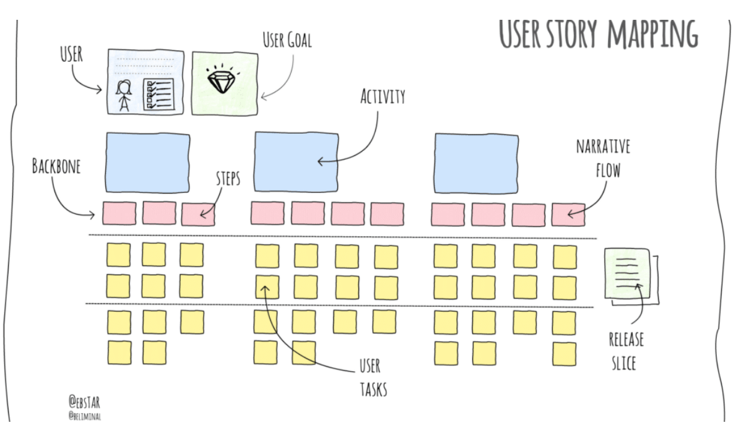
User stories are placed in descending order of priority, with the features they describe naturally organising themselves in a manner similar to the MoSCoW method approach. This makes it easier to “slice” the user stories into layers of importance, helping to define which features should be included in the Minimum Viable Product (MVP) and which can be reserved for future iterations [2].
It is during this stage of the process that a team can decide how best to define the MVP. In some cases, the MVP is interpreted very literally, with the aim being to deliver the minimum functionality considered acceptable to the client and users. In other cases, the MVP is more strategically focused on delivering a version of the product containing the features likely to provide the greatest impact for the least development effort [2].

Evaluation of User Stories and Story Mapping

User Stories
User stories in team “Merge” were largely developed as individual pieces of work. The team generally followed the “As a”, “I want”, “So that” structure when writing them. However, they often read more like a list of requirements adapted into user story format, rather than outcomes that had been fully communicated or discussed.
Figure 2: An example of user stories from team Merge's project.
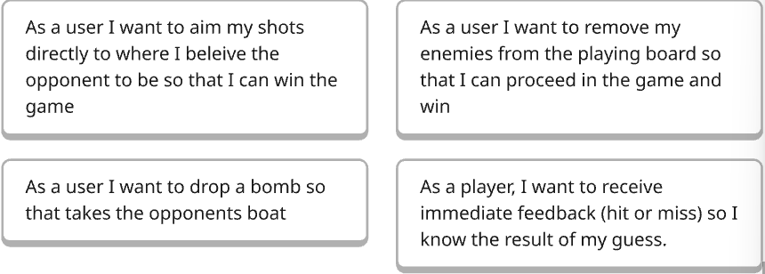
For example, in Figure 2 the bottom-right user story expresses the ‘want’ for immediate feedback when targeting a grid space. However, the addition of a ‘counter-manoeuvre’ ability would require the opponent to make a decision before that feedback could be given. Additionally, the timescale of the game was never discussed, turns could be limited by a timer, or games could extend over days, weeks, or even months. This highlights how certain features were not fully considered in relation to one another, leading to ambiguity in how the application should behave.
Figure 3: Detailed user story for Ship Placement from team Merge’s project
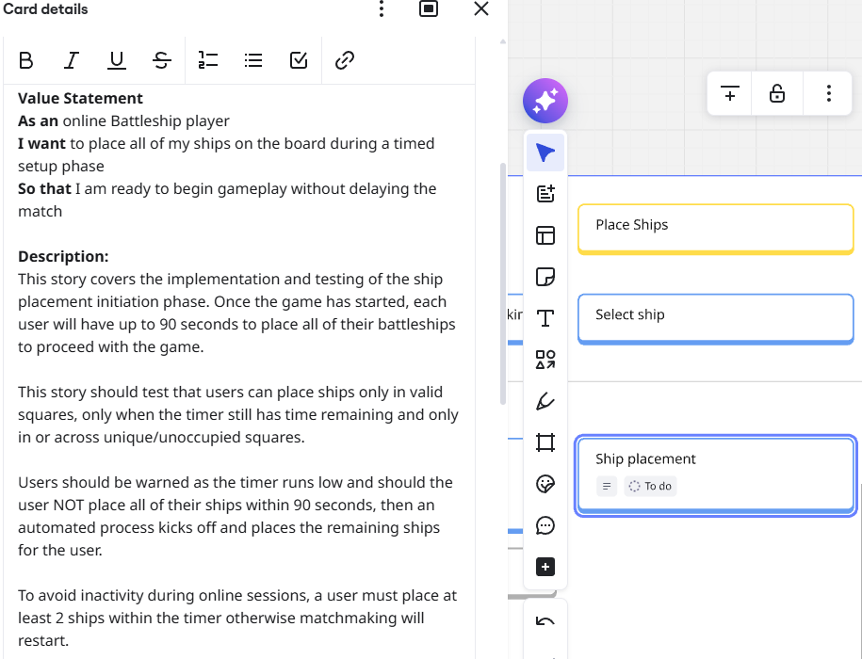
The variation in approach and quality across the user story entries further highlights the individualised nature of the work within team Merge. For example, Figure 3 presents a particularly detailed entry for ‘Ship Placement’. This story considers factors such as time constraints for placement, suggesting the game was not intended for extended, long-term play. It also explores behaviour such as handling inactive users, including the possibility of returning the player to a matchmaking state.
In addition, the entry includes a set of ten acceptance criteria, demonstrating forward consideration of the building and testing phase (See Figures 4). These criteria are clearly structured and cover a range of conditions relevant to the feature.

Figures 4: 'Ship Placement' acceptance criteria examples from team Merge's project.
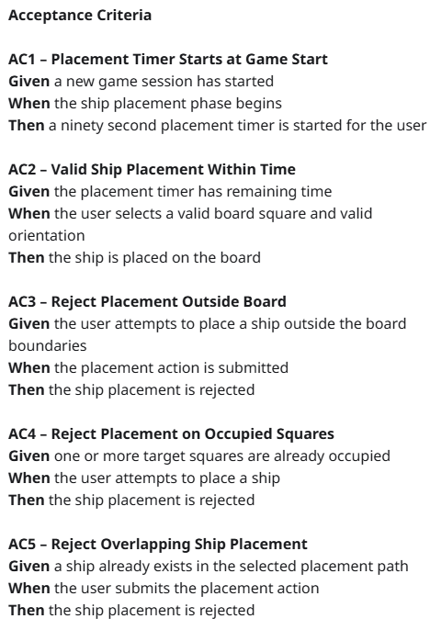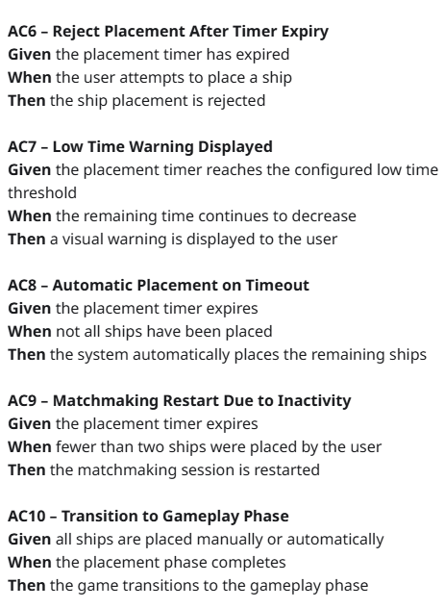
However, this level of detail was not consistent across all user stories. The disparity in quality suggests that stories were developed independently rather than collaboratively, reinforcing the lack of shared understanding within the team.

Story Mapping
Figure 5 shows an image of the story mapping, but for clarity, the Backbone is written out bellow.
Figure 5: Image of team Merge's Story Mapping.
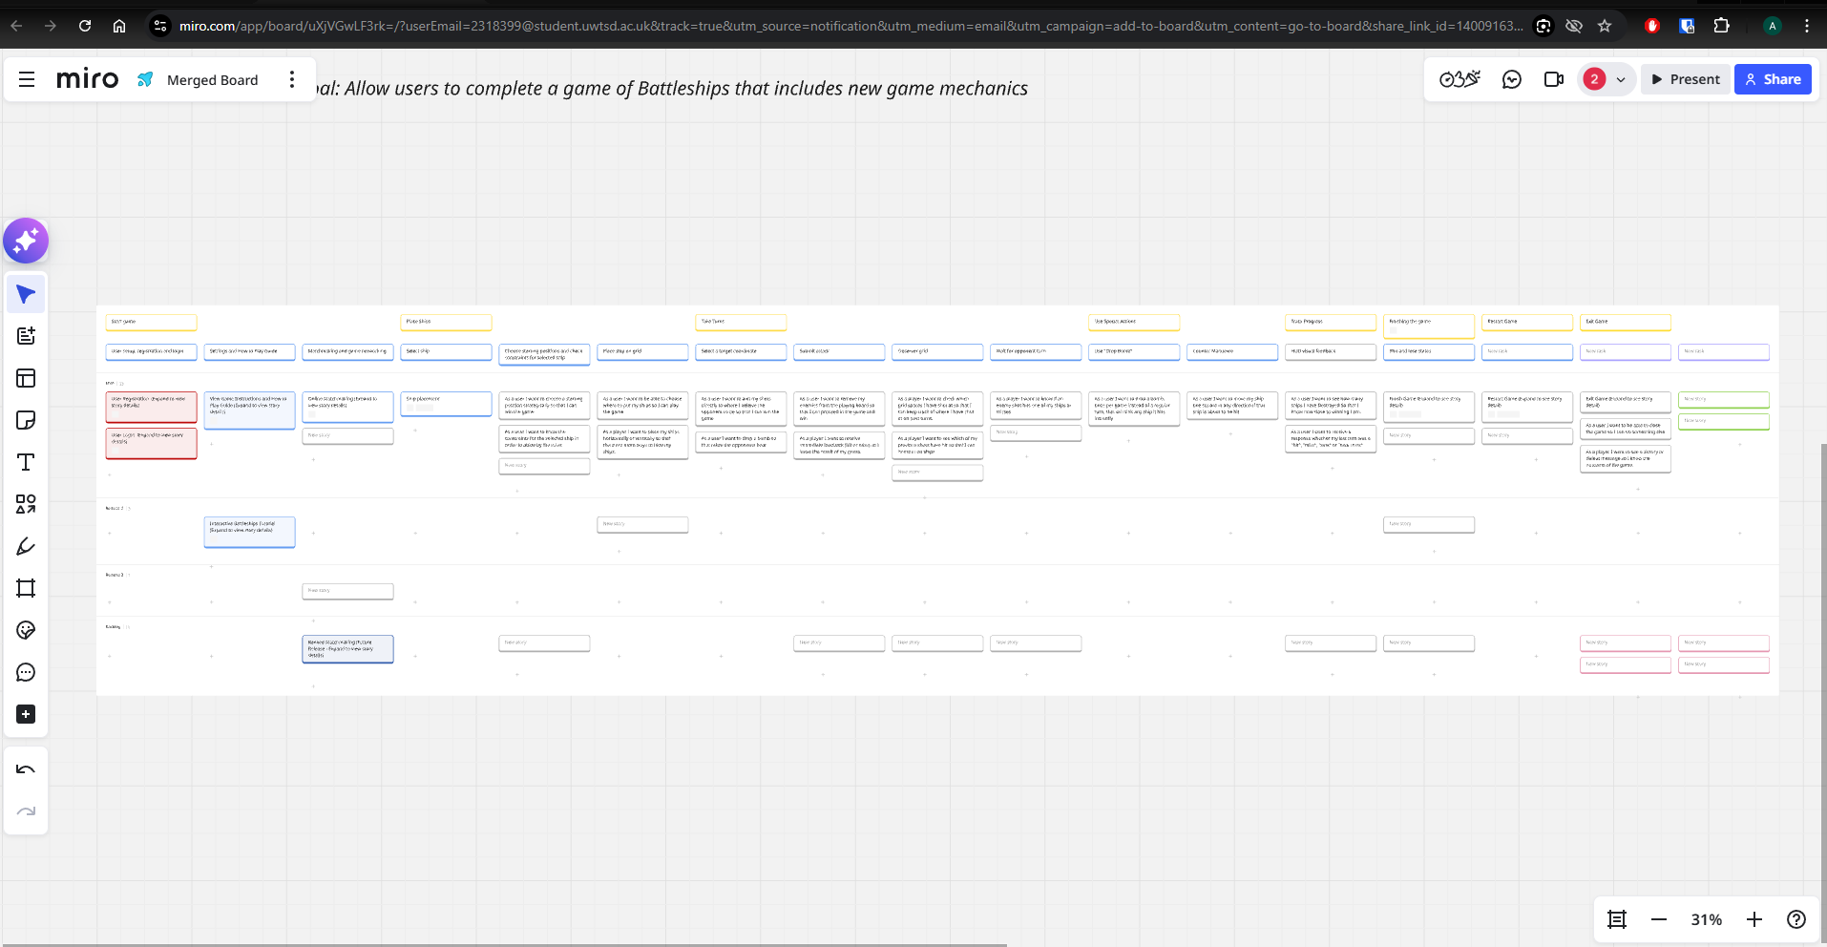

Backbone:
- Start Game
- User setup, registration, and log in.
- Settings and how to play guide.
- Matchmaking and game networking.
- Place Ships
- Select ships.
- Choose starting positions and check constraints for selected ship.
- Place ship on grid.
- Take Turns
- Select a target coordinate.
- Submit attack.
- Observe grid.
- Wait for opponent turn.
- Use Special Actions
- Use ‘Drop Bomb’
- Counter manoeuvre.
- Track Progress
- HUD visual feedback.
- Finish the Game
- Win and lose states.
- Restart Game
- Exit Game
The story mapping produced by Team “Merge” does follow a logical flow from beginning to end. It is structured around activities and steps that guide the user from starting a game through to its conclusion. The map also includes the option for the user to remain within the application and begin another game, effectively looping back into gameplay, or alternatively exiting the program entirely.
However, several improvements could have strengthened the structure and clarity of the map. For example, registration could have been separated from the “Start Game” activity into a broader startup category capable of handling login and account creation. The use of special actions could also have been incorporated more directly into the gameplay turn sequence. Additionally, elements such as progress tracking and the HUD may have been better represented as persistent systems active throughout gameplay, rather than isolated steps within the flow.
As with earlier stages of development, the team worked largely independently, and little collaborative discussion took place during the story mapping process. As a result, potential “holes in the story” were not fully explored, and there was limited consideration given to defining the MVP, planning future iterations, or refining the overall user flow collaboratively.

Teamwork
During the process of creating user stories team Merge did not reflect the collaborative and communicative intent typically associated with Agile methodology practices. The design of user stories to promote a shared understanding through discussion, refinement, and agreement on user needs was largely absent in the experience. The rate of contributions within the shared workspace was fast paced, with some contributions frequently altered or replaced without discussion. As a result, the user stories were developed in isolation rather than through shared input. This limited the opportunity for clarification and refinement, reducing their effectiveness as a tool for aligning the team’s understanding of the product.
This experience suggests that both team Merge, and initially the author, did not fully appreciate the purpose of user stories. Instead of being used to support communication, the user stories were treated mainly as tasks to complete. As a result, the benefits of shared understanding, consistency, and user-focused design were not fully achieved. This demonstrates that the success of user stories is highly dependent on active collaboration, and without it, their value as a development tool is significantly diminished.

Class Responsibility Collaboration Cards (CRC)
The CRC cards are created for each identified class within the program. These classes can often be identified through the nouns and verbs present within a user story. The ‘things’ (nouns) that the ‘actions’ (verbs) act upon. The ‘actions’ within the story can also help identify class collaborators and relationships between classes [4].
For example, if the story states that “the player targets a grid location”, the nouns ‘player’ and ‘grid’ can be identified as potential classes, while the verb ‘targets’ expresses a relationship or interaction between them [4].
The structure of a CRC card will often have the class name at the top, a list of variables and methods on the left, and the collaborator classes on the right (see Figure 6).
Figure 6: Example of a CRC card [4]
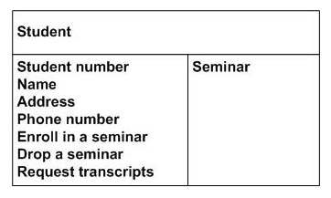

Evaluation of CRC Cards

The overview of team Merge’s CRC cards shows a slightly higher-level approach to the method described above, with greater focus placed on class responsibilities while detailed variables and attributes were deferred to a later stage of development (see Figures 7-11).
Figure 7: Overview of team Merge's CRC cards.
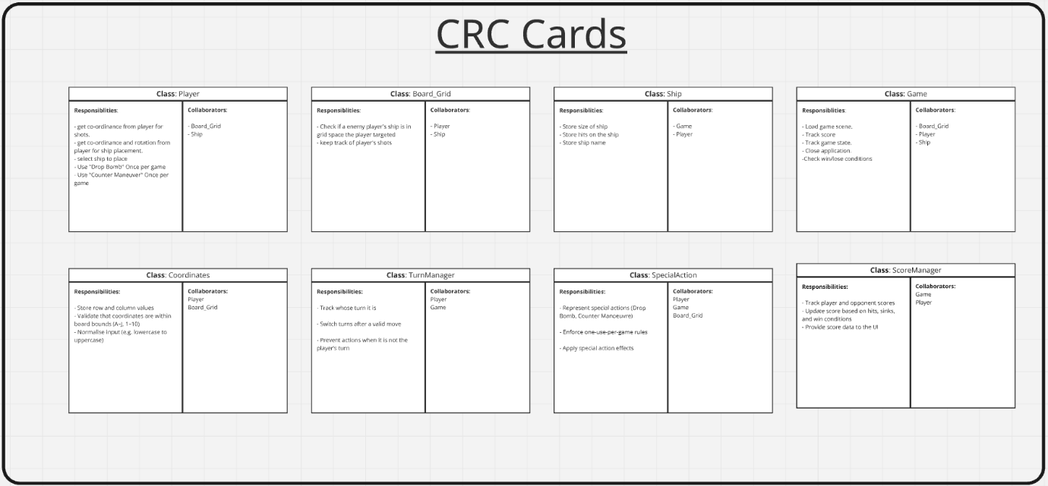
Figure 8: 'Game' class CRC card. Figure 9: 'Player' class CRC card.
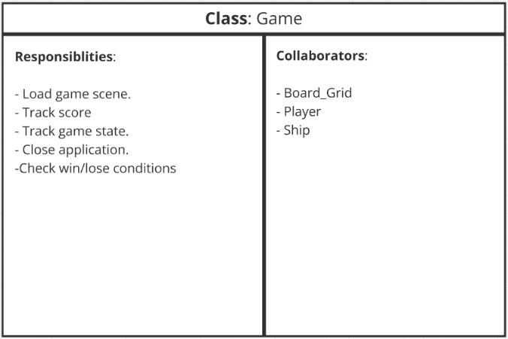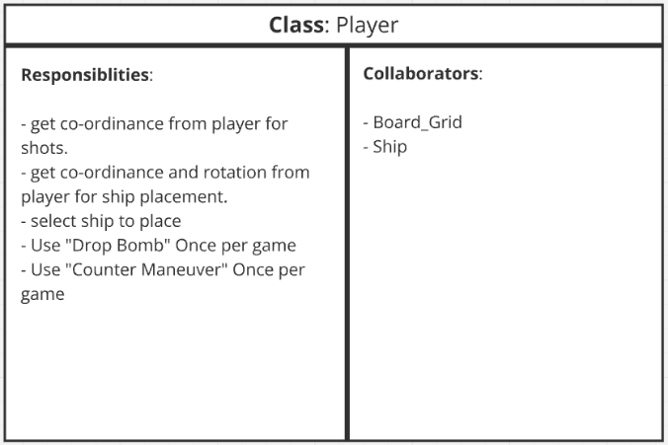
Figure 10: 'Board_Grid' class CRC card. Figure 11: 'Ship' class CRC card.
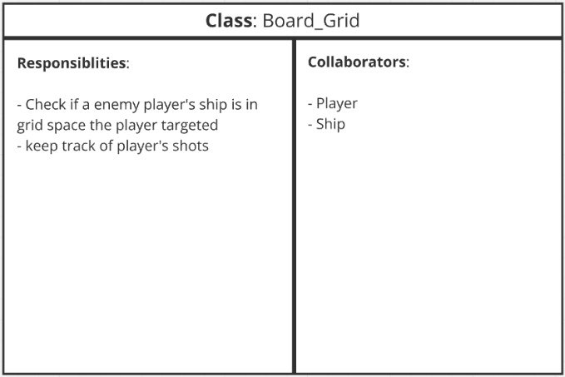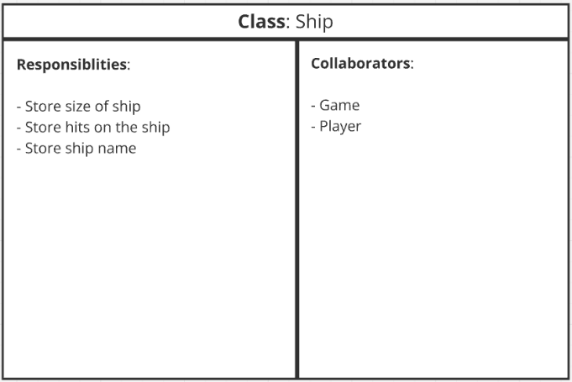

EXAMPLE:
In this example the flow of the program will be followed as a player takes a turn.
Player: Get co-ordinance from player for shots. Coordinates
Coordinates: Store row and column values, Normalise input (eg, lowercase to uppercase), Validate that coordinates are within board bounds (A-J, 1-10)Board_Grid
Board_Grid: Check if an enemy player’s ship is in grid space the player targeted, Keep track of player’s shots. IF HIT Ship, ELSESkip ahead
Ship: Store hits on shipGame.
Game: Check win/lose condition, Track game state. (Signals??) TurnManager AND ScoreManager
(Branch) ScoreManager: Update score based on hit, sinks, and win conditions. END
TurnManager: Switch turns after a valid move. (Loops with new player)

Upon following a turn, it becomes clear that there are some issues with communication between classes, ‘TurnManager’, ‘ScoreManager’, ‘Coordinates’, and ‘SpecialAction’ are not listed as collaborators at all. Additionally, there is some conflict between ‘Game’ and ‘ScoreManager’ over which is responsible for keeping score.
The ‘Coordinates’ class does a good job of handling and validating user input, making sure that the ‘Player’ class is not cluttered. Overall, the structure of the program has a lot of promise, but it could certainly use tidying up.
The author experienced a brief period of effective collaboration within a smaller subset of the group, where ideas around system structure and potential classes were discussed and mapped out. However, due to absence, they also missed the addition of four new classes and any possible discussions surrounding how they function together.

Testing

Black Box Testing
Black Box testing is a specification-based testing technique. It focuses on verifying that a system produces the correct outputs for a given set of inputs, based on the defined requirements. This approach does not consider the internal structure or implementation of the code. Instead, test cases are designed around expected behaviour, ensuring that the system meets its functional specifications [5] [6].

White Box Testing
White box testing, in contrast, focuses on examining the internal structure of a system. With knowledge of the internal design, testing can be used to validate internal logic such as loops, conditions, and branching paths. This approach often involves unit testing, where individual functions or components are tested in isolation to verify their behaviour [5] [7].

Testing the Project

Testing on Coordinates class.
Figure 12: 'Coordinates' class.
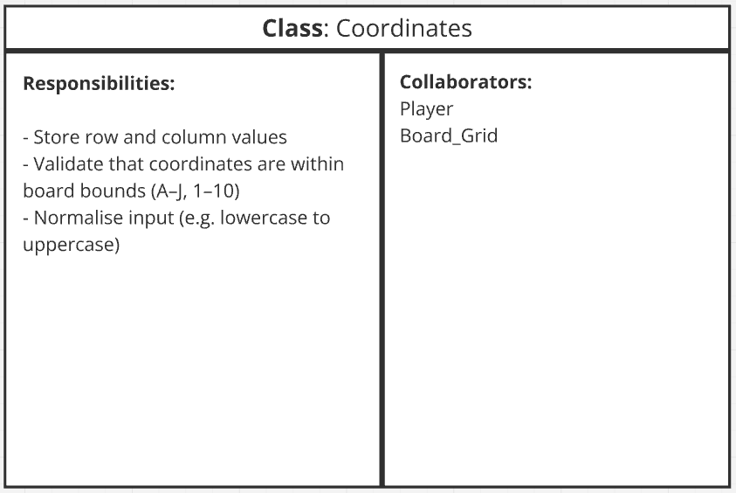

Blackbox:

Test 1 - Valid Coordinate Input
Pre-conditions
The game is running and awaiting coordinate input from the player.
Inputs
C5
Expected Output
The input is accepted and returned unchanged after validation.
Description
This test checks that a correctly formatted coordinate passes validation successfully without modification.

Test 2 - Lowercase Coordinate Input
Pre-conditions
The game is running and awaiting coordinate input from the player.
Inputs
c5
Expected Output
The input is accepted and normalised to C5.
Description
This test checks that the “Normalise Input” method correctly converts lowercase characters into the standard uppercase format.

Test 3 - Invalid Large Input
Pre-conditions
The game is running and awaiting coordinate input from the player.
Inputs
Abc1066
Expected Output
The input is rejected and an error message is displayed directing the user towards the correct coordinate format.
Description
This test checks that invalid coordinate formats are detected correctly and that the system handles malformed input safely.

Test 4 - Boundary Testing
Pre-conditions
The game is running and awaiting coordinate input from the player.
Inputs
K3, J10, A0, A1
Expected Output
- J10 and A1 accepted
- K3 and A0 rejected
Description
This test checks that coordinate validation correctly identifies the upper and lower limits of the grid boundaries.

Test 5 - Optional Input Correction
Pre-conditions
The game is running and awaiting coordinate input from the player.
Inputs
5C
Expected Output
The system automatically converts the coordinate to C5.
Description
This test checks an optional usability feature designed to correct common user formatting mistakes.

Whitebox:
For the white box testing, the methods referenced are based on logical assumptions derived from the CRC design, as the CRC cards provide a high-level abstraction rather than fully defined implementation details.
Test 1 - Coordinate Validation Method
Method Being Tested
validateCoordinate()
Pre-conditions
The validation method is available and supplied with string input.
Inputs
C5
Expected Output
Method returns true.
Description
This test checks the primary successful execution path of the coordinate validation logic. The input should pass all format and boundary checks without triggering error handling conditions.
Test 2 - Input Normalisation Branch
Method Being Tested
normaliseInput()
Inputs
c5
Expected Output
Method returns C5.
Description
This test checks the conditional branch responsible for converting lowercase alphabetic characters into uppercase format.
Test 3 - Invalid Input Error Path
Method Being Tested
validateCoordinate()
Inputs
Abc1066
Expected Output
Method returns false.
Description
This test checks that malformed input fails validation and that the error-handling branch of the coordinate validation logic is executed. It also covers early validation conditions such as input format and length constraints.
Test 4 - Boundary Condition Logic
Method Being Tested
validateCoordinate()
Inputs
K3, J10, A0, A1
Expected Output
J10 and A1 return true,
K3 and A0 return false.
Description
This test ensures that all boundary comparison conditions within the validation logic are executed correctly.
Test 5 - Coordinate Reversal Correction
Method Being Tested
correctCoordinateFormat()
Inputs
5C
Expected Output
Method returns C5.
Description
This test checks the logic branch responsible for detecting reversed coordinate formatting and rearranging the input into the correct structure.

5.4. Unit Testing and White Box Application

Unit testing is a software testing technique that focuses on testing individual units of functionality in isolation. A unit is typically a single function or method within a system. The main aim is to ensure each unit behaves correctly when given specific inputs.
Key principles include isolation, where each unit is tested separately; repeatability, where tests produce consistent results; and focusing on small, clearly defined pieces of functionality [7] [8].
In the Battleships application, unit testing can be applied to the white box tests identified earlier. Methods such as validateCoordinate() and normaliseInput() can be tested individually to ensure correct handling of valid and invalid inputs, as well as edge cases. This allows internal logic to be verified before being integrated into the full system.

Conclusion
This report has examined the application of Agile techniques within the development of a Battleships product, including user stories, CRC cards, and software testing. Each technique serves a different purpose within the development process, from capturing user requirements, to identifying system structure, to verifying system behaviour.
The user story approach is intended to support communication and shared understanding between team members, ensuring that requirements are interpreted consistently. Similarly, CRC cards rely on collaboration to refine system structure and ensure that responsibilities and relationships between classes are clearly defined.
Software testing then provides a method of validating both external behaviour through black box testing and internal logic through white box testing, with unit testing applied to individual components.
Overall, the techniques used demonstrate the importance of communication, collaboration, and structured analysis within software engineering. When applied consistently and with shared understanding, they support clearer design and more reliable implementation of systems.

References

[1] | Miro, “Miro,” [Online]. Available: https://miro.com/. [Accessed 6 March 2026].
[2] | J. Patton, User story mapping : discover the whole story, build the right product, 1st ed., O'Reilly, 2014, pp. 1-80.
[3] | E. Halford, “User story maps: Tips and tricks to get you started fast,” 6 May 2019. [Online]. Available: https://www.beliminal.com/quickstart-guide-to-user-story-maps/. [Accessed 6 May 2026].
[4] | S. W. Ambler, “Class Responsibility Collaborator (CRC) Cards: An Agile Introduction,” [Online]. Available: https://agilemodeling.com/artifacts/crcmodel.htm. [Accessed 8 May 2026].
[5] | B. Hambling and P. Morgan, “04: TEST DESIGN TECHNIQUES,” in Software testing : an ISTQB-ISEB foundation guide, 2010, pp. 74-128.
[6] | Geeks for Geeks, “Black Box Testing - Software Engineering,” 28 April 2026. [Online]. Available: https://www.geeksforgeeks.org/software-testing/software-engineering-black-box-testing/. [Accessed 10 May 2026].
[7] | Geeks for Geeks, “White box Testing - Software Engineering,” 28 April 2026. [Online]. Available: https://www.geeksforgeeks.org/software-testing/software-engineering-white-box-testing/. [Accessed 10 May 2026].
[8] | Geeks for Geeks, “Unit Testing,” 30 April 2026. [Online]. Available: https://www.geeksforgeeks.org/software-testing/unit-testing-software-testing/. [Accessed 10 May 2026].

