EXAMINATION SOLUTIONS
(to accompany the examination paper sent to the external examiner
but NOT to be seen by students)

Programme: | BEng Motorsport / Automotive Engineering | Level: | 4
Module: | Vehicle Technology
Author: | Tim Tudor | Page: | 1

Q | Question | Marks
1  2  3  4  5 | QUESTION ONE (SUSPENSION AND CHASSIS SYSTEMS)  Define the following terms (use diagrams where appropriate) and explain how these effect the performance of a suspension system  - Camber  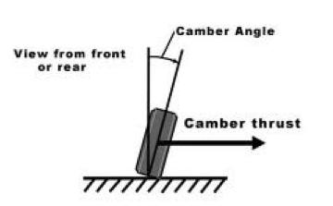  Diagram showing camber angle  Comment mentioning camber thrust and tyre curves increasing lateral grip  - Caster angle  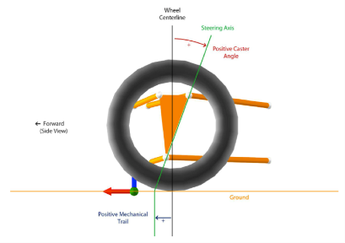  Diagram showing caster angle  Comment mentioning camber change self aligning torque/stability  - Instant Centre  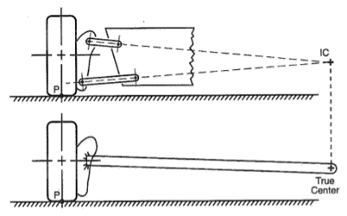  Diagram showing suspension system instant centre as virtual swig arm  Comment mentioning instant centre controls camber change with bump (based on lateral position) and also produces scrub (based on height)  - Roll centre  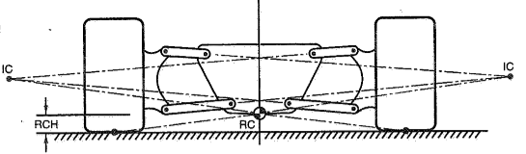  Diagram showing RC  Comment mentioning height defines roll stiffness and jacking forces  QUESTION TWO (TYRES AND WEIGHT TRANSFER)  A vehicle of mass 915Kg drives around a 130m radii corner at 25m/s. If the vehicle has a centre of gravity height of 0.375m an average track of 1.16m and a wheelbase of 2.65m.  - Show that the lateral acceleration of the vehicle is 4.81m/s²  $$a=\frac{v^{2}}{r}=\frac{{25}^{2}}{130}=4.81m/s$$  - Calculate the lateral load transfer which would be experienced by the vehicle during the turn.  $$wt=\frac{mah}{t}=\frac{915×4.81×0.375}{1.16}=1422.1N$$  - Explain why load transfer has a detrimental impact on the overall available grip for a vehicle.  Explain that tyre curves, lateral grip versues vertical force are non linear. Unloading of inside tyre looses more grip than that gained by outside tyre  - With the aid of a diagram explain what is meant by the term ‘Slip Angle’  Explain that tyre defection created by lateral load means tyres path is not the same as the vehicle heading or wheel heading.  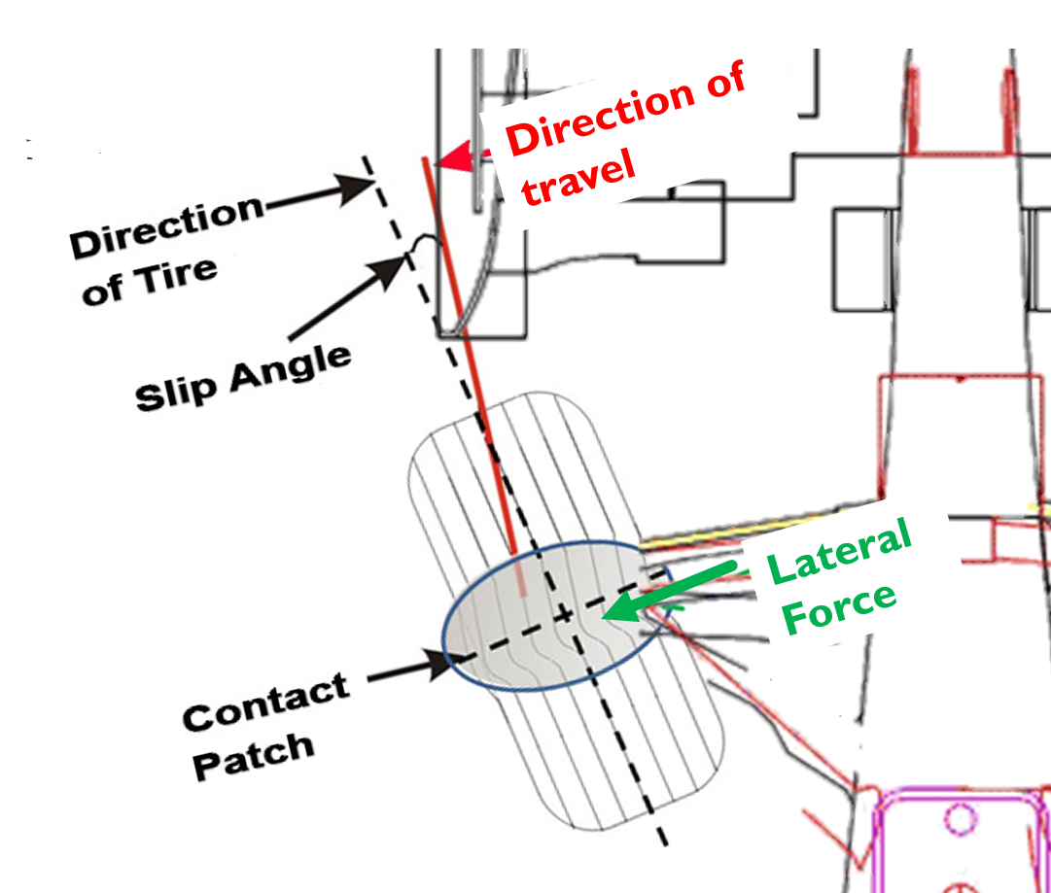  (10 marks)  QUESTION THREE (SPRINGS AND DAMPING)  The front suspension for a Dakar Rally vehicle may be modelled as a system of springs in series and parallel as shown below.  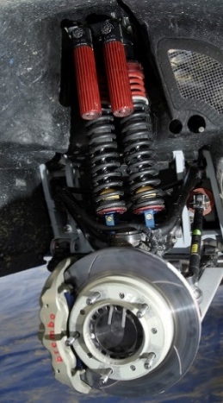  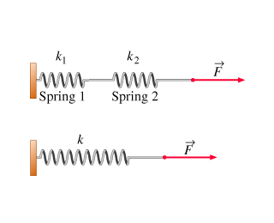  M_{s}  $$k_{1}$$  $$k_{2}$$  $$k_{1}$$  $$k_{2}$$  M_{s} Sprung Mass = 215 Kg  K₁ Helper Spring Rate = 13 000 N/m  K₂ Main Spring Rate = 28 000 N/m  - Calculate the overall spring rate of the suspension system.  $$k=2×\left(\frac{1}{\frac{1}{13000}+\frac{1}{28000}}\right)=17756.1 N/m$$  - Calculate the natural frequency of the suspension system.  $$f_{n}=\frac{1}{2π}\sqrt{\frac{k}{m}}=\frac{1}{2π}\sqrt{\frac{17756.1}{215}}=1.45 Hz$$  - Comment on the natural frequency of the suspension system with reference to its suitability to an off road vehicle.  Mention that this is a low natural frequency but as the vehicle is an off road vehicle this is to be expected as the springs need to be soft for the large bumps to be encountered.  - Draw a diagram to show the response of a spring mass damper system when undamped, overdamped and underdamped.  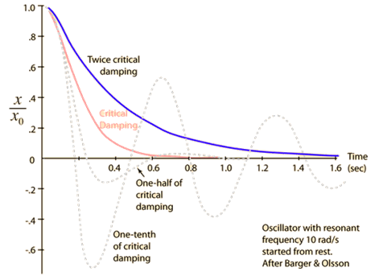  Underdamped Curve  Over Damped Curve  Critically Damper Curve  QUESTION FOUR (BRAKES)  A vehicle of total mass 875 kg must decelerate at 7.5 m/s² when it’s disc brakes are applied. If as a worst case scenario of 100% longitudinal weight transfer is assumed, calculate;  - The deceleration force required to be produced by the front brake system.  $$f=ma=875*14=6562.5 N$$  - The pedal force required if the brake system specification is as follows;  $$Force per wheel=\frac{6562.5}{2}=3281.5N$$  $$Torque required per wheel=F_{w}×R=3281.25×0.285=935.16Nm$$  $$Slave Piston Force=\frac{T}{μ×r}=\frac{935.16}{0.42×0.15}=14,844 N$$  $$Line Pressure= \frac{F_{s}}{A_{s}×n}=\frac{14844}{π{(\frac{0.04445}{2})}^{2}×2}=47.8 ×{10}^{5} N /m^{2}$$  $$Pedal Force=\frac{P×A_{m}}{PR}=\frac{47.8 ×{10}^{5}×π{(\frac{0.015875}{2})}^{2}}{4}=237 N$$  Pedal Ratio 4:1  Master Cylinder Piston Diameter 15.875 mm  Slave Cylinder Piston Area Diameter 44.45 mm  Number of Slave Cylinders 2  Effective Pad Radius 0.15m  Pad Coefficient of Friction 0.42  Rolling Radius 0.285m  QUESTION FIVE (AERODYNAMICS)  A single seater race car with frontal area 1.1m² is tested in the wind tunnel at 35 m/s² and found to produce aerodynamic forces measured at the wheels as shown below. Take the density of air to be 1.223 Kg/m³  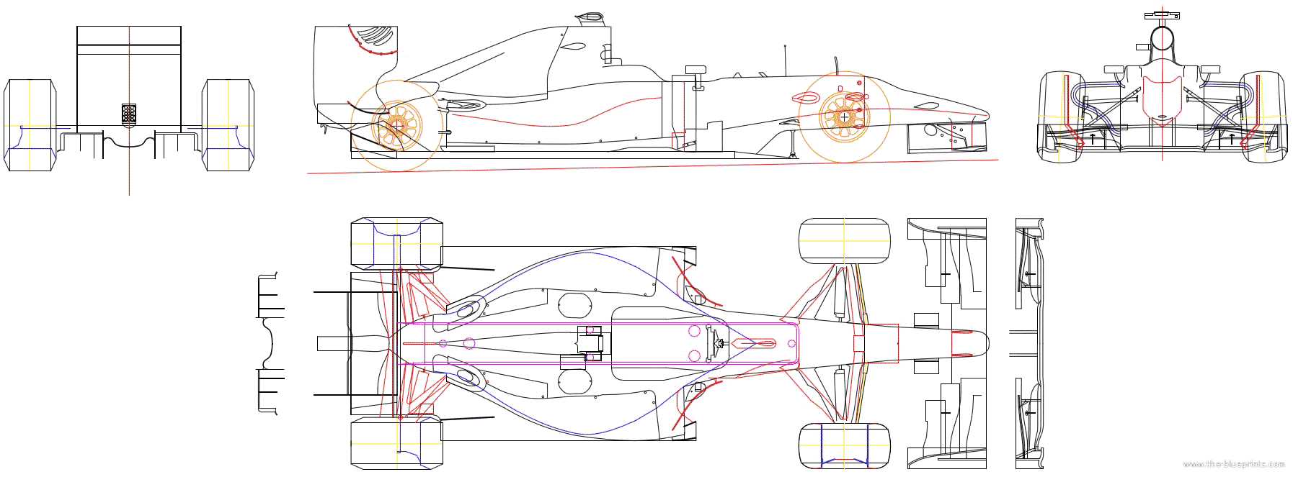  Drag  1485N  1115N  - Explain how the velocity of air around the vehicle relates to the pressure acting on the vehicle surface.  Mention that pressure is inversely proportional to velocity as stated by Bernoulli’s. High Speed air = Low pressure, Low speed air = high pressure.  - Calculate the total downforce produced and the corresponding coefficient of lift for the car.  $$Total Downforce=1115+1485=2600 N$$  $$C_{L}=\frac{Lift}{\frac{1}{2}×ρ ×A{×v}^{2}}=\frac{2600}{0.5×1.1×1.223×{35}^{2}}=3.15$$  - Calculate the drag force which would be produced if the coefficient of drag for the vehicle is 0.67  $$Drag=\frac{1}{2}×ρ{×v}^{2}×A×C_{D}=552.1 N$$  - Calculate the centre of pressure (%) for the vehicle.  $$CoP= \frac{Front Downforce}{Total Downforce}×100=\frac{1115}{2600}×100=42.9\% Front$$ | 1  1  1  1  1  2  1  2  2  3  3  2  3  2  2  1  1  1  1  1  2  2  2  2  3  1  2  2  2

