Continuous Professional Development (BMSK4011)
Nicola Jones
2431355

Introduction
In the busy and people-focused setting of a dentist practice, the receptionists' job is essential to keeping things running smoothly and making sure patients are happy. Not only are receptionists in charge of making sure that paperwork is correct (like keeping track of appointments, payments, and patient notes), but they are also in charge of making patients feel welcome, which makes them less anxious. As patient-centred approaches become more important in healthcare, receptionists’ ability to constantly learn, grow, and adapt becomes a key factor in determining quality and efficiency.
This report looks at what two receptionists at a dental practice need to learn and improve: Person 1, who is very good at organising and managing time but lacks confidence, and Person 2, who is loud and has strong opinions but is good at helping people and talking to them. Both people contribute to the practice in different ways, but they both face problems that could get in the way of their professional growth and the team's work if they aren't fixed.
Using Kolb's Experiential Learning Cycle (Kolb, 1984) , the Johari Window model (Luft & Ingham, 1955), Stephen Corey's Matrix, and Morgan's (2013) points of view, the report looks at how they learn, what they need to improve, and what chances they have. It also makes a distinction between official and informal learning, lists possible obstacles to learning, and suggests ways to get around them. There is a specific Personal Development Plan (PDP) for Person 1 with SMART goals and a CPD log. At the end of the report, Gibbs' (1988) Reflective Cycle is used to do a reflective analysis that shows how insights can help with ongoing professional growth in the dental field.

Kolb's Cycle of Experiential Learning
Kolb (1984) says that learning is a cycle that includes experience, reflection, thinking about what you've learnt, and trying it out. Knowledge is made by changing experience, and this process is not a single event but a constant, changing cycle. There are four stages: Concrete Experience (CE), Reflective Observation (RO), Abstract Conceptualisation (AC), and Active Experimentation (AE). Each stage is different, but they all connect to each other. A dentist receptionist might have to deal with a tense patient (CE), think about what went wrong (RO), learn about the communication theory behind managing patients (AC), and then use the new skills they've learnt in future interactions (AE).
Kolb also names four types of learners:
• Diverging (CE + RO): caring, creative, and focused on people.
• Assimilating (RO + AC): organised, logical, and likes data and ideas.
• Coming together (AC + AE): useful, testing, and fixing problems.
• Accommodating (CE + AE): natural, focused on action, and flexible.
Their Learning Styles
The traits of the Assimilating student can be seen in Person 1. They like things to be clear, structured, and in order. These are skills that help them schedule, keep records, and manage administrative processes well. Person 1, on the other hand, likes structured settings and doesn't have much confidence, which suggests that they feel uncomfortable in unclear or high-pressure social situations. It's possible for them to think too much before moving, which slows down Kolb's "Active Experimentation" phase. This gap can be closed by encouraging small risks and giving patient tasks in guided communication. (McBrayer et al. (2019) .
Person 2 has the Accommodating learning style, on the other hand. They learn best by doing and trying, and talking to patients directly often helps them do well. Their confidence and willingness to act on the spot make the front desk a friendly and lively place to work. This energy can also show up as irritability or dominance in talks, though. One of Person 2's main learning goals is to become more reflective. This means learning to pause, think about other points of view, and control their conversation tone to promote teamwork and inclusion. (Simply Psychology, 2013)

Comparison and Putting Theories Together
According to (Loft and Ingham (1955), the Johari Window is a good way to compare how self-aware two people are. Person 1 has a lot of hidden skills and ideas that they don't share very often because they don't trust themselves. Person 2 has a bigger blind area, which shows behaviours that others can see but not them. This shows that they aren't very aware of their power. Both can open up more by having more conversations and comments within the team. This will lead to better trust, communication, and teamwork. (Kay and Shipman (2014).
Morgan (2013) says that in order to learn effectively at work, you need to be able to change and recognise different ways of learning. Person 1's structured thinking and Person 2's focus on action show the kind of complementary diversity that helps small healthcare teams come up with new ideas. Morgan's idea of learning agility—the ability to learn, forget, and learn again—is very important in modern dental practices where software systems, rules, and patients' standards are always changing. (Bradberry and Greaves (2017).
The Stephen Corey Matrix, which compares confidence to competence, isn't very popular in modern writing because it makes things too simple, but it's a good way to picture these two people. Person 1 is in the quadrant for "high competence and low confidence," while Person 2 is in the quadrant for "moderate competence and high confidence." The model helps show the developmental priority: Person 1 needs to boost their confidence to match their skill, and Person 2 needs to find a balance between their confidence and their ability to think critically.

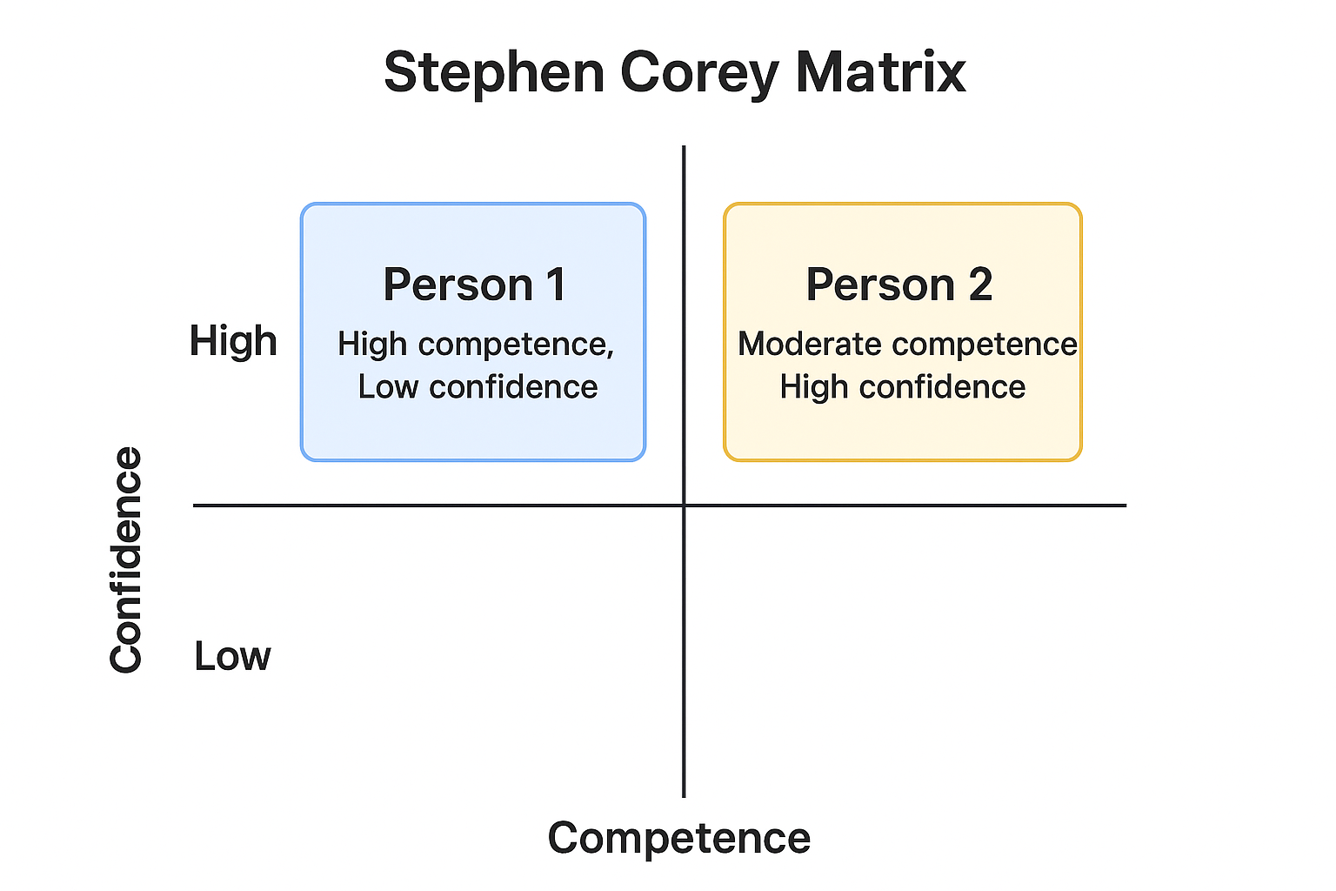

Formal and informal ways to learn
For example, learning in a dental practice includes both official and informal activities.
Formal learning
Formal learning means planned, structured activities that are meant to lead to accreditation or certification. Continuing Professional Development (CPD) classes in patient communication, privacy, or dental terminology could be part of official learning for receptionists.
• An NVQ Level 3 in either Dental Reception Management or Customer Service.
• Workshops on data security (GDPR) and keeping track of patient records.
• E-learning modules through professional dental associations focussing on equality, diversity, and inclusion in healthcare situations.
Formal learning is good for Person 1 because it gives them a safe and predictable place to learn in a way that fits their assimilation style. It gives you clear goals, ways to track your progress, and real results that boost your confidence. For Person 2, formal education gives them a solid base and lets them use their people skills in ways that are supported by facts when dealing with customers.
Informal learning
Informal learning, on the other hand, happens naturally through experience, social contact, and thought. For example, in a dentistry setting, peer learning can happen during shift changes.
• Seeing how top employees deal with complaints.
• The team talks about the tough days.
• Talking about patient comments in a reflective way.
For Person 1, informal learning gives them chances to practise their social skills in safe settings. For Person 2, it balances action with observation by encouraging them to think about what they're doing and share best practices with others.
It is very important to have a balance between formal and informal learning (Akella (2010). Morgan (2013) says that companies that offer both organised training and hands-on, on-the-job learning help employees stay engaged and motivated. In a dental practice, managers can make informal learning more formal by encouraging short reflections after appointments, peer mentoring, or short "micro-learning" sessions that happen during the workday.

Identifying Needs for Development
A SWOT and Gap Analysis method was used to figure out what the learning goals were.
Person 1
Strengths: ability to organise, keep track of time, be accurate, and be reliable.
Weaknesses: Not having enough confidence, not being able to be forceful enough, and having trouble making decisions.
Opportunities: mentoring, building confidence, and giving presentations in team meetings.
Threats: If you don't push yourself enough, you could get stuck or burn out.
Gap analysis shows that Person 1 does a good job with regular tasks but needs specific help with self-expression, talking to others, and building confidence.
Person 2
Strengths: Comfortable talking to people, easy to get along with, great at building relationships.
Weaknesses: tendency to act without thinking, lack of thought, and need to be in charge.
Opportunities: training in reflective practice and leadership coaching.
Threats: Team conflict or less trustworthiness if input isn't considered.
Person 2 is confident, social, and good at developing relationships, yet impulsive and dominant. Reflective thinking, smart decision-making, and collaborative leadership are lacking. Targeted reflective practice and leadership coaching can reduce this gap, lowering team conflict and enhancing trust.

Taking care of these needs will help both staff members find a balance between their intellectual and social skills, which will improve teamwork and the patient experience.

6 Barriers to learning
Learning hurdles can come from the inside (emotional or psychological issues) or the outside (structural or environmental issues).
Person 1
Person 1's main problem is low self-efficacy, which makes them avoid jobs that will be seen by a lot of people. (Bandura's (1997) theory of self-efficacy says that believing in one's own abilities affects drive and performance in a direct way. In a dental setting, this could make people not want to deal with tough patients or speak up in staff meetings. Environmental hurdles, like not having many chances to get feedback or working at a desk where things move quickly, make reflective learning even harder.
Ways to Get Over It: • One-on-one teaching and mentoring to boost confidence.
• Gradual introduction to duties that involve dealing with the public.
• Regular, helpful comments from bosses that builds on accomplishments.
Person 2
Person 2's main problem is that they are too sure of themselves, which can make it hard for them to listen and think. (Raveendran and Gopakumar (2007). The person may see feedback as criticism, which makes it harder for them to grow as a person. Also, the fast-paced nature of working in a dentist receptionist can make it hard to take pauses to think.
Ways to Get Over It: • Keep structured thought logs that you look over once a week.
• Start peer feedback groups to help people understand and care about others.
• To improve patience, encourage people to take classes in mindfulness or emotional intelligence.
By dealing with these mental and behavioural problems, both people can develop resilience and a growth mindset, which are very important in today's healthcare management.

Support systems and chances for development
Support systems help people turn their learning goals into long-lasting changes in their behaviour. (Akella (2010). In this case, help includes both people and buildings:
Giving advice and mentoring:
Person 1 could use a mentor who talks to them with confidence and gives them comments on real conversations. For Person 2, coaching meetings that focus on self-awareness, listening, and empathy would be helpful. Coaching fits with the Johari Window because it helps people see their secret potential or get rid of blind spots.
Peer learning: Encouraging joint problem-solving sessions lets both people trade strengths—Person 1's planning skills work well with Person 2's energy. This way of learning together builds trust and fits with Morgan's (2013) idea of learning as a social process that happens in groups.
Job Rotation: When people on the reception and management teams switch roles for a short time, they both get to try new things. Person 1 could lead a daily briefing to improve their speaking skills, and Person 2 could do office work that requires patience and focus.
Online learning sites, like the British Dental Receptionist Association, are useful resources and learning tools.
• Journals for reflection.
• Surveys with answers from patients and coworkers; • Regular meetings to talk about success.
These features help create a mindset of learning where getting feedback, trying new things, and getting better are all accepted and encouraged.

Personal development plan for person 1
Objective | Actions | Resources/support | Time Frame | Evaluation method
Strengthen decision making | Manage one daily rota independently | Access to rota system, guidance from supervisor | 3 months | Review of accuracy and timeliness
Enhance reflective skills | Maintain weekly learning journal reviewed monthly | Maintain weekly learning journal reviewed monthly | 6 months | Quality of reflection assessed via rubric
Prepare for possible promotion | Complete online Leadership and Communication course | E-learning platform, allocated study hours | 6 months | Certificate completion and manager evaluation
Increase self-confidence and verbal participation | Attend a confidence workshop; role-play patient conversations weekly | Mentor, external trainer, manager feedback | 4 months | 80% improvement in self-assessment survey
Improve assertive communication | Lead at least two team meeting discussions | Pre-meeting coaching, post-meeting feedback | 4 months | Manager observation and feedback

Checking on Progress
Monitoring progress keeps people accountable and keeps the energy going. • Reviewing the PDP every month with the line manager is one effective way.
• 360-degree feedback that includes feedback from patients, mentors, and peers.
• Performance indicators like keeping appointments, getting good comments from patients, and regular absence from work.
• Reflective journals that let each person write down their growth and new ideas.
These methods fit with Kolb's model of continuous learning, which makes the connection between thought and use even stronger.

Conclusion
The study shows that learning in a dentistry receptionist team is multifaceted, including self-awareness, structured training, and practice with reflection. Person 1's strong organisational skills and assimilation learning style make administration run smoothly, while Person 2's flexible style boosts team happiness and interactions with patients. If they get the right help, their different skills can work together to make a balanced, effective reception team.
But growth must be targeted: to reach their full potential, Person 1 needs to work on building their confidence and assertiveness, while Person 2 needs to learn how to be patient, reflect, and control themselves. Formal learning gives you order and measurable results, while informal learning helps you use what you've learnt in your everyday life. These interventions can improve not only individual performance but also the learning culture in the dental practice as a whole when paired with supportive tools like mentoring, coaching, feedback, and organised monitoring.

Using Gibbs' Reflective Cycle to think about the hiring process
Describe
When a new receptionist was being hired, both Person 1 and Person 2 helped with the interviews. Person 1 took detailed notes during the interview and made sure that all of the candidates' paperwork was complete. Person 2 easily led the questions and started conversations with applicants.
How you feel
Person 1 had nervousness and self-doubt, but they were proud of how organised and professional they were. Person 2 was sure of themselves, but got irritated when talks didn't move quickly. Both reactions showed how the people involved learnt: Person 1 was cautious and thought things through, while Person 2 was action-oriented and quick to respond.
Evaluation: The hiring process showed some great qualities: Person 1's attention to detail made sure that the right steps were taken, and Person 2's energy made the workplace a nice place to be. There were, however, flaws. Person 1's silence made it impossible to make fair decisions, and Person 2's control sometimes took attention away from criteria-based assessment.
Analysis
Using the Johari Window, Person 1's "hidden" skills (like analytical thought) were not being used enough, and Person 2's "blind spot" (impulsivity) made it harder for the team to work together. Gibbs' model stresses that this kind of thinking helps people turn their experiences into lessons. Kolb's theory also fits here—neither person finished the learning cycle all the way—person 1 stayed in thought, and person 2 stayed in action.
In conclusion
Person 1's organised planning and Person 2's interesting talking would make for a more fair approach. Realising that these jobs complement each other can help divide up tasks so that everyone can use their strengths.
Plan of Action
In future hiring, Person 1 will be in charge of organising the assessment paperwork and Person 2 will be in charge of leading the first part of getting to know each other. A debriefing after the interview will give you and the other person a chance to think about what happened and give each other feedback, which will reinforce the learning loop. Personal growth will happen over time if you have regular review meetings.

Reflection
A Brief Look at Gibbs' Reflective Cycle
The Reflective Cycle by Gibbs (1988) is a six-step plan that is meant to help people learn from their experiences in a structured way. It supports going from describing to analysing and then taking action, which makes sure that learning is ongoing instead of one-time. Gibbs' model gave me a clear way to think about the hiring process, which helped me figure out what I could learn for myself and for the team as a whole.

Diagram: Gibbs’ Reflective Cycle
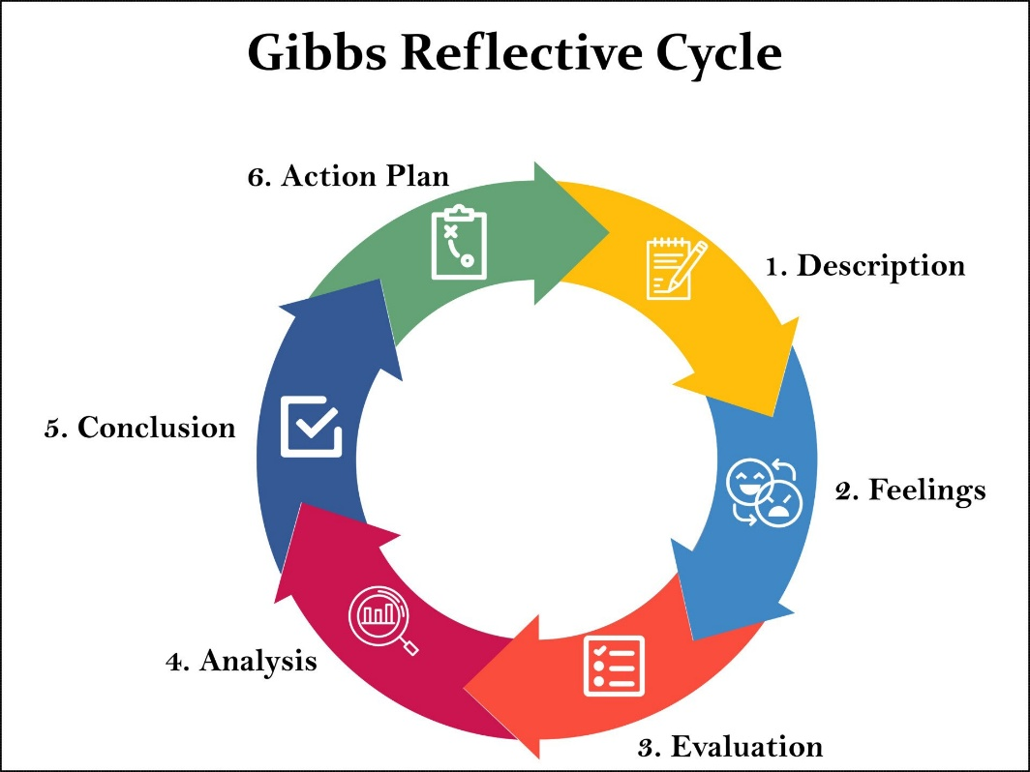
(Adapted from Gibbs, 1988)
Description
Although both Person 1 and Person 2 helped with the hiring process, they did so in very different ways. Person 1 carefully handled the paperwork, and Person 2 lead the discussions with candidates with confidence. Kolb's model had already shown that they had different learning styles, which were now very clear.
Feelings
At first, I was hopeful that their different skills would balance each other out. Later, though, I was worried that Person 1's quietness meant she couldn't add much, and Person 2's dominance sometimes veered the conversation off topic. This made it hard to be efficient and include everyone.
Evaluation
The process had some good points, like being well-organised, professional, and friendly. But it also had some problems, like unequal participation and not enough decisions based on facts. I realised that both staff members were making good contributions, but they needed more discipline and chances to give feedback.
Analysis
Using the Johari Window (Luft & Ingham, 1955), Person 1's "hidden" skills were not shared, and Person 2's "blind spots" threw off the balance of the group. Using Gibbs' reflective lens, this step was the "Analysis" phase, where I thought about why things happened the way they did. Kolb's cycle from 1984 also worked: Person 1 stayed in reflection, and Person 2 stayed in action, showing incomplete learning cycles.
Conclusion
Using Gibbs' model to help me reflect helped me understand that two different people's skills can work well together if they are coordinated well. As a leader, I learnt how important it is to make sure everyone has a chance to contribute, to deal with differences in personality, and to include organised reflection after important events.
Action plan
When hiring again in the future, Person 1 will be in charge of the assessment paperwork and Person 2 will be in charge of getting to know the candidates. A debriefing after the interview will allow for evaluation and feedback. The whole team will also have monthly reflection talks using Gibbs' framework to encourage them to keep learning.

References
Akella, D. (2010). Learning together: Kolb’s experiential theory and its application. Journal of Management & Organization, 16(1), 100–112.
Bandura, A. (1997). Self-efficacy: The exercise of control. W.H. Freeman.
Bradberry, T., & Greaves, J. (2017). Emotional intelligence 2.0. TalentSmart.
Corey, S. M. (1953). Action research to improve school practices. Teachers College Press.
Kay, K., & Shipman, C. (2014). The confidence code: The science and art of self-assurance. HarperBusiness.
Kolb, D. A. (1984). Experiential learning: Experience as the source of learning and development. Prentice Hall.
Luft, J., & Ingham, H. (1955). The Johari Window: A graphic model of interpersonal awareness. Proceedings of the Western Training Laboratory in Group Development.
McBrayer, J., Ballesteros, E., & Egan, J. (2019). Reconceptualising Kolb’s learning cycle as episodic and lifelong. Interactive Learning Environments.
MindTools. (n.d.). The Johari window: Building self-awareness and trust. https://www.mindtools.com
Morgan, P. (2013). Leading for learning: How to build capability for continuous improvement. Learning and Performance Institute.
Raveendran, P. T., & Gopakumar, V. (2007). Exploring the conceptual framework of Johari Window: For self-awareness, personal development, group development and understanding relationships. I-Manager’s Journal on Management, 1(3), 52–58. https://doi.org/10.26634/jmgt.1.3.391
Simply Psychology. (2013). Kolb’s learning styles and experiential learning cycle. https://www.simplypsychology.org
TSW Training. (n.d.). Understanding learning styles and team dynamics. https://www.tsw.co.uk

Appendix 1

Curriculum Vitae
Nicola Jones
60 Cil-Y-Coed, Waunarlwydd, Swansea, SA5 4TG
Mobile: 07980 090338 | Email: noodj1978@gmail.com
Date of Birth: 02 November 1978
- Personal Profile
- I am a dedicated, professional, and personable dental care specialist with over 25 years of experience in both clinical dental nursing and administrative roles. My career has been built on loyalty, trustworthiness, and a commitment to delivering high-quality patient care. I possess excellent customer service skills, and I am highly motivated, organised, and able to work effectively under pressure—whether independently or as part of a team. I am bilingual in Welsh and English, hold a full clean driving licence, and enjoy fostering positive relationships with both colleagues and patients.

Employment History
University Dental Care – Senior Receptionist
September 2023 – Present
- Manage day-to-day reception operations in a busy mixed NHS and private practice.
- Liaise with patients via telephone, email, and in-person, ensuring a professional and welcoming experience.
- Organise appointments, patient records, treatment plans, and financial arrangements.
- Coordinate with dental laboratories to ensure timely delivery and collection of work.
- Order stock and maintain inventory to support smooth practice operations.
- Utilize dental nursing experience to support both administrative and clinical teams effectively.
Welsh Ambulance Service – Dental Health Advisor
April 2023 – September 2023
- Provided dental advice and triaged patient calls across Wales, prioritising urgent needs.
- Delivered guidance on self-care and treatment options in line with local Health Board provisions.
- Maintained accurate records while adhering to confidentiality and data protection policies.
Brynhyfryd Dental Practice – Dental Nurse & Receptionist
1996 – April 2023
- Assisted in clinical procedures, instrument decontamination, and stock management.
- Performed full reception duties including appointment scheduling, telephone and email correspondence, patient records, and payment processing using SOE software.
- Ensured compliance with GDPR and patient confidentiality standards.
- Supported both NHS and private dental services with high efficiency and professionalism.
Additional Experience
- Wyevale Garden Centre Café – Customer Service Role
- The Masons Arms, Waunarlwydd – Hospitality Role

Professional Development & Qualifications
- National Certificate in Dental Nursing (NEBDN) – 1997
- 7 GCSEs
- Child Protection Training
- Fire Safety
- CPR, First Aid & Medical Emergencies
- Safeguarding Vulnerable Adults
- Information Governance & GDPR Compliance
- Radiology and Radiation Protection for DCPs
- Health & Safety
- Welsh Health Technical Memorandum

Key Skills
- Patient care and customer service
- Dental administration and reception management
- Appointment scheduling and record keeping
- Financial transactions and insurance liaison
- Stock control and supply management
- Team collaboration and independent working
- Bilingual in Welsh and English

References
Mrs Amanda Griffiths – Dental Practice Manager
Mobile: 07526 905194 | Email: m4ndgriff@hotmail.co.uk
Gareth Crowther – Principal Dentist, Brynhyfryd Dental Practice
Mobile: 07747 822972 | Email: gareth.crowth@hotmail.co.uk
Lesley Evans – Line Manager, Welsh Ambulance Service
Email: Lesley.evans5@wales.nhs.uk

Appendix 2

CPD log

Date | Activity | Learning Objectives | Key Learning Points / Summary | Reflection (Using Gibbs’ Cycle) | Planned Action / Application | Hours | Verification / Evidence
12/11/25 | Attended “Effective Patient Communication” Workshop | Gain patient contact and complaint handling confidence | Active listening and anxiety management were taught. | Initial nervousness turned into confidence following role-plays. Empathy is crucial to patient rapport (Feelings, Evaluation, Analysis). | Use reception communication skills; ask supervisor for comments after 2 weeks. | 2 Hrs | Attendance certificate
20/11/25 | Online GDPR Refresher Course | Update data protection and patient confidentiality knowledge | Examined GDPR and dental data processing. | Reviewed data entry problems; now more conscious of secure record keeping (Analysis, Conclusion). | Verify all digital records and teach others the correct process. | 1.5 hrs | E-learning certificate
05/12/25 | Shadowed senior receptionist managing patient complaints | Study systematic complaint-handling methods. | Discovered how tone and body language affect patient satisfaction | First viewed passively, then engaged in debate; confidence increases with exposure. | Next patient issue under monitoring; journal entry. | 1 Hr | Supervisor approved.
10/1/26 | Team Gibbs Model Reflection session | Learn introspective practice. | Discussed reception challenges and triumphs | Respected open communication; understood learning style. | Continue monthly reflection sessions and contribute to peer feedback. | 1 Hr | Team meeting notes

