Software Engineering Design and Testing
  - Software Engineering Principles and Practice



Software Engineering

Kayleigh Davies
Student Number: 2316137
Table of Contents
1.Introduction 4
2. Evaluation of Design 4
2.1 Overview of the Design Process 4
2.2 Strengths of the Team’s Approach 6
2.3 Weaknesses and Challenges Encountered 8
2.4 Recommendations for Future Iterations 8
3. User Stories and User Story Map 9
3.1 User Stories Structure and Associated Benefits 9
3.2 Refining User Stories and Developing the User Story Map 10
3.3 Estimating and Understanding Workflow 11
3.4 Further Improvements to User Stories 12
4.CRC Cards 13
4.1 The Design Process for CRC Cards 13
4.2 Cohesion, Coupling and Testable Responsibilities 13
4.3 Alignment with User Stories and Acceptance Criteria 13
4.4 Defining Classes and Collaborators 13
4.5 Refinement and Iterative Improvement of CRC Cards 15
4.6 Evaluating CRC Cards and Next Steps 16
5.Software Testing Evaluation 17
5.1 Importance of Software Testing 17
5.2 White Box Testing 17
5.3 Black Box Testing 18
5.4 Comparison of Testing Methods 18
5.5 Understanding Testable Code 19
6.Application Testing 19
6.1 Black Box Tests for Battleship Application 20
6.1.1 Switching Turns Between Players 20
6.1.1.1 Pre Conditions 20
6.1.1.2 Inputs 20
6.1.1.3 Expected Outcomes 20
6.1.1.4 Purpose of the Test and Testing Method 20
6.2 White Box Tests for Battleship Application 21
6.2.1 Coordinate Validation 21
6.2.1.1 Pre Conditions 21
6.2.1.2 Inputs 21
6.2.1.3 Expected Outcomes 22
6.2.1.4 Purpose of the Test and Testing Method 22
7.Unit Testing Investigation 22
7.1 Principles of Unit Testing 22
7.2 Applying Unit Testing to Battleship Application 23
8.Conclusion 23
9. References 24
10. Appendices 26
Appendix A: User Stories 26
Appendix B: User Story Map 26
Appendix C: CRC Cards Design Iteration 1 27
Appendix D: CRC Cards Design Iteration 2 28
Appendix E: Class Diagrams Design Iteration 1 29
Appendix F: Class Diagrams Design Iteration 2 29
Appendix G: Sequence Diagram 30
Appendix H: Acceptance Criteria 30
Appendix I: Wireframe Diagram 31
Appendix I: Wireframe Diagram - Multiple Layouts 31
Appendix J: Team Collaboration 32

Table of Figures
Figure 1 - Prioritizing Tasks 5
Figure 2 - Team Feedback 6
Figure 3 - Feedback from Team Members 7
Figure 4 – Design Amendments (CRC Cards) 7
Figure 5 - User Story Feedback 9
Figure 6 - User Stories 9
Figure 7 - User Stories 10
Figure 8 - User Story Mapping 11
Figure 9 - User Story Mapping 12
Figure 10 - CRC Card Classes 14
Figure 11 - CRC Cards 15
Figure 12 - CRC Cards 16

1.Introduction
This report evaluates the software design process for developing a web application, with a particular focus on user interface planning, collaborative design activities, and the creation of CRC cards to explain how the system will behave. Working as part of a team provided opportunities to apply agile principles to our project, discuss ideas, refine design decisions, and develop user stories to capture the goals and benefits for the user.
The report also investigates the role of software testing, comparing black box and white box testing and exploring how principles of unit testing can be applied to ensure the application behaves as expected.

2. Evaluation of Design
Evaluating the design while considering Agile methodologies revealed strengths and weaknesses of the planning processes. Using iterative design approaches allowed the team to respond to issues as soon as possible, aiming to improve the clarity and functionality of the design. However, the same flexibility sometimes made it difficult to maintain a consistent direction, especially when focus shifted onto other elements of the design for the web application.
These difficulties highlighted the importance of applying core Agile principles such as responding to changing requirements, continuous improvements, iterative development, promoting face to face collaboration and communications to support the team in adapting the design. Applying these methods ensured the team could work towards achieving technical excellence and simplicity in our designs.

2.1 Overview of the Design Process
The design of the Battleships Application was developed during weekly timeboxing sessions to encourage regular collaboration and communication amongst the team to progress critical tasks for the delivery of the project [1]. These tasks involved producing the first drafts of documentation such as User Stories, User Story Maps, CRC Cards, Class and Sequence Diagrams to demonstrate the design requirements for the application.
The timeboxing sessions were used to prioritize tasks and review the work from previous sessions to determine if any improvements were needed before the end of the design fix. This allowed us to measure progress and work towards maintaining a constant design pace to ensure the first draft of our deliverables could be completed on time or if they would need to be carried over into the next sprint. An example of this is creating lists to keep track of what was done in the previous session and what will need to be actioned at the start of the next session as shown in Figure 1.
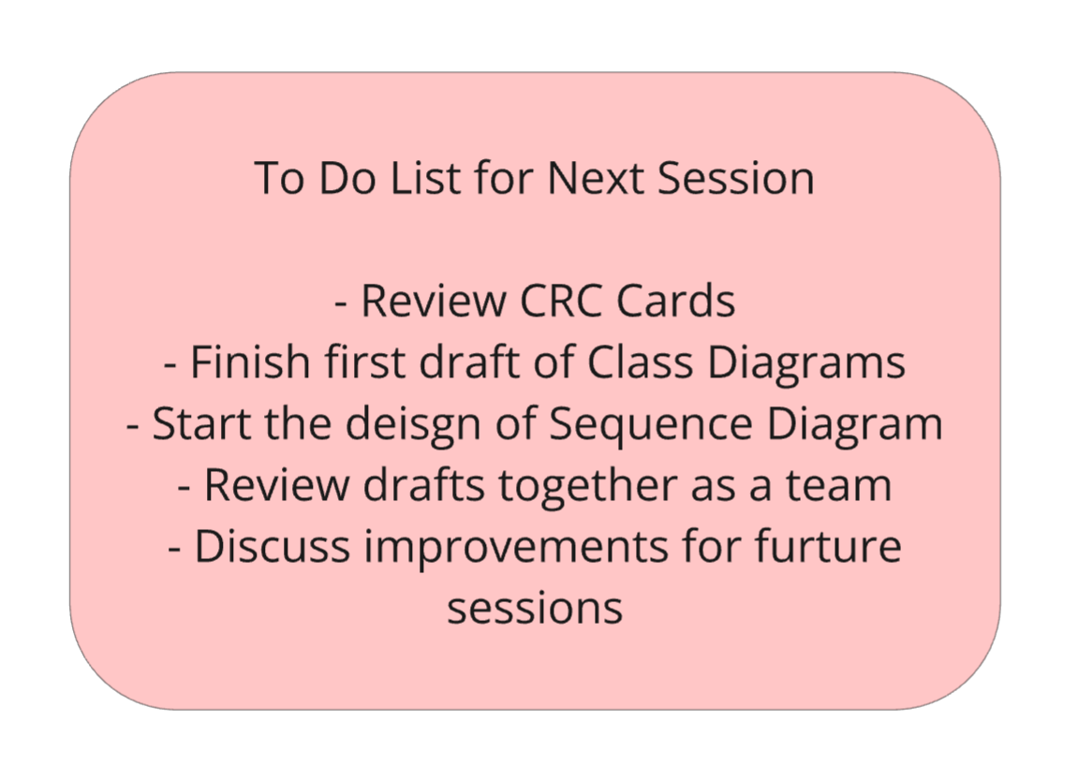
Figure 1 - Prioritizing Tasks
The short iterations allowed the team to focus on different design elements each week to prioritize tasks and productivity [1]. Plus, it presented an opportunity to provide regular feedback to ensure the required changes were made so the overall design aligned with the user stories and acceptance criteria. For example, the class diagrams were missing details that would support the design development. Therefore, feedback was provided along with examples to support the team when making these improvements.
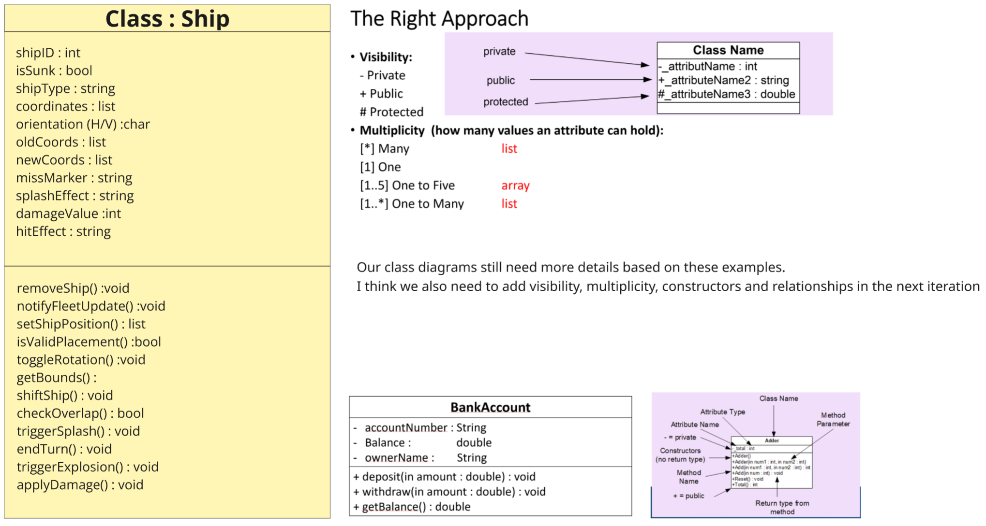
Figure 2 - Team Feedback

2.2 Strengths of the Team’s Approach
The collaboration principle was one of the team strengths as we encouraged communication to share ideas and feedback easily during the early stages of development while drafting the User Stories and CRC cards. This allowed us to discuss the information we were including in the designs along with any adjustments that were needed to meet the objectives. For example, defining the goals and details of the user story map after team reviews.
Decision making was an essential part of the design process to make sure that the details were correct so we could maintain simplicity in our designs. To improve our work, we would discuss feedback and potential changes amongst the team, providing examples and clear expectations of what changes needed to be made and why.
This improved the communication and collaboration of the team, prompting continuous improvements which enabled us to adapt any changing requirements. This meant that our team approach aligned with agile methodologies which made it easier to work together and focus on making progress with our designs.
Regular feedback from the team had a positive impact on our design decisions, as it identified flaws in the early design stages, allowing time for amendments to be made so the design could adapt to suit the user requirements [1]. An example of this was refining our CRC cards and combining the ship class as one rather than having individual classes for each type of movement after feedback from one of our team members as shown in Figures 3 and 4.
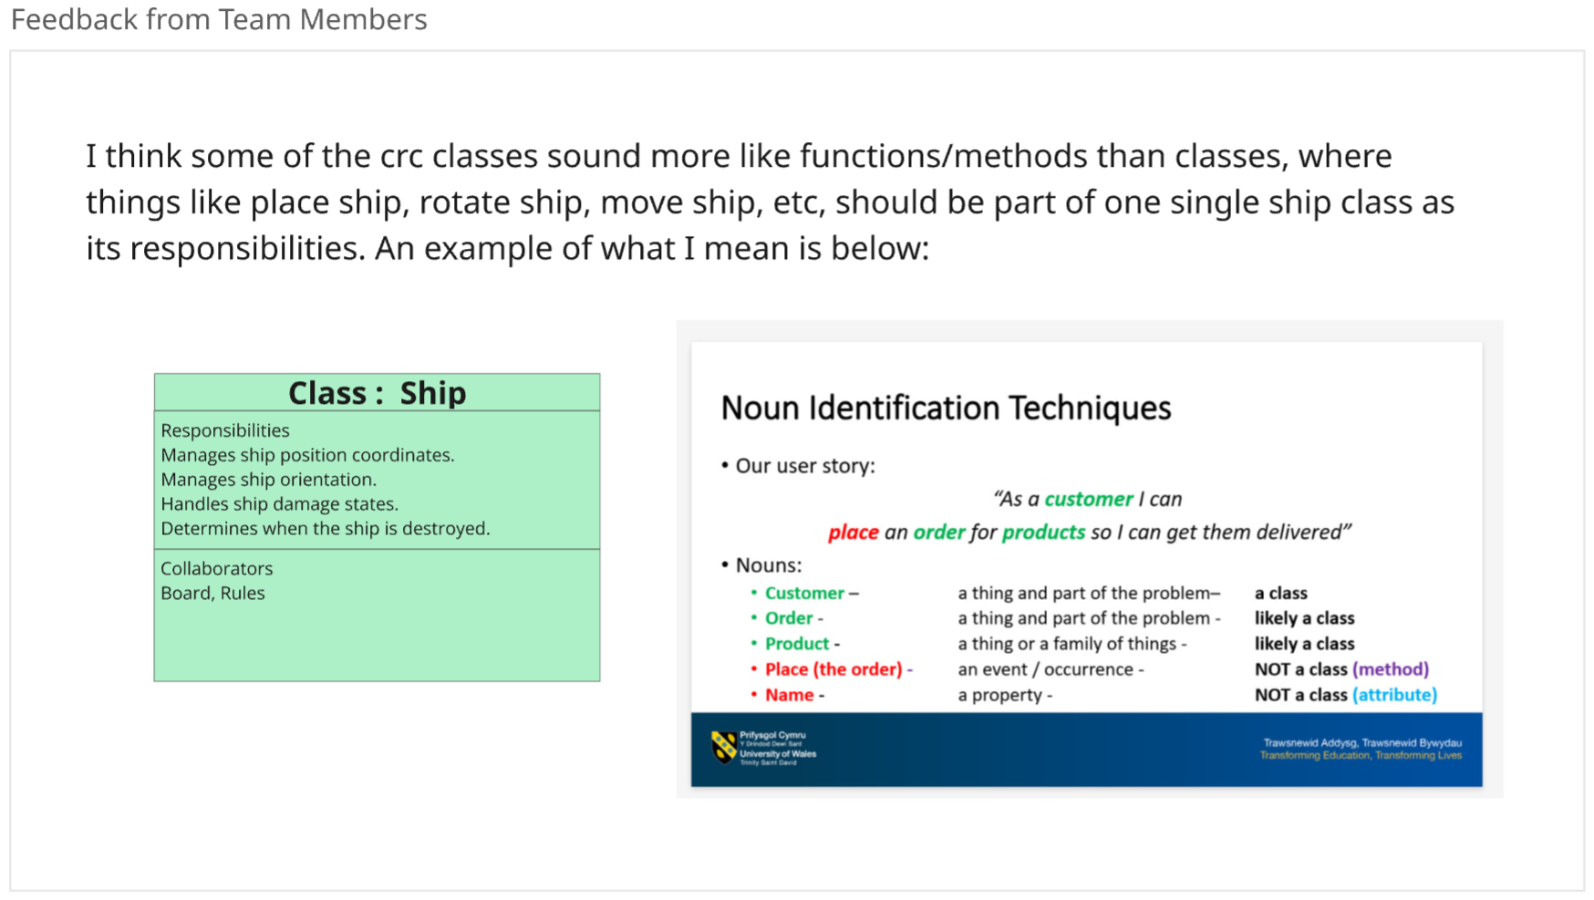
Figure 3 - Feedback from Team Members
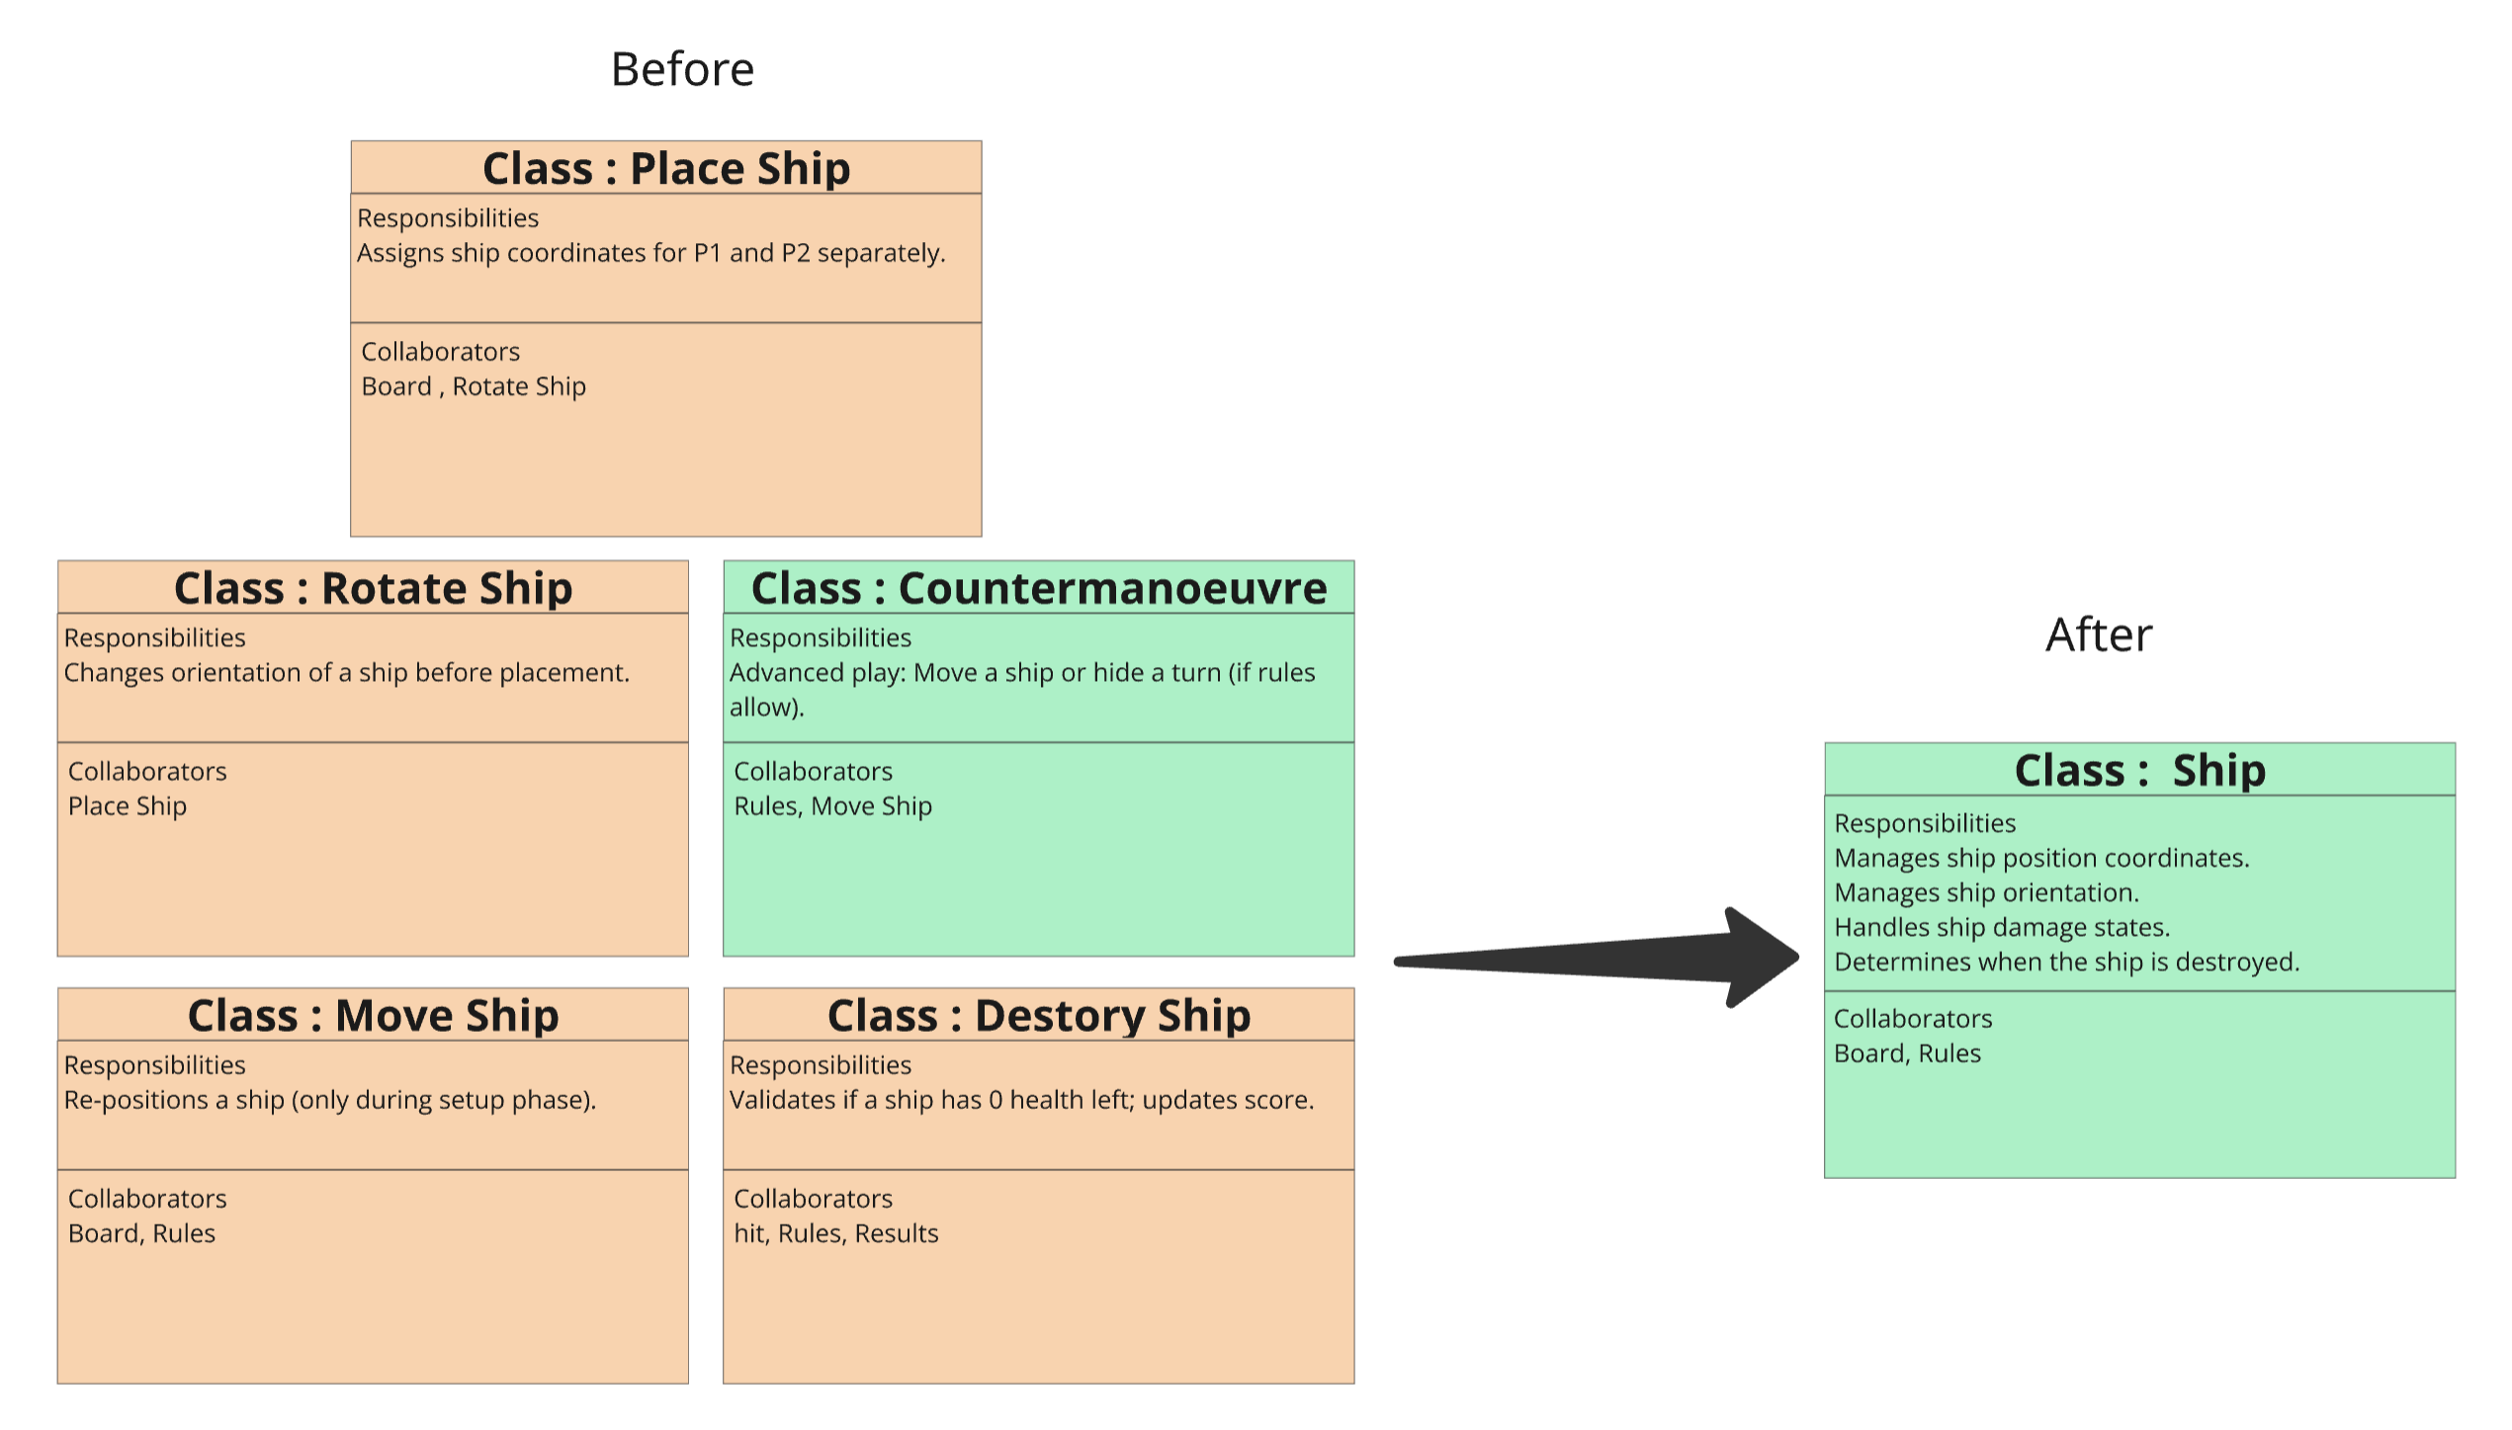
Figure 4 – Design Amendments (CRC Cards)
These changes were made with the aim to simplify the design and make it easier for the developers to understand when they start the programming for the application.

2.3 Weaknesses and Challenges Encountered
However, as mentioned previously the flexibility of the agile methodology sometimes caused confusion making it difficult to focus on one element of the design especially once documents are reviewed and the team are aware of improvements that can be made. Because of this, I found more time was spent on the user stories and user story mapping than aiming to divide our time evenly for each of the tasks. This also meant that some of the design decisions seem rushed compared to others due to the priorities changing.
Working towards the agile value of responding to changes highlighted a challenge which emphasized the importance of maintaining a balance of following a plan and prioritizing tasks especially when trying to respond to changes and encourage continuous improvements of our design.
Another challenge was the time constraints of the timeboxing sessions being limited to a few hours a week and not always having all members of the team available for collaboration which ultimately impacted the progress and quality of our deliverables. This also caused problems with maintaining consistency during design because the team were more focused on responding to changes rather than progressing onto other tasks meaning some elements were more complete than others such as the class diagrams and the sequence diagram.

2.4 Recommendations for Future Iterations
Allowing more time to review the design could uncover weaknesses and identify areas of improvements before the next sprint, ensuring that similar errors are avoided during future design iterations. Applying more agile principles will improve the overall productivity of the team allowing us to maintain a manageable yet consistent development speed to find a balance of simplicity and functionality in our final designs [2].
An example could be arranging stand up sessions once a week to ensure the team are aligned and focused on meeting the same deliverables for the current sprint, allowing us to reflect and improve the design for better end results [2]. Plus, this will also identify risks during the early stages of the sprint, allowing time for suitable measures to be taken to reduce the impacts on delivering our work [2].

3. User Stories and User Story Map
To describe the features and requirements of the Battleships Web Application, we created user stories as a team to understand the purpose of each story and the problems they would address. Preparing the user stories promotes understanding and alignment of project objectives which is crucial for collaborative working and ensuring the requirements can be met during each design iteration [3].
The team made the user stories by brainstorming ideas to capture the main features of the Battleships application, then reviewing the stories against the acceptance criteria and discussing the changes as a group. Figure 5 shows how our team discussed changes and design considerations for this user story to ensure the requirements could be met.
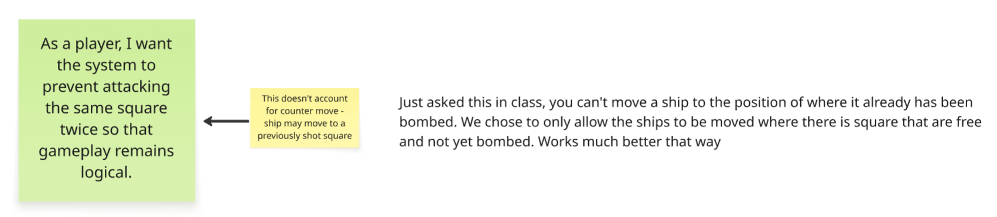
Figure 5 - User Story Feedback

3.1 User Stories Structure and Associated Benefits
Using brief descriptions to make sure the role, action and value of the user story were clear allowed us to consider ideas for solutions based on what the user wants the application to do and why [3]. The benefits of the user stories are identified based on why the user wants the application to have certain features and how the features can improve the overall user experience.
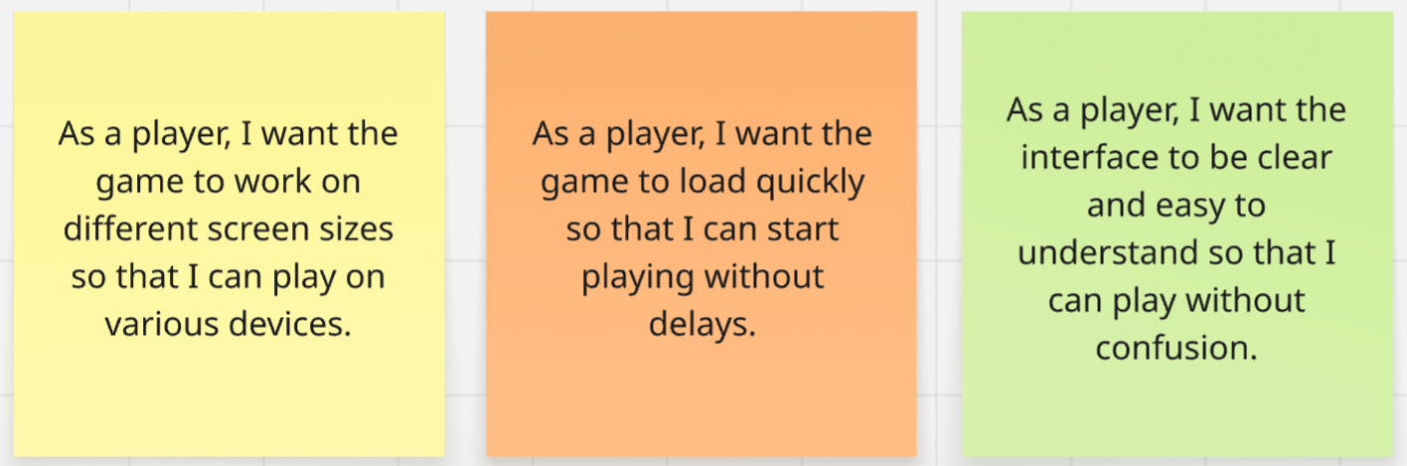
Figure 6 - User Stories
For example, as the product is a web application and users may want to access it on various devices, the application needs to be compatible for using different screen sizes. Therefore, the benefit of this user story is that the application can adapt, allowing the user to play on devices such as a pc, tablet and a phone as explained in the figure above.

3.2 Refining User Stories and Developing the User Story Map
To avoid using epic stories that contain too much detail, we separated them into individual stories to simplify the task and avoid complexity. This made the stories more manageable, making them easier to test and action during design stages [3,4]. This is demonstrated in the figure below as various cards were created for placing and moving the ships based on their benefit to the user.
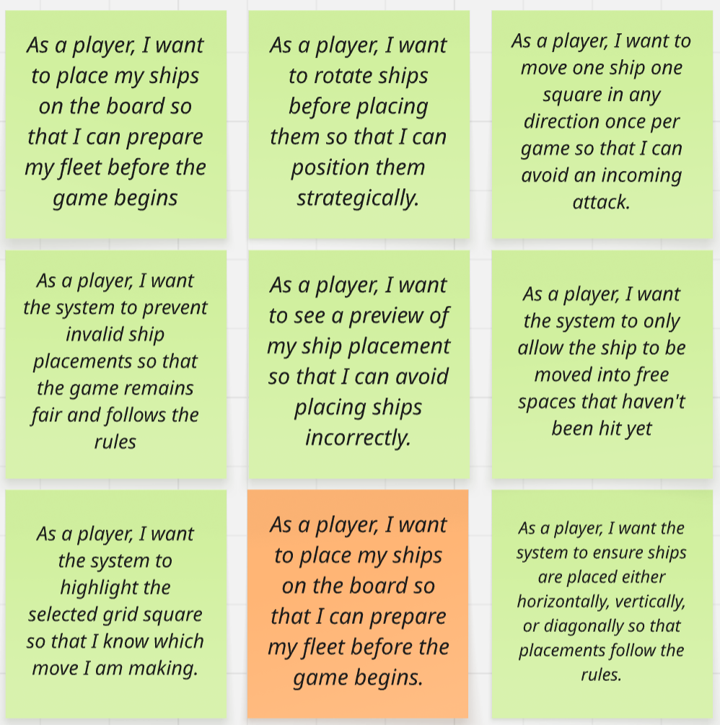
Figure 7 - User Stories
Another advantage of refining the user stories is that it allowed the team to prioritize the features that would benefit the user the most when using the Battleships application and focus on the functionality of the application first, before thinking about future improvements that will enhance the user experience and the performance of the application.
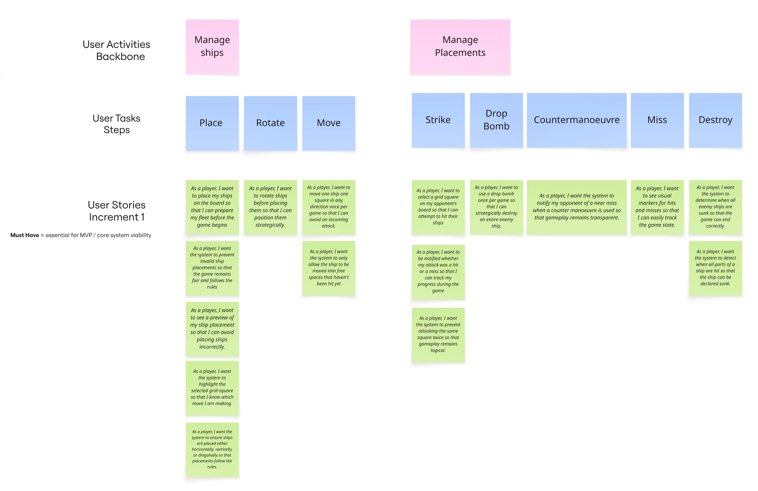
Figure 8 - User Story Mapping
To make this process easier, we created a user story map that explained which stories belonged to each design increment based on the features that were a “must have, should have and could have”, allowing us to prioritize the tasks for the core features that were essential for the MVP and aligning with the user requirements [3].

3.3 Estimating and Understanding Workflow
To determine the position of the user stories on the map and which would be placed in the first increment, we discussed each story amongst the team to decide which were optional and which were essential tasks [5]. Examples of the essential tasks for the application include placing the ships, switching turns between each player, updating the board, recording hits and misses, destroying ships, using counter manoeuvre, drop bomb and ending the game.
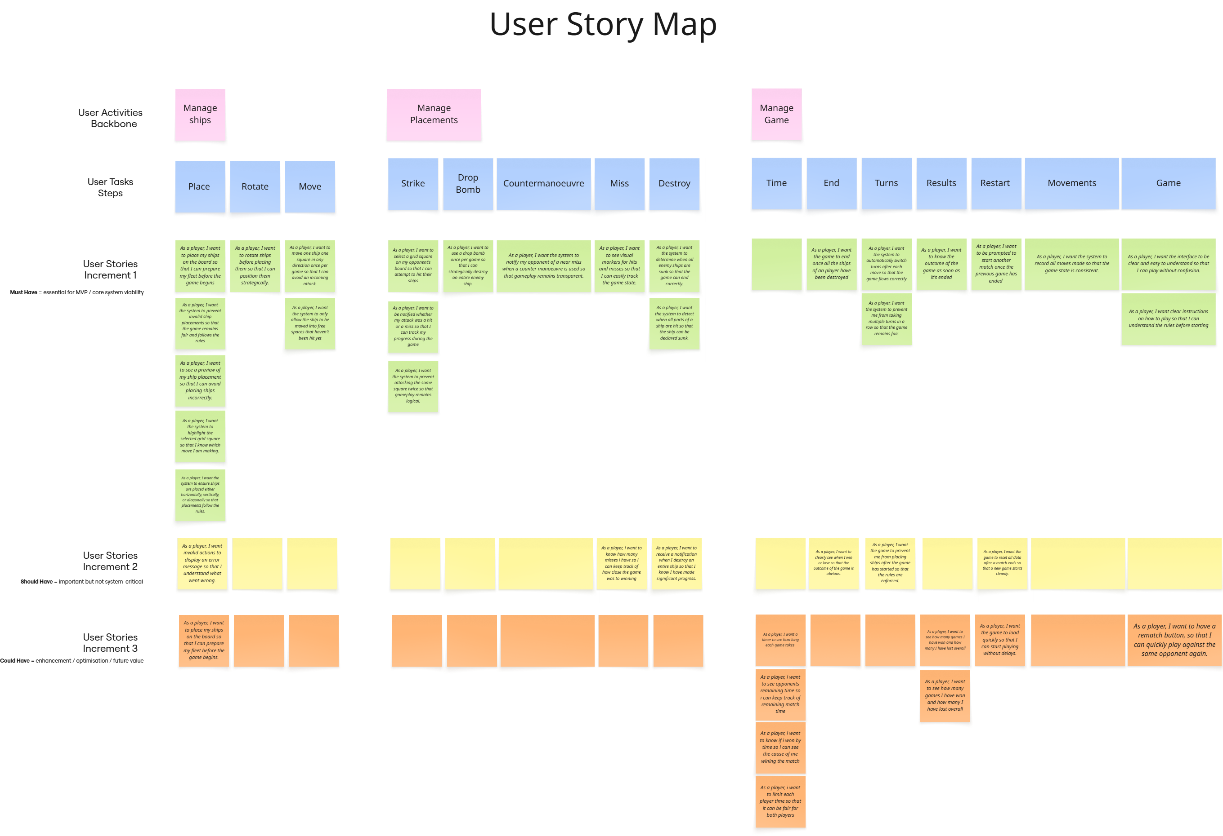
Figure 9 - User Story Mapping
Having a good first draft of the user story map supported the team in understanding the project workflow and providing estimates of how long each task could take. For example, if a story could be completed during a single design iteration or if more time would need to be allocated if the user requirements were more complex.
This also provided the team with a discussion point for future timeboxing sessions to improve the planning and delivery of our tasks and consider factors such the time, value and complexity of the user stories, encouraging us to measure progress throughout each iteration.

3.4 Further Improvements to User Stories
To further enhance the user stories, we could include expectations of the application during the next iteration to provide the team with more details that can be used by the developers when creating the code for the application and considering testing for the end results [5]. Plus, it creates a point of discussion during weekly stand-up meetings to ensure the finer details and depth of the user story remain clear, along with their benefits, requirements and acceptance criteria we are working towards.

4.CRC Cards

4.1 The Design Process for CRC Cards
Creating the CRC cards was an important part of the design process as it enabled us to identify the classes, responsibilities and collaborations of the application which will influence the overall quality of the design and programming [7]. Having a good first draft of the CRC cards ensures that the design can remain simple but effective, supporting better decision making amongst the project team, ultimately reducing any conflicts and their impact on the project [7].

4.2 Cohesion, Coupling and Testable Responsibilities
The aim is that each class should have clear, testable responsibilities that are easy to implement and reuse rather than having classes with too many responsibilities or collaborators which will need to be refactored [7]. Identifying these issues early in the design will reduce the impacts of low cohesion and high coupling where classes are tightly or loosely connected to one another or have multiple purposes. This can cause an imbalance within the design making it difficult for developers to test, change and maintain the application [8].

4.3 Alignment with User Stories and Acceptance Criteria
The acceptance criteria and the responsibilities identified in the CRC cards should align because the responsibilities represent the application behaviours that are required to satisfy the requirements of the user stories. Collaborators are equally as important to understand how different parts of the application will interact with one another and how they will impact the behaviours and methods of other classes within the application [7-8].

4.4 Defining Classes and Collaborators
This stage was effective in defining each of the classes for the Battleships application along with what the user expects each of them to do. Each card defines what the class does and it ‘s responsibilities along with how it interacts with other cards known as it’s collaborators, which provides enough detail to guide implementation.
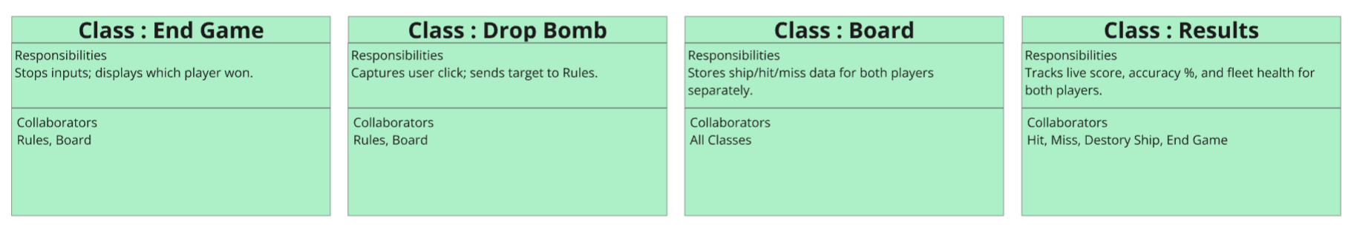
Figure 10 - CRC Card Classes
When designing the first iteration of the CRC cards, it was easy to mix up the responsibilities, functions, and methods of the classes and to understand how to split them appropriately. However, this process also improved my understanding of the application, particularly when considering how the classes collaborate with one another.
One main benefits of the CRC designs are that they helped maintain a logical separation of responsibilities across the classes and made the interaction between classes more visible. For example, understating how the place ship, rules and board classes interacted with each other during the player’s turn. Having this information available to visualize the design supports clear understanding of the workflow and how to develop other documentation to support the design of the application such as class and sequence diagrams.
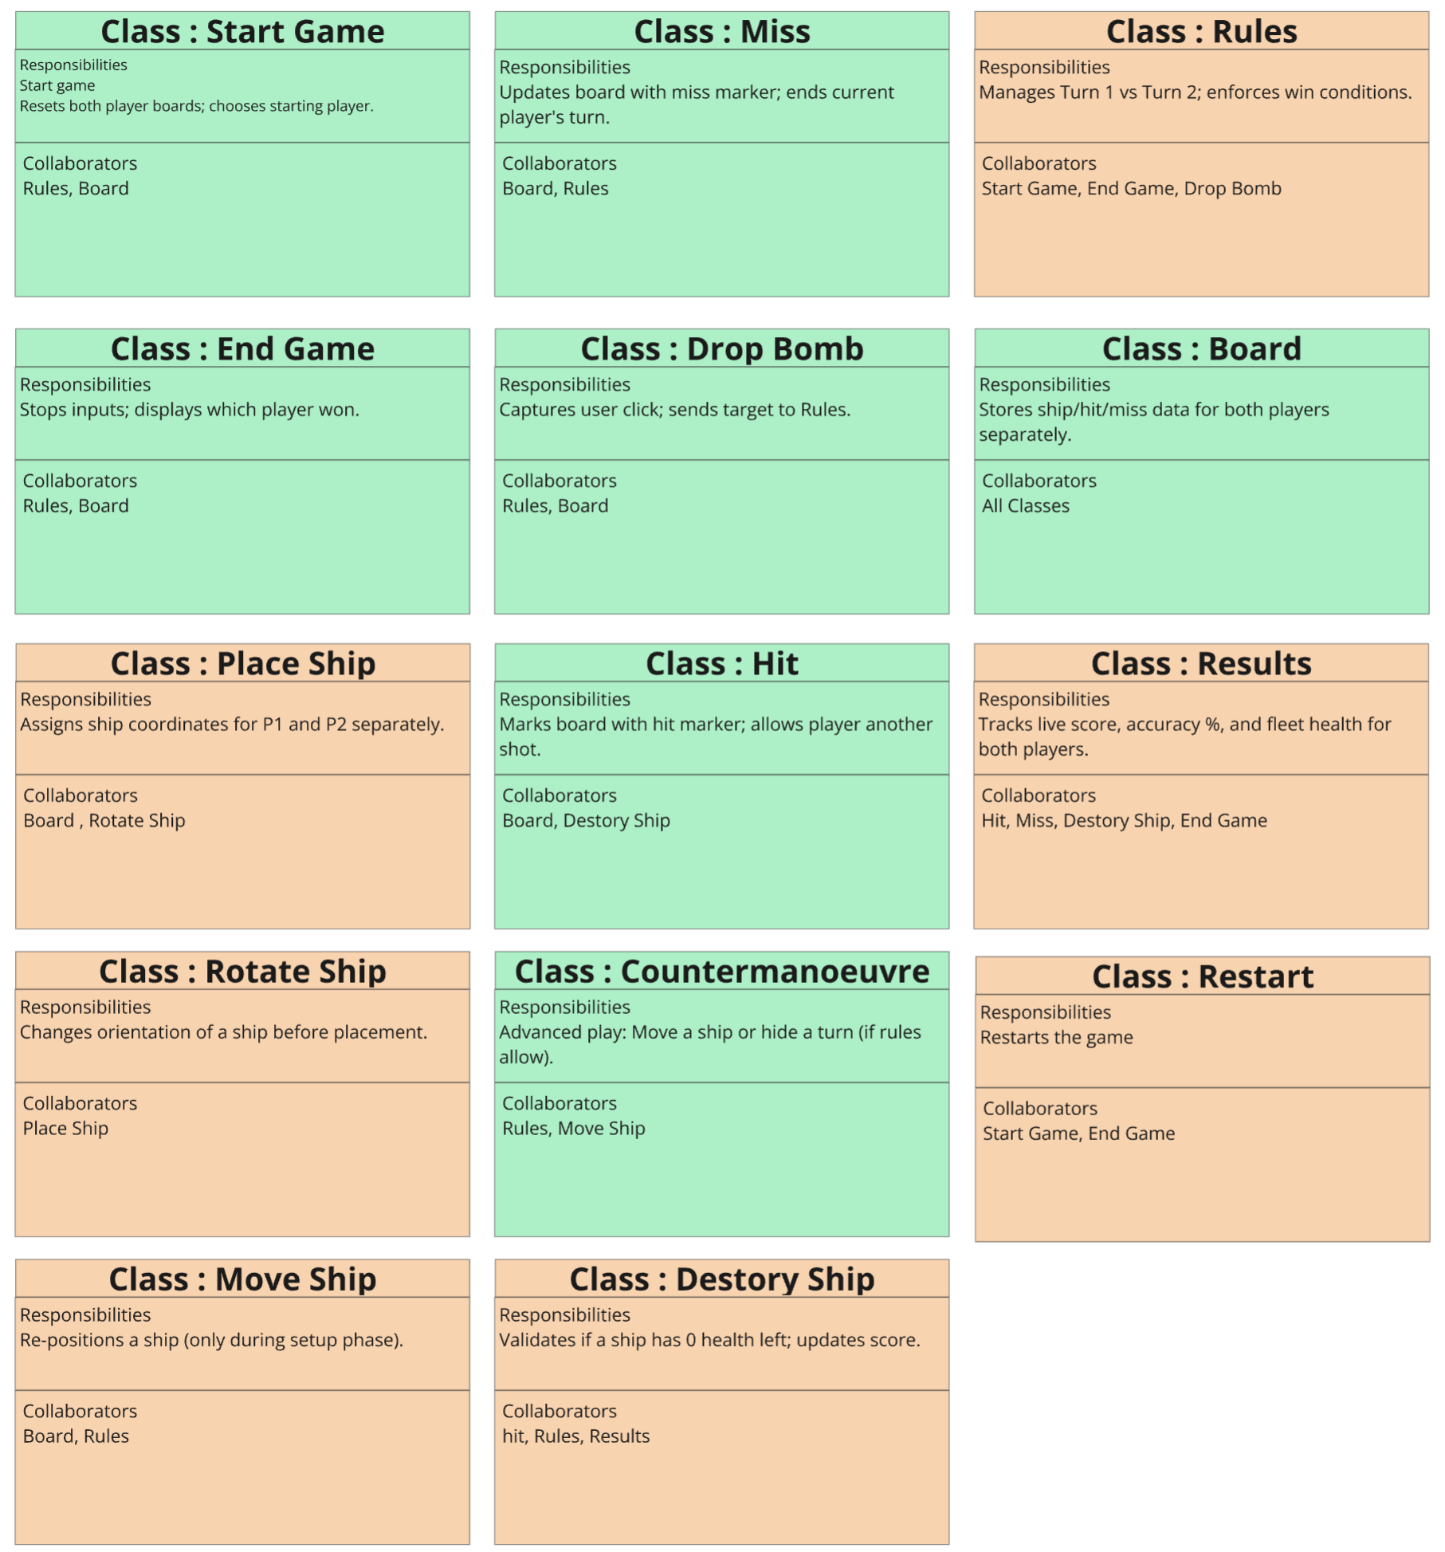
Figure 11 - CRC Cards

4.5 Refinement and Iterative Improvement of CRC Cards
The CRC cards encouraged discussion amongst the team to refine and simplify their design to group together some of the cards to avoid having duplicates or methods and attributes that belonged to another class. However, once the cards were amended based on the group feedback, it also revealed that some classes had too many responsibilities which demonstrated the need for them to be reconsidered in the next iteration. For example, the classes that contain numerous responsibilities such as the Game Class should be refined into smaller classes or use class inheritance. This will make it easier for developers to test the core behaviours and responsibilities of each class which ultimately avoids the risk of confusion as the details will be clearly defined compared to those in the previous iteration.
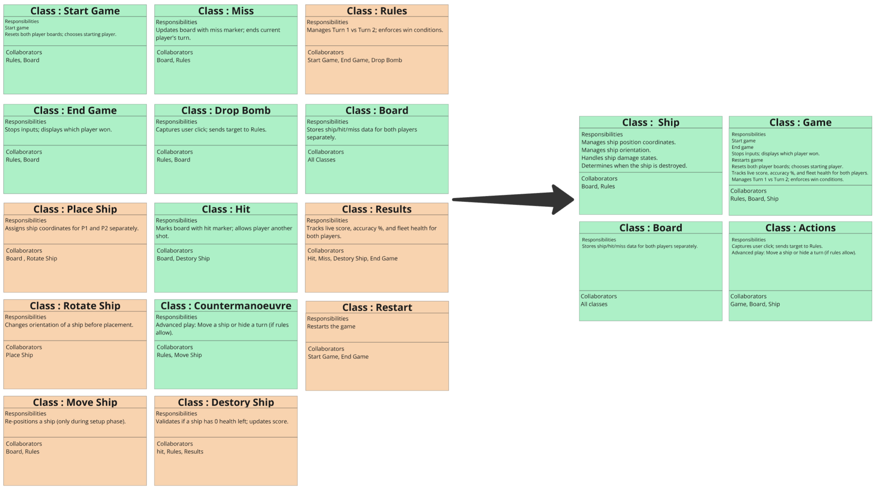
Figure 12 - CRC Cards

4.6 Evaluating CRC Cards and Next Steps
As mentioned above, we believe there is enough detail for a developer to begin implementing and testing the first iterations of the design, although additional refinement will be required for future development. Some of the CRC cards reflect the acceptance criteria identified in the user stories, as demonstrated in the figure above, showing a clear link between user requirements and class responsibilities.
The core functions of the application are explained within the cards, however, the finer details will need to be established during later stages of the design to clarify exactly what should be tested for each class. This will help ensure the code behaves as expected and will make it easier to identify which classes and responsibilities have the greatest impact on the application [7].
However, some user stories were not represented in the CRC cards and did not meet the acceptance criteria. As the acceptance criteria is used to validate that the goals and benefits of the user stories have been achieved, reviewing the acceptance criteria against the CRC cards would highlight if the requirements have been met or if adjustments are needed. For example, the user stories and user story map may need to be reviewed to make sure the design of the CRC cards will meet the objectives of the acceptance criteria [7].
Addressing gaps like this in the next design stage will help ensure that the final implementation fully aligns with user expectations and supports the developer with the testing for the application. Plus, it will support the team in adding more details to the class and sequence diagrams improving the clarity and overall quality of the design.

5.Software Testing Evaluation

5.1 Importance of Software Testing
Software testing is the process of identifying the differences between the expected and actual behaviour of an application based on the outcomes of the tests [8]. Any differences that are identified indicate failures caused by flaws in design that were never fully fixed during the first design iterations. This makes software testing critical because undetected defects can cause costly failures, reduce system reliability, and impact user experience.
Thoroughly testing software supports the validation and verification of a product to ensure it functions correctly and aligns with the objectives specified in the user requirements and acceptance criteria [8]. If the application fails the tests and does not meet the user requirements, further improvements can be made to resolve any bugs and enhance the overall performance for the user. Therefore, effective testing not only improves the quality of a design but also reduces long term maintenance costs by identifying potential issues early in the development stages allowing more time to be spent on further enhancing the performance of the system.
The documentation produced to support the development of the application can also be reviewed to highlight areas where some details are missing or require further refinement to achieve the goals set out in the acceptance criteria and the user stories.

5.2 White Box Testing
White box testing is used to examine the internal structure, code and the logic of a program by testing each of the independent execution paths while ensuing they are evaluated for true and false outcomes [8-9].
As the tests can access the internal structure of the application, they can be refined based on their requirements enhancing the precision of the results [9]. For example, applying tests that cover statements, branches and paths and review the boundaries, conditions and functions too.
For example, white box tests for the battleship’s application could verify the internal logic which checks the placement of the ships is valid and within the specified boundaries through testing the true and false branches of the function. This ensures that all the internal execution paths behave as expected and highlights any areas of the logic that may need to be updated.
The tests can also provide developers with a coverage report which explains how much of the code is never executed during the tests, highlighting areas where the code can be removed or the tests are insufficient and need further adjustments [9].

5.3 Black Box Testing
Black Box Testing evaluates the external behaviours and features of program based on the requirements outlined in the acceptance criteria and user stories to determine whether it does what the user intended it to do [8-9].
The tests focus more on the input and output behaviour of the application to check if the user requirements are met [8]. For example, if the application can start and end a game correctly and switch turns between players.
Another element of the black box tests includes the nonfunctional tests to understand how it would react to working under real conditions. For example, using repetition testing to review the performance of the program when the same operation has been selected repeatedly to understand how it will respond and if there are any bugs that need to be fixed [9].
Another example of a test could be selecting invalid coordinates during a game where a ship has already been placed or destroyed. This will confirm that the system correctly rejects the input and displays an appropriate error messages to the user as expected, without needing to inspect and adjust the internal code.

5.4 Comparison of Testing Methods
The benefit of using black box testing is that no programming knowledge is required, it’s effective for testing larger systems and the test cases can be created as soon as the design specifications are available meaning tests can start during the early stages of design iterations [10]. Yet, a disadvantage of using this method of testing is that it can be difficult to create suitable tests when the application requirements are unclear which can also result in redundant and overestimated test results [10].
The advantage of using White box testing is provides thorough testing techniques that focuses on greater code coverage than black box testing with the aim of optimising the code. Still, one of the problems of using white box testing is that frequent code changes can make test maintenance difficult for the developers since the testing can begin before the user interface exists for the application [10]. This means not all paths can be tested, especially in larger systems which may result in some design flaws being carried over into other iterations of the application.
Although white box and black testing methods have different areas of focus, both methods are essential for enhancing the quality of any application design. When both methods are used together, they reduce the risk of defects by ensuring that external behaviours meet user expectations while internal logic remains robust, efficient, and free from hidden issues, resulting in higher quality and more reliable software design.

5.5 Understanding Testable Code
Testable code can be explained as software that can easily be verified, isolated and observed during manual or automated tests that provides clear behaviours, low coupled components, predictable execution and repeatable automated testing [10]. Testability is essential for creating strong, adaptable applications as it improves defect detection and supports continuous integration and regression testing [10]. It can be influenced by factors such as the code structure including high cohesion, low coupling and single responsibility classes as well as how dependencies are managed, ensuring components can be isolated and tested.
Testable code also supports both black box and white box testing methods by making behaviours predictable and components easier to isolate. This improves test result accuracy and reduces the effort required to maintain and implement appropriate tests as the software evolves.

6.Application Testing
The two tests I would perform to check using black- and white-box testing techniques to ensure the application is working correctly include switching turns between players and reviewing coordinate input, as these are important game functions that would impact the user experience when not behaving as expected.

6.1 Black Box Tests for Battleship Application

6.1.1 Switching Turns Between Players

6.1.1.1 Pre Conditions
- The Battleship application is running
- A new game has started
- Both players have placed their ships, and the board/game has updated
- Player 1 has guessed where a ship is and entered the coordinates to get a hit or miss result
- The game screen should change to Player 2 so they can take their turn
- No internal code or logic is inspected during the test

6.1.1.2 Inputs
- Player 1 tries to take another turn right away by entering new coordinates
- Player 2 enters valid coordinates to begin their turn

6.1.1.3 Expected Outcomes
- If Player 1 tries to take another turn, the system will stop it and show a message saying it is Player 2’s turn
- If Player 2 enters the coordinates, the system accepts them and processes their guess
- The game screen clearly shows whose turn it is using prompts and messages
- The game only moves forward after a player has taken their turn

6.1.1.4 Purpose of the Test and Testing Method
Conducting this black-box test will confirm whether the application correctly enforces the game rules identified in the user stories to prevent players from taking more than one consecutive turn, ensuring that control passes to the correct player after each move is finalised. This is essential for maintaining fairness and consistency throughout the game, ensuring compliance with user requirements and acceptance criteria.
The tests will use the user interface to try actions for both players and check if the system accepts or rejects the input as expected. The application only passes the tests if it always blocks invalid actions from the wrong player and allows valid actions from the correct player during their turn.

6.2 White Box Tests for Battleship Application

6.2.1 Coordinate Validation

6.2.1.1 Pre Conditions
- Access to the internal coordinate validation function
- Set up a unit testing framework.
- The board size and valid coordinate ranges for the 10x10 grid are known.
- Internal variables and return values can be inspected.

6.2.1.2 Inputs
- Valid coordinate
- Input valid coordinate such as “C7”
- All validation checks will pass as expected

- Out of range letter
- Input invalid coordinate such as “Z3”
- Validation checks will fail due to letter range check

- Out of range number
- Input invalid number “A12”
- Validation checks will fail due to number range checks

- Incorrect format
- Input an incorrect coordinate such as “7C”, or leave it blank
- Validation fails due to incorrect formatting

- Previously used coordinate
- Input a coordinate that has been marked as hit or miss on the board
- Validation will fail due to availability check

6.2.1.3 Expected Outcomes
- Valid coordinate
- Function will return as true
- No error messages will appear

- Invalid coordinate:
- Function will return as false
- The specific validation branch for format, range, or availability is triggered
- No changes are made to the board

- Coverage expectations:
- All conditional branches for both true and false are executed.
- All validation paths for format, range, availability are covered.

6.2.1.4 Purpose of the Test and Testing Method
This white box test will check if the validate coordinate function looks at the input format, the letter and number ranges, and whether the coordinates were used in the player's last turn. By reviewing the internal variables and testing different logic paths, we can make sure the function works in all situations or see if it needs any changes to perform better. The test uses controlled inputs to evaluate the function's return values, ensuring that the application behaves correctly under all expected conditions and makes the correct decisions based on the design criteria.

7.Unit Testing Investigation

7.1 Principles of Unit Testing
Unit testing can be explained as execution-based tests where smaller parts of an application such as its methods and classes are tested to verify that each section of the code does what it was designed to do while uncovering as many faults as possible [11-12].
The tests are not limited to final validation checks, because they also include checking that each phase was designed correctly and that the final application will meet the user requirements as expected [12]. Unit testing uses white box techniques because the tester has access to the full structure of the code [12].

Applying Unit Testing to Battleship Application
Applying unit testing methods to the Battleships application will test smaller isolated units of the code, focusing on a single function or method rather than the entire application. This testing approach is well suited for testing functions such as the coordinate validation because various key testing principles can be applied improving the effectiveness of the results. These principles include:
- Testing the validate coordinate function only to ensure the test focus on one isolated unit of logic without interference from other components.
- Avoiding using any user interface elements such as the game flow or board update processes so the test remains independent, focusing on the behaviour of the validate coordinate function.
- Using controlled inputs which have clear expectations for the outcomes of the test. For example, returning true for valid coordinates or displaying error messages for invalid movements.
- Reviewing all branches and decision paths, including as valid coordinate, incorrect formats, out of range values or previously used tiles that have already been marked with hit of miss.
- Testing the boundary conditions for the edges of the grid and the coordinates that are outside specified boundaries to ensure the boundary conditions work as expected.
Using these principles during testing ensures that the validation logic is thoroughly tested, considering each unit of the function, encouraging the development of a reliable and predictable application that meets user requirements.

8.Conclusion
The design and evaluation processes highlighted the importance of teamwork and communication when creating clear user stories and class responsibilities to develop a software application. Having the first iteration of the CRC cards provided a useful starting point for developing the web application along with some of its features and behaviours, but some cards still required further refinement to fully reflect our acceptance criteria and support effective testing to help us achieve technical excellence.
Evaluating black box and white box testing methods demonstrated how different tests can reveal different types of issues, emphasizing the value of creating testable code that is predictable and easy to verify.
By using unit testing principles and white box tests for the Battleships application, we learned how important it is to keep our design and implementation clear. These steps helped the team understand how design, testing, and making changes all work together to build a reliable application that meets what users need.

9. References
[1] A. Srivastava, S. Bhardwaj, and S. Saraswat, “SCRUM model for agile methodology,” in 2017 International Conference on Computing, Communication and Automation (ICCCA), IEEE, 2017, pp. 8–869. doi: 10.1109/CCAA.2017.8229928.
[2] GeeksforGeeks, “What is Agile Methodology?,” GeeksforGeeks, Dec. 13, 2023. https://www.geeksforgeeks.org/software-testing/what-is-agile-methodology/ (accessed May 02, 2026).
[3] University of Wales Trinity Saint David, “Requirement Analysis Part 1 - User Stories.” https://moodle.uwtsd.ac.uk/course/view.php?id=8700 (accessed May 03, 2026).
[4] The Agile Shop, “How to write good User Stories in Agile,” YouTube, Jan. 17, 2022. https://www.youtube.com/watch?v=7hoGqhb6qAs (accessed May 03, 2026).
[5] D. Gruen, T. Rauch, S. Redpath, and S. Ruettinger, “The Use of Stories in User Experience Design,” International Journal of Human-Computer Interaction, vol. 14, no. 3–4, pp. 503–534, Sep. 2002, doi: https://doi.org/10.1080/10447318.2002.9669132.
[6] J. Patton and Economy, P, “Building Better Products Using User Story Mapping,” 2014.
[7] IEEE Staff Corporate Author, “Prioritizing CRC cards as a simple design tool in extreme programming,” in 2013 26th IEEE Canadian Conference on Electrical and Computer Engineering (CCECE), [Place of publication not identified]: IEEE, May 2013, pp. 1–4. doi: 10.1109/CCECE.2013.6567820.
[8] D. Goodwin and University of Bedfordshire, “Patterns and Testing Modelling and Simulation, 2012,” 2012. Accessed: May 04, 2026. [Online]. Available: https://warwick.ac.uk/fac/sci/physics/research/condensedmatt/imr_cdt/students/david_goodwin/teaching/modelling/l7_patterntest.pdf
[9] University of Wales Trinity Saint David, “Software Testing “ https://moodle.uwtsd.ac.uk/course/view.php?id=8700 (accessed May 04, 2026).
[10] A. Verma, A. Khatana, and S. Chaudhary, “A Comparative Study of Black Box Testing and White Box Testing,” International Journal of Computer Sciences and Engineering Open Access Review Paper, vol. 5, no. 5, p. 12, Dec. 2017.
[11] E. Daka and G. Fraser, “A Survey on Unit Testing Practices and Problems,” 2014 IEEE 25th International Symposium on Software Reliability Engineering, pp. 201–211, Nov. 2014, doi: https://doi.org/10.1109/issre.2014.11.

10. Appendices

Appendix A: User Stories
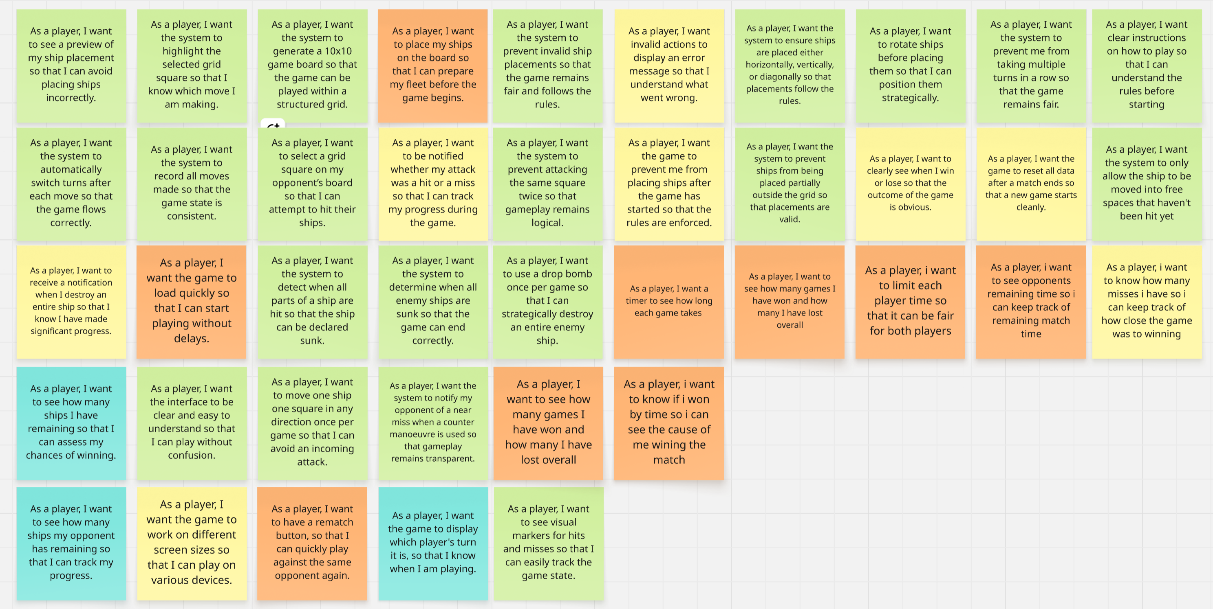

Appendix B: User Story Map
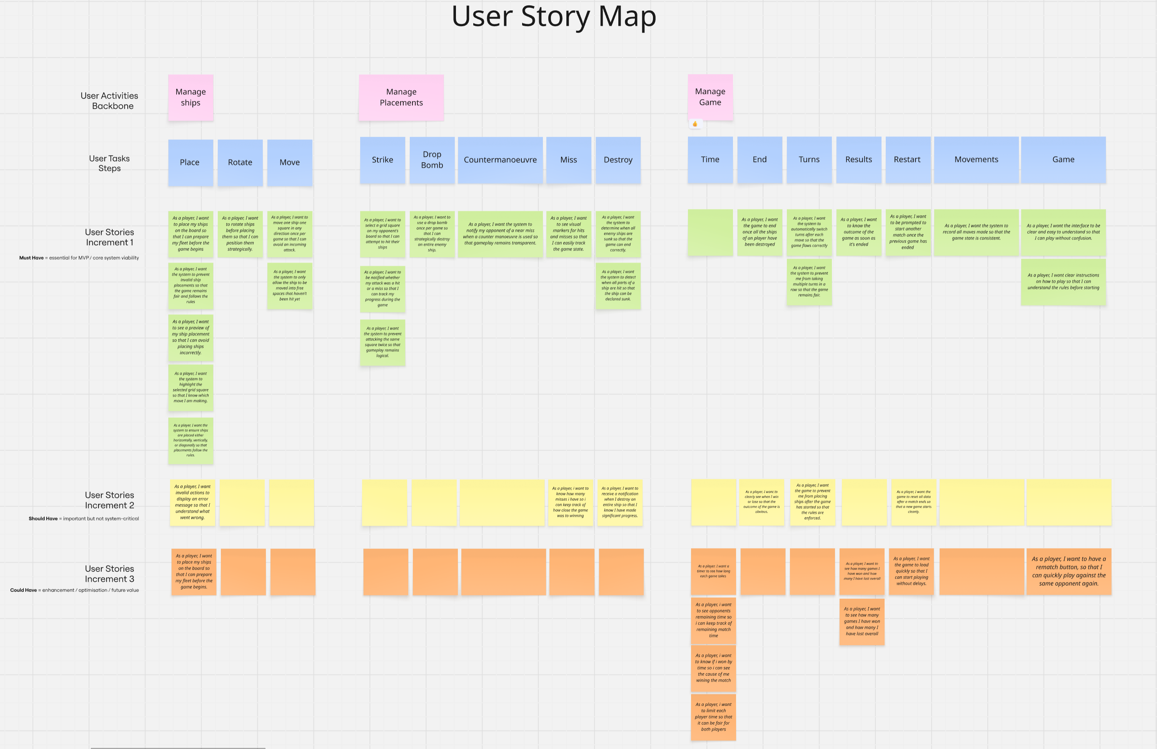

Appendix C: CRC Cards Design Iteration 1

Appendix D: CRC Cards Design Iteration 2
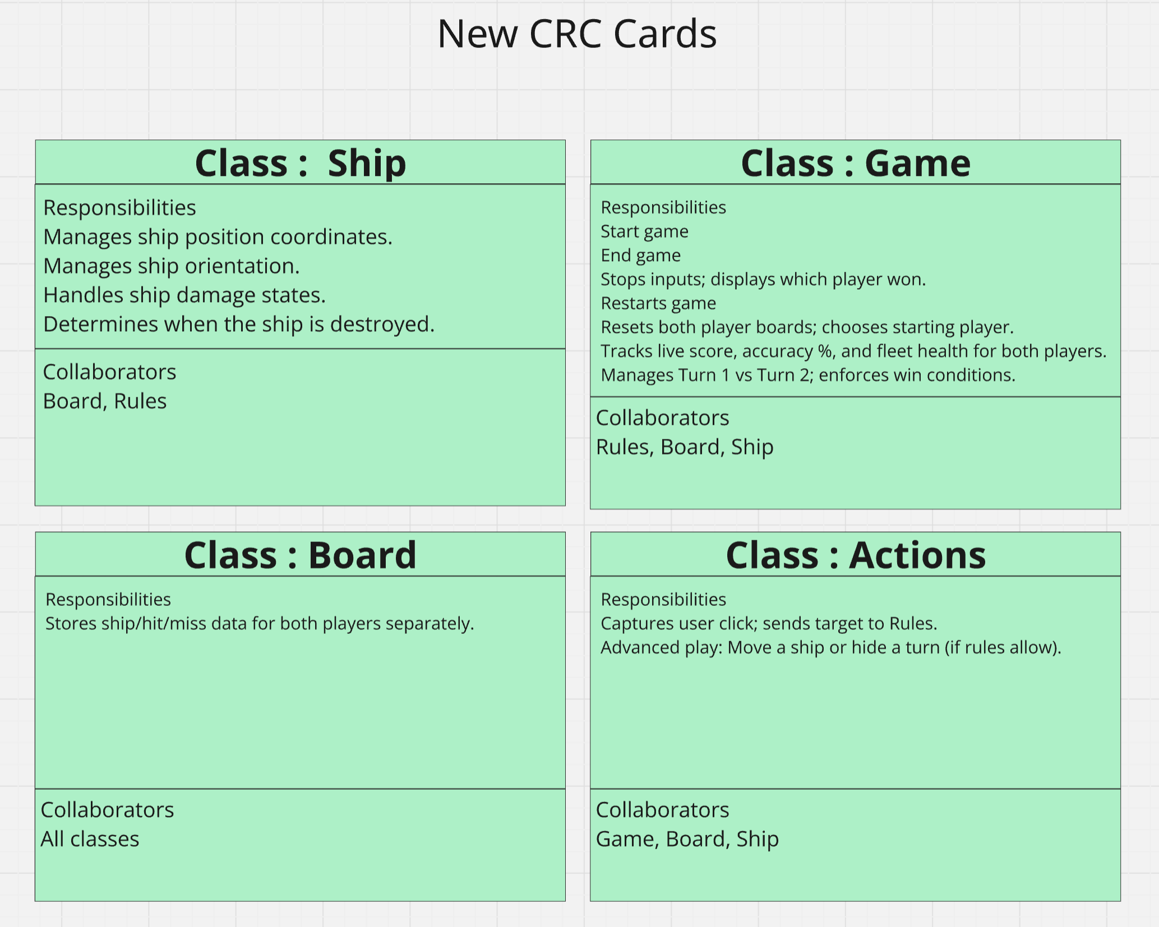

Appendix E: Class Diagrams Design Iteration 1
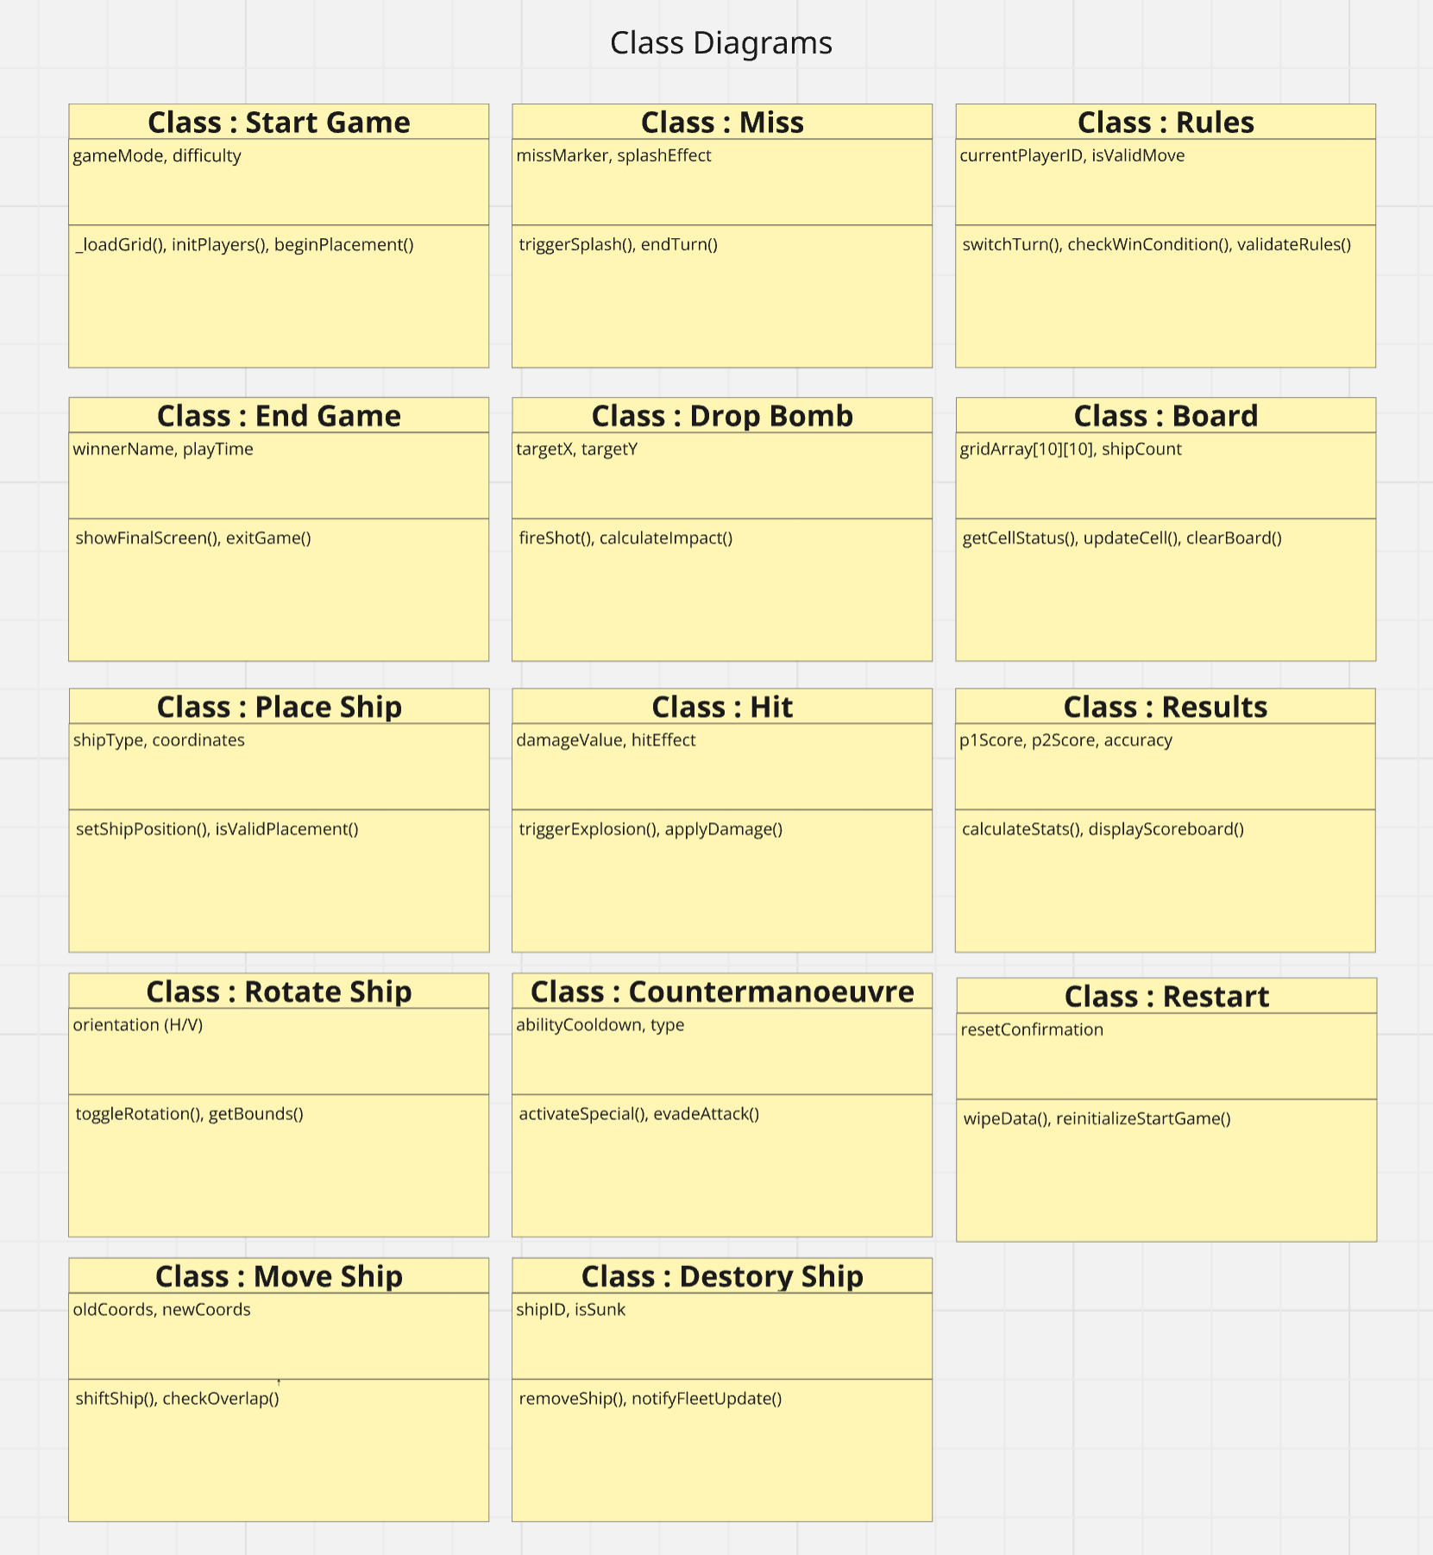

Appendix F: Class Diagrams Design Iteration 2
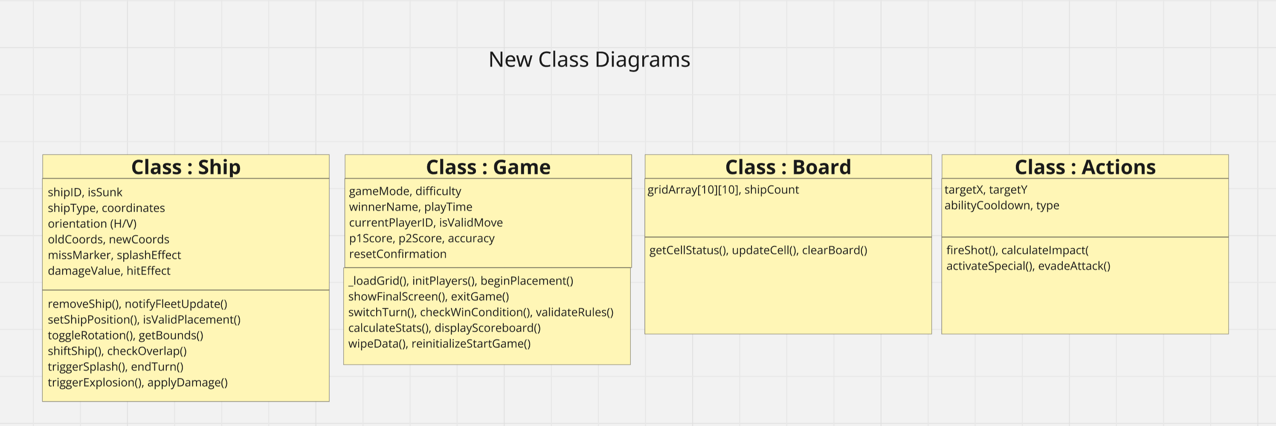

Appendix G: Sequence Diagram
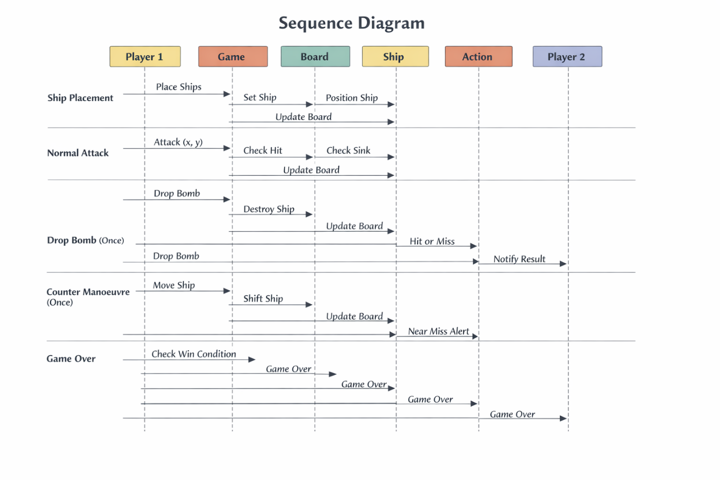

Appendix H: Acceptance Criteria
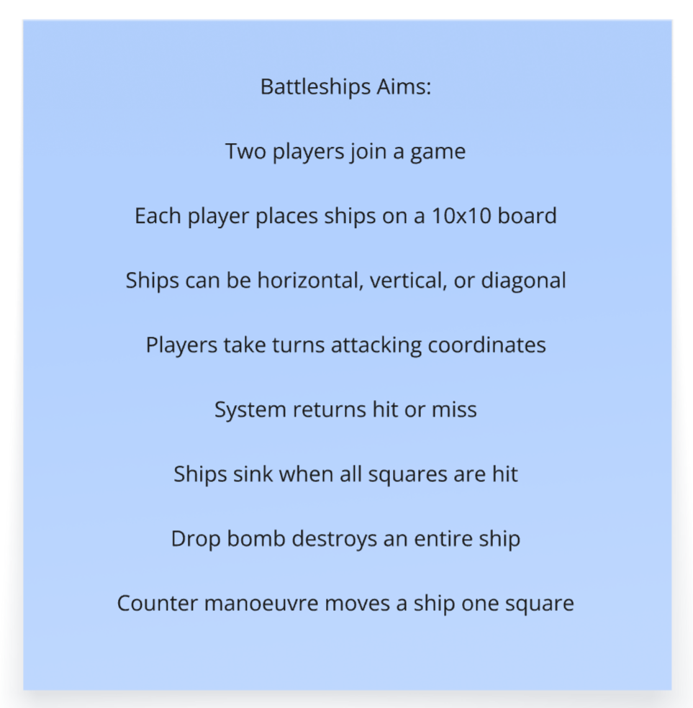

Appendix I: Wireframe Diagram
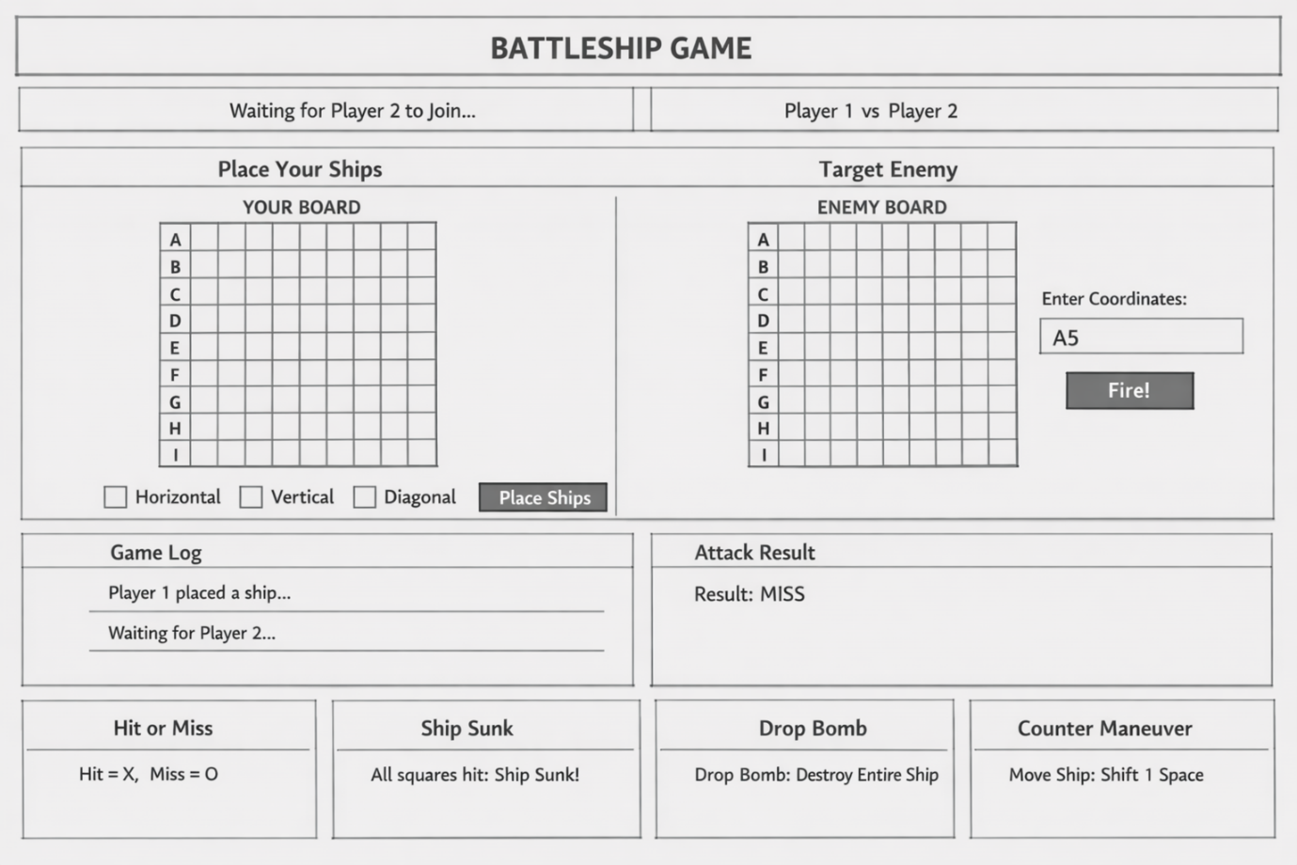

Appendix I: Wireframe Diagram - Multiple Layouts
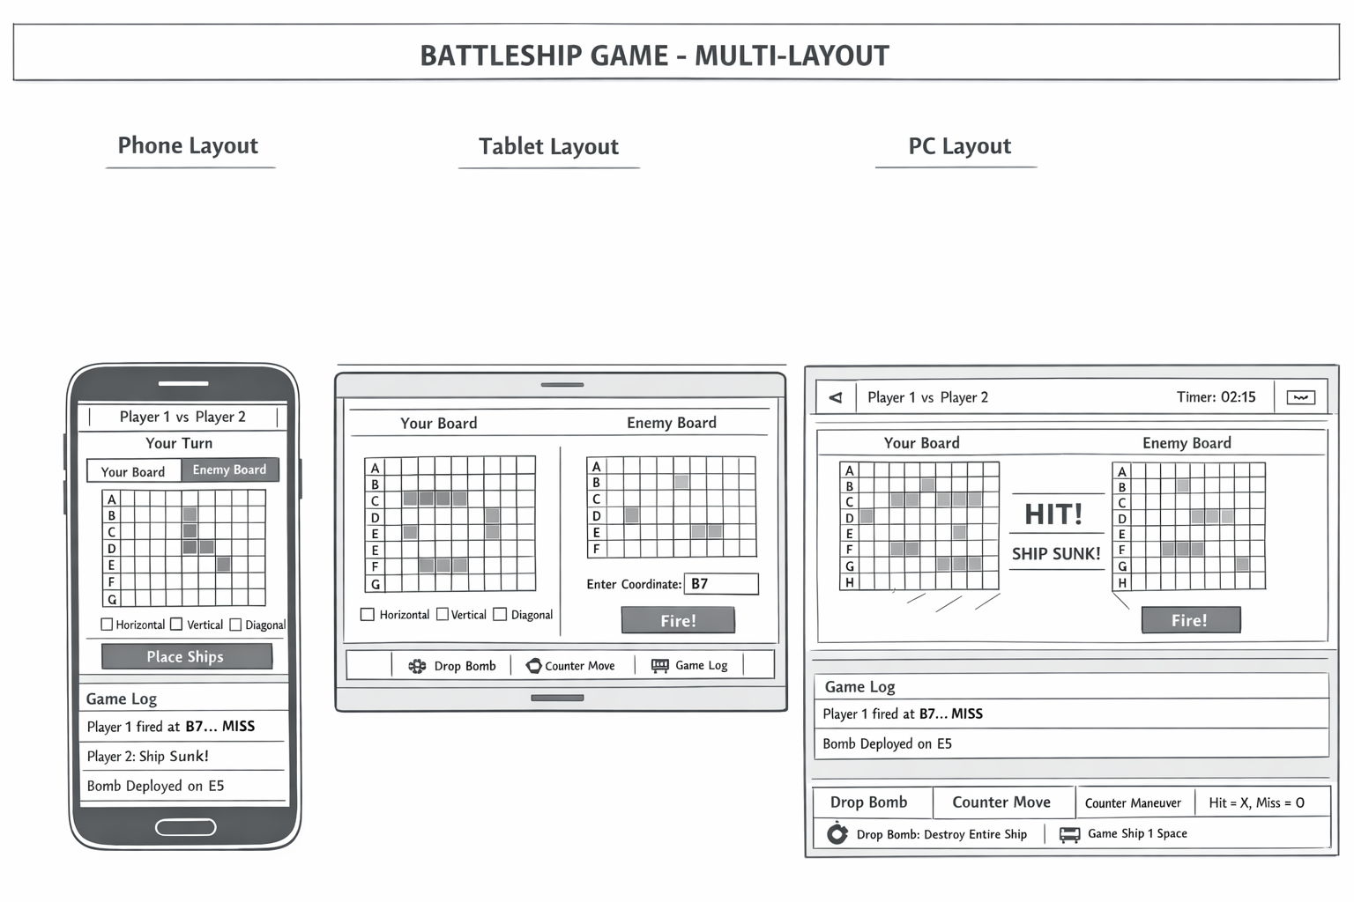

Appendix J: Team Collaboration


