

The Impact of Virtual Learning Environment on Student Learning Experience

Name: Marius Scorcea
Student ID: 1921886

Lecturer: Olusoyi Ashaye

Contents
Introduction 2
Background 3
Aims and Objectives 6
Method 6
Results 7
Discussion 18
Conclusion 19
Appendix 20
References 24

Introduction

The world is evolving, people struggle to find better and easier ways to improve their life. Our life is a sum of numerous domains of activity and we have to admit that technology is the one that registered the most notable process over the years. Everything Is smart, starting with machines and ending up with TV’s, the computers, the phones. So online learning it is a natural step.
According to Malcom Tatum (2020) Virtual Learning Environment is acquiring knowledge, getting information through by the help of an online platform that works based on a specific software. It is designed so that simplifies the process of learning and the one of teaching for both, student and professor. Also is meant to create a powerful experience that replace the presence, the interaction of people in a physical class.
This VLE is beneficial from many points of view, the most important would be a better economisation of time, and also as a chance to complete the studies for many of us.
Not to say that with this pandemic situation, was indeed a way to keep the people safe.
In order to see the impact that VLE has over the student I conducted a research based on data collection, a secondary and a primary research. And I will present the results of these research in the following paragraphs.

Background

QuestionPro defines secondary research as a second-hand information that is obtain from primary data analysis. A secondary research can take the form of a journal article, essay, descriptions, encyclopaedias and compare to primary research has its advantages and disadvantages. The biggest advantage is the fact that you save lot of time and many when the information is at hand and a real disadvantage is that the data might be out of time, and not following your quality standards.
So, as is mentioned above, a secondary research is conducted using primary data researches on the topic that makes our interest. I had to look for the articles, reports that covered the VLE subject and I have to say the interest for this method of study is dated since early 2000.
If we report to the present, where Covid-19 unfortunately came with new rules and regulations that we have to follow, the learning environment suffered big changes, starting with primary schools and ending up with universities.
For my research I used a survey from Jisc that was initiated in 2018 regarding the Virtual Learning environment.
Who is Jisc?
Jisc is a not-for-profit organisation that offers services and solutions for digital infrastructure. They are IT advisors for universities, colleges and other institutions. (Jisc, website).
They analysed the VLE sector getting the point of view of 29531 students that were enrolled on different form of higher education.
From respondents 48,1% were Male, 50,6% Female and 1,3% Other.
The results of the survey showed that:
- Higher Education students were using more than other students the electronic and digital devices that are meant to support their studies (over 90%).
- Over 70% of Higher Education students are accessing computers, laptops or tablets once a week in order to improve their learning performance
- Only 10% of students answered that online technology is more than important for their learning.
- 9% consider the online learning environment useful for their studies.
- More than 80% students were accessing their learning resources through the online platform.
- Regarding the access to the digital provision more than 85% of the students considered that their organisation is above average.
- Concerning the access of a good WIFI network, 85% were satisfied.
- There were 37% students that required the assistance of a teacher in using the VLE
- 26% of students were more interested in receiving help from their colleagues
- On the question regarding their data privacy 54% of the students believed that their data are protected.
- Over 70% students consider their online learning resources above average (from ,,good’, ,,excellent’’ and ,,best imaginable’’).
- Almost 25% from the higher education students never experienced VLE.
- A total of 57% declared that VLE is not complicated to access.
- 40% percent of the student would like their tutors to be more active on VLE
- Regarding their digital skills, only 70% of learners considered them important for their future profession, 19% of them disagreed
- Only 37% of students had the chance to improve their digital skills
- Also, when they were asked if the VLE had a positive impact on their time management, 76% of students agreed.
The conclusions of this study from Jisc point of view are:
- Institutions should Improve the access to the VLE (learning resources, timetables, libraries)
- Universities needs to make sure that the students have the digital skills that VLE requires and if they don’t have, to make sure they facilitate programs that will help the student to develop these skills.
- Made the VLE platform an interactive one, with activities that are challenging for the students.
- Create programs on VLE that will help the student improve not only their digital skills but their team management, team working and other soft skills, things that are mandatory and an important asset for any hiring company.

Aims and Objectives

The Impact of Virtual Learning Environment on Student Learning is a topic more actual than never. Most of the schools implemented this process and analysing the social events that we are living; they will need to develop this online environment in order to enhance the students learning experience. The aim of my primary research is to create a questionnaire that will answer and offer some solution regarding online study. Through analysing the respondents answers I intend to identify which are the student’s frustration and come with solutions in order to eliminate them.

Method
A primary research is a primary data collection conducted by the researcher and is take the form of a questionnaire, survey, interview or observations. Unlike the secondary data collection, with the primary research the information that are collected are accurate and specific. Also, is satisfying the researcher specific needs because the questions are creating exactly with this purpose.
The method that I have used in order to conduct this primary research is by the help of a questionnaire. It is a quantitative research, strictly confidential and according to the data protection act.
A good questionnaire is a combination of close-ended an open-ended short question. If the researcher is interested on their respondent feeling, experiences they can use long-form questions. (Amaresan, n.d.)
Regarding my questionnaire I tried to use short questions, I used a simple design so that my subjects will focus on answering the questions. I used a sample of 40 people and a set of just 15 questions to make sure that they will have time to answer on my questions.
The questions I used were:
- close-ended, with simple answers, yes/ no, male/female, single/married, known as dichotomous questions.
- close-ended with multiple choices answers like: agree/ strongly agree/ strongly disagree or very favourable, favourable, unsure, unfavourable, very unfavourable.
In order to analyse the data that I collected by the help of the questionnaire I created charts. I used pie charts and bar charts models. In order to analyse the question with multiple choice of answers I used the Likert scale.

Results
Analysing the below chart, the participants aged between 21-30 answered in proportion of 16,40%.
Table1
Age of respondents:
18-21 | 15
21-30 | 16
30-40 | 8
>40 | 1
Total | 40

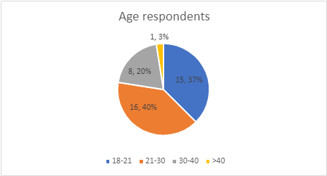

From the total number of participants 63% were women.
Table 2
Sex of respondents
Male | 15
Female | 25
Total | 40

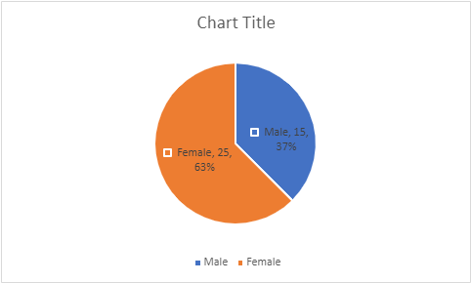

75% of the student first language is not English.

Table 3
English, first language
YES |  | 10
NO |  | 30
Total |  | 40

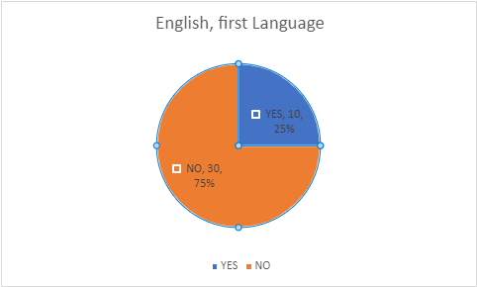

18 people of 40 are fairly confident in the use of VLE, only 5 of them are not very confident.

Table 4
How confident are you in using the VLE?
Not at all confident | 5
Fairly confident | 18
Very Confident | 17
Total | 40

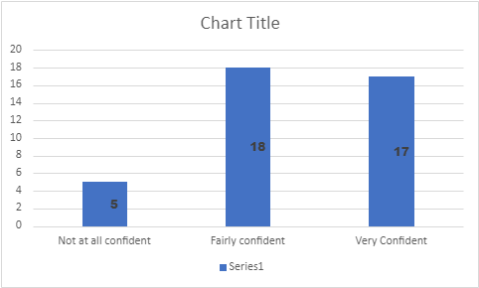

95% of the learners have access to a computer at home.
Table 5
Do you have access to a computer at home?
Yes | 38
No | 2
Total | 40
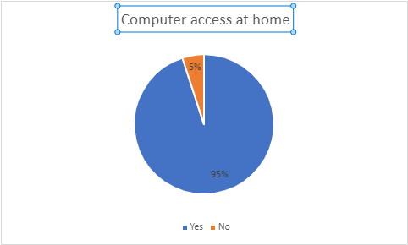

Most of the students are using broadband to access their online platform. Please see below:

Table 6
internet connection you use in order to access the VLE?

WIFI | 10
Broadband | 22
Mobile connection | 8
Total: 40

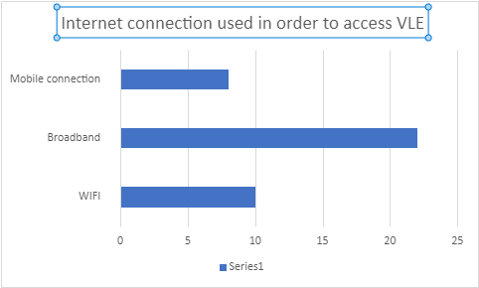

The majority of the students are using a computer in order to access the VLE

Table 7
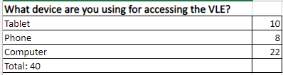

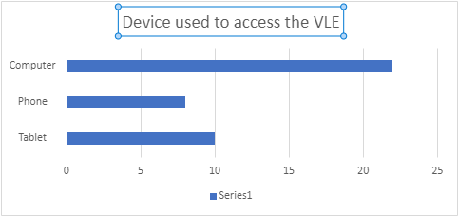

62% of students access their VLE from home.
Table 8
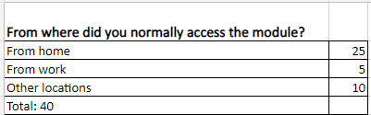

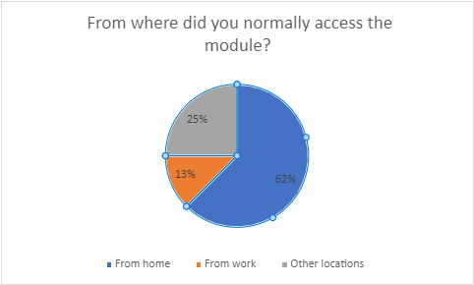

Only 57% of students don’t have issues accesing the VLE.
Table 9

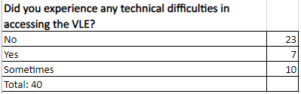

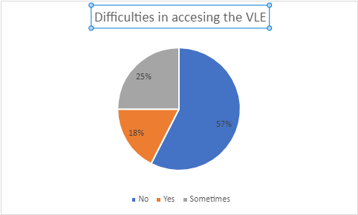

Most of the students are accessing the VLE every other day.

Table 10
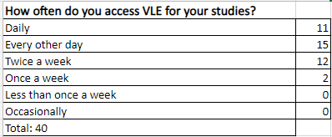

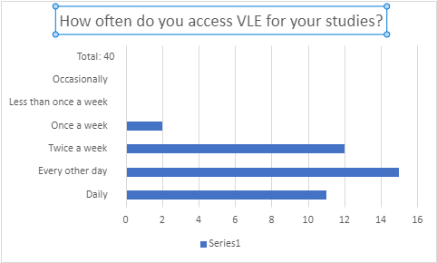

70% of students find VLE very helpful.
Table 11
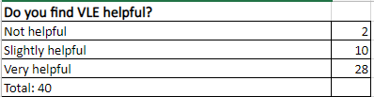

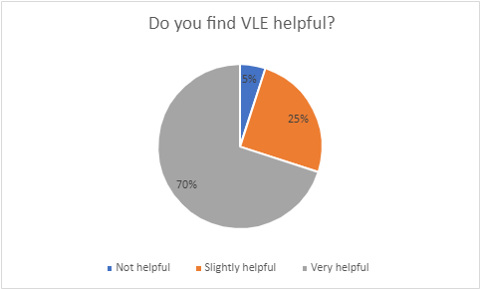

58% of learners considers that face-to-face study is not very important.
Table 12
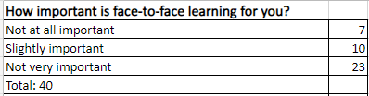

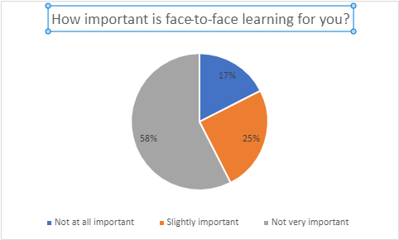

Majority of the student get in touch with their colleagues once a week.
Table 13
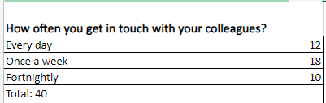

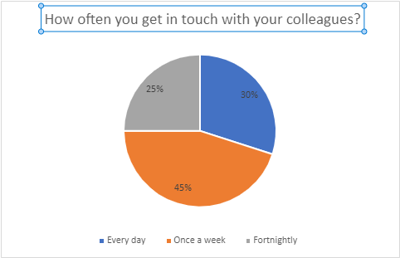

The most important positive feature of VLE is that saves time.
Table 14
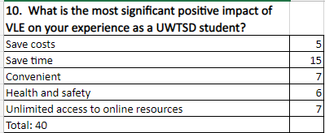

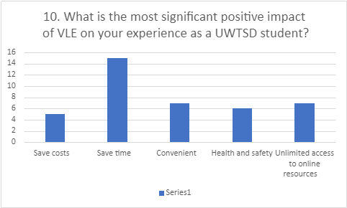

The majority of the students are most affected by the poor social interaction.

Table 15
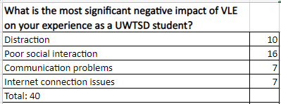

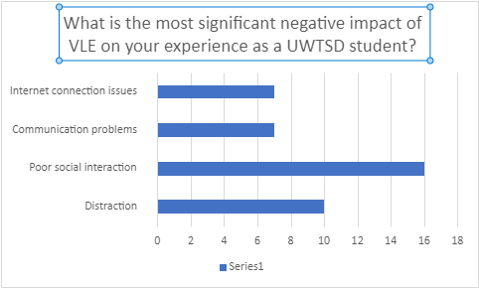

In the below table we have analysed the experience of the students using the VLE resources.

Question | Total | Strongly disagree | Disagree | Neutral | Agree | Strongly Agree | Total
Q1. The information I received regarding the use of VLE was easy to follow. | 40 | 25.00% | 0.00% | 0.00% | 75.00% | 0.00% | 100.00%
Q2. I quickly understood how to find my way around the resource. | 40 | 0.00% | 25.00% | 0.00% | 37.50% | 37.50% | 100.00%
Q3. I think the are presented in an interesting manner | 40 | 0.00% | 0.00% | 62.50% | 37.50% | 0.00% | 100.00%
Q4. I would use the resource again. | 40 | 0.00% | 25.00% | 0.00% | 0.00% | 75.00% | 100.00%
Q5.I would recommend the resource to other students taking this course | 40 | 0.00% | 25.00% | 0.00% | 0.00% | 75.00% | 100.00%

Discussion
According to the results after analysing the data, most of the respondents were female The biggest category of respondents was aged between 21-30 years and most of the students did not have English as their first language.
Majority of the students have a computer at home and they are using a computer to access the VLE. Also, the connection that is used more frequent is the broadband one.
Only 57% of students don’t have technical issues using the VLE, for the others things are not very easy. Also, most of the students are accessing the VLE every day.
A high percent, 70% of learners considers VLE very helpful and more than half of the respondents think that face-to face-learning is not that important.
Even though we speak about online classes, most of the students communicate with their colleagues once a week and the most important positive impact of the VLE is the fact that saves time. On the other hand, the most important negative aspect is the poor social interaction.
Analysing the experience of the students using the VLE resources we could see that most of them agree or strongly agree that they were informed about how to use VLE, but still, they have difficulties in finding the resources they need.
Regarding the manner the classes are presented the majority was neutral, which is not necessary a good thing.
The extra point for VLE use is the fact that most of the students would use this resource again and would recommend it to others.
Even though the results were most of the time positive there is still room to improve the things.
As we could see some of the students are not satisfied with the VLE platform, they have difficulties in accessing it.
The idea is to make whole student happy with their studies. The academic staff should be more preoccupied finding ways to enhance the learning activity of the students. The classes can be more interactive, the resources easier to get for everybody. A good point is that most of the students had a high understanding of VLE platform, so this is a big step in the attempt of improving the VLE program.

Conclusion
The secondary and primary data research made clear that VLE is the future in student learning. This day is the Covid-19 that gave a boost to VLE process, but even so, online classes platforms were implemented since early 2000. It is a work that has to be done together, the teachers and the students as both categories are involved in this VLE process.

Appendix

The Impact of Virtual Learning Environment on Student Learning Experience
We would like to ask you to complete this questionnaire which has a purely academic purpose. The data we collect will help us analyse the impact that the UWTSD online platform, Moodle has over the learning process of the students. The information that we collect will help the staff to rise the quality of the learning resources and enhance your student experience.
We kindly request you to fill in this questionnaire with accuracy. Thank you!

Data Protection
We assure you that all the information we collect will be treated as confidential: it will not be released to third party. According to the data protection act you will have to sigh the below declaration.
I agree that this information, and the data collected from me, may be held and processed by the research team for the purpose of research.

Signature: | Date:

- Information about yourself

Age:

Male Female

Is English your first language?  Yes  No

Had you used the VLE before this module?  Yes  No

How confident are you in using the VLE?

❑ Not at all confident  Fairly confident  Very confident

B. Your access to a networked computer and the use of Moodle
01. Do you have access to a computer at home?
Yes
No

02. Which type of internet connection you use in order to access the VLE?
WIFI
Broadband
Mobile connection

03. What device are you using for accessing the VLE?
Tablet
Phone
Computer

04. From where did you normally access the module?
From home
From work
Other locations

05. Did you experience any technical difficulties in accessing the VLE?
No
Yes
Sometimes

06. How often do you access VLE for your studies?
Daily
Every other day
Twice a week
Once a week
Less than once a week
Occasionally

07. Do you find VLE helpful?
Not helpful
Slightly helpful
Very helpful

08. How important is face-to-face learning for you?
Not at all important
Slightly important
Not very important
Slightly important

09. How often you get in touch with your colleagues?
Every day
Once a week
Fortnightly

10. What is the most significant positive impact of VLE on your experience as a UWTSD student?
Save costs
Save time
Convenient
Health and safety
Unlimited access to online resources
11. What is the most significant negative impact of VLE on your experience as a UWTSD student?
Distraction
Poor social interaction
Communication problems
Internet connection issues
C. Your experience of using the resources

If you have used the resource, indicate your opinion using the following statements: statements about using it (please circle your response)
1= Strongly disagree 2 = Disagree 3 = Neutral 4 = Agree and 5 = strongly agree

Q1. The information I received regarding the use of VLE was easy to follow. | 1 2 3 4 5
Q2. I quickly understood how to find my way around the resource. | 1 2 3 4 5
Q3. I think the are presented in an interesting manner | 1 2 3 4 5
Q4. I would use the resource again. | 1 2 3 4 5
Q5.I would recommend the resource to other students taking this course | 1 2 3 4 5

Please make sure you have marked all the answers.
If you are interested in furthr collaboration regarding this research please provide the below details:

Email address: …………………………………………………… Mobile/Tel no: …………………………………………………………

References

Amaresan, S., (n.d.) 24 Questionnaire Examples, Questions, & Templates to Survey Your Clients. Available at: https://blog.hubspot.com/service/questionnaire, (Accessed on 16DEC20)
Jisc, (n.d.), Who we are and what we do? Available at: https://www.jisc.ac.uk/about/who-we-are-and-what-we-do, (Accessed on 21DEC2020).
Langer-Crame, M. et al, (2019), Digital experience insights survey 2019: findings from students in UK further and higher education. Available at: findings from students in UK further and higher education digitalinsights.jisc.ac.uk, (Accessed on 21DEC2020).
QuestionPro, (n.d.) Secondary Research- Definition, Methods and Examples. ? Available at:
https://www.questionpro.com/blog/secondary-research/, (Accessed on 21DEC2020).
Tatum, M. (2020), What is a Virtual Learning Environment? Available at: https://www.wise-geek.com/what-is-a-virtual-learning-environment.htm, (Accessed on 21DEC2020).
Jisc, (n.d.), Who we are and what we do? Available at: https://www.jisc.ac.uk/about/who-we-are-and-what-we-do, (Accessed on 21DEC2020).

