Appendix Portfolio 2021
ECYW4006 – Preparing the workforce
Field Work
Tia Duckworth
2016419
Contents
Supervision Recordings 3
SUPERVISION RECORDING 1 3
SUPERVISION RECORDING 2 4
SUPERVISION RECORDING 3 5
SUPERVISION RECORDING 4 6
SUPERVISION RECORDING 5 7
SUPERVISION RECORDING 6 8
Placement Reflections 9
Reflection 1 9
Reflection 2 11
Reflection 3 12
Reflection 4 15
Reflection 5 17
Reflection 6 19
Risk Assessment 21
Placement Procedures and Risk assessments 23
Games and Plans 143
Wellbeing program 147
Placement Pictures 149
Supervision Recording 155
Community Profile Brainstorm 156
Questionnaire 157
Questionnaire Results 159

Supervision Recordings

SUPERVISION RECORDING 1
DATE 12.03.2021
TIME: 11am
PEOPLE PRESENT: Tia Duckworth and Julie simpson
DURATION OF THE MEETING: 1hour and 30 minutes
AGENDA/ DISCUSSION POINTS
- Supervisors contract
- Personal development plan
- Reflections
- Arrange dates for further supervisions.

NOTES/ ACTION OF EACH ITEM
- We went through the supervision contract to make sure we were both happy with what was included
- My supervisor is getting back to me on my personal development plan
- We spoke about how to do reflections and what the subject of reflections could be.
- We have arranged dates for the next five sessions

PROBLEMS ENCOUNTERED
REFLECTION ANALYSIS AND LEARNING Links between theory and practice can be made here and referenced in the usual way. Also, reflection on effectiveness of supervision.
It was a nice opportunity to get to know my supervisor.
We had a discussion about, what I could do for level five and my supervisor gave me some ideas.

QUESTIONS ARISING
SIGNED:
STUDENT Tia Duckworth
SUPERVISOR juliesimpson

SUPERVISION RECORDING 2
DATE 15.03.2021
TIME: 10am
PEOPLE PRESENT: Julie Simpson and Tia Duckworth
DURATION OF THE MEETING: 1hour
AGENDA/ DISCUSSION POINTS
- Reflections
- Look at personal development plan

NOTES/ ACTION OF EACH ITEM
- Discussed ways of doing reflections with my supervisor, I found this very helpful
- We have looked in personal development plan. I will see how I get on and discuss in next supervision

PROBLEMS ENCOUNTERED
REFLECTION ANALYSIS AND LEARNING Links between theory and practice can be made here and referenced in the usual way. Also, reflection on effectiveness of supervision.
QUESTIONS ARISING
SIGNED:
STUDENT Tia Duckworth
SUPERVISOR juliesimpson

SUPERVISION RECORDING 3
DATE 17.03.2021
TIME:
PEOPLE PRESENT: julie simpson and Tia Duckworth
DURATION OF THE MEETING: 1hour 30 mins
AGENDA/ DISCUSSION POINTS
- Reflections

- Personal development Plan

NOTES/ ACTION OF EACH ITEM
1. Spoke in depth about reflections and what they are for and their meanings.
I was feeling worried that I had not written them out properly. I am going to send some over to my supervisor to look at.
2 We talked about the personal development plan and I understand that better. I am going to work on that today.
- My supervisor showed me how to not worry about deadline and how to document what I had done and what still needs to be done.

PROBLEMS ENCOUNTERED
REFLECTION ANALYSIS AND LEARNING Links between theory and practice can be made here and referenced in the usual way. Also, reflection on effectiveness of supervision.
QUESTIONS ARISING
SIGNED:
STUDENT Tia Duckworth
SUPERVISOR juliesimpson

SUPERVISION RECORDING 4
DATE 18.03.2021
TIME: 10am
PEOPLE PRESENT: Julie simpson and Tia Duckworth
DURATION OF THE MEETING: 1hr 30 minutes
AGENDA/ DISCUSSION POINTS
- Discuss the reflections I sent
- Discuss the personal development plan I sent
- Look at my risk assessment.

NOTES/ ACTION OF EACH ITEM
- Supervisor was happy with my reflections we went through them one by one and she gave me some tips
- My supervisor looked through my personal development plan and was happy with that
- Risk assessment all completed and happy with.

PROBLEMS ENCOUNTERED
REFLECTION ANALYSIS AND LEARNING Links between theory and practice can be made here and referenced in the usual way. Also, reflection on effectiveness of supervision.
QUESTIONS ARISING
SIGNED:
STUDENT Tia Duckworth
SUPERVISOR julie simpson

SUPERVISION RECORDING 5
DATE
TIME:
PEOPLE PRESENT:
DURATION OF THE MEETING:
AGENDA/ DISCUSSION POINTS
- Checking that everything has been completed for fieldwork portfolio
- Going through the last of the reflections
- Looking through the supervisor’s report

NOTES/ ACTION OF EACH ITEM
- Fieldwork portfolio is coming together really nicely
- All reflections looking good and just nee typing from draft and adding theory.

PROBLEMS ENCOUNTERED
REFLECTION ANALYSIS AND LEARNING Links between theory and practice can be made here and referenced in the usual way. Also, reflection on effectiveness of supervision.
QUESTIONS ARISING
SIGNED:
STUDENT Tia Diuckworth
SUPERVISOR julie simpson

SUPERVISION RECORDING 6
DATE 15.00
TIME: 1 hour 30 minutes
PEOPLE PRESENT: Tia Duckworth and Julie Simpson
DURATION OF THE MEETING:
AGENDA/ DISCUSSION POINTS
- Supervisors report
- How to submit my fieldwork via turn it in.

NOTES/ ACTION OF EACH ITEM
- We went through the supervisor’s report that my supervisor had finished
- We looked from advice from a past student who had also submitted through turn it in

PROBLEMS ENCOUNTERED
REFLECTION ANALYSIS AND LEARNING Links between theory and practice can be made here and referenced in the usual way. Also, reflection on effectiveness of supervision.
- It has been really nice working with Tia.
I wish her well for level 5 and the future. Julie simpson

QUESTIONS ARISING
SIGNED:
STUDENT Tia Duckworth
SUPERVISOR juliesimpson

Placement Reflections

Reflection 1
The first night of my work with the ‘Young guns’ groups at Llandysul Paddlers was nerve racking. I’m usually ok in situations with young people but this wasn’t something I had done before, and I didn’t really know what to expect. My biggest fear was falling into the water and getting cold too early, knowing that this was just the first session of 2 tonight. Because of the nerves and little fear about the coldness, I spent most of the first session watching and observing the instructors but joining in with young people. I got to see the session from their point of view, but I did get involved and thought of a few games the group could play which I can use again in other sessions. The staff were lovely and so kind to me and this helped ease my nerves.
For the second session, the group (with exception to 2 young people) went down the river. As this was my first night, and I’d never been down the river on my own, let alone with a group, it was decided that I would stay with the 2 left on the lake. We tried out different boats to see what they were more comfortable in and discussed the differences and what the river experience would be like next time.
When I was left with this decision, I just thought of the NAOMIE method. Identifying and meeting the needs of these young people. Needs, Aim, Objectives, Method, Indicators, Implement and Evaluate. That’s how I came up with the plan of looking at the different types of kayaks, seeing which ones they liked, to then talk about the river and encourage them it was a safe and fun thing to do when ready.
I was disappointed to not have gone down the river and by this time I had already overcome a number of fears and had settled my nerves, but I knew there would be more chances to experience the river with the young people.
To sum up my first night sessions thoughts. Overall a success!! All the young people had fun and there were no incidents (which is always a win in my books). The nerves and fears I had at the start had pretty much disappeared by the end of the second sessions and to top it off, I’m left feeling proud of myself as I didn’t fall in.

Reflection 2
The young gun sessions that my children are involved with, are probably the most challenging I’ve been involved in. Whether we mean to or not, but we treat other people’s children differently to our own so I thought it would be best to take a back seat in the first session which had two of my children in and observe the games that were played and the interaction between the young people and instructors. I did help out with collection of ‘the drifters’ (those who’s boats had a mind of their own) and the rescuing of the boats with no one in.
The second session was the best so far. This session had what seemed to be an overflow of young people. They kept coming!! The instructors were sorting out the young people with boats and paddles but there were quite a few new paddlers on this session, so it was taking longer to get everyone on the water. I could see a group of young people forming and just waiting around on the water, so I decided to take the lead and got them playing some games whilst adding in revision of all the strokes they had been learning. This was only supposed to keep them entertained until the instructors were free to take over, but I ended up leading the whole session and the staff were so grateful. Still feeling proud I didn’t fall in.
With the third session about to begin and while we were waiting and sorting out the young people with their bouncy aids and helmets, a group of young people began jumping on the raft that was on the beach area. It was in my opinion something they should not have been doing for several reasons. The risk of damaging the raft and the cost to repair it, not to mention the safety of the young people. I was not sure if I would be overstepping my role to say anything to the young people as the other instructors were there and did not say anything. In my opinion it was very disrespectful of the young people to be doing this, however if they weren’t told to stop, they can’t be blamed. I did raise this with the lead instructor, and we discussed this later after the sessions.
For this session, I did feel a little like an outsider as it was a welsh language group, so I wasn’t able to interact much with the young people as I don’t currently speak welsh.

Reflection 3
The session today was with the Pupil Referral Unit in Carmarthen. This was the first time for me in this type of setting and I was working with someone I had not met before either, which made the whole situation really nervous for me. I did do some research on the person I was working with, so I knew who to look out for. The day did not get off to the best of starts as when I met him, he did not know I was meeting him and helping with the session.
Everyone I spoke to beforehand, told me how challenging the young people in the unit could be but I kept an open mind going into the session as I have worked with challenging young people before. I was told to introduce myself, but I chose not to, and I waited for them to come in and come to me. The session today was about repairing bikes, mainly fitting new inter tubes to the existing wheels. I was a bit worried as I knew nothing about bikes but went with the flow. Part for the way through the session, one young lad thought he would ask me who I was. Great I thought, but then he started to make fun of my name, assuming to see how I would react. When he did not get the reaction, he wanted just stopped.
The senior leader of the session showing the young people how to take the wheel off and continued with the instructions to replace the inner tube. I spent this time observing and took in the instructions as well as this was new to me also. During this part of the session, one of the young people was getting really annoyed as they were having trouble completing the task that was set. He then stormed out and I stepped into the task and asked if I could give it ago, while we waited. I amazed myself, as the instructions must have been good as had learnt how to change the inner tube on a bicycle wheel, so I decided to crack a joke about girls being better than boys. This broke the ice.
As we were fixing the tyres, one young person decided to just get up and leave, swiftly followed by one of their classmates attempting to try and follow. Before they were able to leave, I asked him to put the wheel back on the bike, which brought him back to the conversation and he went on to help fix some of the other young people’s bikes too. The support workers/teachers were so grateful.
There was one young person who stayed with us the whole day. After break, we moved into some first aid tuition. As we were talking through some of the theory, one of the young people decided he was just going to get up and try and leave. I asked him if he knew how to do it all. I then asked him to show me by putting me into the recovery position. He wasn’t happy about touching me but was happy to use his teacher to show how to put someone into the position, which was amazing as it meant he was back engaging with us.
We did have few problems that meant the support workers/teachers had to controlled. We were just asked to move to one side while it was being sorted. It was nothing I hadn’t seen before so did not phase me at all.
After lunch, some of the young people that had either stormed off or been removes had come back and apologised. We did a couple of turns on archery whilst making up some different games on it and got on the bikes we repaired to finish off the session. The young person that spoken with me during the morning session, obviously felt fine with me as we had spent most of the day together. I thanked him but it was just amazing how we were teaching each other. I think he enjoyed the fact he got to teach me. We got talking about on of the young people doing wellies on the bike and how he did it. He then went on and showed me. He broke it down step by step to show and teach me, and I was shocked when they asked me to get involved and give it a go myself. I did try and I did fail but he showed me where I was going wrong, and I showed him it was ok not to get things right the first time.
In the afternoon I had a great chat with support staff finding out what they do in the unit and why it was the way it was. It turns out to be a common consensus within the staff that the issues they are having to deal with day in and day out, boil down to ‘the system’ failing these young people and not showing them the consequences of the actions while not building on life skills to help them later in life.
Overall, it was a long day and a lot of standing around waiting for them to come back, but a good day too.
All I could think about was the framework for professional youth work practice, that I had seen in one of my books that I was reading in, how it related to this situation completely, how I had to keep an open mind, even with people saying what they were saying. There is always ways to solve problems if we refer back to our training. I just had to remind myself, what was the Purpose, Practice, Principles, and valves. How could I relate them to Sapin framework?
Sapin says:
Purpose: to enable young people to learn from each other and address their needs and interest.
Practice: listening to young people; bringing them together to enjoy activities, address inequalities and develop services.
Principles: voluntary participation, proactive anti-oppression, confidentiality, accountability, continuous professional development.
Values: having a positive, participative and anti – oppressive approach; respect for human rights and equity.
Sapin, (2013), p4

Reflection 4
This was my second full week working with the Young Guns. I was feeling pumped, I was starting to find my feet in the role. The young people were starting to engage more with me, but I also didn’t know what the plan was. I arrived and was told that this was going to be a session on the river. The nerves started to take over again. I had only been down the river once before which was few weeks before this, so I was not happy or comfortable take children down in a craft that I was in control of, on my own. I told the instructors this and they were all happy for me to go with another adult instructor to help build my confidence. They were amazing and made it so much fun for both me and the young people on both of the sessions that night.
The following night, we had few more sessions and I was feeling ok. However, when I arrived, I was told I had performed perfectly fine the night before so this time I had to take my own boat with young people in it. At this point the nervous kicked in and I opted to take my own children down. At least this option made me feel a bit more at ease, but this session the most stressed out and nervous I had been so far in any of the sessions.
We got down and everyone was safe and sound and although it was stressful, at the same time it was so much fun, and of course, the young people loved it.
By the time we walked with the young people back up to the centre, the second session group were ready to go. The fact that the young people in this session were the older ones, I was a bit more at ease knowing they could and thinking they would, help a bit more to control the craft and get us into the right places. That was a bad assumption to make. We ended up missing our finish and continued down the river to the next location, the beach. It was unplanned but everyone was safe and as the week went on, I got much better at controlling the crafts (with and without help) and the nervous died down. Always nervous getting on the water with other people’s children, but I don’t think that nerves are bad thing to have as it helps to keep things in perspective.
So, with fun on my mind all I could relate to was Article 31: Your right to relax and play. Meaning every child under the age of 18 years of age, has the right to have fun and join in with any activity.

Reflection 5
First zoom call session with some of the young people from the youth club. I felt fine but I was not the person leading the session. This session was to discuss the plans for the coming weeks and to understand what the young people would be interested in doing. We explained that a lot of the activities they wanted to take part in would need to be adjusted as we are still in lockdown due to Covid-19.
What I did notice was how deflated they all were, and this got to me. They had had enough of screens. Zoom gloom and screen fatigue were kicking in with most of them being on calls with their school for up to 6 hours each day. On the positive side I know they all noticed as well, and it went on to show each of them they were not the only ones feeling like this. They were all in fact feeling the same way.
We decided we would hold a couple ‘well-being’ sessions as it would help them now. The only down fall was that the sessions needed to be held over zoom. Because of the screen fatigue, we all decided it would be best to have a session every two weeks for 40 minutes and we would do different tasks. We talked about seeing the light at the end of the tunnel. They were looking forward to getting to the groups allotment and were so happy just knowing at some point soon, they could all meet up with each other again.
The news had just reported that the government was allowing us to me with one other person to exercise with. The young people were so happy with this news, to get out and be with that one friend walking. My heart sunk for them. How this world has changed so much, so quickly. I came off the call and started putting a plan together.
With the young people’s participation, I could not help but investigate developing and understanding of participation and how it affects them. Which I came across United Nations Convention on the rights of the child (UNCRC). Article 12 states:
Parties shall assure to the child who is capable of forming his or her own views the right to express those views freely in all matters affecting the child, the view of the child being given due weight in accordance with age and maturity of the child.
Children have the right to participate in the decision-making processes that may be relevant in their lives and to influence decisions taken in their regard, within the family, the school or the community.
(UNCRC, (1989), P4)
To me this just relates to how young people have the right to their own decisions, have the right to participate in all discussion with their own development. But also made me realise that looking at Maslow’s Hierarchy of needs, that not all their basic needs were being met. Maslow has five different stages to his triangle. Physiological, Safety, Love/belonging, Esteem, Self-actualization. When looking into each section of the stages, you can see there is at least on component missing from each section, which in turn means that young people basic needs are not being met with in all these lock downs that are going on at this moment in time.

Reflection 6
The Covid pandemic has not helped with work placements or mental health. Not just for the young people I’ve been working with but also for me. I start weeks making a plan, only to be told that the centres need to shut. This stop, start, lack of confidence in what is going on completely messes with your head. I can only imagine how the young people are feeling. I can see how this is all effecting my children and can only assume that a lot of the feelings we talk about at home are being seen and replicated across Wales, the UK and even the World. Just listening to the few young people, I have been able to work with and to understand what they are feeling and what they are going through causes my heart to drop for them.
It is because of the conversations that we have had with our young people in the youth club and we are all of the understand that these feelings are pretty much mutual, that we decided to put a well-being program together. To help and support them even just a little bit. To help them get themselves through this and show them that there is light at the end of the tunnel. Just seeing them smile and often making each other smile makes us all feel so much better, even if we don’t get everything we had planned done and ticked off. At the end of the day, it is up to them. The sessions were designed for them and they can complete them in their own time.
As for my own mental health, I find getting stuck into things helps but there is only so much you can get stuck into before that in itself start to wear you out, which is what I’m finding now. I am completely worn out. Worn out as a mother, as a leader and in general as an adult. I cannot recharge my batteries properly with all this going on. It is relentless in the fact that there is no let up and it does not help that we are an outdoor family and to recharge, we travel to various locations to camp and take time out away from the ‘rat race’.
So, between home school, remote learning with children and trying to sort out my course, plus we have our own businesses and general family life, there is just nowhere to relax as we are all stuck in the same place, feeling the same way. We do try and keep spirits up, but of course that involves me sorting out different activities. All I can hope for, is next year it lightens up a bit, but I honestly don’t think it will. We can all live in hope. I would just like to get the experiences that we really should be getting to learn the best I can. To be the best I can be.

Risk Assessment
Ref | Hazard / Task / Activity  Area of Concern | Persons at Risk | Existing Controls | Describe Any Further Controls / Actions Needed | Actions By Whom | Action By When
1 | Equipment | All people using it | All equipment checked regularly before use, and daily | Making sure all equipment is checked daily and before each use | Instructors | Every time used
2 | Lake | Anyone using it or around | Making sure the ratio is right, when activities are on, make sure staff around and on the water | Make sure ratio are right. If parents are around, they should watch their children. Make sure no one is left on there own near water. No one to be there on their own at any time, especially on water. | Parent  Instructors | Every activity  Check the lake hourly/daily depending on weather
3 | River | Anyone using it | People who are qualified can use.  Young people or non-qualified people to only use with instructors  At least 2 people at a time, never on your own | Knowing who is on the river.  Make sure all qualifications are up to date.  Everyone is aware of the rules.  Constant supervision | Parent  Instructors | Daily, hourly, before every use
4 | Trip/falls | Everyone | Make sure equipment is away safely.  accident book Is available  All staff are first aid trained | Potholes filled in.  All staff are trained, know where the first aid kit is and accident book is. | Instructors  owner | Daily
5 | Kayak/canoes | Anyone using them | Entrapment in kayaking/canoes  injuries from boats  colliding into others or objects | Persons to be told how to get in/out of boat safely.  Inform persons on what to do if it happens  Contact supervisor | Instructors | Daily checks of equipment  Record of who knows what,  safety brief every session

Placement Procedures and Risk assessments

2020
Generic Activity Procedures
Emergency Procedures

Activity Specific
Normal Operating Procedures
&
Risk assessments

VERSION 1 - 11/06/18
Updated – 11th June 2019
Updated – 1st September 2020

VERS

Adventure Activity Safety Management

CONTENTS & PAGE NUMBERS
3. INTRODUCTION – TERMINOLOGY & ABBREVIATIONS
4. REVIEW PROCESS
5. STAFF & INSTRUCTOR RESPONSIBILITES
8. GENERIC OPERATING PROCEDURES
14. GENERIC RISK ASSESSMENTS
17. RUN THE RAPIDS NOP & RA’s
22. RUN THE RAPIDS TRAINING AND SIGNOFF
25. RIVER SWIM & SWIMMING WITH INFLATABLES NOP’s & RA’s
30. RIVER SWIM SIGNOFF
33. COASTEERING NOP’s & RA’s
38. COASTEERING SIGN OFF
48. GORGE WALKING NOP’s & RA’s
52. BOARD SURFING NOP’s & RA’S
56. BOARD SURFING TRAINING & SIGNOFF
64. LAKE SUPERVISON NOP’s & RA’s
67. BUSHCRAFT NOP’s & RA’s
73. TEAM BUILDING NOP’s & RA’s
74. IMPROVISED RAFT BUILDING NOP’s & RA’S
77. CAMPING NOP’S & RA’S
81. HILL WALKING NOP’s & RA’s
84. DofE NOP’s & RA’s
88. ROCK CLIMBING NOP’S & RA’s
91. INLAND KAYAKING NOP’s & RA’s
95. SEA KAYAKING NOP’s & RA’s
98. SURF KAYAKING NOP’S & RA’S
101. INLAND OPEN CANOEING NOP’s & RA’s
105. WHITE WATER RAFTING NOP’s & RA’s
109. MOUNTAIN BIKING NOP’s & RA’s
113. BEACH VISIT AND BEACH BBQ’S NOP’s & RA’s
115. ACTIVITY RATIOS
117. EMERGANCY PROCEDURES, IN HOUSE ASSISSTANCE
LLANDYSUL PADDLERS CANOE CENTRE LTD
Llandysul Paddlers Canoe Centre is a not for profit organisation run by committee. It has been in operation since 1998.
Its primary purpose it to encourage participation in adventure activities, particularly paddle sports. It offers a wide range of activities alongside paddle sports, these will be extensively documented in this document.
DOCUMENT INTRODUCTION
This document is intended to outline the essential safety management systems in place at Llandysul paddlers Canoe Centre. The procedures and systems outlined in this document have been created collaboratively with all the staff at the centre. These procedures are only applicable to the Adventure activity operations at Llandysul paddlers.
This is a publicly available document and is available to any who wish to view it. It is not copyrighted. Centre Management, staff, instructors, committee members and Carmarthen County Council are not Liable for any incident occurring from the inappropriate use of any information contained within it if used by a third party.
The intention of this document to logically take the reader through the steps taken at the centre to provide safe, fun and memorable adventure activities. It is assumed that the guidelines within this document will act in such a way as to support instructors delivering adventure activities at the centre, but do not replace the judgement of instructors and their abilities to dynamically assess risk.
This document must be read by all staff before assisting or leading activities. Once they have done so it is vitally important that they sign the staff safety agreement form contained in the master copy “Risk Assessment” file which is held in the office. By signing this form, it states that the individual has read and understood the document and intends to follow the guidelines and procedures within it, whilst leading or assisting activities.
TERMINOLOGY & ABREVIATIONS
CENTRE MANAGEMENT – Gareth Bryant responsible for health and safety management. Day to day decisions can at times be passed to an appointed assistant manager in his absence. At these times the overall responsibility for health and safety still remains with Gareth.
THE CENTRE – Llandysul Paddlers Canoe Centre, Pont Tywelli, Llandysul, Carmarthenshire, SA44 4AA
STAFF – All other employees who do not have an instructional role
INSTRUCTOR – All employees whom perform adventure activity instruction
PARTICIPANT –A paying or Non-paying individual taking part in an activity lead by an instructor.
LEAD INSTRUCTOR – The designated Instructor with overall responsibility for the running of the activity, whom is suitably qualified or signed off to run an activity.
SECOND LEAD INSTRUCTOR – A qualified or signed off instructor leading alongside a lead instructor.
ASSISTANT – Typically a less qualified instructor or has not been signed off to lead an activity.
SUPERVISOR – Typically just for the “open lake” sessions where a supervisor maintains constant supervision of the lake not necessarily providing a coached session.
BC – British Canoeing – Governing body of paddle sport in the UK, and awarding body of qualifications
NOP – Normal Operating Procedure outline how under normal circumstances an activity will be organised and run.
RA – Risk Assessment is the recorded process of identifying hazards and noting the control measures in place to determine weather the identified hazard is managed appropriately.
EAP – Emergency Action Plan outlines the steps taken when an activity moves out of normal operating parameters and external or internal help is required to deal with an incident.
PPE – Personal Protective Equipment worn to provide additional appropriate protection when taking part in adventurous activities.
DOCUMENT REVIEW PROCESS
This document is subject to an annual review which is performed by the centre manager Gareth Bryant, in collaboration with the instructing team.
The individual RA’s will be occasionally reviewed during team meetings. Particularly when accident forms have been reviewed and an incident may have informed a possible change to the RA’s and or procedure.
Any annual changes will be made to the document and saved as the master copy. The original document with be saved electronically in case of being needed for future reference.

STAFF & INSTRUCTOR RESPONSIBILTIES
All staff and instructors at the centre have the responsibility of enabling the centres primary goal of encouraging participation in outdoor activities. The centre has five underlying foundation blocks that work together to balance the successful achievement of this goal.
SAFETY INCLUSION FUN CHALLENGE AFFORDABILTY
SAFE GUARDING
Activities are provided for participants across the full spectrum of age and from all walks of life. Instructors and staff have a duty of care to be vigilant with regards any potential safe guarding issues. All employees must report any concerns they may have with regards potential abuse or misconduct. Staff should be aware of the centre safe guarding policy and a full copy of this is available in the centre office.
All staff and instructors working with young people and venerable adults must present their personal information to centre management to enable a DBS disclosure application to be made.
ETHICAL
The following is a set of guidelines which outline a code of conduct with regards the ethical behaviour of staff and instructors.

- Instructors are in a position of trust and have a duty of care to the individuals for whom they are responsible.
- Instructors, dealings with participants will always be professional, appropriate and justifiable.
- Physical contact is inherent in facilitating outdoor activities. Instructors must be aware of the limits wherein such contact may take place, and its level of appropriateness. Consideration should be made towards the possibility of such contact being misinterpreted.
- Instructors must avoid unnecessary confrontation, and use appropriate language.
- Any form of physical punishment in unlawful, as is any form of physical response to misbehaviour, unless it is by way of appropriate restraint in a potentially dangerous situation.
- Any incident involving restraint must be reported to senior staff and recorded in the “near miss” file.
- An instructor will not enter accommodation or toilet facilities intended for the opposite sex, except in exceptional circumstances (e.g. Fire).
- Activities are to be delivered with a “challenge by choice” mentality. Additional appropriate support and encouragement, for those intimidated by an activity, should be provided by the instructor.
- Accompanying teachers or adults with activity groups should be briefed as to their expected roles in the activity.
- Instructors will show due respect and empathy for the feelings and sensitivities of all participants regardless of gender, race, religious belief, sexual orientation, financial situation and/or disability.
- If first aid is being administered, the dignity of the individual should be considered, where possible avoid treating a person of the opposite sex without others present.
- If instructors feel unable to deal with any situation or problem during the activity, then they should seek assistance and support from a senior member of staff. This may involve stopping the activity.

CONFIDENTIALLITY
All staff & instructors have the responsibility to respect participants right to keep their personal information confidential. This extends to verbal, written and electronic information. All information should be stored and used appropriately in line with the UK governments implementation of the General Date Protection Regulation (GDPR), in the form of the 2018 Date Protection Act.
ENVIROMENTAL
The natural environment is Llandysul Paddlers most important resource, and is explicably linked with the future sustainable existence of the centre. Staff and instructors have a responsibility for being the guardians of the environment for future users and therefore must be role models for how to use it without causing unnecessary harm and protecting it for future generations.
Currently the following steps are being taken.
REDUCE - RE-USE - RECYCLE
- Purchases and procedures are considered carefully to aid in the reduction of waste going to land fill.
- Used equipment and resources are re applied for other appropriate purposes where ever possible.
- Anything that can be recycled is, rather than ending up in land fill sites.
LEAVE NO TRACE
- When delivering adventure activities in the natural environment every step is taken to minimise damage and to leave on trace. Where possible it is encouraged to leave an area in a better state than it was found. HERE is a link to more detail of the leave no trace principles.
REMOVE NON-NATIVE SPECIES
- Staff and instructors are actively involved in local community projects to remove non-native species which are affecting the natural balance of our eco systems.
DRIVING AND VEHICLES
All of the centres vehicles and trailers are maintained on a regular basis to ensure the order and reliability of the vehicles. Although this is done on regular basis it is also the driver’s responsibility to check the vehicles for any defects before use. Any defects found should be reported to centre management and the repairs organised at the soonest opportunity.
Instructors and staff are only to drive within the entitlements given on their licence. A first aid kit must be carried in any vehicle. A document pack should be in the vehicle detailing what to done in the event of a breakdown.
FREELANCE INSTRUCTORS
The following is expected of freelance instructors
- To arrive at the activity venue promptly at the time they have been given by centre management
- To professionally deliver the activity for which they have been employed to deliver
- They are to provide their own PPE and safety equipment required for the activity in which they have been employed to deliver
- To read and agree to adhere to the NOP’s, RA’s and guidance given within this safety document
- To provide physically or electronically copies of their qualification certificates that enable them to deliver the activity they have been employed to deliver

GENERIC OPERATING PROCEDURES
INSTRUCTOR INDUCTION
All new members of staff must follow the induction process identified in the staff induction folder held in the office. This process ensures that all new staff have been informed of the essential processes and procedures that exist for safety reasons. It also outlines to a greater degree than what is included in this document what is expected staff.
INSTRUCTOR QUALIFICATIONS ON FILE
All instructors must present the certificates of their qualifications to be copied and stored securely in their instructor file in the centre office. These certificates may be presented electronically for centre management to print. This instructor file created for each instructor will also be used to store records of training and in house sign off documents.
INSTRUCTOR TRAINING & IN HOUSE SIGN OFF
All staff will be expected to take part in staff training sessions. These sessions will typically take part during normal working hours. They will be run by senior members of staff and/or experienced suitably qualified external trainers depending upon the context.
Staff will at times will have the opportunity to enrol on NGB courses. These may or may not be paid for by the centre, this is decided on a case by case basis by the centre manager.
For activities which do not have a NGB award or are able to signed off in house by a technical advisor, there is an in house competency assessment known as a signoff. The process of achieving a signoff differs from one activity to the next, details of these processes are included in this document.
TECHNICAL ADVISORS
A technical Advisor (TA) is a designated external or internal advisor who can be called upon to provide advice and/or perform in house competency assessments (signoffs).
In addition to this in the case of activities that have an awarding governing body the centre has highly experienced and qualified contacts they can call upon for advice regards advanced level activities, these contacts and referred to as Phone a friends.
ACTIVITY | TA’s NAME | TA STATUS | CONTACT DETAILS
Rock climbing | WLA | External TA | 07812 361064  admin@wlaplay.com
Coastering | Jon Haylock | Internal TA (AALA recognised) | 07979 695733  Jonhaylock1@gmail.com
Run the rapids | Gareth Bryant & Paul Taylor | Internal TA - In house signoff | 07900 570440 bpaddlers@aol.com
River Swim | Gareth Bryant & Paul Taylor | Internal TA – In house signoff | 07900 570440 bpaddlers@aol.com
Gorge walking | WLA | External TA | 07812 361064  admin@wlaplay.com
Inland Kayaking | Gareth Bryant | Internal TA | 07900 570440 bpaddlers@aol.com
Open Canoe | Gareth Bryant | Internal TA | 07900 570440 bpaddlers@aol.com
Advanced Sea/Surf Kayaking | Nige Robinson | Phone a Friend | 07952 596054  info@seakayakguides.co.uk
Advanced WW Kayak & Canoe | Ray Goodwin | Phone a friend | 07890 059907  RaymondGoodwin@  btinternet.com

PEER MONITORING
All staff are required to be monitored to ensure that the guidance and procedure outlined in this document are being adhered to. The monitoring will typically be done by another member of staff or centre management. There is a monitoring form that is to be completed and stored in the monitoring file in the centre office. Once a member of staff has been monitored it is important that the monitoring matrix contained in the file is filled in as it provides feedback at a glance for centre management to ascertain who and which activities have been monitored throughout the year.
REGISTRATION FORMS
All participants must complete a registration form prior to taking part in any activity. There are two types of form. The first is an individual form designed to capture all the essential information regarding a single participant. The second is a group form, which is intended for small groups or families where the majority of information such as address etc is the same.
Both types of form contain a section that informs staff of an individual’s existing medical condition/s. It is essential this this information is read by the lead instructor prior to an activity taking place to enable the instructor to structure the activity appropriately and take the necessary precautions with participants needs in mind.
The signature section at the base of the form MUST be signed to indicate that the statement of risk and health has been read and understood. The statement of risk and health is included below.
Statement of Risk: I understand that every adventurous sport contains an element of risk that Llandysul Paddlers cannot completely eliminate without ruining the experience itself.
Health: I declare that I am/that my child is competent and medically ﬁt to participate in the activities as part of a group and I understand that taking part in adventurous activities includes continuous, moderate exercise for several hours. I agree that medical treatment will be given where necessary.
In the case where and individual participant form has been complete for and under 18-year-old and parent/guardian over the age of 18 MUST sign the declaration. In the case of a group form being completed the one signature is taking responsibility for the whole group on the form.
RATIOS
All activities instructed at the centre have designated instructor to participant ratios. They differ from one activity to the next depending upon the environment and/or the complex nature of the activity. They are an essential step in the process of providing safer adventure activities. The ratios are mentioned in each of the activity NOP’s. To make it simpler an “Activity Ratio Matrix” is included as an appendix to this document as a quick reference guide.
DESTINATION BOARD
Housed in the centre office is the destination board. The purpose of this board is for instructors to be able to leave a notification of what activity they are leading, who is leading it, how to contact these leaders, how many participants there are, the location or intended route of the activity and the timings involved.
This board creates an essential link between the instructional team and other centre staff. It also is an essential step in the “Late back” procedure. As an instructor should wipe themselves off the board once their activity has finished.
MEETINGS
Typically, each morning the instructors with gather at 9.00am to discuss the days activities, this is not an official meeting as quite often participants require picking up before this time. Plans and logistics for the day are often shared on the LP Staff Facebook messenger group. Especially when working off site any changes to the plan that has been recorded on the destination board will be sent via this Facebook messenger group.
Recorded staff meetings are arranged at a suitable time when as many of the staff and instructors are available. During these meetings an agenda of points are covered, recorded then stored in the appropriate file in the office.
- Updates from each member of staff and instructor’s areas of responsibility are given and discussed.
- Any equipment concerns are covered.
- Upcoming events and large groups are discussed.
- The recent completed accident forms are reviewed and any potential actions are discussed.
- Any other concerns are raised and discussed.

EMERGENCY ACTION PLANS
There are three escalating steps of emergency response to an incident at the centre or off-site.
The first is the “Late Back” procedure, which is when 30 mins has passed since the designated time when a group was due to have returned.
The second is the “In House Assistance” procedure, where an instructor will contact the centre for additional in house assistance with dealing with an incident. A grab bag is available at the centre to assist in this instance. Instructors may choose to take additional equipment to be stored in a vehicle when leading an off-site activity.
The third is the “Emergency Services Assistance” procedure where an instructor directly contacts the emergency services for assistance at an incident.
The details of these responses are described in full view below the destination board so they can be followed by instructors or staff. They are also included in the appendix of this document.
ACCIDENT REPORTING & REVIEWS
The Centre Manager must be kept informed of any incidents, accidents or near misses by the use of the accident/near miss forms. Blank forms are stored beside the destination board in the centre office. Completed forms must be made aware to centre management by placing them in the necessary folder below the blank forms. Each form should be reviewed asap and all forms discussed at the next staff meeting to share any lessons or changes to RA’s and/or NOP’s.

These accident forms should be reviewed annually with the report stored in the accident form file. The purpose of this review is to track any trends in incidents which may inform a change in RA’s. Any potential changes to RA’s and procedures as a result of this review should be discussed at recorded staff meetings.

In the event of a serious accident which results in a participant going directly to hospital the incident must be reported to RIDDOR under the Reporting of Injuries Diseases and Dangerous Occurrences Regulations 2013. RIDDOR reports must be processed within 24 hours of a reportable incident. The web link to the HSE site for more information on reportable incidents is http://www.hse.gov.uk/riddor/ and the relevant phone number to report a major incident or fatality is 0345 300 9923.

EQUIPMENT
It is every instructor’s responsibility to ensure they are appropriately equipped for the activity they are working on. This includes being appropriately prepared for the prevailing weather conditions. Equipment must be fit for purpose and maintained to ensure a professional appearance. Discounts are available for all staff at “Outdoor Kit for U”.
Instructors PPE and other essential equipment will be subject to inspection to check it is still fit for purpose. This can happen at any monthly meeting, and should be recorded on the appropriate form.
The expected equipment that an instructor should wear and carry on any given activity is included in the activity specific NOP.
The generic safety equipment that it is expected to be carried by all instructors on all activities is listed in the following table.
INSTRUCTOR
First Aid Kit – replacement contents available from centre first aid stores
Mobile phone – credited with suitable charge to last the duration of activity
Bivi bag and/or group shelter – depending on group size
Watch
EAP Card
Dry bag for safety equipment – depending upon activity
Spare clothing – depending upon weather & activity.

The equipment care considerations that are generic to all wet and dry activities are listed below

- At the end of each day equipment is to be returned to its correct place in the centres stores.
- Wetsuits are to be cleaned and turned round the correct way.
- Any lost equipment must be reported.
- Any damaged equipment must be put in the damaged kit locker in the boot room.
- Larger items such as kayaks should be marked with a do not use label. Then marked in the online recreational boats google sheet log.
- Any defective equipment should be reported to centre management and where possible it should be repaired.
- Any equipment used in a salt water environment must be washed in fresh water before being returned to the stores.

It is expected that all equipment issued by Instructors is visually inspected to ensure it is fit for purpose at the time when it is being issued. If found to be defective it should be placed in the quarantine area in the bootie room. If equipment is broken during an activity, it should if possible be replaced or repaired during the activity.

Climbing helmets, harnesses and hard wear, along with Water sports helmets and buoyancy aids are all subject to logged equipment checks. This is a vital safety step to ensure that this essential PPE remains fit for purpose, and should be done a minimum of three times spread evenly throughout the year. These equipment checks are logged in their respective file stored in the office. Details of how the checks are performed and who can perform them is contained within the files.

WORK PLACEMENT STUDENTS
All students or individuals wishing to visit the centre for a work placement should be approved by centre management, regardless of the duration. All work placement students should be taken through a centre induction and have their roles and responsibilities outlined. No work experience student should be given any leadership responsibilities, and are always considered part of the participant ratios.

GENERIC RISK ASSESSMENT
These are the generic risks associated with all activities. The hazards identified could possibly effect both instructors and participants.
HAZARD | EXISTING CONTROL MEASURE | RISK OK  YES/NO
Crossing roads | - Road crossings are required at a number of our activity sites.  - Instructors are to brief participants with regards awareness.  - Younger participant’s road crossing should be supervised. | Yes
Existing medical conditions not being made aware to instructors | - All participants to complete a registration form and the lead instructor to review these prior to an activity and pass relevant information on to other staff. | Yes
Heat exhaustion/heat stroke resulting in Hyperthermia | - Due care and attention to be taken by instructors when operating in hot climates.  - Regular shelter from the sun and water to drink should be provided. | Yes
Exposure to prolonged cold weather/water resulting in Hypothermia | - All participants to be equipped in sufficient thermal protection suitable to the activity.  - Instructor to ensure they have appropriate safety equipment.  - Store additional warm clothing/equipment in vehicle when working off site. | Yes
Cold water shock following immersion | - All participants to be equipped in sufficient thermal protection suitable to the activity.  - On warm days participants should be encouraged to cool down by wetting themselves before becoming fully immersed | Yes
Drowning | - All participants to have sufficient thermal and buoyancy protection  - Instructors to ensure they are carrying the required safety equipment  - Effective group control and leadership, deploying the C.L.A.P principle.
Slips trips & falls | - Safety brief from instructor specific to the terrain and environment in which the activity is taking place.  - All participants to have suitable footwear  - All instructors to carry essential safety equipment
Sun burn | - Instructors to be aware of the need for participants to cover up on hot sunny days.  - Participants to be encouraged to bring sun screen and apply it themselves.
Poor manual handing | - Instructors to be manual handing role models and use correct techniques themselves.  - Instructors to brief and raise awareness of manual handling issues.
Illness through water borne diseases | - Instructors to encourage participants to wash hands etc after exposure to the water, especially during high water conditions and before handing food.
Jewellery | - Rings should be removed for all activities where possible.  - If it is not possible to remove the ring it should be taped over to help prevent injury  - Long or large hooped earrings should be removed.
Lost or broken equipment | - SELF – TEAM – VICTIM – EQUIPMENT.  - All equipment to be visually checked by instructor as it is issued.  - All essential PPE undergoes logged checks.

LLANDYSUL PADDLERS CANOE CENTRE

NORMAL OPERATING PROCEDURES

RISK ASSESMENTS

STAFF TRAINING & SIGN OFF PROCEDURES

RUN THE RAPIDS - NOP
OVERVIEW
The run the rapids session is an introductory session run on the river Teifi as it runs through Llandysul. Typically, this is a session for first time paddlers or relative novices. The use of relatively stable sit on tops or inflatable kayaks enable clients to enjoy a fun run down the rapids and experience the thrill of paddling and the feeling of success.

QUALIFICATIONS & IN HOUSE SIGNOFF
To lead a run the rapids session you need to have the following qualifications as a minimum:

3 Star trained and WWSR or equivalent experience with a 16 hour first Aid backed up with site specific training and an assessment.

If you hold qualifications higher than this, then there is no need to complete the site specific training however this is recommended. Pier monitoring will take place to ensure quality of session.

The minimal qualification for being a 2nd on a Rapid Running session is to hold a FSRT, first Aid and competent on grade 2 water.

RATIOS
1 lead : 8 participants.
1 lead & 1 assistant: 14 Participants
There is to be a maximum of 8 boats per session, if there are to be more than this number it will require a second that will take the maximum number to 12. Any higher than 12 then another separate group to be formed. Double inflatable kayaks have been added to the fleet to make group management easier.

PARTICIPANTS

6 years old is the minimum age that participants can take part in a group run the rapids session. Under 6 years of age and they would need to be in the same boat as the instructor. The maximum age is based upon fitness and ability.
EQUIPMENT
In addition to generic equipment the following should be carried/used.
PARTICIPANT
Kayak
Paddle
Buoyancy aid
Helmet
Wetsuit – suitable for weather conditions
Footwear – appropriate closed toe
Cag – depending upon weather conditions
Personal medication if required
INSTRUCTOR
Kayak
Paddle
Buoyancy aid
Helmet
Paddling clothing – suitable for prevailing weather conditions
Footwear – appropriate closed toe
Throw line – minimum 15m
Knife
Sling or tape
3 screw gate carabiners
1 Prussic

VENUES & NAMES GIVEN TO SECTIONS USED
The sections we will refer to are they are all Grade 2+ and all are within easy reach of Llandysul Paddlers Centre.
- The park put on in Llandysul – Useful put in handy for teaching ferry gliding and eddy turns.
- The wall get on - Starting at the top of the lake by rocky road, nice way to lengthen the session if needed.
- Wooden bridge put in – the most regular put in. Great for introducing moving water techniques.
- Pipe line rapid – Large eddy river right, however is a little shallow in low water conditions.
- Sexy legs – the narrows below the corner that run on down to the bridge.
- Boat breaker – the narrow below the bridge - narrow at low levels and so named for damaging the tails of fragile slalom boats.
- Power house – The large eddy river left just below the power house art gallery building
- Spar falls – fun wave train rapid formed by the wall on river right.
- The quarry - the final rapid and the take out.

ACTIVITY SPECIFIC GUIDELINES
TYPICAL ACTIVITY FORMAT

Warm up and practice either on the lake or in the park eddy. Usually up to at least 30 mins practice that includes
- Capsizing and get back on a sit on top
- Confidence building games
- Skill development – forwards paddling, turning, balance etc
A flowing fun run down through the rapids making large well attainable eddies
Followed by a possible Second run depending on time and fitness levels. The challenge can be increased by including surfing and making smaller eddies.

THE SAFETY BREIF CONTENT

- Previous experience
- Medical conditions
- Manual Handling
- Correctly sized and fitted equipment
- What to do in the event of a capsize
- Safe white water swimming positions
- Basic signals and introducing 1 person at a time on rapids
- River features
- Not holding onto trees and slalom poles
- What to do if hitting a rock sideways
- Wet slippery river bank

Before the start of each session the trolleys or trailer are to be taken down to the take out at the quarry to assist clients with bringing the boast back to the centre

Maintaining line of sight between instructor/s and clients is the instructor’s responsibility on the session if this is broken it must be maintained as soon as possible.

ACTIVITY SPECIFICS

When running the Pipeline corner rapid, when two instructors are available, one instructor should move to the bottom river right eddy and one should remain in the corner thus maintaining line of sight and ensuring somebody is there in case clients miss the eddy. Otherwise a solo lead will need to find a position on the outside of the bend to keep a clear line of sight and be best placed to perform a rescue.

Sexy legs at low levels can be relatively narrow at the top so instructor positioning needs to take into account the potential for a kayak to become pinned sideways.

When leading Boat Breaker rapid, instructor/s will need to be prepared to work hard and move regularly to maintain an effective line sight.

When running the Quarry rapid, it’s advisable for both instructors are to be below the rapid at the take out area. The group are to be brought down one at a time. If there is a swimmer or somebody misses the take out both instructors can be on hand to assist the participant to the take out. Depending upon the groups experience it may be necessary for an instructor to be posted on the bank with a throw line.

Cauldron rapid after the regular takeout is typically not paddled as part on a run the rapids session. However, an instructor may need to paddle the rapid to recover a kayak. If you have to run down the Cauldron, then you must maintain line of sight with the other instructors or ensure the group is safe before you do so.

WATER HEIGHT

The red mark under the bridge in Llandysul is used as a gauge for when the normal operating of a run the rapids session will not take place. This level has been found over a number of years of using this section of the river Teifi for introductory sessions. At this levels the number of large eddies decrease and the speed of the flow makes running a session challenging. To operate above the red mark senior management could increase the instructor to participant ratio or choose to postpone the activity or offer an alternative, depending upon the age and ability of the group.

RUN THE RAPIDS - RISK ASSESSMENT
The hazards identified could possibly effect both instructors and participants and are in addition to the generic RA’s
HAZARD | EXISTING CONTROL MEASURE | RISK OK  YES/NO
Injuries from Paddles | - Correct PPE worn at all times.  - Briefing from instructors to raise awareness. | YES
Interference from other water users on river | - Instructor to be aware of other users and deploy an appropriate leadership strategy to manage any potential hazard. | YES
Interference from other users on the bank | - Instructor to be aware of other users and deploy an appropriate leadership strategy to manage any potential hazard.  - Instructors to be sensitive to land access and water use issues with other user groups. | YES
Entrapment | - Rocks – Instructor briefing to raise awareness and C.L.A.P protocol used.  - Trees & Strainers – Instructor briefing to raise awareness and techniques  - Equipment – Clean rope and profile to be adhered to as much as possible | YES
Collision with rocks | - Correct PPE worn at all times.  - Briefing from instructors with regards correct techniques and raise awareness. | YES
Collision with slalom poles | - Correct PPE worn at all times.  - Briefing from instructor to raise awareness. | YES
Stoppers, holes & waves | - Briefing from instructor regards correct techniques and strategies. | YES

RUN THE RAPIDS – SIGNOFF ASSESSMENT

INSTRUCTORS NAME……………………………………………………………………...……………………
I have read and understood the risk assessments and normal operation procedures for this activity.
SIGN………………………………………………. DATE……………………

TRAINING LOG

RUN THE RAPIDS SITE SPECIFIC TRAINING
Training Date:
Trainers name & Signature:
Comments & Recommendations:

ASSISTING LOG
(record the dates, lead instructors & details of the activities)

SITE SPECIFIC ASSESSMENT
Assessment date:
Assessors name & signature:
Comments & recommendations:

PRE REQUISITES
- First aid (16 hour) [ ]
- FSRT or above [ ]
- BC 3 star or equivalent [ ]
- Certificates on file [ ]
PERSONAL KIT & EQUIPMENT
- Instructor equipped in appropriate PPE
- Paddling kit [ ]
- Buoyancy aid [ ]
- Helmet [ ]
- Footwear [ ]
- Group safety bag contents fulfil the minimum requirements and meets the need of the group [ ]
- Choice of kayak suitable for the activity [ ]
- Instructor dressed professionally and appropriately for the activity and the days conditions [ ]
COMMENTS

PREPARATION FOR ACTIVITY
- Preparation of equipment prior to the activity [ ]
- Demonstrated the completion of the registration form [ ]
- Fill out the destination board [ ]
COMMENTS

PERSONAL MOVING WATER KAYAKING SKILLS
- Demonstrate competency and confidence whilst effectively manoeuvring through river features on grade 2/3 moving water
- Downstream wave trains [ ]
- Breaking in and out of eddies [ ]
- Ferry gliding [ ]
- Moving through stoppers [ ]
- Confidently perform a moving water roll [ ]
COMMENTS

RESCUE SKILLS
- Demonstration of the effective use of the rescue protocol SELF – TEAM – VICTIM – EQUIPMENT [ ]
- Demonstrate appropriate rescue techniques [ ]
- Nudging / towing boat rescues [ ]
- Bank based throw bag rescue [ ]
- Person / carry towing rescues [ ]
- Entrapment rescue [ ]
- Evacuation of a casualty with injury scenario [ ]
COMMENTS

SESSION LEADERSHIP
Demonstrate an effective warm up and paddling practice on land [ ]
Confidently deliver a full comprehensive and appropriate safety brief [ ]
Demonstrate an understanding of manual handing issues [ ]
Demonstrate effective coaching of the required skills [ ]
Show a clear defined use of the C.L.A.P leadership principles [ ]
Consideration for T.T.P.P leadership principles [ ]
Knowledge of river level markers and online data [ ]
Group safety throughout the session [ ]
Emergency action plans [ ]
Show a clear understanding and knowledge of operating areas [ ]

OVERALL COMMENTS & RECCOMENDATIONS

ASSESSORS SIGNATURE
DATE

RIVER SWIM & Swimming with inflatables - NOP
OVERVIEW

River swimming & swimming with inflatables can take two forms. Either an activity purely focusing on the fun of swimming through rapids and jumping off into the river or it can be an educational activity focusing on water safety.

QUALIFICATIONS & IN HOUSE SIGNOFF

All river swim leaders should follow a 3 phase process of in-house sign off before leading.

Phase 1 Training - The aspirant leader should attend and take full part in an in–house staff training session which would generally be half a day in duration and will cover all the aspects identified in the in-house competency assessment check list. (see attached)

Phase 2 Consolidation & assisting – Depending upon the aspirant leader’s previous experience and level of qualification he/she may need a period of consolidation between training and assessment. This length of time will vary and be discussed as part of the training session. Aspirant leaders may be a Second on a river swim session following the training session, however they must hold the FSRT and a valid first aid certificate.

Phase 3 Assessment – Following a period of consolidation and/or working as a second an instructor must take part in an assessment session and be deemed competent to run a river swimming session. The instructor must hold the FSRT (or above) and have a valid first aid certificate.

Senior Lead instructors- To be a Senior Lead Instructor for river swimming you need to have at least two years’ experience running river swims, hold a WWSR (or higher) and be deemed competent by the centre manager. Senior lead instructors are able to run training sessions and assessments. Overall responsibility for the River Swim sessions at Llandysul Paddlers is held by the Centre Management.

It is Recommend that all river swim instructors are to be working towards their WWSR/WRT.

RATIOS

- Lead instructor + Assistant : maximum 14 persons
- Lead instructor + 2 Assistants : maximum 16 persons
- Senior Lead : 8 persons (only senior leads may “work solo” on river swims)

VENUE
Based on the rapids at Llandysul Paddlers.
The usual start point is from above Sexy Legs rapid at truck stop eddy to bellow quarry. However, depending on conditions and the groups needs it is sometimes extended to include the section from Rocky Road rapid down to below the Cauldron. This is the full extent of the remit of an in-house sign off to run river swims at Llandysul Paddlers.

PARTICIPANTS

- 8 years old is the minimum age that participants can take part in the Full River Swim.
- The maximum age is based upon fitness;
- Children aged 5 to 7 can take part in an under the bridge swim session (with adult supervision) in low water conditions. These are to be organised by a Senior Lead Instructor, will most likely have a high instructor to child ratio.
- Any specific medication should be carried by the participant or the instructor.

EQUIPMENT
In addition to generic equipment the following should be carried/used.

PARTICIPANT
Buoyancy aid
Helmet
Wetsuit – suitable for weather conditions
Footwear – appropriate closed toe
Cag – depending upon weather conditions
Personal medication if required
INSTRUCTOR
Buoyancy aid
Helmet
Paddling clothing – suitable for prevailing weather conditions
Footwear – appropriate closed toe
Throw line – minimum 15m
Knife
2/3m short Sling or tape or length of floating rope
3 screw gate carabiners
1 Prussic

SAFETY BREIF CONTENT
- Road safety
- PPE fitting and checked – including appropriate footwear
- The environment they are about to enter – and its potential hazards
- Describe river features – eddies etc
- Equipment and its uses - throw bag and short rope/tape demonstration
- Medical conditions – medications being carried?
- Manual Handling / good posture especially when assisting people from the water
- Entering the water, shallow water technique, jumping technique and the importance of only jumping in designated places.
- Safe swimming positions both defensive and aggressive – importance of keeping feet up
- Mutually agreed and understood signals

SITE SPECIFIC GUIDELINES

- Instructors are to dynamically assess the water level to decide which rapids are to be swum on any particular day.
- Participants are to be kept to river left (apart from in an emergency) above road bridge, due to land ownership issues.
- Sexy legs rapid is not to be swum from above due to hazard of hitting rocks, walk around river left until passed the rock mid-way down the rapid.
- The Cauldron rapid is not to be swum down from above due to the risk of entrapment and extended down time on the boils.
- Additional instructors must be added to the session or the session is to be cancelled if the water level is above the River Swim high water mark (Red paint, river right under the road bridge). If the water level is above the red mark on the bridge, there must be a senior lead instructor on the session.
- Maintaining line of sight between instructors and clients is the instructor’s responsibility on the session if this is broken it must be maintained as soon as possible.

ACTIVITY SPECIFIC GUIDELINES

ROCK JUMPS

- At jumping locations, staff are to be positioned one at the top and one as downstream cover, line of sight between staff is essential for this activity.
- A specific safety brief is to be delivered that includes the importance of bending the knees and keeping arms by their sides.
- Instructors are not to encourage or recommend diving or flips from jumps.
- The regularly used and identified jumping areas are Quarry rock / Tree Rock / Cauldron Jumps. These are the typically used jumps for sessions however the Lead instructor must take into account the current river levels should always be considered, dynamically risk assessed and deemed appropriate for the group.
- On certain occasions, not part of a standard session Bridge Jump may be used. It is a jump from the center of the walkway bridge facing towards the road bridge. The minimum bridge jump water level is marked with white paint; if the white paint is out of the water then no bridge jump is to take place.

ROPE CHALLENGE

The rope challenge is where participants move hand over hand across the river on the downstream side of a held floating rope. In the downstream facing” V” created by the participant, a number of games may be played for fun and to gain an understanding of the waters power. All participants are to be informed of the importance of not wrapping their hands or feet around the rope. The rope is to be secured at the bag end and the clean end is to be held by an instructor.
HUMAN TRAIN CHALLENGE

This a fun activity, useful in low water conditions to add an extra challenge to the session. It should only be done in an appropriate place and where downstream cover is in place. The number of participants linked in each human train should be dependent upon age, experience, confidence etc.

RIVER SWIM - RISK ASSESSMENT
The hazards identified could possibly effect both instructors and participants and are in addition to the generic RA’s.
HAZARD | EXISTING CONTROL MEASURE | RISK OK  YES/NO
Low water level – impact injuries | - Correct PPE worn at all times.  - Briefing from instructors to raise awareness of exposed rocks.  - Instructor to adapt route choice to suit water levels. | YES
Jumping | - Instructor to select jumping locations following guidelines and water levels.  - Instructor briefing regards correct jumping techniques.  - Acrobatic jumps to be discouraged.
Interference from other water users on river | - Instructor to be aware of other users and deploy an appropriate leadership strategy to manage any potential hazard. | YES
Interference from other users on the bank | - Instructor to be aware of other users and deploy an appropriate leadership strategy to manage any potential hazard.  - Instructors to be sensitive to land access and water use issues with other user groups. | YES
Entrapment | - Rocks – Instructor briefing to raise awareness and C.L.A.P protocol used.  - Trees & Strainers – Instructor briefing to raise awareness and techniques  - Equipment – Clean rope and profile to be adhered to as much as possible | YES
Collision with rocks | - Correct PPE worn at all times.  - Briefing from instructors with regards correct techniques and raise awareness.  - Dry land practice of correct swimming positions and techniques. | YES
Collision with slalom poles | - Correct PPE worn at all times.  - Briefing from instructor to raise awareness. | YES
Stoppers, holes & waves | - Briefing from instructor regards correct swimming techniques and strategies. | YES

RIVER SWIM – SIGNOFF ASSESSMENT

INSTRUCTORS NAME……………………………………………………………………...……………………
I have read and understood the risk assessments and normal operation procedures for this activity.
SIGN………………………………………………. DATE……………………

TRAINING LOG

RIVER SWIM SITE SPECIFIC TRAINING
Training Date:
Trainers name & Signature:
Comments & Recommendations:

ASSISTING LOG
(record the dates, lead instructors & details of the activities)

SITE SPECIFIC ASSESSMENT
Assessment date:
Assessors name & signature:
Comments & recommendations:

PRE REQUISITES
- First aid (16 hour) [ ]
- FSRT or above [ ]
- Certificates on file [ ]

PERSONAL KIT & EQUIPMENT
- Instructor equipped in appropriate PPE
- Wetsuit [ ]
- Buoyancy aid [ ]
- Helmet [ ]
- Footwear [ ]
- Group safety bag contents fulfil the minimum requirements and meets the need of the group [ ]
- Instructor dress professionally and appropriately for the activity and the days conditions [ ]
COMMENTS

PREPARATION FOR ACTIVITY
- Preparation of equipment prior to the activity [ ]
- Demonstrated the completion of the registration form [ ]
- Fill out the destination board [ ]
COMMENTS

PERSONAL RIVER SWIMMING SKILLS
- Demonstrations of the range of appropriate water entry techniques [ ]
- Confidently swimming in the river using defensive and aggressive techniques [ ]
- Demonstrate competency and confidence whilst effectively swimming through river features on grade 2/3 moving water
- Swimming downstream wave trains [ ]
- Breaking in and out of eddies [ ]
- Ferry gliding [ ]
- Moving through stoppers [ ]
- Confidently swimming to all areas of the river [ ]
COMMENTS

RESCUE SKILLS
- Demonstration of the effective use of the rescue protocol SELF – TEAM – VICTIM – EQUIPMENT [ ]
- Demonstrate appropriate rescue techniques [ ]
- Swim towing rescue [ ]
- Bank based throw bag rescue [ ]
- Short rope rescue [ ]
- Entrapment rescue [ ]
- Evacuation of a casualty with injury scenario [ ]
COMMENTS

SESSION LEADERSHIP
Demonstrate an effective warm up [ ]
Confidently deliver a full comprehensive and appropriate safety brief [ ]
Demonstrate an understanding of manual handing issues [ ]
Knowledge of the pre-determined safer jumping sites [ ]
Knowledge of water levels at selected jump sites [ ]
Show a clear defined use of the C.L.A.P leadership principles [ ]
Consideration for T.T.P.P leadership principles [ ]
Knowledge of river level markers and online data [ ]
Group safety throughout the session [ ]
Route choice and activities appropriate for the groups needs [ ]
Emergency action plans [ ]
Show a clear understanding and knowledge of operating areas [ ]
OVERALL COMMENTS & RECCOMENDATIONS

ASSESSORS SIGNATURE

DATE
COASTEERING - NOP
OVERVIEW
Coasteering can be described as an activity that involves scrambling over rocks, climbing at sea level, jumping into the sea and adventure swimming. The prevailing conditions and experience of the group dictate the style of Coasteering however it is assumed that participants will be both on the rocks and in the water.
QUALIFICATIONS & IN HOUSE SIGN OFF
All leading staff must be signed-off and completed the training and assessment criteria set-out in the Llandysul Paddlers Coasteering training and assessment procedures, included in this document.
All training, assessments and training days must be logged individually and filed in appropriate instructor folder. For each training or assessment a completed competency assessment should be attached to outline exactly what has been covered in the training or assessment process.
RATIOS
Senior Lead instructor = maximum 8 participants
Lead instructor + 1 assistant = maximum 10 participants
Lead instructor + 2nd instructor = maximum 16 participants
PARTICIPANTS
- 8 years old is the minimum age that participants can take part in Coasteering.
- For those under adult supervision is required.
- The maximum age is based upon fitness
- Children aged 5 to 7 can take part in a basic beach session to be organised by a senior lead instructor and to have a low child to instructor ratio of: 1 instructor to 3 children.

EQUIPMENT
In addition to generic equipment the following should be carried/used.
PARTICIPANT
Buoyancy aid
Helmet
Wetsuit – suitable for weather conditions
Footwear – appropriate closed toe
Cag – depending upon weather conditions
Personal medication if required
INSTRUCTOR
Buoyancy aid
Helmet
Wetsuit – suitable for prevailing weather conditions
Footwear – appropriate closed toe
Throw line – minimum 15m
Knife
2/3m short Sling or tape or length of floating rope
Emergency locator beacon (stored in the office safe)

ACTIVITY SPECIFIC GUIDELINES
It is the priority of the lead instructor to maintain a line of sight between instructors and participants. If for-any reason this is broken it must be rectified as soon as possible.
SAFETY BREIF CONTENT
Lead instructors are also required to give all participants a comprehensive safety brief consisting of the following as a minimum:
- Previous experience & ability
  - This is to ensure the activity is pitched at the appropriate level for participants
  - Ensuring the participants get the most out of the session
  - To check participants rock and water confidence and ability
- Medical conditions
  - Staff can look at booking forms to see if the participants have any pre-existing medical conditions
  - Staff to ask participants prior to activity commencing and allowing ample time for participants to discuss any conditions in private with staff as some participants may want to keep medical conditions private
  - A waterproof bag/container should be provided for any medication that needs to be taken on activity
- Group equipment checks
  - Ensuring the correct fit and use of all PPE for the participants
  - Basic explanation on how the kit/equipment works
- Road safety
  - Ensure participants are aware that of the road and that there are other road users
- The environment that they are about to enter
  - Brief description of the activity and what is expected of the participants
  - The importance of following the leaders instructions and route choice
  - The specifics of the terrain they will be moving in and techniques to assist with traveling across it
  - Barnacles are sharp and grippy – rocks are slippy
- Equipment (particularly rescue equipment)
  - Demonstration of what safety equipment could be used and how it works, what the participant has to do if used
- Entering and exiting the water (this can be done throughout the session and where appropriate)
  - Demonstrations and explanation on who to safely enter and exit the water (feet first landings)
  - Safe swimming techniques
  - How to assist others out of the water (wrist to wrist)
- Signals
  - Signals that might be used throughout the session

PREVAILING WEATHER CONDITIONS
Due to the fact that the venues that are used are all at least 45-minute drive from the Centre a visual condition check is usually not possible. Instructors should always check the time of high/low water, wind speed/direction, swell height/period and general conditions before departing the Centre. Enabling them to make an informed decision on which venue to choose. Upon arrival instructors should make a visual check to confirm the actual conditions are still suitable for the group.
JUMPING
It is clear that with many groups Coasteering that the jumping element of Coasteering will be a focus point. Often there is pressure placed upon instructors to find higher and higher jumps. It is down to the leadership skill of the instructor not to bow down to this pressure and not purely rely on the jumping element to be the only thrill or challenge on their journey along the coast.
With higher jumps, novice or nervous jumpers the instructor should always be stood beside the participant as they jump, ready to provide balance or to help should they stumble.
Instructors should remind customers of the importance of a quality of the landing and coach effective techniques for this at low levels.
Instructors have little control over someone once they have jumped which makes the choice of jumping locations very important. The knowledge of Coasteering venues is passed on from one instructor to the next with jumping locations being part of this. Aside to that the following factors should always be considered. Access and egress points. Rise and fall cause by swell. Water depth at different tide heights. Access to and stability of jumping platforms. Pronounced rocky features. Participants behaviour.
We discourage participants from jumping from a height greater than 7.5 meters; this can be measured with a throw line (half a 15m rope). This is due to the fact that as jump height increases the effects of a poor landing are increased and therefore increasing the possibility of injury. Participants should only progress to higher jumps (over 5m) when they have demonstrated good control and landing techniques on smaller jumps.
Consideration should be given to diving and acrobatics from lower heights. It’s recommended that participants should be discouraged from diving from above their own head height whilst wearing full PPE, and if so with prior practice and at participants own discretion.
SEA CONDITIONS
Sea conditions are to be appropriate to both the group and equipment in addition to this there must be good visibility and sufficient time for the activity, ensuring there is enough light.
SWELL
As above the swell should be firstly assessed with safety as a priority and benefit and enjoyment second. The assessment of both should be carried out by the leading instructor of the activity and to assist in the decision making a check on the surf and weather should be carried out prior to the activity commencing.

COASTEERING - RISK ASSESSMENT
The hazards identified could possibly effect both instructors and participants in addition to generic RA’s
HAZARD | EXISTING CONTROL MEASURE | RISK OK  YES/NO
Slips and falls | - Specific safety brief to cover coaching points on safer ways to move over the specific terrain found in the inter tidal zone.  - Use of slings or throwlines as handrails to assist in steeper slippery terrain. | YES
Marine life | - Barnacle cuts to be minimised be the coaching of effective feet first landing skills.  - Instructor briefing to raise awareness of the abrasive nature of the inter tidal zone.  - Full length leg and arm covering.  - Appropriate closed toe footwear to be worn.  - Exposure to jelly fish dense areas minimised where possible.  - Instructors to be able to identify jellyfish which are more likely to cause discomfort  - Briefing on the sharpness of barnacles | YES
Sea conditions –  Swell & waves  Tidal flow  Strong Currents | - Instructors intimate knowledge of each Coasteering venue will be used to avoid/manage strong tidal areas.  - Instructor to check tide times and the phase of the lunar month.  - Instructors to always keep an “eye to sea” observing any potential changes in swell & wave conditions.  - Instructors to keep a “weather eye” throughout the activity to keep track of potential changes in conditions.  - Instructor to be aware and plan for known and unexpected rip currents at beaches.  - Instructors to check the weather & swell forecasts prior to activity and adapt plans accordingly. | YES

COASTEERING - SIGNOFF PROCEDURE
TECHNICAL ADVISOR
The AALA recognised internal recognised technical advisor is Jon Haylock. He responsible for the signoff for instructors to lead Coasteering at Moylgrove, St Nons and Abereiddy. He is only able to make the signoff decision based on what he has witness and what is in the instructor’s logbook.
INSTRUCTOR PRE-REQUSISTS
The technical advisor would be looking for a portfolio of experience and qualifications to back up the performance witnessed during the competency assessment process.
This portfolio would typically contain the following:
- Rope work experience: Spa training or assessment - ML training or assessment - In house training
- Tidal knowledge/experience: BC 4-Star (training or assessment) - Level 3 sea kayak- RYA Day Skipper - BC Coastal Nav - In-House Training
- Wave knowledge/experience: ASI/ISA/BSA level 1surf coach - Beach lifeguard - Surfing experience - In-house training
- Lifesaving/experience: Beach Lifeguard – BC FSRT/ WWSR - WRT - In-house training
- First Aid: 8 hour (Assist) -16 hour (Lead)
THE SIGN OFF PROCESS
PHASE ONE - OBSERVATION
(Minimum x2 logged sessions) During this period the aspirant leader will participate but not take any leadership responsibilities throughout the sessions. These sessions should be used to observe experienced leaders in a variety of conditions, with different types of groups and at different venues. Time should be taken after the sessions to discuss with the lead and/or the assistant instructors to discuss how the session went and the pertinent decisions made.
PHASE TWO - ASSIST
(Minimum x2 logged sessions) Working alongside an experienced leader the assistant instructor will be responsible for increasing the ratio by an additional 4 participants. The Assistant will play an active role in the session caring for the participants needs and providing additional safety cover.
PHASE THREE - LEAD
(Minimum x2 logged sessions) The aspirant lead will be “in charge” of the session but with an experienced lead instructor must be present to provide feedback and to take the overall responsibility of the group, only stepping in to ensure a safe quality session if needed.

PHASE FOUR – ASSESSMENT
The assessment coaster will take place with a genuine group the aspirant leader will take full control of the group from start to finish, where they will be responsible for the participant’s complete needs. The assessor will take as minimal part as practically possible and should only “step in” if the aspirant leader is in the process of making an unsafe decision. The assessor will use the attached “Coasteering Assessment of Competency” as the assessment criteria. If the situation of the day (weather conditions and/or venue) does not enable the assessor to see all the points on the check list, then it is possible to use appropriate questioning to gain an understanding of the depth of knowledge of the aspirant leader.
It is important to note that the number of Observation, Assist and Lead sessions an aspirant leader will complete may vary for each individual. The stated 2 logged sessions are considered a minimum requirement. It may be deemed that some leaders may require more sessions during some or all of the phases before proceeding to the assessment.

COASTEERING – SIGNOFF
INSTRUCTORS NAME
TECHNICAL ADVISORS NAME DATE
DECISION MAKING- SITUATION AWARENESS | COMMENTS | COMPETENCE
PRIOR TO SESSION
- Selection of Coasteering location related to group needs & desires
- Creating a mental picture of expected weather, tides, swell & sea conditions
- Equipment selection (personal & group)

UPON ARRIVIAL
- Visual assessment of weather, tide, swell & sea conditions.
- Adaptation of plan & route choice

THROUGHOUT SESSION
- Visual assessment of risks and specific decisions made to minimise effect of hazards
- Awareness of the change in conditions due to weather, tide & swell
- Adaptation of plan to suit the needs of the group

LEADERSHIP
- Safety briefing
- C.L.A.P philosophy demonstrated
- Empathy and group awareness
- Access and Egress management and selection
- Group control at play spots
- Jump management & knowledge of locations & their potential hazards
- Spotting movement over rocky terrain
- Panic management in & out of the water
PERSONAL SKILLS
WATER SKILLS
- Entry & exit from the water in a variety of conditions
- Demonstrate control & confidence in rough water close to the rocks
- 100m swim with urgency in fill kit & with safety bag
- Controlled jump into deep water from a height of 5m (clear demo)
- Demonstrate a safe shallow water entry technique
POOL TEST
- Swim 200m in 5 minutes (not in Coasteering kit)
ROCK SKILLS
- Effective movement through the following Coasteering environments
- Intertidal zone
- Steep ground
- Sea level traversing

RESCUE SKILLS
ROPE WORK
- Accurate & appropriate use of a throw line over a 12m distance
- Confident “reeling in” of participant on the end of the line to the shore in rough conditions
- Confidence roping in a dry land access situation
- Knowledge of appropriate belay techniques
- Short line to extend reach
- Anchors & hand lines for steep ground access and egress

WATER SKILLS
- Demonstrate contact & non-contact towing methods over 50m tow in choppy conditions
- Landing conscious & unconscious casualties to shore
- Perform on the water “rescue Breaths”

ADDITIONAL
- Releases & self-preservation
- Hierarchy of rescue (talk, reach, throw, wade, swim with aid, contact tow)
- First aid techniques specifically adapted to the Coasteering environment
BACKGROUND INFORMATION
- NCC Guidelines
- Rescue services
- Emergency Action Plans
- Llandysul Paddlers risk assessments & SOP’s
ENVIRONMENTAL/ACCESS KNOWLEDGE
- Sound working knowledge of life on the coast, marine life, birds, geological features & local knowledge
- NCC code of conduct
- National Trust concordat
- Site specific agreements

QUALIFICATIONS AND PRE - REQUSITS
 | Qualification / Experience (circle where applies)
Rope work experience | Spa training/assessment - ML training/assessment - In house training
Tidal knowledge | BCU/UKCC 4-Star (training/assessment) - Level 3 sea kayak- RYA Day Skipper - UKCC Coastal Nav - In-House Training
Wave knowledge | ASI/ISA/BSA level 1 - Beach lifeguard - Surfing experience - In-house training
Lifesaving | Beach Lifeguard – BCU FSRT/ WWSR - SRT - In-house training
First Aid | 8 hours – 16 hours – Other

LOGGED SESSIONS
SIGNED & DATED  LEAD/ASSESSOR | SESSION DETAIL – WEATHER, TIDE & GROUP
1st Observation
2nd Observation
1st Assist

2nd Assist

1st Lead

2nd lead

Assessment

COASTEERING SITES SIGNED OF TO ASSIST/LEAD
VENUE | ASSIST | LEAD | DATE | ASSESSOR | COMMENTS
Moylgrove

Abereiddy

St Nons

Gower Caswell bay

Llangrannog

COASTEERING ASSESSMENT - THEORY PAPER
NAME
DATE OF ASSESSMENT
THESE INITIAL QUESTIONS ON THIS PAPER ARE INTENDED TO BE COMPLETED PRIOR TO THE ASSESSMENT AND RELATE TO THE DAY ITSELF.
- Please provide the times and heights of High and Low water for the date and venue of your assessment?

- Describe the expected sea. Please include wind speed, direction and expected swell along with the expected “mental picture” upon arrival?

- List your sources of weather forecasts?

- Are you on Springs or Neaps and how may this affect your session?

- List the decisions taken in the selection of your venue for the session?

- What equipment will you be carrying and why?

- Describe the group you will be leading and any special requirements they may have?

LEADERSHIP SCENARIOS – DESCRIBE HOW YOU MIGHT RESPOND TO THE FOLLOWING SITUATIONS WRITE ON THE BACK OF THIS SHEET

- Your half way through your Coasteer when a member of your group begins to complain that their helmet is uncomfortable and they want to take it off. What do you do?

- You are out Coasteering with a year 7 school group without an accompanying teacher or assistant instructor when a young boy becomes too cold to continue with the session. What do you do?

- Once your session has begun and you are about to jump in the water for the first time a member of your group informs you that she was too embarrassed to tell you before that she can’t swim. How would you accommodate this need?

- You are nearing the end of your session everyone has had a fantastic trip so far, you have made your way to the tallest jumps of the session. A particularly confident member of your group starts insisting that he will complain to “the management” if you don’t let him jump off somewhere higher. How do you respond to this?

ENVIRONMENT

- List 3 seaweeds you commonly find in the Coasteering environment along with their distinguishing features?

- What is this? Do you know any interesting facts about it?

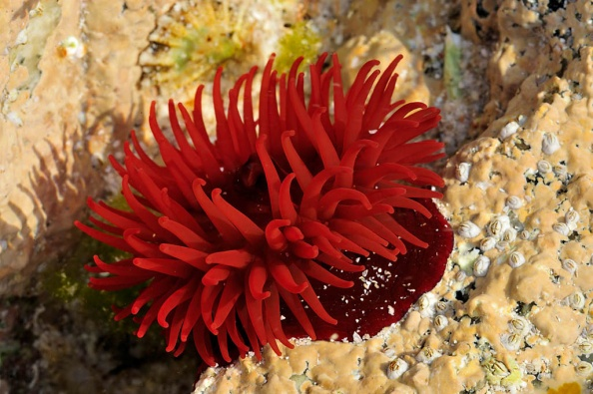

- What is a SSSI?

- What are these? Do you know any interesting facts about them?



- Rate these 3 jelly fish from lowest to highest on their level of sting. Can you name them?

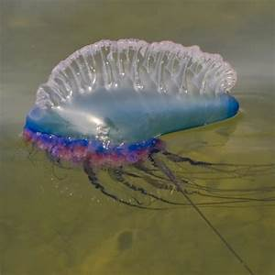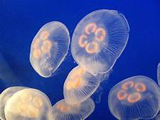



GENERAL KNOWLEDGE
- How would you check a buoyancy aid to see if it fit for purpose?

- What is “tombstoning” and how does it differ from Coasteering?

- Where is the destination board at the centre?

AGENCIES AND ORGANISATIONS

- Who are the RNLI?

- What role does the National Trust play in Coasteering?

- Who are the MCA and how may they help you?

- Where is your nearest MCA and how do you plan to contact them if you need them?

- What is the NCC?

- Who are the POCG and SWOAPG?

GORGE WALKING - NOP
OVERVIEW
Gorge walking is a fantastic group activity that takes the participants into a unique environment of a stunning gorge. Typically, the activity takes the participants on a journey up the gorge whilst taking part in team and individual challenges.
QUALIFICATIONS & IN HOUSE SIGN OFF
The process of becoming a lead instructor for gorge walking is through in house assessment.
A lead instructor must have completed an in house orientation and training session from a Senior Lead instructor. After a designated number of sessions observing and assisting the aspirant lead instructor must be signed off to be deemed competent to lead the activity.
A lead instructor must hold a valid first aid and water rescue qualification.
To be an assistant instructor on a gorge walking session, the assistant must have a valid first aid and have completed a training session run by a senior lead instructor.
A senior lead instructor should have considerable experience of the gorge walking venue in excess of 5 years of experience. The senior lead should also be up to date with the current access and environmental considerations in the gorge. Suitable qualifications for a senior lead would be WRT or WWSR, SPA or ML and a valid first aid.
RATIOS
Senior lead 1 : 6 Participants
1 Lead & 1 Assistant : 10 Participants
1 Lead & 2nd Lead : 16 Participants
PARTICIPANTS
- 8 years old is the minimum age that participants can take part in gorge walking.
- The maximum age is based upon fitness

EQUIPMENT
In addition to generic equipment the following should be carried/used.
PARTICIPANT
Buoyancy aid
Helmet
Wetsuit – suitable for weather conditions
Footwear – appropriate closed toe
Cag – depending upon weather conditions
Personal medication if required
INSTRUCTOR
Buoyancy aid
Helmet
Appropriate clothing – suitable for prevailing weather conditions
Footwear – appropriate closed toe
Throw line – minimum 15m
Knife
2/3m short Sling or tape or length of floating rope
3 screw gate carabiners
1 Prussic

ACTIVITY SPECIFIC GUIDELINES
The lead instructor is to check the prevailing weather conditions to be able to predict changes in river levels in the gorge. Checking the “weather history” and current river levels is essential prior to the activity and will enable the instructor to predict if the river levels are appropriate to run the activity.
SAFETY BRIEF
- Road safety
- PPE fitting and checked – including appropriate footwear
- The environment they are about to enter – and its potential hazards, specifically the delicate nature of the gorge environment
- Equipment and its uses - throw bag and short rope/tape demonstration
- Medical conditions – medications being carried?
- Manual Handling / good posture especially when assisting people from the water
- Entering the water, shallow water technique, jumping technique and the importance of only jumping in designated places.
- Safe swimming positions both defensive and aggressive – importance of keeping feet up
- Mutually agreed and understood signals

JUMPING
There is sometimes pressure placed upon instructors to find higher and higher jumps. It is down to the leadership skill of the instructor not to bow down to this pressure and not purely rely on the jumping element to be the only thrill during the gorge walk
Instructors should remind customers of the importance of a quality of the landing and coach effective techniques for this at low levels. Instructors have little control over someone once they have jumped which makes the choice of jumping locations very important.
We discourage participants from jumping from a height greater than 7.5 meters; this can be measured with a throw line (half a 15m rope). This is due to the fact that as jump height increases the effects of a poor landing are increased and therefore increasing the possibility of injury. Participants should only progress to higher jumps (over 5m) when they have demonstrated good control and landing techniques on smaller jumps.
Consideration should be given to diving and acrobatics from lower heights, and are generally discouraged. It’s recommended that participants should be discouraged from diving from above their own head height whilst wearing full PPE, and if so with prior practice and at participants own discretion.
VENUE
Sychryd Gorge – Brecon Beacons Outdoor Leisure 11 – Grid Reference 912 079
There are numerous access and conservation issues regarding gorge walking at this venue. The most up to date information is on the SWOPAG web site.
With regards specific safety considerations, the mine section above the water fall on the left hand side are to be avoided. Other site specific considerations will be outline as part of the in house training.

GORGE WALKING - RISK ASSESSMENT
The hazards identified could possibly effect both instructors and participants
HAZARD | EXISTING CONTROL MEASURE | RISK OK  YES/NO
Low water level – impact injuries | - Correct PPE worn at all times.  - Briefing from instructors to raise awareness of exposed rocks.  - Instructor to adapt route choice to suit water levels. | YES
Jumping | - Instructor to select jumping locations following guidelines and water levels.  - Instructor briefing regards correct jumping techniques.  - Acrobatic jumps to be discouraged.
Interference from other water users on river | - Instructor to be aware of other users and deploy an appropriate leadership strategy to manage any potential hazard. | YES
Interference from other users on the bank | - Instructor to be aware of other users and deploy an appropriate leadership strategy to manage any potential hazard.  - Instructors to be sensitive to land access and water use issues with other user groups. | YES
Entrapment | - Rocks – Instructor briefing to raise awareness and C.L.A.P protocol used.  - Trees & Strainers – Instructor briefing to raise awareness and techniques  - Equipment – Clean rope and profile to be adhered to as much as possible | YES
Collision with rocks | - Correct PPE worn at all times.  - Briefing from instructors with regards correct techniques and raise awareness.  - Dry land practice of correct swimming positions and techniques. | YES
Rock Fall | - Instructors to be aware of potential danger areas and to plan routes accordingly  - Appropriate PPE to be worn
Stoppers, holes & waves | - Briefing from instructor regards correct swimming techniques and strategies. | YES

BOARD SURFING
NORMAL OPERATING PROCEDURES
OVERVIEW
Board surfing at Llandysul Paddlers is typically delivered at an introductory level, to first time surfers. The venues chosen are dependent upon matching the groups needs with the predicted surf conditions. Instructors have the option to change venue if the actual conditions don’t match the predicted conditions and no longer suit he needs of the group.
QUALIFICATIONS & IN HOUSE SIGN OFF
A Senior lead would normally hold either a Surfing GB or ISA/ASA level 1 or equivalent. A senior lead could be responsible for providing in-house training and competency assessments.
A lead instructor must hold a valid first aid and will take part in staff training and competency assessment lead by a Senior lead.
RATIOS
1 Lead : 8 Participants.
1 Lead & 1 Assistant : 10 Participants
These ratios relate to the number of people I the water at any one time, not exclusively just those on a surf board.
PARTICIPANTS
- 8 years old is the minimum age that participants can take part in surfing lesson.
- The maximum age is based upon fitness
- Children aged 5 to 7 can take part in a basic session typically on body boards to be organised by a senior lead instructor and to have a low child to instructor ratio.
EQUIPMENT
In addition to generic equipment the following should be carried/used.
PARTICIPANT
Surf board
Wetsuit – suitable for weather conditions
Footwear – appropriate closed toe
Personal medication if required
INSTRUCTOR
Surf board – for demonstrations and rescues
Wetsuit – suitable for prevailing weather conditions
Footwear – appropriate closed toe
Beach Bag – Containing safety kit and acting as a marker on the beach

ACTIVITY GUIDELINES
A typical surf lesson will take the form of the standard ABC lesson. Containing theory, prone riding and standing practice.
Section A – Theory (Land Based)
Section B – Technique – theory – prone riding practice (land and water based)
Section C – Technique – Standing Practice (land and water based)
The details of what is contained in these parts of the lesson is outlined in the board surfing instructor training section of this document.
VENUES
A wide variety of venues are used across West Wales, beaches in Ceredigion, Carmarthenshire and Pembrokeshire are used depending upon the expected conditions and the needs of the participants.

BOARD SURFING - RISK ASSESSMENT
The hazards identified could possibly effect both instructors and participants
HAZARD | EXISTING CONTROL MEASURE | RISK OK  YES/NO
Injury from board | - Specific safety brief to cover coaching points on safer ways to carry a surf board.  - Buddying up in strong winds  - Awareness of board and its fins when wiping out. | YES
Beach related debris (sharps, rock, flotsam & jetsam) | - Instructor to consider these hazards when choosing a section of beach to use  - Action on whip out to be taught by instructors | YES
Marine life | - Instructor briefing to raise awareness of weaver fish and jelly fish.  - Full length leg and arm covering.  - Appropriate closed toe footwear to be worn.  - Exposure to jelly fish dense areas minimised where possible.  - Instructors to be able to identify jellyfish which are more likely to cause discomfort | YES
Sea conditions –  Swell & waves  Tide  Strong Currents | - Instructors knowledge of the beach environment and dynamical assess any potential hazards  - Instructors to use a pre agreed designated surfing area and signals  - Instructor to check tide times and the phase of the lunar month, and be aware of how the tide may change the surf.  - Instructors to always keep an “eye to sea” observing any potential changes in swell & wave conditions.  - Instructors to keep a “weather eye” throughout the activity to keep track of potential changes in conditions.  - Instructor to be aware and plan for known and unexpected rip currents at beaches.  - Instructors to check the weather & swell forecasts prior to activity and adapt plans accordingly. | YES
Sand in eyes | - Instructor to have access to fresh water at the beach or in beach bag.  - Appropriate brief. | YES
Other beach users | - Instructors to select a section of beach that is as free from other users as much as possible  - Take lifeguarded zones into consideration  - Consider – kite boarders, beach buggies, walkers, swimmers and other surfers. | YES

BOARD SURFING – INSTRUCTOR TRAINING
SKILL ASSESSMENT
Swimming ability –
A good level of swimming ability is desired. A surf lesson leader should demonstrate the ability to swim 100m off shore in moderate conditions. Including an effective run into the sea from the beach and porposing to get out through the impact zone faster.
Signals –
Demonstrate sound knowledge of key signals
- Recall to beach
- Move left & move right
- Move closer and further in
- Coaching communication
- Surfer in distress signal
Rescue techniques –
Surf lesson leaders should be able to demonstrate the following rescue techniques in a moderate surf environment, from 100m off shore.
- Board rescue
- Contact tow
Surfing ability –
A surf lesson leader should be able to clearly demonstrate the following skills
- Safe walking out into waves
- Paddling for a wave with effective strokes and trim
- Catching a wave and riding prone. Demonstrating leaning to turn
- Catching a wave and standing. Demonstrating good popping technique and demonstrate knee sliding alternatives.
- Wipe out technique and stopping the board.
Recommendations
It is recommended that surf lesson leaders are working towards their Beach life guard award and a surfing instructor award.

THE ABC LESSON
SECTION A – THEORY (LAND BASED)
- Introduction -
- Important to introduce yourself and look to learn the names of the group members where possible.
- Outline the lesson format-
- Explain the ABC format. Many surfers will often only have the one lesson so it is important to cover all the aspects of the lesson especially the beach safety.
- Beach safety -
- Other users – Introduce awareness of other users.
Beach flags and zones
- Rocks – Typical locations on beaches
Choosing position to surf on the beach
Consult lifeguards
- Marine life – Jelly fish
Weaver fish
Not disturbing wildlife – seals etc
- Currents - How they are formed
How to recognise them from the beach
How to swim/paddle out of them
- Equipment issue-
- Wetsuit sizing
- Board sizing and style
- Correct board carrying technique
- Fins forward where you can see them
- Buddy carry on windy day or smaller clients
- Carry / wrap leash
- Action on leaving group/beach (head count)-
- It is imperative that the instructor is fully aware of where all the group members are at all times.
- Action on leaving the group for whatever reason is the group member must let the leader know that they are leaving the beach and where they are going.
- The leader must maintain a positon on the beach or in the water where he/she can keep a head count on the group at all times.
- Recall and other signals (intro buddy system if needed)
- Buddy system of working together in pairs is an effective way of encouraging skill development and improving the level of safety on windy /big days.

SECTION B – PRONE RIDING (LAND & WATER BASED)
- Instruction semi-circle-
- Position the group so they can concentrate, facing away from bright sun and wind/waves
- Parts of the board –
- Identify the common name of the parts of the board to assist with coaching
- Introduce the leash, including how to wear it
- Demonstrate how far the board will travel ahead of the surfer and discuss the dangers of this
- Entry to sea –
    - Correct method, holding the board at your hip by the nose of the board
    - Waist Depth
    - Turning around with board, with the surfers back to the waves
PERFORM A SUITABLE WARMUP
- Catching a wave –
    - Introduce the ideal prone riding position and trim
    - Demonstrate and coach effective paddling technique
    - Correct hand position (hands under armpits) and body position on board when prone riding (trim)
- Stopping board –
- Holding on and slipping off to the side
- Sliding to the back of the board to “apply the breaks”
- Action on wipe-out –
- Cover head and face
- Care to be taken when landing into shallow water
- Remember the board is attached to you
- Recap signals-
- Action on leaving group-
- Letting the instructor know and the Importance of a constant head count
- In water demonstration by instructor
- Demo to the group, effective wave choice, paddling technique and prone riding.
- Supervised practice by student –
- Coaching tips to improve techniques, trim, paddling, wave choice, timing, riding position
- Pulling surfers onto waves, for those who initially struggle with paddling for waves with enough power
SECTION C – STANDING (LAND & WATER BASED)
- Catching wave –
- Recap technique, timing, trim, wave choice.
- Pop/jump up techniques –
- Use a whole/part demo at different speeds
- Intro alternate techniques, knee sliding etc
- Practice (land based)
- Fault correction and development
- Leash foot
- Following dryland “pop” practice the surfer will be able to identify which is their back foot, this is the ankle which the leash is attached to
- Control of board
- Leaning forwards for speed, backwards for turning
- Action on wipe out (from standing)
- Cover head and face
- Care to be taken when landing into shallow water, not to cause arm injury, the “splat” landing
- Recap signals and waist depth
- Recap action on leaving group
- In water demonstration by instructor –
- An appropriate demo to the group, effective wave choice, paddling technique and stand up riding
- In water supervised practice – fault correction and feedback
- Debrief and depart

BOARD SURFING – SIGNOFF
Name…………………………………………………………………………
I have read and understood the risk assessments and normal operation procedures for this activity.
Sign………………………………………………. Date……………………
SKILL ASSESSMENT
SWIMMING ABILTIY [ ]
A good level of swimming ability is desired. A surf lesson leader should demonstrate the ability to swim 100m off shore in moderate conditions. Including an effective run into the sea from the beach and porpoiseing to get out through the impact zone faster.
Comments

SIGNALS
Demonstrate sound knowledge of key signals
- Recall to beach [ ]
- Move left & move right [ ]
- Move closer and further in [ ]
- Coaching communication [ ]
- Surfer in distress signal [ ]
Comments

RESCUE TECHNIQUES
Surf lesson leaders should be able to demonstrate the following rescue techniques in a moderate surf environment, from 100m off shore.
- Board rescue [ ]
- Contact tow [ ]
Comments
SURFING ABILITY
A surf lesson leader should be able to clearly demonstrate the following skills
- Safe walking out into waves [ ]
- Paddling for a wave with effective strokes and trim [ ]
- Catching a wave and riding prone. [ ]
- Demonstrating leaning to turn [ ]
- Catching a wave and standing [ ]
- Demonstrating good popping technique [ ]
- Demonstrate knee sliding alternatives. [ ]
- Wipe out technique and stopping the board [ ]
Comments

THE ABC LESSON
A surf lesson leader should be observed teaching an ABC lesson and should include the following.
SECTION A – THEORY (LAND & WATER BASED)
- Introduction - [ ]
- Outline the lesson format- [ ]
- Beach safety - [ ]
- Other users
- Rocks
- Marine life
- Currents
- Equipment issue- [ ]
- Correct board carrying technique [ ]
- Action on leaving group/beach (head count)- [ ]
- Recall and other signals (intro buddy system if needed) [ ]
Comments

SECTION B – PRONE RIDING (LAND & WATER BASED)
- Instruction semi circle- [ ]
- Parts of the board – [ ]
- Entry to sea – [ ]
- Catching a wave – [ ]
- Stopping board – [ ]
- Action on wipe out – [ ]
- Recap signals - [ ]
- Action on leaving group- [ ]
PERFORM A SUITABLE WARMUP [ ]
- In water demonstration by instructor - [ ]
- Supervised practice by students – [ ]
Comments

SECTION C – STANDING (LAND & WATER BASED)
- Catching wave – [ ]
- Pop/jump up techniques – [ ]
- Practice (land based) - [ ]
- Leash foot - [ ]
- Control of board- [ ]
- Action on wipe out (from standing)- [ ]
- Recap signals and waist depth- [ ]
- Recap action on leaving group- [ ]
- In water demonstration by instructor- [ ]
- In water supervised practice – [ ]
- Debrief and depart [ ]
Comments

Assessor Name……………………………………………..…..
Assessor Recommendation……………………………………………....................
Assessor Sign……………………………….… Date……………………….

LAKE ACTIVITY SUPERVISION (OPEN LAKE) - NOP
OVERVIEW
During the school holidays the lake is open to participants to try kayaking and canoeing for the first time, these sessions are typically not coached sessions and are more likely to be run via bank based supervision.
STAFFING & QUALIFICATIONS
Lake supervisors should hold a valid first aid and an FSRT, or have had equivalent in house training.
RATIOS
1 Supervisor : 15 Participants
2 Supervisors : 25 Participants
PARTICIPANTS
- There is no minimum age for Open Lake days, it is at the parent/guardians discretion if they feel able to appropriately supervise the child
- For those under 5 years old on the water competent adult supervision is required
- For those under 8 years old adult supervision is required.
- For those over 8 years old they are able to be unaccompanied once the relevant paperwork has been completed
- The maximum age is based upon fitness

EQUIPMENT
In addition to generic equipment the following should be carried/used.
PARTICIPANT
Buoyancy aid
Helmet
Wetsuit – suitable for weather conditions
Footwear – appropriate closed toe
Cag – depending upon weather conditions
Personal medication if required
INSTRUCTOR – In addition to generic equipment
Buoyancy aid
Helmet
Appropriate clothing – suitable for prevailing weather conditions
Footwear – appropriate closed toe
Throw line or towline
Knife

VENUE
This supervised activity only takes place on Llandysul Paddlers on site lake.
ACTIVITY GUIDELINES
The responsibilities of a lake supervisor are
- To prepare the equipment for the day – ensuring it is still fit for purpose
- Open the kayak stores and ensure the site is tidy and presentable
- To meet and greet participants, providing a warm welcome and ensuring they have completed the necessary registration forms
- To issue suitable equipment, wetsuits and PPE
- To provide a suitable briefing outlining the inherent hazards associated with the lake and activity equipment
- To assist the participants when selecting the kayaks and canoes – ensuring they are appropriately fitted out
- To provide constant supervision, and be prepared to perform a rescue if required

LAKE SUPERVISION - RISK ASSESSMENT
The hazards identified could possibly effect both instructors and participants
HAZARD | EXISTING CONTROL MEASURE | RISK OK  YES/NO
Entrapment in kayaks & Canoes | - Briefing on how to enter and exit kayaks/canoes  - Instructors to be aware of loose ropes  on rafts and inflatables  - Constant supervision | YES
Injuries from collision with objects or other users | - Briefing and participant management  - Constant supervision
Injuries from equipment | - Briefing from supervisor | YES
Slips trips and falls | - Certain areas of the lake side are very slippery. Supervisors are to be aware where these places are and to warn participants. | YES
Trapped under flipped raft/inflatables | - Constant supervision  - PPE to be worn  - Briefing from supervisor | YES
An incident occurring whilst a supervisor is not present | - Constant supervision at all times  - When a supervisor requires a break temporary cover will be in place before the supervisor leaves the lakeside | YES

BUSHCRAFT - NOP
OVERVIEW
Bush craft is an excellent educational tool to enhance participants understanding of simple life skills and immerse them in the natural environment. It is also a pleasurable activity that is used as an alternative to water activities during school residential programmes or during the winter months.
STAFFING & QUALIFICATIONS
A bush craft leader should have had in house training and have shadowed lead activities until they are deemed competent and feel happy that they understand the specific requirements of the activity. They must hold a valid first aid certificate.
RATIOS
1 Lead : 8 Participants
1 Lead & 1 Assistant : 10 Participants
1 Lead & 2nd Lead : 16 Participants
PARTICIPANTS
- 8 years old is the minimum age that participants can take part in a full bush craft activity.
- For those under adult supervision is required.
- The maximum age is based upon fitness
- Children aged 5 to 7 can take part in a modified activity to be designed by an experienced bush craft instructor and to have a low child to instructor ratio
EQUIPMENT
In addition to generic equipment the following should be carried/used.
PARTICIPANT
Appropriate clothing for the days conditions – ideally “Low melt”
Footwear – appropriate closed toe
Personal medication if required
INSTRUCTOR
Appropriate clothing for the days conditions – ideally “Low melt”
Footwear – appropriate closed toe
Water – for fire control and possible burns

VENUES
There are suitable venues for bush craft on site at the picnic area by the lake, beside the river track and below the Cauldron rapid. At times participants can be taken to offsite venues to nearby woodlands and beaches. At all these venues it is vitally important that leave no trace principles are applied especially when it comes to fire lighting activities.
ACTIVTITY GUIDELINES
FIRE LIGHTING
- Fires must be lit in a controlled fashion in a designated area
- Metal fire pans should be used where possible to prevent damage to the ground
- Water should always be on hand to control the fire and in case of any burns
- All fire lighting activities should be supervised with detailed instructions on how to use the various methods
SHELTER BUILDING
- Participants should be discouraged from leaving the ground when suspending tarps and building shelters
- The practice of cutting live wood for the building of structures should be discouraged to prevent damage to the natural environment
FOOD PREPARATION
- Hand washing should be encouraged and facilities provided
- Clean food preparation surfaces should be provided
- Perishable foods should be carried and stored in an appropriate way
USE OF AXES
- Axes should be kept sharp and well maintained, with special attention given to the secure fixing of the axe head to the shaft
- Teaching the technique of not holding the target piece of wood with a hand but using a length of wood to stabilised the target wood, helps to prevent injuries
- Axes should be used in a designated area and users supervised at all times
- When not in use axes should be safely stored in the designated chopping zone and the carrying of them kept to a minimum
- Consideration should be given to weather an axe needs to be used or not and weather the piece of would could simply be snapped
USE OF KNIFES & SAWS
- Knifes and saw should be kept sharp and well maintained
- Knife users should be taught correct techniques
- Instructors should be mindful to keep knife tasks relatively simple

- Consideration should be given to weather a saw needs to be used or not and weather the piece of would could simply be snapped

BUSHCRAFT - RISK ASSESSMENT
The hazards identified could possibly effect both instructors and participants
HAZARD | EXISTING CONTROL MEASURE | RISK OK  YES/NO
Burns during fire lighting exercises | - Instructors to brief participants on the specific hazards associated with fire lighting and its maintenance  - Fires to be lit under supervision in a prepared and controlled area  - Heat resistant gloves are available and can be used when necessary  - Water to be on hand  - Participants to be encouraged to wear “low melt” clothing such as cotton | YES
Burns from using flint and steel striker tool | - Briefing from instructor on its use  - Supervision during the use of the tool | YES
Smoke inhalation | - Instructor to raise awareness  - Only natural materials to be burn  - Open air location to be used | YES
Injuries whilst shelter building | - Participants discouraged from leaving the floor when suspending tarps or shelters  - Instructors to provide briefing on the fundamentals of a sound structure  - Gloves to be provided if necessary | YES
Use of axes and knifes | - Briefing from instructor on the safer use of each tool.  - Supervision during the use of the tools  - All tools to be well maintained and kept sharp  - Full closed toe appropriate footwear to be worn | YES
Contact with soil bourn micro organism | - To prevent possible illness hand washing or use of hand gel before eating should be encouraged  - Clean surfaces to be provided for food preparation | YES

TEAM BUILDING - NOP
OVERVIEW
Games, tasks and exercises may be undertaken for fun or as part of a group learning experience. Instructors should have a clear understanding of the activity goals and plan accordingly. The variety of activities is great and many can be combined and adapted to create infinite possibilities. The choice and management of activities will be dictated by the instructor’s level of experience and the needs of the participants
STAFFING & QUALIFICATIONS
First Aid. Knowledge and experience of problem solving exercises, reviewing and facilitation skills. In house training when necessary.
RATIOS
This can be 1 instructor : 20 Participants however to ensure the quality of the activity a ratio of 1 instructor : 10 Participants might be more appropriate.
For activities in or near the water the ratios and safety equipment may need to be in-line with water sports guidelines.
EQUIPMENT
In addition to generic equipment the following should be carried/used.
PARTICIPANT
Appropriate clothing for the days conditions
Footwear – appropriate closed toe
Personal medication if required
INSTRUCTOR
Appropriate clothing for the days conditions
Footwear – appropriate closed toe
Associated team task equipment

VENUES
The venues used are varied, however typically they are often on site. When selecting a location to set up team tasks consideration should be given to any specific needs of the group and that the area is relatively clean, presentable and pleasant to spend time in.
ACTIVTITY GUIDELINES
Safety and risk awareness should be maintained as with more adventurous activities, as simple slips or stumbles are common as participants are in a familiar environment and perhaps take less care. It is also common that team building exercises might take the form of a competitive format, which may also lead to over enthusiastic participants.
In the confines of this document it is not possible to list all of the tem tasks that are used, as they are varied and extensive. Fundamentally they are selected with the specific needs and objectives of the participants in mind.
All of the team task are designed in such a way as too encourage the following facilitation method.
PLAN – DO – REVIEW
PLAN – Allow the participants time to understand the requirements of the task and then plan how they want to try and achieve it. An instructor could be on hand to provide subtle guidance to help steer the plan to a successful outcome.
DO – During this time the participants should attempt to execute the plan. The instructor should take a back seat as much as possible to enable the participants to self-govern themselves. Ideally only stepping in to manage any safety issues.
REVIEW – After the completion of the task or the allotted time has elapsed, the instructor should lead a review of the task. Highlighting the good points, negatives and areas for improvement. It is not always necessary for the task to have a successful outcome, as this provides plenty to review. However, over the duration of all task it is ideal if participants tend to improve their performance as this maintains motivation.
This same facilitation method can be applied to the following activity of improvised raft building.

TEAM BUILDING - RISK ASSESSMENT
The hazards identified could possibly effect both instructors and participants. Due to the nature of team buildings various different tasks it is not possible to outline all of them individually in this risk assessment, these are the generic risks associated with all team build tasks.
HAZARD | EXISTING CONTROL MEASURE | RISK OK  YES/NO
Use of blindfolds | - Briefing from instructor regarding appropriate behaviour whilst wearing a blindfold or whilst guiding another participant wearing a blindfold.  - Instructor to intervene if inappropriate behaviour is occurring and/or the participants move out of a designated safer area. | YES
Carrying bulky awkward equipment | - Briefing from instructor with regards safer technique | YES
Lifting of participants | - Where tasks might require this the instructor should be suitably positioned to support the head and shoulders of the participant being lifted. | YES
Tasks involving projectiles or throwing objects | - Objects/projectiles to be of suitable shape, size and material.  - A participant triggering a projectile may need to be wearing safety goggles/glasses depending upon its nature  - A designated zone should be set up for throwing/projectile use. | YES
Fall from height | - If necessary, a climbing helmet may be worn  - Peer/instructor spotting may required | YES
Injuries from task specific equipment | - All equipment used should be suitable and well maintained  - A specific briefing with regards any task equipment should be given by instructors

IMPROVISED RAFT BUILDING - NOP
OVERVIEW
Improvised raft building is typically used as a team building exercise which is ideal for a wide range of ages and abilities. It can be a short activity or part of a full day team building exercise.
STAFFING & QUALIFICATIONS
A raft build lead must have a valid first aid certificate. Also a 2 star/FSRT or equivalent ability would be required to perform the “safety boating” aspect as the rafts are being paddled.
To improve the quality of the activity it is best if an aspiring lead shadows a previous raft build to see how best to run the activity if they have not had any previous experience of the activity.
RATIOS
1 Lead : 10 Participants
1 Lead & 1 Assistant : 12 Participants
1 Lead & 2nd Lead : 20 Participants
PARTICIPANTS
- 8 years old is the minimum age that participants can take part in raft building.
- The maximum age is based upon fitness
- Younger Participants may be able to take part in an adapted activity designed and authorised by a senior instructor

EQUIPMENT
In addition to generic equipment the following should be carried/used.
PARTICIPANT
Buoyancy aid
Helmet
Wetsuit – suitable for weather conditions
Footwear – appropriate closed toe
Cag – depending upon weather conditions
Personal medication if required
INSTRUCTOR
Buoyancy aid
Helmet
Appropriate clothing – suitable for prevailing weather conditions
Footwear – appropriate closed toe
Throw line or towline
Knife

VENUES
This activity typically takes part on site at Llandysul Paddlers lake. If other venues are used they should be carefully selected, taking into account the needs of the group and ensuring that the venue is suitably sheltered enough.
ACTIVTITY GUIDELINES
Step 1- Planning. Once the group is split into teams of up to 6 people it works well to allow some time for the teams to plan how they would like to build the raft. Allowing the teams to do this autonomously with a little guidance will facilitate a greater team building experience. The team should at this stage know how many planks, barrels and lengths of rope they have available.
Step 2 – The Build. On dry land near where the raft will be paddled, the team construct the raft, guidance should be given with regards what knots to use and how to do them.
Step 3 – The Paddle. Once the raft is built the teams should be given a target/ challenge to achieve on the water.
Step 4 – The clean-up. All floating debris should be removed from the water. The raft should be deconstructed and all equipment stored back in its appropriate place.

IMPROVISED RAFT BUILD - RISK ASSESSMENT
The hazards identified could possibly effect both instructors and participants
HAZARD | EXISTING CONTROL MEASURE | RISK OK  YES/NO
Entrapment | - Specific safety brief to cover the importance of not threading any limbs through loose ropes, planks or barrels.  - Awareness of how the rafts have been built, and any obvious possible entrapment points.  - Instructor to carry a knife | YES
Injury from impact from a part of the raft | - Instructor to brief participants with regards awareness as the raft may fall apart.  - Flipping rafts should be avoided if possible  - PPE to be worn | YES
Injuries from paddles | - Instructor briefing to raise awareness of  - PPE to be worn | YES
Injuries from lifting awkward sized equipment | - Briefing to raise awareness of manual handling issues  - Barrels are to rolled around when necessary  - Young people to work in pairs carrying planks  - Full team and supervision when moving the completed raft to the water’s edge | YES
Slips trips and falls | - Awareness raised with regards slippery edges of the lake, especially when carrying equipment | YES
Participants unable to control the raft | - In windy conditions it may be necessary to tether the raft  - Safety boat ready to assist if necessary | YES

CAMPING – NOP
OVERVIEW
These NOP’s and RA’s relate to the activities of wild camping, bivouacking and the use of campsites.
STAFFING AND QUALIFICATIONS
Those supervising camping should have camping experience appropriate to the location and hold a valid first aid qualification.
RATIOS
In line with which ever adventure activity has taken the participants to their camping location. The need for overnight supervision is dependent upon the expedition requirements, the needs of the participants and if there are any other accompanying staff such as teachers/leaders.
EQUIPMENT
PARTICIPANT
Clothing – suitable for weather conditions
Footwear – appropriate for hill environment & closed toe
Water proof outer clothing – suitable for expected weather conditions
Personal medication if required
Camping Equipment – Tent, sleeping bag, stove etc.
INSTRUCTOR
Appropriate clothing – suitable for prevailing weather conditions
Footwear – appropriate for hill environment & closed toe
Additional spare clothing – to suit the environment
Head torch
Personal camping equipment – Tent, sleeping bag, stove etc.
Spare sleeping equipment – perhaps stored in a nearby vehicle

VENUES
There is camping available on site at the centre. Numerous other camping venues are used. From full facility camp sites to remote coastal or mountainous locations. They are selected upon the requirements of the participants and the activity being undertaken. Typically know or previously visited campsites are uses to ensure they are of a suitable quality for the participants. Wild camping sites are selected for their suitability to provide shelter, fresh water supply and attractive setting.

ACTIVTIY GUIDELINES
WILD CAMPING – Specific considerations
- Leave no trace principles should be applied to ensure the selected wild camping spot is left as it was or better. Link to leave to trace HERE
Advice on toileting in the wild
- Select your spot – sometimes it is necessary to design a system to let other participants know so you get some privacy. Choose a spot that is a suitable distance away from water sources.
- Dig a hole – this should ideally be 6 – 8 inches deep.
- Use toilet paper sparingly – carefully burn it on the spot or pack it out.
- Fill in the hole – if staying for a few days it may help to mark the spot.
CAMPSITE CAMPING – Specific considerations
- Toilet and shower facilities should be checked to ensure they are suitable
- It may be necessary at public campsites to secure sole use of toilet and shower facilities especially when working with young people and venerable adults.
- Participants should be encouraged to behave appropriately and respectfully to owners and other users.
USE OF STOVES
- Initially close supervision and further training should be given to ensure their proper use.
- Spare fuel liquid or otherwise should be transported appropriately and stored away from any source of ignition.
FIRE LIGHTING
- Fires must be lit in a controlled fashion in a designated area and only if such an activity is allowed by a land owner or is appropriate
- Metal fire pans should be used where possible to prevent damage to the ground
- Leave no trace principles should be adhered to
- Water should always be on hand to control the fire and in case of any burns
PITCHING TENTS
- Training and supervision should be given to aid in preventing damage to equipment
- Advice and assistance given in choosing a good pitching spot

SHELTER BUILDING – whilst bivouacking
- Participants should be discouraged from leaving the ground when suspending tarps, building shelters and setting up hammocks
- The practice of cutting live wood for the building of structures should be discouraged to prevent damage to the natural environment

FOOD PREPARATION
- Hand washing should be encouraged and facilities provided or identified when possible
- Clean food preparation surfaces should be provided
- Perishable foods should be carried and stored in an appropriate way

CAMPING – RISK ASSESSMENT
The hazards identified could possibly effect both instructors and participants and are in addition to the generic RA’s.
HAZARD | EXISTING CONTROL MEASURE | RISK OK  YES/NO
Burns from fires | - Instructors to brief participants on the specific hazards associated with fire lighting and its maintenance  - Fires to be lit under supervision in a prepared and controlled area  - Participants to be encouraged to wear “low melt” clothing such as cotton | YES
Smoke inhalation | - Instructor to raise awareness  - Only natural materials to be burn  - Open air location to be used | YES
Burns from using stoves | - Briefing from instructor on its use  - Supervision during the use of the tool  - Particular caution when using liquid fuel stoves | YES
Contact with soil bourn micro organism | - To prevent possible illness hand washing or use of hand gel before eating should be encouraged  - Clean surfaces to be provided for food preparation | YES
Slips trips and falls | - Special attention given in briefing to move carefully around tent guy lines and pegs | YES
Specific camping equipment failure | - Spare tent and sleeping equipment available when possible to prevent being exposed to the elements  - Supervision and training when pitching tents | YES
Exposure to inappropriate behaviour from member/s of the public | - Considered selection of public campsites and wild camping spots  - Overnight supervision if necessary | YES

HILL WALKING - NOP
OVERVIEW
These Hill walking NOP’s and RA’s relate anything from short day hikes in low land terrain up to multi day expeditions in high mountainous areas.
STAFFING & QUALIFICATIONS
Hill walking leaders are typically qualified through the UK governing body Mountain Training. It is possible to use instructors who have qualifications from other countries. This is agreed on a case by case basis by centre management. A designated technical advisor may be consulted to ascertain if the non UK qualification is of an equivalent standard.
Instructors are to only lead groups in the mountains within given remit of their qualifications. A fantastic outline of the qualifications available and their remit is available HERE at the Mountain Training website.
RATIOS
1 Instructor : 10 Participants
1 Instructor & 1 Assistant : 12 Participants
1 Instructor & 2nd Lead : 16 Participants
EQUIPMENT
PARTICIPANT
Clothing – suitable for weather conditions
Footwear – appropriate for hill environment & closed toe
Water proof outer clothing – suitable for expected weather conditions
Additional PPE depending upon chosen route and terrain (helmet)
Personal medication if required
INSTRUCTOR
Appropriate clothing – suitable for prevailing weather conditions
Footwear – appropriate for hill environment & closed toe
Map & Compass – Possibly also a route card
Additional spare clothing – to suit the environment
Confidence rope – for security on steep ground
Additional PPE - depending upon chosen route and terrain (helmet)
Head torch

VENUES
Wales and the UK has an abundance of hill and mountainous terrain, any of it may and can be used by a suitably qualified instructor at the appropriate time to suit the needs of a group

ACTIVTITY GUIDELINES
- The intended route should be outlined on the destination board.
- For more complex routes or for multiple days a route card should be completed and handed to centre management.
- Notable deviations from the planned route should be brought to attention of the centre management via the staff Facebook messenger group.
- For overnight wild camps or staying in campsites the NOP’s and RA’s outlined for camping should be adhered to.
- Detailed mountain weather forecasts should be consulted when planning routes with particular changes that occur with the increase of elevation.
- It is common that the obsession with reaching the summit of a mountain could blur sound decision making, instructors should be aware of this and never be afraid to change a plan if necessary.
- Hill walking can be an exhausting business for those unused to physical exertion, participants should be encouraged to move at their own pace. It is in the skill of leadership that an instructor will be able to manage differing abilities within a group

HILL WALKING - RISK ASSESSMENT
The hazards identified could possibly effect both instructors and participants in addition to generic RA’s.
HAZARD | EXISTING CONTROL MEASURE | RISK OK  YES/NO
Getting lost | - In-depth navigation training and practice before expedition  - Clear geographical boundaries set  - Clear and agreed protocol if the group becomes lost or afraid  - Participants to be made aware the supervisors will be located, and contact numbers issued | YES
Exposure to adverse weather conditions | - Participants to be suitably equipped for expected and carry additional clothing to cope with adverse conditions  - Instructor to adjust plans accordingly | YES
Group becoming spilt up | - Briefing from instructor on the importance of staying together  - C.L.A.P leadership principle applied | YES
Contact with soil bourn micro organism | - To prevent possible illness hand washing or use of hand gel before eating should be encouraged | YES
Slips trips and falls | - Special attention given in briefing with regards carrying heavy rucksacks and equipment  - Coaching as to how to travel across uneven terrain effectively  - Appropriate footwear to be worn for the terrain being covered  - Careful route choice to avoid or specific leadership skills used in steep ground terrain | YES
River and Stream crossings | - Crossings to be avoided where possible especially in spate conditions  - Weather conditions observed to keep a check on unexpected water level changes  - When crossings are attempted, specific and effective techniques should be used. | YES

DUKE OF EDINGBOURGH (DofE) - NOP
OVERVIEW
The assessment criteria of a DofE expedition requiring independent remotely supervised travel in wild terrain. This presents unique participant management issues which are outlined in these NOP’s and RA’s.
The full spectrum of DofE services are provided at the centre, training, supervision, assessing along with residential and skill development experiences. The centre is a DofE approved activity provider and many of its full time staff are DofE accredited supervisors and assessors.
The expedition services provided are typically either walking or open canoeing expeditions. These NOP’s and RA’s work directly in conjunction with the Hill walking, inland open canoe and camping NOP’s and RA’s.
STAFFING & QUALIFICATIONS
For aspects of DofE work where skills training is being provided instructors are able to deliver this training under the banner of their qualifications and/or in house sign off.
Supervising and assessing expeditions requires the external DofE assessor status to be gained. Instructors are to provide these services within the confines of their DofE accreditation, their qualifications and experience.
RATIOS
One of the 20 conditions of a DofE expedition is that there must be between 4 – 7 Participants in the group. Due to the nature of the self-guided element of the expeditions it is possible to supervise/assess more than one group at a time. The number of these groups is dependent upon the Supervisor/Assessors discretion and how much assistance can be given by accompanying teachers/leaders.

EQUIPMENT
These are the equipment requirements for a walking based expedition. In addition to the generic activity equipment requirements.
PARTICIPANT
Clothing – suitable for weather conditions
Footwear – appropriate for hill environment & closed toe
Water proof outer clothing – suitable for expected weather conditions
Additional PPE depending upon chosen route and terrain (helmet)
Personal medication if required
Camping equipment
INSTRUCTOR
Appropriate clothing – suitable for prevailing weather conditions
Footwear – appropriate for hill environment & closed toe
Map & Compass – Possibly also a route card
Additional spare clothing – to suit the environment
Confidence rope – for security on steep ground
Additional PPE - depending upon chosen route and terrain (helmet)
Head torch
Camping Equipment
Access to a vehicle if required

These are the equipment requirements for an open canoe based expedition. In addition to the generic activity equipment requirements.
PARTICIPANT
Open Canoe – suitable for the intended journey
Buoyancy aid
Helmet
Wetsuit or Personal paddling clothing suitable for weather conditions
Footwear – appropriate closed toe
Cag – depending upon weather conditions
Personal medication if required
Camping equipment – and a method of keeping this dry – Barrels or Bags
INSTRUCTOR
Open Canoe – suitable for the intended journey
Buoyancy aid
Helmet
Appropriate paddling clothing – suitable for prevailing weather conditions
Footwear – appropriate closed toe
Personal Throw line – minimum 15m
Extra Throwline – Depending on the location - 20m heavyweight line
Knife &/or small folding had saw
Flip line – 3 HMS screw gate karabiners – Prussic – pulley
Spare paddle
Map & compass – especially when operating in unfamiliar locations
Repair kit – to be able to effect repairs during a river trip
Camping equipment – and a method of keeping this dry – Barrels or Bags
VENUES
The venues used are dependent upon the level of the DofE award being completed. They are spread across the length and breadth of the UK. It is important that the DofE “Green Form” is submitted to the DofE when participants are working in wild areas.
ACTIVTITY GUIDELINES
An expedition must comply with the 20 conditions laid out by the DofE. A link to these can be found HERE
Remote supervision requires the assessor to have a sound understanding of the route the group are intending to take. This enables the assessor to be in appropriate places to check up on the progress of groups and ensure they are complying to the 20 conditions.
If at any point the assessor/supervisor feels that the group is potential going to get into difficulty that could possibly cause harm, they are to intervene and take action to rectify the situation.
At any time, it is appropriate to make adjustments to a plan especially in the case of inclement weather.

D of E - RISK ASSESSMENT
The hazards identified could possibly effect both instructors and participants. They work in conjunction with the Camping, Hill walking and Open canoeing RA’s. They pay particular reference to the remote supervision element of DofE expeditions.
HAZARD | EXISTING CONTROL MEASURE | RISK OK  YES/NO
Groups getting lost | - In-depth navigation training and practice before expedition  - Clear geographical boundaries set  - Clear and agreed protocol if the group becomes lost or afraid  - Participants to be made aware the supervisors will be located, and contact numbers issued | YES
Groups arriving late to camp | - Clear timings agreed and all aware of meeting points  - Participants to have a watch | YES
Group becoming spilt up | - Briefing from instructor on the importance of staying together  - All participants to have noted contact numbers for the assessor/supervisor | YES
Contact with soil bourn micro organism | - To prevent possible illness hand washing or use of hand gel before eating should be encouraged | YES
Slips trips and falls | - Special attention given in briefing with regards carrying heavy rucksacks and equipment | YES
Exposure to inappropriate behaviour from member/s of the public | - Briefing with regards how to behave in such a situation  - Group to remain together | YES
Accident or incident whilst not being directly supervised by an instructor | - Group to carry and be proficient in the use of first aid and safety equipment  - Clear protocols agreed in the case of an emergency  - Contact details for supervisors and assessors to be carried by all participants | YES

ROCK CLIMBING - NOP
OVERVIEW
Predominantly introductory climbing and abseiling is provided at single pitch venues. On occasion indoor climbing walls are also used, these NOP’s and RA’s relate to both indoor and outdoor climbing
STAFFING & QUALIFICATIONS
Instructors leading rock climbing at an outdoor venue must be either hold the Single Pitch Award (SPA) or the newer Rock Climbing Instructor Award (RCI). On occasion instructors who hold qualifications from other countries might be employed. They will be able to lead rock climbing if their qualification is the equivalent of the British version. Centre management may contact the designated TA to gain clarification on this matter.
Coupled with the taught elements of a climbing qualification the instructors personal experience and ability are paramount in creating a well-rounded climbing instructor.
An instructor might feel the need to call upon an external more experienced and qualified instructor for advice, centre management will be able to assist with these contacts if required.
RATIOS
1 Lead : 8 Participants
1 Lead & 1 Assistant : 10 Participants
1Lead & 2nd Lead : 16 Participants

EQUIPMENT
PARTICIPANT
Clothing – suitable for weather conditions
Footwear – appropriate closed toe
Water proof outer clothing – suitable for expected weather conditions
Helmet and Harness
Method of tying back long hair
Personal medication if required
INSTRUCTOR
Appropriate clothing – suitable for prevailing weather conditions
Footwear – closed toe
Harness and helmet
Climbing equipment – Ropes and gear to set up climbs and abseils – the amount of gear require depends upon the venue and how many climbing routes and abseils will be needed.

VENUES
The main outdoor venue used for climbing is at the Captain kids crag approximately 10 minutes drive from Llandysul. Special permission has been granted to use this venue and every step should be taken to preserve this by parking appropriately and respecting the venue.
On occasion participants are taken to other single pitch crags in the area. Instructors use local knowledge or guidebooks to find suitable venues.
At indoor climbing venues the facilities rules and regulations should be adhered to and instructors should be prepared to present their qualifications to the climbing wall staff before taking a group there.
ACTIVTITY GUIDELINES
There are two main routes at the captain kid crag which are typically operated by a bottom rope system, that is secured to trees at the top of the crag.
At the captain kids crag, it is only really possible for one instructor to safely manage two climbs at one time
Teaching belaying
- Full demonstration of technique to the whole group
- Individual coaching with each different belayer before their first c limber leaves the ground
- Other participants can be used to tail the rope and back up the belayer
- Instructor to tail the rope
- Instructor to manage and monitor belayer whilst lowering climbers
When bottom roping climbers are not to climb past the karabiners at the top of the route and proceed to the top of the cliff, as a bottom roping system is not setup for leader falls.
A minimum of two solid anchors are to be used when setting bottom ropes and abseils.
Releasable abseil systems should be used to aid in assisting a stranded climber.
Instructors should be proficient in a range of rescues appropriate for use on a single pitch crag.
There are a plethora of games and activities than be used at climbing walls, instructors are always to apply the Keep – It – Simple – Safe rule in mind when devising new activities.

ROCK CLIMBING & ABSEILING - RISK ASSESSMENT
The hazards identified could possibly effect both instructors and participants in addition to the generic RA’s
HAZARD | EXISTING CONTROL MEASURE | RISK OK  YES/NO
Rock fall | - PPE worn and designated safe area for removing/adjusting helmets  - Where possible crags should be inspected for loose rocks  - It is never assumed that a crag is safe | YES
PPE not fitted correctly | - Briefing on use  - Helmets and harnesses to be check by instructor once fitted before anyone climbs or abseils. | YES
Injury due to jewellery and rings | - Briefing from instructor  - All participants to remove hooped earing and rings from fingers  - Rings can be taped over to help prevent them becoming caught. | YES
Hair, clothing or body part entrapment in friction devices | - Hair to be tied back out of the way  - Clothing to be tucked out of the way  - Briefing from instructor on effective use of belay and abseil devices | YES
Slips trips and falls | - Special attention given in briefing with regards concentrating on the uneven surface at the bottom of the crag  - Particular careful management of participants as they walk up the paths | YES
Fall from height | - Effective roped climbing systems  - Briefing from instructor on effective use of belay and abseil devices  - Bouldering restricted to low levels  - Effective belaying techniques taught and managed by instructor  - Participants to be very carefully managed when at the top of the crag and when moving to the abseiling position | YES
Fall from low levels | - Bouldering restricted to low levels  - Peer and/or instructor spotting during bouldering  - The rope connection between belayer and climbing should be kept free of slack especially when the climber is close to the ground | YES
Overly rapid decent down ropes or being lowered to fast | - Lowering managed by instructor  - Briefing from instructor on effective use of belay and abseil devices and demonstrations | YES

INLAND KAYAKING - NOP
OVERVIEW
These NOP’s and RA’s relate to kayaking activities that extend beyond the scope of an in-house signoff for leading “run the rapids” sessions. There is an extensive history at the centre of providing introductory to advanced courses, trips and experiences where instructors are able to coach a develop paddlers for a half day or anything up to years in duration.
STAFFING & QUALIFICATIONS
Instructors providing kayak coaching are typically BC qualified coached and leaders. It is possible to use instructors who have qualifications from other countries. This is agreed on a case by case basis by centre management. Canoe Wales’s coaching workforce manager may be consulted to ascertain if the non UK qualification is of an equivalent standard.
Instructors are to only lead and coach kayaking up to the given remit of their qualifications.
An excellent resource for clarifying instructor qualifications and remit is found HERE in the AALA website.
RATIOS
1 Senior Lead : 6 Participants
1 Lead : 4 Participants
1 lead & 1 Assistant : 8 Participants
1 Lead & 2nd Lead : 10 Participants

EQUIPMENT
In addition to generic equipment the following should be carried/used.
PARTICIPANT
Kayak – suitable for the intended activity
Buoyancy aid
Helmet
Wetsuit or Personal paddling clothing suitable for weather conditions
Footwear – appropriate closed toe
Cag – depending upon weather conditions
Personal medication if required
INSTRUCTOR –
Kayak – suitable for the intended activity and appropriate for any possible rescue situation
Buoyancy aid
Helmet
Appropriate paddling clothing – suitable for prevailing weather conditions
Footwear – appropriate closed toe
Personal Throw line – minimum 15m
Extra Throwline or Towline – Depending on the grade of water
Knife
Flip line – 3 HMS screw gate karabiners – Prussic – pulley
Spare paddle
Map & compass – especially when operating in unfamiliar locations
Repair kit – to be able to effect repairs during a river trip
Head torch

VENUES
A large amount of kayaking takes place near Llandysul along the river Teifi, however many other rivers, lakes, canals and waterways are used in the local area, indeed across the UK and Europe. The list would be endless and pointless in this setting however the venue being used is always selected based on the needs of the participants in mind.
ACTIVTITY GUIDELINES
Instructors are to follow and use the principles, procedure and guidelines covered by their BC qualification. Below is not an exhaustive list of these procedures but some of those commonly used.
C.L.A.P – Communication – Line of sight – Assess – Position of most usefulness is a leadership principle commonly used to lead groups on white water.
SELF – TEAM – VICTIM – EQUIPMENT is a rescue protocol outlining the order of importance in a rescue situation
SHOUT – REACH – THROW – ROW – GO is a rescue protocol that outlines the order of rescue methods in a rescue situation moving from the least to riskiest method.
Coupled with the taught elements of kayaking qualifications the instructors personal experience and ability are paramount in creating a well-rounded and proficient leader.
For advanced kayak coaching an instructor might call upon a more experienced and qualified instructor for advice, centre management will be able to assist with these contacts if required.

INLAND KAYAKING - RISK ASSESSMENT
The hazards identified could possibly effect both instructors and participants
HAZARD | EXISTING CONTROL MEASURE | RISK OK  YES/NO
Entrapment in kayak | - Specific safety brief to cover how to wet exit a kayak  - Instructor to carry a knife  - Clean profile to be applied where possible | YES
Entrapment in river | - Briefing on safer swimming positions  - Clean profile applied where possible  - PPE to be worn | YES
Entrapment/  entanglement with rescue equipment | - PPE to be worn  - Instructor to carry a knife  - Clean rope principle to be applied where possible | YES
Injuries from paddles | - Instructor briefing to raise awareness of paddles and their potential to harm other participants  - PPE to be worn | YES
Injuries from lifting awkward sized equipment | - Briefing to raise awareness of manual handling issues  - Instructors to take charge of lifting and attaching kayaks to trailers and vans | YES
Slips trips and falls | - Awareness raised with regards slippery edges of the river bank, especially when carrying equipment | YES
Over hanging trees and slalom poles | - Briefing to raise awareness and best course of action if in or approaching trees and poles  - PPE to be worn | YES
Damage to kayak | - Simple repair kit to be carried  - Guides to be aware of how to effect common repairs | YES
Kayak becoming pinned on an obstacle | - Instructors to have knowledge of the river and its features, or scout rapids before paddling  - Participants briefed on signals and given guidance towards the line to take on more technical water  - Participants are coached appropriately before more technical waters are reached  - Rescue equipment carried to help rectify such situations | YES
Injuries from collision with obstacles or water features | - Briefing on safer swimming position  - PPE to be worn | YES
Becoming separated from kayak | - Briefing on commands, signals and safer swimming techniques  - Use of rescue protocol SELF – TEAM – VICTIM - EQUIPMENT | YES
Interference from other users on the bank | - Instructor to be aware of other users and deploy an appropriate leadership strategy to manage any potential hazard.  - Instructors to be sensitive to land access and water use issues with other user groups. | YES

SEA KAYAKING - NOP
OVERVIEW
These sea kayaking NOP’s and RA’s relate to the use of sea kayaking specific craft being used for anything from short day trips up to multi day expeditions. These NOP’s also apply to any other craft including Sit on Top kayaks that are being used for touring purposes on the sea.
STAFFING & QUALIFICATIONS
Instructors providing sea kayak coaching are typically BC qualified coaches and leaders. It is possible to use instructors who have qualifications from other countries such as the International Sea Kayak Guide Association. This is agreed on a case by case basis by centre management. Canoe Wales’s coaching workforce manager may be consulted to ascertain if the non UK qualification is of an equivalent standard.
Instructors are to only lead and coach sea kayaking up to the given remit of their qualifications.
An excellent resource for clarifying instructor qualifications and remit is found HERE in the AALA website.
RATIOS
1 Senior Lead : 6 Participants
1 Lead : 4 Participants
1 lead & 1 Assistant : 8 Participants
1 Lead & 2nd Lead : 10 Participants

EQUIPMENT
In addition to generic equipment the following should be carried/used.
PARTICIPANT
Sea Kayak – suitable for the intended trip
Buoyancy aid
Helmet
Wetsuit or Personal paddling clothing suitable for weather conditions
Footwear – appropriate closed toe
Cag – depending upon weather conditions
Personal medication if required
INSTRUCTOR –
Sea Kayak – suitable for the intended journey and appropriate for any possible rescue situation
Buoyancy aid
Helmet
Appropriate paddling clothing – suitable for prevailing weather conditions
Footwear – appropriate closed toe
Towline – Body and/or boat mounted
Knife
Bilge pump
Signalling devices – Flares, VHF, Personal locator beacon – depending upon the intended trip
Spare paddle
Map & compass
Repair kit – to be able to effect repairs during a sea journey
Head torch

VENUES
West wales and indeed many other areas of the UK are a mecca for sea kayaking, there are a plethora of possible paddling locations from sheltered bays, to exposed islands. The trip location will be selected based on the expected conditions and the needs of the group.
ACTIVTITY GUIDELINES
Instructors are to follow and use the principles, procedure and guidelines covered by their BC qualification. Below is not an exhaustive list of these procedures but some of those commonly used.
C.L.A.P – Communication – Line of sight – Assess – Position of most usefulness is a leadership principle commonly used to lead groups on white water.
SELF – TEAM – VICTIM – EQUIPMENT is a rescue protocol outlining the order of importance in a rescue situation
Coupled with the taught elements of a kayaking qualification the instructors personal experience and ability are paramount in creating a well-rounded and proficient leader on the sea.
All sea kayak leaders should be proficient in trip planning, being able to take the weather, sea conditions and tides into account. For advanced journeys an instructor might call upon a more experienced and qualified instructor for advice, centre management will be able to assist with these contacts if required.

Sea KAYAKING - RISK ASSESSMENT
The hazards identified could possibly effect both instructors and participants
HAZARD | EXISTING CONTROL MEASURE | RISK OK  YES/NO
Entrapment in kayak | - Specific safety brief to cover how to wet exit a sea kayak  - Instructor to carry a knife  - Clean profile to be applied where possible | YES
Entrapment/  entanglement with rescue equipment | - PPE to be worn  - Instructor to carry a knife  - Clean rope principle to be applied where possible | YES
Injuries from paddles | - Instructor briefing to raise awareness of paddles and their potential to harm other participants  - PPE to be worn | YES
Injuries from lifting awkward sized equipment | - Briefing to raise awareness of manual handling issues  - Instructors to take charge of lifting and attaching kayaks to trailers and vans | YES
Slips trips and falls | - Awareness raised with regards slippery rocks in the inter tidal zone, especially when carrying equipment | YES
Damage to kayak | - Simple repair kit to be carried  - Guides to be aware of how to effect common repairs | YES
Injuries from collision with rocks | - Briefing on how to paddle in the proximity of the shoreline  - Rock hopping to be closely managed by the instructor  - Carefully selected surf landings  - PPE to be worn | YES
Becoming separated from kayak | - Briefing on action in case of a capsize and the use of deck lines  - Use of rescue protocol SELF – TEAM – VICTIM - EQUIPMENT | YES
Group becoming spilt up | - Instructor to apply the C.L.A.P leadership principle  - Briefing of what is expected of a group in the case of a capsize or incident  - Agreed signals | YES
Collision with other boats and water users | - Briefing and vigilance from instructors  - Awareness in harbours to adhere to any passage restrictions

SURF KAYAKING - NOP
OVERVIEW
These sea kayaking NOP’s and RA’s relate to the use of kayaks in the surf environment. This includes everything from WW kayaks, Sit on Top kayaks and surf specific kayaks. Surf kayaking is typically offered as an introductory session or used as a chance to work on rough water confidence and rolling.
STAFFING & QUALIFICATIONS
Instructors providing surf kayak coaching are typically BC qualified coaches and leaders. It is possible to use instructors who have qualifications from other countries. This is agreed on a case by case basis by centre management. Canoe Wales’s coaching workforce manager may be consulted to ascertain if the non UK qualification is of an equivalent standard.
Instructors are to only lead and coach surf kayaking up to the given remit of their qualifications.
An excellent resource for clarifying instructor qualifications and remit is found HERE in the AALA website.
RATIOS
1 Senior Lead : 6 Participants
1 Lead : 4 Participants
1 lead & 1 Assistant : 8 Participants
1 Lead & 2nd Lead : 10 Participants

EQUIPMENT
In addition to generic equipment the following should be carried/used.
PARTICIPANT
Kayak – suitable for the surf
Buoyancy aid
Helmet
Wetsuit or Personal paddling clothing suitable for weather conditions
Footwear – appropriate closed toe
Cag – depending upon weather conditions
Personal medication if required
INSTRUCTOR –
Kayak – suitable for the surf and appropriate for any possible rescue situation
Buoyancy aid
Helmet
Appropriate paddling clothing – suitable for prevailing weather conditions
Footwear – appropriate closed toe
Repair kit – to be able to effect repairs at the beach

VENUES
A wide variety of venues are used across West Wales, beaches in Ceredigion, Carmarthenshire and Pembrokeshire are used depending upon expected conditions and the needs of the participants.
ACTIVTITY GUIDELINES
Instructors are to follow and use the principles, procedure and guidelines covered by their BC qualification. Below is not an exhaustive list of these procedures but some of those commonly used.
C.L.A.P – Communication – Line of sight – Assess – Position of most usefulness is a leadership principle commonly used to lead groups on white water.
SELF – TEAM – VICTIM – EQUIPMENT is a rescue protocol outlining the order of importance in a rescue situation
Coupled with the taught elements of a kayaking qualification the instructors personal experience and ability are paramount in creating a well-rounded and proficient leader in the surf.
For advanced surf kayak coaching an instructor might call upon a more experienced and qualified instructor for advice, centre management will be able to assist with these contacts if required.
An ideal format for a surf kayak lesson would be as follows
PART 1 – THEORY – an introductory briefing/discussion regarding the key information to help you stay safer kayaking in the surf environment.
- Rocks – Being able to identify where they are and their avoidance
- Other users – The lifeguarded zones on the beach, surf etiquette, awareness of their kayak in close proximity to other surfers
- Currents & Waves – How wave generate currents on the beach and the methods of self-rescue
- Marine life – The key marine life that might be found in the surf environment and how they might harm a surfer
- Signals – Agreed signals to communicate from the beach to the surf kayakers
- Surfing zone identified – A marked zone for the group to stay in, and explain how to paddle out and surf in without getting in each other’s way
PART 2 – PRACTICAL – A progressive session enabling the paddlers to gradually improve their skills, by using the different areas of the surf zone.
Focusing on the following areas of skill development
- Paddling out - Turning around in the soup close to shore
- Edging and low bracing into the wave
- Catching waves
- Manoeuvring on the wave using edging and trim
SURF KAYAKING - RISK ASSESSMENT
The hazards identified could possibly effect both instructors and participants
HAZARD | EXISTING CONTROL MEASURE | RISK OK  YES/NO
Entrapment in kayak | - Specific safety brief to cover how to wet exit a kayak in the surf  - Clean profile to be applied where possible | YES
Injuries from paddles | - Instructor briefing to raise awareness of paddles and their potential to harm other participants  - PPE to be worn | YES
Injuries from lifting awkward sized equipment | - Briefing to raise awareness of manual handling issues  - Instructors to take charge of lifting and attaching kayaks to trailers and vans  - Particular attention to carrying kayaks in strong wind at the beach  - Consider buddying up | YES
Injuries from collision with obstacles or rocks | - Briefing on safer swimming in the surf  - PPE to be worn  - Surfing zone to be designated | YES
Injuries from impact with kayak in the surf | - Briefing on correct swimming position with a kayak in the surf  - PPE to be worn | YES
Caught in rip currents | - Briefing regarding what to do if this happens  - PPE to be worn  - Surfing zone designated to stay clear of rips where possible | YES
Sand in eyes | - Instructor to have access to fresh water at the beach or in beach bag.  - Appropriate brief. | YES
Other beach users | - Instructors to select a section of beach that is as free from other users as much as possible  - Take lifeguarded zones into consideration  - Consider – kite boarders, beach buggies, walkers, swimmers and other surfers. | YES

INLAND OPEN CANOEING - NOP
OVERVIEW
These NOP’s and RA’s relate to the use of open canoes in an inland waterway environment. This may be as a day trip or of part of a multi-day expedition.
STAFFING & QUALIFICATIONS
Instructors providing open canoe coaching are typically BC qualified coached and leaders. It is possible to employ instructors who have qualifications from other countries. This is agreed on a case by case basis by centre management. Canoe Wales’s coaching workforce manager may be consulted to ascertain if the non UK qualification is of an equivalent standard.
Instructors are to only lead and coach canoeing within the given remit of their qualifications.
An excellent resource for clarifying instructor qualifications and remit is found HERE in the AALA website.
RATIOS
1 Senior Lead : 6 Participants
1 Lead : 4 Participants
1 lead & 1 Assistant : 8 Participants
1 Lead & 2nd Lead : 10 Participants

EQUIPMENT
In addition to generic equipment the following should be carried/used.
PARTICIPANT
Open Canoe – suitable for the intended activity
Buoyancy aid
Helmet
Wetsuit or Personal paddling clothing suitable for weather conditions
Footwear – appropriate closed toe
Cag – depending upon weather conditions
Personal medication if required
INSTRUCTOR
Open Canoe – suitable for the intended activity
Buoyancy aid
Helmet
Appropriate paddling clothing – suitable for prevailing weather conditions
Footwear – appropriate closed toe
Personal Throw line – minimum 15m
Extra Throwline – Depending on the grade of river - 20m heavyweight line
Knife &/or small folding had saw
Flip line – 3 HMS screw gate karabiners – Prussic – pulley
Spare paddle
Map & compass – especially when operating in unfamiliar locations
Repair kit – to be able to effect repairs during a river trip
VENUES
A large amount of white water canoeing takes place near Llandysul along the river Teifi, however many other rivers are used in the local area, indeed across the UK and Europe. The list would be endless and pointless in this setting however the river being used is always selected based on the needs of the participants in mind.
ACTIVTITY GUIDELINES
Instructors are to follow and use the principles, procedure and guidelines covered by their BC qualification. Below is not an exhaustive list of these procedures but some of those commonly used.
C.L.A.P – Communication – Line of sight – Assess – Position of most usefulness is a leadership principle commonly used to lead groups on white water.
SELF – TEAM – VICTIM – EQUIPMENT is a rescue protocol outlining the order of importance in a rescue situation
SHOUT – REACH – THROW – ROW – GO is a rescue protocol that outlines the order of rescue methods in a rescue situation moving from the least to riskiest method.
Coupled with the taught elements of a canoeing qualifications the instructors personal experience and ability are paramount in creating a well-rounded and proficient leader on white water.

INLAND OPEN CANOEING - RISK ASSESSMENT
The hazards identified could possibly effect both instructors and participants and are in addition to the generic risks already identified.
HAZARD | EXISTING CONTROL MEASURE | RISK OK  YES/NO
Entrapment in canoe | - Specific safety brief to cover how to wet exit a canoe  - Particular attention paid to paddlers body position around thwarts and yokes  - Instructor to carry a knife &/or Saw  - Clean profile to be applied where possible | YES
Entrapment in river | - Briefing on safer swimming positions  - Clean profile applied where possible  - PPE to be worn | YES
Entrapment/  entanglement with rescue equipment | - PPE to be worn  - Instructor to carry a knife  - Clean rope principle to be applied where possible | YES
Injuries from canoe paddle | - Instructor briefing to raise awareness of paddles and their potential to harm other participants  - PPE to be worn | YES
Injuries from lifting awkward sized equipment | - Briefing to raise awareness of manual handling issues  - Instructors to take charge of lifting and attaching canoes to trailers and vans | YES
Slips trips and falls | - Awareness raised with regards slippery edges of the river bank, especially when carrying equipment | YES
Over hanging trees and slalom poles | - Briefing to raise awareness and best course of action if in or approaching trees and poles  - PPE to be worn | YES
Damage to canoe | - Simple repair kit to be carried  - Guides to be aware of how to effect common repairs | YES
Canoe becoming pinned on an obstacle | - Instructors to have knowledge of the river and its features, or scout rapids before paddling  - Participants briefed on signals and given guidance towards the line to take on more technical water  - Participants are coached appropriate skills before more technical waters are reached  - Overly complex/difficult rapids may be portaged  - Rescue equipment carried to help rectify such situations  - Instructors are proficient in the skills of tracking and lining to enable them to move a canoe past complex river features without having to portage | YES
Injuries from collision with obstacles or water features | - Briefing on safer swimming position  - PPE to be worn | YES
Becoming separated from canoe | - Briefing on commands, signals and safer swimming techniques  - Use of rescue protocol SELF – TEAM – VICTIM - EQUIPMENT | YES
Interference from other users on the bank | - Instructor to be aware of other users and deploy an appropriate leadership strategy to manage any potential hazard.  - Instructors to be sensitive to land access and water use issues with other user groups. | YES
Complications associated with improvised canoe sailing | - Briefing from instructor outlining the specific hazards and their management  - Wind & Wave conditions carefully observed  - Instructor to observe and adjust sailing setups where necessary to ensure they are appropriate  - Knife to be carried  - PPE worn
Complications associated with improvised rafting of canoes | - Canoes rafted with rigid aid (plank or Pole) and securely attached to prevent clam shell action.  - Securely tethered together at the front and rear to prevent separation.

WHITE WATER RAFTING - NOP
OVERVIEW
White water rafting is a exhilarating activity that enables people to experience the thrill of the river, from the confines of a raft with an experienced guide at the helm.
STAFFING & QUALIFICATIONS
Each trip must have a minimum of two rafts or two guides on it. It is possible in the instance of their being only one guide that a competent experienced safety kayaker may accompany the trip.
To guide a trip an instructor needs to hold a valid raft guide qualification that’s is equivalent to an IRF 3 Guide, which enables them to guide on grade 3 water. Along with holding a valid white water rescue qualification and first aid.
RATIOS
1 Guide : 8 Participants
2 Guides : 16 Participants
PARTICIPANTS
Typically, the minimum age for white water rafting is 8 years of age, it would be advisable not to have a whole raft full of 8 year olds. The minimum age can be reduced depending upon conditions and at the centre manager’s discretion. The maximum age is based upon fitness.
EQUIPMENT
PARTICIPANT
Buoyancy aid
Helmet
Wetsuit – suitable for weather conditions
Footwear – appropriate closed toe
Cag – depending upon weather conditions
Personal medication if required
INSTRUCTOR – In addition to generic equipment
Buoyancy aid
Helmet
Appropriate clothing – suitable for prevailing weather conditions
Footwear – appropriate closed toe
Personal Throw line – minimum 15m
Extra Throwline per 2 rafts – Ideally 20m heavyweight line
Knife
Flip line – 3 HMS screw gate karabiners – Prussic – pulley
Spare paddle per raft
Raft pump – small emergency foot pump is adequate

VENUES
The typical raft trip is on the section from Llandysul to Henllan Falls on the river Teifi, however on occasion other sections of the river may be used such as the flat water of the lower tidal sections of Teifi. Other local grade 2/3 may be used on occasion, along with around the UK and Europe.
ACTIVTITY GUIDELINES
For every trip there will be a designated trip leader this is typically the most experienced guide. It is the Trip leader’s responsibility to ensure the following:

- All the instructors are well prepared and the equipment ready prior to the participants’ arrival.
- The participants all sign the registration forms and any medical conditions are addressed.
- The trip runs smoothly and clients are well informed.
- Maintaining line of sight is the guides/safety kayaker’s responsibility on the trip if this is broken it must be maintained as soon as possible.
- Centre Management is informed of any incidents, accidents or deviations from the procedures.

PENTRE CWRT WEIR RECOMMENDATIONS

All rafts are to make the eddy river right after the bridge where guides can inspect the weir to see if it is at a suitable level to run. When running the weir, a get down command is essential for the participants’ safety. When portaging the weir first move the participants safely to where they will get back onto the raft and then line the raft down to them. When lining rafts guides are to work together and use a throw line rather than the bow or stern lines.

Throughout the inspection or portage process PPE (personal protective equipment) is to be worn at all times. If the rafts portage, then so should the safety kayak.

HENLLAN FALLS RECOMMENDATIONS

All rafts are to stop or eddy out above the falls. At least one guide will go down to the rapid and inspect the rapid to ensure it is clear and a suitable height to run. In lower water conditions the guides could use a get down paddles up command whilst running the main drop at Henllan and be conscious of participants hands being squashed against the rocks on the left. When moving up onto the roads guides are still responsible for the participants it is a busy road that needs careful management.

Rafts are to be loaded into and onto trailers where ever possible. If a raft is to be transported on a roof rack then the bow and stern line must be secured to the front and back of the bus, additional straps must then hold the raft down to the roof.

WHITE WATER RAFTING - RISK ASSESSMENT
The hazards identified could possibly effect both instructors and participants
HAZARD | EXISTING CONTROL MEASURE | RISK OK  YES/NO
Entrapment in raft | - Specific safety brief to cover the importance of not threading any limbs through ropes or thwarts on the raft  - Instructor to carry a knife  - Clean line to be applied where possible | YES
Entrapment in river | - Briefing on safer swimming positions  - Clean profile applied where possible  - PPE to be worn | YES
Injury from impact with the raft or another participants | - Instructor to brief participants with regards awareness  - Flipping rafts should be avoided if possible  - Suitable commands used to ensure participants are positioned in a safer part of the raft at the right time  - PPE to be worn | YES
Injuries from paddles | - Instructor briefing to raise awareness of paddles and their potential to harm other participants  - PPE to be worn | YES
Injuries from lifting awkward sized equipment | - Briefing to raise awareness of manual handling issues  - Full team and supervision when moving the raft to the water’s edge | YES
Slips trips and falls | - Awareness raised with regards slippery edges of the river bank, especially when carrying equipment | YES
Over hanging trees and slalom poles | - Briefing to raise awareness and best course of action if in the trees  - PPE to be worn | YES
Puncture or deflation of raft | - Briefing as to necessary procedure  - Guides to be aware of how to “limp a raft home” after such an incident | YES
Raft becoming pinned on an obstacle | - Guides to have local knowledge of the river and its features  - Participants briefed on commands and practice turning the raft before more technical waters are reached  - Rescue equipment carried to help rectify such situations | YES
Injuries from collision with obstacles or water features | - Briefing on safer swimming position  - PPE to be worn | YES
Flip or all out rescue | - Briefing on action in case of a flip | YES
Becoming separated from raft | - Briefing on commands, positions and safer swimming techniques  - Suitable commands used to place participants in a safer place in the raft at the appropriate time
Interference from other users on the bank | - Instructor to be aware of other users and deploy an appropriate leadership strategy to manage any potential hazard.  - Instructors to be sensitive to land access and water use issues with other user groups. | YES

Mountain Biking - NOP
OVERVIEW
These NOP’s and RA’s relate to the use of mountain bikes on trails and low level environment. This may be as a day trip or of part of a multi-day expedition.
STAFFING & QUALIFICATIONS
Instructors providing mountain bike coaching are typically Trail Cycle Leader award holders with a valid first aid certificate. It is possible to employ instructors who have qualifications from other countries. This is agreed on a case by case basis by centre management.
Instructors are to only lead and coach mountain biking within the given remit of their qualifications.
An excellent resource for clarifying instructor qualifications and remit is found HERE in the AALA website.
RATIOS
1 Senior Lead : 6 Participants
1 Lead : 4 Participants
1 lead & 1 Assistant : 8 Participants
1 Lead & 2nd Lead : 10 Participants

EQUIPMENT
In addition to generic equipment the following should be carried/used.
PARTICIPANT
Mountain Bike – suitable for the intended activity
Helmet
Footwear – appropriate closed toe
Cag – depending upon weather conditions
Personal medication if required
INSTRUCTOR
Mountain Bike – suitable for the intended activity
Helmet
Appropriate clothing – suitable for prevailing weather conditions
Footwear – appropriate closed toe
Tool kit including puncture repair
Map & compass – especially when operating in unfamiliar locations
Repair kit – to be able to effect repairs during a trip
VENUES
A large amount of mountain biking takes place near Llandysul along on the Brechfa trails, however many other trails are used in the local area, indeed across the UK and Europe. The list would be endless and pointless in this setting however the route being used is always selected based on the needs of the participants in mind.

ACTIVTITY GUIDELINES
Instructors are to follow and use the principles, procedure and guidelines covered by their qualification. Below is not an exhaustive list of these procedures but some of those commonly used.
C.L.A.P – Communication – Line of sight – Assess – Position of most usefulness is a leadership principle commonly used to lead groups.
SELF – TEAM – VICTIM – EQUIPMENT is a rescue protocol outlining the order of importance in a rescue situation
Coupled with the taught elements of mountain bike qualifications the instructors personal experience and ability are paramount in creating a well-rounded and proficient leader on the trails.

Mountain Biking - RISK ASSESSMENT
The hazards identified could possibly effect both instructors and participants and are in addition to the generic risks already identified.
HAZARD | EXISTING CONTROL MEASURE | RISK OK  YES/NO
Existing medical conditions not being known and effecting the client or staff | Staff to inform manager. Clients to be given a participation form to fill in which will ask for disclosure of medical conditions. Staff to check for medical conditions in safety briefing. Medication to be carried by the client, staff to assist if needed. | YES
Faulty bikes / equipment | Bikes are checked before and after every use and serviced regularly. Helmets are checked on a regular basis and replaced where necessary. | YES
Slips, trips and falls in parking areas | Group should be briefed on any road and/or traffic dangers in the car park. Any drops, steep banks or loose ground should be pointed out to the group. Groups should be made aware of the loose stones, shale, mud and slate on the trails when they get off their bikes. | YES
Harm to persons whilst loading, unloading and moving equipment. Moving the trailers | Education prior and during activity and ensure a good practice of manual handling. Good clear communication when lifting using as many persons as possible to reduce risk. Staff to co ordinate the loading and unloading around trailers, if a trailer is to be moved then use the jockey wheel and lots of people. | YES
Collision with other track, forest or mountain users. | Avoid busy/crowded areas to minimise collisions. Instruct group on braking and manoeuvring techniques prior to and during session. | YES
Effects of cold, hot or wet weather | Clear group briefings and suitable clothing to be worn, staff to monitor group and cancel session if appropriate. Water and ‘energy food’ to be carried by group and spares by instructor. Warm layer & waterproof to be carried also. Ensure that sun cream is carried in summer conditions. Group shelter to be carried. | YES
Grazes, Sprains and strains through activity | Instruct and practice correct riding technique with the group to minimise chance of falls prior to commencing the activity. Check courses and routes used regularly for erosion, fallen trees and adjust routes accordingly. Control speed of group throughout session. Implement spacing for bikers to avoid crashes. Helmets should be well fitted and checked regularly. | YES
Misuse of equipment | Explain to group as part of safety brief the safe handling and use of equipment. | YES
Risk of road traffic collisions | Clear group briefings if any roads are to be crossed or road sections are to be cycled. Busy roads to be avoided for cycling. Group to made aware of other site users in forest, trail and mountain car parks. | YES
Losing members of the group | Instructor to be familiar with route and position themselves in point of maximum usefulness. Work with one instructor at the front and one at the back. Give clear instruction to group before each section describing the trail/route and what to do at any junctions or stop points. | YES

Six figure Grid references for best mobile phone coverage.
Car park at Byrgwm: 544315
Picnic bench at start of Green/Blue single track: 549322

Beach Visit and Beach BBQ
NORMAL OPERATING PROCEDURES
OVERVIEW
During some residential visits or days at the beach we sometimes use these days as low intensity sessions that can include beach games and fire lighting / BBQ’s. We see these as very low levl risk activities but offer the following as NOP and risk assessments –
The venues chosen are dependent upon matching the groups needs with the predicted weather conditions. Instructors have the option to change venue if the actual conditions don’t match the predicted conditions and no longer suit the needs of the group.
QUALIFICATIONS & IN HOUSE SIGN OFF
A Senior lead would normally be with the group on these occasions and would hold a first aid qualification.
A lead instructor must hold a valid first aid and will take part in staff training and competency assessment lead by a Senior lead.
RATIOS
1 Lead : 20 Participants.
1 Lead & 1 Assistant : 30 Participants
These ratios relate to the number of people in the group.
PARTICIPANTS
- There is no minimum age to the beach trip session
- There is no maximum age to the beach trip session

EQUIPMENT
There is no specific equipment that needs to be taken on the beach visit apart from a first aid kit and equipment to help promote activity footballs etc.
ACTIVITY GUIDELINES
No swimming
No climbing on rocks
Clear instructions for the area of activity and walking will be given prior to the session.

Beach visit and BBQ - RISK ASSESSMENT
The hazards identified could possibly effect both instructors and participants
HAZARD | EXISTING CONTROL MEASURE | RISK OK  YES/NO
Injury from b | - Specific safety brief to cover coaching points on safer ways to carry a surf board.  - Buddying up in strong winds  - Awareness of board and its fins when wiping out. | YES
Beach related debris (sharps, rock and debries) | - Instructor to consider these hazards when choosing a section of beach to use  - Group leaders to carry rubbish bags to make sure no litter is left behind and remove existing rubbish from the site. | YES
Sea conditions –  Swell & waves  Tide  Strong Currents | - Instructors knowledge of the beach environment and dynamical assess any potential hazards  - Instructors to use a pre agreed designated play area and signals  - Instructor to check tide times and the phase of the lunar month, and be aware of how the tide may change.  - Instructors to always keep an “eye to sea” observing any potential changes in swell & wave conditions.  - Instructors to keep a “weather eye” throughout the activity to keep track of potential changes in conditions.  - Instructor to be aware and plan for known and unexpected rip currents at beaches.  - Instructors to check the weather & swell forecasts prior to activity and adapt plans accordingly. | YES
Sand in eyes | - Instructor to have access to fresh water at the beach or in beach bag.  - Appropriate brief. | YES
Other beach users | - Instructors to select a section of beach that is as free from other users as much as possible  - Take lifeguarded zones into consideration  - Consider – kite boarders, beach buggies, walkers, swimmers and other surfers. | YES

ACTIVITY RATIO MATRIX
ACTIVITY | RATIOS | MAXIMUM NUMBER
River Swimming & Arking | 1 : 8 Senior Lead : Participants  2 : 12 Lead & Assistant : Participants  2 : 16 Lead & 2nd Lead : Participants | 8  12  16
Run the Rapids | 1 : 8 Lead : Participants  2 : 12 Lead & Assistant : Participants  2 : 16 Lead & 2nd Lead : Participants | 8  12  16
Coasteering | 1 : 8 Senior Lead : Participants  2 : 10 Lead & Assistant : Participants  2 : 16 Lead & 2nd Lead : Participants | 8  10  16
Board surfing | 1 : 8 Lead : Participants  2 : 10 Lead & Assistant : Participants  2 : 16 Lead & 2nd Lead : Participants | 8  10  16
Rock climbing | 1 : 8 Lead : Participants  2 : 10 Lead & Assistant : Participants  2 : 16 Lead & 2nd Lead : Participants | 8  10  16
Lake supervision (open lake) | 1 : 15 Supervisor : Participants  2 : 25 Supervisor & 2nd supervisor : Participants | 15  25
Inland Kayaking & Canoeing | 1 : 6 Lead : Participants  2 : 8 Lead & Assistant : Participants  2 : 10 Lead & 2nd Lead : Participants | 6  8  10
Sea kayaking (including sit on tops) | 1 : 6 Senior Lead : Participants  1 : 4 Lead : Participants  2 : 8 Lead & Assistant : Participants  2 : 10 Lead & 2nd Lead : Participants | 6  4  8  10
Surf Kayaking | 1 : 6 Senior Lead : Participants  1 : 4 Lead : Participants  2 : 8 Lead & Assistant : Participants  2 : 10 Lead & 2nd Lead : Participants | 6  4  8  10
Bush craft | 1 : 8 Lead : Participants  2 : 10 Lead & Assistant : Participants  2 : 16 Lead & 2nd Lead : Participants | 8  10  16
White water rafting | 1 : 8 Guide & safety kayaker : Participants (per raft)  2 : 8 Guide & 2nd Guide : Participant (1 raft trip)  2 : 16 Guide & 2nd Guide : Participants (per raft) | 8  8  16
Gorge walking | 1 : 6 Senior Lead : Participants  2 : 10 Lead & Assistant : Participants  2 : 16 Lead & 2nd Lead : Participants | 6  10  16
Improvised raft building | 1 : 10 Lead : Participants  2 : 12 Lead : Assistant  2 : 20 Lead & 2nd Lead : Participants | 10  12  20
Hill walking | 1 : 10 Lead : Participants  2 : 12 Lead : Assistant  2 : 16 Lead & 2nd Lead : Participants | 10  12  16
Mountain Biking | 1 : 6 Senior Lead : Participants  2 : 10 Lead & Assistant : Participants  2 : 16 Lead & 2nd Lead : Participants | 6  10  16
Beach BBQ | 1 : 15 Lead : Participants  2 : 20 Lead : Assistant  2 : 25 Lead & 2nd Lead : Participants | 15  20  25

LLANDYSUL PADDLERS
Emergency Procedures
Group LATE BACK by 30min’s

ACTION 1. CALL - Attempt to contact instructor leading the group by phone – refer to the destination board for information
ACTION 2. TAKE A LOOK - 1. Centre office
2. Instructor / customer changing rooms
3. Check with other instructors and office staff
ACTION 3. RING senior member of staff to alert them of the situation and set up a member of staff or instructor as a co-ordinator.
ACTION 4. INITIATE search of activity location (max 20min’s) when possible.
ACTION 5. Based on the results of the search or if the group is still not found the appropriate emergency services should be called.

Use the supplied prompt card to ensure the most accurate essential information is passed on the emergency services. Record information about both the incident and the casualty.

Refer to the destination board in the centre office to get the details of the group that is unaccounted for.

ACTION 6. Where necessary the most senior instructors present could proceed to the incident location and be prepared to assist the emergency services if required

ACTION 7. Co-ordinator continues to maintain contact with all parties involved to aid communication.

RECORD ALL INFORMATION REGARDING THE INCIDENT
FILL OUT ACICIDENT/NEAR MISS FORMS
INFORM RIDDOR IF REQUIRED
Instructor calls requiring
immediate IN -HOUSE assistance
(not a 999 call)

ACTION1. RECORD as much information regarding the incident as possible using the supplied record form. Record information about both the incident and the casualty.

ACTION 2. RING senior member of staff to alert them of the situation and set up a senior staff / instructor as a co-ordinator by the phone.

ACTION 3. The instructor and/or the senior instructor will decide on the best course of action to deal with the incident.

ACTION 4. Where appropriate the most senior instructors could proceed to the incident location with sufficient equipment and be prepared to assist the instructor/s at the location if required.

ACTION 5. Based on the instructor/s and/or the senior instructor’s assessment of the situation, the appropriate emergency services could be given an advisory call to let them know that we are dealing with the situation in-house.

ACTION 6. Co-ordinator continues to maintain contact with all parties involved to aid communication.

RECORD ALL INFORMATION REGARDING THE INCIDENT
FILL OUT ACICIDENT/NEAR MISS FORMS
INFORM RIDDOR IF REQUIRED

Instructor requires immediate
EMERGENCY SERVICES ASSISTANCE
(999 CALL)

ACTION 1. Instructor calls emergency services directly and relays all necessary information to assist with incident.

ACTION 2. Instructor calls centre office to inform them of the situation.

RECORD as much information regarding the incident as possible using the supplied record form. Record information about both the incident and the casualty.

ACTION 3. RING senior member of staff to alert them of the situation and set up a senior member of staff / instructor as a co-ordinator by the phone.

ACTION 4. Where appropriate the most senior member/s of activity staff could proceed to the incident location, and be prepared to assist the emergency services if required.

ACTION 6. Co-ordinator continues to maintain contact with all parties involved to aid communication, and is on hand to deal with any logistical issues arising.

RECORD ALL INFORMATION REGARDING THE INCIDENT
FILL OUT ACICIDENT/NEAR MISS FORMS
INFORM RIDDOR IF REQUIRED

Accident / Incident Record Form
Slow the conversation down - Speak clearly and calmly
What activity?
Staff Present ?
Telephone number/s of staff
Casualty

Age

Sex

History

Injuries/illness

Cause for concern

Estimated time of arrival

Notes….
Incident

Exact location

Type of incident

Hazards

Access

Number of casualties

Emergency services required?

Games and Plans
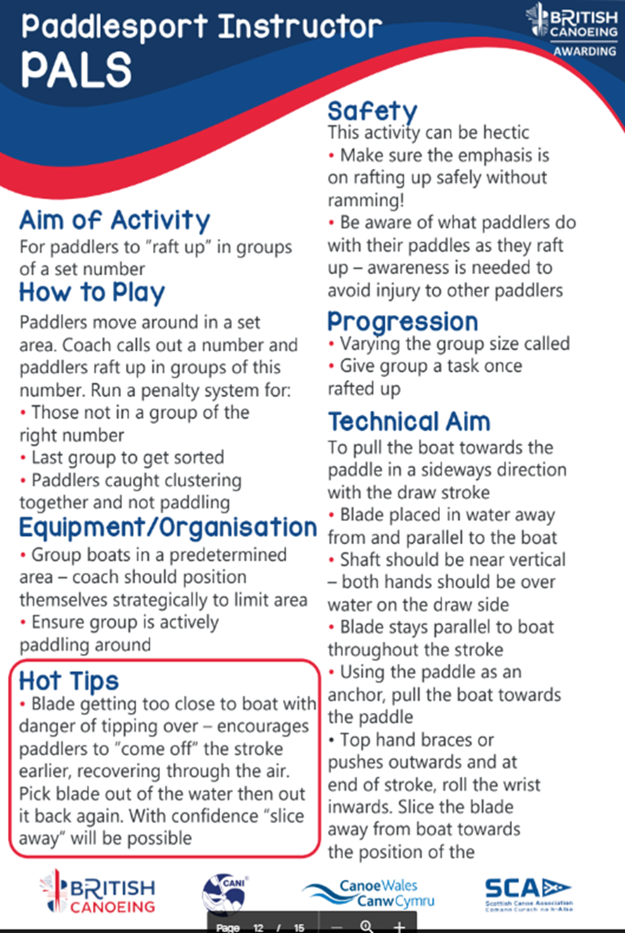

Chase The Ace
How to play
Similar to tag but you are only chasing one person. Each player has a different number from 1 onwards. If there were only 4 playing: 1 chase 2, 2 chase 3, 3chases 4, 4 chases 1.
If someone is caught, they must sprint 15 metres and back as a forfeit (this could be anything). This works well without paddles.
Technical improvement
Forwards paddling, turning, backwards, stamina and many other skills. This game could be used to focus on one particular skill such as backwards, however, playing this game you may end up using a lot more skills than you think. In addition, this game without paddles may provide opportunity to develop the fundamental ‘feel’.
Safety
Ensure you have line of sight of all paddlers, remind the paddlers of the boundaries, ty tagging boats with their hands, they are more likely to let go of their paddle rather than hit people with it.
Progression
To make this easier the paddlers can use only their hands, to get a sense of movement and how the craft they are in work, this will develop the fundamental ‘FEEL’.
Equipment
No equipment needed.
Merrifield, (2019), p50
Bull Dog
How to play
Set 2 designated safe zones, and ‘run/paddle’ zone. Start with one ‘dog’ in the middle, they must use their paddle to tap the front of the runner’s boat, 3 times, they then become in the middle and help catch the rest of the runners, until there is 1 person left. You could change the rules by adding a ball- throw the bull at someone to catch them.
Technical improvement
Forwards paddling, turning, backwards, stamina and many other skills. This game could be used to focus on one particular skill such as backwards, however, playing this game you may end up using a lot more skills than you think.
Safety
Ensure you have line of sight of all paddlers, remind the paddlers of the boundaries, ty ttagging boats with their hands (they are more likely to let go of their paddle rather than hit people with it).
Progression
Challenge paddlers by getting them to paddle in a certain way and stress the way they are paddling causing them to think more. Mixed ability groups of paddlers may need more or less challenges so that it is fair for all paddlers when playing the game.
Equipment
No equipment needed.
You could use a ball to add an extra element to the game.
Merrifield, (2019), p56
Balance games
Water Beatles
Lie down flat, or sitting up on the cockpit, face down, and use your arms and legs to move the boat around. It is a good idea to put the paddle on the side first.
Merrifield, (2019), 62
Around the world
Sit on the back of the cockpit and turn 360 degrees around. Turn to face the back of the boat and then back to the front of the boat.
Merrifield, (2019), p62
Pirates
This is a ‘last man standing’ game. The players need to paddle around and sink each other’s boats. They are not allowed to capsize them but fill their boats up. Once their boat is full, they can still play the game, however, they need to paddle a submersed boat.
Merrifield, (2019), p62
Standing and paddling
Stand up in the boat and paddle around. To make this more difficult play ‘last man standing’, where they can help each other fall into the water. You must be careful playing this game as the participants could fall and land on another boat.
Merrifield, (2019), p62

Wellbeing program
1st week
Worry jars-
You will need:
Salt
Coloured chalk
Jam jar
2 Pieces of paper
Pen
Instructions:
First open the jam jar and put it to the side of you. Lay a piece of paper on the table, in front of you, fold it in half so there is a line down the middle. Pour some salt on to the middle of the paper, now with one of your coloured chalk, rub it over the salt to make the salt change colour. When the colour is right pouring it gentle into the jar. With the other piece of paper, cut it into little pieces that you can write your worry on. Then fold it up and put that in the jar too. Now repeat it all over again, salt on to the paper, rub chalk over, until the jar is completely full. Then put the lid on. This mean you have put all your worries in the jar now. So, there is no need to worry about them.
Talk about the different kind of worries, ones you can do something about and ones you can’t, if you can’t do anything about it then, don’t worry about it, as that means you losing/wasting your time away on worrying about something you cant change.

For next week, draw 14 heart shapes on paper, cut them out and I want you to write one positive thing about yourself, whether it be your smile, body, honesty. But it must be something new for the 14 days, one on each day. Put it in your room or somewhere you look at every day. We will discuss next week.
Week 2
Hearts, affirmations
Talk about allotment
Once we have looking and spoke about everyone’s heart. Well who wants to share theirs. They now I have pick at least 3 and turn them into affirmations. So, every morning when you wake up. Repeat them to yourself, aloud. I am strong, I am kind etc. Better still do it in front of a mirror and say it to yourself aloud.
Let us know how you get on next week, as we now need to fill the hole that is left from all the worries that are not there anymore, fill it will happy positive thoughts.
Seed talk- discuss about delivering the seeds around and we can plant them on the next session
Week 3
Teaching everyone to plant seeds, allowing them to grow ready to put them in the group in our allotment when we can meet.
Talk about how they are feeling- what can we do to help
Would they like a scavenger hunt laid out for them- decided they wanted 2 different ones as not everyone was in the same area, I would get it ready and one would be delivered, other be set out ready for them to do along the way.
Week 4
Discuss how the scavenger hunts went. See how their plants are coming along
Week 5
Discuss easter egg hunt
Now they are all back at school, how can we help them, how are they feeling.
To plan the next few weeks ahead until we can hopefully meet

Placement Pictures
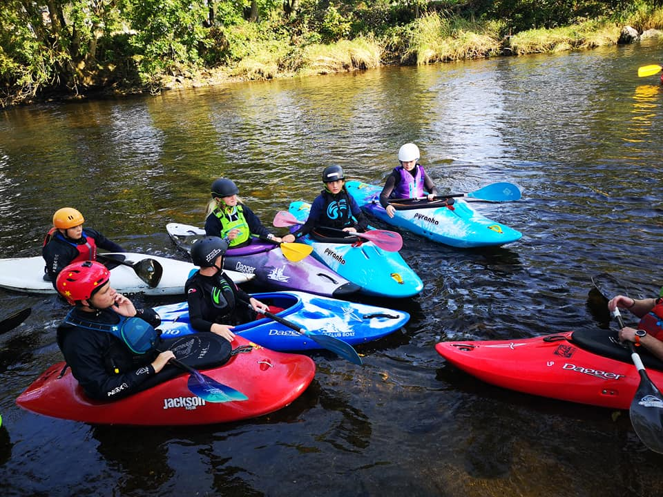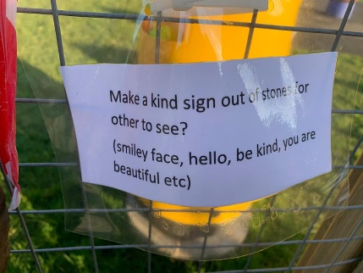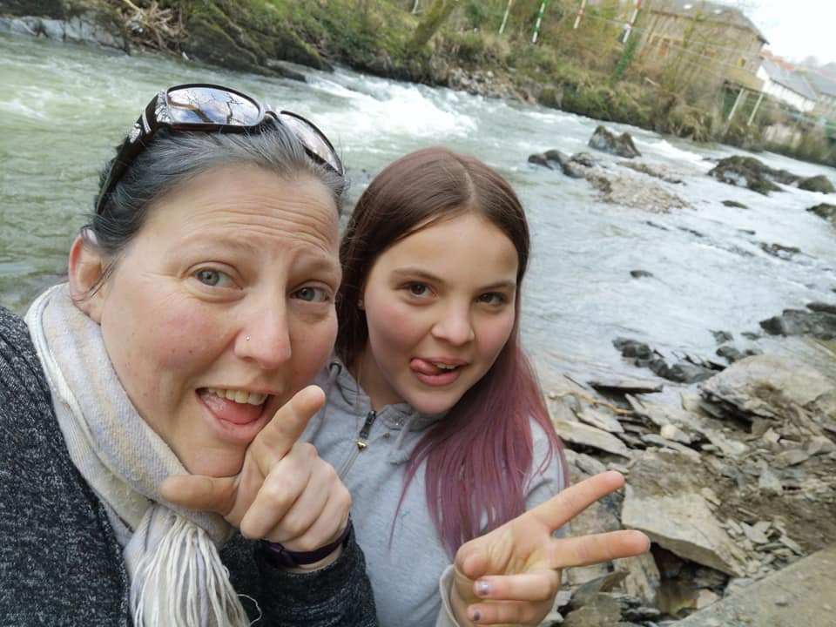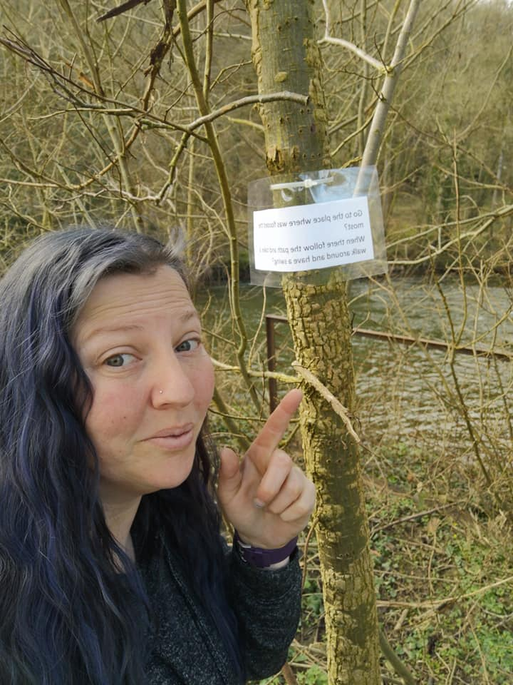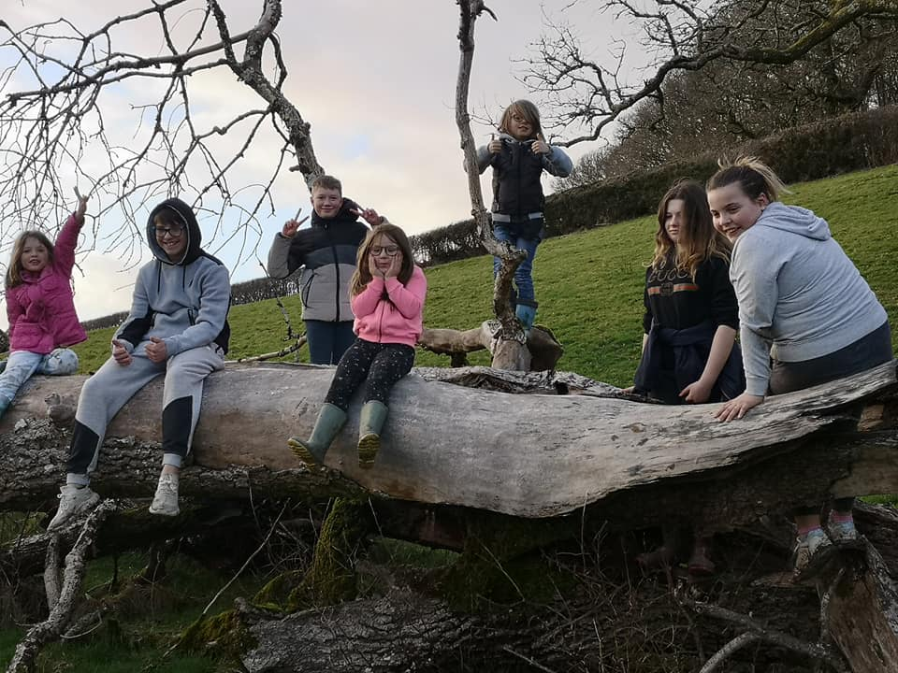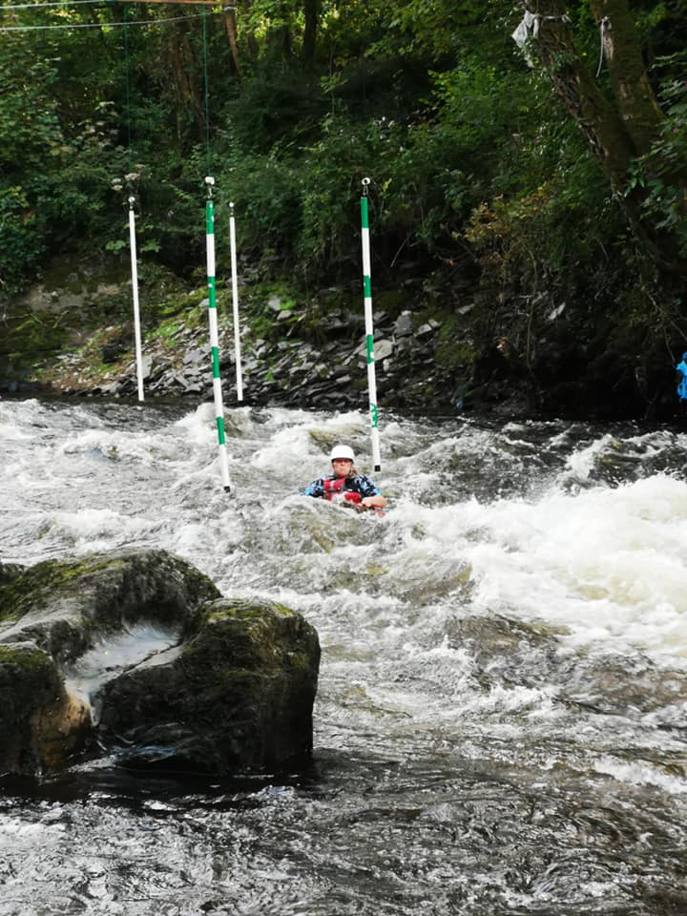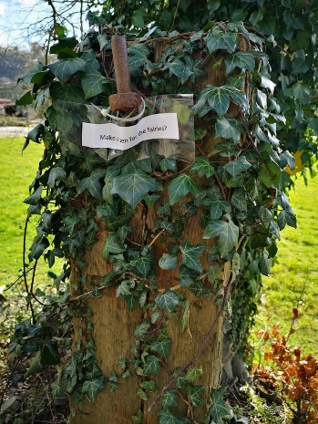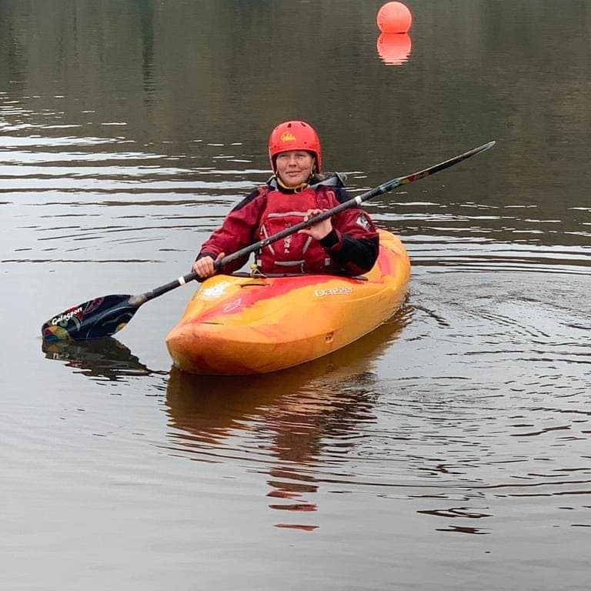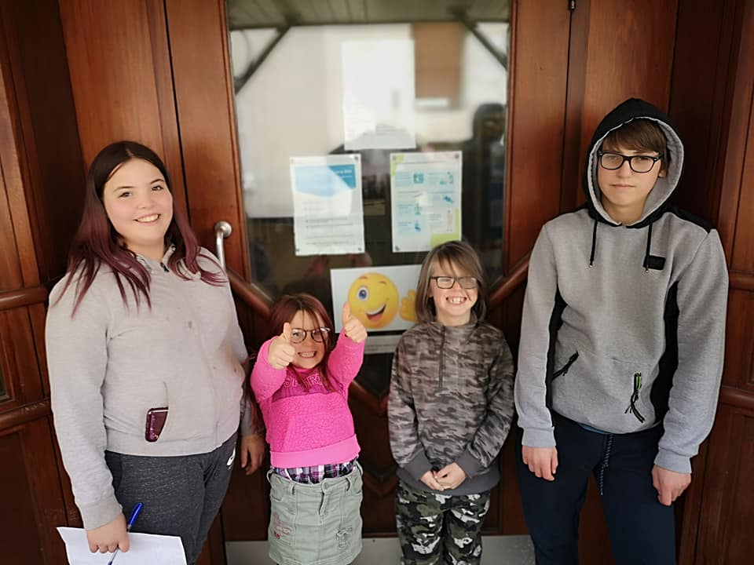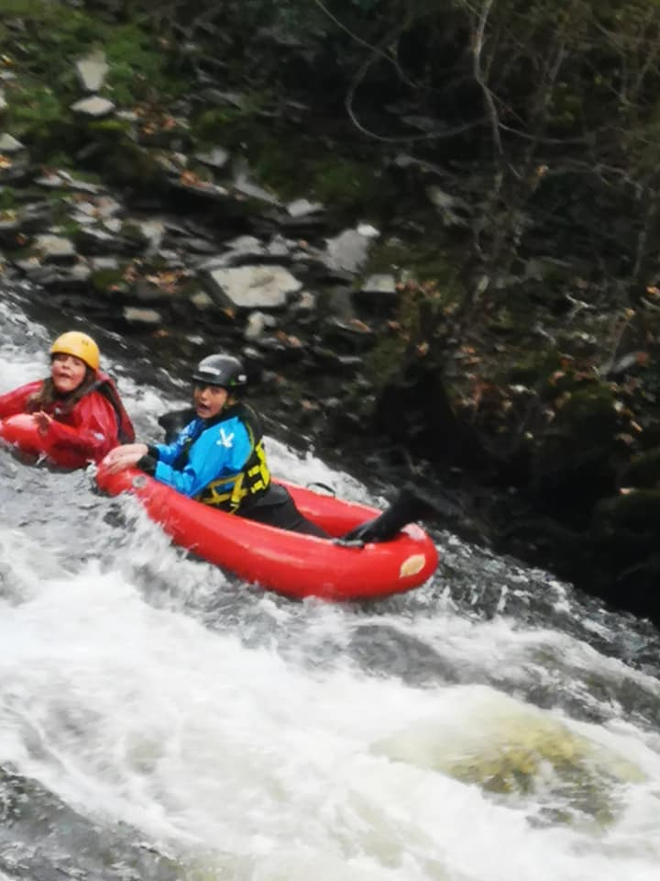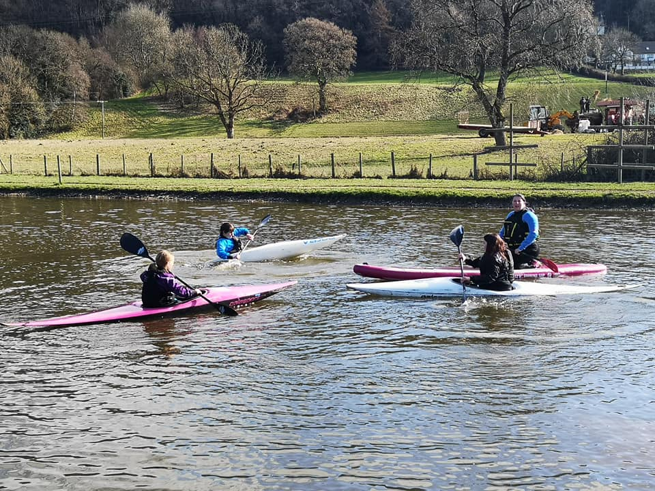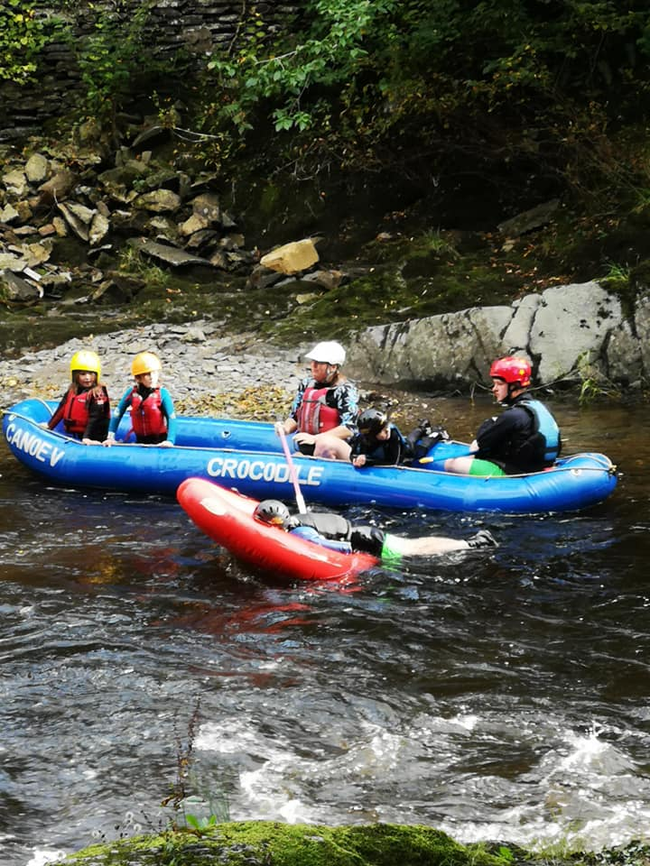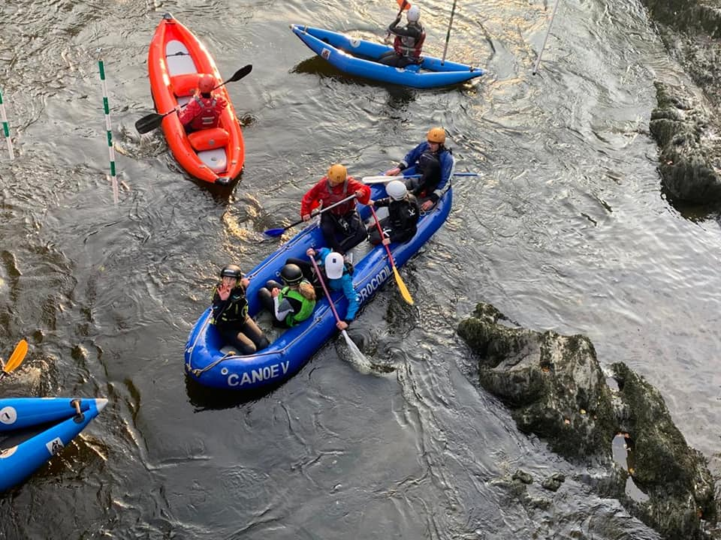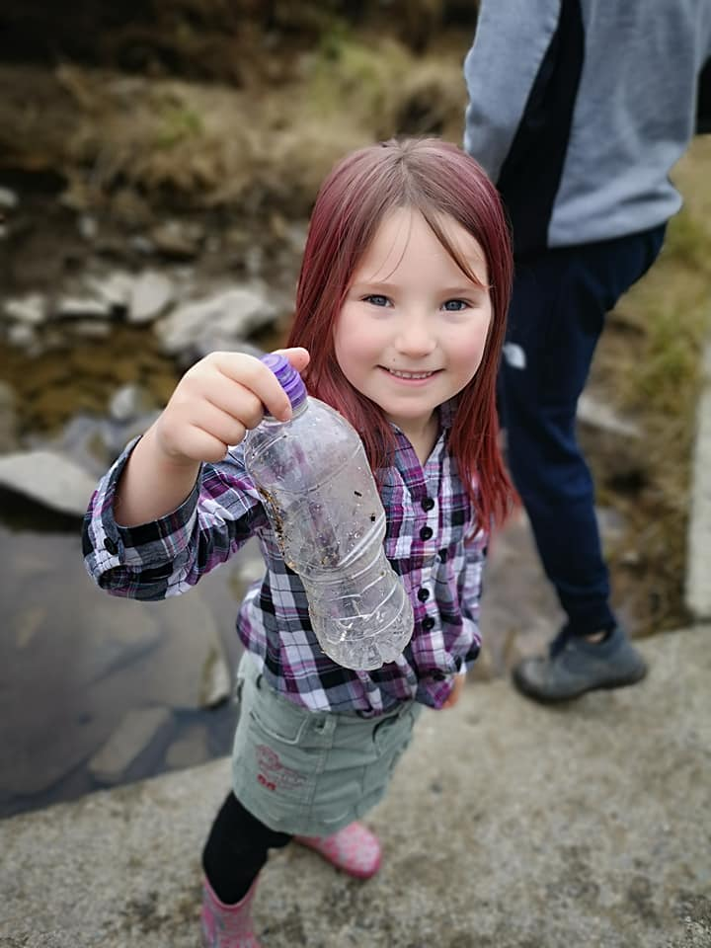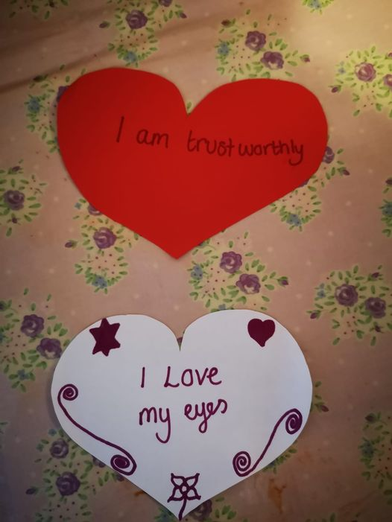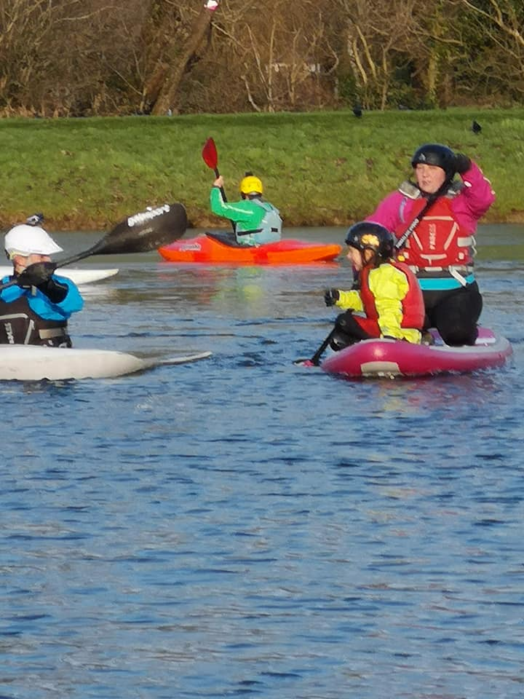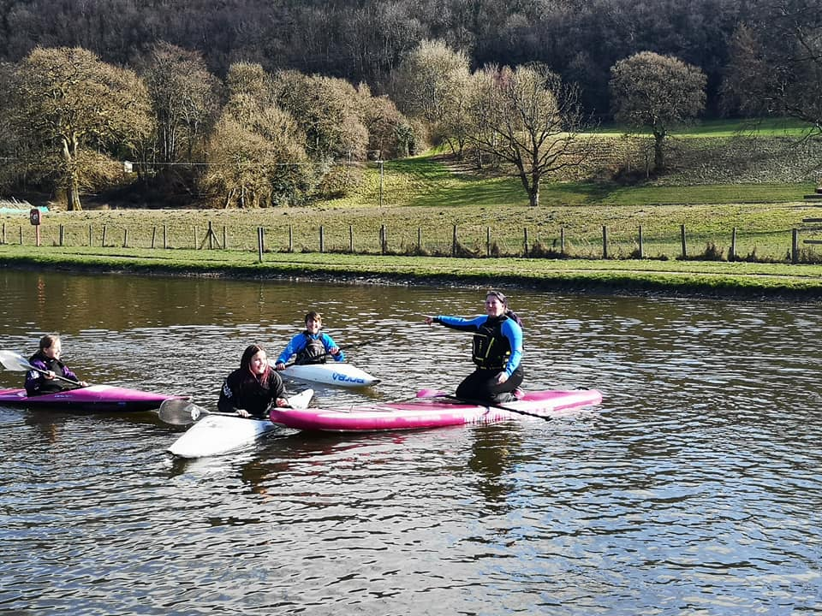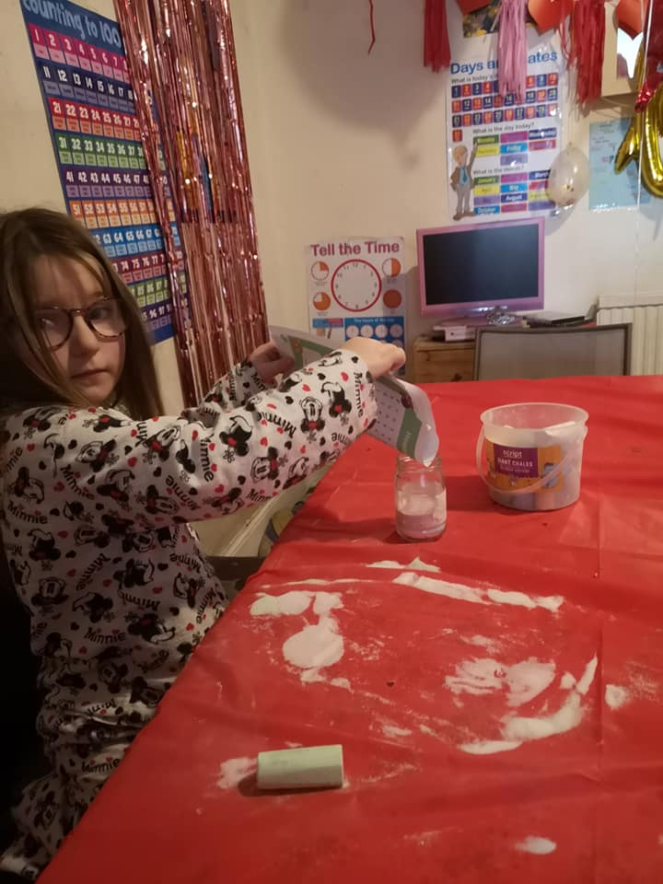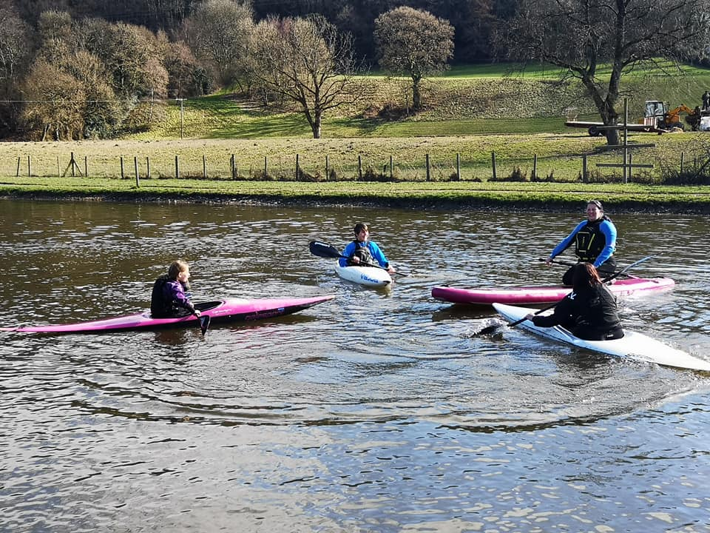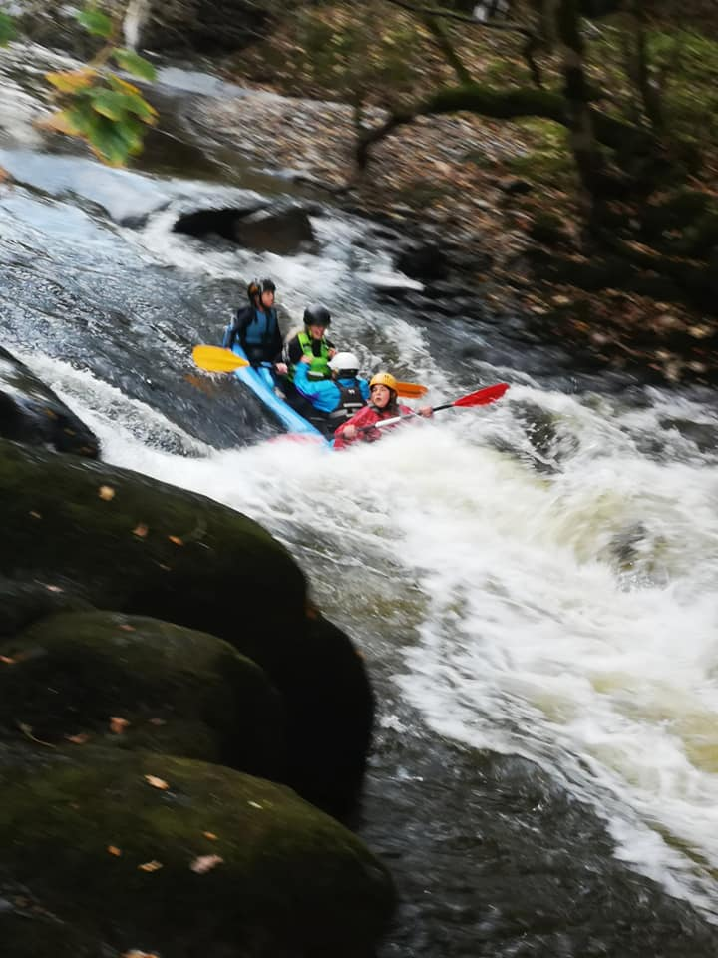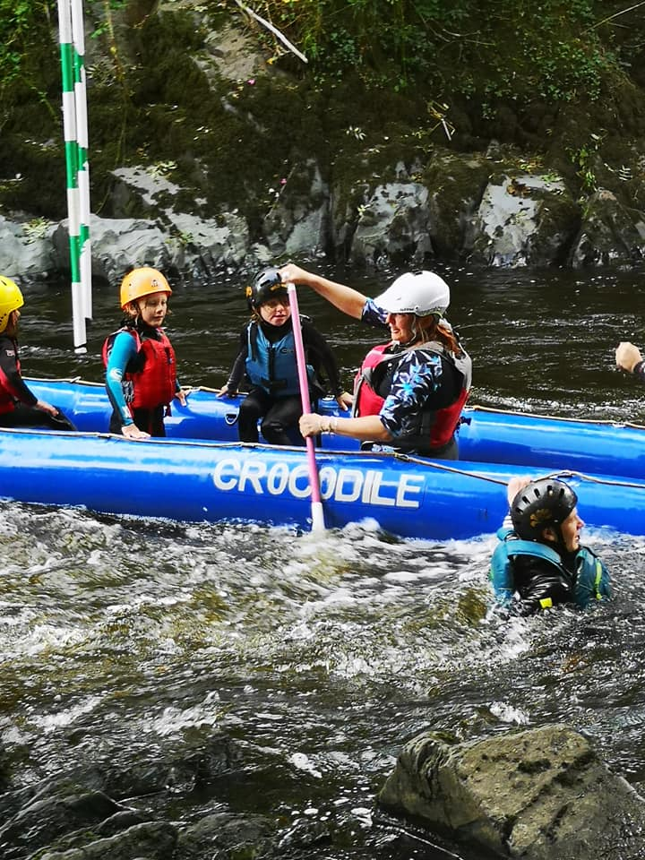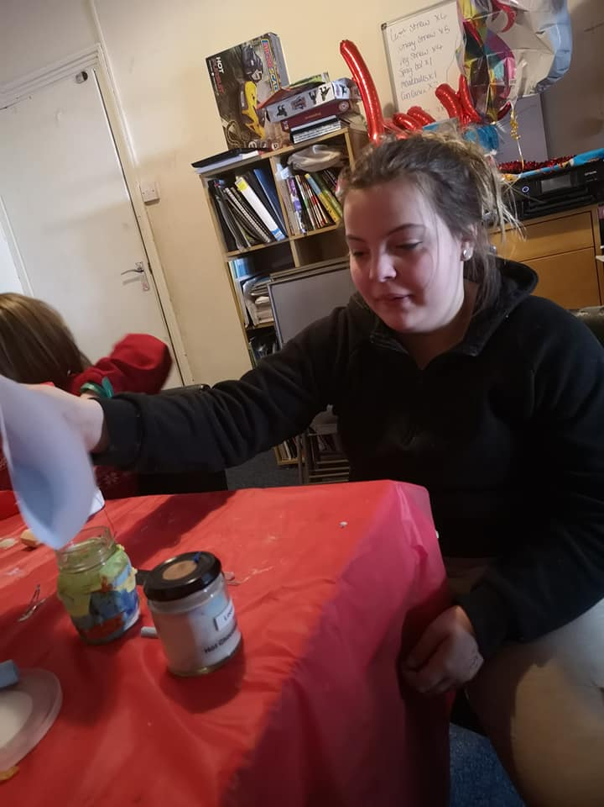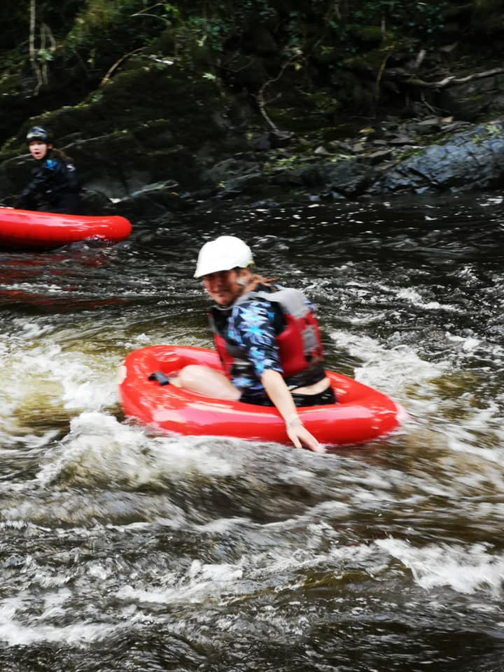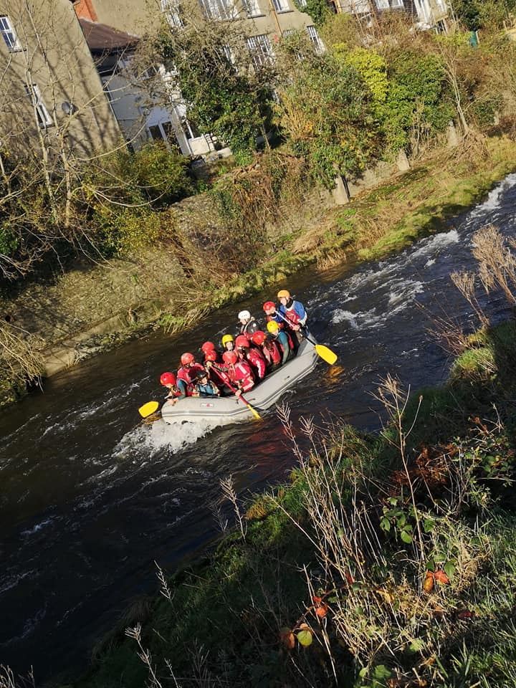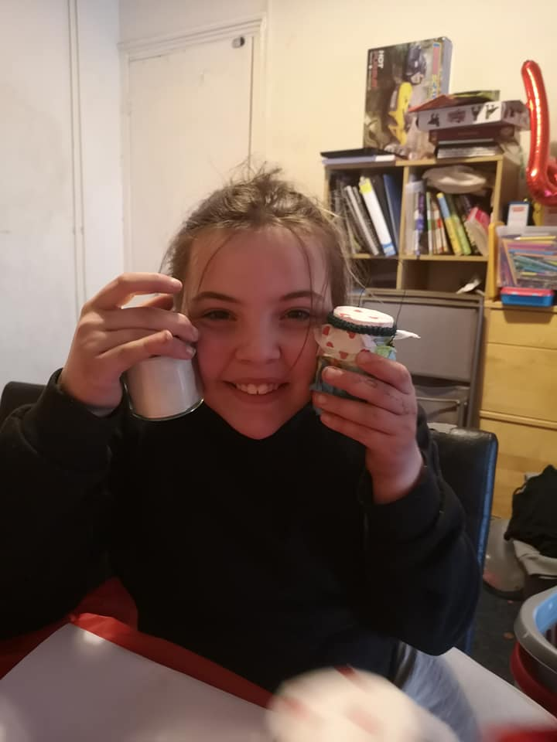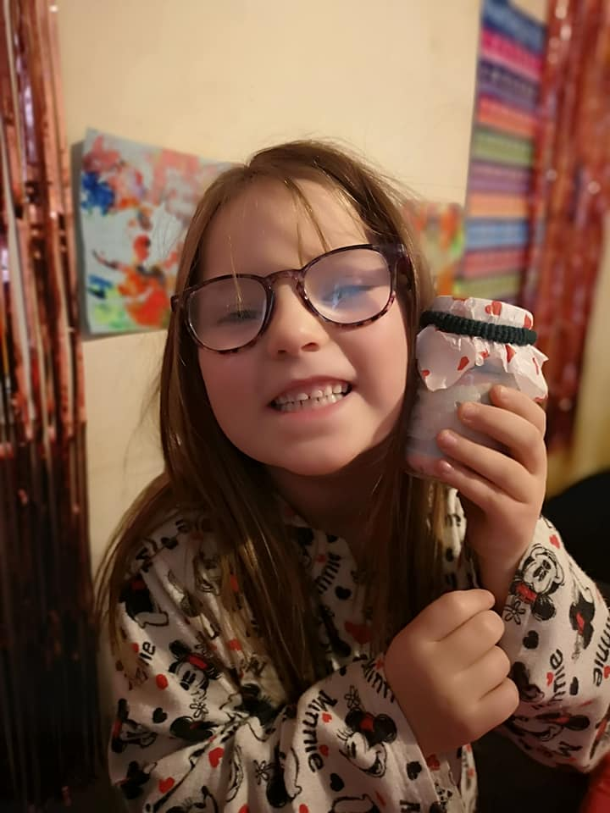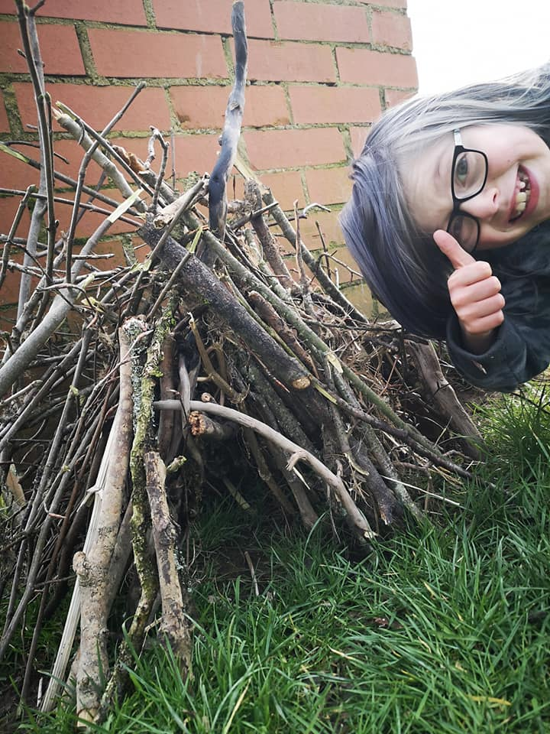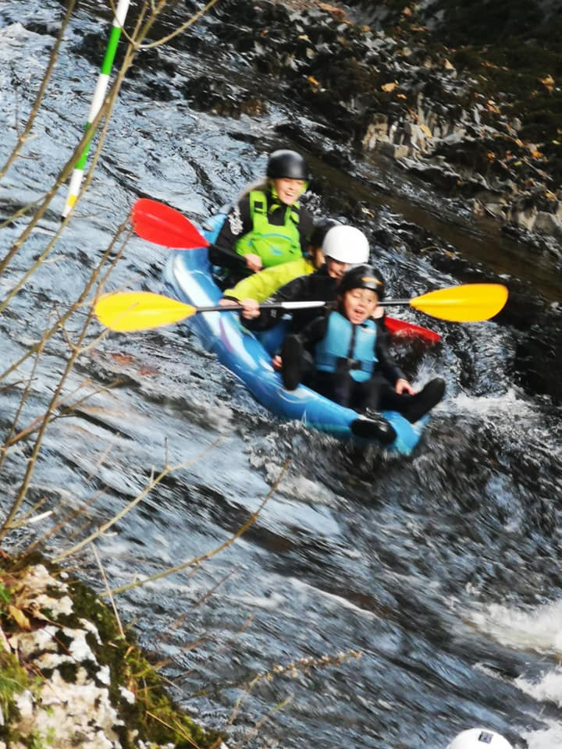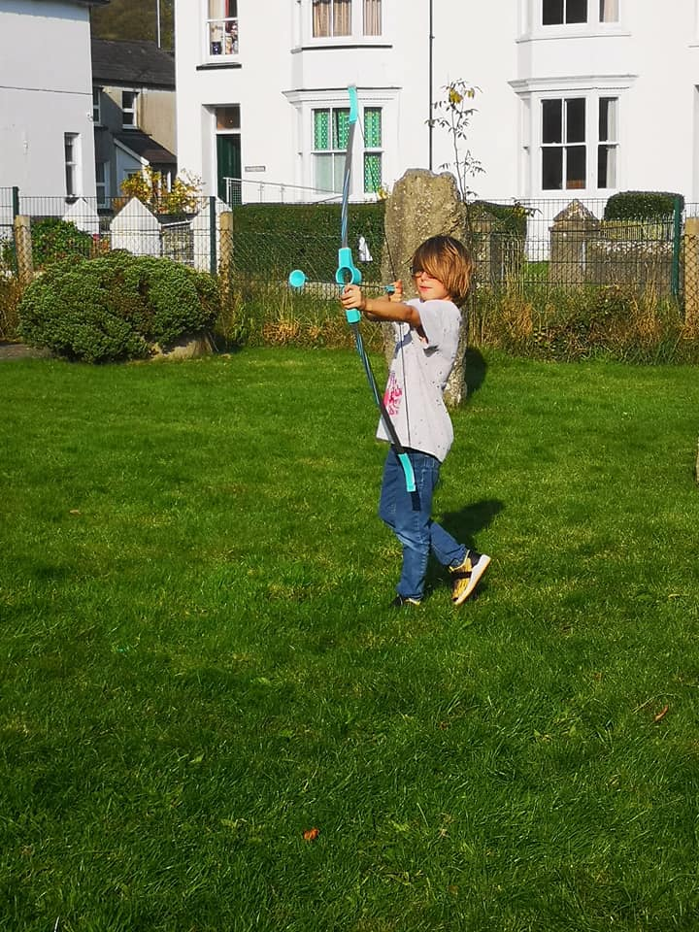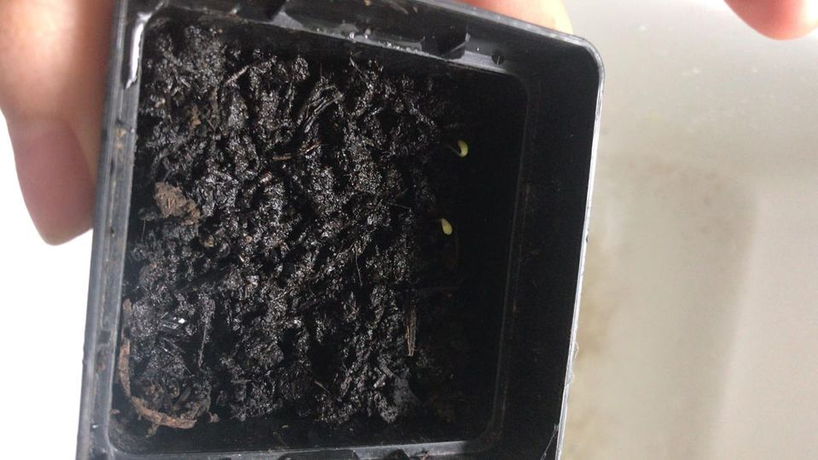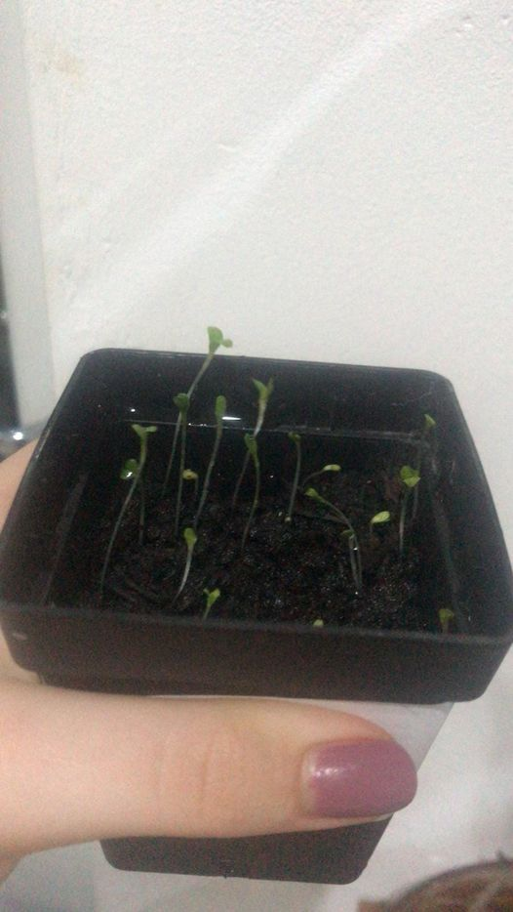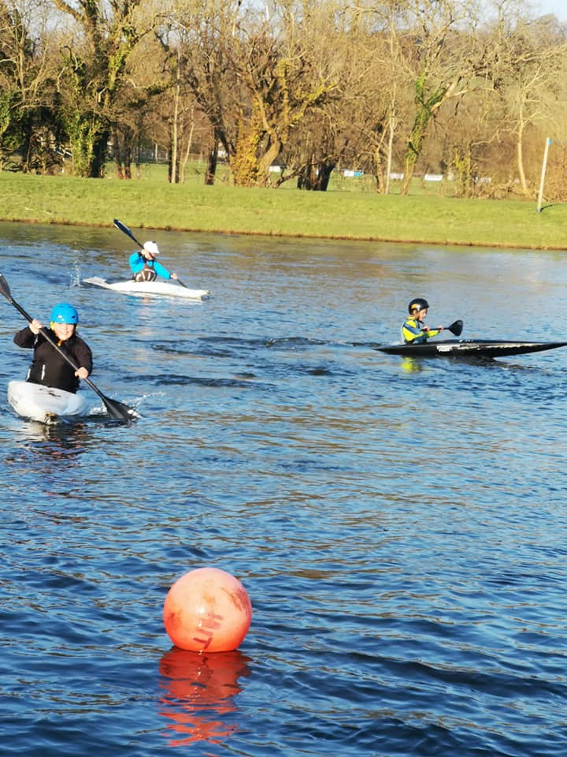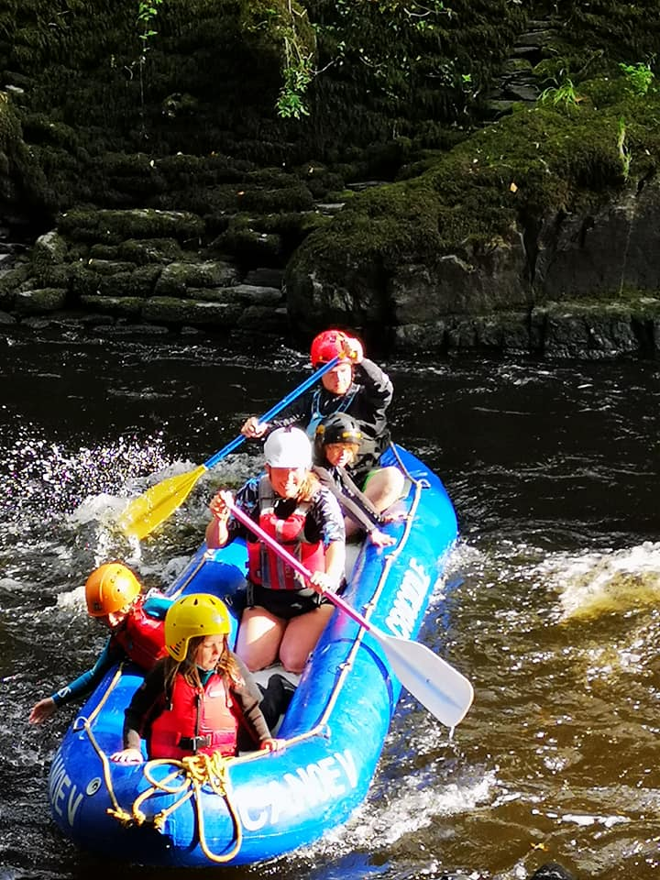

Supervision Recording
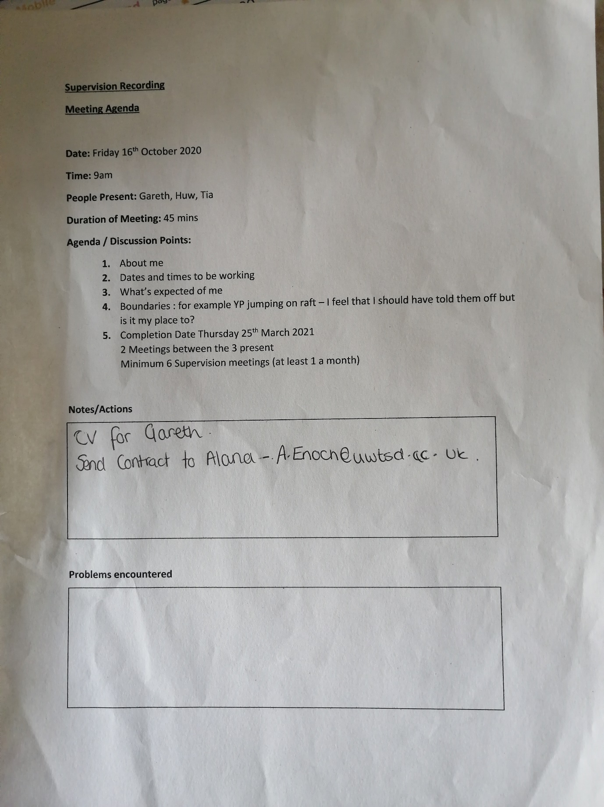

Community Profile Brainstorm

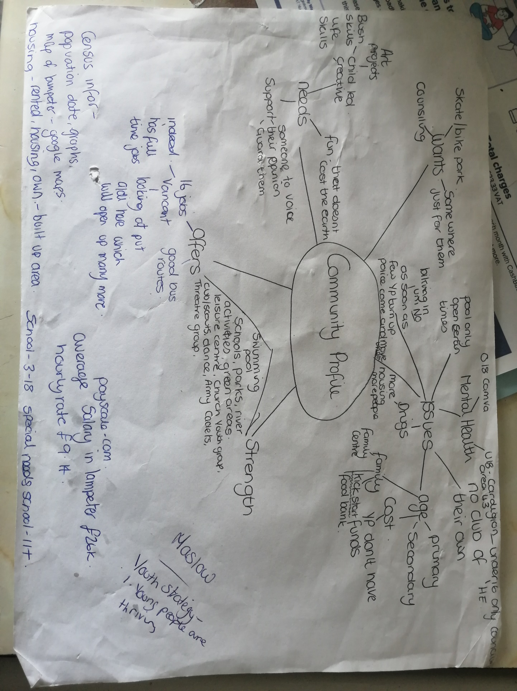

Questionnaire


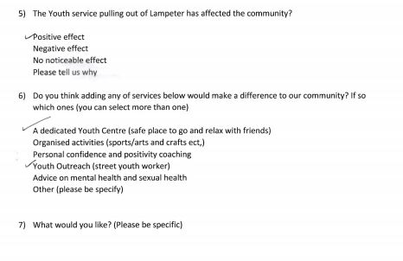

Questionnaire Results


