ARCHAEOLOGY AND THE HUMANITIES
Evan Davies

Exploring the Humanities HPHP4018
Quentin Drew
University of Wales Trinity Saint David
Oct 22, 2023

Archaeology cannot stand alone in the humanities, if archaeology does not work with the other disciplines of the humanities there will be no future for it. In this essay there will be a brief overlook on the history of the humanities, beginning in Ancient Greece, to then develop into the modern humanities we see today that is taught in universities throughout the world. There will also be a look into how humanities are treated in the education system, and why the humanities are mocked. What avenues can be taken in order to stop this? This essay will help the reader gain the ability to understand how archaeology became the discipline it is today, the history behind it and the future it holds, as well as the relationship it has with other disciplines within the humanities.
The history of the humanities begins during the age of antiquity, where the ancient Greeks had the muses. The muses were the nine patron divinities of the arts in the mythology of the ancient Greeks. The institution the muses would reside in is the Museum/Musea/Mouseion. The muses would consist of Calliope (epics), Clio (history), Erato (lyrical poetry), Euterpe (music), Melpomene (tragedy), Polyhymnia (sacred poetry), Terpsichore (dance and chorus), Thalia (comedy), and Urania (astronomy) (Murray, 2020, p. 4). These nine patron divinities would eventually evolve into the modern humanities we have in schools all around the world today. However, this is the very beginning of the history of the humanities (Drew, 2023).
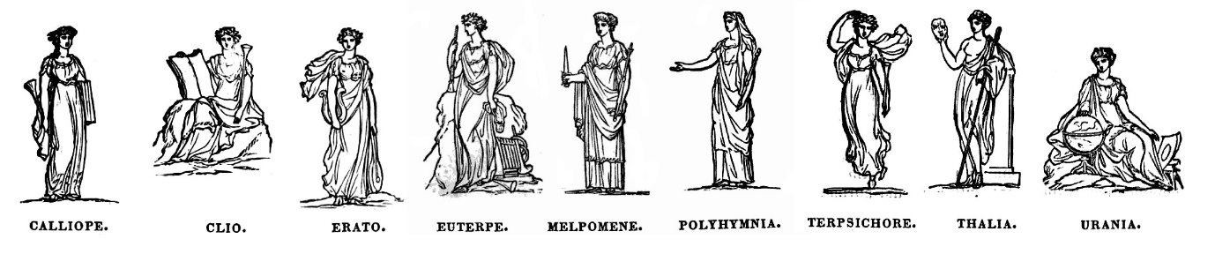
An image of the Greek muses (Greek Boston, no date)
The Romans would in many ways adopt many teachings and practices the ancient Greeks were practising, due to their proximity and the overall influence ancient Greeks had over the Mediterranean Sea during the Classical period. Because of this, the ancient Romans would have a similar form of education, which is heavily influenced and appropriated by that of the Muses. The Romans would call this the seven liberal arts. The liberal arts would be split into two sectors, the Trivium which consisted of grammar, rhetoric, and logic. For the second sector of the liberal arts, there would be the Quadrivium, which consisted of arithmetic, geometry, astronomy, and music (Bod, 2014, p. 34).
The ways of doing, or skills was the name of the education that was seen during the medieval era. However, during the Renaissance there was a huge change in direction. Eventually, the way of doing would develop into humanism, which was familiar to the ancient education that was seen in the past, such as the muses and liberal arts. During the 15th century an Italian named Petrarch would be the person “to revive classical antiquity” (Bod, 2014, p. 142). During this shift humanities would become subjects of study rather than a practice. There would also be a shift from the traditional fields, into fields such as literature and history. Yet again, in the 20th century, the postmodernist movement would change the humanities. It would redefine humanities in a more egalitarian sense. Allowing the humanities to be more suitable for a democratic society, rather than the authoritarian societies that came before it, such as the Roman and Greek societies. The shift to egalitarianism would allow people from all backgrounds to study the disciplines in the humanities. Allowing the working class, women, and more to study (Drew, 2023).
Antiquarianism is linked to archaeology; it has been seen as a precursor to archaeology. It has also had a lot of bad reception from other disciplines in the humanities, it has been described as too narrow by many scholars in the past. Even calling someone an antiquarian in the 19th century was seen as an insult. To describe antiquarianism properly, it is the study of ancient religion, law, clothing, weapons, sports, ritual, architecture, and food, which was usually associated with “early modern European men” (Anderson, 2017, p. 1). Historians and more have not liked antiquarianism due to it being “simple”, as it is just observations. Whereas history includes an interpretation of the past for example. Despite the history on the perception of antiquarianism, it is not inferior or a precursor to archaeology (Drew, 2023)
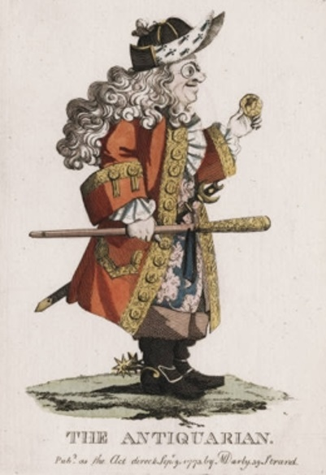

Art of an Antiquarian etching an engraving with hand colouring, this image is supposed to be derogatory towards antiquarians (Darly, 1778).
What is Archaeology? To put it simply, it is the research of human history and prehistory through material culture, the excavation of sites, and the analysis of many artefacts, and physical remains. The discipline studies a broad range of time, to be more exact, archaeology studies the entirety of human history, from the earliest hominins 4 million years ago, to the present day. Because archaeology investigates the less bias resources, such as physical remains and material culture, it allows the answer to how humans lived throughout history to be much clearer, without the influence of bias writings. As well, archaeology is important in learning about human history, only recently have humans been documenting events, or even personal lives. Due to this, 99.9% of the history of humans does not have written documentation, making it much more complicated in researching the lives of ancient humans and cousins of humans (Bate, 2011, p. 31). The most common conversation about archaeology tends to focus on the excavation of sites and fieldwork, which is especially the case in pop culture, rather than the dating and examinations of the artefacts and remains excavated during fieldwork (Daniel, 2023). The dating and examinations are the most significant part of archaeology, as it gives archaeologists the conclusions and allows understanding of these artefacts and remains to become clearer. This is vital for the study of human history and archaeology, since the practice of excavations and fieldwork become unimportant and irrelevant if the answers to these questions that are raised through new discoveries are not further analysed (Daniel, 2023). Why is archaeology important?
“Archaeology gives us the tools to examine and explain human behaviour, understand how society functions, learn from the past and apply those lessons to the present, and analyse the drivers and implications of a changing world and how different countries, places and cultures interact.” (University of Oxford, 2023).
The humanities are “a broad spectrum of subject areas” (Pearsons, no date) and the humanities cover many subjects, ranging from history to philosophy and religious studies. The humanities focus on the subjects that help understanding of what it is to be human, the past and the present. As well, the humanities focus on the study of the human condition (Pearsons, no date). Rens Bod from the New history of the humanities: the search for the principles and patterns from antiquity to the present said,
“What are the humanities? It is like the notion of ‘time’ in St. Augustine: If you don’t ask, we know, but if you ask, we are left empty handed. Since the nineteenth century the humanities have generally been defined as the disciplines that investigate the expressions of the human mind. Such expressions include language, music, art, literature, theatre, and poetry. Thus, philology, linguistics, musicology, art history, literary studies, and theatre studies all belong in the realm of the humanities.” (Bod, 2014, p. 1 - 2).
The relationship archaeology has with the other disciplines in the humanities is vast. Archaeology provides the disciplines such as history and ancient history a plethora of material evidence to either back the claims history and ancient history produces, or to argue against them. Furthermore, archaeology is effective by looking more closely into the lives of humans throughout human history. An example of this is that history only investigates the “important” events of human history, for example, the Viking invasions, history looks into the evidence left behind by monks, lords, and kings. However, archaeology investigates human history differently, compared to the way history and ancient history studies the history of humans, rather than focusing on big events and wars that have happened in the past, archaeology serves the purpose of looking deeper into human lives, how they live and their culture. Archaeology tends to focus on the physical aspects of human history, by doing this it allows modern humans a greater ability to understand how humans of the past have lived, behaved, and thought. Much more effectively than texts written by monks, nobles, and priests, which is the resources ancient history and history rely upon. The relationship archaeology has with history, anthropology, and other social sciences is that it relies on them greatly to gain context for a better understanding of human behaviour in the past. The humanities work together collectively to help the present understand the history of human past. An example of archaeology working with anthropology, specifically palaeoanthropology in an article written by Markus Milligan, a study of Neanderthal and modern Human parietal lobes, it would not be able to be compared, if not for the previous archaeological excavations of Neanderthal physical remains (Milligan, 2020). Without this understanding of human history things could potentially repeat themselves, allowing humans as a species to continue making mistakes. Therefore, the presence of the humanities in the education system is vital for society to avoid mistakes, and to help growth within society. Another positive archaeology brings to the humanities, and especially history and ancient history, is that archaeology gives the humanities a far greater understanding on how humans lived in the past, by doing this, archaeology and additionally anthropology humanises these populations that suffered or thrived under the rule of empires, dynasties, and kingdoms.
What direction is archaeology going to take, and what will be the future of archaeology? The answer to this question lies in many different factors, ranging from political, societal, to economical. Firstly, the political aspect of the direction of archaeology, and the humanities in general is an issue. With the recent conversations with Rishi Sunak in the United Kingdom, the concerns lay when Rishi Sunak said that the humanities are “rip-off courses.” This is especially worrying for the future of the humanities, as the government is “cracking down” on the humanities degrees and has focused on degrees that focus on economic growth, in order to widen access to jobs. The argument the government has given to the disrespect of the humanities is that it leaves “students saddled in debt.” Therefore, making the humanities “low value” according to the government of the United Kingdom (Omer, 2023). This can have a massive impact on how society views the humanities. The government can easily manipulate the public into viewing the humanities as needless degrees, and this will affect the number of new undergraduates that decide to study the humanities. lowering the number, not only by the amount of people that decide to apply for the humanities degrees, but also the lack of funding may affect the amount that can be accepted into the humanities as a whole. Therefore, the outcome of the conversations of the United Kingdom’s government and the conservative party may dangerously affect the future of the humanities. Despite this archaeology has continued to evolve and is continuing to evolve. People often use archaeology to further their xenophobic claims and to further political views. Archaeologist must be able to be involved in these conversations, to ensure that the research is not misconstrued (Stutz, 2018, p. 54). From the Norwegian Archaeological Review an article on the future of archaeology, Liv Nilsson Stutz says that,
“The future of our discipline is in our hands. We can change the game by driving a collaborative transdisciplinary archaeology that truly integrates multiple perspectives to understand the past, and that insists on problematising it – and our contemporary world – not on simplifying it.” (Stutz, 2018, p. 55).
The nature of archaeology is that of humans, the study of what makes humans human, by looking at the material culture, analysing the artefacts and physical remains of the thing’s humans have done in the past. This is in order to understand the cultures and lives of humans throughout history. Even including the prehistoric cousins of modern humans such as Homo Habilis. The essay also included the direction of archaeology. Where it may be led by the politics of today, and how the politics may affect the future of archaeology and the humanities, also looking at how archaeology is continuing to evolve, as well as how the discipline must collaborate with the other disciplines of the humanities to further the perspectives of archaeology. Also including the invasion of nationalism and xenophobia into archaeology and what archaeologist can do in order to fight this threat.

Reference List
Anderson, B. (2017) Antiquarianisms. online edn. Oxford: Oxbow Books
Bate, J. (2011) Public values of the humanities. online edn. London: Bloomsbury Academic
Bod, R. (2014) New history of the humanities: the search for the principles and patterns from
antiquity to the present. online edn. Oxford: Oxford University Press
Britannica. Daniel. (2023) Archaeology. Available at:
https://www.britannica.com/science/archaeology (Accessed: 16 Oct 2023)
Darly, M. (1773) The Antiquarian. [Painting] Yale University. Farmington. (Accessed: 20 Oct
2023)
Drew, Q. (2023) Introduction to the Humanities. Accessed: Moodle (Accessed: 6 Oct 2023)
Murray, P. (2020) A Companion to Ancient Greek and Roman Music. online edn. Hoboken:
Wiley-Blackwell.
Milligan, M. (2020) Study compares parietal lobes of Neanderthals and modern
Humans. Available at: https://heritagedaily.com/2020/04/fstudy-compares-parietal- lobes-of-neanderthals-and-modern-human/127241 (Accessed: 20 Oct 2023)
Pearsons (no date) Humanities matter. Available at: https://www.pearson.com/en-
gb/schools/subject-resources/humanities.html (Accessed: 17 Oct 2023)
Stutz, LN (2018) A Future for Archaeology: In Defense of an Intellectually Engaged,
Collaborative and Confident Archaeology. online edn. Milton Park: Taylor & Francis
The Guardian. Omer (2023) Tuesdays briefing: What Rishi Sunak’s plans to cut down on
“rip-off” courses actually means. Available at: https://www.theguardian.com/world/2023/jul/18/first-edition-low-value-degrees-university-rishi-sunak (Accessed: 18 Oct 2023)
University of Oxford (2022) School of Archaeology. Available at:
https://www.arch.ox.ac.uk/why-archaeology-matters (Accessed: 17 Oct 2023)

