BSc (Hons) SPORT AND EXERCISE THERAPY
No.1

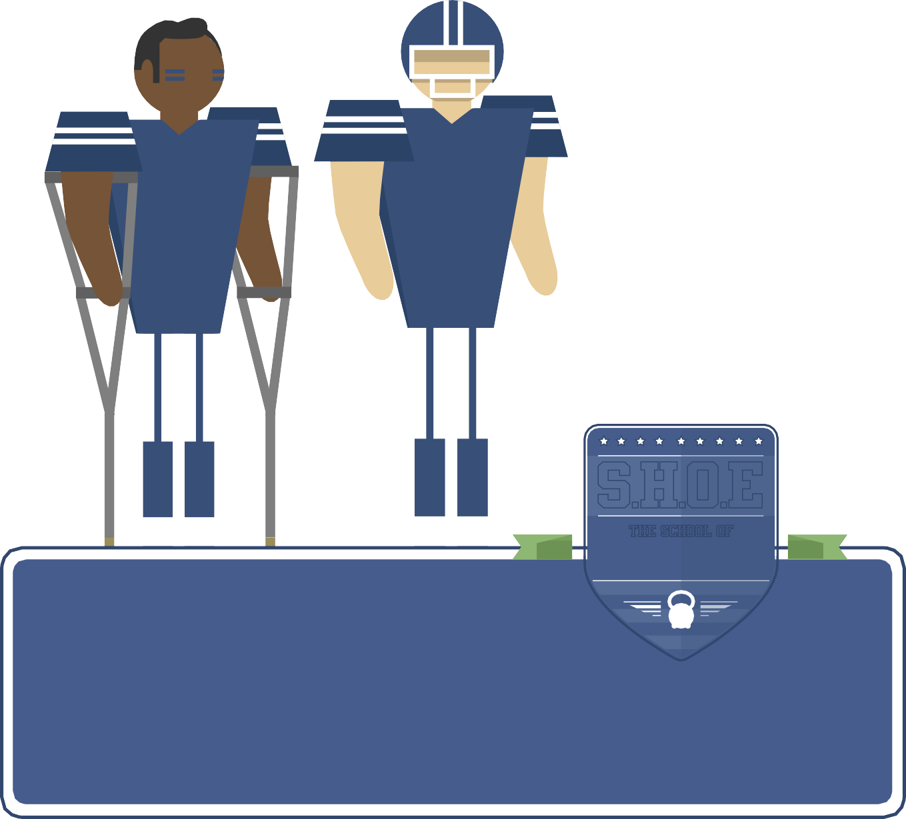



THe School Of
SPORT, HEALTH and OUTDOOR EDUCATION

Lower Limb
KG





BMST 4001 - functional anatomy handbook

Palpation of location of bony points and surface markings of:
Introduction

Having an excellent understanding and knowledge of anatomy is extremely important when working as a Sports Therapist. If you do not know your anatomy then you cannot begin to treat and rehabilitate an injury or even know what injury you are meant to be treating.

The following workbook has been put together to aid your learning of anatomy during your degree. Please use it to make notes and practice your functional anatomy.

range of movement

Every joint that you will assess will have a certain range of movement. As a Sports Therapist you will need to know which movements occur at each joint. During an examination and assessment range of movement is examined in THREE different ways:
- Use the pads of the fingers and / or thumb because they have better discrimination – They can detect points as close as 1-2mm apart!

- Only palpate with one hand as it can get confusing for the patient if they can feel lots of fingers and thumbs! Slow, firm and precise movement of the fingers is needed during palpation. You should not randomly touch
/poke/prod! You are looking for differences between limbs.

- Palpation takes practice, but practice will make it better / easier to identify key bony points and landmarks. You must know your bony points as this will make muscle testing and ligament testing easier.
- Patients must be relaxed during palpation.

- The Therapist needs to explain to the client what they are doing and have tact and sensitivity.

You must look after your hands. Make sure they are clean and smooth. If you do work which may produce calluses be careful or wear gloves. Your hands are your future!

Active:
The range of motion a client can achieve on their own (without assistance). Look at the quality of movement, sticking points, ROM, symmetry of motion. You must Assess FULL ROM - from one end of range to the other and back again. For example when testing flexion, you must go from extension to flexion and then back to extension again.

Passive:
The client takes the joint through the specific range of motion and then the therapist adds an over pressure at the end. This is to see whether there is a passive spring at the end of the joint.

Resistive:
The client takes the joint through the specified range of motion and then you apply a resistance. This examines whether the joint has an ability to protect itself.

Practical Anatomy and
Palpation of the Foot and Ankle

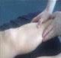
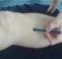
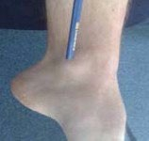
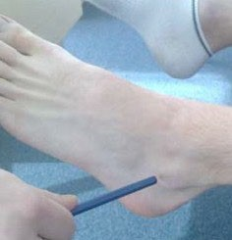
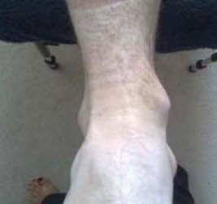
The client should be supine, relaxed, socks off and wearing shorts.
The feet need to be off the edge of the bed when examining the foot and the ankle.

Palpation

Anatomical Point Palpation

Anterior border of the tibia

Medial border of the tibia

Medial Malleolus

Lateral Malleolus

Talocrural joint line
Anatomical Point Palpation

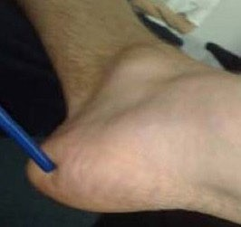
Calcaneum (gross)

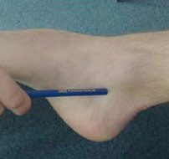
Sustentaculum tali of the calcaneum

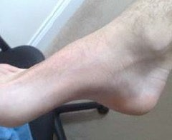
Tuberosity of navicular

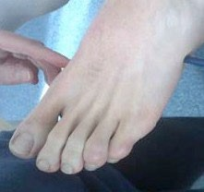
Base of the 5th metatarsal

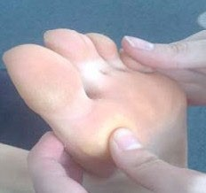
Heads of all 5 metatarsals

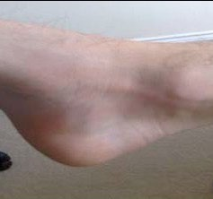
Sub talar joint line

Range of movements 3. Palpate and identify the extent of:

Movement Active Passive Make sure you know the attachments and can demonstrate the entire length of the ligament.

Plantarflexion Ligament Origin, Insertion & Action Palpation

Anterior Talofibular Ligament

Dorsiflexion

Calcaneofibular Ligament

Inversion (Sub-talar)

Posterior Talofibular Ligament

Eversion (Sub-talar)

Inversion (Mid-tarsal)
Deltoid Ligament -
2 layers, deep not palpable, superficial 3 bands

Enversion (Mid-tarsal)

4. Demonstrate by contraction the specified muscles:

You need to explain what you are going to do before you do it. Remember to ‘say’ then ‘do’. This assessment should not be a fight with your client! Start off with a gentle application of force and progress to a stronger application of force if the muscle is not injured. The contractions must be performed in mid to inner range – where the muscles are at their strongest.

Muscle Origin, Insertion & Action Demonstration
Muscle Origin, Insertion & Action Demonstration

Tibialis Posterior

Tibialis Anterior

Extensor Hallucis Longus

Extensor Digitorum Longus

The Peronei (as a group)
Flexor Hallucis Longus

Flexor Digitorum Longus

Gastrocnemius

Soleus

Anatomical Point Palpation
Practical Anatomy and Palpation of the Knee and Thigh

The patella tendon (ligament)

active and passive movements

Movement Active Passive

The tibial tuberosity

Flexion

Tibial plateau

Extension

The head of the fibula

location of bony points and surface markings of:

The following bony points/markings are often easier to palpate with the knee in slight flexion because the contours of the knee / patella disappear in extension.

Anatomical Point Palpation
The epicondyles of the femur

The superior & inferior poles of the patella

The medial & lateral borders of the patella
The joint line of the knee (tibio femoral)

Palpate and identify the extent of:

Ligament Origin, Insertion & Action Palpation

Demonstrate by contraction, and palpate, the specified muscles:

Muscle Origin, Insertion & Action Demonstration

Medial Collateral Ligament (MCL)

Lateral Collateral Ligament (LCL)
Quadriceps (as a group)

Vastus medialis in isolation

Also be aware of:

- Anterior Cruciate Ligament (ACL)

- Posterior Cruciate Ligament (PCL)
Rectus Femoris in isolation

The hamstrings as a group

Popliteus

Practical Anatomy and Palpation of the Hip

active and passive movements

Movement Active Passive

Location of bony points and surface markings of:

Anatomical Point Palpation

Flexion

Extension
Anterior Superior Iliac Spine (ASIS)

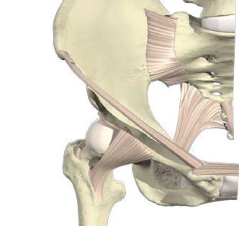
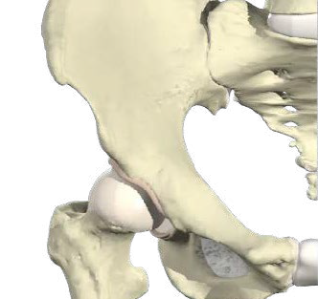
Pubis Symphysis

Adduction

Abduction

Inguinal ligament

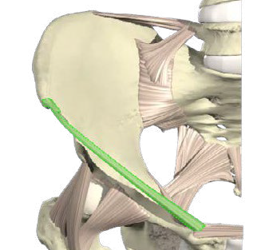
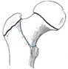
Greater trochanter of the femur

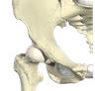
Lateral Rotation Joint line of the hip

Medial Rotation

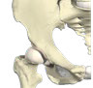
Anterior Inferior Iliac Spine (AIIS)

2. Location of bony points and surface markings of:

Anatomical Point Palpation

4. Demonstrate by contraction, and palpate, the specified muscles:

Muscle Origin, Insertion & Action Demonstration

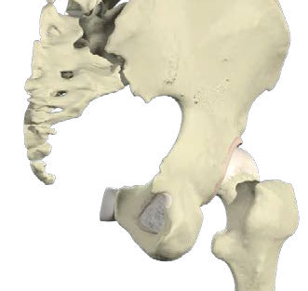
Ischial tuberosity

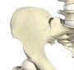
Iliac crests

Rectus femoris

Illiopsoas group

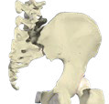
Posterior Superior Iliac Spine (PSIS)
Adductor Brevis

Be aware of the supporting ligaments of the hip:

  - The pubo-femoral ligament

  - The ischio-femoral ligament

  - The ilio-femoral ligament

Adductor Longus

Adductor Magnus

Tensor Fascia Lata

Demonstrate by contraction, and palpate, the specified muscles:

Muscle Origin, Insertion & Action Demonstration

Gluteus Medius and Minimus (as a group)

Gluteus Maximus

Hamstrings (as a hip extensor)



Prifysgol Cymru
=,.
=,.
•
Y Drindod Dewi Sant

University of Wales
Trinity Saint David www.uwtsd.ac.uk

