Morgan Discombe-Hughes

Database Design and Implementation Report

Contents
Introduction 2
Database Design 2
Implementation Documentation 2
Conclusion and Reflection 4
6.1 Conclusion 4
6.2 Reflection 4
References 5

The following SQL and Database was done in Microsoft SQL Server due to original application not running on my laptop

Introduction
This report presents the design and implementation of a relational database system for managing Students’ Union clubs and memberships. It replaces the existing spreadsheet-based approach by providing structure, integrity, and improved data management efficiency.

Database Design
The database for the Students’ Union system is organised around three key entities: Student, Club, and Membership. These tables correspond to the core operational requirements for tracking clubs and student participation. The structure effectively models the many-to-many relationships where a single student may join multiple clubs, and a single club may accept multiple students.

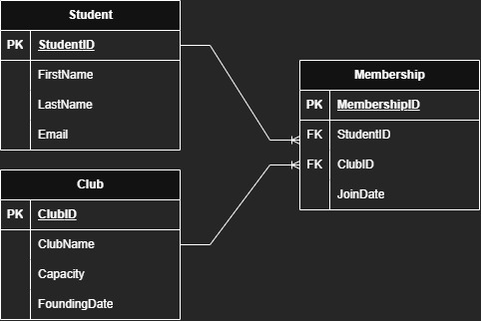

Implementation Documentation
This section provides SQL scripts, sample data, and system features. Screenshots should be added at marked locations.
- Table Creation
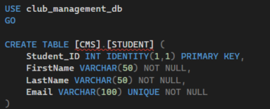
- Sample Data Insertion
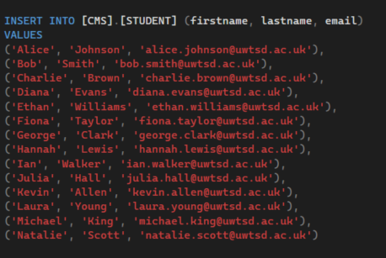
- Trigger Execution
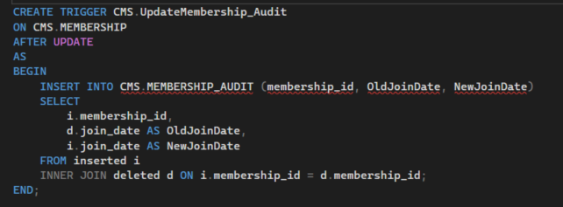
- Stored Procedure Execution
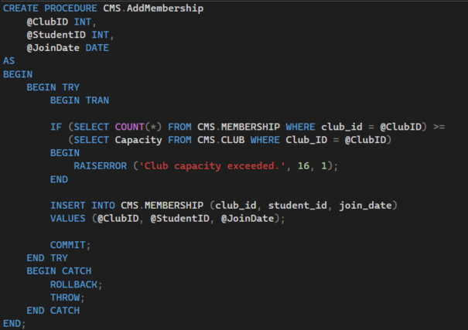

Conclusion and Reflection

6.1 Conclusion
The implemented relational database system successfully meets the core requirements of the Students’ Union by providing a structured, normalised, and efficient approach to managing clubs, students, and memberships.
The design—centred around the Student, Club, and Membership tables—captures all essential relationships using a clean, fully normalised data model. Referential integrity is ensured through foreign key constraints, preventing inconsistent or orphaned membership records.
The SQL Server implementation incorporates essential integrity and operational features such as:
Stored procedures for controlled data manipulation
Transaction handling using BEGIN TRAN, COMMIT, and ROLLBACK
Audit triggers for maintaining historical change logs
Indexes to optimise query performance
Together, these components create a robust, secure, and scalable solution that significantly improves the Students’ Union’s ability to manage club-related data efficiently and reliably.
This system reduces redundancy, improves data quality, and supports faster retrieval of important operational information—offering a substantial improvement over the original spreadsheet-based approach.

6.2 Reflection
Throughout the development of this system, several challenges were encountered and solved through iterative refinement:
1. Designing a Normalised Schema
Ensuring the database adhered to 3NF required careful separation of entities and the creation of a Membership table to manage the many-to-many relationships. This process reinforced the importance of normalisation to reduce redundancy and maintain long-term data quality.
2. Implementing Transaction-Safe Procedures
Building stored procedures with transaction logic highlighted the need for atomic operations. A key challenge was ensuring that operations such as adding a membership would roll back correctly if capacity limits were exceeded. Using TRY…CATCH, RAISERROR, and transactional blocks improved reliability and system stability.
3. Creating an Effective Audit Trail
Designing triggers to log membership updates required careful handling of the inserted and deleted pseudo-tables. Implementing this successfully demonstrated how audit logs support accountability and transparency in real database systems.
Overall, the project provided valuable practical experience in database design, SQL implementation, and performance optimisation, reflecting real-world database development practices.

References
[1] R. Elmasri and S. B. Navathe, Fundamentals of Database Systems, 7th ed. Pearson, 2016.
[2] C. J. Date, An Introduction to Database Systems, 8th ed. Addison-Wesley, 2004.
[3] Microsoft, “SQL Server Documentation,” Microsoft Learn.
https://learn.microsoft.com/sql/
[4] W. Kent, “A Simple Guide to Five Normal Forms in Relational Database Theory,” Communications of the ACM, vol. 26, no. 2, pp. 120–125, 1983.
[5] T. Connolly and C. Begg, Database Systems: A Practical Approach to Design, Implementation, and Management, 6th ed., Pearson, 2015.
[6] M. Stonebraker and P. Brown, Object-Relational DBMSs: Tracking the Next Great Wave, Morgan Kaufmann, 1999.

