

Student Name: DHRUMILKUMAR KETANKUMAR PATEL

Student ID:2510610

Module Name: Marketing Management

Module Code: LCMB7024

Lecturer’s Name: Dr Laila Maazouz (London)

Work Count: 2741

Term 1

Table of Contents
1. Introduction 4
2. Task 1: Critical Analysis of the Macro Marketing Environment 6
2.1 Overview of the Macro Marketing Environment 6
2.2 Selected External Macro Marketing Actors 8
(1) Legal Factors 8
(2) Technological Factors 9
Selected Macro Environmental Actors and Their Relevance 9
2.3 Critical Analysis of Each Actor 10
A. Legal factors 10
Strategic Implications 12
B. Technological factors 13
Strategic Implications 15
3. Task 2: Strategic Responses of Pioneering and Follower Organisations 15
3.1 Pioneering Organisations’ Strategic Responses (Uber) 15
3.1.1 Response to External Challenges and Opportunities 16
3.1.2 Strategic Models for Pioneering Firms 16
(A) Ansoff’s Growth Matrix 16
(B) Porter’s Generic Strategies 18
3.2 Follower Organisations’ Strategic Responses (Bolt) 19
3.2.1 Responses to External Challenges and Opportunities 20
3.2.2 Strategic Models for Follower Firms 20
(A) Ansoff’s Growth Matrix 20
(B) Porter’s Generic Strategies 21
4. Conclusion 22
5. References 23

List of Tables and Figures

Table 1:Selected Macro Environmental Actors and Their Relevance 10
Table 2: Strategic Implications 13
Table 3: Strategic Implications 15
Table 4: Ansoff’s Growth Matrix – Uber (Pioneer) 17
Table 5: Porter’s Generic Strategies – Uber (Pioneer) 18
Table 6:Porter’s Generic Strategies – Bolt (Follower Organisation) 22

Figure 1: PESTLE Framework 6
Figure 2:PESTLE Analysis for Uber 7
Figure 3: PESTLE Analysis for Bolt 8
Figure 4:Uber’s Market Leadership, Growth, and Profitability Metrics (2022–Q1 2025) 11
Figure 5:Estimated Legal Costs Faced by Uber Due to Class Action and Arbitration Claims Filed by Drivers 12
Figure 6: Categorisation of Uber Ride Services Based on Vehicle Type and Service Features 14

1. Introduction
This report makes a critical examination of strategic marketing responses in the global ride hailing and mobility industry with a specific focus on a comparative analysis between the pioneer firm Uber versus the follower firm Bolt. The purpose of this study is to evaluate the way that external macro-environmental forces influence strategic decision-making activities and how the firms experience the need to implement competitive approaches that will help their companies in maintaining performance on the market.
In an environment where the macro marketing environment plays a crucial role, it is essential to have a thorough understanding about it since external forces, such as regulation, technological disruption, consumer behaviour and economic conditions, form the foundation for competitive advantage, pose constraints on business models and outline opportunities for growth.
The environmental analysis helps organisations foresee any threats and be proactive in the market transition and be able to balance the strategic actions with the changing industries. The report is organized to include two tasks. The critical analysis of key macro-environmental players that affect the mobility industry on the frameworks as PESTEL that is supported by industry data is critically analysed in Task1. Task 2 assesses strategic responses of pioneering and follower firms with Ansoff Growth Matrix and Porters Generic Strategies after which a conclusion is given.
Selected Industry- Ride-Hailing & Mobility Platforms


Pioneer company – Uber


Follower company- Bolt
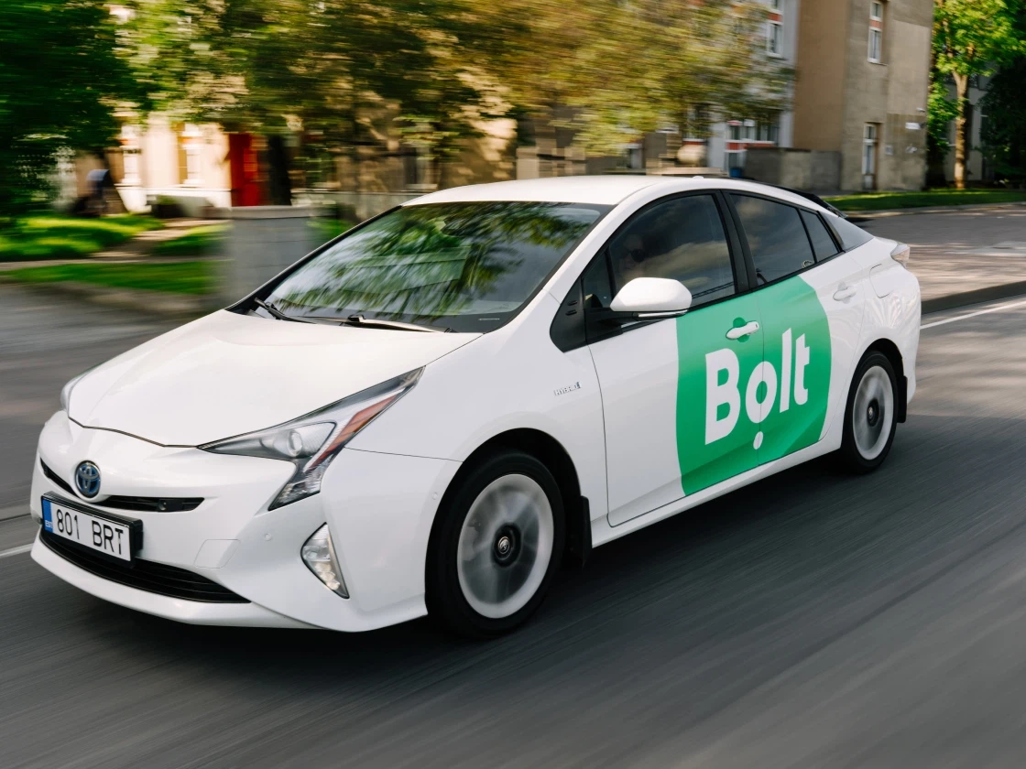

2. Task 1: Critical Analysis of the Macro Marketing Environment

2.1 Overview of the Macro Marketing Environment
The macro marketing environment comprises of external forces which impact the behaviour of industries and strategic results outside the aegis of individual organisations. Within the ride - hailing and mobility sector, such forces modulate pricing structures, employment models, safety regulations, technology adoption and environmental compliance.
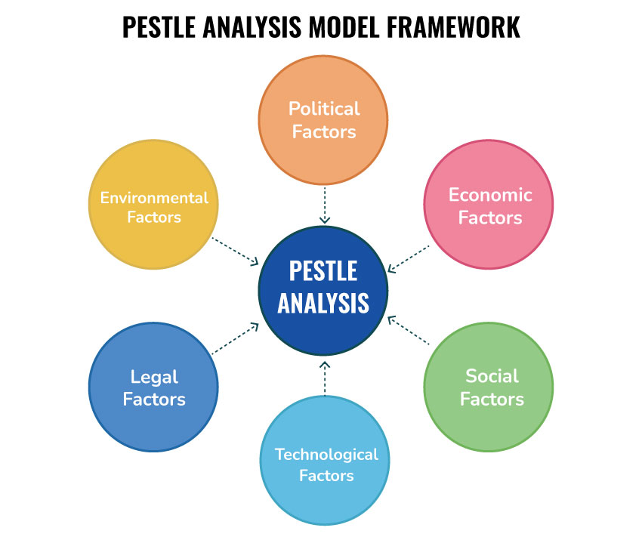
Figure 1: PESTLE Framework
(Source: Siskos et al., 2025).
The PESTEL framework, which includes Political, Economic, Social, Technological, Legal, and Environmental forces is often used to analyse these determinants to reach decisions about market penetration, potential for growth and positioning in the competitive landscape (Siskos et al., 2025).
The source of competitive differentiation, in the context of platform-based mobility, regulatory disruption, technological innovation, and data strategies is the background of competence. As an innovator, Uber was able to take advantage of the weaknesses of the regulation at the start-up to scale relatively quickly, but other newcomers like Bolt have no choice but to operate within regulated environments, developed labour laws, and increased compliance inspections (Collier et al., 2018). Moreover, the shift to autonomous cars and environmental friendliness all over the world continues to redefine industry approaches (Tu et al., 2024).
PESTLE Analysis for Uber
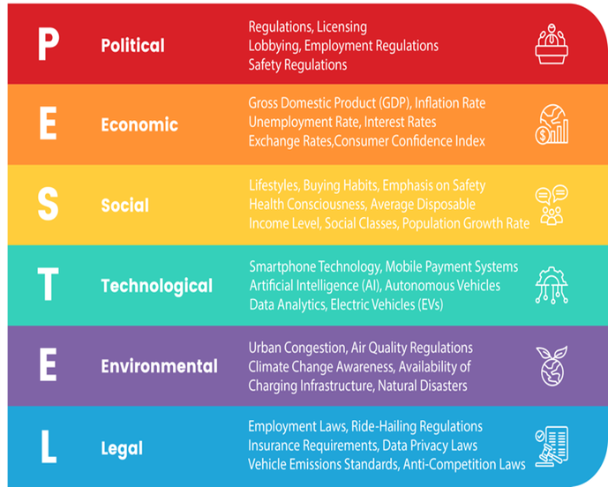
Figure 2:PESTLE Analysis for Uber
(Source: Developed by student, 2025)

PESTLE Analysis for Bolt
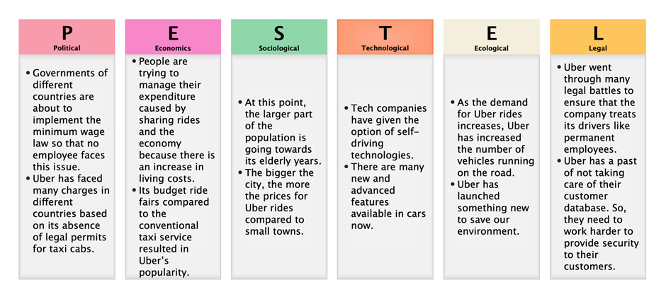
Figure 3: PESTLE Analysis for Bolt
(Source: Developed by student, 2025)

2.2 Selected External Macro Marketing Actors
This analysis focuses on,

(1) Legal Factors
Legal regulations, such as labour classification, insurance requirements and anti-competition laws, significantly influence the business model of ride-hailing, forcing platforms to realign their contractual model and operational compliance mechanisms.
Uber has faced legal battles over the driver's employment status, leading to an increased level of regulatory attention in various jurisdictions (Collier et al., 2018). Moreover, safety and data privacy laws increase the cost of compliance (Louw et al., 2025).

(2) Technological Factors
The adoption of AI-driven routing, enhanced data analytics, autonomous vehicle (AV) and adoption of electric vehicle (EV) improve the efficiency of operations, minimise labour reliance, and are sustainable. Uber strategic technological investments improve organisational pegs of legitimacy and scalability, and autonomous mobility offers disruptive (but at the same time) market potentials alongside related threats (Tu et al., 2024). Urban transport systems become even more efficient with the help of shared mobility innovation (Khavarian-Garmsir et al., 2021).

Selected Macro Environmental Actors and Their Relevance
External Actors | Relevance to Ride-Hailing Industry | Sector Influence | Evidence
Political & Regulatory Environment | Determines legality, labour models, market entry, licensing, safety rules | High influence on operational strategies, pricing, employment rights | Uber faced regulatory resistance in US cities due to taxi lobbying and employment disputes (Collier et al., 2018). Uber drivers report precarity and violence across African markets due to weak labour protections (Louw et al., 2025). South Korea imposed stricter platform regulation influenced by national political discourse (Son et al., 2025).
Technological Advancement & Innovation | Enables platform efficiency, route optimisation, EV integration, autonomous vehicles | Drives cost reductions, experience quality, and strategic differentiation | Shared mobility relies heavily on data analytics, GPS tech, digital platforms (Khavarian-Garmsir et al., 2021). Autonomous vehicles significantly reshape cost structure and service models (Tu et al., 2024). Uber uses institutional strategies to leverage innovation for competitive legitimacy (Distelmans et al., 2021).
Table 1:Selected Macro Environmental Actors and Their Relevance
(Source: Developed by student, 2025)

2.3 Critical Analysis of Each Actor

A. Legal factors
The ride-hailing industry is a very sensitive one regarding political choices, labour regulations and protectionist initiatives. The disruptive model of Uber has led to a ban, licensing bans, and legal lawsuits against the company regarding worker status all around the world (Collier et al., 2018).
In South Korea, unions and taxi associations exerted political pressure on regulators that restricted the growth of Uber (Son et al., 2025).
The African markets display hardships of violent incidents, no driver security, or informality of regulatory competencies, which have impacts on the survival of the platform (Louw et al., 2025).
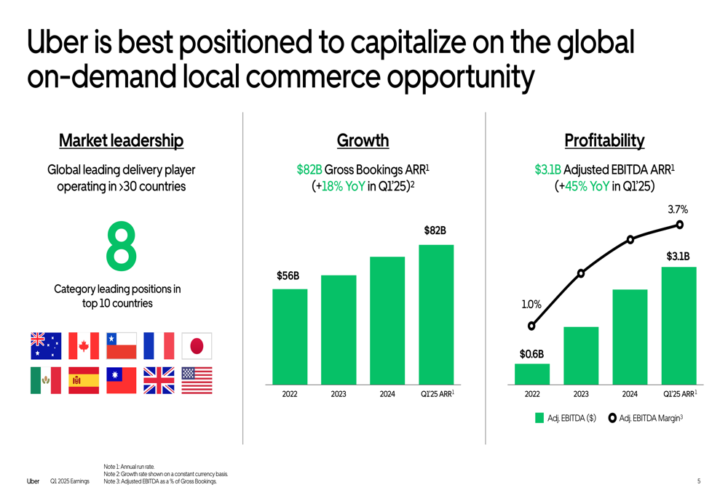
Figure 4:Uber’s Market Leadership, Growth, and Profitability Metrics (2022–Q1 2025)
(Source: Uber, Q1 2025 Earnings Report)

As a pioneer, Uber's sudden growth has brought with it frictions such as anti-competitive scrutiny and compliance penalties.
In Asia-Pacific region, the company's expansion put pressure on local mobility industries and elicited political reactions which have since influenced long term regulatory frameworks (Tavor, 2024). Moreover, entry into developed markets took place by far-reaching institutional strategies to gain legitimacy through their institutions, including compliance and strategic partnerships (Distelmans et al., 2021).
Late entrance into the market meant that Bolt had to abide by existing legal norms. Even though this compliance will lower the regulatory uncertainty, it will also minimize the first-mover advantages as well as limit the opportunity to adopt disruptive growth policies.
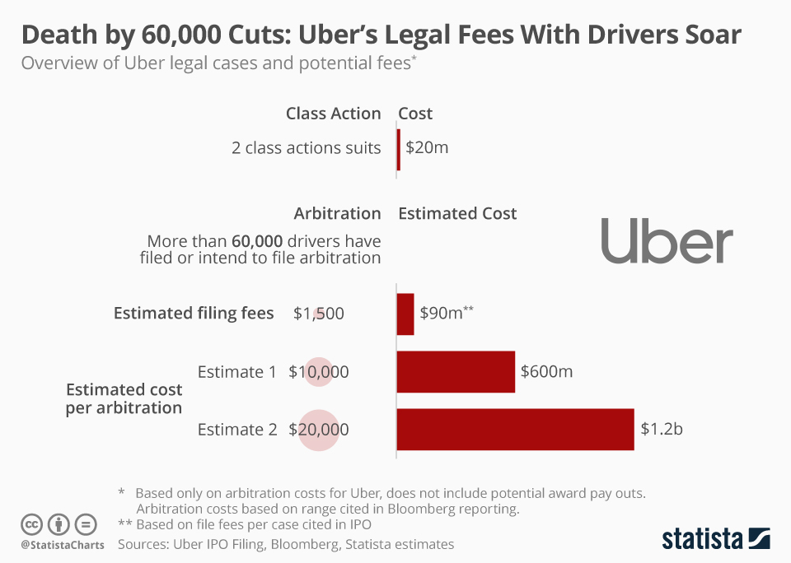
Figure 5:Estimated Legal Costs Faced by Uber Due to Class Action and Arbitration Claims Filed by Drivers
(Source: Statista, based on Uber IPO Filing and Bloomberg reporting)
Now the competitive force facilitated by Uber forces Bolt to comply with the requirements of employment, minimal wages, and safety of vehicles, which did not pertain to the emergent stage of Uber. This also means that Bolt becomes sensitive to changes of political nature because it is more prone to unstable business practices and regulated market conditions but not to influence the regulatory environment based on disruptive innovation.

Strategic Implications
Company | Opportunities | Threats
Uber (Pioneer) | Shape regulation through lobbying; leverage global scale to influence labour policy | Risk of fines and lawsuits; stricter legal scrutiny as a dominant market player
Bolt (Follower) | Operates with regulatory clarity; adopt structured compliance models | Higher compliance costs; limited ability to renegotiate regulatory frameworks
Table 2: Strategic Implications
(Source: Developed by student, 2025)

B. Technological factors
The digital transformation of the ride-hailing sector is the key to both scalability and customer retention. Operators rely on algorithmic pricing schemes, sophisticated matching algorithms, widespread smartphone penetration, advanced data analytics, and mobile payment infrastructure to optimise the performance of their operations (Khavarian-Garmsir et al., 2021). The development of autonomous vehicles is a shift in the paradigm that can lead to decreased labour dependency with a concomitant increase in ethical and legal concerns, while the major advantage of this is the huge increase in efficiency, it also has the risks within to be of substantive adoption (Tu et al., 2024).
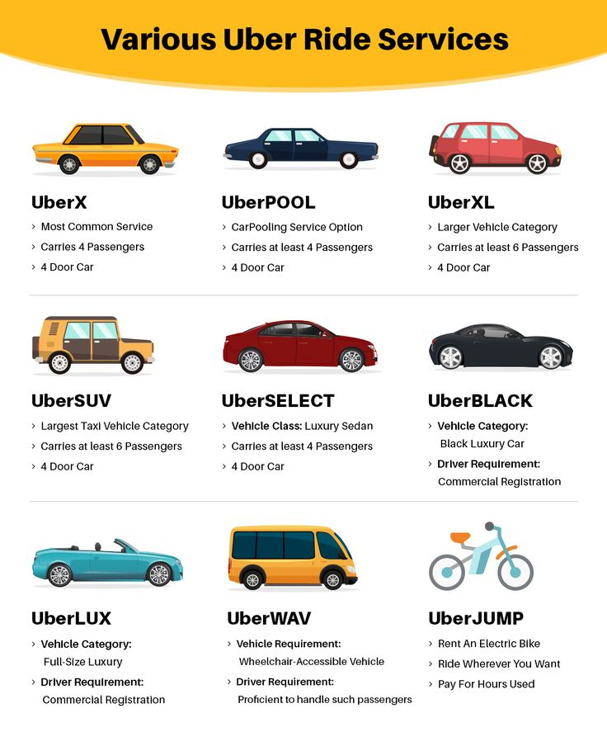
Figure 6: Categorisation of Uber Ride Services Based on Vehicle Type and Service Features
(Source: Uber Service Information, compiled from Uber platform descriptions)
Being a pioneer in its market, Uber has invested heavily in self-driving cars, route optimisation using artificial intelligence, and collaboration with electric vehicles. Such innovation will allow entering various transportation options, including scooters, food delivery, logistics, and autonomous fleets. In line with that, the institutional efforts of Uber support the image of the technological innovator and sustainability supporter (Distelmans et al., 2021).
Using a follower strategy, Bolt is focused on incremental innovation, preserving cost efficiencies while highlighting affordability and market penetration, with little focus on disruptive technology. Its strategic focus is oriented to price-sensitive consumers with special attention to emerging markets and far less investment in the development of expensive autonomous and electric vehicle ecosystems.

Strategic Implications
Company | Opportunities | Threats
Uber (Pioneer) | Lead autonomous mobility; leverage proprietary AI; diversify revenue streams | High R&D costs; regulatory uncertainty; ethical concerns on automation
Bolt (Follower) | Cost leadership; rapid scaling in developing markets; lower innovation risk | Competitive disadvantage if autonomous vehicles scale; dependence on third-party technology
Table 3: Strategic Implications
(Source: Developed by student, 2025)

3. Task 2: Strategic Responses of Pioneering and Follower Organisations

3.1 Pioneering Organisations’ Strategic Responses (Uber)
Early movers launch disruptive models transforming dynamics of industries with innovation, leading market position, and institutional power. The platform model of Uber has created algorithmic pricing, elastic labour force and mobility services through apps, which remains to change transportation markets all over the world. Nevertheless, innovators face the issue of legitimacy issues and regulatory reversal because of its fast growth and displacement of established sectors (Howcroft and Leaver, 2025).

3.1.1 Response to External Challenges and Opportunities
Uber is facing a variety of challenges, from regulatory scrutiny to labour disputes to competition from emerging platforms. In particular, the company's business model has been criticised, being characterised as "unstable" as it lacks constant regulatory compliance and constant public controversies, which inevitably require the necessity of a strategic institutional adaptation (Howcroft et al. 2025. The firm embraces innovation-based legitimacy approaches, as reflected in the expansion of its business in the micro-mobility and delivery sectors in the hopes of diversifying its risk profiles and continuing growth trajectories (Lee, Rindfleisch et al., 2025).
An example of how Uber may achieve business-model flexibilities is its decision to expand to agricultural machinery in India and Nigeria because those markets utilize ride-hailing technology in agricultural resource sharing (Daum et al., 2021). This diversification is in line with the platform scalability and the market penetration strategies.
Statistically, Uber currently has over 150 million active users across the globe and is revenue-generating over USD37.3 billion in 2024 and it, therefore, confirms the scale benefits enjoyed by first mover firms (Uber, 2025). The large global platform base, too, helps in predicting demand and retaining the customer using AI-based churn analytics, which are becoming highly essential in mobility services (Loureiro et al., 2025).

3.1.2 Strategic Models for Pioneering Firms

(A) Ansoff’s Growth Matrix
Ansoff Strategy | Uber Application | Evidence | References
Market Penetration | Increases ride frequency via price promotions, subscription products (Uber One), and improved matching algorithms. | Uber recorded over 150M monthly active users globally in 2024, strengthening penetration in established markets. | (Uber, 2025).
Market Development | Expansion across Asia-Pacific, Africa, and agricultural mobility services. | Uber's entry into tractor-hire platforms in India and Nigeria demonstrates sector expansion beyond transport. | (Daum et al., 2021).
Product Development | New mobility products including Uber Eats, Uber Freight, and electric bike services. | Platform diversification expanded Uber’s multi-product ecosystem, supporting technological transformation. | (Lee, Rindfleisch et al., 2025).
Diversification | Investment in autonomous vehicles, micro-mobility, and new sustainability initiatives. | Diversification enhances innovation classification outcomes in the sharing economy. | (Gurcaylilar-Yenidogan et al., 2017).
Link to Financial Performance | Growth strategies supporting revenue expansion across sectors and markets. | Diversification is associated with positive performance across industries. | (Waititu, Wambui et al., 2025).
Table 4: Ansoff’s Growth Matrix – Uber (Pioneer)
(Source: Developed by student, 2025)

Ansoff's model clarifies the growth paths of organisations in terms of four strategic dimensions which are market penetration, product development, market development and diversification (Gurcaylilar-Yenidogan et al, 2017). Uber is the prime example of diversification with new subsidiaries like Uber Eats, Uber Freight and research projects in autonomous vehicles. The market development aspect of the paradigm is evident in the company's expansion in the Asia-Pacific region, thus having measurable impact on the transport industries in this region (Lee et al, 2025).
Moreover, technology adoption development of platform technology in hiring tractors in India and Nigeria is evidence of diversification in emerging sectors (Daum et al., 2021). There is empirical evidence that diverse strategies are linked to improved financial measures in highly competitive markets, proving a link between the model and performance measures (Waititu et al., 2025).

(B) Porter’s Generic Strategies
Porter Strategy | Uber Application | Evidence | References
Differentiation Leadership | Premium service tiers (Uber Black, Comfort), advanced AI routing, and superior app UX. | Uber generated over USD 37.3 billion in revenue in 2024, demonstrating scale advantages driven by innovation. | (Uber, 2025).
Focus Strategy | Business travel solutions, luxury ride segments, and regional premium offerings. | Strategic innovation protects category leadership in multi-modal mobility ecosystems. | (Lee et al.2025).
Institutional Legitimacy Strategy | Adjusting operations to regulatory shifts, safety mandates, and labour compliance reforms. | Uber’s model is labelled “unstable” due to legitimacy and regulatory conflicts requiring strategic adaptation. | (Howcroft et al., 2025).
Technology-Driven Competitive Advantage | Investments in autonomous driving, GPS optimisation, EV integration, and algorithmic pricing. | Technology drives platform-based differentiation and market influence. | (Gurcaylilar et al., 2017).
Table 5: Porter’s Generic Strategies – Uber (Pioneer)
(Source: Developed by student, 2025)

At Uber, a differentiation leadership strategy is mostly implemented, which includes technological innovations, data analytics, and improved user experience as the creators of value. Vertical differentiation is accomplished by the premium services of the company Uber Black, Uber Comfort, and Uber Business and plays the role of customer retention through products that will be offered on a subscription basis. The aim of the innovation efforts is to enhance the quality of service and support the competitive edge (Lee et al., 2025). However, the differentiation quest increases the cost structures making it difficult to compete with cost focused competitors in new markets.

3.2 Follower Organisations’ Strategic Responses (Bolt)
Followers’ organisations new to an existing market enter those markets by taking advantage of experience gained by first mover firms and aggressively shunning the increased risk induced by an early-stage innovation. Bolt will distinguish itself as a low-price rival, focusing on value-based positioning that focuses on affordability and higher payments to drivers and faster adoption across the market. This strategy has been associated with resource-based perspectives in that the firm makes use of the market structures that are present to attain the competitive advantage without the burden of disrupting the market first.
Located in 45+ countries, Bolt implements a diversified business model in this direction and offers ride-hailing services as well as food delivery and e-scooters, but its operating costs are lower than those of its first-mover competitors (Bolt, 2025). The company pursues a conservative innovation approach, focusing on low prices rather than technological innovations that first movers have. Thus, Bolt can compete well in places like Eastern Europe and Africa where price sensitivity is one of the major factors that determine consumer preference.
Bolt's strategic position is built largely on engaging markets where Uber's marked high-cost differentiation strategy creates affordability gaps, especially in emerging economies with limited disposable income.
Bolt has grown very quickly, and they were said to exceed 150 million customers globally and thus gaining close to the scale of user numbers of Uber (Statista, 2025). The financial efficiency is supplemented by adoption of cost-centric business models in contrast to the massive investments in autonomous vehicle technology.

3.2.1 Responses to External Challenges and Opportunities
Followers face barriers such as regulation limits, which have been influenced by industry pioneers and challenges in labour legislation. Instead of using it to pre-emptively shape regulatory environments, Bolt conforms to existing structured legal frameworks, which limits the uncertainty of the environment allowing for a limited capacity of institutional control.
Bolt's strategy is to focus on low-cost operations and localisation and not on global standardisation. In sectors that depend on infrastructures such as electric mobility, Bolt takes advantage of existing technological ecosystems without having to bear the costs of innovation in the early stages, like the way offshore wind infrastructure is based on stable engineered bolt structures and not own innovation (Mehmanparast et al., 2020). This is an analogy that emphasises Bolt's approach of using existing 'pre'-built environments rather than creating new ones.
To improve retention Bolt increasingly uses customer travel data and churn analytics in a similar way to the models suggested for taxi industries (Loureiro et al., 2025).

3.2.2 Strategic Models for Follower Firms

(A) Ansoff’s Growth Matrix
Strategy Type | Bolt Application | Reference
Market Penetration | Low-fare competitive pricing; higher driver payouts | Bolt (2025)
Market Development | Expansion across African and Eastern European regions | Statista (2025)
Product Development | E-scooters, car-leasing offerings | Bolt (2025)
Diversification | Logistics & food delivery layering onto core mobility | Waititu et al. (2025)

(Source: Developed by student, 2025)

These results are in line with the development strategy put forward by Ansoff which associates with growth strategy and financial performance and subsequently strengthens the encouraging influence on the outcomes of the market expansion (Waititu et al., 2025).

(B) Porter’s Generic Strategies
Porter Strategy | Bolt Application | Evidence | References
Cost Leadership | Bolt competes on affordability by offering lower ride fares and higher driver earnings compared to Uber, especially in emerging markets. | Bolt operates in 45+ countries and serves over 150 million users, driven by price-sensitive adoption. | (Statista, 2025).
Market Focus (Emerging Markets) | Targets regions such as Eastern Europe and Africa where lower operating costs enable rapid penetration and reduced competition. | Bolt’s presence is strongest in developing markets where demand elasticity favours low-cost operators. | (Bolt, 2025).
Product Development for Cost Efficiency | Offers e-scooters, car-leasing, and food delivery while minimising high-cost R&D investments in autonomous vehicles. | Strategic product expansion supports growth without capital-intensive innovation. | (Bolt, 2025).
Data-Driven Service Optimisation | Uses travel data analytics to reduce churn and optimise retention rather than high-tech market disruption. | Data analytics improves service loyalty and efficiency in taxi mobility contexts. | (Loureiro et al., 2025).
Risk-Minimising Innovation Strategy | Adopts proven technological ecosystems rather than developing foundational systems like autonomous platforms. | Followers leverage existing infrastructure instead of pioneering high-risk engineering similar to structural bolt-based system design in other industries. | (Mehmanparast et al., 2020).
Table 6:Porter’s Generic Strategies – Bolt (Follower Organisation)
(Source: Developed by student, 2025)

Bolt uses cost-leadership approach to boost its competitive positioning in emerging markets characterised by a high price elasticity. The cost savings that result allow the ability to obtain price-sensitive consumers, which is the direct opposite of the differentiation model that Uber follows.
However, a cost-based focus limits the ability of the firm to invest in frontier innovations like autonomous vehicles that may cut down its future competitiveness in case labour-free mobility becomes the leading technology (Lee et al., 2025). Companies that follow the same path expose themselves to strategic stagnation, in case the transformation in the industry proves faster.

4. Conclusion
The analysis shows that the ride-hailing and mobility industry is highly affected by the macro-environmental forces, especially political regulation and technological advancement, which impact the strategic decisions of both pioneering entities such as Uber and follower entities such as Bolt. Uber exploited first-mover advantages through diversification, technological innovation, and differentiation approaches to obtain global magnitude and multi-market growth, despite regulatory battles and attacks on legitimacy. As example, Bolt went after cost-leadership and markets strategies, relying on affordability and low-risk innovation for the penetration of new markets with price-sensitive consumer bases.
The use of Ansoff's Growth Matrix and Porter's Generic Strategies emphasise the importance of pioneers innovating to move towards diversification while the followers focus on efficiency, cost optimisation and rapid localisation. Overall, strategic environmental scanning is indispensable to anticipate regulatory changes, technological changes, and changing consumer behaviour. Firms that proactively change the marketing approach in sync with external pressure points are in a better position of retaining their competitiveness and ensure sustainability of growth and ability to disrupt within the global mobility ecosystem.

5. References
Bolt (2025) Bolt – Official Website. Available at: https://bolt.eu/en/
Collier, R.B., Dubal, V. & Carter, C.L. (2018) Disrupting Regulation, Regulating Disruption: The Politics of Uber in the United States. Perspectives on Politics, 16(4), pp.919–937. Available at: https://www.researchgate.net/publication/329157361_Disrupting_Regulation_Regulating_Disruption_The_Politics_of_Uber_in_the_United_States
Daum, T., Villalba, R., Anidi, O., Mayienga, S., Gupta, S. & Birner, R. (2021) Uber for tractors? Opportunities and challenges of digital tools for tractor hire in India and Nigeria. World Development, 144, 105480. Available at: https://www.sciencedirect.com/science/article/pii/S0305750X21000929
Distelmans, M. & Scheerlinck, I. (2021) Institutional Strategies in the Ridesharing Economy: A Content Analysis Based on Uber’s Example. Sustainability, 13(14), 8037. Available at: https://doi.org/10.3390/su13148037
Gurcaylilar-Yenidogan, T. & Aksoy, S. (2017) Applying Ansoff’s Growth Strategy Matrix to Innovation Classification. International Journal of Innovation Management, 22(04), 1850039. Available at: https://www.researchgate.net/publication/321060813_APPLYING_ANSOFF'S_GROWTH_STRATEGY_MATRIX_TO_INNOVATION_CLASSIFICATION
Howcroft, D. & Leaver, A. (2025) Unstable platforms: Uber’s business model and the challenge of organisational legitimacy. Accounting Forum, 49(2). Available at: https://www.tandfonline.com/doi/full/10.1080/01559982.2024.2309018
Khavarian-Garmsir, A.R., Sharifi, A. & Abadi, M.H.H. (2021) The Social, Economic, and Environmental Impacts of Ridesourcing Services: A Literature Review. Future Transportation, 1(2), pp.268–289. Available at: https://doi.org/10.3390/futuretransp1020016
Kulik, C.T. (2025) The Nuts-and-Bolts Problem: Delivering Evidence-Based Operational Advice to Line Managers. Volume 63(3), e70022. Available at: https://onlinelibrary.wiley.com/doi/full/10.1111/1744-7941.70022
Lee, E.J.H., Rindfleisch, A. & Kopalle, P.K. (2025) Innovation in the sharing economy: Examining Uber's transformation. Journal of Innovation Management, 42(5), pp.822–849. Available at: https://www.sciencedirect.com (link via institutional access)
Loureiro, A.L.D., Miguéis, V.L., Costa, Á. & Ferreira, M. (2025) Improving customer retention in the taxi industry using travel data analytics: A churn prediction study. Journal of Retailing and Consumer Services, 85, 104288. Available at: https://www.sciencedirect.com/science/article/pii/S0969698925000670
Louw, H. & Nomdo, G. (2025) Conversations through the rear-view mirror: Uber drivers’ narratives on the precarity of work, ‘belonging’, and violence. African Geographical Review, 44(5). Available at: https://www.tandfonline.com/doi/full/10.1080/19376812.2025.2456753
Mehmanparast, A., Lotfian, S. & Pillai, V.S. (2020) A Review of Challenges and Opportunities Associated with Bolted Flange Connections in the Offshore Wind Industry. Metals, 10(6), 732. Available at: https://www.researchgate.net/publication/341823750_A_Review_of_Challenges_and_Opportunities_Associated_with_Bolted_Flange_Connections_in_the_Offshore_Wind_Industry
Pepać, L. (2018) The sharing economy: Uber and its effect on taxi companies. ACTA ECONOMICA, 16(28). DOI:10.7251/ACE1828123P. Available at: https://www.researchgate.net/publication/329898519_The_sharing_economy_Uber_and_its_effect_on_taxi_companies
Siskos, D.V., Maravas, A. & Mau, R. (2025) PESTLE Analysis of a Seaplane Transport Network in Greece. Aerospace, 12(1), p.28. Available at: https://doi.org/10.3390/aerospace12010028
Son, J.W. & Jung, D. (2025) The politics of the sharing economy: Evidence from Uber in South Korea. Asian Journal of Social Science, 53(2), p.100200. Available at: https://www.sciencedirect.com/science/article/abs/pii/S1568484925000188
Statista (2025) Bolt – statistics & facts. Available at: https://www.statista.com
Statista (2025) Uber Technologies – statistics & facts. Available at: https://www.statista.com/topics/4826/uber-technologies/?srsltid=AfmBOopgggKpKiM63mTPCN29ptGsuUaUDdvnLHLslgd0Jx-soszuh9UQ
Tavor, T. (2024) Uber's impact on Asia Pacific industries: An examination of strategic initiatives and market dynamics. Quantitative Finance and Economics, 8(3), pp.610–634. Available at: https://www.researchgate.net/publication/384333693_Uber's_impact_on_Asia_Pacific_industries_An_examination_of_strategic_initiatives_and_market_dynamics
Tu, L. & Xu, M. (2024) An Analysis of the Use of Autonomous Vehicles in the Shared Mobility Market: Opportunities and Challenges. Sustainability, 16(16), p.6795. Available at: https://doi.org/10.3390/su16166795
Tu, L. & Xu, M. (2024) An Analysis of the Use of Autonomous Vehicles in the Shared Mobility Market: Opportunities and Challenges. Sustainability, 16(16). Available at: https://www.researchgate.net/publication/382987909_An_Analysis_of_the_Use_of_Autonomous_Vehicles_in_the_Shared_Mobility_Market_Opportunities_and_Challenges
Uber (2025) Uber Technologies – Official Website. Available at: https://www.uber.com/lk/en/
Waititu, J., Wambui, M. & Kamande, M. (2025) Ansoff’s Growth Strategies and Financial Performance in Kenya’s Leather Industry. The Journal of Accounting and Management, 1(15), pp.130–140. Available at: https://ideas.repec.org/a/dug/jaccma/y2025i1p130-140.html

