RESEARCH REPORT
Impact of Virtual Learning Environment (VLE) on UWTSD Students

Kelvin Kpenosen
Student ID:1908380
Digital Skills and Research Methods BMSW4003_LON Term 2
Lecturer Modak Koushik

Table of Contents
INTRODUCTION 3
RATIONALE 3
LITERATURE REVIEW 4
RESEARCH METHODOLOGY 6
FINDINGS AND ANALYSIS 8
CONCLUSION AND RECOMMENDATION 14
REFERENCES 15
APPENDIX 17

INTRODUCTION
Teaching and Learning online has turned out to be a recognised and well-known educational paradigm. Communication and Information technologies have been accepted by many educational institutions through online learning environment & are adopted to offer courses and programmes in e-learning mode (Vaganova et al., 2017). Virtual learning environment is a web-based platform in educational technology come up with integrated set of applications and tools that supports the teaching and learning activities across a medium called Internet. UWTSD has created the VLE for digital aspects of study courses mainly for enhancing the student’s learning experiences with the inclusion of computer software and internet in the learning process.
Although there are many proprietary items are provided commercially, an obvious trend in the space of VLEs is the evolvement of Open Course Management Systems, the best example is Moodle. As a stable and well-established tool with versatile structure, Moodle has so much to provide to all the stakeholders- managers, educators and students (Rienties et al, 2016).
Aim
The present study aims at promoting in-depth understanding on the use of VLE-Moodle in the teaching and learning process at UWTSD. The primary focus of this research is on analysing the student’s experience on using VLE-Moodle and how it has made a difference on their studies as compared to the proximate learning in classroom environment.
Objectives
- To measure the effectiveness of VLE-Moodle in this period of quarantine due to COVID-19

RATIONALE
In this current pandemic, the subject of Virtual Learning has become the key focus of the researchers nowadays (Rose, 2020). It has been found that most of the educational institutes have decided to implement virtual learning environment in which they have used virtual classrooms, different applications and social networks so that students can learn effectively. Although, virtual learning is not a new concept but still many people are unfamiliar to this methodology and thus this research will outline some of the key aspects that will promote understanding on virtual learning.

LITERATURE REVIEW

A lot of research has been conducted by several researchers since the birth of VLE, which many report the VLE is very effective, efficient and satisfying compare to the traditional learning situation.
In the Hsu (2011) study, her report shows that face to face learning with E-learning links the gap between students and teachers. Alkhanal and Azmi (2011) study points out, that activities offered via e-learning are more useful and valuable compared to classroom activities in their research.
Ahmad and Al-Khanjari (2011) study on use of MOODLE reviled that students that was introduced to VLE through MOODLE showed positive, optimistic and encouraging approach towards MOODLE. The result also showed that their learning improved, and they have a better understanding of the course materials. However, the study pointed out that most students chose face to face learning, supported with MOODLE.
The report by Holbl & Welzer, (2010) on the study of MOODLE states that student’s attitude towards MOODLE were positive. However, it reflects that majority believe MOODLE is very useful, but face to face learning was also essential.
Study carried out by Zoran and Rozman (2010), shows that MOODLE platform had a great positive impact on Student language learning in Slovenia. Also, MOODLE was found useful, helpful and time saving. The research showed that all students used MOODLE to download Lecture notes, assignments etc
According to Demain & Morrice (2015) VLE has a direct impact on the student’s accomplishment by increasing their motivation and independent learning that ultimately throws a significant impact on students’ engagement, satisfaction and recall. A well-maintained VLE enable students of all learning styles to obtain best possible education. It has been recognised that learning online teaches the time-management skills that are further beneficial in making work-study balance easier.
Kumar et al (2011) states that Moodle is a flexible and a very popular VLE that is specifically planned to support face-to-face teaching with a broader series of multipurpose online tools along with providing a platform to upload study materials for courses. The availability of the tools in Moodle also make it perfect for things such as collaboration, secure file sharing, event management, support research projects & manage questionnaire. This multi-user system is available to Educational institutions, staffs, academics, students, administrators & replaces Cam Tools.
In this current research, the researcher will be using similar techniques has previous researchers have done, by adopting qualitative and quantitative methods. However, the population and the
sample size differs to other researchers’ work. By doing this, the result of the current study will confirm previous research results.

RESEARCH METHODOLOGY

According to Katagiri, 2011, there are two types of research methods which are qualitative method and quantitative method. Brown and Stowers, 2013 stated that quantitative method are data which can be analysis by mathematical tools or analytical method, while qualitative method can not be analysed that way.
Qualitative research method is an exploratory research method which can be used to gain more understanding of underlying reasons, opinions and motivations (DeFranzo, 2011).
Quantitative research method uses measurable data to formulate facts and uncovers patterns in previous research. This method quantifies problems such as attitudes, opinions behaviours and other variables defined in the research (DeFranzo, 2011).
In this current research both methods will be used in order to get a better description in the research study. Qualitative data will be collected in order to understand the research topic in a better way (Kornienko, 2010). While quantitative data will be collected because the data generated can be transformed into usable and meaningful statistics that can be relied on.
Data Collection
There are two significant data collection process which are primary and secondary data.
According to Popping, 2012 Primary can simple defined as a data gathered from a natural environment or from the human participants of a research. While Secondary data is defined as a data gathered from previous research, or any peer reviewed journals, or statistics.
In the present study, researcher will adopt both primary and secondary data to make a critical evaluation of the overall research. It allows the researcher to make a broader analysis of the subject by covering all key aspects.
Data Collection Process
Primary research will be carried out to collect the data directly from the practical responses instead of being dependent on any previous research (Ghauri et al., 2020). In this study, the researcher will use quantitative technique under which a survey will be conducted among 20 students of UWTSD in a way to reflect on their experiences of using VLE-Moodle. Gaining information from the perspective of students would help the researcher in drawing meaningful conclusions.
Secondary research method involves using existing data available in books, journals or online articles. In this study, the researcher is involved in visiting different sites and looking at publications of famous authors on the subject of “Virtual learning” (Ghauri et al., 2020). Although Virtual learning has not covered a wide area of publications but due to the pandemic- COVID-19, many researchers has recently recognised it as an important topic to study and thus a detailed information is available on internet.
Sample Size
This research sample shall be taken from UWTSD population which consist of 2500 people. However, the sample size adopted by the researcher is 20 students from Certificate for skills in the workplace.
Ethical Issues
In this research study several ethical issues are considered and maintained. Issues to be maintained are good morals and individual information assurance. In order to deal with these issues, according to Popping 2012 the participants (students) will be informed about the purpose of the research and all the ethical consideration before taking part or gathering their feedbacks. Their consents will be requested before taking part and they will be well informed that they are free to withdraw their participation at any time (Klassen et al. 2012). Also, Data Protection Act, 1998 will be maintained while gathering feedback from participants; all data will be protected, and information gathered will not be disclosed to anybody.

FINDINGS AND ANALYSIS

The respondents of the survey are 20 students of UWTSD, the respondents are asked to fill up the list of questionnaires sent to them on their mail, this is an online survey with the inclusion of both open-ended and close-ended questions. The analysis will be based on the questionnaire results, which will cover few questions in the questionnaire that can be found in the appendix.

Alternatives | Responses
YES | 16
NO | 04
TOTAL | 20

The above statistical graph represents that more than half of the respondents has understanding of VLE-Moodle and its working although 20% of respondents do not have knowledge regarding the same. It is good to see that 80% of students are aware about working of Moodle, it would help them in getting great learning experience.

Alternatives | Responses
YES | 16
NO | 04
TOTAL | 20

From the above analysis, it is observed that 80% of the students find easy to use VLE-Moodle and states that it also allows them to install, download or update with the recent developments without any additional charges. Further, 20% of students think that using Moodle is not easy, it is somewhere asking for knowledge about programs and basic programming skills.

Alternatives | Responses
YES | 16
NO | 04
TOTAL | 20

In Moodle-library is a space where teachers could add study materials for their student’s learning and to foster knowledge creation. The survey shows that 80% of students has gathered study materials required to them from the VLE-Moodle (library) and think it is useful to source. Furthermore, 20% of students do not agree to this rather think that it is not useful in improving educational access.

Alternatives | Responses
YES | 08
NO | 12
TOTAL | 20

The analysis shows that 60% of total respondents would not prefer to change the layout of Moodle as they do not find any benefits after customizing the Moodle. However, rest of 40% would prefer to customize the Moodle layout to make it even easier to access attendance and deadlines.

Alternatives | Responses
1 (Very Good) | 4
2 (Good) | 6
3 (OK) | 6
4 (Not so good) | 1
5 (Disappointing) | 3
TOTAL | 20

The above analysis states that majority of the respondents’ rate Moodle 2-3 that means more students are appreciating this medium of teaching and learning although rest of them think it is disappointing and cannot fulfil the requirements just as traditional way of teaching.

In this research there are some open ended questions, which the responses are fixture and broad, however it can be stipulated that; From the open ended questions, most people roughly about 65% find VLE made a difference in how they write their assignment, and others thought it made a difference in how they obtain study material.
Most people about 50% will not change the layout of VLE, however roughly about 30% would like the library change and the rest would like easier for access to see deadlines and attendance.
Most people experience of Moodle is it makes it easy to study, self-independent and Networking. The respondent states that VLE-Moodle is a design space for learning and teaching, although some thinks that it invokes an artificial world that has replaced the real life, but some has different opinions regarding this. Majority of the students has good experience with online learning, they share that VLE has neither replace their existing educational practices or classrooms instead it enhanced them.

According to a research result done in an India Business school on student experience on MOODLE, the graph below shows the result (Goyal and Tambe, 2015).
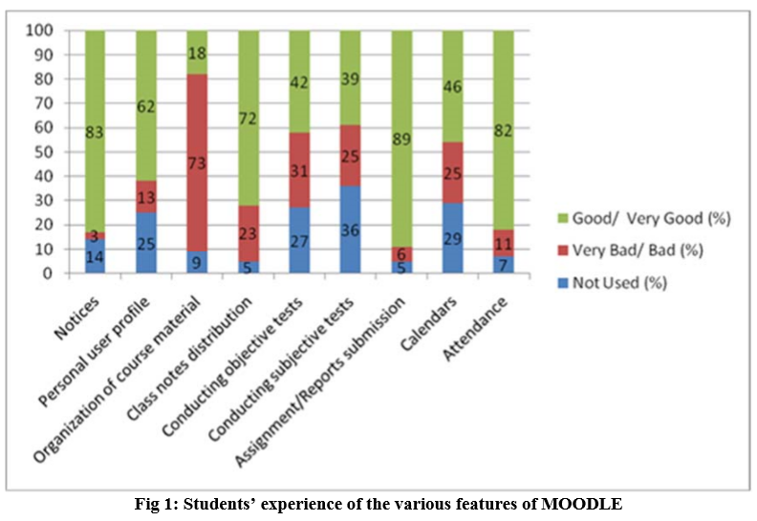

(Source: Goyal and Tambe, 2015)
It can be evidenced in this researcher result that the students found MOODLE very useful and essential to their learning experience. This is crystal clear that the study results also support this current research.

In summary this study has made huge discussion on Moodle and have analysed it that Moodle is a multi-user system that scales well and can be easily used by the educators at UWTSD. UWTSD has introduced online learning platforms so as to cope up with travel restrictions in this quarantine but it has faced issues of educational equity due to which some students have committed that online teaching is not equitable for them however majority of students are in support of online teaching, they take it as an incredible gift as they can connect to their teachers in many ways even in this time of quarantine when they are required to be socially distant (Rose, 2020).

CONCLUSION AND RECOMMENDATION
Conclusion
By going through the entire study, it can be concluded that Virtual learning environment has number of benefits that enhance student’s productivity and lead to efficient learning via online teaching. The researcher absolutely succeeded in addressing research objectives by the means of survey and literature review. It has been found that VLE has enhanced the learning experience of the students by offering digital-based solutions with a focus on creating active and interactive learning environments.
Recommendation
With the advent web-based educational technologies and Internet, the search for a flexible and manageable learning environment does not halt. The below are the recommendations made to the educator of UWTSD for creating an impactful VLE and improving online teaching
- Establish a virtual presence at the initial stage of e-learning course and engage with the students to make them realize the availability and visibility of the teachers. It would maintain the effective learning community.
- Build up a supportive learning environment to create a supportive community online for the students. This can be done by setting up groups just like traditional study groups to maintain mentoring of fellow learners.
- Use combination of learning tools to create kinds of learning environments. It should include both synchronous & asynchronous activities, visual tools & even more collaborative audio. It would help in increasing student engagement with other learners & teachers.

REFERENCES

Ahmad, N. & Al-Khanjari, Z. (2011). Effect of MOODLE on learning: An Oman perception, International Journal of Digital Information and Wireless Communications (IJDIWC), 1(4), pp. 746-752.
Alkhanak, S. A. K. & Azmi I. A. G. (2011). Information technology usage and attitudes towards online resources-Students perspective: African Journal of Business Management, 5(7), pp. 2582-2589.
Brown, J. and Stowers, E. (2013). Use of Data in Collections Work: An Exploratory Survey. Collection Management, 38(2), pp. 143- 351.
DeFranzo, S (2011). Difference Between Qualitative and Quantitative Research. online Snap Surveys Blog. Available at: <https://www.snapsurveys.com/blog/qualitative-vs-quantitative-research/> [Accessed 1 May (2020).
Demain, P., and Morrice, J., (2015). The use of virtual learning environments and their impact on academic performance: Online Retrieved from https://www.tandfonline.com/doi/full/10.11120/ened.2012.07010011. Last accessed at 18th April, (2020).
Ghauri, P., Grønhaug, K. and Strange, R., (2020). Research methods in business studies. Cambridge University Press.
Goyal, E. and Tambe, S., (2015). EFFECTIVENESS OF MOODLE-ENABLED BLENDED LEARNING IN PRIVATE INDIAN BUSINESS SCHOOL TEACHING NICHE PROGRAMS. The Online Journal of New Horizons in Education, Volume 5(Issue 2), p.4.
Hölbl, M. & Welzer, T. (2011). Students' Feedback and Communication Habits using MOODLE, Electronics & Electrical Engineering. [serial online]. July (2010); (102): pp. 63-66. Available from: Computers & Applied Sciences Complete, Ipswich, MA (2010).
Hsu, L. (2011). Blended learning in ethics education: A survey of nursing students, Nursing Ethics, 18(3), pp. 418-430.
Katagiri, M. (2011). A macroeconomic approach to corporate capital structure. Tokyo: Institute for Monetary and Economic Studies, Bank of Japan.
Klassen, A., Creswell, J., Plano Clark, V., Smith, K. and Meissner, H. (2012). Best practices in mixed methods for quality of life research. Qual Life Res, 21(3), pp.377- 380.
Kornienko, S. (2010). Essays on comovement of equity and currency returns.
Kumar, S., Gankotiya, A.K. and Dutta, K., (2011). A comparative study of moodle with other e-learning systems. In (2011) 3rd International Conference on Electronics Computer Technology (Vol. 5, pp. 414-418). IEEE.
Popping, R. (2012). Qualitative Decisions in Quantitative Text Analysis Research. Sociological Methodology, 42(1), pp.88- 90
Rienties, B., Giesbers, B., Lygo-Baker, S., Ma, H.W.S. and Rees, R., (2016). Why some teachers easily learn to use a new virtual learning environment: A technology acceptance perspective. Interactive Learning Environments, 24(3), pp.539-552.
Rose, S., (2020). Medical student education in the time of COVID-19. JAMA.
Vaganova, O.I., Smirnova, Z.V., Mukhina, M.V., Kutepov, M.M., Kutepova, L.I. and Chernysheva, T.L., (2017). The organization of the test control of students' knowledge in a virtual learning environment MOODLE. Journal of Entrepreneurship Education.
Zacarias, E., de Almeida, L.R., Prettz, J.B., da Costa, J.P.C., de Freitas, E.P., Canedo, E.D. and de Sousa, R.T., (2016). Optimizing the access records of students in the Moodle virtual learning environment database. IFAC-PapersOnLine, 49(30), pp.98-101.
Zoran, A. G., & Rozman, K. (2010), Students Perceptions of Using MOODLE, MOODLE.si (2010), 4th International Conference Proceedings, Koper, 21 May (2010).

APPENDIX

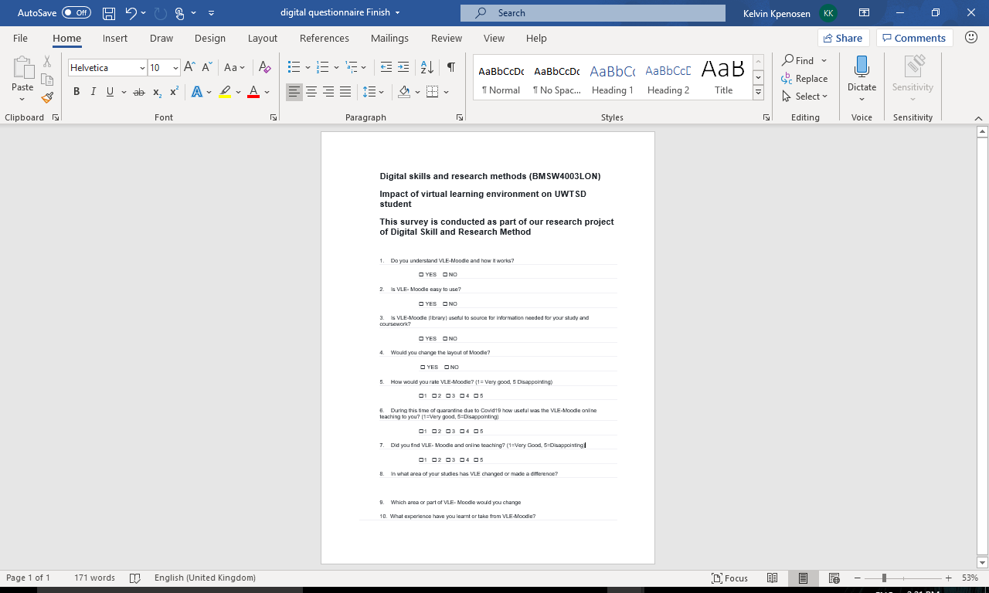
Appendix 1

Appendix 2



