Course nume: Digital Skills(LCLM4002)
Student numer:2612225

Screenshot/Photo 1
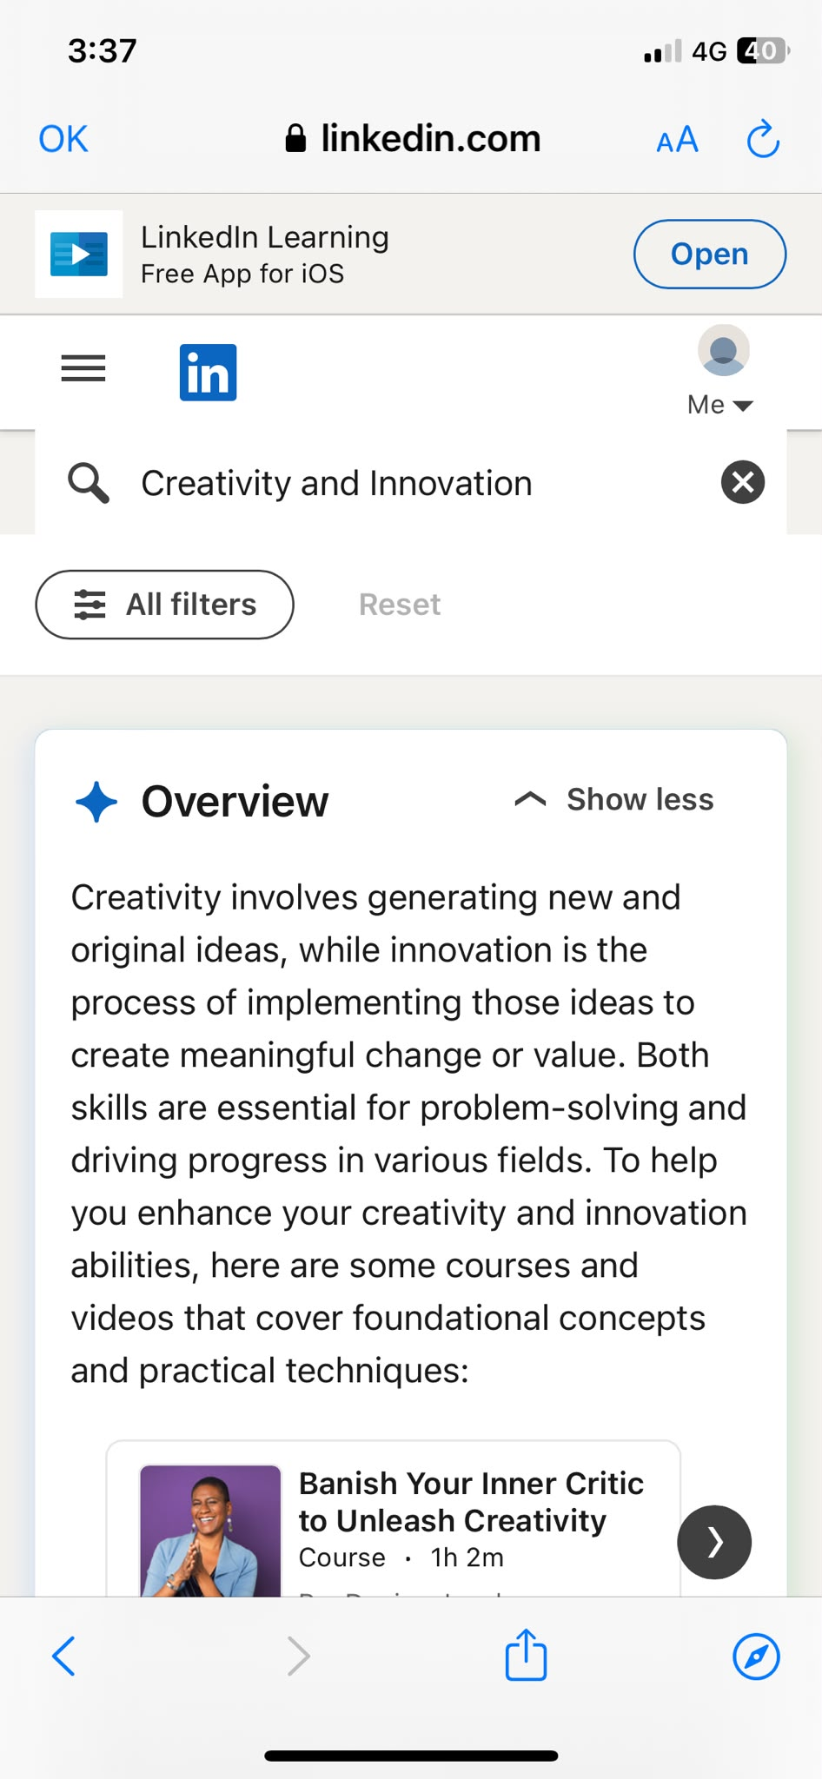
LinkedIn Learning: This screenshot is of my use of LinkedIn Learning in my digital life. I go to the platform to access learning materials, such as creativity and innovativeness classes, to help me obtain valuable academic, professional and personal skills.

Screenshot/Photo 2
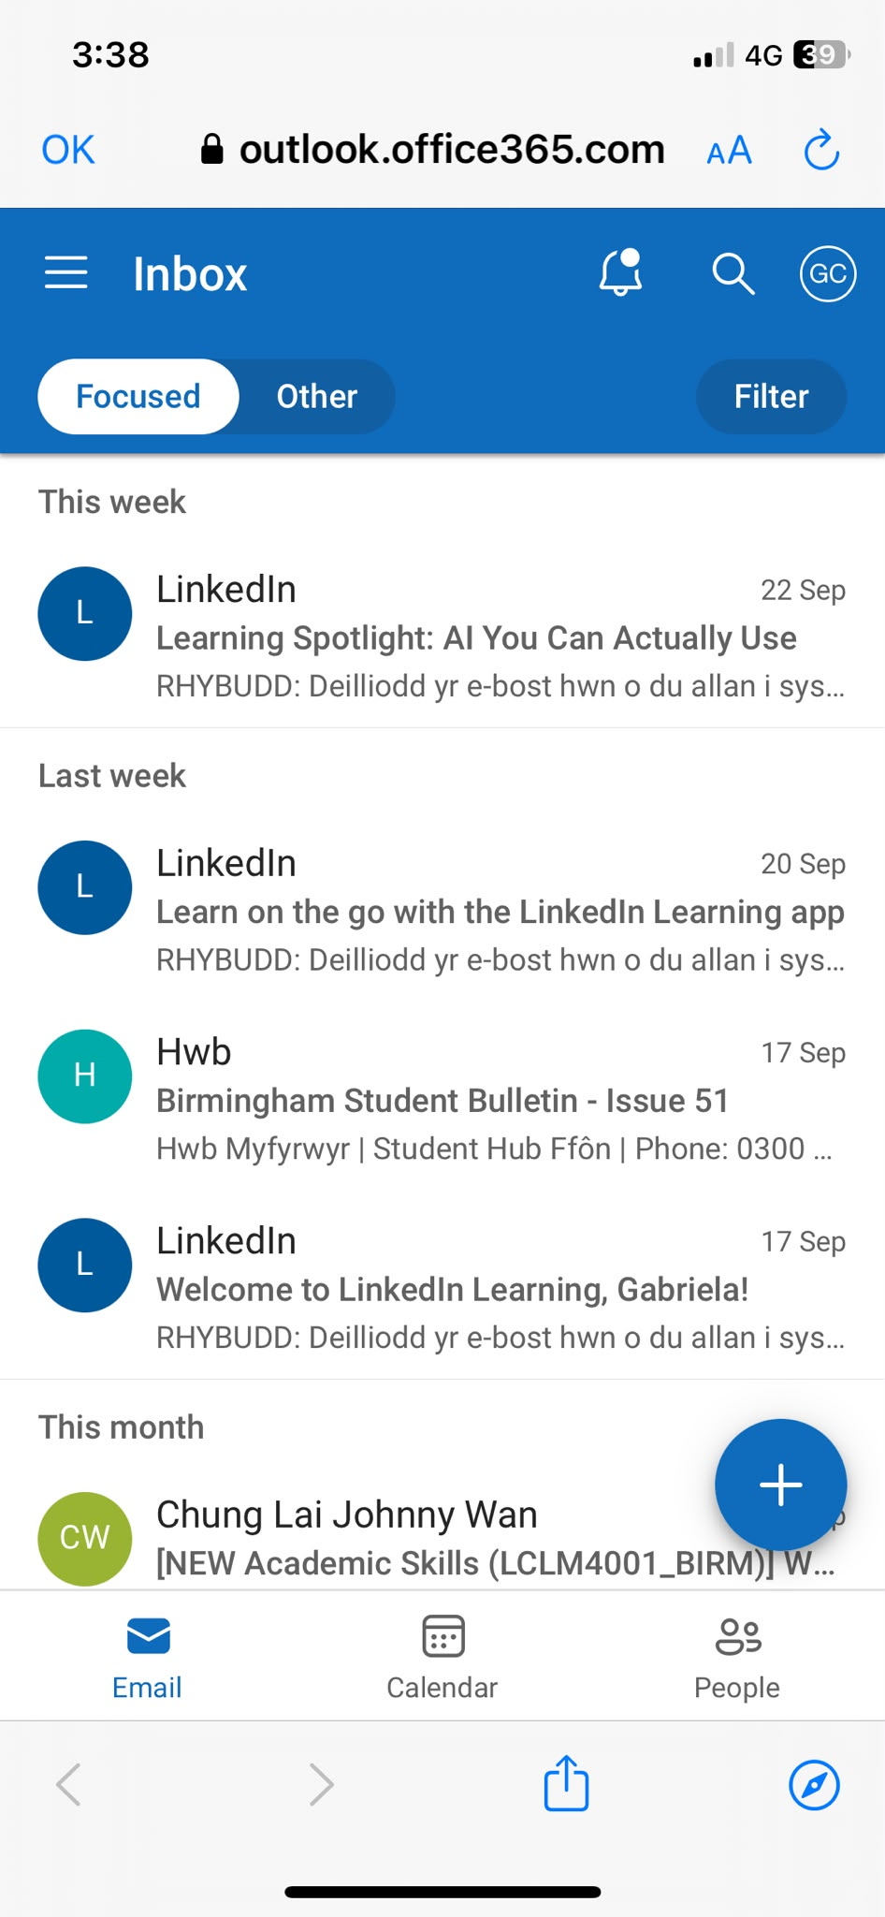
Outlook Email: I have included my outlook email inbox in this screenshot where I use to communicate with the university most of the times. It helps me to get student messages, LinkedIn learning and academic messages and helps me be organised and respond to crucial messages in a limited time.

Screenshot/Photo 3
Digital Skills Module on Moodle
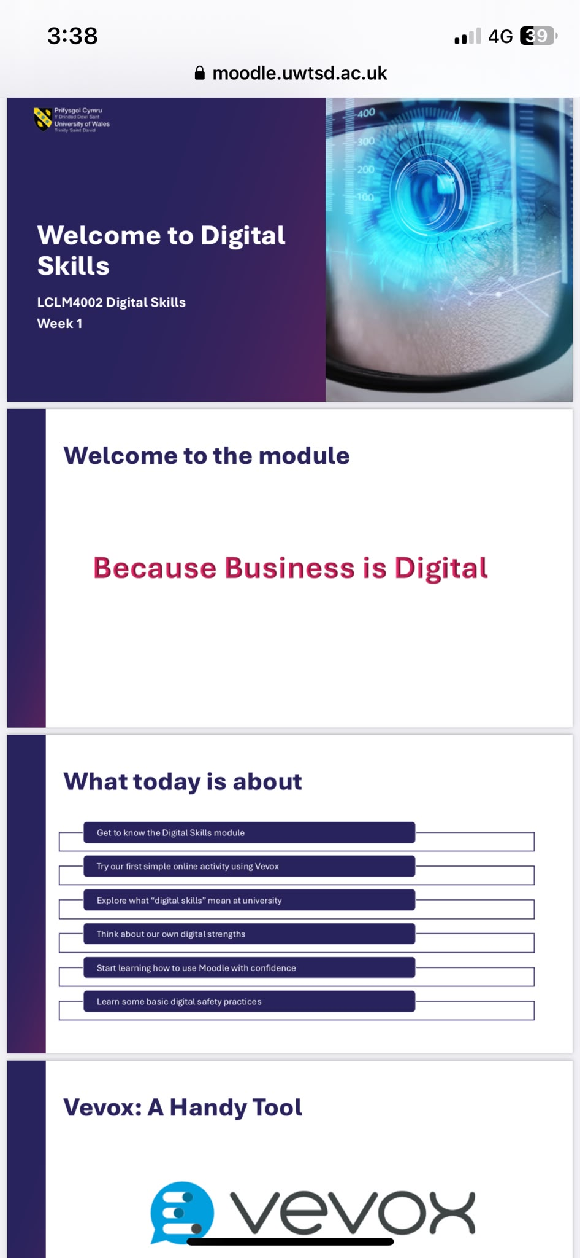
This screenshot demonstrates the Digital Skills module that is offered by Moodle. I additionally utilise the Moodle to gain access to learning materials and activities in the university and the module allows me to understand digital skills, online resources such as Vevox, digital safety and appropriate use of technology in the university.

Screenshot/Photo 4
Personal Email
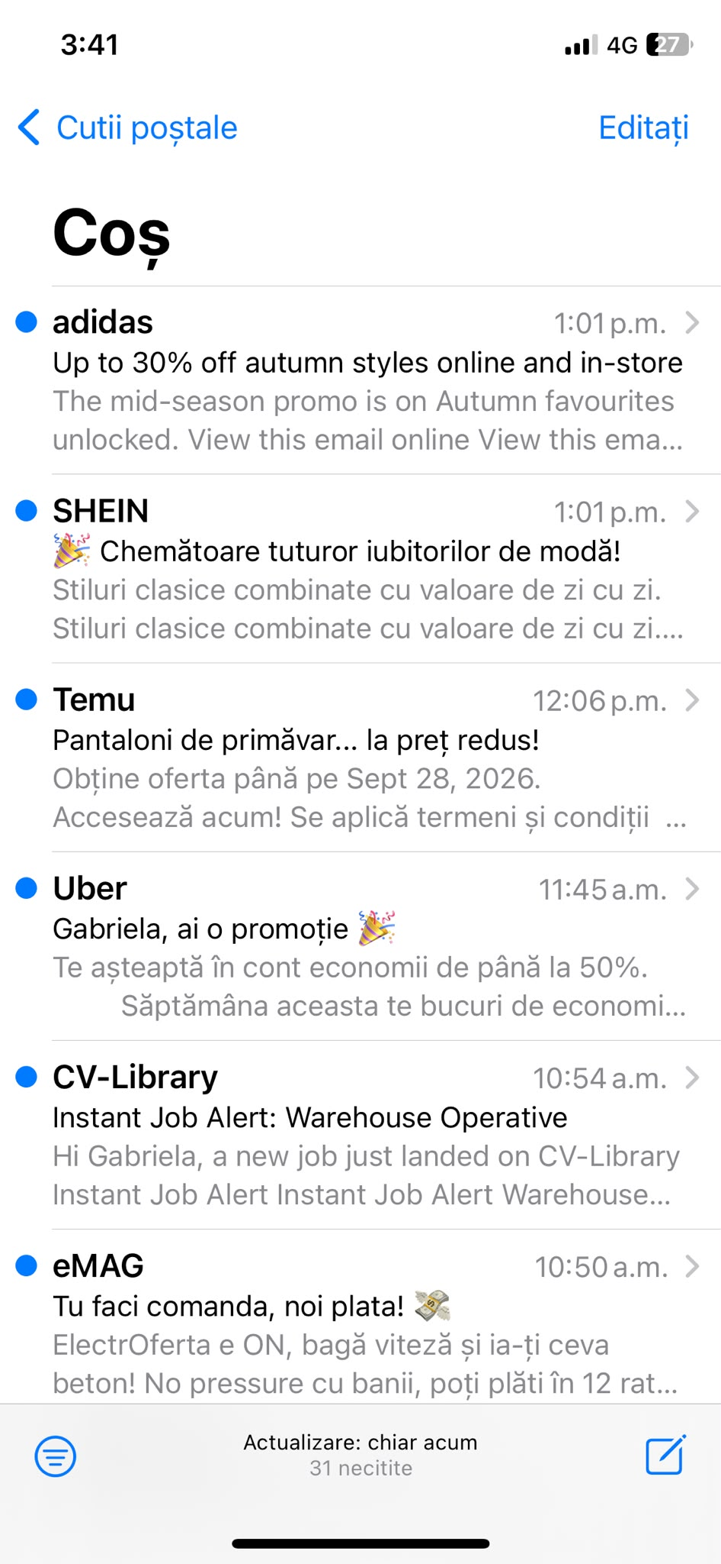
The personal email inbox can be seen, and this is one of the examples that digital communication is my life. I get emails sent by retailers, services and job sites, such as shopping deals and job alerts, which assist in controlling my personal data and opportunities on the internet.

Screenshot/Photo 5
WhatsApp
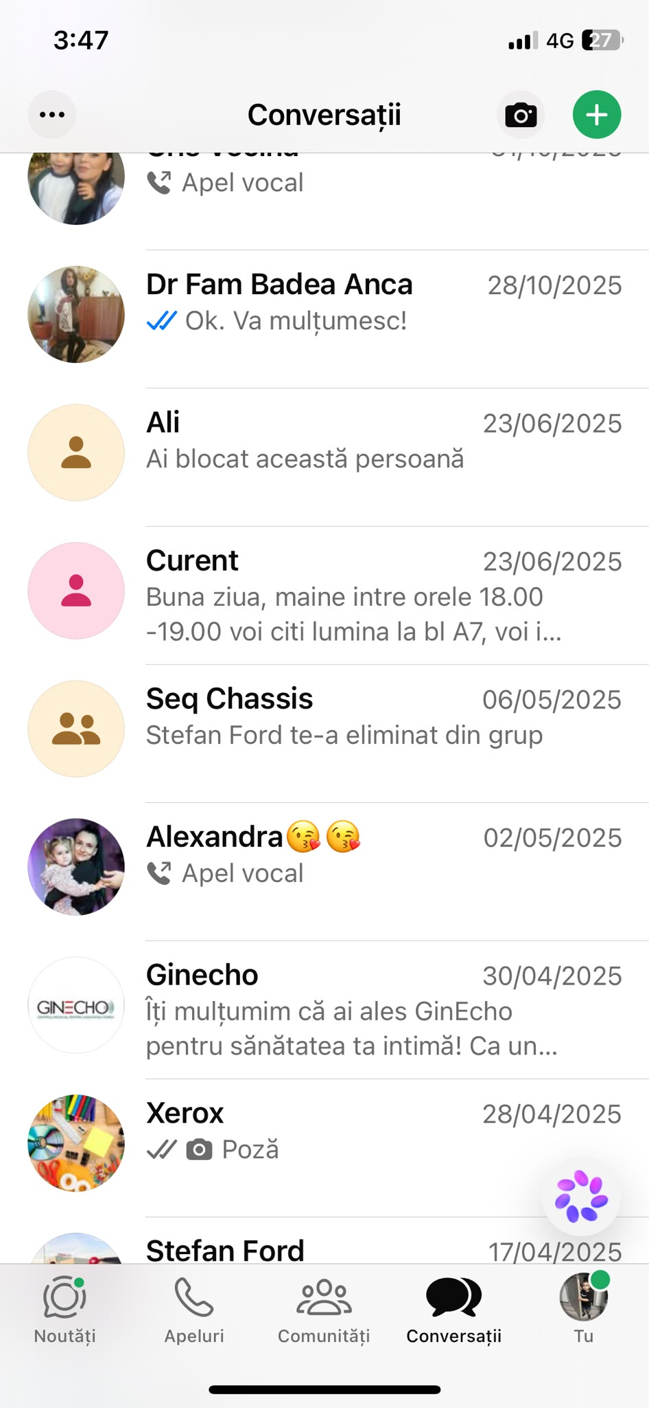
The following is a screen shot of my WhatsApp messages. WhatsApp is a significant digital device I use to interact with friends, family and other contacts via instant messaging, photographs and voice calls, which provide me with daily communication.

Screenshot/Photo 6
TikTok
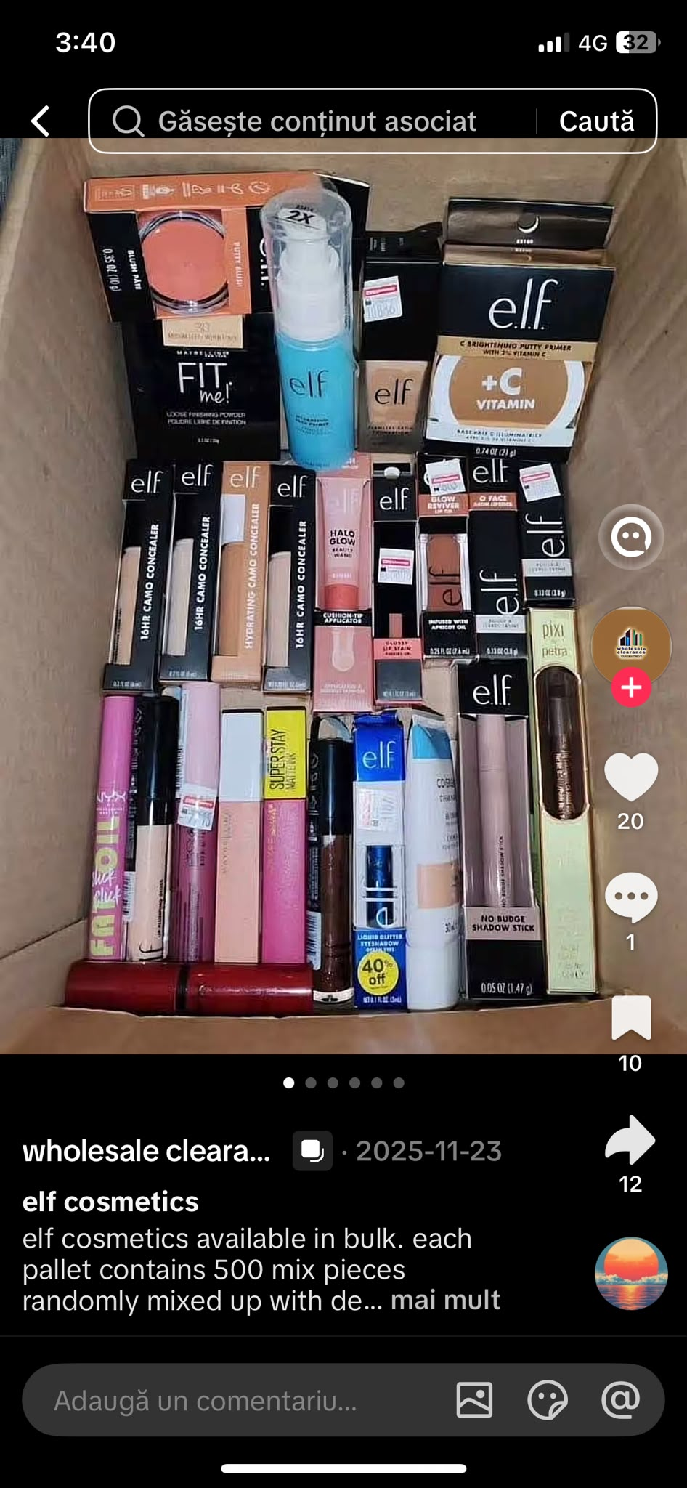
The screenshot illustrates how I go about searching the short-digital content on TikTok, including the videos focusing on products. Tik Tok has become a part of my life since it provides me with a chance to discover the trends, products, ideas, and entertaining information through social media.

My Short Reflection
I use digital tools in my everyday life, both at university and in life. I frequently access Moodle, Outlook, LinkedIn Learning, WhatsApp and social media, and the university student portal provides me with access to the services like Microsoft Teams, Digital ID, student records and the library. I feel confident when using email, messaging applications and online learning platforms (Naghdipour and Manca, 2023). I occasionally fear privacy, safety and location of trusted information using the internet. Another Digital Skills module that I would like to acquire is the confidence to learn and communicate with other people via technology (Rosales-Márquez et al., 2025). Digital skills matter to me as they assist me to study, interact with others and be ready to work in the future.

