Cristoffer Davies (1705493)

Research paper on the potential Use of Plastics in Civil Engineering.
Plastics in Civil Engineering
Materials Engineering – ACBA5005 Lecturer: Allan Nantel

Contents
Evaluate recent research findings in relationship to waste plastic forms as a partial replacement for aggregates in concrete. 2
Evaluate recent research findings in relationship to waste plastic forms as a reinforcing material for mortars. 7
Analyse the application of waste plastic materials in road construction techniques, giving examples of production processes, design methodologies and incorporation utilising case study from both national and international examples. 11
Modular approach 14
Critically assess the material’s practicality, functionality, and future efficiency potential in these applications (1+2), with reference to opinions from the media and professionals, both positive and negative aspects. 16
References 18

Evaluate recent research findings in relationship to waste plastic forms as a partial replacement for aggregates in concrete.

Ma Gour et al (2022) discusses how Polyethylene terephthalate plastic (PET) has been used in previous studies as a partial replacement for coarse aggregate as they believe that the most frequent cause of concrete failure is stone crushing and that using plastics with greater crushing value may produce good results. What previous studies had found was that the higher the percentage of plastic replacing the aggregate in the mix the lower the compressive strength, although anything up to 10% was showing promising results. They also found in previous studies that partial replacement with PET showed higher compressive strength at 5% and 10% which is 39% and 7.6% higher respectively compared with a normal concrete mix. However, in their study they decided to use Polypropylene (PP) plastic due to its higher negative environmental impact value.
Ma Gour et al (2022) cast a total of 72 cubes (150mmx150mmx150mm) and 54 beams (100mmx100mmx500mm). The control mix was M30. The samples were to be tested for compressive strength using an IS 516 approved compressive testing machine, a flexural strength test, a rebar pull out test and a rebound hammer test.
Testing of the PET plastic used in the study showed that it possesses better physical and mechanical properties compared to normal aggregate as evidenced in Table 1 below.
Properties | Coarse aggregate (CA) | Fine aggregate (FA) | PP plastic aggregate
Specific Gravity | 2.7 | 2.5 | 1.22
Absorption | 1.2 | 1.58 | 0
Colour | Grey | Grey | Black
Shape | Angular | - | Angular
Absorption Value | 5.5% | - | 1%
Impact Value | 16.5% | - | 1.8%

Table 1 - Properties (physical and mechanical) of aggregates Ma Gour at al (2022)

Below is a table displaying the quantities of raw materials used for each sample type and the control mix sample.
 | Percentage Replacement of PP Plastic Aggregate
Material Used | Control | SP20 | SP40 | SP60 | SP80 | SP100
Cement (in Kg) | 388 | 388 | 388 | 388 | 388 | 388
Water (in Kg) | 155.25 | 155.25 | 155.25 | 155.25 | 155.25 | 155.25
Water to cement ratio | 0.4 | 0.4 | 0.4 | 0.4 | 0.4 | 0.4
Fine aggregate (in Kg) | 660.02 | 660.02 | 660.02 | 660.02 | 660.02 | 660.02
Coarse Aggregate  (in Kg) (natural) | 1224.13 | 979.10 | 743.478 | 489.65 | 244.82 | 0
Plastic Aggregate (PP Plastic) (in Kg) | 0 | 110.58 | 221.17 | 331.75 | 442.34 | 552.92
Admixture (%) | 1.2 | 1.1 | 1.0 | 0.8 | 0.6 | 0.6
Note –
1.All quantities enlisted above are unit per m³.
2.SP stands for Sample and 20,40,60,80 and 100 are percentage replacement of PP Plastic as Aggregate.

Table 2 - Quantities of raw materials used in the concrete mix - Ma Gour et al (2022)
All samples were kept at a standard room temperature of 27° +/- 1° for 24hrs post casting. After that they were taken from their moulds and placed in a curing tank until 24hrs prior to being tested at the 7,14 and 28 day marks.
The tables below show the results from the tests carried out on the samples:
Compressive strength:
 |  | Compressive Strength (in MPa)
S.No. | % Replacement | 7- Days | 14 -Days | 28 -Days
1. | Control mix | 22.22 | 26.67 | 38.45
2. | SP20 | 18.51 | 21.49 | 34.8
3. | SP40 | 20.22 | 25.54 | 38.1
4. | SP60 | 13.55 | 17.85 | 24.2
5. | SP80 | 10 | 14.25 | 18.84
6. | SP100 | 7.03 | 8.08 | 10.85

Table 3 - Test results for compressive strength - Ma Gour et al (2022)
Flexural Strength:
 |  |  |  | Flexural Strength (in MPa)
 | S.No. | % Replacement |  | 7- Days | 14 -Days |  | 28 -Days
 | 1. | Control mix |  | 3.33 | 3.65 |  | 4.37
 | 2. | SP20 |  | 3.03 | 3.27 |  | 4.15
 | 3. | SP40 |  | 3.16 | 3.55 |  | 4.33
 | 4. | SP60 |  | 2.57 | 2.95 |  | 3.43
 | 5. | SP80 |  | 2.19 | 2.62 |  | 3.02
 | 6. | SP100 |  | 1.83 | 1.96 |  | 2.28
Table 4 - Test results for Flexural Strength - Ma Gour et al (2022)
Bond Strength:
S.No. | % Replacement | Bond Strength (in MPa)
1. | Control mix | 7.77
2. | SP20 | 8.65
3. | SP40 | 6.20
4. | SP60 | 5.25
5. | SP80 | 3.57
6. | SP100 | 7.77

Table 5 - Bond strength at various concrete mixes - Ma Gour et al (2022)

Rebound Value:
S.No. | % Replacement | Average Rebound No.  (Horizontal) | Average Rebound No.  (Vertical)
1. | Control mix | 28 | 33
2. | SP20 | 27 | 32
3. | SP40 | 27 | 32
4. | SP60 | 26 | 31
5. | SP80 | 24 | 26
6. | SP100 | 22 | 25

Table 6 – Rebound value at different mixes - Ma Gour et al (2022)
The test results show that a 40% replacement of coarse aggregate with PP plastic provides satisfactory results across all tests. 20%, 60%, 80% and 100% replacement displays inadequate compressive, flexural, bond and rebound strength.
MD Islam et al (2021) carried out a similar study also using PP plastic as a replacement for coarse aggregate. Their research found similar results to Ma Gour et al. Compressive strength showed a peak at the 10% mark when using PP plastic.
MD Islam et Al’s study used three types of aggregate. Crushed stone, crushed burnt clay brick and waste PP plastic as the replacement material. All material used were graded for similar size, shape and angular similarities.
In the study 16 mixtures with two different water/cement (W/C) ratio’s were produced. The W/C ratios being 0.45 and 0.55. It is important to note that MD Islam et al noted that the specific gravity of PP plastics is much lower than that of natural aggregate so the replacement was made on a volume basis (0%, 10%, 20%, 30%) and not weight. The naming conventions for the samples were unique to display W/C ratio as well as the replacement volume of the PP plastic. (SC45P3 – SC = Stone chip/type of aggregate, 45 = W/C ratio of 0.45, P3 = PP plastic volume of 30%).
Preparation of samples was similar to Ma Gour et al’s study but testing of the samples were carried out at different intervals (7,28 & 90 days) for MD Islams study vs (7,14 & 28 days) for Magour et al. The range of tests carried out by MD Islam also differed from Ma Gour’s: workability, density, compressive strength, tensile strength, modulus of elasticity.

Figure 1 - Variation in slump value to demonstrate workability of the samples - – Islam et al (2021)

The graph above demonstrates improved workability as the W/C increases as well as an increase when samples contained a larger volume/percentage of PP plastic. It is thought that this is due to the low permeability of the material thus creating a ‘wetter’ mix. Crushed Brick inclusion into the samples reduced workability due to its higher permeability values.
Figure 2 - Comparison of concrete compressive strength at the age of 7, 28, and 90 days with various aggregate types (SA, BA, and PPA), and w/c ratios - – Islam et al (2021)

The graph above shows how the various mixes differ in compressive strength at the 7-, 28 and 90-day intervals. It is clear to see from the study that all samples had a greater compressive strength at the 90-day marks and that the best mix for compressive strength would be using stone aggregate a lower W/C ratio and that 10% inclusion of PP plastic shows the greatest strength when the material is used.
Figure 3 - Variation in concrete density at 28 days with aggregate types (SA, BA, and PPA), and water-cement ratios (0.45 and 0.55) – Islam et al (2021)

The graph above shows the Density of the concrete samples at the 90 day mark. As PP plastic has lower specific gravity compared to Stone aggregate it’s density will be lower and the value reduces as the volume of PP plastic increases. W/C ratio does not seem to have an impact with density. A 10% inclusion of PP to Stone aggregate with a 0.45 or 0.55 W/C ratio shows promising results.
Figure 4 - Variation in concrete split tensile strength and modulus of rupture at the age of 28 days with aggregate types (SA, BA, and PPA), and W/C ratio. – Islam et al (2021)

The graph above displays the samples’ tensile strength. These results show a similar trend to compressive strength in that a greater W/C ratio will result in a decrease in tensile strength. Both tensile and rupture strength is increased and peaks when the inclusion of PP plastic is at 10% and decreases from there on after (20%, 30%). It is interesting to note that the increase in tensile and rupture strength can be seen across all mix types except for the Burnt clay at 0.55 W/C ratio.
The results display that the inclusion of 10% PP plastic to produce a general strength 25MPa concrete using a 0.45 W/C ratio is not only satisfactory but key parameters such as workability, compressive strength, ruptural & tensile strength are increased.
Both studies show that PP plastic has significant potential as a partial replacement for traditional aggregate in concrete mixes.

Evaluate recent research findings in relationship to waste plastic forms as a reinforcing material for mortars.
Alsaif et al (2022) conducted a study which aimed to determine the flexural and ductility behaviours of various mortar mixes containing either, recycled post-consumer tire steel fibres (RTSF), Manufactured steel fibres (MSF) or recycled plastic fibres (RPF). The flexural strength and ductility of the samples were determined via a displacement controlled four-point bending ASTM test.
Alsaif et al cast 30 prism samples (100mm x 100mm x 500mm) for the flexural strength tests, 40 cube samples (100mm x 100mm x 100mm) to determine their compressive strength and 10 semi cone samples for determining flow and workability. The entire sample range was produced using Type 1 Portland cement (compliant with ASTM 150 standards), white silica sand and tap water.
The table below shows the mechanical properties of the fibres incorporated into the mixes.
Fiber Type | Length (mm) | Diameter (mm) | Width (mm) | Density (g/cm³) | Tensile Strength (MPa) | Young’s modulus (MPa)
MSF | 60 | 0.75 | - | 7.8 | 1800 | 200,000
RTSF | 10-60 | <0.3 | - | 7.8 | ≈2570 | 200,000
RPF (Flat) | 50 | 0.5 | 2.0 | 1.38 | 310 | 10,200

Table 7 - Mechanical properties of MSF, RTSF and RPF - Alsaif et al (2022)
All 10 mixes were designed following the ASTM C109 standards for a 28 day compressive strength of 50MPa. The mix proportions were 0.5 pts Water, 1.0 pts Cement and 2.0 pts white silica sand. The experimental fibres were added gradually to the mixes to ensure thorough distribution throughout the mixes.

Mix # | Fibers Volumes |  |  | Fibers quantity in KG
Mix # | MSF | RTSF | RPF | MSF | RTSF | RPF
M1 | - | - | - | 0.00 | 0.00 | 0.00
M2 | 0.50% | - | - | 1.18 | 0.00 | 0.00
M3 | - | 0.50% | - | 0.00 | 1.18 | 0.00
M4 | - | - | 0.50% | 0.00 | 0.00 | 0.21
M5 | - | 0.25% | 0.25% | 0.00 | 0.59 | 0.10
M6 | 0.75% | - | - | 1.78 | 0.00 | 0.00
M7 | - | 0.25% | 0.50% | 0.00 | 0.59 | 0.21
M8 | - | 0.50% | 0.25% | 0.00 | 1.18 | 0.10
M9 | 1.00% | - | - | 2.37 | 0.00 | 0.00
M10 | - | 0.50% | 0.50% | 0.00 | 1.18 | 0.21

Table 8 - Volume fractions of different types of fibres used (Table 5 Alsaif et al 2022)
Once mixed, the samples were cast and cured in water for 28 days. Samples are cured in water to reduce heat loss from the curing process which can have an effect on the curing process.
All tests carried out on the samples were done as per the relevant standards associated with the testing procedures:
Results:
Flow:
Figure 5 - Results of the flow test in the different mixes – Alsaif at al (2022)
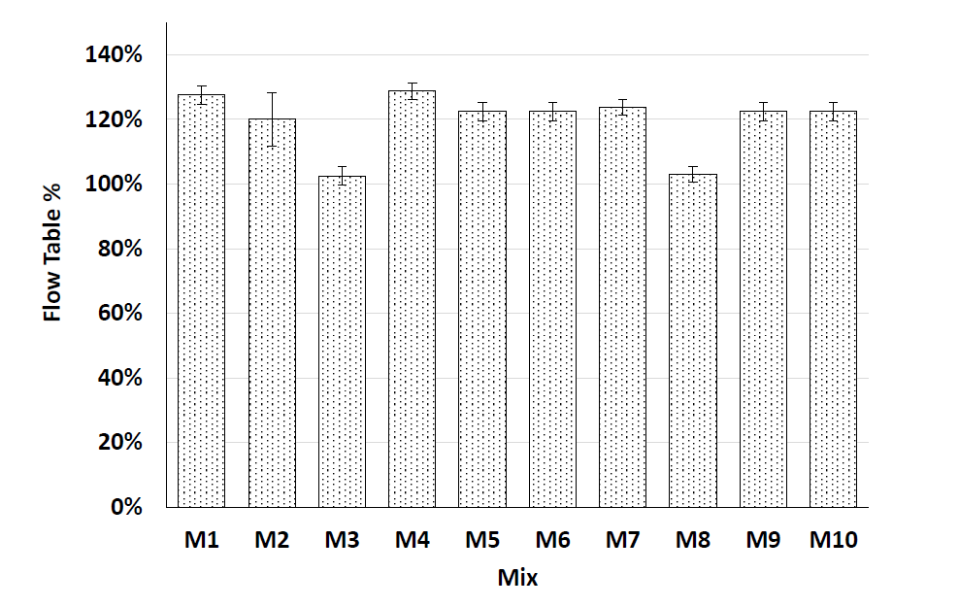
The results of the flow/workability of the different is shown above. Mixes 4,5, 8 & 10 are those containing the RPF. The Results for mixes 4,5 and 10 are shown to be within the flow range described in ASTM C1437-20 and were almost the same as of the control mix. Mixture 8 shows a reduction in flow but Alsaif et al (2022) describe this as being within the range of testing error.
Compressive strength of mortar:
Below is a graph representing the compressive strength results of the cube samples at the 28-day period. The results show that all the mixes are within the range of high strength mortar. M4 was the only mix that contained only RPF, the other contained RPF were hybrid mixes containing a blend of RPF with either MSF or RTSF. M4 showed a compressive strength above that of the control mix.

Figure 6 - Table showing compressive strength results of the samples. - Alsaif at al (2022)
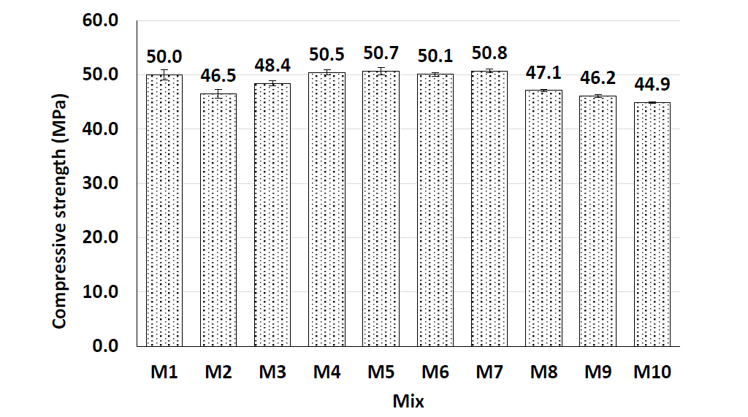
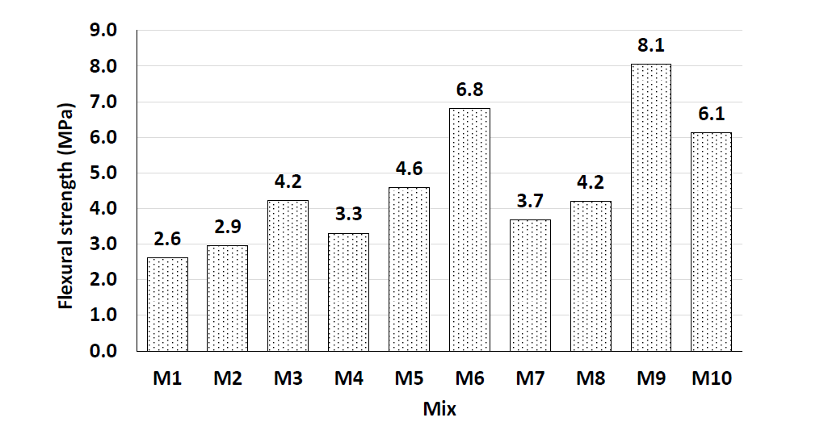
Flexural characteristics:
Figure 7 - Peak flexural strength of all mixes - Alsaif at al (2022)
The figure above shows that the flexural strength of the mortar containing only RPF (M4) is similar of that of the control mix and that the hybrid mixes containing RPF (M5, M7, M8 and M10) all have higher flexural strengths than that of the control. However, it should be noted that M6 and M9 (MSF) results provide even greater flexural strength.

Pederneiras et al (2018) produced a review of studies which was mainly concerned with the cracking properties of mortars using both natural and synthetic fibres. They used a range of natural fibres including bamboo, rice and pig hair and synthetic fibres including nylon and PET (Polyethylene terephthalate plastic). The review concludes that the cracking performance can be improved by the inclusion of recycled fibres. The findings were that both natural and synthetic fibres produce improved performance and that both vegetal and synthetic fibres produced comparable improvements. The review notes that PET reinforced mortar showed the highest level of resistance to cracking of all of the fibres examined.

Analyse the application of waste plastic materials in road construction techniques, giving examples of production processes, design methodologies and incorporation utilising case study from both national and international examples.
In recent years waste plastic has been used in the construction of the top layer of roads and highways. There are three techniques which are used, modular – where the entire road is precast made of plastic and is laid in a ‘lego’ fashion, a wet asphalt process and a dry process. When taking the environment into consideration the modular system has the greatest potential due to the entire system being manufactured from waste plastic. The wet and dry asphalt techniques do not replace 100% of the traditional ingredients with plastic, but relatively small amounts are utilised and added to the current blend of ingredients. It is also widely considered and established that traditional hot mix asphalt (HMA) formulations are affected by the rheological properties of bitumen and that the addition of plastic can improve the asphalt’s physical and mechanical properties.
Viscione et al (2021) conducted a study looking at the performance-based characteristics of recycled polymer modified asphalt.
Bitumen modified using polymers such as Polyethylene (PE), Low Density Polyethylene (LDPE), and others is known as Polymer Modified Bitumen (PMB). The PMB can then be used in the so-called ‘wet process’ to produce a version of HMA referred to as HMA_{PMB}. The wet process requires two manufacturing plants, one to mix the polymers and the bitumen and the other to mix the modified bitumen with the aggregate. This mix will then need to be transported to the lay site whilst being maintained at a temperature of 160-170°c and continually agitated. According to Viscione et al (2021): ‘The use of PMB offers significant advantages over that of neat bitumen and depending on the modifiers used the PMB can be more elastic, flexible, durable and less sensitive to temperature fluctuations and aging’. However, the polymer must be compatible with the bitumen as they are chemically very different. PMB has other drawbacks such as the complexity and environmental unfriendliness of the manufacturing procedure. Further, the product becomes very viscous during mixing.
The so-called dry process can be used to produce Polymer Modified Asphalt (PMA). PMA is produced by directly adding the chosen polymer into the mixed aggregate and bitumen – the process is therefore simpler and, as it only requires one mixing plant, more cost effective. The main benefit of the dry process is that a high temperature isn’t required during the production process thus improving the performance of the HMA compared to the other techniques as the method reduces the likelihood of the polymer and bitumen separating during the mixing process. As a result, PMA or the dry process has more recently been investigated as a potential improved technique. The material produced will be referred to as HMA_{PMA} to distinguish it from the HMA_{PMB} discussed above.
The study examined the physical and mechanical properties of HMA_{PMA} to compare the results with a traditional HMA and with a HMA_{PMB} to evaluate which one would give the best results in the conducted laboratory tests:
- Indirect tensile test (ITS)
- Moisture damage by indirect tensile strength ratio
- Cracking fatigue and semicircular bending tests
- Rutting by considering stiffness modulus and susceptibility to deform by wheel tracking.

All mixes were designed to EN standards and all laboratory tests were also recognised asphalt testing EN standard tests.
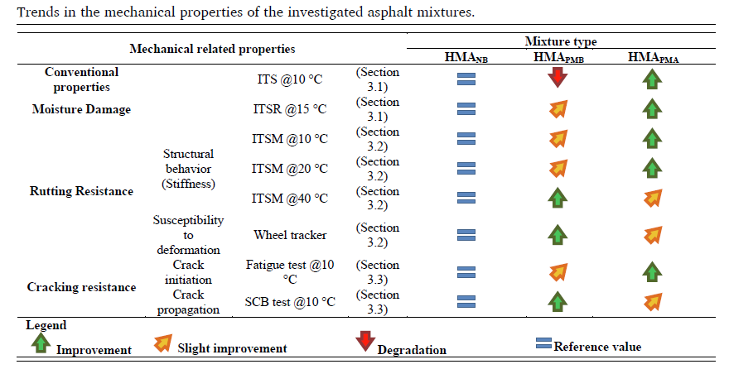
Table 9 - Trends in the mechanical properties of the investigated asphalt mixtures - Viscione et al (2021)
The table above compares the mechanical properties of the tested samples. Overall the study shows that HMA_{PMA} and HMA_{PMB} both display better performance in terms of mechanical characteristics. Moisture damage, rutting resistance and cracking resistance are all improved across both methods except for the ITS at 10°C of the HMA_{PMB} mixture.
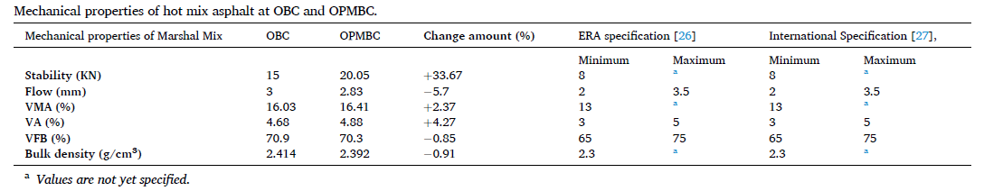
Genet et al (2021) conducted a similar study which was aimed at amplifying the advantage of using the wet process over traditional HMA. Four bitumen mixes were prepared with 4,6,8 & 10% waste LDPE plastic content by weight. The samples were mixed at different temperatures, 160,170 & 180°c. They also looked at different mix times, 1,1.5 & 2hrs. The samples were then tested to evaluate penetration point, softening point and ductility.
Table 10 - Mechanical properties of hot mix asphalt at OBC and OPMBC - Genet at al (2021)
Their major finding of their study was that waste LDPE is advantageous in enhancing HMA. They found that the optimal bitumen content to be added into aggregate mix was found to be 5.16% by the weight of total aggregate mix and the optimum amount of waste LDPE plastic content that should be mixed with bitumen was found to be 6.5% by the weight of OBC and a mixing temperature of 170°c for 1.5 hrs. This manufacturing process displayed a 33.67% higher stability than that of traditional HMA. However, flow and workability were slightly reduced. Generally, all mechanical properties were improved through using waste LDPE in the production of HMA_{PMB}.
The Scottish company Macrebur are also known for incorporating recycled plastic into road construction, both nationally in the UK and Internationally in Africa, Europe and the USA. An example of the use of their method in the UK is the Enfield project in London where they were the contractor for a road resurfacing project using modified resin MR and comparing to traditional HMA. Modified resin is the term used by the company for the modified asphalt used. Their study and work concluded that MR asphalt containing 6, 8 & 10% waste plastic saw moderate to great improvements in ITSM (Indirect tensile strength modulus) tests, fatigue and wheel tracking or deformation testing. Various sections of the resurfaced road were used with the various mixes. MacRebur (2019) reports that a senior site engineer from Enfield council commented that: ‘Green Dragon Lane, Enfield is performing very well to date despite harsh winters and hot summers.’
After analysing the results and considering that HMA_{PMA} is a more cost effective and environmentally friendly option, it is my opinion that industry should focus future R&D of the technology towards PMA techniques. However, PMB displays improvements in mechanical properties so we can conclude that modified asphalt produced by either wet or dry process is a promising material. (Loughran, J. 2019)
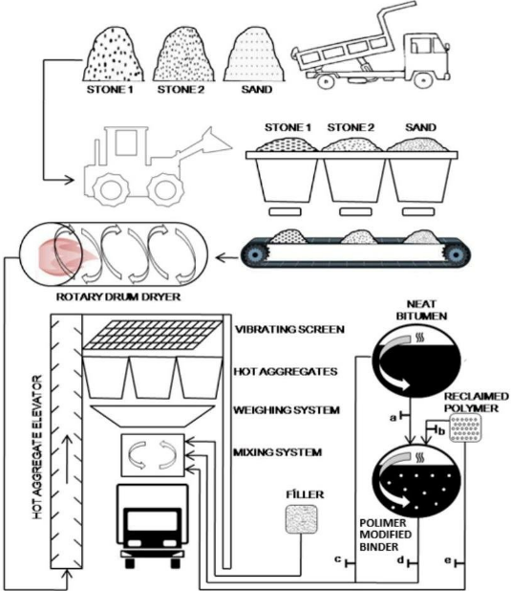
Figure 8 - Wet & Dry process visualization - Anurag et al 2018

Modular approach
Plastic roads or modular plastic roads have emerged as a groundbreaking innovation in the infrastructure sector, and the Netherlands stands at the forefront of this technology. As a country known for its progressive approach towards sustainability and environmental issues, the Netherlands has been experimenting with plastic roads as an eco-friendly alternative to conventional asphalt. The primary motivation behind the development of plastic road development is the environmental impact of plastic waste. By introducing recycled plastic into road construction, the Netherlands aims to contribute to the circular economy by giving a second life to plastic materials that would otherwise end up in landfills or oceans. The initiative is a collaborative effort between the Dutch company KWS Infra, PlasticRoad and Wavin – their aim is to revolutionise the way roads are built and maintained.
The plastic road modules resemble large ‘lego’ blocks consisting of recycled plastic are designed to be modular and easily installed. This modular approach does not only simplify the construction process but also allows for efficient maintenance and future upgrades. The modular approach also accommodates various services and utilities such as pipes and cables to be easily installed and accessed.
Durability and performance are the key design elements of the plastic roads and they are engineered to withstand challenges posed by changing weather conditions, heavy loads and the forces applied by acceleration and deceleration of vehicles. The plastics chosen for these roads are chosen for their strength and resilience. Polyethylene and polypropylene is usually the chosen plastic for manufacturing the modules.

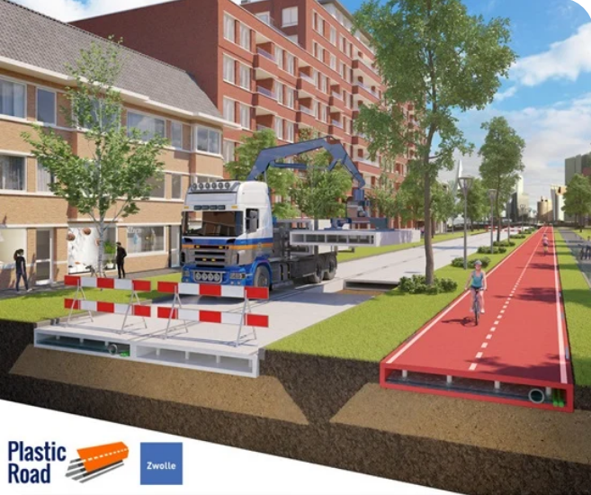
Figure 9 - 3D model demonstrating lay method of modular plastic road and incorporated service system - Wavin.com 2023

In terms of longevity, it has been stated that plastic roads are deemed stronger and more durable than standard asphalt roads. According to (theconstructor.org 2023) they are better to standing up to harsher weather and more resistant to forming potholes and cracks. This is likely due to their ability to flex and adapt to movement in the ground. This flexibility allows the roads to move and stretch with the terrain they are laid on which reduces the risk of crumbling and cracking which asphalt roads frequently do. This reduces the maintenance requirements. One of the other benefits of the plastic roads is that it can be manufactured in less wasteful shapes and generally have less waste product which makes it a more environmentally friendly option.

Critically assess the material’s practicality, functionality, and future efficiency potential in these applications (1+2), with reference to opinions from the media and professionals, both positive and negative aspects.
In sections 1 and 2 of this assignment we have examined the use of waste plastic in a range of engineering applications. If we focus upon the mechanical and physical properties of these materials, then it certainly appears that they have a great deal of potential in the future. The twin motivations of improving the performance of the materials used and the removal of some plastic waste from the environment appear to be satisfied.
As far as the use of waste plastics as partial replacements for aggregates in concrete is concerned the studies appear to show that improvements in a range of physical and mechanical properties can be achieved – including compressive, flexural and bond strength. The studies were not entirely consistent in terms of the optimum percentage replacement rates, but they were consistent in determining that the waste plastics have real potential as a partial replacement for aggregates.
Further, we can see that waste plastics have a potential application as mortar reinforcement material. The use of recycles plastic fibres appears to improve the performance of mortars in both compressive and flexural strength. The study used a range of fibres both individually and in combination so that it seems to be the case that work is needed to find the optimum combinations and quantities of various fibres. However, the findings were clear that waste plastics could have a role to play.
In section 2 of this assignment, we looked at the use of waste plastics in road construction and, once again, there appear to be a range of application in which waste plastics can be utilised. In particular, they can be used in relatively small amounts mixed into hot mix asphalt (HMA) which is a very common material in road construction. It is encouraging to note that the performance of HMA can be improved by the inclusion of these materials. Perhaps the most exciting developments are in the area of modular road construction where a much larger amount of waste plastic can be used with associated environmental benefits that can therefore be achieved.
Waste plastic seems to have a range of possible applications from the production of concrete and mortar to its use in road construction and in terms of physical and mechanical properties several studies have shown definite benefits. It is clear that more work is needed to determine how to achieve the optimum performance for these modified materials and it may be that we should consider how these materials will perform over a much longer time scale than the studies referenced could achieve. It is sobering to note that reinforced autoclaved aerated concrete (RAAC) has become a serious issue in the UK recently and illustrates the need to be careful when considering the long-term performance of new or novel materials.

Cirino et al (2023) discusses the performance effect of plastics in construction materials and civil Engineering. They outline how cohesive strength, compressibility, flexural strength, seismic performance, shear strength and thermal insulation is improved through the addition of plastics. The performance benefits of plastics in the construction of roads are also praised. The ability of the modified asphalt to withstand cracking, rutting and other determinations of weathering were outlined.
The use of plastic in modular plastic road construction is gaining traction nationally in the UK as well as internationally. In my opinion its versatility, durability and environmental friendliness is something that should be considered. However, it does have some disadvantages including the potential leaching of plastics into the environment. If modular plastic roads become increasingly popular then there are likely to be problems in sourcing sufficient quantities of the required base materials.

References
Alsaif, A., & Alshannag, M. (2022). Flexural Behavior of Portland Cement Mortars Reinforced with Hybrid Blends of Recycled Waste Fibers. Sustainability (Basel, Switzerland), 14(20), 13494-. https://doi.org/10.3390/su142013494
Genet, M. B., Sendekie, Z. B., & Jembere, A. L. (2021). Investigation and optimization of waste LDPE plastic as a modifier of asphalt mix for highway asphalt: Case of Ethiopian roads. Case Studies in Chemical and Environmental Engineering, 4, 100150-. https://doi.org/10.1016/j.cscee.2021.100150
Gour, M. A., Sharma, S. K., Garg, N., Das, S. K., & Kumar, S. (2022). Utilization of Plastic Waste as a Partial Replacement of Coarse Aggregates in Concrete. IOP Conference Series. Earth and Environmental Science, 1086(1), 12047-. https://doi.org/10.1088/1755-1315/1086/1/012047
Islam, Md. J., & Shahjalal, M. (2021). Effect of polypropylene plastic on concrete properties as a partial replacement of stone and brick aggregate. Case Studies in Construction Materials, 15, e00627-. https://doi.org/10.1016/j.cscm.2021.e00627
Loughran, J. (2019). News - Comment. Environment - Scottish factory converts plastic waste into road paving material. In Engineering & technology (Vol. 14, Issue 3, pp. 11–11). Institution of Engineering and Technology (IET). https://doi.org/10.1049/et.2019.0320
(No date) Netherlands builds the first plasticroad - wavin. Available at: https://blog.wavin.com/en-gb/netherlands-builds-the-first-plasticroad (Accessed: 12 January 2024).
Pederneiras, C.M., Veiga, M. do R. and de Brito, J. (2018) ‘Effects of the Incorporation of Waste Fibres on the Cracking Resistance of Mortars: A Review’, International Journal of Green Technology [Preprint].
Plastic roads: How they impact our environment (2023) The Constructor. Available at: https://theconstructor.org/others/plastic-roads-how-they-impact-our-environment/569385/ (Accessed: 12 January 2024).
Sustainable polymers for asphalt (2019) MacRebur. Available at: https://www.macrebur.com/#projects (Accessed: 12 January 2024).
Tiwari Anurag V., & Rao Y. R. M. (2018). Study of plastic waste mixed bituminous concrete using dry process for road construction. Selected Scientific Papers, 13(1), 105–112. https://doi.org/10.1515/sspjce-2018-0024
Viscione, N., Lo Presti, D., Veropalumbo, R., Oreto, C., Biancardo, S. A., & Russo, F. (2021). Performance-based characterization of recycled polymer modified asphalt mixture. Construction & Building Materials, 310, 125243-. https://doi.org/10.1016/j.conbuildmat.2021.125243

