UNIVERSITY OF WALES: TRINITY SAINT DAVID
PRIFYSGOL CYMRU: Y DRINDOD DEWI SANT
School of Business
London Campus

Impact of Cultural and Language Barriers on Employee Engagement and Performance of Employees in Zara

Student ID: 2238951
Student Name: Gurvinder Kaur
Module: Dissertation
Module code: LCMB7020
Supervisor Name: Mohamed Asim
Declaration
I declare that this research study “Impact of Cultural and Language Barriers on Employee Engagement and Performance of Employees in Zara” is completed by me and this work contains no material which has been copied directly from any source and does not involve any breach of academic integrity and ethical practice. Reference to the information and knowledge source used in the study has been well cited and documented. That is to say, this work should not have been submitted in part or in full to any other part of the university or other academic institutions. I claim full responsibility for the material and presented conclusions in the work.

Acknowledgement
I would like to pay my gratitude to all the people who encouraged me in carrying out this research as well as offered me a piece of crucial advice on how to do it. I would like to express my gratitude for the helpful suggestions, valuable guidance, and crucial recommendations that contributed to defining the further research strategy. Through their commitment, I was able to create learning that enhanced my understanding of the research topic. These viewpoints enhanced the calibre of my work through the following aspects. It is impossible to find a way to complete this research without the love and support from everyone. I would like to thank you for confirming with me some of my career choices.

Abstract
The main purpose of conducting this study is to analyse the role that cultural and language barriers play in affecting employee engagement and performance while considering the case in the context of Zara. In terms of analysing the data, data obtained from 96 employees in Zara was analysed using quantitative research method, and further analysis was done through statistical analysis.
The outcomes of the study showed that the organisational environment, culture, and leaders contribute to work engagement among corporations. It gets challenging to be an active contributor or to engage with others when others are disengaging themselves. Zara targets its own employees within organisations, developing corporate policies regarding diversity, respect, equal opportunity, balanced working hours, and further education. The fashion industry requires companies to create relevant communication channels with their employees. Efficient or clear communication determines a clear understanding of policies, norms, and procedures that are laid down to eliminate language and cultural barriers. Moreover, promoting ethical practices in the rich diversity of employees in the business is also good because it improves productivity and fosters good teamwork. Besides, the impacts of cultural diversity in the workplace have been assessed to enhance the efficiency and knowledge of employees in the workplace. This promoted courtesy to other persons and the ability to speak different languages, which in turn developed the best consumer satisfaction and reputation of the company.
It has been recommended that Zara introduce enhanced language support and translation services, comprehensive cultural competency training, and structured team-building programmes in order to increase employee engagement and performance while mitigating cultural and language problems within the business.
Keywords: Culture and language, barriers, employee engagement, performance, Zara
Table of Contents
Abstract 4
Chapter 1: Introduction 8
1.1 Research Background 8
1.2 Aim, Objectives and Research Questions 9
1.3 Problem Statement 10
1.4 Research Rationale 10
1.5 Research Significance 11
1.6 Research structure 11
Chapter 2: Literature Review 13
2.1 Introduction 13
2.2 Concepts and notions related to cultural and language barriers in Employee Engagement and Performance 13
2.3 The factors regulating employee engagement and performance within a company. 15
2.3.1 Factors influencing employee engagement within Zara 16
2.3.2 Factors that can impact employee performance within an organisation. 19
2.4 The organisational response to the effective and ethical management of diverse employees within the fashion sector 20
2.5 The relationship between cultural and language variations and the performance and engagement of Zara employees. 22
2.5.1 The relationship between the cultural variations and the performance as well as engagement of ZARA employees. 22

2.5.2 The relationship between the language variations and the performance as well as engagement of ZARA employees. 23
2.6 Conceptual Framework 25
2.7 Research gap 25
2.8 Summary 26
Chapter 3: Research Methodology 27
3.1 Introduction 27
3.2 Research Design 27
3.3 Philosophical Assumption 28
3.4 Research Approach 28
3.5 Research strategy and methods 29
3.6 Population and sampling 30
3.7 Data collection method 30
3.8 Data evaluation method 31
3.9 Ethical consideration 31
3.10 Limitations 31
Chapter 4: Reasearch findings and Analysis 33
4.1 Introduction 33
4.2 Findings 33
Chapter 5: Discussion 47
Chapter 6: Conclusion and Recommendations 51
6.1 Introduction 51
6.2 Conclusion 51
6.3 Recommendations 53
6.4 Recommendations for future research 55
References 56

Chapter 1: Introduction
The purpose of this thesis is to critically analyse the culture and language barriers impacting employee engagement and performance at Zara. The thesis will provide different authors' perspectives in the literature review to examine the current environment of these culture and language barriers and the role of employee engagement in the fashion sector. Additionally, it will also highlight the relevant methods, approaches, and strategies in the research methodology section that will be used to complete the thesis. Furthermore, the thesis aims to help Zara overcome the cultural and language barriers that are affecting employee engagement.

1.1 Research Background
Employee engagement is a concept of human resource management which can be described as satisfaction level, enthusiasm, and dedication among employees towards their job role (Sypniewska, et al., 2023). Engaged employees are highly focused on their performance in order to contribute to the success of the company. Employees' performance can be defined as achieving the targeted goals of the company by matching their standards (Islami, et al., 2018). It effectively involves the measurement of how employees put their efforts towards their job role, complete required tasks and their behaviour at the workplace. These all can effectively provide various benefits to fashion companies such as revenue, customer base, growth and expansion opportunities. In the context of the fashion industry, employee engagement plays a crucial role as it directly impacts employee performance which results in affecting the entire success of the company. When employees are engaged, it helps in generating creative ideas, providing productivity, and motivation in each other, provide strategic and innovative ideas. The impact of employee engagement and their performance on the fashion industry is that they improve customer service, enhance quality, higher retention of employees and improve brand reputation in a competitive market (Dhir and Shukla, 2019).
Cultural and language barriers have a significant impact on employee engagement and performance within the company. Therefore, it is important to manage diverse people and apply an inclusive workforce strategy in the company. It can improve employee performance and ensure a positive culture in the company with employee engagement (Riyanto, et al., 2021). Language and cultural barriers impact the relationships with others in the workplace. Misunderstandings can arise, leading to conflicts, wasted time, and reduced performance within the company. Therefore, Zara also faces problems due to cultural and language barriers in the company, which significantly affects the growth and sales of the organisation. This is because a lack of diversity and inclusion of employees in the fashion industry impacts their designs, customer service, customer base, and satisfaction. This is because diverse people provide creative and strategic ideas for designs and innovations (Kim and Sullivan, 2019).
Zara retains the talent in the company because it is able to attract professional, qualified, and talented people to work in the company. In addition, the company provides various career opportunities to its employees through internal promotion and mobility, which helps them to effectively increase their employees' performance (Static Inditex, 2021). For employee engagement, Zara has also created an InStories programme where they connect with their employees through their internal social network. This program includes seven markets such as Italy, Portugal, Greece, Turkey, Poland, South Korea, and Japan with more than 20,000 users. This strategy helps organizations build a community and connect with their employees, while providing them with a platform for communication channels to convey messages and share thoughts and values ​​(Static Zara, 2020).
1.2 Aim, Objectives and Research Questions
Aim
The proposed aim of the current study is to examine the impact of cultural and language barriers on employee engagement and performance considering the case of Zara.
Objectives
- To analyse the factors regulating employee engagement and performance within a company.
- To examine the organisational response to the effective and ethical management of diverse employees within the fashion sector.
- To investigate the relationship between cultural and language variations and the performance and engagement of Zara employees.
- To determine the issues faced by fashion companies in improving employee engagement and performance due to language and cultural differences in the workforce.

Primary Research Question
- How do cultural and language barriers in Zara impact employee engagement and performance?
Secondary Research Questions
- What forces influence organisational employee engagement and performance?
- How company manage diverse workers more ethically and effectively?
- What is the relationship between Zara’s language, cultural barriers, and performance?
- What issues does Zara face while improving employee performance due to the language and cultural barriers in the company?

1.3 Problem Statement
In the current competitive scenario of the business, ZARA is facing several issues and challenges regarding the engagement of employees and performance in multidimensional applications (Elsbach and Stigliani, 2018). The performance and engagement of the group members are highly impacted due to language and cultural barriers in the workplace. The company operates its business in several global markets therefore presence of the employees from several backgrounds results in issues in enhancing their performance level in the workplace. In the business of ZARA, the cultural and language differences are fostering a culture of the micro-groups that are competing in an effective manner. The issues of cultural differences affect global business in three primary areas that are organisational communication, etiquette, and hierarchy. The reduced engagement of the employees due to the language and cultural differences impacts the efficiency and productivity of the ZARA workplace (Riyanto, et al., 2021).
Therefore, the company needs to prioritise the incorporation of effective development and training programmes for fostering values in the employees and establishing zero tolerance against discrimination in the workplace.

1.4 Research Rationale
The reduced performance and engagement of the employees in the workplace of ZARA due to the presence of cultural and language differences in the workplace of the global as well as domestic workplace. Therefore, the concerned research is beneficial for ZARA in mitigating the issues and problems related to cultural and language differences in the workplace. It has been evaluated that there are various strategies that have been recommended in the research that help ZARA in reducing the impact of cultural barriers in the business scenario (Elsbach and Stigliani, 2018). In the fashion sector, the problem of cultural and language barriers could be suitably underlined in the concerned research paper. Furthermore, in the research, the accumulation of various unethical activities such as biased decision-making and discrimination have been conducted that assist in reducing the productivity of the employees.
The performance of the employee members in the workplace could be reduced with the differences in their languages that assist in reducing workplace productivity (Dewaele and Alfawzan, 2018). The research could be suitably valuable for ZARA in resolving the issues related to employee performance and engagement in the workplace.

1.5 Research Significance
The research is holding significant methods for the businesses that are operating in the fashion industry and especially for ZARA for how to deal with the critical situations that arise due to the language and cultural differences in the workplace. The issues faced by the companies regarding employee engagement and performance in a team that consists of employees from diverse backgrounds could be resolved with the help of some suitable strategies (Kiradoo, 2022). The research suitably helps in emphasising the impact of cultural differences on the growth and profitability of ZARA in the fashion industry. With the help of the research, ZARA could easily deal with the issues related to the cultural and language barriers in the workplace. Furthermore, the research also plays an important role in determining some effective strategies that are beneficial for cultural management and mitigating the challenges related to employee engagement and performance. The information mentioned in the concerned research is beneficial for the fashion sector and companies in handling the changes related to the language and cultural changes in the global as well as domestic marketplace.

1.6 Research structure
Introduction: This section of the research consists of an entire overview of the research title by presenting the background of the study. Furthermore, this also comprises the aim, objectives, research rationale, significance, questions, and problem statement.
Literature review: Furthermore, in this chapter, the analysis of the ideas and concepts stated by the authors in their research papers, articles, and journals helps in understanding the title of the study. Relevant information about the objectives of the study has been mentioned in this section of the study.
Research methodology: This chapter of the study is beneficial in defining the tools, methods, approaches, and techniques that are relevant for collecting, analysing, and interpreting the information associated with the title of the study.
Research finding and analysis: This section of the research paper plays an important role in emphasising the analysis and interpretation of the information gathered for the study. With the help of the interpretation of the information in the study, suitable outcomes could be attained that help in acquiring the aim of the research.
Discussion: This chapter of the research critically discusses the findings obtained from the collected data and the viewpoints of authors evaluated in the literature review to justify the aim.
Conclusion and recommendation: In this last section, the findings of the study have been concluded in a suitable manner that helps in attaining better outcomes in the study. There some suitable recommendations have also been provided in the study in this section that assist in mitigating the issues related to the cultural and language changes.

Chapter 2: Literature Review

2.1 Introduction
The concerned segment of the study includes some critical approaches of the authors concerned with the impact of the language and cultural barriers on employee engagement and performance in the business of ZARA. The viewpoints of different authors have been reviewed in order to gather some relevant information in the research papers. There are various articles, journals, research papers, and newspapers have been critically analysed and reviewed that are beneficial for generating effectiveness of the research based on the language and cultural barriers in the ZARA. In this section, some numerical information and chart graphs have been gathered with the help of the company's statistics and revenue in the global marketplace.

2.2 Concepts and notions related to cultural and language barriers and Employee Engagement and Performance
According to Saks, (2022), employee engagement refers to the human resource concept wherein it describes the level of dedication as well as enthusiasm an individual has for their job. When any challenges occur with employees, they may feel like their work is everything to them and even a part of their own life. Even when employees get involved, they possess many more chances for high efficiency, effectiveness, and lots of positive contributions to the organisation’s purposes and goals. On the other hand, the main achievement is to see that personnel act according to their duties and fulfil the tasks set for them (Chandni and Rahman, 2020). Also, not only employee engagement but also performance is an equally hampering factor in attaining the success of a business.
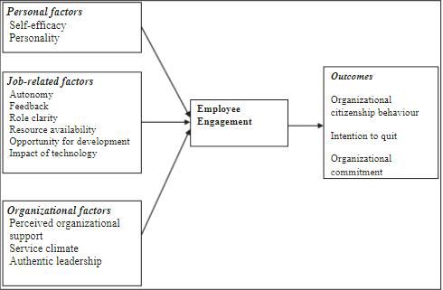
Figure 1: Employee engagement and its outcome
Source: (Masha, et al., 2023)
{The above figure describes that there are personal factors, organisational factors and job-related factors which determine the level of employee engagement. If these factors are supportive or on the favourable side of the employees, they will achieve the desired outcomes with their increased efficiency and effectiveness.)
As per the views of Gut, et al., (2017), cultural and language boundaries can have a consequence on employee engagement level as well as output. Cultural borders are rigid because of the differences in the viewpoints, values, norms, and way of life of a staff comprised of various cultures. Different information systems may result in a number of times in misunderstandings, conflicts, and difficulties in interaction and cooperation. Language barriers are present when staff communicates in different languages or they have a different level of expertise in a language used in the workplace, which is common for the job. For example, if interesting people combat the differences because of the language variations, it may prevent teamwork, productivity, and morale.
From the views of Elia, et al., (2020), management tries to create a situation where everyone is part of a community of different people who appreciate diversity and engage with it. They can generate cultural awareness and sensitivity awareness by the ways of educational software and study groups that educate employees on diverse cultural views. Offering a language guide, which can be translation services or language study, can aid in filling up the communication gaps as well as better knowledge across the team with outstanding language skills. Moreover, ensuring the establishment of an open dialogue and fostering the efforts of teamwork can be a great opportunity to cope with the cultural and language obstacles by means of creating trust, respect, and partnership.
As per the views of Kim (2020), the notion of language and cultural barriers revolve around the resolution of problems which is faced by an individual from a different cultural background while working in specific teams. Even the lack or absence of proper training and management of internal and external culture norms within the firm can degrade the sustainability and morale of employees. Moreover, employees face major issues while integrating cross-cultural communication as it takes more effort from the employee end rather than upper management. On the other hand, Riyanto, et al., (2021), states that the notion of employee engagement as well as performance is focused on the tasks undertaken by a company to improve the comprehensiveness of employees. This may include various factors such as management needing to be more flexible regarding real-time operational effectiveness and provide effective feedback mechanisms to boost performance and align it with the goal of the organisation. Even collaborative activities as well as team building tasks can be good ways to improve communication flow in teams and synchronise team efforts which can further result in potential outcomes with effectual engagement and performance.

2.3 The factors regulating employee engagement and performance within a company.
In the views of Albrecht and Marty, (2020), Employee engagement refers to the level of involvement and enthusiasm, employees have for their work and the workplace. Employers can measure employee engagement to determine whether employees are actively participating at the workplace or making minimum effort. Employees believe that a positive working environment can provide them with job satisfaction and be good for their professional development. As per the views of Arifin, (2020), employee engagement is critical in any organisation, therefore the company ensures a positive environment that can help employees leverage their knowledge to generate favourable results in the organisation.
According to the study conducted by Ali and Anwar, (2021), there are several factors that can influence employee engagement and the performance of employees in the workplace. The factors range from, job satisfaction level, organisational culture, working patterns, talent retention, career advancement opportunities, diversity and inclusion, management and leadership, technical advancement, equitable payment structures, transparency and integrity and more. Zara has been involved in accessible career programmes for their employees and also is dedicated to internal promotions of the employees. These steps by Zara have transformed its employee engagement and performance level. In the viewpoints of Schaefer, et al., (2019), the management of an organisation needs to understand the factors that can impact employee motivation and engagement at the workplace. Employee motivation plays a crucial role in enhancing employee engagement and employee performance within an organisation, therefore companies need to shift their focus on creating a positive work environment to increase employee motivation (Arifin 2020).

2.3.1 Factors influencing employee engagement within Zara
According to the opinions of Sun and Bunchapattanasakda, (2019), employee engagement level denotes the dedication of an employee towards their job work. Employee engagement is critical to the success of the company as it is linked to the level of job satisfaction and morale of the employees during work. Engaged employees are more likely to be more productive than non-engaged employees. Weideman and Hofmeyr, (2020) define that, employee morale has the highest influence on performance levels as low morale can create anxiety and stress which leads to low employee engagement. Job satisfaction level is one of the important factors that can regulate employee performance and engagement within a company. If the employees do not feel motivated, it is difficult for them to be actively engaged during work and produce positive outcomes.
In the perceptions of Albrecht and Marty, (2020), the working atmosphere of companies, their culture and the attitude of the company’s leaders affect employee engagement in the workplace. It becomes difficult for the employees to work actively or stay engaged when others are not doing the same. Zara focuses on its own individuals working in organisations with corporate initiatives on diversity, respect, equal opportunity, work-life balance and professional development. The positive attitude of leaders brings positivity to employees while working and makes them more productive, while a negative attitude leads to reduced productivity and engagement of the employees. The factor that helps in regulating employee engagement is organisational culture, a work culture that is positive, welcoming and energetic will be preferred by employees (Arifin 2020). Therefore, employees who fit in the company’s culture are more likely to be engaged in their work. Companies can improve their organisational culture through a detailed analysis of performance as a positive culture leads to excellent performance of employees (Schaefer, et al., 2019).
In the viewpoints of Moletsane, et al., (2019), the engagement level of employees is highly influenced by the Working patterns followed in an organisation. Working pattern refers to the method of working which includes hybrid workings, on-site working and working from home. The post-pandemic period brought a change in the working pattern, therefore the level of employee engagement changes by their working patterns. A recent study by Ali and Anwar, (2021), showed that companies which adopted hybrid working patterns and work-from-home brought growth and development and achieved high employee productivity. The attitude of managers and team members influences any new employee; therefore the atmosphere must be positive to achieve good employee engagement. Zara fosters a highly engaged workforce that helps the company translate into highly engaged interactions with customers.
Lubis, (2024), states that communication in the organisation is also used to determine employee engagement in the team and firm. Effective communication offers the possibility to make sure that every person is aware of their roles, expectations, and dreams, consequently reducing misunderstandings and creating a sense of connectedness. Commending and recognising employees cannot be overlooked as they build the feeling of involvement and provide employees with a sense of value which, after all, enhances their optimum performance.

Figure 2: Factors regulating employee engagement
Source: (By Author)
(From the above figure, it can be determined that there are several factors important to enhance employee engagement in the organisation. Leadership, effective communication, recognition and rewards, growth opportunities and the organisational culture are the factors that regulate the engagement of employees within the organisation).
On the other hand, Kaur, et al., (2022), states that organisational subculture has a great effect on employee engagement. A culture that enables cooperation, acceptance, and inclusiveness ensures a sense of belonging and self among employees, and thus their dedication to the company’s success. On the contrary, it is a toxic organisational culture, where lack of appreciation, bias, and micromanagement prevail, which can cause the level of disengagement to increase and the turnover costs to become excessive. As well, the availability of resources and assistance within the agency changes or influences the employee interaction with the institution. By providing workers with such instruments, tools, training, and support that they may need as part of their jobs, they feel powerful and motivated to do great work.
As per the views of Mishra and Kasim (2023), diverse opportunities beyond monetary incentives and career-building are viewed by employees as a significant aspect of employee engagement. Employees are inspired by job advancement paths and available chances to gain skills and knowledge. Many of them demonstrate engagement in their work. Work on employee education, mentoring, and job improvement initiatives whilst accompanying employees' skills, they also show the company's desire for their long-term growth and amusement. Similarly, Phuong and Takahashi (2021), also acknowledge that job stability is tied to workers’ engagement to a large extent. Organisations that put extra importance on employee wellness and provide flexible work arrangements, health benefits, as well as leave measures create a great sense of being at work where the workers will not only feel secure but appreciated as well.
However, Ali and Anwar (2021), state that individual recognition and awards are the main employee motivators on the job. When these contributions are highlighted and rewarded in equal measure, it gives them a sense of their accomplishment and therefore it motivates them to keep performing well. Recognition is one of the keys which is great to know and understand workers, and there are a lot of ways to do this, like verbal rewards, bonuses, promotions, or any other incentives that are related to the desires or achievements of employees. Similarly, Baqir, et al., (2020) suggest that identification with organisational values and courage gives room for engagement with workers. When people trust that their work is part of a bigger vision to which people are committed and have a sense of belonging to the companies, they are likely to be more engaged and devoted than be to making a meaningful difference.

2.3.2 Factors that can impact employee performance within an organisation.
According to the views of Heslina and Syahruni, (2021), Employee performance is defined as a working stage of an employee which describes how well an individual executes their job duties and responsibilities. Employees’ performance depends on the level of motivation they possess towards their jobs and also how satisfied they are with their responsibilities. Job satisfaction itself has certain internal factors such as remuneration level, additional monetary benefits, rewards and recognition, which decides the job satisfaction level of the employees. An employee can work in a company even with a toxic environment when they are fairly remunerated with good additional benefits. Many companies evaluate the performance of their employees to recognise the areas for improvement and also to encourage them to do better.
As per the perceptions of Abarantyne, et al., (2019), reward and recognition an important factor that affect employee performance at a strong level, employees want their extra performance must be recognised and rewarded. Rewards can be additional monetary benefits in the form of incentives, bonuses and some non-monetary benefits as well.
Remuneration and salaries can be a sensitive issue within an organisation, therefore the management ensures an equitable pay approach. Transparency and integrity also impact the performance of employees therefore companies must be transparent about their pay structure and norms. In the views of Heslina and Syahruni, (2021), leveraging technology in the workplace can aid employee to accomplish their task quickly and effectively. Technically equipped workplace influences the performance of the employees.
According to Zhang, et al., (2022), employee performance is interlinked with many factors in the organisation which either help in enhancing their work or degrading overall performance. One such element is a work-life balance which is an important factor for an individual to maintain the balance between personal and professional work. Management fails to provide an effective and open workplace that can help the employee find stability in their assigned work. Similarly, Hu, et al., (2022), also acknowledge that individuals who are individuals unable to accomplish professional and personal goals are seen to lack in providing excellent performance in the long run. Such situations also increase stress, anxiety, workload, and lack of commitment toward organisational objectives and personal requirements.
In the opinions of Moletsane, et al., (2019), another factor which impacts the employee's performance is the availability of career advancement opportunities. To keep employees motivated and productive, companies should provide an opportunity to enhance their careers. The opportunities can be offered with career counselling sessions, training and development events and more. According to the saying of Weideman and Hofmeyr (2020), a flexible schedule becomes vital to the success of an organisation as it provides employees with the liberty to work according to their needs and preferences. A flexible work schedule could mean working from home or starting work at an earlier time or later so that employees can manage their chores. Therefore, it emphasizes the work-life balance of employees, ultimately leading to enhanced employee performance and productivity.

2.4 The organisational response to the effective and ethical management of diverse employees within the fashion sector
In the views of Duchek, et al., (2020), researchers found that most of the companies in the fashion industry have begun implementing formal policies to embrace ethical and effective management of diverse employees. Businesses are starting to collect diverse data on their respective workforce to provide them favourble culture. The organisation has started leading the agenda of diversity and making efforts to enhance employee engagement. Embracing diversity and inclusion in a workplace means taking initiative while considering all individuals equally, irrespective of their gender, caste, personality and nationality (Bai, et al., 2023). As per the perceptions of Collins, (2021), the fashion industry is having the spotlight on women, therefore companies are focusing on making strategies to increase female representation at senior levels. In the fashion industry, women are driving the majority of consumers and also make up the majority of the workforce.
According to the viewpoints of Diamantidis and Chatzoglou, (2019), an approach to ethical and effective management of diverse employees includes strategic pillars such as attracting and retaining top talent with diversity. This can be done through fostering a culture of open communication, providing training, and educating employees towards diversity and raising awareness, by implementing an approach of inclusive culture. The organisations are committed to receiving more attention by emphasising diversity in the working culture (Newman and Ford, 2021).
In the words of, Bag, et al., (2023), in a diverse workforce, it is important to manage ethics in the fashion industry that helpsenhance the growth and profitability in the marketplace. It has been evaluated that there are various strategies that help in managing ethics in the diverse workforce in the fashion industry. The strategies are hiring, communication, religious accommodations, team building, procedures and policies, and intercultural interaction. Managing ethics in the diverse workforce of the fashion industry helps provide an effective tool to the company for making consistent decisions about the correct and incorrect things (Duchek, et al.,2020). Furthermore, Bai, et al., (2023), state that incorporating ethical standards in the diverse workforce plays a vital role in cultivating higher productivity and strong teamwork. ZARA could utilise all these strategies for managing ethics in the diverse workforce of the global marketplace, which could be beneficial in fostering a culture of respect and trust. In addition, treating the employees of the diverse workforce ethically could help in stimulating positive behaviours of the employees that lead to better growth of the organisation (Al Halbusi, et al., 2023).
As per the opinion of Leslie, (2019), becoming open-minded can help in the ethical and effective management of employees within an organisation in the fashion industry. The process of management of employees includes the effective implementation of strategies to incorporate a diverse range of perspectives. The strategies involve a concentrated effort to encourage a more heterogenous working environment with the help of promoting a culture of collaboration, open communication, and more strategies. According to the viewpoints of Abdullah, et al., (2019), the ethical management of diverse employees involves creating a conflict management system and strategies to address the issues of tolerance that may arise in the future. For the leadership and management departments to effectively manage diversity in the workplace, they are required to understand the backgrounds of the employees. It also includes an understanding of the behaviours, beliefs and values of the diverse employees. In the perceptions of Gerpott, et al., (2019), understanding employees’ behaviour and attributes can impact leaders' decision-making process within a diverse environment. A company’s senior management enacts policies to create awareness among employees towards cultural diversity and this is how it changes the culture of the corporation.
According to the views of Haldorai, et al., (2020), the companies operating in the fashion industry need to ensure that they establish effective channels of communication with employees. Effective or open communication appeals to a good understanding of policies, norms, and procedures, that are framed to overcome language and cultural barriers. Effective management in an organisation focuses on understanding the distinct values of individuals working as a team. In the opinions of Bernstein, et al., (2020), working with diverse teams, employees learn about different cultures and beliefs which increases employee engagement.
According to the views of Syed, (2020), these mutual understanding and interactions avoid cultural misunderstandings and conflicts. Companies that embrace diversity must consider the policies and practices which are made to protect the rights of the employees. and stay compliant with government regulations. An organisation is required to concentrate on the policies and practices that are made to gain a better understanding of diversity and culture. It is important to ensure that the policies and procedures concerning ethics are explained or communicated by the management to the employees effectively (Abdullah, et al., 2019).
From the above analysis, it has been analysed that the organisation could manage ethical standards in the workplace which helps in enhancing the growth and profitability of the employees as well as the company in the current competitive business scenario of the fashion industry.

2.5 The relationship between cultural and language variations and the performance and engagement of Zara employees.

2.5.1 The relationship between the cultural variations and the performance as well as engagement of ZARA employees.
According to, Meyer, et al., (2023), there are various cultural variations in the workforce that are generational, ethnic, religious, feedback, communication, and teamwork. In the business scenario of ZARA, there are many cultural variations that have a sustainable impact on the performance of the employees. The cultural variations are ethnicity, gender, leadership, religion, business etiquette, age, and disability. It has been evaluated that there is a strong relationship between cultural variations and employee engagement in the business of ZARA. The performance management of the business has been suitably impacted due to the cultural differences in the workplace. In the diverse workforce, different cultural dimensions such as uncertainty avoidance, individualism, and masculinity could influence the employee’s performance outcomes in the business (Pathan, 2023). However, Al-Hiyari, et al., (2023), state that cultural diversity in the workplace improves the performance and knowledge of the employees in the workplace. It enhanced the mutual respect for others, as well as the ability to speak different languages leading to better consumer satisfaction and company reputation.
In the views of, Agustian, et al., (2023), cultural differences in the workplace result in performance issues, absenteeism, struggle to meet targets, and churn. In the diverse workplace, ZARA is facing a major issue of cultural differences in the workplace that results in reducing the engagement and performance of the employees in the workplace. Some challenges faced by ZARA due to the cultural differences in the workplace and managing the diverse workforce. The challenges are communication barriers, handling the perspectives of different employees, aligning diversity with the goals of the organisation, conducting training, and overcoming bias. Furthermore, discrimination, cultural conflicts, sectarianism, prejudice, and stereotyping are some issues that are suitably associated with cultural diversity. According to, Yilmaz, et al., (2023), there are many challenges faced by the managers of ZARA in managing cultural diversity that is reducing the performance and engagement of the employees in the workplace. The challenges are colleagues from other cultures do not like to let their voices be heard, misinterpretation in professional communication, and incorporation across multicultural teams.
In the views of, Akhter and Naveed, (2023), differences in the cultures of the employees due to the presence of a diverse workforce create several issues for the management in streamlining the workflow of the workplace. In the workplace, it has been seen that there is discrimination among the members of the team that is created by the management due to cultural variations in the workplace. The performance, as well as the engagement of the employees, is reduced due to the cultural variations in the workplace. High differences in the cultures of the workforce assist in a higher reduction in the engagement and productivity of the employees. Reduced engagement of the employees in the workplace leads to higher burnout, absenteeism, quality defects, shrinkage, safety incidents, and turnover (Pathan, 2023). In the business due to the reduced performance of the employees, the company could not be able to fulfil the requirements and needs of the consumers in the global as well as diverse marketplace.

2.5.2 The relationship between the language variations and theperformance as well as engagement of ZARA employees.
According to, Dembek, et al., (2023) the language use registers are main variations based on different social contexts, such as informal or formal situations. The term language variation refers to the contextual, social, and regional differences in the ways for the usage of the language. In the business scenario of the fashion industry, there is a significant relationship between language variations and employee performance and engagement. In the workplace, the differences in language lead to enhanced stress, unhappy employees, unfulfilled expectations, and misunderstandings. In the workplace, miscommunication could also cause unnecessary enmity between employees of different cultures in a diverse workforce. Furthermore, in the global marketplace language barriers in the business it very difficult for colleagues to understand the needs of the consumers. In the views of, Kong, et al., (2023), the language barrier in the workplace in a global business scenario is highly hindering the discussion of the team and impairs the processing of complex information tasks due to the lack of fluency.
In the workplace of a diverse workforce, language barriers highly affect the workplace in a manner that leads to miscommunication, and issues during collaboration among the group and prevents the leaders from feeling respected. It has been evaluated that in a diverse workforce, language barriers in the workplace could lead to unnecessary rework of time wastage and certain tasks (Rosales, et al., 2023). Poor communication skills of the leaders and managers in the business could have a significant impact on the performance of the workplace. The employee of the workplace feels disrespected in the workplace due to the language changes in the business. ZARA is a multinational company that is operating its business in the global market therefore the management of the company is facing various issues related to language variations. Due to the variations in the language the company was not able to collaborate with the employees in the workplace (Felix, et al., 2023). The needs and requirements of the employees could not be fulfilled due to changing language in the workplace.
Furthermore, in the views of Khan and Javaid, (2023), differences in the language could result in task differentiation, which has negative impacts on productivity due to the lack of communication skills. Lack of collaboration is the major aspect of the language variations in the diverse workforce of ZARA. In the concerned research paper, the author has gathered the information with the help of the primary data collection method and survey questionnaire method. Lack of collaboration in the workplace assists in reducing the engagement and performance level of the employees in the workplace. The performance level of the employees of the workplace is completely dependent on the ways of language utilised by the managers for managing them.

2.6 Conceptual Framework

Figure 3: Conceptual Framework
(Source: By Author)

2.7 Research gap
The previous research conducted by (Albrecht and Marty, 2020) and (Abarantyne, et al., 2019) has suitably analysed the factors regulating the engagement and performance of the employees in the workplace of ZARA. Furthermore, the authors have also suitably analysed the response of the organisation to ethical and effective management of the diverse employees within the competitive fashion industry. However, both of the employees have failed to determine the issues faced by the fashion companies in improving the performance and engagement of the employees due to cultural and language differences in the workforce. Therefore, the concerned research has suitably filled the gap in the study by suitably determining the issues faced by fashion organisations in improving the performance and engagement of the employees impacted due to cultural and language variations in the workplace. Additionally, the research also helps in investigating the relationship between the language and cultural variations and the performance and engagement of the ZARA employees.

2.8 Summary
Based on the above analysis it can be summarised that several factors regulate the engagement of the employees and their performance in the company. The factors that impact the engagement of employees in the organisation are strong leadership, opportunities for professional growth, autonomy for working independently, inclusive environment of working. However, the factors that impact employee performance are poor cross-team communication, workload imbalance, lack of transparency, uninspiring leadership, and many more. Furthermore, it is evaluated that many strategies help in incorporating a diverse workforce in the workplace. The strategies are promoting collaboration culture and open communication in the business scenario of a diverse workforce. Hiring, religious accommodations, team building, intercultural interaction, procedures and policies, and communication are some strategies that help in managing ethics in a diverse workforce. In addition, implementing ethical standards in the diverse workforce of the business is beneficial in cultivating higher productivity and strong teamwork.
Furthermore, it has been evaluated that there is a strong relationship between cultural and language differences and employee performance and engagement in the business of ZARA. The engagement and performance of the employees are reduced due to the cultural and language variations in the scenario of the business.

Chapter 3: Research Methodology

3.1 Introduction
This is the section which reflects using strategies and techniques for undertaking the studies in the right manner for gathering in addition to analysing the reliable data which fulfilled the necessities of the have a look at. In this phase, the records series technique, philosophy, technique, and evaluation techniques have been defined to offer proper know-how of using that gear to build up dependable findings for the problem count. This segment enables the use of strategies to gather and analyse the information in terms of the impact of language and cultural limitations on the overall performance and employee engagement in Zara.

3.2 Research Design
The research design is taken into consideration as the analytical approach and ordinary composition of strategies for amassing the records to finish the research with the right authenticity (Ghazinoory and Aghaei, 2024). This shows the proper completion of the research by using reliable techniques and strategies to increase the clarity of the moves (Abdelhakin, 2021). The Saunders studies onion framework became utilised to gather and analyse the findings related to the effect of cultural and language hurdles on the engagement of employees in Zara with the aid of using every layer of this version.

Figure 4: Saunders research Onion Framework
Source: (Ghazinoory and Aghaei, 2024; Abdelhakim, 2021)
The above version helped in analysing the used techniques in this thesis for growing the knowledge in phrases of the impact of language and cultural boundaries on the performance and engagement of people within the Zara company. The positivism philosophy has been used to objectively analyse the collected findings as well as deductive approach is used for testing the data to generate valuable outcomes for the study (Ghazinoory and Aghaei, 2024). A mixed-method approach has been used to collect both qualitative and quantitative information by considering both primary as well as secondary methods (Dawadi, et al., 2021). 100 employees of Zara were selected to attain numerical insight within the subject matter whereas previous studies were analysed to collect the theoretical information as well. A descriptive statistical approach was used to analyse the accumulated findings by the use of IBM SPSS software to examine the correlation between variables.

3.3 Philosophical Assumption
Philosophy is one of the methods that is used to conduct studies in the right manner as it is a procedure to apply, gather, accumulate, and examine the records in the right manner (Park, et al., 2020). There are numerous types of philosophies that may be used by authors to finish the thesis, which include interpretivism, positivism, pragmatism, and realism (Pearse, 2021). In this dissertation, positivism philosophy has been used to examine the collected findings by focusing on the goal fact of the accumulated numerical information related to the effect of cultural and language limitations on the overall performance of personnel in Zara objectively. This philosophy is majorly used for analysing the quantitative varieties of data to analyse the genuine facts related to the topic which have been assembled from human individuals (Park, et al., 2020). The relevancy and flexibility of the information have progressed with the assistance of this philosophy as it analyses the notion of employees of Zara effectively to recognise the impact of cultural obstacles on their engagement inside the firm.

3.4 Research Approach
The research technique is known as the right plan and steps for finishing the dissertation and obtaining valuable results as well as outcomes (Okoli, 2023). The three types of procedures are diagnosed such as inductive, deductive, and abductive. In this look, the deductive approach has been used to make the unique conclusion for the examination through formulating the speculation from the numerical statistics properly associated with the impact of limitations associated with performance and subculture on worker performance within the Zara organisation. This method is effective in inspecting the amassed data and offers a certain shape for the research (Casula, et al., 2021). This method has worked effectively in testing the data and often provides evidence for one of them for some practical reason that is relevant to the study and to be used to infer something with the existing standard of quality and accuracy (Park, et al., 2020). This has helped to ensure dependability in the sense that the general output of employees concerning Zara has been affected by language and culture barriers.

3.5 Research strategy and methods
The term research method means facts and a sequence of facts associated with the situation on the side of the subject of the chosen dissertation topic to achieve accuracy of the result related to the subject matter of the dissertation (Mertens, 2023). The type of research methods comprises the following: qualitative, quantitative research, and mixed methods (Rakic et al., 2020). In this study, the mixed approach method has been used to collect primary data for the qualitative and quantitative data on the relationship between culture and language barriers, and workers’ inclusion into Zara. The qualitative data has been collected from several authors through the provision of ideas that they provide in consideration of the issue at hand during the discussion through the review of their contribution in the literature review section of the dissertation (Terrell, 2022). Quantitative data have also been identified and the records have been supported by online surveys of human beings (Mertens, 2023). The hundred personnel of the Zara organisation had been selected as the dependable pattern to gather the facts by resorting to the random sampling method.
The numerical records have been obtained with the help of closed-ended questions that were presented to the employees of Zara through LinkedIn account with reference to online questionnaire to enhance their thoughts about language skills and their impact over the performance of the firm. The adoption of this survey questionnaire technique was considered for completing the survey of the employees of Zara. Google Forms was used to formulate a survey questionnaire to achieve the findings effectively. Therefore, both qualitative and quantitative facts have been analysed in this paper through the usage of a combined approach technique (Mertens, 2023). This has helped in improving the understanding of the focus of the dissertation by attaining actual information from the employees of Zara as well as theoretical insights from the previous studies of various authors.

3.6 Population and sampling
The population is considered as the people who are involved in this study to provide their insight into the topic of the dissertation (Seo, et al., 2021). In this research, the population are the employees of the Zara company who were selected due to their connectivity with the selected firm and provide authentic information related to the impression of cultural and language barricades on their engagement and presentation in the company. The reliable sample of employees for the study is 100 which has been selected by using a random sampling strategy to ensure the reliability and validity of the research. This strategy helps in reducing the biases of selecting the sample of human participants within the research. The 100 employees were approached to give their perception of the study whereas 96 employees responded to the survey questionnaire.

3.7 Data collection method
The data collection is considered the process of collecting the facts and evidence related to the focus of the study (Seo, et al., 2021). In this thesis, both primary and secondary methods of data collection have been used to accumulate numerical as well as theoretical insight related to the performance and engagement of workers in a company which is affected by cultural as well as language barriers. The primary method is used for collecting numerical information from the human participants (Terrell, 2022). Whereas the secondary method is used for collecting speculative information from the observation of various authors from their journals, research papers, and articles (Rakic, et al., 2020). In this thesis, each primary and secondary technique change into considered for analysing the notion of a hundred employees of the Zara organisation associated with the paper. Along with this, insights of various authors are also inclined in this study to enhance the information via using educational data in phrases of the effect of language and subculture obstacles on employees' overall performance in Zara company.
The primary method has helped in assembling the statistics at once from the human members who are the personnel of Zara for the concern depends on acquiring numerical data (Rakic, et al., 2020). This technique is useful in producing numerical insight into the context of the impact of language and lifestyle obstacles on the engagement level of the body of workers in Zara's company. By using the primary information collection method, the proof is collected from the beliefs of employees at Zara to gain current and valuable facts into the focus of the subject matter. In addition to this, an extensive kind of information has additionally been attained by way of the usage of secondary statistics series techniques to beautify the information of the hassle be counted (Dawadi, et al., 2021).

3.8 Data evaluation method
The facts evaluation is a way of evaluating and figuring out the collected findings in an ok manner (Okoli, 2023). In this dissertation, descriptive statistical facts evaluation techniques were used to analyse the numerical findings amassed from the primary approach successfully (Park, et al., 2020). The IBM SPSS software application has been used to look at the correlation of variables and responses of the personnel concerning the effect of language and way-of-life limitations on their performance in the Zara organisation. This technique enables an analysis of the numerical statistics which are provided in the form of graphs and charts nicely associated with the influence of language and cultural limitations on the performance and control of personnel. With the assistance of the descriptive statistical information analysis approach, the effective facts have been analysed with the right authenticity and reliability by means of formulating graphs and charts to acquire higher effects in addition to outcomes inside the context of the challenge recognition (Casula, et al., 2021).

3.9 Ethical consideration
The use of a mixed method approach is considered in this research to attain both qualitative as well as quantitative evidence in the context of the subject matter and these data have been collected by considering the ethical practices of the university. Ethical consideration is effective for the research for setting the practices and regulations which guide in collecting as well as analysing the information (Casula, et al., 2021). The personal information of the human participants has not been asked to ensure their anonymity. Along with this, the gathered data from the employees of Zara has been kept secure in a password-protected drive which is only be opened and accessed by researchers as well as supervisors. The data collected from the viewpoints of various authors has also been as it is presented without any manipulation of their insights.

3.10 Limitations
In this study, the main focus of the topic is on the language and culture barriers in the Zara company and its effect on the employee's performance and engagement of this firm which can be limited in providing in-depth understating regarding the whole fashion industry. This research is also limited in providing better information within the subject matter by focusing on both methods of collecting the data as it becomes very vast to analyse both qualitative and quantitative information. Therefore, the use of one specific method can help in providing better and measurable insight regarding the subject matter. The study can also involve the evaluation of the fashion whole industry to attain proper knowledge in the context of the subject matter.

Chapter 4: Research findings and Analysis

4.1 Introduction
In this research chapter, the findings collected were effectively analysed by using reliable methods such as descriptive statistical methods. The graphs and charts related to the responses of the participants have been effectively analysed in this section to improve the understanding regarding the effect of language and culture barriers on the performance of the workers in Zara. A discussion has also been done between the findings of literature reviews and collected data from human participants to attain better results for the study. The survey forms have been sent to 100 respondents on their LinkedIn profile, out of which 96 have been responded to.

4.2 Findings
Q1. How long have you been working with Zara?

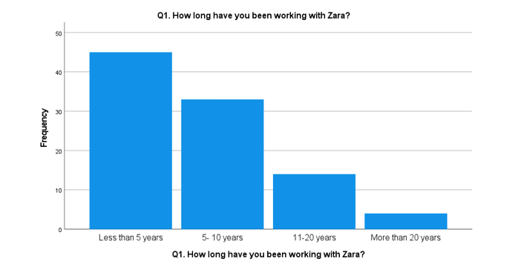
Figure 5: Graph of responses
Interpretation
From the above graph, it can be analysed that 46.5% of Zara employees who gave their response in this research were working in the firms for less than 5 years. Along with this, 34.4% of the workers of this firm were connected to Zara from the last five to ten years and only 14.6% of staff have been associated with the firm for 11 to 20 years as well as only 4.2% of the employees are connected with the organisation more than 20 years. This reflects that the majority of the respondents who responded to this research were associated with Zara for less than 10 years.
From the above interpretation, it can be analysed that most of the employees who have proven their perception of the study focus are connected with the firm for less than five years. This shows that employees may face issues regarding language and cultural differences for doing a job in the company for a longer period. The above results show that the employees are not working at Zara for a long time and only some of the employees who responded have connected with the firm for such a long period. This can show the lower retention rate of employees in Zara company.
Q2. Does your company promote diversity by recruiting employees from different cultural backgrounds?

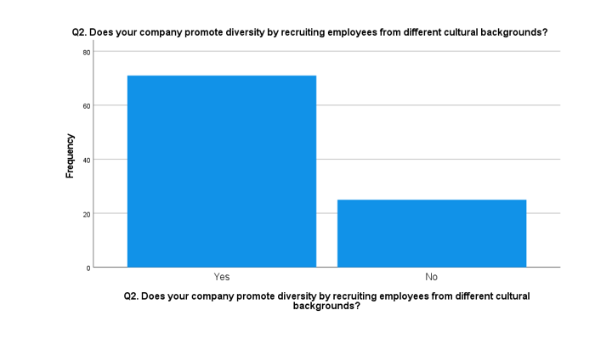
Figure 6: Graph of Responses
Interpretation
Based on the above table and graph of responses it can be identified that the Zara company has promoted diversity in the company by recruiting employees from various cultural backgrounds as 74% of participants gave their response on the side yes option for the question. However, some of the employees of Zara who provide their notion in this study have responded in favour of no option as in their opinion this company has not promoted diversity by recruiting employees who belong to various cultural backgrounds.
From the aspects and perceptions of various employees who provide their opinions in this study and workers in the Zara company have provided the information that their firm is effectively involved in promoting diversity in the workplace by recruiting the workforce who belongs to different cultural backgrounds. The promotion of diversity in the workplace culture is beneficial for Zara in enhancing cross-cultural learning among its employees by enabling the staff to share their cultural beliefs and experiences. The employees of Zara become better, more innovative, creative, and agile thinkers which can help in reducing the cultural and language barriers in the workplace. On the other hand, some employees of Zara who gave their opinion have not supported this argument that their company is promoting diversity in the workplace as they may confronted some cultural and language issues in the firm.
Q3. Do you think that your performance and engagement with the company are negatively impacted due to cultural and linguistic barriers?

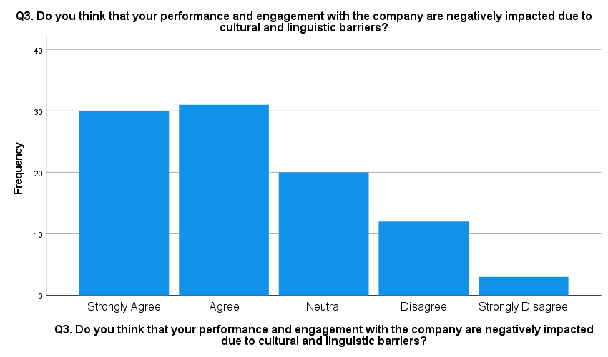
Figure 7: Responses Regarding the Negative Impact of Cultural and Linguistic Barriers on Employee Performance and Engagement

Interpretation
The above graphical representation suggests the opinions of participants for their performance and engagement within the company are negatively impacted by the cultural and linguistic barriers. 31.3% of the people agree with the statement while 3.1% strongly stand the opposite. Meanwhile, as suggested 20.3% of participants form a neutral opinion on the same along with 32.3% that moderately agree. There also exist 12.5% of the people from total survey respondents who form moderate disagreement with the statement.
It can be thus analysed that the majority of the employees believe that their efficiency has deteriorated due to major cultural differences. Moreover, there also exist a few of the proportion that disagree with the statement, however, these numbers can be significantly ignored focusing on the negative measure of these barriers. This directly indicates that the cultural and language gap is a serious matter of concern degrading the productivity of the major task force of the organisation. The mean of 2.24 in the alignment of 1.122 standard deviations suggests the complementary algorithm of the statement presented. In other words, it can be said that language barriers resulting from cultural differences hinder the company from affecting its internal stakeholders. This majorly includes the account of performance and engagement of the employees, which may further serve to surface the serious difficulties of efficiency on them. This may include degrading their work motivation and collaborative issues as well as negatively impacting firms as a whole.
Q4. Do you think that your employer is effectively managing the diverse employee base?

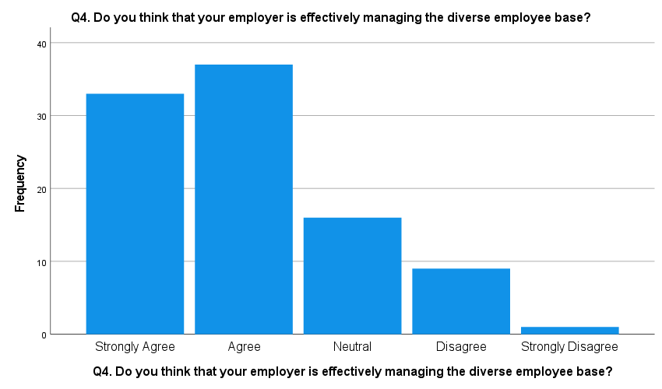
Figure 8: Responses Regarding the Effective Management of Employee Base by the Employer
Interpretation
The image illustrates the statistics of the participants for their opinions on the efficient management of the employee base through the employer suggesting 34.3% agree on the same. Contrarily, 9.4% and 1.0% hold neglecting opinions accompanied by 16.7% of the total participants that have neutral perspectives. However, 38.5% of the respondents highlight their perspectives in the moderate agreement subgroup suggesting they might not strongly agree with the statement but are in favour of the matter stated.
From an analytical view, it can be said that the majority of the participants believe that the employer of the organisation is successful in managing the employee base that accounts from diversified backgrounds. Parallelly, there are also some proportions that have a converse opinion. Even though this fraction is relatively low, it owns a magnificent space in the statistics. This is because there exist employees who doubt the management of employees in dealing with employees who are from varied cultural backgrounds. This directly indicates the poor management of internal operations of the organisation idealising the inefficient management of the major task force, employees. This also surfaces the ineffectiveness of higher management in maintaining the capabilities of the employer to deal with the varied employee base magnificently. In addition, the procured mean value of 2.04 and standard deviation of 0.994 strongly complement the algorithm highlighting the effectiveness of the employer to lead and manage the established employee base that belongs to diverse backgrounds.
Q5. Which of the following factors do you think regulates employee engagement?

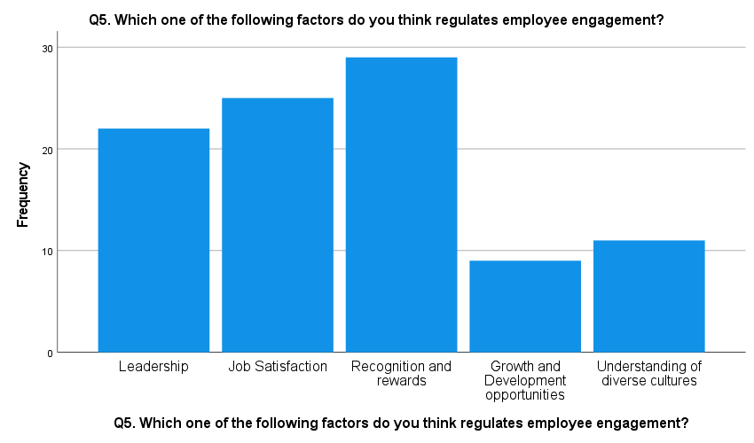
Figure 9: Responses Concerning the Driving Factors of Employee Engagement Regulation
Interpretation
The above pictorial presentation highlights the major factors that regulate employee engagement within the organisation. As highlighted 30.2% of people think that recognition and rewards enhance their engagement within the organisation along with 22.9% of the participants idealising leadership as the driving factor. Also, there are 26.0% of people, emphasise job satisfaction as the leading factor. However, there is a minimal yet significant proportion of 9.4% and 11.5% people who account for growth and development opportunities and understanding of diverse cultural factors, respectively.
It can, therefore, be analysed that a significant proportion of the total participants are inclined toward the opinion that certain factors regulate the overall engagement of the employees. As suggested the majority of the employees believe that recognition and rewards ultimately mean appraisals and other means of recognition are the most leading factors. It is because employees want their performance and efforts to be recognised and appreciated and rewards can be extra monetary benefits in terms of bonuses, incentives and other non-monetary advantages. Also, job satisfaction and leadership are seen to occur in the accounts of maximum selected options suggesting the vitality for the same. However, the other factors also include growth and development opportunities and an understanding of diverse cultures that determine employee engagement. In order to keep the staff members motivated and productive, firms should offer career advancement prospects. These can be offered through sessions of career counselling, training and development programmes and many more.
Although, the statistical proportion of these factors is relatively low, hold significant value in stating that nevertheless, they contribute to employee engagement by multiplying the overall efficiency of the organisation as a whole. The accounted 2.60 mean and 1.261 standard deviation value thus represent the truthfulness of the interpretative information that surfaces the information regarding the regulation of employee engagement through various leading factors.
Q6. In your opinion which of the following factors determines employee performance?

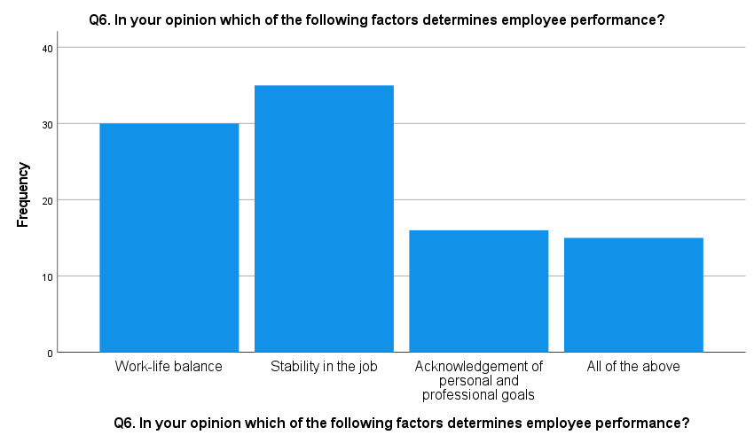
Figure 10: Responses Highlighting the Factors that Determine Employee's Performance
Interpretation
The illustrated representation illuminates various factors that determine the performance of the employees within the organisation. As highlighted, there are 31.3% of the total participants strongly emphasise that work-life balance is one of the most determinant factors of employee performance. The statistics account for 36.5% and 16.7% of people believing that stability in the job and acknowledgement of personal and professional goals, respectively, are the driving factors. However, there also exists a 15.6% fraction that beholds the opinions in favour of all the mentioned factors.
On the basis of the above interpretive statistics, it can be, however, analysed that the major factor that influences the overall performance of the employees is job stability. In other words, it can be said that job security and satisfaction withstanding behind the term ‘job stability’ is the most prominent factor that determines employee performance. In the same context, optimal work-life balance serves to be the second-most major option accounted for impacting employee performance within the organisation. This suggests employees seek a healthy balance in their work-life aiming for the job that can provide them with a sense of security and long-term stability. Furthermore, the acknowledgement of personal and professional goals aligning with progressive growth also regulates the efficiency of the employees. Surprisingly, there also exists a significant fraction that relies on all of these factors that shape employee performance suggesting all of these are equally vital for the employee maintaining their overall efficiency and contributing to the organisation's success. This designates to the fact that all of these factors are relatively vital to lead the optimal performance of the employees.
In other words, there are certain factors that determine employee performance within the organisation. For the same, the obtained mean of 2.17 along with the 1.043 value of standard deviation presents a presiding algorithm for the statistical information that reveals the analytical results.

Q7. To what extent do you agree with the fact that lack of collaborative efforts and changes in language degrade employee performance?

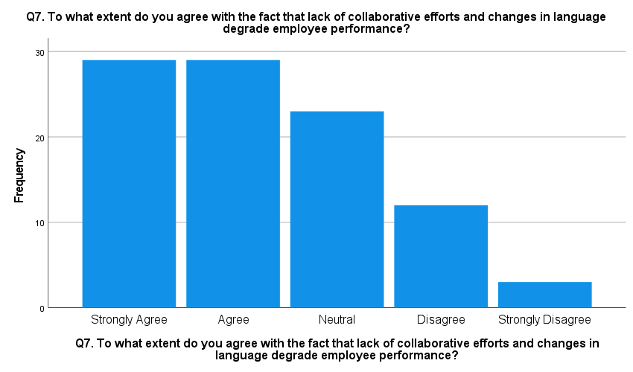
Figure 11: Responses Suggesting the Portion that Illuminates Employee Performance Degrades Due to the Lack of Collaborative Efforts
Interpretation
The pictorial representation of the graphs highlights the statistical information about the lack of collaborative efforts and changes in language that contribute to the degradation of employee performance. As presented 30.2% of the people strongly agree with the statement indicating their high agreement with the repercussions of the absence of collaborative efforts and language changes on employee performance. However, an extra proportion of 30.2% also forms moderate agreement along with 24.0% of people forming a neutral opinion on the matter. Parallelly, 12.5% and 3.1% of the total participants disagreed with the statement.
The statistical interpretation stated above provides information on the influence of lack of collaborative efforts and language changes on the employees' overall performance. The data strongly suggested that most people believe minimal or no collaborative efforts negatively influence optimal employee performance. Within the workplace, it has been observed that discrimination and bias among the staff members are created by the management due to cultural variations. The engagement along with the performance of employees gets reduced because of the cultural differences within the workplace. The high degree of differences among the cultures leads to reduced productivity and engagement of workers.
Moreover, there is only a small proportion that forms the oppositive perspectives indicating they do not idealise the fluctuations in the languages that minimise the performance of the employees. However, these numbers owning a minimal proportion can be relatively ignored because even though the statistics would have shown a minimal proportion of the participants believing the statement, it would hold great significance. This is because it directly indicates that a lack of collaboration accompanying the absence of coordination affects the efficiency and willingness of the employee to work and may contribute to the performance of the organisation as a whole.
Q8. What are the issues that you as an employee of Zara face when the company attempts to incorporate measures to reduce language and cultural barriers?

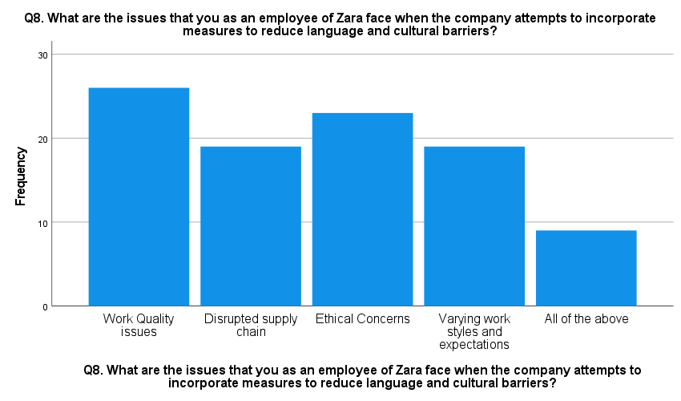
Figure 12: Responses regarding issues faced by employees of Zara
Interpretation
As per the above graph Zara workers experience certain issues when the company seeks to address the language and cultural gap it experiences presenting a multitude of problems. Examining responses from 96 participants, 27.1% opted for ‘Work Quality Issues’ as the main concern which could mean that efforts to bridge cultural barriers may be impacting the efficiency or even the effectiveness of their work. This is probably because of the communicational gaps due to language barriers or the quality differences depending on the cultural background.
‘Ethical Concerns’ was chosen by 24% of the respondents and this implies that the employees have had concerns over the ethical implications of the introduction of different cultures in the workplace and this might include concerns over fairness, respect for certain cultural values and practices and the methods used to enforce the new rules of engagement which might violate already existing ethical standards. Varying working styles and expectations and ‘delays in the supply chain’ were both chosen by 19.8% of respondents. Operational issues account for 8% of the employees. The adoption of different cultural practices might be causing disruptions to formal practices and communication structures not only within the firm but also in the external processes. The differences in various work styles and time expectations can result in waste or conflict for teams and illustrate the challenges of inclusivity in practice.
The mean response score of 2.65 indicates that on average employees considered at least two of these issues to be significant, which suggests a moderate but wide perception of the impact of these integration efforts. This variation in responses clearly shows that the management of Zara needs to improve the approach to the reduction of these barriers since communication styles should be diversified depending on the language and cultural differences of workers and more training should be provided with more clear regulation on the elimination of operational gaps. Such measures could potentially mitigate the broad range of issues identified by their employees, leading to better integration strategies and improved employee morale and performance.

Q9. Do you think that collaborative activities and team building activities improve the flow of communication and synchronisation of team efforts?

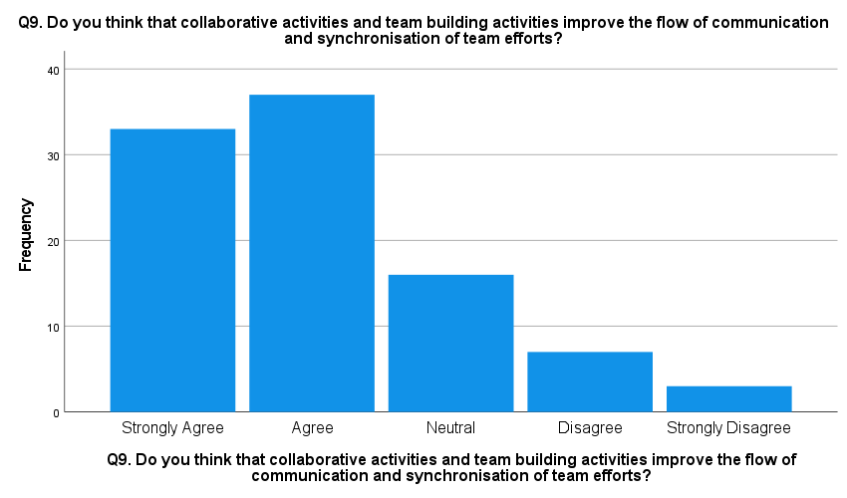
Figure 13: Responses regarding the effect of collaborative activities
Interpretation
The survey determines Zara employees’ perceptions on the impact of team cooperation and group building in evolving admission and coordination of teamwork was only a touch above average. Specifically, 34.4% strongly agreed while 38.5% of the respondents agreed that these tasks are useful and collectively, they derived 72.9%. This majority demonstrates strong support of group and team sports in the organisation to emphasise their perceived relevance in enhancing teamwork.
On the other hand, a lesser proportion of respondents maintain neutrality or have negative attitudes toward the subject, with 16.7%., 7.3% disagreed, there is 3.1% strongly disagreed with the statement. The proportion of negative responses indicates that scepticism or dissatisfaction regarding the effectiveness of such activities is not extensive among most of the personnel. The mean value of 2.06 also determines that collaborative sports enhance workplace discourse and orderliness. This common, especially leaning towards the settlement, strengthens the belief that such activities are determined as a part of the team performance improvement package.
Perhaps this trend could be attributed to the following perceived advantages such as availability of communication channels, collaborative activities; greater alignment and synchronisation of group efforts towards achievement of objectives; and improvement in typical morale and workplace engagement. These factors contribute to a place of work environment that not only appreciates but also optimises the utilisation of teamwork approaches in order to enhance productivity as well as the pride of employees. This can be accomplished by promoting an open communication culture, providing training, cultivating employees towards raising awareness and awareness, by employing an approach of inclusive culture. Therefore, the survey determines a high acceptance of team efforts and cooperation, emphasising the perceived worth of cooperation for an inclusive environment at Zara.
Q10. Which of the following measures do you think would lead to ethical and effective management of a diverse workforce in Zara and would lead to success in the long run?

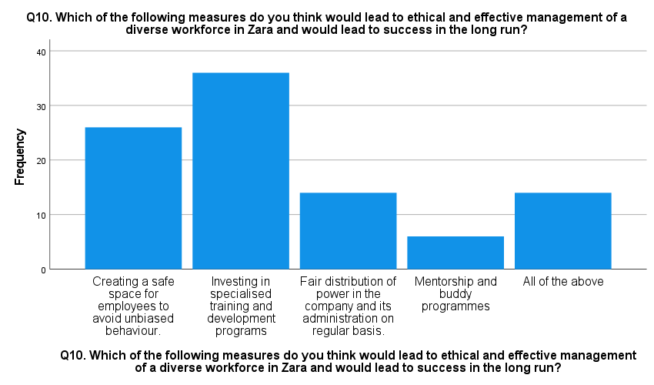
Figure 14: Responses regarding measures of ethical and effective management of diverse workforce
Interpretation
The data above also showed that the intervention with the most support was ‘Investing in specialised training and development programmes’ as 37 participants selected it that is 35% of respondents. This implies a lot of faith in the ability of professional development to unlock the potential of a diverse workplace, meaning that to ensure employees are optimally prepared to work with diversity, targeted training must be provided. ’Creating a safe space for employees avoiding unbiased behaviour’ was chosen by 27.1% of the respondents, thus emphasising the relevance of fostering a positive organisational culture. This means that 29% of the employees are of the view that eradicating bias and fostering diversity are important aspects of principled management.
The overall response to this question was slightly lower at 14% of the respondents. 6% considered that ‘fair delegation of power in the company and its administration as often as possible’ is crucial. It also touches on equity in some decision-making and leadership activities, suggesting a quest for justice in the company's governance framework. Respondents showed very little support for ‘Mentorship and buddy programmes’ indicated by 6%. While not as highly ranked, this still indicates acknowledgement of the importance of mentorship for individual and professional growth, especially within a multicultural context. Interestingly, 14.6 of respondents chose the ‘All of the above’ option, which indicates that some of the workers believe that training, a safe environment, fair distribution of power, as well as mentorship, are important in the workplace.
The mean score of 2.44 indicates that specialised training is considered crucial in areas such as safety, fair power-sharing, and mentorship are also of equal value to the employee. These insights suggest that while training and development are seen as the most critical for immediate impact, a comprehensive strategy that also includes creating an unbiased work environment, equitable power distribution, and opportunities for mentorship can foster a more holistic development of an ethical and effective diverse workforce. This balanced approach may be beneficial for Zara in promoting long-term success, as it addresses multiple facets of workforce management and development in a diverse corporate landscape.

Chapter 5: Discussion
Considering the evaluation provided above, it is identified that cultural and language barriers at Zara have a direct impact on employee engagement and organisational measures of performance through generating misconceptions, demotivation, and lack of strong teamwork. These boundaries manifest themselves as communication problems, staff clashes and stress arising from working with individuals from different cultures, which ultimately leads to reduced commitment and effectiveness. When individuals struggle to communicate because of language differences, they may also experience social exclusion and decisions that demoralise their worth, which ultimately decreases their confidence and productivity.
Various factors influence the organisational employee engagement and performance of the organisation like leadership, recognition, and work-life stability. Job satisfaction is crucial, especially when influenced personnel are likely to be inspired and perform effectively. Another crucial element is the organisational subculture: A positive, inclusive, and friendly one will increase engagement and productivity, while a negative one lowers them. Increased employee engagement is supported by the availability of supportive and communicative managers together with the qualities of effective leadership. Besides, recognition and rewards encourage personnel to perform well, and anexcellent work-life equilibrium ensures that personnel can maintain their public and personal responsibilities, hence resulting in enhanced overall productivity.
The critical review also determined that Zara maintains its body of workers ethically and efficiently by implementing imperative insurance policies that promote diversity, cultural sensitivity, and communication (Riyanto, et al., 2021). The agency also incorporates specialised training applications in order to make personnel aware of cultural diversity and to learn to respect different opinions. Thus, establishing an enclosed space where workers are protected from prejudice and discrimination contributes to a positive organisational climate where everyone can thrive. Another attribute that helps ethical management is the distribution of power and fairness in optimal methods. Mentorship packages also assist in employees’ development and socialisation in the organisation’s different contexts (Albrecht and Marty, 2020). Thus, this addresses the question “What forces influence organisational employee engagement and performance?”
There is a significant correlation between the language and cultural challenges affecting Zara and the performance of the workers. Due to language constraints, there is communication breakdown, misunderstandings, and mistakes which affect performance and cooperation. This can lead to organisational conflict and lack of cooperation since culture can cause differences in expectations and ways of working among personnel. These may also impact the morale of the workers thus contributing to high rates of absenteeism and turnover. Hence, language and cultural barriers should be effectively managed to maintain the levels of productivity and employee motivation at a high level.
Despite all this, Zara has some hurdles even when attempting to increase worker performance due to language and cultural barriers. The main concerns are the lack of effective communication, ethical issues, and differences in management approaches and expectations. These problems can lead to a reduction in the quality of the performance, delays in the supply chain, and technical glitches in operations. They also may feel stressed and unsupported, which leads to less motivation and productivity. To overcome these challenging scenarios, Zara must improve its communication plans, include thorough training, and create a more friendly work environment.
The review of the literature also determined that the fashion industry has problems with culture and language that affect worker motivation and overall performance by causing misunderstanding and low morale (Weideman and Hofmeyr, 2020). Several aspects, such as task identification, organisational culture, management, popularity, and work-life, affect the engagement and performance of the workers. The strategies used by the fashion industry to address the dynamics of a diverse group of workers entail promoting diversity, equal opportunity, and multiculturalism. The association between language and cultural limitations and performance is significant because these barriers can lead to misunderstandings and decreased efficiency (Arifin 2020). These also cause challenges for Zara in increasing performance, but by developing communication and increasing inclusion, the organisation can support its diverse employees and improve overall performance more easily. Thus, the question is “What issues does Zara face while improving employee performance due to the language and cultural barriers in the company?” has been addressed successfully as per the above information.
Moreover, employee engagement at Zara is highly correlated with individual feelings towards work and the workplace among the employees. When there are cultural and language barriers present, people might find it challenging to develop this connection, leading to disconnection. Employees from outstanding cultural backgrounds should likely have outstanding perceptions of organisational behaviours, which can create tensions and controversies. They can lead to a lack of coordination, reduced productivity, or even conflict among the members of the working team.
It has also been identified that task management is determined as one of the leading drivers of the engagement of workers at Zara. It states that when individuals are satisfied with the job they do, they are more inclined to be engaged and prompted. There are several factors that may foster job satisfaction, which are the work environment, remuneration, and advancement in career. Zara has understood the importance of job satisfaction and has initiated various projects to promote it, such as providing high wages, providing chances for career advancement, and creating a great working environment.
The academic review also expressed that organisational culture also plays a crucial role in determining worker involvement (Phuong and Takahashi, 2021). A pleasant and diversified lifestyle that appreciates assortment and acknowledges can go a long way in enhancing worker engagement. Zara has tried creating a culture as regards to inclusion of diversity in the workplace. The firm has applied training applications to sensitise the employees to the culture so that they can embrace diversity and respect it. Through the implementation of the inclusive culture at Zara, the company targets to make all employees feel appreciated, which positively impacts engagement and performance (Abarantyne, et al., 2019).
Leadership is another factor that has an impact on the level of worker engagement and performance. It can be defined as the process of providing assistance, direction, and performance reviews to employees. In Zara, managers are required to practice a supportive and communicative approach to control. In so doing, leaders can ensure that their staff members feel appreciated and supported so that their discretionary effort and productivity can be boosted. Furthermore, identifying and recognising individuals for their performance can also help encourage them to perform well in their tasks. Hence, the question regarding “How company manage diverse workers more ethically and effectively?” has been successfully addressed based on the above evaluation.
Work-life stability is also important for engagement and performance outcomes among employees. Workers who are able to balance their external and work activities tend to be more productive in organisations. Zara has realised that work-life stability is a crucial factor and has put in place policies on it. Flexiblework arrangements, including remote working options and adjustable working hours, are provided by Zara to support employees in managing their work-life responsibilities. Zara should achieve this by targeting a work-life balance with the goal of increasing employee satisfaction and, consequently, efficiency.
The literature also stated that the relationship between language barriers and the efficiency of employees can be observed in the challenges that arise during communication. Language barriers result in misunderstandings and mistakes, which, in turn, have adverse effects on productivity (Bai, et al., 2023). When employees do not speak the same language, they may struggle to communicate effectively and end up making errors and taking a long time to accomplish the assigned work. To manage this issue, the fashion industry has put measures that include offering language learning and interpretation services to enhance the ability of workers to communicate more proficiently (Leslie, 2019). Thus, the question of “What is the relationship between Zara’s language, cultural barriers, and performance?” has been addressed as per the above outcomes.
These differences can also influence the worker output since conflicts and lack of cooperation can arise due to these differences. People from diverse cultural contexts might have certain expectations and ways of working that may lead to issues with others. For example, some cultures can also promote the use of direct speech, while others could use indirect. These variations can cause problems during collaboration and teamwork efforts. To address those challenges, Zara has used cultural awareness training programme to train employees regarding other cultural behaviours and appreciation. Thus, the above findings of data analysis and literature review successfully addressed the primary question of the research which is “How do cultural and language barriers in Zara impact employee engagement and performance?”

Chapter 6: Conclusion and Recommendations

6.1 Introduction
This section is one of the most significant one for the study as the whole research is concluded under this chapter. The outcomes of the literature review and data analysis chapter have been summarised in this section to provide a comprehensive knowledge of the findings that were gained throughout the study. Along with this, potential recommendations has also been provided to Zara in order to foster values in the employees while mitigating the issue of discrimination within the workplace.

6.2 Conclusion
﻿The outcomes of 1st objective established that the fashion industry has the challenging task of handling a culturally and linguistically diverse team of workers. The brand’s response has been a strategic integration of a robust range and inclusion policy that covers all levels within employers. This method entails comprehensive diversity training opportunities of considerable size that are designed to help employees with diverse backgrounds feel included and appreciated. It is not just about hiring people from different backgrounds but using broad perspectives to foster inventiveness and creativity at Zara based on inclusive recruitment regulations. Additionally, by employing cultural sensitivity by promoting workshops and constant learning options, Zara not only meets the requirements of corporate social accountability but also enriches the company culture, making it a more interesting place for global facilities.
This evaluation of the data also proved the positive superiority of Zara projects which showed a considerable increase in employee satisfaction and loyalty. This is especially vast in minimising turnover, a key problem within the retail realm associated with high rates of attrition. Employing a polite and professional work environment as a way of encouraging the involvement of the workers has consequently led to great improvements in productivity. These initiatives also foster a higher level of a harmonious and strong administrative centre where conflict is reduced and cooperation is enhanced.
As per the aspects of objective 2nd, it has been identified that cultural and language issues at Zara prevail in the global fashion industry hindering the way teams operationalise themselves and interact within the organisation. Understanding these challenging circumstances, Zara has implemented culture and language support measures aimed at developing an inclusive work environment. These measures are essential in decreasing the conflict that cultural variations can cause and in creating a framework of respect and cognizance. In doing so, Zara optimises the organisational processes and guarantees that each of its personnel, regardless of cultural identity, feels embraced at the company. This promise to adopt diversity through reasonable learning and other support frameworks is crucial in ensuring that the corporate culture remains elastic and responsive to the global business environment.
The analysis above also reflected that it is evident that the effectiveness of the above-mentioned Initiatives by Zara includes a reduction of the administrative centre conflicts and an enhancement of group dynamics. Increasing beneficial internal communication and boosting worker participation and productivity prove the practical benefits of these cultural and language courses. This statistic underlines the imperative to pursue constant funding of such fields, strengthening the link between cultural competencies and organisational effectiveness.
Based on the outcomes of 3rd objective, it has been argued that the fashion industry, including a global player like Zara, still faces challenges due to the diverse cultures and language barriers in their diverse workforce. These differences can create communication issues that interfere with the easy running of operations and impair staff cohesion. Finally, differences in work values and norms of behaviour between nations can cause dissatisfaction and conflict that can decrease the effectiveness of the operational techniques as well as change the standard organisational motivation at the place of work. Such challenging situations require more significant understanding and targeted initiatives that go beyond diversity training. It indicates that distinct processes for integration and communication are necessary to work out multiculturalism in organisational paradigms and conquer geographic and cultural distances concerning various work ethics and expert expectations to ensure that every employee is transferring closer to organisational objectives with no conflict in cultures and responses.
The evaluation of the data analysis also stated that the existing approaches concerning cultural and language-demanding situations are substantial by using the administration of Zara, however, certain troubles have persisted as mentioned by the employees. Complaints of decreased work quality, ethical concerns, and slow operations highlight the value of tactics which can be not only complete but also versatile in line with the complexities of the organisation’s various personnel. The remarks suggest strengthening clear communication support structures to help groups connect better and developing cultural training programmess that can address the difficulties faced by Zara’s teams. These packages must be extended and improved, which must lead to spectacular development of workers’ commitment and productivity, and, consequently, promote a more diverse and efficient work atmosphere.
Based on the findings of objective 4th, it has been identified that in the culturally rich environment of Zara, active participation and team-building activities are fundamental enablers for which strong communication is not only desirable but essential for synchronising different team efforts towards a common goal. These initiatives are especially valued in Zara’s global context where they serve as enablers of dissolving cultural barriers and building a crew feeling among employees. By attracting employees in these sports, Zara is right to offer a culture that embraces diversity and promotes it. These team-constructing sporting activities are meant to be fun and engaging and will naturally compel personnel to shed their conventional work persona and interact with teammates in a new light. It not only enhances the relations between the team members but also reduces the barriers and promotes knowledge and mutual respect between team members belonging to different organisations or cultures. All of these activities can be viewed as the types of investments in Zara’s organisation well-being so that teams are not only reasonable but also highly integrated.
The data evaluation also determined that the high-quality impact of collaborative activities at Zara is sincerely contemplated in employee remarks and overall performance metrics. This is another indication that Zara’s employee relations are good since most of the employees agree that these projects have greatly enhanced their ability to work as a team. Workers report greater verbal communication, fewer confrontations, and a more stimulating working environment. These consequences underscore the purpose of well-structured crew constructing sports in improving crew methods and worker morale. A vast link between common participation in workplace activities and other good levels of team performance and morale has also been identified. Therefore, constant focus and commitment towards such group development activities are important for the continued maintenance and improvement of the cooperative attitude and performance among Zara’s numerous bodies of workers.

6.3 Recommendations
﻿1. Enhanced language support and translation services: Communication is very important for operational success, especially when there are many people involved in the process, as it is the case with ZARA. Cultivating language help by means of extensive language courses for personnel can mitigate social communication deficits. It can be important to provide language training according to the desire of the team of workers and with the use of more complex translation software in conferences or virtual communications so all the personnel comprehend and are comprehended. This can be complemented through the application of multilingual interfaces on intranet sites and in corporate systems, which allows employees to obtain the necessary information and perform their functions regardless of their language skills.
2. Comprehensive cultural competency training: The place of work must be diverse since it strengthens a corporation but additionally poses difficulties in the communication method among staff. Regular sessions in cultural competency can enhance knowledge and minimize conflict around culture. They have to capture topics that include culture, business etiquette, war strategies, and excellent communication in different cultures. To make this education a mandatory thing of employee development shall help reinforce cultural sensitivity among the corporation. Moreover, multiple workshops and discussion sessions to deliberate cultural peculiarities and find something in common for every employee may help to build trust and non-discrimination.
3. Structured team building programmesmes: Team building exercises that are structured and intended to incorporate aspects of intercultural learning and cooperation can significantly improve team dynamics, particularly in a multicultural environment. Scheduling ignominious group-forming retreats that amalgamate personnel from various spheres in different tasks which require problem-solving and cooperation will help disunite ordinary groups and create a more compact team. These activities must be skilfully developed to ensure that they are useful, convenient, and relevant for all the staff to ensure equal opportunity for team members to learn from each other and thrive in their careers.
4. Tailored communication and feedback mechanisms: Setting up custom communication channels that address the needs of a broad group of employees can considerably improve the way personnel interact and communicate with each other and with management. Establish a feedback system that enables employees to address their concerns associated with cultural misunderstandings or language barriers without fearing backlash. This can be in the form of anonymous feedback tools or regular one-on-one check-ins with HR. Furthermore, management needs to learn how to recognise the signals of disengagement or discontent that might result from cultural or language issues and alleviate these concerns early on.

6.4 Recommendations for future research
﻿As per the quantitative nature of the current research, further research might be done to enhance understanding through a mixed-methods approach. This could involve adding qualitative data through extended interviews or awareness providers to obtain very detailed worker stories and perceptions that quantitative methods usually miss. In addition, the scope of the survey could be expanded in upcoming research regarding demographic and geographic terms for a more comprehensive outlook on cultural influences amongst distinct areas to cover a more extensive range of Zara's overseas locations. It might also be beneficial to improve and utilise more state-of-the-art statistical models that might control for potential confounding variables and provide a clearer representation of the direct effects of cultural and language limitations on other aspects of employee performance and engagement. Such a multidimensional approach further sets the stage for a very comprehensive and precise amount of investigation into not only problems but solutions in managing a culturally diverse workforce.

References
Abarantyne, I., Naidoo, V. and Rugimbana, R. (2019) The impact of psychological contracts on employee engagement at a university of technology. SA Journal of Human Resource Management, 17(1), pp.1-11.
Abdullah, M.I. Dechun, H. Ali, M. and Usman, M. (2019) Ethical leadership and knowledge hiding: a moderated mediation model of relational social capital, and instrumental thinking. Frontiers in Psychology, 10, p.2403.
Agustian, K., Mubarok, E.S., Zen, A., Wiwin, W. and Malik, A.J. (2023) The Impact of Digital Transformation on Business Models and Competitive Advantage. Technology and Society Perspectives (TACIT), 1(2), pp.79-93.
Akhter, A. and Naveed, A. (2023) Role of skill development in job satisfaction through employee engagement as mediator. Dinkum Journal of Economics and Managerial Innovations, 2(04), pp.238-249.
Al Halbusi, H., Ruiz-Palomino, P. and Williams, K.A. (2023) Ethical leadership, subordinates’ moral identity and self-control: Two-and three-way interaction effect on subordinates’ ethical behaviour. Journal of Business Research, 165, p.114044.
Albrecht, S.L. and Marty, A. (2020) Personality, self-efficacy and job resources and their associations with employee engagement, affective commitment and turnover intentions. The International Journal of Human Resource Management, 31(5), pp.657-681.
Al-Hiyari, A., Ismail, A.I., Kolsi, M.C. and Kehinde, O.H. (2023) Environmental, social and governance performance (ESG) and firm investment efficiency in emerging markets: the interaction effect of board cultural diversity. Corporate Governance: The International Journal of Business in Society, 23(3), pp.650-673.
Ali, B.J. and Anwar, G. (2021) Work engagement: how does employee work engagement influence employee satisfaction? Ali, BJ, & Anwar, G.(2021). Work Engagement: How Does Employee Work Engagement Influence Employee Satisfaction, pp.10-21.
Arifin, K. (2020) January. Factors influencing employee attitudes toward organizational change: literature review. In 5th ASEAN Conference on Psychology, Counselling, and Humanities (ACPCH 2019) (pp. 188-191). Atlantis Press.
Bag, S., Rahman, M.S., Rogers, H., Srivastava, G. and Pretorius, J.H.C. (2023) Climate change adaptation and disaster risk reduction in the garment industry supply chain network. Transportation Research Part E: Logistics and Transportation Review, 171, p.103031.
Bai, A., Vahedian, M., Ghahreman, R. and Piri, H. (2023) Elevating Women in the Workplace: The Dual Influence of Spiritual Intelligence and Ethical Environments on Job Satisfaction. arXiv preprint arXiv:2310.16341.
Bernstein, R.S., Bulger, M., Salipante, P. and Weisinger, J.Y. (2020) From diversity to inclusion to equity: A theory of generative interactions. Journal of Business Ethics, 167, pp.395-410.
Chandni, S. and Rahman, Z. (2020) Customer engagement and employee engagement: Systematic review and future directions. The Service Industries Journal, 40(13-14), pp.932-959.
Collins, C.J. (2021) Expanding the resource-based view model of strategic human resource management. The International Journal of Human Resource Management, 32(2), pp.331-358.
Dembek, K., Lüdeke‐Freund, F., Rosati, F. and Froese, T. (2023) Untangling business model outcomes, impacts and value. Business Strategy and the Environment, 32(4), pp.2296-2311.
Dewaele, J.M. and Alfawzan, M. (2018) Does the effect of enjoyment outweigh that of anxiety in foreign language performance? Studies in second language learning and teaching, 8(1), pp.21-45.
Dhir, S. and Shukla, A. (2019) Role of organizational image in employee engagement and performance. Benchmarking: An International Journal, 26(3), pp.971-989.
Diamantidis, A.D. and Chatzoglou, P. (2019) Factors affecting employee performance: an empirical approach. International journal of productivity and performance management, 68(1), pp.171-193.
Duchek, S., Raetze, S. and Scheuch, I. (2020) The role of diversity in organizational resilience: a theoretical framework. Business research, 13(2), pp.387-423.
Elia, S., Petruzzelli, A.M. and Piscitello, L. (2019) The impact of cultural diversity on innovation performance of MNC subsidiaries in strategic alliances. Journal of Business Research, 98, pp.204-213.
Elsbach, K.D. and Stigliani, I. (2018) Design thinking and organizational culture: A review and framework for future research. Journal of Management, 44(6), pp.2274-2306.
Felix, O., Chukwurah, E.E., Emmanuella, U.E. and Oghenekeno, E.F. (2023) Workplace Diversity and Employee Versatility. International Journal of Advances in Engineering and Management, 5(1), pp.628-634.
Gerpott, F.H. Van Quaquebeke, N. Schlamp, S. and Voelpel, S.C. (2019) An identity perspective on ethical leadership to explain organizational citizenship behaviour: the interplay of follower moral identity and leader group prototypicality. Journal of Business Ethics, 156, pp.1063-1078.
Gut, A., Wilczewski, M. and Gorbaniuk, O. (2017) Cultural Differences, Stereotypes, and Communication Needs in Intercultural Communication in a Global Multicultural Environment The Employees’ Perspective. Journal of Intercultural Communication, 17(1), pp.1-18.
Haldorai, K. Kim, W.G., Chang, H.S. and Li, J.J. (2020) Workplace spirituality as a mediator between ethical climate and workplace deviant behaviour. International Journal of Hospitality Management, 86, p.102372.
Heslina, H. and Syahruni, A. (2021) The influence of information technology, human resources competency and employee engagement on the performance of employees. Golden Ratio of Human Resource Management, 1(1), pp.01-12.
Hu, X., Khan, S.M., Huang, S., Abbas, J., Matei, M.C. and Badulescu, D. (2022) Employees’ green enterprise motivation and green creative process engagement and their impact on green creative performance. International Journal of Environmental Research and Public Health, 19(10), p.5983.
Islami, X., Mulolli, E. and Mustafa, N. (2018) Using Management by Objectives as a performance appraisal tool for employee satisfaction. Future Business Journal, 4(1), pp.94-108.
Khan, K. and Javaid, Z.K. (2023) Analysing Employee Performance through Workforce Diversity Management: Role of Workforce Diversity Characteristics. Foundation University Journal of Business & Economics, 8(2), pp.85-101.
Kim, D., 2020. Learning language, learning culture: Teaching language to the whole student. ECNU Review of Education, 3(3), pp.519-541.
Kim, Y.K. and Sullivan, P. (2019) Emotional branding speaks to consumers’ heart: the case of fashion brands. Fashion and textiles, 6(1), pp.1-16.
Kiradoo, G. (2022) Diversity, equity, and inclusion in the workplace: strategies for achieving and sustaining a diverse workforce. Advance Research in Social Science and Management, Edition, 1, pp.139-151.
Kong, G., Kong, T.D., Qin, N. and Yu, L. (2023) Ethnic diversity, trust and corporate social responsibility: the moderating effects of marketization and language. Journal of Business Ethics, 187(3), pp.449-471.
Leslie, L.M. (2019) Diversity initiative effectiveness: A typological theory of unintended consequences. Academy of Management Review, 44(3), pp.538-563.
Lubis, M. (2024) The Role of Communication and Employee Engagement in Promoting Inclusion in the Workplace: A Case Study in the Creative Industry. Feedback International Journal of Communication, 1(1), pp.1-15.
Manmeet Kaur, J.S. and Poh, P.S. (2022) The influence of leadership style on employee engagement. Journal of Business and Social Sciences, 2022(08), pp.1-30.
Masha, A.K., Bwowe, P. and Nikisi, E. (2023) Engagement of Educators in Private Family Business Schools: The Role of a Healthy Leadership Environment.
Meyer, K.E., Li, J., Brouthers, K.D. and Jean, R.J.B. (2023) International business in the digital age: Global strategies in a world of national institutions. Journal of International Business Studies, 54(4), pp.577-598.
Mishra, S.S. and Kasim, J.J. (2023) Team culture, employee commitment and job performance in public sectors: a multi-level analysis. International Journal of Organizational Analysis, 31(2), pp.351-367.
Moletsane, M. Tefera, O. and Migiro, S. (2019) The Relationship between Employee Engagement and Organisational Productivity of the Sugar Industry in South Africa: The Employees' Perspective. African Journal of Business & Economic Research, 14(1).
Newman, S.A. and Ford, R.C. (2021) Five steps to leading your team in the virtual COVID-19 workplace. Organizational Dynamics, 50(1), p.100802.
Pathan, M.S.K. (2023) Assessing the mediating role of job satisfaction in the relationship between organizational culture and employee commitment. International Research Journal of Education and Innovation, 4(1), pp.1-11.
Phuong, T.H. and Takahashi, K. (2021) The impact of authentic leadership on employee creativity in Vietnam: a mediating effect of psychological contract and moderating effects of subcultures. Asia Pacific Business Review, 27(1), pp.77-100.
Riyanto, S., Endri, E. and Herlisha, N. (2021) Effect of work motivation and job satisfaction on employee performance: Mediating role of employee engagement. Problems and Perspectives in Management, 19(3), p.162.
Rosales, R., León, I.A. and León-Fuentes, A.L. (2023) Recommendations for recruitment and retention of a diverse workforce: A report from the field. Behaviour Analysis in Practice, 16(1), pp.346-361.
Saks, A.M. (2022) Caring human resources management and employee engagement. Human Resource Management Review, 32(3), p.100835.
Schaefer, S.D Terlutter, R. and Diehl, S. (2019) Is my company doing good? Factors influencing employees' evaluation of the authenticity of their company's corporate social responsibility engagement. Journal of Business Research, 101, pp.128-143.
Static Inditex. (2021) Collaborating with our people, the engine of that transformation. [Online]. Available at: https://static.inditex.com/annual_report_2021/en/documents/we-are-collaborating-our-people-engine-transformation.pdf [Accessed on: 25 April 2024].
Static Zara. (2020) Inditex Group Annual Report. [Online]. Available at: https://static.zara.net/static/joinlife/2020_Inditex_Annual_Report.pdf [Accessed on: 25 April 2024].
Sun, L. and Bunchapattanasakda, C. (2019) Employee engagement: A literature review. International Journal of Human Resource Studies, 9(1), pp.63-80.
Syed, J. (2020) Diversity management and missing voices. Handbook of research on employee voice, pp.486-508.
Sypniewska, B., Baran, M. and Kłos, M. (2023) Work engagement and employee satisfaction in the practice of sustainable human resource management–based on the study of Polish employees. International Entrepreneurship and Management Journal, 19(3), pp.1069-1100.
Weideman, M. and Hofmeyr, K.B. (2020) The influence of flexible work arrangements on employee engagement: An exploratory study. SA Journal of Human Resource Management, 18(1), pp.1-18.
Yilmaz, M.K., Hacioglu, U., Tatoglu, E., Aksoy, M. and Duran, S. (2023) Measuring the impact of board gender and cultural diversity on corporate governance and social performance: evidence from emerging markets. Economic research-Ekonomskaistraživanja, 36(2).
Zhang, N., Xu, D., Li, J. and Xu, Z. (2022) Effects of role overload, work engagement and perceived organisational support on nurses' job performance during the COVID‐19 pandemic. Journal of Nursing Management, 30(4), pp.901-912.

