

UG ASSIGNMENT SPECIFICATION

Student name: |  |  |  | Student P number:
Programme: | MDes[Hons]|BA [Hons] Automotive Design |  |  | Faculty/School: |  | FAD/SD&AA
Module: | Advanced Automotive Surfacing |  |  | Module Level (4, 5, 6, 7): |  | 5
Module code: | M5X01363 |  |  | Contribution to Overall  Module Assessment (%): |  | A1: 60  A2: 40
Lecturer: | S Fontanarosa |  |  | Internal Verifier: |  | P Morrow
Assignment Title: | The Automotive concept / The Wheel |  |  | Assignment No (x of x): |  | 1/2 of 2
Hand Out Date: | A1: 16.03.18  A2: 02.02.18 | Submission Date: | A1: 18.05.18  A2: 09.03.18 |  | Feedback Date: |  | A1: 25.05.18  A2: 29.03.18

Referencing: | Written coursework submissions: In the main body of your submission you must give credit to authors on whose research your work is based. Append to your submission a reference list that indicates the books, articles, etc. that you have read or quoted in order to complete this assignment (e.g. for books: surname of author and initials, year of publication, title of book, edition, publisher: place of publication). Harvard or APA referencing systems is accepted.  Practical coursework submissions: You must give credit to designers or artists whose work you have used to inspire your own. Where specific designs or images have been used in your development work you must indicate the name of the ‘author’ and details of the source of the work (e.g. book, journal, website etc.).
Disclosure: | I declare that this assignment is all my own work and that I have acknowledged all materials used from the published or unpublished works of other people. All references have been duly cited.
Student’s Signature: | Assignments will not be accepted without a signature here and date > | Date of submission:
Turnitin: Lecturer to tick to indicate if an electronic version of the assignment must be submitted to Turnitin.  If both electronic and hard copy submissions are required then both versions MUST be submitted by the same deadline. No marks will be released until both submissions are received.  Note: the Turnitin version is the primary submission and acts as a proof of receipt for the student.  A paper receipt must be completed for hard copy submissions, including portfolios and other design work. |  |  | YES
 |  |  | NO
Penalties for late submission: Up to ONE week late, maximum mark of 40% for first attempt.
Work cannot be accepted after ONE week and will be recorded as a non-submission, 0%.

- The Assignment Specification Form MUST be at the front of all assignment submission. Assignments will not be accepted without this form, as it is a requirement that you sign the disclosure regarding referencing conventions.
- DO NOT include this form in your Turnitin submission or it will match many similarities with other students’ submissions.

ASSIGNMENT DESCRIPTION

Learning Outcomes (LO)
Module Learning Outcomes being Assessed:
- Use advanced 3D surface modelling tools to create realistic design solutions within a structured modelling workflow and understanding of render workflow and render control.
- Understanding tolerance setting for data transfer to prototype modeling software. Plus knowledge of CNC and Rapid Prototyping data protocols.

Task
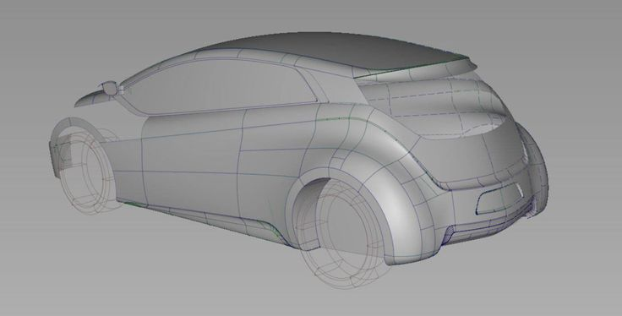
Note: This module runs through the year.
Semester one will be based on lectures and tutorials only. The Assignments will start in Semester two and will be supported by tutorials.

Assignment 1 (A1) – 60% = The Automotive concept
Start sketching a vehicle on paper and define later the orthographic views of it.
Import the four views (Front, Rear, Side and Top) in Alias and build your 3D model.
This brief is completely open, the only hard points are limited to the presence of wheels (you could use the ones you have created in the previous assignment) and an ergonomic manikin that should fit inside your concept.
Also the vehicle should be no longer than 5000mm, no wider than 2000mm and not higher than 1900mm.
Make sure the proportions are realistic and that the edges are rounded.
When happy with the final design, export the model in a scene using VRED to produce some detailed digital renderings.
The work has to be ready by Friday the 18th of May 2018, 10am on your screen in the Cad Lab AA202.
Open it with VRed.
Make sure that you have a backup copy of your work on a memory stick.
Academic Deliverables:
- VRED File of your rendered concept on memory stick
- Final Wireframe file in Alias on memory stick

You will be assessed by the quality of your design and proportions, your 3D modelling abilities, the amount of the details and the use of VRed
Assessment Criteria:
The Automotive concept will be assessed in relation to the specified deliverables as follows:
- LO1 using the common assessment & marking criteria 3, 5.
(All criteria are weighted equally).

Assignment 2 (A2) – 40% = The Wheel

The wheel is an important element in the design process of a car; it can really make a difference in any vehicle’s design if done properly.
You should be confident enough at this stage to create the whole wheel using Alias.
You must produce An “A class” 19 inches wheel in the form of a rendered (using V Red) perspective jpeg file. The hard points are only restricted to the wheel nuts and the number of the spokes:
They both have to be five.
Make sure you have a realistic tyre around your rim.
The work has to be ready by Friday the 9th of March 2018, 10am on your screen in the Cad Lab AA202.
Open it with VRED. Make sure that you have a backup copy of your work on a memory stick.

Academic Deliverables:
- File of your rendered wheel in VRED on memory stick
- Final Wheel and tyre file in Alias on memory stick
- JPEG Screenshot of your Stitched wireframe ready for RP on memory stick

You will be assessed by the quality of your design, the accuracy of surfacing (no holes ready to be 3d printed) and the ability showed in the use of VRED.
Assessment Criteria:
The Wheel will be assessed in relation to the specified deliverables as follows:
- LO2 using the common assessment & marking criteria 3, 5.
(All criteria are weighted equally).

Submission: A1 - 10am 18.05.18; A2 - 10am 09.03.18
Feedback: A1 - 25.05.18; A2- 29.03.18

