

Title of the Dissertation: “Topic-Impact of Talent Management approaches on employee retention of SMEs: A case study of Thirdway Group UK”

Student Name-Daniel Miroslavov Borisov
Student No-1907092
Module Name Dissertation Proposal
Module No-LCBB6000
Lecturer Name- Dr.Mushfiqur Rahman

Abstract
This research provides an introductory chapter where clear goals and purpose of the research has been outlined along with its significance and rationale. There are various scholarly references and evidences that support the context of talent management in SMEs across the UK. This theoretical outlook also explores the various dimensions of study for the current research context. This research proposal also studies the methodology chapter where the undertaken plan and strategies in the current research has been discussed. This methodology section explains how the steps and strategies of conducting the current research align with the goals and purposes of the research.

Table of content
Chapter 1: Introduction 4
1.1 Research aims and objectives 4
1.2 “Research questions” 4
1.3 Background of the organisation 4
1.4 Research gap and contribution 4
1.5 Rationale of the research” 5
1.6 “Outline of the research” 5
Chapter 2: Literature Review 6
2.1 “Concept of talent management and employee retention in SMEs” 6
2.2 “Importance of talent management approaches for retaining employees” 6
2.3 “Challenges of talent management and employee retention in SMEs” 6
2.4 “Strategies to embark effective employee retention approaches in SMEs” 7
2.5 Human Relation Management theory 7
Chapter 3: “Research Methods and Methodology” 8
3.1 “Research philosophy” 8
3.2 “Research paradigm” 8
3.3 “Research approach” 8
3.4 “What research methodology” 8
“3.5 Research strategy” 8
3.6 Sampling methods 8
3.7 Data collection tools 9
3.8 Ways of interpreting data 9
3.9 Time prospects of the research 9
3.10 Ethical consideration of the research 10
Chapter 4: Conclusion 11
Chapter 5: References and Bibliography 12

Chapter 1: Introduction
This research proposal studies the outcomes and consequences of appropriately managing the talented and motivated employees in the small businesses across the UK.

1.1 Research aims and objectives
The aim of this research is to analyse the importance of talent management and implement strategies to effectively retain employees in SMEs.
The objectives of this research are:
- To understand the importance of talent management in retaining employees in SMEs.
- To analyse the factors affecting talent management approaches in SMEs.
- To understand the importance of skilled and loyal employees in SMEs.
- To analyse the strategies for implementing talent management approaches for retaining employees in SMEs.

1.2 “Research questions”
- How can SMEs effectively apply talent management approaches for retaining their employees?
- What is the impact of talent management and employee retention approaches towards the productivity and efficiency of the SMEs.

1.3 Background of the organisation
Thirdway Group UK is a UK based property service SMEs that was established in 2009. It is a London based property service specialists that has about 200 employees. This SME deals in various operations like asset management, inferior design, property development and architectural development. Concerning the competitive market of the property services in the UK this firm needs to establish effective talent management approaches in order to maintain their competitive edge in the market. Since talented and skilled employees are the most essential assets of an organisation they need to retain their key employees for their long term growth and development.

1.4 Research gap and contribution
This research study significantly provides various feasible studies on the topic of talent management in the context of employee retention. However this research study lacks the crucial dimension of long term career development for the policy of employee retention. This research study also lacks a detailed study of attracting and recruiting a new employee in such a process that it can provide long term productivity and benefits to an organisation. Incorporating these issues and concepts would make the study of talent management and employee retention more significant in a broader outlook. The scholarly references and the participants of the current research have been of great importance.

1.5 Rationale of the research”
The concept of talent management is an essential aspect of various organisations in the ever changing dynamic nature of the market. Talent management is crucial in retaining skilled and talented employees for SMEs. They deliver great productivity to the organisation in terms of business operation and brand enlightenment. Retaining employees is essential for the SMEs as the experienced and skilled workers are associated with lesser risk to the organisations. This topic holds a great importance in the changing dynamics of the competitive market.

1.6 “Outline of the research”
Chapter 1 Introduction
Chapter 2 Literature Review
Chapter 3 Research Methods and Methodology
Chapter 4 Conclusion

Chapter 2: Literature Review

2.1 “Concept of talent management and employee retention in SMEs”
According to O’Gorman, K. (2015), the business environment of talent constraint forces the SMEs to innovate and develop their business perspective beyond their limitations. This is done to leverage effective talent sourcing practices in order to acknowledge and develop their talent competencies in the market. He argued that talent management is the strategic approach of emancipating their workforces in order to enhance their efficiency and productivity. This approach is focused on talent retention which concerns that the employee who has gained expertise in the field should serve their knowledge in the same organisation (Saunders, 2019). This is mainly because through the essential skills developed in the organisation they can enhance their organisational competitive edge. Thus the concept of talent management and employee retention is greatly associated with the growth and development of SMEs.

2.2 “Importance of talent management approaches for retaining employees”
As studied by Duignan, (2016), the SMEs usually possess limited resources and are characterised by progressing strategies in order to flourish and develop in the market. They require multi-functioning and highly adaptable employees in order to enhance their position in the competitive market. Thus an effective talent management approach is essential for retaining their skilled employees in their business. He further argued that the SMEs seeking for potential growth are often encountered with making risky decisions. These aspects can make an unstable environment for the employees. In order to overcome these unstable environments in the workplaces of the SMEs it is essential to embark on the policies and provisions of talent management. Retaining skilled and talented employees are greatly responsible to handle and drive the organisations in through the crisis situations.

2.3 “Challenges of talent management and employee retention in SMEs”
As per the study of Denscombe, (2012), talent acquisition for senior and mid level positions at SMEs can be potentially challenging as they portray limited scope for a career prospects. The potential competitor offers more attractive and lucrative packages and offerings with a better brand name that creates a challenging situation for the SMEs. Thus acquiring the right employees as a part of a talent management approach is challenging for SMEs. He further argued that lack of expertise and potential personal constructs is a potential challenge for SMEs in managing their talented and skilled employees. This is mainly because the competitive HR professionals are attracted towards the large corporations and organisations and the matter of fact that SMEs cannot potentially afford them (Oliver, 2012).

2.4 “Strategies to embark effective employee retention approaches in SMEs”
An eminent scholar Blaxter, (2010) , advocates that job autonomy in the SMEs delivers a positive impact on the organisational performances. This induces intrinsic motivation and self initiative among the employees to perform certain tasks. These strategies are very effective especially in the younger SMEs in retaining their valued employees as it facilitates them with the feature of autonomy and job crafting. This aspect also encourages the employees to be satisfied towards their job and encourages long term retention of the talented employees. He further argued that the employee retention can be significantly embarked by providing the workplace flexibilities in the case of SMEs (O’Gorman, 2015). Providing workplace flexibility to the skilled employees encourages the employees as they find themselves in a comfortable position feeling more devoted towards their organisation.

2.5 Human Relation Management theory
As studied by Adla et al, (2019), Human Relation Management theory provides an appropriate approach towards the context of employee management and employee retention in an organisation. This theory can significantly enhance the process of talented employee management and retention in SMEs. As per this there are mainly four factors that influence the talent management in an organisation. Those four factors are individual employees, workforce, management and the employer. This theory advocates a well treatment of the employees as well as an individual in the workplaces. Their motivation towards an organisation is influenced by their unique experiences, personality, thoughts, attitudes and circumstances. Concerning the workforces an organisation should promote a positive working culture with positive shared relationship and values. Group interactions of the workforce concerns a potential factor for talent management and long term employee retention in the SMEs. As per this theory an effective supervision and assistance from the management is crucial for talent management. This is mainly because the behaviours, emotions and attitudes of a talented employee consist of the genesis of their superior authority and their co-workers. The employer of a small business should focus on establishing effective organisational conditions with significant working practices and cultures in their organisational operations. This theory is greatly related to this research because appropriate employee management is concerned with the human expectations and their interaction with the company. This aspect requires a strategic approach that can be facilitated and analysed with the inclusion of human relation management theory.

Chapter 3: “Research Methods and Methodology”

3.1 “Research philosophy”
Research philosophy is associated with the nature, development and source of knowledge of a research topic (Saunders 2019). For the current research positivism research philosophy has been undertaken as it incorporates practical knowledge accumulation through observation.

3.2 “Research paradigm”
It is a set of common agreements and beliefs that are shared between the researchers about addressing and understanding the research topic (Adams, 2014). This research incorporates constructivism research paradigm as it focuses on exploring research topics through the experiences gained.

3.3 “Research approach”
It is a procedure consisting of steps of broad assumption towards details of collecting data in the research (Dul, 2008). Current research incorporates a quantitative approach as it provides measurement of statistical data of the research topic undertaken in this research.

3.4 “What research methodology”
Research methodology concerns the practical way of conducting research (Patton, 2015). This research incorporates a quantitative research methodology through which the practical and statistical data will be accumulated and analysed for understanding the research topic.

“3.5 Research strategy”
It is a step wise procedure of directing the thoughts and efforts of the researchers in the research (Oliver, 2012). The quantitative research strategy will be implemented in this research as more participants will be included in this research for drawing out the practical information and data.

3.6 Sampling methods
For the current research random and unbiased selection of 25 employees from Thirdway Group from various functional departments will be incorporated (Denscombe, 2014). These participants will participate at their own will and can exclude themselves at any point of time.

3.7 Data collection tools
For the current research a survey will be conducted with the incorporation of questionnaire tools. A questionnaire tool is a set of questions where the participants are required to respond and can be significant in understanding their thoughts in the context of a research topic.

3.8 Ways of interpreting data
The data will be interpreted through the analysis of the outcomes of the surveys conducted upon the samples that have participated in this research.

3.9 Time prospects of the research

Activities | Starting date | duration | ending date
Planning Research | 19-Jan | 4 | 23-Jan
Identifying Research Topic | 24-Jan | 5 | 29-Jan
Setting aim and objectives | 30-Jan | 3 | 1-Feb
Identifying Research Literature | 2-Feb | 5 | 6-Feb
Choosing Methodology | 7-Feb | 4 | 11-Feb
Data Analysis | 12-Feb | 12 | 2-Mar
Findings and Discussions | 3-Mar | 8 | 11-Mar
Final Submission | 12-Mar | 1
Table 1: Time prospects of the research
(Source: Created by Learners)
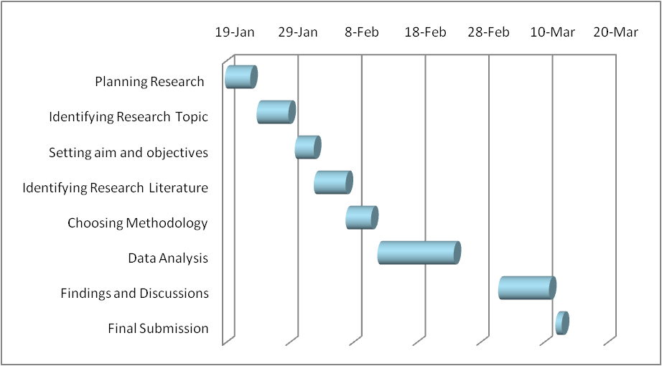
Figure 1: Gantt Chart
(Source: Created by Learners)

3.10 Ethical consideration of the research
All the participants incorporated in this research have participated in their own will and no coercive actions were undertaken. The scholarly references were extracted from their original sources and there are no issues of copyright protection.

Chapter 4: Conclusion
Talent management is essential for the desired growth and development of SMEs as they facilitate retention of talented and skilled employees. The concept of talent management is greatly associated with organisational performances. There are various challenges associated while embarking on talent management in SMEs like lack of expertise and limited budget. Nevertheless this research proposal incorporates strategies through the scholarly references of effectively supporting employee retention through talent management activities.

Chapter 5: References and Bibliography
Adams, J. (2014) Research Methods for Business and Social Science Students. New Delhi: SAGE Publications.
Adla, L., Gallego-Roquelaure, V. and Calamel, L., 2019. Human resource management and innovation in SMEs. Personnel Review.
Blaxter, L. (2010) How to research. Fourth edition. Maidenhead, England: McGraw-Hill/Open University Press.
Denscombe, M. (2012) Research proposals: a practical guide. New York: McGraw Hill Open University Press.
Denscombe, M. (2014) Good Research Guide: For Small-Scale Social Research Projects. 5th ed., McGraw Hill Education.
Duignan, J. (2016) A dictionary of business research methods. Oxford: Oxford University Press.
Dul, J. (2008) Case study methodology in business research. Oxford: Butterworth-Heinemann.
Murray, N. (2008) Writing up your university assignments and research projects: a practical handbook. New York: Open University Press
O’Gorman, K. (2015) Research methods for business & management: a guide to writing your dissertation. 2nd ed. Oxford, England: Goodfellow Publishers Ltd.
Oliver, P. (2012) Succeeding with your literature review: a handbook for students. Berkshire, England: Open University Press; McGraw-Hill.
Patton, M.Q. (2015) Qualitative research and evaluation methods. 4th edition. Los Angeles: SAGE.
Saunders, M.N.K. (2019) Research methods for business students. 8th ed. Harlow: Pearson.

