Boycho Nikolov
Student ID: 2115531

Cloud Computing Architecture(ACCA5025_LON)
Assessment 1
Boycho Nikolov
2115531@student.uwtsd.ac.uk

Contents
Cloud Computing Architecture(ACCA5025_LON) 0
Introduction: 2
Task Description: 2
Virtualisation: 3
Virtual machine: 3
Evaluation of Cloud benefits: 4
Infrastructure as a service: Benefits and Drawbacks 5
Platform as a service: Benefits and Drawbacks 7
Software as a service: 9
Evaluation of Availability: 10
Security Considerations: 12
Conclusion: 12
Bibliography 13

Introduction:

This course will cover all aspects of Virtualizations, Virtual Machines, and process.
In this article, will be explain how virtualization helps to optimize costs, increases transparency and efficiency of work processes. Through this course, will also pay attention to the possible pitfalls and hidden costs associated with its implementation, how it works and key points, advantages, and disadvantages.

Task Description:

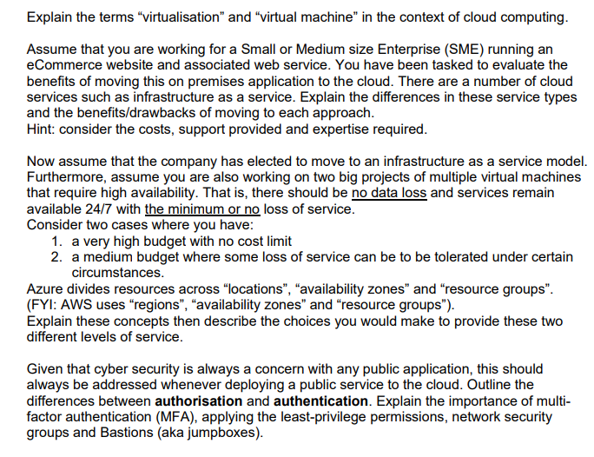

Virtualisation:
Often, technological innovations, along with new optimizations and additional capabilities, bring with them their inconveniences, and their integration is a challenge for the business and the responsible departments, Figure 1.
What is virtualization?
Virtualization - is an abstract model of an object as close as possible to reality, which is used when replacing an actual object (the operating system, data storage device, network resources, server, or other hardware platforms) with its abstract virtual version. [1]

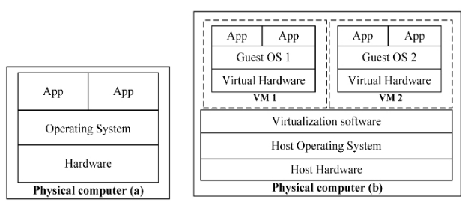
Figure 1

Virtual machine:

Today we hear a lot about cloud services, and every cloud steps on a virtual machine.
A virtual machine is the software recreation of a physical computer (everything that contains CPU, RAM, hard disk, video, and network cards, etc.) with its own operating system and its own applications. Through virtualization, it is possible to run several virtual machines on one (physical) computer at the same time, and each virtual machine can use a different operating system. Virtual machines are isolated from each other, share conflict-free the common resources of the computer architecture, such as memory, CPU, hard disk, etc. in real time, indistinguishable from a physical machine from a virtual machine, Figure 2.
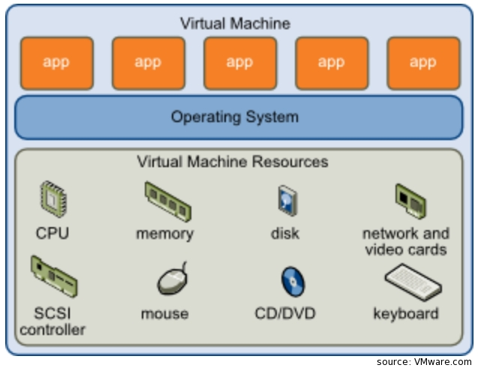
Figure 2

Evaluation of Cloud benefits:

Desktop virtualization could be described as high technology platform that solves several critical problems for the business divided into four categories. [2]
To make decision is the first major leap to network virtualization is the first major hurdle in the implementation process.
- Cost savings
From IT point of view, desktop virtualization helps reduce the time could be taken to provide new desktops and helps reduce cost and resources of managing and maintaining desktops.

- Simplified management
Since management is centralized, and information is well stored and protected, virtual desktops reduce the needs of installations l and update applications, create a backup copy of files, and individually protection for viruses on every client computer. Desktop virtualization as well could help to optimize management and maintenance of your software business assets.

The technology also helps to extend the life of older client computers and to support so-called "thin clients". A thin client is a computer device that, by means of a local network, connects to a terminal server, which in turn is responsible for the computing functions of the system.

- Increased security
Virtual desktops also could provide huge security to organizations because employees are not "porting" confidential data to their personal devices, which could be easily lost, stolen, or damaged. For example, in industries such as web application for banking or shops in this case, where compliance with privacy regulations is necessary, virtual desktops could give to the staff of the store or website access to clients records without fear of having any confidential information stolen from them.

- Increase productivity.
Virtual desktops will give employees full access to applications and software’s from many devices, such as laptops, tablets, and smartphones. This will be increasing productivity, allow the employees to access the data exactly they needed from anywhere, any time.
As a result, the employees could be in another building, country, or on the other side of the globe, a virtualized desktop will give him access them to be productive in any environment.
At the end huge Plus is if an employee's devices is damaged or stolen, they could easy log in from another device and continue working because the is available from everywhere and is not stored locally.
Virtual machines reducing the amount of time of the IT employee, spends time of manually installing new software or to make updates. It increases the productivity of employees as well in a company, especially small companies like in this case which could be seen in the description.

Infrastructure as a service: Benefits and Drawbacks

"Infrastructure as a Service (IaaS) is one of the three main "Cloud" services. The other two are Platform as a Service (PaaS) and Software as a Service (SaaS). IaaS provides the ultimate in control over the software installed on your server. Unlike PaaS, where the service provider has already installed an Operating System and some development and analysis tools, which are limited by their licenses and even by their developers (if the tools are developed by them), IaaS gives you complete freedom to install, whatever you want. IaaS gives you the full opportunity to take advantage of "Bring-your-own license" software. With IaaS, the provider is responsible for the physical maintenance of the servers, the network, firewall and security, as well as ensuring that the data centre has sufficient cooling, power, and a backup power option if there is an emergency.

In this case to migrate Website in cloud Possible uses of IaaS are:
- Full migration
In this scenario, the entire workflow moves to the "Cloud". In this way, you get the security and flexibility of cloud services and extend the life of the resource you already own. This is because most of the load will be transferred to your provider's servers and all your workers' machines must do is keep the video stream coming to them.
- Testing and development
If you want to test your newly created program in many different situations IaaS can overwhelm you. Just virtualize as many machines as you need and when you're done testing, remove them. This way, you have a secure and stable test environment, which will allow you to develop faster and go to market faster.
- High performance computer technologies
High-performance computer technologies help to calculate simulations or other problems with many variables. For example, a model of the financial market, a forecast of weather or climate change, simulations of the consequences after an earthquake.
- Web programs
IaaS provides everything you need for web applications. All the necessary resources are already built, with the necessary disk space, network resources, web and application servers already in place. Thus, your company can easily increase or decrease the resource it uses depending on your needs.
- Storage, backup, and recovery
In this scenario, your company chooses to store your information in a location other than your primary base. Thus, it can be easily recovered in case of disaster. You also save this way by not having to hire someone to handle the complex task of storing your information.
Pros of using IaaS are.
- Reduces the budget through cost optimization.
IaaS removes the cost of purchasing, installing, and managing the data centre. By using the "pay-as-you-go" method, you only pay for the servers you need now. By also removing the need for your IT department to physically maintain the servers, you give them time to concentrate on helping your staff with your core business.
- easy to expand or reduce.
With IaaS, you can easily increase or decrease the number of your servers based on your needs. This way, your employees as well as your customers will have a better time.
- easy to start and expand.
With IaaS, it's easier to start or expand your base because the necessary infrastructure is already in place. No need to wait days or weeks for your new server to arrive. This way, you can introduce your new product to the customer faster.

- Better security
With the right usage agreement, your provider can provide you with better security than if you maintain your data centre yourself.
- Improves productivity and stability.
With guaranteed uptime (up to 99.9% uptime) and a good Support department, you could be sure that their customers and employees will have constant access to the programs and resources they need. In this way, they will not need to disrupt their work process or their mental activity, which will lead to an increase in their productivity.

Platform as a service: Benefits and Drawbacks

Platform as a Service is one of the three main Cloud services. The other two are Infrastructure as a Service (IaaS) and Software as a Service (SaaS). PaaS is the second rung on the ladder. It provides everything that IaaS provides, but also adds everything you will need to build and distribute your software. This includes the middleware, as well as everything needed for information analysis and management. "Platform as a Service" is the ideal way to facilitate the development and optimization process, which will reduce the time from "Idea to Market". With the good foundation provided by PaaS, your staff will be able to use already tried-and-true solutions for some of the standard design and integration problems without needing to "Reinvent the Wheel" every time. This will help you focus on the new things your program will provide, Figure 3.

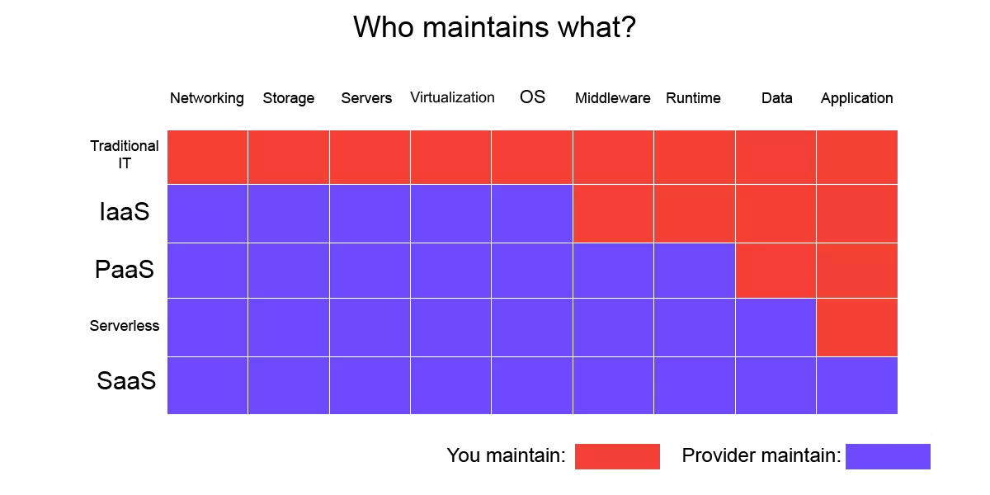
Figure 3

Advantages of Platform as a Service:
- No need for a central office. Because PaaS is accessible over the Internet, your workers will be able to work from anywhere at any time if they have access to the Internet.
- You oversee and lead the product from start to finish. PaaS provides you with the tools you need to continuously collect information and analyse it.
- reduces the programming process. With the foundation provided by PaaS, some of the functionality can be added with just one click.
- Because PaaS is a "Cloud Service", it can provide you with ready-made solutions related to security, verification, and protection of information. For this reason, you will not have to hire a specialist in this matter.
- With "Platform as a Service" you can develop your program to be compatible with several platforms at the same time. This includes desktop, web applications, as well as mobile applications.
- There is no need to maintain the "Cloud" infrastructure, as well as optimize the load, add updates for the tools or upgrade the servers.

Types of PaaS:
- Cloud (Public) – In this scenario, all information and the platform are stored on the provider's servers.
- Private – In this scenario, the platform is installed on the client's servers and placed behind a firewall. Here, the platform acts as a central gateway.
- Hybrid – In this scenario, some of the information is stored on the customer's servers and some on the provider's servers. Usually the "Platform" is stored in the "Cloud", and the information about the new product, as well as the code for it, is stored on the client's servers.
- Open PaaS – Usually comes without a hosting plan. It provides an open-source platform that can be uploaded to any provider or even your servers.
- Platform for communication services. (CPaaS) – This platform is optimized for communication-related software. Because these services are more prone to throttling, lag, or packet loss issues, they need special software and hardware to work properly.
- Mobile platform (MPaaS) offers services optimized for mobile devices.

Software as a service:

"SaaS" or "Software as a Service" this is when customers rent or taking software online decide not to buy and installing on their devices. It could be explained for example, users using Gmail or Any public Mail services. SaaS is the main idea of using SaaS.
The whole business and every of the employees will access their tools as online leased products. All the process and saving will use Internet, with users get access to the resources online.

SaaS, when is in combination with PaaS (Hardware Platform as a Service), this is what could name Cloud Computing.

The benefits of SaaS:
The main benefit of software-as-a-service is:
- Cost reduction for all involved.
- Customers will not spend hours and hours supporting users, only just maintain and repair a central resource and the product online.
- Conversely, consumers will not have to pay the large amount of outright buying, spreadsheets, or other end user services. Users will pay initial amount of money to access the large central resources.

The Disadvantages of SaaS / Cloud Computing
The main risk using SaaS and cloud computing is that customers could take a high level of trust using the software. In a sense, the software company is holding the customers such as a hostage because the whole documentation and productivity is now in the software company hands. File security and privacy protection will become complicated as the vast Internet is now part of every business.

If huge company with many employees moves to cloud computing, will be dramatically cut the administrative costs and staff for using cloud computing software.
However, will be increase in the risks of service fault, connectivity issues, and online security need to be launch.

SaaS / Cloud Example
1: Instead of selling to customer or not a license of Microsoft Word for £300, a cloud computing model will "rent" you word processing software over the Internet for about £5 a month. The customer in our case is small E-commerce business will not install any special software; the customer will be using only home PC to use this online to the product. Must be used only one of the web browsers to log in from any web-based computer and access the software the same way you will be access your Gmail.

SaaS / Cloud Example
2: our small E-commerce business will not spend vast amount of money on a sales database. The company will "rent" access to a complex online sales database, and all employees will have access to this information only using their computers or laptops available on the web.
SaaS and web-based services go hand in hand.
Many businesses would like to strengthen their presence on the Internet, expand their corporate site and give their customers access to various resources through web solutions. Following the steps of this project if the customer wants to increase business and sales, and the employees as well, they will need to purchase software, hardware and hire a trained team to work with them. In our case to migrate E-commerce business to Software as a service solves this problem.

Evaluation of Availability:

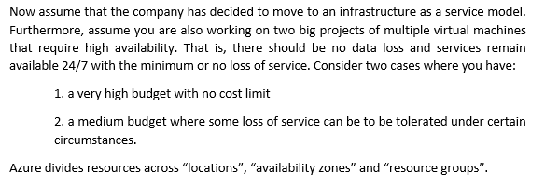

Scenario is given when company decides to migrate to Cloud.
Two scenario is going to be explained here, when the company has no cost limit of the budget and the second one is when the company has medium budget, and some losses of the services could be considered as acceptable.

1 scenario:
If the company has an unlimited budget and the service must stay online 24/7/365.
This means the service and information must be secured in different locations with different time zones and geographic zones.
It must be backed up for connectivity and for servers, two-way authentication, and connection between the servers in the cloud.
The software and especially the data installed must be updated all the time.
Zonal services: A resource will be running to a specific availability zones to get higher value of latency or performance in accord with the request from the customer, in this case company who is migrating to IaaS and requested from the customer. Resiliency is self-architected by replicating applications and data to one or more zones within the region.
Resources must be aligned to a different zone. For example, virtual machines, managed Space and HD, or standard IP addresses could be aligned to a same zone, this will allow for that to increase resiliency by having many instances of resources deployed to different zones.
It will b created Virtua machines.
As can see, various services could be chosen.

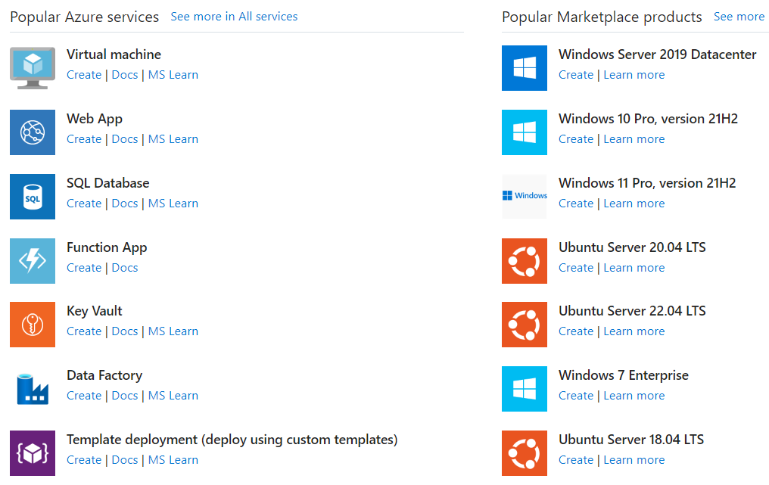
Zone-redundant services: Resources could be replicated or distributed across zones automatically. [3]
For example, zone-redundant services replicate the data in different zones, this means a failure in one zone will not impact for the data and services.
Always-available services: 24/7 available across all Azure geographies and are resilient to zone-wide outages and region-wide outages.
It’s been launched Server and Two virtual PC:
Two subnets must be created in Azure, with two different zones for security and availability.

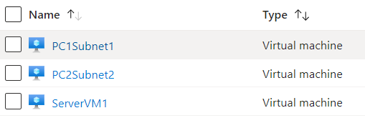

One of the important infrastructure consideration is configuration management and software updates so that the whole deployed infrastructure meets the security and policy requirements in this case. Azure staging areas, plans, and policies ensure that newly deployed infrastructure meets compliance requirements. Azure Security Center, and Log Analytics will help to manage the software configuration of the company and any updates for this company, in our case on-premises, cross-cloud, and cross-platform infrastructure. The Monitoring is crucial to detect any vulnerabilities, attacks, and anomalies, and Microsoft Defender with Azure Sentinel will provide all the threat protection in depth and scope for any workloads across multiple clouds, will be enabling auto detecting and responding.

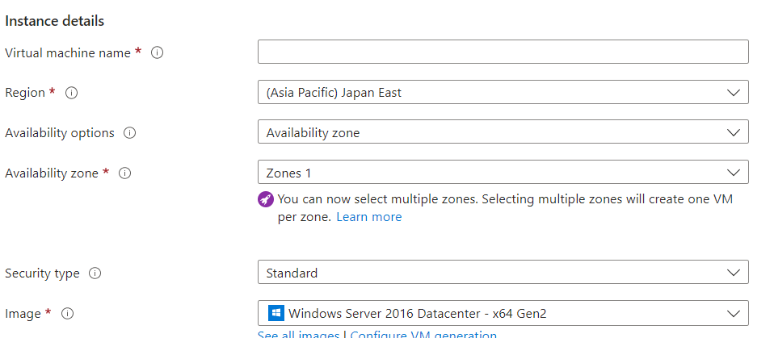

2 Scenario:
This one is easy to execute, the reason for this is the loss of the services could be tolerated.

IN this case no need to locate the services in different zones, only could be in one zone with request for save location and the data and access, authorization.
This will save money and the cost will be lower than in the other case.

One virtual machine with one zone and one Subnet.
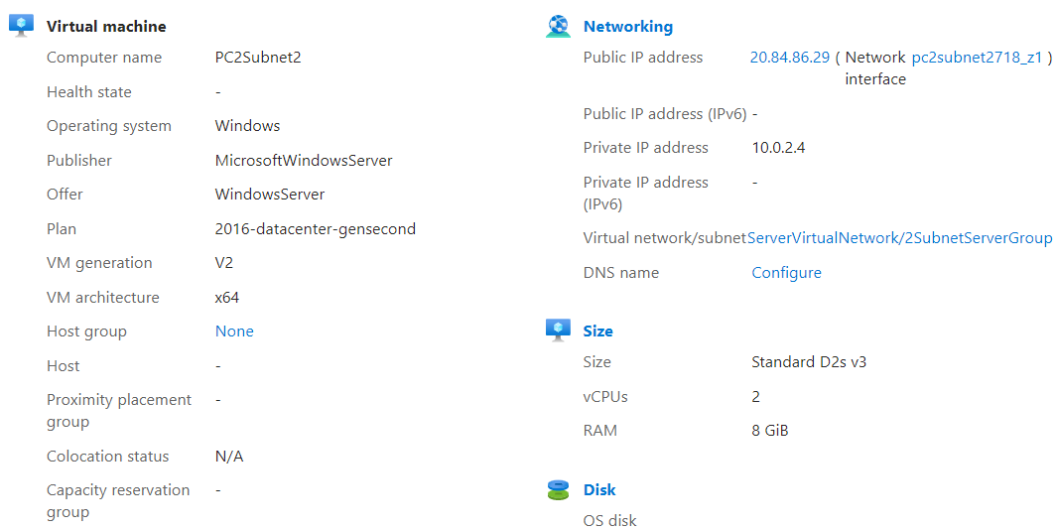

An also Back up could be launched:

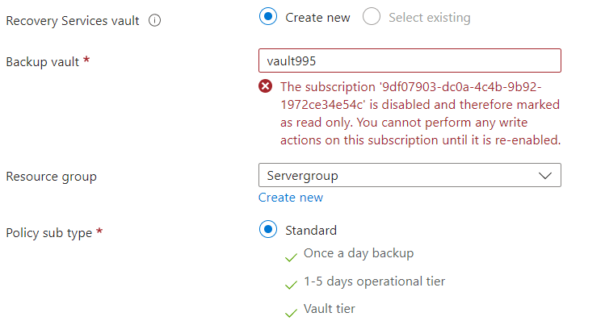

Security Considerations:

Information security is very important for mostly of all the automated systems. Authentication and authorization, this is two mechanisms which could be used in these systems to secure information. Authentication could be used to identify a specific user to allow them access to the system. After authenticating the user, the system, authorization must provide the necessary restrictions or access to the user. [3]
Authentication:
Authentication is about validating your credentials such as username / username and password to confirm your identity. The system will discover who you and say how to use your credentials. In public places and private networks, the system authenticates the user using passwords.
It is usually done through a username and password, and sometimes in conjunction with authentication factors, which refers to the different ways to authenticate.
Authentication factors define the different elements the system using to verify a person identity before giving them access to anything from accessing a file to requesting a bank transaction or document or pay.
An identity of user could be be defined by what data he knows, what information he has, or what he is. In terms of security, at least two or all three authentication factors must be verified to give someone access to the system.

Authorization:
Authorization takes place after the authentication process is complete. Authorization will define to user the permissions granted to the authenticated user. It will be checked whether the user has right to access to resources or not. These all resources ccould be bewho is sending request, directories, or something to access from the Internet.
When the identity is verified by the system and after successful authentication, the user will be authorized to access systems and resources.
This is the process of granting or denying access to a network resource, most computer security systems are based on a two-step process.
This mean in the first stage is authentication, which verify that the user is who they say. The second stage is authorization, which will allow the user to have access to the resources included in the user's identity.
Authentication is using to verifies the user, to identify them, while authorization verifies a user's rights to access resources.

Conclusion:
In conclusion, Virtualization has gone beyond an experimental technology concept long time ago.
It is already a main part of the modern world, any desktop infrastructures, and data centers. In fact, virtual technologies are very important part of modern IT services and our world.
The modern world can’t be imagined without virtualization and cloud technologies surrounding us.

Bibliography

[1] | M. Portnoy, Virtualization Essentials, Sybex, 2012.
[2] | N. B. Ruparelia, Cloud Computing, Massachudetts Institute of Tenology, 2016.
[3] | Microsoft, “https://learn.microsoft.com/,” [Online]. Available: https://learn.microsoft.com/en-us/azure/active-directory/develop/authentication-vs-authorization. [Accessed 2023].

