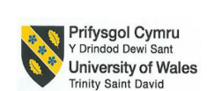

Hospitality and Tourism Management
International Hotel Management
BMIH5006
Module Name: Sustainable Hospitality and Tourism Management
Lecturer Name: Lisa-Marie Bassler
Student Name: Silviu-Nicolae Comanescu
Student ID: 2226638

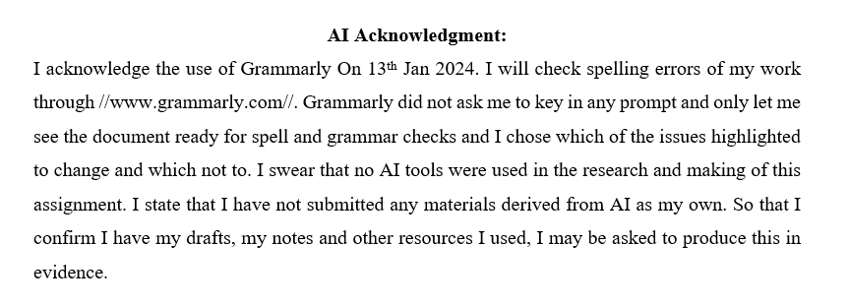
Executive Summary
The report examines the implementation of a sustainable building design initiative at JW Marriott Grosvenor House London by examining the environmental, economic and social implications. The main goal of this initiative is to integrate energy efficient technologies and renewable energy sources, water conservation systems and the replacement of these materials with sustainable ones into the operation of the hotel. They coincide with United Nations Sustainable Development Goals focused on affordable clean energy, responsible consumption and climate action. A discussion of potential benefits including significant reductions in carbon emissions, waste generation and water consumption, along with cost savings and improved guest experiences are explored in the report. Additionally, it is an initiative which strengthens the hotel’s reputation as an environmentally friendly brand for the rapidly growing segment of eco conscious travellers. Several recommendations were made to enable the adoption of this initiative including phased implementation, active stakeholder engagement and partnerships with organizations toward sustainability.
Table of Contents
1 Introduction 4
2 Findings 5
2.1 The Greener Practice Initiative 5
2.2 Examples of Businesses Implementing the Initiatives 5
2.3 Benefits of Implementing the Initiatives 6
2.4 Challenges Associated with Implementation 7
2.5 Environmental Impact of the Initiative 8
3 Conclusion and Recommendations 9
4 References 11

Introduction
With the increasing issues of environmental degradation and climate change, businesses are urged to take appropriate actions (De Grosbois and Fennell, 2022). Different initiatives are designed to minimize environmental impact while improving sustainability. Initiatives in the hospitality sector include energy conservation, waste reduction and green sourcing. Not only does this compliment global environmental goals, but it also optimizes operational efficiency and appeals to eco minded travellers.
JW Marriott Grosvenor House London a Luxury Hotel rich in heritage and impeccable service is the main focus of the report. The hotel is located in midtown Mayfair and serves an affluent, diverse customers and is hence an ideal adopter of green greener practices (JW Marriott, 2025). Incorporating sustainable initiatives allows the hotel to continue to promote itself as a socially responsible business while meeting the contemporary guest perception around the issue of sustainability and eco awareness. The report aims to assess greener initiatives can improve the hotel’s sustainability efforts, and its environmental impact and cost effectiveness. The report will also examine the challenges hotel is facing while implementing green initiative and its environmental benefits.
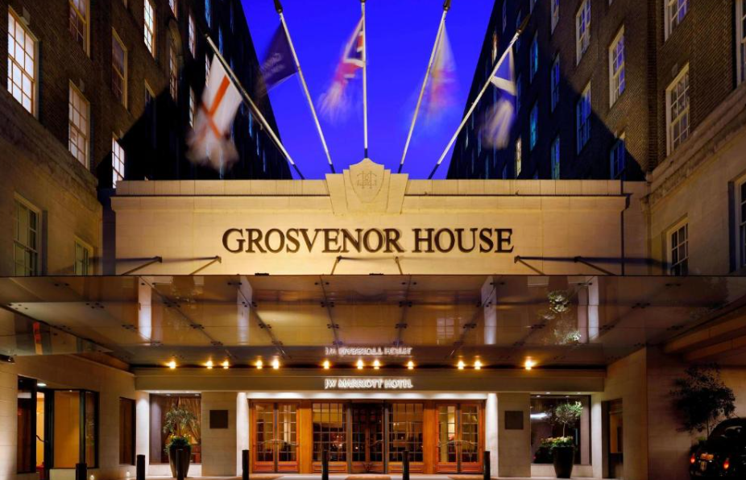
Source: JW Marriott Grosvenor House London (2025)

Findings

The Greener Practice Initiative
The Sustainable Building Design and Operations is the key greener practice initiative for JW Marriott Grosvenor House London (Marriott, 2025). The goal of this initiative is to develop sustainability principles that should be considered while designing, constructing and operating hotel facilities. The use of energy-efficient system is a key element of this initiative. The hotel features state of the art HVAC controls (heating, ventilation, and air conditioning) with LED lighting, as well as smart energy management tools to minimise energy use. With these systems, energy use is optimized based on real time occupancy and weather patterns, while minimizing waste. JW Marriott Grosvenor House London also uses forms of renewable energy, like solar panels, to wean itself off the use of fossil fuels even further (Marriott International, 2025). Also, a key feature of this initiative involves water conservation through installing low flow fixtures and water efficient appliances.
Depending on the application and situation, these measures produce quite substantial water and footprint reductions and is financially beneficial to both the environment and operational costs. In addition, sustainable building design is also concerned about the use of eco-friendly materials and construction processes (Yahia et al., 2024). JW Marriott Grosvenor House London also tries to support staff and guests in learning about sustainability and promoting an environmental responsibility in this practice. This greener initiative adopted by JW Marriott Grosvenor House London is positioning it as a leader in sustainable hospitality the whole time showing how environmental stewardship and luxury can be done perfectly well simultaneously (Kadaei et al., 2021).

Examples of Businesses Implementing the Initiatives
In the UK, several hotels have adopted a sustainable building design and operation as an integral component of their environmental responsibility initiatives. For instance, The Hilton London Bankside is considered a notable example integrating sustainable building design (Hilton, 2025). Opened in 2015, the hotel has taken the prize for the eco-friendly design and operations. It includes energy efficient systems like intelligent light and heating and a firm commitment to building's sustainable practices. Hilton employs water saving fixtures and low energy technology to reduce its consumption, and the building is constructed of locally sourced materials (Orynycz and Tucki, 2021). Hilton also goes further than the building envelope by designing and using building systems that are environmentally friendly. The hotel focuses on sustainability by having the ‘Travel with Purpose sustainability program’. Likewise, historic hotel the Savoy London has also working on sustainable building design. A multimillion pound renovation was recently completed, including the installation of state of the art energy efficient systems and water conservation technologies (The Savoy London, 2025). Sustainability is demonstrated by the use of renewable energy by the Savoy and also through waste reduction efforts and eco-friendly interior designs (Alqahtani, 2024). It has also adopted a sustainable sourcing policy to adopt positive contributions towards the environment, yet offering luxury service standards with the food and materials.
Under the leadership of Premier Inn, has also undertaken major initiatives to integrate sustainable design into its properties across the UK (Premier Inn, 2025a). To help the hotel chain reduce its carbon footprint, for instance, the hotel chain has reduced the systems by incorporating energy efficient systems like LED lighting, better insulation, and high efficiency boilers. Premier Inn is dedicated to advancing its green building practices, and seeks to integrate these efforts in all new buildings’ designs and repurposing existing buildings to meet higher sustainability standards (Premier Inn, 2025).

Benefits of Implementing the Initiatives
One key SDG addressed by this initiative is Goal 7: Clean Economy or Affordable and Clean Energy. The hotel adopts energy efficient systems smart HVAC controls, LED lighting, smart energy with solar panels, etc. that reduce dependency on non-renewable energy. Not only does this reduce carbon emissions, it cuts down operational costs allowing the hotel to continue operating profitably while being responsible (Premier Inn, 2025a). The hotel’s operations are aligned with global efforts to control climate change and adoption of the energy use. Another relevant goal is SDG 12: It is Responsible Consumption and Production. Sustainable resource management is facilitated through the initiative's focus on water conservation, waste reduction as well as use of eco-friendly materials. The environmental footprint has also been reduced by rainwater harvesting, low flow fixtures and comprehensive waste recycling programs among various practices (Arora and Mishra, 2023). It considers these efforts to be the most efficient way to use natural resources and follow circular economy principles, thus preserving a reputation for being a responsible and future-oriented hospitality provider.
The initiative also aligns with Goal 11: Initially, Metro Regions was a Sustainable Cities and Communities outcome area (Botchway et al., 2023). The hotel integrates sustainable building practices, of which green roofs, natural ventilation and locally sourced materials for construction minimize the hotel’s contribution to urban heat islands and pollution. These measures not only contribute to the quality of life around the community, but also show how luxury properties can come alongside urban sustainability goals. Additionally, Goal 13: The initiative acknowledges that Climate Action is directly addressed in focusing on reducing greenhouse gas emissions and mitigating climate related risks (Almulhim et al., 2024). All measures taken by the hotel to reduce its footprint, through technological and renewable energy innovations, are examples of its fight against climate change.
JW Marriott Grosvenor House London follows sustainable building design and operational practice to demonstrate its commitment to the SDGs. Not only do these initiatives help the hotel become more resource efficient and cut costs, they also give the hotel a better reputation as a brand and a more appealing hotel experience for customers (Marzouki et al., 2021). In addition, they advance broader societal goals to demonstrate the luxury hospitality opportunity to deliver positive environmental and social change.

Challenges Associated with Implementation
JW Marriott Grosvenor House London presents many challenges as it attempts to implement sustainable building design and operations: cost effectiveness, and much more. Retrofitting the hotel to accommodate sustainability standards is one of the main obstacles because of the high upfront investment (Singh et al., 2024). Particularly when it comes to energy-efficient systems, renewable energy installations and more eco-friendly materials, substantial capital investment is required. Installation of solar panels, upgraded to smart, energy saving HVAC systems will further press the hotel budget in the short run. These investments are expected to decrease operating costs in the long run but may dissuade immediate installation, especially in a market where the profit margin is tightly watched. Additionally, there is a disruption of daily operations occurring in the implementation phase (Crespi et al., 2021). These disruptions are critical but complex, however, with a luxury experience being expected by guests, it is important to manage the disruption well.
There is another challenge posed by stakeholder alignment. Collaboration between hotel management, franchisees, owners and suppliers and many times hotel operating models are being changed for implementing sustainable initiatives. Getting stakeholders to invest in eco-friendly upgrades, especially when there are limits on short term financial returns can be difficult (Putra and Law, 2024). Also, staff and guests unfamiliar with or accustomed to sustainable practices may well be resistant, and training and awareness campaigns may be required. The initiative is a long term investment rather than an immediate cost saving measure. However, sustainable building projects can be cost effective if they are planned carefully and options are picked between the most powerful technologies as well as using government incentives or grants. If the initiative was implemented in phases, it is achievable, realistically (De Grosbois and Fennell, 2022). Also, partnerships with sustainability consultants and local suppliers will help to reduce the cost and keep the initiative possible.

Environmental Impact of the Initiative
JW Marriott Grosvenor House London has adopted sustainable building design and operational practice that deliver significant environmental benefits through a reduced ecological footprint and responsible resource use (Marriott International, 2025). These benefits correspond with the efforts around the world to combat climate change, conserve natural resources and have healthier environment. Energy efficient technology and renewable energy sources are a key environmental advantage that reduces carbon emissions (Kadaei et al., 2021). JW Marriott Grosvenor House London still sustains emissions by using solar panels, smart HVAC systems and LED lighting is able to minimize its dependence on the use of fossil fuels.
The promoting of water conservation is also one of the initiatives of this initiative. Efficient water use is achieved by implementation of water saving fixtures, like low flow taps and dual flush toilets, as well as the rain water harvest system. It improves stress put on the local water supplies and saves essential resource to be enjoyed by future generations (Si et al., 2022). Another key benefits the initiative gives is reducing the amount of waste that gets sent to landfills. This hotel can reduce contribution to pollution from waste by recycling sustainably and sourcing sustainable material (Si et al., 2022). This initiative also enhances the biodiversity as well. Green roofs, landscaped outdoor spaces feature cities as habitats for urban wildlife that support local ecosystems.

Conclusion and Recommendations
With the adoption of sustainable building design and operational practices, JW Marriott featured in London has made a great step forward in reducing their environmental footprint and using resources more equitably. The hotel is aligned with the United Nation’s Sustainable Development Goals including affordable clean energy, responsible consumption, and climate action, through the integration of energy efficient systems, renewable energy sources and water conservation measures. In addition to enhancing the hotel’s reputation, reducing long term operational costs and helping to preserve natural resources and biodiversity, this initiative allows the hotel to show customers and clients a continued commitment to sustainability. Although high initial costs and potential operational disruption exists, the long term benefits far out way these challenges. Underpinning this success is careful planning and stakeholder partnered implementation of vital changes, both environment and stakeholder friendly. JW Marriott Grosvenor House London has established a standard that other leaders will build upon in the hospitality industry to encourage environmental responsibility. Based on the analysis, below are the key recommendations for JW Marriott Grosvenor House London.
- The hotel needs to use the step-by-step approach to sustainable policies’ implementation, initially focusing on the activities that are easy to accomplish and bring significant results at the same time. For instance, replacing conventional bulbs with energy saving ones and using water-saving devices (Crespi et al., 2021). This will assure the hotel of gradually attaining the sustainable objectives without putting much strain on the financial muscle and functionality of the business.
- The hotel has to work with their stakeholders; the owners, employees and the guests in order to train everyone and to run awareness campaigns in order to address resistance and to make adoption successful (Almulhim et al., 2024). Increased collaboration towards this initiative will be fostered by highlighting the environmental and financial benefits of this initiative.
- Costs can be reduced and efficiency raised by working with sustainability consultants, local suppliers, as well as taking advantage of government incentives or grants. The hotel can also strengthen its reputation as a leader of sustainability by partnerships with eco-friendly organization.

References
Almulhim, A. I., Sharifi, A., Aina, Y. A., Ahmad, S., Mora, L., Filho, W. L., and Abubakar, I. R. (2024). Charting sustainable urban development through a systematic review of SDG11 research. Nature Cities, 1(10), 677-685.
Alqahtani, A. S. (2024). Indisputable roles of different ionic liquids, deep eutectic solvents and nanomaterials in green chemistry for sustainable organic synthesis. Journal of Molecular Liquids, 124469.
Arora, N. K., and Mishra, I. (2023). Responsible consumption and production: a roadmap to sustainable development. Environmental Sustainability, 6(1), 1-6.
Botchway, E. A., Agyekum, K., Kotei-Martin, J. N., Pittri, H., Dompey, A. M. A., Afram, S. O., and Asare, N. E. (2023). Achieving healthy city development in Ghana: referencing sustainable development goal 11. Sustainability, 15(19), 14361.
Crespi, G., Becchio, C., and Corgnati, S. P. (2021). Towards post-carbon cities: which retrofit scenarios for hotels in Italy?. Renewable Energy, 163, 950-963.
De Grosbois, D., and Fennell, D. A. (2022). Determinants of climate change disclosure practices of global hotel companies: Application of institutional and stakeholder theories. Tourism Management, 88, 104404.
Hilton, 2025. JW Hilton 2022 Environmental, Social and Governance Report. [Online] Available at < https://esg.hilton.com/wp-content/uploads/sites/4/2023/04/Hilton-2022-Environmental-Social-and-Governance-Report.pdf [Accessed on 13th Jan 2025].
Jayachandran, M., Gatla, R. K., Rao, K. P., Rao, G. S., Mohammed, S., Milyani, A. H., and Geetha, S. (2022). Challenges in achieving sustainable development goal 7: Affordable and clean energy in light of nascent technologies. Sustainable Energy Technologies and Assessments, 53, 102692.
JW Marriott, 2025. JW Marriott Grosvenor House London. [Online] Available at < https://www.marriott.com/en-us/hotels/longh-jw-marriott-grosvenor-house-london/overview/ [Accessed on 13th Jan 2025].
Kadaei, S., Shayesteh Sadeghian, S. M., Majidi, M., Asaee, Q., and Mehr, H. H. (2021). Hotel construction management considering sustainability architecture and environmental issues. Shock and Vibration, 2021(1), 6363571.
Marriott International, 2025. Sustain responsible operations. [Online] Available at < https://serve360.marriott.com/sustain/ [Accessed on 13th Jan 2025].
Marriott, 2025. Green Initiatives. [Online] Available at < https://www.marriott.com/content/dam/marriott-digital/mc/us-canada/hws/p/pdxor/en_us/document/assets/mc-pdxor-green-initiatives-12279.pdf> [Accessed on 13th Jan 2025].
Marzouki, A., Chouikh, A., Mellouli, S., and Haddad, R. (2021). From sustainable development goals to sustainable cities: A social media analysis for policy-making decision. Sustainability, 13(15), 8136.
Orynycz, O., and Tucki, K. (2021). Total productive maintenance approach to an increase of the energy efficiency of a hotel facility and mitigation of water consumption. Energies, 14(6), 1706.
Premier Inn, 2025. Sustainability Survey reveals need for enhanced sustainability education in hotels in the Middle East. [Online] Available at < https://mena.premierinn.com/en/news/sustainability-survey-by-premier-inn-middle-east-reveals-strong-environmental-awareness/ [Accessed on 13th Jan 2025].
Premier Inn, 2025a. Our pledge to reach net zero carbon emissions ten years early. [Online] Available at < https://www.premierinn.com/gb/en/news/2021/net-zero-carbon-emissions.html [Accessed on 13th Jan 2025].
Putra, F. K. K., and Law, R. (2024). Critical success factors for virtual hotel operator partnership with small-and medium-sized hotels: perspectives of owners and operators. Journal of Hospitality and Tourism Insights, 7(3), 1391-1411.
Si, H., Duan, X., Zhang, W., Su, Y., and Wu, G. (2022). Are you a water saver? Discovering people's water-saving intention by extending the theory of planned behavior. Journal of Environmental Management, 311, 114848.
Singh, A. B., Mishra, Y., and Yadav, S. (2024). Toward Sustainability: Interventions for Implementing Energy-Efficient Systems into Hotel Buildings. Engineering Proceedings, 67(1), 80.
The Savoy London, 2025. Sustainability Initiatives. [Online] Available at < https://www.thesavoylondon.com/about-us/sustainability-initiatives/ [Accessed on 13th Jan 2025].
Yahia, A. K. M., Rahman, D. M. M., Shahjalal, M., and Morshed, A. S. M. (2024). Sustainable materials selection in building design and construction. International Journal of Science and Engineering, 1(04), 106-119.

