Student Self Evaluation Form

This section repeats in brief the common assessment criteria detailed on previous pages. The extent to which these are demonstrated by you determines your mark. Using these criteria, tick the box that best indicates the level of achievement you feel you have achieved with regard to each of them.

Common Assessment Criteria Applied
Common Assessment Criteria Applied | REFER |  | D |  | C |  | B | A
 | OUTRIGHT FAIL | UNSATISFACTORY | SATISFACTORY | GOOD |  | VERY GOOD |  | EXCELLENT
1. Subject Knowledge and Understanding (which includes using research-informed literature and knowledge and understanding of the subject)
 |  |  |  | x
2. Intellectual Skills (Analysis)
2. Intellectual Skills (Analysis) |  |  |  | x
3. Pedagogic and Professional Applications (Practical Application and Deployment)
 |  |  |  | x
4. Key Transferable Skills
4. Key Transferable Skills |  |  |  | x

PLEASE COMMENT ON AREAS IN WHICH YOU FEEL THAT YOU HAVE PERFORMED WELL | PLEASE COMMENT ON AREAS you feel that you need TO DEVELOP
I feel as if I critically analysed my methodology well in the conclusion and discussion. | I found it difficult to write a literature review with that few words. It was difficult to be precise.

Does the use of talk partners improve the quality of responses to higher order questioning in a KS2 classroom?
Student number: 1700870
Group 5
Word count: 6458

Contents Table
Aims, Focus and Purpose of the Research 4
Research Context 4
Literature Review 5
Methodology 7
Ethical Considerations 12
Lesson Study 13
Lesson Study 1 Analysis 14
Lesson Study 2 Analysis 17
Discussion and Conclusions 20
Recommendations 24
References 26
Appendices 30

Aims, Focus and Purpose of the Research
The focus of this research is Assessment for Learning (AfL) strategies as this is regarded as a crucial area for teachers. I valued the opportunity to consider my own practice regarding AfL and specifically look at its potential impact on the learning of children. Higher-order questioning is personally an area I found difficult during my first Professional Teaching Placement (PTE) and consequently was a target for me to consider for my next teaching placement. In my KS2 class, my teacher would encourage me to push the children as they were considered high ability and would do this by asking higher order questions. Therefore, I feel it is important for me to use this opportunity of looking into higher order questions and other AfL strategies to gain better insight for my future career.
Research Context
For this research, I am working with a partner who is a fellow PGCE student. We developed the question together after discovering that we both had similar targets regarding AfL during PTE. We decided to specifically focus on talk partners as this was the AfL strategy we both commonly used in our classes. We decided it would be interesting to discover if this commonly used AfL strategy has an impact on the children’s answers. Together our research question is ‘Does the use of talk partners improve the quality of responses to higher order questioning in a KS2 classroom?’ This question will have an impact on my class as it will give them an allotted time to discuss their answers in pairs and record that. Hopefully, by doing this the children will also see how using talk partners improves their answers.
This research is carried out in two KS2 classrooms. The first is a large primary school in a town in South Wales. The class is a mixed year 5 and year 6 class which contains 27 children. The other class is in a large primary school in suburban Swansea which was my PTE school. This class contains 27 children in year 6.
Literature Review
Assessment for Learning (AfL) is explained as a range of practices that improve pupils’ learning (Black and William, 1998; Black et al., 2003; Wiliam et al., 2004; Lysaght et al., 2017). Anything that is deemed to improve the learning of pupils should be considered important hence why a great emphasis is placed on AfL in the teaching profession. AfL can be inferred as the actions completed by the teacher which allows teachers to adapt their future teaching and plan activities from the information provided from the feedback from these actions (Black and Wiliam, 1998). The AfL strategies that are used and discussed in this essay are talk partners and higher-order questioning.
Oral questioning is deemed an essential skill to effective teaching (Christenbury and Kelly, 1983; Danielson, 1996; McComas and Abraham, 2012). Borich (1992) and Tofade (2013) further state that effective oral questioning can capture children’ attention, develops, encourages their critical thinking, and can gain children’s involvement. This demonstrates the vast reasons why a focus on oral questioning is important for the classroom.
Equally, Tofade et al. (2013) highlight the negative effect poor questions can have on the children. Poorly constructed questions can limit creative thinking, intimidate students, and potentially suppress learning by confusing the children (Chin, 2007; Tofade et al., 2013). To overcome this, they emphasize the importance of planning questions beforehand carefully to guide the children towards a deeper understanding of the subject being taught.
It has been found that, through classroom-based observations, teachers will ask lower-order questions more often than higher-order questions (Sellappah et al., 1998; Saeed et al., 2012; Tofade et al., 2013). Lower-order questions are those that focus on factual recall whereas higher-order questions stimulate deeper thinking as they require children to evaluate and consider ideas hence why it is encouraged for teachers to be using these types of questions more frequently (Christenbury and Kelly, 1983; Wilen, 1991; Ertmer et al., 2011; Saeed et al., 2012; Tofade et al., 2013;). The three domains considered as lower-order questions are knowledge, comprehension, and application whereas higher-order questions are deemed in the analysis, synthesis, and evaluation domain (Ayudaray and Jacobs, 1997; Neal 2012; Tofade et al., 2013). These domains are taken from Bloom’s Taxonomy (Bloom et al., 1956).
Welsh Government (WG) (2010) suggest that talk partners have the potential for the children to evaluate their own learning and thinking. Working collaboratively has long been researched and concluded to have a positive effect on children. Donaldson (2015) emphasises the importance of working collaboratively as it can improve the metacognition skills as it provides the children the opportunity to “talk through their thinking processes, compare them with others and refine their learning skills as a result” (Donaldson, 2015: 69). Therefore, going forward with the new curriculum, teachers need to encourage collaborative learning to improve thinking skills.
Donaldson (2015) references’ Hattie’s (2009) research which states that cooperative learning is effective. Peer collaboration has a positive impact on problem solving, motivation and achievement (Hattie, 2009, as cited in Donaldson, 2015). It has been found that when peer discussion is used, the percentage of correct answers increases (Smith et al., 2009). Reasons for this could include a better understanding for the children after discussion (Smith et al, 2009). However, this research was completed with undergraduate students, therefore, more research needs to be completed before we can generalise these results to primary school children.
Peer collaboration influences a child’s cognitive development. Both Piaget and Vygotsky theories support this (Tudge, 1992; Fawcett, 2002). Research based on Piaget models believe that cognitive change can develop from the cognitive conflict resulting from peer collaboration (Dimant and Bearison, 1991; Light and Littleton, 1994; Druyan, 2001; Fawcett, 2002). Whereas Vygotsky based research suggests that when a child collaborates with a more knowledgeable partner, cognitive development arises (Tudge et al., 1996; Samaha and De Lisi, 2000; Garton and Pratt, 2001; Fawcett, 2002). From whichever perspective researchers take, it is agreed that working in collaboration has a positive impact on the cognitive development of a child.
Despite the many benefits of peer collaboration, using it spontaneously will not allow for all these benefits necessarily. Effective interaction needs some prompting and guidance from the teachers (Bell 2004; Cohen 1994; King 1994; King, 2008). Furthermore, research has found that even when children are instructed to work collaboratively they tend to work on a lower thinking level unless guidance is given on how to interact, then a more abstract, higher-level thinking occurs (Webb et al., 1986; King, 2008). Therefore, to use peer collaboration to its full potential, it needs to be carefully constructed within a lesson and used with guidance from a teacher.
Methodology
Lesson study (LS) research is the methodology used in this study. LS is a form of classroom-based action research which focuses on the development of teacher practice knowledge (Dudley, 2008). A fellow student of the university and I are working collaboratively to plan, teach, observe and analyse a lesson with a chosen focus. My partner will teach the lesson to her class from PTE and I will observe focus children to see the impact of the focus on those children. After the lesson, those children will then be interviewed as a group to gain insight into their view of the lesson. Following this, we will discuss, analyse and refine the lesson. This will be done from the perspective of the pupils and the information we have gained from the pupils. The following day, I will teach the refined lesson to my class from teaching placement and my partner will observe the focus children in the same manner as I had done previously. We will then again interview the focus children and then discuss and analyse the lesson and decide what conclusions can be made from this and how this can feed into our future teaching practice.
LS has many benefits for the teachers involved and the pupils. Through doing LS, teachers can view the children' learning in a much more focused way than usually possible (Dudley, 2011, as cited in Dudley, 2014). From this, they can then identify the gaps in their pupils' learning and plan more efficiently to amend those gaps (Dudley, 2011, as cited in Dudley, 2014). Ls has the potential to improve pupil progress and teaching techniques and develop AfL strategies (Dudley, 2014). The reason for this could be because the teachers are working collaboratively which research has found is the most powerful option a school leader can do to increase pupils' educational results (Robinson et al., 2009).
Though there are many benefits to LS research, the limitations should be discussed also. Completing a LS could be seen a time consuming as each of the teachers involved would need the time out of class to observe the other teachers. In addition, it could be uncomfortable for teachers being observed by peers however this can be overcome if everyone is aware that the observers are there to observe the learning of the target pupils and not the teachers themselves, unlike other observations. All challenges can be overcome if teachers are aware of the many benefits LS can provide them in their professional development.
The methods of data collection used as part of the LS are field notes, non-participant observation, focus group interviews, and reflection. The data collected in this research is qualitative data. Cohen et al. (2007: 461) explain that qualitative data is ‘making sense of data in terms of the participants’ definitions of the situation, noting patterns, themes, categories, and regularities.’ As this research includes identifying if talk partners influence the quality of response to higher-order questions then this needs to be done through looking for patterns in children’s’ responses and how they behave during the time to discuss with talk partners therefore qualitative data suits this research. My research partner and I will analyse the data after each lesson. We will look at each of our focus children individually and analyse their responses and seek to understand the individuals and identify any patterns across all the children.
Qualitative data will allow us to collect more detailed data than quantitative data as we will be collecting data through many different methods. However, there are some limitations to this data collection method. A significant limitation is that the data is open to interpretation and each researcher will interpret the data in a different way. Each researcher will approach the data with their own biases, background, and preconceptions which decreases the validity of the results (Cohen et al., 2007). We attempt to overcome this limitation through the observer of the children not previously knowing the children, therefore, they have no biases towards the children being observed.
Non-participant observation occurs when the researcher stands away from the observed targets to complete the observation, no interaction takes place between the observer and the observed children (Cohen et al., 2007; King, 1979). This gives the observer the opportunity to document and study interactions and behaviour in real time (Ritchie and Lewis, 2003). However, a limitation of this is that it could decrease the ecological validity of the research as children may behave in a different way in the presence of the observer (Cohen et al., 2003).
The non-participant observations were collected through an observation schedule (Appendix 1). My research partner and I created this observation schedule making it specific to our research topic. We aimed to observe how the children behave in their talk partners as this is something teachers do not get the opportunity to do without being actively involved. I observe four target children from my research partners class and she will observe four children from my class.
Focus group interviews are a form of qualitative research that involves interviewing a small group of children to get their insight, perspective, and opinion of the lesson. These types of interviews generate a process where, through the guidance of the interviewer, the group interact with each other and further develop their answers after listening to the others which trigger additional answers (Finch and Lewis, 2003; Stewart and Shamdasi, 1990; Merton et al., 1990). This can often lead to answers on a deeper level (Finch and Lewis, 2003). A limitation of this method of data collection is ensuring that everyone has a chance to say their opinion and no single participant dominates the conversation as we will not have a true representation of a range of opinions. To overcome this the interviewer must ensure a balance between participants so that everyone is heard.
A further potential limitation is that as children are the participants and the interviewer is seen as a teacher and therefore a person of authority, this could lead to the children not being completely honest in their answers as they attempt to please the interviewer (Arksey and Knight, 1999). This could lead to a lack of validity in the results. To overcome this potential limitation, we will explain to the children before conducting the focus group interview that they do not have to participate in the interview if they do not want to, encourage them to be as honest as possible and explain that there will be no consequences to them for doing so. Also, the fact that it is a group interview can make it less intimidating for them which provokes more honest answers (Cohen et al., 2007).
The focus group sample were chosen based on several factors. We chose two sets of talk partners. We required a higher-ability pair and a lower-ability pair as some diversity in the group is deemed beneficial (Finch and Lewis, 2003; Calder 1977). However, common ground is needed between the participants also (Finch and Lewis, 2003; Powell et al., 1996; McLafferty, 2004). The common ground between the participants in this research is that they will all be in the same class and have just experienced the same lesson.
At the end of the lesson, we will undertake reflection. We will do this in order to gain a new understanding of our focus and know how to implement this into our future teaching. By doing this we will, hopefully, understand why our focus is important in the education context. The reflections were captured using assisted reflective conclusions model (ARC) which has been adapted to be specific to our research topic (Appendix 2). Reflection is an important part of action research. Kemmis and McTaggart (1992) claim that one reflects in a more systematic, rigorous and careful way during action research that one usually does in day to day life. By doing this, a rationale is created that has been tested and examined critically for what is being done in the classroom (Cohen et al, 2007).
Ethical Considerations
When completing research in the classroom, there are ethical considerations that need to be considered. I will be following the guidelines set out by British Educational Research Association (BERA) (2011), the University of Wales Trinity Saint David (UWTSD) (2017) and Education Workforce Council (EWC) (date unknown) and have previously completed an ethics form before carrying out the research.
We will gain consent from parents of the children to be part of the research (Appendix 15) and the children will be asked to give their assent before we begin any observations or interviews (Appendix 16). Every child will be made aware from the beginning of the lesson that they have the right to withdraw and not take part and may choose to do so at any point with no repercussions.
All children will be treated equally, including children that choose to withdraw, as the aim is for all children to progress in their learning. As I am perceived as an authority figure it may make the children feel as if they must take part. To overcome this, I will offer no incentives and make it clear that there will no repercussions if they do not take part or want to withdraw at any point.
The well-being of the children will be of the utmost importance throughout the research. To do this, I will follow the schools safeguarding policy which I have read. I will aim to eliminate the risk of stress through intrusion by sitting slightly away from the children that I am observing and not pressuring any children to answer any of the interview questions. These interviews will take place in an open area where other adults are present.
I will follow the legal requirements to work with children and will comply with the legal requirements of storage and use of data. All children will remain anonymous and all data will ensure the children and schools anonymity and confidentiality.
The lesson carried out as part of this research will be considered standard classroom practice, therefore, there will be no additional risk to the children than any other standard lesson.
Lesson study
The learning objective of the lesson was to develop an awareness of how poverty and inequality can cause problems. The children achieved this by exploring how they use water in their lives, understanding the impact of not having clean water on other people’s lives, understanding that a simple action like hand-washing can stop people getting ill, and explore the positive impact of having access to clean water and sanitation (British Red Cross, date unknown) (lesson plan in Appendix 3).
This research is exploring if talk partners improve the quality of the response to higher-order questions. To assess this during the lessons, we posed two higher-order questions to the children. They recorded their own personal response to the question on a post-it note. We emphasised that this should be their own response and not to deliberate yet. They then had the opportunity to discuss their answers with a talk partner and were then encouraged to add or edit their answers after having this discussion using a different pen. Four target children were observed during their discussions for both questions.
The questions asked were taken from Bloom’s Taxonomy sentence starters from the evaluation section. We adapted them to apply to our specific lesson.
Lesson Study 1 Analysis
The first question asked was ‘what could be the consequence of Brenda not having clean water?’ As you can see in Appendix 4, every child has used the opportunity of a discussion with their talk partner to add to their original answers. However, adding to their answer does not necessarily mean they have improved the quality of their answer. Child 1A and Child 1B had separate talk partners but were our lower-ability sample, whilst Child 1C and 1D were talk partners and were the higher-ability sample.
Child 1A has added a whole other view point after her discussion. After discussion with her talk partner, she additionally writes transporting the large containers of water may affect her bones and her growth. This clearly shows how talk partners have improved her answer as without that discussion she would have only considered one point of view. Additionally, from the observation schedule (Appendix 5), she was on task throughout and engaged with her partner in the discussion.
A similar situation appears with child 1B. Through discussion with her partner, she adds another point to her answer. Her post discussion addition attempts to explain ways of making the water clean (Appendix 4). This also shows how talk partners can add a new perspective to a question. From the observation schedule, child 1B dominated the discussion with her partner but remained on task throughout. This is interesting, as you might not necessarily expect a child who dominates in such a way to then add quality to her answer as you could assume that she had spent less time listening to her partner's answer. This shows that despite dominating she did take the opportunity to listen to her partner and improve her answer.
When given the opportunity to discuss with their partner after recording their own individual answer, Child 1C firstly discussed the quantity they had each written and not the content (Appendix 5). With both Child 1C and Child 1D, there was not a great deal of discussion. They merely read out their answers to one another and that was the end of the discussion. They did both briefly add to their original answers. Child 1C’s only addition to his answer was that Brenda could die from dirty water as well as becoming ‘ill and sick.’ You can see that these talk partners have directly taken ideas from one another and added it to their answers. Though in this case, I do not believe that this has added quality to their answers as they have added to their answers slightly on a point that has already been made in their original answer.
The second higher-order question asked was ‘how would you feel if you lived in a country where there is a water shortage? Why?’ Child 1A has again taken this opportunity to improve the quality of her answer (Appendix 6). Her original answer discusses one emotion, whereas after her talk partner discussion she adds two more emotions and giving reasons. This is clear evidence of an improvement in the quality of her answer. She had clearly not considered these emotions before discussion with her partner.
Child 1B has edited her answer in a slightly different way than her answer to the first question. She does add a further explanation to her answer following the discussion, however, she uses the opportunity to edit her original answer. She crosses out the word ‘bad’ and replaces it with the ‘guilty’ (appendix 6). This again shows some improvement in the quality of her response. This supports the observation that she listened to her partner (Appendix 7) as without input from her partner she would not have improved the quality of the vocabulary of her response.
There is evidence that Child 1C has used their talk partner to improve the quality of his response in this instance. He has taken points from his partner and used them in his own answer (Appendix 6). He had clearly not considered these points before the discussion with his talk partner. Child 1D had a quality response before discussion with a partner and had filled the post-it note; consequently, he only adds a small amount to his answer. It is not clear whether this is because he had run out of space on the post-it note or did not feel his partner added sufficiently to his individual answer. It could also be because of a lack of engagement throughout the time given to discuss as he became distracted after merely reading their partners answer as observed in the observation schedule (Appendix 7).
The focus group interview provided some interesting feedback from the children (Appendix 8). All children agreed that talk partners were generally a positive experience and can see their benefits in terms of improving the quality of their answer. They do, however, state that it can cause conflict and that the success of the experience depends on who their talk partner is. When we asked what else we could have done to improve the quality of their answers, Child 1A, Child 1B, Child 1C all alluded to more prompts to help them answer the question. Child 1D thought more time may have improved his answer, however, during the observation on both questions he did not spend the whole time discussing the given question. This could be evidence of a child answering the question to please the interviewer and not giving an honest answer. When asked how to further improve the lesson generally, the children agreed that the use of talk partners should remain part of the lesson and Child 1A even suggested discussing in a group. It was mentioned again about extending the amount of time to discuss the answers.
After considering all aspects of the process, my partner and I reflected on the lesson to decide how we could improve the lesson for the next class. We agreed that the lesson went well and that the children had responded well to the questions. We decided to edit the wording of the first question slightly to make it clearer for the children as some children needed explanation for clarity before being able answer the question. From the feedback of the children, we also decided to add some prompts to help answer the question and would give the children more time in their talk partners to discuss.
Lesson Study 2 Analysis
The wording of the first higher-order question was refined and now asked ‘what is the impact of not having access to clean water on Brenda’s life?’ After the focus group interview, I included key points to consider for example education and hygiene. In this class, Child 2A and Child 2B were our higher-ability talk partners and Child 2C and 2D were our lower-ability talk partners.
Child 2A was on task throughout her discussion with her partner and even directed her partner back on task when the discussion went off topic (Appendix 9). Due to her being engaged, she has a high quality of answer. She has clearly listened to her partner and added more points to her original answer post discussion with her talk partner (Appendix 10). This is evidence that talk partners has improved the quality of her answer.
Child 2B also used the opportunity to add an additional idea to his answer after his discussion with a talk partner (Appendix 10). In my opinion, the talk partner discussion has not improved the quality of response greatly as although an additional point has been added it has not been done in detail. A reason for this could be that towards the end of the time allocated for partner discussion, Child 2B did not use it fully discuss the topic and went off topic (appendix 9). Though, the use of talk partners has been beneficial in making this child consider another perspective.
You can see that the quality of response for Child 2C has improved after discussion with her talk partner (Appendix 10 and Appendix 11). Through talking to her partner, she has added more detail to her answer and thought about her answer in a more considered way. From the observation schedule (Appendix 9), Child 2C did not speak as much as her partner and therefore listened to her partner's points to improve her original answer. She did need some encouragement to begin the talk partner discussion but then related her answer back to her own experience and compared that to those of Brenda’s.
Child 2D has also improved her answer through discussion with her talk partner. She adds another point about Brenda’s energy levels (Appendix 10). This would not have been discovered without the use of talk partners. Similarly to Child 2C, she needed encouragement to talk to her partner (Appendix 9) but led the discussion thereafter and made sure that both partners took turns in talking and sharing their answer and discussed any similarities in their answers.
We made the decision to keep question 2 the same as the previous lesson. Child 2A wrote a full answer that included several points for her individual answer (Appendix 12). Though she adds an additional point post discussion it does not add much quality to her answer. It is brief and not a full explanation. A reason for this could be that she was observed being less engaged in the discussion than in the previous discussion (Appendix 13).
Conversely, Child 2B led the discussion this time and would prompt his group and ask if they had any more to add (Appendix 13). Consequently, he did add quality to his answer. He had only written one feeling as his individual answer and then post discussion he had considered two other emotions and explained them (Appendix 12). This is evidence of talk partners extending a child’s answer and improving the quality.
Child 2C has improved the quality of her answer to the question, however, this time she has added an additional point rather than improving the quality of what she had already written (Appendix 11 and 12). However, in both instances, her overall answer has been improved using talk partners. The observation schedule (Appendix 13) shows that though she was less engaged in this discussion than previously, she spoke more as it says that the discussion was equal this time. Reasons for this could be because she was more confident talking about her own feelings than about someone else.
As the discussion between Child 2C and Child 2D was equal for this question, Child 2C has improved the quality of her answer more so than in the first question. From discussion with her talk partner, she discusses how water could affect her education. This point would not have been made without the discussion with her talk partner demonstrating the effect talk partners can have on improving quality of answers.
As with the first LS lesson, we interviewed these four children in a focus group interview (appendix 14). This focus group sample was in agreeance with the other focus group sample in that they believe that using talk partners is beneficial. They believe it is beneficial because they can get a more detailed answer and it aids them if they are unsure of the answer, to begin with. To further improve the quality of their answer, Child 2C interestingly thought talking to a teacher would improve the quality of her answer. This could be because she lacks confidence and needs the reassurance from the teacher. Similarly, to the first focus group interview sample, the children all agreed that they would keep the talk partner aspect of the lesson the same however have the discussion in larger groups of around 4 as Child 2C pointed out that when groups become too large it can be difficult to listen to everyone.
Following the lesson my partner and I discussed and reflected on the lesson and then I completed an ARC form to further reflect on the lesson (Appendix 17). We agreed that the overall lesson went well. The specific structure we wanted to assess the impact of talk partners was completed more efficiently with the second question as I was clearer about the structure. However, on reflection I do not believe this made a great deal of difference on the responses and answers of the children in the end.
Discussion and Conclusion
We have found that a child’s engagement with the discussion can have an impact on whether the quality of their answer improves or not. When Child 1A was engaged in the discussion her answers improved considerably. On the other hand, the observation schedule (Appendix 5) shows that Child 1D was not engaged throughout the allotted time for talk partner discussion and consequently, the quality of the child’s answer did not improve. However, we can not conclude that engagement is the only reason for this, other avenues will need to be explored before making that conclusion. Nonetheless, Child 2A is a clear example of how the level of engagement in a talk partner discussion impacts the quality of an answer. During the talk partner discussion for the first question, she was actively engaged as she would attempt to keep her partner on task, thus the quality of her answer improved (Appendix 10). Subsequently, when the observation schedule (appendix 13) suggests that she was less engaged in this discussion, her answer does not improve in quality.
A trend had been found in the differences between girls and boys and their use of talk partners to improve the quality of their answer. This trend is not only observed with our observed sample but also in the wider class. The girls would generally spend longer discussing the topic at hand whereas the boys would mostly only spend part of the time allocated discussing the topic. This is evident in our first LS sample. In both talk partner discussions, the boys were observed as merely comparing answers briefly and not engaging in discussion whereas the girls were engaged throughout and consequently their answers improved in quality on both occasions. There is a lack of research considering the gender differences when working collaboratively therefore it is difficult to make conclusions on this aspect.
There could be another explanation for this result. The boys in that sample group were our higher-ability pair whereas the girls were the lower-ability pair. This could also be affecting whether they engage in the discussion. Although Child 1D added to their answer to the second question, it did not necessarily improve the quality of his answer. His answer was already of a high quality and had discussed many points of view. Whereas, the lower ability pairings in both LS samples greatly improved the quality of their answer for both questions. This contradicts the results of Fawcett (2002) study which found that only children that had a higher-ability partner improved their performance. However, in that study, the children were completing a sorting activity which had more concrete results than merely a discussion.
Following the focus group interview in the first LS, I added specific prompts for the first question to aid the children and give the children avenues of thought. This is in agreeance with research that suggests the importance of prompts from teachers aids effective interaction between children (Bell 2004; Cohen 1994; King 1994; King, 2008). As a result, it can be argued that the quality of the answers of the children for that question were of a higher quality in the second LS as opposed to the second LS. Those children had considered the prompts given which aided their answer to be wider before the talk partner discussion had occurred. The talk partner discussion then increased the quality of their answers further.
After reflecting with my partner following the first lesson, we decided to adapt the first question to make it clearer to hopefully generate higher quality answers. This is in agreeance with Tofade et al. (2013) as they emphasise the importance of well-planned and considered questions as they impact on the results of the children. Therefore, we attempted to achieve this after believing that that question needed improvement based on the responses of the children. As you can see from Appendix 4 and 10, we deemed the children in the second lesson have higher quality responses. However, as we also gave children prompts it is difficult to distinguish if the wording of the question or the prompts or a combination of both that resulted in an improvement of quality.
We decided that we would keep the second question the same and not give children prompts due to the fact it was about children’s’ own feelings. We felt that we did not want to influence that. However, on reflection of the second lesson, it may have been beneficial to give children things to consider which could lead to deeper thinking.
Though we have found evidence that talk partners can improve the quality of answers to the higher-order question, there are some limitations to the research carried out. A significant limitation is that the measure of whether an answer is a high-quality, answer or not is subjective. As Cohen et al. (2007) pointed out, it is fully dependent on the perspective and bias of the researcher. My partner and I would agree whether an answer has improved in quality or not, however, it is still not a valid measurement. Then again, as this action-based research reflects real life practice as in schools, outcomes and levels are based on an element of the subjectivity of the teacher.
I am aware that our sample is not a true representation of the classes. We deliberately chose a higher-ability pair and a lower-ability pair to get diverse views. If it was possible, we would have had a middle-ability pair also. However, it would have been difficult to observe three sets of talk partners simultaneously. Having two sets of talk partners, meant that our focus was split which decreases the validity of the research as there is a potential that we have missed crucial moments of each partners discussion.
Due to the reasons stated above and the fact that this was completed as a small-scale action research with the aim of improving my own practice, it is difficult to generalise these results as they are not considered reliable or valid. There was some inter-reliability as both my partner and I agreed on whether answers were high quality or not. However, that is a small number of people that have agreed that. Our sample is very small therefore it can not be generalised to other children.
Despite these limitations, these results have significance to myself as a student teacher. Talk partners do have a positive impact on the children’s’ answers to higher-order questions if the questions and the peer collaboration is planned beforehand. Though many different factors affect the amount talk partners impact on their answers such as gender, perceived ability, and levels of engagement.
If I did this lesson again I would, I would focus on one pair of talk partners at a time to gain a more detailed observation as our attention was split between two pairs which meant we could have missed key events.
Recommendations
It is important that research impacts on my next teaching placement and my NQT year and beyond. Moving forward, I am clearly aware of the impact talk partners can have on the quality of a child’s answer as every focus child, bar one, improved the quality of their answer following a talk partner discussion for at least one of the questions. I have seen first-hand the engaging discussions children having during talk partner discussions and the different points of views and perspectives children can gain from it. From this, I will increase the number of talk partners and other collaborative AfL strategies I use when teaching. This is in agreeance with Donaldson (2015) who emphasises the importance of collaboration as this provides children with the opportunity the discuss ideas and consequently evaluate their ideas and refine their thinking. This is essentially what we saw in this research.
Additionally, this research has provided me with the opportunity to explore the importance of effective questioning. I now realise the importance of carefully constructing the question beforehand to maximise the potential answers of the children. Moving forward, I will always plan my questions beforehand and carefully consider the wording.
Whilst completing this research, I have discovered that most of the research completed on peer collaboration, are investigating groups rather than pairs. Therefore, it would be interesting if further research investigated whether the same benefits occur when children work in pairs in addition to group work. However, this research shows that talk partners can impact on a child’s performance to higher-order questioning. Further research needs to be completed on a larger scale to generalise these results.

References
Arksey, H. and Knight, P. (1999). Interviewing for social scientists. London: Sage Publications.
Ayaduray, J. and Jacobs, G. (1997). Can learner strategy instruction succeed? The case of higher order questions and elaborated responses. System, 25(4), pp.561-570.
Bell, P. (2004). Promoting students’ argument construction and collaborative debate in the classroom. In M. C. Linn, E. A. Davis, and P. Bell (Eds.), Internet environments for science education (pp. 114–144). Mahwah, NJ: Erlbaum
Black, P. and Wiliam, D. (1998). Assessment and Classroom Learning. Assessment in Education: Principles, Policy & Practice, 5(1), pp.7-68.
Black, P., Harrison, C., Lee, C., Marshall, B. and Wiliam, D. (2003). Assessment for learning: Putting it into practice. Berkshire: Open University Press.
Bloom, B. S. (1956). Taxonomy of educational objectives: The classification of educational goals.
Borich, G. (1992). Effective teaching methods. 2nd ed. New York: Merrill.
British Red Cross, (2018). Teaching resources. [online] Available at: https://www.redcross.org.uk/get-involved/teaching-resources [Accessed 15 Apr. 2018].
Britton, B. K., Van Dusen, L., Glynn, S. M., & Hemphill, D. (1990). The impact of inferences on instructional text. In A.C. Graesser & G.H. Bower (Eds.), Inferences and text comprehension (pp. 53–87). San Diego: Academic Press.
Chin, C. (2007). Teacher questioning in science classrooms: Approaches that stimulate productive thinking. Journal of Research in Science Teaching, 44(6), pp.815-843.
Christenbury, L. and Kelly, P. (1983). Questioning; A Path to Critical Thinking. National Council of Teachers of English.
Cohen, E. (1994). Restructuring the Classroom: Conditions for Productive Small Groups. Review of Educational Research, 64(1), p.1.
Cohen, L., Manion, L. and Morrison, K. (2007). Research methods in education. 6th ed. London: Routledge.
Danielson, C. (1996). Enhancing professional practice: A framework for teaching. Alexandria, VA: Association for Supervision and Curriculum Development.
Dimant, R. and Bearison, D. (1991). Development of formal reasoning during successive peer interactions. Developmental Psychology, 27(2), pp.277-284.
Donaldson, G. (2015). Successful Futures. Crown.
Druyan, S. (2001). A comparison of four types of cognitive conflict and their effect on cognitive development. International Journal of Behavioural Development, 25(3), pp.226-236.
Education Workforce Council (n.d.). Code of Professional Conduct and Practice for Registrants with the Education Workforce Council. Cardiff: Education Workforce Council.
Ertmer, P., Sadaf, A. and Ertmer, D. (2011). Student-content interactions in online courses: the role of question prompts in facilitating higher-level engagement with course content. Journal of Computing in Higher Education, 23(2-3), pp.157-186.
Ethical Guidelines for Educational Research. (2011). London: British Educational Research Association.
Fawcett, L. (2002). The Effect of Peer Collaboration on Children' s Problem Solving Ability. Theses. Edith Cowan University.
Finch, H. and Lewis, J. (2003). Focus Groups. In: J. Ritchie and J. Lewis, ed., Qualitative Research Practice. [online] London: SAGE, pp.170-198. Available at: http://www.sxf.uevora.pt/wp-content/uploads/2013/03/Ritchie_2003.pdf [Accessed 10 Apr. 2018].
Garton, A. and Pratt, C. (2001). Peer assistance in children's problem solving. British Journal of Developmental Psychology, 19(2), pp.307-318.
Hattie, J. (2009). Visible learning. London: Routledge.
Kemmis, S. and McTaggart, R. (1992). The Action Research Planner. 3rd ed. Geelong: Deakin University Press.
King, R. (1978). All things bright and beautiful? a sociological study of infants' classrooms. Chichester: Wiley.
King, A. (1994). Guiding Knowledge Construction in the Classroom: Effects of Teaching Children How to Question and How to Explain. American Educational Research Journal, 31(2), pp.338-368.
King, A. (2008). Structuring Peer Interaction to Promote Higher-Order Thinking and Complex Learning in Cooperating Groups. In: R. Gillies, A. Ashman and J. Terwel, ed., The Teacher’s Role in Implementing Cooperative Learning in the Classroom. Springer.
Light, P. and Littleton, K. (2013). Cognitive approaches to group work. In: D. Faulkner, K. Littleton and M. Woodhead, ed., Learning relationships in the classroom. New York: Routledge, pp.171-188.
Lysaght, Z., O'Leary, M. and Ludlow, L. (2017). Measuring Teachers’ Assessment for Learning (AfL) Classroom Practices in Elementary Schools. International Journal of Educational Methodology, 3(2), pp.103-115.
McLafferty, I. (2004). Focus group interviews as a data collecting strategy. Journal of Advanced Nursing, 48(2), pp.187-194.
Merton, R., Lowenthal, M. and Kendall, P. (1990). The focused interview. New York: Free Pree.
Neal, M. (2011). Engaging students through effective questions. Education Canada, 51(1).
Powell, R., Single, H. and Lloyd, K. (1996). Focus Groups in Mental Health Research: Enhancing the Validity of User and Provider Questionnaires. International Journal of Social Psychiatry, 42(3), pp.193-206.
Research Ethics & Integrity Code of Practice. (2017). University of Wales Trinity Saint David.
Ritchie, J. (2003). The Applications of Qualitative Methods to Social Research. In: J. Ritchie and J. Lewis, ed., Qualitative Research Practice. [online] London: SAGE, pp.24-48. Available at: http://www.sxf.uevora.pt/wp-content/uploads/2013/03/Ritchie_2003.pdf [Accessed 10 Apr. 2018].
Saeed, T., Khan, S., Ahmed, A., Gul, R., Cassum, S. and Parpio, Y. (2012). Development of students' critical thinking: the educators' ability to use questioning skills in the baccalaureate programmes in nursing in Pakistan. Journal of Pakistan Medical Association, 3(62), pp.200-203.
Samaha, N. and De Lisi, R. (2000). Peer Collaboration on a Nonverbal Reasoning Task by Urban, Minority Students. The Journal of Experimental Education, 69(1), pp.5-21.
Sellappah, S., Hussey, T., Blackmore, A. and McMurray, A. (1998). The use of questioning strategies by clinical teachers. Journal of Advanced Nursing, 28(1), pp.142-148.
Smith, M., Wood, W., Adams, W., Wieman, C., Knight, J., Guild, N. and Su, T. (2009). Why Peer Discussion Improves Student Performance on In-Class Concept Questions. Science, 323(5910), pp.122-124.
Stewart, D. and Shamdasani, P. (1990). Focus groups: Theory and Practice. Newbury Park, California: SAGE.
Tobin, K. (1987). The Role of Wait Time in Higher Cognitive Level Learning. Review of Educational Research, 57(1), p.69.
Tofade, T., Elsner, J. and Haines, S. (2013). Best Practice Strategies for Effective Use of Questions as a Teaching Tool. American Journal of Pharmaceutical Education, 77(7), p.155.
Tudge, J. (1992). Processes and Consequences of Peer Collaboration: A Vygotskian Analysis. Child Development, 63(6), p.1364.
Tudge, J., Winterhoff, P. and Hogan, D. (1996). The Cognitive Consequences of Collaborative Problem Solving with and without Feedback. Child Development, 67(6), p.2892.
Webb, N., Ender, P. and Lewis, S. (1986). Problem-Solving Strategies and Group Processes in Small Groups Learning Computer Programming. American Educational Research Journal, 23(2), p.243.
Welsh Government (2010). How to develop thinking and assessment for learning in the classroom. Cardiff: Crown.
Wilen, W. (1991). Questioning skills, for teachers. Washington, D.C.: NEA Professional Library, National Education Association.
Wiliam, D., Lee, C., Harrison, C. and Black, P. (2004). Teachers developing assessment for learning: impact on student achievement. Assessment in Education: Principles, Policy & Practice, 11(1), pp.49-65.

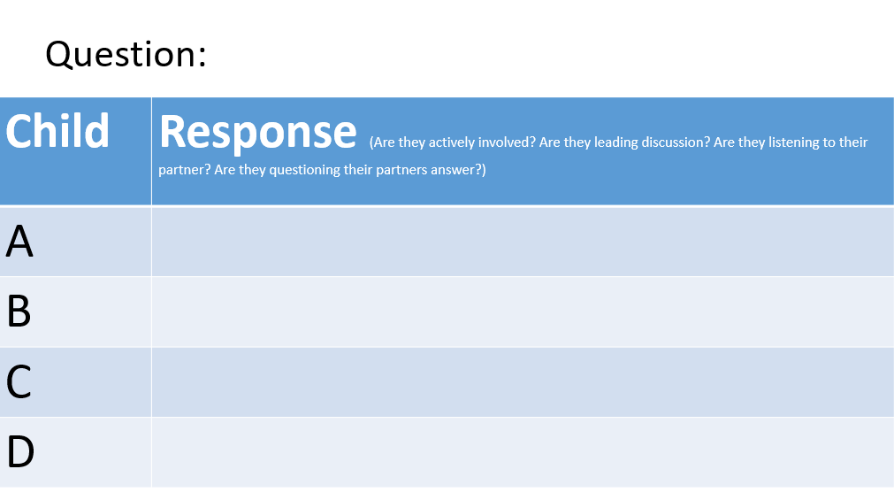
Appendix 1- Blank observation schedule

Appendix 2-

Assisted Reflective Conclusions (ARC) Model
Dyddiad/Date:
Digwyddiad critigol (Ffocws)/Critical incident (focus):

Profiad/ Experience

Teimladau/
Feelings
Beth yw eich teimladau ynghylch y profiad?
“What are your feelings regarding the experience?”

Cofio a Deall/
Remember and Understand
“Can you list the aspects of the talk partner discussions that went well?”

“What were the elements of the talk partner discussions that were disappointing?”

Gwerthuso a dadansoddi/
Evaluate and analyse

“What will you keep the same to ensure effective teaching and learning in the future?”

“What was the cause of the most important disappointing element?”

Casgliadau a chamau gweithredu/
Conclusions and actions

“What are your possible solutions to the disappointing issues identified?”

“What will you do next?”

Y profiad newydd / Transformed experience

Appendix 3- Lesson plan
 |  |  |  |  |  |  |  |  |  |  |  |  |  |  | 1B
 | Session Plan – Key Stage 2
 | Name of trainee: |  |  |  |  |  |  | Session ref: |  |  | TET lesson 28/03/18
 | Personal target(s) in relation to QTS:
 | Year group: |  | 6 |  | No. of learners: |  | 27 |  | ALN: | Asperger
 | Additional Adults:
 | Learning objective(s): WALT: develop an awareness of how poverty and inequality can cause problems |  |  |  |  |  |  |  | Success criteria:  Explore how they use water in their own lives  Understand the impact of not having clean water on other people’s lives  Explore the positive impact of having access to clean water and sanitation (e.g. on education/health)
 | Links to previous learning:
Curriculum coverage (range, skills)
Personal and Social Education
listen carefully, question and respond to others
the challenges learners might have in accessing learning opportunities in school.
develop a positive attitude on issues of poverty and fairness

 | Literacy(LNF)  express issues and ideas clearly, using specialist vocabulary and examples  respond to others with questions and comments which focus on reasons, implications and next steps. |  |  |  |  |  |  | Numeracy (LNF)
 | DCF |  |  |  | Thinking |  |  | ESDGC  Understand that some people are richer and some people are poorer  Understand not everyone has enough food, clean water, safe environment and good relationships |  |  |  |  |  | YCC
Key vocabulary(English/Welsh):
Clean water, hygiene, education, sanitation, poverty

Time |  | Session activities, organisation and management |  |  |  |  |  |  |  |  |  | Key questions & Assessment for Learning opportunities
10 minutes |  | Introduction
 |  | Ask the children- How do you use water? Children to spend time silently thinking about and then in their groups, act out their ideas. The group guesses the action. As a group, children to write a mind map.
 |  |  |  |  |  |  |  |  |  |  |  |  | How do you use water?
 |  |  |  |  |  |  |  |  |  |  |  |  | List of answers
40 minutes |  | Main activities
Explain that children around the world do not necessarily have water that is clean and safe.
Brenda’s story.
Explain that the top left-hand photograph is of Brenda Chepkemoi. Brenda is 14 years old and lives in a small village called Chebelion in the south-west of Kenya. You can show children where Kenya is on the map of Africa on the slide.
Brenda has to start every day with a tiring two-hour round trip to collect water. She gets home just in time to start school, after school she collects water again. Not only is the river far away but the river water is dirty. The other photograph on the slide shows women and children in Brenda’s community carrying water home from the river.

Ask children-
what is the impact of not having access to clean water on Brenda’s life?
Children to note answer on post it note individually.
Then children to discuss answer with partner and add or edit their answer in purple pen.

Children to then categorise their previous list into essential and non-essential water usage.

 |  |  |  |  |  |  |  |  |  |  |  |  | Talk partners
10 minutes |  | Plenary
Ask children- how would you feel if you lived in a country where there is a water shortage? Why?
Children to note answer on post it note individually.
Then children to discuss answer with partner and add or edit their answer in purple pen.

 |  |  |  |  |  |  |  |  |  |  |  |  | Talk partners

Appendix 4- LS1, question 1 responses 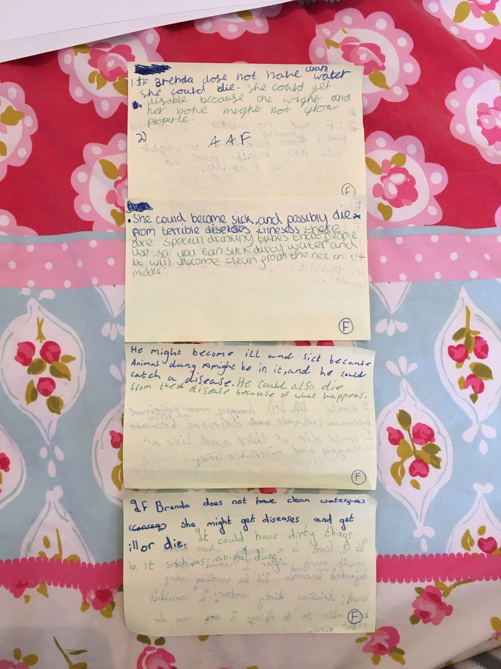
Child 1D
Child 1C
Child 1B
Child 1A

Appendix 5- LS1, question 1 observation schedule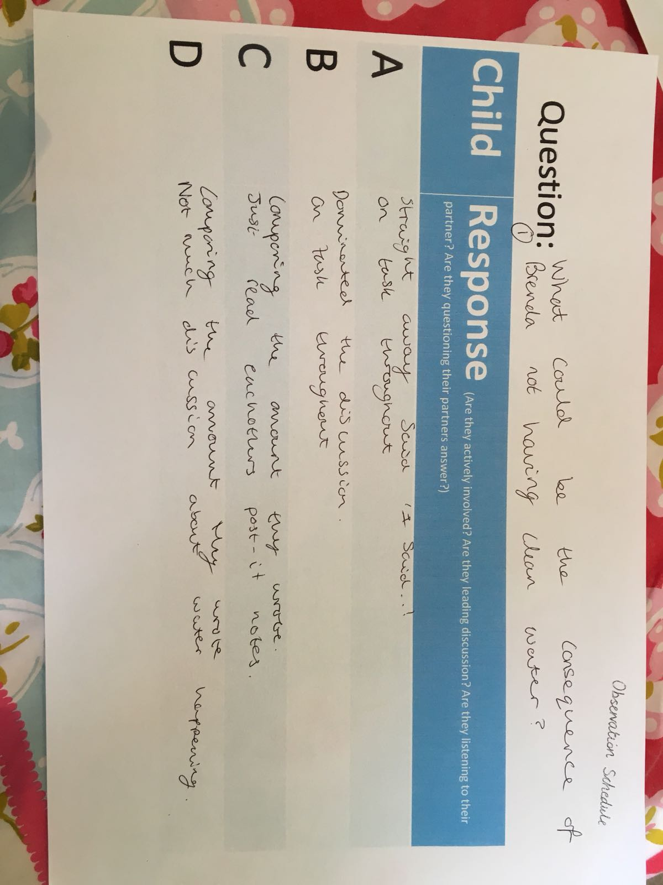

Appendix 6- LS1, question 2 responses
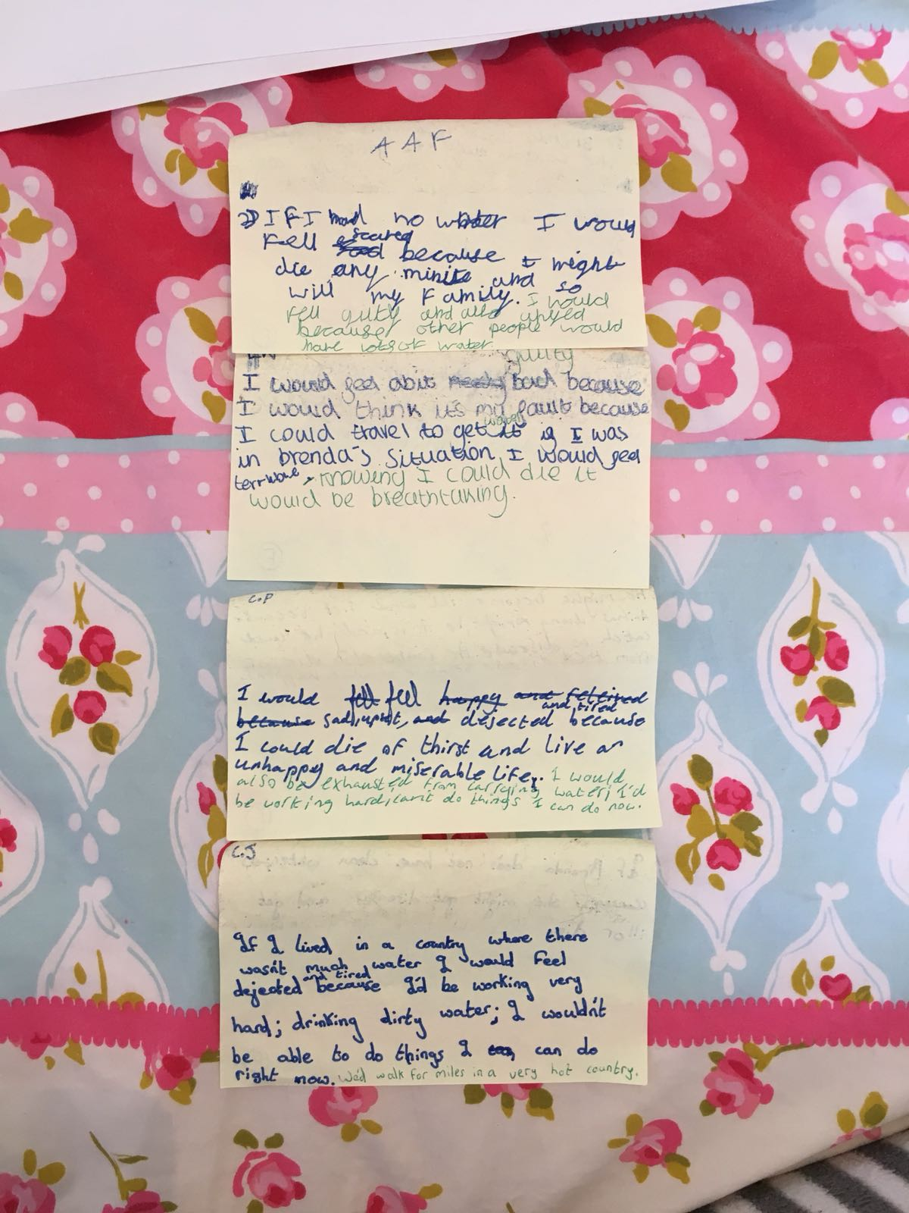
Child 1D
Child 1C
Child 1B
Child 1A

Appendix 7- LS1, question 2 observation schedule
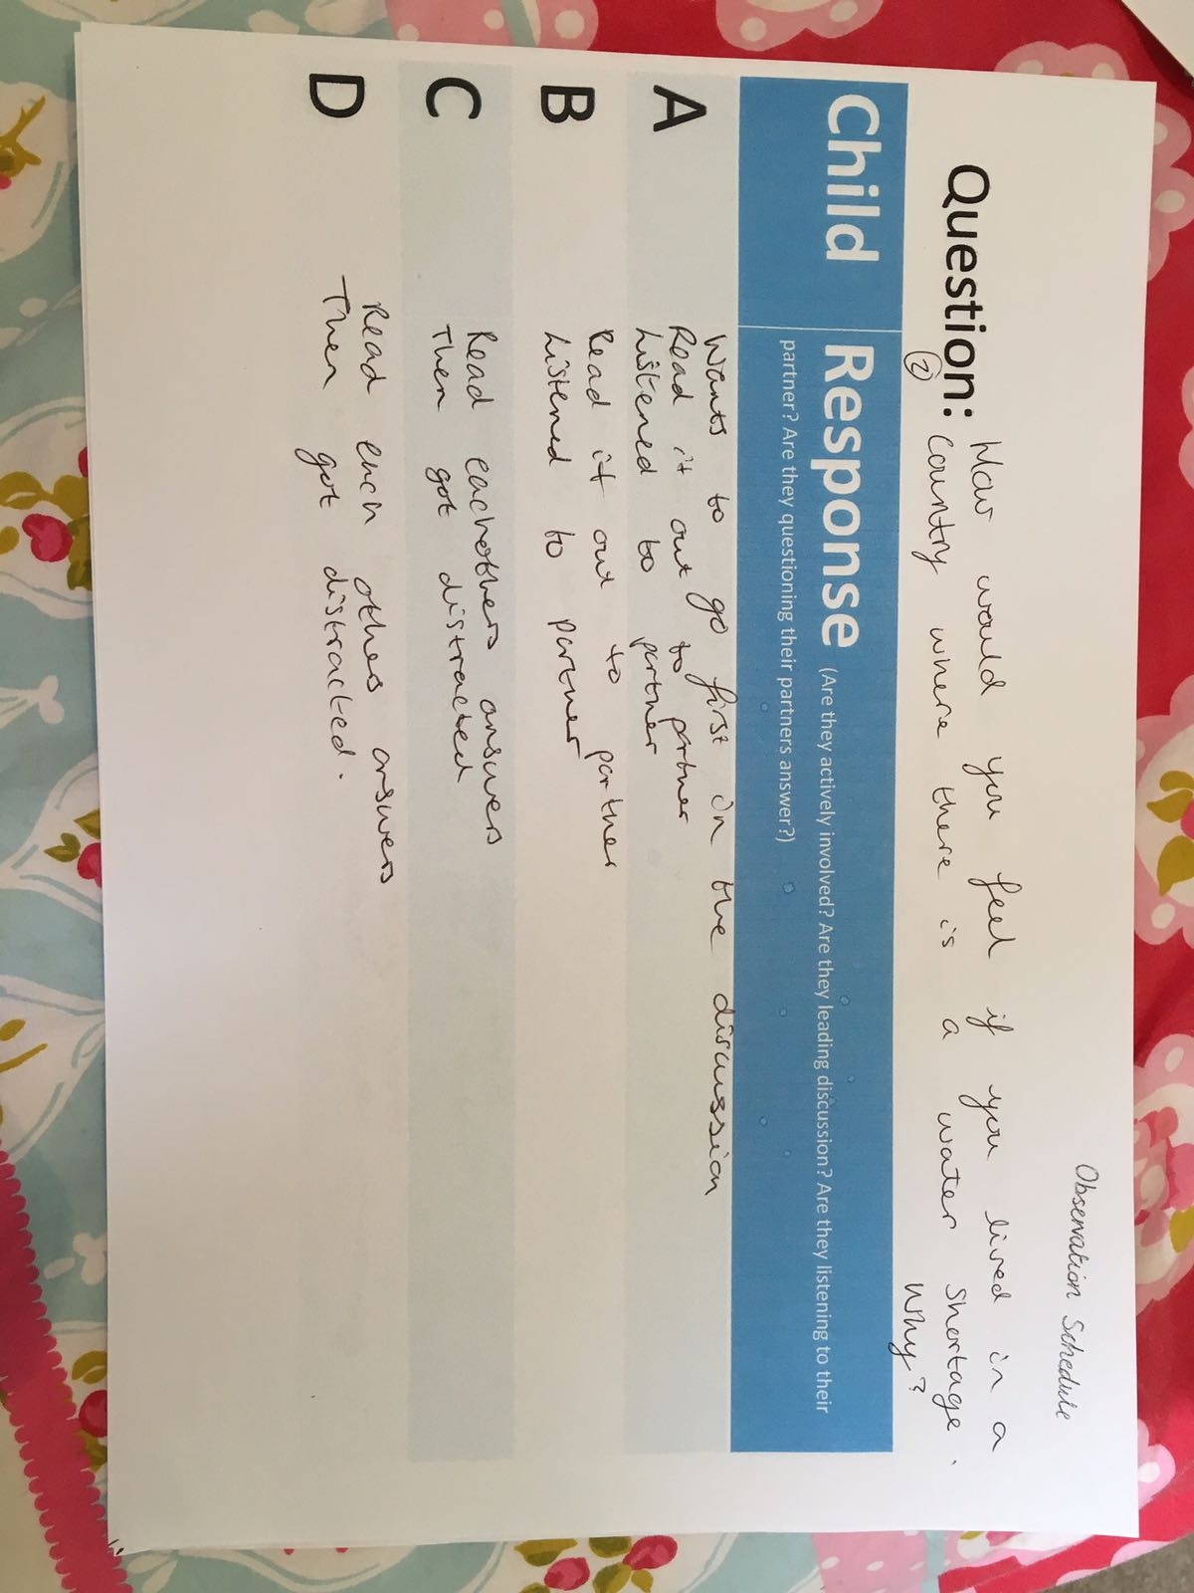

Appendix 8- LS 1, transcript of key point from focus group interview
Lesson study 1
- How do you feel about working in talk partners? Why?
A – Happy but annoyed because it’s difficult when you come to a disagreement. We didn’t come to a conclusion overall because we had different opinions.
B – It was nice to share ideas.
D – I like partner work because I think it improves my work.
C – It can be annoying when you disagree with your partner but it is good for building teamwork skills.

- Do you think using talk partners improves the quality of your answers? Why?
C – Yes it definitely improves your answer because it helps you to add more detail and extend.
B – Yes because it can help you to improve vocabulary for example you may use an adjective and your talk partner may know a better one.
A – I think sometimes talk partners can improve your answer but it depends who your partner is. Today I don’t think it improved my answer much. I was worried my partner was copying me and I think my partners answer improved more than mine.
D – It depends on who your partner is. If you both give equal suggestions I think it can but sometimes your partner may not have much to suggest.

- Do you think your discussions were equal?
B – I don’t think it matters how long you speak for really. I would have liked some more time to share my idea with my partner.
D – I would say we both spoke equally.
A – I think I spoke more than my partner.

- What else do you think we could do to improve the quality of your answers?
B – I think you could give us some sentence starters on the board because sometimes I struggle to think of how to start.
D – I think if you gave us some more time to discuss I would improve my answer.
A – I liked the photo that you used in the PowerPoint but maybe you could show us some more photos of Brenda or a video to help us with our answers.
C – I would like key words around the classroom to help focus my answer so that I know I am writing about the right thing.

- If we were to teach the lesson again, what do you think we should keep the same or change?
D – I think this could be taught over a longer time because I was really enjoying the lesson and wanted to learn more.
B – Definitely keep the talk partners.
A – I think you should keep the talk partners but maybe extend it so there are four people working in a group. I would give children more time to discuss because sometimes we ran out of time. Maybe every group could have an object to pass around and unless you have the object you can’t speak. You could time it so that we know when to pass on the object so that everyone speaks for equal time.
B – I agree I think we could have improved our answers more if we had longer to discuss.
C- I like the idea of using an object to pass around to make sure each person speaks for equal time.

Appendix 9- LS2, question 1 observation schedule

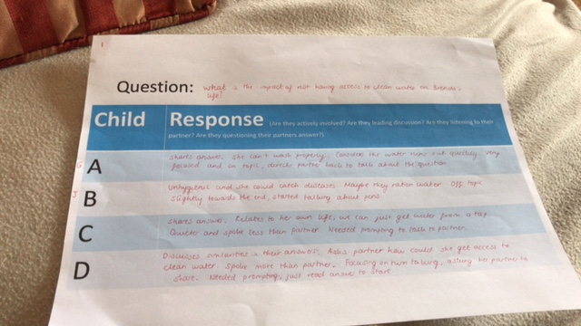
Appendix 10- LS2, question 1 responses
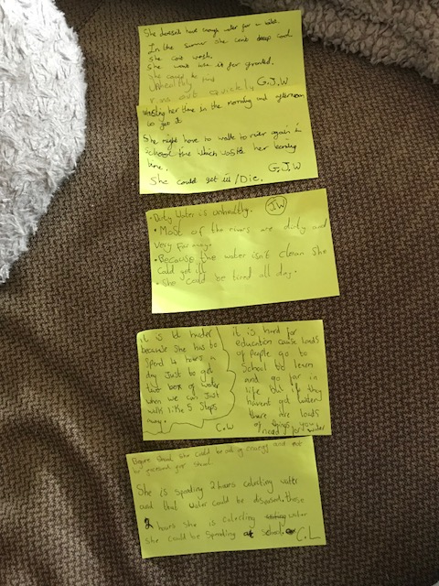
Child 2A

Child 2D
Child 2C
Child 2B

Appendix 11- Further responses of Child 2C
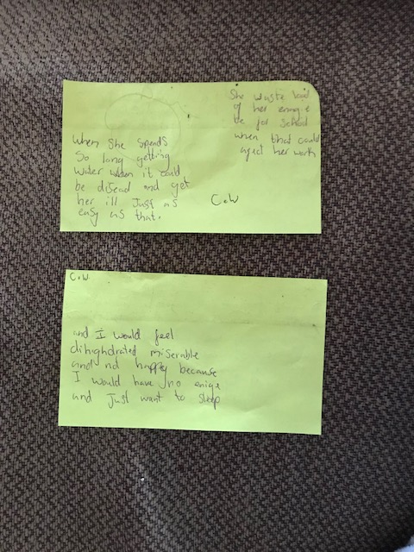
Question 2
response
Question 1
response

Appendix 12- LS2, question 2 responses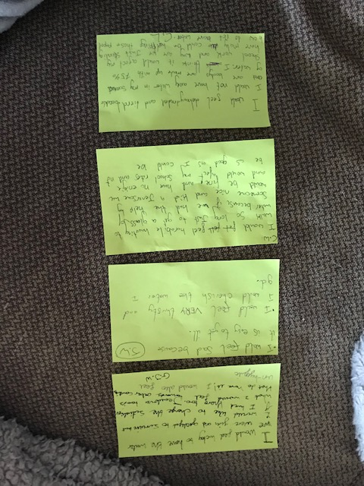

Child 2D
Child 2C
Child 2B
Child 2A

Appendix 13- LS2, question 2 observation schedule
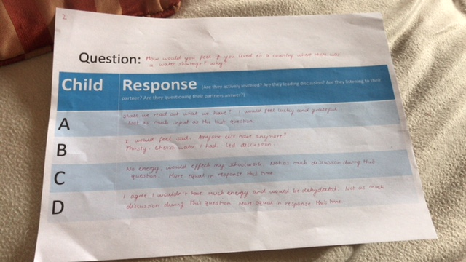

Appendix 14- LS2, transcript of key points of focus group interview
- How do you feel about working in talk partners? Why?
Child D- I feel more comfortable because I can share my ideas with my partner and if I don’t know the answer they can help me.
Child B- It’s good because you can get more than just your point of view.
Child A- You can get more detail because you can share ideas.

- Do you think using talk partners improves the quality of your answers? Why?
- Yes, because you can into more detail, so you can learn more. It helps you understand more as well.
- The other person will know something you don’t know.
D- You can learn and develop from each other.

- Do you think your discussions were equal?
D- I think it depends how much you understand the question and who knows more.
B- I think ours was equal.
- I don’t think it matter if it’s equal. People can help you understand it. You don’t have to feel embarrassed if you don’t know the answer.
- If you start talking about it, you understand more.

- What else do you think we could do to improve the quality of your answers?
D- I think a video of what actually happens and not just pictures.
- Yeah, you don’t know what’s happening if you only see a picture. And give more information about the question after we’ve answered the question.
D- Maybe talk about it again during guided reading so we can understand it more.
C- If you don’t understand it, you could talk with a teacher to help you understand it.

- If we were to teach the lesson again, what do you think we should keep the same or change?
- I think keep the talk partners the same.
- Keep the mind maps the same.
- With the mind maps, work in smaller groups because sometimes not everyone is heard.
- Work in groups as well as partners and I like to have a quiz at the end.
Appendix 15- Parental consent

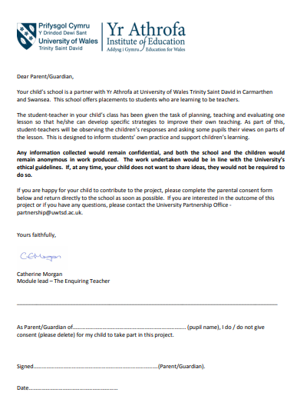
Appendix 16- Children assent
Assent Record
After the lesson, I ______________________ am happy to answer some questions about today’s lesson.
I am aware that I can withdraw at any point and I don’t have to participate if I don’t want to.

Please tick the following box and write your full name if you give assent to take part.

Signed:

Appendix 17- LS2 ARC

Assisted Reflective Conclusions (ARC) Model
Dyddiad/Date: 28/03/18
Digwyddiad critigol (Ffocws)/Critical incident (focus): Does the use of talk partners improve the quality of response to higher-order questions in a KS2 classroom?

Profiad/ Experience

Teimladau/  Feelings  Beth yw eich teimladau ynghylch y profiad?  “What are your feelings regarding the experience?” | I feel the lesson went well overall. Children enjoyed discussing the uses of water in their own lives and in the lives of others in countries that do not have access to clean water.
Cofio a Deall/  Remember and Understand  “Can you list the aspects of the talk partner discussions that went well?”  “What were the elements of the talk partner discussions that were disappointing?” | The children produced interesting points of views to the questions we asked.  The children seemed engaged with the lesson and discussions.  Some children needed encouragement to use the talk partners, especially in the first higher-order question.
Gwerthuso a dadansoddi/  Evaluate and analyse  “What will you keep the same to ensure effective teaching and learning in the future?”  “What was the cause of the most important disappointing element?” | In future lessons, I will plan in a significant amount of time for talk partners as it seems to engage the children and children were responding with some interesting answers.  Also, the focus group interview children said that they enjoyed the use of talk partners.  I will also plan the higher-order questions I wish to ask beforehand.  I did not make it clear to the children that they must first of all answer individually and then secondly, they must discuss with a partner.  When I explained this explicitly for the second question, the children needed less reminding to discuss with a partner.
Casgliadau a chamau gweithredu/  Conclusions and actions  “What are your possible solutions to the disappointing issues identified?”  “What will you do next?” | I needed to explain the talk partner process clearly from the beginning so that children knew exactly what they needed to do and why.  As children benefit from using talk partners, I will explain this to my class and encourage this.  I will plan talk partner opportunities in to my lessons carefully and not use in in the spontaneous manner I had been previously.
Y profiad newydd / Transformed experience

