- DFD 0
This is 0 level diagram 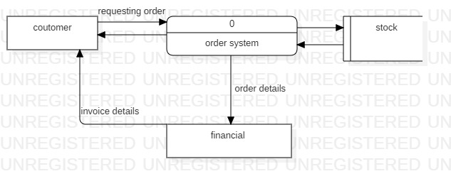
- DFD 1
Level 1 diagram
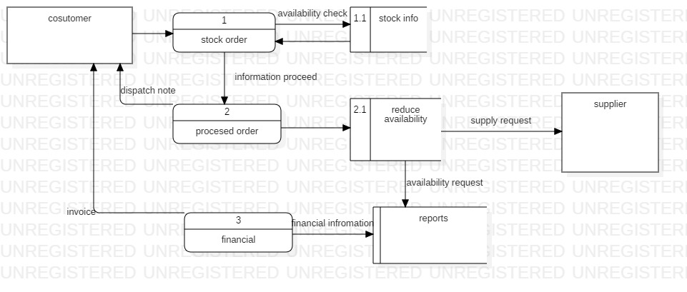
- ERD
Show connections between different components.

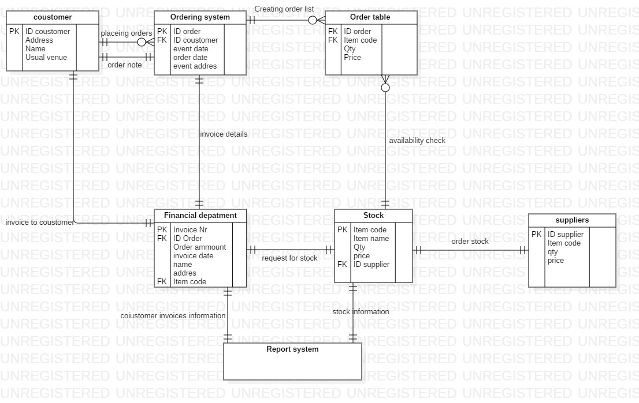

- UCD
Displaying the relation between the users and the rights which they will have in the system 

