
Sports Industry Research Project
Literature Review

Student Name
Rory Thomas

Project Title
Primary school teachers perceived challenges in delivering the ‘Health and Wellbeing’ strand – Wales New Curriculum

Contents Page (use relevant number of pages)
Contents Page
- Aims and Objectives………………………………………………

- Introduction…………………………………………………………

- Primary Physical Education, Coaches and Continuing Professional Development (2011) ………………………………………………….
  - Methods
  - Results

- A Professional Development Programme to Enhance Primary School Teachers Knowledge and Operationalization of Physical Literacy…………
  - Methods
  - Results

- Pre-Service Primary School Teachers Experiences on Physical Education……………………...
  - Methods
  - Results

- Understanding Primary Schools Teachers Perceptions and Ideologies Around the Value of Physical Education…………………………………
  - Methods
  - Results

- The Effects of a Professional Development Programme on Primary School Teachers Perceptions of Physical Education……………………...
  - Methods
  - Results

- The Effect of Non-Specialist Physical Education Primary School Teachers Experiences of Physical Education
  - Methods
  - Results

1.0 Aim and Objectives
Aim
Identify the perceived challenges of primary school teachers in delivering the 'Health and wellbeing’ strand and provide recommendations for education departments.
Objectives
Identify perceived challenges of primary school teachers. I will look at the challenge’s classroom teachers are up against regarding physical education lessons.
I will then look to interpret and categorise the perceived challenges so we know what we can do and how we can overcome them challenges.
Also look to provide recommendations on educational departments and in schools. Once we know the challenges and have categorised them then we can start to look how we can sort them out and put it some recommendations in place.

Literature Review (use relevant number of pages)
2.0 Introduction
Is it important for me to find out reasons about my question is because with the new health and wellbeing curriculum that is out some teachers may not have the knowledge to follow it or deliver the lessons. Some teachers may not feel confident about the whole curriculum which can result in them not delivering or taking much interest in it which will then leave pupils not gaining enough or the correct experience from the lessons. Teachers will then need to fully understand why it is important for themselves and also the pupils as it would give them both a great understanding on what needs to be taught and then what can be learnt from it.

Literature Review
3.0 Primary Physical Education, Coaches and Continuing Professional Development (2011)
Primary school physical education (PE) in England has traditionally been taught mostly by generalist class teachers (Garrett & Wrench, 2007), with a small percentage taught by specialist primary PE teachers.
Physical education in primary schools are taking place but not correctly, the reason being is because most of the PE lessons are taken by teachers who don’t have enough knowledge and how to deliver a PE lesson, but in some primary schools you will have teachers who are specialised in that area of subject and are able to deliver a lesson properly.
Qualified primary teachers have spent at least four years in higher education, with at least one of those years learning to teach across the full range of curriculum subjects taught in primary schools, including PE. However, more recently, some PE in primary schools has been taught by people other than the class teacher; in particular coaches (particularly football coaches; SportscoachUK, 2004, 2007a).
If primary schools are going to employ sports coaches to cover PE lessons and allow teachers to take PPA time, it is essential that they have the knowledge, skill, understanding and expertise to carry out specified work. However, coaches who have learnt to coach through NGB awards, and through their own experiences, may not have the background, experience, knowledge, understanding or skill to carry out specified work within the National Curriculum for Physical Education (NCPE).
3.1 Methods
The sample for this study was 21 Football in the Community Coaches, Schools will employ coaches who will then work predominately with 5 -11-year-old children, in both school and community settings. Coaches will be employed by the Community Sport Trust (a community department of a professional football club that has charitable status) of one English Premier League) club during the 2007 calendar year. Part of the work of these coaches involved undertaking specified work in PE lessons to cover primary teachers’ PPA time.
3.2 Results
Results collected in January 2007 (Blair & Capel, 2007) showed that this group of coaches did not plan for the short and medium term as a matter of course and did not value or understand the importance of planning. As a result of participating in this CPD programme, results showed these coaches increased their awareness of the importance of the planning process in both short term and medium terms.
“Starting the lesson with something short and interesting will help settle the students and engage them with the lesson.” (S.Umair’s, 2015)

Literature Review
4.0 A Professional Development Program to Enhance Primary School Teachers Knowledge and Operationalization of Physical Literacy
The purpose of this study was to devise, implement, and evaluate a professional development program that works in a primary school environment to enhance their knowledge and operationalization of physical literacy. Despite the increase of research and implementation, the physical literacy continues to be largely misinterpreted by practitioners.
Despite the increased interest and attention around the concept of physical literacy on a global and political level (Dudley, Cairney, Wainwright, Kriellaars, & Mitchell, 2017), it continues to be largely misinterpreted by practitioners, including school teachers (Edwards, Bryant, & Jones, 2015).
Although physical literacy is relevant throughout the life course, currently, school66 based physical education (PE) lessons have been recognised as the most common environment in which children and adolescents can develop their physical literacy (Edwards et al., 2018).
4.1 Methods
Following institutional level research ethics committee approval, a purposive sampling procedure was employed to select the schools for this study (Patton, 2002). Specifically, Welsh-medium schools were selected because it was a key requirement of the funding body, the Coleg Cymraeg Cenedlaethol. Written informed consent from two head teachers and three primary school teachers was collected to allow participation in the study.
Further, year six (fifth grade) pupils in their final year of primary school (aged 10-11) who received two one-hour PE lessons per week, were the key focus of this study, given that physical literacy should be nurtured in primary before transitioning to secondary school (Zeedyk et al., 2003).
4.2 Results
Pupils are able to use correct language to describe what they do and what effect it has on the body. In contrast to physical literacy, literacy in PE refers to developing the skills of speaking, listening, reading, and writing in PE lessons (Department for Education and Skills, 2002).
The collaborative discussions developed an awareness of teachers’ responsibility in ensuring positive outcomes to pupils’ health in later life from quality PE provision was prominent.

Literature Review
5.0 Pre – service primary school teachers experiences of physical education
Schools play an important role in supporting children to develop the knowledge and skills to lead physically active lifestyles,4 and key to this is the delivery of high-quality physical education. Many schools did not have a PE policy, plan or program and many had highly sedentary PE lessons that did not sufficiently focus on fundamental movement skill development. Research suggests that schools often face a number of barriers in the provision of quality PE lessons. These include a lack of staff time due to a crowded curriculum, a lack of teacher expertise and confidence, and school prioritisation of other learning areas.
5.1 Methods
To work with universities to enhance the PE skills of graduate primary school teachers. Critical to enhancing the skills of graduate primary teachers, however, are opportunities to observe, practice and receive feedback regarding the teaching of PE to children as part of their university in-school teaching practicum.
Preservice primary school teachers may be required to undertake a final year practicum teaching experience within schools of 20-50 days. In October 2010, we conducted a paper survey with pre-service primary school teachers from one university in NSW, who were in week nine of their final 10-week teaching practicum, to identify the nature of PE teaching experiences while on practicum.
5.2 Results
More than half (59%) of the pre-service teachers had been provided the opportunity to teach PE one day per week or less. Of these, 21% did not teach a PE lesson during their nine weeks in the school. Many had observed their colleague teachers discipline students by excluding them from PE (48%), use PE as punishment (63%) or cancel a PE program because of other events in the school or because of poor weather (58%).
Opportunities to teach PE during practicum are critical to ensure the appropriate development of pre-service teacher skills. However, they may then be undermined once students are employed in schools which do not have a culture which values and practises quality teaching of PE.

6.0 Understanding primary schools teachers perceptions and ideologies around the value of physical education
It is suggested that non-specialist teachers are under qualified and they also lack knowledge when it comes to teaching the physical education. It is very important that primary school teachers understand the perceptions and ideologies and making sure that they also have the proper understanding of physical education.
Primary school teachers fail to acknowledge the importance of PE in comparison to other subjects such as Maths and English, which are viewed as the more ‘academic’ subjects (Barney and Deutsch 2009).
The National Curriculum for Physical Education (NCPE) in Wales aims to ensure that all pupils are able to develop competence in order to excel in a variety of physical activities, to ensure they become physically active for sustained periods of time through engagement in a range of activities and competitive sports, whilst also leading active and healthy lives for the pupils.
6.1 Methods
Semi-structured interviews will be thoroughly planned and conducted professionally, with appropriate questions in order to ensure that the process was efficient and effective. Sparkes and Smith (2014) suggest that one main strength of semi-structured interviews is that the flexibility in which participants can respond to questions being asked, which then enables participants to express their ideas and thoughts with potentially more meaning.
This method is enabled for a subjective and in-depth understanding of individual teachers’ perceptions of high-quality physical education to potentially be gained and understood better.
6.2 Results
Through the identification of key themes, patterns and trends in responses from participants, whilst comparing and analysing these alongside pre-existing literature and theories to develop an understanding of the creation of the teaching identity, and also how their previous experiences help to shape their dispositions towards PE (Sparkes and Smith 2014).
The analysis of the data indicated that previous experiences within PE or early sporting experiences allowed for the construction of teaching dispositions of perceived goods practice of physical education and also ideologies of how to implement these dispositions of perceived good practice in order to deliver quality physical education lessons.
The lack of in-depth understanding of teaching perceptions and ideologies of primary school physical education teachers, and their influence on delivering structured PE lessons.

7.0 The effects of a professional development programme on primary school teachers perceptions of physical education

During the growth of primary school teachers far too many of them have received nothing more than an introduction to physical activity which has then resulted in them having limited knowledge and also can lack confidence in the subject.

In some primary schools there doesn’t seem to be enough teachers who are educated in physical education and this causes problems and impacts the pupils ability to learn in that area. With there not being any specialised teachers in PE then PE lessons are then taken by classroom-based teachers, this is a problem because some primary school teachers do not understand how to deliver a well-structured PE lesson which would help the children benefit.

Primary school teachers tend to hold a negative attitude towards PE as compared to the core subjects such as Maths, English and Science as they have more knowledge of these subjects.

7.1 Methods

Primary PE in England emerged in 2005 where primary school teachers had become entitled to be released from 10% of their timetabled lessons so they can plan, prep and do assessments (Workforce Agreement Monitoring Group 2003). This then opened up the opportunities for external groups (coaches) to come into school and deliver the curriculum PE and also leads to calls for a high quality assurance procedures to make sure that groups have had the correct and professional competence to target pupils learning and raise attainment (Sport England 2005).

An increasing number of Headteachers are making indiscriminate use of the coaches to deliver physical education and also school sports. With this happening it is threatening the high-quality provision in primary schools.

7.2 Results

Primary school teachers expressed negative perceptions and anxieties about teaching PE, they lacked confidence in teaching many PE subjects like Gymnastics. Research shows that 82% of primary school teachers did not hold a PE or sports science degree.

The failure of primary PE-ITT has been a long-standing concern in England (Physical Education Association of the United Kingdom 1998, 2000, CCPR 2004) and has been raised as an important issue by the government’s own problems for schools (Ofsted 2000,2009).

Literature Review
- The effect of non-specialist physical education primary school teachers experiences of physical education
Physical education is currently in a state of neglect in primary schools and is one of the many reasons for this being, the lack of input from teacher training courses to have an effect on teachers’ confidence, knowledge and understanding needed to teach PE.
The concept of PE presents opportunities whereby children can make substantial development (Murdoch & Whitehead, 2013) which are focused upon four broad domains: physical, social, affective and cognitive, all of which aim to promote lifelong physical activity (PA) (Pickup & Price, 2007: Bailey et al., 2009).
Qualified PE specialists are more likely to teach higher quality lessons whereas the classroom teacher would not (Fletcher&Mandigo, 2012). One of many different reasons why qualified PE teachers would benefit more compared to classroom teachers is because they are going to feel more confident when preparing and delivering a lesson and will also find it very enjoyable.
As primary PE is very important in schools and also for pupils development debates arose as to whether non-specialist classroom teachers, who currently take a greater percentage of primary PE (Graber et al., 2008) are best suited to teach primary PE in comparison to a specialist PE teacher (Fletcher & Mandigo, 2012).
8.1 Methods
There are multiple methods to help collect the data to help understand why. Semi-structured interviews will be used as they are beneficial as it lets specific questions to be answered using a progressive structure to maintain focus (Patton, 2002, Walliman, 2011).
However, allowing this type of structure is better because it gives the participants a chance to elaborate on their answers and go into depth on the points they have made (Gratton&Jones, 2004; Walliman, 2011).
Another method that can be used to see if a classroom or qualified PE teacher lessons are better is to get them both to deliver a lesson and then at the end see which one had a better outcome. Also asking the pupils and some teachers to see if they think bringing a qualified PE teacher in would be more beneficial and would see greater results for PE in primary schools.
8.2 Results
Results have shown that primary schools still need to play a huge part to help primary school teachers learn more about physical education. Also, primary schools would benefit more if they employed primary teachers who are specialised in physical education as it will help the pupils increase their knowledge on PE and with having structured PE lessons within schools then pupils gain more. It also is better having a PE teacher and not a classroom-based teacher as there is a different attitude between them both and most classroom teachers would probably gain more out of not having to deliver a PE lesson.

Literature Review

Literature Conclusion

Reference List (use relevant number of pages)
References
Nexus.uwinnipeg.ca. (2015). Importance of Good Lesson Plan - University of Winnipeg. [online] Available at: https://nexus.uwinnipeg.ca/d2l/lms/blog/view_userentry.d2l?ou=6606&ownerId=12756&entryId=1725&ec=1&iu=1&sp=&gb=usr [Accessed 10 Dec. 2019].
Edwards, L., Bryant, A., Morgan, K., Cooper, S., Jones, A. and Keegan, R. (2019). A Professional Development Program to Enhance Primary School Teachers’ Knowledge and Operationalization of Physical Literacy
Nathan, N., Wolfenden, L. and Morgan, P. (2013). Pre-service primary school teachers' experiences of physical education. Australian and New Zealand Journal of Public Health, 37(3), pp.294-294.
Morgan, D (2015) ‘Understanding Primary School Teachers Perceptions and Ideologies Around The Value Of Physical Education
Harris, J., Cale, L. and Musson, H. (2010). The effects of a professional development programme on primary school teachers’ perceptions of physical education. Professional Development in Education, 37(2), pp.291-305.
Porter, L. (2015) The Effect of non-specialist physical education primary school teachers experiences of physical education during their school centred initial teacher training course on their confidence, knowledge and ability to teach physical education pp.6-8.
Philip Morgan & Vibeke Hansen (2007) Recommendations to Improve Primary School Physical Education: Classroom Teachers' Perspective, The Journal of Educational Research, 101:2, 99-108, DOI: 10.3200/JOER.101.2.99-112
Byrne, J., Rietdijk, W. and Pickett, K. (2018). Teachers as health promoters: Factors that influence early career teachers to engage with health and wellbeing education. Teaching and Teacher Education, 69, pp.289-299.
Rainer, P., Cropley, B., Jarvis, S. and Griffiths, R. (2012). From policy to practice: the challenges of providing high quality physical education and school sport faced by head teachers within primary schools. Physical Education & Sport Pedagogy, 17(4), pp.429-446.
Terzieva, G. (2019). A CONCEPT FOR INCLUSIVE PHYSICAL EDUCATION TRAINING PROGRAM FOR FUTURE PRE-SCHOOL AND PRIMARY-SCHOOL TEACHERS. Trakia Journal of Sciences, 17(2), pp.97-100.

Reference List

Bibliography (use relevant number of pages)

Appendices (use relevant number of pages)
3.1 Methods
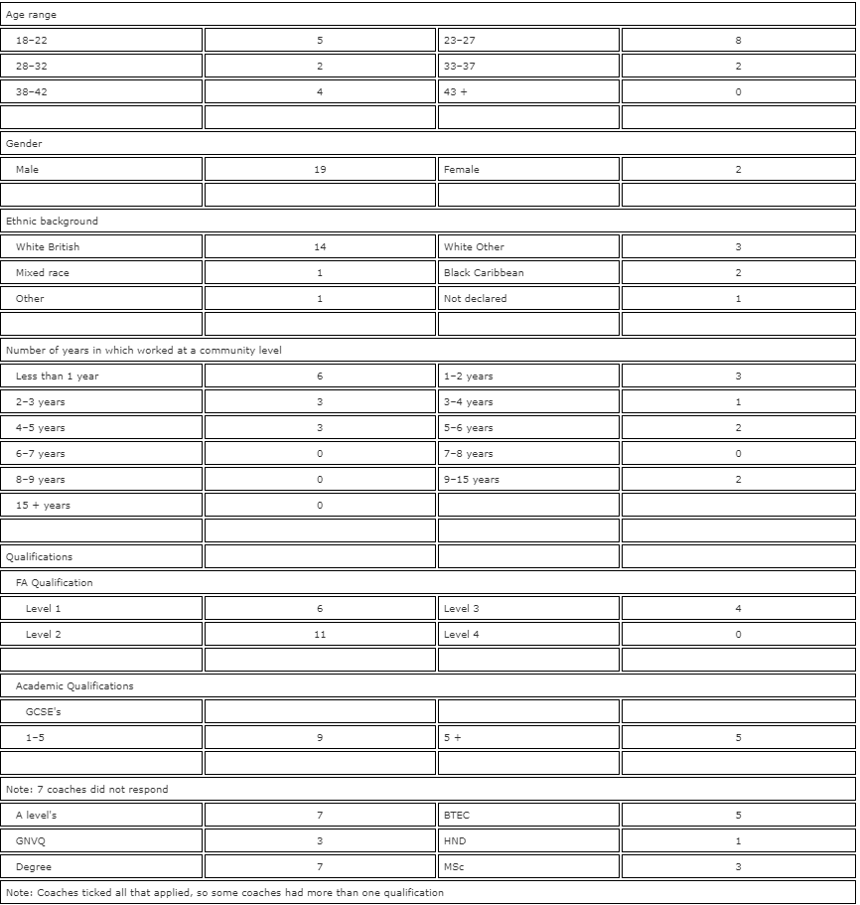



BA Sports Management Portfolio

Literature Review

UWTSDSport

