

Jamie Hodges

Identifying Metal Salts using the Flame Test

UWTSD
OME Level 4

Year 1

UWTSD
OME Level 4

HNC

Academic Year 2023 - 2026

Jamie Hodges

Identifying Metal Salts using the Flame Test

June 2024

This thesis is submitted in partial fulfilment of the requirements for the degree of OME Level 4

© UWTSD 2024. All rights reserved. No part of this publication may be reproduced without the written permission of the copyright owner.

Academic integrity declaration
I declare that:
- the thesis submitted has been written by me alone.
- the thesis submitted has not been previously submitted to this university or any other.
- that all content, including primary and/or secondary data, is true to the best of my knowledge.
- that all quotations and references have been duly acknowledged according to the requirements of academic research.
I understand that to knowingly submit work in violation of the above statement will be considered by examiners as academic misconduct.

Table of Contents
Academic Integrity Declaration…………………………………………………..i
1 Introduction……………………………………………………………………..1
1.1 Aim and Objectives………………………………………………….1
1.2 Hypothesis……………………………………………………………1
2 Results…………………………………………………………………………..3
3 Discussion ……………………………………………………………………...4
4 Conclusion………………………………………………………………………6
5 References……………………………………………………………………...7
6 Appendix………………………………………………………………………...7

Introduction

Aims and Objectives
The aim of this is experiment is to determine which metal salts are in each of the 8 unidentified salt solutions, 7 of which contain a single metal salt and 1 with a mixture of 2 different metal salts. This is done by completing a flame test on each of the solutions and identifying the metal ions via the wavelength of light emitted and comparing it to the table listed. [Figure 1]

Metal Ion | Flame Colour | Metal Ion | Flame Colour
Barium, Ba⁺ | Yellow-Green | Potassium, K⁺ | Lavender
Calcium, Ca²⁺ | Red-Orange | Sodium, Na⁺ | Yellow-Orange
Lithium, Li⁺ | Red-Pink | Copper, Cu²⁺ | Blue-Green
Strontium, Sr²⁺ | Red
Figure 1: Table of metal ions and their corresponding flame colours

Hypothesis
When the metal ions are put into a flame then the colour of the flame will chance according to the specific metal that is present. This is due to the electrons moving to a higher energy level when exposed to heat before returning back to their ground state. In doing so, they release photons of energy which have specific wavelengths depending on the metal ion. These wavelengths correspond to those in the visible light spectrum [Figure 2].
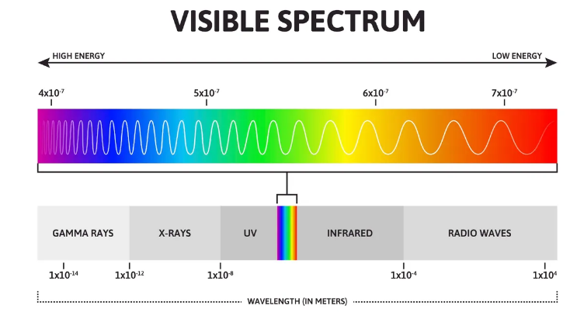
Figure 2: Visible light spectrum and corresponding wavelengths [1]

Results
After conducting the experiment, the student’s results were as in Figure 3
Unknown Metal Salt | Colour of Flame | Identity of Metal | Wavelength (nm)
A | Orange | Na | 615-625
B | Lavender | K | 390-400
C | Red/Orange | Ca | 625-650
D | Red | Sr | 700
E | Green | Cu | 525
F | Pink | Li | 675
G | Green/Yellow | Ba | 575
H | Orange & Purple | Na + K | 625 & 400
Figure 3: Table of results

The student noticed during the experiment that the more reactive elements had more prominent colours whereas the lesser reactive elements had more subtle colourings. Also from the student’s results, the alkali metals decreased in wavelength when going down the group compared to the more random wavelengths found in the alkaline metals.

Discussion
Overall, the student was able to identify the metal salts by the colour of the flame including the sodium and potassium mixture which required the use of cobalt glass to see the colour that was underneath the bright orange emitted from the sodium.
Using the student’s results, the energy released by the photons of specific elements can be calculated in addition to the frequency. There are two formulas used for these calculations which are:
E = hf and E = hc / λ
Where E = energy, h = Plank’s constant, f = frequency, c = speed of light and λ = wavelength
Using the data found for copper and lithium the student calculated both these values as illustrated in Figure 4.
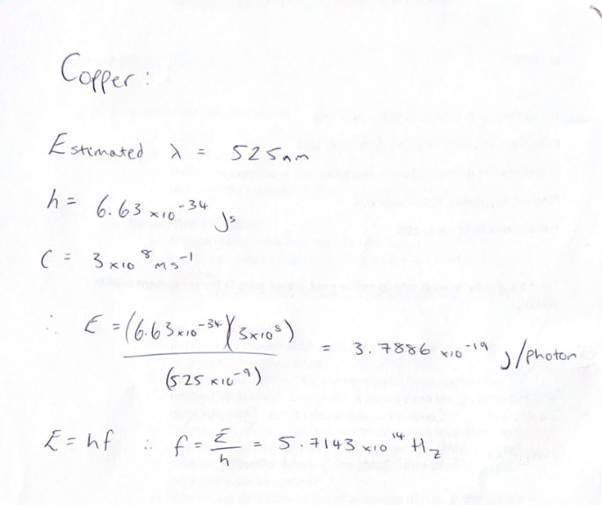
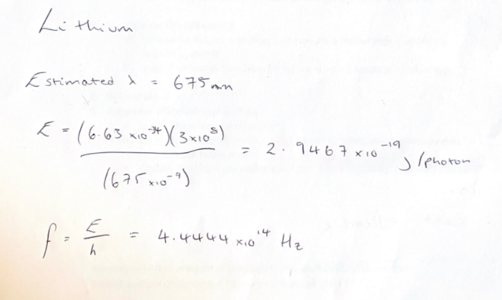

Figure 4: the student’s working out

From these calculations, the student determined that the lower the wavelength of the photons of light, the higher the energy and the frequency is.
The flame test concept is frequently visible in many OME sectors. Most commonly it is used in flares but is also used in tracer rounds. Tracer rounds are small arms ammunition that are filled with a phosphorous alloy as well as propellant so that when fired, in a dark environment, the trajectory can be seen by a streak of red light [2].
During this experiment, the student noticed some limitations and positives of the flame test. Sodium as a compound is very sticky and contaminated the metal rod which made some of the initial results incorrect and required the unknown solutions to be retested. The student also noticed that their lab partner disagreed with some of the colours displayed meaning the colours were subjective depending on who was performing the experiment. However, the student also stated that the experiment was quick and simple, and was a clear display that metal salts do emit different colours when exposed to flames.

Conclusion
Overall, the student decided that this was an effective experiment to prove the hypothesis that metal salts can be identified by the colour emitted when exposed to a flame. In order to make this experiment more effective, it should be undertaken with larger quantities of the metal salts in order to make their colours more prominent and less subjective.

5 References:
[1] J. Lucas, “What is visible light?” May, 2022. [Online]. Available: What is visible light? | Live Science. [Accessed June. 14, 2024].
[2] M. R. Cates, S. M. Goedeke “Preliminary Study of Phosphor-Based Tracer Rounds,” Laboratory Directed Research and Development Program, Mar., pp. 319, 2006.

6 Appendix

6.1 Materials and Equipment
- Bunsen burner
- Heat-resistant mat
- Matches
- Inoculating loop
- 100ml solutions of unknown metal salts labelled A-H
- Beaker with 100ml HCl
- Beaker with 100ml deionised water (DI water)
- Blue cobalt glass

6.2 Procedure
- Setup the Bunsen burner on top of the heat resistant mat and light it with the air flow closed to keep it on safety flame.
- Open the airflow up until a blue ‘roaring’ flame is present with 2 blue cones visible.
- Clean the inoculating loop by dipping it into the HCl and then heating it in the flame (at the tip of the blue cone). Repeat this process until no colour is shown when the loop is in the flame.
- Dip the loop into the DI water to clean off any HCl from the previous step.
- Allow the loop to cool and then dip it into the first unknown metal salt solution. Heat the loop at the tip of the blue cone and record the colour observation. (Cobalt glass should be used for all orange coloured flames to identify the Na + K mixture)
- Repeat steps 3-5 for all the unknown metal salt solutions.

