Conference Research Paper

Assignment One
Module Code: BMIH6001
Student Name: Rezwana Laboni
Student ID: 2242894
Lecturer:Dr Ernest Balutie Wavei
Word Count: 2663

I confirm that I have not used any AI tools in the research and creation of this assignment. I confirm that I have not presented any AI generated materials as my own work. I confirm I have copies of my drafts, notes, and other resources I used, which I may be asked to provide in evidence.
Contents
Abstract 6
Introduction 7
1.1 Topical theme: the sustainability of food waste and hospitality 7
1.2 Genericity to the hotel industry, and response to technology 7
Literature Review 8
2.1 Hospitality wastes of food 8
2.2 Garbage surveillance with the help of AI 8
2.3 The issues of economic performance and costs 9
2.4 Organisational and behavioural results 9
2.5 Missing links, substance of missing links, recent literature 9
Method 11
3.1 Research Design 11
3.2 Data Sources 11
3.3 Analytical Approach 11
Theme Impact Analysis 13
4.1 Introduction: The contextual analysis will be performed using PESTLE 13
4.2 Economic analysis of AI systems for food-waste monitoring 13
4.3 Practicability and industry response 14
4.4 Criticality of impact evaluation 14
4.5 Stakeholder implications 16
4.6 Overall assessment 17
Conclusion 18
Recommendations 19
References 21

Figures
Figure 1: Orbisk Machine
Figure 2: Leanpath Machine 6
Figure 3: Research Design and Analytical Approach 9
Figure 4: Cost-Benefit Analysis Steps 11
Figure 5: Strengths and Weakness Analysis 13

Food waste minimisation and its cost-sustainability trade-off based on AI in hotels

Abstract
The problem of food waste is a sustainability and business issue of the hotel and hospitality industry, which has not been newly developed with the emergence of the service model in the hotel industry that has focused on abundance, unpredictability of demand and severe Food safety circumstances. With the increasing regulatory pressure, net-zero commitments and changing consumer demands, most hotels have resorted to using artificial intelligence (AI)-based food-waste-monitoring tools to enhance the visibility of waste and ways to manage it. The study design used in the research is secondary research, as it reviews the existing body of scholarship and the industry reports to outline the effectiveness of such technologies in the environment and economy. The paper will apply the thematic analysis with the help of Cost-Benefit and PESTLE frameworks to analyse the cost-effectiveness of financial viability, organisational impacts, and trends of adopting the sector. The results have shown that AI systems have large potentials of decreasing food waste and improving sustainability reports, but lack affordability and labour issues restrict them to small and independent hotels. The conclusion offered in this paper is the need to support technology-driven premium waste mitigation, which will need policy intervention and coherent management strategies to establish holistic and sustainable sustainability of the industry in the long term.

Introduction

1.1 Topical theme: the sustainability of food waste and hospitality
Food waste is now turning out to be one of the main international hotel and hospitality business sustainability issues. The buffets, fluctuating demand patterns, menu differentiation, and strict food safety are service designs which arrange proposals to overproduction, and the waste has become a natural manifestation of activities, and it is not an exception. Consequently, hotels have a huge amount of food waste per guest compared to any other service industry, which enhances the impact of environmental footprint and resource wastefulness.

1.2 Genericity to the hotel industry, and response to technology
The nature of the upgrading regulatory pressures, net-zero requirement, and the increased consumer demands have reduced the food-waste minimisation practices from a voluntary ethical issue to a business strategic issue. The second one, in its turn, several hotels are incorporating food-waste monitoring devices that presuppose artificial intelligence as their basis and can rely on smart scales and computer vision to monitor real-time disposal. Although the technologies can be said to have benefits of incremental reduction of waste, as well as improved sustainability reporting, the cost of implementation and operation is still prohibitive, therefore, making the affordability of the technologies and sustainability profitability in the long-term impossible, especially in small and independent properties.

Literature Review

2.1 Hospitality wastes of food
Food waste is another sustainability and operational issue that has continued to affect the hospitality industry. In contrast to other service industries, hotels should ensure that food is present, which in turn ensures the quality of services, specifically buffet and all-inclusive services, which results in systematic overproduction (Batabyal and Das, 2019). The unnecessary cost of disposal and unnecessary carbon emissions comes from the fact that 20 to 40 per cent of the food that is prepared in hotels goes into waste, as the articles of the International Journal of Hospitality Management suggest (Cejas, 2025). Food and Agriculture Organisation (FAO, 2022) also categorises the food waste in hospitals as one of the largest sources of methane emissions in the world via landfills.
Industry stress and sustainability concepts.
The recent studies in the field of hotel and hospitality sustainability are already considered through the lens of the Triple Bottom Line and ESG (Environmental, Social and Governance) construct delimited by the notion of the combination of environmental responsibility with the long-term economic prosperity (Clark et al., 2025). In Europe and Asia, the regulatory procedures are already demanding the publication of books and minimisation courses of food waste offered by large hospitality corporations, and consumer surveys always reveal that environmental responsibility can affect the choice of a hotel by younger or business travellers (Cooper and Hall, 2023). As a result, there is no longer a miracle of an ethical nature to reduce food waste and convert it into a strategic and reputational need.

2.2 Garbage surveillance with the help of AI
New technologies also unveiled AI-based food-waste management machines like Winnow, Leanpath or Orbisk, which are intelligent scales with picture recognition capabilities and recognizes the type of food, the amount of it, as well as the reason why it was discarded. The systems enable managers to identify the inefficiencies in the procurement, portioning, and menu design with some level of precision that would not be possible with the help of manual audits (Leanpath, 2018). The empirical literature also states that an average of 30-50 per cent of waste is cut in the first year of implementation on medium and large hotel and resort properties (Orbisk, 2024).
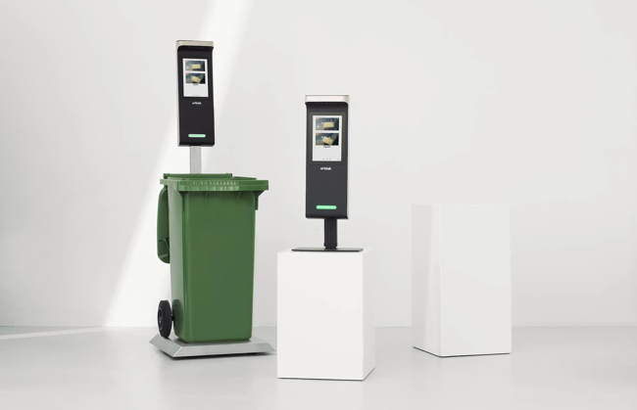
Figure 1: Orbisk Machine Figure 2: Leanpath Machine
Source: (Orbisk, 2024) Source: (Leanpath, 2018)

2.3 The issues of economic performance and costs
The economic benefits of AI introduction are questionable, but the consequences of such introduction are expected to be positive for the environment. The initial installations, subscriptions and employee training and system integration may cost more than PS 10,000 annually per property and can be a major obstacle to small and medium hotels (Darcy, S. Ambrose and J. Bulhalis, 2012). According to the Resource-Based View theory, it can be the strategic resources since such technologies allow it to achieve high operational efficiency and cost leadership (Dheeraj Vaidya, 2018). It is, however, warned by a number of studies that ROI is very much reliant on the amount of food, occupancy and dedication by managers. Boutique and seasonal hotels will tend to fail in amassing sufficient savings to offset the start-up costs.

2.4 Organisational and behavioural results
Outside the economic loop, AI surveillance systems reach the sphere of relations at the workplace. In the case of sociological investigation, the continuity of digital surveillance is experienced by the kitchen staff members in the form of spying, which triggers opposition and demotivation towards the implementation that lacks participatory managerial practices (Graber, 2023). In contrast, behavioural study proposes that the pro-environmental practices and operational responsibility may be facilitated by the systems which are organised as learning systems and not as a control system (Graber, 2023).

2.5 Missing links, substance of missing links, recent literature
The literature that prevails is still dominated by case studies of the multinational hotel chains in the developed economies, and this restricts the generalisation of the small operators and the new markets (Grindle, 2019). Moreover, the review that was conducted with the aid of the vendor can also be biased in terms of reporting the financial benefits and excluding the invisible organisational costs. Also, there are not many longitudinal studies carried out to determine whether the waste reductions can be maintained at the stages following the initial stages of implementation. With these loopholes, it is an indicator that there ought to be a reasonable compromise between addressing the performance of long-term economic viability and sustainability (Wafi and Tumiran, 2024).

Method

3.1 Research Design
The research design proposed is a secondary-research, which will be anchored on a systematic review and synthesis of the available academic and industry literature.

3.2 Data Sources
Data was collected in the period between 2019 and 2025 using the peer-reviewed journals (International Journal of Hospitality Management, Tourism Management, Journal of Sustainable Tourism and Sustainability, as well as the reports prepared by recognised organisations (WRAP, UNEP and large hotel chains)) and reports. The keywords to find the source of interest were food waste, artificial intelligence, hospitality sustainability, and hotel operations.

3.3 Analytical Approach
Thematic coding was applied in the analysis as a method of identifying common economic, environmental, organisational and technological impacts associated with the monitoring of AI-based food-waste systems (Vânia Gonçalves Costa and Costa, 2022). To approximate the financial and operational trade-offs, the Cost-Benefit Analysis (CBA) framework was applied, and the PESTLE analysis supported it in order to contextualise political, economic, social, technological, legal, and environmental aspects (Dheeraj Vaidya, 2018). The combination of such an analysis provides the ability to conduct a systematic appraisal of the performance in terms of sustainability and critically assess the long-term business sustainability of the different types of hotels.
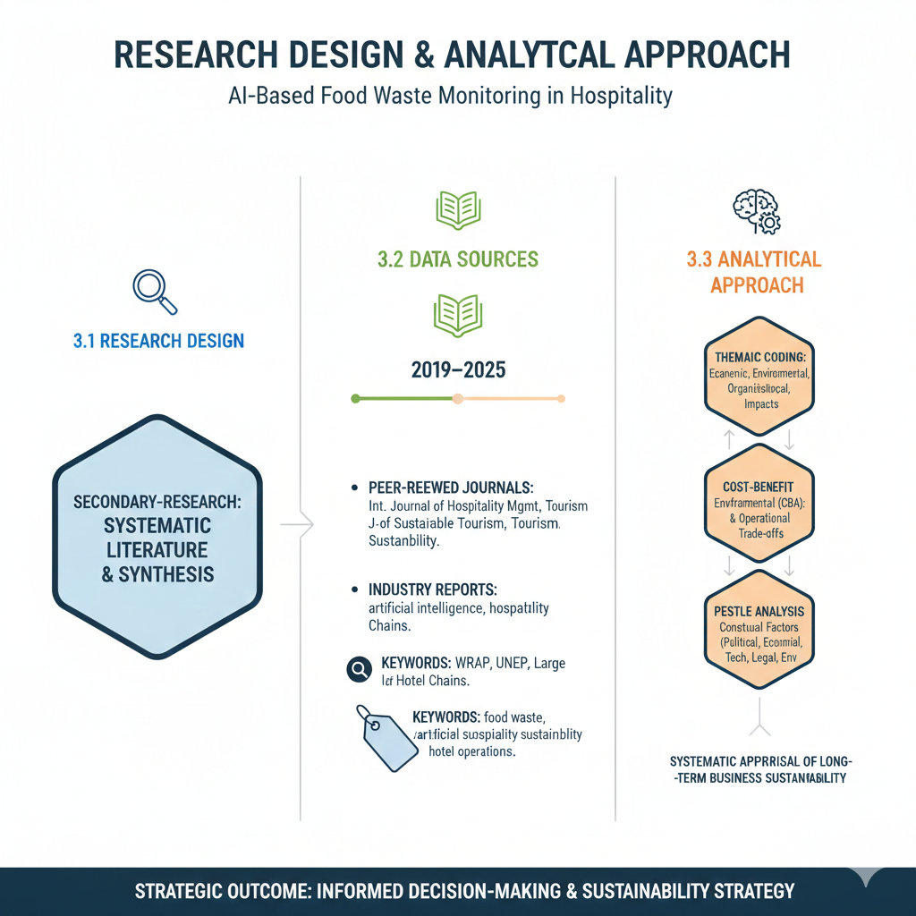
Figure 3: Research Design and Analytical Approach
Source: Author’s creation

Theme Impact Analysis

4.1 Introduction: The contextual analysis will be performed using PESTLE
The use of AI-enabled food-waste tracking systems in hotels is subject to different external forces. Governments are enforcing technology-based compliance by pushing governments to report on waste and institute policies like carbon reduction, which are compulsory both politically and legally (Gromboni et al., 2021). Privately, the hotels are reporting a rise in food expenses, labour costs and inflation pressures, which are further placing pressure on the performance of the operations and capital investment prospects. At the social level, the guests are becoming more sensitive and identify environmental wastefulness with poor corporate ethics. The digital skills gaps in the hospitality workforce exist as the system is now less complex as a result of computer vision innovations and cloud analytics (Hospitality Lexis, 2024). Food waste is also regarded as a significant source of methane emissions, which is ecologically significant, which increases the strategic value of waste-reduction technologies.

4.2 Economic analysis of AI systems for food-waste monitoring
A Cost-Benefit Analysis framework is applied in such a way that it carries out a systematic analysis of the influence of the industry.
Operation and financial costs
The implementation cost of AI in the monitoring systems of the hotels is both costly, indirectly and directly. These include hardware implementation (smart scales and cameras), software subscriptions, integration of the system to procurement systems, training employees and the disruption of the workflow implementation (Socaci et al., 2020). Industry estimates reveal that the costs per property (excluding the opportunity costs of the staff time and process redesign) will range between PS 8,000 and PS 15, 000 per property per year (Killian and Folmer, 2022). This kind of expenditure is a significant threat to the financial expenditure of small and independent hotels with low margins. The other one is the maintenance requirement (long term), and the potential vulnerability to software obsolescence, which is due to dependency on the technology.
Both the environment and financial benefits
Conversely, some considerable advantages are reported. It has been empirically demonstrated that food waste may be minimised by 30 to 50 per cent in big full-service hotels, which leads to lower food buying amounts, lower disposal expenses, and enhanced forecasting of inventory. The savings aid in the recovery of part of the costs in the long term (Lee and Huang, 2023). Besides the direct financial gains, hotels will achieve a higher credibility in ESG reporting, improved brand image, and further backing to the sustainability needs of the investors. The data-driven insights can also enhance the working discipline by optimising the menu and calibration of the portion-size (Sigala et al., 2025).
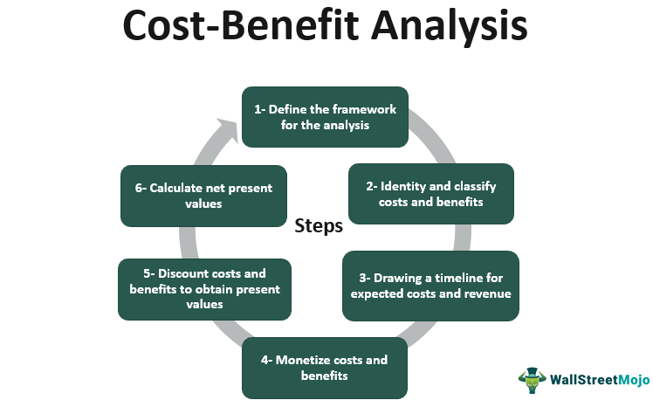
Figure 4: Cost-Benefit Analysis Steps
Source: (Dheeraj Vaidya, 2018)

4.3 Practicability and industry response
Great international hotel chains have become one of the first, as they have included AI systems in centralised sustainability policies. Reflectively, various international brands announce millions of pound annual savings in standardised waste analytics in properties (Li, Lin and Li, 2020). These organisations possess the capital base, technical expertise and procurement benefits that are necessary to assimilate the initial cost and scale benefits.
This is opposite to the case with the boutique hotels and seasonal hotels, where they show restrained involvement. The majority of them apply a manual waste auditing or a combination of employee training and minimal use of online technologies (Marriott, 2024). Shared platforms or short-term pilot projects are other properties used to reduce the financial risk, but they are found to reduce the quality of the data and the efficiency of behavioural change as much as full AI integration.

4.4 Criticality of impact evaluation
Strengths
The AI monitoring of food disposal practices is more open than ever before, and converting waste into a measurable administrative variable. This will result in evidence-based decision-making, increased accountability on sustainability, and foster behaviour change among the employees of the kitchen by giving real-time feedback (Nair, Choudhary and Prasad, 2019). In terms of tactics, competitive advantage can be achieved by the first-mover, who is an environmentally responsible operator in a more sustainability-conscious market.
Limitations
The technology is also a menace to creating structural inequity in the industry. Compared to smaller operators, big hotels have the advantage of not being deprived of the privilege of advanced sustainability infrastructure (Net, 2023). In addition, the employees would also experience that they are being closely observed all the time, and this is probably a demotivating factor when implemented without management participation because it can cause mistrust. The reliability of the data also means that the staff are up to date with the compliance, and this is not uniform across the organisational cultures (Newt, 2025). Ethically, the AI implementation can be threatened to become a simple form of symbolic conformity or the green-signalling rather than the overall sustainability policy, particularly when the decrease in waste is not accompanied by the wider restructuring of the supply-chain.
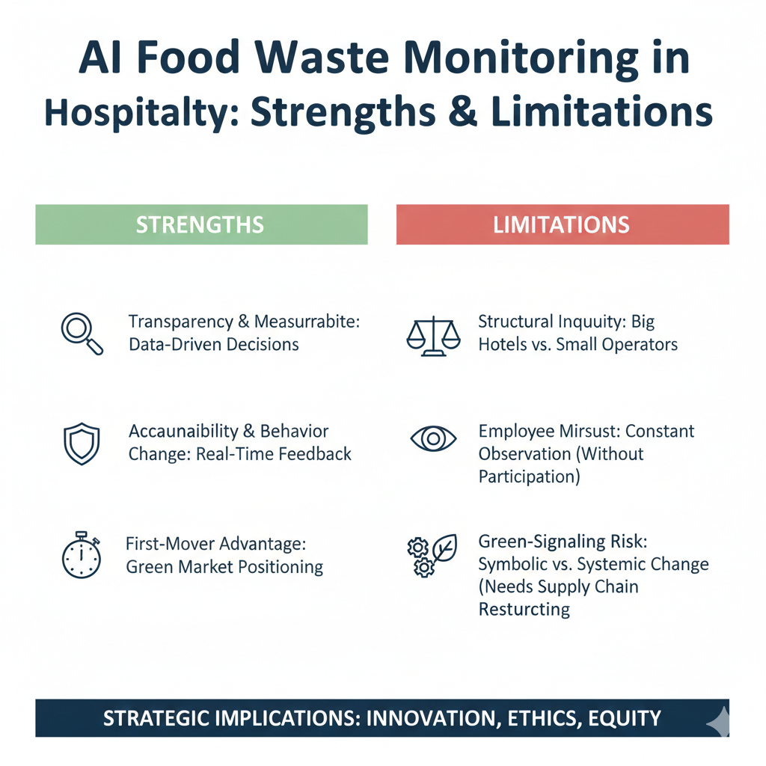
Figure 5: Strengths and Weaknesses Analysis
Source: Author’s creation

4.5 Stakeholder implications
AI systems are not predictable as far as the returns made to owners and investors, but increase the visibility of ESG (Palmer, Oates and Portney, 2022). The managers are faced with an increased complexity in operations, yet strategic planning tools of planning are at their disposal. The degree of performance checks and skills development is increased among the employees. The indirect benefits are that the guests will have less negative impact on the environment and will experience higher room rates in the event that the costs of technology are transferred to the customers (Scamander, 2023). Regulators view such systems as enabling the performance to conform to no standardised benchmarks of performance.

4.6 Overall assessment
The revolutionary but disproportionate impact of AI-based food-waste tracking systems on the hospitality sector is quite high. Because they have been demonstrated to add to sustainability performance and operational intelligence, their monetary cost and organisational implication limits its use by large numbers (Sharma, Singh and Tyagi, 2024). Without policy instruments that could aid and encourage it or co-operation throughout the sector, technological food-waste reduction will be a privilege of scale rather than a universally attainable measure of sustainability.

Conclusion
The AI-based food-waste surveillance is a significant step towards the hospitality industry becoming environmentally friendly and will enable the measurement of the reduction in the amount of waste and improve the visibility of the operations. However, none of them can work due to the high costs of implementation, resistance in the organisation and financial feasibility at a scale that is unfavourable to the small-scale and independent hotels. These technologies, in their turn, may make a substantial contribution to net-zero goals but, in the long-term perspective, will depend on the supportive policy environment, inclusion-based models of their adoption, and overall integration with other methods of waste-prevention.

Recommendations
The hotel and hospitality industry should pursue a multi-tiered approach in its strategy in order to make sure that the AI-assisted food-waste surveillance will contribute to environmental sustainability and economic robustness.
First of all, the models of technology adoption at the different levels should be promoted. The technology suppliers and hotel managers must adopt a scalable and functionality-based modular system at low prices in order to meet the demands of small and large-scale hotels. Simple packages that build on basic waste tracking packages may probably enable small hotels to gain the minimum of sustainability enhancement with the least amount of exposure to capital, and big chains may use advanced predictive analytics in order to introduce strategic optimisation.
Second, the policy intervention needs to address the financial obstacles. Incentives and sustainability grants or carbon-credit schemes should be introduced by governments and tourism agencies for confirmed investments in waste reduction. These would assist in risk reduction within the operators working independently, and overall, the entire sector would be compliant with food-waste and emission policies. Possibly, another way in which the hospitality industry can use public-private partnerships to assist in pilot programmes in markets where digital infrastructure is lacking is in the new markets.
Third, AI systems should become a part of the overall waste-management of hotels. Surveillance of technology will not overcome structural factors such as large menus, non-elasticity of procurement contracts and buffet-based food service models. The management should therefore align digital tools to menu engineering, demand forecasting, staff collaboration with suppliers and staff training. A solution to the resistance may be the engagement of employees in AI systems and increasing their involvement in the development process by framing AI systems as educational and not surveillance.
Fourth, the industry should have cooperation of data. Anonymised and aggregated benchmarking systems may allow hotels to compare performance best practices as well as reduce the cost of analysis. The use of similar reporting systems would also improve transparency by the regulators and investors and lessen the probability of superficial sustainability reporting.
Combined, the steps would enable offering a more equitable availability of waste-cutting technologies, enhance the financial viability in the long-run, as well as ease the procedure of shifting to a more ecologically friendly method of operating the hotels without undermining the competitiveness in the industry.

References
Batabyal, D. and Das, D.K. (2019). Global trends, practices, and challenges in contemporary tourism and hospitality management. Hershey, PA: IGI Global.
Cejas, R. (2025). Food Waste Reduction AI Technologies in Restaurant Management: An MS-TORO Approach. Processes, 13(8), pp.2419–2419. doi:https://doi.org/10.3390/pr13082419.
Clark, Q.M., Kanavikar, D.B., Clark, J. and Donnelly, P.J. (2025). Exploring the potential of AI-driven food waste management strategies used in the hospitality industry for application in household settings. Frontiers in Artificial Intelligence, 7. doi:https://doi.org/10.3389/frai.2024.1429477.
Cooper, C. and Hall, C.M. (2023). Contemporary Tourism. 5th ed. Goodfellow Publishers Ltd.
Darcy, S. Ambrose and J. Bulhalis (2012). Best Practice in Accessible Tourism. Clevedon: Channel View Publications.
Dheeraj Vaidya (2018). Cost-Benefit Analysis | Model | Steps | Uses | Principles. [online] Wallstreetmojo.com. Available at: https://www.wallstreetmojo.com/cost-benefit-analysis/.
FAO (2022). The State of Food and Agriculture 2022 | FAO | Food and Agriculture Organisation of the United Nations. [online] www.fao.org. Available at: https://www.fao.org/publications/sofa/2022/en/.
Graber, J. (2023). Hotel Tech-in: An AI-assisted kitchen solution to help hotels tackle food waste. [online] Hotel Dive. Available at: https://www.hoteldive.com/news/ai-assisted-kitchen-solution-to-reduce-food-waste/649553/.
Grindle, P. (2019). AI Technology Helps IHG Hotels Track, Measure and Reduce Food Waste. [online] Hospitality Technology. Available at: https://hospitalitytech.com/ai-technology-helps-ihg-hotels-track-measure-and-reduce-food-waste.
Gromboni, M., Sales, A., Rezende, M., Moretti, J., Corradini, P. and Mascaro, L. (2021). Impact of agro-industrial waste on steel corrosion susceptibility in media simulating concrete pore solutions. Journal of Cleaner Production, 284, p.124697. doi:https://doi.org/10.1016/j.jclepro.2020.124697.
Hospitality Lexis (2024). Meliá Hotels Limits Food Waste With AI - Hospitality Lexis. [online] Hospitality Lexis. Available at: https://hospitalitylexis.media/melia-hotels-limit-food-waste-with-ai/ [Accessed 17 Jan. 2026].
Killian, S. and Folmer, E. (2022). Sustainable Entrepreneurship Project Adoption Factors to Food Waste Management Technologies: An Empirical Analysis of the Hospitality Industry Candidate: Sara Santoriello (S6081762). [online] Available at: https://campus-fryslan.studenttheses.ub.rug.nl/697/1/MA-6081762SSantoriello.pdf [Accessed 14 Oct. 2025].
Leanpath (2018). Restaurant Food Waste Management | Leanpath. [online] Leanpath.com. Available at: https://restaurants.leanpath.com [Accessed 17 Jan. 2026].
Lee, H.-H. and Huang, P.-Y. (2023). Food Waste and Environmental Sustainability of the Hotel Industry in Taiwan. Sustainability, [online] 15(21), p.15459. doi:https://doi.org/10.3390/su152115459.
Li, Y., Lin, L. and Li, X. (2020). Chemically enhanced primary sedimentation and acidogenesis of organics in sludge for enhanced nitrogen removal in wastewater treatment. Journal of Cleaner Production, 244, p.118705. doi:https://doi.org/10.1016/j.jclepro.2019.118705.
Marriott (2024). AI Monitoring Helps Marriott Hotels to Slash Food Waste. [online] 1hotelnews. Available at: https://www.hotelnewsresource.com/article133469.html.
Nair, G.K., Choudhary, N. and Prasad, S. (2019). ‘Can food waste be reduced?’ An investigation into food waste management in the hospitality industry. International Journal of Hospitality and Event Management, 2(2), p.135. doi:https://doi.org/10.1504/ijhem.2019.10032362.
Net, H. (2023). Award-winning AI technology helps IHG hotels track, measure and reduce food waste. [online] Hospitality Net. Available at: https://www.hospitalitynet.org/news/4093893.html.
Newt, R. (2025). Mandarin Oriental Embraces Artificial Intelligence to Set a New Standard in Food Waste Reduction for Luxury Hospitality. [online] HFTP. Available at: https://www.hftp.org/news/4122341/mandarin-oriental-embraces-artificial-intelligence-to-set-a-new-standard-in-food-waste-reduction-for-luxury-hospitality.
Orbisk (2024). Orbisk - Automatically reduce food waste in your kitchen. [online] Orbisk. Available at: https://orbisk.com.
Palmer, K., Oates, W.E. and Portney, P.R. (2022). Tightening Environmental Standards: The Benefit-Cost or the No-Cost Paradigm? Journal of Economic Perspectives, 9(4), pp.119–132. doi:https://doi.org/10.1257/jep.9.4.119.
Scamander (2023). Food waste: AI supporting Accor hotels. [online] Hospitality Net. Available at: https://www.hospitalitynet.org/news/4118407.html.
Sharma, Singh and Tyagi (2024). Proceedings of the International Conference on Innovation and Regenerative Trends in Tourism and Hospitality Industry (IRTTHI 2024) | Atlantis Press. [online] Atlantis-press.com. Available at: https://www.atlantis-press.com/proceedings/irtthi-24.
Sigala, E.G., Gerwin, P., Chroni, C., Abeliotis, K., Strotmann, C. and Lasaridi, K. (2025). Reducing food waste in the HORECA sector using AI-based waste-tracking devices. Waste Management, [online] 198, pp.77–86. doi:https://doi.org/10.1016/j.wasman.2025.02.044.
Socaci, S.A., Fărcaş, A.C., Thierry Aussenac and Laguerre, J.-C. (2020). Food Preservation and Waste Exploitation. BoD – Books on Demand.
Vânia Gonçalves Costa and Costa, C. (2022). Sustainability and competitiveness in the hospitality industry. Hershey, PA: Business Science Reference.
Wafi, A. and Tumiran, M.A. (2024). Harnessing Artificial Intelligence (AI) to Mitigate Food Waste: Innovative Strategies for Sustainable Consumption. Malaysian Journal of Social Sciences and Humanities (MJSSH), 9(12), pp.e003147–e003147. doi:https://doi.org/10.47405/mjssh.v9i12.3147.

