Production Timesheet

Kaan Hanrahan (1904580)

University of Wales, Trinity Saint David, Dynevor Centre,
De La Beche Street, Swansea, SA1 3EU, Wales, United Kingdom.

1904580@student.uwtsd.ac.uk

 | Week 1 |  | Week 2 |  | Week 3 |  | Week 4 |  | Week 5 |  | Week 6 |  | Week 7 |  | Week 8 |  | Week 9
Assigned Groups
Individual Game Ideas
Gathered Game Ideas
Moodboards
Game Design Document
Assign Roles
Research Software (Unreal Engine 4)
Create Level Blockout
Create Asset List
UE4 Mechanic Research
Implementing Mechanics
Received Assets from Team Members
Imported Assets to the Game
Working on the Game
Game Completed

Week 1

This first week was quite slow in work compared to future weeks of production. Our first lecture for this topic gave everyone the chance to either work solo or find people to work with that share similar interests in the game genre that we were allocated, that being Horror.
After discussing with fellow classmates, I found 2 other people who had similar game ideas to myself. We quickly created a good bond and set each other a task to find some individual game ideas that we could potentially expand upon in the future.

Week 2

In the beginning of this week, we had a small team meeting to discuss our individual games ideas and hopefully decide upon a single idea that we can go forward and create.
We did decide on a game idea and we were assigned the task to create a few moodboards to find a nice way to show our ideas to the lecturer, and for us to reference while creating the game in the future.
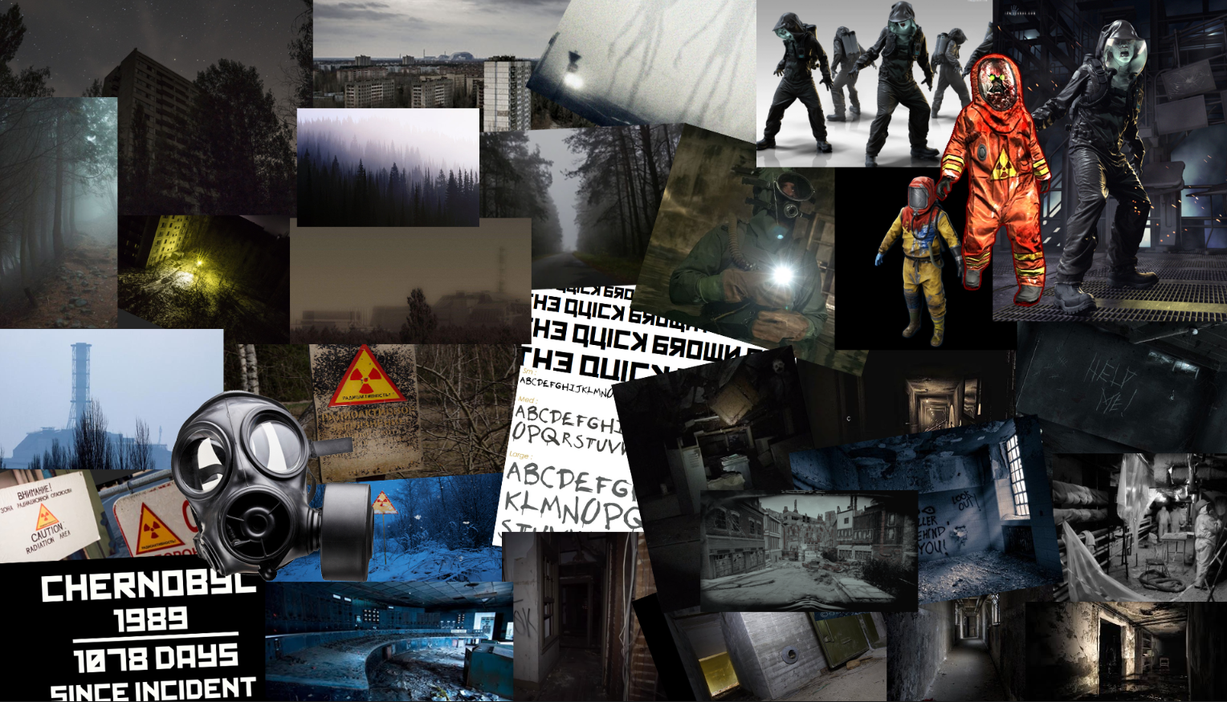
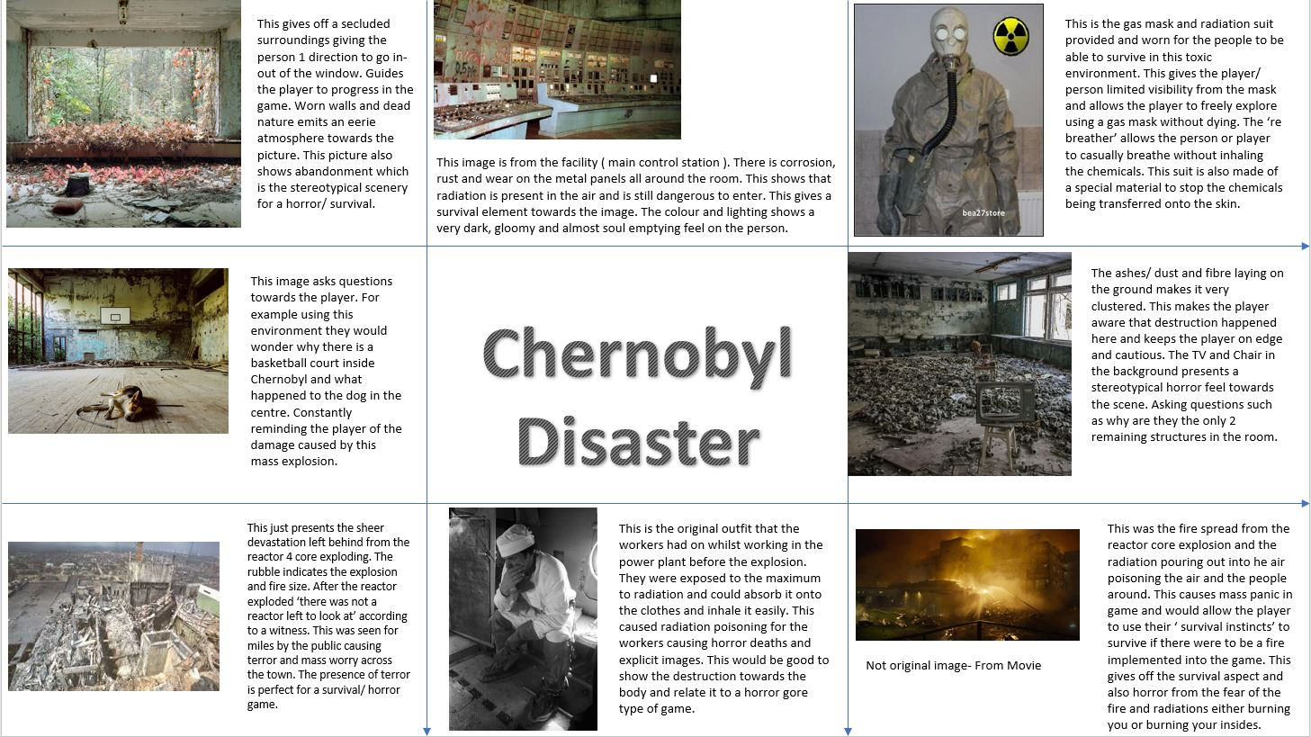
These are the 2 moodboards that we created, one showing a lot of the planned visual style, and one showing images, but described with more information about what the pictures represent.

Week 3

At the beginning of this week, our group was allocated the task to create a Games Design Document before the production of our game. We believed in the fact that Game Design Documents change over the production of the game but we are all happy with our finalised GDD. While creating the GDD, we were all assigned a certain section of the document to complete, my group and I did the entire GDD while in a Discord call with each other on the same Google Docs document, we did this to ensure we all have the same mindset and we all have the same ideas for our game going forward.
The end of week 3 saw us allocating ourselves to certain production roles, I was interested in learning about the Unreal Engine 4 and how it works, so we decided that I could take on the role of the engine and I quickly started researching how the Engine works. The other 2 team members worked on learning Maya and Substance Painter, to create assets and texture them and to send them to me to export into the game.

Week 4

From my point of view, little to no work was complete towards the game this week. I allocated this whole week for practise and learning of the Unreal Engine 4.
I went through many different guides to see what was the most suitable for my methods of learning. I soon found a very helpful guide on YouTube from a channel called ‘Virtus Learning Hub / Creative Tutorials’. At the time of my access, the channel had a very helpful guide on how to create a survival horror game.

Links

Virtus Learning Hub / Creative Tutorials https://www.youtube.com/channel/UCz-eYJAUgSE-mqzKtit7m9g
The Survival Horror Tutorial Playlist
https://www.youtube.com/watch?v=wJJn9igmznc&list=PLL0cLF8gjBpqGJwEe5XL5mSL8UvwwVMKu

Week 5

In week 5, our group had a discussion and they were ready for me to start building a basic blockout for our game. We discussed what the game should look like and then I proceeded to start creating the rough outlines of how the game will look. This was completed relatively quickly so it gave me time to create an asset list for the other group members to create for the game.
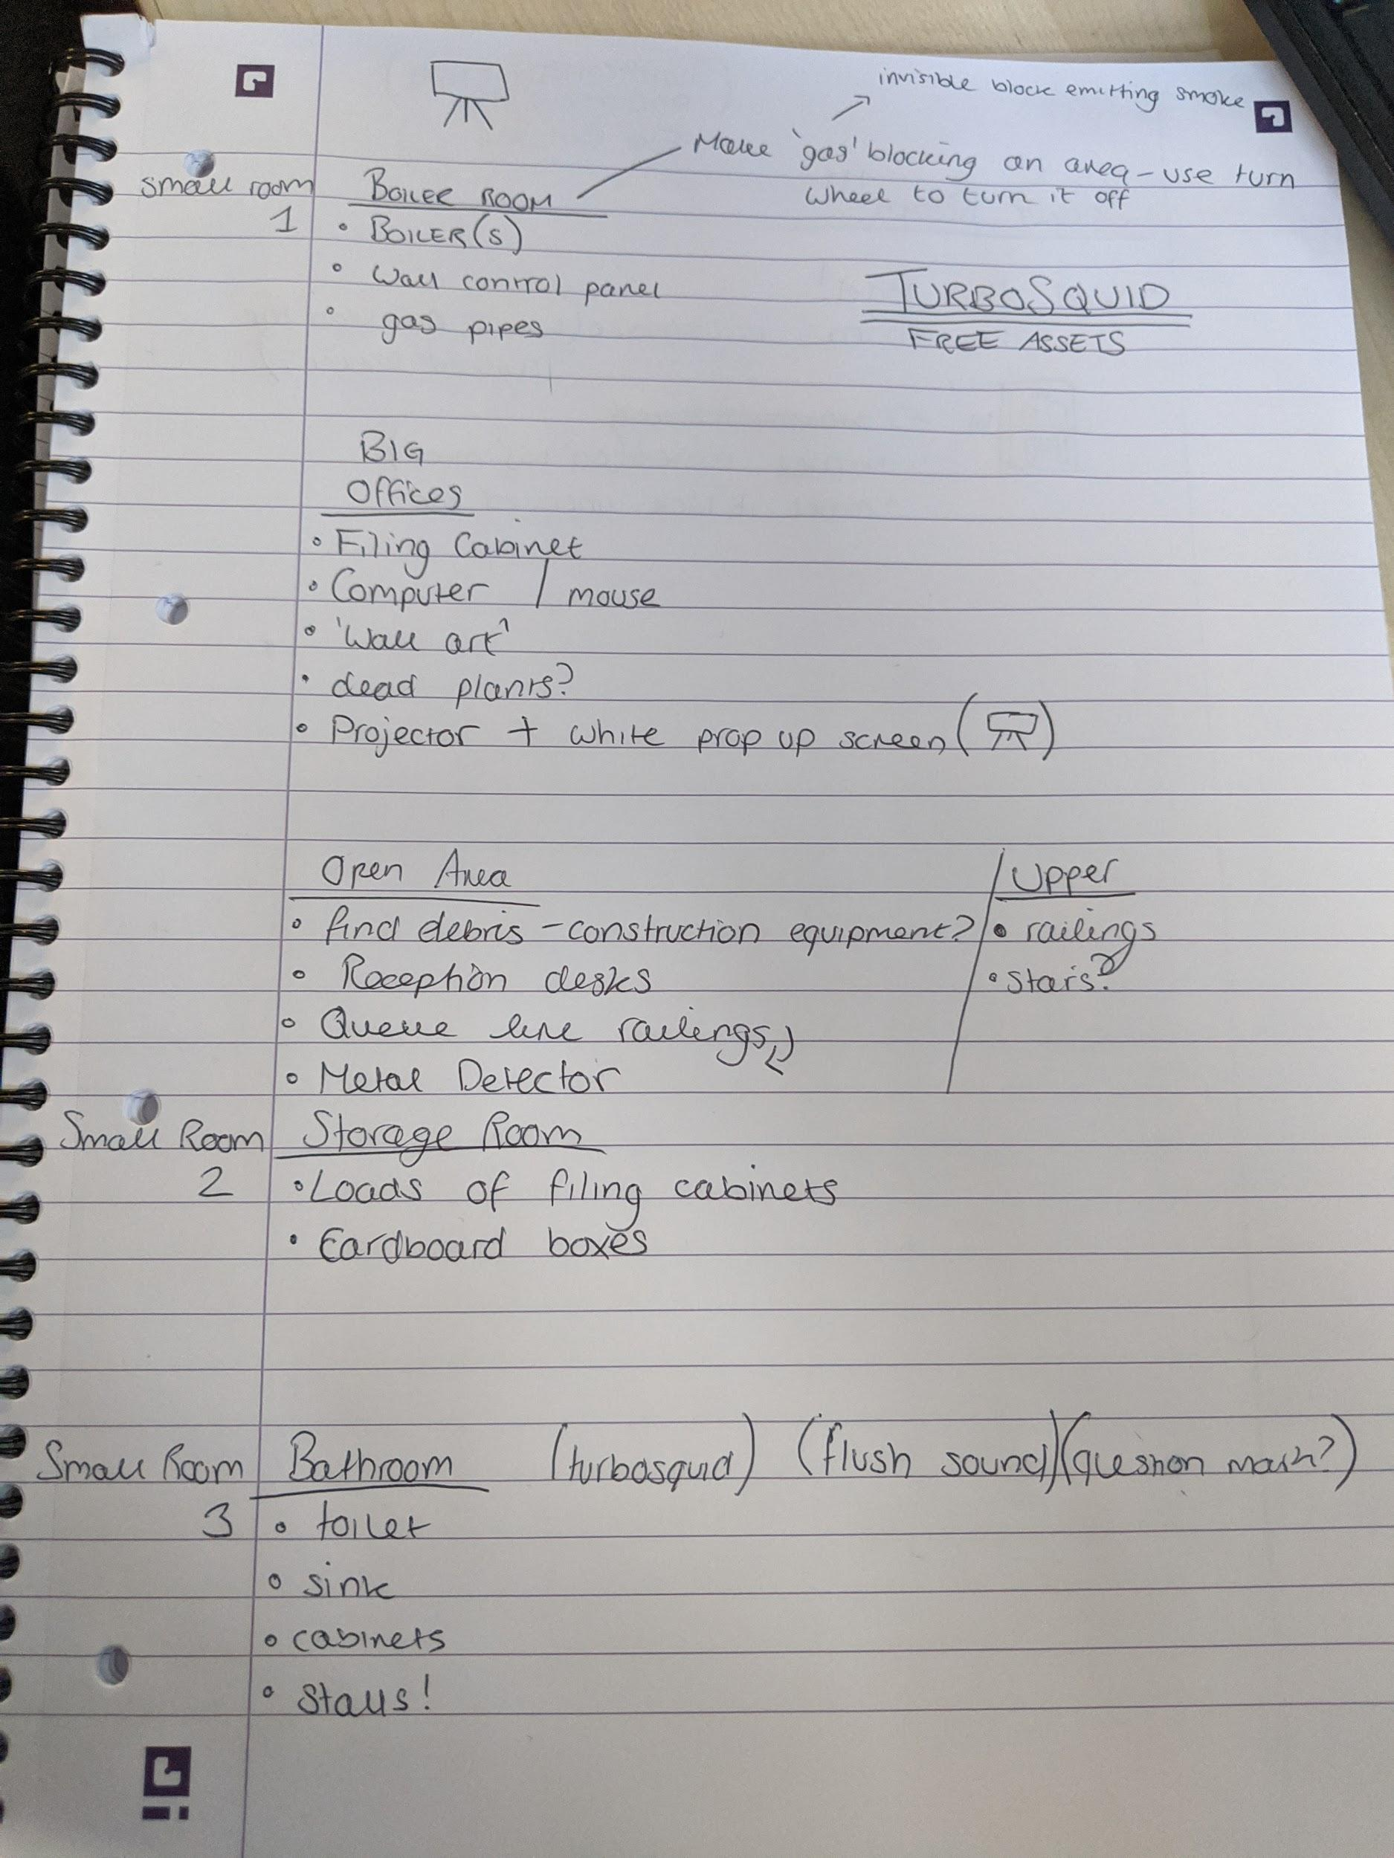
This is a brief, hand-written asset list that I created for my group while we had a small group discussion about what we needed and what was possible. The 2 asset creators talked between themselves to see what assets they would make. It is mentioned in that picture that TurboSquid was an option, after a week or so, we decided that using TurboSquid was not necessary so we avoided it and stuck to creating our own assets.
Since the game’s basic blockout was complete, I decided to start researching different mechanics that I can use for our game.
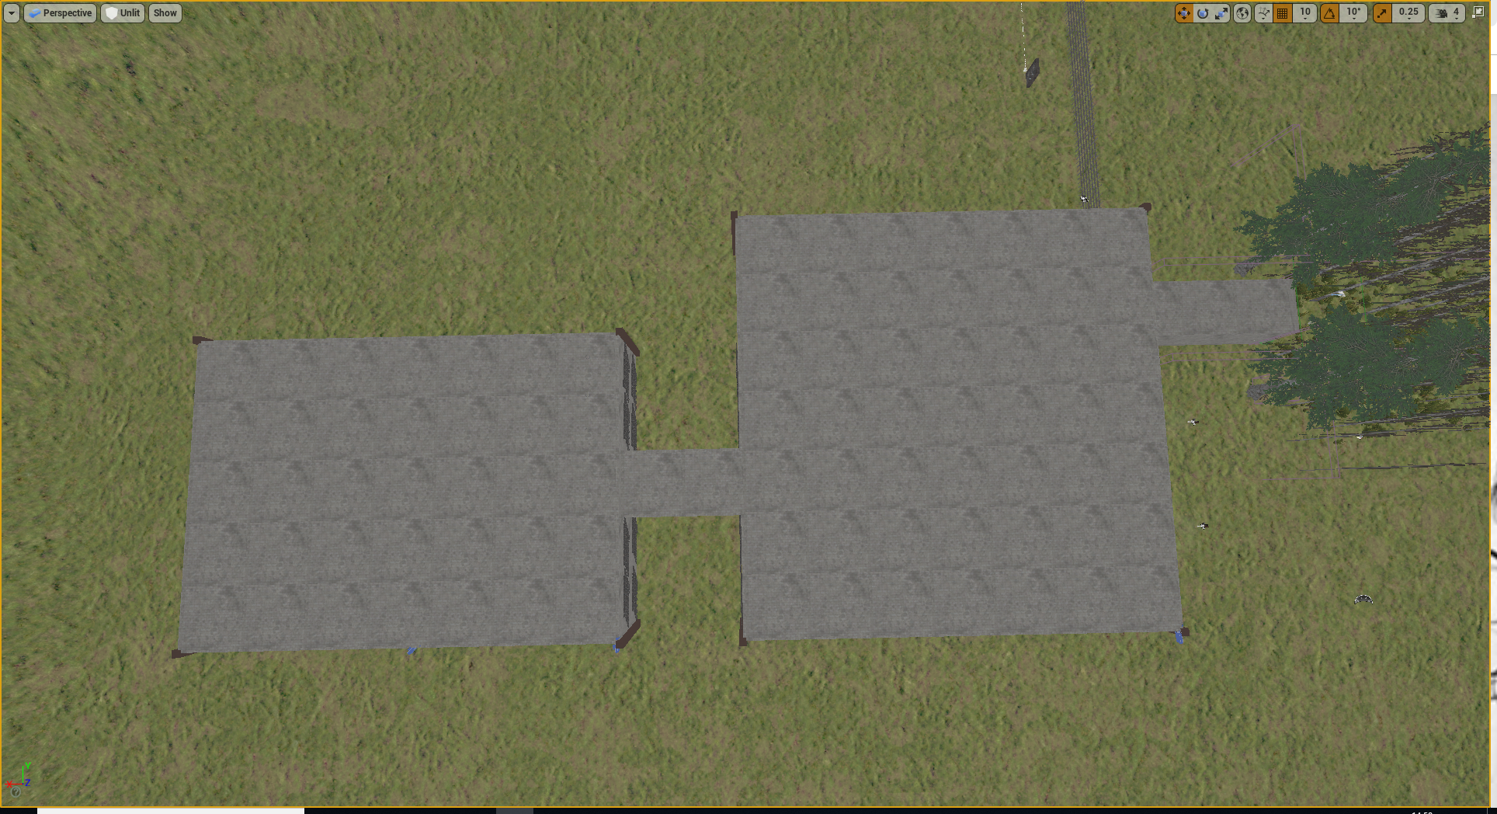
Example of the blockout of the game.

Links

TurboSquid
https://www.turbosquid.com/

Week 6

After starting to research about what gameplay mechanics I can realistically add to our game. I discovered an Unreal Marketplace Addon called ‘Horror Engine’.
This Horror Engine came packed with loads of customizability and the option for me to create certain ‘events’ that can perform different actions in-game. I could manipulate these events to create different mechanics that suited our game’s style perfectly. For example, a key/keycard and locking system was added to most doors in the game, which fulfills our GDD as it makes the player follow certain paths to find keys to unlock doors to retrieve the main package and extract that. I could also use this mechanic system to eventually add jump-scares and 3D ambient sounds, like footsteps in a different area to the player’s location and such.
So I proceeded to add this Addon to our game, and research how to implement these mechanics to the game, after a quick YouTube search, I found a helpful video from the creator of Horror Engine, ‘tansuergene’ and their video describes how events are created.
I got a grasp of how the engine works quite quickly, so I started to implement some mechanics to the game towards the end of the week.

Links
Horror Engine Plugin
https://www.unrealengine.com/marketplace/en-US/slug/horror-engine
Tansuergene
https://www.youtube.com/channel/UCO1pIPW5oprpYgsuchzKxVg
Horror Engine Tutorial - Creating Horror Events
https://www.youtube.com/watch?v=zov_LDbPb4w

Week 7

The beginning of this week was allocated to the group members who were working on assets, so I waited for them to finish up the list and send them over to me via Google Drive, we chose to use this method as we can all access the files from anywhere (assuming we have an internet connection).
Towards the middle of the week, I had received most to all of the assets that were requested so I began to import them into the game.

Horror Engine came with some very useful assets that I could also use for our game, these assets would be quite time costly to create from scratch so we decided that using these premade assets can be useful for our game.
With most of the assets imported and the game’s blockout being created - I decided to start properly working on the game, getting it ready for the deadline at the end of the 9th week.
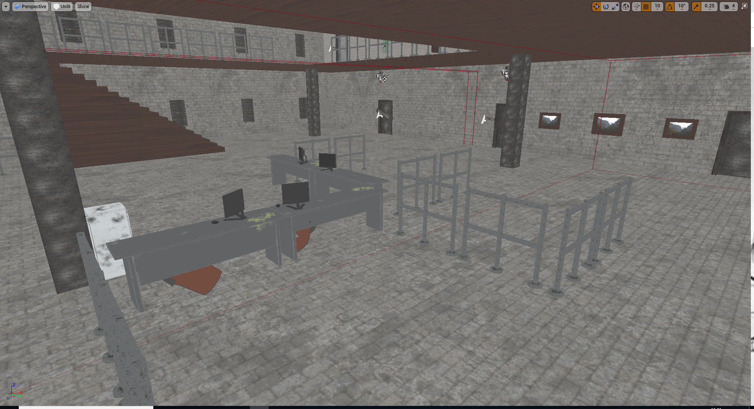
Example of the open area, with the desks and the fences being created by our teammates.
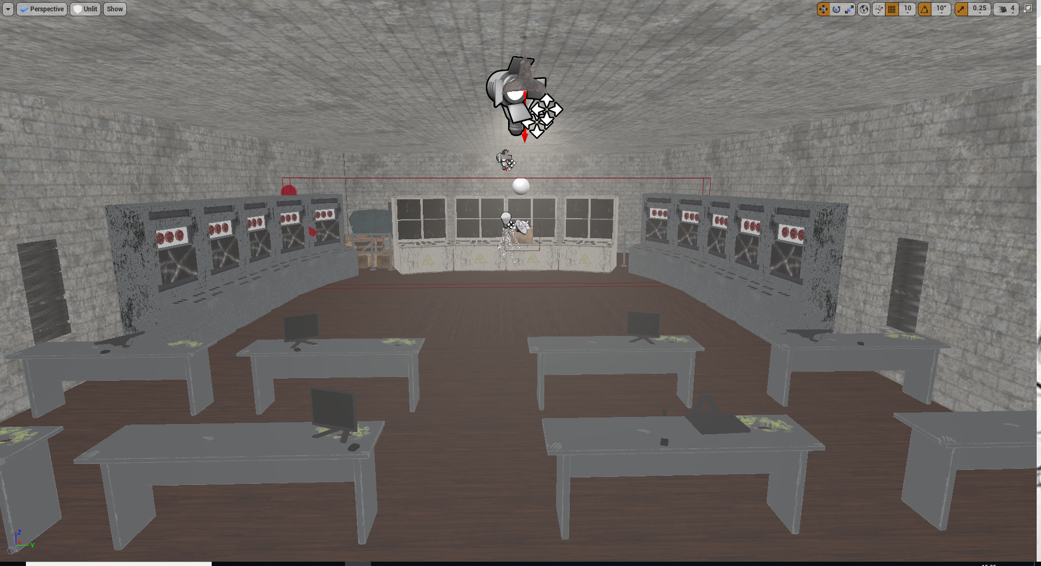
This is a screenshot of the Server Room at the end of the game, with all the servers, desks and the main consoles being created from my teammates
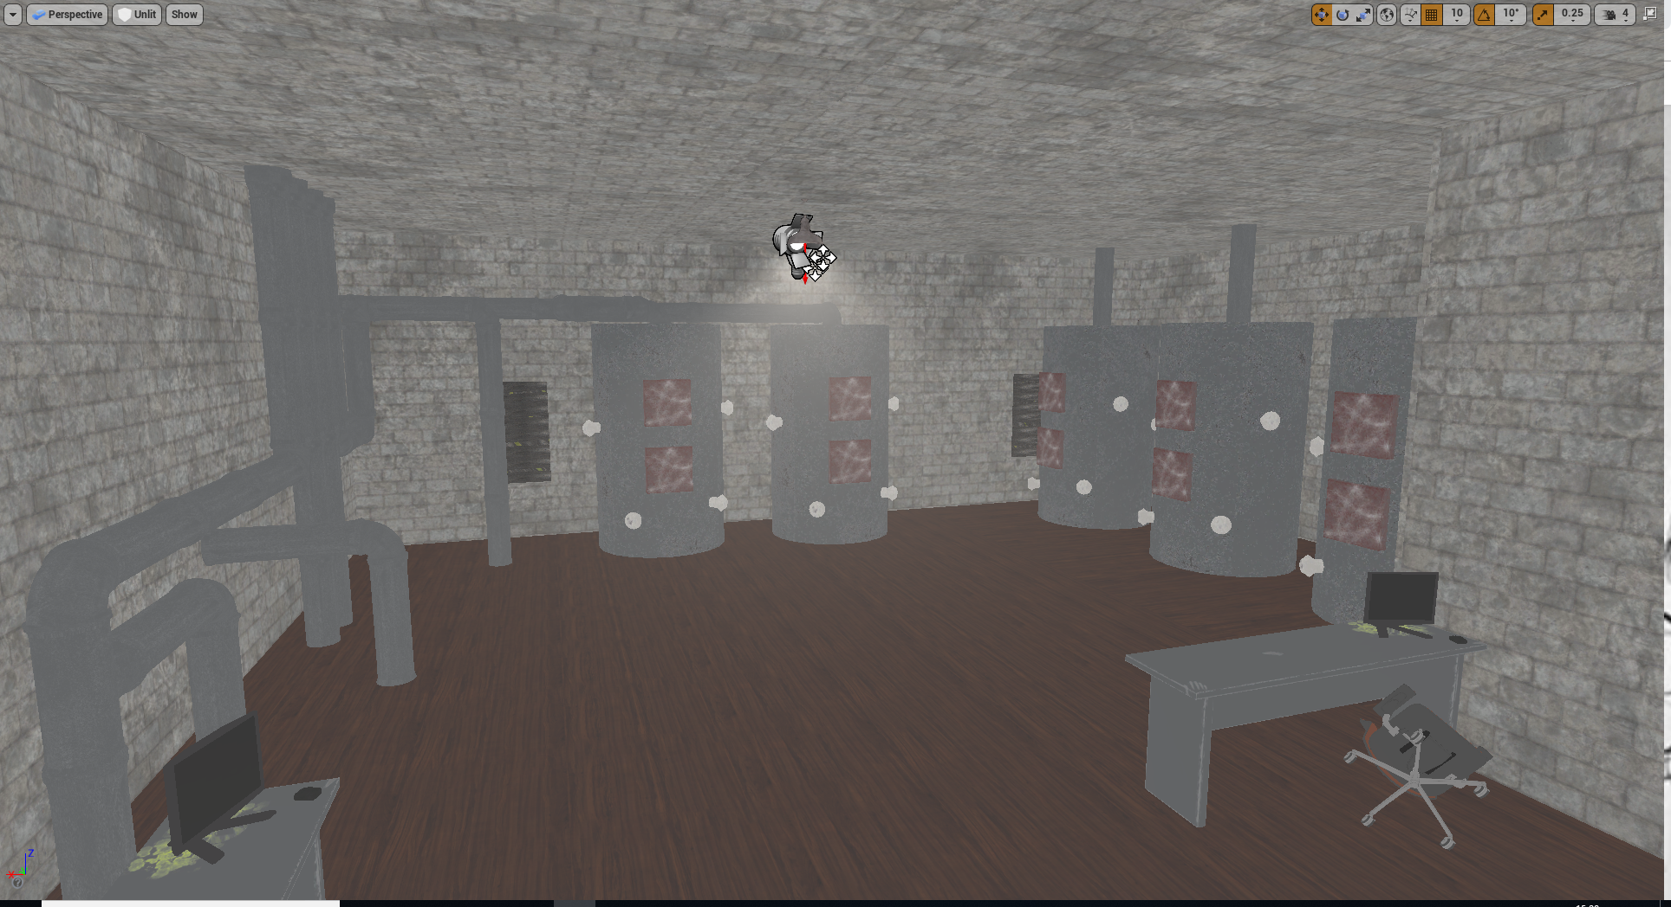This is another area of the game which features a good amount of original content created by my team members. The Boilers and pipes were individual assets that I arranged myself into a nice and cohesive chain of pipes.

Week 8

The 8th week for me was solely focused on getting the game close to finalised and ready for submission.
Any assets that weren’t given to me the previous week were all ready for me to import, so I ensured that all the assets were being used correctly in the game and I proceeded to work on it.

Week 9

The majority of this final week was used to complete the game ready to hand in. A lot of hours were spent this week to ensure that the game could run well and play all the way through with little to no issues.
The end of the week was me quality assuring my game and running through it multiple times to ensure the game is at good quality. A final team meeting was arranged to show my team how the game has progressed so far, everyone was happy with the game’s state and decided that we had created a project that we were happy about and proud of.

Game Design Document

Mechanics Overview
Our game will have basic movement mechanics, them being basic walking, sprinting, crouching and leaning. There will also be player health that can decrease when taking large falls or when hurt by opposing forces.
There will be a flashlight that the player will have control of from the beginning of the game, this will be used by the player to familiarise themselves with the map and to create a sense of tunnel vision, adding to an eeriness factor. The player will also be tasked to find a gun towards the end of the level, this will also be equippable, but the flashlight and the gun will not be able to be equipped at the same time, so some critical thinking is required by the player.
Another main mechanic is the door locking/unlocking system - there will be named keys or keycards found around the map that can be used to unlock specific doors, this will be a main mechanic throughout the entire game. There will also be small but important mechanics, such as batteries for your flashlight; the flashlight that the player has is not infinite, and will eventually run out of batteries, so to counteract this, players will be able to find batteries scattered in random locations around the map - this is to add a small micromanagement detail into the gameplay to add a layer of anxiety into the game.
Inventory
There is an inventory in our game, this is where the batteries, stated above will be kept along with notes, keys and keycards. This will be done via the ‘Horror Engine’ unreal package that we had found during our research methods. In our inventory everything will be able to be seen and rotated / inspected in 3D space also every item will have a description that the player can read.
Main Menu
When the player starts the game, they will not be greeted with a main menu, they will be thrown straight into the game. We did not do this because of time constraints and in an ideal world we would have a main menu in our game, serving as a visual aid will be controls when applicable throughout our level.
Game Over Screen
The information displayed at the end of the game will contain one for accomplishing the task/ completing the game and one for dying or running out of time. The information for completing the game will contain written dialogue of ‘Congratulations you have retrieved the package and escaped’. The game over screen for running out of time the screen would fade to black and restart the level.
Controls
Our game will feature a minimal amount of controls to keep the player from losing immersion. Since this game will be created for PC, our controls will be a default ‘WASD’ layout for movement, and simple commands for anything else, e.g. pressing the ‘1’ key will equip/unequip the flashlight from the player’s inventory. This is the same with the inventory keybind, it will only be a simple key press of ‘TAB’ to open and close.
‘Winning the match’
For the player to win/complete the game they must escape the environment, this will be the only victory condition. This conforms to the sub-genre of survival horror (escape).
Missions and Achievements
The player is only tasked with one mission and that is to retrieve a package within our level, there will be no side quests other than the challenges he/she encounters on the way to the main objective.
Equipment
The player will be given a flashlight after an event trigger once entering the building, this will be their main source of light throughout the entire game and will aid them in being able to navigate our level and finding keycards / keys, to progress. The flashlight’s field of view is wide but isn’t very bright contrasting nicely with the dreary feel to our game, along with volumetric fog that will be somewhere in our level.

