

‘‘The Customer is Always Right.’ Or Are They? A Study Investigating the Customer Service Concept.’’

Researcher: Marsha Thomas (1802118)

University of Wales Trinity Saint David

BA (Hons) Business Management

Word Count: 7759

May 2021

Coronavirus

In light of the continuing impact of the global pandemic, it is important to include a statement at the start of my dissertation which outlines the effects that COVID-19 has had on the research that I have undertaken towards your undergraduate degree.

The University of Wales Trinity Saint David recognises that the COVID-19 pandemic, and consequent closures of our campus (18th March 2020) and national and international lockdowns, has directly or indirectly impacted the work of many of our undergraduate researchers. Although the campus had periods of re-opening in 2020 and 2021, some research will have been disrupted and some personal circumstances difficult to manage. Teaching was arranged via suitable meeting software and documents shared electronically. All research data collection was designed to utilise digital data collection.

The inclusion of this statement is to facilitate the reader’s awareness, both now and in the future, that the pandemic may have had an effect on the scope, direction and presentation of the research.

The academic standards and quality threshold for the award remains unchanged. I wish to reassure readers that this statement is not evidencing a lack of original research or quality.

Declaration

This work has not previously been accepted in substance for any degree and is not being concurrently submitted in candidature for any degree.

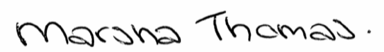
Signed……………………………………………
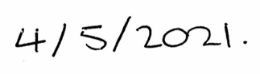
Date………………………………………………

STATEMENT 1

This dissertation is being submitted in partial fulfilment of the requirements for the degree of BA (Hons) Business Management.

Signed…………………………………………….

Date………………………………………………

STATEMENT 2

This dissertation is the result of my own independent work/investigation, except where otherwise stated.

Other sources are acknowledged by footnotes giving explicit references. A bibliography is appended.

Signed……………………………………………

Date………………………………………………

STATEMENT 3

I hereby give consent for my dissertation, if accepted, to be available for photocopying and for interlibrary loan, and for the title and summary to be made available to outside organisations.

Signed………………………………………………
Date…………………………………………………

STATEMENT 4

I hereby give consent for my dissertation, if accepted, to be available on the university’s IT system to those who have consent to use the system.

Signed………………………………………………
Date…………………………………………………

Acknowledgments

I would firstly like to thank my supervisor, Dr Caroline Jawad, for her continued support, guidance, and time throughout the process of this dissertation.

Secondly, I would like to thank my family and friends for their support and encouragement throughout my time at University. The last three years have been an experience I am extremely grateful for, and the continued encouragement from my family and friends has meant the world to me.

Abstract

This study aimed to analyse and evaluate the phrase ‘the customer is always right’ through engagement with employers and managers, employees, and the customer. It has used surveys as the method of data collection in order to understand the different perspectives. It has looked at the overall impact of this phrase and explore how literally it is expected to be adopted.

The inductive and deductive research collection approach had been selected to gather detailed research through observations of literature similar to the topic of interest from which identifications and predictions were made. The mixed-method survey collected primary quantitative and qualitative data for the study. Comparisons were made between the observations of literature and the primary data collected. The researcher is grateful for the provision of secondary literature that helped form discussion within the present study.

The main findings of the study were synonymous with the literature discussed in chapter two. The highest levels of disagreement with the statement ‘The customer is always right’ were from respondents answering from the perspective of manager or employer, or employee. The highest level of agreement with the statement was from those answering from the perspective of a customer. Although these levels of disagreement or agreement were unsurprising, it was found that the manager or employer participants had the highest levels of agreement that the customer should be treated although they are right even when they are not.

The recommendations set out hope to change this or bring attention to the alternative perspective of the worker. One of the recommendations gave consideration to whether the customer should be treated although they are right when they have made a worker feel uncomfortable or upset. The research has highlighted themes and potential issues to the way customer service has been modelled or is expected and how this could affect employees working within customer service or customer-facing roles.

Table of Contents
Coronavirus i
Declaration ii
Acknowledgments iii
Abstract iv
Table of Figures vii
List of Tables ix
1. Chapter One: Introduction 1
1.1 Introduction 1
1.2 Background 1
2. Chapter Two: Literature Review 4
2.1 Introduction 4
2.2 Customer Perception 4
2.3 Consumer Buying Behaviour 5
2.4 Employee Dissatisfaction and Demoralisation 7
2.5 Conclusion 9
3. Chapter Three: Research Method 10
3.1 Introduction 10
3.2 Methodology 10
3.3 Research Onion 10
3.3.1 Philosophy 11
3.3.2 Approach 11
3.3.3 Strategy 12
3.3.4 Choice 12
3.3.5 Time Horizon 12
3.4 Techniques for Data Collection, Processes and Analysis 13
3.4.1 Data Collection 13
3.4.2 Questionnaire Design and Literature Review Matrix 13
3.4.3 Pilot Study 20
3.4.4 Data Analysis 20
3.3 Sample 21
3.4 Reliability and Validity 21
3.5 Limitations and Ethical Considerations 21
3.5.1 Time Management 21
3.5.2 Limitations 21
3.5.3 Ethical Considerations 22
3.6 Conclusion 22
4. Chapter Four: Data Analysis 23
4.1 Introduction 23
4.2 Data Analysis 23
4.3 Methods 23
4.4 Demographics and Descriptive Statistics 24
4.5 Chi-Square Analysis 26
4.5.1 Chi-Square Analysis for Perceptions 26
4.5.2 Chi-Square Analysis for Industry 27
4.5.3 Chi-Square Analysis for Age 29
4.5.4 Chi-Square Analysis for Opinion 30
4.6 Crosstabulation 32
4.7 Discussion and Descriptive Analysis 35
4.8 Conclusion 36
Chapter Five: Conclusions and Recommendations 37
5.1 Introduction 37
5.2 Summary of Main Findings 37
5.3 Implications of Research 37
5.4 Recommendations 38
5.5 Limitations 39
5.6 Recommendations for Future Study 40
5.8 Self Reflection 40
5.9 Conclusion 41
6. Bibliography 42
7. Appendices I
7.1 Appendix 1: Copy of questionnaire I
7.2 Appendix 2: Full SPSS analyses IX
7.3 Appendix 3: List of Questions XVI
7.4 Appendix 4: Q15 Qualitative Response to ‘To what extent do you believe the phrase ‘the customer is always right’ should be understood?’ XIX
7.5 Appendix 5: Q15 Response frequency word cloud XXVII
7.6 Appendix 6: Ethics form XXVIII

Table of Figures

Figure 2.1 The buyer decision process (Kotler et al., 2020). 12

Figure 3.1 The Research Onion, highlighting the process selected by the researcher (Saunders et al., 2016). 17

Figure 4. 1 Chart showing gender of respondents. 29
Figure 4. 2 Chart showing the age of respondents. 29
Figure 4. 3 Chart showing frequencies of perspective respondents answered from. 29
Figure 4. 4 Chart showing frequencies of industry respondents worked in. 30
Figure 4. 5 Chart showing agreement with extent ‘the customer is always right’ should be followed. 30
Figure 4. 6 Chi-Square test Q4 and Q6, showing significant association between perspective answered from and opinion in response to ‘the customer is always right’. (p=.000). 31
Figure 4. 7 Chart showing significant association between perspective answered from and opinion in response to ‘the customer is always right’. (p=.000). 32
Figure 4. 8 Chi-Square Test Q5 and Q6, showing significant association between industry worked in and opinion in response to ‘the customer is always right’. (p=.004). 33
Figure 4. 9 Chart showing significant association between industry worked in and opinion in response to ‘the customer is always right’. (p=.000). 33
Figure 4. 10 Chi-Square test for Q3 and Q6 showing significant association between age and opinion in response to ‘the customer is always right’. (p=.055). 34
Figure 4. 11 Chart showing significant association between age and opinion in response to ‘the customer is always right’. (p=.055) 34
Figure 4. 12 Chi-Square test for Q4 and Q10 showing significant association between perspective answered from and opinion in response to ‘To what extent do you believe the customer is always right. (p=.003). 35
Figure 4. 13 Chart showing significant association between perspective answered from and opinion in response to ‘To what extent do you believe the customer is always right?’ (p=.003). 35
Figure 4. 14 Chi-Square test for Q4 and Q12 showing significant association between perspective answered from and opinion in response to ‘Have you ever complained illegitimately for personal gain?’ (p=.001). 36
Figure 4. 15 Chart showing significant association between perspective answered from and opinion in response to ‘Have you ever complained illegitimately for personal gain?’ (p=.001). 37
Figure 4. 16 Crosstabulation showing negative association between perspective answered from and opinion in response to ‘Do you believe customer complaints are always legitimate?’ (p=.735). 37
Figure 4. 17 Crosstabulation showing significant association between industry worked in and opinion of manager or employer in response to ‘I would expect staff to adopt ‘the customer is always right’ strategy’. (p=.027). 38
Figure 4. 18 Chart showing significant association between industry worked in and opinion of manager or employer in response to ‘I would expect staff to adopt ‘the customer is always right’ strategy’. (p=.027). 39
Figure 4. 19 Chart showing participant agreement with statements in Q8. 40

List of Tables
Table 3. 1: Questionnaire and Literature Review Matrix 14

1. Chapter One: Introduction

1.1 Introduction

This chapter will introduce the topic of study. It will provide background and justification for the topic selected during the study. It will also introduce the aims and objectives of study and explain how the research will be structured.

This study will analyse and evaluate the phrase ‘the customer is always right’ through engagement with employers and managers, employees, and the customer. It will use surveys as the method of data collection in order to understand the different perspectives. It will look at the overall impact of this phrase and explore how literally it is expected to be adopted through dissecting the different expectations of the service provider and the customer (Scott, 1999; Foederer, 2016).

The topic has been selected through an interest in the differing perceptions and vast extent to customer service. Although there has been prior research to the philosophy behind the phrase, much focus has surrounded customer service and customer complaining behaviour. Consequently, there is less research surrounding how employees feel about the phrase, with almost no research on the topic having taken place thus far in 2021. This study will investigate the multiple perspectives with focus on the perception of the employee.

1.2 Background

There has always been speculation around the phrase ‘the customer is always right’ (Borna and Stearns, 1998; Bishop and Hoel, 2008). Despite this attitude appearing new and influential when it became popularised in the early 1900’s (Morgan, 2018) introduced by Harry Gordon Selfridge, John Wanamaker and Marshall Field (Kocher, 2014), they did not intend for it to literally mean that the customer was right in every situation. They instructed that staff were to treat customers although they were right even when they were not. This was a radical change in the way customers were used to being treated. It had a positive impact on the amount of people who began flocking to the department stores of Selfridge, Wanamaker and Field (Morgan, 2018). A number of problems that stem from adopting this ideology have relation to staff morale, business resources, staff versus higher authority bitterness and issues with customers themselves (Sorell, 2004; Mukherjee, 2018).

The phrase ‘the customer is always right’ instigates that organisations should focus on the purpose of making the customer happy. However, this is an unrealistic and arguably incorrect ideology. Customers are not omniscient, although many like to believe otherwise (Neleman, 2018). In modern society online trade has taken over the high street (Jones and Livingstone, 2017) and it is evident consumer behaviour in the way purchase transactions occur have changed, one of the largest changes being the growth of online consumer reviews (Kim, Rahman and Bernard, 2020). These online reviews are essentially unregulated opinions (ibid) and questionability surrounding the motive behind leaving them is a rising issue (Reynolds and Harris, 2009). Research shows that customers have become more aggressive, and the amount of unjust complaints are increasing linked not only to unhappiness or expression of dissatisfaction but with the ulterior motive of financial or compensatory gain (ibid). The rise in customer aggression has caused distress to employees, perhaps worsened through adopting ‘the customer is always right’ hence promoting a sense of entitlement (Kim et al., 2020). Or as suggested by Sama (2019), agitation worsened by false perceptions gathered as a result of untrustworthy advertising. Customer mistreatment is a daily occurrence for service employees causing considerable distress, demoralisation, reduced performance and withdrawal (Yagil, 2017).

1.3 Aims and Objectives

The aim of this study is to investigate ‘the customer is always right’ in order to understand different perspectives. It will look at the overall perceptions surrounding the phrase and explore how literally it is expected through evaluating the expectations of the service provider and the customer.

The following objectives will be achieved through research:

To research and discuss academic literature surrounding differing perspectives of the phrase ‘the customer is always right’.

To conduct primary research using a suitable research approach investigating the alternating perspectives surrounding the phrase ‘the customer is always right’ including the extent which each believe the term should be executed.

To analyse the data collected to explore the alternating perspectives surrounding the phrase ‘the customer is always right’.

To explore through analysis of primary research the impact the phrase ‘the customer is always right’ has on the employee.

To understand the findings of the research, making recommendations for future research or for the use of respondents moving forward when considering ‘the customer is always right’.

To highlight potential avenues for further study, providing limitations to the present study.
.
The aims and objectives will be achieved through data collection.

This chapter has introduced the topic of study and provided background with justification for topic selection during the study. It has introduced the aims and objectives of study and explained how the research will be structured.

2. Chapter Two: Literature Review

2.1 Introduction

The purpose of this chapter is to introduce academic literature discussing factors that contribute to ambiguity around the phrase ‘the customer is always right’, including an understanding of the alternating perspectives from which customer service is provided or received.

This chapter will achieve the first objective of study:

“To research and discuss academic literature surrounding differing perspectives of the phrase ‘the customer is always right’.”

The areas of discussion in the literature review are customer perception, consumer buying behaviour and the dissatisfaction and demoralisation of employees. These sub topics have been selected for discussion as they provide a basis to the potential perspectives that the manager or employer, employee and customer may have surrounding alternative opinions regarding the phrase ‘the customer is always right’.

2.2 Customer Perception

Due to technological innovation and economic development there has been increased interest surrounding the concepts of customer perception and customer perceived value (Zauner, Koller and Hatak, 2015). Zeithaml (1988) introduced the idea that although customer quality and value were aspects marketeers had to consider, the conditions that would make a product or service good quality or good value differentiated as the ideas held about what made a product or service satisfactory differed. This began the attempt to define concepts of price, quality and value from the perspective of the consumer. It was found that consumers used cost as an indicator towards quality and hinted a non-conscious expectance of product quality based on cost (Zeithaml, 1988; Rao, 2005; Imkamp, 2018). The investigation into the concept of value gained more diverse response; equating value with low price, value with quality received for price paid, or equating good value with the quantity the consumer received for the price paid (Zeithaml, 1988; Bolton and Drew, 1991, Potra et al., 2018). This demonstrated how differences between individuals are used to determine whether a product or service is good price or good value. Cost as an indicator towards quality would even differ, as there would be alternating opinions as to whether something is expensive or a fair price (Wen, 2017). This literature exemplifies how different consumers would have alternating opinions. Therefore, questioning the ability of a customer to be ‘right’ if personal views can be so different (Schwager and Meyer, 2007; Halim and Christian, 2013).

The difference between perceived quality and objective quality is a relativistic phenomenon (Zeithaml, 1988; Mitra and Golder, 2006; Stylidis, Wickman and Söderberg, 2020). Customer-based variables in opinion (Calvo-Porral and Levy-Mangin, 2017) would mean that technical excellence based on a product or service in regard to how well it physically works may differ from another (Das-Guru and Paulssen, 2020). As highlighted previously, satisfaction and behaviour of the consumer is influenced by the expectations or perceptions that the customer held prior to purchase (Sheather and Roberts, 2003; Quintana, 2018). An expectation about a product or service conjured by the consumer, that then the product or service did not meet would leave a dissatisfied consumer. Again, questioning whether a customer can be ‘right’ to complain in this situation based on their own preconceived perception (Arora and Chakraborty, 2020). Despite alternating preconceived opinion, the present study seeks to investigate whether the customer believes they are always ‘right’ and the extent they would expect it to be adopted, with consideration to the factors discussed within the literature.

2.3 Consumer Buying Behaviour

Social media and branding can have strong influence over consumer buying decisions from the provision of an advertisement in which the product or service is demonstrated as perfect. Some gain enough trust in a brand through their advertising that they are directly influenced and feel instant attachment, trust, and equity before even purchasing from the organisation (Yu and Yuan, 2019). Brand interaction has become increasingly important to Millennial and Generation Z buyers (Dash, Kiefer and Paul, 2021). Content posted to organisation’s social media can appear so strong to these potential buyers that they feel positive emotion towards it (Dobni and Zinkhan, 1990; Paul, 2019). These perceptions can become demands (Li, Hua and Zhu, 2021) based purely on associations made from viewing an advertisement through advertising campaigns. Often, the product or service does not perform to expectation (Darke, Ashworth and Main, 2009; Nuseir, 2018), then creating a negative customer emotion based upon their preconceived perception (Parameswar, Devasia and Kumar, 2020). This is known as expectancy disconfirmation (Lin and Lekhawipat, 2016) whereby complaints of dissatisfaction and disparagement of the brand begins (Kotler et al., 2020).

The buyer decision process (Kotler et al., 2020) involves ‘information search’. During this stage potential customers research the product or service they are considering purchasing to gather information. The next stage is ‘evaluation of alternatives’ (ibid). Evaluation of alternatives can occur through word-of-mouth, internet research, or forums. An increasingly popular method of evaluating alternatives in the modern day is reading online reviews or searching social media (Schoenmueller, Netzer and Stahl, 2020). The buyer decision process has been selected for the literature as it demonstrates the consumer journey prior to, and post purchase. This process provides the customer with an expectation, information to base their decision on, and provides alternatives.

Figure 2.1 The buyer decision process (Kotler et al., 2020).

Research into the buyer decision process by Kaemingk (2020) found that 93% of consumers were influenced by their purchase decision from reading online reviews, 91% of consumers claimed they would trust online reviews on par with how they would trust a personal recommendation. The second and third steps to the buyer decision process create an expectation, even when the source of information is a third-party online source (Surachartkumtonkun, Grace and Ross, 2020). Organisations are increasingly encouraging consumers to engage prior to and post purchase, with the growth of user-generated online review platforms or website review sections showing positive and negative engagement with the brand (Hollebeek and Macky, 2019). Positive reviews accumulate sales and customer revenue whereas negative reviews can be detrimental to an organisation’s success (Maslowska, Malthouse and Bernritter, 2017). The present study seeks to investigate legitimacy of customer complaints. Consideration is given to online review platform legitimacy and consumer trust.

The final stage of the Kotler (2020) buyer decision process model is ‘post-purchase behaviour’. At this stage consumers evaluate their purchase. In particular, consumers at this stage will form a decision on whether they are satisfied with the product or service they purchased (Jain, Ahuja and Medury, 2014). A dissatisfied customer at this stage will experience cognitive dissonance due to their uncertainty (ibid), this is the point customer complaining behaviour begins. Significant association has been found between individuals who spend time researching alternatives and lack of tolerance to dissatisfactory purchases, indicating that these consumers are less tolerant with what they perceive as a negative purchase and less tolerable when considering the value of purchase (Xhema, 2019). Ledesma (2020) found that consumers are more likely to construct a review when the product or service they have received has an emotional impact, whether this be positive or negative. If the buyer feels let down by their purchase they will likely leave a negative review as a step in the process of venting frustration and anger. This especially resonates when a consumer feels they have been a victim of wrongdoing, some respondents even expressed they felt empowered after leaving a negative review for a product or service they felt wronged by (ibid). This section of literature provides important information for consideration in the present study, as the discussed consumer response to a negative experience being malicious could be considered wrong, as the legitimacy of the complaint is questionable.

A real-life example of alternating perceptions that could question the integrity of ‘the customer is always right’ are as follows. In a restaurant a customer orders a steak to be cooked medium-rare. The meal is brought out and they feel the steak is not cooked the way they requested. However, the steak is cooked perfectly in line with the company standard for how a steak should be cooked medium-rare (Koc, 2017). If the customer in the scenario was to write a review after their visit stating that the food was cooked poorly it would reflect negatively on the restaurant, even though the steak was cooked perfectly in line with the company standard for how a steak should be cooked medium-rare (ibid). This scenario embodies a real-life example of how ‘the customer is always right’ can become blurred. The customer opinion was that the steak was not cooked properly. To the standard the restaurant deemed correct, the steak was cooked perfectly. This example and similar scenarios can create an irate atmosphere whereby the two opposing parties both believe they are correct and one party must accept wrongdoing (Jerger and Wirtz, 2017). The next section of the literature review will discuss how the adoption of ‘the customer is always right’ can cause employee dissatisfaction and demoralisation.

2.4 Employee Dissatisfaction and Demoralisation

As indicated in the previous section by provision of a real-life scenario that often occurs within the hospitality industry (Cuozzo, 2018) highlighted how customer behaviour has an impact on workers. The particular chef in the scenario may have felt embarrassed or even angered that their cooking ability was questioned (Nwosu and Ogunyemi, 2020). This can be applied to any industry role when on the receiving end of a complaint (Prossack, 2019).
A significant association had been found between employee satisfaction and customer satisfaction (ibid). Hence when customer dissatisfaction is present, workers are also negatively affected as they have to manage the complaint of dissatisfaction (ibid).

Many businesses that involve face-to-face customer interaction advocate for ‘the customer is always right’ and welcome criticism or discussion about the dissatisfactory experience the customer has had (Huang et al., 2014; Martin, 2019). However, the adoption of this has also shown to backfire (ibid). One reason being that it welcomes illegitimate complaints due to the knowledge that many organisations would simply accept the complaint, apologise and offer a form of compensation (Bae, Lee and Kim, 2020). This benefit the customer receives can be abused (ibid). Many organisations offer money or redeemable vouchers following a purchase in return for a positive review, diminishing the helpfulness of the rating (Dorner, Giamattei and Greiff, 2020) and misleading others. Again, raising questionability about how this is ‘right’ of a customer.

Another potential backfire of advocating for the phrase regards workers. Many customer-facing roles employ workers on the frontline of dealing with customer behaviour (Torres, Van-Niekerk, Orlowski, 2017; Yagil, 2021). It is not uncommon for employees to be victims of customer aggression in the form of verbal attacks, condescending behaviour and anger when working in customer-facing roles (ibid). Most employee stress is linked to negative customer experience (Groth and Grandey, 2012; Han, Bonn and Cho, 2016; Lee and Kim, 2021) yet many organisations still believe that a customer first business strategy is the most advantageous (Gomes, 2018). Many organisations consider the customer as the leading force for ensuring the future of a company (Joseph, 2015; Morgan, 2019). The Union of Shop Distributive and Allied Workers (2019) campaign seeking to end violence and abuse towards retail workers reported that during 2019, 68% of staff in retail environments had been verbally abused in the workplace by a customer and 43% had been threatened physical violence by a customer (ibid). It is not uncommon to see headlines such as ‘customer lashes out at barista’ (Taylor, 2020) or ‘airline flight attendant slapped by passenger’ (Bailey, 2020). The latter occurred due to a lack of elbow room on a flight, a complaint that would appear seemingly impossible for the individual flight attend to rectify. However, the flight attendant remained calm and listened to the complaint in a professional manner even though they may not have believed it was legitimate (ibid).

The other perspective is that workers are the future of an organisation, and without reliable employees an organisation would not be able to make profit (Ryan, 2018). This perspective would indicate employee satisfaction and safety in the workplace to be a priority to employers or managers (Nielsen et al., 2017). A third of UK employees claim to be miserable within their jobs as 43% report poor management and 39% state they do not feel valued within their role (Gentle, 2016). Yet, are expected to practice ‘service with a smile’ or adopt ‘the customer is always right’ (Turnali, 2014; Frey-Cordes, Eilert and Büttgen, 2020). Workers in customer-facing roles within an environment where the strategy of ‘service with a smile’ and ‘customer is always right’ are enforced were more likely to heavily drink alcohol, or be problem drinkers in attempt to relax after work due to forcing and amplifying false emotional expression during work hours (Grandey et al., 2019). Many employees reported feeling betrayed and embarrassed (Morrison and Robinson, 1997; Litzky, Eddleston and Kidder, 2006; Jung and Yoon, 2019) in situations where a manager has stepped in and made an exception for a dissatisfied, abusive customer and offered a form of compensation (Jiang et al., 2020). This could indicate manager favour toward the feelings of the customer over the employee. The present study seeks to explore this further, as there is a gap in the literature for views of employers or managers in regard to how best deal with customer dissatisfaction. The present study will focus on this with particular interest in these perspectives opinions on ‘the customer is always right.

2.5 Conclusion

This chapter has achieved the first objective of study:

“To research and discuss academic literature surrounding differing perspectives of the phrase ‘the customer is always right’.”

The literature review has provided discussion of factors contributing to the ambiguity surrounding the phrase ‘the customer is always right’ by highlighting alternating opinion and how this difference can produce an alternative outcome. The next chapter will identify the appropriate methods for data collection and discuss selected methodology to meet the remaining objectives of study.

3. Chapter Three: Research Method

3.1 Introduction

The previous chapter achieved the first objective of study, highlighting the ambiguity surrounding ‘the customer is always right’ and outlining the gap in study regarding the perspective of the employee.

This chapter will achieve the second objective:

“To conduct primary research using a suitable research approach investigating the alternating perspectives surrounding the phrase ‘the customer is always right’ including the extent which each believe the term should be executed.”

The research onion (Saunders et al., 2016) will provide guidance through the process outlined in this chapter. This chapter will take consideration to the reliability and validity of the study, alongside the consideration of limitations and ethical issues.

3.2 Methodology

The concept of research can be defined as an investigation performed systematically for the purpose of developing knowledge (Snider and Stroup, 1997). In order to collect valuable and accurate research a method such as the research onion can be adopted (Sahay, 2016).

Saunders et al. (2016) developed the research onion to demonstrate the numerous layers and approaches that should be considered whilst conducting research. One feature from each layer should create a constructive pathway to achieve the research aims and objectives; the diagram below identifies the selected pathway to be used throughout the study.

3.3 Research Onion

The research onion will provide guidance and understanding through the research methodology adopted in this chapter.
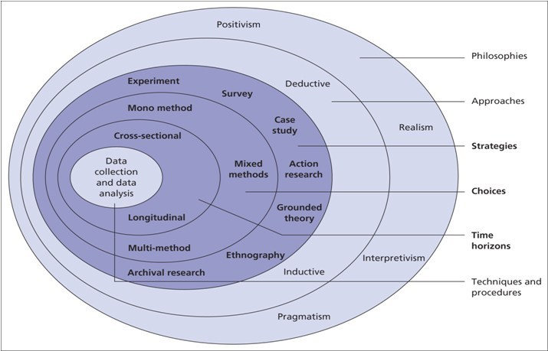
Figure 3.1 The Research Onion, highlighting the process selected by the researcher (Saunders et al., 2016).

3.3.1 Philosophy

Philosophy allows an understanding of the research design and enables a clear view on limitations (Easterby-Smith et al., 2012). Positivism and interpretivism are two philosophies of research methodology, positivism favours quantitative data while interpretivism prefers qualitative data (Alharasheh and Pius, 2020). The present study favours positivism through the selected survey method of data collection. A small number of interpretivist questions were included for further clarification on perspective (Desai and Reimers, 2018).

3.3.2 Approach

An inductive and deductive approach has been selected to gather detailed research through observations of literature similar to the topic of interest from which identifications and predictions can be made (Hayes, 2005). This will provide indication toward patterns demonstrating commonalities or contrast to allow appropriate connections to be made (Bernard, 2011). This approach was adopted in the study as it is concerned with understanding human behaviour and the meaning behind ‘the customer is always right’, which can be investigated through analysing socially constructed ideas (Collis and Hussey, 2014).

The mixed-method of data collection outlines statistical analysis and highlights common themes that can enable data analysis in further depth (Kuckartz and Rädiker, 2019) than closed-questions only (Almedia, 2018).

3.3.3 Strategy

Survey research is a method of collecting and analysing data (Patten, 2016). This research has used surveys to collect views of the public regarding opinion (DeFranzo, 2020) on the phrase ‘the customer is always right’. The inductive survey questions provided an opportunity for depth (Creswell, 2013) and formed contribution towards recommendations for future study. Quantitative data provides fixed and measurable realities (McLeod, 2019). Surveys were selected as the most appropriate choice due to the ease of result comparisons to be made and the benefit of ease in distribution to the audience required (Callegaro and Yang, 2017) however it is recognised that survey research can be considered tedious (Baker, 2017).

The questionnaire style surveys were created using Google Forms then shared online through social media platforms (e.g. LinkedIn, Facebook) to potential participants who were then informed of the rationale for study and provided with contact details of the researcher should further information or discussion regarding the study be required.

3.3.4 Choice

The positivist mixed-method approach favours collection of quantitative data (Shorten and Smith, 2017). The survey had adopted a quantitative approach, however, does expect a small amount of qualitative response via open-ended survey questions. The quantitative survey method collects data for statistical analysis to aid analysis of conclusions surrounding the research question (Albers, 2017).

3.3.5 Time Horizon

The present study uses cross sectional research due to the timeframe provided. Cross sectional research is low cost and a relatively quick approach to collecting data. It provides opportunity for further research however differing timeframes can affect results (Wang and Cheng, 2020).

3.4 Techniques for Data Collection, Processes and Analysis

3.4.1 Data Collection

Primary research involves the collection of new data by the directly involved researcher to gather information addressing a problem (Driscoll, 2011). Mixed-method had been selected for the present study. It is acknowledged that the use of mixed-method data collection produces results that are more in depth, as participants are provided the chance to express their thoughts in detail (Tomas, 2017). Survey research has a reduced potential for bias as many questions are standardised however the input of a small number of open questions had been selected (Caughey et al., 2020), although it is recognised that respondents may not wish to type an answer and would rather select from the multiple-choice answers (Schmidt, Gummer and Robmann, 2020) which is equally welcomed.

3.4.2 Questionnaire Design and Literature Review Matrix

The purpose of a survey is to collect data that will contribute to answering the question or objectives of research (Ghauri et al., 2020). This study includes sixteen questions; four demographic, two open and the remainder closed. The use of closed questions allows responses to be analysed with ease to provide clear findings through prompt for participant response gathering definite answers (Desai and Reimers, 2018). Closed questions allow the participant to answer to which extent they agree with a statement in a clear, precise manner. However, closed questions do not provide space for participant generated data therefore included in the survey were two open questions prompting for a response to answer the research question in participant’s own opinion. Consideration was given to the extent closed questions contribute to answering the research objectives, the closed questions allow for clear opinion however for further research open ended questions were included. A copy of the questionnaire can be seen in appendix 1.

Table 3. 1: Questionnaire and Literature Review Matrix
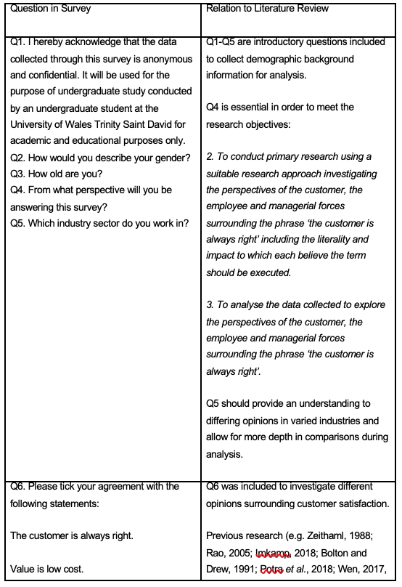
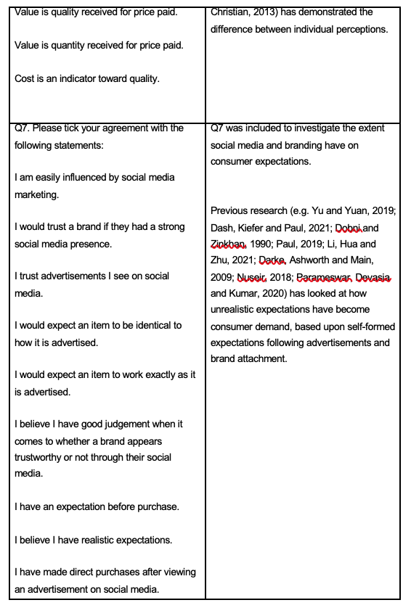
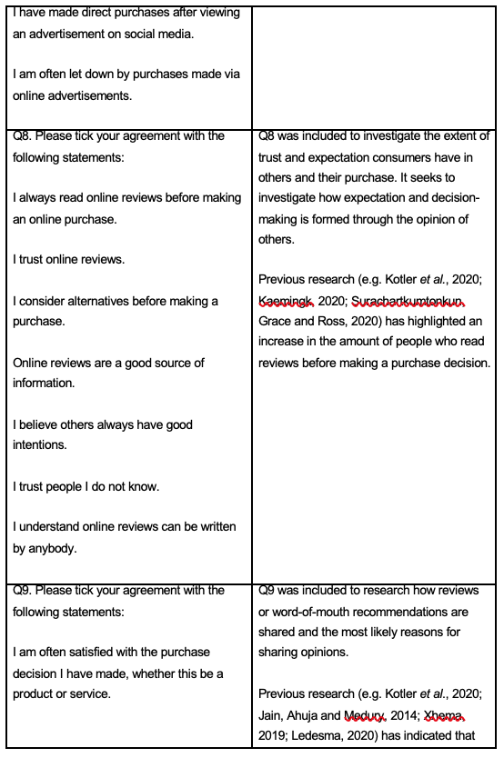

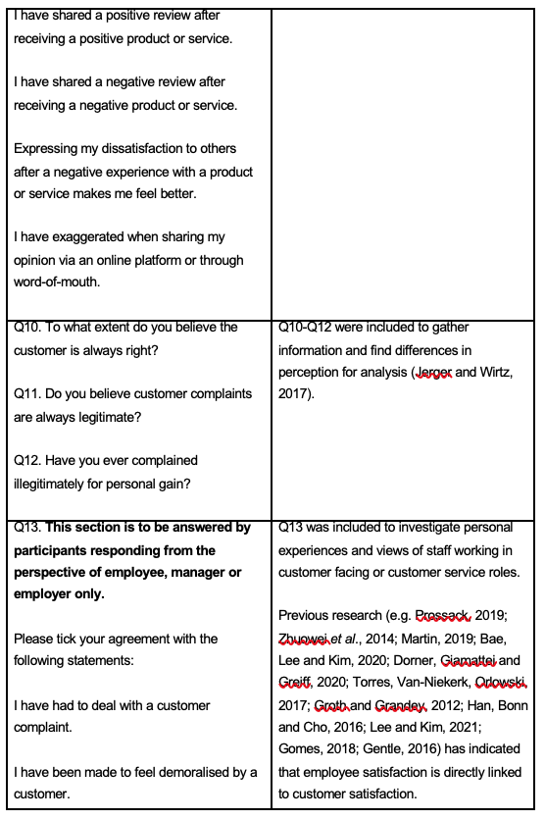

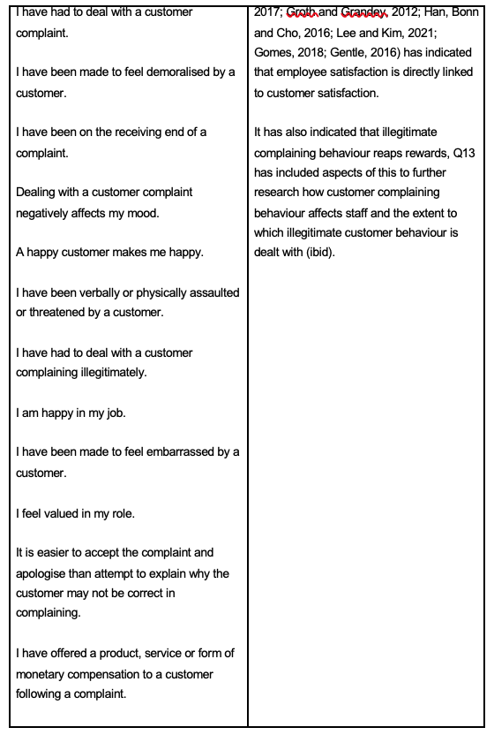
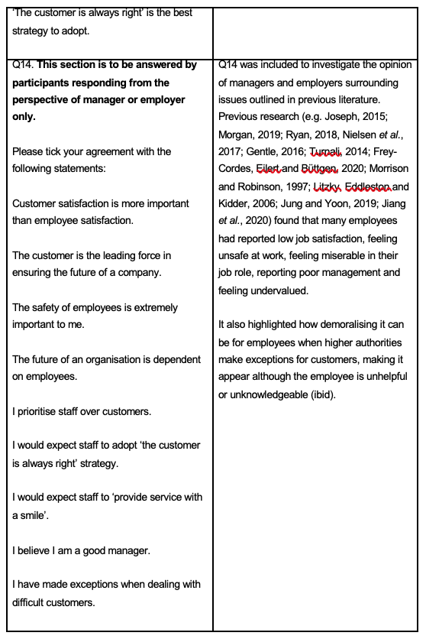

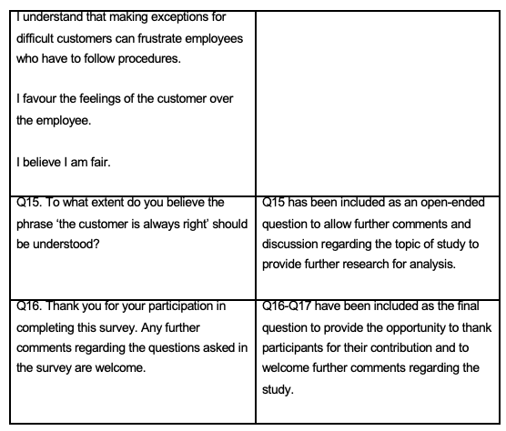

3.4.3 Pilot Study

A pilot study is a trial for data collection that provides the opportunity for feedback on the adopted research method before the substantive study takes place (Malmqvist et al., 2019). The pilot study selected a convenience sample.

3.4.4 Data Analysis

The findings are displayed using tables and figures analysed through Statistical Package for the Social Sciences (SPSS). SPSS has been selected to display key findings. The key findings are presented in an appropriate manner in chapter four, highlighting the most significant SPSS findings including Chi-Square and Crosstabulation tests where common themes are identified (Zamaew, 2015).

3.3 Sample

The two sampling methods ‘probability’ and ‘non-probability’ are appropriate for the sample (Yang, Kim and Song, 2020) as both apply to the perceptions required to investigate the research aims and objectives. The target sample size was a minimum of 100 participants. The population of the study being relatively general would expect the questionnaire to be efficient and have the potential to collect a large variety of results within the timeframe (Jager, Putnick and Bornstein, 2017) as reaching out to a large range in search of information from the perceptions required in the research would be widely available. It is acknowledged that non-probability samples can ensue difficulty in knowing how well the target population of study has been met (Allen, 2017) however that does not largely apply to the target demographic of the present study.

3.4 Reliability and Validity

Reliability is the faith one can have in the obtained data; if it is replicable it is reliable (Mohain, 2017). Validity is the accuracy in the way findings are represented (ibid).

The reliability and validity of data collected are important elements of study (Hayashi, Abib and Hoppen, 2019) and essential considerations during evaluation of the research. It is important that the results gathered have both high validity and high reliability, the research has maintained consistency with the variable being the participant. The research has been conducted to ensures fairness and consistency amongst participants (Bontemps and Orozco, 2020) however, some questions do require to be answered only by respondents answering from the perspective of manager or employer, or employee which will alter the experience some candidates have in answering the study. The study assumed a parametric response which prior research in the literature review contributed to.

3.5 Limitations and Ethical Considerations

3.5.1 Time Management

Due to the nature of study a timeframe was in place. This timeframe may limit the amount of research carried out which may affect the amount of data available to analyse.

3.5.2 Limitations

The proposed samples should sufficiently represent the population required due to the vast nature of the population of interest. The samples were selected as most fit for purpose and effective to implement within the time frame. The risk of bias is potential with some individuals but with a suitably large number of participants this should not disadvantage the research.

3.5.3 Ethical Considerations

The research was only conducted with persons over the age of 18. The topic is intended to explore customer service perspectives, the research should not cause any psychological harm to participants or probe in to feelings of un-comfort or distress. Due to the COVID-19 pandemic considerations for the wellbeing and safety of the researcher and participants meant that all research was to be carried out online in line with government and safety advice (Lobe, Morgan and Hoffman, 2020). The research aligns with the ethical standards of UWTSD and an ethics approval form has been completed.

3.6 Conclusion

This chapter has achieved the second objective:

“To conduct primary research using a suitable research approach investigating the alternating perspectives surrounding the phrase ‘the customer is always right’ including the extent which each believe the term should be executed.”

Chapter three has successfully identified research methodology appropriate for the present study and provided justification. The following chapter will analyse and discuss the collected data.

4. Chapter Four: Data Analysis

4.1 Introduction

The previous chapter achieved the second objective of study through identification and justification for the approaches selected for the study.

This chapter will achieve the third and fourth objective:

“To analyse the data collected to explore the perspectives of the customer, the employee and managerial forces surrounding the phrase ‘the customer is always right’.”

“To explore through analysis of primary research the impact the phrase ‘the customer is always right’ has on the employee.”

This will be achieved by analysing the data collected using a Statistical Package for the Social Sciences (SPSS). SPSS will support in the analysis and discussing the collected quantitative data.

4.2 Data Analysis

Data analysis is the process whereby data is applied using statistical or logical technique in order to describe, understand, view and evaluate data (Shamoo and Resnik, 2009). This stage of research can distinguish the significant findings from the other fluctuations found in data (ibid). The quantitative data from study was analysed using the IBM SPSS statics software package. The functions used were crosstabulations Chi-Square association tests. The data was presented in numerous forms including graphs and charts. The full SPSS analyses can be seen in appendix 2.

4.3 Methods

Participants were categorised by their age, perspective of response, and industry worked in to investigate significant differences between responses to be linked back to the discussion in chapter two. Respondents who did not select the available options and chose to type their answer were removed from the data as many had duplicated the option they could have selected, these were removed for simplicity and to produce clearer data (Buchanan and Scofield, 2018; Google Analytics, 2021).

4.4 Demographics and Descriptive Statistics

The study received 135 voluntary respondents all above the age of 18 years old. The participants took an interest in the research after viewing it on the online platforms selected for distribution (e.g. LinkedIn, Facebook).

Figure 4.1 to 4.4 demonstrate the demographic frequencies of the respondents from gender, age, perspective answered from and industry worked in.

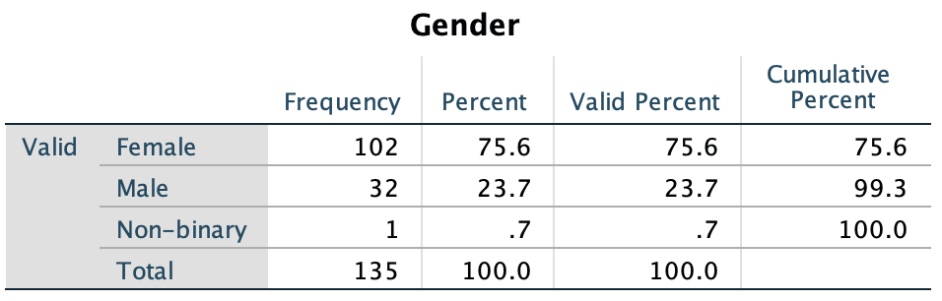
Figure 4. 1 Chart showing gender of respondents.

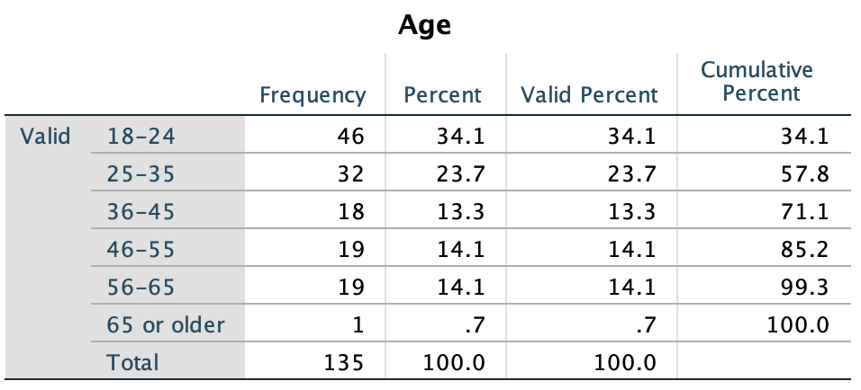
Figure 4. 2 Chart showing the age of respondents.

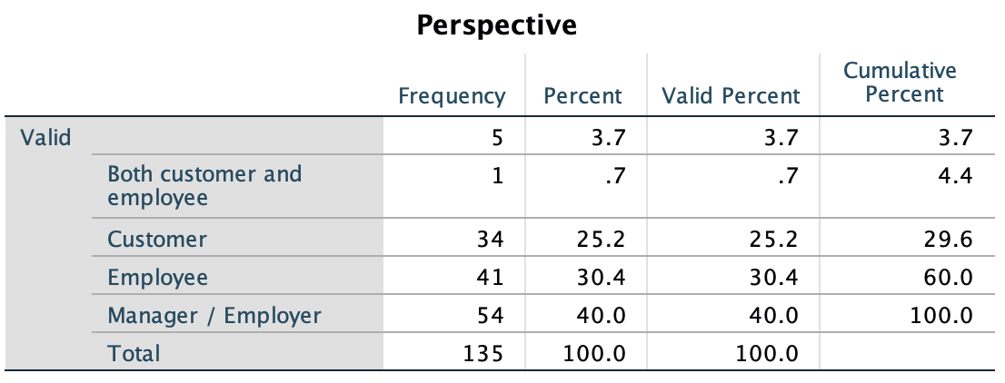
Figure 4. 3 Chart showing frequencies of perspective respondents answered from.

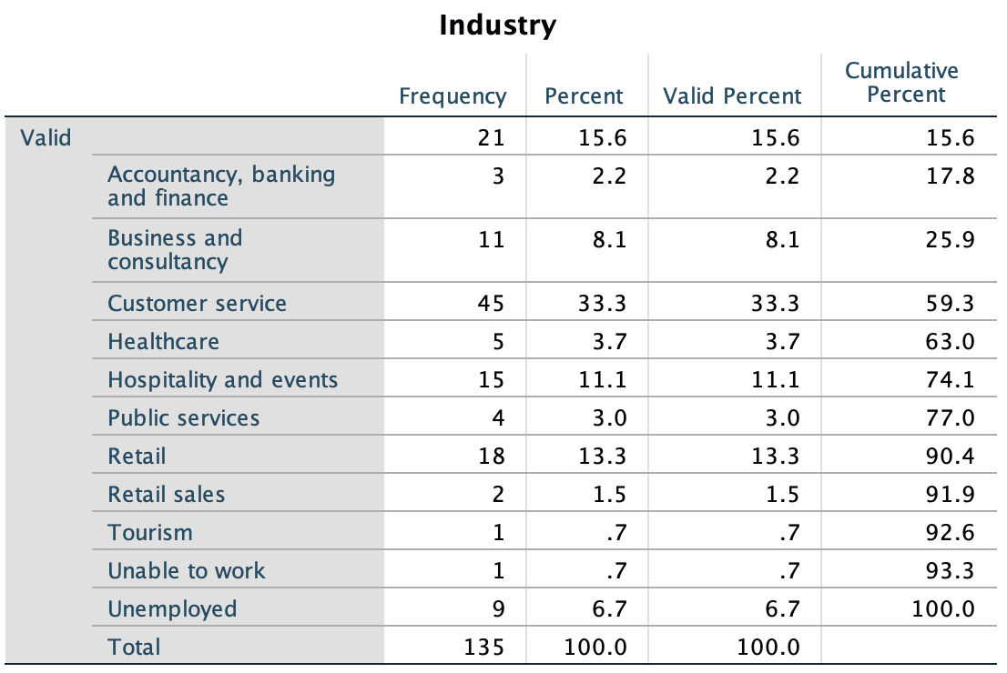
Figure 4. 4 Chart showing frequencies of industry respondents worked in.
Figure 4.5 shows the extent participants agreed that the customer is always right. This has been analysed further throughout the chapter.
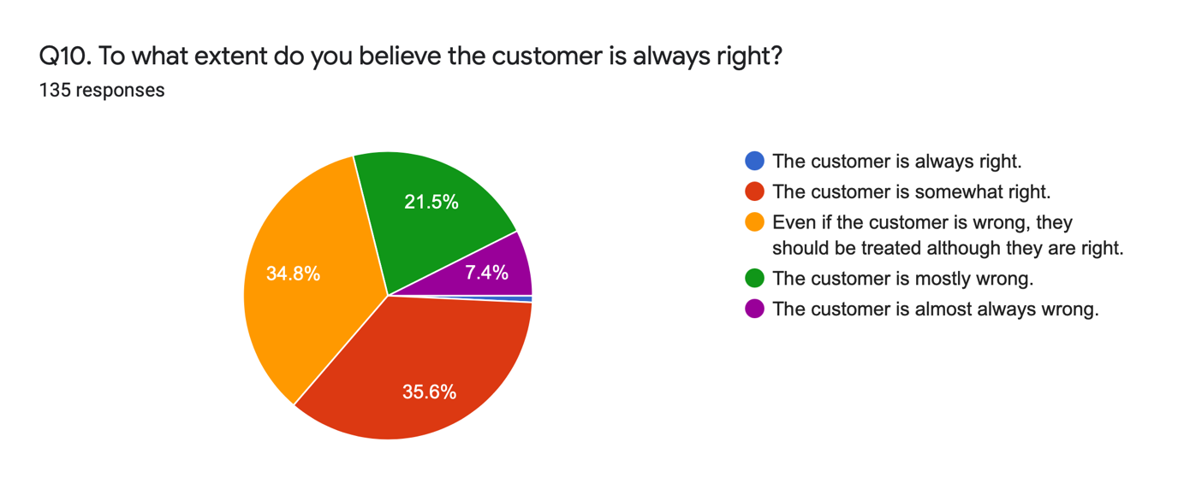
Figure 4. 5 Chart showing agreement with extent ‘the customer is always right’ should be followed.

4.5 Chi-Square Analysis

Chi-Square analyses were conducted to investigate statistical associations between the perspective answered from and personal opinion, or agreement with statements. The crosstabulations for each Chi-Square can be found in appendix 2.

4.5.1 Chi-Square Analysis for Perceptions

Figure 4.6 and 4.7 (below) show a significant association between perspective answered from and answer to Q6. For ease of reference, refer to appendix 3 for the list of questions.

The results show that the highest levels of disagreement with the statement ‘the customer is always right’ came from respondents who were employers or managers. The highest level of disagreement with the statement came from respondents who were employees. The highest level of agreement with the statement came from those who answered from the perspective of a customer. This was unsurprising based on the information discussed in the literature of chapter two.

- 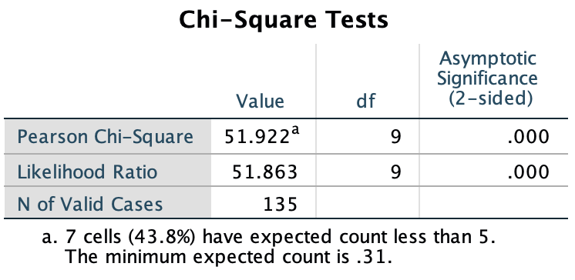
Figure 4. 6 Chi-Square test Q4 and Q6, showing significant association between perspective answered from and opinion in response to ‘the customer is always right’. (p=.000).

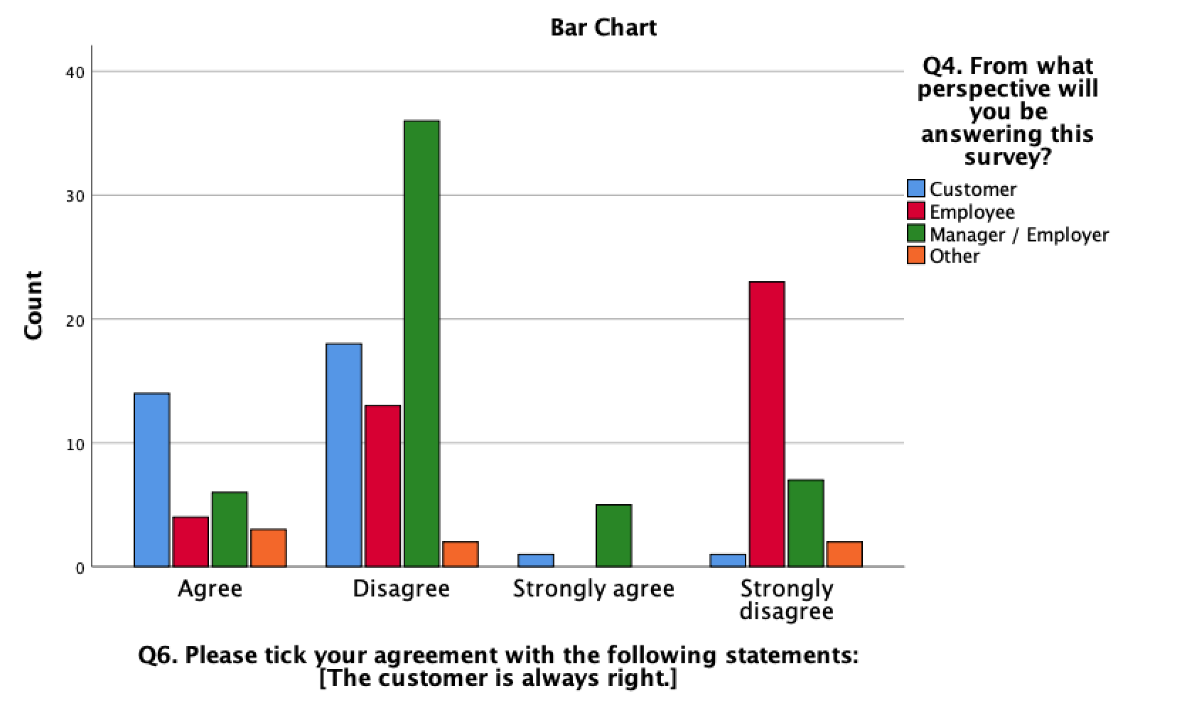
Figure 4. 7 Chart showing significant association between perspective answered from and opinion in response to ‘the customer is always right’. (p=.000).

4.5.2 Chi-Square Analysis for Industry

Figure 4.8 and 4.9 (below) show a significant association between industry worked in and answer to Q6.

The results show that the highest levels of disagreement with the statement ‘the customer is always right’ came from participants who worked in customer service. These participants also contributed to the highest level of strong disagreement with the statement. This is synonymous with literature discussed in chapter two (Torres, Van-Niekerk and Orlowski, 2017).

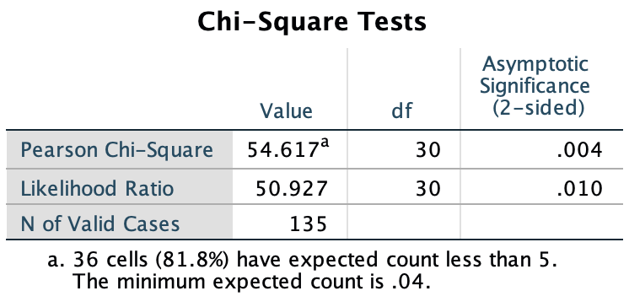
Figure 4. 8 Chi-Square Test Q5 and Q6, showing significant association between industry worked in and opinion in response to ‘the customer is always right’. (p=.004).

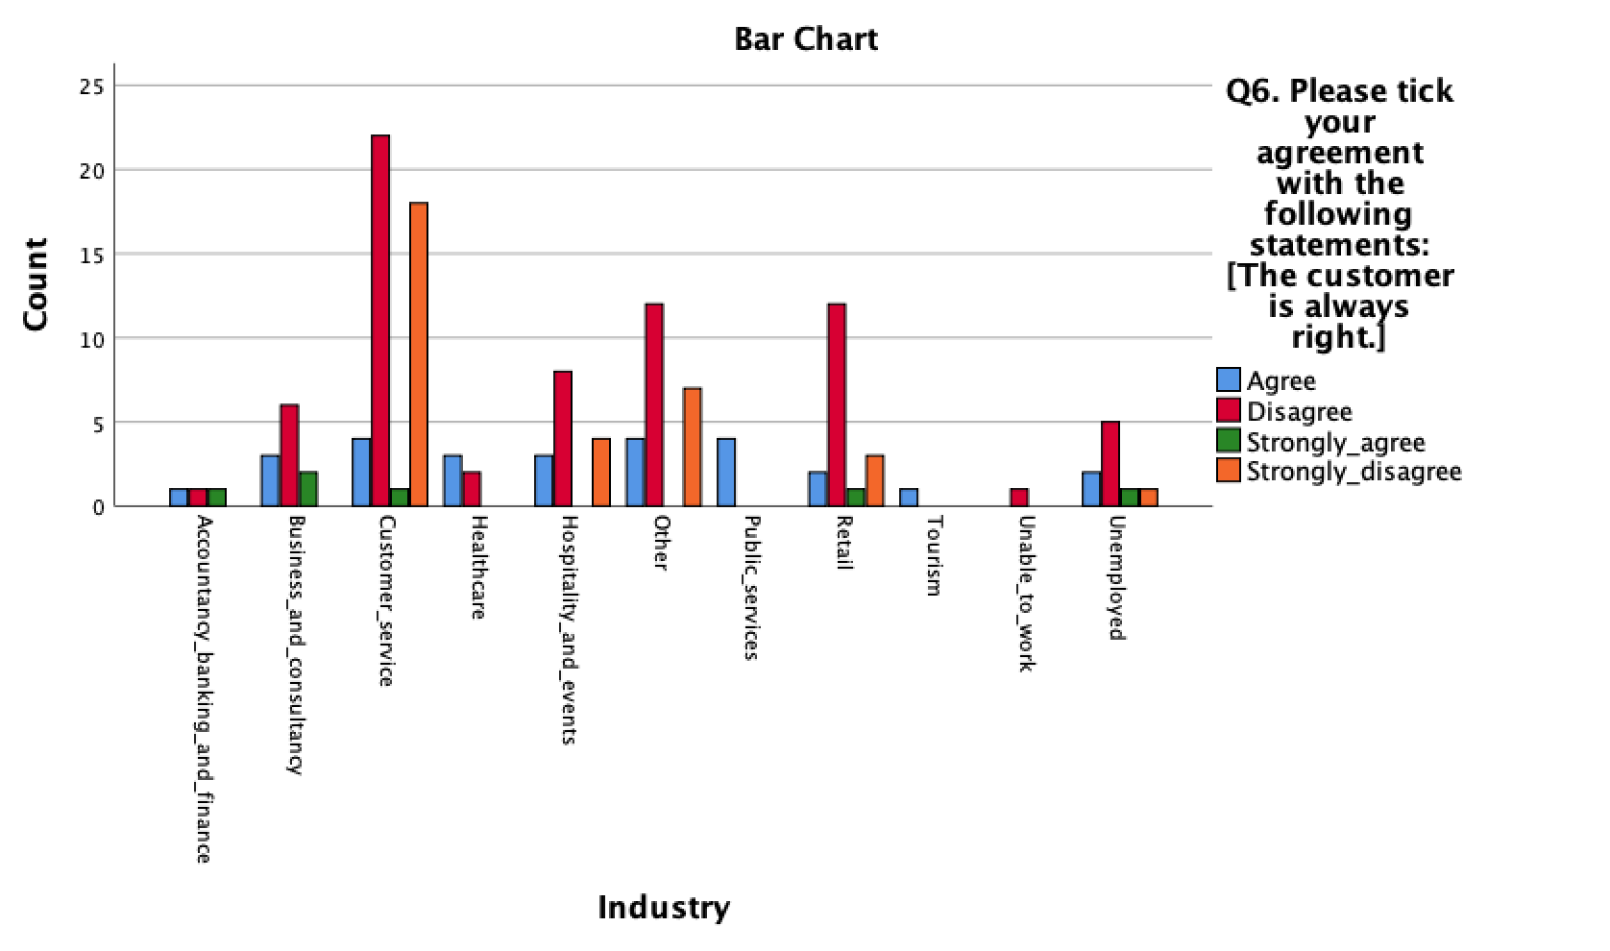
Figure 4. 9 Chart showing significant association between industry worked in and opinion in response to ‘the customer is always right’. (p=.000).

4.5.3 Chi-Square Analysis for Age

Figure 4.10 and 4.11 demonstrate a significant association between age and answer to Q6. The 18-24 age demographic, followed by the 25-35 age demographic responded with the highest levels of disagreement in response to the phrase ‘the customer is always right’.

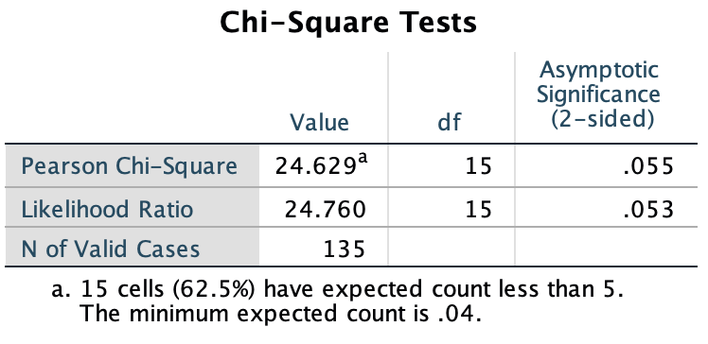
Figure 4. 10 Chi-Square test for Q3 and Q6 showing significant association between age and opinion in response to ‘the customer is always right’. (p=.055).
- 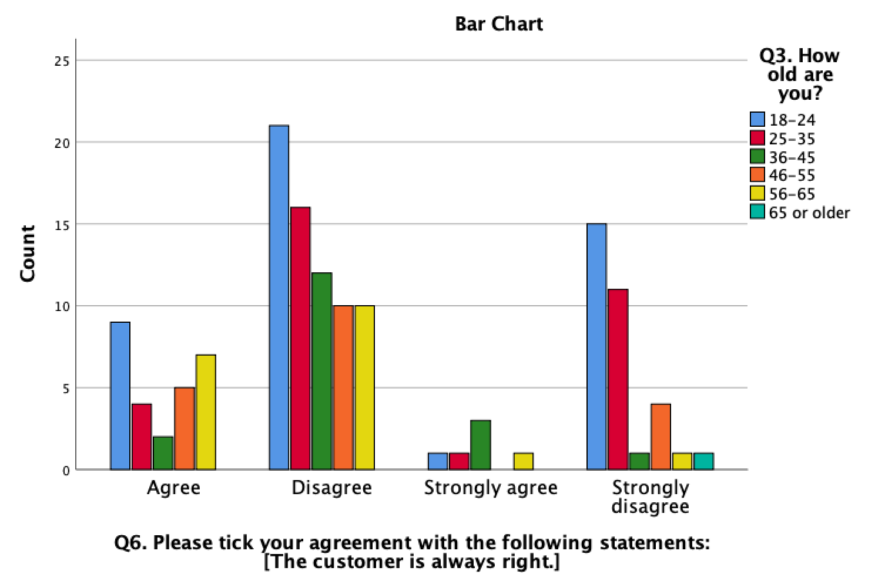
Figure 4. 11 Chart showing significant association between age and opinion in response to ‘the customer is always right’. (p=.055)

4.5.4 Chi-Square Analysis for Opinion

Figure 4.12 and 4.13 show a significant association between Q4 and Q10.

The data shows that although the manager or employer participants disagreed the most with the statement ‘the customer is always right’, that demographic showed the highest level of agreement that the customer should be treated although they are right even when they are not, similar to the literature by Jerger and Wirtz (2017) indicating that one party must accept wrongful doing even if they did not agree with it. These respondents also agreed to nearly the same extent as the customer that the customer is somewhat right. The highest levels of agreement that the customer is almost always wrong or mostly wrong was from the respondents answering from the perspective of an employee.

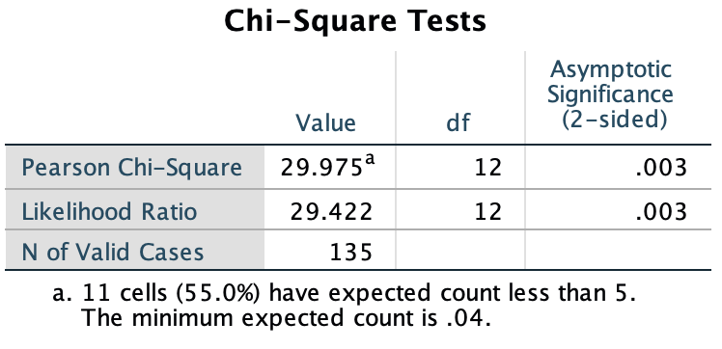
Figure 4. 12 Chi-Square test for Q4 and Q10 showing significant association between perspective answered from and opinion in response to ‘To what extent do you believe the customer is always right. (p=.003).

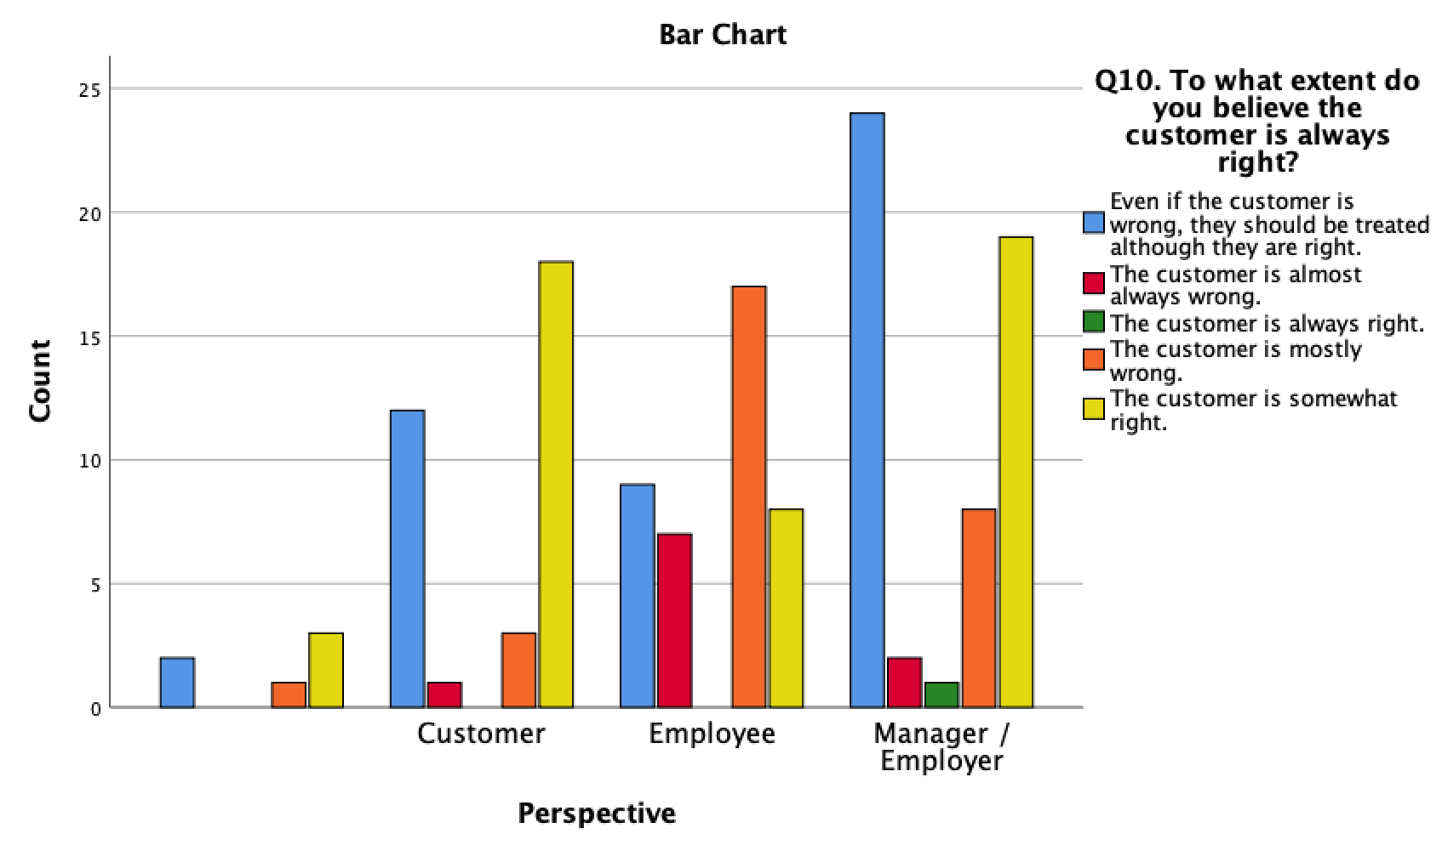
Figure 4. 13 Chart showing significant association between perspective answered from and opinion in response to ‘To what extent do you believe the customer is always right?’ (p=.003).

Figure 4.14 and 4.15 demonstrate a significant association between perspective answered from and opinion in regard to personally complaining illegitimately. Only 7 of 135 participants answered yes that they had complained illegitimately for personal gain and all 7 had answered from the perspective of a customer. This demonstrates significance also to the literature (Huang et al., 2014; Martin, 2019, Bae, Lee and Kim, 2020) where it was highlighted that some customers were aware that many organisations would simply accept the complaint and offer a form of compensation with little investigation into the legitimacy, meaning they are able to get away with illegitimate complaining behaviour for personal gain. This was a theme found in the qualitative analysis also, as shown below. All full written responses can be seen in appendix 4.

P17: ‘there could be many illegitimate claims, or people looking for compensation’.
P32: ‘if I complain enough even if not true, I’ll get free service or product or I’ll get you fired!’
P39: ‘problematic customers treating staff poorly or complaining frequently as they know they will get their way in the end.’
P84: ‘When the customer is clearly lying’ ‘to gain items for free, then they are not right.’ ‘I have had to deal with people like this daily’.

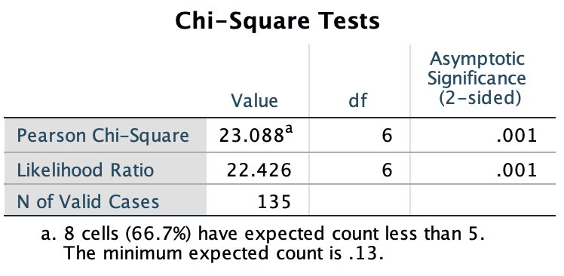
Figure 4. 14 Chi-Square test for Q4 and Q12 showing significant association between perspective answered from and opinion in response to ‘Have you ever complained illegitimately for personal gain?’ (p=.001).

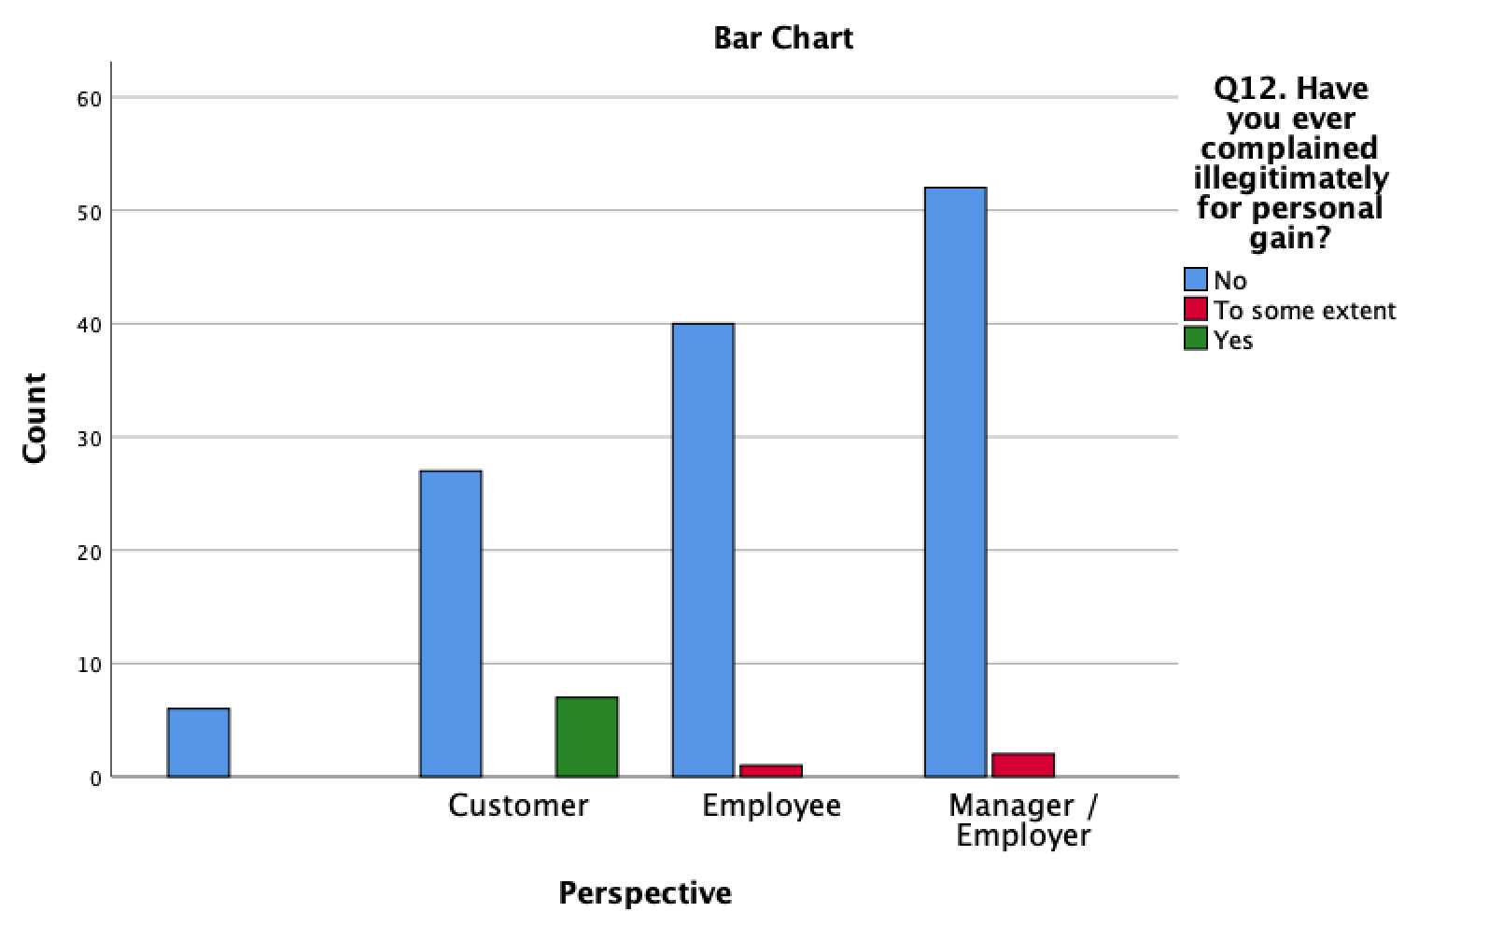
Figure 4. 15 Chart showing significant association between perspective answered from and opinion in response to ‘Have you ever complained illegitimately for personal gain?’ (p=.001).

4.6 Crosstabulation

Figure 4.16 shows a negative association between Q4 and Q11. Although those answering from the perspective of manager or employer and employee reported the highest levels of distrust in customer complaints, the p value = .735 showed this comparison between respondent demographics was insignificant.

- 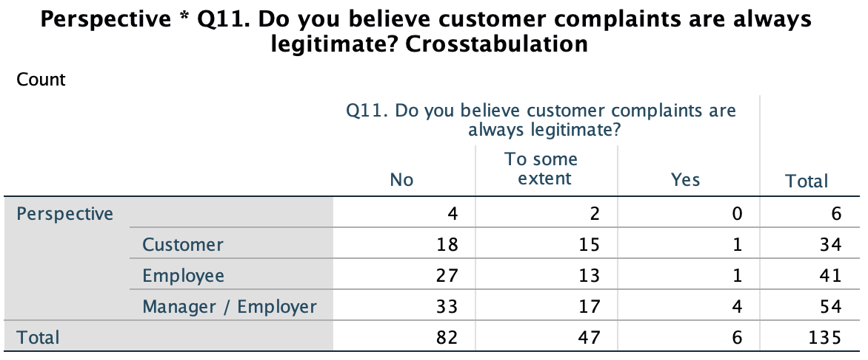
Figure 4. 16 Crosstabulation showing negative association between perspective answered from and opinion in response to ‘Do you believe customer complaints are always legitimate?’ (p=.735).

Q14 required response from participants answering from the perspective of manager or employer only. Figure 4.17 demonstrates a significant association between industry worked in and opinion of manager or employer in regard to expecting staff to adopt ‘the customer is always right’ strategy. The p value = .027 (Chi-Square can be seen in appendix 2) showed that the comparison between industry was significant. The customer service industry employers or managers had the highest level of agreement with the statement which aligns with much of the literature in chapter two (Joseph, 2015; Gomes, 2018; Morgan, 2019) indicating that the phrase should be followed even when it is not completely agreed with. This also aligns with the qualitative data analysed, as shown below. See appendix 4 for full written responses.

P31: ‘Sometimes the best thing to do is give them what they want so they will leave’.
P48: ‘Even if the customer is not right normally they will get what they wanted to an extent.’
P77: ‘Making the customer happy does not mean that they are right.’
P82: ‘The customer isn't always right, but at the end of the day, the customer is the customer.’
P88: ‘Easier to give them what they want than risk a bad review or complaint to corporate.’

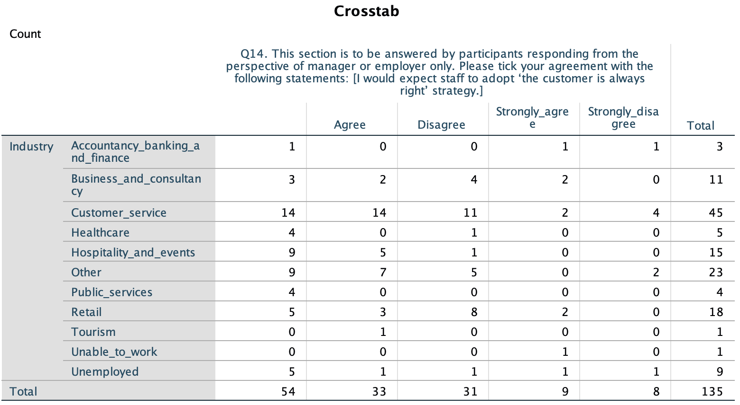
Figure 4. 17 Crosstabulation showing significant association between industry worked in and opinion of manager or employer in response to ‘I would expect staff to adopt ‘the customer is always right’ strategy’. (p=.027).

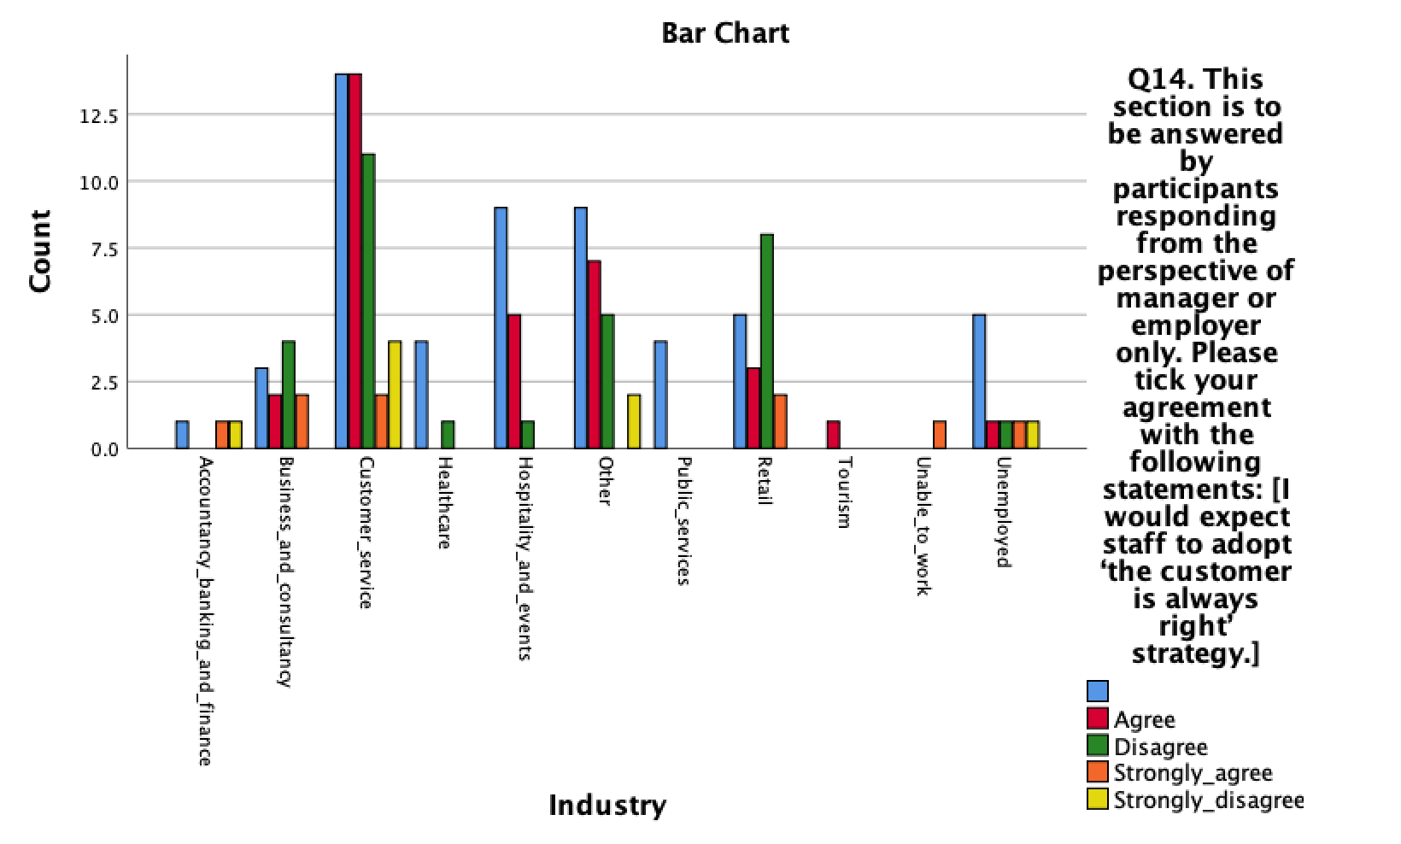
Figure 4. 18 Chart showing significant association between industry worked in and opinion of manager or employer in response to ‘I would expect staff to adopt ‘the customer is always right’ strategy’. (p=.027).

4.7 Discussion and Descriptive Analysis

This section of the chapter will discuss data descriptively. This method of discussion for these responses was selected as it allows for discussion of detail (Trochim, 2020) from questions asked to gain further understanding and provoke further comparison (Foddy and Foddy, 1994; Lohr and Raghunathan, 2017). The full list of questions asked as part of Q13 can be found in appendix 3. The full written responses can be seen in appendix 4. Only a select amount of collected data with most relevance to chapter two will be discussed in this section.

Out of the 135 respondents, 95 answered from the perspective of an employer, manager or employee. 92% strongly agreed that they had dealt with a customer complaint, 69% strongly agreed that they had been made to feel demoralised by a customer, 57% strongly agreed that dealing with a customer complaint negatively affects their mood, 77% strongly agreed that a happy customer makes them feel happy, 66% strongly agreed that they had been verbally or physically assaulted or threatened by a customer, and 72% strongly agreed that they have had to deal with a customer complaining illegitimately. All data collected in this section of the research aligns with previous literature (Morrison and Robinson, 1997; Litzky, Eddleston and Kidder, 2006; Grandey et al., 2019; Jung and Yoon, 2019; Prossack, 2019; Union of Shop Distributive and Allied Workers, 2019; Taylor, 2020; Bailey, 2020; Nwosu and Ogunvemi, 2020).

Despite 72% strongly agreeing that they have had to deal with a customer complaining illegitimately, 87% responded either strongly agree or agree that it is easier to accept the complaint and apologise than explain why the customer may not be correct. This was reoccurring within the written response.

P:11 ‘I think you should treat customers as they are right but they aren’t actually always right’.
P27: ‘The customer is not always right, but the employee should be gentle and comprehensive anyway’.
P33: ‘It’s easier to go along with the customer to keep them happy’.

This also correlates with the general response received from all participants in Q8 whereby participants were asked questions surrounding preconceived perceptions before purchase and correlates with the literature (Bae, Lee and Kim, 2020). 78% either strongly agreed or agreed that they would always read online reviews before making a purchase, 65% either strongly agreed or agreed that they would trust online reviews, 70% claimed that online reviews were a good source of information and 60% strongly agreed that they understood online reviews can be written by anybody. However, the participants also responded by 56% that they did not believe others had good intentions and by 55% that they did not trust people they do not know. This suggests contradiction and is synonymous with the literature discussed in chapter two (Surachartkumtonkun, Grace and Ross, 2020; Schoenmueller, Netzer and Stahl, 2020; Kaemingk, 2020). Figure 4.19 demonstrates this.
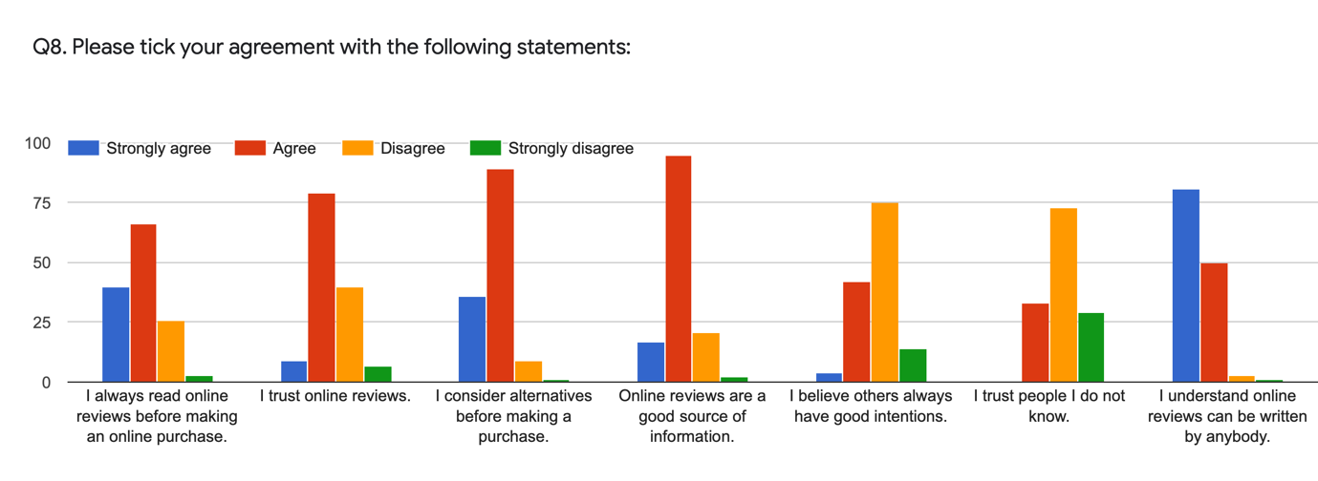
Figure 4. 19 Chart showing participant agreement with statements in Q8.

4.8 Conclusion

This chapter has successfully achieved the third and fourth objectives of study: “To analyse the data collected to explore the perspectives of the customer, the employee and managerial forces surrounding the phrase ‘the customer is always right’.”

“To explore through analysis of primary research the impact the phrase ‘the customer is always right’ has on the employee.”

These objectives have been met through analysing the data collected using SPSS. The final chapter will achieve the final objectives of the study which include recommendations for future research in the topic or for the use of respondents in future, it will also highlight potential avenues for further study with consideration to the limitations in the present study.

5. Chapter Five: Conclusions and Recommendations

5.1 Introduction

The previous chapter successfully achieved the third and fourth objectives of the study. The final chapter will achieve the final objectives of study:

“To understand the findings of the research, making recommendations for future research in the topic or for the use of the respondents moving forward when taking consideration to adopt the phrase ‘the customer is always right’.”

To highlight potential avenues for further study, providing knowledge of limitations to the present study.

There will be an additional section on self-reflection.

5.2 Summary of Main Findings

The main findings of the study were synonymous with the literature discussed in chapter two. The highest levels of disagreement with the statement ‘The customer is always right’ were from respondents answering from the perspective of manager or employer, or employee. The highest level of agreement with the statement was from those answering from the perspective of a customer. Although these levels of disagreement or agreement were unsurprising, it was found that the manager or employer participants had the highest levels of agreement that the customer should be treated although they are right even when they are not.

A significant association was found between perspective answered from and opinion in response to personal illegitimate complaining behaviour. It was found that the customer perspective were the only respondents to admit to illegitimately complaining for personal gain. Participants responding from the perspective of manager or employer, and employee, responded with the highest disagreement (73%) that they believe customer complaints are always legitimate. However, the majority (87%) of these participants responded that it was easier to accept a complaint and apologise than explain why the customer may not be correct.

5.3 Implications of Research

Research can be described as a tool for building knowledge, and increasing awareness of issues (Lukovics et al., 2019). Madan and Teitge (2013) explained research can address issues and create exposure which contributes to the facilitation of a solution.

The current study has highlighted how individuals working in customer facing roles often put their own thoughts and feelings aside to make situations easier for all parties involved, although they may not believe this is right. The abundance of own feeling for the benefit of others although against will demonstrated itself as a common theme throughout the study. The implication of this using the literature review and data collected in the study potentially suggests that there are many workers in similar situations whereby constantly supressing their own emotion to appeal to or improve the experience of another is a day-to-day occurrence. The long-term implication for these workers could be detrimental to their mental health, physical health and self-satisfaction (Clercq et al., 2018; Nadin, 2020) as suppression of emotion can cause physical stress on the body (Cousins, 2018). This has real-world implications to numerous people in employment who deal with customers each day. Until there is a respect or understanding to those who mistreat customer facing workers then many individuals may face the long-term complications previously mentioned. The recommendations, which will be discussed in the next section, will highlight how these implications could be improved.

5.4 Recommendations

Following the study, a number of recommendations can be made. It is important to stress that understandably not everything can be perfect at all times and there will be times and situations whereby somebody will feel they need to express dissatisfaction. However, the mistreatment and emotional impact that the majority of manager or employer, or employee respondents to the study reported would suggest that it is a real-world problem.

It may be helpful to raise awareness of the impact mistreatment of customer-facing workers can have on their mental health, physical health and overall self-satisfaction (Press Association, 2020). In the case of discussion in chapter two and the research collected during the present study the figures reported could be considered shocking in regard to the number of respondents who had been abused in some form at their workplace by a customer. The adoption of ‘the customer is always right’ could be reasonably adjusted to consider that in many cases, they are not.

It could be considered the duty of manager or employers to favour the thoughts and feelings of their employees than that of the customer, taking consideration to the high levels of reported abuse. It could be questioned how ‘the customer is always right’ when they are demoralising, verbally or physically assaulting or threatening staff. The recommendation to consider morally whether the customer should be treated although they are right when they have made a worker feel uncomfortable or upset should be considered by managers or employers. As stated by previous work, it is more beneficial to maintain happy staff than retain a bad customer (Florentine, 2019). It should be assessed on an individual basis whether ‘the customer is always right’ should be adopted when dealing with a complaint or situation. It is understood that customer service is an extremely important aspect of modern-day organisations (Hudson and Hudson, 2017) yet there should be other options when providing good customer service than to simply accommodate and accept unruly behaviour (Tidey, 2019). In the situation of an employee being rude to a customer, there would be repercussions. However, rude customers appear to claim benefit (Reynolds and Harris, 2005; Huang et al., 2014; Arora and Chakraborty, 2021). Consideration should be taken as to when it is appropriate to favour the feeling of a customer over that of an employee.

5.5 Limitations

The present study faced a few limitations. Ross and Zaidi (2019) state that being honest and highlighting limitation can ensure research remains in context so findings are not minimised or overemphasised.

The research was conducted during the COVID-19 pandemic. This limited the initial plan to use a multi-method approach, therefore only quantitative data was collected. This perhaps reduced the depth of findings in the study. Sen-Crowe et al. (2020) highlighted the impact on inability COVID-19 has had due to remote working, online teaching and widespread adoption of telecommunication.

The adoption of a convenience sample could be considered a limitation to the present study as it is generally criticised as non-representative of the population (Etikan, Musa and Alkassim, 2015). However, this was considered appropriate given the nature of study, and due to external limitations to be discussed next.

A final limitation is that the researcher faced time constraint and a maximum word count constraint. As the research was conducted as an undergraduate dissertation the time frame consisted of a mere few months. This limited the amount of time the questionnaire could accept response. A maximum word count constraint in place was part of the reason a more in-depth qualitative analysis was not carried out and the quantitative method was favoured during discussion.

5.6 Recommendations for Future Study

It would be advantageous for future research to attempt to resolve the limitations of the present study. As a start, interviews could produce more in-depth qualitative data to make up for the small amount available in the present study. Interviews would allow qualitative analysis and collect more information on real-life scenarios to gather common themes contributing to abuse towards workers, or common themes in regard to why complaints are received across industries. It could also be insightful to collect more information into illegitimate complaining behaviour, as the present study found a significant association with perception answered from and illegitimate complaining for personal gain. It could be interesting to speak fluently with that demographic to explore further whether the association extends if there were to be a larger demographic response.

It could also be interesting for further study to recruit more male participants, as the present study received a majority female response meaning there may be gender bias (Praveen, 2015). However, this was likely due to the limitation of the convenience sample adopted as previously discussed.

5.8 Self Reflection

The researcher aimed to investigate the customer service concept ‘the customer is always right’, with focus on the perception of workers. The researcher was interested in investigating this further as there is mass research into the concept in regard to the customer perspective and in regard to providing customer service, yet a lack of literature interested in the concept from the alternative perspective of managers, employers or employees. The study has been successful in meeting the objectives outlined at the beginning and end of each chapter.

The researcher has developed skills using SPSS and NVivo, and has demonstrated the ability to work and learn independently. The researcher has also used WordPress for the first time, where the dissertation has been shared (accessible at: marshatthomas.wordpress.com). It has been challenging at times due to restrictions and limitations of COVID-19 and the inability to attend face to face interaction with lecturers. Interruptions to the proposed data collection were difficult as it limited the study. However, the researcher has successfully achieved the objectives.

The researcher feels hopeful for the study that with increased awareness brought to the impact negative customer interaction can have on the worker, that the implications and recommendations discussed can contribute to improving the employment experience for those working in customer service or customer-facing roles.

5.9 Conclusion

This chapter has achieved the final objectives of study:

To understand the findings of the research, making recommendations for future research in the topic or for the use of the respondents moving forward when taking consideration to adopt the phrase ‘the customer is always right’.

To highlight potential avenues for further study, providing knowledge of limitations to the present study.

This study has analysed and evaluated the phrase ‘the customer is always right’ through engagement with employers and managers, employees, and the customer. It has used surveys as the method of data collection in order to understand the different perspectives. It has assessed the overall impact of this phrase and explored how literally it is expected to be adopted through exploring expectations of the service provider and the customer. The study has successfully met the initial objectives, finding that the manager or employer favoured ease and convenience of eradicating a negative customer experience with less regard to the impact this may have had on the employee first dealt with the complaint or abuse even when they did not agree with the customer. The common theme was that the customer should be treated although they are right even when they are not. The recommendations set out hope to change this or bring attention to the alternative perspective of the worker. The research has highlighted themes and potential issues to the way customer service has been modelled or is expected and how this could affect employees working within customer service or customer-facing roles.

6. Bibliography

Albers, M.J. (2017) ‘Quantitative Data Analysis-In the Graduate Curriculum’, Journal of Technical Writing and Communication, 47(2), pp. 215-233. Available at: https://doi.org/10.1177/0047281617692067 (Accessed: 28 February 2021).

Alharahsheh, H. and Pius, A. (2020) ‘A review of key paradigms: Positivism VS interpretivism’, Global Academic Journal of Humanities and Social Sciences, 2(3), pp. 39-43. Available at: https://gajrc.com/gajhss (Accessed: 30 November 2020).

Alharahsheh, H. and Pius, A. (2020) ‘A review of key paradigms: Positivism VS interpretivism’, Global Academic Journal of Humanities and Social Sciences, 2(3), pp. 39-43. Available at: https://gajrc.com/gajhss (Accessed: 28 February 2021).

Allen, M. (2017) ‘Sampling, Nonprobability’, The SAGE Encyclopedia of Communication Research Methods. Available at: https://dx.doi.org/10.4135/9781483381411.n538 (Accessed: 3 March 2021).

Arora, S. and Chakraborty, A. (2020) ‘Consumer Complaining Behaviour: a Paradigmatic Review’, Philosophy of Management, pp. 1-22. Available at: https://doi.org/10.1007/s40926-020-00148-8 (Accessed: 25 January 2021).

Arora, S.D. and Chakraborty, A. (2021) ‘Intellectual structure of consumer complaining behavior (CCB) research: A bibliometric analysis’, Journal of Business Research, 122, pp. 60-74. Available at: https://doi.org/10.1016/j.jbusres.2020.08.043 (Accessed: 27 April 2021).

Bae, G., Lee, S. and Kim, D.Y. (2020) ‘Interactions between Service Recovery Efforts and Customer Characteristics: Apology, Compensation, and Empowerment’, Journal of Quality Assurance in Hospitality & Tourism. DOI: 10.1080/1528008X.2020.1769523.

Bailey, J. (2020) Brussels Airlines Flight Attendant Slapped By Passenger. Available at: https://simpleflying.com/brussels-airlines-flight-attendant-slapped-by-passenger/ (Accessed: 5 February 2021).

Baker, R. (2017) ‘Big Data: A survey research perspective’, Total Survey Error in Practice, pp. 47-69. Available at: https://doi.org/10.1002/9781119041702.ch3 (Accessed: 3 March 2021).

Bernard, H. R. (2011) Research methods in anthropology: Qualitative and quantitative approaches. Lanham, MD: AltaMira.

Bishop, V. and Hoel, H. (2008) ‘The Customer is Always Right?: Exploring the concept of customer bullying in the British Employment Service’, Journal of Consumer Culture, 8(3), pp. 341-367. Available at: https://doi.org/10.1177/1469540508095303 (Accessed: 17 March 2021).

Bolton, R.N. and Drew, J.H. (1991) ‘A Multistage Model of Customers’ Assessments of Service Quality and Value’, Journal of Consumer Research, 17(4), pp. 375-384. Available at: https://doi.org/10.1086/208564 (Accessed: 22 January 2021).

Bontemps, C. and Orozco, V. (2020) ‘Toward a FAIR Reproducible Research’, Toulouse School of Economics, 1161, pp. 1-15. Available at: https://www.tse-fr.eu/sites/default/files/TSE/documents/doc/wp/2020/wp_tse_1161.pdf (Accessed: 27 November 2020).

Bontemps, C. and Orozco, V. (2020) ‘Toward a FAIR Reproducible Research’, Toulouse School of Economics, 1161, pp. 1-15. Available at: https://www.tse-fr.eu/sites/default/files/TSE/documents/doc/wp/2020/wp_tse_1161.pdf (Accessed: 28 February 2021).

Borna, S. and Stearns, J.M. (1998) The Philosopher Is Not Always Right: A Comment on "The Customer Is Not Always Right, Journal of Business Ethics, 17(1), pp. 39-44. Available at: https://www.jstor.org/stable/25073053 (Accessed: 18 January 2021).

Buchanan, E.M. and Scofield, J.E. (2018) ‘Methods to detect low quality data and its implication for psychological research’, Behaviour Research Methods, 50, pp. 2586-2596. Available at: https://doi.org/10.3758/s13428-018-1035-6 (Accessed: 18 April).

Callegaro, M. and Yang, Y. (2017) ‘The Role of Surveys in the Era of ‘Big Data’”, The Palgrave Handbook of Survey Research, pp. 175-192. Available at: https://doi.org/10.1007/978-3-319-54395-6_23 (Accessed: 28 February 2021).

Calvo-Porral, C., and Lévy-Mangin, J.P. (2017) ‘Store brands’ purchase intention: Examining the role of perceived quality’, European Research on Management and Business Economics, 23(2), pp.90-95. Available at: https://doi.org/10.1016/j.iedeen.2016.10.001 (Accessed: 20 January 2021).

Caughey, D., Berinsky, A.J., Chatfield, S., Hartman, E., Schickler, E. and Sekhon, J.S. (2020) ‘Target Estimation and Adjustment Weighting for Survey Nonresponse and Sampling Bias’, Cambridge University Press. Available at: https://doi.org/10.1017/9781108879217 (Accessed: 28 February 2021).

Clercq, D.D., Haq, I.U., Azeem, M.U. and Ahmad, H.N. (2018) ‘The Relationship between Workplace Incivility and Helping Behavior: Roles of Job Dissatisfaction and Political Skill’, The Journal of Psychology, 153(5), pp 507-527. Available at: https://doi.org/10.1080/00223980.2019.1567453 (Accessed: 27 April 2021).

Collis, J. and Hussey, R. (2003) Business Research: A Practical Guide for Undergraduate and Postgraduate Students, 2nd Ed., Macmillan: Basingstoke.

Collis, J. and Hussey, R. (2014) Business Research: A Practical Guide for Undergraduate and Postgraduate Students. 4th edn. Palgrave Macmillan.

Cousins, L.E. (2018) Are there downsides to always trying to be positive? Available at: https://www.hcf.com.au/health-agenda/body-mind/mental-health/downsides-to-always-being-positive (Accessed: 27 April 2021).

Creswell, J.W. (2013) Qualitative inquiry and research design: Choosing among five approaches, 3rd Edn. Los Angeles, CA: Sage.

Cuozzo, S. (2018) Restaurants are cooking your steak wrong on purpose. Available at: https://nypost.com/2018/04/10/restaurants-are-cooking-your-steak-wrong-on-purpose/ (Accessed: 4 February 2021).

Darke, P.R., Ashworth, L. and Main, K.J. (2009) ‘Great expectations and broken promises: misleading claims, product failure, expectancy disconfirmation and consumer distrust’, Journal of the Academy of Marketing Science, 38(3), pp.347–362. DOI: 10.1007/s11747-009-0168-7.

Das Guru, R.R. and Paulssen, M. (2020) ‘Customers’ experienced product quality: scale development and validation’, European Journal of Marketing, 54(4), pp. 645-670. Available at: https://doi.org/10.1108/EJM-03-2018-0156 (Accessed: 21 January 2021).

Deakin, H., and Wakefield, K. (2013) ‘Skype interviewing: Reflections of two PhD researchers’, Qualitative Research, 14(5), pp. 603-613. DOI: 10.1177/1468794113488126.

DeFranzo, S.E. (2020) ‘4 Main Benefits of Survey Research’, Snap Surveys. Available at: https://www.snapsurveys.com/blog/4-main-benefits-survey-research/ (Accessed: 27 November 2020).

Dobni, D. and Zinkhan, G.M. (1990) ‘In search of brand image: A foundation analysis’, ACR North American Advances in Consumer Research, 17, pp. 110-119. Available at: https://www.acrwebsite.org/volumes/7005/volumes/ (Accessed: 1 February 2021).

Dorner, V., Giamattei, M. and Greiff, M. (2020) ‘The Market for Reviews: Strategic Behavior of Online Product Reviewers with Monetary Incentives’, Schmalenback Business Review, 72, pp. 397-435. Available at: https://doi.org/10.1007/s41464-020-00094-y (Accessed: 4 February 2021).

Driscoll, D.L. (2011) ‘Introduction to primary research: Observations, surveys and interviews’, Writing spaces: Readings on writing. 2nd edn.

Easterby-Smith, M., Thorpe, R. and Jackson, P.R. (2012) Management research. Sage.

Etikan, I., Musa, S.A. and Alkassim, R.S. (2015) ‘Comparing of Convenience Sampling and Purposive Sampling’, American Journal of Theoretical and Applied Statistics, 5(1), pp. 1-4. Available at: doi: 10.11648/j.ajtas.20160501.11 (Accessed: 27 April 2021).

Foddy, W. and Foddy, W.H. (1994) Constructing questions for interviews and questionnaires: Theory and practice in social research. Cambridge University Press.

Foederer, M. (2016) Why a service mindset is essential in 2016, Axelos. Available at: https://www.axelos.com/news/blogs/november-2016/why-a-service-mindset-is-essential-in-2016 (Accessed: 18 January 2021).

Frey-Cordes, R., Eilert, M. and Büttgen, M. (2020) ‘Eye for an eye? Frontline service employee reactions to customer incivility’, Journal of Services Marketing, 34(7), pp. 939-953. Available at: https://doi.org/10.1108/JSM-07-2019-0270 (Accessed: 6 February 2021).

Gentle, S. (2016) Overworked, undervalued and underpaid – Britain’s workforce is on the move in 2016. Available at: https://www.onrec.com/news/statistics-and-trends/overworked-undervalued-and-underpaid-–-britain’s-workforce-is-the-move-in (Accessed: 6 February 2021).

Ghauri, P., Grønhaug, K., Strange, R. (2020) Research Methods in Business Studies. Cambridge University Press.

Gomes, J. (2018) Putting The Customer First Is Good For Business. Available at: https://www.forbes.com/sites/forbestechcouncil/2018/03/05/putting-the-customer-first-is-good-for-business/?sh=52c615bc2b9e (Accessed: 4 February 2021).

Google Analytics (2021) About Demographics and Interests. Available at: https://support.google.com/analytics/answer/2799357?hl=en (Accessed: 14 April 2021).

Grandey, A., Frone, M.R., Melloy, R.C. and Sayre, G.M. (2019) ‘When are fakers also drinkers? A self-control view of emotional labor and alcohol consumption among U.S. service workers’, Journal of Occupational Health Psychology, 24(4), 482–497. Available at: https://doi.org/10.1037/ocp0000147 (Accessed: 6 February 2021).

Groth, M., Grandey, A. (2012) ‘From bad to worse: Negative exchange spirals in employee-customer service interactions’, Organizational Psychology Review, 2(3), pp. 208-233. Available at: https://doi.org/10.1177/2041386612441735 (Accessed: 4 February 2021).

Halim, R.E. and Christian, F. (2013) ‘The Effect of Perception and Attitude Toward Consumer Complaint Behaviour’, Journal of Distribution Science, 11(9), pp. 17-24. DOI: 10.13106/jds.2013.vol11.no9.17.

Han, S.J., Bonn, M.A. and Cho, M. (2016) ‘The relationship between customer incivility, restaurant frontline service employee burnout and turnover intention’, International Journal of Hospitality Management, 52, pp.97–106. Available at: https://doi.org/10.1016/j.ijhm.2015.10.002 (Accessed: 4 February 2021).

Hayashi, P., Abib, G. and Hoppen, N. (2019) ‘Validity in Qualitative Research: A Processual Approach’, The Qualitative Report, 24(1), pp. 98-112. Available at: https://search.proquest.com/openview/c200412f0d74bd6a137110fb51805eeb/1?pq-origsite=gscholar&cbl=55152 (Accessed: 27 November 2020).

Hayashi, P., Abib, G. and Hoppen, N. (2019) ‘Validity in Qualitative Research: A Processual Approach’, The Qualitative Report, 24(1), pp. 98-112. Available at: https://search.proquest.com/openview/c200412f0d74bd6a137110fb51805eeb/1?pq-origsite=gscholar&cbl=55152 (Accessed: 27 November 2020).

Hayes, N. (2000) Doing psychological research: Gathering and analysing data. Open University Press.

Hollebeek, L.D. and Macky, K. (2019) ‘Digital Content Marketing’s Role in Fostering Consumer Engagement, Trust, and Value: Framework, Fundamental Propositions, and Implications’, Journal of Interactive Marketing, 45, pp. 27-41. Available at: https://doi.org/10.1016/j.intmar.2018.07.003 (Accessed: 2 February 2021).

Huang, Z., Zhao, C. Miao, L. and Fu, X. (2014) ‘Triggers and inhibitors of illegitimate customer complaining behaviour: Anecdotes from frontline employees in the hospitality industry’, International Journal of Contemporary Hospitality Management, 26(4), pp. 544-571. Available at: https://doi.org/10.1108/IJCHM-11-2012-0209 (Accessed: 27 April 2021).

Huang, Z., Zhao, C., Miao, Li. And Fu, X.(2014) ‘Triggers and inhibitors of illegitimate customer complaining behavior’, International Journal of Contemporary Hospitality Management, 26(4), pp. 544-571. DOI:10.1108/IJCHM-11-2012-0209.

Hudson, S. and Hudson, L. (2017) Customer service in tourism and hospitality. Goodfellow Publishers Ltd.

Imkamp, H. (2018) ‘Should Prices of Consumer Goods Be Better Indicators of Product Quality?’, Journal of Consumer Policy, 41(1), pp. 77-81. Available at: https://doi.org/10.1007/s10603-018-9367-2 (Accessed: 22 January 2021).

Jager, J., Putnick, D.L and Bornstein, M.H. (2017) ‘More than Just Convenient: The Scientific Merits of Homogeneous Convenience Samples’, Monographs of the Society for Research in Child Development, 82(2), pp. 13-30. DOI: 10.1111/mono.12296.

Jain, N., Ahuja, V.A. and Medury, Y. (2014) E-Marketing and Online Consumer Behavior, Marketing and Consumer Behavior: Concepts, Methodologies, Tools, and Applications. 1st edn. IGI Global.

Jerger, C. and Wirtz, J. (2017) ‘Service Employee Responses to Angry Customer Complaints: The Roles of Customer Status and Service Climate’, Journal of Service Research, 20(4), pp. 362-378. DOI: 10.1177/1094670517728339.

Jiang, J., Dong, Y., Hi, B., Gu, H. and Yu, L. (2020) ‘Do feelings matter? The effect of leader affective presence on employee proactive customer service performance’, International Journal of Contemporary Hospitality Management, 32(7), pp. 2305-2323. Available at: https://doi.org/10.1108/IJCHM-06-2019-0538 (Accessed: 6 February 2021).

Jones, C. and Livingstone, N. (2017) The ‘online high street’ or the high street online? The implications for the urban retail hierarchy, The International Review of Retail, Distribution and Consumer Research, 28(6), pp. 1-17. DOI:10.1080/09593969.2017.1393441.

Joseph, J. (2015) 5 Ways to Put Your Customers First. Available at: https://www.entrepreneur.com/article/246391 (Accessed: 4 February 2021).

Jung, H.S. and Yoon, H.H. (2019) ‘The effects of social undermining on employee voice and silence and on organizational deviant behaviors in the hotel industry’, Journal of Service Theory and Practice, 29(2), pp. 213-231. Available at: https://doi.org/10.1108/JSTP-06-2018-0131 (Accessed: 6 February 2021).

Kaemingk, D. (2020) Online review statistics to know in 2021. Available at: https://www.qualtrics.com/blog/online-review-stats/ (Accessed: 22 January 2021).

Kim, S.K., Zhan, Y., Hu, X. and Yao, X. (2020) ‘Effects of Customer Entitlement on Employee Emotion Regulation, Conceding Service Behaviour, and Burnout: The Moderating Role of Customer Sovereignty Belief’, European Journal of Work and Organizational Psychology, pp.1-17. DOI: 10.1080/1359432X.2020.1797680.

Kim, Y. Rahman, I. and Bernard, S. (2020) Comparing online reviews of hyper-local restaurants using deductive content analysis, International Journal of Hospitality Management, 86, p.102445. DOI: 10.1016/j.ijhm.2019.102445.

Koc, E. (2017) Service Failures and Recovery in Tourism and Hospitality: A Practical Manual. CABI.

Kocher, C. (2014) The customer is always right… And other business myths. Available at: https://thetransformation.company/the-customer-is-always-right-and-other-business-myths/ (Accessed: 27 October 2020).

Kotler, P., Armstrong, G., Harris, L.C. and He, H. (2020) Principles of Marketing. 8th edn. Harlow, England: Pearson.

Kuckartz U. and Rädiker S. (2019) ‘Analyzing (Online) Survey Data with Closed and Open-Ended Questions’, Analyzing Qualitative Data with MAXQDA. Springer: Cham. Available at: https://doi.org/10.1007/978-3-030-15671-8_16 (Accessed: 27 November 2020).

Kuckartz U. and Rädiker S. (2019) ‘Analyzing (Online) Survey Data with Closed and Open-Ended Questions’, Analyzing Qualitative Data with MAXQDA. Springer: Cham. Available at: https://doi.org/10.1007/978-3-030-15671-8_16 (Accessed: 28 February 2021).

Ledesma, J. (2020) Why do people write reviews? What our research revealed. Available at: https://uk.business.trustpilot.com/reviews/learn-from-customers/why-do-people-write-reviews-what-our-research-revealed (Accessed: 2 February 2021).

Lee, K.J. and Kim, S.G. (2021) ‘Structural Review of Customer Incivility and Social Competences of Frontline Employees for Prevention and Mitigation’, Journal of Quality Assurance in Hospitality & Tourism, DOI: 10.1080/1528008X.2020.1864564.

Leedy, P. D. and Ormrod, J.E. (2010) Practical research: Planning and design (9th ed.). Upper Saddle River, NJ: Merrill.

Lin, C. and Lekhawipat, W. (2016) ‘How customer expectations become adjusted after purchase’, International Journal of Electronic Commerce, 20(4), pp.443-469. Available at: https://doi.org/10.1080/10864415.2016.1171973 (Accessed: 17 November 2020).

Litzky, B.E., Eddleston, K.A. and Kidder, D.L. (2006) ‘The good, the bad, and the misguided: How managers inadvertently encourage deviant behaviors’, Academy of management perspectives, 20(1), pp. 91-103. Available at: https://doi.org/10.5465/amp.2006.19873411 (Accessed: 6 February 2021).

Lobe, B., Morgan, D. and Hoffman, K.A. (2020) ‘Qualitative data collection in an era of social distancing’, International Journal of Qualitative Methods, 19. Available at: https://doi.org/10.1177/1609406920937875 (Accessed: 27 November 2020).

Lobe, B., Morgan, D. and Hoffman, K.A. (2020) ‘Qualitative data collection in an era of social distancing’, International Journal of Qualitative Methods, 19. Available at: https://doi.org/10.1177/1609406920937875 (Accessed: 27 November 2020).

Lohr, S.L. and Raghunathan, T.E. (2017) Combining Survey Data with Other Data Sources, Statistical Science, 32(2), pp. 293-312. Available at: https://www.jstor.org/stable/26408232 (Accessed: 18 April 2021).

Lukovics, M., Udvari, B., Nádas, N. and Fisher, E. (2019) ‘Raising Awareness of Researchers-in-the-Making Toward Responsible Research and Innovation’, Journal of the Knowledge Economy, 10(1), pp. 1558-1577. Available at: https://doi.org/10.1007/s13132-019-00624-1 (Accessed: 27 April 2021).

Madan, C.R. and Teitge, B.D. (2013) ‘The Benefits of Undergraduate Research: The Student's Perspective’, The Mentor: An Academic Advising Journal, 15. Available at: https://doi.org/10.26209/mj1561274 (Accessed: 27 April 2021).

Malmqvist, J., Hellberg, K., Möllås, G., Rose, R. and Shevlin, M. (2019) ‘Conducting the Pilot Study: A Neglected Part of the Research Process? Methodological Findings Supporting the Importance of Piloting in Qualitative Research Studies’, International Journal of Qualitative Methods, 18(1), pp. 1-11. DOI: 10.1177/1609406919878341.

Martin, G. (2019) The Customer is Always Right is Awfully Wrong. Available at: https://www.linkedin.com/pulse/customer-always-right-awfully-wrong-professor-gary-martin-faim-face/ (Accessed: 4 February 2021).

Maslowska, E., Malthouse, E.C. and Bernritter, S.F. (2017) ‘The Effect of Online Customer Reviews’ Characteristics on Sales’, Advances in Advertising Research, 7, pp. 87-100. DOI: 10.1007/978-3-658-15220-8_8.

McLeod, S. (2019) ‘What’s the difference between qualitative and quantitative research?’, Simply Psychology. Available at: https://www.simplypsychology.org/qualitative-quantitative.html (Accessed: 27 November 2020).

McLeod, S. (2019) ‘What’s the difference between qualitative and quantitative research?’, Simply Psychology. Available at: https://www.simplypsychology.org/qualitative-quantitative.html (Accessed: 28 February 2021).

Miao Li, Ying Hua and Junxuan Zhu, 2021. From Interactivity to Brand Preference: The Role of Social Comparison and Perceived Value in a Virtual Brand Community. Sustainability, 13(625), pp. 625. Available at: https://doi.org/10.3390/su13020625 (Accessed: 2 February 2021).

Mitra, D. and Golder, P.N. (2006) ‘How Does Objective Quality Affect Perceived Quality? Short-Term Effects, Long-Term Effects, and Asymmetries’, Marketing Science, 25(3), pp. 230-247. Available at: https://dl.acm.org/doi/abs/10.5555/2882647.2882651 (Accessed: 6 February 2021).

Mohajan, H. (2017) ‘Two Criteria for Good Measurements in Research: Validity and Reliability’, Annals of Spiru Haret University, Economic Series, 17(4), pp. 59-82. Available at: https://econpapers.repec.org/article/rissphecs/0276.htm (Accessed: 27 November 2020).

Mohajan, H. (2017) ‘Two Criteria for Good Measurements in Research: Validity and Reliability’, Annals of Spiru Haret University, Economic Series, 17(4), pp. 59-82. Available at: https://econpapers.repec.org/article/rissphecs/0276.htm (Accessed: 27 November 2020).

Morgan, B. (2018) A Global View Of 'The Customer Is Always Right', Forbes. Available at: https://www.forbes.com/sites/blakemorgan/2018/09/24/a-global-view-of-the-customer-is-always-right/#4531b3d0236f (Accessed: 27 October 2020).

Morgan, B. (2019) The Customer of the Future: 10 Guiding Principles for Winning Tomorrow’s Business. HarperCollins Leadership.

Morrison, E.W. and Robinson, S.L. (1997) ‘When employees feel betrayed: A model of how psychological contract violation develops’, Academy of management Review, 22(1), pp. 226-256. Available at: https://doi.org/10.5465/amr.1997.9707180265 (Accessed: 6 February 2021).

Mukherjee, B. (2018) 5 Reasons Why the Customer is Not Always Right, Entrepreneur. Available at: https://www.entrepreneur.com/article/308548 (Accessed: 27 October 2020).

Nadin, G. (2020) Employee experience: looking after the mental health of customer-facing employees. Available at: https://www.hrzone.com/perform/people/employee-experience-looking-after-the-mental-health-of-customer-facing-employees (Accessed: 27 April 2021).

Neleman, J. (2018) Why isn’t the customer always right? Unpublished PhD Thesis. Radbound University.

Nielsen, K., Nielsen, M.B., Ogbonnaya, C., Känsälä, M., Saari, E. and Isaksson, K. (2017) ‘Workplace resources to improve both employee well-being and performance: A systematic review and meta-analysis’, An International Journal of Work, Health & Organisations, 31(2), pp. 101-120. DOI: 10.1080/02678373.2017.1304463.

Nuseir, M.T. (2018) ‘Impact of misleading/false advertisement to consumer behaviour’, International Journal of Economics and Business Research, 16(4), pp.453-465. Available at: https://doi.org/10.1504/IJEBR.2018.095343 (Accessed: 1 February 2021).

Nwosu, B. and Ogunyemi, K. (2020) ‘A View from the Top: Hotel HR Directors’ Perspectives of Sustainable HRM in Nigeria’, Sustainable Human Resource Management in Tourism pp. 61-76. Springer, Cham.

Parameswar, S.V., Devasia, S. and Kumar, I.M. (2020) ‘Influence of Social Media in Branding: A Perspective on Consumer Buying Behaviour’, JAC: A Journal of Composition Theory, 13(6), pp. 279-286. Available at: http://www.jctjournal.com/gallery/32-june2020.pdf (Accessed: 17 November 2020).

Patten, M.L. (2016) Questionnaire Research: A Practical Guide. 4th edn. Routledge.

Paul, J. (2019) ‘Masstige model and measure for brand management’, European Management Journal, 37(3), pp. 299-312. Available at: https://doi.org/10.1016/j.emj.2018.07.003 (Accessed: 1 February 2021).

Potra, S., Pugna, A., Negrea, R. and Izvercian, M. (2018) ‘Customer Perspective of value for innovative products and services’, Social and Behavioural Sciences, 283(2), pp. 207-213. DOI:10.1016/j.sbspro.2018.03.025.

Praveen, A. (2015) How can I correct gender bias in my samples? Available at: https://www.researchgate.net/post/How_can_I_correct_for_gender_bias_in_my_samples (Accessed: 28 April 2021).

Press Association (2020) Viewers praise TV campaign highlighting abuse of customer-facing workers. Available at: https://www.heraldscotland.com/news/national-news/18801450.viewers-praise-tv-campaign-highlighting-abuse-customer-facing-workers/ (Accessed: 27 April 2021).

Prossack, A. (2019) How Employee Satisfaction Affects Customer Satisfaction. Available at: https://www.forbes.com/sites/ashiraprossack1/2019/05/31/employee-satisfaction-customer-satisfaction/ (Accessed: 4 February 2021).

Quintana, F. (2018) Satisfaction = Perception – Expectations The Best Kept Secret & First Rule of Customer Service. Available at: https://www.linkedin.com/pulse/satisfaction-perception-expectations-best-kept-secret-felipe-quintana/ (Accessed: 25 January 2021).

Rao, A. R. (2005) ‘The Quality of Price as a Quality Cue’, Journal of Marketing, 42(4), pp. 401-405. Available at: https://doi.org/10.1509/jmkr.2005.42.4.401 (Accessed: 22 January 2021).

Reynolds, K. L. and Harris, L. C. (2009) Dysfunctional customer behaviour severity: An empirical examination. Journal of Retailing, 85(3), pp. 321–335. Available at: https://doi.org/10.1016/j.jretai.2009.05.005 (Accessed: 17 November 2020).

Reynolds, K.L. and Harris, L.C. (2005) ‘When service failure is not service failure: an exploration of the forms and motives of “illegitimate” customer complaining’, Journal of Services Marketing, 19(5), pp. 321-335. Available at: https://doi.org/10.1108/08876040510609934 (Accessed: 27 August 2021).

Ross, P.T. and Zaidi, N.L.B. (2019) ‘Limited by our limitations’, Perspect Medical Education, 8(4), pp. 261-264. Available at: DOI: 10.1007/s40037-019-00530-x (Accessed: 27 April 2021).

Ryan, L. (2016) Five Reasons Employees Are More Important Than Customers. Available at: https://www.forbes.com/sites/lizryan/2016/11/01/five-reasons-employees-are-more-important-than-customers/?sh=2d55807edb3e (Accessed: 5 February 2021).

Sahay, A. (2016) ‘Peeling Saunder's Research Onion’, Research Gate: Art, pp.1-5. Available at: https://www.researchgate.net/profile/Arunaditya_Sahay2/publication/309488459_Peeling_Saunder's_Research_Onion/links/5813283508aedc7d89609ea8/Peeling-Saunders-Research-Onion.pdf (Accessed: 28 February 2021).

Sama, R. (2019) ‘Impact of Media Advertisments on Consumer Behaviour’, Journal of Creative Communications, 14(1), pp. 54-68. Available at: https://doi.org/10.1177/0973258618822624 (Accessed: 18 January 2021).

Saoirse, C.D. and Reimers, S. (2018) ‘Comparing the use of open and closed questions for Web-based measures of the continued-influence effect’, Behaviour Research Methods, 51, pp. 1426-1440. Available at: https://doi.org/10.3758/s13428-018-1066-z (Accessed: 28 February 2021).

Saunders, M. Lewis, P. and Thornhill, A. (2007) Research Methods for Business Students, 6th edn London: Pearson.

Saunders, M., Lewis, P. and Thornhill, A. (2016) Research Methods for Business Students. England: Pearson Education Limited.

Schmidt, K., Gummer, T. and Robmann, J. (2020) ‘Effects of respondent and survey characteristics on the response quality of an open-ended attitude question in web surveys’, Methods, Data, Analyses, 14(1), pp. 32. Available at: https://doi.org/10.12758/mda.2019.05 (Accessed: 3 March 2021).

Schoenmueller, V., Netzer, O. and Stahl, F. (2020) ‘The Polarity of Online Reviews: Prevalence, Drivers and Implications’, Journal of Marketing Research, 57(5), pp. 853-877. Available at: https://doi.org/10.1177/0022243720941832 (Accessed: 22 January 2021).

Schwager, A., Meyer, C. (2007) ‘Understanding Customer Experience’, Harvard Business Review. Available at: https://hbr.org/2007/02/understanding-customer-experience (Accessed: 25 January 2021).

Scott, S.V. (1999) The academic as service provider: is the customer ‘always right?’, Journal of Higher Education Policy and Management, 21(2), pp.193-202.

Sen-Crowe, B., McKenney, M. and Elkbuli, A. (2020) ‘Social distancing during the COVID-19 pandemic: Staying home save lives’, Elsevier Public Health Emergency Collection, 38(7), pp. 1519-1520. Available at: DOI: 10.1016/j.ajem.2020.03.063 (Accessed: 27 April 2021).

Shamoo, A.E. and Resnik, D.B. (2009) Responsible Conduct of Research. Oxford University Press.

Shorten, A. and Smith, J. (2017) ‘Mixed methods research: Expanding the evidence base’, Evidence-Based Nursing, 20(3), pp. 74-75. DOI: 10.1136/eb-2017-102699.

Snider, D. and Stroup, D. (1997) ‘Defining research when it comes to public health’, Public Health Reports, 112(1), pp. 29–32. Available at: https://www.researchgate.net/publication/14191439 (Accessed: 28 February 2021).

Sorell, T. (2004) ‘The customer is not always right’, Journal of Business Ethics, 13, pp. 913-914. Available at: https://doi.org/10.1007/BF00871704 (Accessed: 17 March 2021).

Stylidis, K., Wickman, C. and Söderberg, R. (2020) ‘Perceived quality of products: a framework and attributes ranking method’, Journal of Engineering Design, 31(1), pp. 37-67. Available at: https://doi.org/10.1080/09544828.2019.1669769 (Accessed: 6 February 2021).

Surachartkumtonkun, J., Grace, D. and Ross, M. (2020) ‘Unfair customer reviews: Third-party perceptions and managerial responses’, Journal of Business Research, Available at: https://doi.org/10.1016/j.jbusres.2020.09.071 (Accessed: 25 January 2021).

Taylor, K. (2020) 'I don't have to do what you say!': Pro-Trump Starbucks customer lashes out at a barista in an anti-mask rant, as workers face harassment and violence on the job. Available at: https://www.businessinsider.com/starbucks-customer-anti-mask-rant-workers-enforce-policies-2020-10?r=US&IR=T (Accessed: 6 February 2021).

Tidey, S. (2019) Dealing with aggressive customer behaviour. Available at: https://hrcentral.com.au/blog/dealing-with-aggressive-customer-behaviour/ (Accessed: 27 April 2021).

Tomas, P. (2017) ‘5 Reasons to Combine Different Data Sources in Your Online Research’, Netquest. Available at: https://www.netquest.com/blog/en/5-reasons-to-combine-different-data-sources-in-your-online-research (Accessed: 27 November 2020).

Tomas, P. (2017) ‘5 Reasons to Combine Different Data Sources in Your Online Research’, Netquest. Available at: https://www.netquest.com/blog/en/5-reasons-to-combine-different-data-sources-in-your-online-research (Accessed: 27 November 2020).

Torres, E. N., Van-Niekerk, M. and Orlowski, M. (2017) ‘Customer and employee incivility and its causal effects in the hospitality industry’, Journal of Hospitality Marketing & Management, 26(1), pp. 48–66. Available at: https://doi.org/10.1080/19368623.2016.1178620 (Accessed: 4 February 2021).

Trochim, W.K.R. (2020) Research Methods Knowledge Base. Available at: https://conjointly.com/kb/descriptive-statistics/ (Accessed: 18 April 2021).

Turnali, K. (2014) 4 Reasons Why Excellent Customer Service Should Start With A Smile. Available at: https://www.forbes.com/sites/sap/2014/12/14/4-reasons-why-excellent-customer-service-should-start-with-a-smile/?sh=45ba792229db (Accessed: 6 February 2021).

Union of Shop Distributive and Allied Workers (2019) Campaign to end violence and abuse against retail workers. Survey Results 2019. Available at: https://www.usdaw.org.uk/CMSPages/GetFile.aspx?guid=b9f359fe-97c6-43b0-b5a1-ba5de1b0e261 (Accessed: 5 February 2021).

Wang, X. and Cheng, Z. (2020) ‘Cross-sectional studies: strengths, weaknesses, and recommendations’, Chest, 158(1), pp. 65-71. Available at: https://doi.org/10.1016/j.chest.2020.03.012 (Accessed: 28 February 2021).

Wen, T. (2017) ‘The psychology behind spending big’, BBC, 9th October. Available at: https://www.bbc.com/worklife/article/20171006-the-psychology-behind-spending-big (Accessed: 26 January 2021).

Xhema, J. (2019) ‘Effect of Social Networks on Consumer Behaviour: Complex Buying’, IFAC-PapersOnLine, 52(25), pp. 504-508. DOI: 10.1016/j.ifacol.2019.12.594.

Yagil, D. (2017) There is no dark side of customer aggression− It’s all dark, Journal of Marketing Management, 33(15-16), pp.1413-1420. Available at: https://doi.org/10.1080/0267257X.2017.1357332 (Accessed: 17 November 2020).

Yagil, D. (2021) ‘Abuse from Organisational Outsiders: Customer Aggression and Incivility’, in D’Cruz, P., Keashly, T., Tye-Williams, S. ‘Special Topics and Particular Occupations, Professions and Sectors’, Handbooks of Workplace Bullying, Emotional Abuse and Harrassment, (4). Available at: https://doi.org/10.1007/978-981-10-5308-5_3 (Accessed 17 March 2021).

Yang, S., Kim, J.K. and Song, R. (2020) ‘Doubly robust inference when combining probability and non‐probability samples with high dimensional data’, Journal of the Royal Statistical Society: Series B (Statistical Methodology), 82(2). Available at: https://doi.org/10.1111/rssb.12354 (Accessed: 27 November 2020).

Yang, S., Kim, J.K. and Song, R. (2020) ‘Doubly robust inference when combining probability and non‐probability samples with high dimensional data’, Journal of the Royal Statistical Society: Series B (Statistical Methodology), 82(2). Available at: https://doi.org/10.1111/rssb.12354 (Accessed: 27 November 2020).

Yu, X. and Yuan, C. (2019) ‘How consumers’ brand experience in social media can improve brand perception and customer equity’, Asia Pacific Journal of Marketing and Logistics, 31(5), pp. 1233-1251. Available at: https://doi.org/10.1108/APJML-01-2018-0034 (Accessed: 17 November 2020).

Zamawe, F.C. (2015) ‘The Implication of Using NVivo Software in Qualitative Data Analysis: Evidence-Based Reflections’, Malawi Medical Journal, 27(1), pp. 13-15. DOI: 10.4314/mmj.v27i1.4.

Zauner, A., Koller .M. and Hatak, I. (2015) ‘Customer perceived value - Conceptualization and avenues for future research’, Cogent Psychology, 2(1), pp. 1061782. DOI: 10.1080/23311908.2015.1061782.

Zeithaml, V.A. (1988) ‘Consumer Perceptions of Price, Quality, and Value: A Means-End Model and Synthesis of Evidence’, Journal of Marketing, 52(3), pp. 2-22. Available at: https://doi.org/10.2307/1251446 (Accessed: 20 January 2021).

7. Appendices

7.1 Appendix 1: Copy of questionnaire

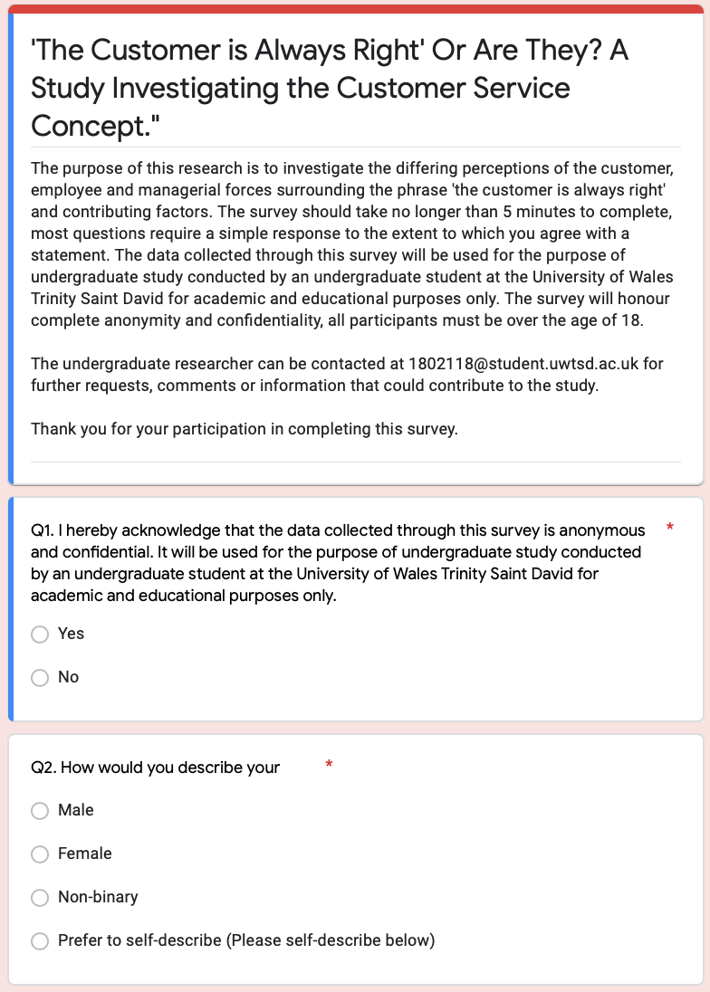
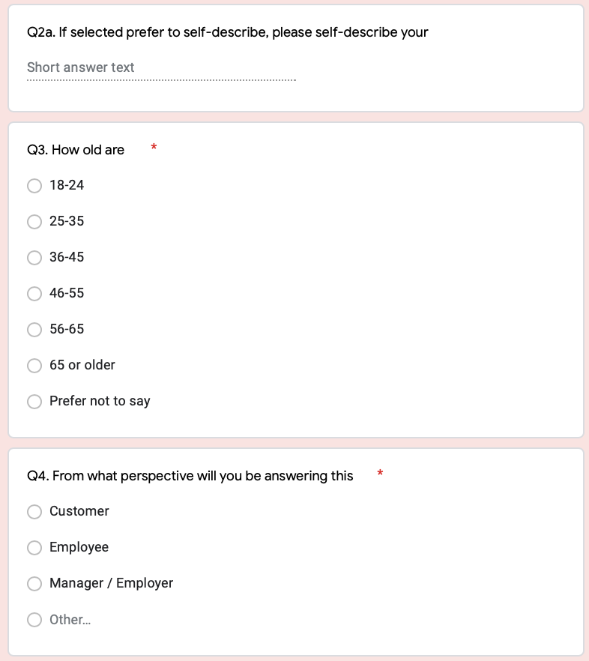

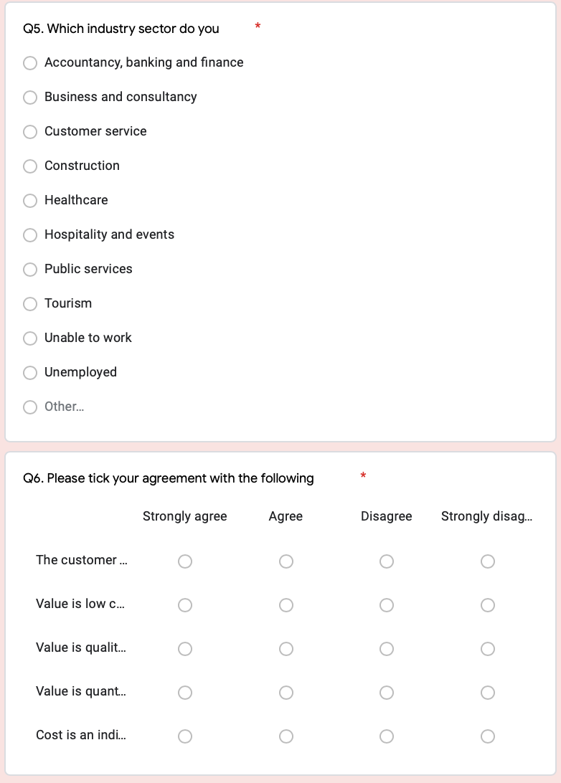

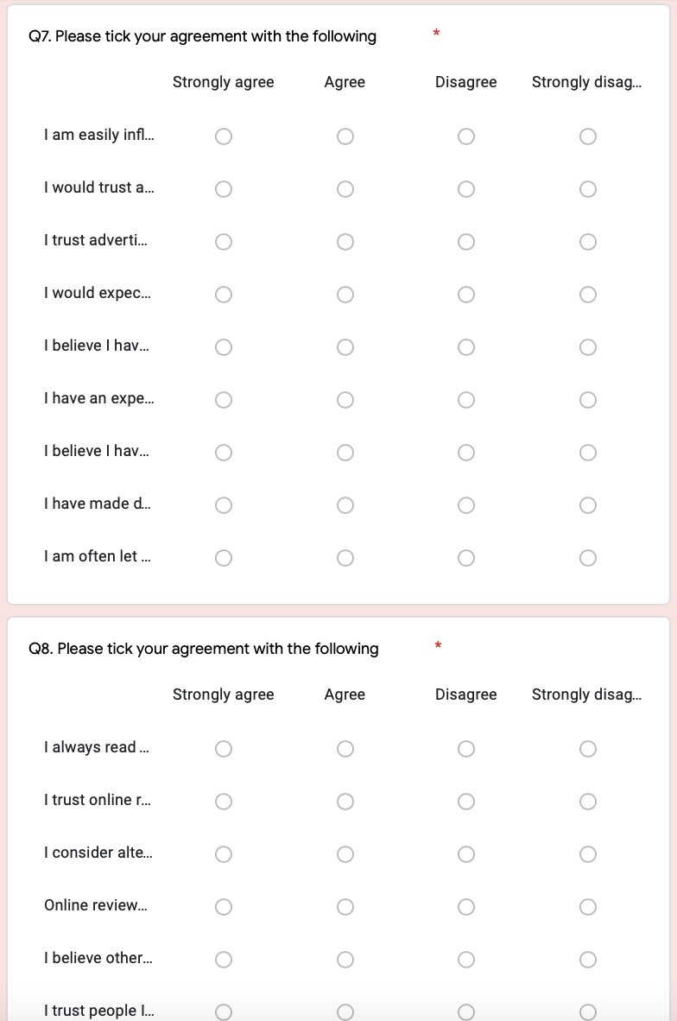
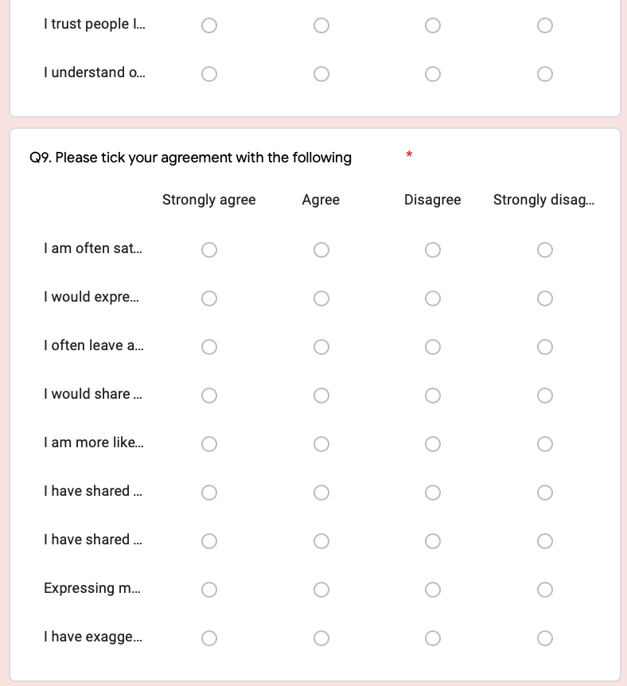

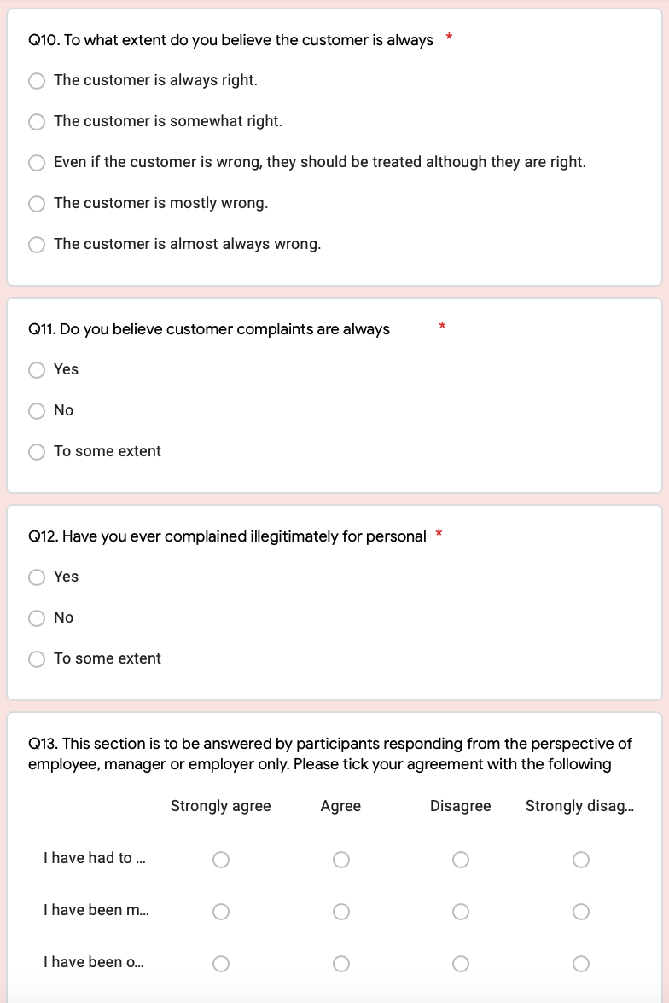

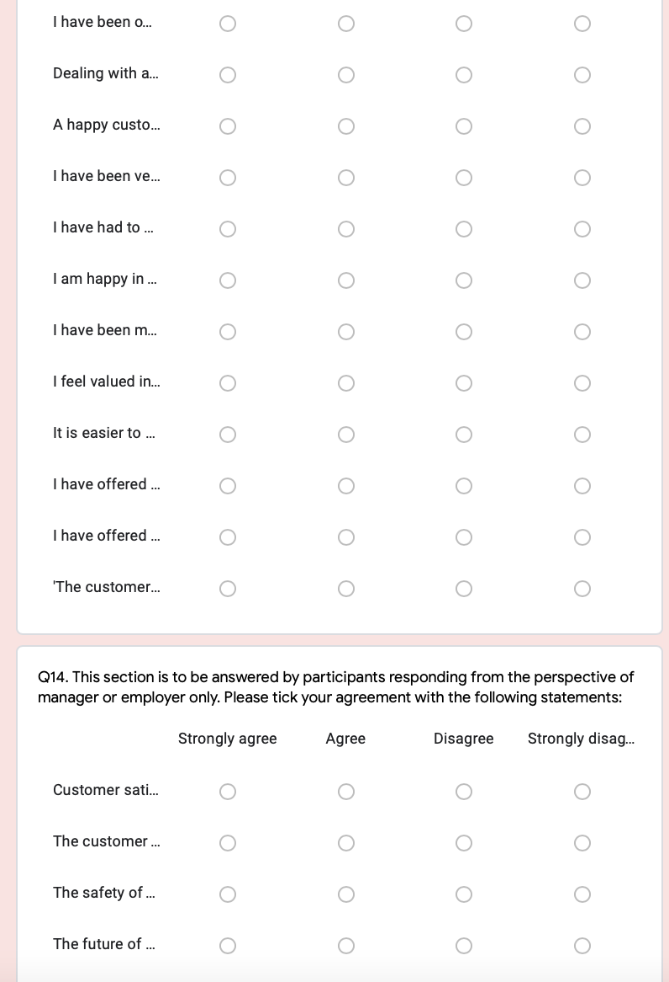

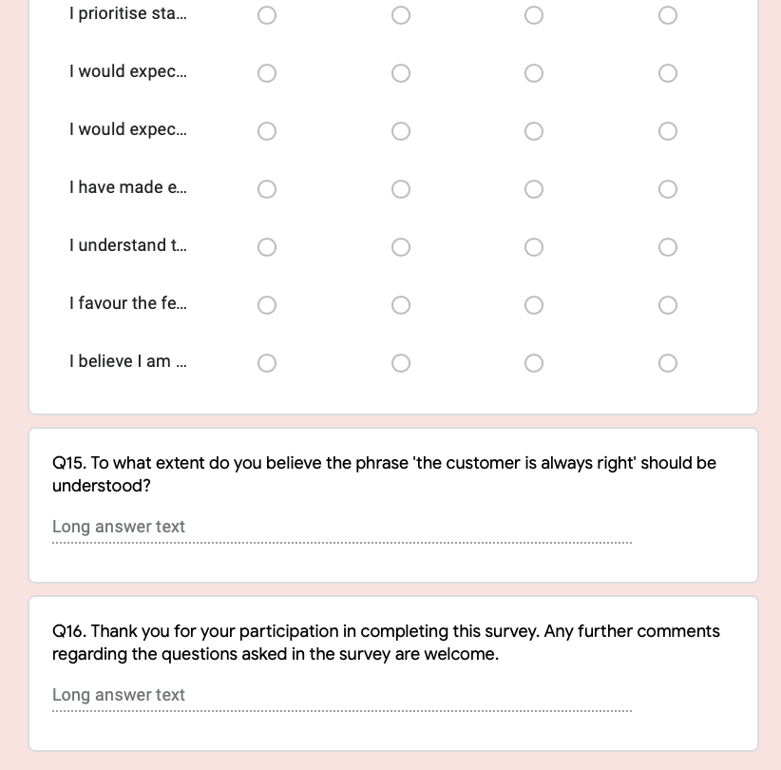

7.2 Appendix 2: Full SPSS analyses

Crosstabulation: Age and Q6
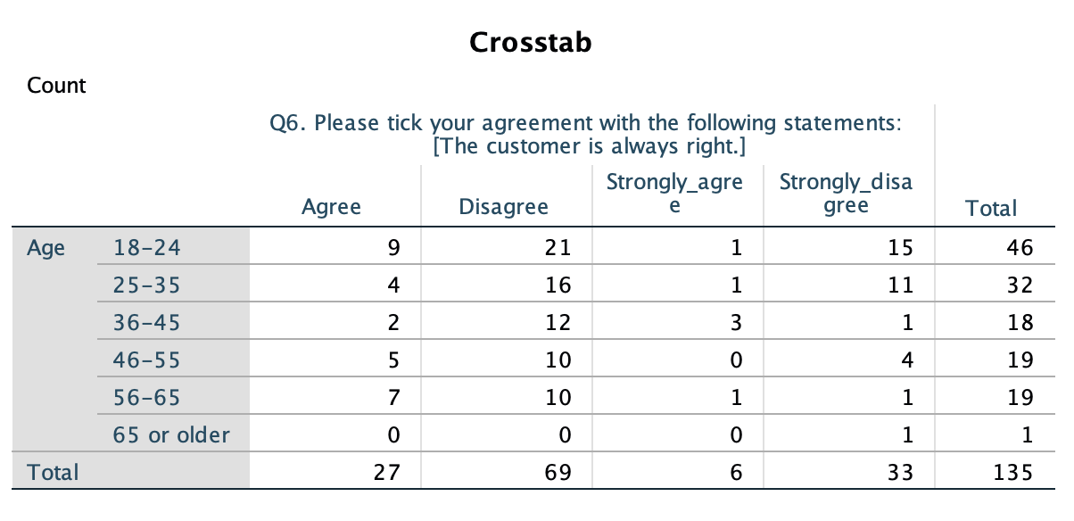
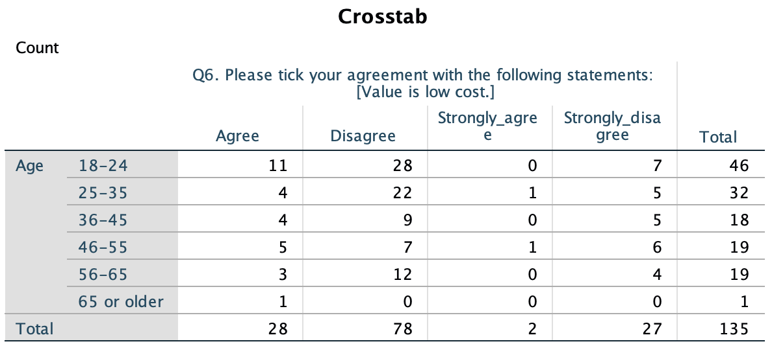

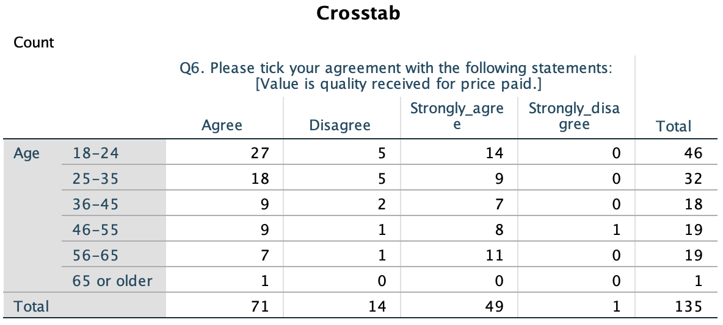

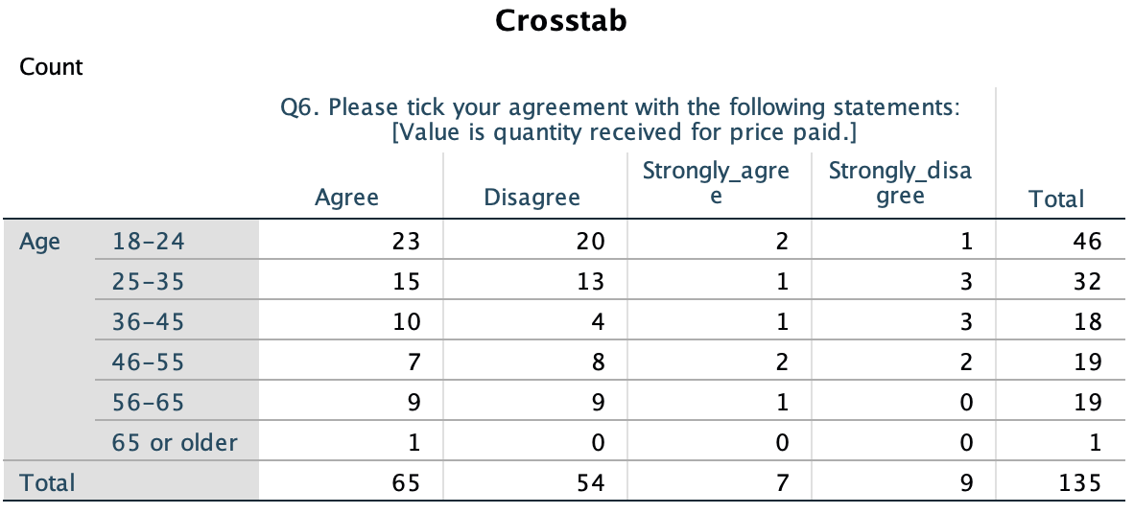

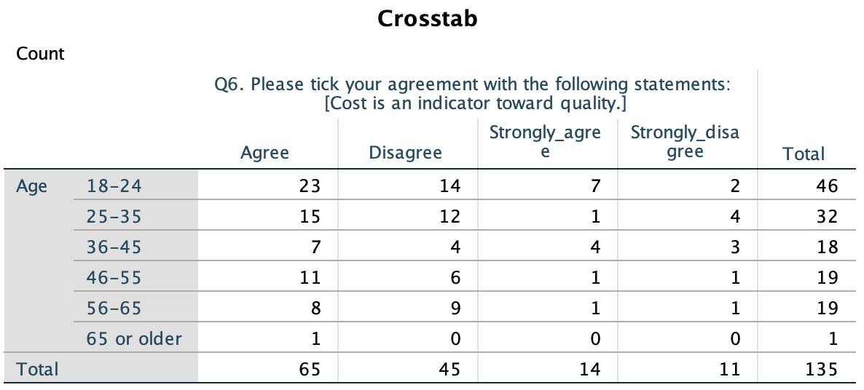

Crosstabulation: Perspective and Q6

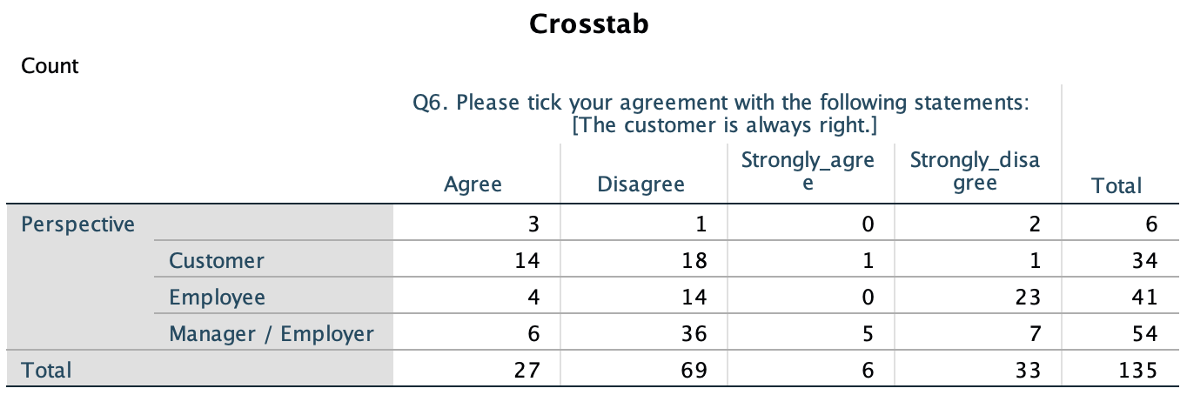

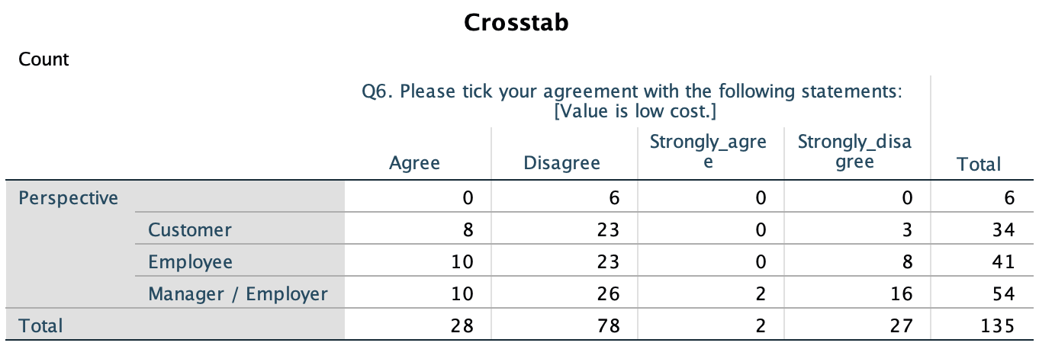

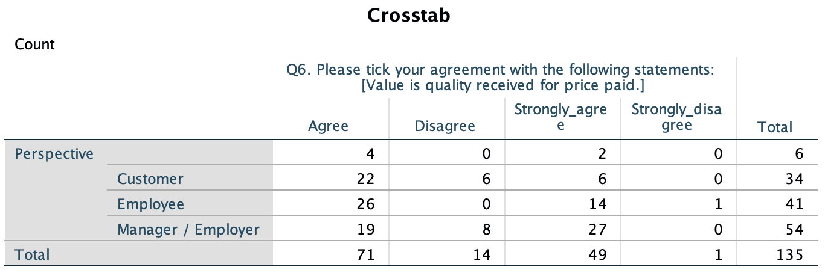

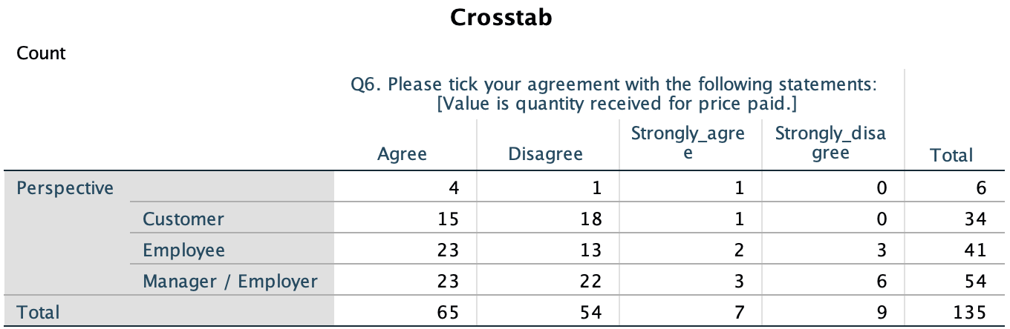

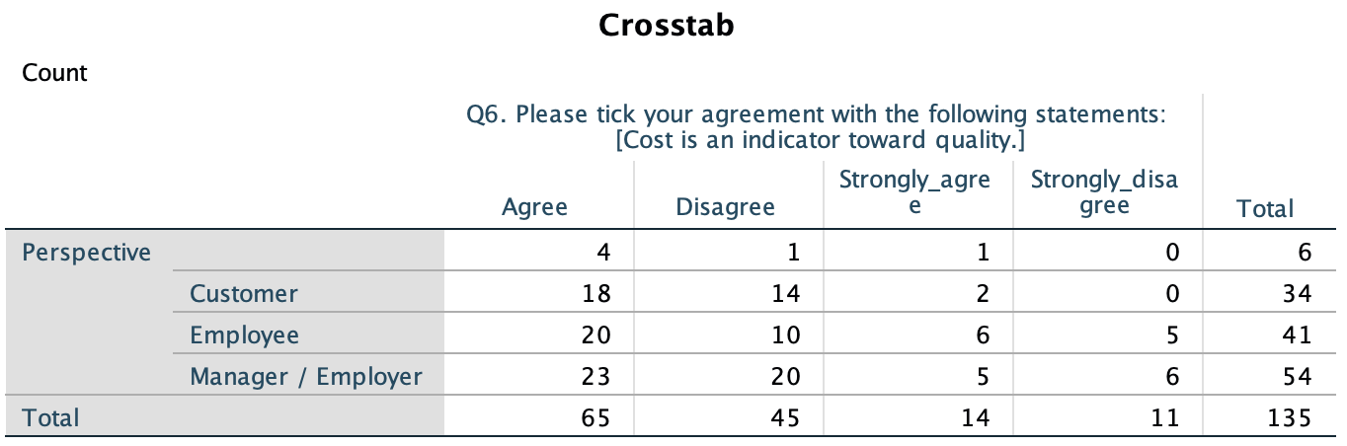

Crosstabulation: Industry and Q6

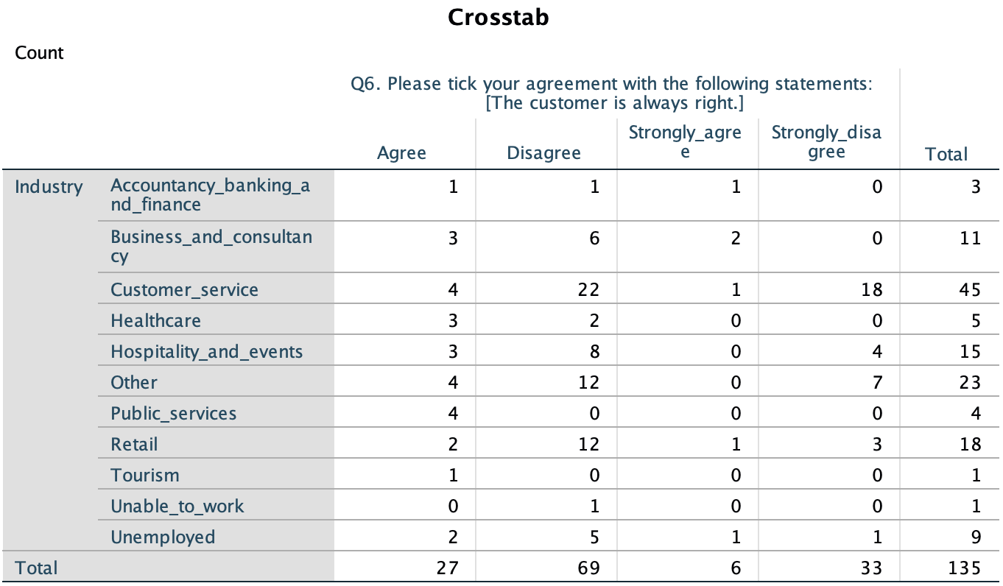

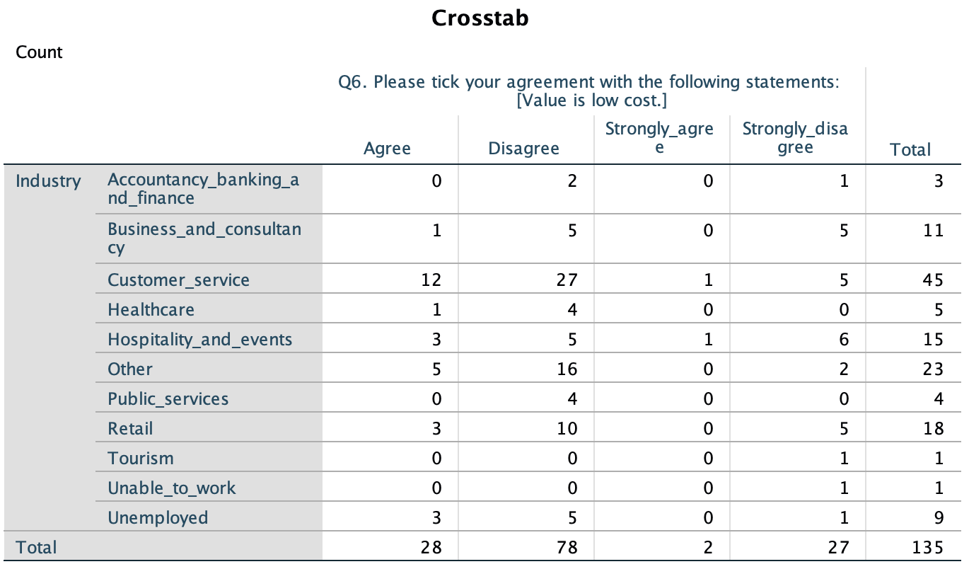

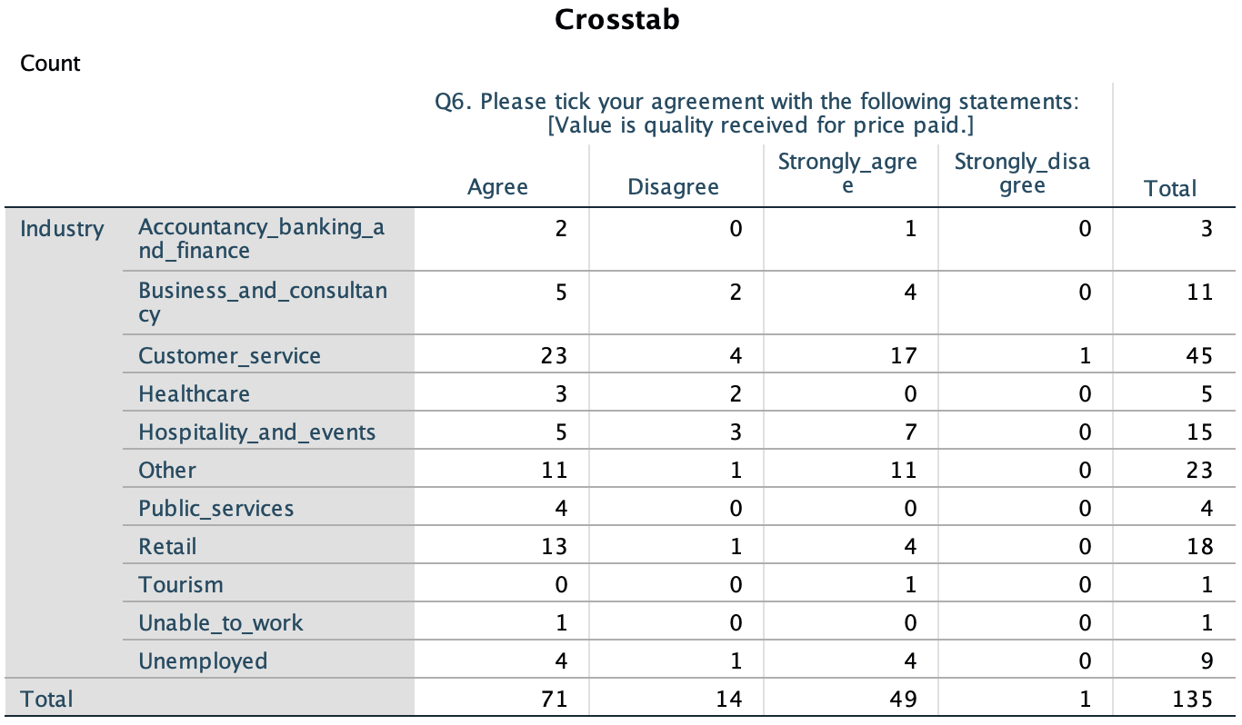

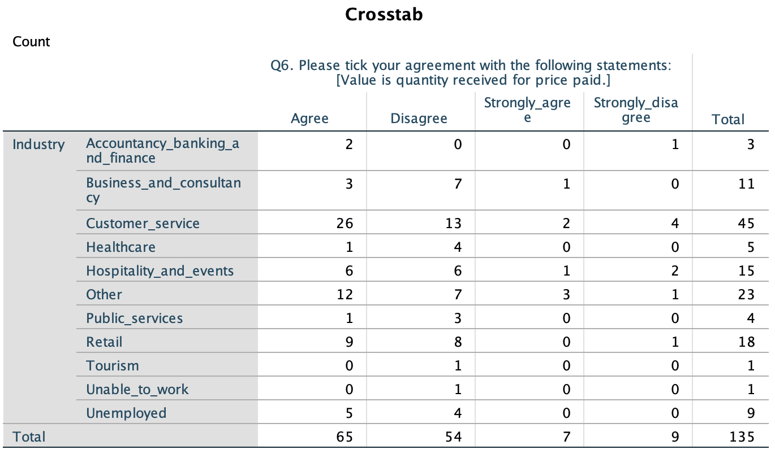

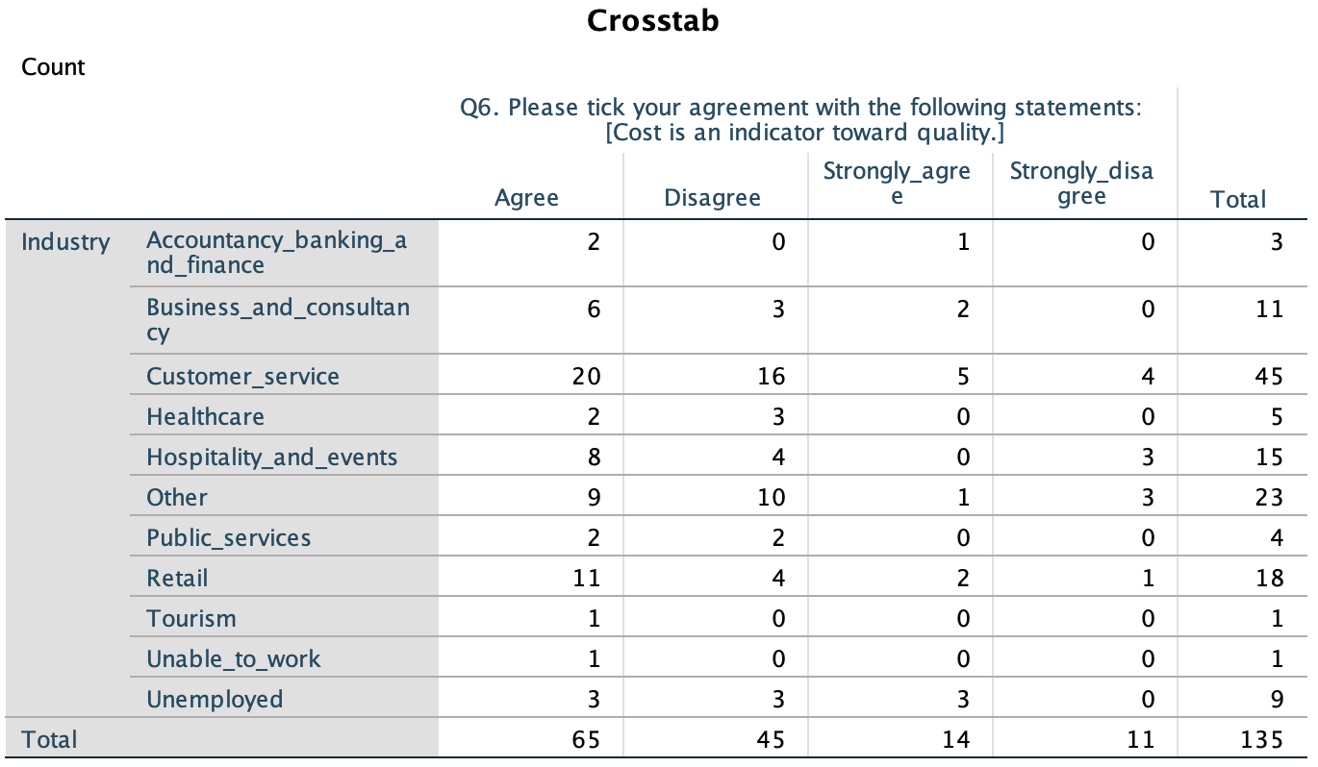

Crosstabulation: Perspective and Q10
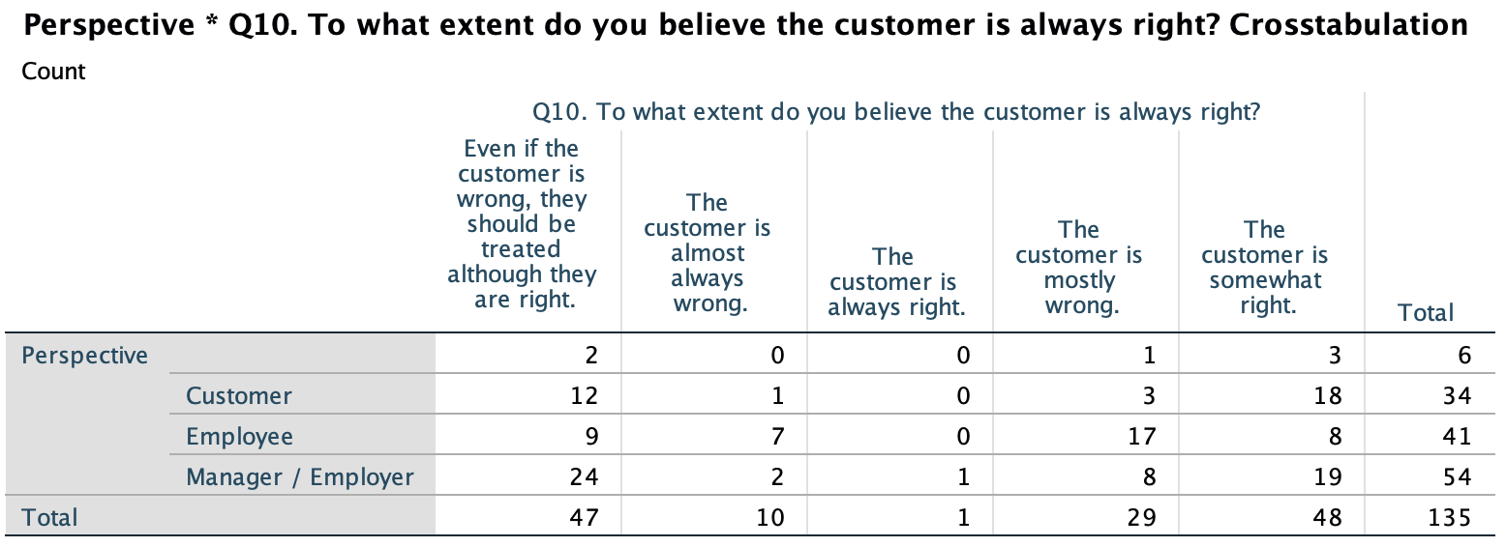

Crosstabulation: Perspective and Q11
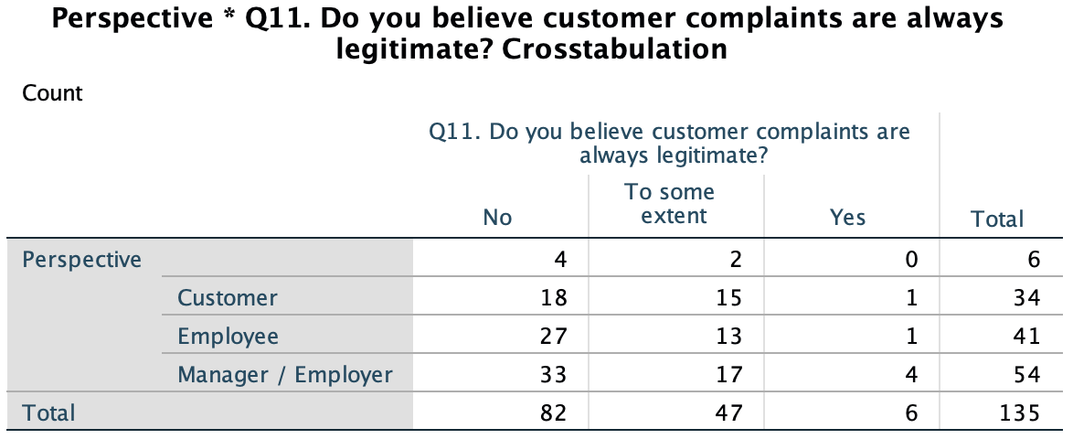

Crosstabulation: Perspective and Q12

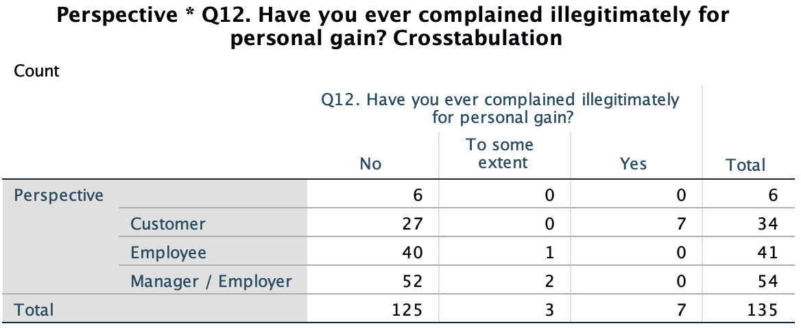

Q14: Significance between industry
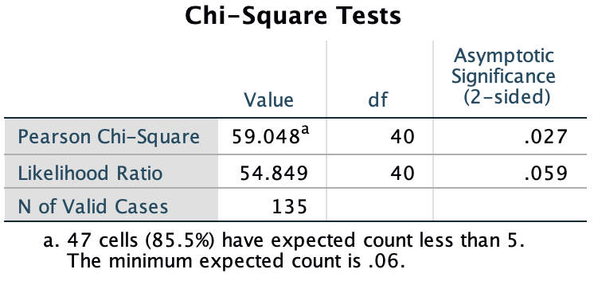

Q14: Chart data
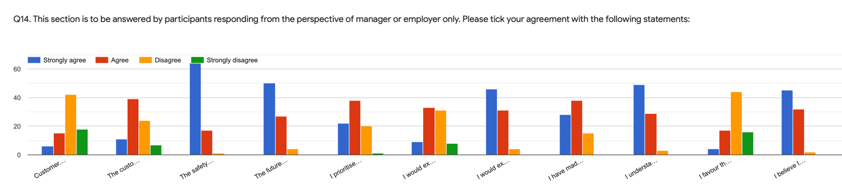

7.3 Appendix 3: List of Questions

Q1. I hereby acknowledge that the data collected through this survey is anonymous and confidential. It will be used for the purpose of undergraduate study conducted by an undergraduate student at the University of Wales Trinity Saint David for academic and educational purposes only.

Q2. How would you describe your gender?

Q3. How old are you?

Q4. From what perspective will you be answering this survey?

Q5. Which industry sector do you work in?

Q6. Please tick your agreement with the following statements:

The customer is always right.

Value is low cost.

Value is quality received for price paid.

Value is quantity received for price paid.

Cost is an indicator toward quality.

Q7. Please tick your agreement with the following statements:

I am easily influenced by social media marketing.

I would trust a brand if they had a strong social media presence.

I trust advertisements I see on social media.

I would expect an item to be identical to how it is advertised.

I would expect an item to work exactly as it is advertised.

I believe I have good judgement when it comes to whether a brand appears trustworthy or not through their social media.

I have an expectation before purchase.

I believe I have realistic expectations.

I have made direct purchases after viewing an advertisement on social media.

I am often let down by purchases made via online advertisements.

Q8. Please tick your agreement with the following statements:

I always read online reviews before making an online purchase.

I trust online reviews.

I consider alternatives before making a purchase.

Online reviews are a good source of information.

I believe others always have good intentions.

I trust people I do not know.

I understand online reviews can be written by anybody.

Q9. Please tick your agreement with the following statements:

I am often satisfied with the purchase decision I have made, whether this be a product or service.

I would express satisfaction through an online review or spreading positive word-of-mouth.

I often leave a review after receiving a product or service.

I would share a review to help others when making their purchase decisions.

I am more likely to leave a review or spread negative word-of-mouth if I am dissatisfied with the product or service.

I have shared a positive review after receiving a positive product or service.

I have shared a negative review after receiving a negative product or service.

Expressing my dissatisfaction to others after a negative experience with a product or service makes me feel better.

I have exaggerated when sharing my opinion via an online platform or through word-of-mouth.

Q10. To what extent do you believe the customer is always right?

Q11. Do you believe customer complaints are always legitimate?

Q12. Have you ever complained illegitimately for personal gain?

Q13. This section is to be answered by participants responding from the perspective of employee, manager or employer only.

Please tick your agreement with the following statements:

I have had to deal with a customer complaint.

I have been made to feel demoralised by a customer.

I have been on the receiving end of a complaint.

Dealing with a customer complaint negatively affects my mood.

A happy customer makes me happy.

I have been verbally or physically assaulted or threatened by a customer.

I have had to deal with a customer complaining illegitimately.

I am happy in my job.

I have been made to feel embarrassed by a customer.

I feel valued in my role.

It is easier to accept the complaint and apologise than attempt to explain why the customer may not be correct in complaining.

I have offered a product, service or form of monetary compensation to a customer following a complaint.

‘The customer is always right’ is the best strategy to adopt.

Q14. This section is to be answered by participants responding from the perspective of manager or employer only.

Please tick your agreement with the following statements:

Customer satisfaction is more important than employee satisfaction.

The customer is the leading force in ensuring the future of a company.

The safety of employees is extremely important to me.

The future of an organisation is dependent on employees.

I prioritise staff over customers.

I would expect staff to adopt ‘the customer is always right’ strategy.

I would expect staff to ‘provide service with a smile’.

I believe I am a good manager.

I have made exceptions when dealing with difficult customers.

I understand that making exceptions for difficult customers can frustrate employees who have to follow procedures.

I favour the feelings of the customer over the employee.

I believe I am fair.

Q15. To what extent do you believe the phrase ‘the customer is always right’ should be understood?

Q16. Thank you for your participation in completing this survey. Any further comments regarding the questions asked in the survey are welcome.

7.4 Appendix 4: Q15 Qualitative Response to ‘To what extent do you believe the phrase ‘the customer is always right’ should be understood?’

P1: To keep customers happy.

P2: No.

P3: This should be within reason, and other factors should be considered for example, do they complain often? Is their complaint legitimate?

P4: As a business, you are there to serve the customers and therefore whether right or wrong, the customer should always be shown the courtesy of being right.

P5: I believe you should have respect for the customer but they are not always right.

R6: Only to a certain extent , try to deal with the problem quickly . If customer is in any way abusive or gets threatening then they need to go.

P7: If they are right. If they are not right you politely say why they are wrong and see what options you can do for them.

P8: This is critical especially for customer facing employees. Understand this concept whilst managing customer expectations is the key to a successful business.

P9: The customer should not be held to a higher importance than the employees having to deal with the customer. I would rather lose a customer than lose a valued employee because they are constantly being harrassed at work. Customer expectations must be managed by providing appropriate content & guidelines so the customer knows exactly what should happen. For example, being clear online about shipping estimates and potential delays. If a customer knows before placing their order that this is a possibility, they are far less likely to complain about it.

P10: Achieving customer satisfaction needs to be the goal of any enterprise. There are, from time to time, customers that are not good for your business and do you, as a leader need to make a decision as to whether this particular customer’s requirements align with your company’s ability to satisfy them. It’s an important distinction that some customer-facing employees may not always understand but is necessary for the long term morale and success of your business.

P11: I think you should treat customers as they are right but they aren’t actually always right but arguing with them and making them realise that they are wrong doesn’t work.

P12: to some extent.

P13: Some degree.

P14: By managers and corporate but not by customers.

P15: The statement needs to be looked at objectively as there could be many illegitimate claims, or people looking for compensation.

P16: The customer is right when he/she does have evidence on his/her complaint or reasoning.

P17: The statement needs to be looked at objectively as there could be many illegitimate claims, or people looking for compensation.

P18: That the customer should be listened to.

P19: I think its rubbish used to make Karen's happy and workers miserable.

P20: It should be taken case by case.

P21: To ensure your brand reputation is protected you try appease the customer to make them feel important to the brand, but not at the expense of staff or what your brand stands for.

P22: I believe that they learn how to behave from us. It does our company a disservice to feed into the customers perceptions. If they misread, arent clear or just do not care about the reality of a situation to obtain a discount or "what they want" they need to have accountability in that. A customer isnt always right when they havent taken the time to understand the service expectations....they rely on their OWN expectations. We have garnered a society where the squeaky wheel gets the grease....and its toxic.

P23: Just a little.

P24: With a pinch of salt. To an extent it means keep the customer happy. But they should not allow the customers to demand and structure how the organisation keeps customers happy.

P25: It depends on the individual circumstances.

P26: When it comes to product advertisement and misunderstanding, we should "make it right for the customer". The customer, however, never has the right to degrade the staff.

P27: The customer is not always right, but the employee should be gentle and comprehensive anyway, because at the endworld theof cutomer is giving you money.

P28: A book could be written on this topic. I believe that customers often do not know what they want themselves and customers often expect way more for way less price. No matter what you build, for whatever price, there will be unhappy customers and people willing to complain. That doesn't mean you did something wrong. You need to be prepared for negativity and complaints and engage in critical thinking on whether those complaints are from the customer being entitled to ''more quality for less price'' or there is a serious issue that needs to be addressed. I would always read customer complaints and negative feedback and evaluate if me and my team can draw on some value from it and learn. If not, it is right to assume that product X was simply not for customer Y and there's nothing wrong with that. Let me re-phrase it. ''Your target market is MOSTLY right. If they are not from your target market, they are MOSTLY wrong.'' As, of course, that leaves some possibility for both the target market and others to be right or wrong at any time for anything.

P29: They are not always right though, they don’t listen or don’t read the clear labels and assume that they know “best”.

P30: The customer is always right but both sides must take into consideration the current situation and evaluate who is actually right and do not assume that one has more advantage than other. Therefore, this way both sides can compromise to a certain level and reach favorable outcomes for both the customer and manager or employee.

P31: I think it should be understood to the extent where it prevents further negativity. For example, if the customer is unpleasant, sometimes the best thing to do is to give them what they want so they will leave.

P32: Within reason. It used to be that we all respected each other and the communities banned together now with this every man for himself mentality it’s more like what can I get you to give me for free if I complain enough even if not true, I’ll get free service or product or I’ll get you fired!

P33: it’s easier to go along with the customer to keep them happy but nothing when they are being abusive and rude.

R34: From the customers perspective they may feel they are correct, but they don’t know more about “product” than the manager or employees.

P35: It needs to be understood that the customer believes they are right; because they fund the business with their purchase of product or service. The reality is that more often then not the customer demo that swears by this mantra is more often then not prepared to leave with something more then they walked in with.

In small service retail, business owners are put out because dissatisfied service can make or break their business early in the pipe dream. Whilst larger franchise owners can stand firm on principle and not be largely affected.

It's largely owed to perception and resilience. For along as there will be a service to provide there will be clients to chant quality x quantity x value = dissatisfaction = business shaming.

P36: That the customer believes they are right, but they may not have all the facts.

P37: Only to a certain point.

P38: To the extent that the customer is satisfied with the service received.

P39: I don’t think this is the right approach to take for any organisation. Sometimes customers get away with absolute murder and by using the phrase “the customer is always right” I believe this reinforces their behaviour which will result in problematic customers treating staff poorly or complaining frequently as they know they will get their way in the end.

P40: Customer satisfaction is a priority.

P41: I believe that if customers complain it should be taken seriously.

P42: The customer may be completely right or completely wrong. It is their perception that matters. Perhaps they misunderstood instructions/policies etc and their perception needs to be altered. Also people sometimes lie for personal gain. Usually however a complaint is based on misinformation or a misunderstanding or a lack clearly defined expectations prior to the purchase.

P43: This used so they continue to be a loyal customer and so there are no arguments even when the customers don’t know what they’re talking about.

P44: It needs to be understood in the context of the situation, particularly in relation to the legitimatcy of the claim and their personal conduct.

P45: When there are more exceptions to the rule than the rule being held up, then the rule becomes the exception. By generally allowing customers to strong hand whatever they want you are teaching customers that this behavior is ok and dynamically changing your culture in a way that harms your most important customer - the internal customer (employees).

P46: If a concern is legitimate or can not be found to be unreasonable the customer needs to be politely and professionally taken care of.

P47: It's a stupid American phrase for a time when staff weren't that educated. Customer satisfaction is a priority, however, when the customer is in the wrong they should be professionally dealt with, educated and the issue resolved. The companies products and reputation are as important so any saying that you are giving a bad service or product when you are not is only going to hurt you in the long run if the customer goes on social media and bad mouths you.

P48: The customer has every right to voice their opinion. That being said it does not mean they’re always right. Even if the customer is not right normally they will get what they wanted to an extent. If I have an employee following policies and the customer is looking to speak to the manager I always explain to the customer that the employee is following The policies and doing everything they were supposed to but in this case as a customer service gesture I will make an exception.

P49: I don’t believe the customer is always right and feel that phrase should be eliminated from the lexicon.

P50: It is extremely overstated. It shouldn’t exist as a phrase.

P51: Take the good with the bad.

P52: The customer has the right to complain, get a refund/exchange for item if not used; they do not have the right to abuse, bully, injure or harass employees.

P53: FYI my answer about "The safety of employees is extremely important to me." Is strong agree, not agree, Google won't let me tick the box.

The customer is always right to an extent, all complaints should be treated as if fair, even if they're not. Sometimes a client doesn't realise they're wrong.

If said complaint is wrong or unfair I'd explain this to the customer. I'd certainly not bend backwards to find another solution (other than money back) if they're rude or unfair.

Money back is an option in most shops so if the client is unhappy, fair or unfair, they are still entitled to this right.

P54: It should be understood in the way the service is shaped, that is customer centered.
Employees have to provide the best experience when it comes to deal with any customer as far as respect and good manners are guaranteed from both parties. Any intent of messing with people just doing their jobs are to be treated as an abuse.

P55. Vast majority of customers honest and should be treated as customer always right unless have evidence that customer is mistaken then should be explained so they understand. Small minority use statement to try and get whatever they can from wherever they can.

P56: You need to make them feel they are right even if you know that it is not true.

P57: In reality, customers usually have very little knowledge of how a service or company works, but they like to think they do, and are rarely “right”. That being said, it’s important for customers to have a good experience at a location. If it’s a situation where it wouldn’t hurt to let the customer have their way, after explaining the real situation or if they just won’t leave, then it’s okay to let them feel “right”. But If that customer is being rude and obnoxious, kick em to the curb.

P58: After investigation you need to let the customer feel they are always right but not necessarily treat them all the same and honesty needs to be paramount.

P59: After investigation you need to let the customer feel they are always right but not necessarily treat them all the same and honesty needs to be paramount.

P60: I believe you should always listen to a customers complaint as it may be legitimate and help your customer satisfaction. However, I disagree completely disagree with the phrase as I have received some ridiculous complaints in my current job and previous roles.

P61: It's not it's an outdate sentence used to stop customers going to the competition.

P62: I believe you should always listen to a customers complaint as it may be legitimate and help your customer satisfaction. However, I disagree completely disagree with the phrase as I have received some ridiculous complaints in my current job and previous roles.

P63: When in a disagreement with a customer, even if i "win," i lose. Unhappy customers spread bad word of mouth. This phrase is binary, but dealing with customer complaints is nuanced and requires finesse.

P64: The policies should apply to everyone, otherwise there is no point in having a policy to begin with. Customers who throw a fuss shouldn't get special treatment because that just reinforces the behavior. It frustrates me when managers just give rude customers whatever they want. When I worked the registers, if we had a coupon running, I would offer it to nice customers but if a customer was rude or disengaged/disinterested, I would not offer them the coupon.

P65: I feel that the customer has the right to be heard and understood with regards to their issue, however they are often wrong in their assumptions. Having worked in hospitality, I frequently dealt with customers who had misunderstood something or were simply incorrect in their complaint. I believe the customer should be remedied or guided if there is a problem regardless of whether they're factually correct or not, for me that's what the phrase eludes; making the customer feel comfortable.

P66: Highly dependent on the sector you are working in.

P67: Fully you should empathize with yhe customers.

P68: Highly dependent on the sector you are working in.

P69: I believe it's a concept that originally meant that companies should make what customers want to buy, not that any person who walks into a store is right in everything they say.

P70: I think the customer deserves to know if they are wrong. I think the least we can do is explain to them maybe what they did wrong in the process so that they can correct it themselves.

P71: Treat customers with dignity and repsect.

P72: It is only right when the customer is being reasonable.

P73: Only if after checking the information are they right. Not until everything is verified.

P74: Make them think they are right while still following actual rules and procedures of the company and the law. If they are truthful or right I would do all in my power to help out. If they are wrong, it’s time fir an education.

P75: It means keep the peace.

P76: When the customer actually has a legitimate complaint.

P77: Making the customer happy does not mean that they are right.

P78: The customer has absolute right to be listened to what is needed and or what went wrong. At the end of it all it's about the customer needs to get what was requested.

P79: It shouldn’t be.

P80: Depends on the situation.

P81: The customer is always right to expect a satisfactory positive experience with a business.

P82: The customer isn't always right, but at the end of the day, the customer is the customer. There's a rule to follow in retail, and that is "Its not your money."

P83: I believe that any employee should always have that phrase in mind, even though in many cases we( employees) don’t really think so. But in order to move on, and everyone to be happy (customer, employer, employee as an extend), we need to act as if the above statement is a fact and we follow it, faking it or not.

P84: When the customer is clearly lying or being belligerent on purpose, to gain items for free, then they are not right. They are grifters and cons. I have to deal with people like this daily and it really is a contributing factor to my frustration with my job.

P85: Unless it causes undue harm or hurts an employee.

P86: It should be understood as the manager will take care of the problem, but its not an entitlement as its been treated.

P87: I think the phrase should be disregarded all together because customers don’t always know company policy and think what ever makes since to them is what should be and when the employer bends to the will of the customer it feels like they’re abandoning the employee and not standing by the policies they created.

P88: Easier to give them what they want than risk a bad review or complaint to corporate. Once a complaint to corporate is made, we end up giving the customer more than what they originally wanted.

P89: The phrase should be seen as a customer sevice tool. For example, you should respond to a customer as if they were right and treat them in a way that does not make them feel silly when they are wrong. For those times when a customer is wrong it should be explained clearly as to the reason why in a clear and confident way to help the customer understand what the correct answer/process is. I do not think you should tell a customer they are wrong to belittle them as this will have a wider adverse affect of their future choices in your organisation.

P90: The customer is never happy, but we are not here to make them happy. Just provide a service.

P91: They have the right to raise a legitimate grievance but should have the courtesy to listen to explanation.

P92: Companies should always think of their services with customer first in mind. I do not believe that a customer should recieve reimbursment every time they complain. The company needs to draw a line somewhere. But - feelings are always correct and true. If a customer feels they have been mistreated, the employees have no say in that. The reasons may vary but the feeling is there nonetheless. You should thereby in most cases act like the customer is right. Some cases you need to take a step back and say no - it is not our fault and not our policy to give the customer any reimbursement.

P93: The situation should be looked at from a win-win Perspective.

P94: To some extent because they may be coming from a genuine place.

P95: The customer drives the business and therefore we should take the customers complaints always serious.

P96: Within reason... One needs to be hear what they have to say.

P97: The situation should be looked at from a win-win Perspective.

P98: The customer is generally not right. I have not had an experience in which they really were. Only exception would be when another location gives them false information by accident and I am willing to honor that due to miscommunication.

P99: That the customer always thinks they are right.

P100: The situation should be looked at from a win-win Perspective.

P101: They should be treated outwards as such but care should always be taken.

P102: I'd say the customer has a right to expect good service or a product as advertised but that doesn't mean that employees have to fulfill every wish.

P03: Not at all.

P104: Middle.

P105: To some extent since some cheat for their own benefits.

P106: only if the customer feels good can he come to purchase next time.

P107: Well put: " The customer should be treated as if they are right, even if they are wrong." Apologize and fix it.

P108: Strongly dependant on how the customer has treated the employee in question.

P109: I think it is an old slogan that should be forgotten about.

P110: Strongly dependant on how the customer has treated the employee in question.

P111: They can be right sometimes but not always. Most customers think they are entitled to be right just because they are customers.

P112: Treating customers well and trying to satisfy their needs. But rules exist and should be stuck to.

P113: the customer should always be treated as though they are right. this is what customer service is about for me.

P114: Some extent, need to know when the customers are right.

P115: It should be taken as an ideal and therefore, will not always be implemented fully. There are always constraints to how expectations of a customer can be lower or higher to the service provided or the product received.

7.5 Appendix 5: Q15 Response frequency word cloud

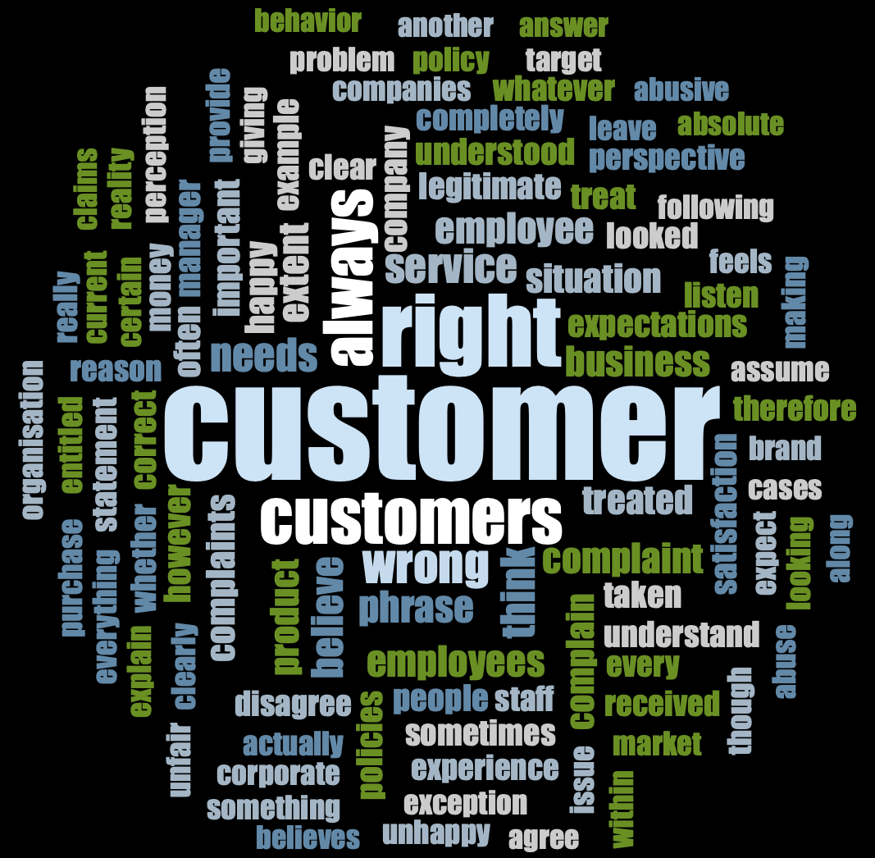

7.6 Appendix 6: Ethics form

APPLICATION FOR ETHICAL APPROVAL

In order for research to result in benefit and minimise risk of harm, it must be conducted ethically. A researcher may not be covered by the University’s insurance if ethical approval has not been obtained prior to commencement.

The University follows the OECD Frascati manual definition of research activity: “creative work undertaken on a systematic basis in order to increase the stock of knowledge, including knowledge of man, culture and society, and the use of this stock of knowledge to devise new applications”. As such this covers activities undertaken by members of staff, postgraduate research students, and both taught postgraduate and undergraduate students working on dissertations/projects.

The individual undertaking the research activity is known as the “principal researcher”.

Ethical approval is not required for routine audits, performance reviews, quality assurance studies, testing within normal educational requirements, and literary or artistic criticism.

Please read the notes for guidance before completing ALL sections of the form.

This form must be completed and approved prior to undertaking any research activity. Please see Checklist for details of process for different categories of application.

Delete the Guidance Notes at the end of the form BEFORE submitting your application

SECTION A: About You (Principal Researcher)
Full Name: |  | Marsha Louise Thomas
Tick all boxes which apply: |  | Member of staff: | ☐ | Honorary research fellow: | ☐
Undergraduate Student | ☒ | Taught Postgraduate Student | ☐ | Postgraduate Research Student | ☐

Institute/Academic Discipline/Centre: | Business School
Campus: | Swansea
E-mail address: | 1802118@student.uwtsd.ac.uk
Contact Telephone Number: | 07557352357
For students:
Student Number: | 1802118
Programme of Study: | Business Management
Director of Studies/Supervisor: | Dr. Caroline Jawad

SECTION B: Approval for Research Activity
Has the research activity received approval in principle?  (please check the Guidance Notes as to the appropriate approval process for different levels of research by different categories of individual) |  | YES | ☒ | NO | ☐
 |  |  |  | Date
If Yes, please indicate source of approval (and date where known): Approval in principle must be obtained from the relevant source prior to seeking ethical approval | Research Degrees Committee |  | ☒
 | Institute Research Committee |  | ☐
 | Other (write in) |  | ☐

SECTION C: Internal and External Ethical Guidance Materials
Please list the core ethical guidance documents that have been referred to during the completion of this form (including any discipline-specific codes of research ethics, and also any specific ethical guidance relating to the proposed methodology). Please tick to confirm that your research proposal adheres to these codes and guidelines.
UWTSD Research Ethics & Integrity Code of Practice | ☒
UWTSD Research Data Management Policy | ☒
 | ☐

SECTION D: External Collaborative Research Activity
Does the research activity involve collaborators outside of the University? |  | YES | ☐ | NO | ☒
If Yes, please provide the name of the external organisation and name and contact details for the main contact person and confirmation this person has consented to their personal data being shared.as part of this collaboration.
Institution
Contact person name
Contact person e-mail address

Has this individual consented to sharing their details on this form? |  | YES | ☐ | NO |  |  | ☒
Are you in receipt of a KESS scholarship? |  | YES | ☐ | NO |  |  | ☒
Is your research externally funded |  | YES | ☐ | NO |  |  | ☒
Are you specifically employed to undertake this research in either a paid or voluntary capacity? | Voluntary | YES | ☐ | NO |  | ☒
 | Employed | YES | ☐ | NO |  | ☒
Is the research being undertaken within an existing UWTSD Athrofa Professional Learning Partnership (APLP) | If YES then the permission question below does not need to be answered. | YES | ☐ | NO |  |  | ☒
Permission to undertake the research has been provided by the partner organisation | (If YES attach copy)  If NO the application cannot continue | YES | ☐ | NO |  |  | ☒

Where research activity is carried out in collaboration with an external organisation
Does this organisation have its own ethics approval system? | YES | ☐ | NO | ☒
If Yes, please attach a copy of any final approval (or interim approval) from the organisation

SECTION E: Details of Research Activity
Indicative title: | ‘‘The Customer is Always Right.’ Or Are They? A Study Investigating the Customer Service Concept’
Proposed start date: | November 2020 | Proposed end date: | May 2021
Introduction to the Research (maximum 300 words)
Ensure that you write for a Non-Specialist Audience when outlining your response to the three points below:
- Purpose of Research Activity
- Proposed Research Question
- Aims of Research Activity
- Objectives of Research Activity
Demonstrate, briefly, how Existing Research has informed the proposed activity and explain
- What the research activity will add to the body of knowledge
- How it addresses an area of importance.
Purpose of Research Activity

This research addresses the case of ‘the customer is always right’ as a philosophy to follow whilst providing or receiving customer service.

Research Questions

Q1: What are the key determinants of customer complaining behaviour and the relation to employee demoralisation?
Q2: To what extent should the literacy of the phrase ‘the customer is always right’ be taken?

Aims of Research Activity

The research aims to evaluate and analyse the phrase ‘the customer is always right’ through engagement with workers from higher managerial authorities, to front of house positions, to customers, using surveys and interviews to collect information in order to understand the different perspectives and their opinions.

Objectives of Research Activity

1. To conduct an extant literature review including consumer buying behaviour, consumer complaining behaviour, demoralisation employees face from customer complaining behaviour, demoralisation employees face from managerial staff disregarding employee demoralisation due to customer behaviour, factors surrounding reasons why ‘the customer is always right’ could be wrong.
2. Investigate and review customer and consumer perceptions of the phrase ‘the customer is always right’.
3. Investigate and review the perception of managers and employees relating to the phrase ‘the customer is always right’.
4. Evaluate the literality and impact of how the term is understood and executed from each perspective.
5. Use literature and primary research to create recommendations for the most suitable and ethical way to perceive the phrase ‘the customer is always right’.

Proposed methods (maximum 600 words)
Provide a brief summary of all the methods that may be used in the research activity, making it clear what specific techniques may be used. If methods other than those listed in this section are deemed appropriate later, additional ethical approval for those methods will be needed.
In this research the method(s) selected as most appropriate are positivistic questionnaires and phenomenological interviews, survey research is a unique way to flexibly gather quantitative and qualitative information from a vast scale of demographics at ease, they can be quick and easy to complete therefore individuals are usually more inclined to participate. Using interviews to collect data allows open-ended questions to provide more depth and narrative, which produce qualitative data. The multi-method approach allows for the collection of data that display both qualitative and quantitative data.

Location of research activity
Identify all locations where research activity will take place.
Wales, the UK.

Research activity outside of the UK
If research activity will take place overseas, you are responsible for ensuring that local ethical considerations are complied with and that the relevant permissions are sought. Specify any local guidelines (e.g. from local professional associations/learned societies/universities) that exist and whether these involve any ethical stipulations beyond those usual in the UK (provide details of any licenses or permissions required). Also specify whether there are any specific ethical issues raised by the local context in which the research activity is taking place, for example, particular cultural and/or legal sensitivities or vulnerabilities of participants.
Use of documentation not in the public domain: Are any documents NOT publicly available? | NO | ☒
 | YES | ☐
If Yes, please provide details here of how you will gain access to specific documentation that is not in the public domain and that this is in accordance with prevailing data protection law of the country in question and England and Wales.

(this box should expand as you type)

SECTION F: Scope of Research Activity
Will the research activity include: | YES | NO
Use of a questionnaire or similar research instrument? | ☒ | ☐
Use of interviews? | ☒ | ☐
Use of diaries? | ☐ | ☒
Participant observation with their knowledge? | ☐ | ☒
Participant observation without their knowledge? | ☐ | ☒
Use of video or audio recording? | ☒ | ☐
Access to personal or confidential information without the participants’ specific consent? | ☐ | ☒
Administration of any questions, test stimuli, presentation that may be experienced as physically, mentally or emotionally harmful / offensive? | ☐ | ☒
Performance of any acts which may cause embarrassment or affect self-esteem? | ☐ | ☒
Investigation of participants involved in illegal activities? | ☐ | ☒
Use of procedures that involve deception? | ☐ | ☒
Administration of any substance, agent or placebo? | ☐ | ☒
Working with live vertebrate animals? | ☐ | ☒
Other primary data collection methods, please explain in this box  For example, ‘focus groups’. Please indicate the type of data collection method(s) in this box and tick the accompany box. | ☐ | ☒
Details of any other primary data collection method:  (this box should expand as you type) | ☐ | ☒
If NO to every question, then the research activity is (ethically) low risk and may be exempt from some of the following sections (please refer to Guidance Notes).

If YES to any question, then no research activity should be undertaken until full ethical approval has been obtained.

SECTION G: Intended Participants
Who are the intended participants: | YES | NO
Students or staff at the University? | ☐ | ☒
Adults (over the age of 18 and competent to give consent)? | ☒ | ☐
Vulnerable adults? | ☐ | ☒
Children and Young People under the age of 18? (Consent from Parent, Carer or Guardian will be required) | ☐ | ☒
Prisoners? | ☐ | ☒
Young offenders? | ☐ | ☒
Those who could be considered to have a particularly dependent relationship with the investigator or a gatekeeper? | ☐ | ☒
People engaged in illegal activities? | ☐ | ☒
Others (please identify specifically any group who may be unable to give consent) please indicate here and tick the appropriate box. | ☐ | ☒
Other – please indicate here:  (this box should expand as you type) | ☐ | ☒

Participant numbers and source
Provide an estimate of the expected number of participants. How will you identify participants and how will they be recruited?
How many participants are expected?

Who will the participants be? | Qualitative interviews will be performed with individuals including managers, employees and customers as this is the population required to investigate the research.  The questionnaire will also be sent to individuals including those stated above and more generally.
How will you identify the participants? | The interview participants will be identified through own knowledge and connections, professionals through LinkedIn with a passion to engage with the study, getting in touch with local businesses, past collegues and current collegues, online groups and forum’s interested in customer service study.

Information for participants: | YES | NO | N/A
Will you describe the main research procedures to participants in advance, so that they are informed about what to expect? | ☒ | ☐ | ☐
Will you tell participants that their participation is voluntary? | ☒ | ☐ | ☐
Will you obtain written consent for participation? | ☒ | ☐ | ☐
Will you explain to participants that refusal to participate in the research will not affect their treatment or education (if relevant)? | ☐ | ☐ | ☒
If the research is observational, will you ask participants for their consent to being observed? | ☐ | ☐ | ☒
Will you tell participants that they may withdraw from the research at any time and for any reason? | ☒ | ☐ | ☐
With questionnaires, will you give participants the option of omitting questions they do not want to answer? | ☒ | ☐ | ☐
Will you tell participants that their data will be treated with full confidentiality and that, if published, it will not be identifiable as theirs? | ☒ | ☐ | ☐
Will you debrief participants at the end of their participation, in a way appropriate to the type of research undertaken? | ☒ | ☐ | ☐
If NO to any of above questions, please give an explanation
(this box should expand as you type)

Information for participants: | YES | NO | N/A
Will participants be paid? | ☐ | ☒ | ☐
Is specialist electrical or other equipment to be used with participants? | ☐ | ☒ | ☐
Are there any financial or other interests to the investigator or University arising from this study? | ☐ | ☒ | ☐
Will the research activity involve deliberately misleading participants in any way, or the partial or full concealment of the specific study aims? | ☐ | ☒ | ☐
If YES to any question, please provide full details
(this box should expand as you type)

SECTION H: Anticipated Risks
Outline any anticipated risks that may adversely affect any of the participants, the researchers and/or the University, and the steps that will be taken to address them.

If you have completed a full risk assessment (for example as required by a laboratory, or external research collaborator) you may append that to this form.
Full risk assessment completed and appended? |  | Yes | ☐
 |  | No | ☒
Risks to participants
For example: emotional distress, financial disclosure, physical harm, transfer of personal data, sensitive organisational information
Risk to Participant:  Refer to Flinders’ Ethical framework (1992) to discuss the risks to participants from the three main stages of the study.  Stage 1: the recruitment. The participants could potentially feel emotionally distressed when they recall the harsh times they have experienced especially when discussing employee demoralisation.  Stage 2: the fieldwork. The participants could concern about the questions related to sensitive organisational information.  Stage 3: Reporting. The participants could concern about confidentiality and anonymity of personal data. | How will you mitigate the Risk to Participant  1. If the participant has potential emotional challenges, the emotional distance strategy needs to be considered. For instance, remind participants of their right to withdraw from research or limit their participation. if they become uncomfortable, provide counselling or psychological support for those who experience distress, and thoroughly debrief with participants after research sessions are completed.  2. Protect confidential data collected as well as the fact that the subject is participating in the research project itself.  3. Protect confidentiality of research data and ensure all relevant local laws. The development of science and technology also puts forward higher requirements for data storage.
If research activity may include sensitive, embarrassing or upsetting topics (e.g. sexual activity, drug use) or issues likely to disclose information requiring further action (e.g. criminal activity), give details of the procedures to deal with these issues, including any support/advice (e.g. helpline numbers) to be offered to participants. Note that where applicable, consent procedures should make it clear that if something potentially or actually illegal is discovered in the course of a project, it may need to be disclosed to the proper authorities
(this box should expand as you type)
Risks to investigator
For example: personal safety, physical harm, emotional distress, risk of accusation of harm/impropriety, conflict of interest
Risk to Investigator:  1. Risk of personal safety when conducting face to face interview.  2. Self-disclosure and objective displays of emotion during the interviews.  3. Occurrence of contingencies not related to the investigator himself. For instance, participants quit midway or unable to find enough participants within the limited time. | How will you mitigate the Risk to Investigator:  1. Terminate the interview, online interview would be easy to end if needs be.  2. The emotional distance strategy needs to be considered.  3. Be fully prepared to deal with any potential difficulties.
University/institutional risks
For example: adverse publicity, financial loss, data protection
Risk to University:  There should be no risk to the university due to the nature of the study.  (this box should expand as you type) | How will you mitigate the Risk to University:  If for whatever reason risk to the university occurs it will be dealt with accordingly.

Disclosure and Barring Service
If the research activity involves children or vulnerable adults, a Disclosure and Barring Service (DBS) certificate must be obtained before any contact with such participants. | YES | NO | N/A
Does your research require you to hold a current DBS Certificate? | ☐ | ☒ | ☐

SECTION I: Feedback, Consent and Confidentiality
Feedback
What de-briefing and feedback will be provided to participants, how will this be done and when?
The feedback will take place on a shared free wordpress.com site after completion of the research activity.

Informed consent
Describe the arrangements to inform potential participants, before providing consent, of what is involved in participating. Describe the arrangements for participants to provide full consent before data collection begins. If gaining consent in this way is inappropriate, explain how consent will be obtained and recorded in accordance with prevailing data protection legislation.
I will ensure that both the consent process and the consent form must be approved by the Ethic committee. The potential participants who are capable of volunteering to participate in a research study must be given sufficient information to allow them to make an informed decision about participation. I will make sure that the participant understands all the important elements of the consent form at the time the consent form is written signed, and, all during the research study. For those online questionnaires, before the questions start, potential participants will be presented (either verbally or in writing) with the same information required in a written consent document.

Confidentiality / Anonymity
Set out how anonymity of participants and confidentiality will be ensured in any outputs. If anonymity is not being offered, explain why this is the case.
Confidentiality and anonymity will be guaranteed by the researcher.
I will employ a number of methods to keep my subjects' identity confidential and anonymous. Foremost, keep their records secure through the use of password protected files, encryption when sending information over the internet. Do not record information in a way that links subject responses with identifying information (usually by use of a code known only to them). And ensure removing the contributor's name as the basic step to protect a participant's identity. Besides, avoiding more pieces of information that are presented together, for example: job title, age, gender, length of service, membership of clubs, and strongly expressed opinions. I will often only report aggregate findings, not individual-level data, to the public.

SECTION J: Data Protection and Storage
In completing this section refer to the University’s Research Data Management Policy and the extensive resources on the University’s Research Data Management web pages (http://uwtsd.ac.uk/library/research-data-management/).
Does the research activity involve personal data (as defined by the General Data Protection Regulation 2016 “GDPR” and the Data Protection Act 2018 “DPA”)? | YES | NO
“Personal data” means any information relating to an identified or identifiable natural person (‘data subject’). An identifiable natural person is one who can be identified, directly or indirectly, in particular by reference to an identifier such as a name, an identification number, location data, an online identifier or to one or more factors specific to the physical, physiological, genetic, mental, economic, cultural or social identity of that natural person. | ☒ | ☐
If YES, provide a description of the data and explain why this data needs to be collected:
To provide an evaluation of how appropriate these determinants are perceived by a defined sample of tourists to the area, age, gender, position, location data, experience will be part of the research.

Does it involve special category data (as defined by the GDPR)? | YES | NO
“Special category data” means sensitive personal data consisting of information as to the data subjects’ –  (a) racial or ethnic origin,  (b) political opinions,  (c ) religious beliefs or other beliefs of a similar nature,  (d) membership of a trade union (within the meaning of the Trade Union and Labour Relations (Consolidation) Act 1992),  (e) physical or mental health or condition,  (f) sexual life,  (g) genetics,  (h) biometric data (as used for ID purposes), | ☐ | ☒
If YES, provide a description of the special category data and explain why this data needs to be collected:
(this box should expand as you type)
Will the research activity involve storing personal data and/or special category data on one of the following: | YES | NO
Manual files (i.e. in paper form)? | ☐ | ☒
University computers? | ☐ | ☒
Private company computers? | ☐ | ☒
Home or other personal computers? | ☒ | ☐
Laptop computers/ CDs/ Portable disk-drives/ memory sticks? | ☒ | ☐
“Cloud” storage or websites? | ☐ | ☒
Other – specify: | ☐ | ☒
For all stored data, explain the measures in place to ensure the security of the data collected, data confidentiality, including details of password protection, encryption, anonymisation and pseudonymisation:
1.Take technical and organisational measures to prevent any unauthorised access. The way to verify the identity of a user is a strong password. Key aspects of a strong password: length (the longer the better), a mix of letters (upper and lower cases), numbers and symbols with no ties to your personal information, and no dictionary words.
2. Establish clear access rules. Make the mechanism to allow or deny access to certain data: based on predefined user lists and access rights, e.g. only myself and my supervisor can access data, based on the functions of each user within the project.
3. Organise the processing in a way that gives you the best possible control, for
example by allowing for tracking of access (logbook)
4. All the participants information will not be recorded in a way that links subject responses with identifying information (usually by use of a code known only to them).

All Data Storage
Will the research activity involve any of the following activities: | YES | NO
Electronic transfer of data in any form? | ☒ | ☐
Sharing of data with others at the University? | ☐ | ☒
Sharing of data with other organisations? | ☐ | ☒
Export of data outside the European Union or importing of data from outside the UK? | ☒ | ☐
Use of personal addresses, postcodes, faxes, emails or telephone numbers? | ☐ | ☒
Publication of data that might allow identification of individuals? | ☐ | ☒
Use of data management system? | ☒ | ☐
Data archiving? | ☒ | ☐
If YES to any question, please provide full details, explaining how this will be conducted in accordance with the GDPR and DPA (and/or any international equivalent):
1. Ensure the storage security. Storage concerns are equally important even when my data are on my local PC, portable storage device or in the cloud storage. For instance, operating system controls (authentication & access control), use of passwords to access electronic files (e.g. use the text editor function to save a document password-protected), local encrypted storage (enable the full disk encryption, enable the file system, enable the text editor encryption), database encryption: turning data into a form that makes them unintelligible (for anyone not having access to the key)
2. Endure safe electronic communication for transferring the data. For instance, encrypted communication (SSL/TLS); (e.g. use web services whose URL starts with ‘https://’ and not only http://), firewall systems and access control lists (e.g. make sure the firewall service is enabled
on my PC), anti-virus & anti-malware systems protect data and data carriers when they are physically transferred (paper notes, laptop etc.).
3. Ensure other IT technical controls. PC configuration: security-aware settings at user level (e.g. installing security updates, anti-virus protection, local back-ups, blocking of certain software installation, etc.).

List all who will have access to the data generated by the research activity:
Myself

List who will have control of, and act as custodian(s) for, data generated by the research activity:
Only myself

Give details of data storage arrangements, including security measures in place to protect the data, where data will be stored, how long for, and in what form. Will data be archived – if so how and if not why not.
Research data must be stored in a managed environment that protects against data loss and corruption, unauthorised access and modification, and complies with relevant legal, regulatory, contractual, and other obligations for the period that it needs to be kept. In my circumstance where institutional storage is not available, I should take steps to maintain the integrity of the data, and ensure that appropriate security measures are in place to prevent unauthorised access. The research data must be transferred into a managed storage environment at the earliest opportunity. Data will be stored on my local PC, portable storage device and in the cloud storage on the University Office 365 system with a strong password to verify the user authentication. Unauthorised access will be prevented through operating system controls, full local data and database encryption, turning data into a form that makes them unintelligible. The data will be stored until the completion of the project and then deleted.

Please indicate if your data will be stored in the UWTSD Research Data Repository (see https://researchdata.uwtsd.ac.uk/ ). If so please explain. (Most relevant to academic staff)
(this box should expand as you type)
Confirm that you have read the UWTSD guidance on data management (see https://www.uwtsd.ac.uk/library/research-data-management/) | YES | ☒
 | NO | ☐
Confirm that you are aware that you need to keep all data until after your research has completed or the end of your funding | YES | ☒
 | NO | ☐

SECTION K: Declaration
The information which I have provided is correct and complete to the best of my knowledge. I have attempted to identify any risks and issues related to the research activity and acknowledge my obligations and the rights of the participants.

In submitting this application I hereby confirm that I undertake to ensure that the above named research activity will meet the University’s Research Ethics and Integrity Code of Practice which is published on the website: https://www.uwtsd.ac.uk/research/research-ethics/
Signature of applicant: | Marsha Thomas | Date:  27 November 2020

For STUDENT Submissions:
Director of Studies/Supervisor: | Dr. Caroline Jawad | Date:  27 November 2020
Signature: |  | Date:  27 November 2020

For STAFF Submissions:
Academic Director/ Assistant Dean: |  | Date:
Signature: |  | Date:

Checklist: Please complete the checklist below to ensure that you have completed the form according to the guidelines and attached any required documentation:
☒ | I have read the guidance notes supplied before completing the form.
☒ | I have completed ALL RELEVANT sections of the form in full.
☒ | I confirm that the research activity has received approval in principle
☒ | I have attached a copy of final/interim approval from external organisation (where appropriate)
☒ | I have attached a full risk assessment (and have NOT completed Section H of this form) (where appropriate) ONLY TICK IF YOU HAVE ATTACHED A FULL RISK ASSESSMENT
☒ | I understand that it is my responsibility to ensure that the above named research activity will meet the University’s Research Ethics and Integrity Code of Practice.
☒ | I understand that before commencing data collection all documents aimed at respondents (including information sheets, consent forms, questionnaires, interview schedules etc.) must be confirmed by the DoS/Supervisor, module tutor or Academic Director.
☒ | I have deleted the guidance notes before submitting the PG2 for consideration

RESEARCH STUDENTS AND STAFF ONLY
All communications relating to this application during its processing must be in writing and emailed to pgresearch@uwtsd.ac.uk , with the title ‘Ethical Approval’ followed by your name.
You will be informed of the outcome of your claim by email; therefore it is important that you check your University and personal email accounts regularly.

STUDENTS ON UNDERGRADUATE OR TAUGHT MASTERS PROGRAMMES should submit this form (and receive the outcome) via systems explained to you by the supervisor/module leader.

This form is available electronically from the Academic Office web pages: https://www.uwtsd.ac.uk/academic-office/appendices-and-forms/

