Abstract
Student id : 2510161
Learning in digital era
Shaun edwin

E PORTFOLIO LINK
https://25101612.wixsite.com/my-site-1/task-2-a
Table of Contents
Introduction 2
Main Body 2
Task 1: Essential Academic and Employment Skills for the future career Path 2
Task 1 (a): Report on Essential Academic and Employment Skills 2
Task 1 (b): Evaluation of Task 1 (a) based on Similarity report 2
Task 2: Collaborative Mind Map and Individual Poster 2
Mind Map (Collaborative) 2
Poster (Individual) 2
Task 3: Virtual Collaboration and RefWorks 2
Report on Virtual Collaboration 2
Step-by-step process of using RefWorks with visuals 2
Task 4: E-Portfolio Creation and Evaluation 2
Task 4 (a): E-Portfolio Creation 2
Task 4 (b): Illustrative Review of E-Portfolio tool Selection 2
Conclusion 2
References 2
Task 1 References: 2
Task 3 References: 2

ESSENTIAL SKILLS FOR STUDY AND EMPLOYMENT
TASK 1 (a)

This is a clear, step-by-step resource that will help students master the essential academic skills needed at university. It explains how students should use sources appropriately and avoid plagiarism by paraphrasing, quoting, summarizing, and referencing. It also covers all major assessment formats: essays, reports, presentations, exams, and group work. Academic language support and relevant examples are provided for each skill. Students engage in practical activities in the book and online to help them put what they learn into practice. The content is designed to build confidence and ensure success across all areas of university study, making it a valuable tool for academic development [1].
The purpose of this study was to determine what kind of employability skills are needed for secondary school graduates, as perceived by employers and supervisors in the Eastern Seaboard Industrial Estate. Data was collected through interviews and questionnaires from business entrepreneurs and company representatives. From the findings, it was found that employers require three skill areas when considering graduate applicants for hiring: personal management skills, such as responsibility and self-discipline; fundamental skills, such as communication and problem-solving; and teamwork skills, including collaboration and adaptability. These competencies were perceived as crucial in providing a graduate with a better opportunity to get hired and perform well in the job. [2]
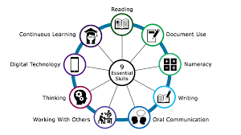

[3]
Higher education has been confronted by major changes in funding, quality, and academic purpose. Analysts link this to increased state and employer influence, shifting focus towards transferable 'key' skills. Reforms at the behest of political and economic pressures challenge traditional university autonomy. Though the transition is not without its controversy, institutions now support personal skill development, evident through the CVCP working with industry bodies to align education with workforce needs. [4]
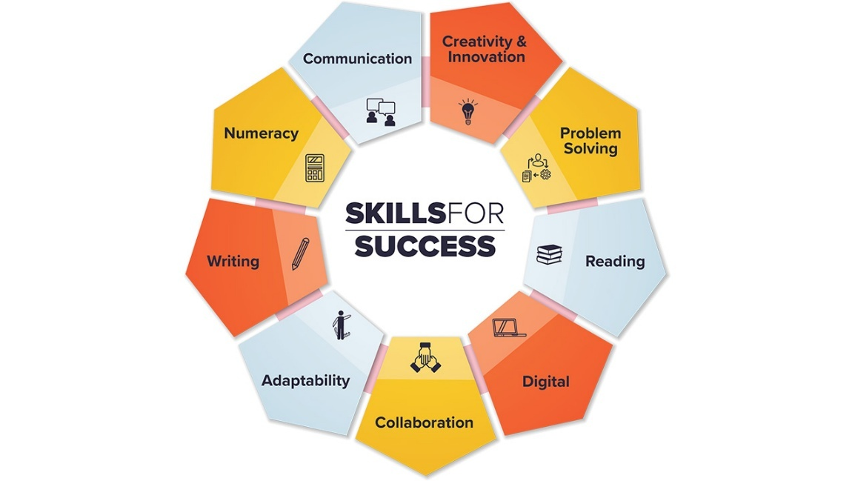

[5]

References

[1] | K. TURNER, "Essential Academic Skills," 2011.
[2] | S. SERMSUK, "Employment Conditions and Essential Employability Skills Required by Employers for Secondary School Graduate".
[3] | [Online]. Available: https://calp.ca/e-learning/?workshop=121.
[4] | N. B. a. C. C. Authors: Elisabeth Dunne, "Three: Skill development in higher education and employment," 2000.
[5] | [Online]. Available: https://www.canada.ca/en/services/jobs/training/initiatives/skills-success.html.

TASK 1 (b)
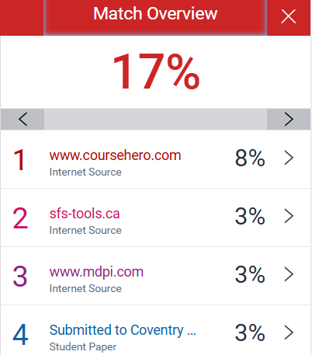

Submitting my summary to Turnitin helped me understand the importance of originality and academic integrity. I reviewed my similarity score carefully to ensure my work was paraphrased in my own words, with no direct copying. This process reminded me to always cite sources properly and avoid plagiarism by using techniques like summarising and referencing.

I also learned how to express academic ideas clearly and concisely. Writing within a word limit challenged me to focus on key points and structure my thoughts effectively. This task improved my confidence in producing authentic university-level work and reinforced the value of independent thinking.

TASK 2 (a)
MINDMAP
https://www.mindmeister.com/app/map/3846671066
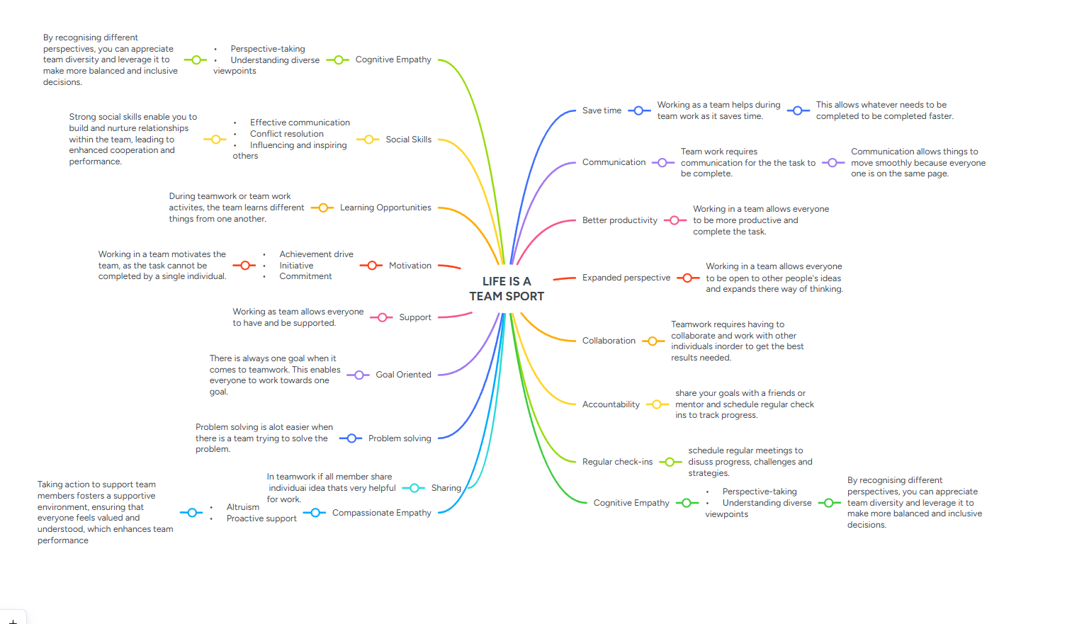

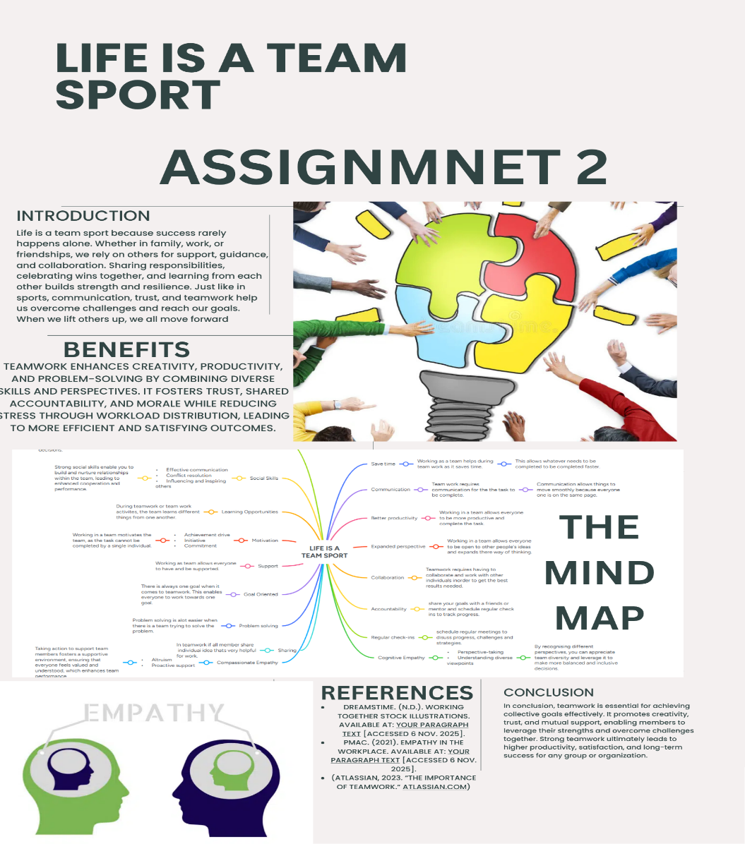

TASK 2 (b)
Poster link
https://www.canva.com/design/DAG377W2AXc/2jGC-1q8x-RwF_rNKbCrRQ/edit?utm_content=DAG377W2AXc&utm_campaign=designshare&utm_medium=link2&utm_source=sharebutton

TASK 3
Virtual Collaboration and Reworks

The study investigates how the diverse range of new ventures necessitates different types of virtual team structures in order to operate effectively. It identifies that, although conceptually well-defined, few studies examine the formation and sustainability of virtual teams across organizations. It integrates cross-disciplinary theories into a conceptual framework of virtual team formation. Results show that interorganizational virtual teams evolve through cyclical, self-energizing processes that emphasize the dynamic and ever-changing nature of collaboration afforded through modern communication technologies.(1)

The paper explores how to form and support teams effectively in online learning environments, in particular, within MOOCs. Recognizing the challenges of voluntary participation and team instability, the researchers propose a team-formation strategy that includes a community deliberation process before collaboration tasks. Through two crowdsourced experiments, they find that teams participating in community discussions before formation show higher performance and better quality of collaboration compared to randomly or pre-discussion formed teams. Moreover, automatic team assignments based on participants' interaction patterns during deliberation further improve outcomes. A case study within a small MOOC confirms the efficacy of the proposed strategy, suggesting that structured, deliberation-based team formation enhances engagement, cooperation, and overall learning performance in online educational settings(2)

Sandia National Laboratories have developed a low-cost, virtual collaboration system using commercial, off-the-shelf video, compression, and networking equipment. The system allows for real-time, high-resolution image transfers to large distributed displays, enabling engineers to jointly design, prototype, and analyze complex simulations. The display quadrant technique enables interactive tera-scale problem-solving across remote sites. Moreover, the cost and network requirements for the system scale linearly with display resolution or for adding multiple locations, making this a very efficient and scalable approach for advanced virtual collaboration and visualization tasks(3)

The article explores the rise of virtual teams enabled by information technology, along with the leadership challenges in their creation and management. It covers various types of virtual teams, their different information and support needs, and the particular demands on leadership each places. The authors provide practical solutions that may help leaders to effectively guide and support these distributed teams(4)
This study investigates the relationship among group cohesion, social presence, and group performance in virtual learning environments, particularly relevant after the COVID-19-driven rise of online education. Drawing on theories of group cohesion, the paper examines how social presence influences collaboration and group efficacy. Using experimental data of 121 participants across 35 virtual learning groups, the results reveal that social presence significantly enhances both group cohesion and efficacy, leading to improved performance. The paper contributes to theoretical and empirical insights in the design of virtual learning systems to enhance social interaction and collaboration and improve group learning outcomes in technology-supported educational settings(5).

REFERENCES
CASCIO, W.F. and SHURYGAILO, S., 2003. E-leadership and virtual teams. Organizational dynamics, .
FRIESEN, J.A. and TARMAN, T.D., 2000. Remote high-performance visualization and collaboration. IEEE Computer Graphics and Applications, 20(4), pp. 45–49.
RATCHEVA, V. and VYAKARNAM, S., 2001a. Exploring team formation processes in virtual partnerships. Integrated Manufacturing Systems, 12(7), pp. 512–523.
RATCHEVA, V. and VYAKARNAM, S., 2001b. Exploring team formation processes in virtual partnerships. Integrated Manufacturing Systems, 12(7), pp. 512–523.
YOON, P. and LEEM, J., 2021. The influence of social presence in online classes using virtual conferencing: Relationships between group cohesion, group efficacy, and academic performance. Sustainability, 13(4), pp. 1988.

TASK 3 (B)

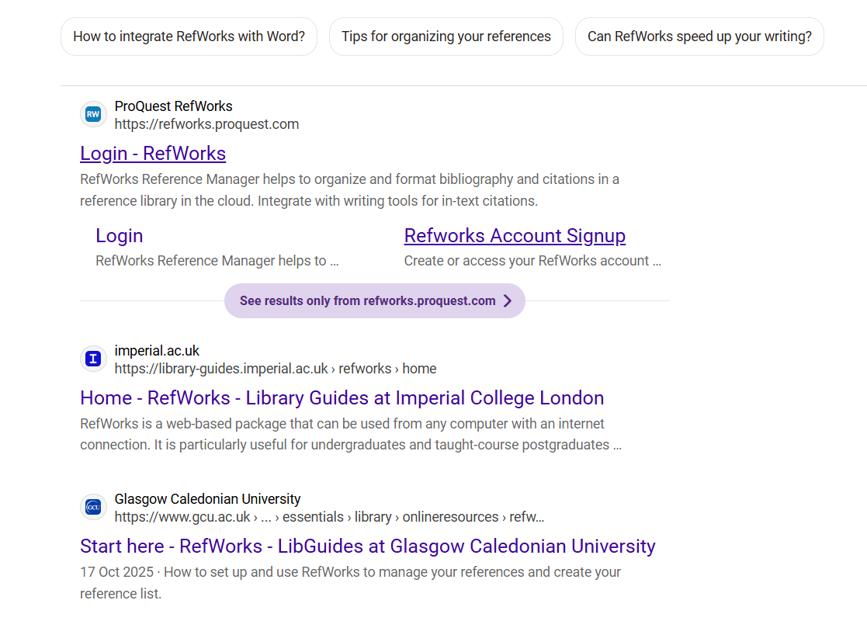

You have to search for refworks on google

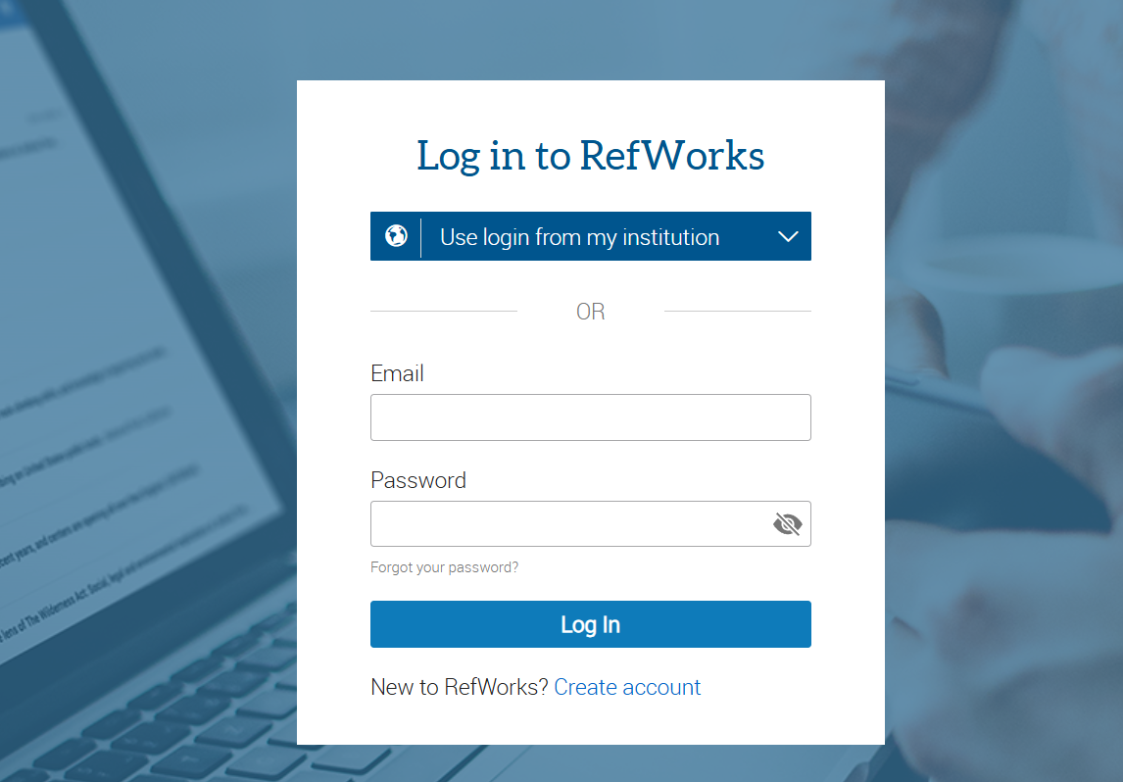

Log in your student account

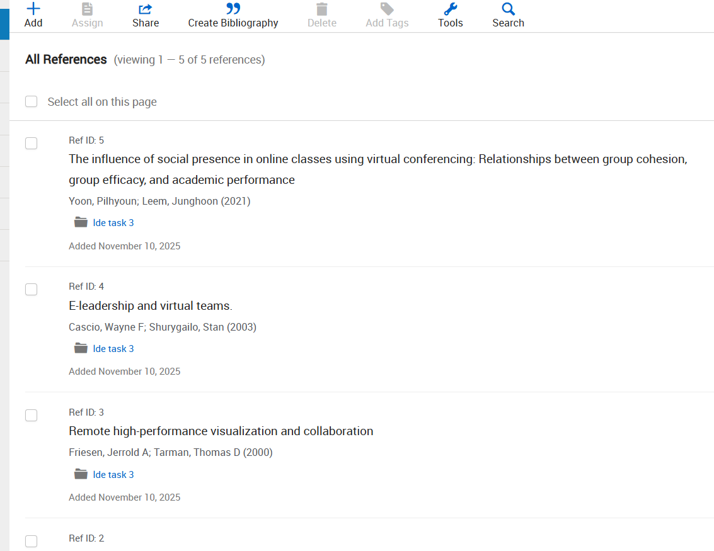
YOU WILL GET INTO THE REFWORKS
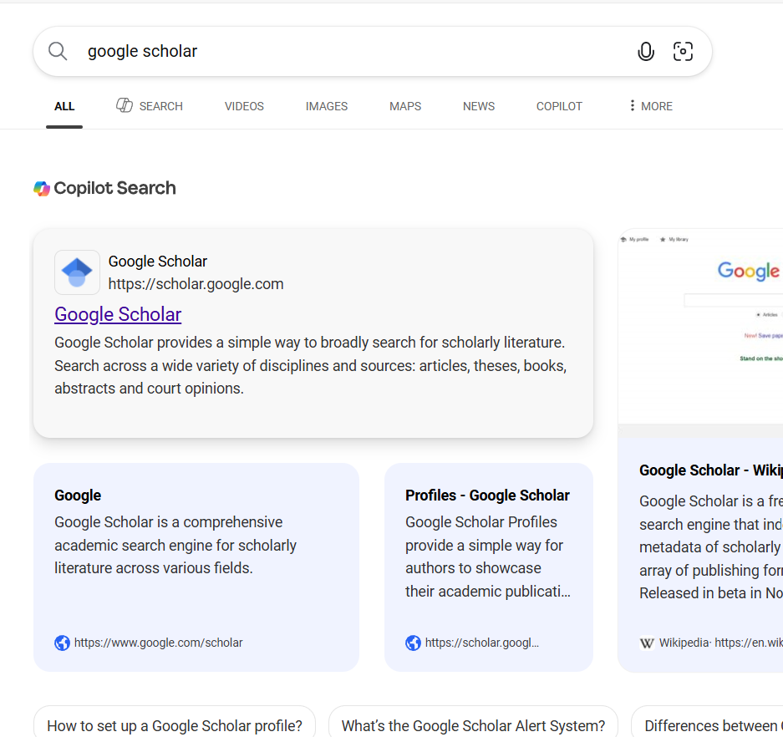

Search for google scholar



Search for your topic on google scholar

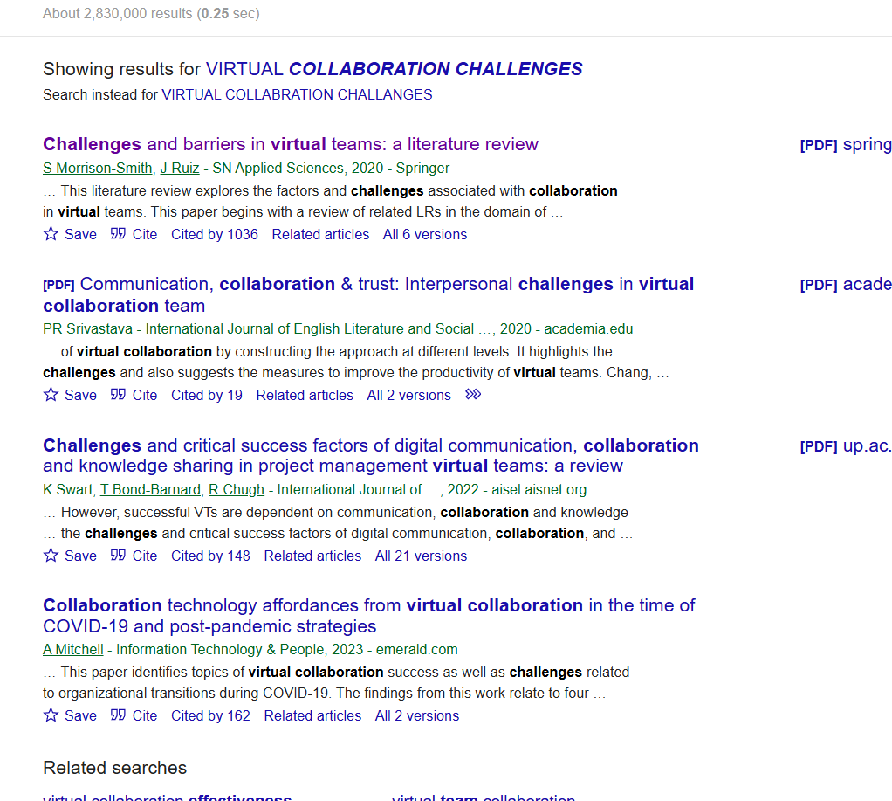

Click the site option under your selected topic

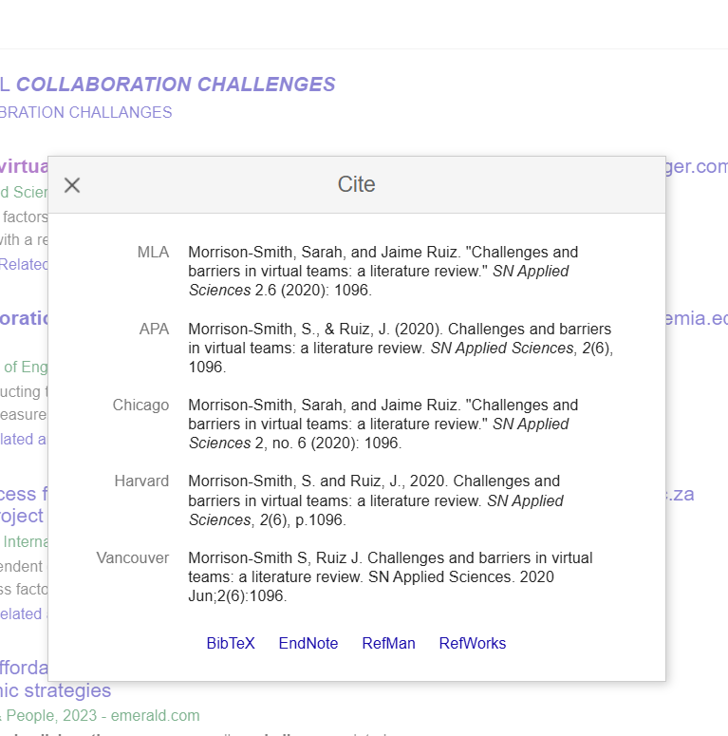

Select the refworks option here

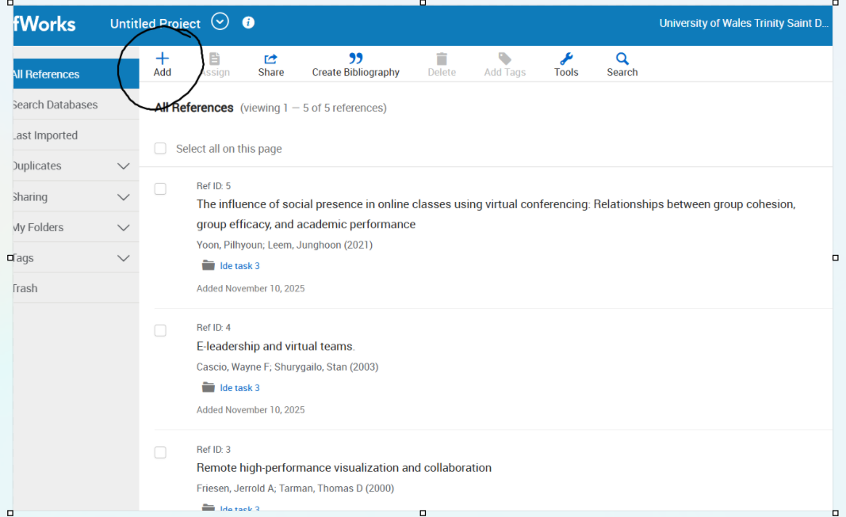

SELECT THE ADD REFERENCE OPTION

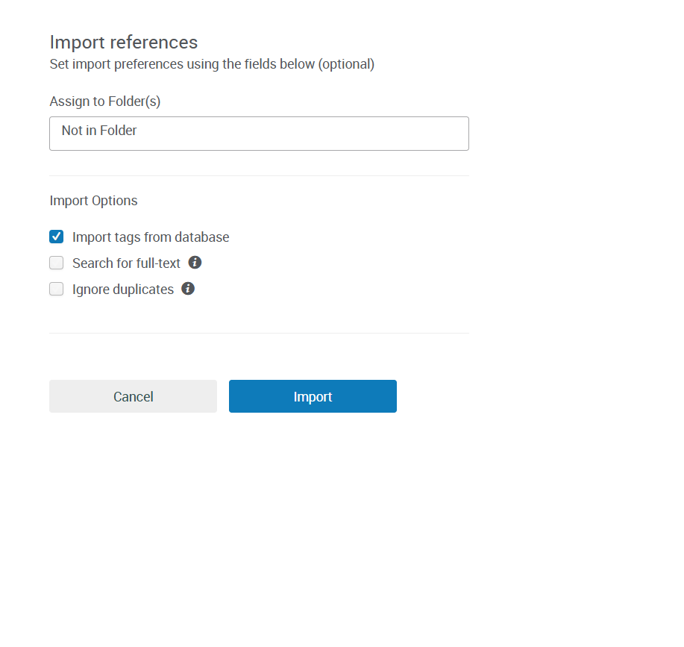

IMPORT YOUR REFERENCES THERE

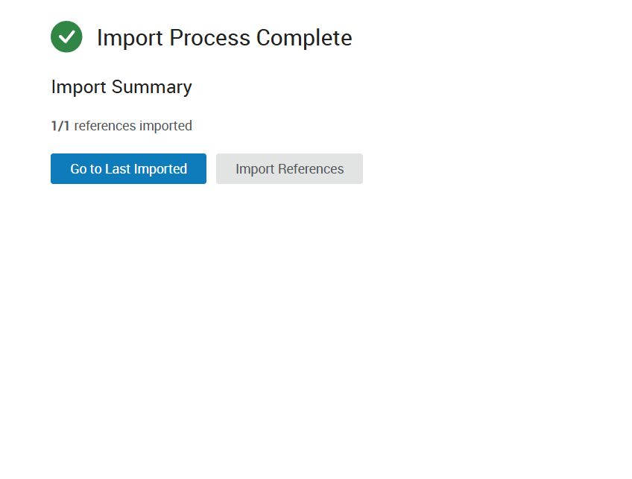

ONCE ITS SUCESSFULLY IMPOTED

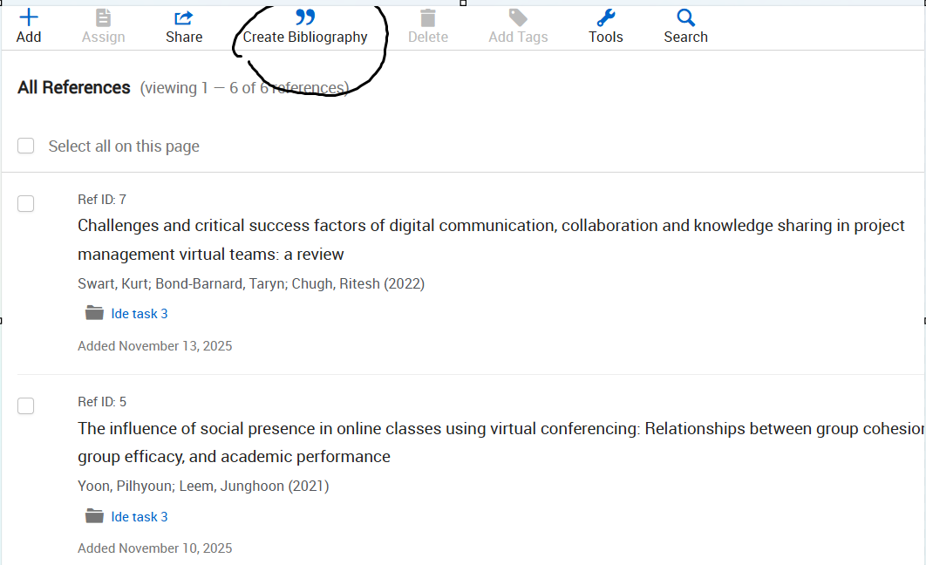

CREATE A BIBLOGRAPHYBIBLIOGRAPHY FO IT

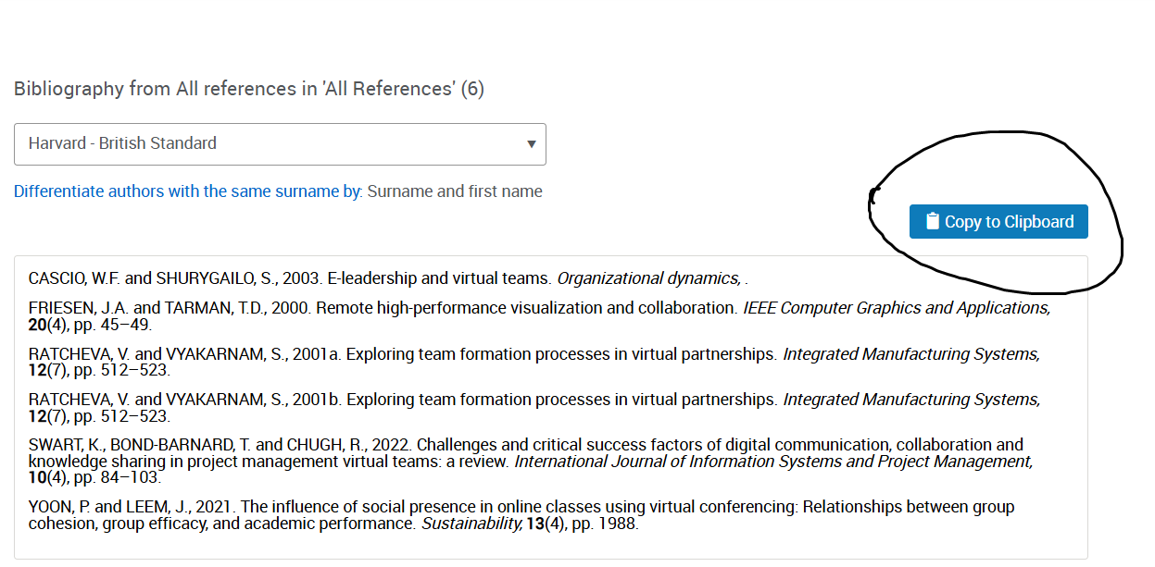

ONCE YOUR REFERENCES ARE IMPORTED JUSTRJUST CLICK ON COPY TO CLIPBOARD

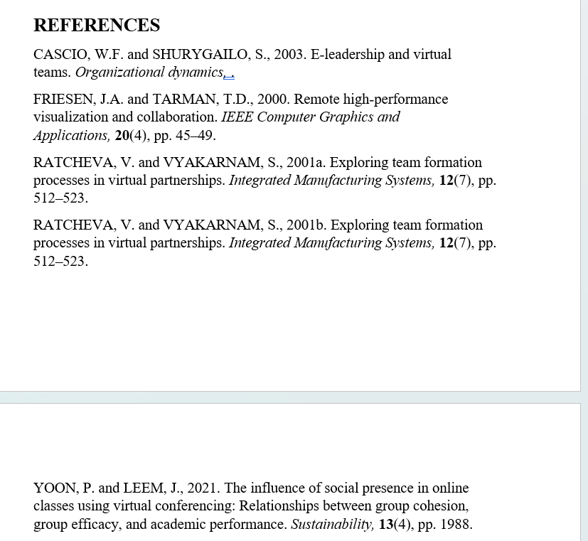

PASTE YOUR REFERENCES HERE

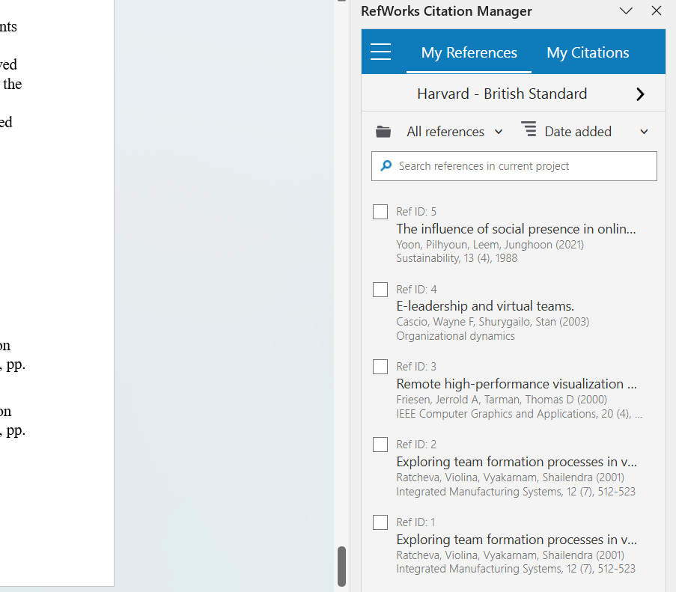

LINK YOUR REFWORKS TO THE WORD

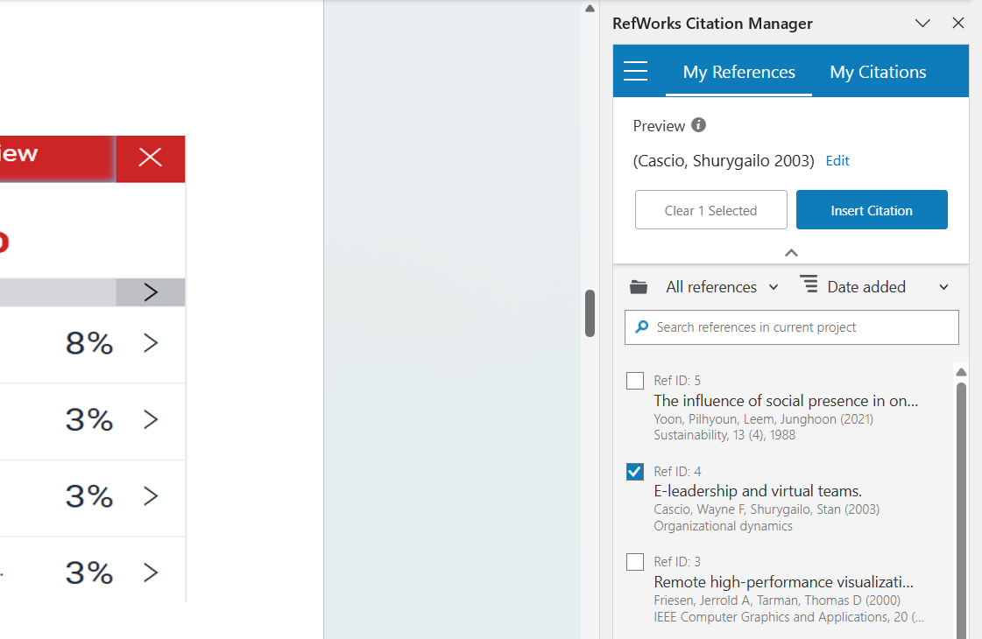

CLICK ON EACH REFERENCE FOR THE FOLLOWING PARAGRAPH THAT YOU HAVE CHOSEN

